ARDS and North Down Borough Council

A hybrid meeting of the Environment Committee was held at the Council Chamber, Church Street, Newtownards, and via Zoom, on Wednesday 10 June 2026 at 7.00 pm.

Present:

In the Chair: Councillor Cathcart

Aldermen: Adair McAlpine (Zoom)
Armstrong-Cotter McRandal
Cummings

Councillors: Boyle (Zoom) Edmund
Blaney (Zoom) Kendall (Zoom)
Brady Newman
Douglas Wray

Officers in Attendance: Director of Environmental Services (G Bannister), Head of Estates (P Caldwell), Licensing and Regulatory Services Manager (D Pearson), Waste Resource and Contracts Manager (J Frazer), Parks and Cemeteries Development Manager (J Bettes) and Democratic Services Officer (H Loebnau).

CHAIRS REMARKS
The incoming Chair of the Environment Committee, Councillor Cathcart, opened the meeting by congratulating the outgoing Chair, Councillor Kendall, on her service and expressed his appreciation for the opportunity to take on the role having been a long standing member of this Committee. He also welcomed the Waste Resources and Contracts Manager to her first meeting.
Councillor Cathcart then addressed the recent violent incident in Belfast on Monday evening and described it as shocking. He expressed gratitude that demonstrations within the Borough had remained peaceful and encouraged that sense of calm to continue, noting that violence would only undermine the sentiments that had been expressed in the days following the attack. He concluded by extending his thoughts to the victim and to those who had subsequently suffered as a result of related criminal behaviour.
1. APOLOGIES

The Chair sought apologies and those were noted from Councillors Ashe and Harbinson.

NOTED.

2. Declarations of Interest

The Chairman sought Declarations of Interest and none were given.

NOTED.

3. FROM WASTE TO WORTH – NORTHERN IRELAND WASTE PREVENTION PROGRAMME CONSULTATION – DRAFT RESPONSE
(Appendices I – III)

PREVIOUSLY CIRCULATED:- Report from the Director of Environmental Services detailing that the Department of Agriculture, Environment and Rural Affairs (DAERA) had launched a public consultation to seek views on its draft Waste Prevention Programme. The draft Waste Prevention Programme followed on from the 2019 ‘Stopping Waste in its Tracks’ programme.

Waste prevention was defined in the draft Programme as ‘stopping waste from being created in the first place’. Regulation 17 of the revised Waste Framework Directive 2011 introduced a legal duty to apply the Waste Hierarchy.
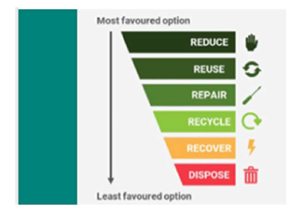
Figure 1: The Waste Hierarchy

Waste prevention was at the top of the Waste Hierarchy because prevention avoided the environmental impacts, costs, and resources used that came with collecting, processing, or disposing of packaging and products.

A public consultation opened on 20 April 2026 and would close on 10 July 2026.

Measures proposed in the draft Programme included incentives to design out waste, measures to reduce consumption, and nudges to change behaviours through education and awareness raising.

Waste Prevention Programme
The draft Programme’s 7 objectives were:

- Reduce Resource Use - Encourage efficient use of materials in manufacturing, packaging, and service delivery.
- Promote Reuse and Repair - Support systems and networks that extend the life of products (e.g. reuse centres, repair cafés).
- Influence Consumer Behaviour - Raise awareness and educate the public on sustainable choices and waste reduction.
- Support Circular Economy Principles - Encourage product design that enables reuse, repair, remanufacturing, recycling, and minimal waste.
- Engage Businesses and Public Sector - Promote waste audits, sustainable procurement, and prevention strategies in organisations.
- Monitor and Report Progress - Track waste generation trends and evaluate the effectiveness of prevention measures.
- Reduce Environmental Impact - Lower greenhouse gas emissions and pollution associated with waste production and disposal.

The draft programme proposed 21 actions. A draft response had been prepared and was attached as an appendix. The draft response text was italicised.
Key response points were:

- This Council supports the publication of the draft Waste Prevention Programme and many of the proposed actions.
- Council welcomes the shift of responsibility to producers, and the proposal to develop eco-labelling to support consumers in making more sustainable choices.
- Council welcomes support for increased reuse, repair, and the circular economy through third sector projects and engagement with schools.
- Call for more of the Carrier Bag Levy revenues to be targeted to waste prevention and recycling projects and campaigns.
- Strong support for measures which reduce avoidable food waste and tackle unnecessary plastics.
- Notes that some proposed actions relate to recycling or tackling litter and are unlikely to have an impact on waste production.
- Some actions appear to duplicate the work of existing programmes and campaigns.

Next Steps
An agreed Ards and North Down Borough Council response to the consultation must be submitted through the Department’s Citizen Space online consultation website by 10 July 2026.

RECOMMENDED that the Council approves the draft consultation response, attached at Appendix 1.

Proposed by Alderman McRandal, seconded by Councillor Kendall that the recommendation be adopted.
Alderman McRandal began by offering his congratulations to the new Chair of the Committee and raised a question relating to the Draft Response, specifically about the recommendation referring to the proposed Deposit Return Scheme and why that would not reduce waste at the point of production. The Waste Resource and Contracts Manager addressed the Alderman’s point in that such measures proposed could reduce litter and increase recycling but clarified that they would not reduce overall waste being produced in the first instance which was what the consultation was about. The Alderman thanked officers for the work that had gone into preparing the draft response.
Councillor Kendall welcomed Councillor Cathcart to the role of Chair and wished him well for the year ahead. She welcomed the Draft Response, considering it well thought out. She noted that while the Council, residents and businesses were working hard to prevent waste, the programmes proposed were, in her view, downstream interventions rather than measures that would reduce waste and pollution at source. She welcomed ongoing collaborative work and expressed hope that greater responsibility would be placed on producers, particularly in relation to microplastics and litter, which had significant health and financial impacts on residents and consumers. She felt the Council had been thoughtfully critical in its response but expressed disappointment that the Department’s proposals had not gone further.
Councillor Newman asked how the Council could support groups to establish repair cafés. The Waste Resource and Contracts Manager explained that the recycling team had been working to expand such programmes and referred to a bicycle repair peddler who had been invited by the Council to provide free repairs as part of efforts to promote sustainability and prevent waste. It was noted that plans were in place to extend that initiative.
AGREED TO RECOMMEND, on the proposal of Alderman McRandal, seconded by Councillor Kendall, that the recommendation be adopted.

4. PRoperTY MAINTENANCE STRATEGY 2026-2036
(Appendix IV)

PREVIOUSLY CIRCULATED:- Report from the Director of Environmental Services detailing that the Council’s new Corporate Plan set a clear direction for delivering high-quality, sustainable and resilient services that met the needs of residents, businesses and visitors. The Property Maintenance Strategy 2026–2036 had been developed to support those priorities by ensuring that the Council’s estate, comprising almost 200 diverse assets across the Borough, was managed in a proactive, efficient and financially responsible manner.

The 2016 Property Maintenance Strategy identified the need for a fundamental shift away from the predominantly reactive maintenance practices operated by the legacy Councils. At that time, approximately 75% of maintenance expenditure was reactive, creating financial uncertainty, increased downtime and reduced service quality. Over the past decade, the Council had successfully transitioned to a planned and preventative maintenance model, with 78% of expenditure now directed to planned works. That shift had materially improved the condition, reliability and sustainability of the estate and established strong foundations for the next phase of strategic development.

The new strategy built upon that progress and aligned maintenance activity with wider Council objectives, including environmental sustainability, statutory compliance, good governance and continuous improvement. It reflected emerging legislative requirements; most notably the Climate Change Act (Northern Ireland) 2022 and the need to further enhance the resilience, energy performance and long-term value of the Council’s property portfolio.

Key Issues
1. Modernising and Strengthening Maintenance Practices
Significant progress had been made in embedding planned preventative maintenance across the estate. The strategy outlined the continued use of cyclical condition surveys, structured refurbishment planning, statutory compliance regimes, and the integration of AssetHQ to monitor performance and prioritise works.

2. Growing Sustainability and Net-Zero Obligations
The Climate Change Act (Northern Ireland) 2022 required a 48% reduction in emissions by 2030 and net-zero by 2050. Meeting those targets would necessitate a substantial and sustained programme of energy-saving initiatives, integration of low-carbon technologies, and enhanced cross-departmental working. The improved condition of the estate now enabled increased investment in Energy Saving Initiatives (ESIs) as reactive pressures continued to fall.

3. Long-Term Financial Planning
The current annual maintenance budget of approximately £3.4 million reflected the Council’s commitment to proactive asset management. However, the ongoing replacement of mechanical and electrical assets, refurbishment of play areas, enhancements to public-realm assets, and harbour and car-park works would require careful long-term financial planning and prioritisation. The strategy clearly set out the expected investment levels required over the next decade, including a £5 million rolling programme for M&E replacements and growing allocations for energy-efficiency work.

4. Ensuring Compliance and Governance
Statutory obligations relating to electrical safety, fire safety, lifting equipment, legionella and other regulated systems continued to expand. The strategy strengthened governance arrangements and outlined improved oversight of third-party operated buildings, alongside greater technical involvement in new capital projects to ensure long-term affordability and maintainability.

5. Supporting Service Delivery and Community Outcomes
Well-maintained assets were essential for providing safe, reliable and fit-for-purpose facilities. The strategy included targeted approaches to high-risk and high-use asset groups such as play parks, public conveniences, leisure centres, administrative buildings and public-realm spaces.

Next Steps
The following actions would support implementation of the strategy:
- Embed the new 10-year maintenance and refurbishment planning cycle, ensuring surveys, reporting and budget-setting processes were synchronised and transparent.
- Progressively scale investment in energy-saving measures, in line with statutory climate obligations and the long-term transition to a low-carbon estate.
- Deliver annual condition-survey programmes, ensuring that each building was surveyed on a three-year cycle, enabling data-driven prioritisation of works.
- Apply the agreed thresholds for refurbishment and replacement, ensuring investment was aligned with asset condition, statutory compliance and long-term strategic value.
- Strengthen cross-departmental collaboration, particularly around future capital planning, sustainability programmes and service transformation initiatives.
- Maintain a strong focus on public-realm and harbour assets, ensuring high-profile areas continued to meet public expectations and support the Borough’s attractiveness.
- Monitor performance and report progress, with flexibility to adapt the strategy in response to budgetary, legislative or organisational changes.

Summary
The Property Maintenance Strategy 2026–2036 represented a major step forward in the strategic management of the Council’s estate. It built on a decade of transformation that successfully shifted the organisation from reactive to planned maintenance, significantly improved the condition and reliability of its buildings and assets, and placed the Council on a stronger footing to meet future challenges.

The strategy responded directly to the priorities of the new Corporate Plan and acknowledged the scale of the Council’s obligations under the Climate Change Act (Northern Ireland) 2022. It set out clear priorities for planned maintenance, refurbishment, statutory compliance, sustainability and long-term financial stewardship.

By adopting a structured, data-driven and proactive approach, the Council would ensure that its estate remained safe, compliant, resilient and aligned with community needs. The strategy provided a clear framework for future investment, supported long-term budget predictability and underpinned the Council’s broader ambition to deliver sustainable and high-quality services across the Borough.

RECOMMENDED that the Council approves the implementation of the attached Property Maintenance Strategy 2026-2036.

Proposed by Alderman Adair, seconded by Councillor Wray, that the recommendation be adopted.
Alderman Adair praised the Head of Estates for a thorough report, stressing the importance of maintaining Council assets. He welcomed the new scoring approach for playparks and community centres, calling it a strong investment. He asked when scoring plans would reach Committee and was advised they were underway and would be presented in the Autumn before rates setting. He closed by thanking the team.
Councillor Wray congratulated the new Chair and seconded the recommendation, highlighting the achievement of moving from reactive to planned maintenance. He supported the seven actions and the renewed focus on the public realm. While pleased with maintenance of playparks and community halls, he said a broader strategy for public realm assets, including car parks, would be needed to support non-domestic rate growth.
Councillor Kendall sought more detail on the “social adjustment” element referenced in the report. The Head of Estates explained it allowed for score adjustments in closed or poorly used assets, but noted most Council assets were well used, which she found reassuring. She asked about third-party contractors and technical governance, and was told compliance would be built into operating agreements. She also queried decisions on refurbishment versus replacement and was advised that assets would be replaced when refurbishment exceeded 85% of rebuild cost.
Alderman McAlpine welcome work on public realm assets but asked when updates for the years after 2022/23 would be provided. The officer said the table simply illustrated the cyclical programme and the commitment to maximise available funding. The years heading could be read as years 1 to 5.
The Chair said he would like more detail on the schemes delivered but overall viewed the report as positive.
Councillor Brady congratulated the new Chair and welcomed the Council’s proactive approach, thanking the Estates team. He asked for clarification on compliance maintenance, and the Head of Estates explained it covered the legal requirements and routine tasks such as boiler servicing. When asked about climate-related building hardening, the officer confirmed climate resilience was referred to in the report as part of the cyclical surveys.
AGREED TO RECOMMEND, on the proposal of Alderman Adair, seconded by Councillor Wray, that the recommendation be adopted.

5. oFF Street parking activity

PREVIOUSLY CIRCULATED:- Report from the Director of Environmental Services detailing that Members would be aware that the Council had a vast car park estate, currently operating 22 pay and display car parks in Bangor, Holywood and Newtownards, and managing further car parks across the Borough.

The report aimed to update Members on expenditure, income and PCNs generated at each of the relevant car parks in the period 1 October 2025 to 31 March 2026. It would also provide Members with an update following some associated decisions related to the approval of a new car park order made at the February 2026 Council meeting, and general off-street parking information.

Key Issues
Off Street Parking Activity 1 October 2025 to 31 March 2026.

Table 1: Income from Ticket Sales
 | 1 October 2025 to 31 March 2026 | Previous year  1 October 2024 to 31 March 2025
Income from ticket sales | £449,086 | £450,854

Table 2: PCN’s Issued
 | 1 October 2025 to 31 March 2026 | Previous year  1 October 2025 to 31 March 2026
Total | 2090 | 2587

Officers continued to monitor compliance with Ards and North Down Off-Street Parking (Public Car Parks) Order 2024 and work with our enforcement partner to ensure compliance across the car park estate, introducing enforcement in additional car parks. The next car parks to progress to enforcement would be Spafield, Holywood and Newtownards Road/ Church Street, Bangor.

Table 3: Expenditure
 | 1 October 2025 to 31 March 2026
Enforcement Contract | £77,179.35
Maintenance | £187,140.15
Grounds Maintenance | £2147.63
Signage | -
Total | £266,467.13

Update from 4 February 2026 meeting

At its meeting on 4 February 2026, the Environment Committee agreed the Ards and North Down Off-Street Parking (Public Car Parks) Order 2025 subject to additional decisions which included the following:

- That a parking app which set a time limit on parking (rather than stop/start) was introduced as soon as possible.

- That the Chambers of Commerce and city/town advisory groups were consulted on their views on the introduction of 2 hour waiting restrictions (instead of one hour) for Department for Infrastructure managed on-street parking spaces, to inform the Committee before the Council lobbied the Department on any potential changes.

Officers were continuing to liaise with DfI Transport Legislation Branch through the Regional Off Street Parking Group to agree a date for the revocation of the Off-Street Parking Order 2000 and implementation of Ards and North Down Off-Street Parking (Public Car Parks) Order 2025, and a further update would be brought to the Council as soon as possible.

Car Parking App Update

Officers liaised with the Council’s parking app provider RingGo and initiated a change from their “Start/Stop” model to their “Buy Time” model effective from 1 May 2026.

That meant that users now choose how long they wished to stay on arrival and pay up front for their parking in the same way as they did at the pay and display terminal.

A communications strategy to ensure app users were aware of the change was implemented, including posts on the Council’s social media channels, signage in all 22 charged car parks and an updated webpage with a user video.

The model continued to provide flexibility by allowing users to extend their parking period without having to return to the car park which was assisted by a timer and removed the need to remember to stop your session on return to your vehicle; ensuring that users were not overpaying for their parking session.

Data from the first two weeks of ‘Buy-Time’ showed an increased uptake in app usage and an average saving per transaction for app users.

Consultation on 2 Hour waiting Restriction for on street parking.

Officers met with Ards and North Down Business Forum, who represented the five Chambers of Commerce of Bangor, Newtownards, Holywood, Comber, and Donaghadee, and with each of the Local Action Groups to discuss a possibility of lobbying the Department for Infrastructure and ask it to amend the current legislation which permitted up to 1 hour on-street parking, to allow instead up to 2 hours on-street parking across the Borough.

The Newtownards Local Action Group was in support of the Council lobbying the Department for Infrastructure to amend the current legislation which permitted 1 hour on-street parking to allow 2 hours on-street parking.

The Local Action Group also requested that Council lobby the Department to resolve an anomaly in the legislation regarding the return within 1 hour clause which was leading to some vehicles parking all day, whereby the ‘no return’ was interpreted as no return to the exact same parking spot.

Donaghadee Local Action Group was in support of Council lobbying the Department for Infrastructure to amend the current legislation which permitted 1 hour on-street parking to allow 2 hours on-street parking.

The Local Action Group also requested that Council lobby the Department to introduce a 2 hour on-street parking restriction on part of Shore Street and The Parade and echoed the request regarding the anomaly in the legislation regarding the return within 1 hour clause.

Comber Local Action Group highlighted the restricted on-street parking was more limited within Comber and that was not something they had previously considered. Following discussion and further consultation with the Chamber, they agreed to support the Council lobbying the Department for Infrastructure to trial extending 1 hour on-street parking to 2 hours on-street parking, with the exception of the spaces in Castle Street and Mill Street.

Holywood Local Action Group discussed the matter and could see the benefits to both 1 hour and 2 hour on-street parking restrictions. It was noted that 1 hour assisted turnover in Holywood town centre, and the town centre car parks were easily accessible for longer stays. The voluntary sector noted that a 2 hour on-street period would be beneficial for clients who attended counselling sessions, and discussion took place around the possibility of a trial period. Further consultation with the Chamber showed support for the extension but also concerns regarding extending the length of stay in the already limited number of available spaces.

The Local Action Group also requested that the Council highlight to the Department its support for a Residents’ On-Street Parking Permit Scheme in Holywood, and further lobby the Department to address on-pavement obstructions outside commercial premises, which extended beyond the current pavement café licensing scheme.

Bangor Local Action Group was in support of the Council lobbying the Department for Infrastructure to amend the current legislation which permitted 1 hour on-street parking to allow 2 hours on-street parking.

The Bangor Local Action Group also requested that the Council lobby the Department to resolve the anomaly in the legislation regarding the return within 1 hour clause.

Next Steps

- Lobbying
Council to give consideration to lobby the DFI on behalf of the groups consulted, as per the recommendations contained in this report

- Replacement of car park machines
As part of the rate setting process, budget was allocated to replacement of the current pay and display machines across the charged car park estate, which transferred from DfI in 2015.

Officers were beginning to see increased machine failures as those approached the end of their lifespan, causing difficulties for car park users and a loss of revenue for the Council. New machines would encompass a keypad and contactless payment technology which allowed for future ticketless parking and supported the overall modernisation of the car park estate.

Those new machines also provided an opportunity for the Council to make savings on cash collection costs and physical tickets, as well as supporting the Council’s net zero targets. The current machines required non-recyclable printed tickets to be issued for display with 672,662 non-recyclable paper tickets issued in 24/25 and 617,503 in 25/26, which ended up in landfill or as litter on streets, and a future campaign would be launched to remove the need to use that method.

Members had previously raised concerns about ticket transfers and the ability of car park users to transfer tickets, that would be resolved with the new machines, ensuring that all car park users paid for the service as they used it.

The replacement programme was expected to be completed over the coming months. New signage and a full communications strategy would be implemented by officers ensuring minimal disruption for car park users.

- Grounds maintenance
A grounds maintenance programme had been initiated across the car park estate and would continue throughout the 26/27 financial year, enhancing the visual appeal of the car park estate and overall experience of those who used it.

Summary
Following consultation with the Local Action Groups as outlined in the report, officers proposed that the Council writes to the Department for Infrastructure in respect of On-Street Parking.

A further activity report would be brought to the Council in the Autumn, outlining activity for the first half of 2026/27 and providing a further update on the ongoing work to enhance the car park estate.

RECOMMENDED that the Council notes the information in this report and agrees to:

Lobby the Department for Infrastructure to extend the on-street parking waiting restriction to 2 hours in Bangor, Newtownards and Donaghadee.

- Lobby the Department for Infrastructure to address the no return within 1 hour anomaly with on-street parking waiting legislation.

- Lobby the Department for Infrastructure to extend the 2-hour on-street parking waiting restriction to include part of Shore Street and The Parade in Donaghadee.

- Lobby the Department for Infrastructure to trial an extension of the on-street parking waiting restriction to 2 hours in Holywood and Comber, with the exception of Castle Street and Mill Street.

- Lobby the Department for Infrastructure to address pavement obstructions outside commercial premises generally caused by inconsiderate parking.

- Write to the Department for Infrastructure to support a Resident’s On-Street Parking Permit Scheme in Holywood.

Proposed by Councillor Edmund, seconded by Councillor Brady, that the recommendation be adopted.

The Chair thanked the Licensing and Regulatory Services Manager for the work that had been done in relation to off-street car parking acknowledging that different towns had differing priorities.

Councillor Edmund was delighted with the report and the effort that had gone in to producing it and thought it was a step in the right direction and he was happy to see it progress. As seconder Councillor Brady shared that view.

Councillor Kendall also welcomed the report and found the recommendations to be very good. She referred to supporting residents parking schemes in Holywood and thought that it would have been helpful to have a meeting with the Department to support residents in their work to address congestion around the town. She had been made aware that communities were being asked to do much work on behalf of the Department that in her opinion they should not have to do and that barrier was a little preventative to reaching solutions. The problems around parking for residents of Holywood were obvious and had been ongoing for many years. She thought that Councils could be a little more proactive in helping residents of these areas and not put all the onus on them to come to solutions since it was a reasonable requirement to be able to park outside one’s home.

The Chair asked if the Member was making the proposal that the Committee invite the Department to speak to the Committee and Councillor Kendall welcomed any position that would help. It was suggested instead that the Council include that in its communication with the Department and the proposer and seconder were in agreement with that. It was noted that some roads and car parks were also in a poor state of repair and resurfacing had been delayed and it was hoped that that work would be carried out during this financial year.

AGREED TO RECOMMEND, on the proposal of Councillor Edmund, seconded by Councillor Brady, that the recommendation be adopted.

6. RoLLO Gillespie Monument, Comber – phase 2 works update
(Appendix V)

PREVIOUSLY CIRCULATED:- Report from the Director of Environmental Services detailing that a report was presented to the Environment Committee in February 2024 outlining the condition of the Rollo Gillespie Monument in Comber and the works required to address deterioration identified through a specialist conservation survey. At that time, officers recommended a two-stage approach, with the initial phase addressing urgent health and safety issues and essential repairs, together with investigative works to inform the scope and cost of the second phase.

Key Issues
Since the earlier report, officers had explored potential external funding opportunities to assist with delivery of Phase 2 works. No suitable external funding source had been identified for the project. In light of that position, a sum of £90,000 had been included in the rates for 2026/27 to provide for delivery of the Phase 2 works and to allow the required conservation repairs to progress.

Next Steps
Subject to Council approval, officers would proceed with the necessary actions to carry out the Phase 2 works. That would include progressing the required approvals, procuring the specialist conservation contractor input as necessary, and programming the works for delivery from the 2026/27 budget provision. The works to be carried out were detailed in the attached report.

Summary
The Phase 2 works to the Rollo Gillespie Monument remained necessary to protect the structure and address the issues identified through the condition survey. As no suitable external funding had been secured, provision had been made through the 2026/27 rates process. Officers therefore requested permission to proceed with the Phase 2 works.

RECOMMENDED that the grants approval for officers to proceed to carry out the Phase 2 works to the Rollo Gillespie Monument, Comber, funded from the £90,000 included in the rates for 2026/27.

Proposed by Alderman Cummings, seconded by Councillor Douglas, that the recommendation be adopted.

Alderman Cummings thanked officers for working diligently on the monument and thought that the report was comprehensive. She referred to the vulnerability of the sandstone on the monument and the need to restore that but asked about the inscription to the east side and asked was the intention to replace it with like stone or if a plate would be attached with the inscription. The Head of Estates apologised that he was unaware of that detail but would follow up on that while recognising that the cost could be quite significant.

It was enquired if there had been any feedback on heritage lottery funding or from the masonic in Dublin and it was noted that had been sought without success. The Committee was informed that a report would be brought back before the work commenced properly.

The Chair sought assurances that the local war memorials were in a good condition before the Remembrance Day commemorations and Members were assured that assessment would take place in the later part of the summer as every year.

AGREED TO RECOMMEND, on the proposal of Alderman Cummings, seconded by Councillor Douglas, that the recommendation be adopted.

7. notice of motion 629 clandeboye park and pitch update

PREVIOUSLY CIRCULATED:- Report from the Director of Environmental Services detailing that in September 2024 the Council agreed a Notice of Motion stating:

“That this council notes that significant investment was previously made to deliver a play park, MUGA and amateur league sized football pitch on the Clandeboye road. Notes with regret there have been ongoing issues with the pitch. Instructs officers to reinstate the goalposts and mark out the pitch so that it can be played on by the local community. Furthermore, following consultation with the local community, that a report is brought back regarding the longer-term maintenance and enhancement of the site, to ensure any necessary provisions can be considered during the rate setting process to ensure that the football pitch is fit for purpose and can be used as previously agreed.”

A report was tabled at the Community and Wellbeing Committee in January 2025, with a number of options and a recommendation. Elected Members decided to progress an option to reinstate the football pitch to intermediate dimensions with full size goal posts. A budget was agreed separately and within the 2025/6 financial year.

A programme of works was approved in June 2025 to prepare the pitch for the 2025 season. The following had been delivered as a result:

- Installation of full-size goalposts and ball stop fencing
- Overseeding, sand dressing and pitch aeration
- Weed treatment and fertiliser programme
- Line marking and inclusion in the annual maintenance programme
- Independent turf assessment and maintenance plan

Those works had reinstated the pitch for community use. The current pitch measures 88m x 46m, below intermediate standards, initially requested by the local community. Constraints to widening included:

- Underground water infrastructure
- Sloping ground levels
- Proximity to the MUGA and paths

A feasibility study confirmed that widening would require significant works, including regrading, a retaining wall, and infrastructure adjustments (subject to external approvals). Estimated costs:

- Construction: £98,500
- Additional costs (fees, approvals, access changes etc.): approx. £30,000

The pitch would also be unavailable for approximately twelve months during establishment.

Engagement was undertaken with local stakeholders, including schools, community groups and sports clubs.

Key priorities identified:
- Toilet provision
- Dog exercise area to reduce fouling
- Outdoor learning and biodiversity spaces
- Intermediate football use would require 90m x 55m pitch dimensions
- Youth football requires smaller formats
- Changing, storage and toilet facilities would be needed

As reported to the Environment Committee in December 2025 the report considered that:
- The cost and scale of works were significant for an informal community facility
- There was no current strategic need for intermediate-level provision at this location
- The proposal did not represent value for money
- The upcoming Leisure Strategy audit should inform any future decision

It was recommended to the Environment Committee in December 2025 that Council:
- Notes the reinstatement and ongoing maintenance of the pitch
- Notes the engagement outcomes and current constraints; and
- Agrees not to progress pitch widening at this time, pending the Leisure Strategy facilities audit.

Key Issues
At the Environment Committee meeting in December 2025 an alternative recommendation was agreed: “That the Item be deferred to allow officers to set up a meeting as soon as possible between:

- Council Officers,
- Clandeboye Village Community Association, and
- interested environment committee & Bangor West DEA elected reps.”

An on-site meeting was held on Monday 16 March 2026 which was attended by Council Officers, Clandeboye Village Community Association and Elected Representatives. The meeting was productive with views from all sides heard. It was agreed that a further report would be brought to the Council outlining the findings.

On 23 March 2026 officers received communication from Elected Members asking if the dimensions of the pitch could be extended, not to the previously requested intermediate dimensions of 90m by 55m, but to at least 90m by 50m.

Officers investigated this request and agreed it was achievable. That was agreed as acceptable by Clandeboye Village Community Association. During those communications, a request to increase the pitch length to between 95m and 100m was made by the Community Association. The request also included installation of stanchions in the corners of the existing posts to aid hanging of nets. Both those requests were investigated by officers and were deemed to be achievable.

Next Steps
The following works were proposed:

- Increase the pitch width to 50m
- Increase the pitch length to 96m
- Install corner stanchions on both sets of goalposts.

This approach was agreed in writing by Clandeboye Village Community Association on 13 May 2026. If the report was agreed, works would be progressed through the Summer months of 2026.

Summary
The Council reinstated the football pitch at Clandeboye Road during 2025, including new goalposts, pitch improvements and ongoing maintenance, enabling continued community use. The pitch remained below the intermediate size initially requested, due to site constraints and the significant works required to achieve those dimensions were not recommended in December 2025.

Following further engagement with local stakeholders and Elected Members in early 2026, a revised and more achievable enhancement option had been agreed. That included extension of the pitch to 96m x 50m and installation of corner stanchions.

Those works had been agreed with the Clandeboye Village Community Association and were proposed for delivery during Summer 2026, subject to Council approval

RECOMMENDED that the Council agrees to the progression of the proposed works as outlined in this report.

The Chair informed the Committee that Councillor Gilmour had been given speaking rights for this item.

Proposed by Councillor Brady, seconded by Councillor Newman, that the recommendation be adopted.

Councillor Brady was pleased to see that a compromise had been reached and the contractor would carry out the work for the teams in advance of the new season. Councillor Newman said that finally the community could see light at the end of the tunnel. The compromise had been given full support and the Association had waited too long for this outcome. The facility could be used by Bangor Football Club as a pitch for training. She asked if a commitment could be made to the community that the work would be done before the end of the summer to reach a swift and satisfactory conclusion and that was confirmed with a start being made following the approval of the full Council.

Councillor Gilmour thanked the Committee for the opportunity to speak and welcomed the Chair to his new role. She explained that she had previously brought this as a Notice of Motion and the issue had been ongoing for that community over many years. She pointed out that the report did not recognise that the pitch had not been built to the correct size at the outset but to get it to full size would be costly and would add years to the delivery time. She thought the compromise would be to make the pitch as wide as possible on the site to make it as versatile as possible.

She had two questions referring to pre-season intentions to have the Village Association work with Bangor Football Club and if the Association could be kept up to date when the works would be progressing. It was evident that dog fouling occurred in the area so she called for additional signage to make the land a useable football pitch that would benefit the community going forward. The Parks and Cemeteries Development Manager agreed that the community would be kept up to date on progress.

Councillor Kendall thanked officers and also relaying thanks on behalf of Councillor McKee, shared the same view in respect of what Councillor Gilmour had said. She was grateful to the community for its advocacy for driving the project forward and thanked them for agreeing to the compromise. She agreed that it was not what had been promised but hoped it could be delivered and used by the community as soon as possible.

The Chair added his support and had been pleased that a compromise had been found.

AGREED TO RECOMMEND, on the proposal of Councillor Brady, seconded by Councillor Newman, that the recommendation be adopted.

8. Local biodiversity action plan update 2026
(Appendix VI)

PREVIOUSLY CIRCULATED:- Report from the Director of Environmental Services detailing that Biodiversity was supported through a statutory duty under the Wildlife and Natural Environment Act (Northern Ireland) 2011. The Act required public bodies to take reasonable steps to further the conservation of priority habitats and species and to encourage others to do so. The development and delivery of the Local Biodiversity Action Plan (LBAP) helped to demonstrate the Council’s compliance with this duty. In line with the Act, the Council’s responsibilities related to five key aspects of biodiversity:

- Protection of Biodiversity
- Maintenance of Biodiversity
- Enhancing Biodiversity
- Restoring Biodiversity
- Promoting Biodiversity

The Borough’s second Biodiversity Action Plan was approved and adopted in April 2023. Since then, it had provided a framework for coordinating activity to protect and enhance biodiversity across the Borough. The preparation of the Plan marked an important step in recognising the value of local biodiversity and ensuring that international, national, regional, and local objectives were progressed through partnership working.

Key Issues
The LBAP set out 84 actions across four themes. Those actions were intended to protect, conserve and enhance the priority habitats and species identified through the Borough audit. For ease of reference, actions were grouped under the following themes:

- Theme 1: Education and Awareness
- Theme 2: Research and Monitoring
- Theme 3: Land Management
- Theme 4: Building Partnerships

The LBAP was embedded within the Parks and Cemeteries Service Plan 2026–27 and supported delivery of the Plan’s agreed strategic objectives and operational priorities. It reinforced the Council’s wider commitment to environmental sustainability, climate resilience and community involvement by evidencing activity underway and progress achieved in improving local biodiversity. In particular, the LBAP aligned strongly with the Service Plan objectives for climate recovery and biodiversity gain.

The report highlighted the Council’s contribution to those aims through actions such as protecting and enhancing habitats, delivering education and engagement activity, and working collaboratively with a range of stakeholders to support LBAP delivery. Collectively, those interventions could support carbon sequestration, improve air quality and strengthen biodiversity. Continued monitoring, through formal surveys and bioblitz events, alongside community-led and incidental records, would help build an increasingly robust understanding of the condition of local biodiversity and the Borough’s green spaces over time.

The LBAP contributed to a number of Service Plan performance measures, including the management of 154,002m² of rewilded Council land. It also supported achievement within wider quality and place-making programmes, including Bloom/Best Kept Awards, and the maintenance of seven Green Flag Award sites.

In addition to environmental and climate benefits, the LBAP supported community wellbeing and aligned with the Five Steps to Wellbeing framework. Outdoor initiatives, such as birdwatching sessions, bioblitzes, Bug ID activities and wider engagement events encouraging residents to spend time in green spaces and to value, enjoy and help safeguard the local environment. That could contribute to physical and mental health benefits associated with time outdoors, while also providing opportunities for social connection and helping to reduce isolation through shared participation.

Next Steps
Over the coming year, work would continue to progress and refine LBAP delivery by building on actions already underway, initiating actions that had not yet advanced, and prioritising activity where it could deliver the greatest benefit for priority habitats and species. The Council would also seek to strengthen and expand partnership working with key stakeholders to support coordinated delivery, share expertise and leverage resources. Community involvement would remain a key focus, with continued engagement through events, volunteering, education and citizen science initiatives to increase awareness, encourage positive behaviours and improve the evidence base through ongoing recording and monitoring.

Summary
The report provided an update on delivery of Ards and North Down Borough Council’s Local Biodiversity Action Plan (LBAP), which supported the Council’s statutory duty under the Wildlife and Natural Environment Act (Northern Ireland) 2011 and provided a framework for coordinated action following adoption of the Borough’s second plan in April 2023. It outlined progress across the LBAP’s 84 actions under four themes, Education and Awareness, Research and Monitoring, Land Management, and Building Partnerships, and highlighted how the work was embedded within the Parks and Cemeteries Service Plan 2026–27, to support agreed strategic objectives, including climate recovery and biodiversity gain.

The report also noted the wider benefits of LBAP activity, including habitat enhancement, engagement and partnership working, improved evidence through surveys and citizen science, contributions to performance measures (including rewilded Council land and Green Flag sites) and positive impacts for community wellbeing through nature-based participation. Next steps focused on progressing and prioritising outstanding actions, strengthening collaboration with stakeholders, and maintaining community involvement to build the evidence base and maximise benefits for priority habitats and species.

RECOMMENDED that the Council notes this report.

Proposed by Alderman McRandal, seconded by Alderman Adair, that the recommendation be adopted.

Alderman McRandal always welcomed this report and the involvement of engaging with community groups. He asked if work was being done that was not in the report and the officer said that more detail could be provided if required but the report would then be very large.

Alderman Adair thanked the Parks and Cemeteries Development Manager on the eighty-four actions but thought that the sand dunes around the Borough’s coastline also needed to be protected. He noted that on the Ards Peninsula there had been a lot or erosion of sand dunes and it was important that that did not continue or the Council could lose its beaches. He asked for that to be prioritised going forward. A little progress had been seen but great care was needed and the officer indicated that the dunes were being given priority and, since they were complex areas, the Council was being given help by outside sources. It was planned to bring back a report in September in relation to the work on sand dunes. Alderman Adair said he would look forward to that and referred to the Strangford Lough and Lecale partnership and hoped to see change on the ground in the near future.

Councillor Douglas asked if there was work planned for the river which flowed through Comber and the officer agreed to come back with further information on that directly to the Member.

AGREED TO RECOMMEND, on the proposal of Alderman McRandal, seconded by Alderman Adair, that the recommendation be adopted.

9. north down coastal path working group
(Appendix VII)

PREVIOUSLY CIRCULATED:- Report from the Director of Environmental Services detailing that the North Down Coastal Path Task and Finish Working Group was established in September 2023 to address issues of connectivity, access and maintenance along the North Down Coastal Path. That followed a decision to withdraw the planning application for the proposed Kinnegar to Donaghadee Greenway Scheme. The Working Group met quarterly and was attended by Elected Members, community and business groups.

Key Issues
A meeting of the North Down Coastal Path Working Group was held on 5 January 2026 and the minutes of the meeting were agreed by the Working Group at the 27 April 2026 meeting.

Next Steps
Council to note the minutes and note the progress of the North Down Coastal Path Task and Finish Working Group. Meetings would continue quarterly with the next meeting due on 29 June 2026. The minutes of the last meeting (27 April 2026) would be considered at that meeting, and a proposal made to agree future minutes by email to allow earlier reporting to Council and publication.

Summary
The North Down Coastal Path Task and Finish Working Group, formed in September 2023 to address maintenance and connectivity, had ratified minutes from its 5 January 2026 meeting. The Council was asked to note the progress made by the group, which held quarterly meetings to oversee improvements along the North Down Coastal Path.

RECOMMENDED that the Council notes the attached minutes of the North Down Coastal Path Working Group held on 5 January 2026.

Proposed by Councillor Brady, seconded by Alderman McRandal, that the recommendation be adopted.

Alderman McRandal and Councillor Newman pointed out that they had been present at the meeting but that had not been recorded in the minutes.

AGREED TO RECOMMEND, on the proposal of Councillor Brady, seconded by Alderman McRandal, that the recommendation be adopted.

10. tree and woodland update report 2026

PREVIOUSLY CIRCULATED:- Report from the Director of Environmental Services detailing that the purpose of this report was to update Members on the Council’s Tree and Woodland Strategy that was agreed in March 2021. The purpose of the Tree and Woodland Strategy was to recognise the importance of trees, the many benefits they afforded and the increasingly important role they could play in mitigating the effects of climate change. The strategy was required to ensure the Council’s limited budget was focused on positive planting programmes and managing tree care and risks.

Residents of the Borough were rightly proud of the greenness around but it was something that was not static and which could not be taken for granted. Trees played a significant role in improving environmental conditions and people’s quality of life. Trees acted as carbon sinks and absorbed carbon dioxide (the main greenhouse gas) and produced oxygen. In addition, trees filtered, absorbed and reduce pollutants. Trees could make the Borough a healthier, more attractive and more comfortable place to live and work. Trees provided food and shelter for wildlife such as birds, squirrels and insects, as well as for people. Trees had been proven to increase property value and to help relax people by lowering heart rates and reducing stress.

The Council was committed to conserving and retaining existing trees and other features where it was considered that they had landscape or amenity value and would use its powers to protect trees where necessary. The Council was also committed to ensuring improved tree cover within the Borough, and to promote the importance of trees to ensure a number of Corporate and Community Plan objectives were met. The Council had a legal 'duty of care' and would provide appropriate levels of management arrangements to ensure that users and neighbours of its land were reasonably safe.

The Tree and Woodland Report played a vital role in supporting the strategic objectives and operational priorities set out in the Parks and Cemeteries Service Plan for 2025–2026. It strengthened the Council’s overarching commitment to environmental sustainability, climate resilience, and active community engagement by providing clear evidence of ongoing work and measurable progress in tree and woodland management.

A key area of alignment was with the strategic objectives of climate recovery and biodiversity gain. The report demonstrated significant contributions to those goals through large-scale tree planting, over 15,000 trees annually and the expansion of the urban tree canopy. Those efforts contributed directly to carbon sequestration, improved air quality, and enhanced biodiversity. Notably, the STAND4TREES initiative, which aimed to plant 160,000 trees by 2032, was a clear example of how the report’s content supported the Council’s net-zero and climate mitigation targets set out in the Corporate Plan.

In terms of community engagement and volunteering, the report highlighted active partnerships with schools, community organisations, and volunteer groups. Initiatives such as Seed2Leaf nurseries and commemorative tree plantings fostered a sense of ownership and inclusion within local communities. That was closely aligned with the Service Plan’s objective to strengthen and grow Friends Groups and other volunteer-led programmes, enhancing the social value of parks and green spaces.

The Tree and Woodland Report contributed directly to several Key Performance Indicators (KPIs) within the Service Plan. Those included the annual planting of 15,000 trees in line with the STAND4TREES target, the delivery of over 70 community-focused projects such as orchard plantings and mindfulness sessions, a marked reduction in herbicide use through sustainable practices, and the expansion of rewilded land to a target of 130,000 square metres.

Environmental sustainability remained a core priority of the Service Plan, and the Tree and Woodland Report complemented that through its promotion of native species, improved urban canopy equity, and increased resilience to storms. It also demonstrated economic and social value, with a Tree Asset Valuation estimating £277 million in amenity value and £7.6 million in carbon storage, figures that supported the Service Plan’s focus on income generation through green infrastructure.

The Council’s Tree and Woodland Strategy not only advanced environmental and climate goals but also significantly contributed to community wellbeing, aligning closely with the Five Steps to Wellbeing framework. Initiatives such as mindfulness sessions in Bangor Walled Garden, guided tree tours, and community planting events improved connections by bringing people together, while outdoor activities like orchard clean-ups and tree planting promoted being active. Events like National Tree Week encouraged participants to take notice of nature’s beauty, and educational programs like Seed2Leaf nurseries and Forest Schools supported continuous learning. Finally, volunteering opportunities and community-led projects embodied the spirit of giving, strengthening social bonds and collective pride in local green spaces. By integrating those principles, the Strategy ensured that trees and woodlands served as vital assets for both planetary and human health.

Key Issues

2025/2026 Tree Plantings
The Council undertook to replace trees in numbers in excess of those that needed to be felled and had an annual tree-planting programme which saw many trees of both native and interesting varieties planted over each Autumn/Winter season.

For example, our STAND4TREES initiative aimed to plant a tree for every person in the Borough, that was approximately 160,000 trees. Through planting season 2025-2026 in excess of 15,000 new trees were planting in the Borough. To date, the Council had planted over 77,206 new trees, the yearly breakdown is:

- 2021/22 – 12,435
- 2022/23 – 15,223
- 2023/24 – 18,269
- 2024/25 – 15,532
- 2025-26 – 15,747

In general, trees planted would be native species such as oak, elder, hazel, hawthorn and birch, in line with Council’s Local Biodiversity Action Plan, unless there was a specific ornamental scheme which required cultivated species. An example of that was Castle Park (Bangor) and Ballymenoch Park (Holywood) which were regarded as historic tree arboretums and would require rare and unusual trees as replacements. That was intended to ensure that there was a diverse collection of tree colonies across the Borough.

Location | Standard (large trees) | Whip  (small trees) | Orchard (fruit trees) | Total Trees
Castle Park, Bangor |  |  | 15 | 15
Ward Park, Bangor | 10 |  |  | 10
Smelt Bay, Bangor |  | 500 |  | 500
Kerrs Wood, Bangor | 100 |  |  | 100
Killaire Woods, Bangor |  | 300 |  | 300
Lisnabreen Church, Bangor | 10 |  |  | 10
Coastline, Groomsport | 5 |  |  | 5
Playpark, Conlig | 2 |  |  | 2
Jacks Cut, Newtownards |  | 7,000 | 30 | 7,030
Frances Street, Newtownards | 7 |  |  | 7
Regent Street, Newtownards | 2 |  |  | 2
Conway Square, Newtownards | 6 |  |  | 6
Greyabbey Cemetery, Greyabbey |  | 800 |  | 800
Hunts Park, Donaghadee |  | 500 |  | 500
Lawson Gardens Community Orchard, Portavogie |  | 1500 |  | 1500
Football Pitch, Cloughey |  |  | 10 | 10
Portaferry Community Orchard, Portaferry |  | 451 |  | 450
Kircubbin Rewilding Site |  | 3000 |  | 3000
Moss Road Football Pitch, Ballygowan |  | 1500 |  | 1500
Overall Total | 142 | 15,550 | 55 | 15,747

The Council planted 15,748 young trees (whips) between November 2025 and March 2026. Local schools, volunteers, and community groups led the way, helping install most of the new trees, hedgerows, and orchards.

Community Engagement
Community engagement was vital for successful tree and woodland initiatives. Involving residents, schools, and volunteer groups fostered a sense of ownership and responsibility for green spaces. Engaged communities were more likely to protect those areas, ensuring long-term sustainability. Furthermore, participating in planting and maintenance strengthened social bonds, promoted environmental awareness, and enhanced well-being.

The Events Calendar was the foundation for the Council’s engagement activities. Each year would feature new initiatives alongside core activities to support our STAND4TREES goal: planting 160,000 trees by 2032, one for every resident in the Borough.

2025/2026 Tree and Woodland Calendar of Events
Tree and Woodland events were scheduled up to 31 March each year, aligning with the tree planting season (November–March). That timing allowed Parks Officers to maximise engagement and deliver a wide range of activities for the local community. Below was a month-by-month engagement calendar highlighting major events from the past year. The template would guide future years’ programming, with new activities introduced annually to keep engagement dynamic and inclusive.

April | Awake the Garden – Tree Officer hosted a tree tour of Castle Park, Bangor  Groomsport Play Park – Community orchard planted with help from the local community.
May | National Hedgerow Week – Council promoted the beneficial impact of hedgerows.  Linear Park, Bangor – an orchard clean-up was organised in which the local community came out to help clean and mulch around the fruit trees.
June | Each Thursday in June, Bangor Walled Garden hosted a Mindfulness Session which proved to be a massive hit.
July | Each Thursday in July, Bangor Walled Garden hosted a Mindfulness Session  Tree officer hosted a tree tour of Castle Park, Bangor
Love Parks Week 25 July – 1 August | Love Parks Week is an annual campaign that celebrates parks, green spaces, and the dedicated volunteers and workers that look after them all year round. Parks are vibrant, living spaces bring communities together and provide an opportunity to connect with nature in the heart of our cities, towns, and neighbourhoods. Ards and North Down Borough Council ran a number of family-friendly events such as:  - Bird Walk  - Bat Night  - Kids Park Art  - Volunteering Promo and experience  - Nature Skills for families  - Tree and Plant ID
August | Wild Days Out – August saw a variety of child friendly outdoor events:  Feasts for Feathers  Location: Kiltonga Nature Reserve, Newtownards  Get your binoculars ready! We’ll go on a gentle guided walk to spot and identify native birds. Kids will also get to make eco-friendly bird treats using natural and recycled materials a fun way to support our feathered friends!  Coastline Biodiversity  Location: Coastal Playpark, Millisle  Explore the shoreline and learn all about the animals and plants that call our coast home. This hands-on session will have kids discovering shells, seaweed, and even tiny sea creatures!  Tremendous Trees and Plants  Location: Walled Garden (Playpark), Bangor  Learn how to identify native trees and wildflowers, then try ‘Hapa Zome’ a creative Japanese technique of leaf dyeing. Kids can make their own natural artwork to take home!
September | Tree Seed Gathering Season: Council welcomed Orchardville Community to Castle Park, Bangor for a tree seed gathering event.
October | Tree officer hosted a tree tour of Castle Park, Bangor for students from Greenmount Campus.
National Tree Week | National Tree Week, the UK’s largest annual celebration of trees, is here! Each year, tree-lovers come together to kick off the tree planting season, and our Borough is taking huge strides to build a greener future with the STAND4TREES initiative. Since its launch in 2021, our goal has been to plant one tree for every person in the Borough – that’s 160,000 trees by 2032! Ards and North Down Borough Council ran a number of family-friendly events such as:  - Community orchard and hedgerow planting with Cloughey P.S and members from the Health and Social Trust.  - Tree planting with TCV and local Scots group in Castle Park, Bangor  - Tree Tour of Carin Wood
January | Tree planting event at Kerrs Wood, Bangor. This saw 40 standard trees being planted with the help of the local community.  Tree planting event at Killaire Wood, Bangor. In association with Choice Housing, Council supplied and helped plant 300 tree whips in there new housing development.
February | Tree and hedgerow planting event at Smelt Mill Bay, Bangor. This saw 40 standard trees being planted with the help of the local community.  Community orchard and tree planting event at Jacks Cut, Newtownards. Over two days, students from Bangor Assessment came out to help plant a new community orchard and 3,000 tree whips.
March | Tree planting event at Hunts Park, Donaghadee. In association with the local community of Donaghadee, parks officer helped organise a tree planting event which saw 500 tree whips being planted.  Woodland Wellness Walks: Thursday 5 and Thursday 19 March saw the first Woodland Wellness Walks hosted in Stricklands Glen, Bangor. This event allows participants to unwind in amongst woodlands via a guided walk and mindfulness sessions.

Community Orchard Plantings
As part of the Council’s commitment to the Tree and Woodland Strategy, Park Officers had identified potential sites for new community orchards. The selection followed a process of community engagement and internal site management, with the goal of planting three new orchards every year.

Community orchards were excellent places for people to connect, providing a space for celebrations and a local source of fresh food. They served as an educational resource for schools and community groups. More broadly, trees helped reduce stress and improve wellbeing by providing "psychological refreshment" and a sense of permanence.

Beyond encouraging healthy eating and outdoor activity, orchards made our neighbourhoods more pleasant places to live. Those plantations served as community focal points, offering aesthetic and historic value while acting as landmark features in both towns and the open countryside.

Ards and North Down had reached its latest Tree and Woodland Strategy milestone with the addition of several new community orchards. Those sites, planted by local groups and schools, included recent additions at Cloughey Playing Fields, Jacks Cut in Newtownards, and Castle Park in Bangor.

Ards and North Down Orchard Locations:

- Ann Street, Portaferry
- Lawson Gardens, Portavogie
- Village Hall, Greyabbey
- Brice Park, Bangor
- Londonderry Park, Newtownards
- Cottown Open Space, Six Roads Ends
- Kerr Park, Holywood
- Holywood Nature Park, Holywood
- The Green, Kircubbin
- Laurel Bank Lane, Comber
- Hunts Park, Donaghadee
- Springwell Crescent Playpark, Groomsport
- Linear Park, Bangor
- Helens Bay Playpark, Helens Bay
- Ward Park, Bangor
- Clifton School, Bangor
- Football Pitch, Cloughey
- Jacks Cut, Newtownards
- Castle Park, Bangor

Recently, the Council had approved proposals to allow Peninsula Healthy Living (PHL) to expand its current premises at Kircubbin Community Centre. As a result, the community orchard that was planted on the site in February 2024 would need to be relocated.

Council officers had proposed contacting PHL to arrange for the orchard trees to be lifted and replanted by local residents who wished to have a fruit tree in their own garden. In addition, as part of Council’s aim to provide a community orchard in every city, town, and village across the Borough, a new community orchard would be established at the recently developed Kircubbin Railway Site, located adjacent to Kircubbin Cemetery.

Seed2Leaf: Community Tree Nursery
The Seed2Leaf initiative was a cornerstone of the Council's Tree and Woodland Strategy. It directly supported the STAND4TREES target: planting 160,000 trees across the Borough by 2032. The programme invited residents to lead the full growth cycle, from gathering seeds to nurturing saplings. By doing so, it built long-term environmental responsibility and local pride. Following a successful debut year with Portaferry In Bloom and Missile Youth Forum, the report outlined the programme's impact.

The primary objective of Seed2Leaf was to create a sustainable network of community-managed tree nurseries that served multiple purposes. Those nurseries increased the availability of locally sourced native tree stock for Council planting schemes while simultaneously strengthening community involvement in environmental initiatives. The programme provided valuable educational opportunities for schools and youth groups and offered a cost-effective approach to tree procurement through local seed collection and propagation.

The initiative moved through four key phases. The seed gathering phase involved Council officers and volunteers collecting locally adapted tree species such as oak, hazel, and rowan. Selected community groups then established nurseries using Council-provided funding, materials such as raised beds and soil, and comprehensive training. Volunteers subsequently nurtured the seeds into viable saplings over a one-to-three-year period. Finally, the mature saplings were replanted across the Borough in public parks, school grounds and housing estates, directly contributing to the STAND4TREES planting targets.

The programme had seen the successful establishment of three community nurseries through a competitive application process. Portaferry In Bloom created a fully operational nursery with Council-supported infrastructure and partnered with Portaferry Primary School to conduct seed-gathering activities, resulting in over 200 native saplings currently in propagation. Missile Youth Forum engaged young participants in urban greening projects with a particular focus on planting hedgerow species to enhance local biodiversity. Orchardville Community came to Castle Park, Bangor in September 2025 to collect tree seeds for their new community tree nursery.

Northern Ireland Forest School Association (NIFSA)
The Council was expanding environmental education through a formal partnership with the Northern Ireland Forest School Association (NIFSA). That collaboration aimed to establish three new Forest Schools annually, reinforcing our commitment to nature-based learning and community stewardship.

At its core, the initiative integrated outdoor education into the daily lives of residents. Those structured experiences provided a unique environment for children to explore and connect with nature, boosting physical health, creativity, and social skills. To ensure high standards, NIFSA provided the only nationally recognised Forest School qualification in Northern Ireland. To date, they had trained hundreds of accredited Level 3 Leaders, supporting over 5,000 pupils monthly across 200 official sites.

Sustainability was the partnership’s primary focus. Rather than simply launching schools, the Council’s Parks and Cemeteries Service ensured their longevity by funding five new Forest Schools per year at a cost of £1,000 each. By empowering teachers and pupils to become lifelong guardians of their local environment, Ards and North Down Borough Council was securing a greener, more interconnected future for the community.

Over the past two years, six schools had joined the programme:

- Andrews Memorial Primary School, Comber
- Camphill Community, Holywood
- Portavogie Primary School, Portavogie
- Clifton School, Bangor
- Kilmood Playgroup, Killinchy
- St Mary’s Primary School, Kircubbin

Partnership with DFI Roads: Expanding Street Trees
Recognising the importance of urban forestry, Council officers had established a collaborative partnership with the Department for Infrastructure (DfI) Roads to identify suitable locations for future street tree planting across the Borough. The partnership created a strategic approach to urban greening that aligned with both organisations’ environmental objectives while addressing the practicalities of long-term maintenance.

Through that collaboration, officers were developing a systematic methodology to identify planting opportunities along urban streets. The process considered factors such as existing canopy coverage, soil conditions, underground utilities, and pedestrian safety. Particular attention was being given to areas that benefitted most from increased cover, such as urban heat islands and neighbourhoods with limited access to green space.

Recent Tree Planting Successes: Hibernia Street – 2 x standard street trees planted; Frances Street – 7 x standard street trees planted; Regent Street – 2 x standard street trees planted; Conway Square – 6 x standard street trees planted.

Those projects marked the first set of street tree initiatives delivered through this collaborative approach, providing a practical example of how coordinated planning could deliver high-quality urban greening. Initial discussions had identified additional locations for potential pilot schemes, with several sites in Bangor and Newtownards currently being assessed. Those early projects established a replicable framework for future initiatives that could be expanded across the Borough in the coming years.

Overall, that cooperative approach ensured that street tree planting complemented existing infrastructure, remained deliverable within highway constraints, and maximised environmental and social benefits. Officers would continue to develop this partnership and pursue further opportunities to strategically expand the Borough’s urban tree canopy, in line with the Council’s Tree and Woodland Strategy.

Opportunities for Land Acquisition to Support Canopy Expansion
In delivering the Tree and Woodland Strategy (2021–2032), Ards and North Down Borough Council was actively seeking to increase woodland cover, tree canopy, and biodiversity across the Borough. While the Council continued to maximise planting on its own land, the current estate was insufficient to meet long-term expansion targets or offset losses caused by storms, pests, diseases, and natural decline.

To address that, the Council was exploring land acquisition through targeted purchases, long-term leases, and partnership-based access. Securing new sites would enable the Council to:

- Boost Biodiversity: Establish larger woodland areas capable of delivering landscape-scale environmental benefits.
- Climate Resilience: Expand urban canopy to reduce heat-island effects and improve air quality.
- Support Carbon Goals: Increase long-term carbon sequestration / storage to meet climate-action commitments.
- Public Wellbeing: Improve access to green space in line with Community Plan priorities.
- Habitat Connectivity: Strengthen ecological networks by linking fragmented habitats and supporting species movement across the Borough.

Tree Works
Ards and North Down Borough Council managed its tree stock through a proactive, evidence-based, and responsible framework. In accordance with the Tree and Woodland Strategy (2021–2032), the Council maintained a legal duty of care to ensure public safety.

To manage risks as low as reasonably practicable (ALARP), the Council employed qualified arboricultural consultants and trained officers. Those specialists conducted routine inspections to national standards, specifically Quantified Tree Risk Assessment (QTRA) and BS 3998:2010 – Tree Work: Recommendations.

Scheduled Works during 2025/26
During the 2025/26 reporting period, the Council completed across the Borough:

- 51 scheduled tree fells
- 18 scheduled pruning operations

Those works were recommended following routine inspections that identified foreseeable defects such as decay, structural weakness, or declining vitality. The Council currently had 6,028 trees recorded on the GIS Tree Map, representing approximately 80% of the Council’s known tree stock. As surveying continued year‑on‑year, that figure would increase until full coverage was achieved.

The number of scheduled fells recorded for the year represented less than 1% of the overall tree population. In arboriculture, that was widely regarded as a healthy and expected proportion for a responsibly managed tree population. A well‑balanced urban forest undergoes natural attrition as trees aged, declined, or became unsafe; removing up to 1% of the stock annually was typical across well‑managed estates and ensured that long‑term risks were controlled while maintaining overall canopy health. The level of removals reflected normal population dynamics, allowing for gradual replacement, improved species diversity, and increased resilience against pests, diseases, and storm events.

Unscheduled Works during 2025/26
While the Council aimed to schedule as much essential tree work as possible, tree management was dynamic. Unscheduled, reactive works were regularly required in response to:

- Storm events, where trees or large branches had failed or become unstable.
- Public reports and house‑call inspections, where trees had been identified as dangerous, dead, or structurally compromised.
- Emergency situations, where immediate intervention was required to maintain public safety.

Those works were undertaken promptly, particularly in high‑use public areas such as footpaths, play parks, town centres, and transport corridors. All reactive interventions followed the same professional standards as scheduled works: defects were assessed using QTRA, interventions were proportionate and justified, and all works complied with BS 3998 to support long‑term tree health wherever practicable.

To support openness and community understanding, the Council provided a publicly accessible Tree Map on its website. That interactive tool enabled residents to:

- View trees that had been inspected,
- Identify those scheduled for pruning, monitoring, or removal, and
- Access up‑to‑date information on location, condition, and required works.

By making this data available, the Council ensured residents could clearly see why works were being carried out and how decisions were made, balancing public safety, biodiversity protection, and the long‑term sustainability of the Borough’s urban forest.

Impact of Weather Conditions on Tree Works
Between April 2025 and March 2026, the UK and Ireland experienced a series of significant storm events that placed increased pressure on the Council’s tree-risk management and maintenance operations. Notable storms during this period included Storm Floris (4–6 August 2025), one of the most severe summer windstorms on record for the wider UK; Storm Amy (3–4 October 2025), which brought wind gusts exceeding 80 kt (92 mph) to north-western regions; Storm Claudia (14 November 2025), producing widespread heavy rainfall and soil saturation; and Storm Bram (9–10 December 2025), which delivered strong winds and heavy rain across western and northern parts of the UK. In early 2026, Storm Goretti (8–9 January 2026) brought damaging winds to areas including Northern Ireland, followed later that month by Storm Chandra (26–27 January 2026), which resulted in exceptionally wet conditions affecting the east of Northern Ireland and further weakening root stability in saturated soils.

Although outside the main reporting window, residual impacts from Storm Éowyn (January 2025) continued to be evident, with the event recorded as the UK’s most powerful windstorm in over a decade and the most significant for Northern Ireland since 1998, contributing to ongoing structural weaknesses in susceptible trees. Across the year, those combined storms led to repeated occurrences of uprooting, branch failure, and destabilisation, particularly following periods of prolonged rainfall and sequential storm cycles.

The Council’s response had continued to be guided by the Tree and Woodland Strategy (2021–2032), which set out a robust framework for managing storm-related risks. Proactive inspections, carried out using the Quantified Tree Risk Assessment (QTRA) methodology, enabled identification of high-risk trees prior to and following significant weather events, ensuring that interventions were proportionate and compliant with BS 3998:2010. Reactive works were prioritised in high-use public areas following major storms such as Bram, Amy and Chandra. Species diversification, with a focus on resilient native species, continued to strengthen long-term storm resilience across the Borough, contrasting the performance of storm-prone conifer blocks in areas like Cairn Wood.

Overall, the 2025/26 storm period reinforced the importance of sustained investment in proactive inspection regimes, species-resilient planting, rapid response capability, and ongoing public communication as climate-driven weather volatility continued to increase.

Tree Inspections
Ards and North Down Borough Council had a legal duty of care to take reasonable steps to ensure that people using Council‑owned land were not exposed to unacceptable tree‑related risks. That required the identification of foreseeable hazards and the management of associated risks so far as was reasonably practicable, balancing public safety with the significant environmental, social and climate benefits provided by trees. Liability may arise where a defect or hazard was reasonably foreseeable and proportionate management action was not taken.

To meet that duty, the Council operated a structured, risk‑based tree inspection programme aligned with industry best practice and the objectives of the Tree and Woodland Strategy (2021–2032). Inspections were undertaken using the Visual Tree Assessment (VTA) methodology, which evaluated tree health, vitality and structural condition through visual indicators. That approach supported informed, evidence‑based decision‑making and allowed officers to distinguish between tolerable defects and those requiring intervention.

Tree‑related risks were assessed in accordance with the National Tree Safety Group’s Common Sense Risk Management of Trees (2011) and the International Society of Arboriculture (ISA) Tree Risk Assessment Best Practice Guidance. Risk management decisions were guided by the principle of ALARP (As Low As Reasonably Practicable), ensuring that risks were reduced to a level that was proportionate to both the likelihood of harm and the cost, practicality and environmental impact of mitigation.

The Council also applied Quantified Tree Risk Assessment (QTRA) to support decision‑making in higher‑risk or more complex situations. QTRA provided a transparent and defensible framework for assessing tree risk by combining the probability of failure, the likelihood of impact and the severity of consequences into a quantified assessment. That enabled officers to prioritise works effectively while avoiding unnecessary tree removal or excessive intervention.

Recent investment in digital inspection tools had further strengthened that approach. Integrating VTA observations with ArcGIS‑based mapping, photographic records and quantitative risk ratings allowed inspections to be prioritised intelligently and managed consistently across the estate. That ensured that safety risks were addressed while retaining trees wherever possible and maximising long‑term environmental value.

Through the combined application of VTA, structured risk assessment, ALARP principles and QTRA where appropriate, the Council maintained a proportionate, defensible and sustainable approach to tree safety management. That framework enabled Ards and North Down Borough Council to meet its statutory responsibilities while supporting the resilience, biodiversity and climate‑adaptation benefits of the Borough’s tree stock.

Next Steps

New Woodland and Hedgerow Plantings 2026/2027
A total of 15,130 tree whips would be ordered this year for the next tree and hedgerow planting season, which ran from November 2026 through March 2027. The locations of the new tree and hedgerow plantings were outlined below. For many of the sites, tree and hedgerow planting events would be held in partnership with local community groups, volunteer days and local schools.

Bloomfield Playing Pitches, Bangor (Woodland Planting - 6,000 whips)

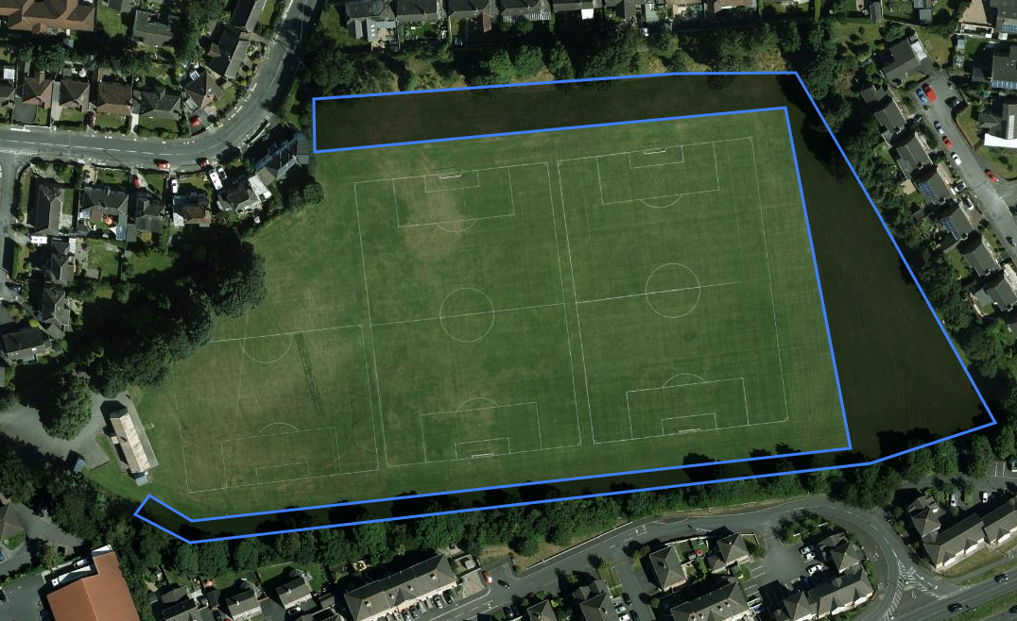

Stricklands Glen, Bangor (Hedgerow Planting – 1,250 whips)

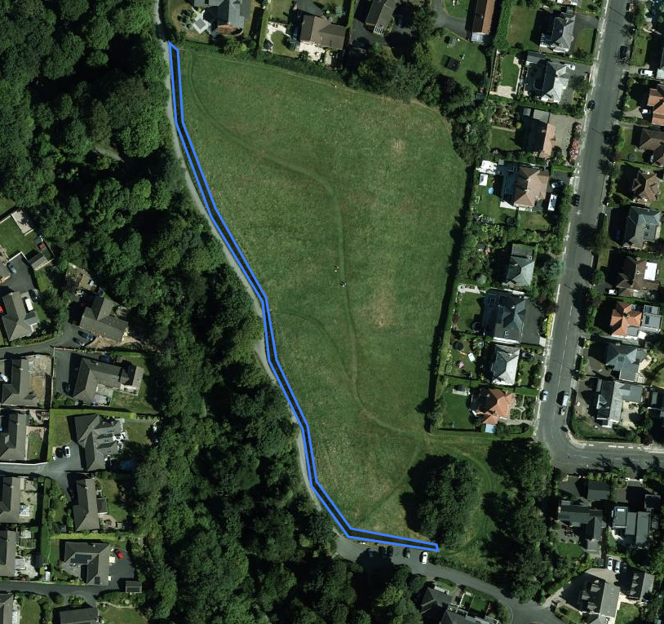
Greenway, Newtownards/Bangor (Hedgerow Planting - 4,000 whips)

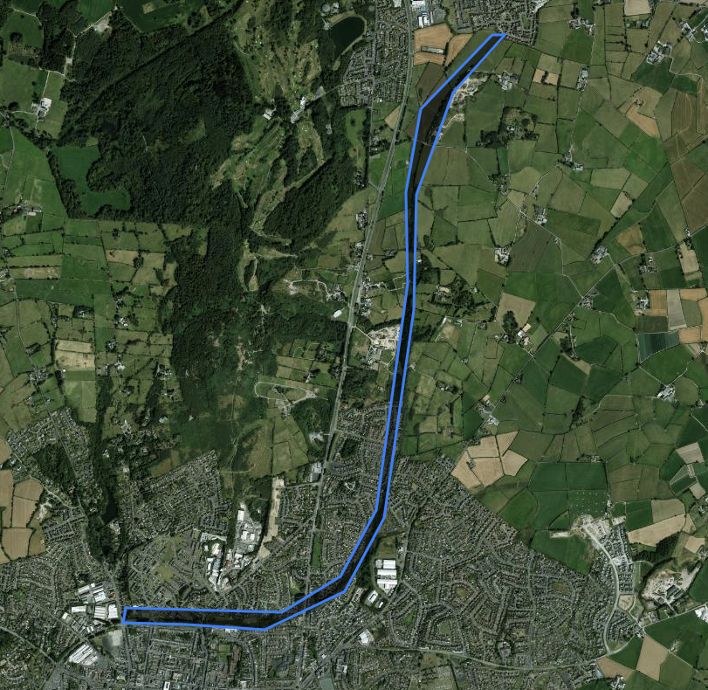

King John Walk (Right of Way), Holywood (Hedgerow Planting – 350 whips)

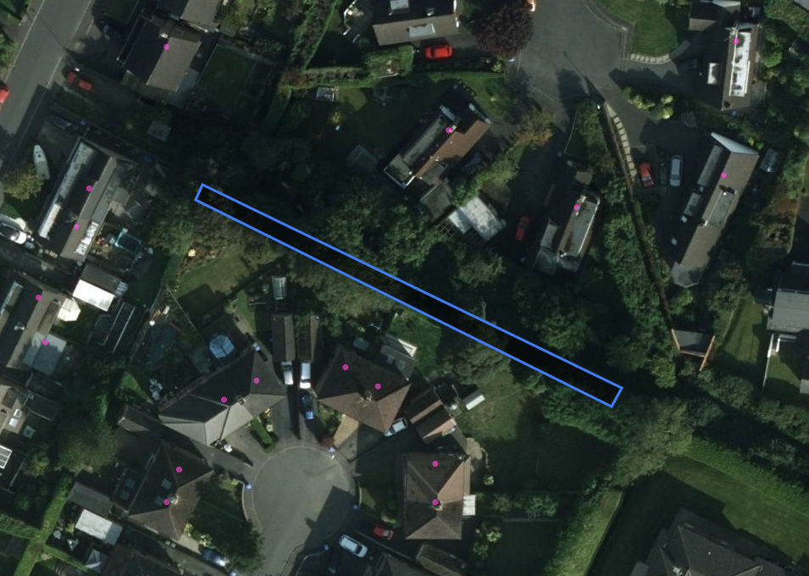

Ballymenoch Park, Holywood (Woodland Planting - 30 Light/Heavy Standards)

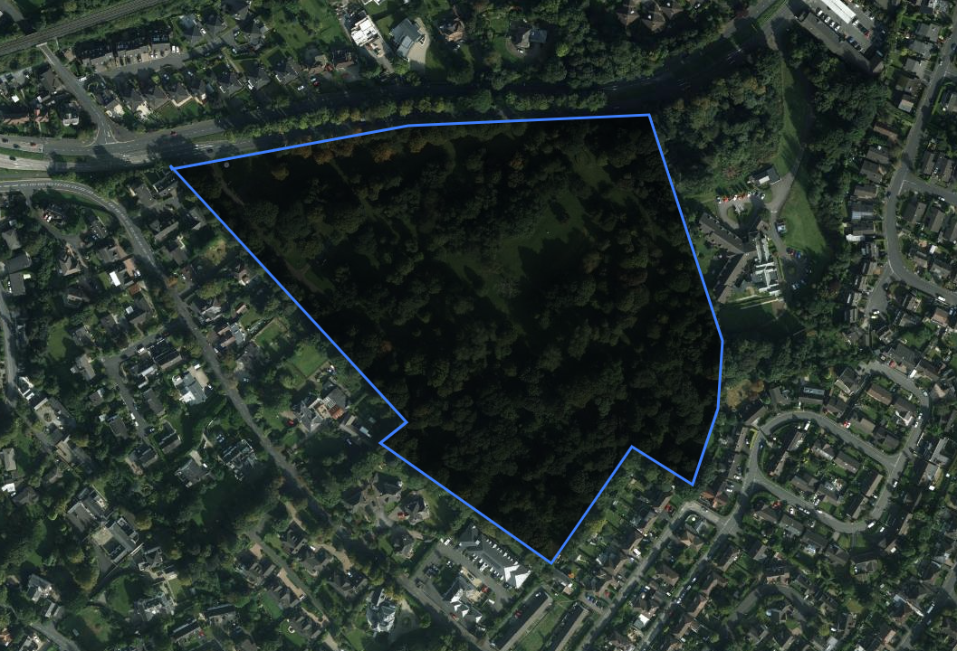

Moss Road Football Playing Pitches, Ballygowan (Woodland Planting - 2,500 whips)

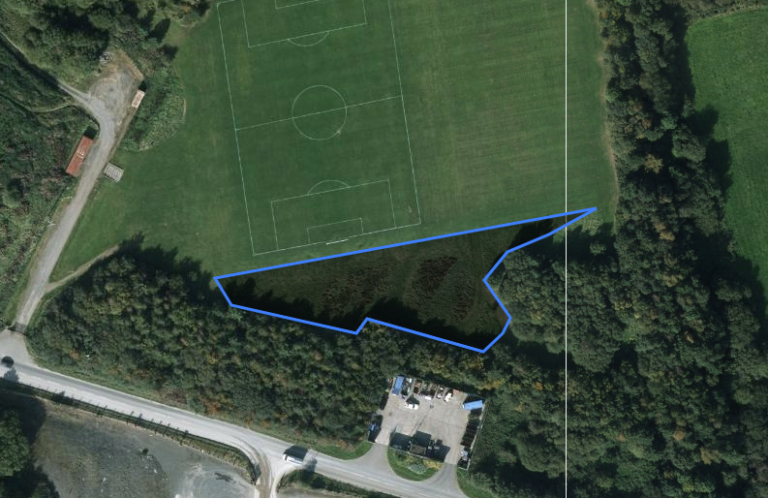

Second Commons, Donaghadee (Woodland Planting – 1,000 whips)

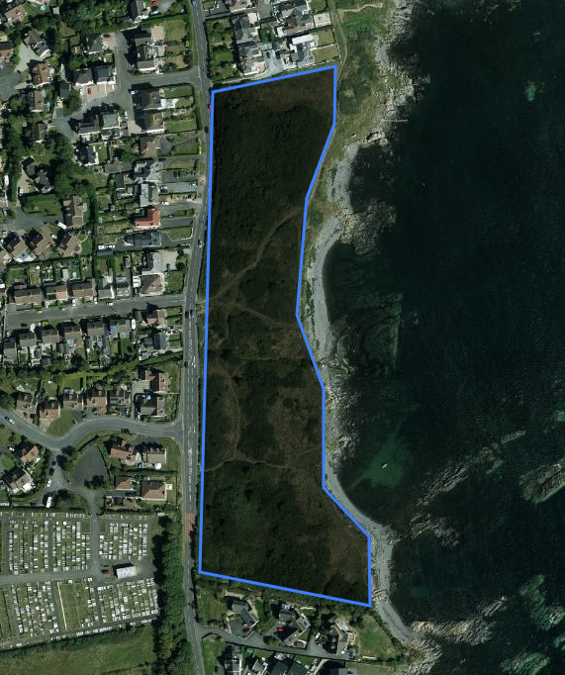

Upcoming Community Orchard Plantings 2026/2027
For each of the proposed community orchard sites, Council officers conducted an onsite visit to determine the feasibility of the orchard. Where possible, officers would also invite local community group representatives who would provide feedback on the orchard site. While on site, officers and local community reps would assess the ground condition, usage and proximity of local schools and community groups who could potentially help plant and maintain the orchard. All the below community orchard sites had been identified as viable locations. Once approved, Council officers would begin to engage local schools and community groups regarding possible planting dates.

Ballymenoch Park, Holywood (30 mixed fruit trees)

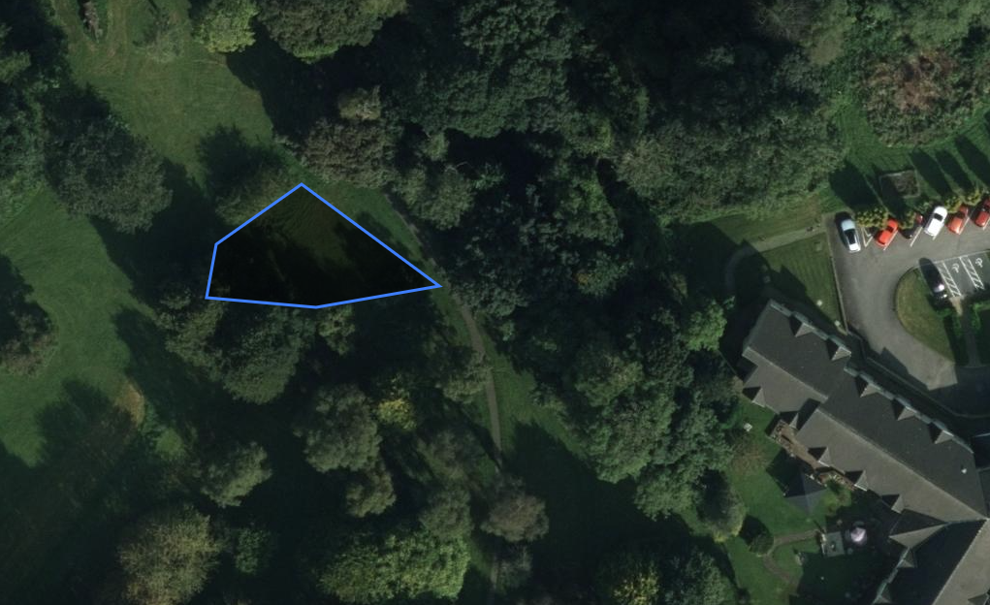

Ards Blair Mayne, Newtownards (15 mixed fruit trees)

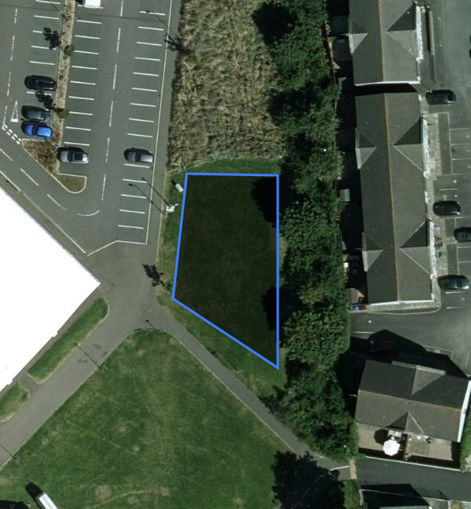

Bridge Street, Comber (15 mixed fruit trees)

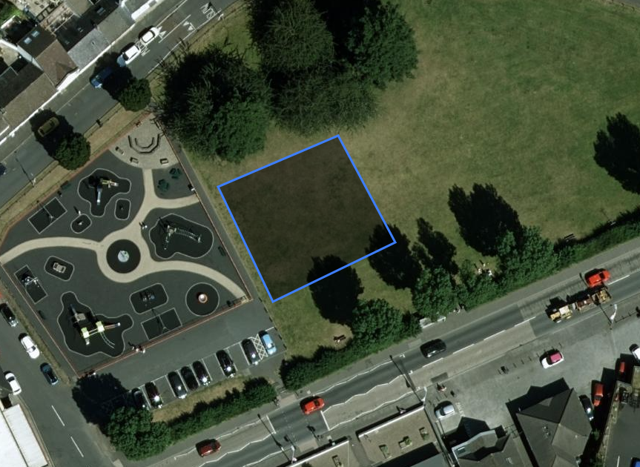

Seed2Leaf: Community Tree Nursery
To build on that success, the programme would reopen for applications on 1 June 2026, with the aim of establishing additional nurseries in the coming year. Eligibility would extend to schools, residents' associations, environmental groups and youth organisations, prioritising areas with low tree canopy cover or higher levels of social deprivation. Each selected group would receive a comprehensive support package including grants for essential equipment such as raised beds and tools, specialised training in seed stratification and nursery maintenance, and ongoing mentorship from Council officers. The expansion would seek to develop new partnerships with local businesses for potential sponsorship opportunities and explore collaborations with health trusts to incorporate therapeutic horticulture elements.

Northern Ireland Forest School Association: Revised Application Timeline

Unlike previous years when applications opened in January, the window to apply for Forest School status would now reopen at the start of May. That change gave schools the opportunity to begin the programme at the start of the new academic year in September 2026.

Partnership with DFI Roads: Expanding Urban Street Trees
Initial discussions identifying additional sites for pilot schemes in Bangor and Newtownards, currently undergoing feasibility assessments. The partnership aimed to create a replicable framework for future collaborative planting initiatives that could be expanded across the Borough in coming years.

That cooperative approach ensured that street tree planting complemented existing infrastructure while maximising the environmental and social benefits of urban trees. By working closely with DFI Roads, the Council could strategically expand the urban tree canopy in locations where it would have the greatest positive impact on local communities and the wider environment.

Opportunities for Land Acquisition to Support Canopy Expansion
To build on current progress, officers proposed further development of a structured land‑search and site‑suitability framework. That would assist in identifying potential sites based on ecological value, soil conditions, planting capacity, habitat connectivity and long‑term management feasibility.

Tree Canopy Partnership Scheme
Alongside targeted land acquisition, Council officers were further developing a Tree Canopy Partnership Scheme to support wider canopy expansion across privately owned land within Ards and North Down Borough. That programme built on existing engagement with residents and landowners and provided a structured mechanism to extend woodland cover, hedgerows and ecological connectivity beyond the Council estate.

The programme enabled eligible residents and landowners within the Borough to apply for free native tree whips, supported by professional advice and aftercare guidance. Planting proposals must meet minimum thresholds to ensure meaningful environmental outcomes, specifically:

- The creation of a new native woodland block of at least 0.1 hectares; or
- The establishment of a new native hedgerow of at least 20 metres in length.

Species supplied through the programme would be predominantly native and selected in line with the Council’s Tree and Woodland Strategy and Local Biodiversity Action Plan, ensuring planting contributed to habitat creation, climate resilience and long‑term ecological value. Species mixes would be tailored to site conditions where possible, supporting successful establishment and climate adaptability.

To ensure public investment delivered lasting benefit, participation would be subject to agreed conditions, including the retention and appropriate management of planted trees. Council officers would undertake follow‑up site checks over a three‑year period to assess establishment success, offer practical aftercare advice and identify any issues affecting survival. That approach supported best‑practice tree establishment while maintaining positive engagement with participants.

Summary
The report outlined the continued implementation of the Tree and Woodland Strategy 2021–2032 and associated Action Plan. The strategy formalised the Council’s commitment to enhancing local biodiversity and mitigating climate change. It provided a vital framework for prioritising limited budgets toward proactive planting, essential maintenance, and effective risk management across the Council’s tree stock.

RECOMMENDED that the Council notes this report.

Proposed by Councillor Kendall, seconded by Alderman Adair, that the recommendation be adopted.

Councillor Kendall was happy to support and thought there was a lot of great content in the report. She referred to the tree and woodland calendar of events and thought much of that was focused on Bangor and she suggested that it would be welcomed to have that extended more widely throughout the Borough.

It was thought that Members would not be too surprised to see the plans on this in respect of the King John Walk, where there would be some cutting back of Ash trees and there would be some hedgerows being planted as well as more mature trees.

Alderman Adair thought this was a good report and he was pleased to see that the Council was engaging with local schools. He referred to The Green in Kircubbin where the Cherry Blossom had been very welcomed by local people and asked if more of those trees could be planted in that area.

The Chair of the Committee also welcomed the extensive tree planting being undertaken in the Borough and referring to the planting at Bloomfield hoped the path around the sports pitch as a way to immerse people in trees would be retained.

AGREED TO RECOMMEND, on the proposal of Councillor Kendall, seconded by Alderman Adair, that the recommendation be adopted.

11. rewilding – 2026 progress report

PREVIOUSLY CIRCULATED:- Report from the Director of Environmental Services detailing that this report provided Members with an update on the Council’s Rewilding Initiative and the progress made in recent months. Rewilding focused on restoring natural ecosystems and supporting a healthier balance between people and nature, enabling both to thrive.

Across the UK, public open spaces were increasingly being managed to create and maintain meadow grasslands. The Council’s vision for the Rewilding Initiative was to manage our natural assets in a way that supported nature’s recovery. Amenity grassland represented the Council’s largest landholding, but it was also the least biodiverse. Changing how the land was managed therefore had the potential to make the greatest impact on local biodiversity. Promoting biodiversity was also a statutory requirement under the Wildlife and Natural Environment Act (Northern Ireland) 2011.

The sites currently being managed for rewilding covered a total of 154,002m², following the addition of a further 21,700m² last year (reported in May 2025). Those sites would continue under an updated maintenance programme aimed at increasing the diversity and abundance of flowering plants, benefitting pollinators and enhancing overall biodiversity. Alongside routine maintenance, schedules would be adjusted to accommodate occasional event use at certain locations.

It was important that the rewilding initiative complemented the wider use of parks, ensuring a balanced offer across the portfolio. Events and community use would therefore continue to be supported through an integrated grassland management approach tailored to each site. At this stage, there had been no further increase in the total area rewilded. The focus had instead been on transitioning each site, in turn, to a management approach that reflected its specific ground conditions and local climate.

Key Issues

Key updates 2025-2026  Rewilding Signage  Additional rewilding signs had been delivered ahead of installation across rewilding locations. The signs mirrored the Brompton design and included information on rewilding, together with a QR code linking to the Council website. | 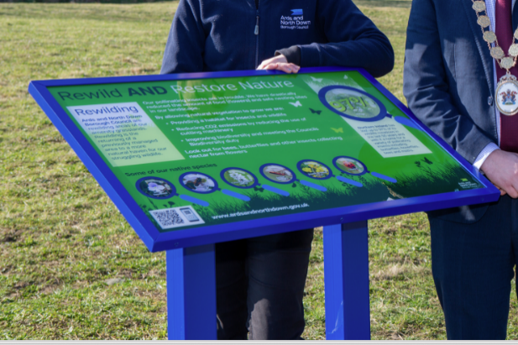
Rewilding Through the Seasons: Staff from Parks and Cemeteries had engaged a local photographer to visually capture the rewilding process across sites managed under the initiative throughout the year. That would help us monitor seasonal landscape changes and track the evolution of those sites over time.

As an example, the Bowtown Rewilding Site was surveyed by the RSPB in 2023. It was recorded as a mix of poor semi-improved grassland, scrub, hedgerow, and a small number of trees. Species such as ragwort, dock, and spear thistle were found across the site, suggesting it had previously been managed intensively.

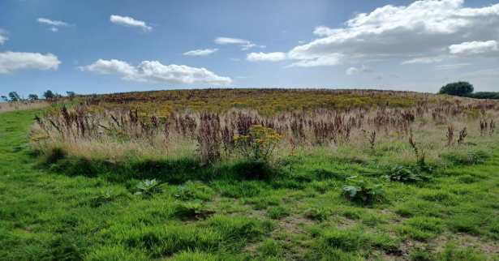

Following implementation of the site management plan, the ragwort, dock and thistle sward had been reduced, and a native wildflower meadow had been established. The images below showed some of the new species recorded on site over the past twelve months.

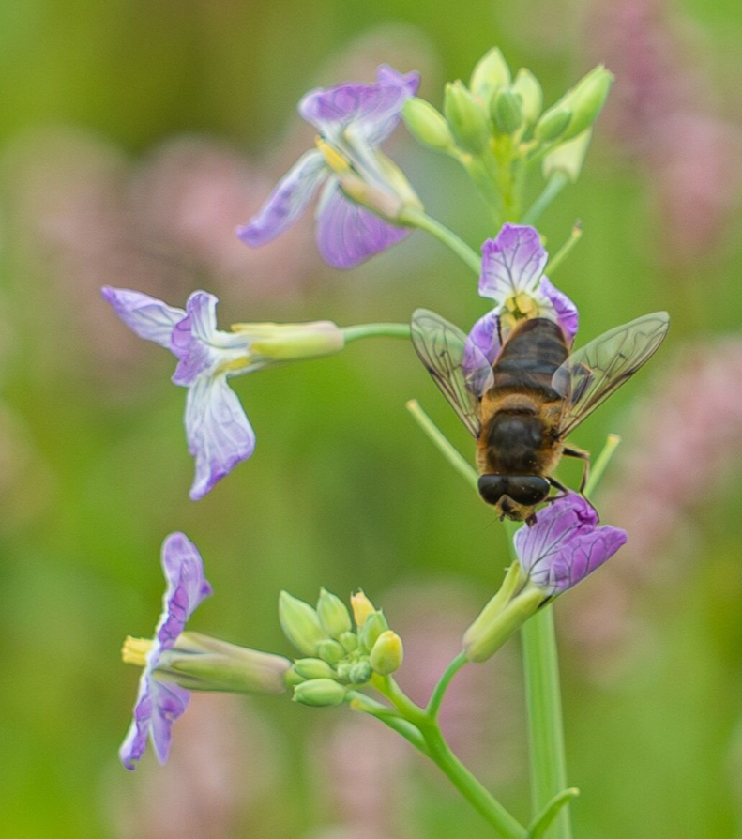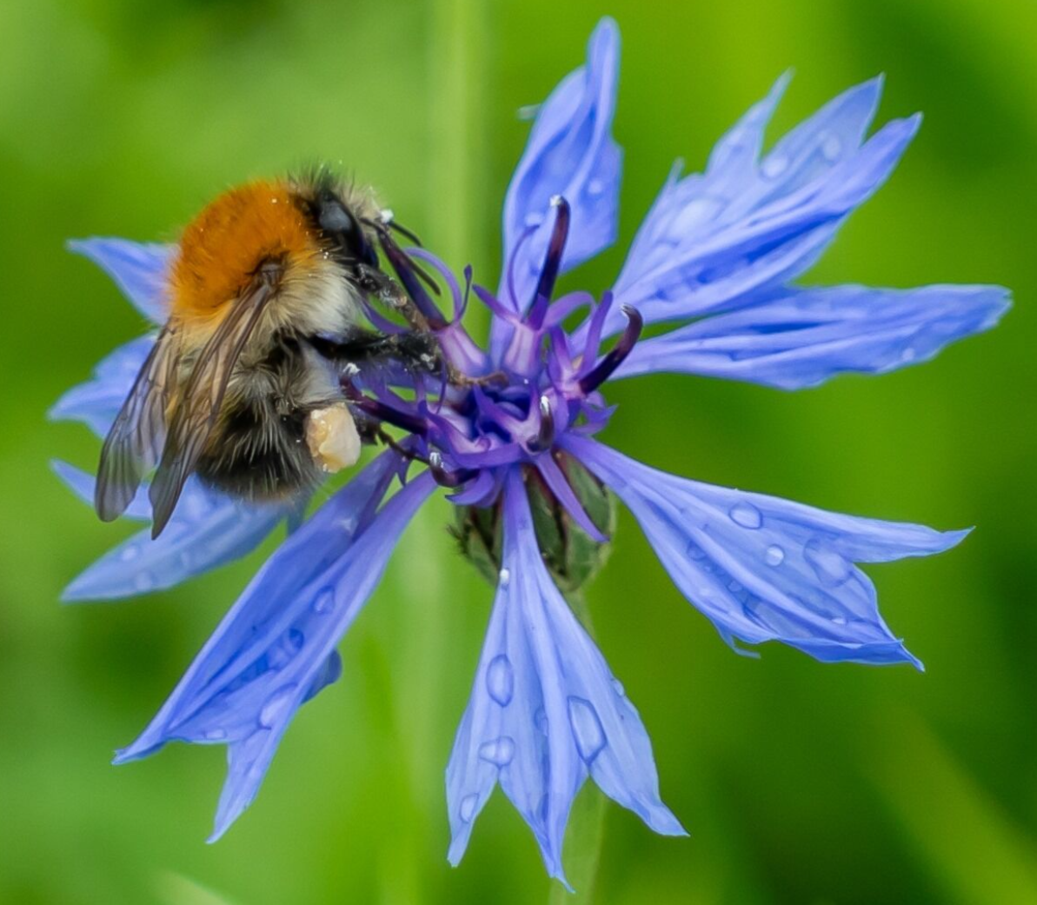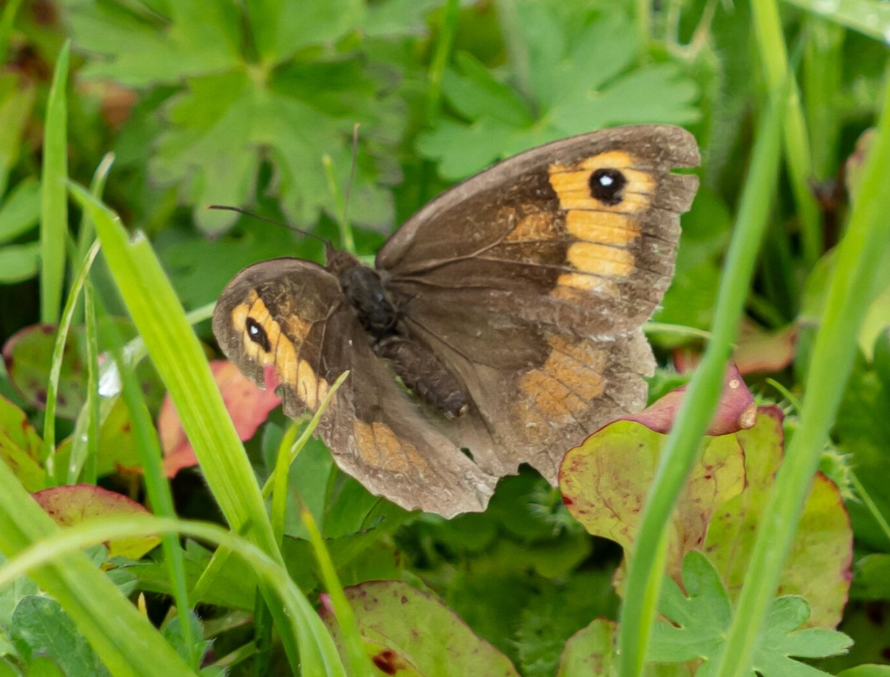
Images above – bee on radish, bumblebee on cornflower, meadow brown butterfly
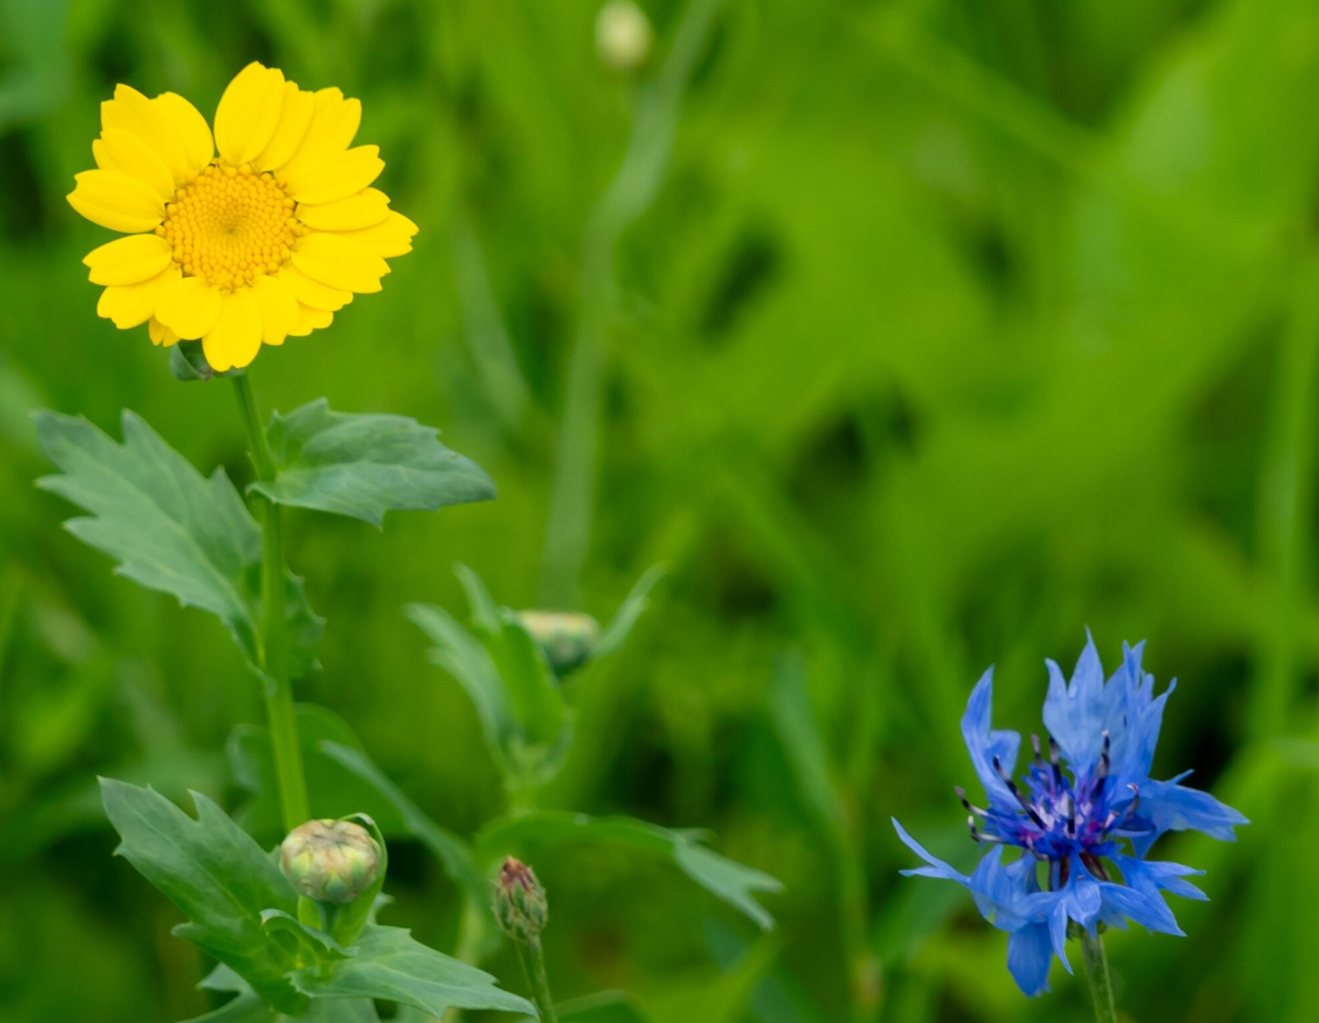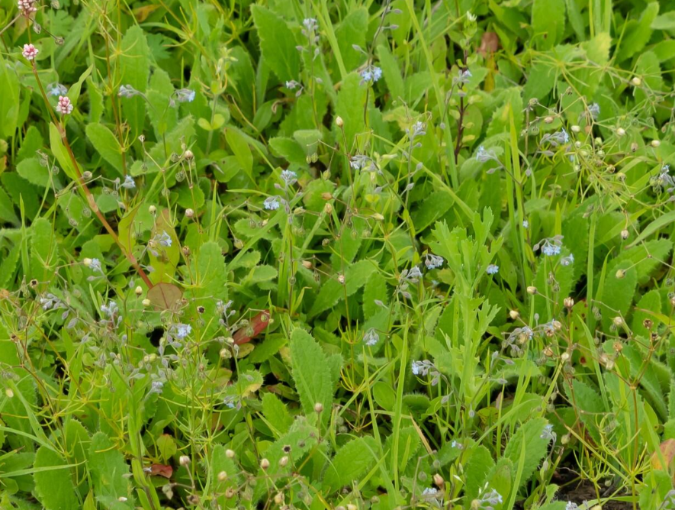
Images above – corn marigold, cornflower and forget-me-not

In the longer term, parts of the site would be transitioned to a wild bird cover crop to help support farmland bird species. The plan also included developing other habitats by strengthening and extending native hedgerows, managing existing trees, and working in partnership with Castle Gardens Primary School and local community groups to install bird and hedgehog boxes. That approach helped build a community that was invested not just in using the site, but in looking after it for years to come.

The Council would continue to manage and monitor the site and would regularly engage with the local community to ensure it was used in a way that worked for both people and nature.

Rewilding Workshop
On 18 March 2026, frontline Parks and Cemeteries staff participated in a rewilding workshop delivered by Buglife and True Harvest Seeds. Buglife, a UK charity dedicated to the conservation of invertebrates, provided an overview of the critical role insects played in supporting resilient and healthy ecosystems. The session highlighted practical actions that could be implemented locally to enhance habitats and support biodiversity across the Borough.

True Harvest Seeds, based in Strangford, outlined their work in the collection and preservation of native seed stocks, contributing to the long-term protection and restoration of indigenous plant species.

The workshop also included an update on the Council’s current rewilding sites, demonstrating the positive impact those initiatives were having in improving biodiversity and ecological value within managed green spaces.

Feedback from staff was very positive, with strong engagement and interest in developing further knowledge and skills, particularly in insect identification and seed collection. In response, additional training opportunities were being planned to support ongoing capacity building within the service.

Seapark - In partnership with Buglife Northern Ireland, Seapark had been selected as a coastal rewilding pilot to enhance habitat and increase invertebrate diversity. Ground preparation was completed by EcoSeeds (cutting, lifting and scarifying to support locally sourced yellow rattle). The site would be sown in Autumn (September/October, weather dependent) with locally sourced brush-harvested seed; in the interim, Parks staff would leave vegetation uncut, keep pathways clear and undertake litter picking as required. Staff training, new signage and ongoing monitoring would support delivery and evaluation.

Next Steps
There had been no increase in the area rewilded at this stage, as the focus had been and would continue to be on moving each site, one by one, to a management approach that suited the site and its specific ground conditions and local climate. The Council would continue to monitor these sites in terms of species and habitats whilst engaging with local communities to ensure sites were used and protected for people and for nature.

Summary
The report updated Members on the Council’s Rewilding Initiative, which was enhancing biodiversity by adapting the management of amenity grassland in line with statutory duties. The programme currently covered 154,002 m² across identified sites (Appendix 1) and was being delivered on a site-by-site basis to increase flowering plant diversity for pollinators while maintaining provision for events and community use.

During 2025–2026, progress had included the installation of new public signage and the introduction of seasonal photography to monitor change; implementation of the Bowtown plan (including weed reduction, establishment of native meadow areas, and wider habitat improvements); staff training through a workshop delivered in partnership with Buglife and True Harvest Seeds; and advancement of Seapark as a coastal rewilding pilot, where ground preparation had been completed and Autumn seeding was planned.

Next steps included continued phased delivery across sites, ongoing monitoring, and further community engagement.

RECOMMENDED that the Council notes this report.

Proposed by Councillor Kendall, seconded by Alderman McRandal, that the recommendation be adopted.

Alderman McRandal welcomed the report and referred to Seapark and Buglife and wondered if the plan was to include the community. The Parks and Cemeteries Development Manager informed the Committee that communities were always involved in rewilding location identification and Buglife had been brought in to help the Council increase rewilding in particular.

The Chair had a question in relation to rewilding in areas where it did not appear to be suitable and in response the officer said that the Council would look at other options and that was one of the reasons for taking advice from Buglife.

AGREED TO RECOMMEND, on the proposal of Councillor Kendall, seconded by Alderman McRandal, that the recommendation be adopted.

12. quarterly sustainable energy management strategy update 2025-2026 quarter 4
(Appendix VIII)

PREVIOUSLY CIRCULATED:- Report from the Director of Environmental Services detailing that in June 2024 Council agreed the Sustainable Energy Management Strategy and Action Plan. One of the actions within the Plan was to “Improve governance arrangements to ensure that energy management has effective oversight and accountability within the Council.”

Improving oversight and accountability within the Council for energy management would ensure that consumption performance and the implementation of the Strategy and this action plan would be continuously monitored. Improved monitoring and governance would improve energy performance by ensuring actions were effectively implemented and consumption trends routinely monitored, which should result in reduced consumption, costs, and emissions.

Key Issues
The report was part of our ongoing quarterly series, tracking energy consumption against our 2019/20 baseline and highlighting current and upcoming energy-saving initiatives.

Period: | Reported in:
Quarter 1: April to June | September
Quarter 2: July to September | December
Quarter 3: October to December | March
Quarter 4: January to March | June

Energy Consumption for this Period

Total Energy Consumption for 2025-2026

Electricity
As shown in the graphs above, electricity consumption increased in Q4, rising by 5% compared with the same period in the 2024/25 financial year. Despite that increase, the impact on emissions was mitigated by the use of green energy supply, resulting in a net reduction of 29.4 tCO₂.

When measured against our baseline year, Q4 also demonstrated a notable improvement, delivering a 29% reduction in carbon emissions, equivalent to 109.6 tCO₂. That reflected continued progress towards our emissions reduction objectives. We remained committed to building on this momentum through the implementation of additional energy-saving measures and by strengthening staff engagement across both new and existing initiatives, in support of our 2030 target.

Electricity consumption had continued to trend downward, with a cumulative reduction in carbon emissions of 16.5% across Q1–Q4, resulting in a 180.35 tCO₂ reduction compared to the 2024/2025 financial year.

Carbon emissions from electricity consumption had reduced overall by 34% equating to 474.36 tCO₂ reduction from the 2019/2020 baseline year.

Top 4 sites with the most significant decrease in electricity consumption in 2025-26

- Aurora Leisure Centre
- North Road Depot Waste Transfer Station
- Queens Leisure Centre
- Bangor City Hall

Top 4 sites with the most significant increase in electricity consumption in 2025-26

- Ards Blair Mayne Leisure Centre
- Londonderry Park
- Comber Leisure Centre
- Environmental Resource Centre/Waste Transfer Station

The increase in electricity consumption across the three leisure facilities appeared primarily driven by increased membership from the previous year, resulting in higher occupancy and demand.

The waste transfer station had had its third compactor and ‘cyclovent’ re-commissioned following recent accommodation works. The equipment represented a significant electrical load on the site. Wind turbine generation remained consistent with the previous year, however export to grid reduced due to higher on-site electrical demand.

Gas
Natural gas carbon emissions decreased by 1.1% in Q4, compared to the same period in the 2024/25 financial year, resulting in an estimated 9.2 tCO₂ reduction in emissions.

Relative to our baseline year, Q4 also showed continued progress, with a 2.8% decrease in gas carbon emissions equivalent to a 24.01 tCO₂ reduction.

Gas carbon emissions had continued to trend downward, with a cumulative reduction of 5.5% across Q1–Q4, resulting in a 150.52 tCO₂ emissions reduction compared to the 2024/2025 financial year.

A comparison of weather trend data for 2024/25 and 2025/26 indicated broadly similar temperature and climate conditions.

Carbon emissions from gas consumption had reduced overall by 9.8% equating to 296.49 tCO₂ reduction from the 2019/2020 baseline year.

Top 4 sites with the most significant decrease in gas consumption in 2025-26

- Ards Blair Mayne Leisure Centre
- Aurora Leisure Centre
- Queens Leisure Centre
- Londonderry Park

Top 4 sites with the most significant increase in gas consumption in 2025-26

- Comber Leisure Centre
- Environmental Resource Centre/Waste Transfer Station
- North Road Depot Waste Transfer Station
- Spafield Pavilion

The increase in gas consumption across the two leisure facilities appeared primarily driven by increased occupancy and demand.

The Environmental Resource Centre/Waste Transfer Station experienced a major boiler failure during the height of winter. To maintain continuity of service, a temporary solution was implemented. However, the replacement boiler currently in use was slightly undersized compared to the original fixed installation, as it was the most suitable unit available at short notice. As a result, it was operating under greater demand to achieve ambient temperatures than the previous larger capacity system.

The North Road Depot Waste Transfer Station had an electric boiler installed last year to operate alongside a new gas boiler. Further optimisation was required to achieve the most effective balance between reducing carbon emission and managing operating costs, as the electric system offered lower emissions but higher running costs compared with the gas boiler.

Looking ahead, further action would be required to reduce gas consumption across the estate. Gas remained the Council’s second-largest source of carbon emissions and addressing that was critical to achieving our 2030 emissions reduction targets. Planned measures included:

- Council Building Heating Policy - Reviewing and lowering existing heating control set-point temperatures to optimise energy use. Automating heating controls and expanding remote management capabilities to enhance control and consistency.
- Assessing the operational efficiencies of leisure centres with swimming pools. Those were the Council’s largest gas consumers and carbon emitters. The assessment should identify opportunities for further savings through behavioural change and system optimisation.
- Reviewing and lowering swimming pool temperatures where operationally feasible.
- Optimising and transitioning to electric heating systems, supported by solar PV and other low-carbon generation technologies, to support long-term decarbonisation.

Kerosene
Historical data from 2019/20 suggested that six community centre central heating systems were previously operating on Gas Oil (red diesel). Those systems had since been upgraded to use Kerosene, which had contributed to an apparent increase in reported consumption. As such, caution should be exercised when comparing Kerosene usage data between 2025/26 and the baseline year, as the fuel switch impacted the comparability of figures.

As a result, the data showed an apparent increase in kerosene consumption compared to the baseline 2019/20 year, for the reasons outlined above.

Kerosene carbon emissions had seen a reduction of 65.8% in Q4 compared to the same period in 2024/25 financial year, resulting in a 31.29 tCO₂ emissions reduction.

Kerosene carbon emissions had continued to trend downward, with a cumulative reduction of 31.8% across Q1–Q4, resulting in a 40.83 tCO₂ emissions reduction compared to the 2024/2025 financial year.

Diesel
Carbon emissions figures for gas oil (red diesel) used in small plant and Derv (diesel) used in the road fleet had been combined to provide a cumulative total for 2019/20 Q4 diesel emission, in line with the 2022 reform on red diesel usage.

Considering the combined reporting of diesel consumption, overall usage had increased by 21.3% in Q4 compared to the 2019/20 baseline year, leading to an increase of 94.35 tCO₂ emissions.

Diesel consumption in Q4 was also higher than in the same reporting period in 2024/25. That increase was primarily attributable to reduced operating efficiency across several vehicle categories, including rear-end loaders (RELs), refuse collection vehicles (RCVs), MacPac units, 4x4s and vans.

Total fleet mileage for this reporting period was 398,192 miles, representing a 4.5% reduction compared with the same reporting period in the previous financial year. Fleet diesel consumption totalled 194,365 litres, reflecting a 0.8% increase compared with the same reporting period in the previous financial year.

Diesel carbon emissions had demonstrated a minor increase of 2.1% across Q1–Q4, resulting in a 45 tCO₂ emissions increase compared to the 2024/2025 financial year.

A review comparing fleet performance data from this year compared to the 2024/25 reporting period identified an increase in fuel consumption of 23,307 litres, associated with a rise in vehicle usage of 199,847 miles.

A comparison with the previous financial year showed no increase in fleet vehicles.

Consumption Costs
The table below presents fuel consumption costs for each year, along with the corresponding unit prices. That allowed for a comparison of both usage and changes in market rates over time.

Quarter 4 Utility/Fuel Type | 2019/20 Costs £(NET) | 2019/  20 Unit Rate £/unit (NET) | 2025/26 Costs £(NET) | 2025/26 Unit Rate  £/unit (NET)
Electric | £223,293.85 | £0.16 | £426,752.72 | £0.29
Gas | £187,824.39 | £0.04 | £304,892.85 | £0.07
Kerosene | £1,539.07 | £0.42 | £4,020.26 | £0.63
Derv | £136,267.76 | £1.00 | £224,115.85 | £1.12
Gasoil | £14,282.96 | £0.52 | £1,867.17 | £0.81
TOTAL | £563,208.03 | - | £959,781.68 | -

Highlights of Energy Saving Initiatives Delivered this Reporting Period

List below of recent energy saving initiatives in Q4:
Description | Annual energy saving estimate | Annual tCO₂e reduction estimate | Annual cost saving estimate £(NET)
Ards Blair Mayne Leisure Centre Solar PV | 226,515 kWh | 40 | £67,107
TOTAL | 226,515 kWh | 40 | £67,107

Refer to the attached updated Sustainable Energy Action Plan for comprehensive updates on all noted actions.

Next Steps
Future Measures Currently Under Consideration/Planning

- Fleet and Waste services would review the factor contributing to increased fuel consumption and identify opportunities to improve vehicle operational efficiency.
- Feasibility assessment into the trial of an Electric refuse collection vehicle (RCV)
- Use the Council’s monthly newsletter to share energy-saving best practices with staff, encouraging their active participation in further reducing energy consumption.
- Develop and implement a Council-wide policy for the seasonal shutdown of heating systems during the summer months across the entire estate.
- Develop and implement an employee e-learning programme to promote awareness and best practices for energy conservation in the workplace.
- Replacement of boilers at various Council properties and upgrade of control systems.
- Survey and retrofit of LED lighting and lighting controls at various public toilets.
- Solar PV Installation at chosen compatible Council properties.
- Continuation of Car Park lighting LED installation.
- Walk-round surveys of properties to examine and review existing controls and settings.
- Surveys of existing buildings for insulation installation to be carried out and implemented.
- Energy targets & KPIs for service unit managers to be agreed for 2025/2026.
- Introduction of half-hourly Automatic Meter Reading (AMR) systems in highest energy consuming buildings.
- Installation of Building Management System (BMS) with Energy monitoring at various Council buildings. Further development opportunities for improved zoning, remote heating controls, heating automation and sub-metering of equipment to enable accurate scrutiny.
- Optimising existing electric heating systems.
- Installation of double-glazed windows at Church Street Offices.
- Installation of double-glazed windows at Ballygowan Community Centre.
- Energy assessment and feasibility study of Ards Blair Mayne and Aurora Leisure Centres.

List below of future planned works

Description | Annual energy saving estimate | Annual tCO₂e reduction estimate | Annual cost saving estimate £(NET)
Queen’s Leisure Centre – LED Lighting Upgrade | 11,977 kWh | 2.1 | £3,114
Combers Leisure Centre – Dome Lighting | 8,553 kWh | 1.5 | £2,224
Bangor Sportsplex LED Lighting (Outdoor Floodlights) | 11,866 kWh | 2.1 | £3,085
Bangor Sportsplex LED Lighting (Car Park) | 7854 kWh | 1.4 | £2,042
Signal Centre – LED Lighting Upgrade | 5500 kWh | 1.0 | £1,430
Bangor Aurora Leisure Centre LED Lighting upgrade | 37,739 kWh | 6.6 | £9,812
North Road Depot Waste Transfer Station LED lighting upgrade | 17,860 kWh | 3.2 | £4,644
Environmental Resource Centre LED lighting upgrade | 7,523 kWh | 1.3 | £1,956
Environmental Resource Centre Solar PV | 81,358 kWh | 14.4 | £21,153
Londonderry Park Solar PV with Battery Storage | 75,950 kWh | 13.4 | £19,747
Carrowdore Community Centre Solar PV with Battery Storage | ~8,000 kWh (design estimate only) | 1.4 | £2,080
Alderman George Green Community Centre Solar PV with Battery Storage | ~8,000 kWh (design estimate only) | 1.4 | £2,080
Glen Community Centre Solar PV with Battery Storage | ~8,000 kWh (design estimate only) | 1.4 | £2,080
Kilcooley Community Centre Solar PV with Battery Storage | ~8,000 kWh (design estimate only) | 1.4 | £2,080
Redburn Community Centre Solar PV with Battery Storage | ~8,000 kWh (design estimate only) | 1.4 | £2,080
West Winds Community Centre Solar PV with Battery Storage | ~8,000 kWh (design estimate only) | 1.4 | £2,080
Portavogie Community Centre – Battery Storage | ~2,000 kWh (design estimate only) | 0.35 | £520
Ballygowan Community Centre – Battery Storage | ~2,000 kWh (design estimate only) | 0.35 | £520
Green Road Community Centre – Battery Storage | ~2,000 kWh (design estimate only) | 0.35 | £520
Skipperstone Road Community Centre – Battery Storage | ~2,000 kWh (design estimate only) | 0.35 | £520
Donaghadee Parade – Public Toilets Refurb | 2539 kWh | 0.44 | £660
Banks Lane – Public Toilet Refurb | 1532 kWh | 0.27 | £398
Ballyholme – Public Toilet Refurb | 1442 kWh | 0.26 | £375
TOTAL | 327,693 kWh | 57.77 | £85,200

Summary
The graph below showed the overall reduction in energy-related emissions across the Estates assets since the 2019/20 baseline year.

The blue line represented the projected reduction pathway based on forecasted and actual savings achieved to date through planned works, while the red line showed the targets agreed within the Carbon Reduction Targets 2026–2030 framework.

Significant progress had been made towards achieving the Council’s emissions reduction objectives. Current performance was ahead of the committed target trajectory and, with continued investment in resources and sustained delivery efforts, officers were confident that the long-term targets could be achieved.

Additional resource and forward planning would be required to develop feasible and practical energy saving initiatives from 2028/29 onwards, in order to recover the foreast variance and remained aligned with the target.

The graph below shows the overall change in fuel-related emissions across the Council’s fleet since the 2019/20 baseline year.

The blue line represented the projected emissions pathway based on forecast data, including the anticipated year-on-year increase associated with service delivery demands. Those projections also accounted for forecast emissions savings arising from the transition of the smaller fleet, including 4x4 vehicles and car-derived vans to electric vehicles (EVs).

The red line illustrated the emissions reduction targets and the incremental annual reductions required to achieve the Council’s 2030 target.

At present, there were no fully implemented solutions for decarbonising the heavy goods vehicle (HGV) fleet. The Council was currently exploring the feasibility of introducing electric refuse collection vehicles and electrifying other HGVs within the fleet. However, full electrification of the HGV fleet would require significant investment and would lead to a substantial increase in electricity demand and associated carbon emissions from grid electricity consumption unless supported by low-carbon energy sources.

Significant investment in renewable energy generation infrastructure and grid reinforcement would therefore be required to realise the full carbon reduction benefits of fleet electrification.

RECOMMENDED that the Council notes the latest quarterly energy consumption update.

Proposed by Councillor Kendall, seconded by Alderman McRandal, that the recommendation be adopted.

Councillor Kendall was happy to propose what was a comprehensive report but she appreciated the actions to tackle the Council’s carbon contribution. Alderman McRandal was in agreement with that view and had nothing further to add.

AGREED TO RECOMMEND, on the proposal of Councillor Kendall, seconded by Alderman McRandal, that the recommendation be adopted.

13. NOTICE OF MOTION 595 BANGOR CHRISTIAN HERITAGE RESPONSE

PREVIOUSLY CIRCULATED:- Report from the Director of Environmental Services detailing that the Council had previously agreed the following Notice of Motion:

“This Council recognises the importance of Bangor’s early Christian heritage in the story of our city, and its role in local tourism strategies. This Council requests that officers bring back a report which evaluates how the physical link between two main sites, Bangor Abbey and the North Down Museum, could be improved, to include the renovation and potential remodelling of Bell’s Walk, with consideration for improved wayfinding and lighting. The motion also requests that officers consider how Bangor Castle Gardens and The Walled Garden could be better incorporated into the walking route, and how the overall attraction could be packaged to create a more complete tourism and placemaking experience.”

Key Issues
A multi-departmental site visit took place on 9 August 2024, attended by officers from Parks and Leisure, Tourism, and Community and Culture. A second site visit was held on 26 November 2024, attended by Councillor McCracken and officers from Parks and Leisure, Community and Culture, Tourism, and Assets and Property to further explore opportunities and constraints.

The first meeting of the Task and Finish Group was held on 7 April 2025, during which a series of actions were agreed. Progress against those actions was summarised below.

Uplighting has been repaired and is operational on Fluctus Angelorum.

Cleaning of three existing bell sculptures had been completed and continued to be monitored. Replacement signage requested for those bells would be considered within the wider signage review process and the ‘Castle Park Reimagined’ project.

Discussions were ongoing with Historic Environment Division (HED) regarding uplighting of the significantly historic St Malachi’s Wall Lighting structure.

The artist who originally created the bells had confirmed that they would have no issue with some bells being repositioned. Installation of a new path from the vicinity of bell ‘Bregenz’’ toward Bangor Castle was currently being constructed. Once complete, bells ‘St Gallen’ and ‘Milan’ would be relocated on this new section of path creating a better flow of the trail and placing the bells in a more prominent position. Relocation of the ‘Bobbio’ bell would be considered as part of the wider park project when potential impact of visitors to North Down Museum could be considered.

Relocation of the bells would require redevelopment of the Bangor Bell Trail physical maps and heritage interpretation materials. That would be put in place following installation when exact locations would be known.

The new path currently being installed would also improve access directly to ‘Cross Hill.’ While that was welcome, officers had identified a significant amount of work required for this area of the Castle Park not only to reach its potential for promoting Christian Hertitage, but also as a recreational offering for residents and visitors. Design of this area would be developed through the wider parks project.

Next Steps
Work to date was contributing towards a more cohesive and engaging visitor experience by strengthening physical and visual connections between Bangor Abbey, Bell’s Walk and North Down Museum, while also enhancing interpretation of Bangor’s early Christian heritage. However, much more could be done to integrate those areas as well as the wider Castle Park and Walled Garden footprint into a broader heritage and leisure offer. That could be achieved by improving accessibility and navigation through upgraded paths and wayfinding while also supporting the development of a packaged tourism and placemaking experience.

To begin to achieve the full potential of Castle Park, a feasibility study would be commissioned through 2026/27 as part of the ‘Castle Park Reimagined’ project. The project aimed to create a major nature-inspired visitor destination, cultural and business opportunities, exceptional recreational and visitor facilities. Central to achieving that would be promoting and enhancing the heritage offering, building on the offering already in place within Castle Park and the great success of Bangor Castle Walled Garden.

Summary
The Council agreed to explore improvements to the links between Bangor Abbey, Bell’s Walk and North Down Museum, including better paths, lighting, wayfinding, and integration with Castle Park and the Walled Garden to enhance the overall visitor experience.

Since then, works had progressed, including repairing lighting, cleaning, process of repositioning bell sculptures, constructing of new paths, and progressing discussions with heritage bodies. Further updates to signage and interpretation would follow once changes were complete.

While those works had improved connectivity and the visitor experience, further development was needed to fully realise the area’s heritage and recreational potential. A feasibility study would be commissioned in 2026/27 as part of the ‘Castle Park Reimagined’ project to develop a more integrated, high-quality tourism and placemaking offer.

RECOMMENDED that the Council notes this report.

Proposed by Alderman McRandal, seconded by Councillor Wray, that the recommendation be adopted.

Alderman McRandal thought the report was very positive and had referred many times to the Borough’s very rich early Christian heritage. It was also welcomed by his colleague Councillor McCracken. He believed the initiative should be celebrated and used to promote tourism. He welcomed the plans and the enhancements to the Bell walk and the sculpture itself. As seconder, Councillor Wray echoed those words believing the initiative to be fantastic.

The Chair also welcomed the proposals and added that lighting up the area would be enhancing at night. He hoped that signage would also be added to explain the significance of the area to residents and visitors to the area.

AGREED TO RECOMMEND, on the proposal of Alderman McRandal, seconded by Councillor Wray, that the recommendation be adopted.

14. DONAGHADEE FOOTBALL AND HOCKEY UPDATE

PREVIOUSLY CIRCULATED:- Report from the Director of Environmental Services detailing that the purpose of the report was to update Members on the current position regarding an element of sports facility investment in Donaghadee, to outline the steps now being taken following the transfer of Outdoor Leisure responsibilities to the Parks and Cemeteries Service, and to confirm that an updated Outline Business Case would be progressed to assess options, affordability, deliverability and stakeholder requirements.

The Donaghadee Sports Project had been under development since the project was managed by Ards Borough Council, since then a number of feasibility studies, business cases and site options had been explored. In 2017, Strategic Leisure Limited (SLL) completed a Borough-wide facilities review on behalf of Sport NI which recommended the development of a single multi-sport hub to accommodate all four Donaghadee sports clubs (Rugby, Cricket, Football and Hockey) on one shared site. A subsequent Business Case and design process produced a shared site proposal estimated then at £7.6 million, aligned with Sport NI’s recommendation at the time of strategic shared hubs. However, the proposal did not progress due to several factors, including planning advice indicating that development on designated Green Space was unlikely to be approved, not all clubs willing to co-operate sufficiently, and indicative costs of clubs booking and using new facilities. Further site investigations considered the potential expansion of Donaldson Park, including the purchase of adjacent land.

Council subsequently adopted the Treasury Green Book Business Case Model for projects of this size, and a review concluded that the original single site approach offered too narrow an options base in any case, and a new business case was commissioned.

That was completed in May 2022 by S3 Solutions. The new business case was approved by the Council which found that cricket, rugby and football were generally content to remain at their current locations but required major facility upgrades. Hockey, based in Bangor, wished to return to Donaghadee, and several location options were assessed. S3 Solutions presented options outlining potential layouts and management models. Following discussions with clubs and stakeholders, two options were recommended to be progressed for further Council consideration. Clubs were asked for their input into developing operating models and their preferred location options. Engagement with the clubs continued as a result in an attempt to determine that. Some progress was made in relation to cricket and rugby which led to the development of leasing models at their existing sites.

On 15 January 2025, a report was presented to the Community and Wellbeing Committee in response to a Notice of Motion acknowledging the considerable delays and frustration experienced by the football club. The Motion requested that officers engage meaningfully with all Donaghadee sports clubs and bring forward a report on external funding opportunities or, if necessary, options for direct Council investment. Football had not reciprocated the attempts by officers to obtain meaningful information that could be acted upon up to this time.

In 2025, the Council also established a Member Working Group to review the Council’s overall capital ambition. While no firm recommendations had yet been made, it was anticipated that this work would deliver recommendations for the Council’s consideration.

Key Issues
In October 2025, a structural change in Council was agreed whereby responsibility for Outdoor Leisure facilities operated by Council transferred to the Parks and Cemeteries Service. That was significant in the context of the Donaghadee Sports Project, as Parks and Cemeteries now had operational responsibility for the management, maintenance and bookings of Crommelin Park, the location of Donaghadee Football Club.

Officers recognised that the clubs had experienced frustration due to the length of time the project had been under consideration. The project had been affected by a number of factors, including changes in stated preferences of delivery models by clubs, land availability, planning considerations, capital governance requirements and wider affordability pressures. However, the transfer of Outdoor Leisure to Parks and Cemeteries had provided an opportunity to reset the football club part of the project, establish a clearer operational lead and progress the next stage in a structured and evidence-based manner. Subsequent to the internal restructuring, the hockey club also confirmed its preference to relocate from Bangor to Crommelin Park, which allowed officers to re-engage on that basis.

Parks and Cemeteries Officers were currently therefore working with the hockey and football clubs regarding the Crommelin Park site, which was under Council management for maintenance and bookings. (NB The Leisure Services Team under Active and healthy Communities continue to engage separately with Donaghadee Rugby Club regarding potential development of the leased arrangement at Donaldson Park, because that site is not Council Managed, and are working on developing the business case for that site.)

Officers recently attended the Donaghadee Local Action Group meeting in April to provide an update on the current position. Further engagement would be undertaken as the Outline Business Cases progressed, including direct discussions with the relevant clubs to confirm current demand, facility requirements, programming needs, potential partnership arrangements and any club-led funding opportunities.

While the long‑term project had been under development, the Council had continued to invest in Donaghadee’s existing sports facilities. Crommelin Park had recently benefited from approximately £80,000 of drainage improvements to the grass pitches, and significant works had been undertaken in previous years to upgrade the changing pavilions.

Next Steps
For Crommelin Park, an updated Outline Business Case (OBC) was now required and would be developed by officers. The OBC would:

- Rigorously appraise all viable options
- Assess feasibility, affordability and sustainability
- Consider projected demand, programming requirements and partnership opportunities
- Identify a preferred delivery approach for Members’ consideration.
As part of the process, officers would implement a structured engagement plan with all clubs and stakeholders, including scheduled meetings, progress updates and opportunities for input into design and operational considerations.

The forthcoming regulatory changes relating to microplastic infill for synthetic pitches from 2031 would be factored into any future 3G development proposals at Crommelin Park. Officers would ensure that any recommended option was compliant, environmentally responsible and future‑proofed. The site appraisal would also have to take into account DFI access requirements through a currently narrow entrance and any drainage infrastructure requirements from NIW.

Officers, as with all projects, would continue to support all clubs in identifying potential external funding opportunities, for example through the Sports Development team and the Borough’s Sports Forum.

Parks and Cemeteries officers would maintain close engagement with the Donaghadee Local Action Group and with the relevant sports clubs as proposals for Crommelin Park and other sites progressed.

Summary
The Donaghadee Sports Project has been in development for over a decade, during which several feasibility studies, business cases and site options had been explored. Earlier proposals for a single shared multi‑sport hub proved unviable due to planning constraints and land availability, leading to a renewed business case in 2022 that recommended upgrading existing club facilities and identifying a suitable location for hockey’s return to Donaghadee.

The Council recognised the significant delays experienced by the clubs and acknowledged the frustration that had caused. Council officers were committed to communication, transparency and collaborative planning as the project moved into its next phase.

A key structural change in 2025 transferred responsibility for Outdoor Leisure to the Parks and Cemeteries Service. That provided a clearer operational pathway and would accelerate progress. Officers were working closely with stakeholders at Crommelin Park.

The next stage was the development of an updated Outline Business Case, which would rigorously assess all viable options, including feasibility, affordability, sustainability and compliance with forthcoming environmental regulations on synthetic pitch infill. Engagement with clubs and stakeholders would be central to the process, ensuring that needs, demand and partnership opportunities were fully reflected.

Officers would continue to report opportunities to members for decisions, while progressing the long-term development plan.

RECOMMENDED that the Council notes this report update.

Proposed by Councillor Wray, seconded by Alderman McRandal, that the recommendation be adopted.

Councillor Wray had two brief questions, how long the Council envisaged this taking and what were the lessons learned that could speed this on. The Parks and Cemeteries Development Manager considered that it would normally take six months for the Outline Business Case.

Alderman Adair shared the frustrations of the people of Donaghadee, noting that the Council did not have a good record on such projects and that Portavogie had waited fifteen years and he hoped that the initiatives at Donaghadee would progress more quickly. He asked if there was an indicative timetable of when that would be presented to the Committee and the Director stated that officers were being as precise with the timeline stated as it was possible, in that it would take about six months to complete normally once all information had been obtained and a specification for the consultant to do the business case was appointed.

Alderman Adair said there was frustration being felt across the Chamber for the delay and lack of delivery and residents wanted to see projects progress.

AGREED TO RECOMMEND, on the proposal of Councillor Wray, seconded by Alderman McRandal, that the recommendation be adopted.

15. CEMETERY MAINTENANCE SIX MONTHLY UPDATE

PREVIOUSLY CIRCULATED:- Report from the Director of Environmental Services detailing that in September 2023, the following Notice of Motion was agreed by Council:

“That Council notes the increasing complaints regarding the poor condition and appearance of our cemeteries across the Borough and tasks Officers to bring back a report on options to improve the maintenance of our cemeteries, which are places of special significance to those who have lost loved ones.”

A response was tabled at the Community and Wellbeing Committee meeting in December 2023, at which Elected Members requested that a further report be brought forward setting out tangible options to improve cemetery maintenance. Further reports were subsequently submitted in June 2024, January 2025, June 2025 and December 2025.

At the above previous meetings, the Council agreed that six-monthly review reports would continue to be submitted. The report provided a further six-month update on cemetery maintenance activity and outlined the operational position since the previous report.

The Parks and Cemeteries Service was responsible for burials in twelve active cemeteries and for the maintenance of nineteen cemeteries across the Borough, alongside a wider portfolio of parks, open spaces and associated assets. Cemetery operations were delivered by skilled in-house teams working to established Standard Operating Procedures and in accordance with the Burial Grounds Regulations (Northern Ireland) 1992.

During the reporting period, officers had continued to focus on maintaining safe, tidy and respectful cemetery facilities, progressing site improvements where possible, and responding to operational pressures including adverse weather, infrastructure issues, grave settlement and staffing constraints.

Routine inspections, supervisory oversight and ongoing improvement measures had supported the continued delivery of cemetery maintenance standards across the Borough.

Key Issues
Cemetery maintenance standards continued to be monitored through routine inspections, supervisory checks and issue reporting by operational staff. Priority continued to be given to burial operations, visitor safety, grass cutting, grave reinstatement, access routes, waste management, general appearance and the respectful upkeep of cemetery environments.

The reporting period had presented a number of operational challenges, particularly due to prolonged wet ground conditions at the beginning of 2026. Those conditions affected the delivery of some routine maintenance activities and increased the number of grave settlement issues requiring reactive attention.

Burial operations also had an impact on lawn areas due to necessary machinery access. Staff mitigated that where possible through the use of ground boards and by undertaking remedial repairs following works.

Staffing levels had reduced in recent months due in particular to vacant posts. Operational capacity had been kept up with use of agency staff, parks staff and contractors carrying out duties were possible. Despite those pressures, cemetery standards had continued to be maintained within available resources, with officers prioritising health and safety, burial operations, visitor access and site appearance. Cemetery maintenance standards continued to be monitored through routine inspections, supervisory checks and issue reporting by operational staff. Priority continued to be given to burial operations, visitor safety, grass cutting, grave reinstatement, access routes, waste management, general appearance and the respectful upkeep of cemetery environments.

The introduction of PSS Ultimate software had improved the recording and monitoring of those activities, supporting better visibility of service delivery and identifying areas for improvement. PSS Ultimate was implemented in September 2025. The Council was still at an early stage in the full utilisation of the system, with new sites, task types and asset details being added on an ongoing basis to build a more comprehensive dataset. Despite that, the system was already enabling us to monitor activity more effectively and provide clear, transparent information on service delivery.

The data captured was helping us to better understand where time and resources were predominantly being deployed, while also highlighting areas where service shortfalls may exist. That insight would support future decision-making and allow us to target resources more efficiently as the system continued to develop.

Adverse weather conditions and prolonged wet ground at the beginning of 2026 created operational challenges across cemetery sites. That affected routine grounds maintenance, machinery access and the condition of lawned areas. The wet conditions also contributed to increased grave settlement, requiring staff to respond reactively on a frequent basis. Grave settlement continued to be monitored and addressed in line with operational procedures and available resources.

Maintenance issues relating to roads, paths, potholes and other infrastructure continued to be identified and reported for repair. While those matters were being progressed through the appropriate channels, delays had been experienced due to contractor availability. Officers would continue to monitor infrastructure-related issues and escalate priority repairs where there were health and safety, access or visitor experience concerns.

Concerns were raised regarding the effectiveness of the one-way traffic management system at Movilla Cemetery, due to poor road markings and signage. Since those issues were reported, road markings were to be refreshed and additional signage had been installed. That had resulted in an improvement to site traffic management.

At Loughview Cemetery, issues were reported in relation to horses entering the site. Following engagement with horse owners, some progress was made by the adjoining landowner to repair boundary fencing. However, further reports were subsequently received. In response, officers installed Heras-style fencing as an interim measure. No further incidents had been reported to date. Officers would continue to monitor the effectiveness of those arrangements.

Complaints and service requests relating to cemetery maintenance continued to be monitored by officers. The majority of issues raised during the reporting period had related to weather-related ground conditions, grave settlement, infrastructure defects, grass cutting, access and site-specific maintenance matters.

Where issues were reported, they were reviewed and actioned where appropriate within available resources. Priority was given to matters involving health and safety, burial operations, visitor access, grave reinstatement and the appearance of all cemetery sites.

Officers would continue to use inspection findings, staff feedback and service request information to identify recurring issues and inform future maintenance priorities.

The principal risks affecting cemetery maintenance continued to include:

- prolonged adverse weather and wet ground conditions
- increased grave settlement
- delays to infrastructure repairs
- temporary staffing pressures
- contractor availability
- visitor dissatisfaction where works are delayed; and
- the cumulative pressure of maintaining nineteen cemetery sites alongside wider Parks and Cemeteries responsibilities.

Those risks were being mitigated through routine inspections and in particular the introduction of PSS Ultimate, manager oversight, prioritisation of health and safety issues, use of protective ground measures during burial operations, reactive grave reinstatement, escalation of infrastructure repairs and progression of approved improvement works.

It should be noted that continued delivery of improved cemetery maintenance standards would depend on maintaining appropriate staffing levels, timely recruitment, responsive contractor support and sufficient revenue and capital provision for repairs, maintenance and site improvements.

Officers would continue to identify and pursue opportunities to enhance cemetery appearance, improve the visitor experience, and increase operational efficiency, subject to available resources and approved budgets. Potential areas for continued review included:

- targeted resurfacing of roads and paths
- improved signage and wayfinding
- continued review of traffic management arrangements at larger cemetery sites
- prioritised response to recurring grave settlement issues
- further improvements to operational storage arrangements
- accessibility improvements where gradients, paths or surfacing present difficulties
- continued review of boundary security at sites where external access issues arise; and
- use of inspection and service request data to identify trends and future maintenance priorities.

Those opportunities would be considered alongside existing operational commitments, budget availability and wider Parks and Cemeteries Service pressures.

Next Steps
Officers would continue to monitor cemetery maintenance standards across all sites through routine inspections, supervisory oversight and service request information. Recruitment activity to address current staffing pressures would continue to be progressed. Operational teams would also continue to respond to grave settlement issues, weather-related impacts and site upkeep matters as they arose. Planned capital and improvement works would continue to be advanced during 2026, including:

Cemetery | Issue / Improvement | Current Position
Bangor New Cemetery | Automatic gates | Business case approved; installation scheduled during 2026.
Redburn Cemetery | Automatic gates and path gradient concerns | Gates scheduled for 2026; options to improve path gradients under review.
Kirkistown Cemetery | Operational storage and site presentation | New gravediggers’ storage area constructed at the far end of the cemetery, reducing impact on visitors and improving the entrance to the lawn sections.
Loughview Cemetery | Visitor shelter and horse access | Visitor shelter works underway; interim fencing installed to prevent horse access, with no further incidents reported to date.
Whitechurch Cemetery | ‘O’ Section works | Scheduled to proceed in the coming months.
Movilla Cemetery | Traffic management system | The business case for improving site traffic management has been approved, with work scheduled to begin in the coming months.

Infrastructure repair requests would remain under review with the relevant contractors and services, with priority issues escalated as necessary.

Summary
This report provided a six-month update on cemetery maintenance activity and confirmed that service delivery had continued broadly in line with expected standards.

While wet weather, grave settlement, temporary staffing pressures and delays to infrastructure repairs had presented challenges during the period, those had been managed within normal operational arrangements. Progress had also continued on several improvement projects, including planned automatic gate installations, new visitor facilities, site enhancement works, traffic management improvements and scheduled works at Whitechurch Cemetery following weather-related delay.

Overall, cemetery standards had been maintained within available resources, with officers continuing to address site-specific issues, progress continuous improvement and monitor operational risks.

Officers would continue to review cemetery maintenance standards, respond to issues raised, progress agreed improvement works and identify further opportunities to enhance the appearance, safety and visitor experience of cemetery sites across the Borough.

RECOMMENDED that the Council notes this update report on cemetery maintenance and improvement made within the Borough.

Proposed by Alderman Adair, seconded by Alderman Armstrong-Cotter, that the recommendation be adopted.

Alderman Adair considered an amendment that reports on cemeteries continued to be brought on a six monthly basis and the Director gave assurances that this was already the case having been agreed previously. The Alderman was pleased and reported that there had been a vast improvement in services within the cemeteries over the previous two years and it was important that continue by keeping the work under review. He went on to say that cemeteries were special places and the final resting places of our loved ones. He commended the work on the ground of cemetery staff and welcomed the new pedestrian access at Kirkiston. He explained that he and Councillor Edmund had met with staff to discuss cemeteries including memorial benches and maintenance and he hoped that could be built upon. He also appreciated the introduction of wooden memorials and he felt that was an appropriate step forward.

Seconding the recommendation Alderman Armstrong-Cotter thought it appropriate to highlight the work that was taking place on the ground and when she needed to address issues they were always rectified promptly. That acknowledgment had helped a grieving family to feel heard and acknowledged. Overall, she agreed that the report was welcome and she was interested to see what the new signage would do at Movilla in terms of traffic flow. She asked for her thanks to the team to be put on record.

Councillor Douglas thanked officers for the six monthly report and referred to an ongoing issue at Loughview cemetery related to horses and noticed that new fencing had been put up. She asked about the shelter at Loughview and when it would be put in place and the Parks and Cemeteries Development Manager reported that was scheduled for later in this financial year.

Councillor Wray referred to signage at Kirkiston Cemetery which was faded and now almost illegible. After discussion about the ownership of the sign Alderman Adair beleived that the signage was owned by the Council and he had asked for it to be erected originally.

From his own perspective the Chair had never received many complaints in relation to the maintenance of cemeteries and he considered that the staff in the North Down area did an outstanding job. He referred to Bangor New Cemetery which had some very old graves and surrounds which were difficult to maintain and he asked what the Council could do there especially considering younger relatives had likely also died over the past hundred years. He asked what other Councils did in this position and he encouraged officers to see if lessons could be learnt from others.

AGREED TO RECOMMEND, on the proposal of Alderman Adair, seconded by Alderman Armstrong-Cotter, that the recommendation be adopted.

16. PROACTIVE CLEANING AND MAINTENANCE REGIMES INCLUDING RESPONSE TO NOTICE OF MOTION 702
(Appendices IX – XI)

PREVIOUSLY CIRCULATED:- Report from the Director of Environmental Services detailing that the Council was responsible for maintaining and cleaning over 300 hectares of open public space including parks, path networks, and public realm areas. The responsibility fell mainly to staff in the Environmental Services Directorate, across all three departments namely Waste and Cleansing, Estates, and Parks and Cemeteries. The maintenance and cleansing was carried out mainly on a scheduled proactive basis, determined by implementing an appropriate balance between prioritised need and budget made available. Those scheduled activities involved power washing, street cleansing, maintenance of planted open space and grasslands, and significant proactive maintenance of fixed assets including benches, tables, hard standing areas and all Council buildings.

The need for a review was determined following restructuring as for the first time all the departments responsible for public open space maintenance and cleansing became part of one Directorate, so opportunities for improvement and efficiencies were being given ongoing and further consideration. More recently a Motion brought to Council and agreed asked for the ongoing review to be reported back with options for Members to consider which could improve outcomes. The Motion that was agreed at February 2026 Council was as follows:
“That this Council recognises its responsibility to ensure that our city, towns and villages are looking the best that they can be, to be welcoming places for visitors and our residents. It is therefore essential that the correct structures and policies are in place to ensure that within the resources made available all expected maintenance is being carried out efficiently and effectively.
A proactive maintenance regime was agreed when this Council was created and has worked well in some areas but has not had the desired impact in other areas. Basic maintenance and upkeep of our public realm particularly in our centres and prominent areas can and should be improved.
The Council therefore commits to reporting on a review of its current proactive maintenance and cleansing regimes, highlighting options and opportunities for improvement and associated budgetary requirements, so as to allow Members to consider potential improvements in outcomes concerning the maintenance of Council property and the public realm.”

Current Proactive Activity
The proactive activity for ease was set out in two sections. Maintenance (repairs, repainting, grass cutting etc) and cleansing (washing, cleaning and litter control).

1. Maintenance
The Council approved a Property Maintenance Strategy in October 2016 which focused significantly on a move towards a more planned proactive approach to maintenance. That covered the period up to 2026 and was currently under review. It related to not just buildings and facilities but also ‘shop front’ outdoor areas, particularly the busier areas where there was often higher footfall from residents and visitors alike. A full breakdown of the journey toward Planned Maintenance was included in the forthcoming Maintenance Strategy update report. The report however focussed solely on the maintenance of prominent outdoor spaces.

The Estates Department, as part of its planned maintenance activity established a public realm maintenance initiative with an initial budget of £30k per year. Its scope of works was to proactively clean, repaint, renew or repair the paths, benches, picnic tables, signs and bins in 20 high profile locations as follows.

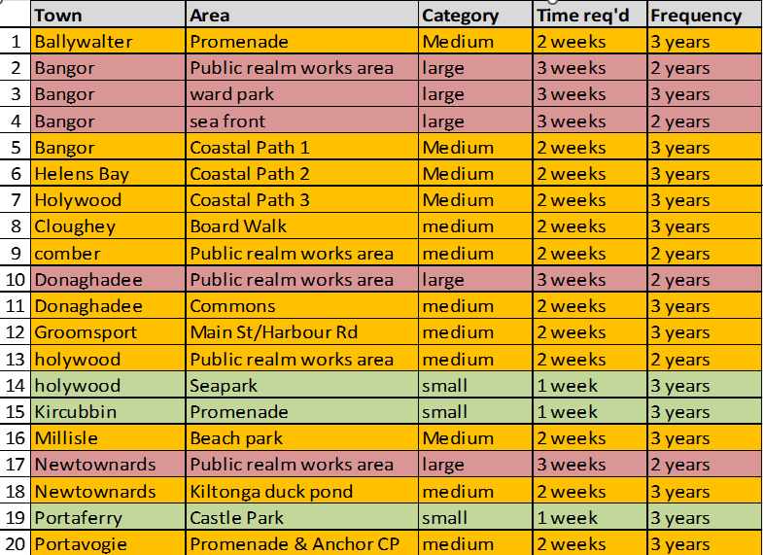

The location of those areas was highlighted in the map in Appendix 1.

Further details of the activities at each location were detailed in Appendix 2.

For financial year 2026/27, the Estates Service received Council approval to increase this £30k budget to £55k, with a further £25k to be added to the budget for 2027/28. The additional budget would considerably increase the ability to proactively maintain those public “shop front” areas.

Since the introduction of PSS Ultimate, the Parks and Cemeteries Service task management software, this moved to digitally recording operational tasks within the service. From implementation in September 2025 to date, a total of 7,694 task records had been logged across the department, alongside 8,966 site quality check records. The Council was still at an early stage in the full utilisation of the system, with new sites, task types and asset details being added on an ongoing basis to build a more comprehensive dataset. Despite that, the system was already enabling us to monitor activity more effectively and provide clear, transparent information on service delivery.

The data captured was helping us to better understand where time and resources were predominantly being deployed, while also highlighting areas where service shortfalls may exist. That insight would support future decision-making and allow the Council to target resources more efficiently as the system continued to develop.

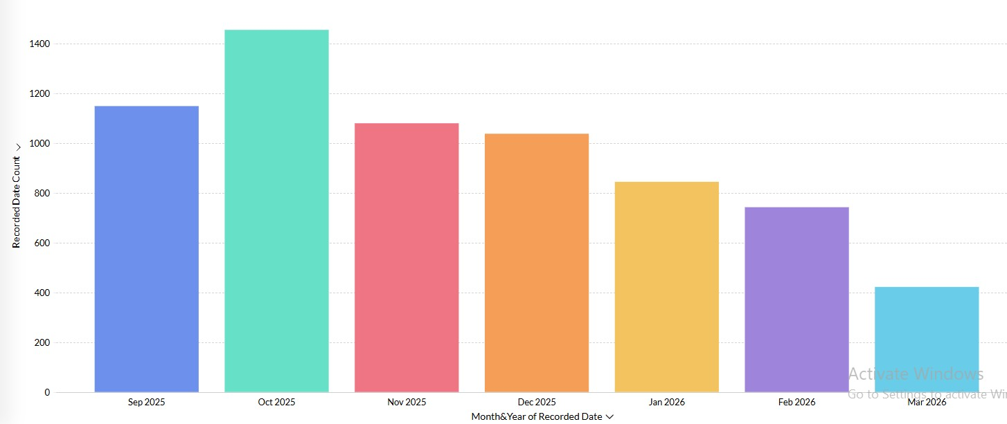

2. Cleansing
The Council’s cleansing service carried out a significant degree of proactive activity in order to keep streets, public toilets and other estate clean and free from litter.

That could be considered in four categories:

Public Litter Bins
Approximately £753k was spent on this aspect annually. (£487k by street cleansing and £266 by Parks) The five largest city and town centres were serviced daily by Cleansing and all other areas were serviced between one and three times per week. During the high season, tourist areas such as beaches and promenades were serviced up to three times per day. The Parks Service also carried out routine servicing of litter bins in public parks and Council managed open spaces. Since 2022 the Parks Service and Cleansing had rationalised activity where possible to avoid duplicate teams servicing the same area. To address the issues raised by the Notice of Motion, Council Managers from Parks and Cleansing had continued to meet to work more collaboratively in order to maximise efficiency and effectiveness of litter bin maintenance across all areas of the Borough and improve outcomes.

The key objective of that was to firstly ascertain where there were areas of service cross over and identify where both services could work in collaboration to address litter collection during peak demand. All litter bins (Parks and Cleansing) across the Borough were now plotted on the Council’s GIS system. That had allowed for greater route maximisation and sharing between departments. In addition, purchasing more bins, extending the use of larger capacity bins with anti-bird flaps, more targeted use of litter collection, weekend rangers and volunteering had seen a dramatic drop in litter complaints since 2023. Services continued to meet to tackle litter and deliver continuous improvement, through better operational activity, engagement with community partners, education and behavioural change campaigns and enforcement.

Whilst it had proven impractical to transfer all waste bin maintenance to one department, the increased collaboration had improved the overall cleansing service provided by both departments. Furthermore, in the interests of providing an integrated, single point of contact to Members for the purpose of flagging up significant and urgent littering issues that arose at the weekend, whether they be in areas maintained by the Parks or Cleansing Service Units, a single email address was available (weekendlitter@ardsandnorthdown.gov.uk) for Elected Members to use.

Mechanical Road Sweeping
Council spent over £1.15m annually on road sweeping. The five largest town and city centres were swept daily 7 days per week, supplemented by town centre warden activity. Some of those were five days per week and some were seven. Other towns and villages were serviced between two and four times per week. Many high-density housing areas were also swept every four weeks with anti-litter teams inspecting those every few weeks.

Power washing
The main streets and public areas of the five largest towns and city centres were each power washed three times a year at a cost of circa £130k, including chewing gum removal.

There were also proactive cleaning regimes in place for the Borough’s slipways, harbour steps, skateparks and pump tracks.

Members may recall that there was an issue reported with the cleansing of street and facility signage during the Christmas period in 2025. A number of the areas highlighted were under Council control however many were not. In order to address the issue going forward it had been agreed that the facility or building manager, which was identifiable in every case, would be reminded of their responsibility to carry out cleaning of such external elements as well as routinely ensuring the cleanliness and timely reporting of maintenance issues within the facilities. That had been endorsed by the Corporate Leadership Team and communicated to all Heads of Service for onward messaging to their teams.

Town Centre Wardens.
The town and city centre wardens were ‘on the ground’ carrying out routine litter picking duties and genal identification of issues for onward reporting. The regime was introduced in 2016 and had proven to be effective and any further opportunities for improvements to that service would be reviewed and introduced in so far as budgets permitted.

Borough Cleansing Survey
Council recently re-commissioned Keep Northern Ireland beautiful (now rebranded as Live Here Love Here) to conduct quarterly independent surveys of the Borough's main town and city centres, and to provide a performance report provided to Council officers. Survey results would be included in regular KPI reporting to Council. In previous years' reports, that had provided evidence of positive outcomes of the Council's routine cleansing activities and litter levels at randomly sampled times. Permission had been given by the Council to fund a similar monitoring arrangement going forward which would provide indication to officers on any areas that may require further attention.

3. Cleaning of Parks and Other Council Owned Open Spaces
The Parks and Cemeteries Service delivered routine cleaning and maintenance across a wide range of open spaces including parks, play parks, cemeteries, greenways, and landscaped areas. Planned activity included:

- Litter picking and bin emptying
- Path and hard surface cleaning (as required via contractors or using department owned sweeping vehicles)
- Graffiti removal (where required)
- Inspection and cleaning of play areas

Frequencies varied depending on the classification of the site, with high-profile and high-footfall sites (e.g. destination parks and promenades) receiving more frequent attention, while lower footfall sites were serviced on a programmed basis.

The introduction of PSS Ultimate software had improved the recording and monitoring of those activities, supporting better visibility of service delivery and identifying areas for improvement.

The service had recently invested capital expenditure in the region of £200,000 in additional equipment to assist in the ongoing proactive maintenance of areas under the control of the parks service. Those included up to date Parks sweeping vehicles, pedestrian footways sweeping equipment, and alternative weed control equipment. In addition to proactive maintenance equipment, the service was also a key stakeholder in all new infrastructure projects to ensure that it was best placed to effectively plan for and maintain and manage the public realm of such projects.

As a result of some now historic previous public realm schemes whereby the service was not considered as a stakeholder, there had been significant difficulties in efficiently maintaining certain locations. To that end, officers were working to address such issues with particular regard, as an example to Abbey Street Roundabouts and High Street planters in Bangor. That was intended to create a more visually attractive street scene with a minimal impact upon current workstreams and reduce maintenance demands. An example of that could be seen in the photos below depicting Abbey Street roundabouts with the planned investment of a resin bound surface :-

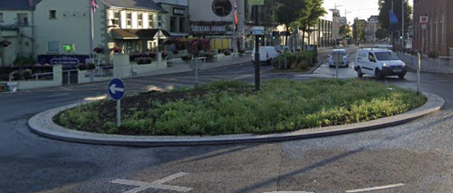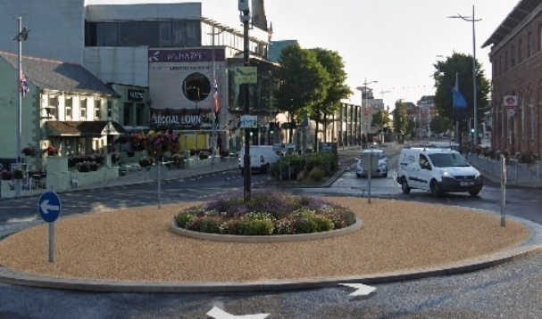

As part of the ongoing process of continuous improvement across the Parks service, Officers had detailed service elements into Standard Operating Procedures (SOPs). While currently in the development stage, once completed, the SOPs would provide the foundation to have greater standardisation across the service. That would inform the operational teams of the required level of maintenance across specific functions and bring uniformity to the service provision across the Borough.

Seasonally, high levels of waste could present difficulties across the service. In order to address that, the most efficient method of collection for both urban and rural locations was by way of compaction vehicles as currently deployed by Cleansing. That was an example of where greater collaboration had assisted in addressing peak waste flows during busy periods.

Ards and North Down had achieved a strong track record of success across both Best Kept and In Bloom competitions, with a number of towns and villages receiving top awards and runner-up positions. A Best Kept or In Bloom award demonstrated that a town was maintained to a high standard, with clean, attractive streets, well-kept parks, and strong attention to the overall environment. It reflected a commitment to good management of public spaces, including planting, biodiversity, and sustainability, which contributed to a positive and welcoming impression.

Locations including Comber, Groomsport and Donaghadee had secured category wins, while Bangor and Holywood had also been recognised at a high level. Donaghadee in particular had demonstrated consistent success across multiple competitions, including achieving top regional placings and national-level recognition and had qualified for the 2026 Ireland’s Best Kept Town Awards. Importantly, those awards also highlighted strong community pride and involvement. Success typically depended on collaboration between the Council, local groups, businesses, and volunteers, showing that people actively cared about and took ownership of their area. As a result, the town was seen as a high-quality place to live and visit, supporting tourism, placemaking, and civic identity.

In addition to the above awards, external validation of the service was provided through the Keep Northern Ireland Beautiful Green Flag Awards. Essentially, that was an opportunity for elements of the service to be critiqued against quality standards set out in the Green Flag programme. Currently, the Council had 7 Green Flag accredited sites. Those were at the following locations:

- Castle Park and Walled Garden
- Clandeboye Cemetery
- Ballymenoch Park
- Kiltonga
- Londonderry Park
- Cairnwood
- Linear Park

Reactive Activity
The Estates service operated a reactive maintenance provision for all Council assets. Works requests were logged on an Asset Management System and assigned a priority timescale for completion, either by our in-house team or a contractor. Around 6,000 such requests are received each year.

In Parks and Cemeteries in addition to planned maintenance and cleansing, a large proportion of resources was allocated to reactive activity. That included responding to:

- Increased waste volumes as a result of high visitor numbers
- Vandalism and graffiti
- Storm or weather-related damage
- Repairs to paths, structures and street furniture
- Fly-tipping and illegal dumping
- Public reports of cleanliness or safety concerns

High visitor numbers during periods of good weather had a significant impact on the service’s ability to deliver its core grounds maintenance activities. Key resources had to be diverted from grass cutting and other horticulture duties to litter picking and bin emptying. That had a significant impact on the cyclic maintenance schedules for key locations and presented backlogs to key tasks.

Reactive work consisted of a considerable proportion of the overall maintenance workload and represented a substantial financial pressure.

Reactive activity was inherently unpredictable and could divert resources away from planned maintenance programmes, reducing the overall effectiveness of proactive regimes as previously stated.

Key Issues
The various proactive regimes were determined by the prioritisation of need within available budgets. Therefore there were a number of ways, either individually or combined, in which the activity undertaken could be enhanced in order to achieve better outcomes. Ways that could be achieved included.

- Rationalise activity in individual locations so that more was carried out by one individual team from one department.
- Reallocate existing budgets towards the higher profile areas and shift the balance of activity from one location to another.
- Inject additional resource specifically towards areas to which more attention to cleaning and maintenance was desired.

In order to implement elements of those options Officers had been working towards the following and would continue to do so over the next 12 to 18 months.

- As a result of approvals given in the 2026/2027 rates, a Premises Officer would be appointed to each building within the estate as a central point of contact for any maintenance issues. Those were not new posts but an enhancement to the role of facility owners to recognise the duties associated with taking responsibility for additional elements such as compliance checks. That would also provide an opportunity to streamline the understanding of other duties such as cleansing (including outdoor signage), reporting and generally ensuring that visually standards were maintained to an acceptable standard.

- As a result of approvals given in the 2026/2027 rates, there was now an increase in the proactive maintenance budget for Estates (as noted above). That would allow further resource to be targeted at the higher priority areas.

- As referred to above (Vibrant Towns and Cities Fund) Place and Prosperity colleagues had applied for an Injection of funding from DFC, circa £1m to allow targeting of maintenance and cleansing, repairs and a replacement of public realm furniture, fixtures and equipment in the 5 main settlements. That would be administered through the Regeneration unit of Place and Prosperity and would allow further higher profile targeting and investment as required for cleaning maintenance repairs and replacements of FF&E.

- Additional high-profile areas were being created which would need to be prioritised in terms of maintaining their condition and acceptability in standards. Allocation of resources to those higher profile areas such Marine Gardens, the new Ward Park areas and Greenways would be as a result of reprofiling of budgets and reallocation of staff, and if necessary subject to future business case approvals.

- As a result of liaising with business and trade representatives over the winter, it had been agreed to implement routine walkabouts to which Elected Members and trade representatives would be invited to identify further opportunities for suggesting changes to regimes and reprioritisation.

Next Steps
Officers would ensure that the above additional measures and activities were undertaken and that a progress report was brought back for Members’ attention in 2027/2028 on the impacts of the changes that would be made to prioritisation and allocation of resources and adjustment of regimes.

Summary
A significant amount of resource both financial and staff was committed daily to routinely cleaning and maintaining Council assets and the public realm as detailed in the report. Officers would continue to implement the changes and activities as detailed above over the next 12 to 18 months and report back to Members on the impacts of those for further consideration.

RECOMMENDED that the Council notes the significant amount of proactive cleaning and maintenance activity already undertaken in public areas and the additional activity and resources planned to be continued with or introduced during 2026 and 2027.

Proposed by Alderman Adair, seconded by Alderman Armstrong-Cotter, that the recommendation be adopted.

Alderman Adair praised the Notice of Motion in relation to the public realm areas and the cleaning of those particularly on the Ards peninsula was to be welcomed. He thought that it appeared that two areas were missing, Portaferry and Portavogie and he hoped that had been an oversight since the Council had agreed to maintain those areas too. The Head of Estates explained that there was a limited budget and the Council could not include every area at every time but it did not mean that they were being neglected. The Alderman thought that it should be monitored to ensure that the investment made in those areas was maintained and he viewed it as important that the villages were kept maintained to the same standards as the city and larger towns.

As seconder of the recommendation Alderman Armstrong-Cotter thanked the team for the work that was done in Newtownards in advance of the King’s visit but added that she would like to see that same standard every day of the week since Conway Square had looked beautiful. She expressed hope that the planting around Blair Mayne be continued. She had noted the Kiltonga area was on the scheme and it had been highlighted to her the problem of overgrown nettles and weeds there and she hoped that area could be maintained by the budget. It was explained that Kiltonga was managed on various levels and the aim was to let the area grow as naturally as possible with a commitment to keep the path clear.

Alderman McRandal asked about the maintenance of public bins at Seapark, Holywood, and Banks Lane, Bangor and if the service had been rationalised within the Council. The Director replied that the service had been rationalised as best it could be for now but was aware that there were a few matters remaining with overflowing bins which would always be kept under review and improved on further where possible.

Councillor Douglas thanked officers for the report and referred to public litter bins at Island Hill, Comber. The officer explained that that site was serviced by Council staff seven days a week in the summer and the position was challenging because the area was so popular with visitors. The Director added that the message to the public should be two pronged as it was good practise for residents and visitors to the countryside to take their own litter home.

The Chair thanked officers for the very detailed report and he considered walkabouts with the community a positive move to identify issues. He also asked about the use of town centre wardens who had been in place throughout the Borough for the past ten years. He thought it would be worthwhile reviewing the system at this stage to find out if that had been successful since feedback was not generally provided on their work. The Director replied that it was the intention to bring back a report on that work in town centres but they were a positive onsite presence litter picking and reporting back on damage. The Best Kept Awards successes were viewed as proof that the town centre wardens were doing a good job on the ground. The Chair also referred to the Parks team who did, in his words, an amazing work but not on the Borough’s roundabouts and he considered planting here would be quick wins for the Council since they were prominent. It was reported that there were plans for those areas with permanent planting and that would help significantly.

AGREED TO RECOMMEND, on the proposal of Alderman Adair, seconded by Alderman Armstrong-Cotter, that the recommendation be adopted.

17. NORTHERN IRELAND LOCAL AUTHORITY MUNICIPAL WASTE MANAGEMENT STATISTICS, OCTOBER TO DECEMBER 2025
(Appendix XII)

PREVIOUSLY CIRCULATED:- Report from the Director of Environmental Services detailing that the official waste management statistics for the third quarter of 2025/2026 (October to December 2025) had been released by the Northern Ireland Environment Agency.

The aim of this report was to:
- Report key quarterly waste management performance statistics relative to the same period last year and other Northern Ireland councils.
- Provide some detail around operational waste service management activities/actions that had been implemented during the quarter with the aim of improving performance.

In summary, key indicators remained positive for this reporting period. They showed that the Council had been successful in maintaining high levels of reuse and recycling. More detailed analysis revealed a reliance of higher performing HRC diversion, with a reduction in the percentage of kerbside collected waste diverted for recycling.

Key headlines
Sources: Quarterly data from DAERA’s quarterly waste statistics reports. Annual performance data from DAERA’s waste statistics 2024/25 annual report. [www.daera-ni.gov.uk]

Table 1: Overall performance 2025/26 vs 2024/25
Household Waste Recycling Rate (KPI(a2))
(National recycling performance indicator)
 | Q1 | Q2 | Q3 | Q4 | Annual
2024 - 2025 | 59.8% | 58.1% | 53.6% | 51.5% | 56.1%
2025 - 2026 | 63.1% | 61.0% | 56.0%
CHANGE | +3.3% | +2.9% | +2.4%
Waste From Household Recycling Rates
(Official UK recycling measure)
 | Q1 | Q2 | Q3 | Q4 | Annual
2024 - 2025 | 59.7% | 58.0% | 53.5% | 51.4% | 55.9%
2025 - 2026 | 62.7% | 60.9% | 55.4%
CHANGE | +3.0% | +2.9% | +1.9%
NI Household Recycling Rate Ranking (KPI(a2))
 | Q1 | Q2 | Q3 | Q4 | Annual
2024 - 2025 | 3rd | 3rd | 3rd | 2nd | 3rd
2025 - 2026 | 1st | 2nd | 2nd
CHANGE | up 2 | up 1 | up 1
Composting Rate
 | Q1 | Q2 | Q 3 | Q 4 | Annual
2024 - 2025 | 38.8% | 38.1% | 30.0% | 25.7% | 33.6%
2025 - 2026 | 37.3% | 37.3% | 29.4%
CHANGE | -1.5% | -0.8% | -0.6%
Dry Recycling Rate
 | Q1 | Q2 | Q 3 | Q 4 | Annual
2024 - 2025 | 20.6% | 19.5% | 23.3% | 25.4% | 22.1%
2025 - 2026 | 25.4% | 23.3% | 26.2%
CHANGE | +4.8% | +3.8% | +2.9%

The headlines for household waste recycling were:
- Household waste recycling rate (KPI(a2)) rose by 2.4% compared to the same quarter last year, from 53.6% to 56%. That was 5.6 percentage points higher than the NI average of 49.8%. We were ranked second out of the eleven NI councils for our household waste recycling rate, up one place from the same quarter last year.
- Waste from Households recycling rate rose 1.9% to 55.4% compared to the same quarter last year.
- Household waste composting rate fell by 0.6% compared to the same quarter last year - from 30% to 29.4%. Our household waste composting rate was 5.2% higher than the NI average of 24.2%. Ards and North Down was ranked 3rd in the council performance table for that stream.
- Household waste dry recycling rate rose by 2.9% compared to the same quarter last year - from 23.3% to 26.2%. Our household waste dry recycling rate (i.e. recycling of items other than organic food and garden waste) was 0.9% higher than the N.I. average of 25.3%. Ards and North Down was ranked 3rd in the council performance table for that stream.
- Kerbside compostables capture rate was 71.8% compared to a NI Council average of 63.8%.

Table 2: HRC performance 2025/26 vs 2024/25
HRC waste received (total tonnes)
 | Q1 | Q2 | Q3 | Q4 | Annual
2024 - 2025 | 5,769 | 5,971 | 4,555 | 4,663 | 20,959
2025 - 2026 | 5,824 | 6,275 | 5,572
CHANGE | +1% | +5.1% | +22.3%
HRC residual (tonnes)
 | Q1 | Q2 | Q3 | Q4 | Annual
2024 - 2025 | 1,474 | 1,445 | 1,245 | 769 | 4,933
2025 - 2026 | 1,364 | 1,283 | 1,502
CHANGE | down 7.5% | down 11% | up 20.6%
HRC recycling (tonnes)
 | Q1 | Q2 | Q3 | Q4 | Annual
2024 - 2025 | 4,295 | 4,526 | 3,310 | 3,894 | 16,026
2025 - 2026 | 4,460 | 4,992 | 4,070
CHANGE | up 3.8% | up 10.3% | up 22.9%
HRC recycling (%)
 | Q1 | Q2 | Q3 | Q4 | Annual
2024 - 2025 | 74.0% | 75.8% | 72.7% | 83% | 76.4%
2025 - 2026 | 76.6% | 79.6% | 73.0%
CHANGE | up 2.6% | up 3.8% | up 0.3%

The headlines for HRC performance were:
- Total HRC waste per capita averaged 33.7kg, compared to an average 39.9kg per capita for all other NI councils.
- HRC residual waste per capita was 9.1kg, compared to an average of 15.8kg per capita for all other NI councils.
- HRC recycling percentage was 73% in this quarter, compared to an average rate of 60.4% for other councils. During the same quarter the previous year, our HRC recycling rate was 72.7%, compared to an average of 62.2% for other councils.

Table 3: Kerbside performance 2025/26 vs 2024/25
Total kerbside waste collected (tonnes)
 | Q1 | Q2 | Q3 | Q4 | Annual
2024 - 2025 | 16,109 | 16,038 | 13,919 | 14,446 | 60,512
2025 - 2026 | 15,610 | 15,874 | 13,850
CHANGE | down 3.1% | down 3.0% | down 0.5%
Kerbside residual collected (tonnes)
 | Q1 | Q2 | Q3 | Q4 | Annual
2024 - 2025 | 6,029 | 6,543 | 6,143 | 7,205 | 25,920
2025 - 2026 | 5,992 | 6,744 | 6,428
CHANGE | down 0.6% | up 3.0% | up 4.6%
Kerbside recycling collected (tonnes)
 | Q1 | Q2 | Q3 | Q4 | Annual
2024 - 2025 | 10,080 | 9,495 | 7,776 | 7,241 | 34,592
2025 - 2026 | 9,618 | 9,130 | 7,422
CHANGE | down 4.6% | down 3.0% | down 4.6%
Kerbside collected for recycling (%)
 | Q1 | Q2 | Q3 | Q4 | Annual
2024 - 2025 | 62.6% | 59.5% | 55.8% | 50.1% | 57.1%
2025 - 2026 | 61.6% | 57.5% | 53.6%
CHANGE | down 1% | down 2.0% | down 2.2%

The headlines for kerbside collection performance were:

- Kerbside collected waste per capita averaged 83.7kg during this quarter. The average for all other Northern Ireland councils was 82.2kg per capita.
- Kerbside collected residual waste per capita averaged 38.9kg per capita, compared to an average of 47.5kg per capita for the other Northern Ireland councils.
- Kerbside collected recycling per capita averaged 44.9kg per capita, compared to an average of 34.8kg per capita for the other Northern Ireland councils.
- Kerbside recycling percentage (the proportion of waste collected for recycling through our kerbside bin collection) was 53.6%. Although that was lower than for the same quarter in the previous year, it remained higher than the 42.3% average for other Northern Ireland councils.

Municipal waste overview

In Quarter 3 of 2025/26, 56.4% (11,473 tonnes) of the Council’s municipal waste was sent for recycling or composting. That included all material received through kerbside collections, HRCs, bring sites, and non-household collections.

The Council reported that 0.4% (78 tonnes) was sent for re-use or repair.
For residual waste, 42% (8,546 tonnes) was sent for energy recovery during the quarter, and 0.6% (118 tonnes) was rejected as non-target material by our reprocessors and sent to landfill.

Operational Performance Improvement Measures
MC1 - Marketing and Communications Indicators
64 social media posts were issued across Facebook, Instagram and X. Those represented a mix of educational and operational messages including:

- Recycle Week (follow up messages)
- E-Waste Recycling including International E-Waste Day,
- Foil Fridays and Seasonal (Halloween & Xmas)
- Foil Recycling (Alupro assets),
- Cloth Nappy Scheme promotion,
- Food Waste (Pumpkins),
- Battery Recycling
- Festive Food Waste Campaign (WRAP Assets),
- Recycle Your Electricals/Disposal of Old Tech,
- Operational messages re: Bin Collections/HRC opening hours over festive season,
- The Winter Coat Project.

1 x press release issued. Copy available on website at Love Your Leftovers: Feast Smart, Waste Less This Christmas in Ards and North Down - Ards and North Down Borough Council

More detail on social media posts during the quarter was included in Appendix 1.

MC2 Bin-Ovation
- 4 Bin-Ovation ‘News and Info’ articles were published including holiday collection/HRC arrangements for Christmas, Feast Smart, Waste Less, Battery Fire Risk and E-waste Day 2025.
- 4 Bin-Ovation’ push notifications issued.
- 1,621 Bin-Ovation downloads recorded.

MC3 – Officers delivered 18 community and engagement events, reaching 1068 people.

- 2 x Events
- 8 x schools
- 2 x adult groups
- 1 x Brownies group
- 5 x Youth groups

Household Recycling Centre Indicators

HRC2 Number of visitors turned away from site: 436

HRC2a Number of HRC bookings: 77,429

HRC2b – Average number of HRC visits per household: 1.08 (averaged across the 71,976 households in the Borough)

2.3 Kerbside Household Waste Collections Indicators

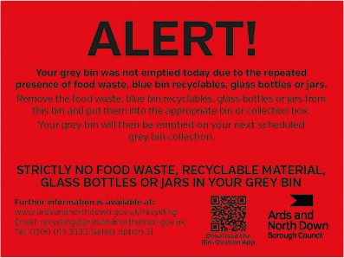

KSI – Number of recycling alert stickers applied to grey bins (yellow): 1612
KS2 – Number of recycling alert stickers applied to grey bins (amber): 133
KS3 – Number of recycling alert stickers applied to grey bins (red): 63

2.4 Summary and Trend Analysis of Indicators
Indicator Reference | Monitoring Period 10  (Apr to Jun 2025) | Monitoring Period 11  (Jul to Sept 2025) | Monitoring Period 12  (Oct to Dec 2025)
MC1  Social media posts | 41 | 50 | 64
MC2  Print press and online articles | 0 | 1 | 1
MC3  Engagement events/sessions | 17 | 16 | 18
HRC2  Visitors denied entry | 645 | 697 | 436
HRC2a  No. of bookings | 80,136 | 85,160 | 77,429
HRC2b  Average no. of HRC visits per household in the Borough | 1.11 | 1.18 | 1.08
KS1  Yellow warning stickers on grey bins | 1938 | 1913 | 1612
KS2  Amber warning stickers on grey bins | 161 | 133 | 133
KS3  Red warning stickers on grey bins | 88 | 53 | 63

Summary Analysis
Our overall recycling performance demonstrated an increase of 2.4 percentage points over the same quarter in 2024/25 with the Council maintaining its 2nd place ranking in the NI council recycling performance table. This quarter’s performance was in part due to good diversion at the Council’s network of HRCs.

During the quarter October to December 2025, ANDBC:

- Recorded household waste recycling rate of 56%; the second highest household recycling rate of the 11 NI councils. That was an increase of 2.4 percentage points from the same quarter in 2024/25.
- Maintained a 73% recycling rate at our HRCs.
The total tonnage of material collected at the kerbside was similar to the tonnage collected in the same quarter of 2024/25. There was, however, an increase of 285 tonnes (4.6%) in the tonnage of kerbside non-recyclable waste and a decrease of 354 tonnes (4.6%) in the tonnage of recycling collected. For the last three quarters, the kerbside recycling rate had remained consistently below the rate recorded in the corresponding quarters of the previous year. Council Officers were reviewing options to increase kerbside communications messages and necessary enforcement interventions.

Overall composting tonnages were lower than for the same period in the previous year. One of the reasons for that could be the sensitivity of garden waste to seasonal growth conditions. Autumn 2025 was the third wettest on record in Northern Ireland, with rainfall 39% above the long-term average. That may have reduced gardening activity during the period leading to less material being placed out for kerbside collection.

The Council’s HRC network continued to perform well despite some limitations at smaller sites. The controlled access provided by the HRC booking system improved site flow and allows for better interaction between staff and users, helping to encourage correct segregation and higher recycling levels.

The Council continued to anticipate DAERA’s published response to its 2024 Rethinking Our Resources consultation. The recycling consultation response was expected to outline consistent material collection requirements and new opportunities to support workplace recycling. That would inform and shape the Council’s future waste and recycling service plans.

RECOMMENDED that the Council notes this report.

Proposed by Councillor Wray, seconded by Alderman McRandal, that the recommendation be adopted.

Councillor Wray was encouraged that the figures were continuing to improve and that Council staff and the public were buying in to the messages being sent out. He enquired about the recycling of hard plastics on the Peninsula and if more information could be provided on that. The Waste Resource and Contracts Manager replied that that was still being worked on and under the HRC review it was believed that there should be good provision right across the Borough and that was one of the objectives.

Alderman Adair concurred in respect of plastics and he considered that Kircubbin was the best site since it was bigger and more accessible to all. He wondered about increasing capacity at the kerbside such as for small electrical items, textiles and soft plastics. The officer advised that it was hoped to introduce soft plastics soon and that was at tendering process and was more delayed than had been hoped. The Chair added that the market had collapsed for textiles but he thanked officers and the public for the progress that was being made.

AGREED TO RECOMMEND, on the proposal of Councillor Wray, seconded by Alderman McRandal, that the recommendation be adopted.

18. ISLE OF MAN VISA REQUIREMENTS FOR FISHING VESSELS
(Appendix XIII)

PREVIOUSLY CIRCULATED:- Report from the Director of Environmental Services detailing that in April 2026, the Council agreed to the following as a result of a Notice of Motion.

That this Council is deeply concerned at the impact of the change to Isle of Man’s visa requirements on the Northen Ireland fishing fleet. The changes which mean that overseas crew require an Isle of Mans work visa rather than the transit visa or UK skilled worker visa and therefore cannot fish within the Isle of Man 12 nautical mile limit, effectively excluding the Northern Ireland fishing fleet from its fishing traditional waters. Council requests that officers write to the Manx Government, to highlight the damage to the Northern Fishing and Fish Processing Industry and request that the relevant measures are taken by the Manx Government to reverse the impact of these changes.

Key Issues
The debate centred around the negative impacts understood to be experienced by the Northern Ireland Fishing Fleet due to changes in visa requirements. It was agreed that a letter be sent to the Isle of Man Government asking that measures are taken to reverse the impact of the changes. A response was received from Hon Alfred Cannan MHK Chief Minister of the Isle of Man Government on 27 May 2026 and was attached.

Next Steps
The Council was asked to note the contents of the response letter attached.

Summary
As a result of the notice of motion detailed in this report, a letter was sent as agreed to the Isle of Man Government. A response was received which Members are asked to note.

RECOMMENDED that the Council notes the attached letter.

Proposed by Councillor Edmund, seconded by Alderman Adair, that the recommendation be adopted.

Councillor Edmund appreciated the correspondence and the outcome.
He could not say that he was totally happy but he did view it as progress. He pointed out that there would be a cost involved in getting visas and that, along with the rising cost of fuel, was an ongoing challenge to the fishing industry. He said that he had since spoken with Dr David Bird, Manx Fishermen Producers Association and the response was confirmed. The Chair of the Committee praised Councillor Edmund for being a great champion for the fishing industry.

Alderman Adair shared the view that the response had not been what had been wished but stressed that the industry was a significant part of the economy of the Borough and he wanted to thank the Council for supporting it unanimously and doing all it could to protect the industry.

Councillor Brady had been happy to learn that there had been some positive movement on this and referred to the efforts of the immigrant community in supporting the industry. Alderman Armstrong-Cotter commented and thanked Councillor Edmund for raising the Isle of Man visa issue and was disappointed that would be a further cost to fishermen.

AGREED TO RECOMMEND, on the proposal of Councillor Edmund, seconded by Alderman Adair, that the recommendation be adopted.

19. NOTICES OF MOTION

19.1 Notice of Motion submitted by Councillor Edmund and Alderman Adair

That this Council task officers to bring forward a costed programme of works to bring slipways and harbours in Council ownership or control up to an appropriate standard in order that they can be utilised by leisure users as part of our wider tourism offering and to investigate appropriate funding streams to deliver this.

Proposed by Councillor Edmund, seconded by Alderman Adair, that the Notice of Motion be adopted.

Councillor Edmund said this was not necessarily about checking slips and harbours but he wished to see how those could be best utilised for recreational purposes and how they could be used for various sea activities. He appreciated that this would be a lengthy piece of work but it was vital that it was provided. He also encouraged officers to look for funding opportunities externally.

RECESS 9.02 pm
RECOMMENCED 9.15 pm

In seconding, Alderman Adair said he believed that all areas should be examined, and it was important to search for external funding opportunities.

AGREED, on the proposal of Councillor Edmund, seconded by Alderman Adair, that the Notice of Motion be adopted.

19.2 Notice of Motion submitted by Councillor W Irvine and Councillor S Irvine

This Council recognises the service and sacrifice of members of the Ulster Defence Regiment (UDR), including those from the Borough and surrounding areas who served with dedication during a difficult period in Northern Ireland’s history.

Accordingly, tasks officers to bring back a report to this Council on providing a memorial bench within Clandeboye Cemetery, Bangor, dedicated to the memory and service of members of the Ulster Defence Regiment.

The proposed bench should provide a dignified place for remembrance and reflection for families, veterans, and members of the wider community.

Proposed by Councillor W Irvine, seconded by Councillor S Irvine, that the Notice of Motion be adopted.

Councillor W Irvine explained that the reason for bringing the Motion forward was that some of the members of the North Down Branch had come to him for advice on the policy for memorial benches. They had not been successful themselves and he had since spoken to officers who had suggested a Notice of Motion. The Veterans Champion had worked with the group in the past and there were around forty members of the Association buried at Clandeboye Cemetery. He thought that a bench would be a fitting and respectful memorial and many local families valued the way it would enhance the Cemetery. He asked Members to support and approve the installation since the Ulster Defence Regiment had an important role in maintaining law and order during a difficult time in Northern Ireland’s history.

Councillor S Irvine seconded the Motion and acknowledged the service of those who in the Ulster Defence Regiment, including many local men and women, who carried out their duties during a challenging and often dangerous period in Northern Ireland's history.

He said the UDR served the country for 22 years, from 1970 until 1992, and throughout that time its members played a significant role in protecting communities and supporting the security forces during The Troubles and many had paid a significant personal price for that service, and many families continued to live with the consequences of that today.

He spoke from personal experience, having friends who had served, and knew of the commitment, courage and sense of duty they brought to that role including recent former Councillor Stephen Cooper, whose service and dedication to both community and country would be remembered by many.

At the same time he recognised Northern Ireland’s shared history was viewed through different perspectives across the community. Memorials and acts of remembrance should therefore be approached with sensitivity, dignity and respect. It was for that reason he supported the proposal to request a report from officers on the provision of a memorial bench within Clandeboye Cemetery. Seeking a report did not predetermine the final design, location or wording, but it allowed the Council to consider those matters carefully and appropriately.

A memorial bench would provide a quiet place for reflection and remembrance for families, veterans and members of the wider community. It would also be a fitting and dignified tribute to those who served, and an opportunity to ensure that their contribution was remembered by future generations.

Speaking as the Council’s Veterans’ Champion Alderman Cummings commended the Members for their Notice of Motion explaining that he worked closely with the Association. He said this was a unique regiment whose battalions had lost 198 soldiers in the height of The Troubles. It had now been amalgamated with the Royal Irish Regiment and he looked forward to an officers report and was pleased to support the Motion.

Councillor Wray thanked Members for bringing forward the Motion and looked forward to further information on the special proposal.

AGREED, on the proposal of Councillor W Irvine, seconded by Councillor S Irvine, that the recommendation be adopted.

20. ANY OTHER NOTIFIED BUSINESS

There were no items of Any Other Notified Business.

EXCLUSION OF PUBLIC/PRESS

AGREED, on the proposal of Councillor Edmund, seconded by Alderman Cummings, that the public and press be excluded from the following items of confidential business.

21. TENDER REPORTS

21.1 EXTENSION OF HAULAGE CONTRACT

***IN CONFIDENCE***

PREVIOUSLY CIRCULATED:- Report from the Director of Environmental Services detailing that the contract for The Supply of Services Relating to the loading, haulage and transfer of residual municipal, co-mingled dry recyclable, organic, street sweeping and bulky wastes, was due to expire on 1 August 2026.

The Arc 21 Joint Committee through which the tender was originally processed had agreed that it should be extended for a further 12 months. Council Officers were in agreement with that approach for the reasons given in this report.

RECOMMENDED that the Council approves the extension of the contract.

RESOLVED, on the proposal of Alderman Cummings, seconded by Councillor Edmund, that the recommendation be adopted.

21.2 EXTENSION OF TENDER FOR THE PROVISION OF LEGIONELLA SERVICES

***IN CONFIDENCE***

PREVIOUSLY CIRCULATED:- Report from the Director of Environmental Services detailing that to ensure compliance across Council facilities, officers procured specialist contractors to provide Legionella services.

The Council’s Procurement Section carried out a procurement exercise, and the tender for the Provision of Legionella Services was awarded on 27 June 2024. The contract was initially awarded for one year, with the option to extend for up to three further 12-month periods, subject to annual review. The original award was reported to the May 2024 Committee, and the first contract extension was reported to the April 2025 Environment Committee.

RECOMMENDED that the Council agrees to extending the contract with the above contractor for Lot 2 of the Provision of Legionella Services be extended for a further year, in accordance with the terms set out in the original tender.

RESOLVED, on the proposal of Councillor Wray, seconded by Alderman Armstrong-Cotter, that the recommendation be adopted.

RE-ADMITTANCE OF PUBLIC/PRESS

AGREED, on the proposal of Alderman Armstrong-Cotter, seconded by Councillor Edmund, that the public/press be re-admitted to the meeting.

TERMINATION OF MEETING

The meeting terminated at 9.29 pm.

