ARDS and North Down Borough Council

A hybrid meeting of the Environment Committee was held at the Council Chamber, Church Street, Newtownards, and via Zoom, on Wednesday 6 May 2026 at 7.00 pm.

Present:

In the Chair: Councillor Kendall

Aldermen: Adair McAlpine
Cummings

Councillors: Ashe (7.15 pm Zoom) Douglas
Boyle Edmund
Blaney Harbinson
Brady (Zoom) Newman
Wray

In Attendance: Alderman Graham, Councillor Cochrane and Councillor Thompson

Officers in Attendance: Director of Environmental Services (G Bannister), Head of Parks and Cemeteries (S Daye), Head of Waste and Cleansing (K Patterson), Head of Estates (P Caldwell) and Democratic Services Officer (H Loebnau).

INTRODUCTION

Councillor Kendall welcomed everyone to her last meeting as Chair and expressed her gratitude to the Committee for what had been quite a pleasant term and she had enjoyed the agreement and disagreement expressed in the scrutiny of decision making. She also thanked Council officers for their support and the work provided by the Democratic Services team. She also thanked the public for listening and the constructive feedback provided by them. In closing she welcomed again the new Head of Waste and Cleansing and hoped that he had had a good introduction to the work of the Council.

Speaking on behalf of his Party Alderman Adair praised the Chair believing her to have been fair and that she had conducted business well and should be proud of her record.

NOTED.

1. APOLOGIES

The Chair sought apologies and those were noted from Alderman McRandal, Alderman Armstrong-Cotter and Councillor Cathcart. Apologies for lateness were received from Councillor Ashe.

NOTED.

2. Declarations of Interest

The Chairman sought Declarations of Interest and none were noted.

NOTED.

3. Notice of Motion 655 Additional Names for Comber War Memorial

PREVIOUSLY CIRCULATED:- Report from the Director of Environmental Services detailing that in March 2025, the Council agreed the following Notice of Motion

That this Council brings back a report outlining the design, cost and positioning of an additional plaque on the War Memorial in Comber, to accommodate a list of historically researched names, currently being collated as per War Memorial Trust guidelines, of the fallen in the Great War 1914-1918, which were previously not included.

At the meeting, it was pointed out that the Comber Branch of the Royal British Legion had been provided with a historically researched and compiled list of individuals believed to have been omitted from the town’s War Memorial. The list related to casualties from the First World War, covering the period 1914–1918.

Upon receipt of this information, the Branch agreed to initiate a process in accordance with War Memorial Trust Guidelines. That included the establishment of a working group to undertake detailed scrutiny of the names and to commence a formal verification process.

Key Issues
Officers had since been collaborating with the working group and all missing names were now believed to have been collated and verified.

In total, 123 names have been collected and verified by the working group. It was proposed that those names would be distributed over three plaques, situated on the existing war memorial as shown below.

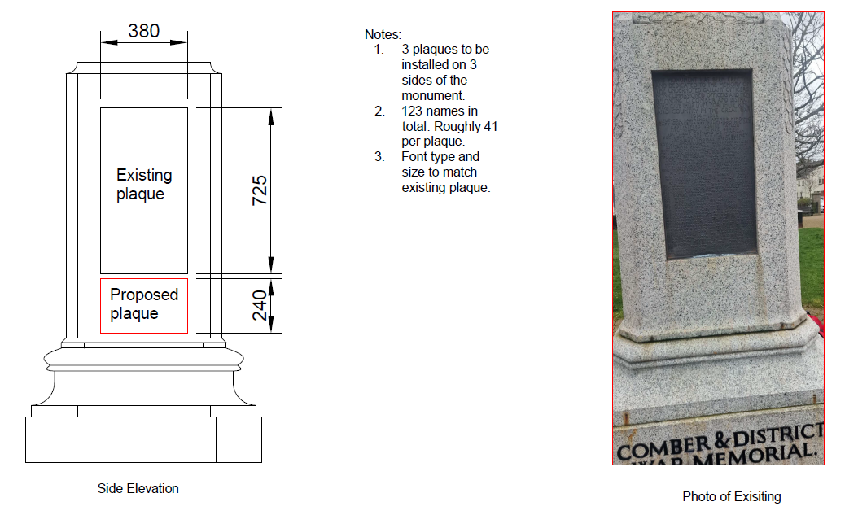

Next Steps
Officers had approached a local foundry for the production of the plaques. Initial budget costs indicated an approximate total cost of £5,000 for the three plaques and could be procured.

Summary
A list of individuals believed to have been omitted from the town’s War Memorial had been identified. The list related to casualties from the First World War, and could be added to the Comber War Memorial as described in this report.

RECOMMENDED that the Council agrees to progress with the production of the three plaques as outlined above, utilising existing maintenance budgets.

Proposed by Alderman Cummings, seconded by Councillor Douglas, that the recommendation be adopted.

Alderman Cummings thanked officers for the report and its recommendations and also asked for thanks to be recorded for Dr Stange who had been very diligent with his work behind the scenes in compiling the detailed record. He believed that the work was coming at a good time and the appeal from local families was that the list should be comprehensive and complete.

He had a question in relation to the positioning of the plaques on the memorial and if the overall cost would include the casting of names. The Committee was informed that the cost did include that and the intention was that the plaque be set on the surface memorial rather than recessed in to the existing stone which could lead to damage. Alderman Cummings expressed his satisfaction with that. Members were also informed that if the recommendation was agreed this evening officers would move as soon as possible back to the working group which could engage with the Council to mark the addition in advance of the Somme Commemoration at the start of July, if that was at all possible.

Seconding the recommendation Councillor Douglas stressed that it was incredibly important to keep the memory alive of those who had lost their lives during the First World War and she made a special mention for the work of the Comber Branch of the Royal British Legion which had assisted in the compilation of the additional names.

Councillor Boyle rose to speak and after thanking and praising the Chair for her time in that role he said he welcomed the report and thanked Alderman Cummings for bringing the Notice of Motion originally. He thought that the report had been sensible and meaningful and referred to the names that had been missing and forgotten but would now be on display and rightfully remembered by their families and the communities they had represented. He thought this had been a tremendous piece of work and offered his congratulations to the working group and hoped that the numbers were now complete and that every life sacrificed would be given the respect and honour that was deserved.

AGREED TO RECOMMEND, on the proposal of Alderman Cummings, seconded by Councillor Douglas, that the recommendation be adopted.

4. HRC Extended opening hours

PREVIOUSLY CIRCULATED:- Report from the Director of Environmental Services detailing that the Household Recycling Centre (HRC) extended opening hours trial was a response to a proposal by the Council to revert to pre-Covid seasonal opening times with the aim to increase accessibility for residents.

Key Issues
Scope of the trial:
It was agreed that the trial would run over the brighter months of June, July, August and September. The trial involved alternating additional evening opening hours across the nine HRCs from Monday to Friday.

Extended Opening Hours were agreed as followed for 1 June to 30 September, 8am to 8pm.

- Monday - Donaghadee and Holywood HRCs
- Tuesday - Comber and Kircubbin HRCs
- Wednesday - Portaferry and Newtownards HRCs
- Thursday - Balloo, Bangor HRC
- Friday - Millisle and Ballygowan HRCs

The last bookable appointment was 7:40pm.

The trial was heavily publicised using Council social media platforms and the Bin-ovation app.

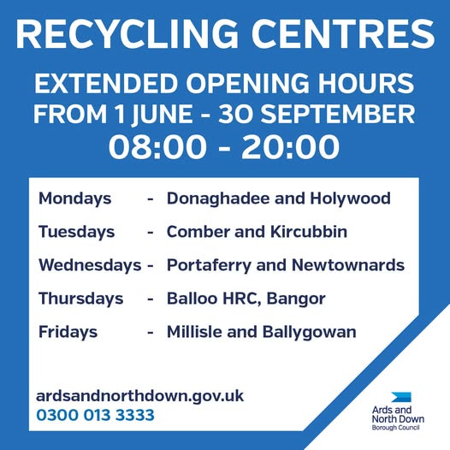
Figure 1.0 HRC extended opening hours social media post

Results of the trial:
The trial measured the number of booked slots as a percentage of the total additional number of slots made available. The table below was a summary of site usage during the extended opening hours between 1 June to 30 September 2025.

Total - Extended Opening
1 June to 30 September 2025 | Extra  slots available | Bookings created | % of extra slots booked per site | No shows | % of no shows per site | Bookings completed | % of extra slots used per site
Balloo | 3,060 | 1,163 | 38% | 111 | 4% | 1,052 | 34%
Newtownards | 3,060 | 381 | 12% | 16 | 1% | 339 | 11%
Comber | 2,448 | 215 | 9% | 15 | 1% | 185 | 8%
Holywood | 800 | 112 | 14% | 8 | 1% | 100 | 13%
Ballygowan | 1,530 | 117 | 8% | 5 | 0% | 106 | 7%
Millisle | 1,836 | 121 | 7% | 5 | 0% | 109 | 6%
Kircubbin | 1,224 | 106 | 9% | 4 | 0% | 90 | 7%
Portaferry | 1,224 | 103 | 8% | 3 | 0% | 97 | 8%
Donaghadee | 864 | 65 | 8% | 1 | 0% | 62 | 7%
Total | 16,046 | 2,383 | Avg. 12% | 168 | Avg. 1% | 2,140 | Avg. 11%

Summary
The trial of extended opening hours at nine Household Recycling Centres demonstrated a lack of significant demand for the additional operating times.

Only one of the nine sites managed to utilise over 15% of its extended booking slot availability, while the remaining eight experienced notably low attendance.

That outcome suggested that while extended hours might cater to a specific localised need, without increased public engagement a broader service implementation could result in an inefficient resource allocation with minimal public benefit. In order to inform the next steps, Members were advised that budget existed for any of the three possible options as set out below.

Next Steps
Recommended options:
Officers would suggest consideration of the following three potential options:

- As in the 2025 trial, extend HRC opening hours to provide one late opening evening per week at each site from 1 June to 30 September. Resourcing that option would cost an estimated additional £45,000
- As in the 2025 trial, extend HRC opening hours to provide one late opening evening per week, but only at five sites - Balloo, Newtownards, Comber, Millisle, and Portaferry in order to balance demand and geographical access. Resourcing that option would cost an estimated additional £38,500.
- Do not extend HRC opening hours, retaining consistent opening hours. That option would have no additional staffing or budgetary implications.

RECOMMENDED that the Council approves Option 2.

Proposed by Alderman Adair, seconded by Councillor Douglas, that Option 1 be adopted.

Alderman Adair proposed Option 1 believing that the additional resource was well worth the spend to ensure equal treatment of extended opening hours across the Borough over the summer months; including the Ards Peninsula. He thought that having Kircubbin excluded was unacceptable and therefore Option 1 was a sensible alternative. He argued that people led busy lives and should not be expected to travel long distances to their nearest recycling site. He urged Members to support the proposal, stating that the Council existed to serve the public and that the additional investment would be worthwhile.

Councillor Douglas was happy to second that proposal noting that while Option 2 covered her area she saw the merit in having the service extended so that it was convenient to all residents of the Borough. Councillor Boyle agreed with the amended proposal to adopt Option 1 believing that the service should be spread as widely as possible.

Also rising to support was Councillor Wray who began by thanking Councillor Kendall for her time in the role of Chair of the Environment Committee. He thought he could give Option 1 his support provided it proved to be value for money. He referred to the mathematics of the service in terms of the percentage of slots used in the evenings and compared that to the cost and usage of daytime slots provided following a question to the Head of Service. He recognised the additional cost of the extension but also saw the point of view of providing a balance for people who worked 9-5 pm and who would benefit most from the access that the extended hours would provide.

(Councillor Ashe entered the meeting at 7.15 pm)
Councillor Edmund thanked the team for their work and agreed that many residents could not visit HRCs during standard working hours. He felt extended hours could have the benefit of reducing fly-tipping and increase recycling of items such as small electricals as an example and believed that all centres should remain open rather than a selected few.
Councillor Brady thanked the outgoing Chair for her contribution and also supported Option 1, noting that residents who lived in Holywood would have been very unhappy had the centre there been closed over summer in the evenings. He queried the higher ‘no-show’ rates at Balloo. The Head of Service said that no clear explanation for that could be ascertained
Councillor Newman also supported Option 1, believing that residents would be unhappy if their local centre was to be closed while other centres were open. She expected an annual review of the service and believed the additional investment was fair to ratepayers.
Councillor Blaney noted that some percentages were lower than anticipated and recognised that withdrawing a service once it had been introduced was difficult. He viewed Option 1 as the only realistic option and supported it for a further year, while stressing the need to ensure ratepayers received value for money.
Councillor Harbinson thanked Councillor Kendall for her fairness as Chair of the Committee and supported Option 1 as a balance between utility and cost. He felt evening opening would help those doing garden work throughout the summer and expected usage to rise as awareness of the service increased.
The Chair agreed that the points in relation to Holywood were well made. She thought the trial that had been previously established must run long enough to be properly assessed and that the service should suit those working the traditional working day.
Summing up Alderman Adair noted that ratepayers had just received their bills for the year ahead and stressed the need to ensure everyone had fair access to Council services, including their local recycling centre.
AGREED TO RECOMMEND, on the proposal of Alderman Adair, seconded by Councillor Douglas, that Option 1 be adopted.

5. Notice of motion 330 donaghadee swim SHELTER

PREVIOUSLY CIRCULATED:- Report from the Director of Environmental Services detailing that in March 2019 a decision was taken on a Notice of Motion as followed:

That Council brings back a report on providing a shelter or sheltered area near the slipway in Donaghadee which would provide cover for the growing numbers of open water swimmers that use the area on a daily basis. It is important that we recognise the many benefits that such activity brings to those that take part - enhancing peoples physical and mental wellbeing. The fact is that a significant number of our residents are swimming in the waters around our coast - we as a Council should not be seeking to deter them in any way, instead we should be looking how we can assist them and in doing so encourage others to improve their lifestyles. As part of the report, the Council will engage with the community in Donaghadee to hear views and ideas on possible solutions.

Key Issues
Previously Assets and Property Services (now Estates) had been progressing this and officers had met with Donaghadee Sailing Club and the local open water swimming group, the Chunky Dunkers, shortly after the Notice of Motion was submitted to inform the design and preferred location. Below was a design concept that was drawn up based on those discussions.

The Parks and Cemeteries Service was now progressing the project and it was proposed to submit a planning application for the shelter and as part of that, full detailed designs would be prepared with associated costs estimated. In addition, a business case would be required to progress the installation of the proposal.

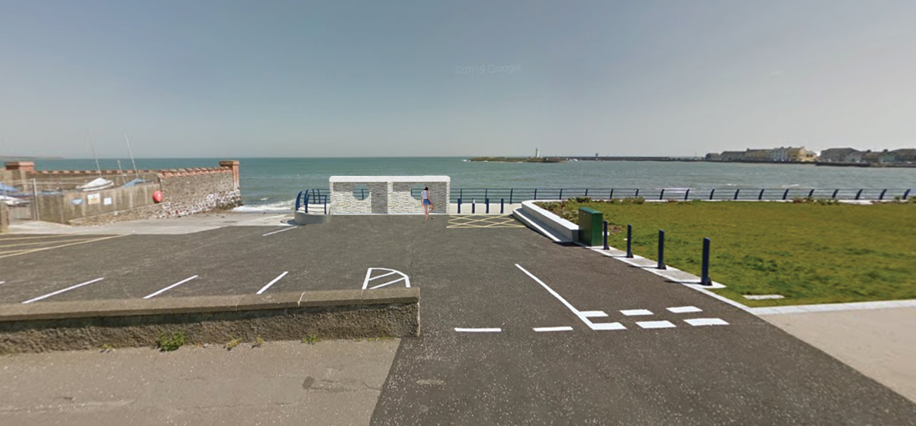
Proposed swimming shelter

In 2025 Donaghadee was designated as a Designated Bathing Water Site by the Department of Agriculture, Environment and Rural Affairs.

The provision of a modest shelter would respond directly to the Notice of Motion and would support an established and growing open water swimming community in Donaghadee. It would provide a practical facility for swimmers using the area, improve comfort and amenity at the site, and demonstrate the Council’s support for healthy outdoor recreation. The proposal would also align with the increased profile of Donaghadee as a recognised bathing water location.

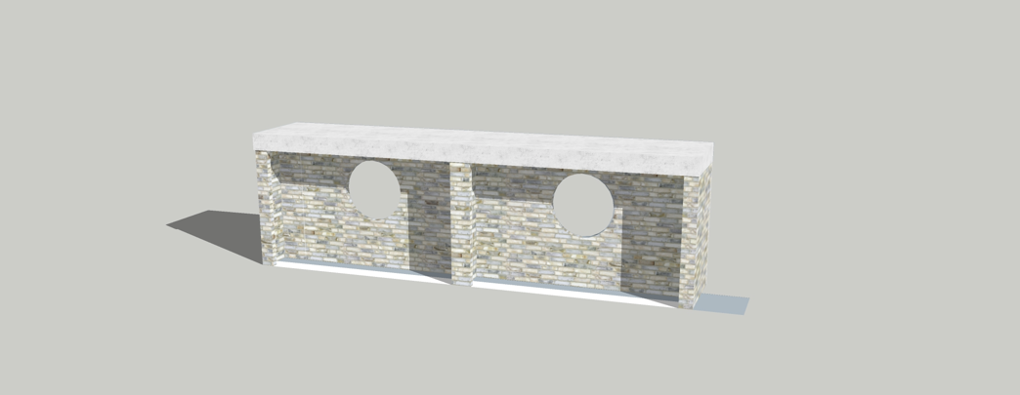
Rear view which will face the road

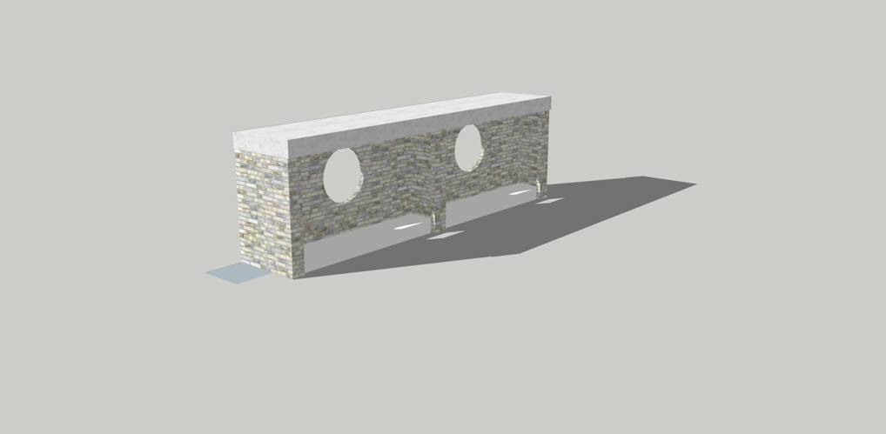
Seating will face towards the sea

Next Steps
The next stage would be to develop the proposal to a level suitable for submission of a planning application. As part of that work, detailed design drawings would be prepared and more accurate capital cost estimates would be established. In parallel, a business case would be required to assess the justification, affordability, deliverability and ongoing implications of the proposal before any decision was taken on installation.

Summary
The Donaghadee swimming shelter proposal had its origin in a Council Notice of Motion and had already been informed by engagement with local stakeholders. Given the continued popularity of open water swimming and Donaghadee’s formal designation as a bathing water site in 2025, there was a clear basis for progressing the scheme to the next stage through detailed design, planning and business case development.

RECOMMENDED that the Council agrees to submit a planning application for the proposed swimming shelter.

Proposed by Councillor Wray, seconded by Alderman McAlpine, that the recommendation be adopted.

Councillor Wray had been very impressed by the report and the proposed design and thought that it would be the envy of a lot of other coastal villages. He praised the design and the colour scheme and knew it would be a welcome addition to Donaghadee and he expressed his pleasure for the town. Alderman McAlpine referred to her colleague, Councillor Hennessey, who was also delighted with the plans and knew that the Dee Dunkers particularly would also be.

Alderman Adair gave the proposal his support but was unhappy that ones provided in the peninsula were not as good and not similar since, and that he had been calling for that for some time. He stressed that all ratepayers needed to be treated equally and he would continue to press for this to be extended on the Ards Peninsula.

AGREED TO RECOMMEND, on the proposal of Councillor Wray, seconded by Alderman McAlpine, that the recommendation be adopted.

6. notice of motion 616 donaghadee harbour and parade
(Appendices I – III)

PREVIOUSLY CIRCULATED:- Report from the Director of Environmental Services detailing that as a result of a significant report into the opportunities for development of Donaghadee Harbour in 2020 by RPS, a further Council decision was taken in April 2024 as followed, as a result of a Member’s Motion.

“That this Council recognises the significant opportunities which the redevelopment of Donaghadee Harbour could bring to the local economy in terms of leisure sailing and tourism and thus instructs officers to work with local groups to scope potential operational facilities which could enhance the offering in the Harbour and further brings back a feasibility report on the various options, including costings and possible funding streams.

Further, that this Council recognises the issues associated with high winds and coastal change and reviews the original 2020 Harbour Study conducted by RPS including the necessity for an offshore breakwater and agrees to bring back a report in time to be presented to Council in September 2024, outlining the budget required to undertake this work, any key considerations, next steps and identify which stakeholders would need to be involved.”

An update report was presented to the Council in September 2024 providing information on works completed to date which included the following concerning the first part of the Motion.

“Officers met with representatives from the Sailing Club and other relevant groups on 9 May and discussed a number of potential small-scale operational improvements to the harbour. Officers felt the meeting was productive and a number of low or no-cost improvements have been implemented.”

As Members were aware a number of reports had been returned to the Committee, most recently in March 2026, when officers recommended that the report be noted given the costs involved compared to outcomes that may be achieved. In March 2026, the Council agreed as followed.

1. That the option of an outer breakwater should not be dismissed outright. The RPS Harbour Study (2020) indicated that an offshore breakwater could moderate wave conditions within Donaghadee Harbour to a more acceptable level and potentially reduce wave impacts along the adjacent shoreline. While the Council recognised that it did not have the financial resources to deliver such infrastructure independently, officers should continue to explore potential external funding opportunities.

2. That Council writes to the Minister for Infrastructure calling on her Department to invest in improved coastal defences for Donaghadee, recognising the Department’s responsibility for flood risk management and sea defence infrastructure in Northern Ireland, particularly in relation to coastal erosion and flooding along the town’s seafront.

Key Issues
A letter was issued under point two of this decision and a response had now been received, attached at appendix 3. Previous responses were also attached for context and Members’ information.

In relation to point one that referred to the RPS Harbour Study (2020) which indicated that an offshore breakwater could moderate wave conditions within Donaghadee Harbour to a more acceptable level and potentially reduce wave impacts along the adjacent shoreline, a further report was commissioned by the Council and presented to Members in 2025 to test that possibility. Members would recall that this confirmed that in relation to the potential of a break water reducing wave impacts along the adjacent shoreline, that was not the case. That would require as pointed out in the report instead, other means of enhancing costal protection schemes, other than a breakwater.

Members were also reminded that it was the Council’s responsibility only to ensure protection of the property it owned, and that DFI was responsible for the integrity of its assets, including public highways that would benefit from such works.

Next Steps
From the work done to date, continuing to pursue a breakwater project would be very difficult to justify financially and so officers recommended initially that no further activity should be embarked upon in relation to the matter. However, further research would be undertaken in relation to sourcing possible funding in relation to point 1 of the decision taken in March 2026.

Summary
The latest response from the Department was brought to Members’ attention through the report.

RECOMMENDED that the Council notes this report.

Proposed by Councillor Edmund, seconded by Councillor Wray, that the recommendation be adopted.

Councillor Edmund thanked officers for the comprehensive report and the work undertaken and Councillor Wray had been disappointed in the response from the Minister which had not been helpful nor welcomed. He believed it was what the Council had come to expect from that Department but knew this was not the end of the matter since a solution needed to be brought to combat the coastal erosion at the harbour. He stressed the need for the Northern Ireland Assembly to get moving on the work required. Alderman Adair agreed with Councillor Wray’s comments believing that the Department for Infrastructure should be rebranded the Department for Inaction which he felt the Borough was bearing the brunt of.

AGREED TO RECOMMEND, on the proposal of Councillor Edmund, seconded by Councillor Wray, that the recommendation be adopted.

7. portavogie and portaferry 3g pitch projects

PREVIOUSLY CIRCULATED:- Report from the Director of Environmental Services detailing that in February 2024, the Council agreed to the following:

“That Council notes the closure of the training area at Portavogie Football Pitch due to health and safety concerns, recognises the negative impact this has on local provision and sports development and tasks Officers to bring forward a report on options to provide temporary training facilities in the village in the short term and repairs to the pitch in the long term. As a matter of urgency Council tasks Officers to bring forward a bimonthly progress report on the development of the Portavogie 3G Pitch, Portaferry Sports Centre and Portaferry 3G Pitch to this committee.”

The last report of this nature was reported to the Community and Wellbeing Committee in September 2025, and since then, in relation to the two 3G pitch projects, Members and primary stakeholders had only been updated by other means of communication including email and telephone calls. Whereas the pitches would continue to be reported to the Environment Committee, the update on the Portaferry Sports Centre was now a matter for the Active and Health Communities Directorate.

Formal bi-monthly reporting was temporarily paused to allow time to deal with some sensitive issues pertaining to land, access, property and confidential matters, which had now largely been resolved. The pattern of reporting using the RAG status would recommence from September 2026, and information updates on the two projects would be provided as required.

Key Issues
Portaferry Pitch Project
An application for planning approval was submitted in February 2026 following a period of design that took account of, amongst many other things, an extensive period of consultation and stakeholder and partner collaboration. An updated business case would be developed should planning permission be granted in due course to allow Members to make decisions in relation to next steps regarding the project.

Portavogie Pitch Project
Planning approval was granted on 31 March 2026 therefore all matters pertaining to planning had now been either agreed by that service and its statutory consultees, or conditions had been attached that must be discharged before development could begin.

In order for the Council to proceed to the next stage, which was the appointment of an Integrated Supply Team (IST) completion of final design packages, discharge of any planning conditions, and construction, the Council would need to consider an updated business case which included all elements required by HM Treasury’s Green Book Five Case Model. An update to costs was being formalised by the Council’s consultants and QS and a partner was currently being procured to develop the business case which would be brought to Members when completed.

Next Steps
Both project teams would continue to develop the projects in accordance with the Council’s capital project governance requirements. In the short term, the priority was to complete the business case for the Portavogie 3G project to allow that to be presented to the Council at the earliest opportunity, and to work on any necessary liaison with planning colleagues as the Portaferry project passed through the Planning application process.

Summary
Both projects continued to be developed as required by Council processes.

RECOMMENDED that the Council notes this update.

Proposed by Alderman Adair, seconded by Councillor Boyle, that the recommendation be adopted.

Alderman Adair thanked officers and looked forward to the delivery of the 3G pitch at Portavogie which in his view was long overdue. He noted that Members were frustrated by the long delays, especially since the project had been previously lapsed and ground to a halt. He asked about the business case and how it was being delivered. The Director advised work on the group would be expected to begin once quotations had been received. With a further question about land acquisition the Director confirmed it was underway and also subject to the business case, with the Chief Executive having written to the Department of Education to push for progress in relation to a legal agreement concerning the drainage solution.

Alderman Adair sought assurance that he could speak to his constituents explaining the progress but he stressed that he would accept nothing less than the project being delivered. He emphasised that there was a clear need on the Ards Peninsula and residents there paid the same rates as everyone else in the Borough and the Council should now proceed in earnest.

Councillor Boyle was in full agreement with Alderman Adair’s comments and thought that the whole journey had been extremely frustrating. He remembered the ideas being initiated and would never have guessed that he would still be speaking about the same ideas in 2026. He went on to say that Portaferry welcomed the fact that that one was now in the planning system and hoped that lessons could have been learnt from the experiences at Portavogie. In response the Director explained that lessons had been learnt and the Council was more aware of what to anticipate as the application continued through the planning system and information requested for Portavogie had been front loaded for Portaferry. Councillor Boyle thought that the Ards Peninsula had been starved of sports resources for many years and he thanked the Director and his team for the work that had been done to date and hoped the Council would be able to progress swiftly with both projects.

Councillor Wray expressed disbelief that the initiative had now taken fifteen years and there had been so many false dawns but the Council needed to be honest with the public and he believed firmly that both projects must progress. While the geography was important both resources were for all the people of the Ards Peninsula and the Borough as a whole and should be delivered as soon as possible.

Councillor Edmund gave his support and welcomed the process of the applications through the planning system. He pointed to the facility at Londonderry Park which was bouncing and used to capacity so he believed that the investment would be beneficial to the Peninsula.

In summing up Alderman Adair thanked Members for their comments and reminded the committee that the pitch in Portaferry was a multiuse facility and not just for one sport.

AGREED TO RECOMMEND, on the proposal of Alderman Adair, seconded by Councillor Boyle, that the recommendation be adopted.

8. greenways update

PREVIOUSLY CIRCULATED:- Report from the Director of Environmental Services detailing that the new Whitespots Line of the Comber Greenway was nearing completion with an expected opening at the end of May/start of June 2026. That would be a transformative 5.4-kilometre active travel route linking Newtownards and Bangor.

The Department for Infrastructure Minister Liz Kimmons visited the project in March 2026 and was given a further update of the progress to date. A group of pupils from West Winds Primary School came along on their bikes assisted by the PSNI and some Elected Members, the acting Chief Executive, Director, officers and Deputy Mayor were also in attendance.

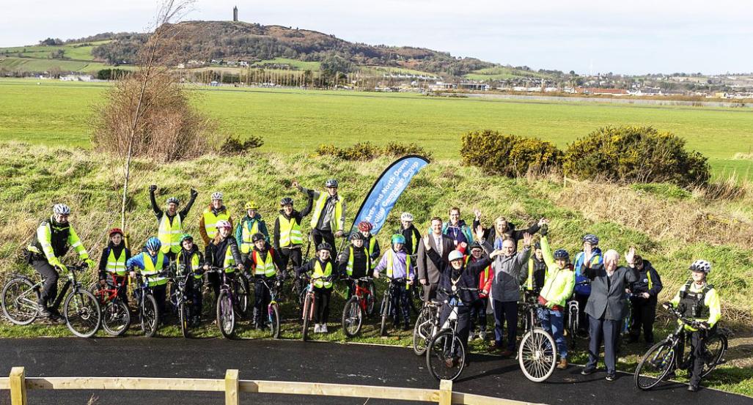

Key Issues
The Greenway contractor Charles Brand Ltd had almost completed the following sections:

- The Floodgates Park section
- The section from Bangor Road to SERC
- The section from Green Road through Breezemount
- The section through Londonderry Park

The above sections were still under the control/responsibility of the contractor until such times as the outstanding snags had been addressed and it was formally handed over to the Council.

The remaining sections were still being finished:

- The boundary at Breezemount to Drumhirk Way
- Drumhirk Way down towards Ark Farm/The Somme/Whitespots
- Ark Farm along the rear of Belvedere back down to the Bangor Road
- The Floodwall over to Ballyrickard Waste Water Treatment Works.

Next Steps
Welcome signage and wayfinding signage was currently being produced and would be installed in due course. The branding followed the design of existing sections of the Comber Greenway in Comber, Dundonald and Belfast. A map was also being produced for installation at key entry points and would be added to the website also when finalised. The planting, fencing and addition of bins and benches was also being finalised.


Welcome Signage

The Comber to Newtownards section of the Greenway that would connect the existing Comber Greenway, was granted planning approval in January 2025.

The discussions to connect the Greenway from the section at Ballyrickard Waste Water Treatment Works through Comber to connect with the existing Comber Greenway were ongoing. A planning application to deliver the section along the A21 was still required. Draft drawings were currently with DFI for its input prior to the submission of the planning application for that one missing section.

A feasibility study for the proposed Green Road to Donaghadee Greenway would be instigated later this year.

Summary
The new Whitespots Line of the Comber Greenway was nearing completion with an expected opening at the end of May/start of June 2026.

RECOMMENDED that the Council notes the progress in the delivery of the Greenway network.

Proposed by Alderman Cummings, seconded by Councillor Douglas, that the recommendation be adopted.

Alderman Cummings was pleased to read about the progress on the Greenway and thought it was becoming a very encouraging development. He referred to the name Comber Greenway and asked if the name would be reconsidered as the Greenway was extended to other parts of the Borough. The Director explained that a decision had been taken by the Council to call the facility the Comber Greenway as this was a well known brand and that it was all linked together, but the decision was also to name the new sections as lines, i.e. The Scrabo Line from Comber to Newtownards, and the Whitespots Line from Newtownards to Bangor with emphasis on the locality of them for clarity. Seconding the proposal Councillor Douglas was pleased to note the progress.

Councillor Brady echoed those comments and believed this was a very good news story. He had walked the length of it with a Council officer and noted some flooding concerns and wondered if the rivers would be dredged where required. It was reported that snags were noted and the contractor tasked to rectify them before handover. Council officers were satisfied that all that work required to date was being carried out by the contractor.

AGREED TO RECOMMEND, on the proposal of Alderman Cummings, seconded by Councillor Douglas, that the recommendation be adopted.

9. notice of motion 707 removal of planting at The commons, donaghadee
(Appendix IV)

PREVIOUSLY CIRCULATED:- Report from the Director of Environmental Services detailing that in March 2026, the Council agreed to the following Motion:

“That this Council notes with deep concern the recent destruction caused to bushes, trees and wild grass in The Commons, Donaghadee.

Further to this, Council agrees to write to the Minister of Agriculture, Environment and Rural Affairs, calling upon him to designate The Commons, Donaghadee as either an Area of Special Scientific Interest (ASSI), or another appropriate form of protected status, in order to help safeguard this important green space.”

Key Issues
The main concern that was discussed was the unapproved removal of a wide range of grasses and bushes from The Commons by a local resident, leaving the Council land in an unacceptable state. The Council had since been working alongside natural processes to restore the lands as quickly as possible. A complaint was made by the Council to the PSNI in relation to that, and depending on that outcome, a civil case may then also be considered for damages and compensation for losses that occurred. A letter was also sent to the Minister for DEARA asking that the area be designated for future protection. A response to that letter was received on 21st April 2026 and was appended to this report.

Next Steps
Members were being asked to consider the contents of the letter and decide if any further actions were appropriate at this time.

Summary
A letter in response to the Council’s request to DEARA to consider an environmental designation of The Commons had been received for Members consideration.

RECOMMENDED that the Council notes this report.

Proposed by Councillor Harbinson, seconded by Alderman Adair, that the recommendation be adopted.

Proposing Councillor Harbinson was pleased that the Council could use the Nature Conservation and Amenity Lands Act to take its own action and he was also encouraged that the Council would be engaging with the Northern Ireland Environment Agency to combat the environmental damage. As seconder Alderman Adair was in agreement and he commended Councillor Cochrane and Alderman Brooks for bringing the Notice of Motion forward and he looked forward to a further report.

At this point Alderman Adair suggested an alternative proposal and after discussion with the proposer on withdrawing his proposal, Councillor Harbinson stated that he did not wish to withdraw and instead to have his proposal debated in the normal manner.

The Chair (Councillor Kendall) asked about the future of the area in question knowing that the area would in some ways regenerate itself but wondered if the Council would take the opportunity to improve the biodiversity now that there was an opportunity to.

The Head of Parks and Cemeteries explained that the Council would bring forward the Tree and Woodland Strategy Update Report in June and one of the items was about improving that area and that would be in the report and that he had asked the Biodviersity Officer to identify opportunities in the Biodiversity Action Plan for local nature reserves which could include The Commons. The Chair thought that was encouraging and expressed keenness to see that progressed.

The Chair was aware that Members were not in agreement and the recommendation was voted on with a show of hands. Nine Members voted for the recommendation, four voted against and it was carried.

AGREED TO RECOMMEND, on the proposal of Councillor Harbinson, seconded by Alderman Adair, that the recommendation be adopted.

10. reusable nappy trial update

PREVIOUSLY CIRCULATED:- Report from the Director of Environmental Services detailing that disposable nappies comprised 4.9% of Northern Ireland’s kerbside collected waste (NI Kerbside Waste Composition, DAERA 2018). That material was not currently recyclable and was sent for pre-treatment and incineration.

Modern reusable cloth nappies provided a zero-waste alternative to disposables and could work out cheaper in the long run. However, washing cloth nappies required water and energy and some users could find them less convenient than disposables. The cost of investing in a ‘cloth nappy kit’ was a barrier to parents and carers trying reusable nappies.

The Cloth Nappy Library
Ards and North Down Borough Council officers introduced a modest incentive scheme whereby cloth nappy ‘trial kits’ would be purchased and administered from The Library Group (a cloth nappy ‘library’). The Library Group provided information and support to parents and carers wishing to use cloth nappies and slings with their children. Those kits would allow up to 30 people/year to be loaned a nappy trial kit from The Library Group and that would in turn give insight into which cloth nappy style would suit the user before making their own personal financial commitment to buying cloth nappies for use as an alternative to disposable nappies.

The Library Group offered trial packs which were supplied on a two-week basis so parents could “try before they buy” and see what was on offer in terms of styles and materials. Trial kits were mailed out to participating families and The Library Group supplied all instructions (both written and video) via email. The kit was then returned at the end of the trial period and sanitised before being loaned to the next family. The participants could watch the videos back at any time during the trial and if they had questions, they could contact The Library Group for further advice and information.

It was agreed that a budget of £1,080 would be allocated to the scheme, from within existing revenue budgets. The kits would only be available to loan to Ards and North Down residents. The administration of the kits would be the responsibility of The Library Group.

Key Issues
The scheme was promoted via the following methods:
- Five heavily shared Facebook posts spread out over the financial year
- Bin-ovation Push Notification
- Bin-ovation News/Info
- ANDBC website
- Recycling and Waste Minimisation educational presentations
- Recycling information stalls
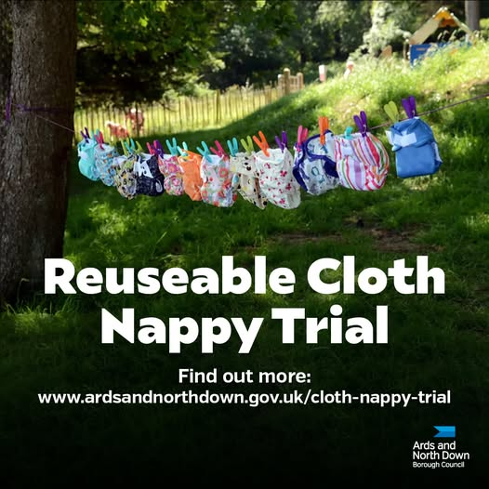
Figure 1.0 Reusable cloth nappy trial social media post

A total of 42 expressions of interest were completed via the online application process, the breakdown was as followed:

- 17 applicants engaged with the scheme
- 25 applicants did not respond to reach outs
- 14 applicants completed trials

At the end of the financial year officers were informed that due to increased charges with Companies House, increases in insurance, postal, electricity and heating costs impacting running costs, The Library Group Ltd did not consider it viable to offer a renewal quote.

Summary
Officers had engaged with the Northern Ireland Resource Network and would continue to research suitable alternative suppliers or methods of supporting householders to test reusable cloth nappies.

Next Steps
The Council was asked to note the content of this update and that alternative suppliers were being investigated.

RECOMMENDED that the Council notes this report.

Proposed by Councillor Harbinson, seconded by Alderman McAlpine that the recommendation be adopted.

Councillor Harbinson thought this was a great initiative and hoped that an alternative supplier could be identified. Alderman McAlpine noted that disposable nappies made up 5% of the household waste collected in the Borough and thought that anyone making the effort to use cloth nappies should be supported.

AGREED TO RECOMMEND, on the proposal of Councillor Harbinson, seconded by Alderman McAlpine, that the recommendation be adopted.

11. notices of motion

11.1 Notice of Motion submitted by Alderman Graham and Councillor Gimour

Council notes the extension to the platform at Helen’s Bay Station to enhance the safety of high numbers of visitors at peak times. To cope with such influxes of visitors, Council writes to Translink and requests that it provides toilet facilities at the railway station.

Proposed by Alderman Graham, seconded by Alderman Adair, that the Notice of Motion be adopted.

Alderman Graham began by stating that his Motion was a simple request and it was asking for toilet facilities at the Helen’s Bay station to help accommodate the needs of the large number of people who came to the seaside there in warm, sunny weather. It was unfortunate that some people were using private property to urinate in and that was also occurring in the underpass close to the platform which made for a very unpleasant experience for visitors to the station and surrounding area. Alderman Graham felt that Translink benefitted from additional revenue at those peak times and therefore felt that it would be a positive move if that one simple facility could be provided and supplied to mitigate a nuisance for the residents of Helen’s Bay.

Seconding the Motion on behalf of Councillor Gilmour, Alderman Adair stated that the recent extension had been a welcome step to improve public safety and it underlined how popular the area had become. He recognised that the popularity had brought challenges. People from across the area visited so the Council must work towards finding a solution in his view. Often that influx of people was leading to antisocial behaviour so toilet facilities would help to address that in part.

The Chair explained that she too had been contacted by some residents who had additional health or accessibility needs and needed frequent toilet stops. Councillor Blaney asked if there had been a consultation with residents since the Council would not want to be in a position of lobbying Translink only to find that residents did not want toilet facilities at the station.

Councillor Edmund believed that the majority of people would rather have public toilets than public urination which was unacceptable. He said he would happily support the Motion and in doing so was supporting the residents of Helen’s Bay. He felt that it made sense to get the ball rolling in advance of the summer months.

In summing up Alderman Graham thought that a public consultation would fall to Translink and he agreed with his Council colleague that most people would likely prefer portaloos than urination in the under tunnel of the station and therefore it was difficult to imagine too much objection. He felt that the request was reasonable.

AGREED TO RECOMMEND, on the proposal of Alderman Graham, seconded by Alderman Adair, that the Notice of Motion be adopted.

11.2 Notice of Motion submitted by Councillor Cochrane and Councillor Thompson

That this Council notes the need for adequate coastal defences and the ongoing issues affecting Donaghdee Harbour.

Council further acknowledges the continued work and contribution of Donaghadee Sailing Club and Donaghdee Community Development Association in seeking solutions to these challenges. It further notes that significant engagement has already taken place with some public representatives and government bodies to this regard.

Council therefore agrees to instruct officers to engage with counterparts in Dun Laoghaire-Rathdown County Council to explore the potential for shared Island Funding as a means of supporting the delivery of necessary coastal defence infrastructure.

Proposed by Councillor Cochrane, seconded by Councillor Thompson, that the recommendation be adopted.

Councillor Cochrane was pleased to bring his Motion in respect of one of the most recognised coastal towns in Northern Ireland which was facing very real and growing pressures on its harbour infrastructure. Predictably the response from the Department had fallen short and Donaghadee had been let down. He called for the Department to step up as a full partner to the Council to work constructively on creating a solution. He particularly recognised the work of Peter Martin MLA and shared the sense of urgency which was being felt in the local community hoping that the Council could explore the potential for shared island funding. Donaghadee and Dun Laoghaire harbours were both built with real maritime need and historically were key links between Great Britain and Ireland.

Therefore, in his view, there was a strong foundation for co-operation between Donaghadee and Dun Laoghaire and he encouraged officers to follow that up with a report. He referred to the Shared Island Fund which was designed for cross border cooperation. He described his Motion as a call for action and it was not about rhetoric. Donaghadee Harbour could not be allowed to deteriorate further because the Council had failed to engage.

Seconding the Motion Councillor Thompson said he had brought it to explore the potential for funding since despite much engagement the Council had not been able to engage sufficiently with the Department and this deterioration was beginning to affect homes and businesses close to the Shore Road. The Council had been assured by the Department that the wall was safe and there was no evidence to suggest strengthening was needed but he thought this was a trust issue and the people of Donaghadee did not believe what the Department for Infrastructure was saying. He said there were clear signs of deterioration – including at the children’s play areas and an escalating threat to the infrastructure. It was as a result of those ongoing concerns that the sailing club and other community groups did not want to see any more delays and they were supporting the exploration of shared island funding which it was hoped would lead to a successful bid. He added that this was a fantastic proposal to bring forward important development and it was important to use the relationships that the Council had built up.

Alderman McAlpine was very pleased to see that there was support across parties along with a lot of goodwill to address the issue. She referred to her Council colleague, Councillor Hennessey, who had been working to make links. People living on the Peninsula were very frustrated about forty-eight areas where work needed to be done to repair the roads close to the coast. She thought that something catastrophic could occur if something was not done.

Councillor Boyle welcomed the Motion and it was good to see a willingness to work, on something he fully supported, towards obtaining shared island funding, from the Republic of Ireland, for what was clearly a major and ongoing problem in Donaghadee.

It was however unfortunate to him that, as a Council, there was a tendency to either avoid or withdraw from representation on outside bodies and that, in his mind, put the Council at a distinct disadvantage. He thought that the Council needed to try to inject a level of vision and broaden its thinking similar to other councils. Meetings with Southern counterparts, Minister’s, TD’s and Councillors should take place and continue, particularly on the shared island funding. He said, unfortunately, at this stage, due to not being members, the Council would not be at the table or represented like the other 10 Councils at this forum as currently it had withdrawn from the body dealing with such issues.

He said he would clarify how the Shared Island Fund actually worked in practice, particularly in relation to coastal defence proposals in areas like Donaghadee. There was a perception that if funding was available through the Shared Island Fund initiative, then projects could simply move forward on that basis. However, the reality was a bit more complex, and he thought it was important to understand that.

First of all, the Shared Island Fund was not a delivery body, it did not directly build infrastructure, and it did not operate independently within Northern Ireland. It was a funding mechanism used by the Irish Government to support projects that were jointly developed and delivered on a North–South basis.

That meant that any project in Northern Ireland still depended on the relevant government department, in this case of Coastal Defence and that responsibility sat with the Department for Infrastructure. So, for any scheme, in Donaghadee or elsewhere, the Department would need to; agree the project was a priority,
take responsibility for design and delivery, manage planning and environmental approvals and ultimately own and maintain the infrastructure long-term. Even where external funding was available, those responsibilities did not change.

Shared Island funding could support a project, but it could not create a priority where one did not already exist. If a scheme was not currently prioritised by the Department for Infrastructure then the presence of Shared Island funding did not, in itself, move that project up the list. The Department would still need to commit staff, expertise, and resources. It would still need to take on long-term liability and it would still need to fit the project within its wider programme of work.

There was also the cross-border requirement, he added, and for a project to qualify, it must demonstrate clear North-South collaboration working with partners in Ireland, such as the Office of Public Works or relevant local authorities. That usually meant that projects were framed not as standalone local repairs, but as part of a wider programme looking at shared challenges like coastal erosion, flood risk, and climate adaptation across multiple locations. Even then, the same principle applied;
without active participation and commitment from the Department for Infrastructure, the project would not proceed beyond the early stages.

The Shared Island Fund was a supporting mechanism, it did not replace local decision-making, and it did not remove the need for Departmental prioritisation, capacity, or responsibility. He added that if the Council was serious about progressing any coastal defence scheme in Donaghadee, the starting point remained the same; engagement with, and prioritisation by, the Department for Infrastructure. Without that, the likelihood of a project moving forward, regardless of potential funding streams was very limited.

Councillor Edmund stated that no single Department in Northern Ireland seemed to be responsible for coastal erosion and that saddened him in the hope to have Donaghadee protected. However he fully supported the Motion and wished it every success.

Alderman Adair stated that for once he and Councillor Boyle were in agreement, but could not agree with his comments on the Council’s lack of involvement with shared island funding. He said that this Council did work in a cross border capacity and he was happy to do that as long as Northern Ireland’s constitutional position was respected. He said that the Council had harnessed agreement for funding for Ballyhalbert, it had met representatives and had worked to get Shared Island Funding in that area so he thought it was nonsense to say that the Council was not engaged. Much funding had been brought to the Borough and the Council was happy to work with others and that was what it was about.

Councillor Cochrane thanked Members for the support expressed and hoped that the Department for Infrastructure would change its tune. He was asking for extended collaboration to try to come to a solution.

AGREED TO RECOMMEND, on the proposal of Councillor Cochrane, seconded by Councillor Thompson, that the Notice of Motion be adopted.

12. Any other notified business

There were no items of Any Other Notified Business.

EXCLUSION OF PUBLIC/PRESS

AGREED TO RECOMMEND on the proposal of Councillor Edmund, seconded by Councillor Blaney, that the recommendation be adopted.

13. CONTRACT EXTENSION FOR GROUNDS MAINTENANCE SUPPORT SERVICES

***IN CONFIDENCE***

Background.
PREVIOUSLY CIRCULATED:- Report from the Director of Environmental Services detailing that the contract for the Provision of Grounds Maintenance Support Services was awarded on 1 July 2024 for an initial period of 1 year, with an option to extend for a further 3 x one-year periods.

Key Issues
All companies had been contacted to confirm their agreement to extend their contract for a second time.

All companies agreed, some with a percentage rise in their rates.

Next Steps
Following a satisfactory service review, officers now recommended to extend the contract for all Lots as outlined above, for a further 12-month period (1 July 2026 – 30 June 2027) as detailed in the original tender documents.

Summary
The Council was asked to approve the extension.

RECOMMENDED that the Council approves the extensions as proposed.

Proposed by Alderman Adair, seconded by Councillor Harbinson that the recommendation be adopted.

RESOLVED, on the proposal of Alderman Adair, seconded by Councillor Harbinson, that the recommendation be adopted.

RE-ADMITTANCE OF PUBLIC/PRESS

AGREED, on the proposal of Councillor Edmund, seconded by Alderman Cummings, that the public/press be re-admitted to the meeting.

TERMINATION OF MEETING

The meeting terminated at 8.49 pm.

