ARDS and North Down Borough Council

A hybrid meeting of the Environment Committee was held at the Council Chamber, Church Street, Newtownards, and via Zoom, on Wednesday 8 April 2026 at 7.00 pm.

Present:

***PLEASE NOTE MATTER OF ACCURACY RAISED AT APRIL COUNCIL MEETING 2026**

In the Chair: Councillor Kendall

Aldermen: Adair McAlpine
Cummings (Zoom)

Councillors: Boyle Edmund
Blaney Harbinson
Brady Newman
Cathcart (Zoom) Wray
Douglas

In Attendance: Director of Environmental Services (G Bannister), Head of Parks
and Cemeteries (S Daye), Head of Waste and Cleansing (K
Patterson), Head of Estates (P Caldwell) and Democratic Services Officer (S McCrea).

1. APOLOGIES

The Chair sought apologies and received an apology for non-attendance from Councillor Ashe.

NOTED.

2. Declarations of Interest

The Chairman sought Declarations of Interest and none were noted.

NOTED.

3. proposal for partnership with the national trust cockle island tern conservation project

PREVIOUSLY CIRCULATED:- Report from the Director of Environmental Services, outlining a proposed partnership between ANDBC Harbours and the National Trust to safeguard the Tern colony at Groomsport through the deployment of a dedicated nesting raft.

Cockle Island, located within Groomsport Harbour, was a critical summer breeding site for several hundred pairs of Arctic Terns and Common Terns. Managed by the National Trust, this colony was of significant local and ecological importance.

However, the colony faced two major threats at the time of writing:
- Sea-Level Rise and Tidal Surges: High spring tides frequently washed over the low-lying island, destroying nests and eggs.
- Ecological Fragility: Significant losses due to Avian Influenza in 2023 had made the remaining population more vulnerable, increasing the risk of the colony abandoning the site for the Copeland Islands.

To mitigate these risks and provide a "high-ground" nesting alternative, the National Trust had proposed a Tern Raft Project.

Key Issues
To ensure the success of this conservation initiative, it was proposed that Council supported the National Trust by providing essential infrastructure and logistical assistance.

The proposed commitments were as follows:
- Mooring Provision: Provide a suitable mooring for a Tern raft (up to 6 metres, provided by National Trust) adjacent to Cockle Island. The proposed location will utilise an existing mud anchor. This service would be provided free of charge.
- Secure Storage: Allocate space within the Groomsport Harbour locked storage area for the raft during the off-season, free of charge.
- Operational Support: Assist with the seasonal launch and berthing of the raft at the start of the breeding season, and its subsequent recovery to storage at the season's end.
- Maintenance: Conduct a safety check of the mooring twice annually to ensure the raft remains secure.

Next Steps
Harbours and National Trust staff would review this arrangement on an annual basis to ensure operational compatibility and project efficacy.

Summary
The report proposed a partnership with the National Trust to protect the vulnerable Tern colony at Cockle Island by supporting the installation and seasonal management of a nesting raft. The Council would provide a mooring, off-season storage, operational assistance, and safety checks, with the arrangement reviewed annually to ensure effectiveness and reinforce the Council’s commitment to local biodiversity.

RECOMMENDED that Council Approves this collaborative approach, reinforcing ANDBC’s commitment to local biodiversity and the protection of a signature species within the Borough’s coastal waters.

Proposed by Councillor Boyle, seconded by Councillor Cathcart, that the recommendation be adopted.

Councillor Boyle noted that the proposal offered an opportunity to demonstrate the Council’s commitment to biodiversity and to develop future partnership work with the National Trust.

Councillor Cathcart provided some background information, explaining that Peter Martin MLA had been engaging for some time with local stakeholders in Groomsport, including DAERA, the Cockle Island Boat Club and conservationist Andrew McGeehean. He highlighted concerns raised regarding the threat to arctic terns, noting that while the source of the threat was unclear, it was important that efforts were made to protect the species. He explained that the proposal sought to support tern nesting and had originally been suggested by Mr McGeehean several years earlier in relation to the low-lying section of the island. He queried whether, if the birds were under threat in that area, they might also be vulnerable on the raft itself.

The Head of Estates explained that the Harbour Master had discussed the matter with the National Trust, and the understanding at the time of writing was that the threat stemmed from rising tides and high sea levels washing out nesting areas.

Councillor Cathcart was concerned that it could also be some form of predation but was hopeful that the proposed measures would be effective, while acknowledging that further review might be required if seagulls were found to be a threat. He noted that the most recent count recorded approximately 250 terns and emphasised the need to monitor the situation.

Councillor Kendall asked whether a progress report would be brought back at a later stage to assess the impact of the nesting rafts. The Head of Estates confirmed that a report could be provided at the end of the season.

[Councillor Wray left the meeting at 19:06.]

Councillor Harbinson noted that Councillor Hennessy and former Councillor Irwin had also been engaged on the issue, described the initiative as worthwhile, and stated that he looked forward to receiving the report.

AGREED TO RECOMMEND, on the proposal of Councillor Boyle, seconded by Councillor Cathcart, that the recommendation be adopted.

4. ITEM WITHDRAWN

5. CAR PARK CAPITAL WORKS 2026-27

PREVIOUSLY CIRCULATED:- Report from the Director of Environmental Services which explained that the Council’s agreed Maintenance Strategy incorporated a “needs based” approach for its refurbishment programme. Car Parks were scored every year and the lowest scoring of them were earmarked for resurfacing, subject to budgetary constraints.

Background
The Council’s agreed Maintenance Strategy incorporated a “needs based” approach for its refurbishment programme. Car Parks were scored every year and the lowest scoring of them were earmarked for resurfacing, subject to budgetary constraints.

Key Issues
As resurfacing works were carried out from our capital budget, a set amount was required to be identified each year to facilitate accurate capital budget forecasting.

An annual figure of £50k was included in the capital budget, however as noted in previous reports and our Car Park Strategy, this amount was inadequate in terms of achieving a vision of a modern, attractive and fully fit for purpose public car park estate.

Our Car Park Strategy, agreed in 2021, set out a vision for a high standard public asset that realised its full potential in helping to promote a sustainable Borough – driving forward economic, environmental and social well-being. The implementation of a number of key improvements to our car parks was essential, including:

• Resurfacing
• New line marking, utilising the upper end of the standard widths for parking
spaces to help accommodate the larger, SUV type vehicles that have
increased in popularity in recent years.
• New fully DDA compliant spacing with drop-kerbs for wheelchair use.
• LED lighting that provides a clearer, brighter light but uses less power and
incorporates automatic dimming features.

In addition to the above, several further enhancements had been identified as being important in terms of realising our vision for high quality modern car parks, including:

• Enhanced signage
• Enhanced environmental features, planting etc.
• Bicycle and motorcycle parking facilities
• EV charging infrastructure

The implementation of such an improvement programme would not be possible within the current budget availability.

A new tariff structure had been agreed, with projected additional revenue of £0.5M, based on current usage patterns. This would provide much needed additional funds to implement the Car Park Strategy, paid for by car park users.

Implementation of these tariffs was dependent on the Department for Infrastructure resolving the legislative impediment allowing Council to legislate the transferred car parks. Although Officers believed the Department may make steps to revoke the legislation in Autumn 2026, a formal timeline had not been provided, and therefore plans could not be made for this projected revenue.

Condition Scores
The table at Appendix 1 provided a list of all car parks. They had been surveyed and ranked in order of their condition. Given that their users could reasonably have expectations of a higher standard; charged car parks had had a weighting added to lower their scores so that they gained priority over others. Similarly, car parks within town/village centres also had a (slightly lesser) weighting added so that they could be prioritised over the less frequently used, more rural car parks. Works identified, and costings provided generally only related to more ‘essential’ maintenance/enhancement works (resurfacing) and did not include the further desirable enhancements set out above.

Cognisance of wider strategies and plans for these assets was essential to reducing the likelihood of spending significant sums of money on assets that may be disposed of or replaced in the foreseeable future. Therefore, discussions with relevant officers had taken place to ensure that proposed works reflect any known plans for the assets concerned.

Any car parks with known imminent works to be carried out had been exempted from the scoring.

Next Steps
Within the current limits of our agreed 2026-27 capital budget for car park works, it was planned that the following works would be undertaken in accordance with the prioritisation process outlined in this report:

- Upgrade of Old Cross East, Newtownards
- Upper Court St, Newtownards

These two projects had an estimated total of £38,920. Whilst the remaining budget of £11,080 was not sufficient to complete any further projects, officers would keep budgets under review and if sufficient surplus budget became available (from income or underspends) officers will complete a third project at:

- Newtownards Road/Church St, Bangor.

RECOMMENDED that Council Agrees the car park capital works for 2026-27 as outlined in this report.

[Councillor Wray returned to the meeting at 19:08.]

Alderman Adair proposed an amendment, seconded by Councillor Edmund, that Council agree the recommendation but further task officers to source funding opportunities to further upgrade car parks across the Borough.

Alderman Adair thanked officers for the detailed report and noted that one of the lowest-scoring car parks was Shore Road in Kircubbin which was in very poor condition. He acknowledged that the Council did not have the resources to upgrade all car parks to the standard desired and that the 2026/27 budget would only allow for two schemes. However, undertaking Shore Road alone would exhaust the allocation. He suggested that officers explore external funding opportunities, referring to previous investment secured through the Mourne Coastal Route initiative, and noted that similar opportunities on the lough side might allow for enhancements where full repairs were not feasible. He emphasised that while the report highlighted the significant need for investment in car parks, the budget was insufficient and external support should be sought.

Councillor Edmund seconded the proposal and remarked that Members were well aware of the circumstances under which the Council had inherited the car parks, describing them as “second-hand car parks gifted to us,” without funding and stressing the importance of seeking funding.

Councillor Cathcart recalled that DFI had carried out very little maintenance prior to the transfer of responsibility. He thanked officers for the work completed at Holburn Avenue car park the previous year, noting that it had been an excellent job and that the space would be used for events during the summer. He raised concerns regarding the Newtownards Road/Church Street car park, observing that although £11,000 was included in the budget, this was not sufficient to complete the necessary works. He suggested that part of the site was owned by a nearby chemist, which created complications as it would be unusual for the Council to resurface only its portion while the privately owned section remained untreated. He also noted that, as some of the parking spaces were owned by the chemist, this could create a grey area for enforcement which would also be problematic as the line markings had deteriorated. He asked whether the matter could be addressed urgently, as the car park would otherwise be unenforceable.

The Head of Estates advised that they were not aware of the land ownership issue at Church Street and confirmed that relining was funded from a separate budget covering all Council-owned car parks. He undertook to check progress on the relining programme and stated that, if funds remained available, they would be content to arrange for the car park to be relined.

AGREED TO RECOMMEND, on the proposal of Alderman Adair, seconded by Councillor Edmund, that the recommendation be adopted and further task officers to source funding opportunities to further upgrade car parks across the Borough.

6. NOTICE OF MOTION 632 HRC PEDESTRiaN ACCESS

PREVIOUSLY CIRCULATED:- Report from the Director of Environmental Services which explained that, from July 2025 to September 2025 the Council led a pedestrian access trial at two of the Council’s smaller household recycling centres, Holywood HRC and Donaghadee HRC. The pilot involved setting aside and publicising specific periods for pedestrian-only access. Evaluation of the trial found that these periods were not well used.

A report summarising the results of the pedestrian access trial were presented to Environment Committee in December 2025. The report recommended that Council should not continue with dedicated pedestrian access periods and committed that officers would explore alternative good practice which might allow safe pedestrian access to HRCs.

Key Issues
A four-part review had been undertaken, including reviewing:

- Published good practice relating to pedestrian access in HRC operations.
- Health and safety regulations and guidance relating to HRC operations.
- Good operational practice at HRCs in other Northern Ireland councils.
- Site-by-site review of potential pedestrian access at AND’s HRCs.

- Published good practice
There was limited published guidance on pedestrian access at HRCs. Extracts from two key guidance documents were included below.

WRAP's HWRC Guide
https://eur01.safelinks.protection.outlook.com/?url=https%3A%2F%2Fwww.wrap.ngo%2Fresources%2Fguide%2Fhousehold-waste-recycling-centre-hwrc-guide&data=05%7C02%7Cjenna.frazer%40ardsandnorthdown.gov.uk%7C495280d84bb6427d21e408de5e9d919a%7C39416dee5c8e4f5cb59d05c4bd0dd472%7C0%7C0%7C639052228005576232%7CUnknown%7CTWFpbGZsb3d8eyJFbXB0eU1hcGkiOnRydWUsIlYiOiIwLjAuMDAwMCIsIlAiOiJXaW4zMiIsIkFOIjoiTWFpbCIsIldUIjoyfQ%3D%3D%7C0%7C%7C%7C&sdata=fWlKiBauhGpYYEuseFdUme6%2FHBZ5gljH3JlMOd9c6jk%3D&reserved=0

Section 6.2, Pedestrian and cycle access
Pedestrian and cycle access at HWRCs is typically restricted or carefully managed due to health and safety concerns. HWRCs historically have primarily been designed for vehicle access, with busy traffic flows and large waste-carrying vehicles on site, which can pose risks to pedestrians and cyclists. Where pedestrian and cycle access are allowed, strict guidelines are usually in place to ensure safety. These may include designated pedestrian and cycle lanes, restricted access to certain areas, or supervised entry. Some HWRCs require pedestrians and cyclists to book an appointment or wear high-visibility clothing. Retrospectively providing dedicated access to pedestrians and cyclists can be challenging but should form part of any new design to facilitate improved access for a broad range of users.

WISH Safe traffic management on waste and recycling sites
https://www.wishforum.org.uk/wp-content/uploads/2025/08/WISH-WASTE-09-Safe-traffic-management-on-waste-and-recycling-sites-V2.pdf

3.2.2 Segregated/separated walkway design
All vehicles (including mobile plant) and pedestrians should be segregated/separated from each other, so far as was reasonably practicable following the general guidance hierarchy below:

- Provide walkways which are separated from roads/vehicle routes or trafficked areas
- Provide physical barriers to segregate pedestrians from vehicles, in the preference order of:
  - Solid and permanently installed concrete or similar construction
  - Double Armco or similar ‘vehicle proof’ designs
  - Single Armco or similar
  - Permanent railings/fencing
  - Removable/moveable barriers and similar
  - Raised kerbs
- Or a combination of the above. For example, a raised kerb with a pedestrian railing/fence mounted on it
- Where physical barriers cannot practicably be installed, the use of painted walkways, avoiding any potential vehicle blind spots, may be considered (along with the use of hi-vis PPE). As noted above and in the case study on page 14 of this document these can be unreliable as an effective control as without strict monitoring they can easily be bypassed
- Control measures need to be implemented that provide sufficient protection for pedestrians considering the volume and type of vehicles operating at the premises and the activity being undertaken. For example, a raised kerb may be adequate at the side of a straight access road but may not be acceptable where vehicles reverse
- If pedestrians and vehicles must share the same route, such as an access road, it should be wide enough to allow vehicles to pass pedestrians safely. At the least, suitable warning signs and road markings should be displayed and where practicable physical protection provided
- Provide barriers at buildings’ pedestrian exits to prevent pedestrians walking unexpectedly onto roads/vehicle routes
- Provide adequate lighting to increase visibility of pedestrians during the hours of darkness. Consider increasing/improving lighting where this would assist in improving visibility and reducing risk dependent on factors such as the type of activity taking place in the area
- Vehicle speed retarders (speed bumps/humps) may be required to protect the areas where vehicles and pedestrians interact, such as when approaching pedestrian crossing points or at the entry to higher-risk traffic areas
- Where there are high volumes of pedestrians, consider installing subways, bridges and traffic lights, or a combination of these
- Ensure pedestrians are a safe distance from, and as practicable excluded from, areas where vehicle loading/unloading, tipping, sheeting and reversing take place

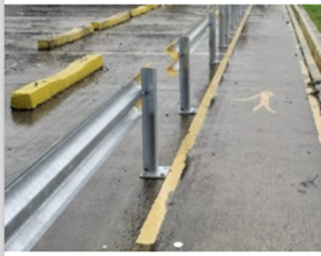
Figure 1 Example of physical barrier and a separated walkway

- Health and Safety Regulations and Guidance
In 2016, the Health and Safety Executive Northern Ireland (HSENI) advised the Council to ensure the safety of members of the public by providing suitable vehicle and pedestrian segregation, particularly at the entrance to and the exit from its sites.
It was the responsibility of the Council to determine a safe method of implementing this. The Council’s HRCs, however, were designed for vehicular access and the disposal of larger items not suitable for disposal through kerbside or bring bank services. There was consequently no separate, dedicated pedestrian access at the Council’s HRCs. The Council, in undertaking its statutory duty to take all reasonable steps to protect the health, safety and welfare of employees and other users, considered practical options before suspending pedestrian access at its HRCs.

Communication with HSE (NI) in February 2026 affirmed that HSE’s position remained unchanged. They advised that it remained the responsibility of the Council to decide what measures were to be put in place based on the findings of risk assessments for specific sites and to ensure that the requirements of the Workplace (Health, Safety and Welfare) Regulations (NI) 1993 – No. 37 and in particular (Reg 17) were being met and effectively managed on site.

The HSE (NI) officer noted that there would always be an element of pedestrian movement when drivers exit their vehicles, and this must be safely managed. The officer commented that they had been made aware of occasional accidents involving pedestrians and vehicles at HRCs, and that it was difficult to fully eliminate the risk. A requirement for ‘suitable segregation’ of traffic routes ‘without causing danger to the health and safety’ applies to all persons entering a site.

- Good operational practice at other Northern Ireland councils
Belfast City Council had four Household Recycling Centres, and the Council was introducing pedestrian access. This included a dedicated walkway and access gate and full segregation of pedestrians from vehicular traffic. Officers reported that, where pedestrian access was provided, the sites received 2 or 3 pedestrian visitors per week, and that the waste was primarily black bags from vans bypassing the Council’s booking system.

ANDBC officers visited Alexandra Park HRC on Tuesday 10 March 2026 to gather information on how pedestrian access is implemented safely on site. The images below showed a separate entrance for pedestrians, metal block barriers on pedestrians' immediate access and egress point, clear markings on the ground which included two pedestrian crossings and high visibility bollards throughout the site to separate the pedestrians from vehicle movement.

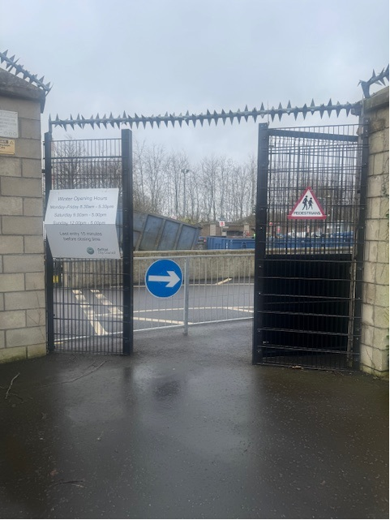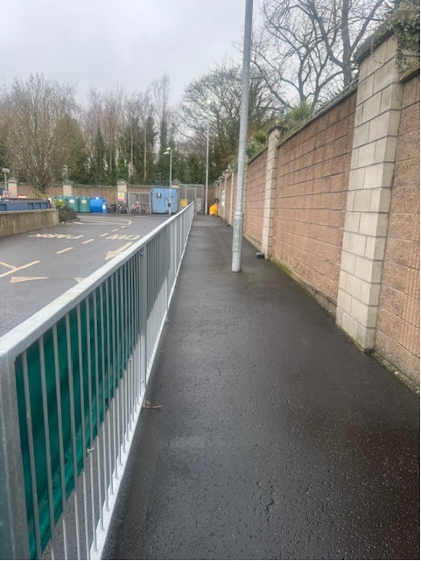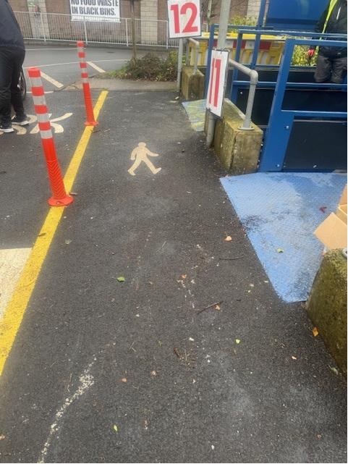
Figure 2 Pedestrian access measures at Belfast City Council’s Alexandra Park Avenue HRC

- Site-by-site review of AND’s HRCs

Balloo
At Balloo Household Recycling Centre there was, at the time of writing no pedestrian access. There was one entrance gate for vehicles and one exit gate for vehicles. Site rules included a one-way system and a restricted speed limit of 5mph. This site was located in a busy industrial estate and had pedestrian footpaths leading towards the site. This site was not located close to a residential area.

*Pedestrian access at Balloo Household Recycling Centre was for building access only.

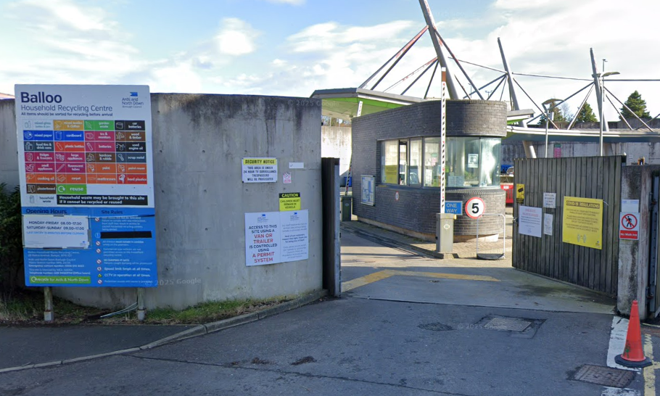
Figure 3 Balloo HRC entrance and signage

Newtownards
At Newtownards Household Recycling Centre, there was, at the time of writing, no pedestrian access. There was one entrance gate for vehicles and one exit gate for vehicles. Site rules include a one-way system and a restricted speed limit of 10mph. This site was located in a busy industrial estate beside North Road Depot. It did have a pedestrian footpath leading towards the site, but this was normally blocked by vehicles parking on the footpath. The closest resident to the site was at the bottom of North Road some distance away.

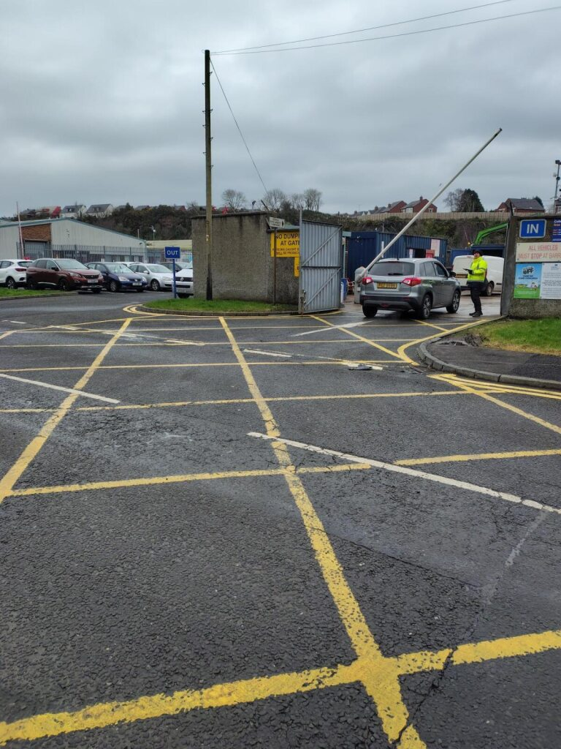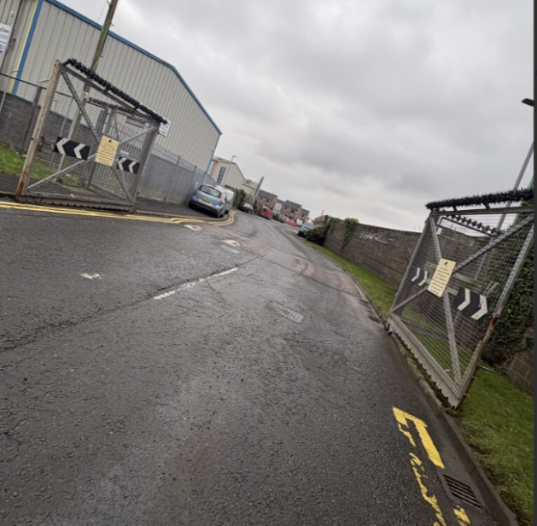
Figure 4 Newtownards HRC entrance and signage

Ballygowan
At Ballygowan Household Recycling Centre there was, at the time of writing, no pedestrian access. There was one entrance gate for vehicles and one exit gate for vehicles. Site rules included a one-way system and a restricted speed limit of 10mph. This site was located on a national speed limit road and there are no pedestrian footpaths leading to the site entrance. There were no residential properties close to this site.

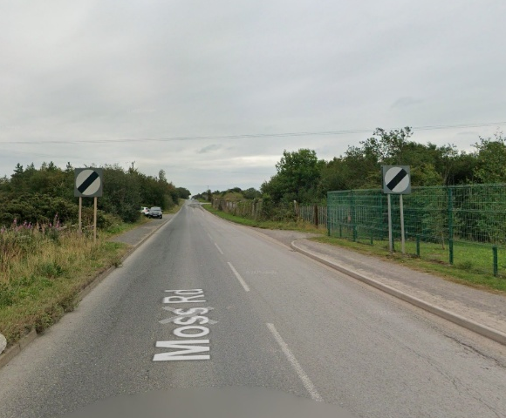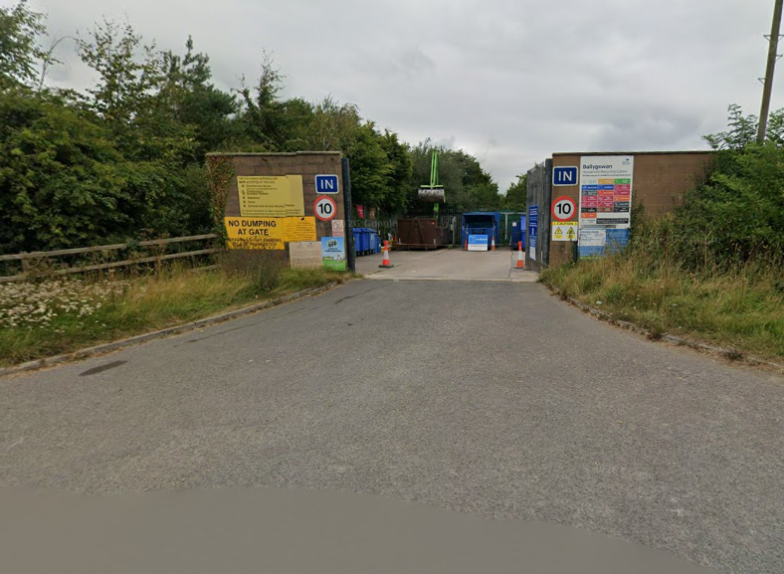
Figure 5 Ballygowan HRC entrance and signage

Comber
At Comber Household Recycling Centre there was, at the time of writing, pedestrian access. There was one entrance gate for vehicles and one exit gate for vehicles. Site rules included a one-way system and a restricted speed limit of 10mph. There were no footpaths leading to the site entrance. This site had a few new residential properties adjacent to the site.

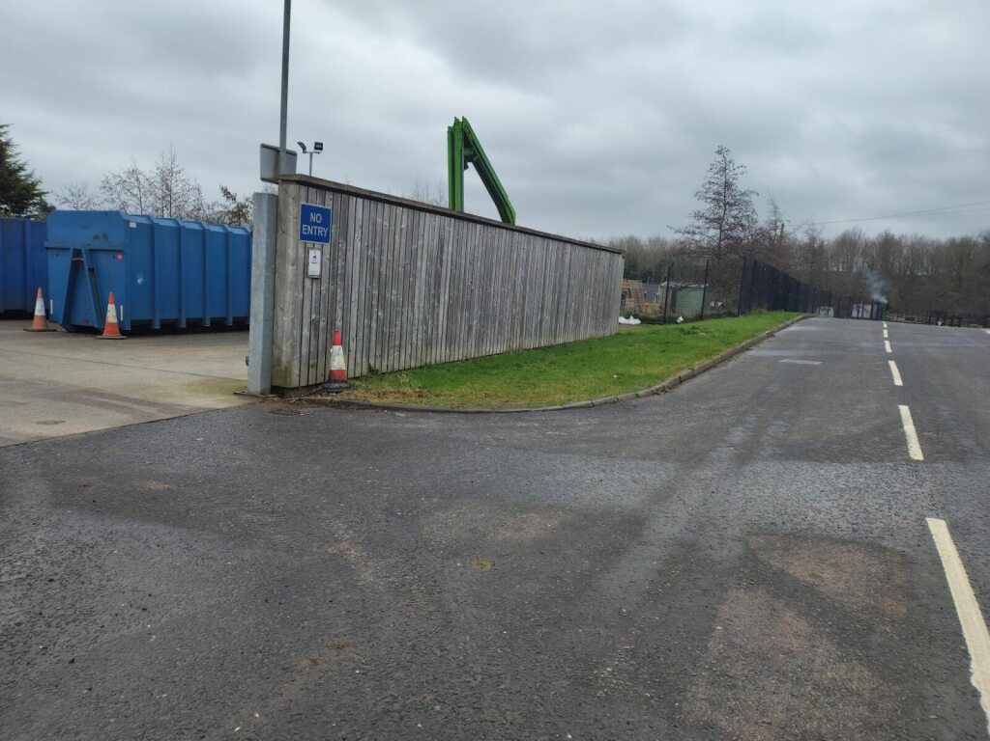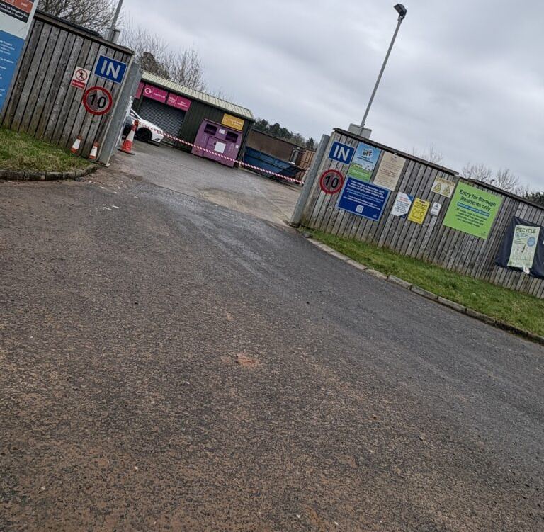
Figure 6 Comber HRC entrance and signage

Kircubbin
At Kircubbin Household Recycling Centre there was, at the time of writing, no pedestrian access. There was only one gate for vehicles to entrance and exit. Site rules included a restricted speed limit of 10mph. There were no footpaths leading to the site entrance and this is a single manned site. This site was located in a residential area.

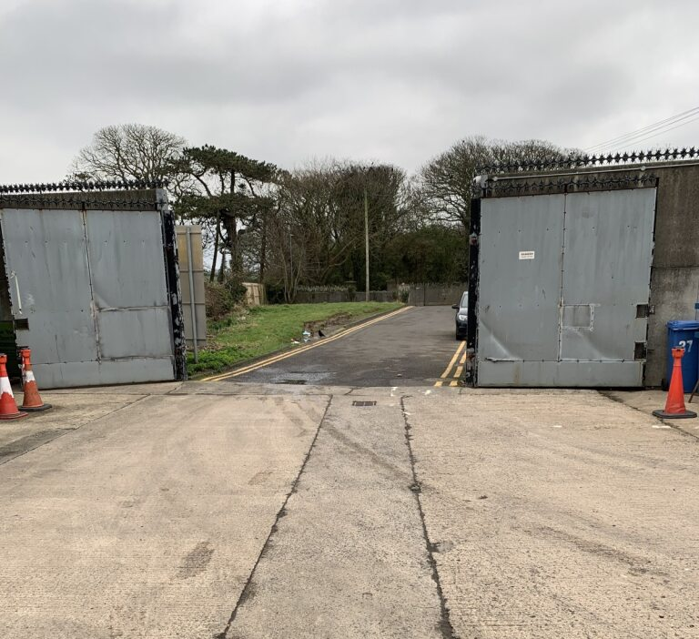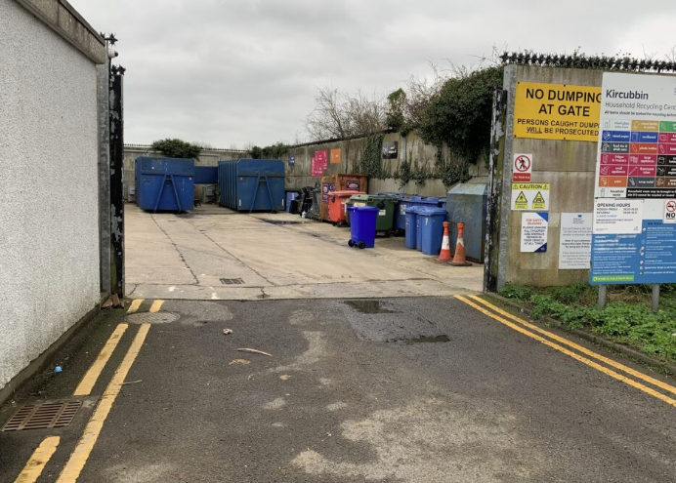
Figure 7 Kircubbin HRC entrance and signage

Donaghadee
At Donaghadee Household Recycling Centre there was, at the time of writing, no pedestrian access. There was one entrance gate for vehicles and one exit gate for vehicles. Site rules included a one-way system and a restricted speed limit of 10mph. There were footpaths leading to the site entrance. This site was located in a residential area.
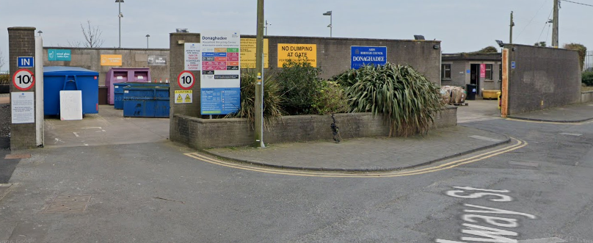
Figure 8 Donaghadee HRC entrance and signage

Millisle
At Millisle Household Recycling Centre there was, at the time of writing, no pedestrian access. There was one entrance gate for vehicles and one exit gate for vehicles. Site rules included a one-way system and a restricted speed limit of 10mph. There were footpaths leading to the site entrance. This site had several residential properties adjacent.

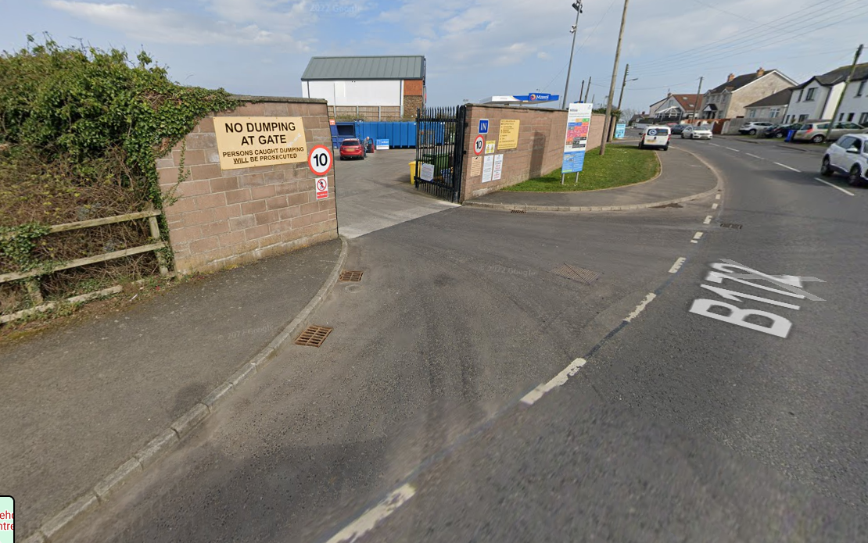
Figure 9 Millisle HRC entrance and signage

Holywood
At Holywood Household Recycling Centre, there, was, at the time of writing, no pedestrian access. There was one entrance gate for vehicles, one exit gate for vehicles and one separate gate for pedestrians. Site rules included a one-way system and a restricted speed limit of 10mph. There were footpaths leading to the site entrance. This site had several residential properties close by and was close to the town centre.
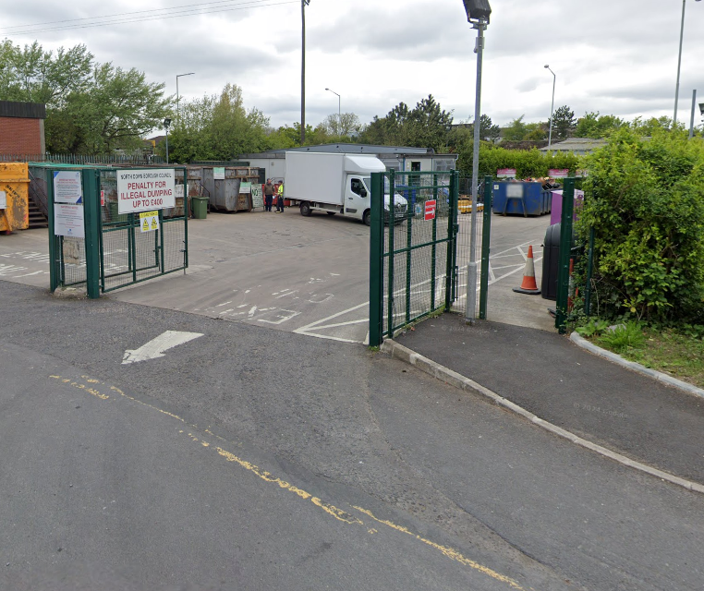
Figure 10 Holywood HRC entrance and signage

Portaferry
At Portaferry Household Recycling Centre there was, at the time of writing, no pedestrian access. There was one entrance gate for vehicles and one exit gate for vehicles. Site rules included a one-way system and a restricted speed limit of 10mph. There were no footpaths leading to the site entrance and this was a single manned site. There were no residential properties close to this site.

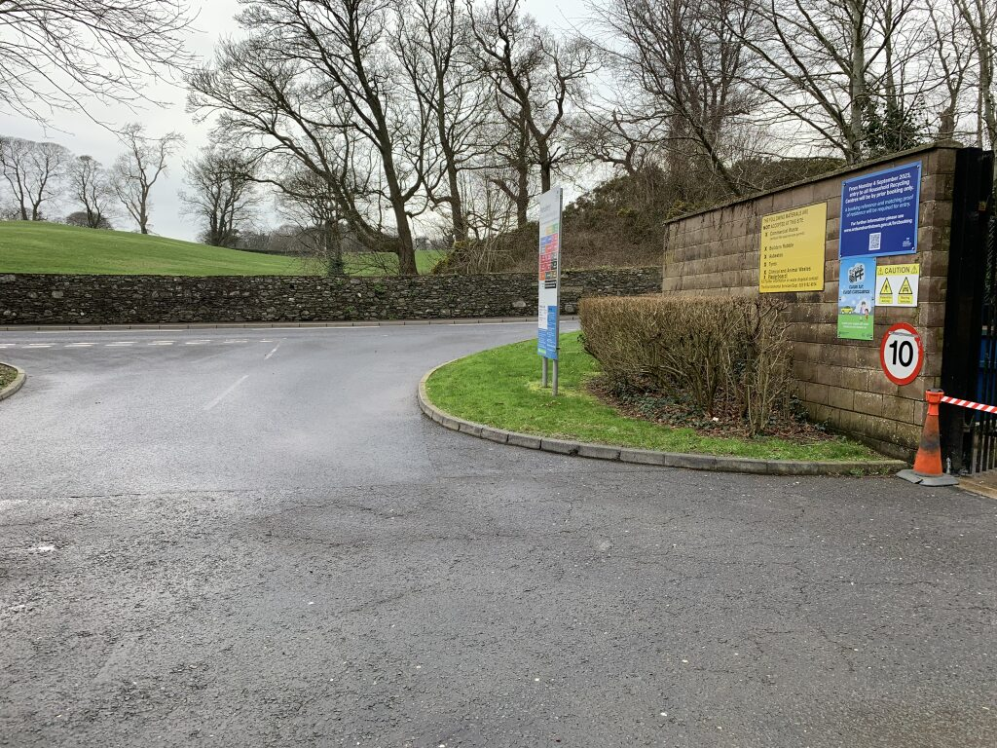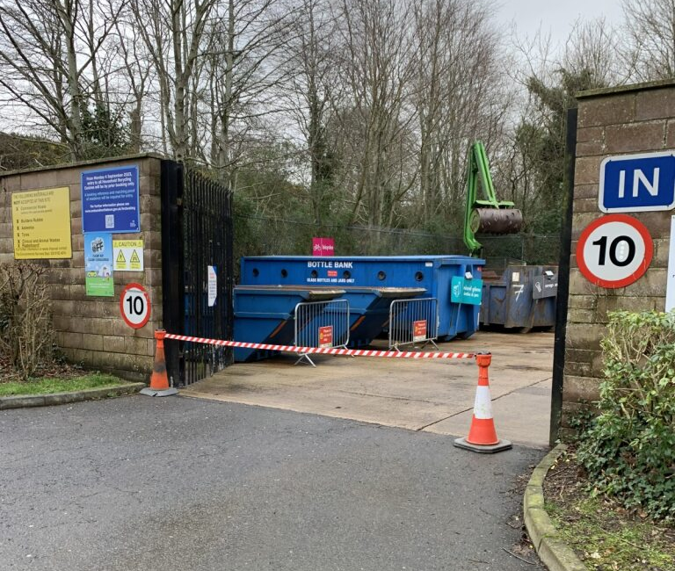
Figure 11 Portaferry HRC entrance and signage

Summary of findings
Ards and North Down’s HRCs had some of the highest recycling rates of any sites in Northern Ireland. This was, in part, due to managed access to the sites, and clear directions to separate items for reuse and recycling.

If introduced, a pedestrian accessing the Council’s HRCs should be required to make a booking using the online HRC booking system. One booking would count for one entry. A pedestrian should be able to carry items without blocking their vision i.e., items should not be piled high in their hands. In accordance with HSE (NI) guidance, a pedestrian should be required to access and egress a site through a dedicated pedestrian gate and not through the vehicle access and egress.

Following a detailed review of the Council’s HRC network, officers did not recommend pedestrian access at the following sites:

- Balloo HRC – Located in an industrial complex, internal site layout not suitable, site not located close to residential properties, no additional space to introduce a pedestrian access gate.
- Newtownards HRC – Located in an industrial complex, reduced footpath access to site.
- Ballygowan HRC –Site not located close to residential properties, no footpaths leading to site entrance, site on a national speed limit road.
- Comber HRC - No footpaths leading to site entrance
- Kircubbin HRC - No footpaths leading to site entrance, no additional space to introduce a pedestrian access gate.
- Portaferry HRC– Not close to residential properties, no footpaths leading to site entrance
- Donaghadee – A time bound option was the only feasible possibility and the previous trial indicated low usage and potential displacement of vehicular access users.

To introduce pedestrian access into any of the Councils HRC sites would cost a significant capital investment to ensure proper segregation between pedestrians and vehicles, and not require a ‘pedestrian only access’ time slot which Council had rejected on the basis of the results of last years trial. This was not provided for within the 2026/27 budgets.

Subject to the implementation of additional safety measures, officers considered pedestrian access during all opening hours could be introduced at the following sites from a practical perspective and their proximity to housing.

- Millisle HRC – Additional space existed to introduce a pedestrian access gate. Internal layout would need improved i.e., pedestrian walkways, bollards, line markings etc.
- Holywood HRC – A pedestrian gate was already in place. However, to use this, the internal layout would need improved i.e., pedestrian walkways, bollards, line markings etc. This would be a different approach previously trialled which was time bound and therefore may yield different usage.

It was important to note that the above sites must close while being serviced which meant exact booking times sometimes needed to be flexible. Servicing was often outside the control of the Council as many waste stream collections are contracted out.

Next Steps
The pedestrian access trial in the summer of 2025 identified that dedicated pedestrian access periods were not well used. The ‘pedestrian only access’ time slot approach also removed access for vehicle bookings at those sites and therefore in accordance with the Council decision on the matter was not being reconsidered.

A routine refresh of site markings at all 9 HRCs, including those marking vehicle zones and pedestrian walkways (for vehicle occupants / site users), would be undertaken from April 2026 and had been scheduled. Parallel to this, officers could work up a business case for 2027/2028 for the investment that would be required to introduce pedestrian access at the two HRCs referred to, including an analysis of demand.

Summary
If it was to be agreed to implement further measures to allow pedestrian access at the two sites this would require additional works and a phased introduction as follows.

- Holywood HRC had a separate pedestrian access gate; however, the current layout did not adequately segregate vehicles and pedestrians. It was recommended that pedestrian access was considered following improvements to the site layout, refreshed site markings, and introduction of bollards. This was subject to availability of budget.

A separate new pedestrian access gate as provided at Millisle HRC. This would be in addition to refreshed site markings, changes to the site layout, and introduction of bollards. This was subject to availability of budget.

Therefore, work up a business case for 2027/2028 for the investment that would be required to introduce pedestrian access at the two HRCs referred to, including an analysis of demand.

Alternatively, members may wish to

- Keep current arrangements and don’t allow pedestrian entrance

Or

- Consider pedestrian entrance as part of the wider strategic reviews of HRC provision in the Borough

RECOMMENDED that Council Agrees to consider the way forward.

Proposed by Alderman McRandal, seconded by Councillor Harbinson, that a version of Option 1 be adopted.

Alderman McRandal read out the chosen option for clarity, “that the Committee notes the report and tasks Officers to prepare a business case for the investment that would be required to introduce pedestrian access at Holywood and Millisle HRCs. A further report, including analysis of demand, is to be presented to Committee in advance of the business case being considered during the 2027/2028 rates setting process.”

He reminded the Committee that the report had arisen from a Notice of Motion submitted jointly by himself and former Councillor, Hannah Irwin, and expressed thanks for the detailed and significant amount of work undertaken to date. He stated that, although the results of the Holywood trial did not reflect it, there was clear demand for pedestrian access as he regularly received queries from residents. He highlighted that many people lived close to Holywood HRC and wished to recycle without having to travel by car, which he felt was inconsistent with the Council’s environmental objectives. Alderman McRandal added that a significant number of residents did not drive due to age or medical reasons, creating a sense of exclusion. He also referred to concerns raised by residents that, once they exited their vehicles within an HRC, they effectively became pedestrians. He welcomed officers’ consideration of the issue and emphasised that the proposal sought only a report, with no commitment at this stage, and that he wished to see a full cost-benefit analysis.

Councillor Harbinson supported obtaining further information to explore options that would enable non‑drivers to access facilities.

Councillor Wray asked that the alternative proposal be read again, and the Chair, Councillor Kendall, did so. Councillor Wray stated that the matter was not a significant issue within his DEA but acknowledged that it was a concern in others. He did not support pedestrian-only time slots, noting that the previous trial had demonstrated the challenges of removing capacity from other users. He recognised the concerns about pedestrians within sites but stressed the need to comply with health and safety regulations. He noted that Alderman McRandal’s proposal related to Option 1, which would involve officers preparing a business case for Millisle and Holywood, and asked for clarification on the scale of work required.

The Director of Environmental Services advised that the business case could be completed in‑house using existing templates and processes. Councillor Kendall commented that the cost would therefore be minimal.

Councillor Cathcart agreed, noting that the issue had been ongoing for several years. He stated that only one resident in Bangor had raised the issue of pedestrian access with him, and that many HRCs were unsuitable for pedestrian access due to their rural locations and lack of footpaths. He suggested that Holywood might be reconfigured if an existing gate could be utilised and looked forward to receiving costing reports. He did not consider it necessary to examine sites across the entire Borough.

Alderman Adair agreed with Councillor Wray, noting that the issue was rarely raised in the Ards Peninsula, with only a small number of queries in Millisle. He highlighted that many pedestrians sought access primarily to dispose of small electrical items and, from his own research, advised that some English councils offered kerbside collection for such items. He recalled that the Council had previously explored kerbside clothing collection which had not progressed due to market conditions, and suggested that a similar service for small electricals might benefit residents and lessen the burden of HRC operations.

Councillor Kendall had also received regular queries within the Holywood DEA and supported Alderman McRandal’s view that requiring residents to drive in order to recycle was counterintuitive to environmental aims.

Councillor Brady also supported the proposal, suggesting that some residents may not have been captured in the survey because they were unaware of the timeslots or unable to attend during the allocated hours. He questioned the need for designated pedestrian times and was of the view that pedestrians and vehicles had coexisted safely for many years, provided users exercised common sense. He suggested that signage encouraging mutual awareness might be sufficient.

The Director of Environmental Services advised that risk assessments were required to meet statutory health and safety obligations and that general signage alone would probably not satisfy legislative requirements. He confirmed that the recommended approach included undertaking the necessary assessments for the two identified sites.

AGREED TO RECOMMEND, on the proposal of Alderman McRandal, seconded by Councillor Harbinson, that a version of option one be adopted; that the Committee notes the report and tasks Officers to prepare a business case for the investment that would be required to introduce pedestrian access at Holywood and Millisle HRCs. A further report, including analysis of demand, is to be presented to Committee in advance of the business case being considered during the 2027/2028 rates setting process.

7. aRDS AND nORTH dOWN IN bLOOM ANNUAL GRANTS

PREVIOUSLY CIRCULATED:- Report from the Director of Environmental Services which explained that its purpose was to note the 31 applications for the annual Ards and North Down in Bloom funding grants. Ards and North Down Borough had a reputation for leading the way with our floral displays. The Borough had won regional and national competitions in recent years and the common theme throughout all the success was the incredible hard work and enthusiasm shown by our staff and the local communities they work with.

The grant scheme assists the Ards and North Down in Bloom initiative which had been developed with three overlapping objectives: horticultural excellence, community participation and environmentally sustainable practices. These were in line with objectives of Translink Ulster in Bloom and other regional awards schemes. By actively supporting this competition, applicants not only made their communities more attractive, but also contribute to the Borough’s entry to the Translink Ulster in Bloom Competition and other regional awards.

This collective effort continued to pay off. Recent award successes included Holywood achieving Runner-Up for Best Kept Medium Town, Groomsport winning Best Kept Large Village, Donaghadee securing the title of Best Kept Small Town, Bangor earning Runner-Up for Best Kept City, and Newtownards being named a Finalist for Best Kept Large Town. These achievements built on an impressive track record including Donaghadee winning Gold in Britain in Bloom 2025 — a remarkable accomplishment and a powerful showcase of the Borough’s dedication to excellence.

Key Issues
Ards and North Down Borough Council, at the time of writing, had budget provision for the allocation of funding to community groups in order to assist with floral displays in the city, towns and villages throughout the Borough, to assist with the Council’s commitment to the Translink Ulster in Bloom competition. The allocation for funding was intended to supplement floral display and amenity area maintenance currently carried out by the Council’s Parks and Cemeteries Service. This may be in the form of planters, flower beds, sustainable wildflower displays or equipment to support this work, either on Council or other statutory bodies land or privately owned non-domestic areas in public view.

The Ards and North Down in Bloom Grants Policy Review was approved by Council in January 2025.The maximum limit for funding is £1,250 per annum per group. This increase was approved by Council in January 2025. A further grant may be provided for funding, in whole or in part, for appropriate liability insurance covering the floral display work over and above the group’s normal insured activities. Insurance grants could be provided for up to 40% of the total project costs. Funding would be allocated with 50% advance payment, with the further 50% paid upon the receipt of invoices as per Council wide policy.

Council welcomed applications from multiple groups within the same town or village, recognising that different organisations may be working in distinct areas and that funding was limited. However, projects must demonstrate coverage across a wider area and must not duplicate or overlap in a way that suggests double funding. To promote collaboration and ensure fair distribution of resources, where more than one group applied from the same city, town or village, the Council may only be able to support one project if funding was limited.

Next Steps
The 31 applications were assessed against the following criteria:

- Meet the core objectives of Ards and North Down in Bloom – Horticultural excellence, Environmental Sustainability and Community.
- Provide a vision as to how the funding will enhance the particular areas and how this will be sustained in subsequent years.
- Evidence of approval from relevant landowner where works are to be carried out.
- Where appropriate insurance liability cover is in place, copy of certificate and schedule to be submitted.
- How the works are to be carried out, and by whom.
- Detailed breakdown of how funding will be utilised, and receipts submitted accordingly.

Summary
Appendix 1 summarised how each application met the criteria. In the assessment, 31 of the applications were considered to have met the criteria with minor stipulations. Currently, there was a budget allocation of £37,000 for the In Bloom programme. The applications amount to a total of £33,090.85 plus £500.00 for insurance.

RECOMMENDED that Council Notes this report.

Proposed by Alderman Armstrong-Cotter, seconded by Councillor Wray, that the recommendation be adopted.

Alderman Armstrong-Cotter welcomed the report, noting that the projects supported through the scheme were particularly positive, not only for their environmental benefits but also for the community focused planting initiatives they enabled. She highlighted the dementia friendly garden being developed in Castle Gardens with the involvement of local schoolchildren and how it would help young people learn new skills while contributing to their community and fostering inter-generational connections. She also commended the success of groups in Bowtown and Westwinds in securing grants and remarked on the positive impact that bright planting had on community wellbeing. She praised the project delivered by Ards Rugby Club and expressed her appreciation for the wide geographical spread of initiatives. She encouraged continued community involvement and thanked officers for their work, emphasising that the committee’s community-based projects could have a lasting impact.

Councillor Wray echoed these comments and was proud of the work of volunteers. He asked that his objection to the 50/50 funding split be placed on record, stating that it was unfair to expect volunteers to contribute large sums of their own money upfront. He looked forward to the forthcoming report and advised that his concerns should not detract from the positive nature of the report.

Councillor Boyle stated that the Borough was fortunate to have a level of community engagement that many others did not. He observed that the colourful appearance of towns and villages was a testament to the dedication of volunteers, with 31 organisations participating and many receiving external recognition through awards. He noted that the scheme fostered healthy and constructive competition between communities and hoped that funding and volunteer involvement would continue.
Councillor Kendall added that the funded projects had made areas look attractive and noted that five organisations in Holywood had been successful, commending their efforts.

Councillor Cathcart agreed with his colleagues and remarked on the high number of applications from Holywood. He queried the comparatively low number of applications from Bangor and asked how this was being addressed.

The Head of Parks and Cemeteries advised that the grant scheme had been running for five years, beginning with low uptake but increasing steadily. He confirmed that this year had seen the highest number of applications so far and that officers were actively promoting the scheme. Though the funding available was modest, they had generally been able to support almost all applicants. He confirmed that the Council intended to seek further funding for 2027/28 and would continue to promote the scheme widely.

Councillor Cathcart welcomed the news but asked whether officers were undertaking targeted engagement in areas with low participation.

The Head of Parks and Cemeteries explained that the grant was promoted through the Council’s email system, social media, and through the extensive programme of approximately 150 parks-related events and activities delivered annually. Officers engaged with communities to build capacity in areas without established groups and supported the formation of new groups where they could. He noted that the list of applicants had grown significantly since the previous year, including participation from groups that had not previously been involved, such as sporting organisations.

AGREED TO RECOMMEND, on the proposal of Alderman Armstrong-Cotter, seconded by Councillor Wray, that the recommendation be adopted.

8. nOTICE OF MOTION 689 – FEASIBILITY OF PERMITTING WOODEN MEMORIALS

PREVIOUSLY CIRCULATED:- Report from the Director of Environmental Services detailing that, In November 2025 the following Notice of Motion was agreed by Council:

“That Council task officers to bring forward a report on the possibly of permitting wooden memorials at our cemeteries as part of regulations going forward.”

At present the Council agreed document ‘Procedures, Rules and Regulations for Cemeteries’ did not permit the erection of any wooden memorials. Below outlined the practical, regulatory, environmental, legal, and operational considerations of such a policy change, with reference to the Burial Ground Regulations (NI) 1992.

Key Issues
Councils in NI operated under the Burial Grounds Regulations (NI) 1992, which required cemetery authorities to ensure safe conditions for visitors and staff.

The installation of Wooden Memorials would require a regulatory approach and an application process. While generally constructed from a more perishable material than conventional stone memorials, there would still be a form of foundation required to ensure stability and minimise structural failure.

Wooden memorials deteriorate more rapidly than stone because of exposure to moisture, frost, fungal decay and insect damage. Burial Grounds Regulations (NI) 1992 emphasised the need to ensure memorials remained structurally sound and safe due to historical health and safety incidents linked to unstable memorials.

Memorial safety was a statutory duty and required memorials to be stable and built to specific standards for long-term safety. Council, at the time of writing, carried out an industry approved inspection regime and the introduction of wooden memorials would need to be included in this regime but with a more regular inspection programme due to the perishable nature of the construction material. This would be at an additional cost to Council. Rapid degradation increased the risk of collapse, making wooden memorials potentially more maintenance-intensive for the grave plot owner. As all memorials were subject to a robust application and approval process, significant risk may be mitigated by the introduction of size limitations and installation requirements, similar to those of stone memorials.

Council would potentially face higher maintenance demands when memorials degraded prematurely. Ensuring safety (removal, repair or repositioning) would require additional officer time, inspections and possible costs recoverable from grave owners.

Council maintained cemetery “lawn-style” layouts with consistent memorial materials, usually stone. Wooden markers would introduce visual inconsistency, not in keeping with the aesthetics of the cemetery layout. As referred to previously, all memorials were subject to a robust application and approval process, aesthetics of the cemetery layout may be controlled by the introduction of size limitations.

Wooden memorials could be seen as sustainable if sourced responsibly. However, untreated timber had limited lifespan; treated timber may raise environmental concerns regarding chemical leaching. In addition, wood was more vulnerable to vandalism (fire, carving, breaking).

Such risks may mean increased reporting, repairs and possible insurance implications. While memorial maintenance fell with the grave owner, Council would be the first point of contact regarding a memorial failure and responsible for ensuring the safety for all site users.

In the Council agreed document ‘Procedures, Rules and Regulations for Cemeteries’ Sections 31 and 32 were most relevant to this report. Section 31 clearly states that all headstones shall be of stone or other non-perishable material and shall be placed on a solid foundation and that Council did not permit the erection of any wooden memorials. In addition, headstones were not to exceed 1.371m in height, depending on headstone type. It also stated that other items, other than the headstone, should be no more that 508mm. Section 32 stated that each grave owner must keep the grave, monument or railing in good order and repair to the satisfaction of the Council, and should anyone fail to do so the Council may put in order and/or repair at the expense of the grave owner and refuse opening until the costs of such repairs or removal is paid.

Across Northern Ireland, Councils followed the Burial Grounds Regulations (NI) 1992, which set strict guidance on cemetery functions including memorial permissions. In Ards and North Down Borough Council the Council’s cemetery rules did not expressly permit the erection of wooden memorials. To consider a change to the burial rules, an Equality Impact Assessment was required along with Committee approval.

Officers had reviewed a selection of other Councils regarding permitting wooden memorials in their current regulations. The findings are as follows:

Antrim & Newtownabbey: All such erections shall be of stone or other non-perishable material and shall be located only on the solid foundation. No reference to wooden memorials.

Belfast City Council: The Council’s memorial management policy emphasises memorial stability, adherence to strict material and fixing standards, and the need to avoid memorial types that present safety risks. All memorials must be made of stone or another non-perishable material, such as granite. Temporary hardwood memorials are allowed only for the first year after burial with a height restriction of 76.2cm.

Mid Ulster District Council: The Council’s cemetery management policy outlined detailed rules on memorial structures but restricted materials to those capable of meeting safety standards and long-term stability. All memorials/headstones must be made of stone or other non-perishable material such as granite. Temporary hardwood memorials could be erected but only for six months.

Mid & East Antrim Borough Council: The Council regulations similarly required durable materials and compliance with safety and working standards. All memorials and headstones must be made of stone or other non-perishable material such as granite. Temporary hardwood memorials could be erected but only for the first year, a height restriction of 110cm was in place.

Derry City & Strabane District Council: The Council regulations stated that all memorials/headstones must be made of stone or other non-perishable material such as granite. No reference to wooden memorials.

Fermanagh and Omagh District Council: All memorials and memorial stones must be made of stone or other non-perishable material such as granite. No wooden memorials permitted.

Lisburn and Castlereagh District Council: Materials for Headstones/Tablets: All such erections shall be of stone or other non-perishable material and shall be located only on the solid foundation. No reference to wooden memorials.

Newry Mourne and Down District Council: All memorials and memorial stones must be made of stone or other non-perishable material such as granite. Temporary hardwood memorials could be erected.

Next Steps
The Council agreed document ‘Procedures, Rules and Regulations for Cemeteries’ was due for review in September 2027, during the consultation period Officers will assess demand for wooden memorials.

Summary
In the Council document ‘Procedures, Rules and Regulations for Cemeteries’ Section 31 stated that all headstones shall be of stone or other non-perishable material and shall be placed on a solid foundation and that Council did not permit the erection of any wooden memorials. In addition, headstones were not to exceed 1.371m in height, depending on headstone type. Although, some councils did permit wooden headstones this was a temporary measure and height restrictions applied.

RECOMMENDED that Council Notes this report.

Alderman Adair proposed, seconded by Councillor Edmund, that council amend cemetery regulations to allow the inclusion of wooden memorials provided they have a concrete base and meet health and safety requirements.

Alderman Adair stated that grief affected everyone differently and that each memorial was unique to the family concerned. He explained that he had brought forward the Notice of Motion following a request from a family in his constituency who wished to install a wooden memorial. Alderman Adair had been disappointed with the recommendation before Members, noting that it effectively meant no change, with only a suggestion that the matter be considered as part of a wider review in 2027. He said this was not what he, nor the family had hoped for and stressed the importance of addressing the issue sooner. He referred to the report’s comparison with other Councils, noting that Antrim and Newtownabbey and Derry City and Strabane did not explicitly reference wooden memorials in their regulations. He had contacted those Councils and a sculptor, all of whom confirmed that wooden memorials were permitted provided they were installed on a concrete base and met health and safety requirements. Alderman Adair asked Members to support offering families this choice, emphasising that many people visited cemeteries daily and that memorials were deeply personal. He noted that some religions would use wooden crosses and that families’ wishes should be respected, subject to compliance with safety standards.

Councillor Edmund supported Alderman Adair’s comments, stating that cemeteries were places where people spent time reflecting on loved ones and that memorials were personal expressions of grief. He believed that, provided memorials were dignified and appropriate to their surroundings, there should be no objection. He said the Council should assist families at difficult times and ensure that policies did not add to their distress.

Councillor Boyle noted that he had supported the previous request for further information and questioned why Members could not support a more detailed report. He observed that policies and procedures were amended regularly and that officers had outlined the current position, yet the amendment sought to set this aside. He asked how long the existing regulations had been in place and whether they originated from the amalgamation or legacy councils.

The Head of Parks and Cemeteries advised that the current regulations had been adjusted and agreed approximately five years earlier and were due for review the following year. He said they were broadly similar to previous policies and to those of other authorities and that they had always permitted stone memorials but not wooden ones. He explained that temporary wooden crosses, usually around one foot high, were sometimes used until a permanent stone was installed. He noted that Newtownabbey’s Parks Manager had confirmed to him during his research that wooden memorials were not permitted there other than on a temporary basis.

Councillor Boyle acknowledged that wooden crosses were commonly used in Catholic cemeteries before a headstone was erected. He recognised the sensitivity of the issue and asked officers to outline the practical concerns associated with allowing wooden memorials, including any implications for maintenance or cost.
The Head of Parks and Cemeteries referred to the concerns set out in the report, including additional monitoring and potential costs. He cautioned against changing policy in response to a single request, stating that good policy should be shaped through broader consultation.

Councillor Boyle asked whether the matter could be included in the forthcoming full review of cemetery regulations. The Head of Parks and Cemeteries confirmed that was what was intended by the report and a fundamental review was planned, which would include simplifying the regulations, improving clarity, and exploring potential changes. He emphasised the importance of public consultation and sound evidence and advised that a report was expected by September 2027.

Councillor Wray advised that the report did not offer any more information than what would have already been known to those present. He acknowledged the time required to prepare reports but said the reasons given for maintaining the current policy, such as the limited lifespan of untreated timber and concerns about vandalism, were not compelling. He argued that vandalism could occur regardless of material and that Members had a responsibility to listen to constituents and amend policy where appropriate. He believed the change would be a minor adjustment and that only a small number of families were likely to request wooden memorials, but that the option should be available.

Councillor Brady supported this view, stating that restricting families’ choices at a time of grief placed unnecessary stress on them. He shared his own experience of bereavement and said he would have been extremely upset if told he could not choose a particular memorial. He noted that while wooden crosses might have durability issues, it was the family’s responsibility to maintain them, and replacements could be arranged if needed.

Alderman Armstrong-Cotter said that Councillor Wray had covered many of the points she wished to make. She advised that while respectful of officers’ advice, Members must listen to constituents. She noted that the issue had not arisen frequently and was unlikely to become widespread, but should nonetheless be considered. She referred to concerns about officer time and maintenance but suggested that these could be mitigated if memorials were installed on a hard base. She felt that allowing wooden crosses was a reasonable and compassionate option and that, if problems emerged, the policy could be revisited, adding that cemeteries were deeply meaningful places and that families often faced challenges in securing the memorials they wanted.

Councillor Blaney stated that policies naturally evolved and that practices once considered unusual, such as wicker coffins, had become more common. He viewed the proposal as an example of the Council adapting to changing expectations and acting compassionately.

Councillor Kendall asked whether, if the alternative proposal were agreed, officers would amend the policy and return it to Members, particularly in light of health and safety considerations. She also queried whether an equality impact assessment would be required and what the timescale would be.

The Head of Parks and Cemeteries confirmed that the proposal was to consider the matter as part of the wider review in 2027 and that wooden memorials would be included in that updated set of rules and regulations. He explained that any amendment would need to follow the Council’s internal policy development process, including an equality impact assessment, and that even a single-issue review could take several months. He noted that religious considerations would also need to be assessed and that the earliest timeframe would be autumn or winter.

Alderman Adair concluded by stating that Members were asking for the policy to be amended and that additional procedures were unnecessary. He said it was important for the Council to demonstrate compassion and that, while officers provided advice, it was for elected Members to make decisions. He reiterated that he had brought the matter forward to support a constituent whose application had been refused and asked Members to support the proposal on behalf of that family and others in similar circumstances.

AGREED TO RECOMMEND, on the proposal of Alderman Adair, seconded by Councillor Edmund, that Council amend cemetery regulations to allow the inclusion of wooden memorials provided they have a concrete base and meet health and safety requirements.

9. NOTICE OF MOTION 677 – PROPOSAL FOR PUBLIC HIRE BICYCLE SCHEME

PREVIOUSLY CIRCULATED:- Report from the Director of Environmental Services detailing that, in September 2025 the following Notice of Motion was agreed by Council:

“That this Council produces a report to scope the potential of introducing a public hire bicycle scheme similar to Belfast Bikes for use across the new Greenway network. That the report outlines the benefits, risks, costs, potential partnerships and any funding opportunities including those provided through Department for Infrastructure [DfI] Active Travel to inform a Council decision on progressing such a scheme.”

With the first Ards and North Down (AND) Greenway opening soon between Newtownards and Bangor, this Council could become a cycling Borough by prioritising active modes of transport for short journeys, that people usually drove but could easily cycle.

Not everyone had access to a bicycle or the means or willingness to invest in one, especially those who ere only starting out or visiting the area. Public cycle-share schemes could bring significant benefits in these circumstances.

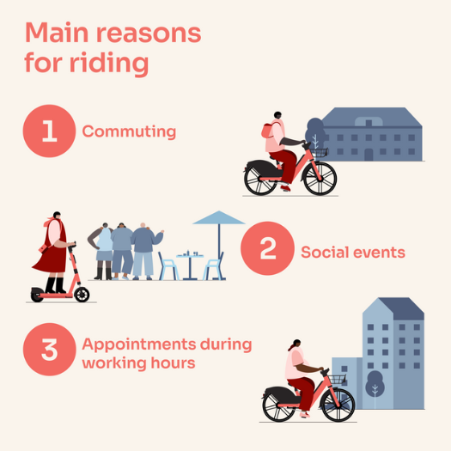

Cycling improved physical health and psychological wellbeing, and it saved money on fuel or public transport. Fewer motor vehicles meant reduced congestion, fewer collisions, lower emissions, and improved air quality.

Providing bicycles was known to positively influence behaviour and the environment by increasing micromobility through active travel and using nudge techniques such as bicycles, active travel challenges, and apps that inform and motivate people to cycle.

Key Issues
Public cycle share schemes fell into two models: docked and dockless, as illustrated in table below:

Docked at fixed docking stations | Dockless model with bikes parked out of the way in designated areas on pavements and at other points
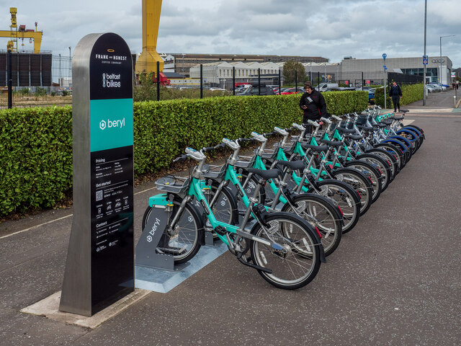 | 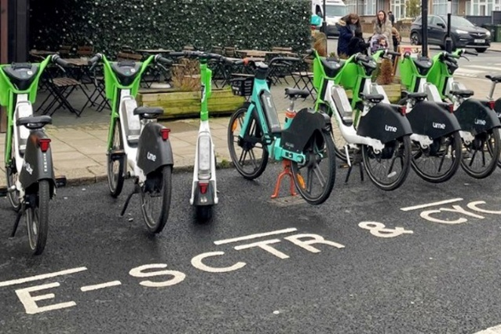

With a variety of schemes around the UK, currently managed by nine different operators. The most well-known local example was the Belfast bike hire scheme.

Belfast Bikes Scheme
The scheme had operated since April 2015 and continued to use a subscription and usage fee model, with pricing set by Belfast City Council to maintain affordability and accessibility. The scheme was established with £700,000 of external funding, delivering 30 docking stations and 300 bikes. A strategic review in 2020 identified: consistent growth in users and rentals and strong public support, with clear evidence of modal shift and improved health outcomes. In 2025, a new provider, Beryl, partnered with Frank and Honest Coffee Company to install 60 docking bays, with a 300-bike and 100-e-bike serviced network, expanding greener journey options across Belfast.

Edinburgh Dockless Cycle Hire Scheme
Launched in September 2025, this scheme introduced 50 electric bikes across an 8sq km zone. Key features include: No cost to Edinburgh Council; Bikes rented via the Voi app; Fares: £0.11 per minute (£6.60 per hour), with bundles and subscriptions available; dockless model with designated parking points; and improved bike durability and better technology to manage coverage.

Active Travel Hubs
The first Active Travel Hub to open in Northern Ireland was located in East Belfast and was a base for The Walk Wheel and Cycle Trust (formally Sustrans) to encourage commuters and locals in East Belfast to try travel alternatives, such as public transport or cycling and walking along the Comber Greenway. The project ran from an eye-catching container hub based in the new community pocket park in the East Side Urban Villages area. A similar scheme was later launched in Derry-Londonderry.

The project, funded by the Urban Villages Initiative, regenerated a previously derelict site, transformed with landscaping, planting, street furniture and three shipping containers for various uses, including the Active Travel Hub and a cycling café. The venue delivered lessons in cycling for all ages and abilities, journey planning for cyclists, bicycle repair and skill development.

It should be noted that the East Belfast Active Travel Hub was located at the busy intersection of two Greenways.

As the AND Greenway Network continued to develop, an opportunity existed to potentially connect Beryl bikes from Belfast along the Greenways, creating a wider cycling loop and improving access for visitors.

Risks and Considerations
- Choosing the right mix of modes, Pedal bikes; E-bikes; E-scooters etc, to match the objectives and therefore maximise active travel and the users move away from car usage.
- Providing a dense network of docking stations [300-500m apart] within existing cycling infrastructure for connectivity.
- Vandalism of publicly accessible bikes, ensure robust bike design and considerate docking locations.
- Costs of installation and operation. Installation of docking stations has an estimated cost of £35,000-40,000 per station and could include 12 docks each with 10 bikes. Dockless system with provider such as the Voi model runs at no cost to Council.
- Operation including maintenance and effective stocking of popular docking stations.
- Tariff pricing model should be designed to be inclusive and had potential to be made up of 3 price plans: pay as you go, casual and annual.
- Subsidy income was generated through subscriptions and usage fees, with pricing kept affordable to encourage uptake.

Potential partnership opportunities through sponsorship could involve associating the image of one or more companies to the service, exploiting the values and visibility offered by the public bike service in cities or towns. This included advertising on the bikes; operational vehicles; digital media; naming of docking stations by local businesses.

Funding Opportunities
The Belfast Bike scheme was developed as part of the Belfast City Council Physical Investment Programme launched in 2012. The Department for Infrastructure (Department for Regional Development in 2012) provided initial capital funding for the scheme as part of their Active Travel Demonstration Projects budget.

While funding of this nature did not exist at the time of writing, the launch of the new DFI Active Travel plan may provide opportunity in future. The Climate Change Act (Northern Ireland) 2022 underscored the crucial role of active travel in addressing climate goals. It mandated the development of sectoral plans for transport which set a minimum spend on active travel from the overall transport budgets of 10%. The plan aimed maximise the benefits of this increased investment, creating a seamless, integrated network that allows more people, regardless of age or ability, to choose active travel for many of their everyday journeys.

A new bike hire scheme for Ards and North Down could of course be funded by Council which would be subject to an approved business case and budget availability.

The Active Travel Hub detailed in this report was developed using a central government funding stream. While a similar funding stream was not available at the time of writing, this may change in future and Officers will continue to actively pursue such funding. A similar scheme to the Active Travel Hub.

Opportunity did exist to advertise the operation of the service through and Expression of Interest and allow a contracted company to operate the service at no cost to Council, similar to the scheme described in Edinburgh. However, the installation of infrastructure etc, would be unlikely to attract interest at this stage of the AND Greenway project.

Next Steps

Council was amidst the process of developing a Cycling Masterplan for the Borough, which was being compiled by the Walk, Wheel, Cycle Trust. This Masterplan would consider how to encourage Active Travel in the Borough, enhance connectivity, improve accessibility, support sustainable tourism and contribute to net zero goals. There would be an Action Plan suggesting what infrastructure was required at a settlement level to enable these aims to be delivered as well as wider recommendations to support behavioural change and modal shift.

Council also provided a range of activities to promote and enhance the use of community trails and Greenways by residents and visitors. This was achieved through the provision of a range of activities that increase participation in active travel, physical education and mental wellbeing.

Activities such as Park Pedal, Teens on Wheels and the disability bicycle scheme at Bangor Sportsplex, all contributed to maximising the usage of the new Greenways network in Ards and North Down. These activities would continue on the new AND Greenways with continued engagement and understanding on user needs. This may, in future, lead to the conclusion that active travel Hubs or similar would be beneficial.

Council would also continue to deliver the Newtownards to Comber Greenway through the current capital project, actively working with partners in DFI to link Greenway sections and cycle paths.

Summary

While it was a good news story that the first phase of the AND Greenway network was nearing completion, it had also been noted that a large project remained to connect the network directly to the existing Comber Greenway and to fully connect urban sections of the new route, in partnership with DFI. While a similar scheme to the Belfast Bikes could be introduced it would not be feasible to do it at present, a rental scheme would be considered as Council progresses our Greenway network.

RECOMMENDED that Council Notes the above report.

[Councillor Harbinson left the meeting at 19:59.]

Proposed by Councillor Wray, seconded by Councillor Blaney, that the recommendation be adopted.

Councillor Wray noted that the proposal had originally been brought forward by Alderman Smith and that the reports already highlighted the benefits of cycling, as well as examples of successful schemes in Belfast and other parts of the UK. He acknowledged that funding and timing were key issues and sought clarification from officers on whether the intention was to proceed once the cycling network could be fully connected with support from DFI. He asked whether the matter was primarily a timing issue, whether a realistic timeframe could be identified, and whether potential funding sources could be explored in the interim.
The Head of Parks and Cemeteries confirmed that the intention was to use a route masterplan, with implementation forming one of its actions. He advised that there was little value in progressing the scheme until full connectivity could be achieved. Officers were currently working on other greenways and cycle routes across the Borough in partnership with DFI and Translink. He stated that the proposal was a good idea and should be implemented, but that the timing was not yet right. He added that discussions with DFI and other partners would continue, although the project would be costly. He was unable to provide a timescale, noting that work was still ongoing on the Comber to Newtownards connection.

Councillor Blaney asked whether consideration was being given to locations beyond greenways, noting that such schemes were commonly found in towns and cities elsewhere.

[Councillor Harbinson returned to the meeting at 20:02]

He suggested that bike‑hire facilities might also be appropriate in those settings. The Head of Parks and Cemeteries advised that the masterplan would map the safest possible cycling routes across the Borough and that this would guide future decisions. While greenways had been examined, the work extended to urban centres as well.

Councillor Blaney added that the final railway halt to Bangor would be a logical location for bike provision, enabling onward travel for commuters and visitors.
Alderman Armstrong‑Cotter referred to a trip she had taken to Nashville, where cycle and scooter hire schemes operated successfully and were well integrated with other modes of transport. She noted that not all visitors to the greenway would have their own bicycles and that such schemes could support both active travel and tourism. She emphasised the importance of seeking funding not only through health and active‑lifestyle programmes but also through tourism initiatives, and suggested working with the Place and Prosperity team to identify opportunities. She added that a scheme limited to Bangor or Newtownards alone would be too restrictive and that a wider approach would be more beneficial.

AGREED TO RECOMMEND, on the proposal of Councillor Wray, seconded by Councillor Blaney, that the recommendation be adopted.

10. NOTICES OF MOTION

10.1. NOTICE OF MOTION SUBMITTED BY COUNCILLOR EDMUND AND ALDERMAN ADAIR

That this Council is deeply concerned at the impact of the change to Isle of Man’s visa requirements on the Northern Ireland fishing fleet. The changes which mean that overseas crew require an Isle of Man’s work visa rather than the transit visa or UK skilled worker visa and therefore cannot fish within the Isle of Man 12 nautical mile limit, effectively excluding the Northern Ireland fishing fleet from its fishing traditional waters. Council requests that officers write to the Manx Government, to highlight the damage to the Northern Fishing and Fish Processing Industry and request that the relevant measures are taken by the Manx Government to reverse the impact of these changes.

Councillor Edmund speaking on the Notice of Motion advised that that, having long experience in the fishing industry, he was deeply concerned about the impact of recent Manx regulatory changes on fishermen and coastal communities, particularly in the Newtownards Peninsula. He explained that livelihoods were now under threat due to new Isle of Man transit visa requirements, which prevented UK‑based crew from operating in Manx waters unless they held an Isle of Man visa. To obtain such a visa, vessel owners were required to register their businesses in the Isle of Man, creating significant financial and administrative burdens.

He noted that the local fleet already struggled to recruit crew, with around 70% of workers being overseas fishermen who contributed greatly to coastal communities. The new rules, he said, took no account of this reality and warned that Northern Ireland vessels, despite holding lawfully purchased licences and having fished in those waters for generations, now risked being excluded from the 12‑mile zone. He recalled previous challenges, including exclusion zones introduced two years earlier on environmental grounds, which many believed had favoured Manx vessels.

Councillor Edmund advised of how the sector was already under severe pressure from rising fuel costs, regulatory demands and tight margins, and that removing access to these grounds placed businesses in jeopardy. He referred to correspondence from Michelle McIlveen MLA to the Minister of Agriculture highlighting the need for urgent action and stated that the resilience of the sector had limits. Councillor Edmund believed any and all affected by the change should be brought together by the Minister to enter direct discussion with the Isle of Man authorities. Michelle McIlveen MLA had also written to the Isle of Man Government. If actions were taken without regard of the consequences, the long term future of the sector was at risk. Councillor Edmund urged Members not to allow the industry to be disadvantaged without challenge.

Alderman Adair thanked Councillor Edmund and noted that it had been some time since a fishing‑related motion had come before the Council, but that the challenges were now greater than ever. He stressed that the issue would have significant consequences for Northern Ireland, as fishing rights in those waters dated back centuries. It was essential to send a strong message of support for the industry. Alderman Adair welcomed the engagement of Michelle McIlveen MLA and Minister Andrew Muir and stated that the Council must make clear that the new regulations were unworkable and unjust. He highlighted the rising cost of fuel, which had more than doubled, and the concerns expressed by industry representatives. He urged Members to support the motion, emphasising the importance of protecting not only the fishing fleet but also the many associated jobs and businesses that depended on it.

Alderman McRandal expressed his support and thanked Members for bringing the matter forward. He noted that Minister Muir had been working closely with industry representatives and had raised concerns directly with the Manx Government. He advised that the Minister was due to travel to the Isle of Man the following week to discuss the issue in person.

Councillor Boyle acknowledged the difficult and dangerous nature of the fishing profession, noting that it carried significantly higher risks than most occupations. Fishing was central to the life of Portavogie and that the industry was already struggling to attract younger workers. He welcomed the involvement of Michelle McIlveen MLA and the DAERA Minister and asked whether there was value in involving the local MP, given the wider implications for other fishing ports. He warned that the consequences of the new rules would be severe if not addressed and that the industry had faced many obstacles over the years. He stressed the need to use all available representation to support fishermen.

Alderman Armstrong‑Cotter noted that Jim Shannon MP represented the area and also spoke for fishing communities in Kilkeel and Ardglass. She said similar concerns had been raised in Newry, Mourne and Down, where crews from Northern Ireland were permitted to work in local waters but were now restricted in Manx waters. She reported that Mr Shannon had met with both the Immigration Minister and the Fisheries Minister to highlight the issue, including the fact that fishermen possessed high skill levels and salaries that did not match. She argued that fisheries required their own visa category and that the Isle of Man’s position was unacceptable. Alderman Armstrong-Cotter said Members would continue to fight for the sector and stressed that young people would only enter the industry if it offered a viable future. She emphasised the importance of the Council sending a clear message of support for fishermen and rejecting the Isle of Man’s ruling.

Councillor Blaney advised he had a small declaration of interest, noting that some of his clients worked in the industry. He said they had expressed frustration at the last‑minute nature of the changes and urged that this point be raised with the Minister. He argued that any future legislative changes by the Isle of Man should be subject to a consultation period of at least six months, allowing time to assess the impact on fishermen’s livelihoods.

Councillor Edmund summarised, noting the long history of Northern Ireland’s fishing presence in Manx waters. He described how his grandfather had taken over the family boat at the age of 14 and had fished until the age of 84, illustrating the generational nature of the industry. He said the new rules were unjust, particularly as Manx scallop boats could enter Northern Ireland waters during unfavourable weather, often in significant numbers. Councillor Edmund shared a personal account of losing a relative at sea near the Isle of Man, whose body had never been recovered, and described the hardship faced by families in the industry. He thanked Members for their support and noted that colleagues in Kilkeel had brought forward similar proposals. He said pressure must be applied collectively across the entire coast to ensure the issue was addressed at the highest levels.

AGREED TO RECOMMEND, on the proposal of Councillor Edmund, seconded by Alderman Adair, that the Notice of Motion be adopted.

10.2. NOTICE OF MOTION SUBMITTED BY COUNCILLOR MCCOLLUM AND COUNCILLOR WRAY

That this Council notes the profound impact on the Clandeboye Community of the tragic death of 16 year old DICE leader and Army Cadet Jaidyn Rice on the 8th July 2025 and further notes the terrible loss of seven other lives on roads in our Borough during 2025, the highest of any Council area.

Further that this Council tasks officers to work with the Rice family to create a bench honouring Jaidyn's contribution to her community, such bench to be a place of reflection, connection and outreach, in an agreed location and incorporating Council's Here to Help app for signposting to vital support services around the Borough.

Councillor McCollum joined the meeting at 20:26 to speak on her Notice of Motion.

Councillor McCollum introduced the motion and spoke of the tragic loss of life on the roads of Ards and North Down in 2025, noting that seven families had received devastating news during that year. Among them was the family of 16‑year‑old Jaidyn Rice, whose death on 8 July 2025 had profoundly affected not only her loved ones but the wider Clandeboye community. She said the community had lost a young woman who was both a role model and a source of light, and who had already made an extraordinary impact through her leadership in the DICE project. Jaidyn’s empathy, compassion and natural leadership had earned her responsibilities beyond her years, and she believed deeply in the power of community and in helping others to grow and thrive.

Councillor McCollum highlighted that Jaidyn had also been a committed Army Cadet, a role she took seriously as an opportunity to serve and support others. Although her life had been short, her impact had been significant, and it was the enduring wish of her family, friends and community that her legacy continue. She stressed that community safety, whether in homes, towns, villages or on the roads, was a shared responsibility and lay at the heart of the Council’s work, including through the PCSP. Inspired by Jaidyn’s values, the Rice family had worked with various groups since her passing to improve road safety and support others.

Councillor McCOllum explained that the family wished to create a bench in an agreed and appropriate location, not as a traditional memorial but as a living space for reflection, connection and support. The bench would incorporate a QR code linking to the Here to Help app, which provided quick access to support services covering mental health, addiction, domestic abuse, housing and emergency pathways such as 999, Lifeline and Samaritans. The bench would offer a discreet way for people in distress to seek help without judgement and would serve as a reminder that support was always available. The proposal was not intended to bypass the Council’s memorial bench policy, as it was not a static memorial but a practical and compassionate resource reflecting Jaidyn’s outward‑looking nature. If the bench helped even one person, she said, it would have fulfilled its purpose and become a meaningful legacy.

Councillor Wray seconded the motion and thanked the Mayor for her work with officers and the Rice family. He said he had mentored Jaidyn in 2022 and described her as kind, driven and committed to helping others. Her involvement in DICE and the cadets reflected her desire to ensure young people knew support was available and that they could achieve great things. He said the bench was a fitting tribute and an important tool for all ages. He also reflected on recent frustrations about negative generalisations of young people, noting that the vast majority were like Jaidyn; positive, engaged and community‑minded. He said the bench would support both victims of harm and those who caused it, by signposting them to help. He commended the compassionate approach taken and urged Members to support the proposal.

Councillor Cummings, speaking as the Council’s representative on the Reserve Forces and Cadets Association, expressed his thanks to the Mayor and Councillor Wray. He said Jaidyn had been held in high esteem within the cadet community and that the bench would be a fitting tribute, reflecting her values and leadership. It would provide a place for reflection and a practical source of support for those in need.
Councillor Cathcart thanked Members for their contributions and said that although he had not known Jaidyn, the tributes made clear the depth of her impact and the loss felt by the community. He commended the Rice family for their strength in using their grief to advocate for improved road safety and said the proposed bench would be a meaningful tribute.

Councillor Newman also expressed her support, noting Jaidyn’s commitment to service through DICE and the cadets. She said the bench would offer hope and reflection for young people and others, and she trusted officers to work closely with the family to progress the project in time for her anniversary.

Alderman Armstrong‑Cotter reflected on the loss of Jaidyn’s life and future, and said it was heartening that the lives she might have touched could still be reached through this initiative. She spoke of the pressures facing young people, including online bullying, and said the bench and QR code would remind them they were not alone. She hoped the Council could help send a message of hope.

Councillor Boyle thanked the Mayor and Councillor Wray for bringing forward the motion. He said the themes of reflection, connection and outreach were powerful and important for young people. Although he had not known Jaidyn, he felt he had come to know her through the tributes. He noted that the loss of young life had a profound impact on communities, recalling that another young person had died in Portaferry on the same date. He said the bench would provide a place for people to sit, talk and feel supported, and that such gestures demonstrated the Council’s care.
In summing up, Councillor McCollum thanked Members for their kindness, compassion and support, and conveyed the gratitude of the Rice family.

Councillor Kendall concluded that it was a privilege to support the proposal, noting that the bench would be much more than a physical structure. She said it would be a place of compassion, connection and outreach, honouring Jaidyn’s life and supporting others.

AGREED TO RECOMMEND, on the proposal of Councillor McCollum, seconded by Councillor Wray, that the Notice of Motion be adopted.

11. ANY OTHER NOTIFIED BUSINESS

There were no items of Any Other Notified Business.

EXCLUSION OF PUBLIC/PRESS

Agreed, on the proposal of Alderman Armstrong-Cotter, seconded by Councillor Edmund, that the public/press be excluded during the discussion of the undernoted items of confidential business.

12. TENDER REPORTS

12.1. TENDER FOR THE SUPPLY OF LIQUD FUELS AT ARDS AND NORTH DOWN COUNCIL PROPERTIES

**DELEGATED TO COMMITTEE**

***IN CONFIDENCE***

***NOT FOR PUBLICATION***

SCHDEDULE 6 – Exemption: relating to the financial or business affairs of any particular person

PREVIOUSLY CIRCULATED:- Report from the Director of Environmental Services detailing that he current contract for the Provision of Fuel Oil Supplies had been in operation from 1 April 2024. This tender had previously been procured through the Crown Commercial Service (CCS) operating on the Council’s behalf under a call-off contract, National Fuels Framework Agreement. Council Officers provided details to CCS of liquid fuel consumption and storage information for inclusion in a new tender exercise.

The Crown Commercial Service had undertaken a tender exercise including Council’s consumption data, to obtain the most economically advantageous contractor for the provision of liquid fuel oils. The contractor recommended under this tender exercise and were also the incumbent contractor, was Nicholl Fuel Oils.

RECOMMENDED that Council agree that Crown Commercial Service continue to be utilised and the Contract for the Provision of Fuel Oil Supplies be awarded to the highest scoring company as recommended by Crown Commercial Services.

RESOLVED, on the proposal of Alderman Adair, seconded by Alderman Armstrong-Cotter, that the recommendation be adopted.

12.2. TENDER EXTENSION FOR THE PROVISION OF GROUNDS MAINTENANCE EQUIPMENT REPAIRS AND SERVICING

**DELEGATED TO COMMITTEE**

***IN CONFIDENCE***

***NOT FOR PUBLICATION***

SCHDEDULE 6 – Exemption: relating to the financial or business affairs of any particular person

PREVIOUSLY CIRCULATED:- Report from the Director of Environmental Services detailing that the tender for the Provision of Grounds Maintenance Equipment Repairs and Servicing was awarded on 9 July 2025 for an initial period of 12 months with an option to extend for a further three periods of one year each.

Following a satisfactory service review, Officers wished to extend the contract for a further 12-month period as permitted in the original tender documents.

RECOMMENDED that Council ​Approves​ an extension of the Tender for the Provision of Grounds Maintenance Equipment Repairs and Servicing contract for a further twelve-month period under the existing Tender Option.

RESOLVED, on the proposal of Alderman Adair, seconded by Alderman Armstrong-Cotter, that the recommendation be adopted.

12.3. TENDER EXTENSION FOR THE PROVISION OF MEMORIAL TESTING

**DELEGATED TO COMMITTEE**

***IN CONFIDENCE***

***NOT FOR PUBLICATION***

SCHDEDULE 6 – Exemption: relating to the financial or business affairs of any particular person

PREVIOUSLY CIRCULATED:- Report from the Director of Environmental Services detailing that the tender for the Provision of Memorial Testing was awarded 1 July 2025 for an initial period of 12 months with an option to extend for a further three periods of one year.

Following a satisfactory service review, Officers wished to extend the contract for a further 12-month period as permitted in the original tender documents.

RECOMMENDED that Council ​Approves​ an extension of the Memorial Testing contract for a further 12-month period under the existing Tender Option.

RESOLVED, on the proposal of Alderman Adair, seconded by Alderman Armstrong-Cotter, that the recommendation be adopted.

12.4. APPOINTMENT OF ICE CREAM AND HOT DRINKS VENDORS AT VARIOUS LOCATIONS IN THE BOROUGH 2026-27

**DELEGATED TO COMMITTEE**

***IN CONFIDENCE***

***NOT FOR PUBLICATION***

SCHDEDULE 6 – Exemption: relating to the financial or business affairs of any particular person

PREVIOUSLY CIRCULATED:- Report from the Director of Environmental Services to update Elected Members on the appointment of Hot Drinks Vendors at three available locations in the Borough and sought approval to move forward following the recent expression of interest period.

Officers identified one winning bid from applications The two remaining locations (Groomsport and Cairn Wood) would be readvertised.

RECOMMENDED that Council ​Approves​ the appointment.

RESOLVED, on the proposal of Alderman Adair, seconded by Alderman Armstrong-Cotter, that the recommendation be adopted.

RE-ADMITTANCE OF PUBLIC/PRESS

AGREED, on the proposal of Alderman Armstrong-Cotter, seconded by Councillor Edmund, that the public/press be re-admitted to the meeting.

TERMINATION OF MEETING

The meeting terminated at 20:55.

