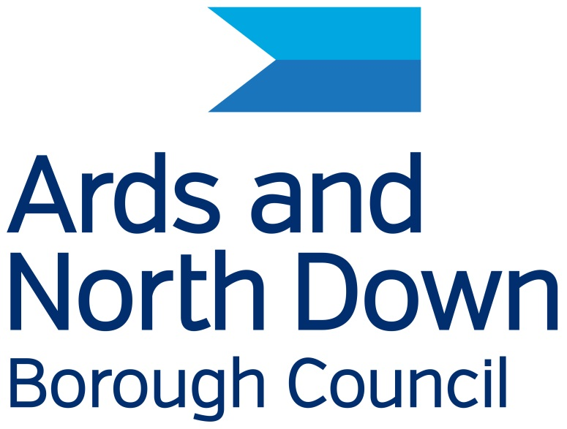

Ards and North Down Borough Council

Disability Action Plan

2026 – 2031

This Disability Action Plan can be obtained from the Council in
alternative formats and languages where a need is identified.
It may also be downloaded from the Council’s website Disability - Ards and North Down Borough Council

If you would like a copy in an alternative format, or have any queries, please contact:

Ards and North Down Borough Council

Compliance Officer (Equality and Disability)
City Hall, The Castle,
Bangor
BT20 4BT
Tel: 0300 013 3333 ext. 40114
E-mail: equalityanddisability@ardsandnorthdown.gov.uk

Contents
Purpose 4
Key aims and objectives 4
The Council – its role, functions and policies 5
Council responsibility 6
Public life positions over which the Council has responsibility 6
Effective implementation of the Disability Action Plan 7
Internal arrangements 7
Effective engagement 8
Annual report 8
Review of the Disability Action Plan 8
Consultation 8
Performance Indicators and actionable measures 9

Purpose

The purpose of a Disability Action Plan is fundamentally rooted in the legal framework established by Section 75 of the Northern Ireland Act 1998 and Section 49A of the Disability Discrimination Act 1995 (as amended) It is a commitment to fostering an inclusive society. This Disability Action Plan has been developed to align with the outcomes identified in the Ards and North Down Borough Council Corporate Plan.

Key aims and objectives

Promoting Positive Attitudes:
A core objective is to actively work towards changing societal perceptions and promoting positive attitudes towards people with disabilities.

Encouraging Participation:
The plans aim to break down barriers and create opportunities for people with disabilities to fully participate in public life.

Fulfilling Legal Duties:
Disability Action Plans are a mechanism for public authorities to demonstrate how they are complying with legal duties, particularly those stemming from the Disability Discrimination Act 1995 (as amended). Specifically, the plans help public authorities demonstrate that they have had "due regard" to the need to promote positive attitudes toward disabled people and encourage participation by disabled people in public life.

Addressing Barriers:
This plan is designed to identify and address the various barriers that people with disabilities face, whether they are physical, attitudinal, or systemic.

Improving Accessibility:
A significant focus of this Disability Action plan is on enhancing the accessibility of services, information, and environments for people with disabilities.

Providing a Framework for Action:
This Disability Action Plan offers a structured framework for Ards and North Down Borough Council to implement disability duties, monitor their progress, and ensure that disability considerations are integrated into our day-to-day operations.

Improving Service Delivery:
This Disability Action Plan strives to improve the delivery of public services to ensure they are accessible and equitable for all members of society and are effectively mainstreamed within Council.

The Council – its role, functions and policies

The roles and functions of Councils fall within three types:
- Direct - the direct provision of a number of services and facilities including the promotion of the arts, tourism, community and economic development and the regulation and licensing of certain activities relating to environmental health, consumer protection and public safety
- Representative - a representative role on a number of bodies and boards including Education and Health as well as an advocacy role for the Borough
- Consultative - a consultative role in relation to functions conducted by other Government bodies and agencies on issues such as water, roads and housing and the promotion of the arts, tourism, community and economic development, the regulation and licensing of certain activities relating to environmental health, consumer protection and public safety.

In the performance of the above roles the Council carries out functions in
the following areas: (This is not an exhaustive list)

Service provision:
The council is responsible for delivering essential local services, including:
* Refuse collection and waste management.
* Environmental services.
* Leisure and recreation facilities.
* Parks and Cemetries.
* Planning and building control.

Community Development:
The council works to promote community well-being and development,
supporting local initiatives and addressing community needs.

Economic Development:
It plays a role in fostering economic growth within the borough, attracting investment, and supporting local businesses.

Tourism:
Ards and North Down boasts a beautiful coastline and rich heritage, and the council actively promotes tourism in the area.

Governance:
It is responsible for local governance, making decisions on local policies and managing council resources.

To enable the Council to provide the above services and perform its other functions it must levy an annual rate and has the power to: -
• acquire and dispose of land;
• borrow money;
• employ staff;
• procure goods and services.

Council provides its services through the employment of approximately 1000 employees who are full time, part time, permanent and casual employees.

To support and implement the above statutory functions and provision of services and facilities, the Council has adopted a number of policies. All policies are screened for impacts of S75 categories, Rural needs, Sustainability and Data Protection.

Council responsibility

Ards and North Down Borough Council has 40 councillors representing seven district electoral areas. These members provide leadership for Ards and North Down Borough Council. They represent the interests of their constituents and ensure the views of people across Ards and North Down are reflected in the council's decisions and how services are delivered.

Public life positions over which the Council has responsibility

The Council has responsibility over a number of public life positions i.e. committees in which members of the public participate. A full list of these positions is available on request.

Effective implementation of the Disability Action Plan

The Mayor and Chief Executive of the Council are dedicated to effectively implementing this plan and ensuring the disability duties are executed throughout the organisation. They will allocate all available resources—people, time, and finances—to achieve these goals.

As part of its corporate planning process, the Council will integrate objectives, target setting, and monitoring into relevant business plans. These will be reflected at all levels of the Council’s strategic planning, including individual staff objectives and annual plans. Progress towards meeting these objectives will be monitored and reported to the relevant managers and elected members every year. Individual performance in these areas will be reviewed through internal performance review processes.

A formal progress report on meeting objectives related to equality and disability duties will be included in the Council's Annual Report to the Equality Commission.

Internal arrangements

The Council consists of 40 elected representatives, each elected for a four-year period. A full list of the Council’s standing and sub-committees are available on the council’s website and are also available on request.

The Chief Executive oversees the work of the departments through the Corporate Leadership Team which, together with the Elected Members, create the corporate body of the Council. The Chief Executive is the principal advisor to the Council and responsible for the strategic management of the organisation, for the day-to-day management of services and the longer-term planning and allocation of resources.

The departmental structure of Ards and North Down Borough Council is available on request and is subject to change.

The Chief Executive has overall responsibility for ensuring the effective implementation of this plan, with the support of the Corporate Leadership Team.

Responsibility for implementing, reviewing and evaluating this Disability Action Plan, and the point of contact within the Council is the Compliance Officer (Equality and Disability).

The Council offers public documents in various accessible formats, including large print, easy read, and audio, with options for translation into minority languages. Equality and disability documents are created in clear Arial Font size 14. Information is accessible through the ReachDeck facility, and translators or sign language interpreters are provided at meetings as needed. Loop systems are available in Bangor City Hall and some other facilities, while a British Sign Language interpreting service provides instant access to online interpreters for Deaf or hearing-impaired customers.

Every council employee and member of a Council Body or Panel, including the Policing and Community Safety Partnership, Community Planning Partnership, and Peace IV Partnership, has a responsibility to uphold disability duties. All employees and elected members receive training on relevant legislation and are accountable for ensuring that the Council meets its obligations. It is essential that they avoid any inappropriate actions that could lead to a failure in these duties.

Effective engagement

The Council is committed to engaging with stakeholders and representative groups in drafting, implementing, monitoring, and reviewing this Plan.

Annual report

The Council will prepare an annual report outlining its progress in implementing the equality scheme using the Disability Action Plan. This report will be submitted to the Equality Commission. A copy of the annual report will also be available on the Council’s website.

Review of the Disability Action Plan

The Council will conduct a four-year review of its plan. After it is ratified by Council, the review will be submitted to the Equality Commission for Northern Ireland.

This Disability Action Plan has been created to align with the outcomes identified in the Corporate Plan and to further our disability duties.

Consultation

The Council is dedicated to meaningful consultations in developing its Disability Action Plan over 12 weeks, engaging key stakeholders and service users. Comments and suggestions will be incorporated into the Plan. To ensure public involvement, the Council will work with representative groups and meet with individuals upon request.

The Disability Action Plan will be advertised on the Council's website and social media. The Council will collaborate with groups to ensure clear communication and accessibility, acknowledging that individuals may face different barriers. The Plan will be promoted through various channels, and requests for minority language versions will be addressed as needed. Employees will also be informed about the Plan and their roles in fulfilling the Council's obligations.

Performance Indicators and actionable measures

The Council is committed to monitoring and reviewing policies and practices to ensure the disability duties are met. This process is undertaken through the policy making and screening processes.

The Council will undertake a review of this plan on an annual basis. This review process assists in the drafting of appropriate actions and performance targets for the next period, as well as highlighting the achievements from the period of the annual review.

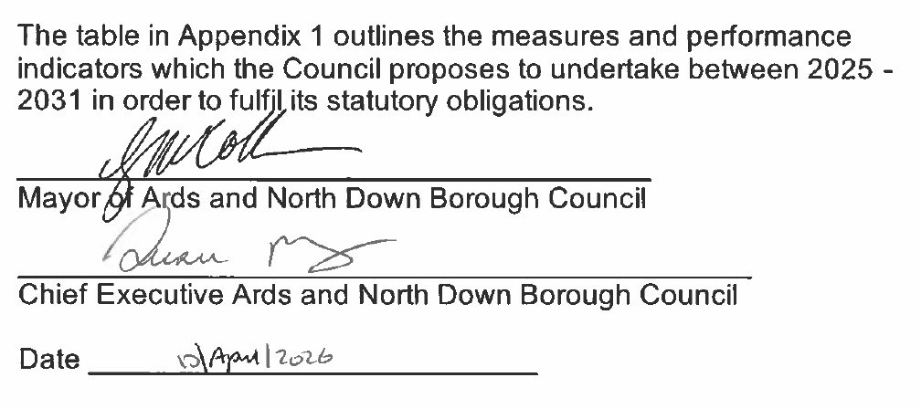

1. We have an engaged Borough with citizens and businesses who have opportunities to influence the delivery of services, plans and investment
We will commit to | We will do | SMART OBJECTIVE - We will know we have been successful by:
1.1 Screening 100% of all new and revised policies to ensure compliance with disability duties and Section 75 of the Northern Ireland Act 1988. | Ensure compliance of Council policies with disability duties. | 100% of policies submitted via Jotform are screened for compliance with disability duties and reviewed by the Compliance section within 10 working days of receipt. Investigate method to monitor mitigations going forward.  ALL
1.2 Provide a meaningful forum for individuals with disabilities and their representatives to collaborate with the Council to highlight needs for appropriate action through the Disability Forum. | Maintain a database of all local and regional disability representatives and carer representative organisations. | Maintain and update a representative database of local and regional groups of potential and current members annually to ensure accurate and inclusive engagement continually identifying and addressing gaps in representation.  CO (E&D)
Review the agreed Constitution every three years, with participation from members including champions from across the organisation.
CO (E&D)
 | Encourage representative groups to engage individuals at relevant Council consultations | Invite at least one speaker from an external organisation/ or internal project to each Forum meeting (four per annum).  CO (E&D)
1.3 Working collaboratively with members of disability groups to raise awareness and signpost to information and help including people with multiple disabilities. | Mark and celebrate disability by promoting and publicising disability related days and events. | Maintain and annually update a calendar of equality and disability-related events, ensuring each event is publicised through multiple channels and tracked using engagement metrics such as attendance and feedback to support continuous improvement.  CO (E&D)
1.4 To ensure the Council engage with a broad range of stakeholders. | Have a range of sources to provide alternative formats as requested including easy read and Sign Video | All published documents should be produced to accessible standards (including option for alternative formats as appropriate)  ALL
Introduce automated accessibility checks using Microsoft technology across all document creation platforms which will alert users when content falls below accessibility standards.
ALL
1.5 Enable disabled people to get involved with the Council, be heard and inform decisions made including direct engagement not simply reactive. | Ensure a range of Disability groups are available for consultation | Communicate to all staff the importance of early engagement with the Disability Forum and encourage officers to attend meetings when at early stages of project development. Retain a log of engagement through this Forum.  CO (E&D)  Produce guidance for staff on how to effectively engage with disabled people in decision making processes.  CO (E&D)  Measure direct contact using the email: equalityanddisability@ardsandnorthdown.gov.uk.  CO (E&D)
 | Produce staff guidance on how to effectively engage with disabled people in decision making processes.
 | Provide clear path to communicate via dedicated equality and disability email.

2. We have a thriving and sustainable economy

We will commit to: | We will do | We will know we have been successful by:
2.1 Ensure recruitment process is inclusive and accessible. | Ensure recruitment process meets the Disability Discrimination Act 1995. Anticipate and provide reasonable adjustments as required  Review recruitment practices in line with ECNI guidance for recruiting people with disabilities | HR to monitor and report the number of reasonable adjustments arranged at interviews and across council services, with 100% of adjustments recorded in a central log and annual reporting beginning by April 2026, to support accessibility and continuous improvement  HR
2.2 Ensure the Council remains Disability Confident Committed employer (Level 1) | Offer to provide employment/ work experience/ placement related opportunities for disabled people | Establish baseline of the number of work experience and placement opportunities for individuals with a disability. Increase number by 1% annually from March 2027 through targeted outreach, inclusive support, and annual monitoring of participation and outcomes.  HR
2.3 Employee Profile Review – Review arrangements to ensure all employees including permanent, temporary and agency are aware of the support available for employees with a disability. | Monitor employees to identify those who have a disability and are comfortable disclosing this information. | Establish and maintain an up-to-date register of reasonable adjustments by March 2027, ensuring 100% of adjustments are recorded, reviewed annually, and informed by annual feedback from employees with disabilities to support inclusive workplace practices.”  HR

3. We have a vibrant, attractive, sustainable Borough for citizens, visitors, businesses and investors

We will commit to: | We will do | We will know we have been successful by:
3.1 To ensure all public spaces, services and events are accessible and reasonable adjustments are made were possible (while still respecting the historical nature and environmental sensitives of each location). | Encourage participation of disabled people to attend Council spaces, services and large events. Continue to engage with Disability forum for ‘walkability’ audits. Increase number of inclusive events and services throughout the borough. | Continue to use AccessAble website for facilities.  CO (E&D)  Services that arrange events/service or design public spaces to ensure adjustments are considered at early stage of development. Any mitigations and adjustments that are determined should be recorded where possible.  ALL
3.2 Provision of mobile changing places where changing places are not conveniently located. | Enable individuals and their carers to participate in any event by having suitable toilet facilities available. | By April 2027, review and analyse all comments and complaints regarding the location and suitability of Changing Places facilities to identify key improvement areas and inform future planning.  EVENTS
3.3 Demonstrate the council’s support and appreciation for carers of all ages from across the Borough | Enable carers from the South Eastern Health and Social Care Trust area to be invited to an event in the Borough annually | Host 1 event to celebrate carers annually. Ensure at least one group of carers each event, with ongoing support provided throughout the year where possible.  CO (E&D)
We will commit to: | We will do | We will know we have been successful by:
3.4 Disability Friendly Borough – To work within the Council, with community partners, including IMTAC and Service providers across the Borough to ensure Ards and North Down Borough Council is a welcoming place for all in relation to access to all facilities and services. | Work with Council customer facing services, employers, and service providers across the Borough to encourage all providers of services to have in place reasonable adjustments to suit the breadth of users and potential users. | Establish baseline by April 2027 and increase the number and diversity of initiatives led by Council officers to encourage participation in Council services by people with disabilities and carers, with measurable progress tracked throughout the year. ALL/CO (E&D)  Economic Development team to promote disability initiatives and considerations with local businesses through their E-zine ED  Ensure 100% of Council’s Major or Strategic Capital projects engage with IMTAC members during the design consultation phase, with compliance monitored and reported throughout the year. CP  Ensure all newly designated car parking spaces meet best practice guidance, including where possible provision for Wheelchair Accessible Vehicles (WAVs), with compliance monitored for each installation throughout the year.  ALL/CO (E&D)  Review of all relevant Council facilities as part of the Estates Maintenance Strategy condition surveys. The three yearly survey would assess the feasibility of including a Changing Places Toilet space, for use by individuals with carers.  CO (E&D) /A&P

3.5 Work to make Ards and North Down a Visually Aware Borough. | Help raise awareness over the challenges faced by blind and partially sighted people.  Ensuring anyone with a visual impairment can expect a safe and accessible welcome from the Borough. | Develop and implement an annual action plan to include: awareness training and initiatives, policy review, accessibility audits, inclusive technology, stakeholder engagement and inclusion initiatives.  Review implementation in April 2027.  CO (E&D)

4. We have socially sustainable communities that are safe and welcoming

We will commit to: | We will do | We will know we have been successful by:
4.1 Disability Responsibility -  Identify Diversity Ambassadors | Agree three Elected Members at the Annual Meeting to attend Disability Forum quarterly. | Invite and encourage elected members to attend each Disability Forum throughout the year, with attendance tracked and reported to support consistent engagement and representation.  CO (E&D)
 | Agree a council officer as Diversity Ambassador (to be agreed by Council as agreed with LGSC ) | Appoint three Elected Members at the annual meeting and one Officer who meets the LGSC-defined criteria of a Diversity Ambassador  CO (E&D)
4.2 Ards and North Down Policing and Community Safety Partnership (PCSP) to engage with people with a disability. | Engage actively and meaningfully with people with a disability via the annual PCSP Disability Action Plan | Ensure that Disability Forum members attend at least one PCSP meeting annually, and that the PCSP Manager attends at least one Disability Forum meeting annually, with attendance tracked and reported each year to support cross-sector collaboration.  PCSP/ CO (E&D)
4.3 Improve accessibility and availability of Council information. | Ensure recommended best practice for everyone accessing information on the Council’s website. | Ensure all public websites and mobile applications comply with the Accessibility Regulations 2018 and publishing a compliant accessibility statement, with progress reviewed annually.  COMMS

5. We have active and healthy people

We will commit to: | We will do | We will know we have been successful by:
5.1 Host an event with the Council to raise awareness of World Mental Health Day (10th October) | Organise events in support of World Mental Health Day for employees. | Increase staff awareness of World Mental Health Day through targeted internal communications and engagement activities, with participation and feedback monitored annually to assess impact and inform future initiatives.  EH
 | Increase public awareness of mental health issues through Council events and information | Raise public awareness of mental health through targeted external communications campaigns, with reach and participation metrics tracked and evaluated annually to inform future messaging.  EH
5.2 To develop and implement a Leisure strategy which will be inclusive | Ensure that disabled people have access to leisure facilities and classes. Emphasise the importance of making active leisure opportunities more inclusive, particularly for disabled people. | Increase regular participation in active leisure activities, with progress tracked throughout the year .  Leisure
Increase daytime delivery of active leisure opportunities by activity providers, with progress tracked throughout the year.
Leisure
Expand active leisure opportunities available to the wider community, with progress tracked throughout the year .
Leisure

Increase the delivery of opportunities and provision of equipment in community centres and sports clubs.
Leisure
Implement flexible scheduling for active leisure opportunities.
Leisure
5.3 AccessAble – To promote access to premises and facilities and other premises throughout the Borough by auditing for the AccessAble access guide | Audit Council premises and facilities annually by AccessAble to identify access and good practice procedures for all users | Conduct an annual review of 201 Detailed Access Guides and 10 Summary Access Guides listed on the Ards and North Down Borough Council pages of AccessAble.co.uk, ensuring updates are made where necessary to maintain accuracy and accessibility standards.  CO (E&D)
 | Deliver 2 days’ worth of engagement activity (in person or virtual) with local disabled people and disability groups each year. | Commission AccessAble surveyor to resurvey 10% of all listed venues (20), with completion tracked and updates reflected in the Detailed Access Guides to ensure continued accuracy and accessibility.
CO (E&D)
Resurvey all Council venues on a rolling basis to include updated, larger imagery on AccessAble, ensuring enhanced visual accessibility and accuracy, with progress tracked and reported annually.
CO (E&D)
 | Communicate AccessAble more regularly | Create an annual communication programme to promote AccessAble across digital and non-digital communication channels, with engagement metrics tracked to evaluate reach and effectiveness.  CO (E&D)
5.4 Buddycard – Promotion of existing buddy card schemes to ensure that cards are accepted in all Council leisure facilities and for relevant arts events. | Increase the use of the leisure centre by individuals with a disability with the support of their carer(s). | Raise the profile of the Buddycard scheme within and outside the Borough by delivering targeted promotional activities / campaigns throughout the year, with engagement and reach monitored annually.  LEISURE
 | Increase Council support for carers at Tourism Experiences leisure facilities and arts events. | Achieve a 5% increase in the use of facilities by individuals with a disability and their carers, with progress monitored throughout the year through facility reports and user feedback.  Arts and Heritage/Tourism
5.5 Accessible Beach – To promote Groomsport Beach area and changing places facility as a family friendly facility and encourage Translink to extend service routes. | Support families to experience beach facilities together. | Increase the number of seasonal events delivered by the Mae Murray Foundation from 4 to 7 per season, ensuring each event is inclusive and accessible to all participants through user feedback.  Community  Achieve a 10% increase in the usage of the accessible beach and toilet facility, as measured by visitor logs and feedback surveys, to enhance inclusive access for all users.  Community
 | Raise awareness of the facilities available at Groomsport Harbour.
5.6 Dementia Friendly Garden, Ward Park | Maintain a garden full of sensory planting for people affected by dementia or with educational needs. | Continue to monitor the garden and address issues as they arise.  Parks

6. Ards and North Down Borough Council is a high performing organisation

We will commit to: | We will do | We will know we have been successful by:
6.1 Ensure Corporate Leadership Team, Heads of Service and Service Unit Managers are aware of their responsibilities under relevant Disability legislation. | Keep employees informed about the Council’s Disability Action Plan | Regular updates via staff communication channels on significant DAP developments, deliveries and milestones.  CO (E&D)
 | Ensure employees attend mandatory disability awareness training every three years. | Ensure all employees complete mandatory Disability Awareness training—including understanding of learning difficulties and challenging behaviour—via eLearning or face-to-face delivery every three years, with completion tracked and reported on completion.  OD
6.2 Provide training on specific disabilities for policy makers, operational managers, and employees | Organise specific disability training where a need is identified by Elected members, officers, or consultees. | Record the number of employees attending awareness training sessions yearly, with the goal of increasing understanding and support for individuals requiring accommodations, reporting on participation and impact.  ALL
 | Review our staff training programmes and ensure that training is informative, that reflects lived experience and includes information on disability and the disability duties. | Record the locations and types of reasonable adjustments adopted by employees following training and user feedback, to support colleagues and service users, with data reviewed annually to inform inclusive practice improvements.  HR
6.3 Raise awareness of hidden disabilities and the initiatives. | Address hidden disabilities by raising awareness and highlighting the importance of an inclusive workplace culture. | Reviewing mandatory disability awareness training to ensure that hidden disabilities are addressed appropriately.  Increase staff awareness through targeted internal communications and engagement activities across Invisible Disabilities Week (October 18 to 24) to include display of signs stating "Not every disability is visible" and promote the use of the Hidden Disabilities Sunflower lanyard.
 | Promote digital handbook on disability developed for use by all employees (see 1.5) | Review all comments regarding the handbook and monitor its usage quarterly, using feedback to inform updates and improve accessibility and relevance.  CO (E&D)
6.4 Staff Health & Wellbeing Group To continue to provide a Staff Health & Wellbeing Group to promote and take positive action to ensure employees’ health and welfare are prioritised, advice identified, and events arranged to promote the commitment to employees. | Hold a Wellbeing Group that is representative of the Council employees and directorates and provides for the needs of employees. | Hold a minimum of four Wellbeing Group meetings per year, with attendance and outcomes recorded to support continuous improvement in staff wellbeing initiatives.  EH
 | Provide an appropriate range of Employee Health and Wellbeing events that are open to all employees.
Deliver at least six Health & Wellbeing initiatives for employees annually, with each initiative recorded and evaluated for participation and impact to support continuous improvement in staff wellbeing.
EH
 | Positively engage people with mental ill health and their representatives in the development and review of all relevant employment policies. | Collect and analyse anonymised data from Westfield to identify the range and volume of enquiries handled, with findings used to inform service improvements and reviewed annually.  EH
Agree and implement a Code of Conduct for Mental Health First Aiders and ensure it is communicated to all employees through internal channels including emails, intranet, HOST, and SUM, with confirmation of awareness reviewed annually.
EH
 | Deliver ECNI Mental Health Charter commitments through the ANDBC Mental Health Charter and Code of Conduct | Increase employee awareness of referral agencies through regular internal communications, including intranet updates, email bulletins, and staff briefings, with engagement monitored via annual feedback surveys.  EH/HR
6.5 Promote equality of opportunity in terms of how we provide goods and services to disabled customers. | Incorporate the Equality Commission’s template ECC Customer Services Policy into compliant handling procedure. | Produce statistics to enable better decision making and S75 screening decisions  Customer Services / CO (E&D)
 | Devise a suitable monitoring form and actively seek views on the customer experience of disabled people, including those with mental ill health

