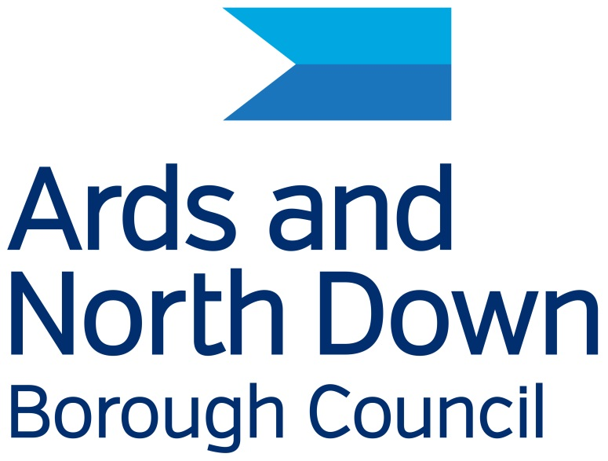

Ards and North Down Borough Council

Equality Action Plan

2026 - 2031

This Equality Action Plan can be obtained from the Council in
alternative formats and languages where a need is identified.
It may also be downloaded from the Council’s website at:
Equality

If you would like a copy in an alternative format, or have any queries, please contact:

Ards and North Down Borough Council

Compliance Officer (Equality and Disability)
City Hall, The Castle,
Bangor
BT20 4BT
Tel: 0300 013 3333 ext. 40114
E-mail: equalityanddisability@ardsandnorthdown.gov.uk

Contents
Purpose 4
Key aims and Objectives: 4
The Council – its role, functions and policies 5
Council responsibility 6
Public life positions over which the Council has responsibility 7
Effective implementation of the Equality Action Plan 7
Internal arrangements 7
Effective engagement 8
Annual report 8
Review of the Equality Action Plan 8
Consultation 9
Performance Indicators and actionable measures 9
Ards and North Down Draft Equality Action Plan 2025 - 2031 11

Purpose

The purpose of an Equality Action Plan is fundamentally rooted in the legal framework established by Section 75 of the Northern Ireland Act 1998. As part of their Equality Scheme, public authorities are expected to develop an Equality Action Plan. This plan details the specific actions the authority will take to address inequalities and promote equality of opportunity and good relations in relation to their functions. It is a commitment to fostering an inclusive society. This Equality Action Plan has been developed to align with the outcomes identified in the Ards and North Down Borough Council Corporate Plan.

Key aims and Objectives:

Promoting Equality of Opportunity:
The core aim is to ensure that the Council actively work towards creating equal opportunities for all individuals, regardless of their religious belief, political opinion, racial group, age, marital status, sexual orientation, disability, or whether they have dependants.

Fulfilling Legal Obligations:
Section 75 of the Northern Ireland Act 1998 places a statutory duty on public authorities to have "due regard" to the need to promote equality of opportunity. This Equality action plan serves as a practical tool to demonstrate how we are meeting these legal obligations.

Addressing Inequalities:
This plan aims to identify and address existing inequalities within Councils services and policies. Council have conducted an audit of inequalities and have developed specific actions to mitigate them.

Promoting Good Relations:
In addition to equality of opportunity, there's also a focus on promoting good relations between people of different religious beliefs, political opinions, and racial groups.

Providing a Framework for Action:
This Equality action plans offers a structured framework for Ards and North Down Borough Council to implement equality initiatives, monitor their progress, and ensure that equality considerations are integrated into our day-to-day operations.

Improving Service Delivery:
Ultimately, this equality action plan strives to improve the delivery of public services to ensure they are accessible and equitable for all members of society and are effectively mainstreamed within Council.

The Council – its role, functions and policies

The roles and functions of Councils fall within three types:

- Direct - the direct provision of a number of services and facilities including the promotion of the arts, tourism, community and economic development and the regulation and licensing of certain activities relating to environmental health, consumer protection and public safety
- Representative - a representative role on a number of bodies and boards including Education and Health as well as an advocacy role for the Borough
- Consultative - a consultative role in relation to functions conducted by other Government bodies and agencies on issues such as water, roads and housing and the promotion of the arts, tourism, community and economic development, the regulation and licensing of certain activities relating to environmental health, consumer protection and public safety.

In the performance of the above roles the Council carries out functions in the following areas: (This is not an exhaustive list)

Service provision:
The council is responsible for delivering essential local services, including:
* Refuse collection and waste management.
* Environmental services.
* Leisure and recreation facilities.
* Parks and Cemetries.
* Planning and building control.

Community Development:
The council works to promote community well-being and development,
supporting local initiatives and addressing community needs.

Economic Development:
It plays a role in fostering economic growth within the borough, attracting investment, and supporting local businesses.

Tourism:
Ards and North Down boast a beautiful coastline and rich heritage, and the council actively promotes tourism in the area.

Governance:
It is responsible for local governance, making decisions on local policies and managing council resources.

To enable the Council to provide the above services and perform its other functions it must levy an annual rate and has the power to: -
• acquire and dispose of land;
• borrow money;
• employ staff;
• procure goods and services.

Council provides its services through the employment of approximately 1000 employees who are full time, part time, permanent and casual employees.

To support and implement the above statutory functions and provision of services and facilities, the Council has adopted a number of policies. All policies are screened for impacts of S75 categories, Rural needs, Sustainability and Data Protection.

Council responsibility

Ards and North Down Borough Council has 40 councillors representing seven district electoral areas. These members provide leadership for Ards and North Down Borough Council. They represent the interests of their constituents and ensure the views of people across Ards and North Down are reflected in the council's decisions and how services are delivered.

Public life positions over which the Council has responsibility

The Council has responsibility over a number of public life positions i.e. committees in which members of the public participate. A full list of these positions is available on request.

Effective implementation of the Equality Action Plan

The Mayor and Chief Executive of the Council are dedicated to effectively implementing this plan and ensuring equality throughout the organisation. They will allocate all available resources—people, time, and finances—to achieve these goals.

As part of its corporate planning process, the Council will integrate objectives, target setting, and monitoring into relevant business plans. These will be reflected at all levels of the Council’s strategic planning, including individual staff objectives and annual plans. Progress towards meeting these objectives will be monitored and reported to the relevant managers and elected members every year. Individual performance in these areas will be reviewed through internal performance review processes.

A formal progress report on meeting objectives related to equality and disability duties will be included in the Council's Annual Report to the Equality Commission.

Internal arrangements

The Council consists of 40 elected representatives, each elected for a four-year period. A full list of the Council’s standing and sub-committees are available on the council’s website and are also available on request.

The Chief Executive oversees the work of the departments through the Corporate Leadership Team which, together with the Elected Members, create the corporate body of the Council.

The Chief Executive is the principal advisor to the Council and responsible for the strategic management of the organisation, for the day-to-day management of services and the longer-term planning and allocation of resources.

The departmental structure of Ards and North Down Borough Council is available on request and is subject to change.

The Chief Executive has overall responsibility for ensuring the effective implementation of this plan, with the support of the Corporate Leadership Team.

Responsibility for implementing, reviewing and evaluating this Equality Action Plan, and the point of contact within the Council is the Compliance Officer (Equality and Disability) – contact details can be found on page 2.

The Council offers public documents in various accessible formats, including large print, easy read, and audio, with options for translation into minority languages. Equality and disability documents are created in clear Arial Font size 14. Information is accessible through the ReachDeck facility, and translators or sign language interpreters are provided at meetings as needed. Loop systems are available in Bangor City Hall and some other facilities, while a British Sign Language interpreting service provides instant access to online interpreters for Deaf or hearing-impaired customers.

Every council employee and member of a Council Body or Panel, including the Policing and Community Safety Partnership, Community Planning Partnership, and Peace IV Partnership, has a responsibility to uphold equality duties. All employees and elected members receive training on relevant legislation and are accountable for ensuring that the Council meets its obligations. It is essential that they avoid any inappropriate actions that could lead to a failure in these duties.

Effective engagement

The Council is committed to engaging with stakeholders and representative groups in drafting, implementing, monitoring, and reviewing this Plan.

Annual report

The Council will prepare an annual report outlining its progress in implementing the equality scheme and the Disability Action Plan. This report will be submitted to the Equality Commission. A copy of the annual report will also be available on the Council’s website.

Review of the Equality Action Plan

The Council will conduct a four-year review of its plan. After it is ratified by Ards and North Down Borough Council, the review will be submitted to the Equality Commission for Northern Ireland.

This Equality Action Plan has been created to align with the seven outcomes identified in the Corporate Plan and to further our equality duties.

Consultation

The Council is dedicated to meaningful consultations in developing its Equality Action Plan over 12 weeks, engaging key stakeholders and service users. Comments and suggestions will be incorporated into the Plan. To ensure public involvement, the Council will work with representative groups and meet with individuals upon request.

The Equality Action Plan will be advertised on the Council's website and social media. The Council will collaborate with groups to ensure clear communication and accessibility, acknowledging that individuals may face different barriers. The Plan will be promoted through various channels, and requests for minority language versions will be addressed as needed. Employees will also be informed about the Plan and their roles in fulfilling the Council's obligations.

Performance Indicators and actionable measures

The Council is committed to monitoring and reviewing policies and practices to ensure the disability duties are met. This process is undertaken through the policy making and screening processes.

The Council will undertake a review of this plan on an annual basis. This review process assists in the drafting of appropriate actions and performance targets for the next period, as well as highlighting the achievements from the period of the annual review.

The table in Appendix 1 outlines the measures and performance indicators which the Council proposes to undertake between 1 April 2025 and 31 March 2031 in order to fulfil its statutory obligations.

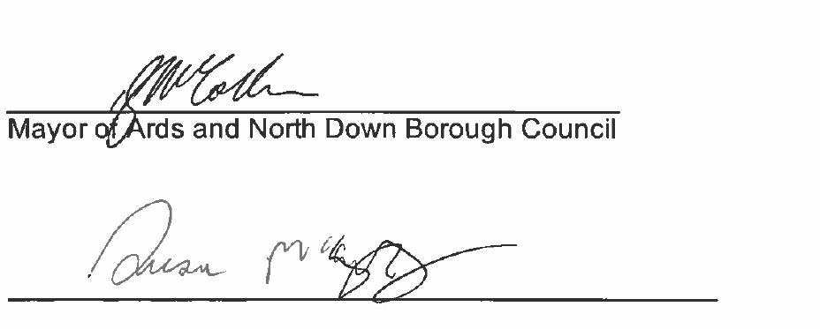__________________________________________
Chief Executive Ards and North Down Borough Council

Date ____10/4/2026_______________________

Ards and North Down Draft Equality Action Plan 2025 - 2031
1. We have an engaged Borough with citizens and businesses who have opportunities to influence the delivery of services, plans and investment
We will commit to: | Outcome/Impact | We will know we have been successful by:
1.1 Addressing digital exclusion and engage with those who experience difficulty in accessing our services and facilities  Section 75 category affected:  Age  Dependants  Disability | 1. Identify and continue to engage with underrepresented categories. Though Disability forum, over 50s forum, consultative panel, age friendly alliance. | Ensure that all Council information and services—particularly digital content—meet the accessibility standards set out in the Public Sector Bodies (Websites and Mobile Applications) (No. 2) Accessibility Regulations 2018, and that any accessibility issues identified through the Government Digital Services (GDS) audit are corrected.  CO (E&D)
 | 2. Monitor the Councils Digital by Default Policy to ensure this will not exclude those without digital access and those that require support to enable them to benefit from the information available. | Ensuring traditional channels (phone, in person) remain available for those who cannot or prefer not to use digital services.  Communications / Performance & Improvement
1.2 Provide access to Council information and services in suitable formats/languages  Section 75 category affected:  Age  Dependants  Disability  Political  Opinion  Race | 1. Provide accessible channels of Communication to reflect the diverse needs of stakeholders. | Increase in those using ReachDeck, service monitor and assessing accessibility to the Councils websites based on good practice guidelines.  Communications / Compliance (E&D)
 | 2.Identitify target languages through analysing service usage | Increase Sign Video in all Council Buildings. Monitor the usage per identified location for BSL SignVideo.  Communications / Compliance (E&D)
Increase in translation software and translation services.
Communications / Compliance (E&D)
1.3 Increase younger demographic (16-34) engaging with Council consultation.  Section 75 category affected:  Age  Dependants  All | 1.Utilising Social media platforms for consultation and information sharing, create engaging campaigns to encourage participation. | Stereotypes to be broken down to make sure services are accessible and inclusive of all age groups.  Evidence of increase in 16-34 engagement.  Communications / Performance & Improvement
 | 2.Implement an all-Council Consultation list, to include all section S75 categories | Recruit and retain younger members for Consultative Forum  CO (E&D) / Good Relations
1.4 Promote services to empower customers and employees with disabilities who need reasonable adjustments to fulfil their needs.  Section 75 category affected:  Disability  Age | 1. All employees are required to participate in training that addresses the concerns of individuals with disabilities and their caregivers, as well as the effects on access to Council services. | Provide mandatory awareness training in a range of identified disabilities for all Customer Service employees, and employees dealing with the public and those with line management responsibility.  HR / CO (E&D) / A&HC / P&P / All Directorates that provide frontline services
 | 2. Identify and take action to remove barriers that prevent individuals from fully participating in Council activities, services, and public life. | Undertake an Audit of Walkability events to include Disability and Age awareness.  Human Resources / CO (E&D) / A&HCand Place directorates / All Directorates that provide frontline services
 | 3. Make necessary adjustments to ensure that the workplace and services are accessible to all users based on their needs, while considering any potential restrictions or changes in operations. | Raise awareness of hidden disabilities and the initiatives that help, such as the Jam Card and Sunflower lanyards  Human Resources / CO (E&D) / A&HCand Place directorates / All Directorates that provide frontline services
 | 4. Record and monitor customer comments and complaints in relation to access to Council services and information and put in place corrective action where appropriate. | 100% of Complaints in relation to Access resolved at stage 1  Human Resources / CO (E&D) / A&HCand Place directorates / All Directorates that provide frontline services
- We have a thriving and sustainable economy
We will commit to: | Outcome/Impact | We will know we have been successful by:
2.1 Working with specifics groups and employers to encourage work placements for the unemployed.  Section 75 category affected:  Age  Dependants  Disability  Sex  Race | Work collaboratively with statutory, voluntary and community organisations to assess need and improve local labour market conditions. | Successfully navigate and adapt to the evolving landscape of employability provision, enhancing support for job seekers while also meeting the needs and expectations of employers.  Increase number of annual work placements.  Labour Market Partnership (LMP)
2.2 Economic development programmes will be accessible to everyone regardless of background.  Section 75 category affected:  All | Supporting businesses owned by individuals from underrepresented groups and addressing potential disparities. | Reduce disparities by targets resources and support to those areas of need.  Economic Development
Implementing funding opportunities for local business.
Economic Development
- We have a vibrant, attractive, sustainable Borough for citizens, visitors, businesses and investors
We will commit to: | Outcome/Impact | We will know we have been successful by:
3.1 Collaborating with diverse stakeholders to enhance the well-being of our residents and visitors, fostering the ongoing growth and success of our rural community.  Section 75 category affected:  All | Ensuring regeneration efforts are aligned with local needs and are designed to be sustainable in the long term. | Successfully securing funding and implementing capital and revenue projects that contribute to the development and enhancement of vibrant and thriving villages within the Borough.  Rural Regeneration Team
3.2 Ensuring family friendly toilets are available to ensure Families can enjoy and make use of Councils Green/Blue spaces  Section 75 category affected:  Age  Dependants  Disability  Sex  Marital Status | Desktop study and consultation to identify possible sites and implement family friendly toilets. Ensuring family friendly toilets are incorporated into all new Flagship projects. | Family friendly toilets are established in blue/greenspaces.  Assets and property / Regeneration Team
3.3 Increased engagement and usage with green and blue spaces.  Section 75 category affected:  All | Encourage participation in outdoor experiences, ensuring that sustainability makes a positive contribution to all communities. | Develop sustainable tourism and events to be inclusive of S75 Categories.  Assets and property / Regeneration Team
Audit of activities accessible to disabled people.
Assets and property / Regeneration Team
- We have socially sustainable communities that are safe and welcoming
We will commit to: | Outcome/Impact | We will know we have been successful by:
4.1 Increased engagement between communities in relation to minority communities.  Section 75 category affected:  Political Opinion  Race  Religious Belief | Discuss and address issues related to racism and sectarianism. | Meeting the aims of the Community Development and Good Relations Strategies as well as meeting the needs identified through the PeacePLUS partnership and PCSP.  Good Relations / Community development, Peace IV and good relations.
 | Engage with service users and non-service users to identify programmes that will meet their specific needs
4.2 Implement the Ending Violence Against Women and Girls (EVAWG) Strategic Framework  Section 75 category affected:  Age  Dependants  Disability  Sex  Marital Status | Comprehensively tackle all forms of gender-based violence, abuse, and harm that disproportionately affect women and girls, addressing the underlying issue of gender inequality | Successful implementation of the change Fund to help to mobilise grassroots action, support innovative delivery, and maximise the impact of community-led initiatives that contribute to the prevention outcomes of the EVAWG Strategic Framework.  PSCP
 | Partner with local organisations and to deliver the Momentum Programme, a transformative initiative aimed at equipping local organisations to participate in the Change Fund
- We have active and healthy people
We will commit to: | Outcome/Impact | We will know we have been successful by:
5.1 Maintain and promote accessible beach facility at Groomsport.  Section 75 category affected:  Age  Dependants  Disability  Gender | Work in partnership with Mae Murray Foundation to promote use of beach and toilet facilities at Groomsport. | Increase participation of beach amenities to enable families and groups to have a shared experience on the sand.  Community and Wellbeing
5.2 Establishing Friends' Groups across Ards and North Down Borough Council.  Section 75 category affected:  All | Support friends' groups to enhance local parks and green spaces | Enhanced community engagement and environmental advocacy.  Local perspectives are represented, fostering a stronger sense of community involvement.  Parks and Cemeteries
5.3 Ensuring that all groups have the opportunity to participate in various leisure activity programs, removing any barriers that may prevent their involvement.  Section 75 category affected:  All | Proactive approach to promote, engage and target underrepresented groups, ensuring that their specific needs are met and that they have access to meaningful recreational opportunities. | Successful identification of under-represented groups / individuals experiencing barriers to access, leading to the development of tailored / inclusive leisure programs.  Leisure Services
- Maintaining an Age Friendly Borough A place where people of all ages can live healthy, active lives, treated with respect. A community where they can remain in their homes, engage in valued activities, and contribute for as long as possible.  Section 75 category affected:  All | Continue to deliver the Age Friendly Strategy and Action Plan specifically aimed at Enhanced Community Engagement, Improved Accessibility, Support Services Expansion, Health and Wellbeing Initiatives, Intergenerational Programs, Community Awareness and Advocacy, Collaboration with Stakeholders | Information will be collected from lead partners to measure the impact of the actions have and an annual report published on the findings.  Community Planning and Environmental Health
Ards and North Down Borough Council is a high performing organisation
We will commit to: | Outcome/Impact | We will know we have been successful by:
6.1 Equality of opportunity and good relations is promoted at strategic levels within Council.  Section 75 category affected:  All | Continue to S75 screen 100% of policies, to ensure equality of opportunity and good relations are considered | Equality and Good relation screening of all new and revised policies/initiatives at draft and final stage of policy development process  CLT, HOST and SUM
 |  | Continue to host Internal Screening Panel and external Consultative Panel meetings. Elected members invited to Consultative panel annually CLT, HOST and SUM
Review Policy Development Process to include monitoring, review and recording of all live polices on SharePoint.
CLT, HOST and SUM
6.2 Raise the profile of  underrepresented Section 75  Groups (and other protected groups) within the district.  Section 75 category affected:  All | Implementation of targeted events and initiatives effectively addresses the specific needs and challenges faced by Section 75 Groups, fostering greater awareness and support for these individuals and communities. | Host or promote 3 annual events celebrating the diversity of the area Eg. Shared Voices, Holocaust Memorial Day, No hate here  Corporate Communications / CO (E&D)  / Good Relations
6.3 Circulation and workplace areas to be shared spaces for all users.  Section 75 category affected:  All | Conduct a cataloguing exercise of all display assets in Council buildings as part of the broader asset cataloguing exercise connected with the Civic Building move. | There will be a catalogue of all display assets.  Head of Corporate Governance  There will be a plan for retention of assets as part of process to move to new civic building in conjunction with Elected Members.  Head of Corporate Governance/ Elected members
 | Agree a plan for retention of assets as part of process to move to new civic building in conjunction with Elected Members.

