ARDS and North Down Borough Council

A hybrid meeting of the Environment Committee was held at the Council Chamber, Church Street, Newtownards, and via Zoom, on Wednesday 4 March 2026 at 7.00 pm.

Present:

In the Chair: Councillor Kendall

Aldermen: Adair McAlpine
Cummings

Councillors: Ashe Douglas
Boyle Edmund
Blaney Harbinson
Brady Newman
Cathcart Wray

Officers in Attendance: Director of Environmental Services (G Bannister), Head of Parks and Cemeteries (S Daye), Head of Waste and Cleansing (K Patterson), Head of Estates (P Caldwell) and Democratic Services Officer (H Loebnau).

1. APOLOGIES

The Chair sought apologies and those were noted from Alderman Armstrong-Cotter and Councillor Irwin.

NOTED.

2. Declarations of Interest

The Chairman sought Declarations of Interest and none were noted.

NOTED.

3. Annual Service PLANS 2026-27

PREVIOUSLY CIRCULATED:- Report from the Director of Environmental Services detailing that Members would be aware that Council was required, under the Local Government Act 2014, to have in place arrangements to secure continuous improvement in the exercise of its functions. To fulfil that requirement Council had in place a Performance Management Policy and Handbook. The Performance Management Handbook outlined the approach to the Performance Planning and Management process as:

- Community Plan – published every 10-15 years
- Corporate Plan – published every 4 years (Corporate Plan 2024 - 2028 in operation)
- Performance Improvement Plan (PIP) – published annually
- Service Plan – developed annually
The Council’s 16 Service Plans outlined how each respective Service would contribute to the achievement of the corporate objectives including, but not limited to, any relevant actions identified in the PIP.

Plans were intended to:
- Encourage compliance with legal, audit and operational context.
- Provide focus on direction.
- Facilitate alignment between Corporate, Service and individual plans and activities.
- Motivate and develop staff.
- Promote performance improvement, encourage innovation and share good practice.
- Encourage transparency of performance outcomes.
- Better enable us to recognise success and address underperformance.

Key Issues
Any key issues that the Service may face in 2026/27 had been detailed within the attached Service Plans.

Next Steps
Attached were the 2026/27 Service Plans for Estates Services, Parks and Cemeteries and Waste and Cleansing in accordance with the Council’s Performance Management Policy and Handbook for Members consideration and approval.

Summary
The attached Plans:
- Had been developed to align with the objectives of the Big Plan (2017 – 2032) and the Corporate Plan 2024 – 2028 and had been developed in conjunction with staff, officers and management, and in consultation with key stakeholders where relevant.
- Set out the objectives for the Services for 2026-27 and identified the key performance indicators used to illustrate the level of achievement of each objective, and the targets that the Service would try to attain along with key actions required to do so.
- Were based on the agreed budget. It should be noted that, should there be significant changes in-year (e.g. due to Council decisions, budget revisions or changes to the PIP), the Plans may need to be revised.
- Would be reported to the Committee on a six-monthly basis as undernoted.

Reference | Period | Reporting Month
Half Yearly 1 | April – September | December
Half Yearly 2 | October – March | June

RECOMMENDED that the Council approves the attached Service Plans for 2026-27.

3.1 Estates Service
(Appendix I)

PREVIOUSLY CIRCULATED: Estates Service Plan 2026-27.

RECOMMENDED that the Council approves the attached Service Plan for 2026-27.

Proposed by Councillor Wray, seconded by Councillor Harbinson, that the recommendation be adopted.

Councillor Wray was happy with the three priorities in the Plan, economic, environmental and social and thought it was important to strike the correct balance between those. He asked how the seven outcomes were being achieved and the Director informed him that was demonstrated in the six monthly reports that had been produced in the past and would be produced going forward.

AGREED TO RECOMMEND, on the proposal of Councillor Wray, seconded by Councillor Harbinson, that the recommendation be adopted.

3.2 Parks and Cemeteries
(Appendix II)

PREVIOUSLY CIRCULATED: Parks and Cemeteries Service Plan 2026-27.

RECOMMENDED that the Council approves the attached Service Plan for 2026-27.

Proposed by Alderman Adair, seconded by Alderman Cummings, that the recommendation be adopted.

Alderman Adair commended the parks and cemeteries team and, in particular, the Head of Parks and Cemeteries for the work that had been done and the increased maintenance that had been evident over recent years and looked forward to even greater success in the years to come.

Councillor Wray raised a finding, which had been highlighted in a University of Leeds report, that skateparks and MUGAs were predominantly used by males. He asked what those spaces could look like if the Council wished to increase participation by women and girls.

The Head of Parks and Cemeteries reported that officers had been considering the matter for some time. He outlined proposed initiatives such as Spark Here events which were scheduled to run from March this year to June, which were funded projects aimed specifically at encouraging women and girls to take part. He confirmed that those considerations would be incorporated into forthcoming projects and that the service was fully committed to making facilities more accessible and welcoming for women and girls.

The officer advised that a full report would be brought to the Committee in September, detailing the work already undertaken and planned future actions.

AGREED TO RECOMMEND, on the proposal of Alderman Adair, seconded by Alderman Cummings, that the recommendation be adopted.

3.3 Waste and Cleansing Services
(Appendix III)

PREVIOUSLY CIRCULATED: Waste and Cleansing Service Plan 2026-27.

RECOMMENDED that the Council approves the attached Service Plan for 2026-27.

Proposed by Alderman Adair, seconded by Councillor Cathcart, that the recommendation be adopted.

Alderman Adair paid tribute to the Waste and Cleansing team, noting that it had continued to work in all weather conditions and had demonstrated consistent perseverance and dedication. He also highlighted the difficulties experienced during storm conditions, when high winds had blown over bins left out for collection resulting in littered streets. He asked if, during severe weather and particularly on blue bin weeks, the Council could issue advance warnings that bins would not be collected the following day.

The Director acknowledged the points raised and explained that weather warnings were issued at yellow, amber and red levels. The recent incident the Member was referring to had involved an amber warning, and under such circumstances the Council had been unable to take an earlier decision. However, he stated that the intention was always to make early determinations with the information available.

The Head of Estates received praise also for the maintenance team’s responsiveness when required and appreciated that a bigger budget would have enabled them to do more.

A query was raised regarding the proposed trial for the recycling of soft plastics which remained on hold subject to funding. The Director advised that the Waste Working Group would meet at the end of the month and that a report would be brought later in the year in respect of that matter, noting that legislative changes relating to soft plastics were forthcoming and required first.

The Chair noted the update and looked forward to receiving the report in due course.

AGREED TO RECOMMEND, on the proposal of Alderman Adair, seconded by Councillor Cathcart, that the recommendation be adopted.

4. NOTICE OF MOTION 670 Recycling on the go pilot

PREVIOUSLY CIRCULATED:- Report from the Director of Environmental Services detailing that a Notice of Motion (NOM 670) was agreed at Environment Committee in June 2025. The NOM stated, ‘This Council is pleased with the recycling rates for waste that have been achieved in the Borough, however there are currently limited facilities to recycle litter. This sends out a poor message to our residents and visitors. This Council asks that officers bring back a report that explores how, and when recycling litter bins could be introduced to the Borough. Indication of costs should be included.’

Facilitating sustainable practices was a priority for Ards and North Down Borough Council. That included providing opportunities for residents, employees at work, and visitors to recycle packaging and food waste at home, at work, and at many Council premises.

For household recycling, the Council provided a comprehensive waste and recycling service. That included kerbside collections, bring banks and HRCs. Household recycling performance was 56.1% in 2024/25 and exceeded 60% in the first half of 2025/26.

For businesses and other non-household organisations, the Council had a statutory duty to provide a commercial waste collection where this service was requested. It was Council policy to require its commercial waste service customers to also separate recyclable materials for collection.

There were fewer opportunities for residents and visitors to recycle items outside the home or workplace. The proposed pilot scheme would seek to improve recycling opportunities for people ‘on the go’ particularly those making use of our public parks.

Aim of the trial
To extend recycling opportunities to residents and visitors of Ards and North Down’s public parks and to measure the effectiveness of the scheme infrastructure, communications, and user satisfaction.

Existing good practice
The design and execution of the Ards and North Down ‘Recycle on the Go’ (RoTG) pilot would benefit from similar initiatives across the UK and Ireland. WRAP guidance was published in 2012, and Belfast City Council recently completed a similar on-street recycling trial with environmental charity, Hubbub. The AND pilot would employ insights from those schemes, including:

- The use of highly visible recycling bins
- Clear and specific messages on target materials, i.e. plastic drinks bottles and metal drinks cans
- Use of bold images and iconography
- Clarity on non-target items, eg. coffee cups, liquids

The scope of the AND RoTG pilot had yet to be finalised but would draw from existing good practice.

The pilot scheme
The project would be led by a cross-service team in both Parks and Cemeteries Service and Waste and Cleansing Services. A project manager would be identified from the Council’s recycling officers. The project team would include close engagement with the Council’s Communications team. It was anticipated that joint learning from this pilot would inform potential extension of this initiative beyond Council parks.

The Council proposed a phased introduction of new recycling bins, with a pilot exercise in Ward Park and Council-managed bowling greens. The containers would be co-located with litter bins in areas of high footfall so that visitors could dispose of rubbish and recycling conveniently at one location. The accessibility of the recycling bin would also eliminate a physical barrier to recycling. Co-located bins would also maximise capture of recyclables and minimise contamination.

The scheme would target two key material streams – plastic drinks bottles and metal drinks cans. Those two material streams were recyclable at the kerbside and commonly used by people when out and about. Provision of a recycling container would positively reinforce recycling behaviours and divert additional recyclables from disposal.

A recent successful pilot by Belfast City Council and environmental charity, Hubbub, found that the RoTG recycling comprised almost 50% by weight of target material. The trial found that contamination levels were low enough that the recycling could be sent for reprocessing.

The Ards and North Down pilot would follow the same approach as the Belfast pilot. It would ensure that the containers were clearly labelled with both materials iconography and wording to make targeted recyclable materials clear. That would reduce confusion and contamination. Examples of clearly labelled RoTG containers were shown below.

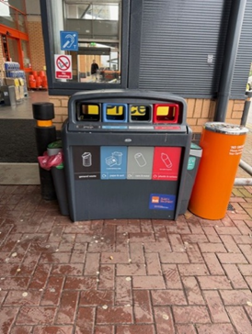
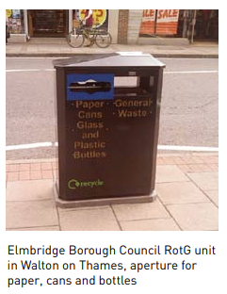
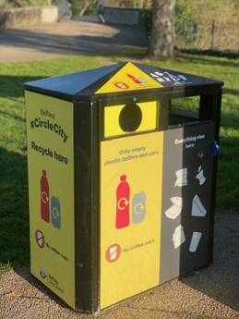
Images (left to right): Victoria Park, Belfast; B&Q Holywood Exchange; and Elmbridge BC (from WRAP’s ‘Recycle on the Go’ guidance (2012)

Cost of delivering the RoTG pilot
A budget of £45k had been identified to support the delivery of the pilot. That included £15k capital funding of the new recycling bins and £30k revenue for communications, operations, and project evaluation.

The trial would target key packaging materials for recycling. For that reason, it was possible to cover the costs of delivering the RoTG trial with funding received from the Extended Producer Responsibility (EPR) scheme.

Monitoring and evaluation of the pilot
The evaluation of the pilot scheme would include:

- Public engagement with AND messages and communications, e.g. Council website and social media channels
- Waste composition analysis to measure the quantity and types of target and non-target material captured
- User satisfaction survey
- Net costs or savings of delivering the pilot scheme

A project report would be brought to the Environment Committee at the end of the trial period.

RECOMMENDED that the Council approves to proceed with a trial as set out in this report.

Proposed by Councillor Harbinson, seconded by Councillor Cathcart, that the recommendation be adopted.

Councillor Harbinson referred to the pilot scheme and enquired about the duration of the trial. The Head of Parks and Cemeteries advised that the pilot would run for a six‑month period at bowling greens and Ward Park after which there would be an opportunity to review the outcomes and begin the process of wider rollout based on the lessons learned.

Councillor Cathcart welcomed the increase in recycling, noting both the environmental benefits and the potential savings to the ratepayer. He referred to positive results from similar trials in Belfast and expressed hope that the initiative would encourage behavioural change, particularly around “on‑the‑go” recycling. He commented that residents already recycled well at the kerbside and emphasised the importance of communication to highlight that recycling both saved money and benefited the environment. He stated that while progress had been made, further improvement was still required, and he looked forward to the results of the pilot, which he found encouraging.

AGREED TO RECOMMEND, on the proposal of Councillor Harbinson, seconded by Councillor Cathcart, that the recommendation be adopted.

5. PLAY PARK REFUBISHMENTS AND OLDER CHILDREN PLAY PROVISION FOR 2026/27

[Please note amendment agreed at Council dated Wednesday 25th March 2026]

PREVIOUSLY CIRCULATED:- Report from the Director of Environmental Services detailing that the Ards and North Down Borough Council’s Play Strategy (2021–2032) promoted the modernisation of local play areas. Under the Strategy, sites were prioritised within the Annual Independent Inspectors Report, supplemented by local knowledge and insight, and in accordance with the budget made available.

Furthermore, the agreed Strategy included a settlement hierarchy approach to fund provisions for older children, such as skate parks, pump tracks, and Multi-Use Games Areas (MUGAs).

To ensure high standards, the Council employed expert contractors who adhered to specific design criteria, including age-appropriate equipment ratios and a minimum of 30% inclusive equipment. All projects complied with British and European safety standards. Rigorous oversight was provided by an independent inspector accredited by the Register of Play Inspectors International (RPII), ensuring all assessments remained objective and professional.

2025/2026 Financial Year
To date in 2025/2026 the following play parks had been completed:

- Seafront Play Park, Groomsport

The following facilities were due for completion by the end of March 2026:

- Northfield Play Park, Donaghadee
- Island View Play Park, Greyabbey
- Moss Road Multi Use Games Area, Ballygowan

An agreed Multiuse Use Games Area (MUGA) for older children’s play at Seapark, Holywood had been delayed due to the requirement to submit a Certificate of Lawful Use/Development to the Planning Department and a determination was awaited for that. It was expected that the budget earmarked for the project could be accrued into the 2026/27 Financial Year if required.

As in all previous years from 2015, sourcing of external funding would continue to be explored by officers for future play park developments.

Key Issues

- Older Children Facilities in 2026/27
1.1 If a Certificate of Lawful Use was approved then the MUGA at Seapark would be delivered.
1.2 The next location identified for an older children’s facility, based on the settlement hierarchy approach outlined in the Play Strategy, was Portaferry. It was envisaged that the location would be adjacent to the play park at Cloughey Road. A public consultation would be carried out to ascertain what type of older children’s facility the local teenagers and wider community would like to see delivered.
  - Members would also be aware that, through Peace Plus funding, a Pump Track was due to be delivered this year at The Commons, Donaghadee and a Pump Track element (along with other cycling facilities) would be delivered at Sportsplex, Bangor. It was proposed to install a youth shelter (£15,000) adjacent to the new pump track at The Commons, Donaghadee.

  - It was further proposed to install a basketball area (£15,000) to the rear of the tennis pavilion in Ward Park, Bangor, as that was a significant request raised through the public consultation, carried out as part of the wider Ward Park redevelopment project. The associated cost included the need for some groundworks and resurfacing of the area.

- Play Parks in 2026/27
The budget available for play park refurbishments for the 2026/27 Financial Year was £1,125,000. The refurbishment approach outlined below, while taking cognisance of the Independent Inspector’s scores, attempted to use the available budget in a targeted approach to ensure a fair spread of investment across the Borough, especially those areas that had not received investment in the recent past.

Members should be aware that the relative prioritisation between sites could change each year, for example the rate of deterioration of facilities could vary due to amount of use and/or location.

Based on the evidence from the Independent Inspector’s Report and supplemented by local knowledge and insight it was recommended that the following Play Parks were proposed for refurbishment.

- Tullymally, Portaferry
- Sportsplex, Bangor
- Glenford, Newtownards
- Skipperstone, Bangor
- Main Street, Ballyhalbert (currently a Tier 2 will be upgraded to a Tier 1)
- Ballywalter Road, Millisle (Tier 1)

Next Steps
It was proposed that Council proceeded to deliver the following play parks and older children provision based on the Independent Inspector’s report on need and officers’ input to ensure a fair distribution across the Borough and within available budget.

Summary
Recommended Play Park Refurbishments proposed based on the independent report and officers’ input:

- Tullymally, Portaferry (Tier 3) £85,000
- Sportsplex, Bangor (Tier 2) £170,000
- Glenford, Newtownards (Tier 2) £170,000
- Skipperstone, Bangor (Tier 2) £170,000
- Main Street, Ballyhalbert (currently a Tier 2 will be upgraded to a Tier 1) £250,000
- Ballywalter Road, Millisle (Tier 1) £250,000

Older Children Play Provision Proposed
- An older children facility would be delivered at Cloughey Road, Portaferry, £200,000.
- A youth shelter adjacent to the new pump track at Donaghadee, £15,000
- A basketball area to the rear of the tennis pavilion building in Ward park (partial MUGA), £15,000.

RECOMMENDED that the Council approves the delivery of play refurbishments as detailed in this report.

Proposed by Alderman Adair, seconded by Councillor Cathcart, that the recommendations outlined in the report are accepted except that that officers bring back a report to next month’s committee to consider replacing the Glenford Play Park with the Abbot Gardens Play Park for refurbishment for 2026/27.

Alderman Adair explained that he would make his own comments first and then read those remarks that Alderman McIlveen had submitted directly to him. He stated that he welcomed the report but believed that the Council was still not investing enough in the Borough’s play parks, noting strong public demand for improved facilities. He welcomed planned upgrades for Ballyhalbert, Millisle and Tullymalley, and the consideration of provision for older children in Portaferry and urged officers to maintain or increase the budget for these.

Speaking on behalf of Alderman McIlveen, he referred to the December report linking Glenford Play Park to the Translink Park and Ride project. He noted that Bowtown had originally been a low score within the Borough’s playparks being next in the list but had since been overtaken by other sites while being considered unfit for purpose. He understood that funding for the future development of Glenford Play Park was expected to come from the sale of the former Newtownards Leisure Centre site and asked Members to support an amendment to pause the decision for one month to explore whether Council funding could be made first to the Park at Bowtown noting that Translink had not yet submitted its application and progress was not imminent.

Councillor Cathcart supported the amendment, emphasising that it did not remove funding from Glenford but would direct current budgets to Bowtown instead. He reported that he had previously raised safety concerns about Skipperstone Play Park in terms of enclosing it for safety and the Director confirmed that fencing formed part of the upgrade proposed. The Member was pleased to hear that and praised the overall quality of the Council’s play parks.

Councillor Wray asked about funding the playparks and the Director confirmed that the Council was due to receive a significant receipt from the sale of land to Translink. The Member expressed sympathy for the amendment that had been brought but explained that he was generally not supportive of frequent amendments in relation to play parks but that he did welcome the report.

Councillor Boyle opposed the amendment, and explained that the Council had commissioned an independent report to ensure fairness across the funding process and should not deviate from that and described the report as excellent.

Councillor Douglas supported the amendment and asked for an update on progress at the Moss Road MUGA in Ballygowan. She was informed that that park was expected to be completed before Easter 2026.

Other Members shared concern in relation to the amendment including Alderman McAlpine and Councillor Brady and could not support it. Councillor Brady stated how it was disconcerting that so many departments were involved in delivering playparks. The Chair welcomed the increased budget and the progress being made in developing excellent parks and Councillor Edmund welcomed the inclusion of Ballyhalbert, noting the significant population growth in that village.

In summing up, Alderman Adair reiterated that the Council was not strictly following the independent report alone as shown with that of Ballyholme which was a very low scoring site but would be funded separately under funds from City Deal. He stressed that the amendment would not delay any scheme but would allow the Council to gather full information. He went on to say that both Glenford and Bowtown were in Newtownards, and he urged Members to support a short pause while requesting a recorded vote.

Before the vote was taken the Director confirmed that only one Council directorate was concerned with delivering these playparks and the Council was due to receive a substantial sum equivalent to the value of the land sale as advised by its valuer which it could allocate how it wished within its funding policies.

On being put to the meeting with 5 voting FOR, 7 voting AGAINST, 2 ABSTAINING and 2 ABSENT, the amendment FELL.

The voting was as follows:

FOR (5) | AGAINST (7) | ABSTAINED (2) | ABSENT (2)
Aldermen | Alderman | Councillors | Alderman
Adair | McAlpine | Brady | Armstrong-Cotter
Cummings  Councillors | Councillors  Ashe | Kendall | Councillor  Irwin
Cathcart | Blaney
Douglas | Boyle
Edmund | Harbinson
 | Newman
 | Wray

Alderman Adair was disappointed but thought that Alderman McIlveen might raise the matter again at full Council and welcomed investment for all the Borough’s playparks.
AGREED TO RECOMMEND, on the proposal of Alderman Adair, seconded by Councillor Wray, that the recommendation be adopted.

6. ON STREET RESIDENTIAL CHARGING SCHEME Update

PREVIOUSLY CIRCULATED:- Report from the Director of Environmental Services detailing that Members would be aware that the Council was participating in the “On Street Residential ChargePoint Scheme” (ORCS). The scheme was 75% funded by the “Office for Zero Emission Vehicles” (OZEV) with 25% match funded by the Department for Infrastructure (DfI). The project had been progressed by the EV consortium, led by Derry City and Strabane District Council.

The Council agreed the tender for the Supply, Installation, Operation and Maintenance of Electric Vehicle charge points for the NI Electric Vehicle Consortium to Weev in February 2025, and the Concession Agreement was signed at its meeting in on 31 January 2026.

Charge Point Locations
The charge points would be positioned in a range of locations that were in ‘close proximity to a residential area’, as the aim of the scheme was to benefit homes without driveways/off-street parking.

The EV Chargers for the Ards and North Down Borough Council area, as previously agreed, were in the following car parks:

Holborn Square, Bangor (2 charge points)
Bingham Lane, Bangor
Ann Street, Newtownards (2 charge points)
Kennel Lane, Newtownards (2 charge points)
West Street, Newtownards
Mill Street Gasworks, Newtownards (2 charge points)
Church Road, Holywood (2 charge points)
Meeting House Street, Portaferry

Due to NIE connection issues the following ChargePoint locations had been amended:

- Central Avenue, Bangor moved to Abbey Street East, Bangor.
New location was 300 metres (4-minute walk) from original location and serviced the same homes as the original location.

- Manor Street, Donaghadee moved to The Harbour Car Park, The Commons, Donaghadee.
New location was 180 metres (2-minute walk) from original location and serviced the same homes as the original location.

Next Steps
Officers were currently working with Weev to carry out the preparatory works and provide the necessary permissions to allow charge points to be installed in Spring 2026.

When a “live” date for the charge points became available, officers would ensure there was appropriate communication with residents to raise awareness of the charge points.

Once operational, officers would monitor usage of those charge points to better inform any future strategy relating to EV charging across Ards and North Down.

RECOMMENDED that the Council agrees the two alternative locations as identified in this report.

Proposed by Councillor Cathcart, seconded by Councillor Brady, that the recommendation be adopted.

Councillor Cathcart was happy with the alternative sites and believed that the Council should absolutely target and accept any funding available but considered that the matter needed a wider and more focused strategy. The Head of Estates said he would report back to the Committee on any progress that could be made.

Councillor Douglas congratulated Comber Recreational Football Club which had, to her knowledge, been the first sports ground in Northern Ireland to have installed double electrical vehicle points on its property. Councillor Boyle agreed and praised the Club. He referred to some charging points which appeared to be defunct in the car park at Exploris, and some around the Meeting House in the town and asked if work on that could be done in 2026. The Head of Estates replied that Council did not own those but hoped that there would be a further roll out of charging points in the future. Councillor Boyle thanked the officer for the good work to date and the Chair of the Committee concluded by stressing the need for more charging points generally.

AGREED TO RECOMMEND, on the proposal of Councillor Cathcart, seconded by Councillor Brady, that the recommendation be adopted.

7. Estates carbon reduction targets

PREVIOUSLY CIRCULATED:- Report from the Director of Environmental Services detailing that Members would be aware that the Climate Change Act 2022 imposed mandatory reductions in our carbon emissions with a target of 48% reduction over baseline data by 2030 and 100% by 2050.

Officers had since developed a number of Policies and Strategies in order to meet those targets, including:

- Sustainable Energy Management Strategy and Action Plan
- Roadmap to Sustainability
- Roadmap to Green Fleet
- Sustainable Waste Resource Management Strategy
- Climate Action Plan
- Climate Adaptation Plan
- Corporate Plan

Performance Targets
In order to help us meet those targets, officers would propose to implement a series of strategic annual targets, or milestones, that would help the Council monitor progress toward the longer term (2030) target.

Those milestones had been developed by calculating the carbon savings associated with the implementation of the energy saving initiatives highlighted within the Sustainable Energy Management Strategy’s Action Plan. An updated Action plan was presented to the Council each quarter, as part of the Sustainable Energy Management Plan update. The projects therefore which would deliver on the carbon reduction target for 2026/2027 in the table below, were listed in report item 11 (Appendix 1).

Naturally, the carbon reductions would only be possible if ALL the proposed projects were completed and it assumed that the required ongoing budget would be available. Existing annual budgets included a considerable amount for those projects (£500k per year) and that would need to be retained or expanded in future years in order to deliver the projects.

Year | Target Reduction over baseline emissions | Budget Required
2025-2026 | 15% | £500k
2026-2027 | 16% | £650k
2027-2028 | 19% | £600k
2028-2029 | 37% | £750k
2029-2030 | 53% | £900k
Table 1
Reporting and Review
It was worth noting that the carbon savings on which the targets were based were theoretical, based on a number of complex variables, many of which, (such as weather) were outside of the Council’s direct control. There was therefore likely to be times where the targets were not met, but nonetheless officers believed they were important milestones to serve as a general indicator of the performance of our journey toward carbon neutrality.

There was also scope for new technologies to be introduced that may create the need to adjust targets.

For those reasons, it was proposed for Members to agree the forthcoming annual target and associated budget as part of the Service Planning Process each year. That would enable us to keep the targets under review and adjust the targets for the following years. Those targets would form part of the Estates Services Annual Service Plan, for which Members would receive 6-monthly updates on our performance.

Other Carbon Emitters
Members should note that these projects and the associated carbon reduction targets focused ONLY on the utilities (Electricity, Gas and Oil) and did not include targets for reducing the carbon output of our fleet.

Our fleet would be an extremely challenging task to decarbonise and that was explained further in our “Roadmap to Green Fleet” document, for which a separate update had been produced.

RECOMMENDED that the Council agree the annual carbon reduction target for 2026/27, contained within Table 1 above.

Proposed by Councillor Edmund, seconded by Councillor Ashe, that the recommendation be adopted.

Councillor Edmund commented that it had been good to see the targets set out and stated that achieving the carbon emissions reduction was worthwhile and he thanked officers for the work which had been undertaken to achieve that.

Councillor Cathcart sought clarification on the percentage reduction targets rather than the associated budgets, noting that the budget had already been agreed. The Director confirmed that the budget had already been agreed through the rates and it was now a matter of setting the policy against that. He advised that a further report later in the meeting contained detailed information on the proposed projects and how they would be delivered, with the full list of carbon reduction projects included within that report.

AGREED TO RECOMMEND, on the proposal of Councillor Edmund, seconded by Councillor Ashe, that the recommendation be adopted.

8. NI WASTE MANAGEMENT STRATEGY – CONSULTATION RESPONSE
(Appendices IV-VI)

PREVIOUSLY CIRCULATED:- Report from the Director of Environmental Services detailing that the Department of Agriculture, Environment and Rural Affairs (DAERA) had launched a public consultation to seek views on its draft Rethinking Our Resources: Northern Ireland Resources and Waste Management Strategy.

The Waste Management Strategy Regulations (Northern Ireland) 2009 stated that the Department shall have a waste management strategy containing policies in relation to the recovery and disposal of waste in Northern Ireland. The Regulations stated that the Department must consult with district councils and other relevant stakeholders in its preparation of the strategy.

A public consultation opened on 15 January 2026 and would close on 8 April 2026.
That was a public consultation on a draft Northern Ireland Resources and Waste Strategy. The Department was yet to publish its response to its recycling consultation - Measures for Climate Action and a Circular Economy in Northern Ireland Consultation.

Key issues
Ards and North Down Borough Council had one of the highest local authority recycling rates in Northern Ireland. That was, in large part, due to the provision of a comprehensive kerbside recycling collection service, an effective network of HRCs, and the support and active participation of the Borough’s citizens.

The Council’s ambition was to build on this performance through improved design and delivery of waste and recycling services and supporting householders and employees to minimise waste at source and recycle as much as they can. The publication of a new NI Resources and Waste Strategy was important in informing and enabling our future service delivery.

The draft strategy’s aimed to:

- maximise the potential for better use of the resources consumed in Northern Ireland
- prevent them becoming waste, or where generated, to ensure they were captured and processed into products that minimised environmental pollution
- build on previous plans by broadening the range of sectors obligated, presenting new actions to achieve higher targets
- set out the greater ambition necessary to meet net zero
- integrate policy reforms, modern technology, and partnerships to ensure long term sustainability and adaptability.

The draft strategy set out 10 targets and 63 actions which would help government, and its stakeholders meet and exceed targets, whilst transforming the landscape of waste management.

A draft response had been prepared and was attached. The draft response text was italicised.

Key response points were:

- This Council supports the publication of the draft NI Resources and Waste Strategy and welcomes its alignment with the objectives of the Council’s Corporate Plan.
- Notes the opportunities presented by the proposals, but stresses the need for robust evidence, clear policy recommendations, investment, communications and behaviour change programmes, and a fully resourced regulatory enforcement function.
- Supports the inclusion of the proposed sectors within the scope of the strategy and calls for support, guidance, and tools for obligated sectors to minimise any cost burden associated with regulatory compliance.
- Expresses concern on the lack of clarity on how the proposed implementation will be funded and resourced.
- Records Council’s concern on the delayed publication of a response to the Rethinking our Resources recycling consultation.

Next Steps
An agreed Ards and North Down Borough Council response to this consultation must be submitted through the Department’s Citizen Space online consultation website by 8 April 2026.

RECOMMENDED that the Council approves the draft consultation response attached at Appendix 3.

The Director began by giving an update that the Department had confirmed that it would extend the Consultation response time from 8 April until 6 May to permit further comments. There were also a number of minor typing mistakes in the document and the Director pointed those out.

Proposed by Councillor Wray, seconded by Councillor Cathcart that the recommendation be adopted.

Councillor Cathcart thanked officers for preparing the extensive response which made fairly sensible points but that could only be achieved with the financial support of the Department.

The Chair thanked officers for the detailed response.

AGREED TO RECOMMEND, on the proposal of Councillor Wray, seconded by Councillor Cathcart, that the recommendation be adopted.

9. NOTICE OF MOTION 616 DONAGHADEE HARBOUR AND PARADE
(Appendices VII&VIII)

PREVIOUSLY CIRCULATED:- Report from the Director of Environment detailing that as a result of a significant report into the opportunities for development of Donaghadee Harbour in 2020 by RPS, a further Council decision was taken in April 2024 as follows, as a result of a Member’s motion.

“That this Council recognises the significant opportunities which the redevelopment of Donaghadee Harbour could bring to the local economy in terms of leisure sailing and tourism and thus instructs officers to work with local groups to scope potential operational facilities which could enhance the offering in the Harbour and further brings back a feasibility report on the various options, including costings and possible funding streams.

Further, that this Council recognises the issues associated with high winds and coastal change and reviews the original 2020 Harbour Study conducted by RPS including the necessity for an offshore breakwater and agrees to bring back a report in time to be presented to Council in September 2024, outlining the budget required to undertake this work, any key considerations, next steps and identify which stakeholders would need to be involved.”

An update report was presented to the Council in September 2024 providing information on works completed to date which included the following concerning the first part of the motion.

“Officers met with representatives from the Sailing Club and other relevant groups on 9 May and discussed a number of potential small-scale operational improvements to the harbour. Officers felt the meeting was productive and a number of low or no-cost improvements have been implemented.”

To address the second part of the NoM concerning the review of the RPS report, the September update report also proposed some questions that could be put to consultants in order to form the scope of a subsequent technical report concerning in particular the necessity of an offshore breakwater.

In November 2024 it was reported back to Members that the Council had received confirmation from the Secretary of Levelling Up, Housing and Communities, that the Council had been allocated funding (£21,100) from the UK Shared Prosperity Fund in order to undertake the further investigation work as set out in the September report to Committee.

The findings of the report were presented to the Environment Committee at its meeting on 11 June 2025. The Council agreed as a result of the findings it should write to the DFI Minister, sharing the findings of the report and ask that the recommended enhanced coastal defences schemes be progressed for the inner and outer parades in Donaghadee, (given that those were public roads for which DFI were responsible in relation to flood protection) and that an update report be brought back to Council in six months. The matter was shared with the Minister at a cross-party meeting of Ards and North Down Members, including the Mayor shortly afterwards at Stormont, which was followed up with a copy of the said report on 8 July 2025.

Key Issues
The 2025 report had drawn a number of conclusions, most pertinent of which were as follows.

- The risk of flooding is to the public infrastructure either side of Lemons Wharf rather than the harbour itself.

- It is clear that a breakwater would not have any justifiable impact on managing overtopping and flooding along the parade, and no impact whatsoever on influencing overtopping or flooding on the harbour itself.

- A breakwater would however improve tidal conditions in the harbour and therefore its use by recreational vessels. However, to provide this would entail a substantial cost

- The report recommended recurved seawalls and rock armouring along the promenade as an extension to what was already provided there. That was DFI’s responsibility and why the report was sent to them and a meeting with the Minister held about that. (Protection of public highways is the DFI’s responsibility). The Minister replied to the Council’s initial letter which asked for that to be considered, and a reply was received on 24 July 2025, attached at Appendix 1. However, given the more recent collapse of part of the sea wall in that location, a follow up letter was sent to the Minister’s office in February 2026 suggesting a reconsideration of that position. A reply to that was included at appendix 2.

Next Steps
From the work done to date, continuing to pursue a breakwater project would be very difficult to justify financially and so officers recommend that no further activity should be embarked upon in relation to the matter.

Summary
- The report clearly says that a breakwater would improve conditions in the harbour for vessels and therefore have a possible direct benefit on recreational use, but without it being shown that it would improve coastal protection from flooding, it would be extremely difficult to justify the cost for that alone (irrespective of the source of public funding required).

- The DFI had indicated that it currently had no plans to further improve the coastal defences along the public infrastructure at The Parade and Shore Street at this time.

RECOMMENDED that the Council notes this update.

Proposed by Councillor Cathcart proposed an amendment which was seconded by Councillor Edmund.

This Council notes the contents of the report; however, it agrees the following actions:
- That the option of an outer breakwater should not be dismissed outright. The RPS Harbour Study (2020) indicated that an offshore breakwater could moderate wave conditions within Donaghadee Harbour to a more acceptable level and potentially reduce wave impacts along the adjacent shoreline. While Council recognises that it does not have the financial resources to deliver such infrastructure independently, officers should continue to explore potential external funding opportunities.
- That Council writes to the Minister for Infrastructure calling on her Department to invest in improved coastal defences for Donaghadee, recognising the Department’s responsibility for flood risk management and sea defence infrastructure in Northern Ireland, particularly in relation to coastal erosion and flooding along the town’s seafront.
Councillor Cathcart presented a detailed report outlining the increasing impact of storms on the Borough. He noted that severe weather events were becoming more frequent and that that posed a significant issue for a coastal area such as Ards and North Down. Businesses were also experiencing repeated flooding, and he expressed concern that the Department for Infrastructure (DfI) did not appear to be taking sufficient action to address that. He stated that he was unsure about what the Department was doing about it currently and requested further information. As a prominent coastal Borough, he believed the Council should raise those matters more forcefully with the Department.
Councillor Cathcart referred to the breakwater and reminded Members that the Council had statutory obligations to maintain and improve the harbour. The breakwater was one such responsibility, although not the only one. While some believed the structure helped moderate wave action, he felt that the Council should explore external funding opportunities to support the works that would be necessary. He emphasised that the Minister should step up to the obligations of the role, as the situation could become very dangerous if left unaddressed.
Councillor Edmund spoke regarding the breakwater and the swell of the sea, noting that these forces would inevitably affect the harbour wall. He acknowledged that marine engineering was costly but stated that it was achievable with the right expertise. He expressed willingness to keep the matter active so that, should external opportunities arise, the Borough would be in a position to take advantage. He highlighted that coastal erosion was not the responsibility of any single Department in Stormont, yet pointed to what he reported to be 85 erosion hotspots along the Borough’s coastline. He questioned where the Council should turn for support and warned that the short term responsibility might ultimately fall to the Roads Service. He confirmed his support for the amendment.
Councillor Wray also fully supported the amendment, describing coastal erosion as a major issue of the time and warned that something serious was likely to occur if action was not taken. Referring to Storm Eowyn, he noted that the tides had been favourable on that occasion, but that might not be the case in future storms. He thanked Members for bringing forward the amendment.
Alderman McAlpine also expressed support stating that the harbour walls required patching and that only some areas had been attended to. The mortar was weak, and without intervention, the walls would eventually fail suggesting that simple, practical steps could be taken immediately. She emphasised the need to raise questions with DfI regarding the breakwater and to ensure that roads and walls remained safe for the public.
AGREED TO RECOMMEND, on the proposal of Councillor Cathcart, seconded by Councillor Edmund, that this Council notes the contents of the report; however, it agrees the following actions:
  - That the option of an outer breakwater should not be dismissed outright. The RPS Harbour Study (2020) indicated that an offshore breakwater could moderate wave conditions within Donaghadee Harbour to a more acceptable level and potentially reduce wave impacts along the adjacent shoreline. While Council recognises that it does not have the financial resources to deliver such infrastructure independently, officers should continue to explore potential external funding opportunities.
  - That Council writes to the Minister for Infrastructure calling on her Department to invest in improved coastal defences for Donaghadee, recognising the Department’s responsibility for flood risk management and sea defence infrastructure in Northern Ireland, particularly in relation to coastal erosion and flooding along the town’s seafront.

10. Update on green fleet
(Appendices IX&X)

PREVIOUSLY CIRCULATED:- Report from the Director of Environmental Services detailing that in January 2024 the Council agreed that, after reviewing the Alternate Fuel feasibility study, commissioned by East Border Region group of Councils, officers would use the information contained therein as a basis for the “Roadmap to a Green Fleet” document. The document was subsequently developed, outlining that the most viable fuel for the Council’s smaller vehicles was battery electric (BEV) and the most viable fuel for the heavier fleet was Hydrogen. The Roadmap to Green Fleet (attached) was agreed in October 2024.

The report noted that the transition to a green fleet contributed to the Council’s Roadmap to Sustainability, Action 16 the delivery of a Carbon Reduction Strategy, and contributed to the outworking following its declaration of a Climate Emergency. However, the report also noted some significant challenges to the Council’s ability to transition toward a green fleet in an efficient and effective way.

Key Issues
The Roadmap to Green fleet document noted numerous challenges in achieving the required 48% reduction in Carbon by 2030, when considering the Fleet as a stand-alone component. The difficulties noted and explained within the report included: refuelling infrastructure, technological uncertainty, operational suitability, budget, depot suitability and skills and equipment.

Update
Due to those challenges, a phased approach was agreed, which included the following:

- Installing charging infrastructure at North Road Depot, to maximise use of the current NIE transformer, without needing to upgrade it at this time.
- Having the staff and resources in place to maintain the new renewable fleet.
- Replacing all suitable vehicles with battery equivalent.
- Exploring hydrogen power and the potential for hydrogen sharing agreements with suitable public sector organisations.
- Review the suitability of our depots, ensuring they can meet the organisation’s needs to deliver phase 2 of this strategy.
- Utilise HVO to achieve additional carbon savings, if required, to meet the 2030 target of 48% reduction.

Following agreement of the Roadmap to Green Fleet, an action plan was developed to track progress and had been updated and attached.

Replacement of suitable vehicles with BEV
At present 6 vehicles were due to be replaced with BEV. Traditionally, the Council would generally purchase vehicles outright, however for a number of reasons officers were currently investigating leasing the electric vans. As part of the procurement strategy, officers would carry out a cost benefit analysis on leasing versus purchase and the outcome of the subsequent procurement process would be reported in due course.

Next Steps
Officers would continue to progress the actions highlighted within the Action Plan and bring a further update to committee at an appropriate juncture but no later than March 2027.

RECOMMENDED that the Council notes the contents of the report.

Proposed by Councillor Harbinson, seconded by Councillor Ashe, that the recommendation be adopted.

Councillor Harbinson was pleased to propose the recommendation noting that these green vehicles should be the future. Councillor Brady asked about vehicles using hydrogen fuel and asked about the safety of those in a crash situation. The Head of Estates stated that all those technologies were in their infancy and vehicles were still at an exploratory phase.

AGREED TO RECOMMEND, on the proposal of Councillor Harbinson, seconded by Councillor Ashe, that the recommendation be adopted.

11. quarterly sustainable energy management strategy Update 2025-2026 quarter 3
(Appendix XI)

PREVIOUSLY CIRCULATED:- Report from the Director of Environmental Services detailing that in June 2024 the Council agreed the Sustainable Energy Management Strategy and Action Plan. One of the actions within the Plan was to “Improve governance arrangements to ensure that energy management has effective oversight and accountability within the Council.”

Improving oversight and accountability within the Council for energy management would ensure that consumption performance and the implementation of the Strategy and this action plan would be continuously monitored. Improved monitoring and governance would improve energy performance by ensuring actions were effectively implemented and consumption trends routinely monitored, which should result in reduced consumption, costs, and emissions.

Key Issues
The report was part of our ongoing quarterly series, tracking energy consumption against our 2019/20 baseline and highlighting current and upcoming energy-saving initiatives.

Period: | Reported in:
Quarter 1: April to June | September
Quarter 2: July to September | December
Quarter 3: October to December | March
Quarter 4: January to March | June

Energy Consumption for this Period

Electricity
As shown in the graph above, electricity consumption increased in Q3, rising by 14% compared with the same period in the 2024/25 financial year. Despite the increase, the impact on emissions was mitigated by the use of green energy supply, resulting in a net reduction of 24.26 tCO₂.

When measured against our baseline year, Q3 also demonstrated a notable improvement, delivering a 6.5% reduction in carbon emissions, equivalent to 130.66 tCO₂. That reflected continued progress towards the Council’s emissions reduction objectives. We remain committed to building on that momentum through the implementation of additional energy-saving measures and by strengthening staff engagement across both new and existing initiatives, in support of the 2030 target.

A review of electricity consumption data had been undertaken to identify the underlying causes of the increase observed in Q3. The analysis indicated that several leisure centres, sports pavilions and community centres recorded higher electricity usage compared to the same reporting period last year. While this was currently assumed to be linked to increased occupancy and facility usage, further investigation was required. Targeted energy efficiency initiatives would be developed and implemented at these sites as part of ongoing efforts to manage and reduce consumption.

Sites with the most significant decreases in electricity consumption:

- North Road Depot Waste Transfer Station
- Queens Leisure Centre
- Ards Blair Mayne Leisure Centre
- Green Road Community Centre
- Portavogie Community Centre
- Bangor City Hall
- Signal Centre

Sites with the most significant increases in electricity consumption:

- Bangor Aurora Leisure Centre
- Environmental Resource Centre
- Balloo Avenue Bangor Recycling Centre
- Queens Hall Newtownards Library
- Londonderry Park
- Comber Leisure Centre
- Hamilton Hub
- Donaghadee Community Centre
- Spafield Pavilion
- Church Street Offices

Gas

Natural gas consumption decreased by 5.5% in Q3, compared to the same period in the 2024/25 financial year, resulting in an estimated 44.2 tCO₂ reduction in emissions.

Relative to our baseline year, Q3 also showed continued progress, with an 7.9% decrease in gas consumption, equivalent to a 65.49 tCO₂ reduction.

Sites with the most significant decreases in gas consumption:

- North Road Depot Waste Transfer Station
- Environmental Resource Centre
- Ards Blair Mayne Leisure Centre
- Bangor Aurora Leisure Centre
- Queens Leisure Centre

Sites with the most significant increases in gas consumption:

- Comber Leisure Centre
- Signal Centre
- Hamilton Hub
- Donaghadee Community Centre
- Bangor City Hall
- Londonderry Park
- Alderman George Green Community Centre
- Redburn Community Centre
- Queens Hall Newtownards Library

Looking ahead, further action would be required to reduce gas consumption across the estate. Gas remained the Council’s second-largest source of carbon emissions and addressing that was critical to achieving our 2030 emissions reduction targets. Planned measures included:

- Reviewing and lowering existing heating control set-point temperatures to optimise energy use.
- Assessing the operational efficiencies of leisure centres with swimming pools. Those were the Council’s largest gas consumers and carbon emitters. This assessment should identify opportunities for further savings through behavioural change and system optimisation.
- Reviewing and lowering swimming pool temperatures where operationally feasible.
- Automating heating controls and expanding remote management capabilities to enhance control and consistency.
- Transitioning to electric heating systems, supported by solar PV and other low-carbon generation technologies, to support long-term decarbonisation.

Kersosene

Kerosene oil was typically procured at the start of Q1 each year to replenish depleted stocks and ensure readiness for the Autumn heating season. In some instances, depleted stocks were also replenished in Q2, where oil prices had shown further reductions over the summer period. That approach helped maintain continuity of public services in the event of an unexpected drop in temperature. The advance stocking ensured adequate supply when usage rose.

Kerosene consumption had seen a reduction of 12% in Q3 compared to the same period in 2024/25 financial year, resulting in a 4.6 tCO₂ emissions reduction.

A comparison of Q3 weather trend data for 2024/25 and 2025/26 indicated broadly similar temperature and climate conditions. Therefore, the observed reduction in consumption could reasonably be attributed to depleted fuel stocks being replenished in Q1.

Historical data from 2019/20 suggested that six community centre central heating systems were previously operating on Gas Oil (red diesel). Those systems had since been upgraded to use Kerosene, which had contributed to an apparent increase in reported consumption. As such, caution should be exercised when comparing Kerosene usage data between 2025/26 and the baseline year, as the fuel switch impacted the comparability of figures.

As a result, kerosene stock data however showed an apparent increase in kerosene purchased in Q3 compared to the baseline 2019/20 year, for the reasons outlined above.

Diesel
Carbon emissions figures for gas oil (red diesel) used in small plant and Derv (diesel) used in the road fleet had been combined to provide a cumulative total for 2019/20 Q3 diesel emission, in line with the 2022 reform on red diesel usage.

Considering the combined reporting of diesel consumption, overall usage had increased by 5.7% in Q3 , leading to an increase of 29.9 tCO₂ emissions compared to the 2019/20 baseline year

Diesel consumption in Q3 was also higher than in the same reporting period in 2024/25. That increase was primarily attributable to reduced operating efficiency across several vehicle categories, including rear-end loaders (RELs), refuse collection vehicles (RCVs), MacPac units, and 4x4s. In addition, the fleet travelled an extra 10,805 miles during the period, consuming a further 20,426 litres of diesel.

Total fleet mileage for this reporting period was 424,142 miles, representing a 2.5% increase compared with the same reporting period in the previous financial year. Diesel consumption totalled 209,335 litres, reflecting a 4.78% increase compared with the same reporting period in the previous financial year.

A comparison with the previous financial year showed no increase in fleet vehicles.

As a result, carbon emissions rose by 25.4 tCO₂ compared with the previous year, representing a 3.6% increase.

Consumption Costs
The table below presented fuel consumption costs for each year, along with the corresponding unit prices. That allowed for a comparison of both usage and changes in market rates over time.

Quarter 3 Utility/Fuel Type | 2019/20 Costs £(NET) | 2019/20 Unit Rate £/unit (NET) | 2025/26 Costs £(NET) | 2025/26 Unit Rate  £/unit (NET) | Projected Cost of 2019/20 Usage at Current Unit Rates £(NET) | Projected Cost Saving Between 2025/26 and 2019/20 Usage at Current Unit Rates £(NET) | Percentage Cost Difference Between 2025/26 and 2019/20 Usage at Current Unit Rates
Electric | £218,370 | £0.15 | £383,205 | £0.28 | £409,839 | £26,634 | 6.5% decrease
Gas | £175,759 | £0.04 | £163,097 | £0.04 | £176,250 | £13,153 | 7.5% decrease
Kerosene | £3,337 | £0.44 | £7,259 | £0.53 | £4,044 | -£3,215 | 79% increase
Derv | £165,454 | £1.01 | £236,846 | £1.13 | £184,885 | -£51,961 | 28% increase
Gasoil | £17,811 | £0.56 | N/A | £0.70 | £22,418 | N/A | N/A
TOTAL | £580,731 | - | £790,407 | - | £797,436 | £-15,389 | 1% decrease

Highlights of Energy Saving Initiatives Delivered this Reporting Period

List below of recent energy saving initiatives in Q3:

Description | Annual energy saving estimate | Annual tCO₂e reduction estimate | Annual cost saving estimate £(NET)
Ballygowan Community Centre Solar PV | 8,230 kWh | 1.5 | £2,421
Green Road Community Centre Solar PV | 6,758 kWh | 1.2 | £1,937
Skipperstone Community Centre Solar PV | 4,250 kWh | 0.8 | £1,920
Manor Court Community Centre Solar PV | 2943 kWh | 0.5 | £629
Portavogie Community Centre Solar PV | 7348 kWh | 1.3 | £2,138
TOTAL | 29,529 kWh | 5.3 | £9045

Refer to the attached updated Sustainable Energy Action Plan for comprehensive updates on all noted actions.

Next Steps
From the next reporting period, the Energy Efficiency Officer would highlight any increases in building energy consumption to relevant Service Unit Managers. That would enable identification of root causes and facilitate discussion on targets and long-term actions to achieve measurable reductions in energy consumption.

Future Measures Currently Under Consideration/Planning
- Use the Council’s monthly newsletter to share energy-saving best practices with staff, encouraging their active participation in further reducing energy consumption.
- Develop and implement a Council-wide policy for the seasonal shutdown of heating systems during the summer months across the entire estate.
- Develop and implement an employee e-learning programme to promote awareness and best practices for energy conservation in the workplace.
- Replacement of boilers at various Council properties and upgrade of control systems.
- Design of new lighting control and LED lighting at North Road Depot and Environmental Resource Centre
- Design of new lighting control and LED lighting at various Council properties
- Solar PV Installation at chosen compatible Council properties.
- Continuation of Car Park lighting LED installation.
- Walk-round surveys of properties to examine and review existing controls and settings.
- Surveys of existing buildings for insulation installation to be carried out and implemented.
- Energy targets & KPI’s for service unit managers to be agreed for 2025/2026.
- Introduction of Half-Hourly Automatic Meter Reading (AMR) systems in highest energy consuming buildings.
- Installation of double-glazed windows at Church Street Offices.
- Installation of double-glazed windows at Ballygowan Community Centre

List below of future planned works

Description | Annual energy saving estimate | Annual tCO₂e reduction estimate | Annual cost saving estimate £(NET)
Queen’s Leisure Centre – LED Lighting Upgrade | 11,977 kWh | 2.1 | £2,515
Combers Leisure Centre – Dome Lighting | 8,553 kWh | 1.5 | £2,566
Ards Blair Mayne Leisure Centre Solar PV | 226,515 kWh | 40 | £67,107
Bangor Sportsplex LED Lighting (Outdoor Floodlights) | 11,866 kWh | 2.1 | £2,966
Bangor Sportsplex LED Lighting (Car Park) | 7854 kWh | 1.4 | £2,123
Environmental Resource Centre Solar PV | 81,358 kWh | 14.4 | £20,340
Bangor Aurora Leisure Centre LED Lighting upgrade | 37,739 kWh | 6.6 | £9,057
North Road Depot Waste Transfer Station LED lighting upgrade | 17,860 kWh | 3.2 | £4,338
Environmental Resource Centre LED lighting upgrade | 7,523 kWh | 1.3 | £1,805
TOTAL | 403,391 kWh | 71.2 | £110,694

Summary
The graph below illustrated the Council overall energy emissions for this period, set against the 2030 target. The linear trendline represented the trajectory required to achieve the Council’s 48% emission reduction target by 2030. A modest level of overall progress had been made towards achieving the emissions reduction goals. While we were currently behind the linear trendline target, with sufficient investment and continued efforts particularly regarding transition to a greener fleet, officers believed that we would achieve our long-term targets.

RECOMMENDED that the Council notes the latest quarterly energy consumption update.

Proposed by Councillor Wray, seconded by Councillor Brady, that the recommendation be adopted.

During discussion of the energy report, Councillor Brady queried the 14% increase in energy usage in Quarter 3 compared with the previous year which had been detailed in the report. The Head of Estates explained that several factors had contributed to the rise, particularly the combined heat and power system at Aurora being offline, which had resulted in greater reliance on electricity. Consequently, electricity consumption had increased while gas usage had fallen, leading to the spike.

Councillor Cathcart then referred to the cost‑saving estimates table within the report and asked for further information on installation costs and the expected payback period, noting that such details would help assess the value of the initiatives. The Head of Estates advised that a payback analysis could be incorporated into future reports, although the lifespan of the initiative under discussion was significantly longer than five years, making a simple short‑term payback calculation less representative of its long‑term benefits.

AGREED TO RECOMMEND, on the proposal of Councillor Wray, seconded by Councillor Brady, that the recommendation be adopted.

12. northern ireland local authority municipal waste management statistics, april to june 2025
(Appendix XII)

PREVIOUSLY CIRCULATED:- Report from the Director of Environmental Services detailing that the official waste management statistics for the second quarter of 2025/2026 (July to September 2025) had been released by the Northern Ireland Environment Agency.

The aim of the report was to:

- Report key quarterly waste management performance statistics relative to the same period last year and other Northern Ireland councils.
- Provide some detail around operational waste service management activities/actions that had been implemented during the quarter with the aim of improving performance.

In summary, all key indicators were very positive for the reporting period. They demonstrated continuous improvement in recycling achieved as a result of householder participation and combined communications, monitoring and enforcement interventions.

Our residual (non-recycled waste) was now disposed of via a new residual waste treatment contract, and the Council recorded a 38.2% increase in the waste energy recovery rate - the largest of all Councils.

Key headlines
Sources: Quarterly data from DAERA’s quarterly waste statistics reports. Annual performance data from DAERA’s waste statistics 2024/25 annual report. [www.daera-ni.gov.uk]

Table 1: Overall performance 2025/26 vs 2024/25
Household Waste Recycling Rate (KPI(a2))
(National recycling performance indicator)
 | Q1 | Q2 | Q3 | Q4 | Annual
2024 - 2025 | 59.8% | 58.1% | 53.6% | 51.5% | 56.1%
2025 - 2026 | 63.1% | 61.0%
CHANGE | +3.3% | +2.9%
Waste From Household Recycling Rates
(Official UK recycling measure)
 | Q1 | Q2 | Q3 | Q4 | Annual
2024 - 2025 | 59.7% | 58.0% | 53.5% | 51.4% | 55.9%
2025 - 2026 | 62.7% | 60.9%
CHANGE | +3.0% | +2.9%
NI Household Recycling Rate Ranking (KPI(a2))
 | Q1 | Q2 | Q3 | Q4 | Annual
2024 - 2025 | 3rd | 3rd | 3rd | 2nd | 3rd
2025 - 2026 | 1st | 2nd
CHANGE | up 2 | up 1
Composting Rate
 | Q1 | Q2 | Q 3 | Q 4 | Annual
2024 - 2025 | 38.8% | 38.1% | 30% | 25.7% | 33.6%
2025 - 2026 | 37.3% | 37.3%
CHANGE | -1.5% | -0.8%
Dry Recycling Rate
 | Q1 | Q2 | Q 3 | Q 4 | Annual
2024 - 2025 | 20.6% | 19.5% | 23.3% | 25.4% | 22.1%
2025 - 2026 | 25.4% | 23.3%
CHANGE | +4.8% | +3.8%

The headlines for household waste recycling were:
- Household waste recycling rate (KPI(a2)) rose by 2.9% compared to the same quarter last year, from 58.1% to 61%. That was 7.4 percentage points higher than the NI average of 53.6%. We were ranked second out of the eleven NI Councils for our household waste recycling rate, up one place from the same quarter last year.
- Waste from households recycling rate rose 2.9% to 60.9% compared to the same quarter last year.
- Household waste composting rate fell by 0.8% compared to the same quarter last year - from 38.1% to 37.3%. Our household waste composting rate was 6.7% higher than the NI average of 30.6%. Ards and North Down was ranked joint 3rd in the Council performance table for this stream.
- Household waste dry recycling rate rose by 3.8% compared to the same quarter last year - from 19.5% to 23.3%. Our household waste dry recycling rate (i.e. recycling of items other than organic food and garden waste) was 0.6% higher than the NI average of 22.7%.
- Kerbside compostables capture rate was 78.2% compared to a NI Council average of 71.3%.

Table 2: HRC performance 2025/26 vs 2024/25
HRC waste received (total tonnes)
 | Q1 | Q2 | Q3 | Q4 | Annual
2024 - 2025 | 5,769 | 5,971 | 4,555 | 4,663 | 20,959
2025 - 2026 | 5,824 | 6,275
CHANGE | +1% | +5.1%
HRC residual (tonnes)
 | Q1 | Q2 | Q3 | Q4 | Annual
2024 - 2025 | 1,474 | 1,445 | 1,245 | 769 | 4,933
2025 - 2026 | 1,364 | 1,283
CHANGE | down 7.5% | down 11%
HRC recycling (tonnes)
 | Q1 | Q2 | Q3 | Q4 | Annual
2024 - 2025 | 4,295 | 4,526 | 3,310 | 3,894 | 16,026
2025 - 2026 | 4,460 | 4,992
CHANGE | up 3.8% | up 10.3%
HRC recycling (%)
 | Q1 | Q2 | Q3 | Q4 | Annual
2024 - 2025 | 74.0% | 75.8% | 72.7% | 83% | 76.4%
2025 - 2026 | 76.6% | 79.6%
CHANGE | up 2.6% | up 3.8%

The headlines for HRC performance were:
- Total HRC waste per capita averaged 37.9kg, compared to an average 46.4kg per capita for all other NI councils.
- HRC residual waste per capita was 7.6kg, compared to an average of 16.6kg per capita for all other NI councils.
- HRC recycling percentage was 79.6% in this quarter, compared to an average rate of 64.2% for other Councils. During the same quarter the previous year, our HRC recycling rate was 75.8%, compared to an average of 65.6% for other Councils.

Table 3: Kerbside performance 2025/26 vs 2024/25
Total kerbside waste collected (tonnes)
 | Q1 | Q2 | Q3 | Q4 | Annual
2024 – 2025 | 16,109 | 16,038 | 13,919 | 14,446 | 60,512
2025 - 2026 | 15,610 | 15,874
CHANGE | down 3.1% | down 3.0%
Kerbside residual collected (tonnes)
 | Q1 | Q2 | Q3 | Q4 | Annual
2024 - 2025 | 6,029 | 6,543 | 6,143 | 7,205 | 25,920
2025 - 2026 | 5,992 | 6,744
CHANGE | down 0.6% | up 3.0%
Kerbside recycling collected (tonnes)
 | Q1 | Q2 | Q3 | Q4 | Annual
2024 - 2025 | 10,080 | 9,495 | 7,776 | 7,241 | 34,592
2025 - 2026 | 9,618 | 9,130
CHANGE | down 4.6% | down 3.0%
Kerbside collected for recycling (%)
 | Q1 | Q2 | Q3 | Q4 | Annual
2024 - 2025 | 62.6% | 59.5% | 55.8% | 50.1% | 57.1%
2025 - 2026 | 61.6% | 57.5%
CHANGE | down 1% | down 2.0%

The headlines for kerbside collection performance were:
- Kerbside collected waste per capita averaged 95.9kg during this quarter. The average for all other Northern Ireland councils was 90kg per capita.
- Kerbside collected residual waste per capita averaged 40.7kg per capita, compared to an average of 47.2k per capita for the other Northern Ireland councils.
- Kerbside collected recycling per capita averaged 55.2kg per capita, compared to an average of 42.9kg per capita for the other Northern Ireland councils.
- Kerbside recycling percentage (the proportion of waste collected for recycling through our kerbside bin collection) was 57.5%. Although that was lower than for the same quarter in the previous year, it remained higher than the 47.6% average for other Northern Ireland councils.

Municipal waste overview

In Quarter 2 of 2025/26, 61% (13,831 tonnes) of the Council’s municipal waste was sent for recycling or composting. That included all material received through kerbside collections, HRCs, bring sites, and non-household collections.

The Council reported that 0.4% (93 tonnes) was sent for re-use or repair.

For residual waste, 38.3% (8,691 tonnes) was sent for energy recovery during the quarter, and 0.1% (20 tonnes) was rejected as non-target material by our reprocessors and sent to landfill.

Operational Performance Improvement Measures
MC1 - Marketing and Communications Indicators

50 social media posts were issued across Facebook, Instagram and X. Those represented a mix of educational and operational messages including:

Paint Reuse Scheme at HRCs, School Uniform Project (Donations and Pop-Up shops promotion), Recycling videos (Blue Bin Burp, Recycling Journey, Glass Recycling), aluminium/foil recycling, Chewing Gum Grant/purchase of equipment, and Battery Recycling/HRCs Fires. Operational messages included HRCs summer opening hours and the pedestrian access trial, temporary changes to bin collections (Bank Holidays) and facilities access (HRC sites and public toilets.)
1 x press release issued. Copy available on website at Council Secures Funding to tackle Chewing Gum on Borough's Streets - Ards and North Down Borough Council

Chewing Gum – Purchase of Equipment  3 July 2025  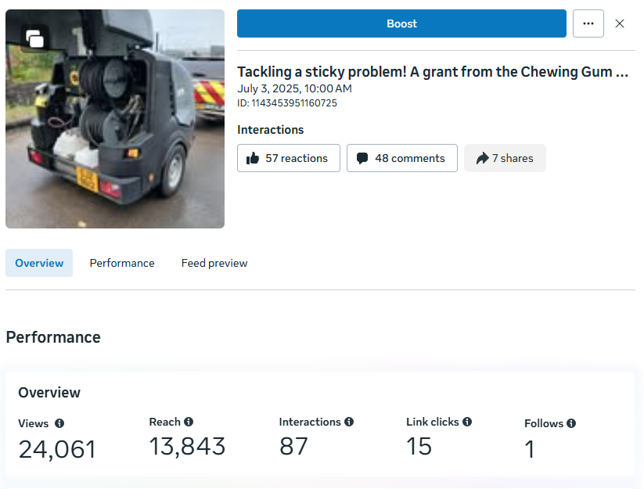 | 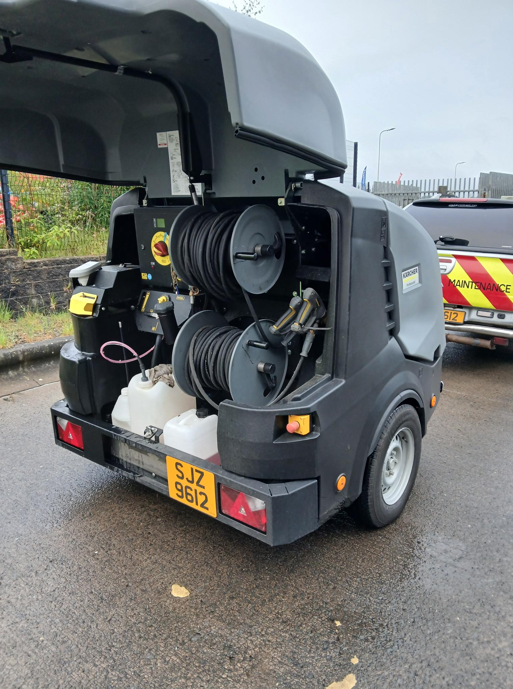
Recycling Journey video  7 July 2025  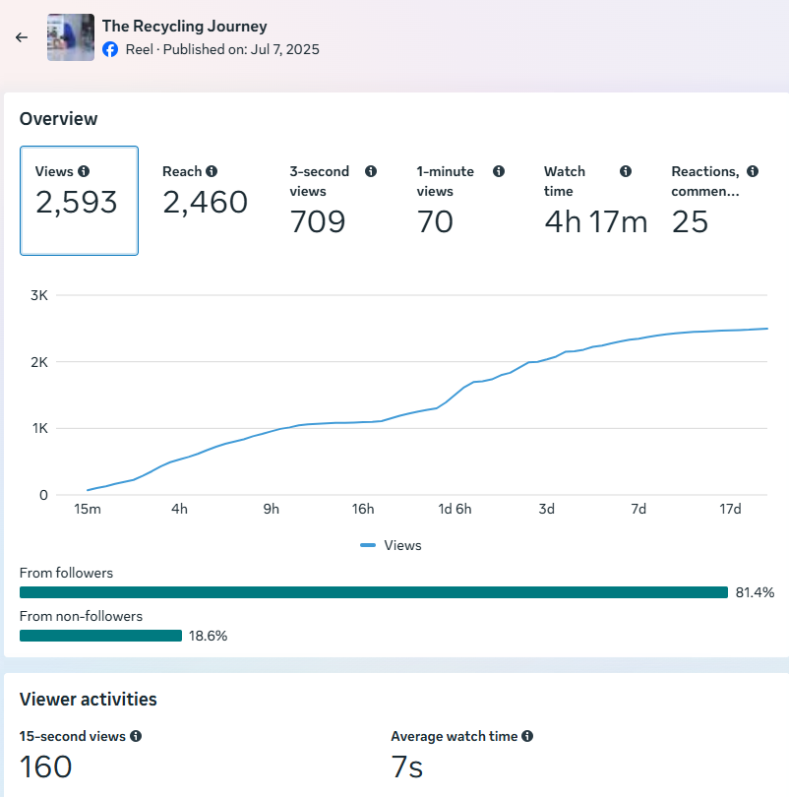 | 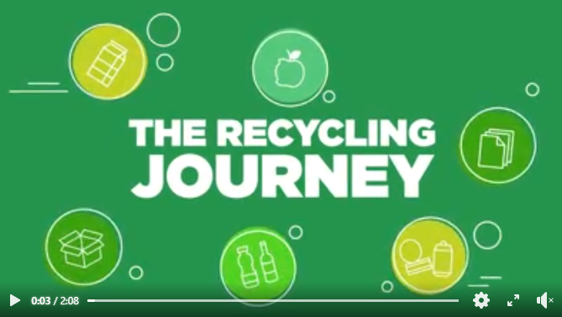  
HRC fire/safe battery disposal  8 July 2025  [Posted in response to a fire at N’Ards HRC]  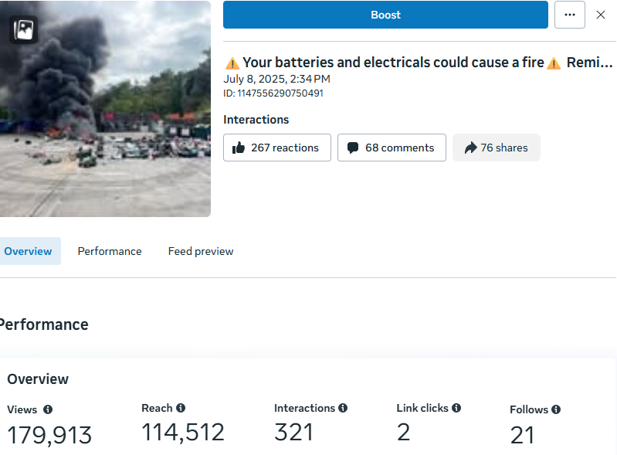 | 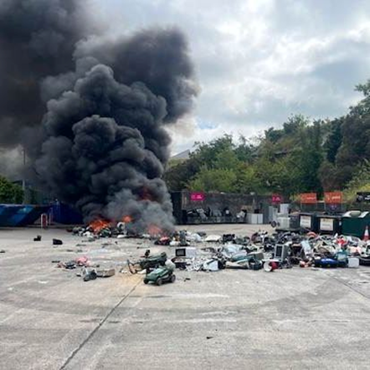
Extended summer Opening Hours at HRCs 16 July 2025  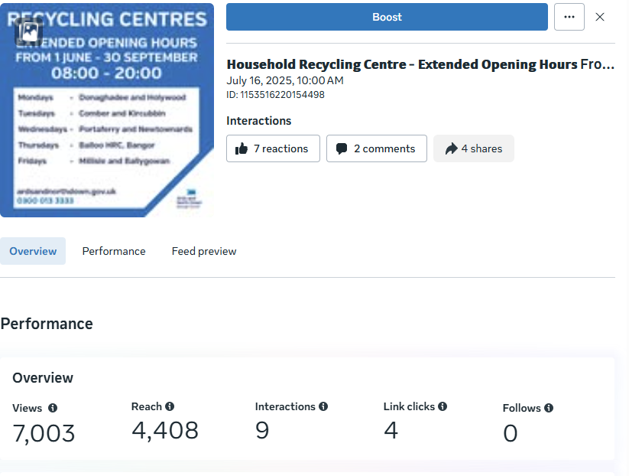 | 
School Uniform Project: Multiple posts throughout the month  Example - Date for Diary post re: pop up shops / 18 July 2025  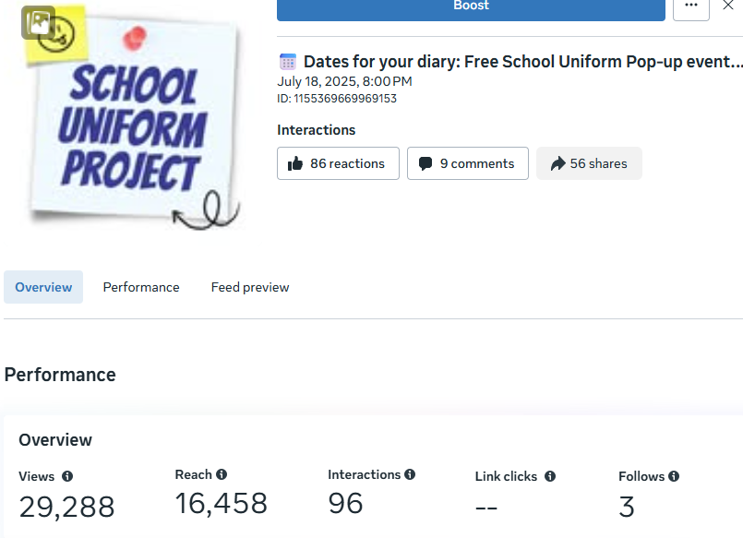 | 
HRC Pedestrian Access trial  21 July 2025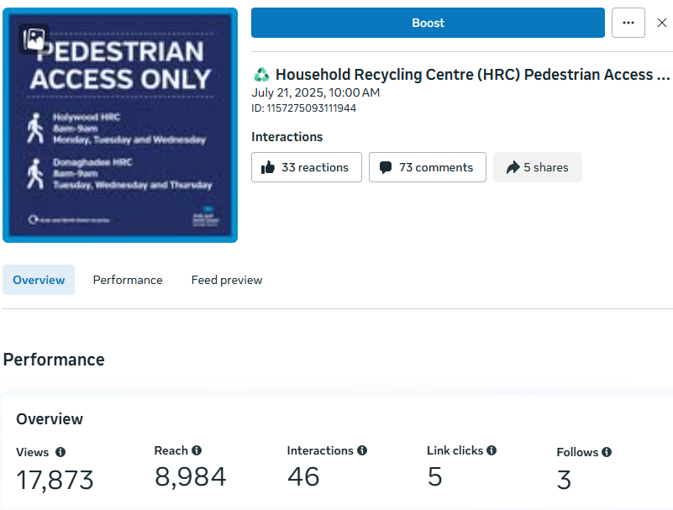 | 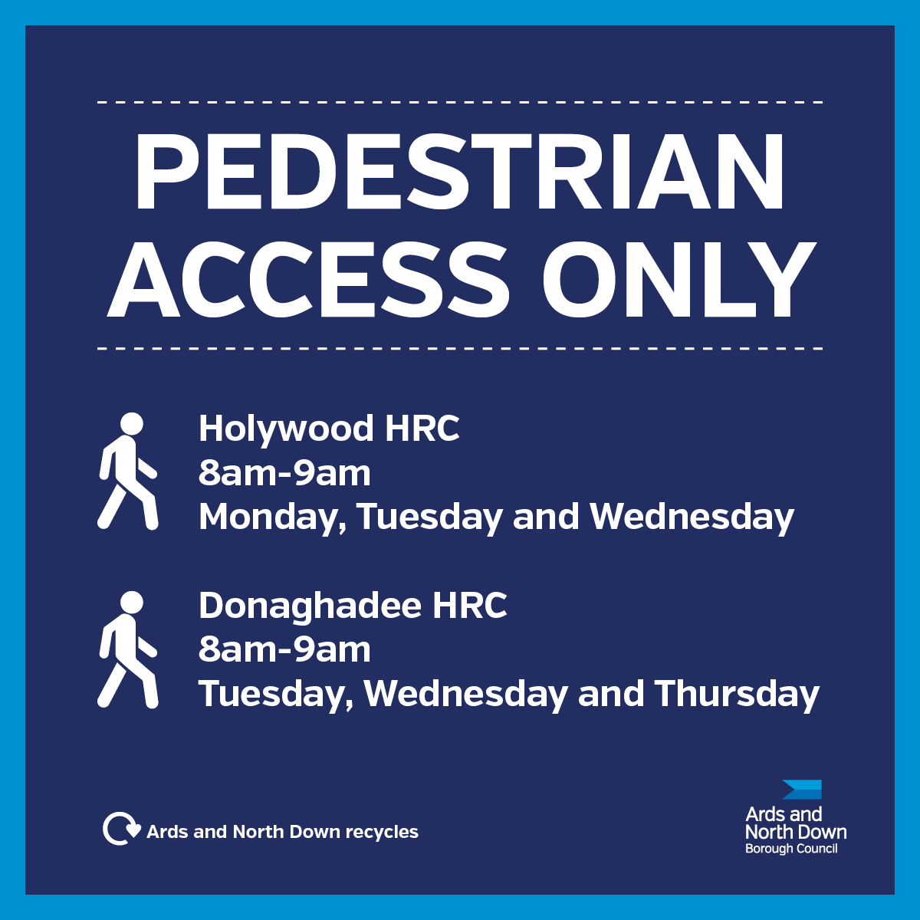
Glass Recycling video  22 July 2025  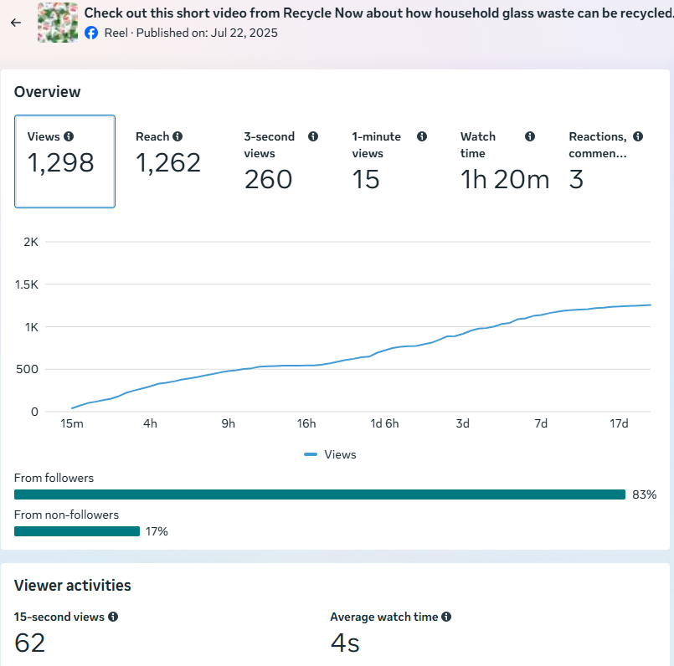 | 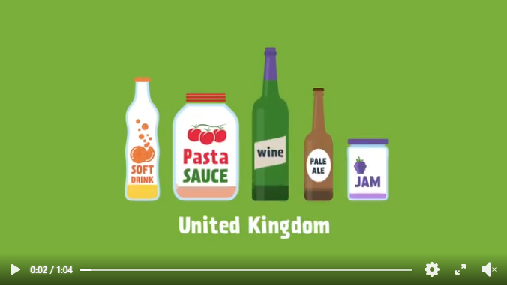
Blue Bin Burp video  28 July 2025  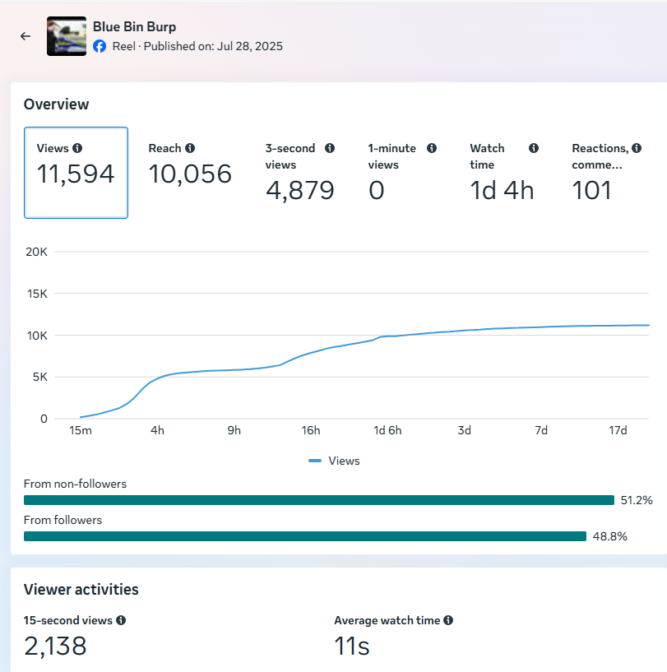 | 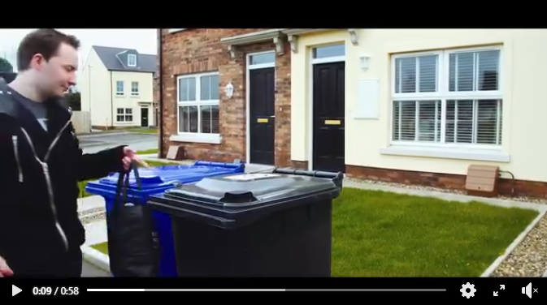
Paint Reuse Scheme Expands Borough-Wide  30 July 2025  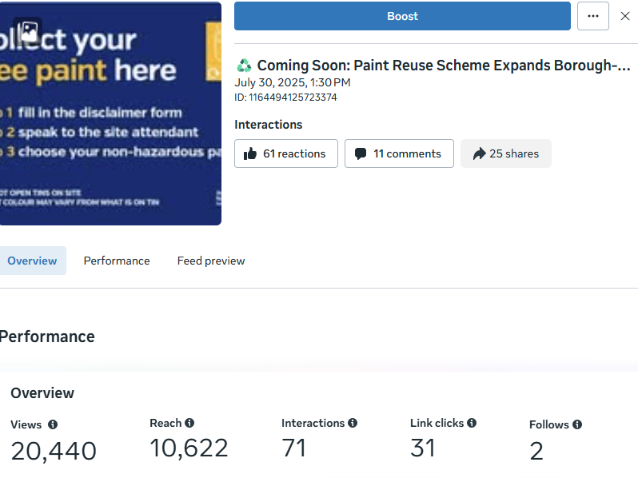 | 
Aerosol (aluminium) Recycling  15 August 2025 (Alupro video assets)  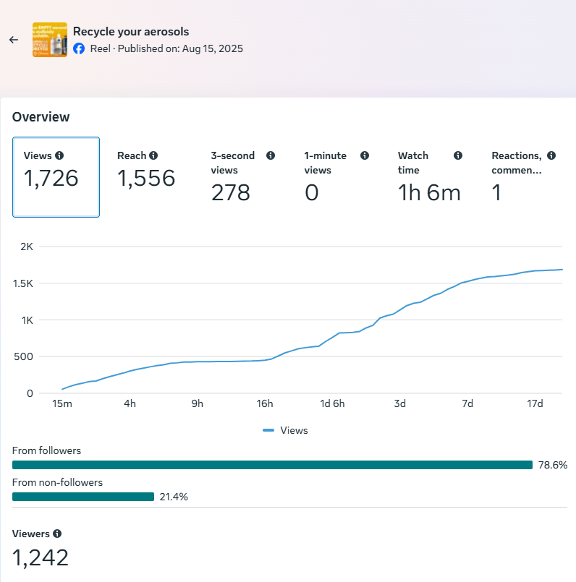 | 
Foil (aluminium) recycling – BBQs  19 August 2025 (Alupro video assets)  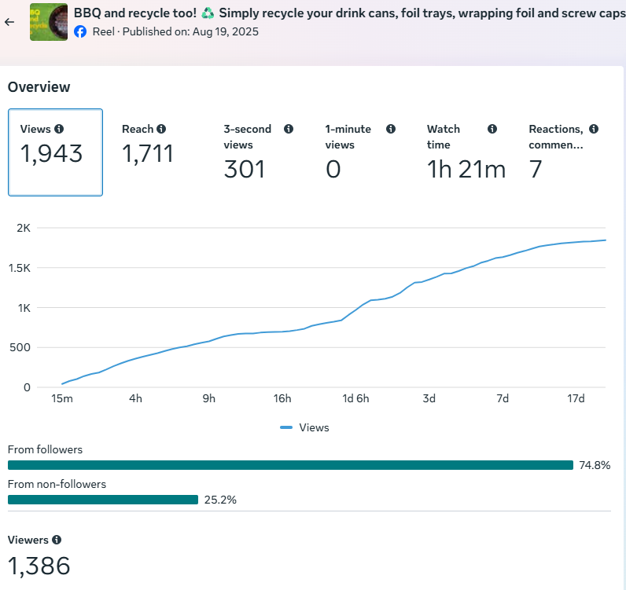 | 
Recycle week / 22-30 September 2025  Multiple posts across FB and Insta using WRAP assets / characters with Ards and North Down Recycles tagline | 

MC2 Bin-Ovation
- 5 Bin-Ovation ‘News and Info’ articles were published including four service / Bank Holiday updates and a post promoting International E-Waste Day.
- 9 Bin-Ovation push notifications issued.
- 1,928 Bin-Ovation downloads recorded.

MC3 – Officers delivered 16 community and engagement events, talking to 776 people.
- 12 x Summer Schemes
- 1 x Schools
- 1 x Adult groups
- 1 x Community Safety project (Urban Samurai)
- 1 x Brownies group

Household Recycling Centre Indicators
HRC1 Volume of blue bin recyclable materials separated from mixed waste by residents on-site: 757,220 litres.

That equated to approximately 32 tons of blue bin waste. That material included recyclables removed from residual waste following intervention and engagement with HRC staff. That practice both increased recycling and provided an opportunity to engage with site users on the value of recycling - promoting more efficient separation of waste in the home and greater use of blue bins at the kerbside.

That represented just one type of recyclable waste category which was prevented from entering landfill skips at HRCs because of our more focused attention to supervision of landfill skip access; many other recyclable waste types would also have been prevented from entering the landfill skips.

HRC2 Number of visitors turned away from site: 697

HRC2a – Number of HRC bookings: 85,160

HRC2b – Average number of HRC visits per household: 1.18 (averaged across the 71,976 households in the Borough)

2.3 Kerbside Household Waste Collections Indicators

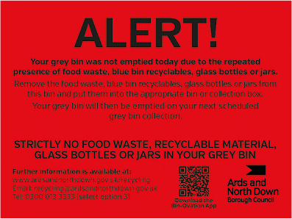
KSI – Number of recycling alert stickers applied to grey bins (yellow): 1913
KS2 – Number of recycling alert stickers applied to grey bins (amber): 133
KS3 – Number of recycling alert stickers applied to grey bins (red): 53

2.4 Summary and Trend Analysis of Indicators
Indicator Reference | Monitoring Period 9 (Jan to Mar 2025) | Monitoring Period 10  (Apr to Jun 2025) | Monitoring Period 11  (Jul to Sept 2025)
MC1  Social media posts | 83 | 41 | 50
MC2  Print press and online articles | 6 | 0 | 1
MC3  Engagement events/sessions | 9 | 17 | 16
HRC1  Blue bin waste (litres) | 677,500 | 719,940 | 757,220
HRC2  Visitors denied entry | 653 | 645 | 697
HRC2a  No. of bookings | 73,224 | 80,136 | 85,160
HRC2b  Average no. of HRC visits per household in the Borough | 1.02 | 1.11 | 1.18
KS1  Yellow warning stickers on grey bins | 1860 | 1938 | 1913
KS2  Amber warning stickers on grey bins | 145 | 161 | 133
KS3  Red warning stickers on grey bins | 71 | 88 | 53

2.5 Summary Analysis

Our overall recycling performance demonstrated an increase of 2.9 percentage points over the same quarter in 2024/25 with the Council ranked 2nd in the NI council recycling performance table. This quarter’s performance was largely due to good diversion at the Council’s network of HRCs.
The total tonnage of material collected at the kerbside and the tonnage collected for recycling both dropped by 3% in comparison to the same quarter in 2024/25. The tonnage of non-recyclable material collected at the kerbside increased by 3%.

Waste tonnages fluctuated across the year because of changes in demand for services and seasonal factors, for example, increases in garden waste during spring and summer. One of the reasons for that could be the sensitivity of garden waste to seasonal growth conditions. In comparison to the same period in 2024/25, Q2 2025/26 had higher rainfall and below average sunshine which may have resulted in reduced growth and less material being placed out for kerbside collection.

During the quarter July to September 2025, we recorded:
- A 3.8% increase in the proportion of HRC materials diverted for reuse and recycling over the same period in 2024/25.
- A household waste recycling rate of 61%; the second highest household recycling rate of the 11 NI councils. That was an increase of 2.9 percentage points from the same quarter in 2024/25.

ANDBC’s recycling performance was driven by strong resident engagement, making clear feedback on results and material destinations essential. The live NI Resources and Waste Management Strategy provided an indication of the Department’s future policy framework, but clearer policy direction was anticipated when DAERA published its response to its 2024 Rethinking Our Resources consultation. The recycling consultation response was expected to outline consistent material collection requirements and new opportunities to support workplace recycling. That would inform and shape the Council’s future waste and recycling service plans.

RECOMMENDED that the Council notes this report.

Proposed by Councillor Harbinson, seconded by Councillor Ashe, that the recommendation be adopted.

Councillor Harbinson noted that most of the performance figures appeared to be moving in the right direction, but he queried why the composting figure had fallen. Responding, the Head of Waste and Cleansing explained that the reduction was largely due to weather conditions, as the previous year had benefited from better growing conditions, which produced more garden waste for composting.

Councillor Cathcart recognised that kerbside recycling tonnages naturally fluctuated from year to year and that the recent change was relatively small. It was highlighted that the team was proactive in checking materials and was reviewing communications to further address the recycling issue but despite the variations, overall kerbside recycling had increased.

The Chair asked whether the overall position could be considered positive. The Head of Waste and Cleansing responded that performance was broadly similar to previous years and that, while there were areas of improvement, the overall trend remained steady.

AGREED TO RECOMMEND, on the proposal of Councillor Harbinson, seconded by Councillor Ashe, that the recommendation be adopted.

13. NOTICE OF MOTION 665 COMBER DOG PARK

PREVIOUSLY CIRCULATED:- Report from the Director of Environmental Services detailing that in April 2025 the following decision was agreed by the Council as a result of a Notice of Motion:

“We are all aware that dog ownership has increased significantly over the past years. There is fenced of area on “Muckers” in Comber, which is currently being used by NIW which when they have finished their work might lend itself to creating a dog park. This Council should bring back a report that explores the options for creating a dog park in Comber.”

The proposal reflected growing interest in dedicated spaces for dog exercise and training, as well as wider discussions around balancing the needs of different park users. Designated dog parks can offer benefits in certain contexts, including more structured off-lead space and clearer separation of uses. However, they could also have implications for park management, maintenance, enforcement, biodiversity, amenity use, and community cohesion. As such, any proposal required consideration of evidence of need, suitability of the location, and local community views.

Key Issues
Comber Park Way currently operated as an informal open space used by a range of park users, including walkers, families, and dog owners. There was no existing designation for off-lead dog use beyond general controls, and no formal dog park infrastructure was in place. Operational feedback indicated that the site functioned largely without significant conflict between user groups. The space consisted of a large green with tree planting, pitch, skate park etc. The site was characteristically “wet” and ground conditions during wet spells would be marshy. The site was also used weekly for a Park Run event.

Parks officers met with colleagues in NET, to request a history of enforcement records relating to dog use which had been reviewed to identify any trends or recurring issues that might support the need for a designated dog park facility. Recorded Incidents – Muckers Field, Comber (2018–2024): A review of dog-related reports at Muckers Field, Comber, since 2018, showed there were four recorded dog-related incidents over this recorded period ie. 2018, 2020, 2023 & 2024.

The frequency and nature of those incidents was extremely low and largely relate to isolated matters. Enforcement data did not indicate persistent issues with dog behaviour, lack of control, or conflict at this location. Taken together, the available evidence suggested that current arrangements were generally effective and that there was no demonstrated enforcement-led requirement for the introduction of a dedicated dog park or introduction of a dog order at Comber, Muckers Field at this time.

Officers considered the following factors when carrying out an assessment of need:

- Compatibility with existing recreational uses and shared-space principles
- Potential impacts on grassed areas and wider biodiversity
- Health and safety considerations, including fencing, entrances and dog/user separation
- Visual and amenity impacts on neighbouring residents
- Ongoing maintenance, cleansing, and enforcement requirements
- Capital and revenue cost implications

While no clear operational or enforcement need had been identified, it was recognised that potential community interest and demand should be explored further. A local community survey and engagement exercise was undertaken to:

- Gauge public support or opposition to a dog park at Comber, Muckers Field
- Understand levels of satisfaction with current arrangements
- Identify specific concerns, including noise, safety, cleanliness, and impact on other users
- Capture views on alternative approaches or locations, if relevant

Analysis of the Comber Dog Park survey responses showed that the majority of participants did not support the creation of a designated dog park at Mucker’s Field. Out of the 35 responses received, 19 respondents indicated “No”, compared with 14 who said “Yes” and 2 who were unsure. Notably, 28 respondents identified as dog walkers, indicating that feedback came predominantly from regular users who walked dogs in the area. The “No” responses frequently referenced concerns about cost, antisocial behaviour, dog waste, and a preference for maintaining the space as it currently was or using it for alternative community purposes such as seating, gardens, or other recreational facilities. Many daily users of the field, including dog owners, expressed apprehension that a dedicated dog park may not address existing issues and could introduce new management or enforcement challenges. Overall, the survey results indicated that there was not sufficient community support at this time to advance the proposal for a designated dog park at Mucker’s Field.

Next Steps
The site was a vital asset for Comber, and public consultations highlighted strong community interest in its improvement. To move forward, officers would progress a feasibility study to develop a formal business case for future budget review.

Summary
Current enforcement and operational data did not justify the immediate creation of a dedicated dog park in Comber. While public opinion remained divided over the dog park proposal, there was a clear case for a comprehensive feasibility study to inform a potential business case for the wider site.

RECOMMENDED that the Council notes this report.

Councillor Morgan had been given speaking rights on the item and she was invited to join the meeting.

Proposed by Councillor Ashe, seconded by Alderman Cummings, that the recommendation be adopted.

Councillor Ashe thanked officers for their hard work in carrying out the feasibility study and had stated that she looked forward to its progression. Seconding the recommendation Alderman Cummings had commented that well‑behaved dogs and responsible dog owners had become a victim of their own success in the area. He noted the strong community interest and was pleased with the officers’ findings and the further responses that would be provided.

Councillor Morgan also thanked officers and had remarked that it was pleasing to note there had been only four dog‑related behavioural issues raised. She had clarified that had not been the reason for bringing the matter before the Council and her initial concerns had stemmed from general user feedback rather than any belief that there was a significant problem. She had asked for an explanation of how the survey had been conducted.

The Head of Parks and Cemeteries informed the Committee that two members of the parks team had carried out interviews in the area on a number of occasions. He had reported that, overall, respondents did not wish to see a dedicated dog park but did express interest in other improvements within the park. It was stated that further research would be required and it was acknowledged that the area was much loved by the Comber community. A further feasibility study could explore alternative concepts and that innovative solutions could create a very attractive space and the enthusiasm shown for any future project would be welcomed by both the Committee and the community at Comber.

AGREED TO RECOMMEND, on the proposal of Councillor Ashe, seconded by Alderman Cummings, that the recommendation be adopted.

14. NOTICES OF MOTION

14.1 Notice of Motion submitted by Councillor Douglas and Alderman Cummings

To task officers to investigate and engage with other statutory agencies to work together to safely remove the fallen tree over the Enler River, Comber, which has been there since Storm Eowyn.

Councillor Douglas drew Members attention to the slightly amended Motion below:

To task officers to investigate and engage with other statutory agencies to work together to safely remove the fallen trees over the Enler River, Comber, which had been there since Storm Eowyn.
Councillor Douglas referred to photographs that had been circulated in advance of the meeting and outlined the impact of Storm Eowyn, which had struck Ards and North Down in January 2025. The storm had caused significant damage across the Borough, including to the roof of the Bangor Aurora Leisure Complex, extensive tree loss in parks, and widespread debris that had resulted in the closure of roads and some cemeteries.
She reported that along the Enler River in Comber, several trees had fallen across the riverbank and onto fencing belonging to social housing at Newtown Green. She advised that she had been contacted by numerous constituents who regularly walked the area with their dogs and children, and noted that the location was also used by young people accessing the nearby skate park. She stated that requests had been made to the Rivers Agency, the Department for Infrastructure, and Apex Housing Association, but none of the statutory bodies had accepted responsibility for removing the fallen trees.
The Member expressed concern that the trees, which lay from one bank of the river to the other, posed a clear danger by tempting children and young people to climb across them, creating a risk of falling into the river. She further highlighted that the damage to fencing created a security issue for residents of Newtown Green. With brighter evenings approaching and increased activity expected in the area, she asked that the Council support efforts to identify the relevant landowner and work with statutory agencies to ensure the trees would be removed as soon as possible.
Alderman Cummings seconded the Motion and thanked Councillor Douglas for bringing forward what he considered to be an important health and safety matter. He stated that the fallen trees presented an obvious temptation to children and that a coordinated, interagency response was required. He believed the Council was best placed to lead on securing a resolution. He also noted that the trees lay parallel to Park Way and Comber Greenway, both of which would see increased use during the summer months, and therefore the issue should be addressed at the earliest opportunity.
Councillor Boyle indicated his full support for the Motion and emphasised the need to clarify land ownership, noting that the responsible party should be required to remove the trees.
Councillor Blaney also expressed his support and although unfamiliar with the specific location, he agreed that the matter required action to prevent injury and reiterated the importance of establishing ownership. He commented that this was an example of local elected members acting as the “eyes and ears” of the community.
Councillor Ashe supported the Motion and stated that it was unreasonable that the trees had remained in place for so long since they were clearly a health and safety concern. She advised that her Assembly colleague, Nick Mathison, had also been working to progress the issue, and she reported that the Department for Infrastructure had made a statement that it was not responsible.
Councillor Edmund thanked Councillor Douglas for bringing the Motion forward and expressed disappointment that the relevant Department had not taken action and did not think that reflected well.
In summing up, Councillor Douglas thanked Members for their support and reiterated that the key issue was to establish land ownership as a priority in order to bring the matter to a sensible and timely conclusion.

AGREED TO RECOMMEND, on the proposal of Councillor Douglas, seconded by Alderman Cummings, that the Notice of Motion be adopted.

14.2 Notice of Motion submitted by Councillor Cochrane and Alderman Brooks

That this Council notes with deep concern the recent destruction caused to bushes trees and wild grass in The Commons, Donaghadee.

Further to this, Council agrees to write to the Minister of Agriculture, Environment and Rural Affairs, calling upon him to designate The Commons, Donaghadee, as either an Area of Special Scientific interest (ASSI), or another appropriate form of protected status, in order to help safeguard this important green space.

Proposed by Councillor Cochrane, seconded by Councillor Brooks, that the Notice of Motion be adopted.

Councillor Cochrane stated that he wished to bring forward his Motion in respect of The Commons, Donaghadee, a place that many in that town regarded not simply as a patch of grassland, but as part of the community’s heritage, landscape and identity.

He explained that residents had watched with disbelief and anger as bushes, trees and wild grasses on The Commons were cut down and destroyed. That was not routine maintenance, not planned environmental management, and not work authorised by the Council but rather the deliberate clearing of natural vegetation on public land - an act that had left local people shocked and deeply concerned.

The area affected was part of what locals referred to as the town’s “second Commons,” a natural space above the shoreline near Stellenbosch Avenue that had, over time, developed into a rich patch of biodiversity with wild hedges, grasses and trees which were evolving naturally.

For years, that space had been used and valued by residents, by families walking along the coast, by dog walkers enjoying the open air, and by people simply seeking a quiet connection with nature. The reaction to the destruction of the area from the community had been strong.

Local residents had raised the alarm when heavy equipment appeared and began clearing the vegetation. Many initially believed it must have been work carried out by the Council, since nobody expected others to simply decide to take it upon themselves to remove vegetation from a public green space. Instead, what residents witnessed was the wholesale removal of natural shrubbery and habitat, something that many had described as shocking and unacceptable.

It had not been just grass cutting but an ecosystem of hedgerows, wild plants, and trees that had taken years, even decades, to establish themselves. As had been pointed out locally, those natural areas could not simply be replaced overnight and once they were removed, it could take a very long time for wildlife habitats to recover. He stressed that the issue mattered. It was about more than a single incident, it was about recognising the value of the natural spaces that existed within the Borough’s towns and communities.

The Commons in Donaghadee was not a manicured park, and that was exactly its value. It was a piece of land where biodiversity had been allowed to flourish naturally over many years. The habitat provided shelter for insects, birds and small animals and formed part of a wider coastal ecosystem. Spaces like these were increasingly rare.

He went on to say that across Northern Ireland, natural habitats were disappearing at an alarming rate. When they were lost, they were often replaced with development, or with overly managed landscapes that lacked the richness of the natural environment they replaced.

The Commons had always been different and had existed in its natural state for generations. As had been noted locally, the land had effectively been left to grow and evolve for hundreds of years, allowing biodiversity to develop in ways that could not be artificially recreated. When the landscape was suddenly altered or destroyed, the loss was not only visual but ecological.

His Motion proposed that the Council write to the Minister for Agriculture, Environment and Rural Affairs and ask that The Commons be considered for designation as an Area of Special Scientific Interest or another appropriate form of protected status.

He said that such designations existed for exactly this purpose: to recognise and protect places that had environmental value, biodiversity significance, or scientific importance. A Designation would help ensure that the ecological value of the site was recognised and safeguarded and would send a clear message that natural heritage mattered, that those landscapes were not disposable, and that they deserved protection. It would also give the people of Donaghadee reassurance that the place they cherished would be protected for generations to come.

Councillor Cochrane concluded by stressing that the strength of feeling within the community should not be underestimated and residents had described The Commons as a treasured public space and was part of the character of Donaghadee.

Seconding the Motion Alderman Brooks stated that the incident that had occurred in the area had been disastrous and amounted to a crime. He noted that the community believed they knew who had been responsible and where the individuals lived. The matter had been reported to the Police Service for Northern Ireland, but he stressed that the crime needed to be punished. He described the attack as unbelievable and said the local community was rightfully outraged.

In the longer term, he believed the actions being requested were appropriate given the gravity of the situation, noting that someone had entered a property and caused extensive damage, and he supported the proposal for the Council to write to the Minister seeking assistance. He expressed satisfaction that the Motion had come before the Council and reiterated that this was Council property and the act had been outrageous.

Councillor Boyle thanked Members for bringing the Motion forward. He stated that it had been a long time since he had been so appalled to hear of such an incident. He noted that the local community appeared to know who had carried out the crime and he welcomed the fact that the police were investigating the matter. He asked what further action the Council could take to address the matter now and for the future and expressed hope that the site would qualify for protection. He looked forward to a positive outcome.

Councillor Edmund thanked the proposers and said that the reaction from the community had been one of despair at such vandalism. He hoped that the outcome deserved by the community would be achieved in due course.

Councillor Brady expressed his full support, noting that Northern Ireland was the twelfth worst country in the world for biodiversity loss. He supported criminal proceedings and thanked Members for bringing the Motion.

Councillor Harbinson also expressed support, agreeing that action should be taken to protect the area in the future and hoping that the culprit would be held to account.

The Head of Parks and Cemeteries reported that officers were currently in communication with the Police Service of Northern Ireland and were awaiting the outcome of the investigation. He confirmed that the Council would become more involved as the investigation progressed.

The Chair noted that the area had high amenity value and that Tree Preservation Orders could be considered as a future option. She acknowledged that similar incidents occurred elsewhere and expressed full agreement with the sentiments raised by the Committee.

In summing up, Councillor Cochrane thanked Members for their unanimous support. He noted that the incident had taken place during daylight hours and encouraged anyone with information to contact the police. He reiterated the importance of protecting the area and expressed hope that justice would be achieved.

AGREED TO RECOMMEND, on the proposal of Councillor Cochrane, seconded by Alderman Brooks, that the Notice of Motion be adopted.

The Chair thanked Councillor Cochrane and Alderman Brooks for presenting their Motion and they left the meeting.

15. ANY OTHER NOTIFIED BUSINESS

There were no items of Any Other Notified Business.

EXCLUSION OF PUBLIC/PRESS

agreed, on the proposal of Councillor Cathcart, seconded by Alderman Cummings, that the public/press be excluded during the discussion of the undernoted items of confidential business.

16. TENDER REPORTS

16.1 Tender for the Provision of New and Replacement Play Areas, and Play Area Maintenance within the Borough of Ards and North Down

**IN CONFIDENCE**

**ITEM DELEGATED FOR APPROVAL**

PREVIOUSLY CIRCULATED:- Report from the Director of Environmental detailing that there were currently over 80 play areas in the Borough including play parks, Multi Use Games Areas, skateparks and pump tracks.

RECOMMENDED that the Council gives approval to award the contracts for the provision of new and replacement play areas and play area maintenance to the companies recommended

Proposed by Alderman Adair, seconded by Councillor Douglas, that the recommendation be adopted.

AGREED TO RECOMMEND on the proposal of Alderman Adair, seconded by Councillor Douglas, that the recommendation be adopted.

16.2 Extension of Ice Cream and Hot Drinks Vendors and Various Locations in the Borough 2026-27

**IN CONFIDENCE**

**ITEM DELEGATED FOR APPROVAL**

PREVIOUSLY CIRCULATED:- Report from the Director of Environment detailing that the purpose of this report was to update Elected Members on the appointment of Ice Cream and Hot Drinks Vendors at various locations in the Borough and seek approval to extend the contract period for financial year 2026-27, following the successful delivery of service.

RECOMMENDED that the Council approves the extensions as detailed.

Proposed by Alderman Adair, seconded by Councillor Douglas, that the recommendation be adopted.

AGREED TO RECOMMEND on the proposal of Alderman Adair, seconded by Councillor Douglas, that the recommendation be adopted.

16.3 Extension of Catering Services Provider at Bangor Walled Garden

**IN CONFIDENCE**

**ITEM DELEGATED FOR APPROVAL**

PREVIOUSLY CIRCULATED:- Report from the Director of Environment detailing that the purpose of this report was to update Elected Members on the appointment of a Catering Services Provider at Bangor Castle Walled Garden and seek approval to extend the contract period for financial year 2026-27, following the successful delivery of service.

RECOMMENDED that the Council approves the extension of the Catering Services Provider at Bangor Castle Walled Garden through 2026-27.

AGREED TO RECOMMEND on the proposal of Alderman Adair, seconded by Councillor Douglas, that the recommendation be adopted.

16.4 Extension of Key Holder Response and Opening and Locking Tender 2026-2027

**IN CONFIDENCE**

**ITEM DELEGATED FOR APPROVAL**

The tender for a Keyholder Response Service and Opening and Locking of various Council areas was awarded in April 2024 for a period of 1-year from 1 April 2024 to 31 March 2025, with an option to extend for a further 3 x 12-month periods.

RECOMMENDED that the Council approves the extension of the Tender for Key Holder Response and Opening and Locking of Council areas.

AGREED TO RECOMMEND on the proposal of Alderman Adair, seconded by Councillor Douglas, that the recommendation be adopted.

16.5 Building Repair Tender

**IN CONFIDENCE**

**ITEM DELEGATED FOR APPROVAL**

PREVIOUSLY CIRCULATED:- Report from the Director of Environment detailing that the tender for the Building Repair works had been operational for the full extent of the contract and due to expire on 31 March 2026. Due to the on-going requirement a revised tender for Building Work was developed by officers and a procurement exercise undertaken.

RECOMMENDED that the Council gives approval to award the contract for the Provision of Building Repair work to the companies as detailed in the report.

AGREED TO RECOMMEND on the proposal of Alderman Adair, seconded by Councillor Douglas, that the recommendation be adopted.

RECESS 9.00 pm
RECOMMENCED 9.12 pm

(Councillor Blaney left the meeting at 9 pm)

17. WARD PARK FULL BUSINESS CASE
(Appendices XIII-XVI)

**IN CONFIDENCE**

**ITEM DELEGATED FOR APPROVAL**

PREVIOUSLY CIRCULATED:- Report from the Director of Environmental Services detailing that the purpose of this report was to recommend approval of the attached full business case for the redevelopment of Ward Park.

RECOMMENDED that the Council approves the attached business case (FBC) and its recommendation to continue to proceed with Option 4.

AGREED TO RECOMMEND on the proposal of Councillor Cathcart, seconded by Councillor Brady, that the recommendation be adopted.

18. COMBER GREENWAY LANDS (COMBER SECTION)
(Appendices XVII-IXX)

**IN CONFIDENCE**

PREVIOUSLY CIRCULATED:- Report from the Director of Environmental Services detailing an update on the section of the proposed Comber Greenway from the Belfast Road to the Comber Leisure Centre.

RECOMMENDED that the Council notes the update.

Proposed by Alderman Cummings, seconded by Councillor Douglas, that the recommendation be adopted.

AGREED TO RECOMMEND on the proposal of Alderman Cummings, seconded by Councillor Douglas, that the recommendation be adopted.

19. RESIDUAL WASTE TREATMENT REPORT

**IN CONFIDENCE**

PREVIOUSLY CIRCULATED:- Report from the Director of Environmental Services detailing that following a report to the Environment Committee in January 2026, Members requested a further report into the Council practice of sending its residual waste for pre-treatment and energy recovery. The report set out the factors leading to a change in the Council practice of landfilling waste as well as the costs and benefits of pre-treatment and energy recovery.

RECOMMENDED that the Council notes this report.

Proposed by Councillor Wray, seconded by Councillor Edmund that the recommendation be adopted.

AGREED TO RECOMMEND, on the proposal of Wray, seconded by Councillor Edmund, that the recommendation be adopted.

RE-ADMITTANCE OF PUBLIC/PRESS

AGREED, on the proposal of Councillor Edmund, seconded by Councillor Douglas, that the public/press be re-admitted to the meeting.

TERMINATION OF MEETING

The meeting terminated at 9.25 pm.

