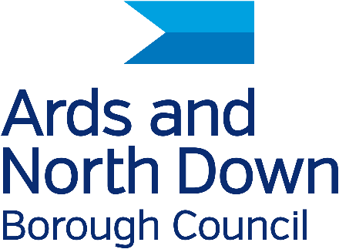

PUBLIC RIGHT OF WAY

LANDOWNER EVIDENCE FORM

Under the Access to the Countryside (NI) Order 1983 this form should be completed by the owner of the land in question, or a person duly authorised to respond on behalf of the owner.

It is important that you answer all the questions accurately and as fully as possible because the information given may be examined at a Public Inquiry or Court.

Route Details:

Starting Point -

Finishing Point -

Townland:

Claimed Status of Route: Footpath / Bridleway/ Carriageway

---------------------------------------------------------------------------------------
PLEASE GIVE THE FOLLOWING INFORMATION

Full Name:

Address:

Post Code:

Telephone No:

Email:

Page 1 of 4
NOW PLEASE ANSWER ALL THE QUESTIONS AS INDICATED AND CONTINUE ON A SEPARATE SHEET IF NECESSARY.

1. The route is shown on the accompanying map. Does this route cross or adjoin your land? (If not, no further questions need be answered – please date and sign and return this form as indicated on page 4)

Yes __________ No ____________ (please tick as applicable)

If yes, please indicate the boundaries of your land on the attached map.

1a. How long has this land been in your ownership? ____________ years or in your
tenancy? ______________ years.

2. Do you believe this route to be public?
Yes __________ No ____________ (please tick as applicable)

2a. If yes, with what status? i.e. footpath, bridleway, other.

____________________________________________________________________

2b. For how long have you held this belief? ___________________ years.

3. Have you ever seen or been aware of members of the public using
the route?

Yes __________ No ____________ (please tick as applicable)

3a. If yes, for how long? From ____________ (year) to ____________ (year)

3b. How frequently? e.g. once a week __________________________________________________________

3c. What were they doing? e.g. walking, riding, shooting, other.

____________________________________________________________________

4. Have you ever required members of the public to ask permission before using the route?

Yes __________ No ____________ (please tick as applicable)

4a. If yes, please give details:

Page 2 of 4

5. Have you, or someone on your behalf, ever turned back or stopped members of the public using the route?

Yes __________ No ____________ (please tick as applicable)

5a. If yes, please give details:
____________________________________________________________________

____________________________________________________________________

6. Have you, or someone on your behalf, ever told anyone using the route that it was not public?

Yes __________ No ____________ (please tick as applicable)

6a. If yes, please give details:
____________________________________________________________________

____________________________________________________________________

7. Have you ever erected signs or notices stating that the route was not public?

Yes __________ No ____________ (please tick as applicable)

7a. If yes, please give details and approximate dates.
____________________________________________________________________

____________________________________________________________________

7b. State whether these signs or notices were ever defaced or destroyed.
____________________________________________________________________

7c. Please show their position on the accompanying map.

8. Have there, to your knowledge ever been any stiles or gates along the route?

Yes __________ No ____________ (please tick as applicable)

8a. If yes, please state if the gates were ever locked and if so when.
____________________________________________________________________

8b. Please show their position on the accompanying map.

Page 3 of 4
9. Have you ever obstructed the route?

Yes __________ No ____________ (please tick as applicable)

9a. If yes, please state where, how, when and for what reason.
____________________________________________________________________

____________________________________________________________________

10. Can you give any further information? (continue on a separate sheet if necessary).
___________________________________________________________

____________________________________________________________________

____________________________________________________________________

____________________________________________________________________

___________________________________________________________________

I hereby certify that, to the best of my knowledge and belief, the
information I have given is true. I understand that I may be required to attend a hearing or Court to give evidence on oath on this matter should this prove necessary.

Signature: ___________________________________________________________

Date: ______________________

Please return to:
Public Rights of Way Officer
Ards and North Down Borough Council
City Hall
The Castle
Bangor
BT20 4BT

Ards and North Down Borough Council’s Compliance Section has collected the information on this form only for the purpose of fulfilling its public duty under the Access to the Countryside (NI) Order 1983. Your information will not be shared with a third party without your consent but will be held by the Council in line with Council’s data protection policy. You have a right to see and review the information held on you. If you wish to request your personal information or have a data protection query, please contact the Data Protection Officer, at Ards and North Down Borough Council, City Hall, The Castle, Bangor, BT20 4BT, Email: dataprotection@ardsandnorthdown.gov.uk Tel: 0300 013 3333.

Page 4 of 4

