Ards and North Down Borough Council

A meeting of the Environment Committee was held remotely via Zoom on Wednesday, 7 September 2022 at 7.00 pm.

PRESENT:

In the Chair: Alderman McDowell

Aldermen: Armstrong-Cotter
Carson
M Smith (7.15 pm)

Councillors: Boyle Johnson
Cathcart Kendall
Cummings MacArthur
Edmund (7.25 pm) McAlpine Greer (7.15 pm) McKee
Irwin Smart

Officers:- Director of Environment (D Lindsay), Head of Waste and Cleansing Services (N Martin) Head of Assets and Property Services (P Caldwell) Head of Regulatory Services (S Addy) and Democratic Services Officer (H Loebnau)

1. Apologies

Apologies for lateness were received from Alderman M Smith and Councillor Greer.

NOTED.

2. Declarations of Interest

The Chair asked for Declarations of Interest and he himself declared an interest in:

Item 5 – Waste Re-Use Projects – Update Report

He explained that the Vice Chair, Councillor Kendall, would take on the role of Chair for that item.

NOTED.

3. Q4 Service Plan Performance Reports

3.1 Waste and Cleansing Services
(Appendix I)

PREVIOUSLY CIRCULATED:- Report from the Director of Environment detailing that Members would be aware that the Council was required, under the Local Government Act 2014, to have in place arrangements to secure continuous improvement in the exercise of its functions. To fulfil that requirement the Council approved the Performance Management Policy and Handbook in October 2015. The Performance Management Handbook outlined the approach to Performance Planning and Management process as:

- Community Plan – published every 10-15 years
- Corporate Plan – published every 4 years (Corporate Plan Towards 2024 in operation)
- Performance Improvement Plan (PIP) – published annually (for publication 30 September 2021)
- Service Plan – developed annually (approved April/May 2021)

The Council’s 17 Service Plans outlined how each respective Service would contribute to the achievement of the Corporate objectives including, but not limited to, any relevant actions identified in the PIP.

Reporting approach

The Service Plans would be reported to relevant Committees on a quarterly basis as undernoted:

Reference | Period | Reporting Month
Quarter 1 (Q1) | April – June | September
Q2 | July – September | December
Q3 | October – December | March
Q4 | January - March | June

The report for Quarter 4 2021-22 was attached.

Key points to note:
- Where applicable, a number of targets/data were cumulative (as indicated), reflecting the 2021/22 year rather than the final three months (Quarter 4).
- The delivery of several targets was subject to Council approval for proposed service delivery changes not yet agreed and/or the approval of a business case where additional resources were needed.
- The Covid-19 pandemic continued to impact across the range of services delivered by Waste and Cleansing during Q4.

Key achievements:
- Despite the continuing impact of Covid-19 on staffing levels and the need to change service delivery methods to meet social distancing requirements, all waste collection services were delivered as scheduled, except for disruption caused by industrial action during March 2022.

Emerging issues:
- While the threat of further industrial action remained, there was the potential for major disruption to both waste collection and cleansing services during 2022/23.
- The spike in waste generation during the Covid-19 pandemic appeared to have ended with waste arisings falling towards pre-covid levels (down from 21,505 tonnes in Q4 – 2021 to 18,455 tonnes in Q4 – 2022, a fall of 3050 tonnes), whilst still remaining higher than the NI Council average especially at HRCs. The Council’s recycling rate remained significantly lower than pre-pandemic levels.

Action to be taken:
- To help with the recovery of recycling rates, it was intended to recommence the waste education and awareness programmes with schools, community groups and other organisations.
- With the removal of remaining restrictions and controls introduced during the Covid pandemic to meet social distancing requirements a range of measures targeting contamination and misuse of wheeled bins could recommence. Other operational service management controls were also under consideration aimed at enhancing recycling participation.

RECOMMENDED that the Council notes the report.

Proposed by Councillor MacArthur, seconded by Councillor Kendall, that the recommendation be adopted.

Councillor MacArthur referred to the spike in waste generation during the Covid-19 pandemic which appeared to have ended with the fall of 3050 tonnes of waste being generated and she asked how that compared with pre pandemic levels of waste. The Director did not have the figures to hand but explained that while there appeared to be a levelling of the spike, the level of overall waste arisings in the Borough as well as the amount of residual (non-recycled) waste were higher than that in other Councils and still well above 2019 levels.

Councillor Kendall praised officers for continuing household collections seamlessly over the past weeks despite the challenges the Council had been facing in connection with discussions with Union representatives and for the unbroken service throughout the past couple of years of Covid challenge.

Councillor Cathcart referred to the cleaning of the public realm areas and asked for an update on that since the Council had secured the new machine. He questioned if the machine had contributed to a real difference in terms of cleaning.

Officers had confirmed that the machine’s effectiveness had been very good and there had been significant improvements to the cleanliness of streets due to its ability to perform a more thorough and deeper clean, although it was noted that it did take time. Obviously, an outdoor surface such as a town centre footway could deteriorate quickly if spillages, for example, occurred within a short time of the washing process. It was considered that resources would permit each town in the Borough to be cleaned up to three times per year. Overall, it was expected the new washing regime would make a significant difference to the appearance of the towns.

Councillor Cathcart continued hoping that the old machine could be used in between the deeper cleans for more superficial maintenance. The Director confirmed that would be the case and it was the intention of officers to commit to a sustained planned washing regime for the public realm areas of the towns in the Borough.

AGREED TO RECOMMEND, on the proposal of Councillor MacArthur, seconded by Councillor Kendall, that the recommendation be adopted.

3.2 Assets and Property Services
(Appendix II)

PREVIOUSLY CIRCULATED:- Report from the Director of Environment detailing that Members would be aware that the Council was required, under the Local Government Act 2014, to have in place arrangements to secure continuous improvement in the exercise of its functions. To fulfil that requirement the Council approved the Performance Management Policy and Handbook in October 2015. The Performance Management Handbook outlined the approach to Performance Planning and Management process as:

- Community Plan – published every 10-15 years
- Corporate Plan – published every 4 years (Corporate Plan Towards 2024 in operation)
- Performance Improvement Plan (PIP) – published annually (for publication 30 September 2021)
- Service Plan – developed annually (approved April/May 2021)

The Council’s 17 Service Plans outlined how each respective Service would contribute to the achievement of the corporate objectives including, but not limited to, any relevant actions identified in the PIP.

Reporting approach
The Service Plans would be reported to relevant Committees on a quarterly basis as undernoted:

Reference | Period | Reporting Month
Quarter 1 (Q1) | April – June | September
Q2 | July – September | December
Q3 | October – December | March
Q4 | January - March | June

The report for Quarter 4 2021-22 was attached.

Key points to note:
- The appointed consultant had now delivered the Sustainable Energy Management Strategy and Action Plan however officers must now work though the document set key dates (and budget) for each action. Report to follow.
- The Biofuel Trial remained an ongoing project. The fuel was subject to a significant price increase soon after the Council agreed to implement the trial, making it unfeasible. Officers had then been awaiting the UK Government fuel supply framework to produce competitive costs, but no returns from NI were received. Officers were currently seeking updated costs from local suppliers to assess viability.
- Roadside audits were suspended during 21/22 due to Covid.
- Staff attendance was down due to the pandemic and several instances of long-term sick.
- Training courses completed were below target due to the inability to hold classroom-based activities during the pandemic.

Key achievements:
- All KPIs associated with the Council’s core outputs were met or exceeded, despite significant challenges.
- Despite rising utilities costs and significant unplanned works (including Maypole replacement at £25k, remedial works following rockfall at North Road depot at £30k and unplanned asbestos removals at Ward Park at £25k) budgetary overspend was limited to just 2.95%.

RECOMMENDED that the Council notes the report.

Proposed by Councillor Cathcart, seconded by Councillor MacArthur that the recommendation be adopted.

Councillor Cathcart asked the Head of Assets and Property Services if, in his opinion, the maintenance regime was adequate. In response the officer explained that a team of 12 staff and a wider supplement of contractors were used. There were particular difficulties currently with some staff on long term sickness absence, but generally if the full complement of staff was available the estate was well managed and maintained. Indeed, the KPIs indicated that there were no significant issues present.

He went on to state that proactive maintenance of the estate through the Council’s strategy, had made a positive difference and was without doubt a benefit to the Borough. Currently higher property condition scores were being achieved with a smaller budget and that was expected to continue.

Councillor Cathcart was encouraged by those comments and stressed the importance of the work since it was so visual to ratepayers and that the environment in general looked better when that work was done properly. The officer agreed and remarked that it was a constant battle juggling priorities.

(Alderman M Smith and Councillor Greer entered the meeting at 7.15 pm)

Councillor MacArthur thanked the Head of Assets and Property Services for the responsiveness that they showed when interacting with Members. She shared what must be their frustration at times when coping with vandalism and since property was so visual a quick response was normally necessary. She was aware that the team was doing its best and she appreciated that.

Councillor McKee agreed with those comments and paid tribute to officers who had dealt with approximately £80k of unbudgeted funds on emergency spend and had still managed to stay close to the target budget set.

AGREED TO RECOMMEND, on the proposal of Councillor Cathcart, seconded by Councillor MacArthur, that the recommendation be adopted.

3.3 Regulatory Services
(Appendix III)

PREVIOUSLY CIRCULATED:- Report from the Director of Environment detailing that Members would be aware that the Council was required, under the Local Government Act 2014, to have in place arrangements to secure continuous improvement in the exercise of its functions. To fulfil that requirement the Council approved the Performance Management Policy and Handbook in October 2015. The Performance Management Handbook outlined the approach to Performance Planning and Management process as:

- Community Plan – published every 10-15 years
- Corporate Plan – published every 4 years (Corporate Plan Towards 2024 in operation)
- Performance Improvement Plan (PIP) – published annually (for publication 30 September 2021)
- Service Plan – developed annually (approved April/May 2021)

The Council’s 17 Service Plans outlined how each respective Service would contribute to the achievement of the Corporate objectives including, but not limited to, any relevant actions identified in the PIP.

Reporting approach
The Service Plans would be reported to relevant Committees on a quarterly basis as undernoted:

Reference | Period | Reporting Month
Quarter 1 (Q1) | April – June | September
Q2 | July – September | December
Q3 | October – December | March
Q4 | January - March | June

The report for Quarter 4 2021-22 was attached.

Key achievements:
- Building Control was extremely busy but was meeting the increased demand and was therefore generating a larger than expected income. The Licensing Department also faced the increased demand of interpreting changing legislation and guidance from the NI Executive as well as being short staffed. Staff right across Regulatory Services had performed extremely well in Q4 to meet those demands.

Emerging issues:
- The ‘after use’ surveys that all Regulatory Service users received had an extremely low uptake. That was important as our four customer service objectives used that data to report on performance. That was despite many attempts to encourage and make as easy as possible for people to access and fill out. Ongoing efforts would be made to promote customer feedback engagement.
- The education programmes had not developed as quickly as expected due to staff shortages and working with schools was still more challenging as a result of the pandemic recovery process.

Action to be taken:
- The Service Plan for 22/23 was currently being developed and early discussions were looking at more meaningful and qualitive ways to accurately gauge customer service performance.
- The organisation and Regulatory Services were exploring ways to speed up recruitment as well as widen our appeal to more people as a potential employer/career choice.

RECOMMENDED that the Council notes the report.

Proposed by Councillor Kendall, seconded by Councillor McKee, that the recommendation be adopted.

In proposing the recommendation Councillor Kendall recognised the work that had been carried out and thanked officers for the report. Councillor McKee had nothing further to add to those comments.

AGREED TO RECOMMEND, on the proposal of Councillor Kendall, seconded by Councillor McKee, that the recommendation be adopted.

4. Eco-Schools Awards 2022
(Appendix IV)

PREVIOUSLY CIRCULATED:- Report from the Director of Environment dated 8 July 2022 detailing that most young people cared deeply about environmental issues and wished to make a positive change in the environment around them. The Eco-Schools programme provided an ideal way for fostering environmental awareness in the entire school in a way that linked to many curriculum subjects. The primary aim of the Eco-Schools programme was to educate and empower young people to make positive decisions and become change makers for an environmentally sustainable world.

The Eco-Schools Awards scheme provided a vehicle through which to promote sustainable living through whole-school action supported by learning resources, management tools and the internationally recognised Green Flag award scheme.
Ards and North Down Borough Council was an active and enthusiastic partner in the Eco-Schools programme and supported it both through the engagement of Council officers in the practical delivery and promotion of the scheme as well as financially through the highest tier ‘preferential support’ package amounting to c£11k per year. The latter equated to an investment of approximately forty-seven pence per pupil in the Borough and along with a range of key environmental education support benefit provided by KNIB/Eco-Schools it also covered the running costs of the ‘Wheelie Big Challenge.’ That combined teaching resources with practical actions and advice on how to improve the schools’ performance in the sphere of waste management.

Eco-Schools Awards 2022
On 22 June 2022, the awards ceremony for the Borough was held in Ards Blair Mayne Wellbeing and Leisure Complex, where eight local Primary Schools were presented with their prestigious Green Flag Awards by the Mayor:

- Clandeboye Primary School
- Comber Primary School
- Holywood Primary School
- Kircubbin Primary School
- Londonderry Primary School
- St Comgall's Primary School
- St Mary's Primary School
- Towerview Primary School

Several other key awards were made during the ceremony to:

- Londonderry Primary School for achieving Ambassador status.
- Kircubbin Primary School for winning Eco-School of the Year for Ards and North Down Borough Council (award sponsored by Ni4kids)
- Londonderry Primary School for winning Biodiversity Champion (sponsored by Radius Housing)
- Loraine Hutton of Londonderry Primary School for winning Eco Teacher of the Year prize (sponsored by Twinkl Northern Ireland).

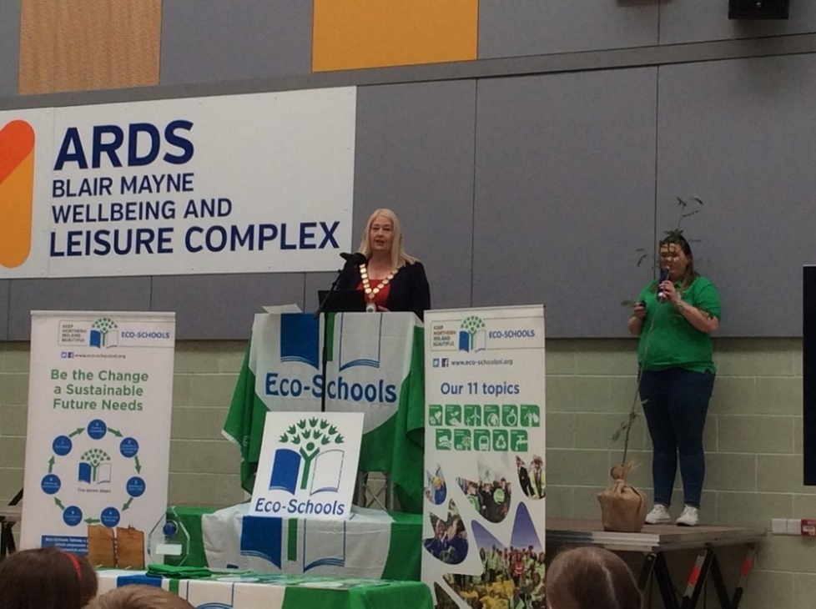

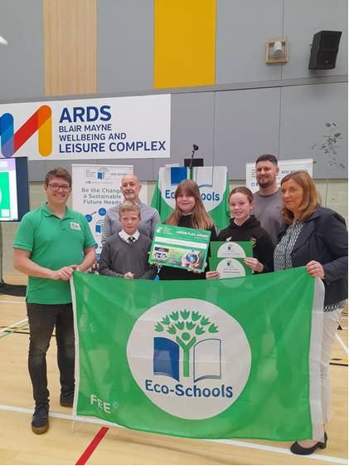



The event at Ards Blair Mayne was hugely successful, greatly enjoyed by pupils, teachers and all those involved with the Eco-Schools programme. Eco-Schools was a key element of the overall environmental education programme that Council relied upon in its mission to transform the attitudes and behaviours of school children and adults, complementing a range of other important initiatives that the Council rans/partnered in to achieve that outcome. Currently, the Waste and Litter topics had been the most successfully engaged in topics out of the eleven individual topics schools could choose from through the Eco-Schools programme – which augered well in particular for the campaign to inspire a recycling revolution across the Borough.
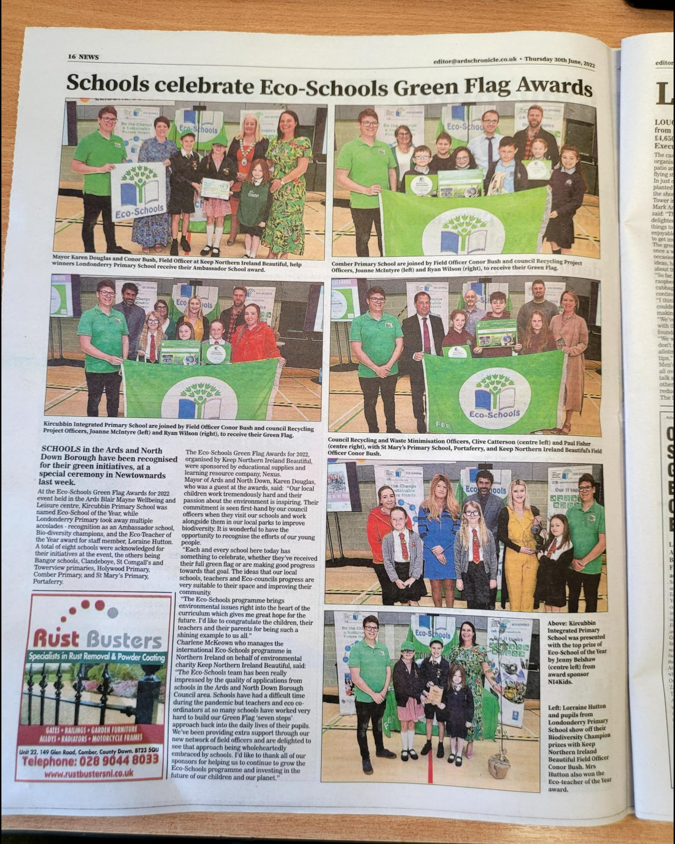

Attached at Appendix 1 is the Eco-Schools Impact Score Card for Ards and North Down.

RECOMMENDED that the Council notes the report.

The Director advised Members that there had been discussions with local schools involved, and it was the Council’s intention to invite some of the pupils to make a presentation to the Environment Committee about their work on the Eco Schools initiative. It was hoped that that would take place when physical meetings resumed later in the year.
Proposed by Councillor MacArthur, seconded by Councillor Irwin, that the recommendation be adopted.

Councillor MacArthur recalled that she had attended the recent Eco Schools award ceremony and noted that Ards and North Down Borough Council contributed £11k locally to schools which was considerably more than any other Council in Northern Ireland. She offered congratulations to teachers and schools for the programmes they had carried out and welcomed the contribution the pupils would make at a future committee. She also referred to the collaboration of four schools in Donaghadee who had worked together to examine water samples for a marine litter project under the Live Here Love Here programme.

Councillor Irwin also praised the Eco Schools initiative which she thought was hugely important particularly in respect of recycling and waste reduction and for encouraging the upcoming generation to make good environmental choices.

Councillor McKee congratulated the schools taking part and asked officers about the lapsed flags that he had noticed for some and if there was any support that officers or Keep Northern Ireland Beautiful (KNIB) could provide to help them get back on board.

(Councillor Edmund entered the meeting at 7.25 pm)

The Director gave his assurance to Members that the Council, along with KNIB, was working continually with schools to overcome the barriers that some of them faced in terms of keeping up this great environmental work. He added that everyone was aware that schools and teachers were under immense pressure and stress and had done fantastically well to date coping with many competing challenges over recent years. The Council remained mindful of that and would continue to engage with schools. He stressed that whilst green flag accreditation status may lapse from time to time for a school, usually the school was still actively engaged in the Eco-Schools programme.

Councillor Johnson echoed the comments of Members adding that while it was of course excellent that young people were engaged with environmental issues they were also developing skills in active citizenship and that in turn would make them positive participants in community life.

Councillor Kendall thanked officers and agreed with all the positive comments that had been expressed. She considered it an achievement in itself that over 30% of schools in the Borough were participating in the initiative and believed that Members would do all they could to help schools if necessary.

Councillor Boyle referred to the encouraging report which had made excellent reading and considered the work with schools to be a massive success story in this Borough when looking at the statistics. He congratulated all those who were participating and noted that this would be the generation that would make wiser decisions about the environment throughout their lives.
AGREED TO RECOMMEND, on the proposal of Councillor MacArthur, seconded by Councillor Irwin, that the recommendation be adopted.

(Having declared an interest in Item 5 Alderman McDowell left the meeting at 7.35 pm and Councillor Kendall took the role of Chair at that point)

5. Waste Re-Use Projects - Update Report

PREVIOUSLY CIRCULATED:- Report from the Director of Environment detailing that Members would recall that over the past year the Council had implemented several projects aimed at pushing the management of certain waste arising in the Borough, further up the waste hierarchy.

Waste Hierarchy

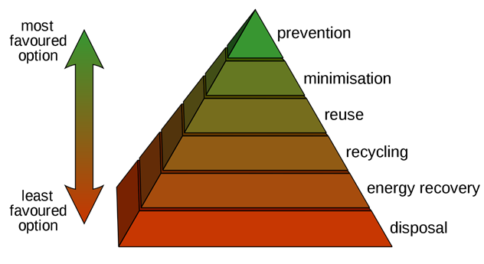

- Community Paint Reuse Scheme
- White Goods Reuse Collection Service
- Household Furniture Reuse Collection Service

Choose To Reuse 2022 | Ards and North Down Borough Council

Disposal of Paint | Ards and North Down Borough Council

Community Paint Reuse Scheme
An estimated 50 million litres of the 320 million litres of paint sold in the UK each year goes to waste. The leftover paint was either thrown away or stored in homes or garages despite over 50% of it still being usable.

As well as being incredibly wasteful and harmful to the environment, paint disposal was very costly. In November 2021, the Council introduced a scheme whereby the general public and community organisations had been encouraged to collect surplus to requirements/unused paint that had previously been brought by others to the Council’s HRCs for disposal.
The designated paint reuse collection point was initially introduced in Newtownards and following the success of the scheme Comber was added in June 2022. The scheme was to be further expanded to the Balloo HRC in September 2022 once the necessary receptacles were fitted out. The number of collection points must be kept limited to ensure that there was a sufficient amount of paint available for selection by those who wished to find paint that they could re-use; it was therefore not possible to spread designated collection points across all HRCs.

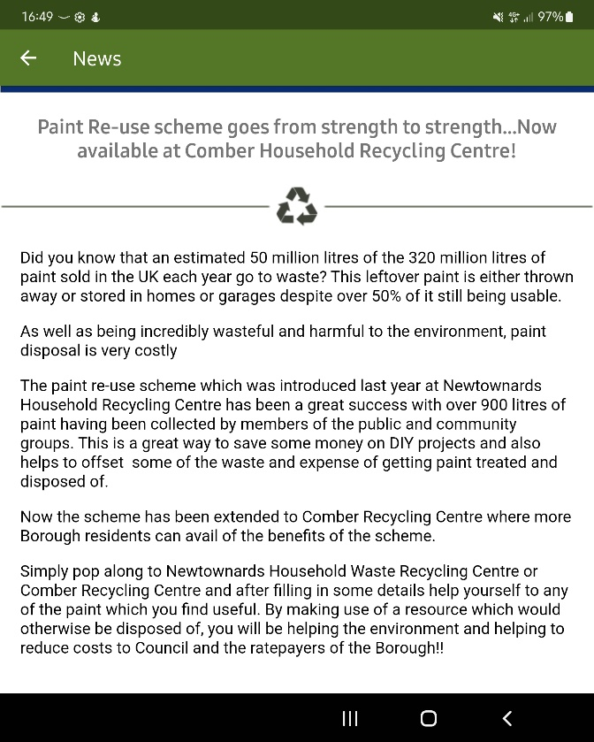



News Items Publicised on Binovation App

Between November 2021 and June 2022, over 640 cans, estimated at 3,230 litres of paint, had been claimed by residents from the re-use scheme. That had saved carbon emissions estimated at around 9 tonnes of CO2e, as well as avoiding a disposal cost to ratepayers of around £3k. Overall, the programme to reduce paint waste disposal via the Council’s HRCs had led to a saving of over £11K over a 7-month period.

The initiative had proven to be very popular and was something which officers planned to build upon and encourage ongoing/wider adoption of a paint re-use culture amongst our communities as they grew in their appreciation of both the significant environmental and financial benefits.

White Goods Re-Use Collection Service
Every year an estimated two million tonnes of Waste Electrical and Electronic Equipment (WEEE) items were discarded by householders and companies in the UK, 40% of which comprised large household white goods appliances.

The Council partnered with Refresh Appliances in applying for an application to the Waste Electrical and Electronic Equipment (WEEE) Local Project Fund. Refresh Appliances was a local Social Enterprise Company based in Newtownards that provided a domestic appliance sales and repair service which included the remanufacture and repair of the large appliances. The company was contracted with the European Recycling Platform (ERP) to collect appliances from HRCs in the six Council areas of Arc21, including Ards and North Down.

One of the barriers to re-use of white goods appliances was the damage that was often caused to those items as they are transported by residents to HRCs and damage that occurred as they were moved around the sites themselves. In a bid to further improve the service to ratepayers and maximise the re-use outcomes for appliances, funding was secured to provide a direct collection service from householders for one year. The scheme was free of charge and launched on Tuesday 4 January 2022.

Large appliances, which were eligible for collection as part of the scheme were:
- Washing machines
- Tumble dryers
- Dishwashers
- Cookers and hobs



News Item Published on Binovation App

Bookings for collection by any resident of the Borough could be made directly through Refresh Appliances and officers also liaised where appropriate with Refresh in relation to bulky waste collection requests received by the Council, that included the eligible appliances.

Statistics to 22 June 2022 showed that 380 appliances were collected via the scheme, representing 22.8 Tons of WEEE - with a reuse rate of 38% (8.7 Tons).
An average of around 63 collections were being carried out per month. Based upon the carbon savings of reusing a washing machine compared to recycling it, the overall carbon savings arising from the 8.7 tons of white goods reused in this scheme so far, was estimated at 17.9 Tons CO2e (compared to 10.4 Tons CO2e if the appliances had been recycled).

Once again, the scheme had proven to be hugely popular so far and would continue to be actively promoted by Council officers in collaboration with Refresh Appliances.

Freecycle Household Furniture Reuse Collection Service
Utilising underspend from the RCIF last year, the Council introduced a 12-week trial aimed at encouraging residents to donate and receive large household furniture items for reuse, rather than disposing of them.

Under the scheme, items listed by residents of the Borough on the openly/freely available ‘Freecycle’ platform, for collection from and delivery to homes within the Borough were eligible for a free transport service by the Council. That was designed to promote willingness by residents to more actively consider the option of furniture ‘reuse’, by encouraging use of the existing ‘Freecycle’ platform and removing the ‘barrier’ of residents having to source a suitable means of transporting larger furniture items from the donor to the recipient homes.

Freecycle: Front Door

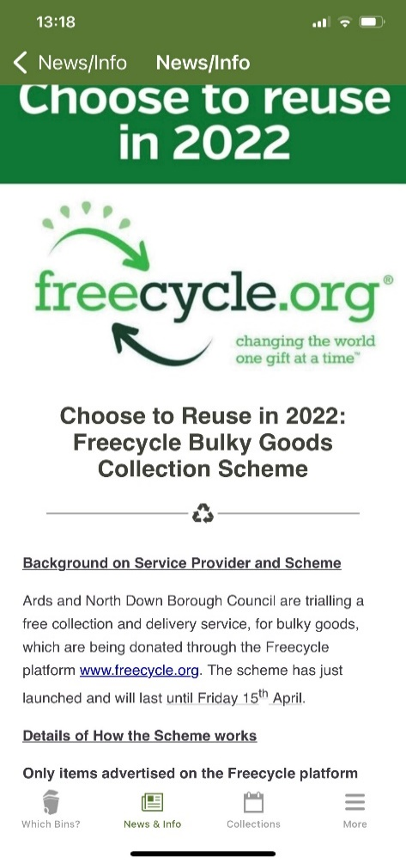

News Item Published on Binovation App

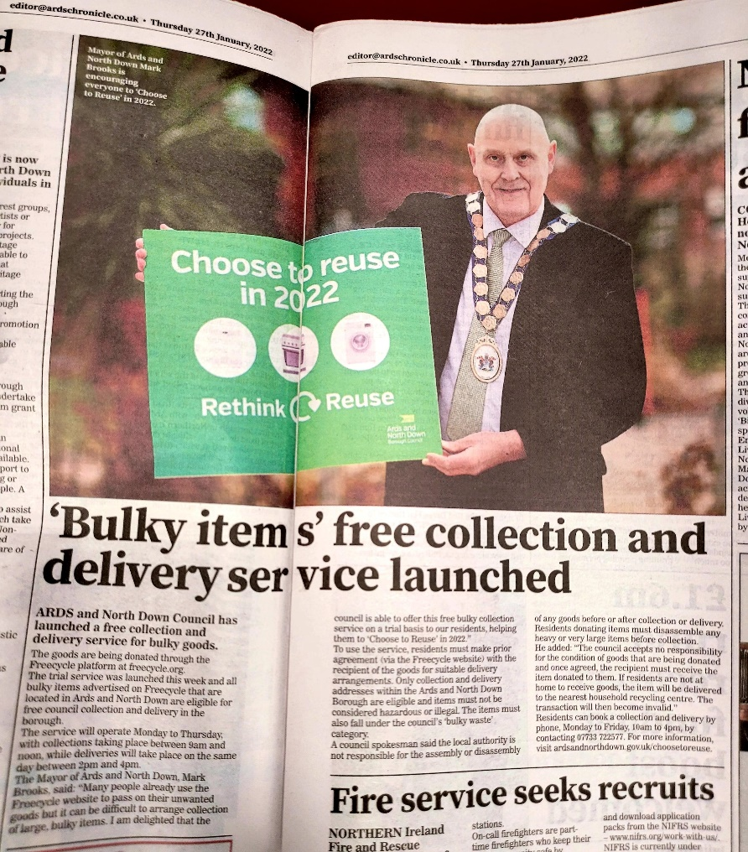

Local Press Article

In all of the Council’s publicity around this scheme, residents were urged to first consider donating furniture items to locally based charities.

Unfortunately, despite the extensive publicity and promotion of the trial, only seven collections/delivery of furniture items for reuse were undertaken. That was very disappointing, and officers would continue to look at ways in which the Council could try to encourage and incentivise further reuse of household furniture items in the future. The resources that were put in place (van and operatives) were productively utilised when not undertaking the Freecycle deliveries, by supplementing the capacity to deliver the normal bulky refuse service.

RECOMMENDED that the Council notes the report.

Proposed by Alderman M Smith, seconded by Councillor MacArthur, that the recommendation be adopted.

Alderman M Smith referred to the recycling initiative for household furniture and was disappointed to read that only seven households had used the service. She wondered if there had been any waste associated with that and the Director informed Members that surplus resource for that initiative had been productively redeployed to boost the bulky waste collection service – so no resources were in fact wasted.
Councillor MacArthur shared that disappointment in terms of the Freecycle initiative but recognised that it was a busy marketplace and that overall this was an encouraging report. The real success story was in paint recycling, and she wondered if that could be extended further by working with paint distributers. Paint was a very expensive item, and the sharing of paint was welcomed by many, some of whom, may be struggling with the rising costs of living.

The Director indicated that officers were expanding the initiative and would look at any options that were considered viable.

Councillor Cathcart praised the initiatives being taken, which were providing significant benefits in helping some with the rising cost of living and reducing the Council’s costs of waste disposal. He was encouraged about the recycling of white goods and his mother had participated in that without his prompting, so he knew that the public was being kept aware of options.

Councillor Smart believed that some aspects of the report were fantastic in making environmental improvements and that the Council should be proud of its contribution to that. He requested that staff be congratulated on those achievements. He also asked how much of the donated paint was reused and how much was destroyed. The Director replied that approximately 3,200 litres of paint had been taken for reuse and that that was a very significant proportion of the paint available. He also referred to the partnerships the Council had with social enterprises who could distribute items such as furniture which was still in good/reusable condition and had been brought to HRCs.

AGREED TO RECOMMEND, on the proposal of Alderman M Smith, seconded by Councillor MacArthur, that the recommendation be adopted.

(Alderman McDowell was returned to the meeting at 7.51 pm)

6. Additional Bin Collection Vehicles and Staff Resource

PREVIOUSLY CIRCULATED:- Report from the Director of Environment detailing that the following creation of the new Council in 2015, efficiencies were created by implementing an integrated approach to kerbside bin collections across the two legacy Council areas, facilitated by a new software system (Webaspx) that had been deployed very effectively over the past number of years to redefine and adjust collection routes as new properties had been developed and demand for kerbside bin collection services had changed/expanded in various parts of the Borough. That planned approach had meant that despite the number of residential properties in the Borough growing by 4,652 between 2015 and 2021 (per published DoF Housing Stock Statistics), the Council had been able to avoid the need for expansion of the complement of kerbside waste collection resources by more efficiently managing the combined legacy Council collection routes.

The point had now come whereby capacity to manage the legacy Council collection routes more efficiently (and thereby avoid expansion of the number of routes despite growing numbers of properties to be serviced), had been exhausted. Collection routes were now at capacity and beyond, placing rising pressure on the Council’s ability to fulfil kerbside waste collections to all homes up to the standards expected. The collection service had become dependent on the use of a support vehicle to assist a number of rounds during certain periods and in particular the organic (brown bin rounds) during the grass growing season when the bin set out rate increased significantly.

To further guarantee continuity of those core/frontline services and continued high quality service delivery, two additional crews (initially two Category C drivers and two loaders, but ultimately also requiring two additional loaders as the new routes filled out further) plus two additional RCVs would be required.

Two main options were considered in the business case:

Option 1: Address additional service demands through continuation of ever- increasing overtime working and piecemeal catchup working across existing collection routes.

Option 2: Expand the complement of collection routes/crews by two.

Whilst Option 1 represented the lowest cost option over the 5-year period of the Business Plan, when the non-monetary benefit score was factored in Option 2 became the highest ranked option. Essentially, whilst theoretically the extra service demand could be managed through increased reliance upon overtime working and piecemeal delivery of bin collections to ongoing increases in residential properties, that was not deemed practicably viable in a manner that would deliver the required continuity and quality of service standards.

The estimated annual average cost of the extra bin collection resource required (financing of additional refuse collection vehicles and running costs, plus staff costs) over the 5-year period of the business case was £210k (£197k in year 1).

RECOMMENDED that approval is granted to make provision in the 2023/24 estimates process for the procurement of two additional Refuse Collection Vehicles and recruitment of an additional four waste collection operatives (2 Category C Drivers and two Refuse Recycling and Street Cleansing Operatives).

The Director referred to the report and stated that after the two Councils merged over seven years ago the legacy bin collection routes and crews had been merged. Since that time the officers and crews had carried out a fantastic job, being integrated efficiently across the new Borough. While the number of new properties within the Borough continued to increase, with significant associated additional rate income, efficiency planning of legacy resources meant no additional vehicles or crews had been required to date. However, it had now reached the stage where all potential efficiencies had been exhausted and the service was coming towards tipping point - so additional resources were required to continue to deliver the Council’s normal high standard of service.

Proposed by Councillor Boyle, seconded by Councillor Cummings, that the recommendation be adopted.

Councillor Boyle put on record his thanks to the Director and to the Head of Waste and Cleansing and their teams for the service that had been provided over the previous years and in particular throughout the Covid-19 pandemic. He did not want to jeopardise the service which was so valued by ratepayers by stretching it unnecessarily and was happy to propose the recommendation. He asked that thanks be conveyed to all staff in the department for their great work.

In seconding the recommendation Councillor Cummings added his appreciation suggesting that Option 2 was the most practical response. In doing so it increased the capacity of the Council fleet and helped to serve a population that was continuing to grow. He asked about the training or availability of Category C drivers to drive the vehicles.

The Head of Waste and Cleansing stated that a recruitment exercise would be undertaken but that training would also be provided in house and that had been costed in the report.

Councillor Smart also expressed support for Option 2 stressing that this was an essential service, so it was absolutely right that further resources were allocated to it. He paid tribute to officers when thinking of the scheduling changes that the officers had put in place over the years which had run seamlessly and which gave him further faith in the proposal which was now being put forward.

The Chair, Alderman McDowell highlighted that the Environment Directorate had offered up a lot of the efficiency savings to the Council historically.

AGREED TO RECOMMEND, on the proposal of Councillor Boyle, seconded by Councillor Cummings, that the recommendation be adopted.

7. Northern Ireland Local Authority Municipal Waste Management Statistics, January to March 2022

PREVIOUSLY CIRCULATED:- Report from the Director of Environment detailing that the official waste management statistics for the final quarter of 2021/2022 (January to March 2022) had been released by the Northern Ireland Environment Agency.

The significant headlines contained within the latest DAERA report showed that:

- The Council’s household waste recycling rate fell by 0.4% compared to Q4 last year, (from 43.2% to 42.8%) and had now fallen by 8.5% compared to Q4 peak rate achieved in the 2018/19 year (from 51.31% to 42.8%).

- The Council’s household waste recycling rate of 42.8%, was 3% lower than the NI average of 45.8%.

- The Council was ranked ninth out of the eleven NI Councils for its household waste recycling rate.

- The Council’s household waste composting rate fell by 0.4% - from 21.6% to 21.2%. The household waste dry recycling rate fell by 0.2% - from 21.3% to 21.1%.

- The Council’s household waste composting rate of 21.2% was 0.4% higher than the NI average of 20.8%.

- The Council’s household waste dry recycling rate (i.e., recycling of items other than organic food and garden waste) of 21.1% was 3.7% lower than the NI average of 24.8%.

- The Council’s kerbside recycling capture rate of 62.4% for household compostable waste materials compared to a NI Council average of 59.5%.

- The Council was at the bottom end of the performance table for ‘dry’ recycling rate, ranking tenth out of eleven Councils.

- The Council received 36% more waste per capita at its HRCs compared to the average for other NI Councils.

- The amount of waste collected at the Councils HRC sites for recycling was significantly less than the average for other Councils – 58.5%, compared to an average rate of 70.5% for other Councils.

- The amount of waste collected for recycling through the Council’s kerbside bin collection system was higher than the average for other Councils – 47%, compared to an average of 43.7% for other Councils. However, the kerbside recycling rate had fallen by 3.8% compared to the same period last year and the margin over the average kerbside recycling rate for all Councils, had fallen significantly.

This latest official Municipal Waste Management Statistics report presented further clear evidence that the Council’s performance in relation to waste resource management had suffered a significant sustained deterioration, both in absolute and relative terms.

The Council’s rolling 12-month average recycling rate of 48.3% had fallen back from a high of 54.7% and was currently some 21.7% below the statutory recycling target of 70% by 2030 as set out in the recently enacted Climate Change Act (NI) 2022.

Officers were working on ways of contributing more effectively towards to the achievement of new statutory recycling and landfill targets whilst at the same time improving levels of customer service. Project teams would focus on both the HRC service and kerbside recycle bin service. With regard to HRCs, emphasis would be on more effectively implementing site operational controls such as checks at entry for all prospective site users, site layout and supervision arrangements to promote, support and enforce better separation of recyclable waste etc. Regarding kerbside bin service, the Council would be working to relaunch and strengthen recycling communications and bin monitoring protocols – with relaunch of the bin contamination warning label system where grey bins contained recyclable waste items. Further information on those two major campaigns would emerge in coming weeks.

RECOMMENDED that the Council notes the report.

The Director introduced the report highlighting that Members would be aware that he had been in discussions with party leaders in terms of an immediate and longer-term plan in respect of this matter. A report would be brought to the Environment Committee in October outlining to Members the proposed way forward to attempt to regain the high ground that the Council once held before the Covid-19 pandemic struck, by pushing back up the rates of recycling in the Borough.

Proposed by Councillor Greer, seconded by Councillor Smart, that the recommendation be adopted.

Councillor Greer thought that the results within the report had been disappointing and that the rates of recycling had been going in the wrong direction for some considerable time. She referred to additional waste through many residents continuing to work from home when they may have spent much more time working in Belfast for example prior to the pandemic. However, there was something that the Council was doing wrong compared to other Council areas as this Borough also had a much higher percentage of waste being disposed of at HRCs.

She went on to ask what the Council could do in the short term and reminded Members that a recycling rate of 70% needed to be achieved by 2030 and that the Borough would struggle to meet that target. The Director explained what was in place but was reluctant to pre-empt the information and debate which would be coming to the Committee next month. However, in summary it was planned to deploy resources to apply and enforce agreed access and recycling rules for HRCs and recycling engagement in kerbside bin collections much more rigorously. It was hoped that programmes around that will be ready to launch by the end of November. That would also include a very significant information campaign around those two key strands of the Council’s waste management service.

The Chairman encouraged Members to hold off discussion until the report was brought before them, but what had been spoken of gave a sense of direction.

Councillor Smart was in agreement that there was little joy in reading the report and that the Council was verging on sitting at the bottom of the scale when at a time it was leading the way in terms of recycling. That position was obviously unsustainable. He recognised that that position would not change overnight and would need a radical transformation. He believed that most residents of the Borough were prepared to play their part in helping but sometimes were not fully informed about what needed to be done.

Councillor Boyle was of the opinion that a definite changing of culture was needed. He was concerned that those neighbouring the Borough were using the Council’s HRCs but stressed that there was something seriously wrong when HRCs in Ards and North Down were contributing almost as much to landfill as Belfast City Council. He agreed that hard decisions would need to be taken in the interest of the Borough’s ratepayers.

Councillor Kendall reminded Members that the Committee had seen this coming for some time and thought that if householders were tightening their belts financially they would not be happy for their rates to be spent irresponsibly through excessive waste disposal costs. Members had a duty to ensure that did not happen, so would need to be brave and try to make the savings that were necessary.

Councillor Armstrong-Cotter looked forward to the report and believed that online messaging would be essential to bring people on board by showing them how much waste was costing and stressing that the Council was trying to do its best for ratepayers. This could not become a party-political matter but should be considered in context of the tough financial climate society at large was facing. Councillor MacArthur was in agreement with that, and the necessity to get out the stark messaging via social media. She highlighted the evidence she had personally witnessed of far too many people using HRCs to simply dump bags of mixed and waste into landfill skips, much of which was probably recyclable.

AGREED TO RECOMMEND, on the proposal of Greer, seconded by Councillor Smart, that the recommendation be adopted.

8. Ballywalter Harbour Damage Repair Scheme

PREVIOUSLY CIRCULATED:- Report from the Director of Environment detailing that Members would recall that on 7 December 2021 Storm Barra battered much of the British Isles and many areas within the Borough suffered flooding and storm damage.

Ballywalter Harbour was significantly damaged during the storm, with a huge hole being punched through the sea wall by the relentless wave action. The pier was closed off during the storm to prevent access due to the risk from large waves and the cordon remained in place afterwards due to the risk of collapse.

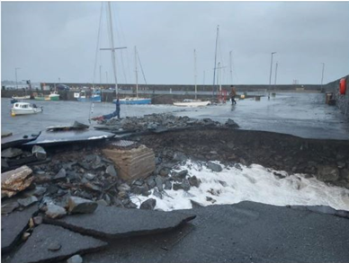

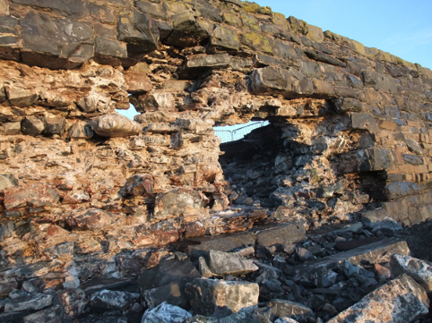

Initial Steps
Many elements of the wall/backfill and bitumen deck of the structure were in a very unstable condition and therefore susceptible to further collapse in the very near future. For that reason, officers acted quickly to remove unstable/exposed elements where possible and to stabilise the void and prevent any further loss of material.

The pier was reopened to fishermen only and a cordon left in place around the hole over the Christmas period.

In the New Year, the undermined/unstable section of the wall was demolished as it was deemed unsuitable and unsafe to repair. The unstable section measured approximately 20m long and 6m high. The Department for Agriculture, Environment and Rural Affairs (DAERA) granted the Council an exemption to conduct those works but requested sight of the repair methodology and a Habitats Regulations Assessment to cover the works.

Design Phase
Developing permanent works to remediate the wall and pier took some time as appropriate fixing methods, reinforcement and mortar needed to be tested and selected. A consultant specialising in Marine Infrastructure was appointed to create a design, methodology and material specification. During the design phase, the necessary approvals and risk assessments, as required by DAERA, were prepared and subsequently approved.

Permanent Repair
On site works to repair the structure began in early May 2022. Each of the large stones at sea level were drilled and L shaped steel reinforcing bars were epoxy bonded into position. Those re-enforcing bars travelled through the wall and a concrete mass was poured below deck level on the inside to secure the stones into position. Furthermore, each stone was bedded in a specialist marine epoxy that dried quickly, bonded strongly and did not shrink or deteriorate over time.
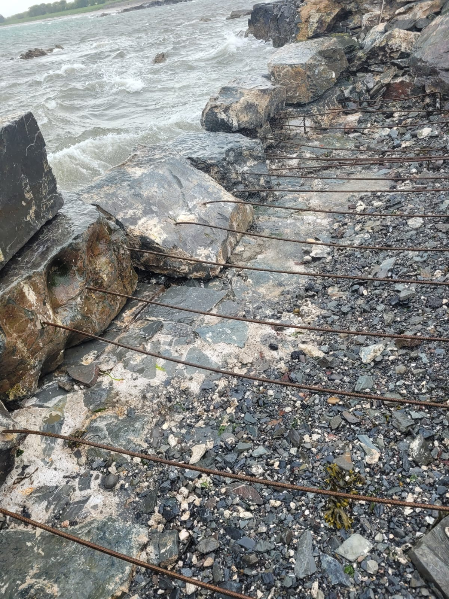
L shaped reinforcing bars to anchor the stones in position

To add strength and reduce labour costs, the core in the between the inner and outer skins was filled with mortar and small rocks.

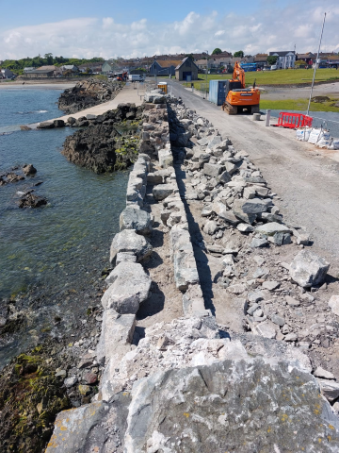
Core between inner and outer skins filled to remove voids

Finally, each joint was pointed with a quick drying epoxy mortar to prevent future water ingress.
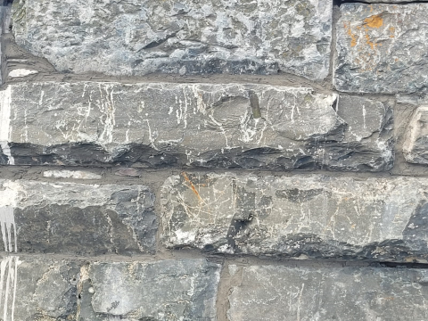

Once the wall was completed the repairs to the bitmac surface were completed and the area reopened to the public. The works took approximately eleven weeks to complete with the final cost approximately £85k, which was expected to be sourced from capital budgets. That was inclusive of all consultancy, design and specialist materials needed.

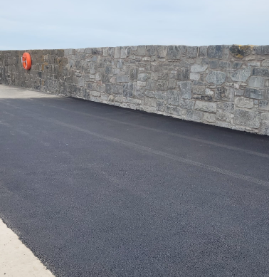

RECOMMENDED that the Council notes this report.

Proposed by Councillor Edmund, seconded by Councillor Boyle, that the recommendation be adopted.

Councillor Edmund thanked the Head of Assets and Property Services and praised the completion of such a fantastic piece of work. He noted that the harbour had been in place since the 1600s and he hoped that the work that had been carried out would last well into the future. He was aware that the fishermen working in that area were glad to be able to use the harbour again. He said that since the initial collapse of the wall the Council team had worked fast to secure the area and had continued to collaborate with the fishermen there.

Councillor Boyle agreed with the previous comments and thanked officers for overseeing the problem at Ballywalter and the construction team for reinstating the wall. He asked that the thanks of Councillors be passed on to the team.

AGREED TO RECOMMEND, on the proposal of Councillor Edmund, seconded by Councillor Boyle, that the recommendation be adopted.

9. Result of Court Proceedings - Neighbourhood Environment Team

PREVIOUSLY CIRCULATED:- Report from the Director of Environment detailing that:

The following convictions were secured at Newtownards Magistrate’s Court in the Quarters 1 January 2022 to 31 March 2022 and 1 April 2022 to 31 June 2022. See Appendix A attached.

In accordance with the instructions of the Resident Magistrate, the Council’s solicitor would notify defendants upon first appearance in court in response to a summons, that they may seek to have the matter withdrawn upon payment of legal costs and any fixed penalty notice previously offered. The cases were then adjourned to permit a further opportunity for payment. That had resulted in a number of cases being settled and withdrawn on the day of court upon payment of all costs and fines.

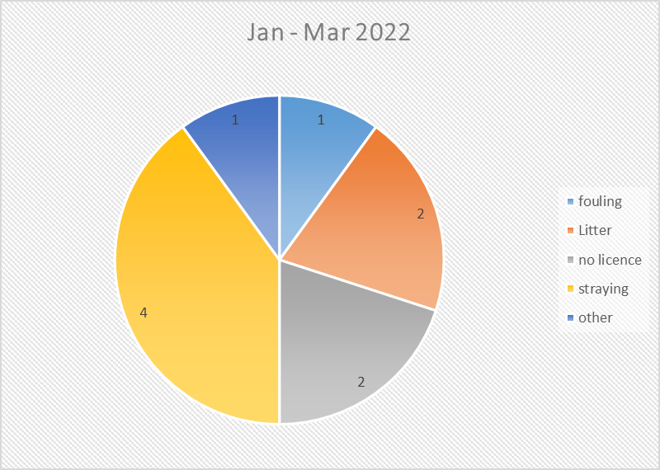

The above pie chart outlined how many of each of the ten prosecution cases were in each category. They were disposed of by the court during the period January to March 2022 as follows:

- One case was withdrawn as defendant’s whereabouts are now unknown.
- Six cases were settled and withdrawn.
- Three convictions were obtained.
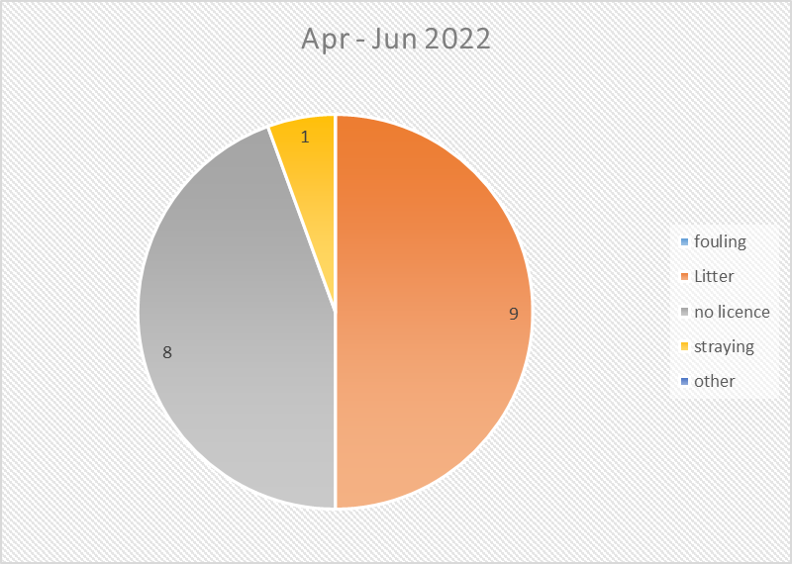
The above pie chart outlined how many of each of the eighteen prosecution cases were in each category. They were disposed of by the court during the period April to June 2022 as follows:

- Three cases were withdrawn as defendant’s whereabouts were now unknown.
- Four cases were settled and withdrawn.
- Eleven convictions were obtained.

The enforcement process carried out by the Neighbourhood Environment Team was as follows:

Detection of offence where fixed penalty permitted | Detection of more serious or repeat offence where a fixed penalty is not applicable
DOWN
 | DOWN
Fixed Penalty Issued | Investigation carried out
14 days at £60 then 14 days at £80 | DOWN
DOWN | Case reviewed by Solicitor
2 Reminder letters issued | DOWN
DOWN | Referred for Prosecution
Service Unit Manager Appeals/ Reviews carried out | DOWN
DOWN | Summons Issued
Case reviewed by Solicitor
DOWN
Referred for Prosecution
DOWN
Summons Issued | DOWN
DOWN
Adjournment on first appearance
Solicitor offers further opportunity to discharge liability on payment of fixed penalty and costs
DOWN
Case heard before Magistrates Court | Case heard before Magistrates Court.

Council Solicitor reports outcome and Environment Committee informed

RECOMMENDED that the Council notes the report.

AGREED TO RECOMMEND, on the proposal of Councillor Smart, seconded by Councillor Edmund, that the recommendation be adopted.

10. BUILDING CONTROL Q4 ACTIVITY REPORT (1 JANUARY 2022 TO 31 MARCH 2022)

PREVIOUSLY CIRCULATED:- Report from the Director of Environment detailing that the information provided in the report covered, unless otherwise stated, the period 1 January 2022 to 31 March 2022 (Quarter 4). The aim of the report was to provide Members with details of some of the key activities of Building Control, the range of services it provided along with details of level of performance. The report format had been introduced across Regulatory Services.

Applications
Full Plan applications were made to Building Control for building works to any commercial building, or for larger schemes in relation to residential dwellings.

Building Notice applications were submitted for minor alterations such as internal wall removal, installation of heating boilers or systems, installation of all types of insulation and must be made before work commenced. Those applications were for residential properties only.

Regularisation applications considered all works carried out illegally without a previous Building Control application in both commercial and residential properties. A regularisation application considered all types of work retrospectively and under the Building Regulations in force at the time the works were carried out.

Property Certificate applications were essential to the conveyancing process in the sale of any property, residential or commercial, and provided information on Building Control history and Council held data.

 | Period of Report  01/01/2022 – 31/03/2022 | 01/01/2021- 31/03/2021 | 01/01/2020 – 31/03/2020
Full Plan Applications | 200 | 201 | 200
Building Notice Applications | 491 | 530 | 644
Regularisation Applications | 199 | 259 | 156
Property Certificate Applications | 860 | 942 | 725

The number of Full Plan applications received was very much determined by the economic climate, any changes in bank lending or uncertainly in the marketplace may cause a reduction in Full Plan applications. There were no direct internal means to control the number of applications received.

Regulatory Approvals and Completions
Turnaround times for full plan applications were measured in calendar days from the day of receipt within the Council, to day of posting (inclusive).

Inspections had to be carried out on the day requested due to commercial pressures on the developer/builder/householder, and as such any pressures on that end of the business reflected on the turnaround of plans timescale.

 | Period of Report  01/01/2022 – 31/03/2022 | Same quarter last year | Comparison | Average number of days to turnaround plan
Domestic Full Plan Turnarounds within target  (21 calendar days) | 51.9% | 76% | DOWN | 30
Non-Domestic Full Plan Turnarounds within target  (35 calendar days) | 70.0% | 65% | UP | 38

Regulatory Approvals and Completions
The issuing of Building Control Completion Certificates indicated that works were carried out to a satisfactory level and met the current Building Regulations.

Building Control Full Plan Approval indicated that the information and drawings submitted as part of an application met current Building Regulations and works could commence on site.

 | Period of Report  01/01/2022 – 31/03/2022 | 01/01/2021 – 31/03/2021 | 01/01/2020 – 31/03/2020
Full Plan Approvals | 162 | 153 | 117
Full Plan Completions | 253 | 242 | 358
Building Notice Completions | 283 | 299 | 261
Regularisation Completions | 145 | 180 | 129

Inspections
Under the Building Regulations applicants were required to give notice at specific points in the building process to allow inspections. The inspections were used to determine compliance and for improvement or enforcement.

 | Period of Report  01/01/2022 - 31/03/2022 | 01/01/2021 – 31/03/2021 | 01/01/2020 – 31/03/2020
Full Plan Inspections | 1876 | 1836 | 1864
Building Notice Inspections | 667 | 739 | 848
Regularisation Inspections | 285 | 383 | 240
Dangerous structures initial inspection | 4 | 6 | 3
Dangerous structure re-inspections | 8 | 6 | 4
Total inspections | 2840 | 2970 | 2959

Non-Compliance
Where it was not possible to Approve full plan applications they were required to be rejected. Building Control Full Plan Rejection Notices indicated that after assessment there were aspects of the drawings provided that did not meet current Building Regulations. A Building Control Rejection Notice set out the changes or aspects of the drawings provided that needed to be amended. After those amendments were completed, the amended drawings should be submitted to Building Control for further assessment and approval.

 | Period of Report  01/01/2022 – 31/03/2022 | 01/01/2021 – 31/03/2021 | 01/01/2020 – 31/03/2020
Full Plan Rejection Notice | 126 | 102 | 147
Dangerous Structure Recommended for legal action | 0 | 0 | 0
Court Cases | 0 | 0 | 0
Other | 0 | 0 | 0

RECOMMENDED that the Council notes the report.

Proposed by Councillor Cathcart, seconded by Councillor Boyle, that the recommendation be adopted.

Councillor Cathcart noted that the Council’s turnaround times for domestic full plans had fallen but looking at the number of applications there seemed to be roughly the same amount and he wondered about the reason for that. The Director could not give a definitive answer but thought that there were issues around unfilled staff vacancies. He agreed to come back to the Member on the matter when he had spoken with the Building Control Manager.

AGREED TO RECOMMEND, on the proposal of Councillor Cathcart, seconded by Councillor Boyle, that the recommendation be adopted.

11. Neighbourhood Environment Team Q1 Activity Report (1 April 2022 to 30 June 2022)

PREVIOUSLY CIRCULATED:- Report from the Director of Environment detailing that the information provided in the report covered, unless otherwise stated, the period 1 April to 30 June 2022. The aim of the report was to provide Members with details of some of the key activities of the Team, the range of services it provided along with details of level of performance.

Applications to the Neighbourhood Environment Team
The Dogs (NI) Order 1983

It should be noted that those figures included block licences where one licence could be issued for multiple dogs in specific circumstances.

 | Period of Report  April – June 2022 | Same 3 months April – June 2021 | Comparison
Dog licences issued during the three months | 4953 | 4610 | UP

Concessionary licences remained at 82% of dog licences issued over the period. That included the categories of neutering (£5) / over 65 (Free – first dog) / over 65 subsequent dog (£5) and income related benefits (£5). Standard dog licence £12.50 and block licence £32.

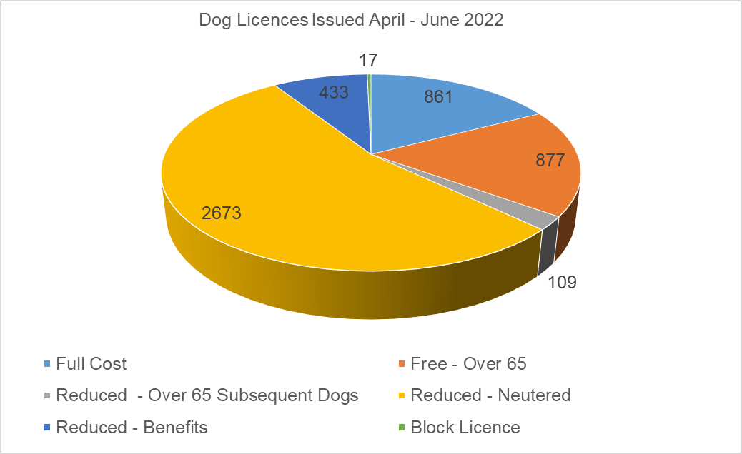

Investigations
The Neighbourhood Environment Team responded to a range of service requests. In terms of time spent, some types of service requests would be completed immediately whilst others required a longer-term strategy to find a resolution. The total number of service requests had been outlined together with a sample of the types of requests received.

 | Period of Report  April – June 2022 | Same 3 months  April - June 2021 | Comparison
Service Requests received the three months | 832 | 1008 | DOWN

Non-Compliance
Prosecutions

 | Period of Report  April – June 2022 | Same 3 months April – June 2021 | Comparison
Total Prosecutions | 17 | 44 | DOWN

The level of prosecutions during the same period last year included a back log of cases delayed due to Covid-19.

Fixed Penalty Notices
In addition to cases being prosecuted through the court, 121 fixed penalty notices had been issued in respect of various matters. That continued to demonstrate a sustained Council focus upon detecting and punishing those who persisted in committing environmental offences in the Borough and highlighted one patrolling outcome of the Neighbourhood Environment Team achieved despite the reduction in staffing levels due to sickness and vacant posts.

The main categories of fixed penalties were shown below. Other categories existed ie. breach of dog control conditions, exclusion order and off lead offences. The offer of an £80 Fixed Penalty Fine was an opportunity to discharge liability to prosecution.
A payment period of 28 days was permitted. If paid within 14 days, the fine was discounted to £60. As staff recruitment and retention remained a challenge that had impacted on the number of notices issued during the quarter.

 | Period of Report  April – June 2022 | Same 3 months April – June 2021 | Comparison
Fouling | 14 | 18 | DOWN
Litter | 81 | 99 | DOWN
No Dog Licence | 11 | 16 | DOWN
Straying | 15 | 8 | UP

The following graphs demonstrate:

- the total number of fixed penalties issued by the Neighbourhood Environment Team during each month of the period of report
- the fixed penalties issued during the period of report by type

Appendix A to the report provided a street level location for each of the penalty fines issued during the period of report 1 April to 30 June 2022.

Environmental Education Programme – Preliminary Actions
The Neighbourhood Environment Team had traditionally undertaken an Education Programme for primary and post primary schools and also for youth and community groups. As Covid-19 restrictions eased, we now plan to reintroduce a new programme of environmental awareness subjects which would be delivered in house by Council staff and supported by external agencies where necessary. That educational workstream complimented the enforcement work and was aimed at encouraging behavioural change and reducing environmental crime across the Borough.

The Recycling Community Investment Fund (RCIF) would contribute £25k towards the programme as this budget was previously earmarked for the previous CLEAR programme which ended when the RADAR facility closed.

The Neighbourhood Environment Team was presently undertaking the detailed planning of a structured sustainable programme designed for communities and schools. It would be the intention to have three main strands to the Environmental Education Programme focusing on education and schools, education in the community, and education around waste and recycling.

The team would work closely with the corporate communications section in the design of a strategy and branding to maximise engagement with young people at a suitable level for each age range and impact the wider community with positive messaging which reinforced community and individual responsibility to better protect the environment.

The Council was developing and assessing the effectiveness of a programme which may include elements such as a series of engaging talks and presentations delivered on current environmental topics such as climate change, human impact on landscape, littering, marine microplastics, practical classroom-based fish conservation projects and rewilding. That part of the programme would be offered on a modular basis with schools that completed the most modules being eligible for an end of year outdoor event.
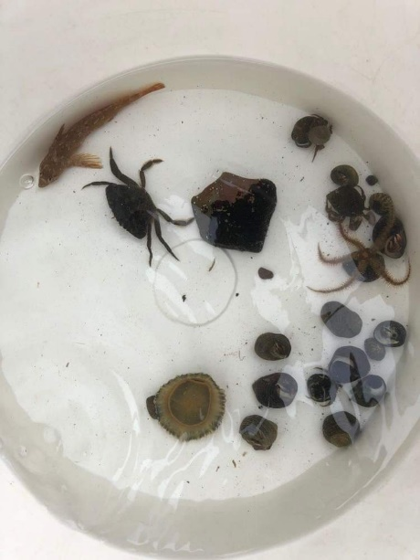
An example of rock pool finds during an outdoor school session

Additionally, a suite of initiatives would be offered to improve and enhance local communities. That would include support for beach clean ups, advice on community improvement projects, and liaising with Live Here Love Here to improve community engagement and to share experience and expertise.

It would be the intention to undertake promotional work and to engage with schools from September to December 2022 and begin with Year 8 presentations in schools in January 2023.

RECOMMENDED that the Council notes the report.

Proposed by Councillor MacArthur, seconded by Councillor Smart, that the recommendation be adopted.

On proposing the recommendation Councillor MacArthur thought that under education some of the topics being covered had, in her opinion, been well done already.

AGREED TO RECOMMEND, on the proposal of Councillor MacArthur, seconded by Councillor Smart, that the recommendation be adopted.

12. Grant of Amusement Permit

PREVIOUSLY CIRCULATED:- Report from the Director of Environment detailing that the following application for an Amusement Permit had been received:

Premises: Oasis Gaming, 39 High Street, Newtownards
Applicant: Mr Martin Trimble, Gowan Heights, Belfast
Mr Gerald Steinberg, Ailsa Road, Holywood

Application for a provisional licence had been made under Article 108 (1) (ca) of the Order to provide gaming machines with a maximum cash prize pay-out of £25. Access to the premises would be restricted to over 18-year-olds only.

A provisional licence application was made before the premises were completed. Once completed to the Council’s satisfaction the application would need to be brought back to the Council to confirm it.

Comment
The application had been publicly advertised as required by the Order and there had been no objections.

The PSNI had also confirmed that they did not have any objection to the provisional grant of the application.

Planning approval had also been granted for Oasis Gaming, 39 High Street, Newtownards.

Should the Council be minded to refuse the application or wish to impose further restrictions on the applicant then the Council was required to serve Notice on the applicant stating the proposed grounds for the refusal or additional restrictions. The applicant then had 14 days to inform the Council in writing of their desire to show cause, in person or by a representative as to why the application should not be refused or the additional conditions applied.

RECOMMENDED that the Council considers the application and confirms if they wish to grant or indicate their intention to refuse the application.

Proposed by Councillor Boyle, seconded by Councillor McKee, that the recommendation be adopted and that the application be approved.

Alderman Armstrong-Cotter put on record that she could not support the application. When it had come to the Council as a planning issue, she had been lobbied by a number of local businesses which were not happy with a licence being given for a location on one of the main streets of the town. It was for that reason that she could not add her name in support.

Other Members who also wished to oppose the application were Councillor Edmund, Councillor MacArthur and Councillor Cummings.

AGREED TO RECOMMEND, on the proposal of Councillor Boyle, seconded by Councillor McKee, that the recommendation be adopted.

13. GRANT OF ENTERTAINMENT LICENCES

PREVIOUSLY CIRCULATED:- Report from the Director of Environment detailing that applications had been received for the grant of entertainment licences as follows:

- Field of Dreams – Stretch Tent
Applicant: Mr Greg Brown, 55 Gransha Road, Bangor

Days and Hours: Monday to Sunday during the permitted hours when alcohol may be served on these premises under the Licensing (NI) Order 1996

Type of entertainment: Indoor dancing, singing and music or any other entertainment of a like kind.

- James Carrol Memorial Hall
Applicant: Mr Paul Greer, 9 Nairn Court, Newtownards

Days and Hours: The permitted hours during which intoxicating liquor may be sold or consumed on these premises under The Registration of Clubs (NI) Order.

Type of entertainment: Indoor dancing, singing and music or any other entertainment of a like kind.

- The Tipsy Gypsy, 1-3 Court Square, Newtownards
Applicant: Mr Ben Stewart, 80 Belfast Road, Antrim

Days and Hours: Monday to Sunday during the permitted hours when alcohol may be served on these premises under the Licensing (NI) Order 1996

Type of entertainment: Indoor dancing, singing and music.

- Alexander’s, 57 High Street, Holywood
Applicant: Mr Ben Stewart, 80 Belfast Road, Antrim

Days and Hours: Monday to Sunday during the permitted hours when alcohol may be served on these premises under the Licensing (NI) Order 1996

Type of entertainment: Indoor dancing, singing and music.

- The Sandpiper Inn, 64 Main Street, Ballywalter
Applicant: Ms Karen Collins, 54 Sandhill Parade, Belfast

Days and Hours: Monday to Sunday during the permitted hours when alcohol may be served on these premises under the Licensing (NI) Order 1996

Type of entertainment: Any entertainment which consisted of or included any public contest, match, exhibition or display of - boxing, wrestling, judo, karate or any similar sport, billiards, pool, snooker or any similar game or darts.

Dancing, singing or music or any other entertainment of a like kind.

Machines for entertainment and amusement. Equipment for playing snooker or similar games.

Comment

All of the above applications had been publicly advertised and no objections had been received.

The PSNI and NIFRS had also advised that they had no objections.

RECOMMENDED that the Council grants the applications listed in the report.

AGREED TO RECOMMEND, on the proposal of Councillor Kendall, seconded by Councillor McKee, that the recommendation be adopted.

14. GRANT OF PAVEMENT CAFÉ LICENCES

PREVIOUSLY CIRCULATED:- Report from the Director of Environment detailing that the following applications had been received for the grant of a Pavement Café Licences:

- Suitor & Co
Applicant: Ms Victoria McAleese, 106 Willowbrook Park, Bangor

Venue: Suitor & Co Café, 45 High Street, Holywood

Day and hours of use:
Monday 08.30 - 16.00
Tuesday – Sunday 07.30 - 17.00

- Lynchpin
Applicant: Mr Joseph McGowan, 10 Southview Street, Belfast

Venue: Lynchpin Café, 49 High Street, Holywood

Day and hours of use:
Wednesday – Sunday 09.00 - 17.00

- The Woburn Arms
Applicant: Mr Thomas Bickerstaff, 52 Abbey Road, Millisle

Venue: The Woburn Arms Public House, 69 Main Street, Millisle

Day and hours of use:

Monday – Saturday 12.00 - 21.00
Sunday 12.30 - 21.00

Comment
The applications had been publicly displayed on the relevant premises for 28 days as required in the legislation. No objections had been received.

DFI Roads and the Planning Service had been consulted and where necessary the PSNI. No objections had been raised to those applications.

Under the agreed conditions of licence, the pavement cafes would be required to:

- only use the agreed area to be outlined in the licence,
- provide only the approved furniture,
- completely remove any furniture from the pavement at the end of each day’s trading
- keep the area used for the café clean of litter and liquid spills.

RECOMMENDED that the Council grants the above licences.

Proposed by Councillor Boyle, seconded by Councillor Cathcart that the recommendation be adopted.

Councillor Boyle was happy to propose the recommendation stating that businesses needed all the support that could be given to them.

Seconding the recommendation Councillor Cathcart asked if alcohol could be included in a pavement café licence and the Committee was informed that alcohol could only be served within the designated delineated licenced area of a premises.

AGREED TO RECOMMEND, on the proposal of Councillor Boyle, seconded by Councillor Cathcart, that the recommendation be adopted.

15. GRANT OF STREET TRADING LICENCE

PREVIOUSLY CIRCULATED:- Report from the Director of Environment detailing that an application had been received for the grant of a Stationary Street Trading Licence, to trade at designated sites within the Borough:

Applicant: Mr William Cariaga Medina

Address: 35 Manse Gate, Newtownards

Goods to be supplied: Hot Food - Pizza

There were no objections to this application.

RECOMMENDED that the Council grants the Street Trading Licence.

AGREED TO RECOMMEND, on the proposal of Councillor Boyle, seconded by Councillor McKee, that the recommendation be adopted.

16. PROPOSED STREET NAMING – WOODLAND AVENUE, WOODLAND GREEN, AND WOODLAND WALK, COMBER

PREVIOUSLY CIRCULATED:- Report from the Director of Environment detailing that a development comprising of 58 dwellings was currently under construction on lands at Ardara Grove, Comber.

The developer had suggested the names Woodland Avenue, Woodland Green and Woodland Walk to recognise the mature/veteran trees marking the site line at both the Northern and Eastern boundaries. The site also included a mature woodland to the South. The names were in keeping with the general neighbourhood.

RECOMMENDED that the Council:

- adopt the street names Woodland Avenue, Woodland Green and Woodland Walk; and
- accepts the general name and delegates acceptance of suffixes to the Building Control department.

AGREED TO RECOMMEND, on the proposal of Councillor Cummings, seconded by Councillor Cathcart, that the recommendation be adopted.

17. PROPOSED STREET NAMING – CASTLELODGE GARDENS, COMBER

PREVIOUSLY CIRCULATED:- Report from the Director of Environment detailing that a development comprising of 22 dwellings was currently under construction on lands at Castlelodge Park, Comber.

The developer had suggested the name Castlelodge Gardens which was in keeping with the general neighbourhood.

RECOMMENDED that the Council:

- adopt the street name Castlelodge Gardens; and
- accepts the general name and delegates acceptance of suffixes to the Building Control department.

AGREED TO RECOMMEND, on the proposal of Councillor Cummings, seconded by Councillor Cathcart, that the recommendation be adopted.

18. ON STREET ELECTRIC CHARGE POINT SCHEME UPDATE

PREVIOUSLY CIRCULATED:- Report from the Director of Environment detailing that Members may recall from previous reports on the subject that the UK government had established a capital grant funding scheme for installation of On Street Residential Charge Points. That was a UK wide £20M grant pot administered by the Office for Zero Emission Vehicles (OZEV), and the scheme was extended into the current 2022-23 financial year. It was only available to Local Authorities and the funding available was for 75% of the capital costs of procuring and installing on-street residential charge points and associated dedicated parking bays (where applicable), in line with OLEV technical specifications. NI Local Authorities were eligible, like all other UK local authorities, to apply to the On Street Residential Charge Point Scheme (ORCS) - whilst central government departments such as the Department for Infrastructure (DfI) could not. That reflected the GB position (unlike NI) whereby Local Authorities were the statutory roads authorities; they owned and controlled the streets where the installation of the on-street residential charging infrastructure was to be installed under the ORCS. However, under the scheme Councils were also able to apply for funding from the ORCS to install residential charge points in public car parks (rather than on a residential street itself), provided the car park was located in a residential area where there was demand for residential EV charging and there was 24/7 access.

Last year, the then DfI Minister Nicola Mallon, announced that her Department would provide the 25% balance of funding to NI Councils that were successful in securing the 75% funding package from the UK ORCS – meaning that NI Councils would be able to play their role in delivering that type of infrastructure support for the transition to an Electric Vehicle society, at no cost to local ratepayers.

An NI EV Consortium Working Group was established in 2021 to facilitate the improvement of NI Councils’ electric vehicle Charge Point Infrastructure. That working group contributed to the Councils’ objective to net zero carbon in line with Government targets.

The scope of the EV NI Consortium Working Group was to create and develop a knowledge-based approach and share best practice from other UK and EU cities. Many of those cities had successfully implemented EV Charge point infrastructures within their local areas and the working group could benefit from those experiences.

Working Group membership was open to a number of public stakeholders such as ten Councils across Northern Ireland, Department of Infrastructure, NI Housing Executive and Sustainable NI. The Working group members would act as a key point of contact within their respective organisations, with the aim to share knowledge and best practice. A database of membership was maintained by Derry City and Strabane District Council.

Derry City and Strabane District Council co-ordinated the collation of a list of potential electric vehicle charge point sites from all Council areas within the Consortium.

Ards and North Down Borough Council had submitted a list of fifteen suitable Council car park sites, located widely across the Borough in Bangor, Newtownards, Holywood, Comber, Donaghadee, Groomsport, Portaferry and Kircubbin. Council officers had focussed upon suitable Council owned car parks, as those were deemed to be electric vehicle charge point sites that were most readily deliverable by the Council with the minimum of impediments and timeframes required.

That list was compiled following discussions with all relevant Service Units including Assets and Property and Licensing and Regulatory Services. Key considerations in those discussions were: proximity to residential properties that did not have access to off street parking (and therefore convenient home electric vehicle charging options), size of car park and if the location was already serviced by charge points and/or was on the list as a potential location for the EU Interreg FASTER project (The Faster Project - Sustainable Transition to EV's (fasterevcharge.com).

The list was then assessed by NIE in terms of feasibility and current infrastructure suitability.

ORCS Application Update
A joint application was submitted to the ORCS Fund on the Consortium’s behalf by Derry City and Strabane Council earlier in the year. Notification had now been received that the bid was successful, and Ards and North Down had secured funding for fifteen EV Dual Charge Point Installations, across nine Council owned off street public car park locations

Holborn Square, Bangor | 2 x Dual Charge Point Installations
Central Avenue, Bangor | 1 x Dual Charge Point Installation
Bingham Lane, Bangor | 1 x Dual Charge Point Installation
Ann Street, Newtownards | 2 x Dual Charge Point Installations
Kennel Lane, Newtownards | 2 x Dual Charge Point Installations
West Street, Newtownards | 1 x Dual Charge Point Installation
Mill Street Gasworks, Newtownards | 2 x Dual Charge Point Installations
Church Road, Newtownards | 2 x Dual Charge Point Installations
Manor Street, Donaghadee | 1 x Dual Charge Point Installation
Meeting House Street, Portaferry | 1 x Dual Charge Point Installation
Total | 15 x Dual Charge Point Installations

That was excellent news, and the work of Derry City and Strabane Council in playing a co-ordinating role for the successful bid was to be commended. One particular benefit of the collaborative bid across the nine participating NI Councils was the ability to aggregate the costs associated with all of the various proposed installation sites; the Council benefitted in particular from that since although several of our proposed sites went above the cost cap provided for per site within the scheme, they were able to be approved through the collaborative bid process across all Councils.

Next Steps
The Council agreed back in June 2022 to its participation in a collaborative tender process managed by Derry City and Strabane, for the appointment of a suitable Electric Vehicle Charge Point Operator (CPO) to procure, install, operate and maintain the planned 124 charge points through a public procurement process within the Crown Commercial Services Framework: Vehicle Charging Infrastructure Solutions (ref No: RM6213). That tender process was ongoing presently and was expected to be completed by the Autumn with an appointment of a CPO in late September or early October 2022.

Further updates on the project would be brought to the Council as and when available.

RECOMMENDED that the Council notes this report.

The Director gave an overview of the report and explained that this was a good outcome and was testament to the collaborate working among the Councils. He was particularly grateful to Derry City and Strabane Council who had facilitated the work. He added that he believed the funding needed to be spent before the end of this financial year and the work tied in with the Council’s own car parking strategy.

Proposed by Councillor Kendall, seconded by Councillor Boyle, that the recommendation be adopted.

Councillor Kendall welcomed the electric charge points and hoped to see some further investment in this technology soon. She thought it would be impossible not to support a movement to more sustainable ways of travel and looked forward to seeing the new charge points in place.

Councillor Boyle agreed and paid tribute to former Minister Mallon, Department for Infrastructure, for her support for the initiative.

Councillor Cummings gave his support particularly since there had been no cost to the Borough’s ratepayers and the matter had been discussed now for many years. He was aware that Alderman McIlveen would be pleased to see this come forward and expressed some disappointment that Comber had missed out in this round of funding. He asked the Director if he could give an indication as to the assessment of the areas and how they had been chosen.

In response the Director explained that the assessment criteria had been fairly complex. The Council had decided to use land owned and controlled by itself to reduce the number of barriers to development, it needed to be close to residences without private off-street parking and there were various technical criteria laid down by NIE. The intention was to have a good spread of locations throughout the Borough. He added that through the Council’s car parking strategy there was an intention to move forward with rapid chargers that would facilitate visitors and commuters into the Borough. The Council was working to secure some of the rapid chargers through the Interreg Faster Project.

Councillor Smart congratulated the Director and his team and considered this to be a radical transformation in terms of the infrastructure needed. He welcomed the additional nine charge points for Newtownards for use by residents and visitors to the area.

Councillor Greer was encouraged by the collaborate working across Councils and hoped that that could continue with other projects. Councillor MacArthur agreed pointing to the dearth of charging points in Northern Ireland. She wondered how charging would work in practice and how the resource could reach a large number of users. She also hoped that the areas which had been unsuccessful for this round of funding could perhaps try again at some future point.

The Director of Environment explained that the fine details of the use of the charge points would be established in due course. One of the conditions was that they had to be located in areas with unhindered access to residents, including at night. He also considered that an application could be resubmitted in future funding rounds if unsuccessful this time.

RECESS 9.02 pm
RECOMMENCED 9.12 pm

(Councillor Kendall and Councillor Johnson left the meeting at 9.12 pm)

Councillor Edmund welcomed this positive step forward and hoped that there would be further charge points on the Ards Peninsula coastline in the near future to support both local residents and visitors to the area. He thanked Alderman McIlveen for bringing the Motion before the Council in the first instance.

The Director highlighted an error in the table of proposed charge points, indicating that the double charge point listed for Church Road Newtownards, should instead have read Church Street Holywood. Councillors Greer and Kendall welcomed that information.

AGREED TO RECOMMEND, on the proposal of Councillor Kendall, seconded by Councillor Boyle, that the recommendation be adopted.

19. PARTNERING ARRANGEMENTS FOR THE REMOVAL OF SNOW AND ICE FROM TOWN CENTRE FOOTWAYS AND PEDESTRIAN AREAS
(Appendix V & VI)

PREVIOUSLY CIRCULATED:- Report from the Director of Environment detailing that reference was made to correspondence (Appendix 1) from DRD Transport NI relating to proposals for renewal of a voluntary partnership arrangement in relation to clearance of town centre footways and pedestrian areas of snow and ice, which had been in place for the past three years. That was administered under the auspices of a Memorandum of Understanding between the Council and the Department, and a request had been received for the partnership arrangement to be extended for another 3-year period.

Both legacy Councils had in the past, notably in the Winter of 2010, assisted with the clearance of snow and ice during a prolonged period of extreme weather which significantly affected accessibility around town centres and caused severe disruption to normal community and business activity.

Officers remained content that during periods of exceptionally prolonged, extreme weather conditions (e.g. such as those that prevailed in the Winter of 2010), when routine Council services had been disrupted and the Council personnel were as a consequence available, we could facilitate the spirit of the Memorandum.

RECOMMENDED that the Council agrees to renewal of the Memorandum of Understanding with DRD Transport NI for a 3-year period subject to the following conditions:

- Any Council support in relation to snow and ice clearance from town centres will only be provided under exceptionally prolonged, extreme weather conditions when normal Council services have consequently been disrupted and personnel and other Council resources are available to divert to snow and ice clearance activities.
- The schedule of agreed footways to be treated shall be as agreed by Transport NI with Council Officers and may change depending upon operational circumstances and resource availability.
- Confirmation from the Council’s insurers that it is content with the Council’s engagement under the Memorandum.

The Director advised that this MoU had this in place for a number of years and demonstrates willing on Council’s part to collaborate with another statutory agency to alleviate the impact on the local community of an extreme weather event.

Proposed by Councillor Edmund, seconded by Councillor Boyle, that the recommendation be adopted.

Councillor Boyle referred to the legacy arrangement with the Department for Infrastructure (DfI) which had been unclear about which organisation was responsible for the clearance of streets from snow and ice. He hoped that the Council was not doing the work of the Department.

The Director recognised that a modest sum of funding was offered by DfI but the Council only stepped in to clear snow and ice in exceptional circumstances, mainly to help clear the town centres when its own staff were unable to deliver other services such as street cleansing or bin collections and were therefore available for redeployment. There was a limit to what the Council was committing to. The intent of the agreement was that the Department had the ultimate responsibility in terms of liability.

Councillor McAlpine pointed out that the legacy systems still appeared to be in place with legacy North Down having a list street names/locations and legacy Ards showing maps. She urged the Council to have one recording system to be in place to reflect the new Council area of Ards and North Down.

AGREED TO RECOMMEND, on the proposal of Councillor Edmund, seconded by Councillor Boyle, that the recommendation be adopted.

20. NOTICE OF MOTION

20.1 Notice of Motion submitted by Alderman Irvine and Keery

That this Council changes the name of Queen’s Parade to Queen’s Platinum Jubilee Parade in honour and recognition of the 70th anniversary of the Queen’s accession to the throne.

Amendment Received from Councillor Cathcart

That this Council, in recognition of Her Majesty’s Platinum Jubilee and her conferment of City Status upon Bangor, agree to name an appropriate place or building within Bangor in her honour and that future Council Bangor entrance signs make reference to Bangor being a Platinum Jubilee City.

Alderman Irvine referred to his Motion and the intention to mark the 70th anniversary of the Queen’s accession to the throne and her honouring Bangor with City Status. He noted the amendment brought by Councillor Cathcart which in his opinion had the same general principle of his original Motion and he was happy to support the amendment.

Alderman Irvine said that it had not been his intention to be controversial with his Motion but on reflection the amendment would be a better way forward.

Alderman Irvine wished for a long-lasting recognition of the Queens Platinum Jubilee and the conferment of City Status upon Bangor. Those had been two significant events in history. He hoped that in the future there would be Council signs at the entrance of Bangor recognising that it had been a Jubilee City. The Queen’s Platinum Jubilee had been hugely successful, and he believed there would be opportunities to name other streets or parks in this way in time perhaps around the newly developed Marine Gardens. He was content that officers bring back a report on the options that Members could look at.

Alderman Keery did not think that there was much further to add other than that it would be an appropriate gesture to mark the Platinum Jubilee. He believed that there was no controversary around that and thought that it was something to which the Council could agree.

Proposed by Councillor Cathcart, seconded by Alderman Smith that the amended proposal be adopted.

Councillor Cathcart thanked Alderman Irvine and Alderman Keery for bringing the Motion and considered that it might be problematic to change a street name and he had gotten the impression that residents would not have been keen to add further to their Queen’s Parade address. He referred to the history of Queen’s Parade which had been named after Queen Alexandra in 1903 after a royal visit to Bangor. The nature of his amendment was to extend the possibilities and look at further options to pay tribute to the Queen and name something in her honour. He agreed that entrance signs to Bangor could be changed to reflect the City Status. The Platinum Jubilee had been a momentous occasion for Her Majesty the Queen, and he looked forward to a report coming back to the Committee.

Alderman M Smith was very pleased to second the amendment and hoped that officers would come back with a sensible way forward to mark Bangor’s City Status in the Platinum Jubilee year.

Councillor Boyle had no problems supporting the amendment and thanked Councillor Cathcart for bringing it. He asked if the Director had any idea of the timescale for new signs to Bangor and believed that it would be right for that to happen as soon as possible. The Director stated that officers would take guidance from Members and look at options if that was the view of the Committee.

Councillor Cathcart was of the opinion that the signs could come in the longer term and in the short term a street or park could be named marking the Platinum Jubilee year and Alderman Irvine agreed with that. Councillor Cathcart suggested that the Town steering group could be involved in choosing a suitable location to name.

Councillor Smart was happy to support the amendment and viewed it as offering further and wider scope. The Platinum Jubilee had had a uniting effect across the nation and the service and dedication of Her Majesty over so many years should be marked. He suggested that elected Members of the Bangor Central Ward could also be part of a working group to give the subject further consideration and set out an historical marker.

Councillor MacArthur added her support to those comments and had hoped to second the amendment. She agreed that this would be an important historical marker.

(Councillor McKee left the meeting at 9.50 pm)

Alderman Irvine thanked Members for all their comments and helpful suggestions.

The Chair concluded the discussion emphasising that it would be very important to recognise the work of Queen Elizabeth II, and this was also a very important historical moment which should be recognised. It was therefore important in his view to take a bit of time to consider options and get something right and fitting to mark the occasion.

AMENDED MOTION AGREED.

20.2 Notice of Motion submitted by Councillors Chambers and Brooks

We ask this Council to consider the urgent provision of sea rescue equipment to Cove Bay beach, known locally as the third beach, in Groomsport. A review into other locations around the Borough, should also be considered.

Proposed by Councillor Chambers, seconded by Councillor Smart, that the Notice of Motion be adopted.

Councillor Chambers explained that he was a fairly frequent walker on the coastline between Ballyholme and Orlock but until recently it had never occurred to him that there was no safety equipment available in that area. That had been highlighted to him lately under traumatic circumstances when someone had got into difficulty in the water and local people had taken to the shoreline to help, attempting to use anything that they could find to come to assistance. It had been very stressful.

Members were aware that over the past few years there had been a marked increase in sea swimming and other water-based activities but along with those came an increase in danger and something as simple as a life ring could be the difference between life and death. He was aware that the same situation could apply to other areas of the coastline.

Councillor Smart gave his support in seconding the Motion and had first-hand experience of the real dangers of the sea both with increasing recreation in the water and a larger population. He thought that the onus was on the Council to do what it could to support people close to the sea and looked forward to what might come from a review.

The Chair asked Councillor Chambers if he would like a report to look at the policy and provision of sea rescue equipment throughout the Borough and the Member agreed but asked that Groomsport be considered in the first instance since that village had been the purpose of his Motion.

Councillors Edmund, Boyle and MacArthur also expressed their support for the Motion noting that the lifeboats had been busy this year so the Council should be proactive at looking at this for Groomsport with a further review for other parts of the Borough.

AGREED.

21. Any Other Notified Business

There were no items of Any Other Notified Business.

Exclusion of the Public/Press

AGREED, on the proposal of Councillor Boyle, seconded by Councillor Greer, that the public/press be excluded during the discussion of the undernoted items of confidential business.

22. REVIEW OF TOWN CENTRE CCTV SYSTEM

***IN CONFIDENCE***

NOT FOR PUBLICATION
SCHEDULE 6 – INFORMATION RELATING TO THE FINANCIAL OR BUSINESS AFFAIRS OF ANY PARTICULAR PERSON (INCLUDING THE COUNCIL HOLDNG THAT INFORMATION)

23. PROPOSED LITTER CAM TRIAL – UPDATE

***IN CONFIDENCE***

NOT FOR PUBLICATION
SCHEDULE 6 – INFORMATION RELATING TO THE FINANCIAL OR BUSINESS AFFAIRS OF ANY PARTICULAR PERSON (INCLUDING THE COUNCIL HOLDNG THAT INFORMATION)

24. AURORA ROOF DEFECTS

***IN CONFIDENCE***

NOT FOR PUBLICATION
SCHEDULE 6 – INFORMATION RELATING TO THE FINANCIAL OR BUSINESS AFFAIRS OF ANY PARTICULAR PERSON (INCLUDING THE COUNCIL HOLDNG THAT INFORMATION)

Re-admittance of public/press

AGREED, on the proposal of Councillor Armstrong-Cotter, seconded by Councillor Edmund, that the public/press be re-admitted to the meeting.

Termination of meeting

The meeting terminated at 10.34 pm.

