Ards and North Down Borough Council

A meeting of the Environment Committee was held remotely via Zoom on Wednesday, 2 March 2022 at 7.00 pm.

PRESENT:

In the Chair: Councillor MacArthur

Alderman: Wilson

Councillors: Armstrong-Cotter Greer
Boyle Johnson
Cathcart Kendall
Cummings McAlpine
Douglas McKee
Edmund Smart

Officers:- Director of Environment (D Lindsay), Head of Waste and Cleansing Services (N Martin), Head of Assets and Property Services (P Caldwell) and Democratic Services Officer (H Loebnau)

UKRAINE

The Chair, like all Members and officers, had been horrified to witness the unfolding scenes within the country of Ukraine following the invasion by Russia. The Ards and North Down community had been deeply affected by the reporting and she asked for a moment of silent prayer or reflection to remember the Ukrainian people and the ongoing situation in that country.

1. Apologies

Apologies for inability to attend were received from Alderman M Smith and Alderman Carson who was unwell. The Chair sent best wishes to Alderman Carson in wishing him a speedy recovery.

NOTED.

2. Declarations of Interest

The Chair asked for Declarations of Interest and none were made.

NOTED.

3. Environment Directorate Annual Service Plans 2021 – 2022

Previously circulated:- Report dated 9 February 2022 from the Director of Environment stating that since 2017/18 Service Plans were produced by each Service in accordance with the Council’s Performance Management policy.

Plans were intended to:

- Encourage compliance with the new legal, audit and operational context
- Provide focus on direction
- Facilitate alignment between Corporate, Service and Individual plans and activities
- Motivate and develop staff
- Promote performance improvement, encourage innovation and share good practice
- Encourage transparency of performance outcomes
- Better enable us to recognise success and address underperformance

Draft Service Plans for 2022/23 year were attached for the following areas:

- Waste and Cleansing Services
- Asset and Property Services
- Regulatory Services

The plans had been developed to align with outcomes of the Big Plan for Ards and North Down and with the PEOPLE priorities of the Corporate Plan Towards 2024.

The Service Plans highlighted where the services contributed to the Council KPIs as set out in the Corporate Plan Towards 2024 and, where that was the case, set out the objectives of the service for the 2022/23 year. It further identified the performance measures used to illustrate the level of achievement of each objective, and the targets that the Service would try to attain along with key actions required to do so.

The Service Plans also identified key risks to the services along with analysis of those and necessary actions to mitigate/manage risks. Key risks impacting the services were mapped to the Corporate Risk Register.

The plans were based on the agreed budget for 2022/23. It should be noted that, should there be significant changes in-year (e.g., due to Council decisions, budget revisions or changes to the community planning legislation) the plans may need to be revised. The Committee would be provided with quarterly update reports on performance against the agreed plans.

RECOMMENDED that the Council adopts the attached plans.

3.1 Waste and Cleansing Services
(Appendix I)

PREVIOUSLY CIRCULATED:- Copy of the Waste and Cleansing Services Service Plan.

RECOMMENDED that the Council adopts the attached plan.

Proposed by Councillor Douglas, seconded by Councillor Johnson that the recommendation be adopted.

Councillor Douglas agreed with the requirement for seasonal bins observing that they had been well used the previous year and while they were not a panacea for litter management during the warmer months, they certainly helped to contribute to litter management in public areas. She thanked Council officers for those and also for the support being given to community groups carrying out litter picks around coastal areas.

The Member also expressed concern about the high levels of litter found on arterial routes around the main towns of the Borough, where the problem was exposed particularly during the summer grass cutting season and she remembered that some time ago the Council had raised that matter with the Department for Infrastructure which had come back with a lukewarm response. It was clearly unsafe for litter pickers to collect in those places due to the fast-moving traffic flows. She hoped for a joint initiative between the Council and the Department to help to address the matter and remove the litter which looked unsightly.

The Director explained that the Corporate Leadership Team from the Council had held a meeting with senior officials from the Department, and that had been one of the matters for discussion. The Department explained that it was under a legal obligation not to unduly hinder the flow of traffic in any area so even if the Council applied for permission to close a section of road it would have to be carefully managed. It was a vexing problem for the Council which had been highlighted in the service plan and was one of the biggest challenges being faced. However, at the meeting several actions had been discussed in an attempt to maximise the opportunity for collaborative work between the two organisations and others who were also making applications to close roads.

Councillor Douglas continued with a question about cleansing of town centres and the role of the newly appointed town centre wardens, and she wondered if an audit had been carried out on the impact of those roles and how the investment in personnel had translated into practice. The Head of Waste and Cleansing explained that the appointment of those wardens had coincided with the onset of the Covid-19 pandemic and since then there had rarely been a full complement of staff operating - some of those staff being placed in other critical service areas to deal with Covid absences. There was, however, an overall performance index standard applied to the whole Borough including town centres, and the score in the Ards and North Down Borough was 73 with a Northern Ireland average of 75.

Referring to the point which had been made previously about litter on arterial roads Councillor Cathcart stated that it was a huge issue around Bangor and looked poor from a Council point of view. He believed that the Department seemed to consistently block delivery for the people of the Borough and he pleaded to the Director to keep pushing to find a solution. He was frustrated to hear about the town centre wardens and hoped that in time they could fully perform their own roles and that they, along with improved street washing in town centres, would make an improvement in these areas.

Councillor Cathcart asked about the staffing position within the department and the committee was informed that there was rarely a full complement of staff at any given time. Job vacancies, along with Covid absence and other types of sickness placed a strain on the department but the Head of Waste and Cleansing and his team did a sterling job at filling the gaps and continuing essential services.

The Head of Waste and Cleansing explained that the Council had carried out a number of recruitment exercises for drivers and cleansing operatives and as some joined others were lost to retirement or moving on to other positions. It was a continual process and currently the section was twenty staff down, and so reliance was being placed upon availability of agency staff. There were currently also around four Covid related absences at any time, and that was a burden along with managing staff leave as the Council moved close to the end of the financial year and the continuing need for social distancing. It was still far from being a normal situation.

Councillor Cathcart wished staff well, particularly those who currently had Covid and he congratulated the team as a whole for the work that had been done throughout the pandemic and currently in the absence of being a full team. He asked if there were timescales in place for the washing of the public realm streets and was informed that the new equipment was due imminently, and recruitment of new staff would also be required followed by training. The new service would be commenced as soon as possible.

Councillor Greer noted the Council’s current recycling rates and while disappointed asked what the plan was to increase that going forward in 2022/23. Ards and North Down had once been in the top four Councils in Northern Ireland for recycling and had slipped considerably. In response the Director stated that it was his intention to bring a paper to the party group leaders which would focus on some of those questions. The trajectory was still discouraging but the two key targets for turning the current situation around were to increase the blue bin capacity available to householders over each 4 weekly collection cycle, and address the ongoing problems with excess waste receipt at the Council’s Household Recycling Centres. Failure to tackle these two core issues would involve extra costs to the ratepayer, adversely impact the environment and would impair our ability to meet statutory waste management targets.

Councillor Greer asked what Ards and North Down Borough could learn from other Councils since the pandemic had affected them in similar ways. The Director indicated that there was ongoing discussion on waste matters at the Northern Ireland Waste Forum. Throughout the pandemic recycling performance had fallen across NI, but Ards and North Down had seen a disproportionate fall and the main reason for that was the historic problem associated with the Borough’s Household Recycling Centres, how those were used and by whom. That was the most significant reason that the Council suffered more than other Councils from falling recycling rates.

Councillor Smart was mindful that Members were considering Service Delivery Plans and he put on record his thanks to officers for how they had responded to his requests personally and for how the service had been delivered consistently throughout the pandemic. He too was disappointed to hear that the Department for Infrastructure could not be more helpful in working in partnership to permit the Council to remove litter on arterial roads. He asked about cleanliness of paving in the public realm schemes and thought that it looked well currently, but he had noticed recently that some of the pointing around the paving stones in Newtownards seemed to be disintegrating. When he had looked at the paving in Bangor, he noted that it did not seem to be suffering from the same issues in that respect. He asked if that was on the Council’s radar.

In response to his questions the Head of Waste and Cleansing Services explained that it was hoped that closer co-operation could be established with the Department. He explained that the Department contracted out a large amount of grass cutting to subcontractors who were able to fulfil the requirements of that within their own schedules. The Department had agreed to inform the Council if it intended to close roads for any time within the Borough. There were many operational issues around that and obvious safety concerns of having fast moving grass cutting machines working alongside litter pickers. In respect of the conditions of pavements in the public realms Members were informed that these public realm areas had been transferred back to TFI, who would take responsibility for repairs and maintenance going forward.

(Councillor Johnson left the meeting at 7.40 pm)

Councillor Edmund thought it was worth remembering that the Council was approaching grass cutting season when the litter was revealed at the side of roads. He hoped that a solution could be found with the Department and its subcontractors. The Director explained that a fruitful meeting had taken place where the Council had highlighted the issue as a concern. The Department had taken the comments on board and were willing to explore the matter to more effectively maximise litter management and make the best of a difficult situation. Following a further question about litter cams the Director confirmed that the agreed trial would be progressed in the incoming year, when it was hoped to locate cameras in a couple of locations where roadside littering was most prolific.

Councillor Kendall expressed concern for households in the light of the current energy crisis and rising costs being experienced locally. She was also troubled to hear about the apparent recruitment issues being experienced within the Council. When thinking about the costs of waste disposal she thought it could be helpful to bring people on board with the changes which were now necessary by communicating directly with ratepayers about the true costs of waste and giving options about how that could be improved. In relation to staff recruitment, she was aware that that was difficult across the board and wondered what was being considered at a strategic level to encourage people to take up posts within the Council and to assist existing staff who would be feeling the pressure of a reduced workforce.

In response and referring to Councillor Kendal’s question on informing the public on the cost of landfilling to the Council, the Director stated that it was the role of officers to bring such information before Members, explaining the key data that would help to inform the decisions that needed to be taken - so that that in turn could be communicated to the wider public. He agreed with the Member stating that cost was a key factor, and when that message had been communicated previously in our marketing and communications campaigns, it had caught the attention of the public. Ratepayers did not like to consider that their money was being wasted in paying for landfill tax when different approaches could ensure that more waste resources were recycled and in turn money could be saved. That should always be a key part of the Council’s communications. In respect of staffing matters, there was a joint Council management/union forum in place - and one of the key items on the agenda of those meetings was staff recruitment and retention. The Council had an ongoing commitment to limit the use of temporary/agency staff since it was not a desirable way for people to have make a living, and he wished to reassure Members that the Council would continue to review the situation.

Councillor Boyle put on record his thanks to the Director and teams across the service areas and praised the high standard of delivery of each of them. Councillor McAlpine agreed with those comments and the Council had done a fine job of keeping the show on the road during what had been and continued to be very challenging times. Geographically she stressed that the Borough was very unusual in its urban/rural mix, and she thought that unique for service delivery across most of Northern Ireland.

AGREED TO RECOMMEND, on the proposal of Councillor Douglas, seconded by Councillor Johnson, that the Council adopts the Service Plan.

3.2 Assets and Property Services
(Appendix II)

PREVIOUSLY CIRCULATED:- Copy of the Assets and Property Services Service Plan.

RECOMMENDED that the Council adopts the attached plan.

Proposed by Councillor Douglas, seconded by Councillor Johnson that the recommendation be adopted.

Councillor Douglas had noted that a condition survey had been taking place on the Council’s estate and she asked for an update on the condition of Ward Park Bowling Pavilion. The Head of Property and Assets explained that a significant amount of asbestos had been uncovered in that building and as a result the work had taken longer to complete than expected. However, the work was almost complete.

The officer took the opportunity to explain that there had been a mistake on page eight of the report. He assured Members that the targets for condition surveys and refurbishments had not been reduced, and they remained at 100%.

AGREED TO RECOMMEND, on the proposal of Councillor Douglas, seconded by Councillor Johnson, that the Council adopts the Service Plan.

3.3 Regulatory Services
(Appendix III)

PREVIOUSLY CIRCULATED:- Copy of the Regulatory Services Service Plan.

RECOMMENDED that the Council adopts the attached plan.

Proposed by Councillor Douglas, seconded by Councillor Johnson that the recommendation be adopted.

Councillor Douglas reported that a constituent of hers had referred to the lack of signage in Ward Park in relation to the management of dogs and enquired what additional measures could be put in place to ensure the health and safety of people using the park. The Director explained that there was a budget for additional signage and that both Members and park users could alert the enforcement team within the Council when dog owners were not using the parks in a respectful manner.

AGREED TO RECOMMEND, on the proposal of Councillor Douglas, seconded by Councillor Johnson, that the Council adopts the Service Plan.

4. Proposed Street Naming – Copeland Place, Comber

Previously circulated:- Report dated 16 February 2022 from the Director of Environment detailing that a small development comprising of six dwellings was currently under construction on lands adjacent to 53 Newtownards Road, Comber.

The developer suggested the name Copeland Place as the site was directly adjacent to the existing street named Copeland Walk and was in close proximity to the existing streets Copeland Link and Copeland Crescent, which was in keeping with the general neighbourhood.

RECOMMENDED that Copeland Place be adopted.

Further recommended that Council accept the general name and delegate acceptance of suffixes to the Building Control department.

AGREED TO RECOMMEND, on the proposal of Councillor Cummings, seconded by Councillor Smart, that the recommendation be adopted.

5. Proposed Street Naming – Orchard Meadow, Killinchy

Previously circulated:- Report dated 2 February 2022 from the Director of Environment detailing that a development comprising of 34 dwellings was currently under construction on lands adjacent to 68 Whiterock Road, Killinchy.

The developer suggested the name Orchard Meadow due to the site being constructed on a meadow located behind the existing street Orchard Drive and was in keeping with the general neighbourhood.

RECOMMENDED that Orchard Meadow, be adopted.

Further recommended that Council accept the general name and delegate acceptance of suffixes to the Building Control department.

AGREED TO RECOMMEND, on the proposal of Alderman Wilson, seconded by Councillor Cummings, that the recommendation be adopted.

6. Soft Plastics Recycling at Supermarkets

Previously circulated:- Report from the Director of Environment detailing that Members may recall that back in 2019 the Council lobbied local large supermarket chains for the provision of comprehensive in-store facilities where the public could deposit soft plastics which were not accepted in the Council’s blue bin service due to being more difficult to recycle and hence lower resource value.

The supermarkets subsequently responded in various ways, generally in a positive vein, supporting the goal of instore soft plastics recycling provision for their customers.

Update – Supermarket In-Store Soft Plastics Recycling Facilities

Officers were pleased to report that recent surveys had shown that most if not all of the larger supermarket chains were now providing in store soft plastics collection points within stores located around the Borough. The images below showed conveniently located drop off points in local Tesco, Sainsburys, Asda, Lidl and Co-op store outlets; other stores may well also provide similar such facilities.

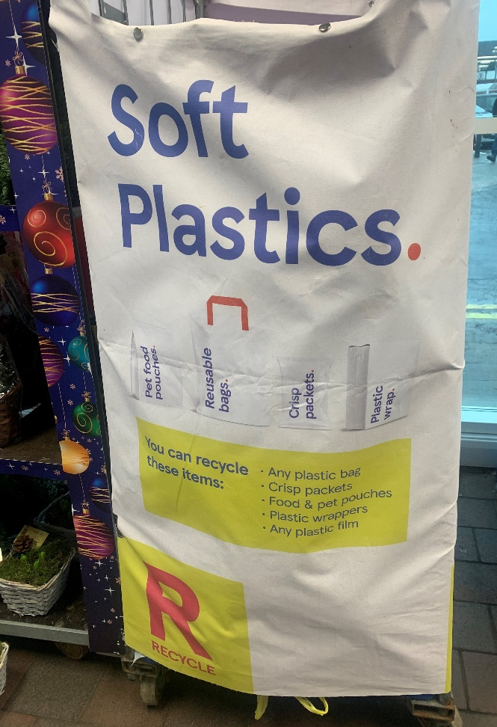

Soft Plastics Recycling Cage at Tesco

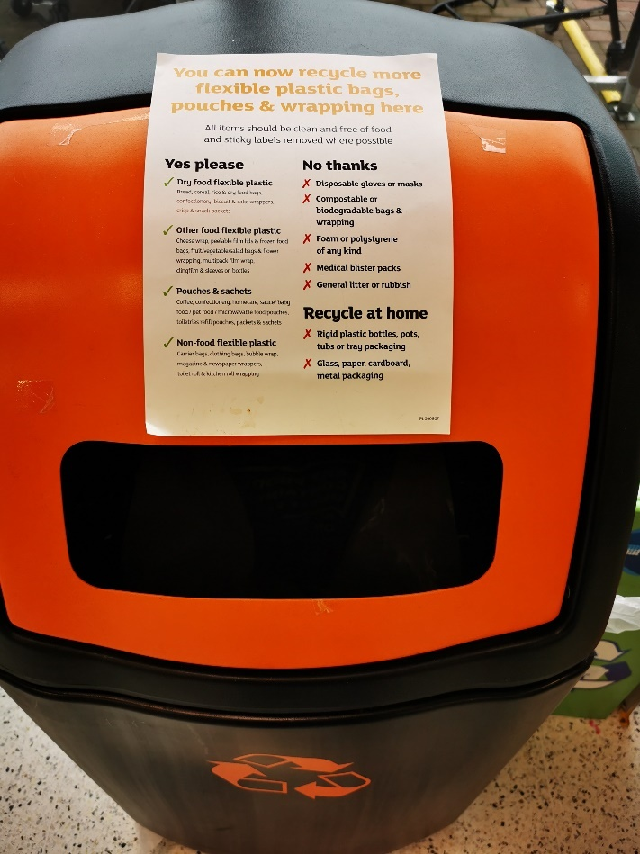

Sainsburys
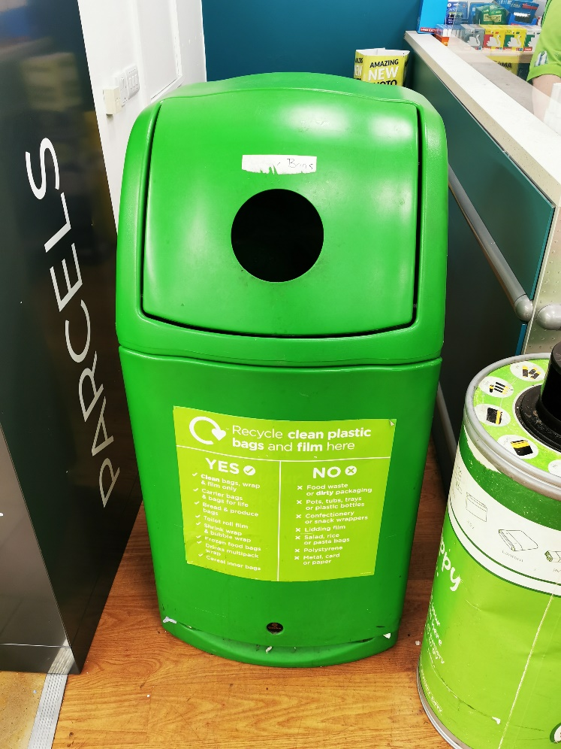
Asda

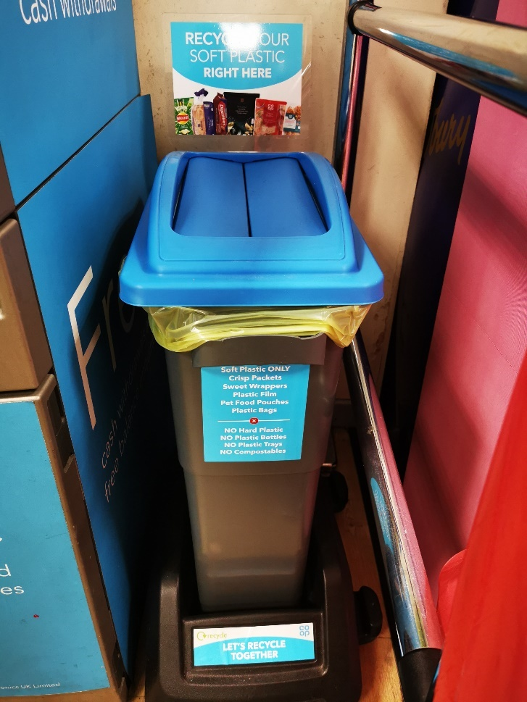
Co-op
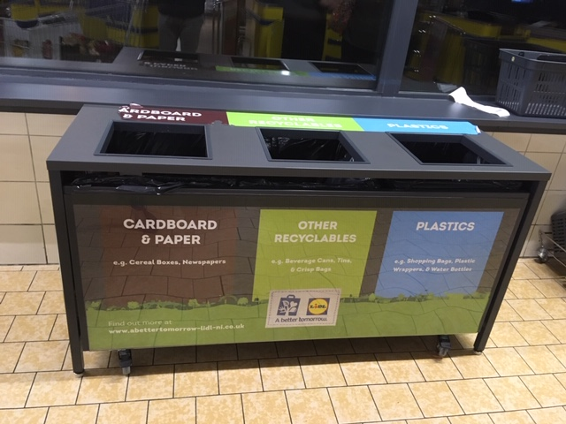
Lidl

The range of target soft plastics for each supermarket retailer varied slightly in description, although each outlet provided clear signage to inform their customers which soft plastics they would like them to recycle using the in-store drop off facilities.

Tesco: any plastic bag; crisp packets; food and pet pouches; plastic wrappers; any plastic film.

Sainsburys: dry food flexible plastic; other food flexible plastic; pouches and sachets; non-food flexible plastic.

Asda: clean bags wrap and film; carrier bags and bags for life; bread and produce bags; toilet roll film; shrink wrap and bubble wrap; frozen food bags; drinks multi-pack wrap; cereal inner bags.

Co-op: crisp packets; sweet wrappers; plastic film; pet food pouches; plastic bags.
Lidl: shopping bags; plastic wrappers.

Campaign to Promote Routine Use of Supermarket In-Store Soft Plastics
Recycling Facilities by Householders

The most recent waste composition survey showed that 11% of the contents of grey bins in the Borough comprised plastic film that could not yet be accepted in blue bin collections; that equated to around 2,300 tons of such materials currently going to landfill, based on 2020-21 statistics.

Now that we have successfully progressed to a situation whereby many local supermarkets in the Borough were providing in-store recycling drop off points for a wide range of soft plastics, officers would be promoting a campaign to encourage every household across the Borough to use those facilities to complement their blue bin recycling efforts. The key message would be to ask residents to get into the routine habit of collecting up such packaging materials around the home throughout the week and take them along to the designated soft plastics recycling drop off point at their local supermarket, whilst they were out doing groceries shopping. If all of the soft plastics that could now be recycled in that way were to be kept out of grey bins, the Borough would be saving around £250k per year in landfill costs - not to mention the positive impact upon the environment.

Marketing and communications on that key recycling subject would be progressed through local press, social media, the Council’s Bin-Ovation App, and other Council information channels. Members were encouraged to promote the campaign to their local constituents as much as possible.

RECOMMENDED that the Council notes this report.

Proposed by Councillor Greer, seconded by Councillor Armstrong-Cotter, that the recommendation be adopted.

Councillor Greer was delighted to propose the recommendation and had been amazed to consider the amount of waste that was being placed in her grey bin that could be recycled through this service. She thought that supermarkets had been taking a slow approach to date and it was the role of customers to get recyclable waste that the Council could not yet deal with, back to the source. She thought every resident of the Borough should be encouraged to take back those materials wherever possible. Supermarkets had power in turn to exert pressure on producers to make products simpler to recycle.

The Director explained that the Council had lobbied supermarkets for instore soft plastics take back schemes. Within the grey bin soft plastics were by far the biggest proportion of material that couldn’t be accepted in Council kerbside recycling bins, and supermarkets had now agreed to take back that recyclable material in-store, so it was incumbent that the Council put that message out to the public and encourage them to use this additional opportunity to recycle further.

Councillor Armstrong-Cotter explained that since the start of the Covid pandemic she had purposefully tried to shop more locally to encourage small businesses. She had found in doing that, there was automatically less plastic involved. She asked the Council to make contact with the Henderson Group about the instore soft plastics take back scheme, since there were many Spar grocery stores on the Peninsula. She also considered that it would help further if the Education Authority could run a promotion in schools on the matter since children were often the drivers of recycling in their homes.

Councillor McKee asked the Council to give consideration to providing a receptable to the public to encourage them to store the soft plastics materials before they were taken back to the supermarkets. It might prove to be a worthwhile investment. The Director agreed that that could be considered, but many people were currently using a soft plastic bag to store and transfer other pieces of soft plastic.

Councillor Douglas thanked officers for the initiative. It had been helpful to see the responses from the supermarkets and in turn it could place greater expectations on suppliers of products. She asked about plans for TerraCycle schemes and the Director explained that plans to work on that had been introduced just as the Covid pandemic had begun, so would now need to be refreshed. However it was noted that some materials covered by TerraCycle schemes were now included in the new supermarket soft plastics take back schemes.

Councillor Cummings was pleased at the very positive report and asked if the supermarkets could take a more uniform approach in terms of the design and appearance of in store soft plastics bins and signage. The Director explained that it was up to each of the businesses to make their own corporate decisions and probably unlikely that we would be in a position to achieve a completely uniform approach. However, he noted that those schemes would cost the supermarkets money and it was great that the Council had been instrumental in the campaign to win the argument about responsible environmental behaviour by the companies in this regard. The Council’s message was to inform the public about the opportunities to recycle at these supermarkets and in turn the reduced cost to the ratepayer of landfilling such waste if supermarket recycling of soft plastics could be ‘normalised’ across all households.

Councillor Kendal asked if consideration could be given to glossy stickers on bins to highlight the issue. The Director agreed that aside from the ongoing drip feed or recycling messages, it was necessary from time to time to undertake a bigger scale ‘relaunch’ with a more hard-hitting campaign. Any further review of the kerbside collection service model would be accompanied by such a major marketing and promotion campaign.

AGREED TO RECOMMEND, on the proposal of Councillor Greer, seconded by Councillor Armstrong-Cotter, that the recommendation be adopted.

7. NI Local Authority Municipal Waste Management Statistics – July to September 2021

Previously circulated:- Report from the Director of Environment The official waste management statistics for the second quarter of 2021/2022 (July to September 2021) had been released by the Northern Ireland Environment Agency.

The significant headlines contained within the latest DAERA report showed that:

- The Council’s household waste recycling rate fell by 2.3% compared to Q2 last year, (from 53.7% to 51.4%) and by 7.9% compared to Q2 the previous (2019/20) year (from 59.3% to 51.4%).

- The Council’s household waste recycling rate of 51.4%, was 1.6% lower than the NI average of 53%.

- Ards and North Down was ranked fourth lowest out of the 11 NI Councils for its household waste recycling rate.

- Ards and North Down household waste composting rate fell by 1.7% - from 34.4% to 32.7%. The household waste dry recycling rate fell by 0.9% - from 19.1% to 18.2%.

- The household waste composting rate of 32.7% was 2.3% higher than the NI average of 30.4%.

- The Council’s household waste dry recycling rate (i.e. recycling of items other than organic food and garden waste) of 18.2% was 4.1% lower than the NI average of 22.3%.

- The Council’s kerbside recycling capture rate of 74.3% for household compostable waste materials compared to a NI Council average of 70.7%.

- The Council was at the bottom end of the performance table for ‘dry’ recycling rate, ranking tenth out of eleven Councils.

- The Council received 45% more waste per capita at its HRCs compared to the average for other NI Councils. That represented a sustained trend over five successive quarterly reporting periods of HRC waste reverting back to excessive levels compared to other NI Councils.

- The amount of waste collected at HRC sites for recycling was significantly less than the average for other Councils – 65%, compared to an average rate of 75% for other Councils.

- The Council collected 4% more waste per capita from homes through its kerbside bin collection services.

- The amount of waste collected for recycling through the Council’s kerbside bin collection system was higher than the average for other Councils – 55.4%, compared to an average of 49.8% for other Councils.

The latest official Municipal Waste Management Statistics report presented further clear evidence that the Council’s performance in relation to waste resource management had suffered a significant sustained deterioration, both in absolute and relative terms.

The amount of waste the Council is landfilling, and its rate of recycling were now returning close to the levels in the strategy baseline year of 2015/16. The Council’s rolling 12-month average recycling rate of 47.8% has now fallen back below the current statutory minimum of 50% and we are at risk of breaching the annual landfill allowances stipulated under the NI Landfill Allowance Scheme (NILAS).

Officers would reiterate a view that the structure of the Council’s waste management services and how they were delivered must further adapt and change if the Council was to see a return to previous improvements in performance levels, let alone achieve further gains towards the challenging recycling and landfill diversion targets set out in the government’s circular economy package as well as the Council’s own sustainable waste resource management agenda.

RECOMMENDED that the Council notes the report.

Proposed by Councillor Boyle, seconded by Councillor Cummings, that the recommendation be adopted.

Councillor Boyle began by stating that he had omitted to thank the Chair for her opening comments about the situation in Ukraine. The thoughts and prayers of most people including himself were clearly with the people of Ukraine who had suffered terrible bombing of their country. He hoped and prayed that the peace talks would be fruitful and that the Ukrainian people could get back to living a normal life.

Referring to the report before the committee he considered that what was being presented was nothing short of damning and it was worth doing more than simply noting it. He believed that it was now time for an honest assessment of where the Council stood, and he thought that if the Council was a business it would now be bankrupt, since it was rapidly heading toward the bottom of the class in terms of recycling and landfill performance. He asserted that this was a wake-up call to start doing things differently. The Council’s current model was simply not delivering, and it was time for a different approach. Members and officers were custodians of ratepayers’ money and must take courageous decisions, this was not a new problem which had been presented before the Environment Committee but one which had been brought for as long as he could remember and he urged Members to be mindful of the costs they were placing on ratepayers as a result of their decisions.

The Director explained the landfill allowance scheme and saw a three-dimensional position around the key messaging on that subject. Firstly, there was the financial impact which was very significant and indeed had accounted for a significant proportion of the Council’s rate rise for the coming year. Secondly, there was the environmental detriment which could be thought of as an even bigger issue and finally there was also a statutory compliance dimension as highlighted in the report. Statutory targets were set in law and non-compliance would result in sanctions and fines; the implications of that would come in time. It was therefore incumbent upon officers to advise Members so that the Council could be navigated clear of such costs. Members were aware of the circular economy which had been introduced by the UK government, involving an even higher recycling target than was currently in place and which the Council was currently unable to meet - and that situation was of grave concern to officers.

Councillor Boyle thanked the Director for those comments and considered that this was not new language and local ratepayers would be angered if the Council did not act promptly to address that situation.

Referring to a question by Councillor Cummings the Director explained he did not believe that there had not been a significant noticeable increase in the van and trailer permits granted for use of the Household Recycling Centres. Officers had observed that the pattern of how larger volumes of waste being brought in had started to change since the permit scheme had been introduced – and officers’ belief that a lot of commercial/trade/business waste was now being brought in regularly by car/small trailer that did not require a permit.

Councillor Kendall was in agreement with Councillor Boyle and was also wary of the same excuses for excess waste such as the Covid pandemic or waste tourism. The trajectory of the figures was significant and the Council was on a cliff edge which was ultimately costing hard pressed ratepayers money that they no longer had in many cases, and the issue could no longer be deferred for consideration to a date in the future. She asked the Director had the identification check at the Household Recycling Centres proven to be successful and he explained that a sample exercise had been run, but it was not sustainable to check every person in the absence of having a booking system in place which would regulate the pace of traffic flow through the centres and provide space and time for scrutiny.

Councillor Greer asked if all Councils were capable of recycling the same materials. The Head of Waste and Cleansing confirmed that for the vast majority of materials it was the same across Northern Ireland. One difference between Ards and North Down and some other Councils was that they were recovering some extra recyclables from residual waste by sending to energy from waste contracts. The Councillor asked the Council to consider something similar and the Head of Waste and Cleansing said that it was already doing so through Arc21.

The Director made it clear that the vast majority of what was currently found in the grey bin, could go into the blue or brown recycling bins (or the new soft plastics bins in supermarkets). When more effective diversion/recovery of the larger scale ‘core’ materials had been achieved, Council could consider looking at potential for recycling of a wider range of smaller volume materials.

In concluding the debate Councillor Smart recognised the scale of the current difficulties both on the environment and the ratepayers’ pockets. Ratepayers were hard pressed financially and would continue to be and since this was the Council’s most significant cost base Members owed it to the Borough’s ratepayers to support and encourage more positive behaviours.

AGREED TO RECOMMEND, on the proposal of Councillor Boyle, seconded by Councillor Cummings, that the recommendation be adopted.

8. Consultation on the Introduction of Mandatory Digital Waste Tracking

Previously circulated:- Report dated 16 February from the Director of Environment detailing that the Consultation Paper related to proposals for the introduction of an electronic system for tracking waste movements across the UK. The current systems across the four administrations were not joined up, with a variety of methods of recording waste movements. The perceived benefits included providing a comprehensive understanding of what waste was recycled, recovered, or disposed of. It was envisaged that the reporting requirements would also make illegal activities easier to identify.

While the Consultation Paper was for a large part of a technical nature, the introduction of mandatory digital waste tracking had the potential to place an additional administrative and financial burden on the Council from 2023 – 2024 onwards. At this stage Officers had not received a demonstration of how the system would work, the details to be inputted, etc. As stated in the response, the Council operated eleven licensed waste facilities and two sites with Waste Management Licence exemptions. Waste movements from each of those sites would have to be recorded on the proposed system. While collections from domestic premises would be exempted, the Council would also have to record all commercial waste collections from over 1,000 businesses across the Borough. Current regulations permitted the Council to issue an annual ‘season ticket’ to businesses detailing repetitive collections over a 12-month period. It was not clear whether a similar system would be included, or whether there would be a need to make returns after each commercial collection.

The proposed introduction would require training and the possible need for additional support staff, particularly in relation to waste movements from the nine HRCs. In terms of the Waste Transfer Stations, it was hoped that the weighbridge software at Balloo ERC and North Road Depot would allow data transfer to the system.

The emerging environmental problem of Persistent Organic Pollutants (POPs) and recording their presence was also raised in the Consultation Paper. POPs included a range of organic chemicals used in a wide range of household products, that did not break down when such items were placed in landfill. They could only be destroyed by incineration. They were found in electrical products, household furnishings and textile products. They were also found in older paint products and various now banned herbicides and insecticides, that still turned up on occasions at HRCs, when residents were clearing out garages and old garden sheds.

The Consultation included a series of questions regarding the proposals and the suggested Council response was included in and appendix. The full document could be obtained using the following link:

Consultation document Introduction of mandatory digital waste tracking.pdf (defra.gov.uk)

RECOMMENDED that the Council agrees the proposed response attached.

The Head of Waste and Cleansing gave a background to the consultation paper. The intention going forward was for a four-nation approach to establish how the information could be reported and recorded. The solution appeared to be an electronic system from the producer to the end destination in terms of treatment or recycling. It would present a challenge for the Council since there was a requirement to log all of its waste movements individually, which would require an additional administration and financial burden.

AGREED TO RECOMMEND, on the proposal of Councillor Kendall, seconded by Councillor Douglas, that the recommendation be adopted.

RECESS 8.59 pm
MEETING RECOMMENCED 9.11 pm

9. Power Supplies to Mobile Food Vendors

PREVIOUSLY CIRCULATED:- Report dated 4 February 2022 from the Director of Environment detailing that the Council currently had contracts with mobile food vendors at the following locations: Bank’s Lane Bangor, Kingsland Bangor, Seapark Holywood, Groomsport Harbour, Millisle beach Park, Cairn Wood Craigantlet and Kiltonga Duck Pond Newtownards.

Mobile food vendors typically used diesel powered generators to provide electricity for cooking, heating, refrigeration etc. However, the use of those generators had a number of drawbacks:

- They could be noisy, causing a nuisance to staff, customers and nearby residents.
- They producef harmful emissions causing a nuisance and contributing to air pollution.
- They could be unreliable, affecting trade.

In addition, as previously reported to the Environment Committee, HMRC would no longer permit the use of red diesel for those applications, meaning the vendors fuel costs would rise by around 40% when they switched to white diesel.

Proposal

- Officers had surveyed the relevant sites and would propose to phase in the introduction of mains powered “feeder pillars” where it was practical to do so.
- The feeder pillars would be equipped with a top-up card system, the same as what was currently being used at the Council’s harbours.
- Vendors would buy cards with top-up credits from the Council, which would then be used to activate the power supplies. The rate per KWh was set by the Council and could therefore include a modest fee to cover any associated maintenance costs.
- The feeder pillar would have a suitably rated, anti-vandal power outlet on the side which the vendors would plug into, to avail of power (similar to the systems found in caravan sites).
- The power outlets remained without power until the card was inserted, thereby avoiding unauthorised usage.
- Council electricity was sourced from 100% renewables suppliers, therefore reducing the carbon footprint of the venders.
- A trial installation had operated this season at Banks Lane, Bangor to alleviate issues with noise following residents’ complaints. If the recommendation was passed the Banks Lane supply would be altered to include the card top up system (it currently relied on meter reads).

Consultation with Current Venders

Colleagues in the Tourism Service had had initial conversations with all of the current providers about the proposal. No objections were noted but there was a variance in requested urgency for the scheme to be implemented. Some vendors were exceptionally keen for it to be done right away whereas others less so, generally content with their existing arrangements. Therefore, installation would be carried out on a phased basis by the Council in line with available budget and with consideration of specific vendor need/preference.

Costs

Installation costs varied for each site as they were largely affected by the availability of local power supplies.

Cairn Wood did not have any nearby power supplies (or NIE equipment) so used a solar array for power and was therefore unlikely to be suitable for the initiative.
Most sites typically cost around £4k to £6k to provide the necessary equipment and cabling.

No budget existed for the work, but it was proposed to ring-fence approximately £10k per year to roll out the installation over the next 2 to 3 years.

Opt-Out

It was not anticipated to make it mandatory for vendors to utilise the system at this stage, meaning vendors could continue to use their own power generation if desired. However, Members may wish to review the position once all locations had had the infrastructure installed, thereby giving adequate time for vendors to adjust and prepare. That would be subject to a further report to the Council at that time.
It should be noted that the current contracts with vendors ran for a period of three years, renewed on an annual basis, through to March 2024. Therefore, the Council position could be amended for the start of each financial year.

RECOMMENDED that the Council agrees to phase in the introduction of feeder pillars for mobile food vendors as detailed within this report.

Proposed by Councillor Douglas, seconded by Councillor McKee that the recommendation be adopted.

Councillor Douglas greatly welcomed the report and she had spoken to a vendor at Banks Lane, Ballyholme about the matter and was aware that constituents had raised concerns about the noise of the generator, and hopefully this would make an improvement.

Councillor McKee was also pleased to read the report and had been unaware that those kiosk businesses had required a generator to run them constantly. This would be an opportunity to improve the air quality at sites in Millisle, Kingsland and Seapark which were locations right beside children’s playparks.

The Head of Assets and Property Services stated that it was the Council’s intention to roll the initiative out over the coming two years. If the businesses were happy and there were no operational issues, it would be included in the tender exercise for trading concessions on our property - which is due out in 2024.

AGREED TO RECOMMEND, on the proposal of Councillor Douglas, seconded by Councillor McKee, that the recommendation be adopted.

10. Grant of Outdoor Entertainment Licences

Previously circulated:- Report dated 22 February 2022 from the Director of Environment detailing that an application for an outdoor entertainment licence had been received.

- Crawfordsburn Scout Centre – Lisburn Community Choir

Applicant: Richard Thompson, Lisburn Community Choir, 18 Mount Royal, Lisburn

This event was proposed for 7 April 2022 from 7pm to 9pm.

The proposal was for an outdoor concert for audience of up to 350 people.

The event would be a choral musical event.

RECOMMENDED that the Council grants this licence with the condition that it will not be issued until the licensee provides and implements an Event Management plan to the satisfaction of the PSNI, NIFRS and Council Officers.

AGREED TO RECOMMEND, on the proposal of Councillor Greer, seconded by Councillor Douglas, that the recommendation be adopted.

11. Grant of Entertainment Licence

Previously circulated:- Report dated 15 February 2022 from the Director of Environment detailing that an application had been received for the grant of entertainment licence as follows:

The Quays, 81 New Harbour Road, Portavogie

Applicant: Ms Leigh Eileen Gamble, 15 Ballyfrench Road, Portavogie

Days and Hours: Monday to Sunday during the permitted hours when alcohol may be served on these premises under the Licensing (NI) Order 1996

Type of entertainment: Indoor dancing, singing and music.

RECOMMENDED that the Council grants the application.

AGREED TO RECOMMEND, on the proposal of Councillor Edmund, seconded by Councillor Douglas, that the recommendation be adopted.

12. Notices of Motion

There were no Notices of Motion.

13. Any Other Notified Business

There were no items of Any Other Notified Business.

Exclusion of the Public/Press

AGREED, on the proposal of Councillor Douglas, seconded by Councillor Kendall, that the public/press be excluded during the discussion of the undernoted items of confidential business.

14. TENDER FOR EXTENSION FOR THE TREATMENT OF STREET SWEEPINGS 2022/23

***IN CONFIDENCE***

NOT FOR PUBLICATION

SCHEDULE 6 – INFORMATION RELATING TO THE FINANCIAL OR BUSINESS AFFAIRS OF ANY PARTICULAR PERSON (INCLUDING THE COUNCIL HOLDNG THAT INFORMATION)

15. Tender for the Collection and Reprocessing of Various Waste Streams from Ards and North Down Borough Council Household Recycling Centres

***IN CONFIDENCE***

NOT FOR PUBLICATION
SCHEDULE 6 – INFORMATION RELATING TO THE FINANCIAL OR BUSINESS AFFAIRS OF ANY PARTICULAR PERSON (INCLUDING THE COUNCIL HOLDNG THAT INFORMATION)

Circulated for information

***IN CONFIDENCE***

NOT FOR PUBLICATION

SCHEDULE 6 – INFORMATION RELATING TO THE FINANCIAL OR BUSINESS AFFAIRS OF ANY PARTICULAR PERSON (INCLUDING THE COUNCIL HOLDNG THAT INFORMATION)

Re-admittance of public/press

AGREED, on the proposal of Councillor Douglas, seconded by Councillor Armstrong-Cotter, that the public/press be re-admitted to the meeting.

Termination of meeting

The meeting terminated at 9.35 pm.

