ARDS and North Down Borough Council

A virtual meeting of the Corporate Services Committee was held via Zoom on Tuesday 14 June 2022 at 7.00pm.

PRESENT:

In the Chair:

Aldermen: Gibson Irvine McIlveen
Girvan Keery

Councillors: Blaney Irwin
Chambers McKimm
Douglas P Smith
Greer T Smith (7.12pm)
Gilmour

Officers: Chief Executive (S Reid), Head of Finance (S Grieve), Head of Human Resources & Organisational Development (R McCullough), Head of Administration (A Curtis), Head of Strategic Transformation & Performance (S Denny), Community Planning Manager (P Mackey), Performance Improvement Manager (M McVeigh), and Democratic Services Officers (S McCrea)

1. Apologies

Director of Finance and Performance (S Christie), Director of Organisational Development and Administration (W Swanston) and Councillor Cooper.

NOTED.

2. Declarations of Interest

The Chairman sought any Declarations of Interest at this stage and the following declarations were made:

Councillor P Smith – Item 15b.

3. performance reports q4 2021-22
(Appendix 3a through 3g)

Previously circulated- Copies of the undernoted minutes

The following excerpt preceded, ‘Key points to note,’ within each report.

Members would have been aware that Council was required, under the Local Government Act 2014, to have in place arrangements to secure continuous improvement in the exercise of its functions. To fulfil this requirement Council approved the Performance Management Policy and Handbook in October 2015. The Performance Management Handbook outlined the approach to Performance Planning and Management process as:

- Community Plan – published every 10-15 years
- Corporate Plan – published every 4 years (Corporate Plan Towards 2024 in operation)
- Performance Improvement Plan (PIP) – published annually (for publication 30 September 2021)
- Service Plan – developed annually (approved April/May 2021)

The Council’s 17 Service Plans outlined how each respective Service was to contribute to the achievement of the Corporate objectives including, but not limited to, any relevant actions identified in the PIP.

Reporting approach
The Service Plans were to be reported to relevant Committees on a quarterly basis as undernoted:

Reference | Period | Reporting Month
Quarter 1 (Q1) | April – June | September
Q2 | July – September | December
Q3 | October – December | March
Q4 | January - March | June

3a. Community Planning Q4 Performance Report

Previously circulated- Copies of the undernoted minutes

Key points to note:
- Final budget information had not been made available to service. There would be an underspend due to maternity leave and the delay in printing a Big Age friendly Guide. This guide had been finished and was designed to ensure it was accessible to older people. It was to be launched in early Autumn to coincide with Age Friendly month.

Key achievements:
- Consider work undertaken to develop content for Big Age Friendly Guide to help people with limited digital ability to identify how to contact relevant services. Workshop with Elected Members as part of their Charter Plus project provided useful feedback on content of Guide. Follow up workshops/consultation with Age Friendly Alliance, Cedar Foundation, Youth Council and Comber Rotary also provided feedback on content and accessibility.
- Big Plan Part II | Our Big Priorities was published, and work started to produce an easy read version.
Emerging issues:
- Lots of links being formed between food priorities – Social supermarket, Sustainable Food and outdoor learning.

Action to be taken:
- Assessment of Wellbeing to be finalised. Easy read info graphics being developed.
- Performance Scorecards for priorities to be finalised.
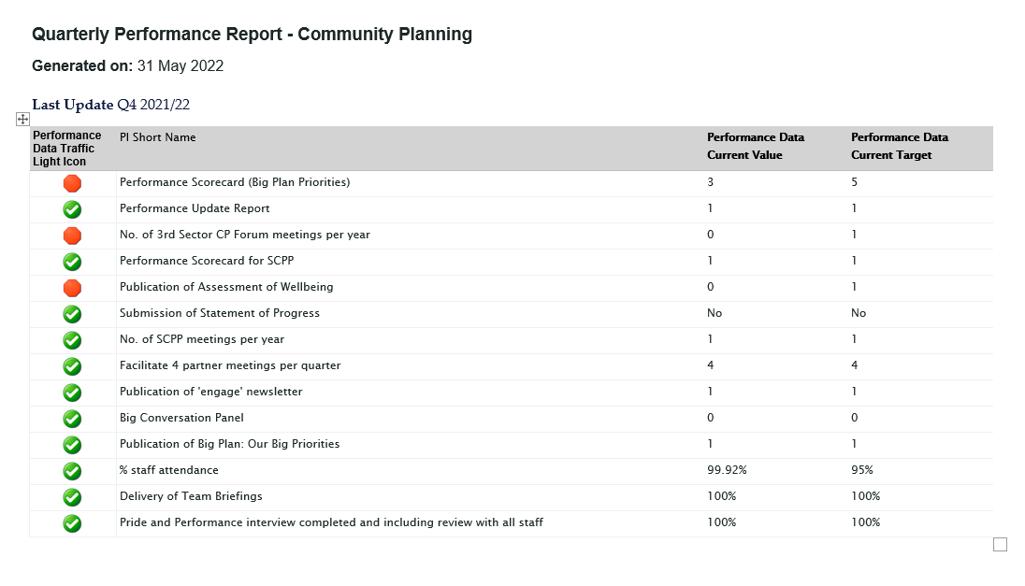
RECOMMENDED that Council notes this report.

3b. Corporate Communications Q4 Performance Report

Previously circulated- Copies of the undernoted minutes

Key points to note:
- A significant focus during this period was lobbying activity in relation to DfI returning the Queen’s Parade Planning Application to Council to determine. This was successfully achieved on 9 March 2022.
- Planning was ongoing for Communication and Marketing activity in support of key events including the Platinum Jubilee and Freedom of the Borough for the Irish Guards.
- Borough and Tourism Marketing changed reporting lines to create the new service unit of ‘Communications and Marketing’ in February 2022.

Key achievements:
- Council’s social media channels continued to perform strongly with growth across all platforms. Positive progress was being made on addressing issues raised in the recent social media audit including more effective cross-service working to identify/share key messages and tailored training for staff involved in managing social media accounts on behalf of Council.
- Borough Magazine produced and distributed to all households and businesses in the Borough. Digital version with links to further multi-media content had been made available online. Features on a number of key capital projects including Greenways and Bangor Waterfront.
- PR activity during the period included the launch of the Experiences programme, Guitar Festival, Confirmation of Complimentary Fund and Levelling Up Funding, Launch of Choose to Reuse and Freecycle Bulky Collection Schemes, Sustainable Giants Launch, Various Tree Planting Events, Apprenticeship Week, Marine Litter.
- Comms, Marketing, Technical support provided for several events including the Sports Awards, Food Showcase and Viking Festival.
- Make it Yours Campaign, featuring a number of attractions across the Borough, launched with significant profile on the Discover NI website.
Emerging issues:
- Some work was to be done to ensure the new Communications and Marketing team was working effectively together and sharing knowledge to help streamline marcomms activities.
- There was due to be an extremely busy programme of events in June, which would require significant resource. Some reprioritisation of other projects would have been required.
Action to be taken:
- Focus Groups were held with staff representatives to collate inputs into the Council’s ‘Our People Plan’ for 2022-23. This had provided insights in relation to preferred engagement activity moving forward which was due to be actioned throughout 2022/23.
- KPIs in relation Consultation and Engagement have been rolled into the 2022-23 service plan and will be actioned by the new Bangor Regeneration Communication Manager.

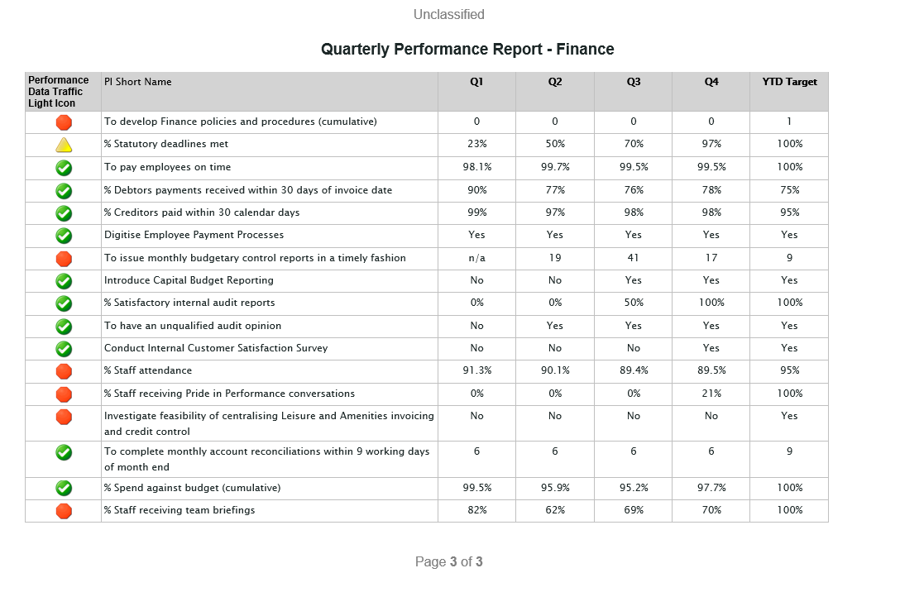

RECOMMENDED that Council notes this report.

3c. Finance Q4 Performance Report

Previously circulated- Copies of the undernoted minutes

Key points to note:
- 10 targets were met this year, despite continuing financial challenges and a significant dip in attendance. At one point during the year, only two thirds of posts were covered due to both vacancies and long-term sickness. Although this situation has been slowly resolving, there were significant operational challenges which had restricted the quality of service provided.

Key achievements:
- All core transactional targets were met throughout the year for the first time, with the exception of one statutory return being submitted late, early in the year.
- All significant regulatory deadlines were met during the year in respect of both the publication of the Financial Statements and setting of the district rates.
- The first phase of the new Core integrated Human Resources, Employee Payments, Time and Attendance system was successfully implemented with all staff working from home. Although there continues to be some operational challenges, this project had marked a significant step in the transformation of processes to a digital format in line with the Council’s Digital by Default policy.

Action to be taken:
- These are set out in the Service Delivery Plan for 2022/23.
RECOMMENDED that Council notes this report.

3d. Strategic Capital Development Q4 Performance Report

Previously circulated- Copies of the undernoted minutes

Key points to note
- Attendance levels remained at 100% exceeding the 95% Target.
- There continued to be good investment in staff briefings with regular fortnightly team meetings.
- Professional development had also been continuing as the unit continued to deliver a capital portfolio in excess of £170m over the next 10 years.
- PiP Conversations had been completed for all staff.
- There continued to be a good level of consultation with other Councils and Government departments through BRCD, Community Estates, the Greenways projects and individual meetings.

Key achievements
- Continued to share capital knowledge and allow a holistic approach to all large, small and maintenance capital projects undertaken by a wide range of directorates through CPAG.

Emerging issues
- DfI Greenways funding.
- Delays in statutory responses to planning creating knock-on delays in programming projects.
- Short term very high construction inflation.

Action to be taken:
- Assist in the Estate Strategy implementation.
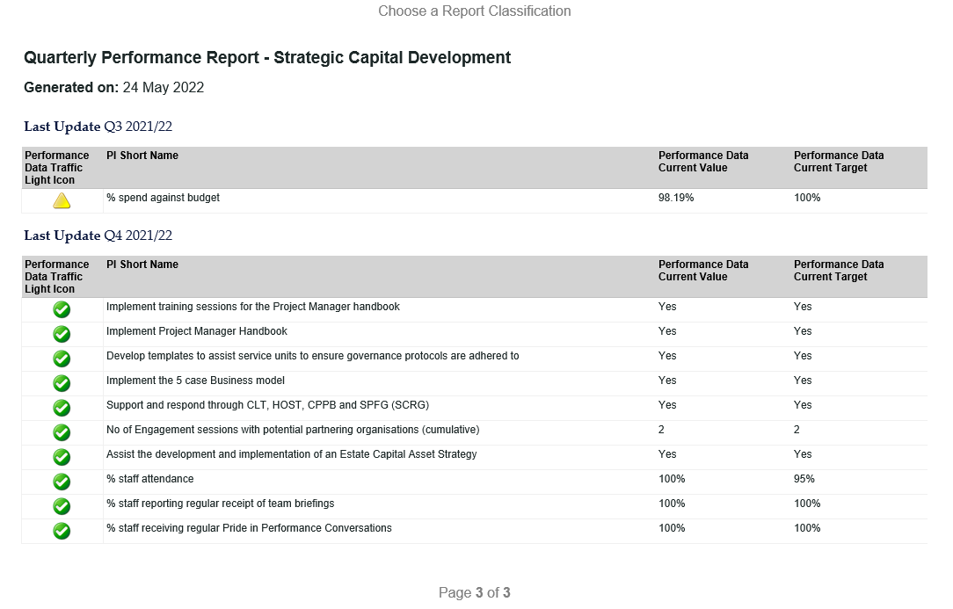

RECOMMENDED that Council notes this report.

3e. Strategic Transformation & Performance Q4 Performance Report

Previously circulated- Copies of the undernoted minutes

Key points to note:
- The Head of Strategic Transformation and Performance post which had been vacant since July 2020 was successfully filled at the end of April 2022.
- The Procurement Manager post had been vacant since November 2021. The successful candidate in this recruitment withdrew, and temporary measures were put in place to fill the post. Procurement also suffered the loss of the Procurement Assistant which left the unit with only 1 remaining member of staff. Recruitment exercises for the Procurement Officer and Assistant posts are in the pipeline.
- Procurement Savings of £115,173 fell short of the target of £250,000 as we continued to experience challenges on achieving savings as a result of increases in energy prices, raw materials costs, and shipping costs. The reform of red diesel legislation had also negatively impacted on costs. The supply chain disruption caused by both Brexit (NI Protocol) and the Covid pandemic has also been impacting on the overall cost of goods and services in NI.
- Owing to staff shortages, the Review of Procurement policies, processes, handbook and working practices was delayed and would take place in Q1 2022/23.
- The Review of Business Technology Service Desk Operation had not been completed and would be carried forward into the 2022/23 Service Plan.
- The Service sets itself ambitious customer satisfaction targets of 95% each year and achieved a rating of 90% overall. Individual service unit satisfaction rates are set out in the table below. Overall satisfaction levels were good. However, a low response rate of 18% and a small number of dissatisfied users could give rise to sampling bias.
- Staff satisfaction was not measured in the 2021/22 year owing to the loss of key members of staff (Head of Service in 2020; Procurement Manager 2021 and Procurement Assistant 2022). As the Head of Service post had now been filled, it is felt that the survey would be more meaningful later in the 2022/23 year.

Key achievements:
- Attendance is 99.45% with 9 days lost in the quarter and 16 days lost in the year.
- On track for spend against budget.
- Good progress continues to be made on in-service efficiency projects.

Action to be taken:
- Ensure Officers consider market changes when the estimated contract costs are made at the outset of new procurement exercises.
- The Head of Service and Service Unit Managers will review the suggested improvements arising from the annual Satisfaction Survey and try to achieve a higher buy-in and response rate to future Satisfaction Surveys.

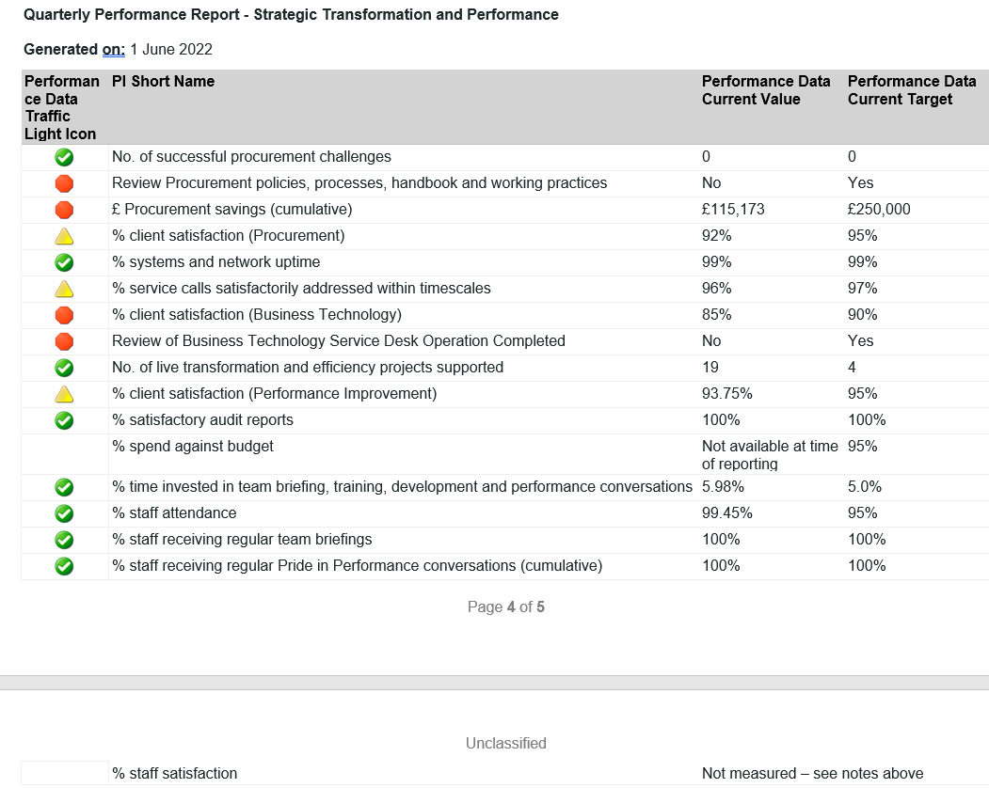
RECOMMENDED that Council notes this report.

3f. Administration Q4 Performance Report

Previously circulated- Copies of the undernoted minutes

Key points to note:
The majority of targets in the Administration Service Plan are measured annually.

Table 1: Q4 performance update

Performance Measures | Q1 update
Update Customer Service Excellence Strategy and Action Plan | Missed Target: The Action Plan has been updated and the Strategy is almost complete and will be going to consultation phase in June 2022.
Pilot paperless filing for new files in 2 Departments | Missed target - Scoping work being undertaken at the time of writing with two internal service areas being considered. This is now included in the larger digital transformation project.
All agendas circulated within 5-day notice period | Met target - 100% of Agendas went out 5 days in advance of all Committee and Council meetings.
Prioritise 5 potential Public Rights of Way (PROW) and assert at least 1 per year | Missed target - A full review of all PROW (alleged and asserted) was underway, however there is no-one in post at the time of writing. Recruitment for officer was due to commence in June 2022. Many of the PROW files had been digitised and would assist in easier access to historical information in the future.
Procure and introduce integrated Health and Safety and Risk/Claims Management system | Met target – Integrated system had been procured and data inputted. Software in use by Risk Management and Health and Safety Officers.
EMS – Retain accreditation and expand framework to all Council buildings with a view to accreditation in future years | Met target – The Council have retained accreditation.
FOI/EIR Information response times in compliance with legislation | Missed Target – 93% This is an improvement from 87% for same period last year and given the increased number and complex nature of many FOI requests this is an excellent compliance rate.
Train all CLT/HOST in emergency planning response protocol | Met target
Hold 4 Corporate Health and Safety meetings – with input from directorate Health and Safety meetings | Missed target – One took place in year. To put in context of Covid pandemic – there were many other meetings and task groups set up to deal with specific covid related issues and well as continued support and liaison with Health and Safety/Risk Management Officers.
Have 2 emergency planning test activations | Met target
Hold 2 EPIG meetings | Met target
Deliver 5-year Equality Action Plan | Met target
Monitor the Roadmap to Sustainability | Met target
Review Lands Policy | Missed target – review underway, due to resource issues review delayed
Develop Claims Management Policy | Missed target –work underway
% Staff Attendance (95%) | Met target –96.01%
% Spend against budget (+/-5% of budget) | Met target – 85.83%
% Staff reporting regular receipt of team briefings | 100% - Team meets once a month
Pride in Performance Conversations | Met target

Key achievements:
- In terms of the number of FOI requests and the increasing complexity of them achieving 93% was a great success.
- The recertification of the EMS continues to demonstrate the Council and staff’s commitment to the environment regardless of where their work is being carried out.
- The Roadmap to Sustainability was in place and the Council continued to demonstrate leadership. The monitoring reports to Council had shown that progress was being made on many aspects through many service areas, both working on specific service agendas as well as many cross-council partnerships.

Emerging issues:
The effect of the pandemic had remained evident in the workload of this service. There were many issues that had been noted since this/other service(s) were historically paper-based. The pandemic had demonstrated the need for systems to be digitised going forward so that information could be accessed in a timely manner as well as to ensure security of data. This required investment and would fall into the transformation programme that the Council had agreed.

Action to be taken:
We continue to work towards all the KPIs.
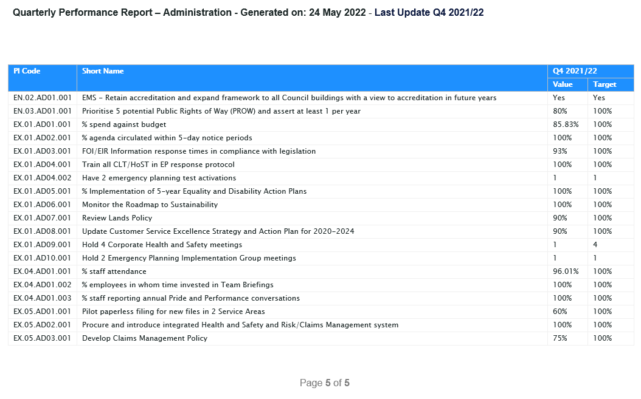
RECOMMENDED that Council notes this report.

3g. Human RESOURCES Q4 PERFORMANCE REPORT

Previously circulated- Copies of the undernoted minutes

Key points to note
- This reported on progress against the 23 Service Plan KPIs. Good progress was being made against the PIs with 12 being on target at the time of writing.
- 6 were ongoing, therefore progress had been made, but the targets had not been completed and 5 targets had not been achieved.

HR successes
HR and OD had been successful in ensuring that there was excellent communication with trade unions with regard to all covid issues and in the review of all the main HR and OD policies. Staff attendance had been very high within the HR team and we had a committed and diligent workforce within this service. Resourcing were extremely efficient in informing candidates for employment of the outcome of recruitment exercises and 100% of candidates were informed of the outcome within 2 weeks of a shortlisting meeting or attending interview.

Targets that are borderline
- % spend against budget has been lower than anticipated owing to:
  - Staff vacancies; and
  - Impact of Covid on Employee Training and associated costs
- Work was ongoing on a formal home working policy with an aim for this to be in place on 1 October 2022, there is an interim policy in place at the time of writing
- The flexible working policy was under review.
- Progress had been made to develop a formal workforce strategy and we have been in the process of piloting a Gap Analysis survey with a small sample group to identify any potential problem areas before roll-out to the Heads of Service and Service Unit Managers.
- Development of the Corporate Induction Programme for all new Council staff had been delayed and would be progressed in the year ahead.
- Work was ongoing with regard to creating a regional Apprenticeship scheme, though we had initiated some local apprenticeship schemes.

Targets not achieved
- Council wide absence had remained challenging with a YTD figure of 6.57% against a target of 5.00%. Detailed information on absence was due to be reported to committee on 14 June 2022.
- Officers were unable to complete a number of the activities within the People Plan owing to the ongoing impact of Covid-19. It is hoped these would be progressed in Q4.
- Visits to other work locations to discuss HR issues with managers had not taken place due to covid restrictions.
- Whistle blowing training had not yet taken place.

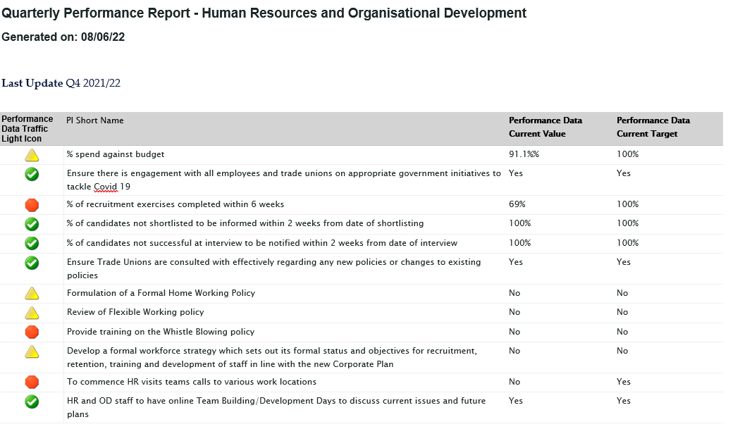

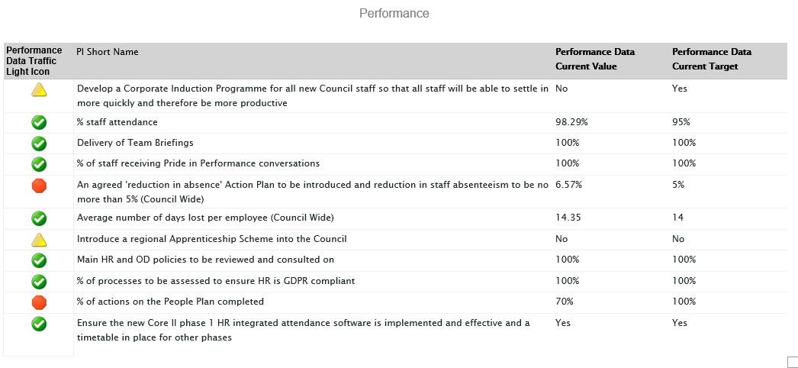

RECOMMENDED that Council notes this report.

Councillor Gilmour proposed, seconded by Alderman Irvine, that the recommendations of items 3a through 3g be adopted and reports noted.

Alderman Irvine referred to Item 3b: Corporate Communications Q4 Performance Report and asked if the events to be hosted over the summer months by the Council may require additional staff. In addition, he asked if difficulties in filling posts had improved and if there had been higher levels of applicants. The Chief Executive explained that with regard to Communications Unit staffing levels, these were within budget and there was one current vacancy so despite being very busy no additional cover was being requested.. The Head of HR & Organisational Development advised there had been difficulties on occasion finding suitable candidates for roles but that a working group had been set up recently to look towards improving the Council’s recruitment and retention practices.

Councillor McKimm welcomed new members to the Committee before referencing Item 3G, page 2’s mention of development over home working strategies and asked if there would be any indication on such works for Autumn 2022 given their relevancy on recruitment. The Head of HR & Organisational Development advised that an interim homeworking policy existed but, with recent changes in guidance, all staff were being expected to return partially to the office, with aspirations of retaining flexible home working in a hybrid model going forward.

Alderman Girvan congratulated the Head of Strategic Transformation & Performance on her newly acquired role. Alderman Girvan asked if it was possible to update contact details for senior management, which the Chief Executive agreed to have done.

AGREED TO RECOMMEND, on the proposal of Councillor Gilmour, seconded by Alderman Irvine that the recommendation be adopted to note reports.

4. Budget Report – Period 12

Previously circulated- Copies of the undernoted minutes

The primary focus for the Council in 2021/22 was to stabilise its finances and to further increase financial strength and resilience, to successfully manage the high inflationary environment that the economy is now in. This report demonstrates that the Council has successfully delivered this.

The Revenue Budgetary Control Report by Directorate for 2021/22 is set out in Report 1 on page 5 and shows an overall budgetary surplus of £296k (box A).

Explanation of Variance
The Council’s budget performance is further analysed on pages 6-8 into 3 key areas:

Report | Type | Variance | Page
Report 2 | Payroll Expenditure | £ 479k favourable | 6
Report 3 | Goods & Services Expenditure | £4,956k adverse | 7
Report 4 | Income | £4,773k favourable | 8

Explanation of Variance
The Council’s overall favourable variance can be summarised by the following table:

Type | Variance  £’000 | Comment
Payroll Expenditure | (479) | There were a number of vacant posts throughout the Council due to Covid 19 lockdowns creating a back log of staff recruitment. Recruitment and retention of staff continues to be challenging.
Goods & Services Expenditure
C & W HQ | 230 | Covid 19 cost pressures
Leisure | 270 | Utility prices
Waste & Cleansing | 428 | Waste disposal costs driven by lower recycling rates
Assets & Property | 451 | Vehicle maintenance costs subject to significant inflation.
Regeneration | (397) | A number of workstreams either were cancelled due to the pandemic or delayed due to programme slippage.
Capital Financing | (150) | Lower expenditure in 2020/21 reduced MRP and lower expenditure in 2021/22 reduced the need to borrow and pay interest
Transfers to Funds | 5,907 | To support a range of future inflationary expenditure commitments.
Income
Services Income | (1,406) | Additional grant income received and faster recovery from Covid across a number of services.
Covid 19 Fund Released | (1,598) | Additional funding released to support additional Covid cost pressures
District Rates | (1,306) | Lower debt write-offs and costs of collection resulting in higher recovery rate
Covid 19 Funding | (329) | Council’s actual funding received was higher than budgeted.

RECOMMENDED that Council notes this report.

Upon request of the Chair, Councillor P Smith, that the Head of Finance provided a summary breakdown of the above report to members.

Councillor McKimm proposed, seconded by Alderman McIlveen, that the recommendation be adopted.

Councillor McKimm thanked the Head of Finance for making the report understandable before referencing page 17, good & services and commented on the significant expenditure that had been described as adverse. He asked what the immediate to long-term effects would be. The Head of Finance pointed members to page two’s table of major variances, specifically noting transfers to funds for future inflation and expenditure commitments; these were the, ‘adverse,’ items and would be discussed later in the committee.

Alderman Irvine queried whether central government support would occur with regard to utility prices such as electricity and gas expenditures. The Head of Finance reported that an underspend had occurred in the reporting year due to the fixed nature of contracts that had expired but that an increase potentially in excess of 100% was due. Works were in progress with professional groups to bring collated information from the eleven councils to SOLACE and DfC with the aim of securing support.

AGREED TO RECOMMEND, on the proposal of Councillor McKimm, seconded by Alderman McIlveen that the recommendation be adopted to note.

5. Authorised signatories update

Previously circulated- Copies of the undernoted minutes

In line with the Scheme of Delegation, Corporate Leadership Team recently approved the restructuring of the Finance Service to increase capacity for value added activities, increase flexibility, and process the increased workload. This was carried out at no extra cost.

As this structure now included an additional Service Unit Manager, it was therefore necessary to review the authorised signatories to ensure that adequate arrangements were in place for corporate banking and treasury management functions.

Authorised signatories are required as follows:
- Cheques: to be signed by any two authorised cheque signatories, provided they have not also authorised the payment request.

- Online Banking: to be processed by any two of the authorised electronic signatories, provided they have not also authorised the payment request; and

- BACS Payments: to be processed by any one of the authorised electronic signatories; and

- Treasury management decisions: to be processed by any two of the authorised signatories.

It was appropriate that the new Financial Operations Accountant had the same level of authorisation as the existing Service Unit Managers and therefore the recommended revised specified posts and the appropriate authorisations were as follows:
Position | Banking Signatories |  | Treasury Decisions
Position | Cheque | Electronic | Short-term Borrowing and Investment | Long-term Borrowing
Chief Executive | Yes | No | Yes | Yes
Director of Finance & Performance | Yes | Yes | Yes | Yes
Head of Finance | Yes | Yes | Yes | Yes
Corporate Accountant | Yes | Yes | Yes | No
Performance Accountant | Yes | Yes | Yes | No
Capital Accountant | Yes | Yes | Yes | No
Financial Operations Accountant | Yes | Yes | Yes | No

RECOMMENDED that Council approves the amendment to the authorised signatories for Corporate banking and Treasury Management activities as detailed above, amends the Treasury Management Policy accordingly, and completes the appropriate standard mandates.

The Head of Finance summarised the report for members, stating a restructure of the Finance Service had taken place within the last six months which has created a new manager post (at no additional cost). A new post holder has been recruited and is due to start in the middle of August 2022. This individual was expected to be a bank signatory and so Council permission was required to add them to the bank mandates.

AGREED TO RECOMMEND, on the proposal of Alderman Irvine, seconded by Alderman Girvan that the recommendation be adopted.

6. Accessible version of ‘our big priorities’
(Appendices I & II)

Previously circulated- Copies of the undernoted minutes

Background
The Big Plan for Ards and North Down was published in March 2017. Part 10, sections 69 and 70 of the Local Government (2014) Act stipulates that the first community plan should be reviewed before the fourth anniversary of the date on which the community plans were published. A one-year extension was given due to the impact of Covid-19 and the need to refocus limited resources on community support initiatives. The Big Plan Part II | Our Big Priorities was published in April 2022. The document provided community planning partners, stakeholders and the public with updated content and clarified how our 10 focused priorities had been chosen. It explained how the partnership will use workstreams to take each priority forwarded in order to move towards the desired outcomes of the Big Plan. An update on the indicators was also provided. Some additional indicators have been added to reflect the priorities.

The Big Plan Part II | Out Big Priorities was endorsed by Ards and North Down’s Strategic Community Planning Partnership on 22 February 2022.
Members will remember that the publication was reported to Corporate Service on 10 May 2022. At this meeting it was agreed:

“that the Council notes this report and furthermore in addition to noting, it was agreed to seek an exploratory report into the possibility of providing an accessibly inclusive format for all user-groups. The review should provide a costs analysis of such a task and general guidance that may be used for future plans”

When the Big Plan 2017-2032 was published in 2017, it was also supported by an easy read version and six animations. All of these are available on Council’s website. At the time, the easy read version was developed via guidance from the Council’s Equality Officer as well as other Community Planning community partners and their service users. To make the Big Plan more accessible (understandable and interesting) to the public it was supported by a series of animations that explained what each of the outcomes meant. This approach was well received and has been commended by many organisations including the Department for Communities and the Carnegie Trust UK. The later referenced our approach, as an example that others could follow, in their publication ‘Embedding Wellbeing in Northern Ireland Support for Community Planning Partnerships - Statements of Progress: Examples of visual communication of data’

As mentioned at the meeting of 10 May 2022, work had already started to produce an easy read version of the Big Plan Part II | Our Big Priorities. The term easy read is a generic term used to highlight that a more complex document has been simplified. Easy read is used by lots of organisations including Health, Education and NICCY (NI Children’s Commissioner) to identify publications that are simpler to read and understand. A document written with children and young people in mind can also be read by people with other accessibility issues as well people who only want the highlights and don’t need all the background information that is relevant to other readers such as community planning partners, government departments and community organisations.

Following the recommendation from Council, contact was made with NICCY to clarify the Community Planning Services approach to accessibility of publication. The Community Planning Manager is a member of NICCY’s Participation Forum. NICCY had fed back that our planned approach to produce an easy read version takes accessibility into account. They also cited the value of our previous animations. They have suggested that we engage with our Youth Council to check readability of the document. They also provided their Participation Advice Guidance which includes a chapter on how to produce children and young person friendly documents and an example of one of their easy read reports.

There was no cost to produce an easy read version of Our Big Priorities as it was already in production at the time of the 10 May meeting and it did not require specialist input. A draft version (pre consultation with user groups) was attached to this report to show what has been done to produce a document that provides information that is easy for everyone to understand. Our next steps would be to test the draft document with our various audiences to check with them on the understandability of the language used, the layout and the relevant of the images.

The other method that was successful to explain the Big Plan was the animations. However, this had not been considered in Community Planning Services 2022/23 budget. However, this was something that we could have consider for 2023/24 to explain in plain English what Council and its community planning partners are doing. In 2017, the six explainer animated videos cost £7,000. It is probable that to update these animations and explain (in plain English) to a public audience a budget of £10,000 would be required. A business case would be required to ask for it to be included in the 2023/24 budget. This is something that could also involve the Youth Council.

RECOMMENDED that Council notes this report.

Councillor McKimm, seconded by Alderman Girvan, that the recommendation be adopted.

Councillor McKimm explained that the accessibility version had been brought forth at the last meeting and the response to developing it has been positive in the community. He looked forward to similar accessible versions of reports and policies in the future, adding that engaging younger generations would be hugely beneficial. Alderman Girvan shared the sentiments of her colleague, adding that it had been a huge undertaking and commended efforts in regard to animations and easily readable content.

AGREED TO RECOMMEND, on the proposal of Councillor McKimm, seconded by Alderman Girvan that the recommendation be adopted.

7. Roadmap to sustainability – update
(Appendix I)

Previously circulated- Copies of the undernoted minutes
The Roadmap toSustainability was agreed by Council in March 2021. It had been developed to formalise, within one document, the Council’s commitment to becoming more sustainable and to act as a key enabler in this regard.

The Road map runs from the period 2021 to 2028 to coincide with 2 Corporate Plan phases. It will be updated periodically, with the accompanying Action Plan reviewed and updated on an annual basis, and update reports provided to Council on a quarterly or six-monthly basis depending on progress.

The first update report summarising progress against the key actions agreed in the Roadmap was provided to Council in December 2021. As six months had since passed, a further update against actions was prepared for Members and attached to this report.

RECOMMENDED that Council notes this report.

Councillor Douglas proposed, seconded by Alderman Irvine, that the recommendation be adopted.

Councillor Douglas welcomed the report and commended officers for their work. In reference to page six, point eight, she advised members that both she and her colleague, Councillor Wilson, had brought forth a proposal previously on an interagency working group to look at car parking and travel. She queried if any update existed as there was a necessity to address connectivity and promote the likes of park & ride.

The Head of Administration advised that the appropriate person to answer the query was the Head of Regulatory Services and a request would be made to him for an update to be provided.

Councillor Douglas made reference to the harsh cuts to the investment fund for recycling and asked if a proposal could be put forth to increase the budget. The Chief Executive stated that it was a matter for the estimates in the Autumn 2022.

Alderman Irvine pointed members to page 4, point 8: Develop a car park strategy, and queried the delay and, as the car park management had been devolved to the Council, was there was a delay in tariffs. The Chief Executive advised that the legislation was not yet in place to allow Councils to vary tariffs and that it was a matter that the Environment Committee was looking into which affected all councils and being taken up with DfI.

Alderman Girvan added that mention was made too of sustainable forms of transport such as electric vehicles. She asked of progress on electric charging points in the Borough, citing that the only two she knew of were located at Bloomfields Shopping Centre. The Chief Executive advised that charging points fell under the Environment Committee responsibility but he advised the Committee that the UK Government had passed legislation allowing for funding to be distributed to Councils for installation works using street lighting columns for instance. However, it is DfI who is responsible for the roads and street lights in Northern Ireland. This matter is with the DfI to resolve.
AGREED TO RECOMMEND, on the proposal of Councillor Douglas, seconded by Alderman Irvine that the recommendation be adopted.

8. Environmental Management System certification - Surveillance Audit

Previously circulated- Copies of the undernoted minutes

The Council’s Sustainability and Climate Change Policy gave a commitment that the Council would endeavour to reduce its impact on the local and global environment by demonstrating clear leadership, providing high quality services, whilst preventing pollution, reducing waste and greenhouse gas emissions, and saving energy and water.

The Council will strive towards compliance with all sustainability, environmental and climate change legislation, guidance, and best practice principles to fulfil its statutory responsibilities.

The Council would do so via an Environmental Management System (EMS), a systemic approach to handling environmental issues within an organization. ISO 14001 is an environmental management standard which specifies the requirements of an EMS for small to large organisations. The ISO 14001 standard is based on the Plan-Check-Do-Review-Improve cycle.

Through the implementation of our EMS the Council would:
- Set realistic and measurable objectives and targets together with an Environmental Management Programme to ensure continual improvement in environmental performance; and
- Regularly review this policy to ensure it continues to be effective and representative of our activities and services.

This was further supported by the development of the Roadmap to Sustainability and a number of key actions within it to develop our environmental sustainability.

On 11 & 16 May 2022, an external auditor from NQA, approved by the United Kingdom Accreditation Service, assessed the Council’s EMS system and documentation and carried out a virtual audit of ‘Head Office’, Bangor Castle and Portaferry and Kircubbin recycling Centres. This was a Surveillance Audit. A full re-certification of ISO14001 is carried out every 3 years with surveillance audits annually in the years in between. No issues were raised, and feedback was positive:

‘The organisation has set up a very comprehensive set of objectives and plans for the future, this has been noted as best practice within the audit report. This demonstrates the commitment shown by the team. The sites at Portaferry & Kircubbin were very well managed.... In summary this is a company that are meeting the requirements of ISO14001:2015 standards to manage and continually improve their integrated management system.’

RECOMMENDED that Council notes this report.

AGREED TO RECOMMEND, on the proposal of Alderman Irvine, seconded by Alderman Keery that the recommendation be adopted.

9. sustainable foodplaces – house of commons event

Previously circulated- Copies of the undernoted minutes

Ards and North Down Borough Council became a member of Sustainable Food Places (SFP) in April 2022 (reported to Corporate Committee in May 2022).

The ambition of SFP is to create a transition to a healthy, sustainable, and more equitable food system. Not only does this require strong national policy, but also collaborative action between policy makers, businesses, and society at the local level. It promotes a systems approach that involves and connects key actors at all levels and across all parts of the food system.

As part of this membership the Ards and North Down Partnership can avail of a network of contacts and knowledge, apply for grants/funding and attend events.

On 20 July 2022 SFP have secured a place at a House of Commons event celebrating the role of local food partnerships. It will highlight the role of food partnerships in delivering on national policy priorities, in the wake of the Government Food Strategy White Paper, and progress on Scotland’s Good Food Nation Bill and a Welsh food bill.

The Council’s Compliance Officer (Sustainability), who leads on this work with SFP, has been invited to attend the event. SFP will cover costs of up to £300 for travel, accommodation and subsistence and has advised that there is a small additional budget set aside that could be used to cover any additional costs. They are keen that a representative from each NI member organisation attends.

RECOMMENDED that Council approves the attendance of the Compliance Officer (Sustainability) at the event in London in July 2022 at no cost to Council.

AGREED TO RECOMMEND, on the proposal of Alderman Girvan seconded by Councillor Blaney that the recommendation be adopted.

10. Request for Submission - Mid Programme Review of NI Climate Change Adaptation Programme
(Appendix I)

Previously circulated:- Copies of the undernoted minutes.

Background
Northern Ireland’s second Climate Change Adaptation Programme (NICCAP2) was published in September 2019 and it covers the period 2019-2024. The programme contained the NI Civil Service response to the risks and opportunities relevant to Northern Ireland as identified in the UK Climate Change Risk Assessment 2017, setting out the policies and strategies to deliver against the priority areas.

NICCAP2 also contained a chapter which sat outside government, titled ‘Civil Society and Local Government Adapts’. The chapter was written by Climate NI, in conjunction with stakeholders outside government, and was the first of its kind in the UK. Recognising that central government cannot act alone, this chapter was the first attempt to report on how Civil Society and Local Government sectors contribute to the national priority areas for action on climate risk and adaptation.

SOLACE supported two actions in the NICCAP2 for local government which are now due for an update on progress:

- Work with local councils to embed the adaptation cycle across local council planning with the aim of encouraging councils to complete a minimum of step 1 by 2021 and step 4 by 2024.
- In bringing forward their LDPs, Councils will take account of climate change adaptation considerations as indicated in the Strategic Planning Policy Statement.
Climate NI had supported Ards and North Down Borough Council for the past 2 years in preparing our own Adaptation Plan. This had been reported to date through the Sustainability Roadmap.

Council was asked to complete the attached document to provide an update to Climate NI for submission to the NICCAP2 Review.

RECOMMENDED that Council agrees to submit the attached NICCAP2 response document to Climate NI.

AGREED TO RECOMMEND, on the proposal of Alderman Irvine, seconded by Alderman Keery that the recommendation be adopted.

11. Update on Ards and North Down Consultative PANEL
(Appendix I)

Previously circulated- Copies of the undernoted minutes

Background
The Ards and North Down Borough Council Consultative Panel on Equality and Good Relations (the Panel) comprised a group of individuals from across the Borough. The Panel meets at least twice a year to primarily reflect on the Section 75 screening outcomes of draft or newly implemented Council policies and occasionally other related business.

This external consultation enabled the needs, knowledge and experiences of individuals from a range of communities across the Borough to bear on Council’s Section 75 deliberations and decision-making while recognising that authority and responsibility for those decisions still rests exclusively with the Council.
Following an online meeting of the Consultative Panel on Thursday 1 October 2020, the Compliance Officer (Equality and Safeguarding) agreed with the Panel members that an online forum was not a workable platform through which to run these meetings. However, it was felt that face-to-face meetings could, at the time of writing safely resume and given this, Officers believed it was timely to undertake a review of the membership of the Panel and meeting arrangements.

Review of membership
Ards and North Down Borough Council was the only Council in Northern Ireland with an external screening panel of this nature. It was regularly noted by the Equality Commission in their annual report that this was a positive and meaningful way for the Council to consult, scrutinise, evaluate, and engage its impacts on each of the Section 75 categories.

Officers were to undertake a review of membership, initially by contacting all previous Consultative Panel members and asking if they wished to remain as members and, if so, how Officers could assist them to attend and meaningfully contribute to meetings. Their views would also be sought in terms of meeting arrangements.

Once this information is gathered, the Council was to review the composition of the Panel to ensure that the various Section 75 categories are represented insofar as possible (see paragraph below) and where there are gaps, Officers were also to try to fill these by directly approaching local community groups and strategic partners that already work with and are engaged with the Council.

Previously, Officers had been able to ensure representation for s75 categories such as disability or sexual orientation by bringing on board people involved with voluntary or community groups operating in the Borough, to support individuals within these categories. Such individuals can broadly be considered to represent the interests of their wider Section 75 category. This is much more difficult to achieve with the ‘political opinion’ group as it was very diverse. Officers have not identified an organised community or voluntary network operating within the Borough for each of the two main community backgrounds in Northern Ireland, but even if they did, within each main community background existed sub-categories of opinions and beliefs. There was also a significant proportion of the population that did not class themselves as falling within either of these two main community backgrounds. It would have been extremely difficult for Officers to select individuals based on their ‘political opinion’ in such a way that ensured the broad spectrum of political opinion in Northern Ireland was evenly represented. It would have also not been appropriate to ask the existing members of the panel to declare their political affiliations. Therefore, while Officers had kept this under review and had strived to ensure that the Panel was as representative as possible of all the Section 75 groupings, it was unlikely that the reconstituted Consultative Panel would have had individuals sitting on it specifically for their knowledge and background in relation to the ‘political opinion’ category, nor would officers be monitoring the political affiliations of the Panel members.

Meeting arrangements
Panel meetings had generally taken a ‘challenge workshop’ format, independently chaired by an external facilitator with first-hand experience in s75 matters and a working knowledge of local government.

The attached document was a draft constitution and sets out the established meeting arrangements for the Panel that operated effectively previously. The draft constitution was to be agreed with the Panel at its first meeting.

Once membership had been established as outlined above, the Compliance Officer (Equality and Safeguarding) was to organise training for Panel members and this would have potentially also been offered to Elected Members to attend as joint event, thus enabling them to meet and engage with the Panel.

It is proposed that thereafter, elected Members would have been invited once a year to meet informally with the Consultative Panel members at further shared learning events.

RECOMMENDED that Council notes this report.

Councillor Blaney proposed, seconded by Alderman Gibson, that the recommendation be adopted.

Councillor T Smith asked on behalf of his absent colleague, Councillor Cooper if, once membership was established, the detail would be made available to the public. The Chief Executive stated that the names of the consultative panel were already in the public domain.

AGREED TO RECOMMEND, on the proposal of Councillor Blaney, seconded by Alderman Gibson that the recommendation be adopted.

12. Equality Commission NI Annual Progress Report 2021/22
(Appendix 1)

Previously circulated:- Copies of the undernoted minutes.

The Equality Commission for Northern Ireland (ECNI) has requested that all Councils complete a template every year to demonstrate progress on their implementation of the section 75 statutory duties contained within the Northern Ireland Act 1998 and progress on implementation of positive duties under Section 49A of the Disability Discrimination Order (DDO) 2006.

The attached completed template covers the period 1 April 2021 – 31 March 2022. The template is to be returned electronically to ECNI by 31 August 2022.

RECOMMENDED that Council agrees to adopt and forward to the Equality Commission for Northern Ireland the attached Annual Progress Report for the period 1 April 2021 – 31 March 2022.

AGREED TO RECOMMEND, on the proposal of Councillor McKimm, seconded by Alderman Irvine that the recommendation be adopted.

13. Attendance at the SOLACE Summit, Birmingham October 2022

Previously circulated- Copies of the undernoted minutes

Solace represented Local Government Chief Executives and Directors throughout the United Kingdom. They were committed to public service excellence and support their membership with learning and development as well as having contributed to policy work, responding to consultations, and representing the professional views of the sector.

Solace UK held a range of events throughout the year as part of their role. The Annual Conference, known as the Solace Summit, was to be held in Birmingham this year. This provided a vital opportunity for networking and debating challenges and solutions to common issues facing the Local Government sector at a senior level.

The Summit was to be held in The Hilton Birmingham Metropole,12th – 13th October 2022 and the delegate fee for members was £525 plus VAT.

The Summit presented an opportunity for the Chief Executive to attend, contribute and report back to colleagues and Members on a range of current challenges and opportunities facing the Council at the time and in planning for the future.

RECOMMENDED that Council approves the attendance of the Chief Executive at the Solace Summit in Birmingham 12-13 October 2022, with delegate fee, travel and accommodation costs to be met from existing budgets.
Alderman Gibson proposed, seconded by Alderman Girvan, that the recommendation be adopted.

Councillor T Smith stated that he would not be in support of the recommendation, citing sustainability and that Council had met for over two years via Zoom and asked why events such as the Solace Summit could not be held in the same manner.

AGREED TO RECOMMEND, on the proposal of Alderman Gibson, seconded by Alderman Girvan that the recommendation be adopted.

14. REquest to light up council buildings

- In support of Ukraine

Previously circulated- Copies of the undernoted minutes

In response to the invasion by Russia of Ukraine in February 2022, and to show Council’s support for and solidarity with Ukraine, it was agreed at March 2022 Corporate Committee (and subsequently ratified at March Council) by Members through the Party Group Leaders, Independents, and single Member Parties to light up Council buildings blue and yellow on Friday 25, Saturday 26 and Sunday 27 February 2022.

It was further proposed by Councillor P Smith, seconded by Councillor T Smith, as an amendment, that the Council continued to light up its buildings in support and in solidarity with the people of Ukraine if there were no other scheduled events, and review that in one month. It was agreed that Corporate Services Committee would undertake the review.

It was agreed in May 2022 that this practice was to continue and this decision was due to be reviewed in June 2022

RECOMMENDED Council continues to light up for Ukraine and review the decision monthly at Corporate Services Committee, on dates when there are no other light ups programmed.

AGREED TO RECOMMEND, on the proposal of Councillor Blaney, seconded by Councillor Douglas that the recommendation be adopted.

- in support of Tourettes Syndrome Awareness, Parenting NI and Go Red for Dyslexia and Srebrenica Genocide

Previously circulated- Copies of the undernoted minutes

Tourette’s Syndrome Awareness

Requestor
Naomi Johnston – Action Tourette’s

Reason for request
To mark Tourettes Syndrome Awareness Day.

Dates and colours
Lighting up Ards Arts Centre / Ards Town Hall and McKee Clock teal on 7th June 2022 and annually thereafter.

Background information
Tourette’s Syndrome Month is the 15 May to 15 June 2022. It was hoped that lighting up Council buildings would raise awareness of Tourette’s Syndrome, and there would be less discrimination to people who suffered from this misunderstood condition. Many councils across the UK had agreed to light up their local landmarks teal to mark the day and show their support.

Tourette’s Syndrome is an inherited neurological condition, the key features of which are tics, involuntary and uncontrollable sounds, and movements. Tourette’s Syndrome is a complex condition and covers a wide spectrum of symptoms.

Tourettes Action was a support and research charity that worked to improve the lives of people living with Tourette’s Syndrome. Their services included on-line live chat and email support, a befriender network, information, webinars, events, and resources.

Does it meet policy requirements?
Yes - request had been received from a non-profit making organisation based in the Borough to mark a significant occasion.

As the request was received in late May and it met the policy criteria, Council officers approved it and it is being brought to Committee retrospectively for noting and for agreement to light up annually on this date.

Parenting NI

Requestor
Conal Baxter – Parenting NI

Reason for request
To mark the start of Parenting Week which runs from Monday 17th to Friday 21st October 2022.

Dates and colours
Lighting up Ards Arts Centre / Ards Town Hall and McKee Clock purple on Monday 17th October 2022, and annually thereafter.

Background information
Parenting NI has provided the following information:
“Parents have an incredibly special role to play within our society - they are raising our future generation. Whilst most people would agree that this is an important and at times difficult job, often the expectations the society place on parents can make their job much more challenging.

This year the Parenting Week theme is ‘New Horizons’. We will be running free workshops for parents during this week, hosting coffee mornings, sharing top tips and sharing activities and ideas on how parents can share special experiences with their children.

Parenting NI has a vision of a future where parenting is highly valued and so we believe it's important to take Parenting Week to recognise the important role parents, and those in a parenting role, have to play in their child’s lives and highlight the amazing job they do every day.
Parenting NI, established as Parents Advice Centre in 1979, is a unique family support organisation providing services regionally throughout Northern Ireland in that we focus on improving outcomes for children and young people by supporting parents with their parenting skills. As a leading family support organisation our focus is on prevention and early intervention to improve outcomes for children and young people by supporting parents. The key purpose of the organisation is to empower parents. This is the underpinning principle of the support given through the organisation’s services.

Parenting NI works in partnership with statutory, voluntary and community groups to ensure that parents are able to access the range of support they need to optimise the outcomes for their children. By working collaboratively, services can co-ordinate their expertise and deliver services efficiently, thereby improving the chances of better outcomes for children, young people and families.”

They have advised they also have the support of several Parent Champions from Ards and North Down Borough Council including Councillor David Chambers, Councillor Gillian Greer and Councillor Stephen Dunlop.

Does it meet policy requirements?
Yes - request had been received from a non-profit making organisation based in the Borough to mark a significant occasion.

Go Red for Dyslexia

Requestor
Maria Scotto – Succeed with Dyslexia

Reason for request
To mark the start of Go Red for Dyslexia which runs during the first week of October 2022.

Dates and colours
Lighting up Ards Arts Centre / Ards Town Hall and McKee Clock red on 7th October 2022 and annually thereafter.

Background information
Go Red for Dyslexia was a global campaign by Succeed With Dyslexia that aimed to change the narrative for people with dyslexia and low literacy. They had provided the following information:
“2022 is our year of inclusivity: we’re focusing on celebrating and helping the people who are building the foundations for a better, more accessible tomorrow. That means lighting up even more of the world up in red, applauding even more incredible achievements, and providing our global neurodiversity community with the resources that they need to put positive change at the heart of what they do.

Dyslexia is the world’s most common disability. Most people with dyslexia never even know it, yet often dyslexia plays a central part in their daily life and more than often impacts their outcomes. Plenty has been achieved in the last 70 years (International Dyslexia Association founded in 1949), but there is still so much more to be done. We believe in investing time and energy in raising greater awareness of dyslexia and support strategies, advocating for wider diagnosis and helping to reduce stigma.

We collaborate on a number of campaigns with individuals and organisations to raise awareness of dyslexia and the power of literacy. These campaigns run throughout the year. Our biggest campaign Go Red for Dyslexia is a movement to celebrate dyslexia at a global level. October is dyslexia awareness month and together we’ll be turning the world red.”
Does it meet policy requirements?
As this request did not meet the specific criteria set out in the policy (not based in or connected to the Borough), it required the consideration and approval of the Council.

Developmental Language Disorder

Requestor
Zoe Brown – South Eastern Health & Social Care Trust

Reason for request
To raise awareness of language disorders and to support the dedicated language unit located within Castle Gardens Primary School.

Dates and colours
Lighting up Ards Arts Centre / Ards Town Hall and McKee Clock purple and yellow on 14th October 2022.

Background information
Information provided by the requestor:
“Each year we attempt to raise awareness of Developmental Language Disorder (DLD) which affects 2 children in every classroom (1 in 14). DLD can severely impact upon a child’s comprehension of language and can affect spoken language through grammar skills and sound disorders which can result in speech being extremely unclear. Local primary school Castle Gardens houses a dedicated Speech and Language Unit which receives input from highly trained teachers and Speech and Language Therapists. Children attend from Newtownards, Bangor, Comber, and Ards Peninsula areas to receive intensive input to support their language, literacy and spoken language. In previous years we have obtained coverage from local newspapers and have run sponsored events within the school to raise awareness and we are keen to expand our range and raise awareness with other members of the public who may not have heard of Developmental Language Disorder.

The Speech and Language Therapy (NHS) team has provided a service into Speech and Language Units in this council area for many years, initially as it was located with Killard House School, both in Newtownards and in Donaghadee, and more recently within Castle Gardens Primary School in Newtownards where the units have re-located to. The Unit is dedicated to supporting those children affected by Developmental Language Disorder to understand and use language and also to improve their speech sounds in spoken language. Each year the RADLD organisation (Raising Awareness of Developmental Language Disorder) aims to promote the awareness of DLD to the general public by setting aside a date in mid-October to target information sheets, t-shirts, news articles, pictures, baking, sponsored events etc through which they can raise awareness and give others a better understanding of DLD. This has always been well supported by Castle Gardens P.S and more recently supported by Newspaper articles and we are keen to increase awareness through the light-up of the Ards Art Centre and the McKee Clock in Bangor. The Speech and Language Unit is attended by children from the local area including Newtownards, the Ards peninsula, Bangor and Comber, and the unit provides regular, intensive therapy and teaching and also educates parents on how best to support their children with DLD, which is a life-long condition.”
Does it meet policy requirements?
Yes - request had been received from a non-profit making organisation based in the Borough to mark a significant occasion.

Srebrenica Genocide

Requestor
Peter Osborne – Remembering Srebrenica UK

Reason for request
To commemorate the genocide in Srebrenica, Bosnia as part of a week-long light up by other Councils in NI, including these approved so far below:

4th July Ards & North Down Borough Council (if approved)
5th July Belfast City Council
6th July Derry City & Strabane District Council
7th July Fermanagh & Omagh District Council

Dates and colours
Lighting up Ards Arts Centre / Ards Town Hall and McKee Clock green on 4th July 2022 and annually thereafter.

Background information
The request had come via Council’s Good Relations Team, who had advised that this was one of the programmes highlighted by them during Holocaust Remembrance in January, and they had provided the information below.

“The request is to commemorate the genocide in Srebrenica, Bosnia as part of a week-long light up with other Councils. Srebrenica Genocide Memorial Day is a solemn remembrance observed on 11th July every year. It honours the memory of more than 8,000 Muslim Bosniaks who fell victim to genocide during the collapse of Yugoslavia. The Green represents the Mothers’ (victims group) colour.”

Does it meet policy requirements?
As this request did not meet the specific criteria set out in the policy (not based in or connected to the Borough), it required the consideration and approval of the Council.

RECOMMENDED that Council approves all the light up proposals that meet the Policy as detailed in items 1 to 5 in the report; and considers the request from Srebrenica Genocide which falls outside the specific criteria and therefore requires the approval of Council (item 5).

AGREED TO RECOMMEND, on the proposal of Councillor Douglas seconded by Alderman Girvan that the recommendation be adopted.

15. RESPONSE to notices of motion

NOTE: NOMs A, C & D were discussed first, with Item B being left to last due to a Declaration of Interest.

(A) NOM 160 – Sportsplex Park and Ride Facilities
(Appendix I)

Previously circulated- Copies of the undernoted minutes

A Notice of Motion debated at Corporate Committee in March 2022 and subsequently ratified by Council stated:

“We ask this Council to engage with Translink to establish the possibility of using part of the car park at Bangor Sportsplex as a park and ride. This is to, hopefully, find a way to mitigate the parking issues residents and commuters are facing daily, in Bangor West. A bus service departing from here to Belfast or/and the train station using a booking system could potentially offer a solution to the ongoing problems”

A letter was sent from the Chief Executive on 20 April 2022 to the Chief Executive of Translink and a reply was received on 17 May 2022.

Officers from the Environment directorate were to initiate contact and report future progress through the Environment Committee.

RECOMMENDED that Council notes the responses to the Notice of Motion.

Councillor Chambers proposed, seconded by Alderman Girvan, that the recommendation be adopted.

Councillor Chambers stated that he was happy to hear that correspondence had been received in a positive manner. Councillor Irwin paid tribute to Connie Egan her predecessor’s work and advised that this had been a large issue for residents and that the council should continue to facilitate users making the switch to use public transport.

AGREED TO RECOMMEND, on the proposal of Councillor Chambers, seconded by Alderman Girvan that the recommendation be adopted.

(C) NOM 159 – Queen’s Jubilee
(Appendices I & II)

Previously circulated- Copies of the undernoted minutes

A Notice of Motion debated at Corporate Committee in March 2022 and subsequently ratified by Council stated:

“That this council recognises the remarkable reign of Her Majesty the Queen and Her devotion and dedication to the people of the United Kingdom and the Commonwealth and will write to the Secretary of State and all ministers in the N.I Executive to urge adequate funding to be available to all eleven councils in N.I. for celebrating Her Platinum Jubilee in a manner befitting such a memorable and historic achievement; and furthermore, tasks officers to investigate all possible external revenue streams to identify financial sources to enable our council to hold a programme of events in our borough to honour this unique and inspiring occasion.”

Letters were sent from the Chief Executive on 21 April 2022 to all MLA’s in the Executive and the Secretary of State for Northern Ireland. Replies were received from The Department of Finance on 26 April 2022 and from the Northern Ireland Office on 11 May 2022.

RECOMMENDED that Council notes the responses to the Notice of Motion.

Alderman Irvine proposed, seconded by Alderman McIlveen, that the recommendation be adopted.

Alderman Irvine expressed disappointment that the central government & Executive did not contribute much to the Jubilee festivities with the council leading the way such as organising beacons and events with an estimated 50,000 people having attended Bangor over the two days.

Alderman McIlveen agreed with the sentiments of his colleague. He spoke of the Department of Education having supplied funding to schools to allow individual schools to hold their own celebrations. Despite no funding coming from the Executive, he praised the efforts of departments that had stepped up instead. Alderman McIlveen advised that he had heard some complaints in Newtownards that the National Anthem had not been played at the end of the Jubilee Beacon lighting ceremony; something that appeared unusual given the celebrations in question. The Chief Executive explained that the playing of the National Anthem was not part of the programme as set out by the Pageant Master, which indicated the playing of the Commonwealth Anthem. The Chief Executive apologised for any disappointment felt by anyone attending but the Council had followed the programme as set out for the Jubilee Celebrations.

AGREED TO RECOMMEND, on the proposal of Alderman Irvine, seconded by Alderman McIlveen that the recommendation be adopted.

(D) NOM 161 – Resurface Bridge Road South
(Appendix I)

Previously circulated- Copies of the undernoted minutes

A Notice of Motion debated at Corporate Committee in April 2022 and subsequently ratified by Council stated:

“That Council writes to the Department for Infrastructure calling for the prioritisation of the resurfacing of Bridge Road South, Helen’s Bay due to the appalling state of the current road surface and the recent injury of a child.”

A letter was sent from the Chief Executive on 11 May 2022 to the Minister for Infrastructure and a reply was received on 1 June 2022.

RECOMMENDED that Council notes the responses to the Notice of Motion.
Councillor P Smith asked to clarify his understanding of the letter; that the contract for resurfacing expired in November 2021 meaning no contract would be in place until the latter part of 2022; he asked if such could be clarified with the DfI. The Chief Executive advised he would seek clarification and bring further information back to the Committee.

Councillor Greer proposed, seconded by Alderman McIlveen, that the recommendation be adopted.

Councillor Greer expressed concern over the expired contract, believing government agencies would have been aware of contract-end dates which has resulted in local council areas suffering. With no willingness to resurface roads for some time, she spoke of a child who had been recently injured in the area due to the state of the road and the hurdle of having a budget agreed by the assembly.

Alderman McIlveen believed the issue had been raised in Assembly with the previous Infrastructure Minister as well as issues surrounding other contracts across NI. There are many roads across the Borough in desperate need of attention and a larger budget would be hugely beneficial.

Councillor Blaney asked for more information in regard to how government contracts are initially granted, how they could lapse and if it was only to do with this particular department or several. The Chief Executive advised that these were the questions that should be posed in a letter to seek clarification.

AGREED TO RECOMMEND, on the proposal of Councillor Greer, seconded by Alderman McIlveen that the recommendation be adopted.

(B) NOM 162 – Soapbox Race Event in Comber

(Councillor P Smith declared an interest and Alderman McIlveen acted as Chair in his absence)

Previously circulated- Copies of the undernoted minutes

Following a Notice of Motion to Corporate Committee on 10 May 2022, Officers were asked to bring back a report on how the Council might facilitate the Comber TT Soapbox Race and help them organise insurance for the event. This request had been reviewed by the Council’s Risk Manager.

Findings
Council was not able to assist in this matter for the following reasons:
- It was not possible to extend Council’s own insurance to cover a third-party event.
- This was not be regarded as a normal council function therefore we did not have indemnity insurance cover for this type of activity. In addition, we were not recognised by the insurance market as a broker, this would have been essential to access the full market.

Whilst the event organiser could have contacted insurers directly, the insurance market was diverse and complex. Insurance brokers had expert, qualified personnel that were best placed to advise the event organiser and to undertake a search of likely insurers for the type of event proposed. Use of a brokerage experienced with events would increase the likelihood of successfully sourcing appropriate insurance cover.

RECOMMENDED that Council agree that the event organiser be advised that Council is unable to assist in this matter. The best option available to the event organiser is to consult insurance brokers specialising in events insurance products.

Alderman Keery proposed, seconded by Alderman Gibson, that the recommendation be adopted.

Councillor Blaney expressed disappointment in the Council’s inability to assist with the event insurance and asked if all avenues had been explored in assisting the event managers. The Chief Executive advised that all efforts had been made as per the report and that the Council would direct event organisers to other companies who had gone through similar difficulties in the hopes of finding cover. Similarly, if the Council themselves were the event organisers for a soap box race, the same difficulties would have existed due to the level of risk.

Alderman Girvan agreed with Councillor Blaney, stating that an organiser failing to get insurance could stop events from occurring, and associated finances made up a large part of overall costs. She asked where the Comber Soap box organisers were directed to and what the costs involved would be. The Chief Executive was unable to provide this information as it was held by the organisers.

Councillor T Smith was also disappointed for the organisers but understood the position of the Council; to cover one event would create demand and expectation of other event organisers for similar treatment. Due to this, he wondered whether it was possible for the event organisers to apply for funding grants. The Chief Executive advised that there were no specific insurance funding grants but that grants could possibly be accessed through the likes of Tourism NI and community festivals funding.

Alderman McIlveen recalled the Notice of Motion was not in relation to costs but the ability to obtain insurance and cited an accident in England in a similar event that resulted in injury setting a precedent for insurance cover in such events. The Chief Executive explained that the Motion was for Council to take over insurance which was not possible.

AGREED TO RECOMMEND, on the proposal of Alderman Keery, seconded by Alderman Gibson that the recommendation be adopted.

(Councillor P Smith returned to the meeting at 19:59).

16. NOTICES OF MOTION

No Notices of Motion were submitted.

17. CITY STATUS
(Appendices I & II)

Previously circulated- Copies of the undernoted minutes

Background
It had been agreed by the Council in September 2021 to enter Bangor into the Platinum Jubilee Civic Honours Competition. This was part of Her Majesty The Queen’s Platinum Jubilee celebrations in 2022 and was open to places across the United Kingdom, Crown Dependencies and Overseas Territories.

Applicants were invited to submit their bids to conform to a template setting out why the place deserved to be awarded city status, with particular reference to the following:
- Distinct identity
- Civic pride
- Cultural infrastructure, interesting heritage, history and traditions
- Vibrant and welcoming community
- Record of innovation
- Sound governance and administration
- Associations with Royalty
- Other particular distinctive features, age, residents or communities who had made widely recognised significant contributions to and cultural infrastructure
A profile of the area including the resident population, economic activity, green open spaces, sport and leisure facilities and shopping centres, in addition to Local Authority support for the voluntary sector. A maximum of 50 photographs could be used and a map including transport routes was required.

Three tenets were submitted for Bangor’s claim: Heritage, Heart and Hope.
Firstly, ‘Heritage’, which covered Bangor’s Christian and global monastic influence, industrial growth and innovation, and proud naval traditions and Royal connections.
‘Heart’ included references to Bangor’s coastal and creative landscape including the seafront and Marina, and its roots in music, art and literature. References to Bangor’s businesses, communities and civic pride were also included.
‘Hope’ focused on the future and the regeneration of Bangor, including plans for the Waterfront, Queen’s Parade and Bangor’s sustainable future.

The bid document was prepared by Officers in compliance with the rules of the competition and a copy of the final document is attached for information. The entry was submitted on 8 December 2021.

The competition entries were to be assessed initially by an independent panel of experts to inform Minster’s consideration before recommendations were made to Her Majesty The Queen. It was announced that a total of 39 entries were submitted for city status.

Following the tragic murder of Sir David Amess MP in October 2021 and following his long campaign on the matter, Southend on Sea was granted city status a few days later, out of respect.

The Council received a letter on 19 May from the Minister of State for the Cabinet Office, Lord True CBE (copy attached), advising the Council that its application for city status for Bangor had been successful and this had been approved by Her Majesty The Queen.

It was noted in the letter that, ‘this is a rare honour granted by Her Majesty The Queen and given the standard and number of applications was very high you should be very proud’. There had been a total of eight successful awards of city status, in addition to Southend on Sea as follows:
- Bangor
- Colchester
- Doncaster
- Douglas, Isle of Man
- Dunfermline
- Milton Keynes
- Stanley, Falkland Islands
- Wrexham
Bangor was the only place in Northern Ireland awarded city status, and the first award since 2002. Whilst the award did not confer any additional functions, funding or powers it would generate great civic pride and hope for opportunities ahead for investment and growth and these benefits should be seen right across the Borough.

The process for the formal conferment and the presentation of Letters Patent was to follow and be the subject of a further report.

RECOMMENDED that Council notes this report.

Before seeking a proposal, the Chief Executive was invited to discuss the report. He explained that the next stage would involve a patent letter which may take six months. Seven other cities were due to receive the same accolade. He thanked the staff who had worked on the bid documents, advising members that a report would be forthcoming on the patent process and timeframe in due time.

Councillor Douglas proposed, seconded by Alderman Irvine, that the recommendation be adopted.

Councillor Douglas thanked staff for their efforts in producing the documents and looked forward to further reports. Alderman Irvine added that he was delighted with the result, and that a lot of people had asked of the city status benefits. He reiterated the tenets of the bid documents; heritage, heart and hope and if used correctly, it could open transformation opportunities for Bangor. From the bid documents, he noted there were 16,000 active volunteers showed good will within Bangor for the betterment of the town.

Councillor Gilmour also thanked everyone for their involvement in the successful bid for Bangor City but proposed an amendment to the report instead of simply noting;
“This Council Writes to Her Majesty, congratulating her on the historic occasion of Her Platinum Jubilee and thanking her for bestowing the tremendous Honour of City status upon Bangor. We welcome the recent visit from His Royal Highness Prince Edward, the Earl and Countess of Wessex and issue an open invitation for further Royal visits to our City.”

Councillor Gilmour proposed, seconded by Councillor McKimm, that the amendment be adopted.

Alderman Girvan referenced the report’s stating of Bangor having once been a city before, and that a copy of the Mappa Mundi existed in Bangor Abbey that showed its status in the 1300s. She asked if the report would be made available to the general public given its wealth of information. The Chief Executive advised it was already available to the public on the Council website but he undertook to resend the link to all Members...

AGREED TO RECOMMEND, on the proposal of Councillor Douglas, seconded by Alderman Irvine that the recommendation be adopted.

On proposal of Councillor Gilmour, seconded by Councillor McKimm, that amendment be made to the recommendation to write to Her Majesty, congratulating her on the Jubilee, thanking her for bestowing city-ship upon Bangor and to welcome the recent Royal visit to Bangor and issue an open invitation for further visits.

18. Any other notified business

There were no items of any other notified business.

NOTED

Exclusion of Public/Press

AGREED, on the proposal of Alderman Girvan, seconded by Mayor Douglas, that the public/press be excluded during the discussion of the undernoted items of confidential business.

19. ANDBC Absence Report – Yearly figures 2021/22

***IN CONFIDENCE***

NOT FOR PUBLICATION
SCHEDULE 6 – INFORMATION RELATING TO THE FINANCIAL OR BUSINESS AFFAIRS OF ANY PARTICULAR PERSON (INCLUDING THE COUNCIL HOLDNG THAT INFORMATION)

20. Investors in people assessment
(Appendix I)

***IN CONFIDENCE***

NOT FOR PUBLICATION
SCHEDULE 6 – INFORMATION RELATING TO THE FINANCIAL OR BUSINESS AFFAIRS OF ANY PARTICULAR PERSON (INCLUDING THE COUNCIL HOLDNG THAT INFORMATION)

21. Payments to councillors return

***IN CONFIDENCE***

NOT FOR PUBLICATION
SCHEDULE 6 – INFORMATION RELATING TO THE FINANCIAL OR BUSINESS AFFAIRS OF ANY PARTICULAR PERSON (INCLUDING THE COUNCIL HOLDNG THAT INFORMATION)

22. Outturn report 2021/22

***IN CONFIDENCE***

NOT FOR PUBLICATION
SCHEDULE 6 – INFORMATION RELATING TO THE FINANCIAL OR BUSINESS AFFAIRS OF ANY PARTICULAR PERSON (INCLUDING THE COUNCIL HOLDNG THAT INFORMATION)

23. Notification of Phoenix Gas works at the entrance to Ward Park on Hamilton Road, Bangor
(Appendices I & II)

***IN CONFIDENCE***

NOT FOR PUBLICATION
SCHEDULE 6 – INFORMATION RELATING TO THE FINANCIAL OR BUSINESS AFFAIRS OF ANY PARTICULAR PERSON (INCLUDING THE COUNCIL HOLDNG THAT INFORMATION)

24. Request from Curry’s Amusements to use the space at the McKee Clock Arena, Bangor for an Autumn funfair
(Appendix I)

***IN CONFIDENCE***

NOT FOR PUBLICATION
SCHEDULE 6 – INFORMATION RELATING TO THE FINANCIAL OR BUSINESS AFFAIRS OF ANY PARTICULAR PERSON (INCLUDING THE COUNCIL HOLDNG THAT INFORMATION)

25. Lease of land at Portaferry Road to Ards FC
(Appendix I)

***IN CONFIDENCE***

NOT FOR PUBLICATION
SCHEDULE 6 – INFORMATION RELATING TO THE FINANCIAL OR BUSINESS AFFAIRS OF ANY PARTICULAR PERSON (INCLUDING THE COUNCIL HOLDNG THAT INFORMATION)

26. Managed Wide Area Network Procurement

***IN CONFIDENCE***

NOT FOR PUBLICATION
SCHEDULE 6 – INFORMATION RELATING TO THE FINANCIAL OR BUSINESS AFFAIRS OF ANY PARTICULAR PERSON (INCLUDING THE COUNCIL HOLDNG THAT INFORMATION)

27. Request from the Donaghadee Heritage Preservation Company Ltd to extend the Lease of the Sir Samuel Kelly Lifeboat site
(Appendices I & II)

***IN CONFIDENCE***

NOT FOR PUBLICATION
SCHEDULE 6 – INFORMATION RELATING TO THE FINANCIAL OR BUSINESS AFFAIRS OF ANY PARTICULAR PERSON (INCLUDING THE COUNCIL HOLDNG THAT INFORMATION)

28. Request from North Down Hockey Club to install a gravel path and sign at Comber Leisure Centre

***IN CONFIDENCE***

NOT FOR PUBLICATION
SCHEDULE 6 – INFORMATION RELATING TO THE FINANCIAL OR BUSINESS AFFAIRS OF ANY PARTICULAR PERSON (INCLUDING THE COUNCIL HOLDNG THAT INFORMATION)

29. Rory McIlroy – Update on NOM

***IN CONFIDENCE***

NOT FOR PUBLICATION
SCHEDULE 6 – INFORMATION RELATING TO THE FINANCIAL OR BUSINESS AFFAIRS OF ANY PARTICULAR PERSON (INCLUDING THE COUNCIL HOLDNG THAT INFORMATION)

30. Draft Performance Improvement Plan 2022/2023
(Appendix I)

***IN CONFIDENCE***

NOT FOR PUBLICATION
SCHEDULE 6 – INFORMATION RELATING TO THE FINANCIAL OR BUSINESS AFFAIRS OF ANY PARTICULAR PERSON (INCLUDING THE COUNCIL HOLDNG THAT INFORMATION)

Re-admittance of Public/Press

AGREED, on the proposal of Councillor Greer, seconded by Alderman Keery, that the public/press be re-admitted to the meeting.

Termination of meeting

The meeting terminated at 8.58pm.

