Ards and North Down Borough Council

A virtual meeting of the Community and Wellbeing Committee was held via Zoom on Wednesday 9th November 2022 at 7:00 pm.

Present:

In the Chair: Councillor Edmund

Alderman: Wilson

Councillors: Boyle McRandal
Chambers Moore
Douglas Smart
S Irvine T Smith
Johnson (7.25 pm) Thompson
MacArthur (7.06 pm)

Officers: Director of Community and Wellbeing (G Bannister), Head of Community & Culture (J Nixey), Head of Leisure Services (I O’Neill), Head of Parks & Cemeteries (S Daye), Head of Environmental Health, Protection & Development (A Faulkner) and Democratic Services Officer (H Loebnau)

Apologies

The Chairman sought apologies and those were received from Aldermen Carson and Irvine and Councillor Woods. Apologies for lateness were received from Councillors Moore and MacArthur.

NOTED.

Declarations of Interest

The Chairman asked for any Declarations of Interest at this stage and the following declarations were made:

Councillor Chambers – Item 27 – Leisure Insourcing – HR Update.

NOTED.

VICTORIA PRIMARY SCHOOL PLAY AREA RESPONSE TO NOTICE OF MOTION

Previously CIRCULATED: - Report dated 24 October 2022 from the Director of Community and Wellbeing detailing that the following motion was agreed by Council in June 2022:

“That this Council task officers to enter into discussions with the Education Authority concerning the redevelopment of the play area fronting Victoria Primary School (which is a shared facility between the school and public) as a potential Peace Plus project to enhance recreation and sports facilities for Ballyhalbert.”

The area of land in question, outlined in red below was currently owned by the Education Authority. Therefore, in order to develop anything on that piece of land agreement with the Education Authority would be required.

Contact had been made with the Department of Education and the Education Authority who stated the following:

“The Education Authority has a statutory duty to promote and facilitate Community Use of Schools. This includes working with statutory and other partners on capital projects which increase use of school facilities by their local communities.

Any such projects, including those that were substantially funded through external organisations, would be subject to due diligence processes carried out by EA for schools over which it had managing authority (i.e. Controlled schools). As well as confirmation that funding was in place, that due diligence also included the completion of a business case which demonstrated an identified need for the project within the community and confirmed that the use of the facility was financially sustainable in the long term.”

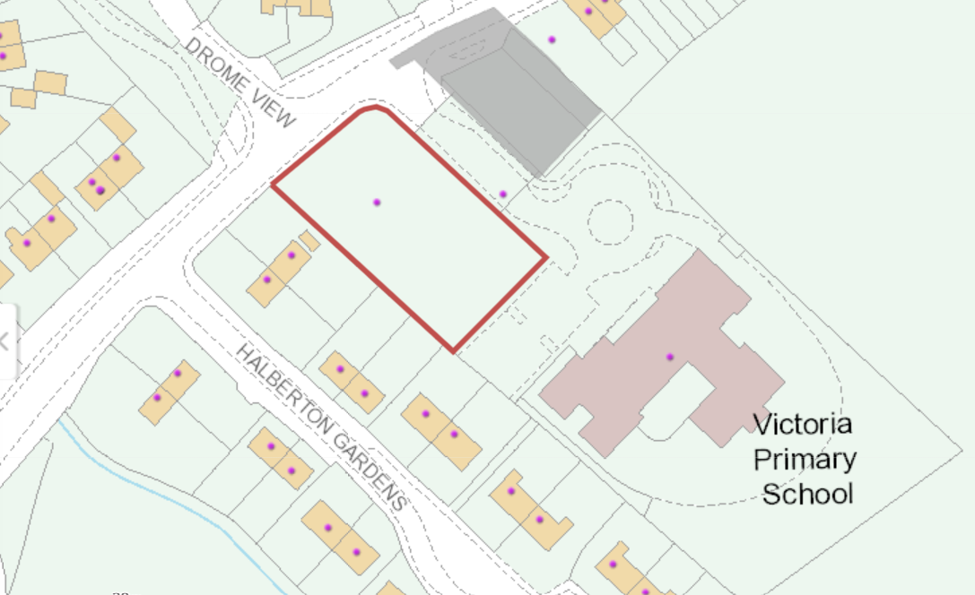

In previous discussions with the Education Authority in the past it had pointed to the fact that there was a grass pitch and a 3G pitch at Glastry College which was available for community use and which was 0.8km to the west of the village.

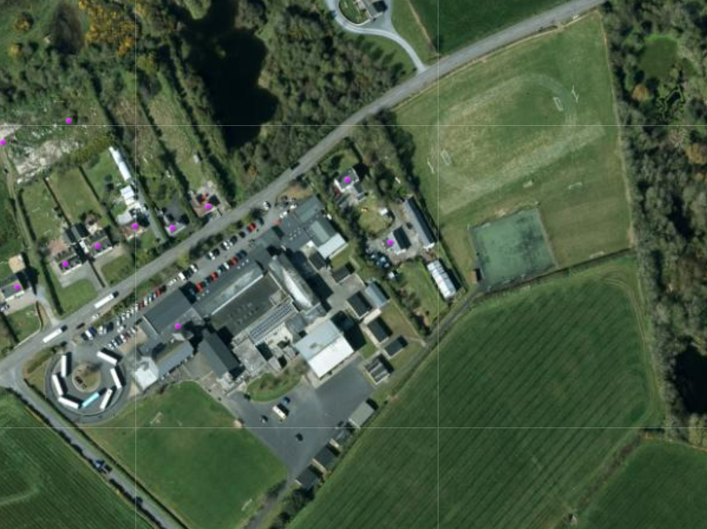

Play Strategy

In terms of older children provision the Play Strategy stated the following:

The delivery of such provision was to be focused in areas which were identified as having a higher concentration of older children (from the census data). It would also follow the settlement hierarchy with the larger settlements (in terms of population) being provided for as a priority and also to provide an even geographical spread across the Borough. The availability of Council owned land or the acquisition of additional land (and its associated implications and costs etc) was also a consideration for locating such facilities. For example, Bangor only had one MUGA and Holywood and Donagahadee had no provision at all for older children at present, with Holywood having one of the highest concentrations of older children in its DEA and across the Borough. The aim was to provide an even distribution of such facilities across the Borough with those having the greatest need (population/demographic) being provided for in the first instance.

The delivery of the provision for older children would require the securing of additional capital funds to construct them by completing the required business cases for approval. There may be opportunities to deliver such facilities using external funding which may be location specific (such a Village Renewal funding etc.). In some instances, the delivery of that additional older children provision would be in conjunction with other proposals at a settlement level in terms of upgrades and removals etc. Public consultation exercises would be undertaken in the proposed locations to establish the type of facility that the local community would like to see delivered and where it should be located.

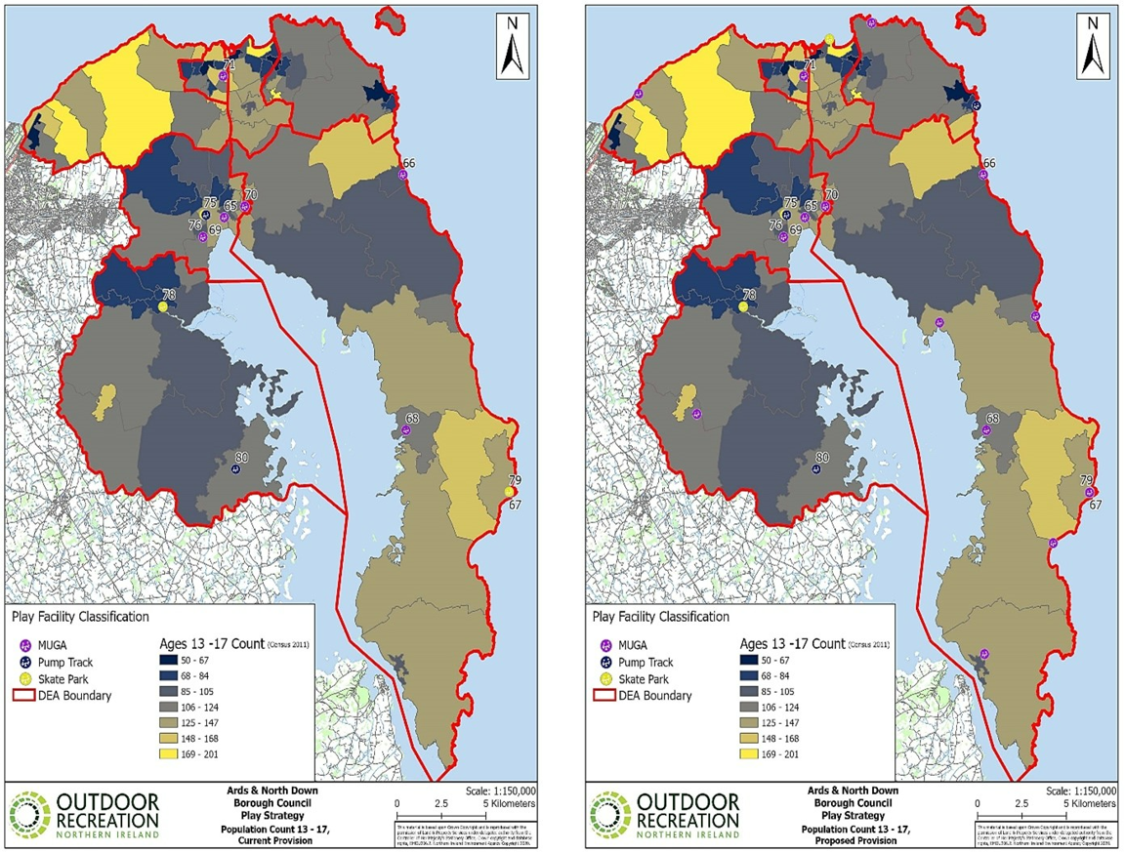
Existing and proposed older children and young people provision.

Existing Provision

Location | Facility
Bangor | MUGA Clandeboye Road
Newtownards | MUGA x3  West Winds  Bowtown (managed by the Community Association)  Londonderry Park (partial MUGA)  Skate Park, ABMWLC  Pump Track, ABMWLC
Comber | Skate Park, Muckers Field
Millisle | MUGA Ballywalter Road
Portavogie | Skate Park, New Harbour Road
Kircubbin | MUGA, Parsons Road (partial MUGA)
Killinchy | Pump Track

Proposed Provision

The locations identified in the Play Strategy for Older Children Provision were as follows:

- Bangor
- Holywood
- Donaghadee
- Groomsport
- Ballygowan
- Ballywalter
- Kircubbin
- Cloughey
- Greyabbey

The type of facility to be delivered and the locations within the settlements would be the subject of local Community consultation. The locations identified in the Play Strategy were to ensure an even geographical spread across the Borough and could be delivered using Council owned land.

Ballyhalbert was not identified for any older children provision over the course of the Play Strategy.

PEACEPLUS

In terms of identifying projects to be taken forward for PEACEPLUS the Council had established a new PEACEPLUS Partnership for the new PEACEPLUS Programme 2022-2027 for the Ards and North Down Council area. The PEACEPLUS Partnership would oversee the design and implementation of a co-designed overarching PEACEPLUS Action Plan for the Borough area.

The Ards and North Down Borough Council (ANDBC) PEACEPLUS Programme, would build upon the work of previous PEACE programmes and enable and empower local community partnerships, led by the Council to co design, select and deliver priority projects on a cross community basis, which would result in shared and inclusive local services, facilities and spaces and make a significant and lasting contribution to peace and reconciliation.

The three core themes were as follows:

(i) Local community regeneration and transformation;
(ii) Thriving and peaceful communities; and
(iii) Building respect for all cultural identities.

There was a process to follow in terms of which projects would be taken forward for delivery funded by PEACEPLUS.

- Community Consultation
- Online Survey
- Development of a co-design process
- Development of an Action Plan
- Identification of priority projects
- Application submission under the Themes

Therefore, until that process had been completed, it could not be guaranteed that a project to deliver a facility at Ballyhalbert would be identified as being one of the priority projects identified for PEACEPLUS funding.

RECOMMENDED that the Council approve that Ballyhalbert community continue to avail of the existing facilities at Glastry College. The potential for a project in front of Victoria Primary could potentially be added to the list of projects being put forward for PEACEPLUS and considered by the PEACEPLUS Partnership and progressed through the process outlined above. Consideration should also be given to the other sites identified in the Play Strategy for older children provision as part of the PEACEPLUS process that could be delivered on Council land.

Proposed by Councillor Boyle, seconded by Councillor Smart, that the recommendation be adopted.

Councillor Boyle thanked officers for the detailed report explaining where the Council stood and where it might be able to channel its thoughts for the future. In his opinion it would be important for Ballyhalbert to get something from this work but warned about overly building up expectations at this stage and instead continue to explore every opportunity available.

Councillor Smart was in agreement and also praised officers for their endeavours to put this work together in the hope that PEACEPLUS could come up with something. For now, he viewed it as a positive step forward.

AGREED TO RECOMMEND, on the proposal of Councillor Boyle, seconded by Councillor Smart, that the recommendation be adopted.

(Councillor MacArthur entered the meeting at 7.06 pm)

item withdrawn

aSHBURY PLAY PARK – LINEAR PARK / BALLYCROCHAN

Previously CIRCULATED: - Report dated 24 October 2022 from the Director of Community and Wellbeing detailing that under the legacy North Down Borough Council 2014 Playpark Strategy and the more recent Ards and North Down Play Strategy in 2021, the Bangor East area was identified as having a lack of playground provision. An area around Ashbury Avenue (Ashbury shops) and Linear Park was identified as being the best location to locate a play facility in that area to serve the local population.

A Public Consultation exercise was undertaken in 2019 to determine the preferred site. The sites considered were a site located on the grass area to the front of the shops (Site A) and another site in Linear Park (Site B).

The results were that 42% of respondents favoured Site A and 46% favoured Site B with 3% having no preference and 9% didn’t specify a preferred location. At a subsequent Council meeting in August 2020, it was determined that the play area should be delivered at Site A.

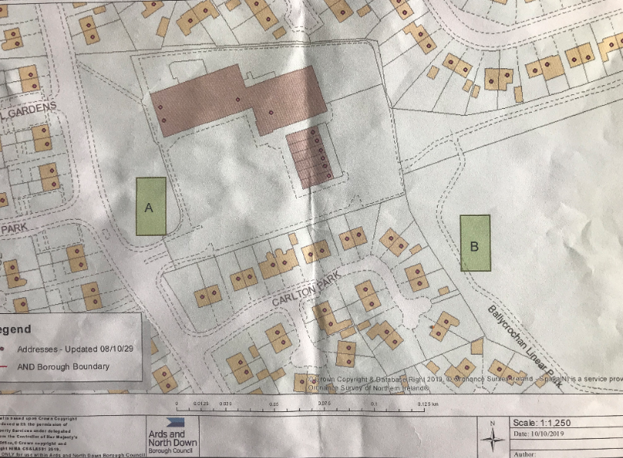

Figure 1. Map which was shown at public consultation events.

Following the Council decision, Council Officers started negotiations with the landowners as well as Land and Property Service to establish if the land could be obtained to deliver the play area and under what conditions. The landowners had aspirations of extending their commercial units at the site and following lengthy negotiations it was finally agreed that they would submit a planning application for their commercial extension. That application included additional commercial units, an extension of the car park and the play area. The play area was designed by the Council’s contracted Play Park Installers in line with the normal Council specifications and the drawings were issued to the landowner’s agent for inclusion in the planning application. The Council also paid the element of the planning fee attributable to the play area (£848). Indication was given by the landowners that when they received planning permission, they would then transfer the land needed for the play area to the Council and the Council would deliver the play park. The conditions of the land transfer would be determined at that point.

Given that the land was not yet in Council ownership the normal planning permitted development rights did not apply, so the play park could not be delivered and had to be brought forward as part of the wider planning application.

The planning application was submitted on 20th July 2022:

LA06/2022/0750/F: Two class 1 shop units and 1 hot food unit to the ground floor and first floor accommodation for use as class B1(a) or class A2 financial professional and other service use with associated car parking and children's play area.

At present NI Water had responded with the following:

For the reasons detailed below NI Water recommend that this application for planning approval should be Refused.

There is a public foul sewer within 20m of the proposed development boundary. A high-level assessment has indicated potential network capacity issues. This establishes significant risks of detrimental effect to the environment and detrimental impact on existing properties. For this reason, NI Water is recommending connections to the public sewerage system are curtailed.

The landowner’s agent was now required to undertake a study in relation to the network capacity in that area.

Until that had been completed, submitted and reconsidered by Planning and NI Water the planning application could not be determined.

The play area could not be delivered until the planning process had been completed. The terms of the transfer would then be determined, and the legal transfer process would need to be undertaken. Should the application not be successful then further negotiations would be required.

RECOMMENDED that the Council note that the Ashbury Play Area cannot be delivered until the planning application has been determined.

Councillor T Smith asked to make an amendment to the proposal which was seconded by Councillor Chambers.

This Council expresses its disappointment at the latest delay to this project. It therefore asks officers to bring back another report no later than 3 months from now. That report should provide an update on the planning application and should also explore other options for the delivery of this much needed play park.

Councillor T Smith explained that he had brought the amendment forward since the matter had been ongoing for many years now and it seemed to present a struggle at every step. He highlighted that this was no criticism of the landowner but rather another impasse by NI Water which had raised an objection and as a result further uncertainty. Thousands of children who might have benefitted from this had now grown up and had missed out on that play provision and he did not want to see if further unnecessarily delayed. He urged the Council to continue to review the position and believed that it had an obligation to deliver play facilities in that area.

He wondered if the application could be split as a way to take the permission forward with the playpark separate from the retail units. He recognised that this was the Council’s preferred site but he suggested that an alternative, such as Linear Park, should be looked at if a reassessment was needed in three months’ time.

Councillor Chambers thanked Councillor T Smith for bringing the proposal and was sure that Members would be in agreement with it. He knew that the Council wanted to deliver this project but there was a general public perception that it was failing to deliver which was unfortunate. He worried that the NI Water objection could mean that the Council’s chosen site could be unviable, and he called for the Council to monitor developments closely. He asked if the officers concerned had a back-up plan and how long the Council intended to pursue this option.

The Head of Parks and Cemeteries appreciated the disappointment being expressed and the report had been intended to be an update to Members on the current position. Presently the application was going through the planning process and the Council was in regular communication with the landowner and he would endeavour to bring back a further report on progress over the next few months.

Councillor Boyle also shared his disappointment having read the report and considered that NI Water seemed to be interrupting a range of project plans within the Borough. He understood Councillor T Smith’s reasoning and asked officers if they believed that progress could be made in a relatively short period of time.

The Director reminded Members that this was not the Council’s planning application so it had limited influence on the detail but that work would continue with the landowner to progress the application as much as possible. The Head of Parks and Cemeteries had nothing further to add but he gave assurances that an update would be provided after the Christmas break.

In summing up Councillor T Smith though that the onus was on the Council to build what was a much-needed playpark and that the application should be closely monitored over the coming months.

AGREED TO RECOMMEND, on the proposal of Councillor T Smith, seconded by Councillor Chambers, that this Council expresses its disappointment at the latest delay to this project. It therefore asks officers to bring back another report no later than 3 months from now. That report should provide an update on the planning application and should also explore other options for the delivery of this much needed play park.

dISPLAY BED APPLICATIONS
(Appendix I)

Previously CIRCULATED: - Report dated 24 October 2022 from the Director of Community and Wellbeing detailing that Members would be aware that on the 27 February 2019, Council agreed a policy for the use of Display Beds in the Borough. That policy required Officers to report to the Council any applications received by external organisations. The Council had received three applications for use of the display beds. Officers had assessed applications and had determined that the requests met the criteria in the policy and were recommended for approval. The applications were deemed by Officers to not require equality screening.

The Parks team would endeavour to replicate the design as far as possible, however detail design may alter to facilitate installation. If necessary, the Officer would liaise with the applicant if the installation may have to be significantly different from that proposed.

The applications were as follows, and the proposed design of the display was included in the attached appendix.

Name of Group / Organisation | Display Bed Location | Proposed Dates of Display | Reason for the Display
Glenlola Collegiate School | Adjacent to Bangor Post and Sorting Office | 09/01/2023 - 20/03/2023 | To celebrate 125 years of educating girls in Bangor
North Down Parkinsons Support Group | Adjacent to Bangor Post and Sorting Office | 01/04/2023 – 30/04/2023 | Celebrate World Parkinsons Day 11 April 2023
Donaghadee Women’s Institute | East Street, Donaghadee | 01/05/2023 - 31/05/2023 | To mark the 80th anniversary of Donaghadee Women’s Institute

RECOMMENDED that the Council approves the above applications for the display beds.

AGREED TO RECOMMEND, on the proposal of Councillor Chambers, seconded by Councillor Smart, that the recommendation be adopted.

sCHOOL GROWING CLUBS
(Appendix II)

Previously CIRCULATED: - Report dated 24 October 2022 from the Director of Community and Wellbeing detailing that Ards and North Down had 74 Schools accommodating circa 14,000 pupils. The Council’s Parks Service actively engaged with many of those schools through Ards and North Down ‘In Bloom’. The structure of the ‘In Bloom’ initiative recognised the importance of educating young people on environmental responsibility, benefiting the Borough now and for future generations. The Community Competitions included categories specifically aimed at entrants aged under 16. Schools were further engaged through the #STAND4TREES initiative which put young people at the heart of many tree planting schemes and climate change education.

Council Parks Officers regularly held educational workshops throughout the Borough themed around horticulture, biodiversity and the environment. Parks Service hoped to build on that success through a new School Growing Clubs initiative.

School Growing Clubs were a great opportunity for schools to promote healthy eating as well as a deeper understanding of sustainable food issues. Pupils and teachers would be inspired to work together in their outside space, learn gardening skills for life and learn to take care of their local environment. Research suggested schools taking part benefitted through healthier and happier children spending more of their time outside.

Schools would be able to use this initiative as a tool for development, enabling them to provide an exciting curriculum for children and young people. Schools could introduce children to the natural environment and in particular to gardening in a variety of ways. Gardening was not just a science subject, but the arts, language, geography, and technology, could all be employed to further a pupil’s understanding, knowledge and skills of planting and growing.

Growing areas in schools could be created with as little as container planting, up to more extensive gardening areas. Growing areas offered pupils the benefit of practical hands-on activities, helping to motivate and enhance their learning experience. Gardening had many positive benefits, particularly in increasing younger children's likelihood of trying new fruit or vegetables that they had grown and improving all pupils' understanding of healthy eating.

Educating children in the planting and harvesting of fruit and vegetables supported transition to a healthy, sustainable, and more equitable food system, in line with the Council’s membership of Sustainable Food Places. Ards and North Down Sustainable Food Community recognised the need to support local communities in reclaiming existing outdoor spaces, aiming to connect and support a wider food network to improve partnership working and share skills and ideas.

The Parks Service was committed to offering guidance to schools through the ‘Let’s Grow Together’ Strategy. The Council wanted to assist schools to set-up successful growing areas, developing a positive link with the wider Ards and North Down In Bloom initiative. This School Growing Clubs initiative would provide practical advice and a support package to set-up or improve an existing gardening club within six schools each year. Extension of the In Bloom initiative re-enforced Council’s commitment to support communities in achieving horticultural excellence, increasing community participation and promoting environmentally sustainable practices. Since 2019 Ards and North Down In Bloom funding had awarded more than £54,000 supporting 64 projects.

The School Growing Clubs was aimed at promoting sustainable outdoor education to inspire and support learning around horticulture, growing your own, sustainability, biodiversity, the ‘reduce reuse recycle’ message, and encouraging civic pride within young people. The programme would be delivered by the Council’s Parks Service and funded within the Council’s existing grants budget. Parks Officers would commit to delivering four gardening sessions with each of the six schools (24 sessions in total), to include a celebration event at the end of the programme. The Parks Service would also supply a tool and growing equipment kit to the six schools.

The School Growing Clubs Package aimed to support schools and youth organisations to:
- Create a growing area within the school grounds
- Plan, sow, tend and harvest a range of fruit and vegetables at school
- Produce crops which can be eaten in school
- Show schools how you can work together, making the best use of resources.
- Extend pupils understanding of sustainable food issues
- Promote healthier eating and drinking messages for pupils
- Inspire pupils to take care of, and respect, their local environment
- Work towards Eco School criteria and Green Flag

Selected schools would receive: -
- A four-session programme between January and October 2023.
- A Schools Growing Club Starter Kit including tools, equipment and resources.
- Certificates for participating pupils.

All schools in the Borough would be invited to apply to become a School Growing Club in Autumn 2022, with six schools being chosen by the panel (made up of Council Staff), with the programme running from January to October 2023 with publicity throughout.

RECOMMENDED that the Council supports the implementation of Ards and North Down School Growing Clubs.

Proposed by Councillor MacArthur, seconded by Councillor Smart, that the recommendation be adopted.

Councillor MacArthur welcomed the initiative and even though it was on a small scale with the participation of six schools it had the potential to help schools that might be struggling to start on this food journey. She pointed to the fact that there was an abundance of information on the topic, and it formed part of the Northern Ireland Curriculum. She encouraged schools to participate and referred to the success of it in her own school.

Councillor Smart agreed thanking officers for their efforts and he was encouraged that the Council had been able to support some local schools who were starting on this food journey.

AGREED TO RECOMMEND, on the proposal of Councillor MacArthur, seconded by Councillor Smart, that the recommendation be adopted.

lOCAL BIODIVERSITY ACTION PLAN 2022 – 2032
(Appendices III & IV)

Previously CIRCULATED: - Report dated 14 October 2022 from the Director of Community and Wellbeing detailing that the purpose of the report was to seek approval for the public consultation of the Second Ards and North Down Local Biodiversity Action Plan 2022–2032.

Biodiversity was the variety of plant and animal life in the world, or in a particular place or habitat, and included all species of plants and animals, and the habitats in which they lived. Humans were a part of biodiversity, and the way the land was used and managed across various habitats could have a knock-on effect for many other species.

The biodiversity of Northern Ireland was of international importance and around 20,000 species were found in a wide variety of habitats.

A vast range of habitats could be found throughout the Ards and North Down Borough Council area including saltmarsh, rivers and lakes, fens, sand dunes, woodland, and grassland. Urban habitats within parks, cemeteries and gardens were also important for biodiversity. Notable habitats within the Borough and the species they support were outlined in the plan. Many of the habitats present in Ards and North Down, such as unimproved grasslands, species rich hedgerows and inter-drumlin wetlands were under severe risk of damage or loss. The main drivers of biodiversity loss included:

- Habitat Loss and Fragmentation
- Invasive Species
- Invasive Non-native Plant and animal Species
- Pollution
- Climate Change
- Land Management

The Wildlife and Natural Environment Act (NI) placed a statutory duty on all public bodies to “further the conservation of biodiversity in exercising any function.” The production of this Local Biodiversity Action Plan would assist in demonstrating the Council’s compliance with the statutory duty. Under the WANE Act, the Council was responsible for considering five key aspects of biodiversity. Those were:

- Protection of Biodiversity
- Maintenance of Biodiversity
- Enhancing Biodiversity
- Restoring Biodiversity
- Promoting Biodiversity

The development of the Local Biodiversity Action Plan (LBAP) for ANDBC, (in appendix), was an important step in recognising the importance of local biodiversity. It aimed to ensure that international, national, regional and local biodiversity objectives were achieved through a range of partnerships.

An essential part of the LBAP process was to establish, through a biodiversity audit, which of the internationally important, and UK and Northern Ireland priority, habitats and species occurred in the Council area. The audit provided essential information on local species and habitats under threat. That was then used to identify those habitats and species to be prioritised for conservation action. A total of six Priority Habitats and 29 Priority Species were identified through the audit process. The LBAP report expanded further providing additional information on each of those habitats and species, identifying key locations within the Borough where they could be found and the specific threats they faced.

A series of actions had been designed to conserve and enhance the priority habitats and species identified that were of international, national, regional, and crucially local significance within the Council area, (in attached appendix). The proposed LBAP Actions fell under one of four themes:

- Theme 1: Education and Awareness
- Theme 2: Research and Monitoring
- Theme 3: Land Management
- Theme 4: Building Partnerships

A total of 77 Actions had been proposed across all four Themes.

The habitats and species listed in in the LBAP represented a selection of what was present in the North Down and Ards area. That selection would be prioritised for action. It was likely that other habitats and species may be added to this list as priorities may change over the life span of the plan.

The Plan would be a dynamic document which would be subject to constant review. It would guide the protection and enhancement of biodiversity in Ards and North Down Borough Council over the next ten years. Progress towards the targeted actions would be assessed and reported annually and LBAP would be reviewed after five years. Reporting on progress would be undertaken by the Council on behalf of the LBAP Partnership.

To conserve our habitats and the species they supported we must take ownership and get involved now to protect them.

RECOMMENDED that the Council approves the Local Biodiversity Action Plan for ANDBC 2022 – 2032, Appendix 1, and associated actions, Appendix 2, for public consultation.

Proposed by Councillor McRandal, seconded by Alderman Wilson, that the recommendation be adopted.

Councillor McRandal welcomed the report and explained that he had taken part in some consultation events which had led to the report. He thanked all the officers who had been involved in that process. He referred to the links the Council had with established charities and agencies and wished to see the local communities involved as much as possible in that and wondered how the Council planned to develop those links.

The Head of Parks and Cemeteries stated that community events were part of the Local Biodiversity Plan and gave an example of a summer programme that the Council had run earlier in the year at Castle Park, Bangor. That would be expanded in the coming year drawing in to established events such as a butterfly count. This Council area was well represented in the United Kingdom for the Citizen Science programme which the Council supported, and it involved many people of all ages in the community working to support biodiversity.

Alderman Wilson also welcomed the report and had received an email earlier that day from the local conservation group Greenspaces which welcomed the plan. That group had suggested a central communication point to share information about the removal of trees and shrubs locally. He referred to Translink having removed shrub at Stricklands in Bangor and hoped that a mechanism could be built to make everyone aware of such local environmental developments.

(Councillor Johnson entered the meeting at 7.25 pm)

The Head of Parks and Cemeteries explained that the Council had its own tree and woodland strategy, and it did engage with communities and intended to pull together statutory agencies to have more regular contact regarding biodiversity issues. Alderman Wilson acknowledged that it was not an easy exercise but better communication going forward would be helpful.

Councillor MacArthur raised the challenges of dealing with invasive species and referred to Japanese Knotweed, growing on the Commons, Donaghadee as well as Rhododendrons and asked if any mapping of these invasive species had been carried out since there was some local concern being expressed.

The Head of Parks and Leisure informed Members that the Council had a strategy for removing such species and had developed an App for Council staff to record where those were being found. The Council was working with Queen’s University, Belfast, and had had a student work with it for three months over the summer progressing the list. Over the Autumn months the Council would inject those species with weed control but noted that it was unfortunate that the vegetation spread rapidly.

Councillor MacArthur continued asking about further education to local schools about the biodiversity on the Borough’s doorstep. The Head of Parks and Cemeteries assured her that that would be developed significantly over the coming years and much information was already available due to the Citizen Science projects.

Councillor Douglas welcomed the report thanking officers and agreed that public consultation was of crucial importance. She praised the work of the Citizen Science events and that the Walled Garden in Bangor had had some success in that. There was a desire locally to be engaged in environmental and sustainability issues and the Council should seek the broadest range of consultation possible.

At the close of the discussion Councillor T Smith stated that he would support the recommendation but with one caveat. In actions of conservation of the Red Squirrel he could not support the culling of the Grey Squirrel since it was also a species in its own right.

AGREED TO RECOMMEND, on the proposal of Councillor McRandal, seconded by Alderman Wilson, that the recommendation be adopted.

cEMETERY PRICING
(Appendix V)

Previously CIRCULATED: - Report dated 25 October 2022 from the Director of Community and Wellbeing detailing that Ards and North Down Borough Council was responsible for the management and maintenance of twelve active cemeteries, two closed cemeteries and seven historical cemeteries.

Members may be aware that the Council Cemetery pricing was last increased by 2% in April 2022 however there had been no increase in the 2021/22 financial year.

Currently the Cemetery department was operating at an annual net cost to the ratepayer of approximately £600,000 excluding utilities, capital costs and general maintenance.

The following report outlined the applicable charges relating to the Cemeteries Service across the Borough. In line with the budget setting process, it was proposed to apply a 10% increase to the cemetery charges for 2023/24, rounded to the nearest £1 for each charge. That was above the 5% already submitted by the service for the estimates process, a 5% was also submitted for information. Members were reminded that the current rate of inflation was 10.1%.

Officers had bench marked the pricing across neighbouring Councils and in several of the pricing categories Ards and North Down was significantly lower in the cost of burial provision.

In addition, Officers would suggest that Members consider an annual inflationary increase to be applied to the Scale of Charges using a percentage uplift based on the October ‘Office of National Statistics Consumer Prices Index (CPI): All Items Index’ from 1st January each year.

The table in the appendix set out the current charges together with the proposed charges for 2022/23.

RECOMMENDED that the Council adopt and approve the charges as outlined above and set out in the appendix and also approve the annual percentage uplift for subsequent years to be in line with the October Consumer Price Index (CPI) applicable from the start of each year.

Councillor Boyle proposed the recommendation but this was not seconded and therefore not moved.

GrOOMPORT PADDLING POOL / SPLASH PAD PLAY UPGRADE
(Appendix VI)

Previously CIRCULATED: - Report dated 25 October 2022 from the Director of Community and Wellbeing detailing that Members would recall in September that an update was given on the play areas that would undergo refurbishment this financial year, including the proposed upgrade to the paddling pools at Groomsport to splash pads. A proposal was subsequently agreed at Council as follows:

“That a full report detailing the maintenance issues with Groomsport Paddling Pool and costs to repair these issues is brought to Committee and that an assurance is given that a paddling pool area is retained.”

There had been issues with drainage and leakage at the paddling pool in Groomsport so given that there was additional budget available as a result of the Rural Development Funding, it was determined that the existing paddling pool could be converted into a splash pad area, similar to that at Pickie, providing a significant upgrade to the facility.

The Council’s Property and Assets Department had encountered leakages due to a faulty valve, as well as several instances of surface cracking. Full resurfacing had been carried out in the pool in the last four years, as well as ongoing localised surface repairs and resurfacing.

Currently there was a leak, believed to be related to the old drainage pipe work below the pool. That could potentially require excavating through the pool surface to repair or replace the old pipework. There were also additional further localised surface repairs to undertake. On top of the ongoing repairs there was regular reactive and planned power washing, and cleaning.

Parks and Cemeteries also cleaned the pools and changed the water on a weekly basis with power washing occurring generally at the start of the season prior to the first filling of the pool for the summer season. Below was a breakdown of the costs associated with the pool over the last 3 years.

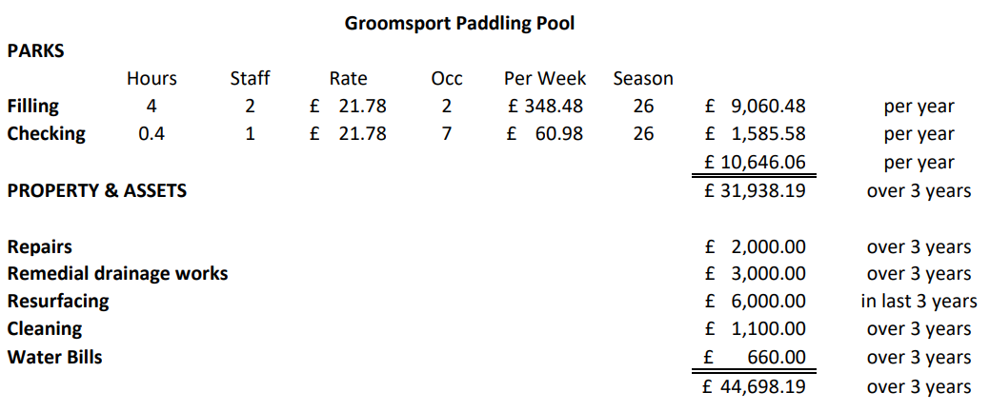

Following the discussion at the September Committee and Council meeting, the contracted playground designer, Garden Escapes, was asked to revise the designs to retain a pool area and remodel the splash pad design previously submitted to work within the allocated budget - attached was the revised design. The splash pad area was fully accessible to those with mobility issues and an area of pool was retained. The contractors would, as part of the works, resolve the valve/pipework issue and resurface the pool. The design attached may be subject to change in relation to the Splash Pad elements (jets etc) depending on confirmation of technical suitability, following exploration works.

RECOMMENDED that the Council approves the attached amended designs, and that Officers can progress implementation.

Proposed by Councillor Chambers, seconded by Councillor T Smith, that the recommendation be adopted.

Councillor Chambers believed that this matter had been debated enough and he was pleased with the design of the pool and believed, like others, that it offered the best of the old and the new design. The splash pad was fully accessible to those with mobility issues and he thanked officers knowing that the proposal was something that would satisfy many people.

He went on to refer to a report which was being brought to the Regeneration and Development Committee describing that similar at Pickie in Bangor was now thought to be outdated and costly to update and that had caused him some concern. He asked the officer to explain the difference in the two and hopefully give reassurance to Members that the right decision was being taken in respect of the water features.

The Head of Parks and Cemeteries stated that he was unaware of the position at Pickie but would follow it up with the relevant officers, but it may be simply older and in need of attention because of that. He explained how the splash pads could be adjusted and that this was new spec design and officers were confident that what was being proposed was a reasonable and good option for Groomsport.

Seconding the recommendation Councillor T Smith was in agreement and was pleased to see the design which retained the history and yet looked to the future. He hoped the plans would be progressed soon.

Councillor MacArthur welcomed the consideration which had been given to children with mobility issues and thanked officers for the work which had been undertaken so far.

AGREED TO RECOMMEND, on the proposal of Councillor Chambers, seconded by Councillor T Smith, that the recommendation be adopted.

enVIRONMENT HEALTH PROTECTION AND development ACTIVITY

Previously CIRCULATED: - Report dated 21 October 2022 from the Director of Community and Wellbeing detailing that under the Council’s scheme of delegation and in order to allow for timely service delivery, the application of legislation relating to Environmental Health matters had been delegated to officers to implement. A condition of that delegated authority was that related activity be reported to Council from time to time. The following was the report for the 2021-2022 year and included such delegated activity.

- Summary of Environmental Health Protection and Development Service Activity 2021-22

The role of the Environmental Health Protection and Development Department was to contribute to ensuring a better quality of life for all. From the Health Protection perspective, the service monitored, advised and enforced compliance with Food, Public Health, Pollution, Health and Safety at Work, Consumer Safety and Housing legislation and standards to protect the public from physical, chemical and biological agents, and conditions that may cause ill health or harm.

During the 2021-22 year the service faced significant challenges including redeployment of staff into Covid enforcement, a significant increase in noise complaints, increased number of new food business, catching up on works not progressed during 2020-21 and significant staff recruitment and retention issues. Regardless, the performance of the team remained positive with the majority of KPI’s, and targets being reached.

  - Functions within the department

The range of statutory and non-statutory functions delivered on behalf of the Council
were as followed:

- Food Control (including food manufacturing and fisheries).
- Consumer Protection. (Safety of consumer goods)
- Health and Safety at Work
- Caravan Site Licensing
- A wide range of commercial premises
- Petroleum Licensing
- Sunbeds
- Fireworks

- Pollution Control
- Noise
- Air quality

- Public Health (nuisance)
- Pest Control
- Private rented Housing

- Health and Wellbeing / Health initiatives
- Affordable Warmth.
- Tobacco Control
- Home Safety
- Community Planning lead for Age Friendly, Community Resuscitation,
- Health Development

  - Service Provision

Service provision included
- service requests,
- planned inspections and proactive visits to commercial premises and
- wellbeing intervention activities.

1.2.1 Service Requests
Service requests related to individuals’ requests for assistance for example in relation to pest control, or when the activities of one party caused an adverse effect on another for example in relation to nuisance and pollution.

The number of service requests by category 2021-22.
Department Function | Number of Requests
Pest Control | 720
General Environmental Health | 712
Food Hygiene and Standards | 661
Pollution Control | 936
Private Tenancies Complaints | 169
Health and Safety | 439
Consumer Protection | 25
Tobacco Control | 2
Caravan/Petroleum Licensing | 4
Total | 3668

In addition to the above, 89 property inspections were carried out under the Private Tenancies Order to have homes assessed against the fitness standard.

A total of 93 statutory notices were issued under the Clean Neighbourhoods and Environment Act (Northern Ireland) 2011, to secure environmental improvements and abatement of nuisances.

Officers responded to 323 consultations from the Council’s planning department on planning matters that could potentially affect public or environmental health.

The performance indicator target for a response to service requests was 94% within two working days. For the year 2021/22 the target was achieved.

The number of service requests received was 14% lower than for 2020/21, but still markedly higher (30%) than pre-Covid levels.

1.3 Planned Inspection and Proactive visits to commercial premises

There were currently 4420 operating commercial premises on the Environmental Health database. During the year 1253 (28%) of those premises were visited to assess compliance with legislation, to educate business operators on new legislation and requirements and to obtain samples. In order to reduce the burden on business many of those visits were carried out concurrently with officers assessing a range of legislative compliance - for example food hygiene, food standards and tobacco control addressed by an officer during one visit. Businesses and premises were risk assessed to ensure that those which might present the greatest potential risk to public health were visited most frequently.

- Area specific performance

2.1 Food Control
The Food Control Service continued to meet the requirements of the FSA’s Recovery Plan in 21/22. The Recovery Plan was devised to ensure that resources were targeted where they added the greatest value, such as identifying risks with new businesses and ensuring more routine operation of the Food Hygiene Rating Scheme.

In addition to the routine inspection of food premises and the reactive work in dealing with complaints and notification of food poisoning incidents, a food sampling programme was undertaken. Food sampling was an essential and effective tool in ensuring that consumers were provided with safe food and the information to enable them to make informed choices about food purchases.

2.1.1 Food Hygiene
- Inspected all category A premises
- Investigated 35 food poisoning identifications on behalf of the Public Health Agency
- Reacted to and actioned 91 complaints regarding premises hygiene.
- Collected 623 food samples for microbiological analysis.
- 69.4% of new businesses received an onsite inspection.
- Served 5 Hygiene Improvement Notices.
- Served 1 Remedial Action Notice.
- 2 Food businesses voluntary closed.

2.1.2 Food Standards
- 16 A rated premises inspected for food standards.
- Collected 345 food samples for chemical analysis.
- Investigated 139 complaints regarding allergens, composition, and labelling irregularities.
- Conducted a fish speciation survey to identify if substitution was being carried out.
- Mailshot sent out to 679 premises outlining the legal requirements for labelling foods that were prepacked for direct sale.
- 183 Businesses contacted either via email or mailshot regarding reformulation of cheesecake workshop hosted by the Food Standards Agency.

2.2 Consumer Protection
The consumer protection team provided a support and advisory service to local manufacturers, suppliers, and distributors of non-food consumer products in respect of their safety. The activities that had been undertaken included:
- Populated a database with details of all known local manufacturers, importers, and first-time distributors (and most retail and other outlets)
- Planned a targeted programme of work on a quarterly basis
- Participated in the work of the Northern Ireland Consumer Protection Group (NICPG) and provided a delegate to their subgroup working on links with Economic Development and the production of a training resource and on-line information pack for businesses.
- Disseminated information and advice provided through NICPG various areas such as product recall, e-cigarettes, hired goods, second-hand goods.
- Investigated complaints.
- Provided advice following requests from local manufacturers of toys, golf buggies, upholstered furniture, and cosmetics.

2.3 Health and Safety, Caravan Site and Petroleum Licensing
The responsibility for both advice in relation to and enforcement of the Coronavirus restriction regulations fell largely to the H&S and Licensing Officers with the knock-on effect being that focus was shifted from planned inspections of premises based on risk ratings allocated on the Tascomi data management system to dealing with complaints. Queries and requests for advice in relation to this novel legislation. The focus in 2021-22 was on assisting open businesses to comply with social distancing requirements; monitoring and advising closed businesses; and issuing advice on operating safely.

While there were no lockdowns in this period, restriction regulations were regularly changing. That led to a high demand from the service in relation to explaining the Covid rules to both businesses and members of the public. Officers from the department helped develop advice and guidance for businesses at a local, regional, and national level to assist them, in mitigating the Covid pandemic.

2.3.1 Health and Safety
A total number of 2654 premises were registered for health and safety on 31 March 2022, and 380 visits were completed during the year. The breakdown of those visits was as followed:
196 Visits in relation to Covid-19 requirements
35 H&S Inspections and Revisits
10 Visits to investigate accidents
6 Visits in response to requests for advice
10 Visits in response to complaints about premises or work activities
13 Sunbed Premises Inspections
36 Caravan Site Inspections and Revisits
71 Petroleum Site Licensing inspections and revisits
3 Firework and MSER site visits

Visits to assess compliance with general Health and Safety legislation were impacted by response to service requests in relation to Covid-19, with restrictions being relaxed from February 2022, and replaced with ongoing guidance.

While 7 Improvement Notices were served in relation to serious contraventions or continuing non-compliance, no Prohibition Notices were issued, and no prosecutions instituted in respect of issues presenting a serious risk to health or safety.

2.3.2 Caravan Site Licensing
That involved an annual assessment visit to each of the 26 Caravan Sites located throughout the Borough, and revisits as necessary. Officers also completed a Health and Safety inspection of sites where that was due. In 2021-22, 26 inspections and 10 revisits were undertaken.
2.3.3 Petroleum Licensing
During the period 49 inspections and 22 revisits were completed of filling stations located within the borough in order to ensure that licences were issued in a timely manner. Health and Safety Inspections of the premises had been completed in a single combined visit where appropriate.
2.3.4 Sunbed Test Purchase Exercises
Due to the Covid-19 pandemic test purchase exercises were not carried out however 14 Sunbed premises were visited in relation to compliance with the requirements of both the Sunbeds Act (NI) 2011 and Covid-19 restrictions.

2.3.5 Firework Licence Applications
Officers were warranted by the Department of Justice Firearms and Explosives Branch (FEB) and provided comments and where necessary additional conditions to the FEB, who in turn issued Licences for fireworks display if officers were content that it was safe to do so.

Nine Firework Licence applications were assessed by officers for displays held within the Borough. That was significantly less than the number assessed in previous years, most likely due to restriction on gatherings during the pandemic. Officers also inspected one premises where Fireworks or flares were stored and which was registered under the Manufacture and Storage of Explosives Regulations.

2.4 Pollution Control
2.4.1 Noise
765 complaints about noise were received in 2021/22. That was a further rise over the significant increase in complaints recorded between 2019/20 and 2020/21. While part of the increase could be attributed to the fact that, prior to 2020 complaints relating to dog barking were received by the Neighbourhood and Environment team in the first instance, this alone did not account for the sustained level of complaints. It was possible that this may be due in part to impacts of the pandemic, including working from home arrangements, or particularly in relation to dog barking and the subsequent return to the workplace.

100% of the complaints that were made received a response. Of the 765 complaints received approximately 39% wanted to proceed after their initial contact. Complaints may not progress past initial information and advice for a number of reasons including; where a disturbance was reported as a side issue to a wider neighbour dispute or a reciprocal complaint; where complainants were unwilling to provide their details or engage in the necessary procedures; where complainants were reluctant to proceed fearing a negative reaction from noise sources or on social media, or where complainants were open to approaching the source directly. At the stage of a formal investigation, complainants may again choose not to proceed if they were not prepared to collect the evidence required or appear as a witness in court.

Noise Abatement Notices
Of the 113 complaints formally investigated, nine abatement notices were served with other continuing investigations leading to further notices outside of the reporting period. An abatement notice was served in all cases where a statutory nuisance was established, and legal proceedings consequently instituted, if continued disturbance was reported and breach of notice was established.
Of the abatement notices served seven related to dogs barking excessively, one related to music and amplified noise from a Public House and one to loud music, singing and shouting from a domestic property.

No legal proceedings were instituted during the period in relation to noise nuisance in breach of a Noise Abatement Notice.
2.4.2 Air Quality
This is a shared service with Lisburn and Castlereagh City Council. Local air quality was monitored at 16 sites in the Borough, with annual reports being submitted to DAERA as required by legislation. A successful grant application was made to DAERA for staff resource and equipment maintenance. Additional funds were also received in relation to the ‘Engine Off, Prevent the Cough’ campaign which aimed to reduce vehicle emissions outside local primary schools.

Monitoring was also undertaken in relation to radiation levels in the Borough, via sampling of foodstuffs and a permanent monitoring station in Portavogie. There were no incidents of concern during the year.
2.5 Public Health
Service Requests
Much of the work of the Public Health and Housing service unit related to service requests from residents. For the year 2021/22, Officers responded to 1601 service requests relating to pest control, housing/drainage issues and neighbourhood nuisance (excluding noise).

The most common types of service request related to pest control, with rodent and flying insect complaints being received in the greatest numbers. The service provided investigation and advice, which ensured that the root cause of pest problems could be properly identified, and effective solutions could be made. Support was also provided to Officers carrying out the food hygiene function when assistance was required in relation to pest control matters.

Other types of service requests received included neighbourhood complaints in relation to housing defects, malodour, smoke, and problems with drainage/flooding.

2.6 Private Rented Housing
Regulation of the private rented housing sector was carried out, primarily through the enforcement of the Private Tenancies (Northern Ireland) Order 2006 and ancillary regulations. Officers inspected rented properties to ensure they were fit for habitation, free from disrepair and that they were not in a condition that was prejudicial to health. During 2021/22, the service unit issued 78 Certificates of Fitness, while 11 properties were found to be unfit, and Notices of Refusal were served on the landlords.

Housing officers also worked to ensure that landlords complied with tenancy deposit and landlord registration requirements. The legislation was reviewed during the year with the aim of correcting current weaknesses in its wording; that would aid regulation but would likely increase demand for the services. Housing officers also proactively searched for properties which may require a Certificate of Fitness to ensure that residents in the private rented sector were living in acceptable housing. At any given time, Officers would be investigating 75-100 properties to determine if there were any breaches of housing legislation.

Notices Issued and Prosecutions
84 notices were served using the Clean Neighbourhoods and Environment Act (NI) 2011, following service requests or housing standards inspections.
There were 3 successful prosecutions during this financial year:

One landlord was prosecuted for failing to apply for a certificate of fitness for a property. Incurring a £100 fine, and the Council was awarded £250 costs.

One landlord was prosecuted for failing to comply with a Notice of Unfitness. Incurring a £200 fine, and the Council was awarded £250 costs.

One landlord was fined £200 for failing to register with the NI Landlord Registration Scheme, with the Council awarded £150 costs.
2.7 Health Development and Wellbeing
The department supported the Take Five Steps to Wellbeing principles which developed public health and wellbeing both within the organisation and externally.

That included initiatives to enhance the lives of the fuel poor, the safety of young and old in the home, mental health, and other issues.

During the 2021-22-year partnership work with Community Planning progressed, including supporting the Community Recovery process from the pandemic and rebuilding services and operations to as close to pre-pandemic levels as possible.
2.7.1 Affordable Warmth
The Affordable Warmth Scheme had been designed to target support at those households which needed to spend 25% or more of their income on heating and lighting their home. It is open to both owner occupiers and tenants from the private rented sector with a household income of less than £23,000. Full grant was available to owner occupiers and landlords made a 50% contribution towards the cost of the energy efficiency improvement work.

Working from targeted lists, the number of referrals that could be made each month was set at 30 for 2021/22 but that was not always easy to achieve. There was a reluctance from some householders to have visits; and although Covid safe measures were introduced, with enhanced technical support, many still refused to have contractors attend to complete the measures once approved.

In 2021/22 the NIHE statistics for the Ards and North Down area were as follows: -
Referrals to NIHE by Council | 342
Properties Visited by NIHE | 306
Approved Works | 231
Value of Approved Works | £861,913.35
Measures Installed | 392
Homes Improved | 241
Grant Expenditure 21/22 | £843,213

The management of the Scheme remained challenging due to decreasing annual budgets and changing targets. The concerns of Members and Officers were regularly raised both at meetings and in writing with the Department of Communities (DfC).
2.7.2 Tobacco Control
The Tobacco Control function was currently operated as a shared service between Ards and North Down Lisburn and Castlereagh and Newry, Mourne and Down.

During the Covid-19 pandemic the approach to inspections was risk based with an education focus and written warnings were issued rather than fixed penalty notices.

There was a marked fall in compliance rates compared to previous years.

In Ards and North Down, 713 inspections were carried out with 304 written warnings subsequently issued for non -compliance. The TCO also signposted 154 ANDBC premises to smoking cessation services and worked with 711 businesses to promote smoking policies.

107 Tobacco Retailers were visited in ANDBC to promote compliance with age of sale legislation and ensure compliance with all tobacco related legislation. Five written warnings were issued for offences under the legislation. Advice was provided to over 115 premises on the new e-cigarettes age restricted sales legislation.

A new initiative working with the Northern Ireland Ambulance Service (NIAS) commenced in Quarter 3. Under Community Planning a Community Resuscitation Group was established to promote the chain of survival across the Borough.

Officers promoting the NIAS Regional Registration programme for Defibrillators by assisting with citing location of those devices for use across Northern Ireland and provided signposting information to relevant premises regarding how to register their device. To date 109 premises had been contacted.
2.7.3 Home Safety
The Home Safety Scheme was operated as a shared service by Ards and North Down Borough Council, Lisburn and Castlereagh and the Down portion of Newry, Mourne and Down. Target visits to priority groups (older people, children under 5, those with disabilities/vulnerabilities) are agreed with Public Health Agency (PHA) which co-funded the service. A total of 794 home safety checks were carried out with 338 in Ards and North Down, (212 Older Persons & 126 under 5s) exceeding the PHA target of 270.

Home Safety Officers provided over 1498 pieces of equipment to older people in ANDBC and 1201 to households with children under the age of 5 during these Home Safety Checks.

Home Safety Officers made a total of 221 onward referrals (133 of which were from Ards and North Down) to other organisations and departments.
PHA and PCSP funding facilitated the regional production of a range of videos and accompanying teacher packs covering BeSafe topics such as internet safety, water safety, transport and road safety and farm safety. 17 schools availed of the virtual sessions offers with positive feedback on the approach. Social media campaigns were used to highlight regional safety messages including burns and scalds and button battery dangers.

2.7.4 Age Friendly
Having committed to achieving World Health Organisation’s Age Friendly status in October 2017, work was undertaken to develop a Strategy and Action Plan 2019 -2022 for the Council area through the establishment of an Age Friendly Alliance (AFA). Much of the work was still at an early stage when the Covid-19 pandemic arrived and many of the partner organisations, including the Council, had changes in priorities and personnel over the next 12 months as resources were diverted to address the pandemic. In 2021/22 the PHA agreed to provide funding for an Age Friendly Coordinator AFC in every Council area with the AFC in Ards and North Down starting 1 February 2022.

The AFC spent time connecting with partner organisations and other AFCs throughout the UK and Ireland. Key priorities over the next 5 years were agreed with PHA and short-, medium- and long-term targets were set to achieve those.
2.7.5 Health Development
Mind Body and Business
Working closely with Economic Development, the Mind, Body Business (MBB) project supported local businesses to put the health and wellbeing of their staff higher up on the business agenda. 28 business signed up to MBB in 2021-22, exceeding the target of 10. They were provided with an employee/lead officer health and wellbeing box containing information, games and ideas including a step challenge. The MBB website was kept updated and promoted, with e-zines and emails to connect with businesses and promote activities and health messages. MBB business cards were produced and distributed to promote programme, website, activities and fitness videos.

A survey was undertaken to assess the needs of businesses and employees, to inform the MBB programme. Further promotion of the exercise videos produced by MBB in 2020/21 took place to encourage those working from home/sitting at desks to be more active. Free health checks were also offered to businesses alongside a selection of online health webinars with an interest/focus for the Business Community. Accredited Mental Health First Aider courses to support local businesses were also delivered, recognising the increased need to focus on mental health following the pandemic.

Employee Health and Wellbeing
Health and Wellbeing also lead on Employee Health and Wellbeing, delivering over 20 different events and activities to improve staff morale, encourage self-awareness of health issues and promote the Take 5 messages.

In 2021/22 there were 8 creative workshops covering cookery, ceramics, Christmas wreaths and wood carving with almost 100 staff taking part. Wear it Pink and Christmas Jumper days raised over £270 alongside donations to Woman’s Aid, Foodbanks, Mission Christmas Toy Appeal and Silver Santa.

107 employees under 50 were vaccinated as part of the flu prevention programme and 70 staff undertook Action Cancer Health Checks with a further 30 attending sessions with qualified Leisure and Fitness Instructors in Ards Blair Mayne.

Men’s Health Week was well supported with the usual activities of football, craft, lunches and newspapers. Two employees did Grow a Mo in Movember to raise awareness of Men’s health and 17 more undertook the Move for Movember Challenge. Over 30 joined in the Step Challenge and all staff received winter road safety information, world mental health day communications and competitions and lots of articles in News AND Info.

The launch of the new Employee Health and Wellbeing website STAY Well took place, with all staff given a pen with the website details and a Kit Kat to take a break and go online to access it. The site, in association with the Local Government Staff Commission, was an excellent source of reputable health and wellbeing information. It highlighted all the key health campaigns throughout the year and also provided space to advertise in house events and an online booking system to sign up.

- Summary
During the 2021-22 year the service faced significant challenges including redeployment of staff into Covid enforcement, a significant increase in noise complaints, increased number of new food business, catching up on works not progressed during 2020-21 and significant staff recruitment and retention issues.

Regardless, the performance of the team met the majority of KPI’s and targets and had a significant positive impact on the community planning outcomes.

RECOMMENDED that the Council notes the above report.

Proposed by Councillor MacArthur, seconded by Councillor Johnson, that the recommendation be adopted.

Councillor MacArthur thanked officers for the comprehensive report particularly in what had been a difficult time in the environmental health department with staffing issues. She asked the Head of Environmental Health Protection and Development if those difficulties had now been resolved. It was explained that the backlog in workload was being dealt with and while there were now a smaller number of vacancies of a temporary nature in the department, targets were being reached and the work was progressing in the right direction.
The Member went on to refer to the Home Safety Checks which were offered by the Council and how referrals could be made for those. The officer explained that most came through a healthcare practitioner and were for more vulnerable Members of the community such as older people or those who had very young children in the home and that it was not a means tested service. Priority to services depended on the personal circumstance of any individual. It was possible for Members to refer people to officers for consideration if they fell into those priority groups.

AGREED TO RECOMMEND, on the proposal of Councillor MacArthur, seconded by Councillor Johnson, that the recommendation be adopted.

pEACEPLUS MINUTES 8TH SEPTEMBER 2022

Previously CIRCULATED: - Minutes of PEACEPLUS dated 8 September 2022.

AGREED TO RECOMMEND, on the proposal of Councillor Smart, seconded by Councillor Chambers, that the minutes be noted.

pEACEPLUS VACANCY
(Appendix VII)

Previously CIRCULATED: - Report dated 24 October 2022 from the Director of Community and Wellbeing detailing that the Council had agreed that the PEACEPLUS Partnership should be comprised of a total of 31 representatives under 4 designated pillars:

11 Elected Members (10 Selected by D’Hondt +1)
9 Public Sector Bodies
5 Social Partners – Geographical Community Representatives/Civic Society
6 Social Partners – PEACEPLUS Target Groups; S75/under-represented groups

A breakdown of the membership is attached along with the nominations from each partner agency/sector.

The only remaining vacancy was the place allocated to Invest NI. However, Invest NI had recently advised that it did not wish to take up a position on the Partnership as it was not a “fit” for its organisation.

As ANDBC agreed the composition of the PEACEPLUS Partnership, it would now be necessary for the Council to nominate an alternative Public Sector partner.

The matter had been discussed by the PEACEPLUS Partnership and some of the suggestions for Council consideration, based on engagement in previous peace programmes, was to offer the vacancy to one of the following sectors/agencies:

- Sport NI
- The Chambers
- Trade Unions
In terms of a nomination from the Chambers, it should be noted that the Business Sector was already represented on the PEACEPLUS Partnership, through the “Social Partners – Geographical Community Representatives/Civic Society” appointment.

Whilst Trade Unions had been represented on previous PEACE Partnerships, a significant proportion of previously delivered projects had been sports based programmes, which was a tool to engage people and young people in peace building activities. Therefore, it should be noted that a partnership with the Sports Council NI could be very beneficial for the ANDBC PEACEPLUS Programme and assist the Partnership in the achievement of its targets.

RECOMMENDED that the Council agrees to invite and if agreeable appoint an alternative sector/agency to the PEACEPLUS Partnership, based on the information detailed within this report.

Proposed by Councillor Boyle, seconded by Alderman Wilson, that the recommendation be adopted.

The Director sought clarity on if the recommendation being made was that the PEACEPLUS partnership was to decide which of the three organisations should be invited, or did it wish Council to nominate one to be approached. The committee agreed that it would at the discretion of the Partnership which organisation it approached.

AGREED TO RECOMMEND, on the proposal of Councillor Boyle, seconded by Alderman Wilson, that the recommendation be adopted.

pCSP aNNUAL REPORT 2021 – 2022
(Appendix VIII)

Previously CIRCULATED: - Report dated 24 October 2022 from the Director of Community and Wellbeing detailing that Members would be aware that the AND PCSP was required under the Local Government Justice Act (2011) to submit an Annual report to the Joint Committee of the NI Policing Board and Department of Justice.

A report was attached for information.

RECOMMENDED that the Council notes the report.

AGREED TO RECOMMEND, on the proposal of Councillor Douglas, seconded by Councillor Chambers, that the recommendation be adopted.

400th anniversary of kirkistown castle
(Appendix IX)

Previously CIRCULATED: - Report dated 11 October 2022 from the Director of Community and Wellbeing detailing that the following Notice of Motion was agreed by Council in April 2022:

“To mark the 400th anniversary of the building of Kirkistown Castle, Council tasks officers to work with the Department of Communities (Historic Monuments Division), local community groups and schools, to deliver a community programme of events to mark this important milestone in the history of the village of Cloughey.”

On Saturday 8 October 2022 an event took place between 12pm-4pm to celebrate the 400th Anniversary of Kirkistown Castle.

The event was postponed from 10 September due to the death of HRH Queen Elizabeth II and although some momentum was lost in marketing and on social media the event was very well supported with a steady stream of 1,150 visitors throughout the day.

A traffic management plan was put in place due to the limited access to the site and a Park and Ride operated from the car park adjacent to Cloughey Pavilion. That was greatly appreciated by local residents and visitors.

The event was delivered by the Councils Arts team in conjunction with the Community Development team, working in partnership with the Department of Communities Heritage Environment Division (HED) which provided significant funding to help animate the site with music, storytelling and re-enactments. £1,000 funding was also gratefully received from Trinity Presbyterian Church. The shortfall was met by the Arts and Community Services budgets. A full budget breakdown could be found in the appendix.

The following was a summary of the activities that visitors enjoyed on the day:

Musical Interludes
Atmospheric music was played throughout the day from trio Seefin and traditional music from a trio of Ards Comhaltas Ceoltóirí Éireann. A highlight of the day was a performance by Kirkistown Castle Pipe Band with lots of visitors using the deck chairs provided to enjoy the performances.

Storytelling
Inside the Castle visitors were given historical information by HED Officers and enjoyed family friendly tales of myths and legends by Janice Witherspoon and Willie Drennan.

Medieval Combat Group
MCG is an Historic European Martial Arts (HEMA) group based in Belfast. Visitors enjoyed the swords clashing as they demonstrated medieval martial arts using techniques from surviving 14th to 15th century manuscripts.

Valhalla Street Theatre
Valhalla Street Theatre brought history to life with a specially commissioned story featuring characters and tales from 400yrs ago. Visitors enjoyed taking photographs with the characters.

Craft
Traditional Rope Making skills were demonstrated by Paul Whitla and traditional Pole Lathe Woodcraft demonstrated by Craig Sands. Visitors enjoyed being able to try their hand at these traditional skills.

The stone house played host to children’s craft activities and a Treasure Hunt.

RECOMMENDED that the Council notes this update report.

Proposed by Councillor Boyle, seconded by Councillor Douglas, that the recommendation be adopted.
Councillor Boyle thanked officers for the work that had been put in to organising the event and to those who had contributed to funding the programme. The success of the day had undoubtedly been helped by the excellent weather and the bus transport to the site had eased traffic congestion and helped to keep people safe.

He referred to the two-way traffic on the stairwell and the low head room in that part of the Castle and thought that could have been dangerous but thankfully everyone had been kept safe. He was pleased to see the large group of visitors and the steady flow of people many of whom had expressed the hope that the building could be opened to the public on a more regular basis.

Councillor Douglas agreed that the day had been fantastic and she thanked Councillors Adair and Edmund for bringing the Castle to everyone’s attention with their Notice of Motion. She also thanked Council officers who had helped to make the event happen, particularly the Arts and Heritage Manager. She hoped the public would continue to enjoy the Borough’s historic sites and the Castle could be opened on future dates.

The Chair, Councillor Edmund commented on the 1,150 visitors to the fun day and expressed his thanks to Trinity Presbyterian Church for the financial support it had provided and the Department of Communities heritage section along with Council officers.

AGREED TO RECOMMEND, on the proposal of Councillor Boyle, seconded by Councillor Douglas, that the recommendation be adopted.

percy french collection
(Appendix X)

Previously CIRCULATED: - Report dated 24 October 2022 from the Director of Community and Wellbeing detailing that on 17 November 1997, North Down Borough Council entered into a 25-year agreement with the Percy French Society. In this document, the Trustees of the society agreed to deliver their collection of Percy French materials into the care of the Council and in return the Council would look after, store, display and loan out artefacts as required.

As the term of the agreement was to finish in November 2022, the Percy French Society had decided to gift the collection to Ards and North Down Borough Council.

North Down Museum held the collection in its own secure storeroom under museum standard conditions including archival materials and environmental and pest monitoring. Over the past 10 years at least one exhibition per year had gone on display either in the museum or online.

The collection had been externally audited in the past and would be audited before any formal handover. A copy of which would be given to the society.

The offer also stated that upon agreement the Council would not break up or sell any part of the collection. That fitted in with the museum’s Collections Development Policy that there was a strong presumption that collections were not sold.

The offer also asked for a biannual audit to take place. That would need to be discussed with the Society as the museum did not fully audit its collections every two years. The Council’s process involved carrying out an annual spot check of the assets audit and the Percy French Collection would fall under that programme.

RECOMMENDED that the Council accepts the offer of the Percy French Collection subject to reaching agreement on the auditing arrangements for the collection, with the Percy French Society.

AGREED TO RECOMMEND, on the proposal of Councillor Smart, seconded by Councillor Moore, that the recommendation be adopted.

north down museum collections development policy 2023-2027
(Appendix XI)

Previously CIRCULATED: - A report dated 5 October 2022 from the Director of Community and Wellbeing detailing that the revised Collections Development Policy 2023-2027 for North Down Museum was an updated version of the Council’s previous Collections Development Policy 2017-2022.

The only amendments included:

- The addition of the new museum Digital Image Database in conjunction with eight local Historical Societies. That database would become the central repository for digital images across the Borough.
- The themes for future collecting had been updated to reflect the limited storage space for future collecting and focus future acquisitions so that they fit in the space currently provided.

This policy had been developed in line with UK Museum Accreditation guidelines and standards.

RECOMMENDED that the Council approves the revised Collections Development Policy 2023-2028 for North Down Museum.

Proposed by Councillor Johnson, seconded by Councillor Douglas, that the recommendation be adopted.

Councillor Johnson congratulated the North Down Museum for its work stating that it was a valuable resource supporting the area’s local heritage. Councillor Douglas agreed and put on record her thanks to the former Manager of the Museum, Heather McGuickan, who had now left the Council. Heather had carried out sterling work over the years with schools and historical societies and would be a significant loss to the Museum.

AGREED TO RECOMMEND, on the proposal of Councillor Johnson, seconded by Councillor Douglas, that the recommendation be adopted.

community development grants assessment 2023-2024

Previously CIRCULATED: - Report dated 25 October 2022 from the Director of Community and Wellbeing detailing that the Community Development (CD) Fund was managed by the Council’s Community Development Service. The total budget for the fund was £93,000, of which in 2022-23 £41,083.18 was funded by the Department of Communities (DfC) and £51,916.82 was match funded by the Council.

The CD fund was split into two categories:
- Running costs up to £2000, for administration and overhead costs. The majority of the applications received were from community houses/bases to assist with their heating and electric costs.
- Project costs up to £1000, for community-based projects.

Feedback from communities, through the Council’ Community Support Group and the Poverty Forum, demonstrated that our community groups were relying on the fund to continue to operate, particularly during the current cost of living crisis. At present many groups were creating plans to open their doors more frequently to allow members of their community to attend those warm spaces to ease the pressure of the rising energy prices. It was crucial to those groups that they had increased funding to ensure they could provide those spaces.
In 22/23 £16,915.54 was awarded from the fund for community-based project costs and £76,914.15 was awarded to running costs. It was proposed that in order to assist groups during the cost of living crisis that project costs were removed from the fund and 100% of the fund was allocated to running costs. Furthermore, it was recommended that the budget for individual applications be increased from £2000 to £2500. That would enable the Council to provide groups with more support towards their energy bills and provided an opportunity for more groups to apply for the fund.

At this crucial time, it was important that community groups were supported by Council with their increasing running costs. In 2022 successful applicants received only 80% of their costs applied for. By increasing the eligible amount to £2500, it would give more groups the opportunity to apply and allow the percentage of successful costs applied for to increase.

For those groups which required funding for project costs, Community Development officers had access to Grant Finder, an online resource which searched for external funding streams.

The expected outcomes for the Community Development Fund were:
- To strengthen local communities
- To increase community participation
- To promote social inclusion through the stimulation and support of community groups
- To encourage and promote community activity
- To increase the amount available to apply for to £2500 in recognition that the rising cost of living was putting extra strain on community groups
- To focus on funding small community groups working a grassroot level
- To build community capacity and enable groups to continue to run and support their areas
- By removing project fund focus can put in ensuring more essential costs could be funded such as insurance, utilities, and rent/venue hire
- To increase the percentage awarded (80% of costs applied for was awarded in 2022) to each group by increasing the amount of running costs available to apply for

There were no viable alternatives to providing that support. As the Community Development Fund was part funded from Department for Communities the Council was obligated to match fund the stream to maximise support for community groups as stated in the Letter of Offer and Memorandum of Understanding from DFC.
Over the years there had been an increase of groups whose primary focus was not community development, that included groups who delivered community development outcomes however had a different core focus. i.e., sports, arts, religious, heritage and culture. The Council and DfC had alternative funding streams for those sectors, therefore it was recommended that those groups/sectors were omitted within the criteria and guidance so local grassroots community and voluntary groups only could apply to the fund.

RECOMMENDED that the Council approve that:
- Project costs are removed from the CD fund and 100% of the fund is allocated to running costs.
- The maximum available for individual applications is increased from £2000 to £2500.
- The criteria and guidance for the grant is amended so only grassroot community and voluntary groups can avail of the fund.

Proposed by Councillor MacArthur, seconded by Councillor Chambers that the recommendation be adopted.

Councillor MacArthur remarked on the significant work which was carried out across the Borough by community groups which, like everyone, had been hit by the rapidly rising cost of energy. Many were struggling to keep their doors open and she asked if there was a mechanism within the Council to support people. She also referred to charities and the churches which had begun to support the community by offering warm and safe spaces.

The Head of Community and Culture replied that the Council was collecting a database of what was being provided and making that available to the public to help everyone tackle the cost of living crisis.

With reference to point three in the recommendation only grass root community groups could be helped. Faith based organisations were excluded from receiving financial support due to the limited pot of funding that the Council had.

Councillor T Smith indicated that he was broadly in favour with the recommendation but had concerns about the removal of the project costs and the impact that would have on local communities. He would also have been interested to have seen the list of different projects that were carried out last year. It was a finally balanced decision and he understood that costs were at an all-time high. He asked to abstain from making a decision at the moment and asked for examples of projects that had been supported during the previous year. The Head of Community and Culture undertook to provide some examples from previous years.

AGREED TO RECOMMEND, on the proposal of Councillor MacArthur, seconded by Councillor Chambers, that the recommendation be adopted.

summer scheme evaluation 2022
(Appendices XII & XIII)

Previously CIRCULATED: - Report dated 25 October 2022 from the Director of Community and Wellbeing detailing that in 2022 the Council led summer schemes were delivered by the Community Development Team in the following Community Centres/locations:

- Alderman George Green Community Centre
- Ballygowan Village Hall
- Bowtown Community Hall
- Carrowdore Community Centre
- Portavogie Primary School
- Redburn Community Centre
- Westwinds Community Centre

Five Community Led Summer Schemes were to be delivered in the following areas:
- Breezemount, Green Road Community Centre – Breezemount Community Association
- Bangor, Kilcooley Community Centre – Kilcooley Women’s Centre
- Killinchy, Killinchy Community Hall - Killinchy and District Community Development Association
- Millisle, Millisle Community Hub - Millisle Youth Forum
- Portaferry, Steel Dickson Avenue - Ballyphilip Youth Club

Two Community Partners withdrew from receiving assistance from the Council to deliver their schemes. Breezemount Community Association withdrew as it received funding from another source to deliver its scheme, while Killinchy withdrew as it raised concerns around the tight time frame in which it could build its capacity enough to deliver its scheme. That meant of the five agreed partners only three would be able to deliver Community Led Summer Schemes funded by the Council, whilst one other was delivered using an alternative funding source.

Across both schemes there was a total of 476 child places (336 Council places, 140 Community partner places) available each week across the period 18/07/2022 to 05/08/2022). That equated to an increase of 112 places per week compared with 2021 figures.

Table 1
Council Led locations x 2 weeks | Number of children 2021 | Number of children 2022 |  | Community Partner location | Number  of  children 2021 | Number  of  children 2022
Ards-Bowtown | N/A | 48 |  | Breezemount x 3 weeks | 32 | N/A
Ards-Westwinds | 12 | 48 |  | Kilcooley x 2 (x3) weeks | 50 | 60
Ballygowan | 38 | 48 |  | Millisle x 2 weeks | 60 | 30
Bangor | 64 | 48 |  | Portaferry x 1 week | 32 | 50
Carrowdore | N/A | 48
Holywood | 38 | 48
Portavogie | 38 | 48
Total Per Week | 190 | 336 |  | Total Per Week | 174 | 140
The heat maps in the attached appendices demonstrated the increase in the Council’s Summer Scheme provision from 2021 to 2022 and showed an equitable spread of provision across the Borough.

The Process
This year the Community Development Team provided an online registration process. Not only did that significantly reduce the costs that were usually associated with registration such as venue hire and staff wages, but also increased the availability of summer scheme places to residents of the Borough as they could register from home and work etc.

Within the first 30 minutes of the online registration process for summer scheme going live, 340 children had been registered onto the scheme.

Face-to-face verification of forms (birth certificates, utility bills etc.), was provided at Ards Blair Mayne and Well Being Centre (ABMWBLC), where summer scheme fees could be collected. Again, that was well received as it was the first year that electronic card payments could be received from parents. Where parents struggled with producing the necessary paperwork or making payment officers provided individual support.

Further provision was supported for those parents who were unable to attend ABMWBLC. They could bring their documents for ratification and their cash payment along to the centre in which their child was registered on the first day of the summer scheme.

Staffing
The Council Led Schemes employed 56 agency staff, supplied by The Recruitment Co. The approach of bringing Summer Scheme Coordinators into planning meetings was not employed due to the time constraints laid upon the Community Development Team to deliver the Summer Schemes.

Summer Scheme Promotion
Registration for both Council and Community Partner schemes was advertised through Council’s website and Facebook pages. Flyers were delivered around the areas where summer schemes were being delivered.

In terms of marketing the schemes, a photographer was engaged to take photos for dissemination across social media and the Council website.

Programme delivery
This year programme delivery relied heavily upon the agency staff that had been recruited. Those staff used initiative and understanding to help them deliver education and physical sessions to the young people.

Facilitators costs were reduced dramatically as activities were able to be offered outdoors, due to the good weather and activity-based trips were once again able to take place, due to Covid-19 restrictions being eased.

Parent Surveys
89.53% of parents that responded to the summer scheme survey showed they found the online registration process easy, with 8.57% of parents finding the process moderate and 1.9% of those surveyed found the online process difficult. 84.76% of parents showed they thought the programme content was excellent, with 10.48% describing it as very good and the remaining 4.76% describing it as good.

100% of parents that responded to the survey said they would travel to other locations to access summer scheme provision and thought the schemes were value for money. They also rated the summer scheme staff as good or above (84.76% excellent, 12.38% very good, 2.86% good).

Children feedback
Feedback from the children was very positive, with children stating they enjoyed a positive experience, with particular reference made to the interactive experiences delivered throughout the summer scheme. Children displaying negative behaviours were at an all-time low, which demonstrated the programme to be full, enriched, challenging, educational, exciting, and attractive to children attending. Parents endorsed that view saying their children were happy and exhausted each day, with the scheme being excellent value for money.

RECOMMENDED that the Council notes this report.

Proposed by Councillor Johnson, seconded by Councillor T Smith, that the recommendation be adopted.

Councillor T Smith stressed that the summer schemes were very valuable and he hoped that at some point they could be extended further within communities but he did recognise the challenging financial times that everyone was living through.

Councillor MacArthur agreed entirely and pointed to the information within the report that showed that the feedback from the children had been excellent. To her that showed that the children had been fully engaged. She trusted that in the coming year Donaghadee would be in the mix.

Councillor Boyle thanked the Head of Community and Culture and her team for the work which went into summer schemes and the benefits and positive returns they had within the Borough. There had been a sizeable increase in the programme at Portaferry and he wondered if it was the Council’s intention to spread the scheme further or keep the same pattern in future years. The Head of Community and Culture reported that the Breezemount scheme had been withdrawn because it had obtained alternative funding but that generally evaluations were made from what had taken place and that formed the basis for moving forward.

Following a question from Councillor Irvine about the Council linking in with other providers the officer explained that all of the provision from as many providers that it was aware of was considered for any area by the Council when it was making decisions on where to hold its summer schemes but that it did not go into partnerships with other organisations.
The Chair congratulated the team for the work which had been organised for the summer months and he knew that the schemes made a huge difference to the lives of parents and children, many of whom had indicated that they would be willing to travel to ensure that their child got a place.

AGREED TO RECOMMEND, on the proposal of Councillor Johnson, seconded by Councillor T Smith, that the recommendation be adopted.

ards and north down sports forum grants (WG October 2022
(Appendices XIV – XVII)

Previously CIRCULATED: - Report dated 17 October 2022 from the Director of Community and Wellbeing detailing that Members would be aware that on the 26 August 2015 Council delegated authority to the Ards and North Down Sports Forum, in order to allow it to administer sports grants funding on behalf of the Council. £40,000 had been allocated within the 2022/2023 revenue budget for that purpose.

The Council further authorised the Forum under delegated powers to award grants of up to £250. Grants above £250 still required Council approval. In addition, the Council requested that regular updates were reported to Members.

During September 2022, the Forum received a total of 29 grant applications: 1 Coaching, 5 Goldcard, 22 Individual Travel/Accommodation and 1 Club Travel/Accommodation. A summary of the 17 successful applications was detailed in the attached Successful Coaching, Goldcard and Individual Travel & Accommodation Appendices.

For information, the annual budget and spend to date on grant categories was as follows:
 | Annual Budget | Funding Awarded  September 2022 | Remaining Budget
Anniversary | £1,000 | £0 | £250
Coaching | £3,000 | *£495 | £1,038.75
Equipment | £11,000 | £0 | *£3,406.84
Events | £6,000 | £0 | £1,700
Seeding | £500 | £0 | £250
Travel and Accommodation | £14,500 | *£1,950 | £1,484.09
Discretionary | £1,000 | £0 | £1,000
New category under development | £3,000 | £0 | £3,000
Goldcards proposed during the period September 2022 is 3.

* The proposed remaining budget for Coaching of £1,038.75 was based on a proposed award of £495 for Approval. *The proposed remaining budget for Equipment of £3,406.84 was based on reclaimed costs of £10.14. The proposed remaining budget for Travel and Accommodation of £1,484.09 was based on a proposed award of £1,950 – for Noting, and withdrawn costs of £24.14.
RECOMMENDED that the Council approves the attached applications for financial assistance for sporting purposes valued at above £250, and that the applications approved by the Forum (valued at below £250) are noted.

Proposed by Councillor Boyle, seconded by Councillor S Irvine, that the recommendation be adopted.

Councillor Boyle welcomed the sports forum grants going out to applicants and again acknowledged that this Borough was punching well above its weight when it came to sporting achievement. He mentioned and congratulated Rhys McClenaghan from Newtownards who had recently won a gold medal at the world championships in Liverpool as an example of what could be achieved. He asked about what made an organisation eligible to receive funding from the Council. The Head of Leisure Services informed Members that the safest mechanism was to ensure any group applying was tied into the appropriate governing body recognised by Sport NI. If the Council was to move from that set standard it would be required to visit each club to make decisions on its constitution and governance and that that would be very unwieldy.

He suggested that it was not an issue for the Council but perhaps more one for Sport NI and the Sports Forum could work to take that forward. He reminded the committee that most other Councils operated in the same way as this Council.

Seconding the recommendation Councillor S Irvine agreed with Councillor Boyle and he was aware of many local clubs which had benefitted greatly due to these grants and hoped that the great work carried out in the past would continue.

AGREED TO RECOMMEND, on the proposal of Councillor Boyle, seconded by Councillor S Irvine, that the recommendation be adopted.

aRDs Peninsula 3G Multi-Use Pitch

Previously CIRCULATED: - Report dated 14 October 2022 from the Director of Community and Wellbeing detailing that Members would be aware that it was agreed at the Community and Wellbeing Committee in February 2022 to commission an Integrated Design Team (IDT) to progress the project to the design and planning stage and to commission a suitable consultant(s) to carry out the appropriate site investigations.

As a result of a delay due to other demands on the Council’s Procurement and Capital Projects Units, the tender process commenced in September 2022 and a draft set of tender documents had been established. To that end, a timetable had now been agreed with Procurement and key dates were outlined in the table below.

ACTIVITY | Dates
Preparation of PQQ documents | Early October 2022
Publication of PQQ via eTendersNI | End of October 2022
Closing date for return of PQQ | 21 November 2022
Evaluation panel to meet | 6 December 2022
Issue ITT Invitations via eTendersNI | Before end of December 2022
Closing Date for return of ITT Submissions | February 2023
Evaluation panel to meet | 20 February 2023
Seek Committee & Council Approval (March) | March 2023
IDT appointed, and award letter issued | April 2023
Concept Design and Site Investigations | April – August 2023
Developed Design | August – October 2023
Planning (Major Application): Pre-Application Community Consultation | 25 August 2023 – 2 December 2023
Planning Application Process | December 2023 – December 2024
Technical Design | December 2024 – March 2025
Contractor Procurement and Appointment | March 2025 – September 2025
Construction on site | September – June 2026
Facility available for opening | Summer 2026
Defects Period | One year from handover
Post Project Evaluation | August 2027

In parallel to above land ownership discussions would continue to be progressed with the relevant parties. Members should be aware that the above schedule was indicative at this stage and dependant on availability of funding and permissions being granted as planned.

RECOMMENDED that the Council note the above draft programme and that following presentation of that to Council, Council Officers would engage further with key stakeholders.

Proposed by Councillor Boyle, seconded by Councillor McRandal, that the recommendation be adopted.

Councillor Boyle thanked the Head of Leisure Services for the report following on from the update some months previously. He was keen to progress the 3G pitch on the peninsula and hoped NI Water would not be putting up obstacles to this one too. He hoped that the Council would keep this matter on its radar and follow up progress regularly.

AGREED TO RECOMMEND, on the proposal of Councillor Boyle, seconded by Councillor McRandal, that the recommendation be adopted.

notice of Motion submitted by Councillor Cooper and councillor Irvine

That this Council opts out of the Service Level Agreement Commitments, under Item 5, in the Community and Wellbeing Committee in January 2022 and subsequently ratified in Council in January and will write to all other Councils in Northern Ireland to urge them to follow our lead.

Councillor Irvine requested to defer the Motion to another date due to the absence of Councillor Cooper. The Director clarified that that was possible and that it was normal to defer the Motion to the meeting the following month. That, however, was a matter for the proposer and he should resubmit the request to the Chief Executive 5 working days in advance of a Council meeting for consideration as before.

AGREED.

any other notified business

There were no items of Any Other Notified Business.
EXCLUSION OF PUBLIC/PRESS

AGREED, on the proposal of Alderman Wilson, seconded by Councillor Douglas, that the public/press be excluded from the meeting.

pCSP Minutes 20th June 2022

***IN CONFIDENCE***

SCHEDULE 6 – INFORMATION RELATING TO THE FINANCIAL OR BUSINESS AFFAIRS OF ANY PARTICULAR PERSON (INCLUDING THE COUNCIL HOLDING THAT INFORMATION)

NOTED.

coffee cure contract extension

***IN CONFIDENCE***

SCHEDULE 6 – INFORMATION RELATING TO THE FINANCIAL OR BUSINESS AFFAIRS OF ANY PARTICULAR PERSON (INCLUDING THE COUNCIL HOLDING THAT INFORMATION)

NOTED.

padel tennis
(Appendices XVIII – XX)

***IN CONFIDENCE***

SCHEDULE 6 – INFORMATION RELATING TO THE FINANCIAL OR BUSINESS AFFAIRS OF ANY PARTICULAR PERSON (INCLUDING THE COUNCIL HOLDING THAT INFORMATION)

NOTED.

(Having declared an interest in Item 27 Councillor Chambers left the meeting at 8.37 pm)

Leisure Insourcing – hR Update

***IN CONFIDENCE***

SCHEDULE 6 – INFORMATION RELATING TO THE FINANCIAL OR BUSINESS AFFAIRS OF ANY PARTICULAR PERSON (INCLUDING THE COUNCIL HOLDING THAT INFORMATION)
NOTED.

RE-ADMITTANCE OF PUBLIC/PRESS

AGREED, on the proposal of Councillor Douglas, seconded by Councillor Boyle, that the public/press be re-admitted to the meeting.

TERMINATION OF MEETING

The meeting terminated at 8.39 pm.

