Ards and North Down Borough Council

A hybrid meeting (in person and via Zoom) of the Environment Committee was held at the Council Chamber, Church Street, Newtownards and via Zoom, on Wednesday, 6th December 2023 at 7.00 pm.

PRESENT:

In the Chair: Councillor Morgan

Aldermen: Armstrong-Cotter (Zoom)
Cummings
McAlpine

Councillors: Boyle McKee (Zoom)
Cathcart (Zoom) Rossiter
Douglas Smart (Zoom)
Edmund Wray

Officers: Director of Environment (D Lindsay), Head of Waste and Cleansing Services (N Martin), Head of Regulatory Services (Temporary) (R McCracken), and Democratic Services Officer (H Loebnau)

1. Apologies

Apologies were received from Councillors Blaney, Harbinson and Kerr.

NOTED.

2. Declarations of Interest

There were no declarations of interest.

NOTED.

3. DEPUTATION by Re-Gen – Recycling and Waste Management (Appendix I)

The Chair welcomed Joseph Doherty, Managing Director of Re-Gen, to the meeting along with some of his colleagues and he made a deputation in relation to the work of Re-Gen in managing recycling and waste.

Re-Gen was based in Newry and recycled waste from across the United Kingdom and Ireland, and that contributed greatly to the Northern Ireland economy. While the company managed some waste locally, Northern Ireland was still dependent on the export market for some materials which could not be recycled locally. He explained how some of the residual waste the company received was sent to Sweden which had the infrastructure to use that waste to produce heat for individual homes there. The carbon involved in shipping the waste was considered to be negligible considering the benefits that it produced.

However, Re-Gen was investing £50M on the non-recyclable waste faction in Newry and that investment aimed to take mixed waste and form it into fuel which was a far better product than simply incinerating it. It was his opinion that the Beacon project, planned locally, was too large and was about ten years out of date. He considered that it would be better value to use shorter term contracts with SMEs which offered solutions and reduced the need for a large waste energy plant. New technologies were being developed rapidly and committing to one long term solution at this point could prove to be wasteful in the long term.

Many countries had already, or were, introducing taxes on carbon and waste and those charges would have a considerable impact on behaviour. He described the benefits of a co-mingled recyclable collection system. Indeed, the top Councils in terms of recycling used that system which he believed to be simpler for the householder. It had been recognised that when householders were asked to separate recycling into different containers, more waste was sent to residual bins. It was therefore imperative that recycling be made as easy as possible and Re-Gen viewed new technology and robots as the future, using Artificial Intelligence to decipher materials.

Members were invited to ask questions and Councillor McKee thanked Re-Gen for the presentation and referred to the company’s use of cement kilns to burn residual waste. Mr Doherty said it was the aim of the company to move closer to this in the future since that produced a quality product, but it should be recognised that it would not cope with all waste. The Member believed that public education on matters relating to recycling and waste was still of great importance even with the move to using robots to help in the recycling process.

Councillor Boyle also appreciated the presentation and referred to the Directorate’s enthusiasm for everything related to recycling and the reduction of waste. He was aware that it was often Elected Members who were at times apprehensive to make changes and he asked for an opinion on what single thing the Council could do to improve recycling in the Ards and North Down Borough.

In response it was the view that reducing the size of the residual bin would be the biggest ‘win’ the Council could achieve in the long term. He recognised the problem that the Council had in that householders would view that as a reduced service, but it was a policy that would have to come at some point. He suggested that the recycling capacity could be increased at the same time which would force people to recycle more.

He explained that as carbon taxes came in that would force more opportunities for recycling and the Council would have more options. It was for that reason that he did not believe it to be wise to tie up waste for decades at a time, in a recycling plant in Belfast. Landfilling was not an option, but incineration should be viewed as a stepping stone until society moved to a position of creating less waste.

The Chair asked where the glass collected from the co-mingled went and it was explained that it was currently sent to Belgium because companies in Northern Ireland had not invested in the technology that was available. He considered that householders in Northern Ireland were still being asked to do all the recycling work when there was technology available to do that – but had not yet been invested in.

Councillor McAlpine had been fascinated to hear that a co-mingled system of recycling worked better and asked if there was any research on that. Re-Gen had a paper on that which they agreed to share as well as extending an invitation to Members to view the facilities they had in Newry.

Councillor Cathcart was aware that there was a recycling and waste energy plant close to Dublin and asked Re-Gen if it would not make better sense in terms of carbon footprint to send waste there rather than to Sweden. It was explained that Dublin had the same issue in that the heat element generated in the Swedish plants could not be used. Building a waste plant was a significant long-term investment and different methods of dealing with waste were being developed all the time, and so the need for a large local energy waste plant was starting to diminish.

Councillor Cathcart referred to the smaller residual bin alongside the larger recycling bin and the costs involved to change bins. He considered that residents might consider that they were getting a better service if they were able to recycle glass, textiles, waste electricals and soft plastics with a more regular collection.

Councillor Wray believed that the Deputation had been very beneficial and would welcome a visit to see the Re-Gen plant at Newry. Meantime recycling was stressed and maximising the value from that along with reducing the black residual bin space.

The Chair thanked the delegation from Re-Gen and they left the meeting at 7.40 pm.

NOTED.

4. PRoposed street naming – brynmor park, newtownards

PREVIOUSLY CIRCULATED: Report from the Director of Environment detailing that a small development comprising 11 dwellings was currently under construction at 111 Bangor Road, Newtownards.

The developer had requested the name Brynmor Park for the new development.

Brynmor was derived from a feminine name of Welsh and Gaelic origin, meaning “hill”. The new development sat on the side of a hill located off the Bangor Road and had grass land and protected trees forming the entrance to the development.

RECOMMENDED that the Council adopts the street name of Brynmor Park for this development.

That the Council accepts the general name and delegates acceptance of suffixes to the Building Control department.

AGREED TO RECOMMEND, on the proposal of Alderman Armstrong-Cotter, seconded by Councillor Douglas, that the recommendation be adopted.

5. street naming report – reactivation of sloans hill, millisle

PREVIOUSLY CIRCULATED: Report from the Director of Environment detailing that a dwelling was currently being constructed on a site adjacent to 8 Mud Row, Millisle.

The owner had requested that the street serving their dwelling be named Sloans Hill. Archived maps from pre-1973, showed there were historically 7 cottage dwellings numbered 1-7 Sloans Hill on that site, accessed off Windmill Road, Millisle.

However, presently records held Sloans Hill as an unadopted street and it was requested that the name Sloans Hill be adopted.

RECOMMENDED that the unadopted name of Sloans Hill be adopted for this dwelling address.

That the Council accepts the general name and delegate acceptance of suffixes to the Building Control department.

AGREED TO RECOMMEND, on the proposal of Councillor Wray, seconded by Councillor Edmund, that the recommendation be adopted.

6. renaming of a street – 78b, 78c and 78d Newtowanrds Road, BaNgor – Stage 2

PREVIOUSLY CIRCULATED: Report from the Director of Environment detailing that a small development comprising of 5 dwellings was currently at the final stages of construction at 78 Newtownards Road, Bangor.

A report was brought to the Environmental Committee on 7 November 2023 to start the first stage of the process of re-naming a street for the three dwellings 78b, 78c and 78d Newtownards Road, to Morston Manor. The recommendation from the meeting was for the next stage to commence survey actions and report back to Council once completed, with a recommendation for action based on the finding of the survey process.

On 16 November 2023, the Building Control department sent letters to the occupiers of 78b, 78b and 78d Newtownards Road, asking them to confirm they were still in agreement with changing their address. There was official confirmation from the permitted quota of residents that they were satisfied that their address may change. It was now therefore possible to proceed to the final stage of street re-naming process set out under Council’s policy.

RECOMMENDED that the laneway be re-named Morston Manor, which is in keeping with the general neighbourhood.

AGREED TO RECOMMEND, on the proposal of Councillor McKee, seconded by Councillor Wray, that the recommendation be adopted.

7. northern ireland local authority municipal Waste Management Statistics, April to June 2023 and quarterly update on recycling progress

PREVIOUSLY CIRCULATED: Report from the Director of Environment detailing that the official waste management statistics for the first quarter of 2023/2024 (April to June 2023) had been released by the Northern Ireland Environment Agency.

The aim of this report was to:

- Report key quarterly waste management performance statistics relative to the new baseline year of 2021-22, and
- Provide some detail around operational waste service management activities/actions that had been implemented during the quarter with the aim of improving performance.

Northern Ireland Local Authority Collected Municipal Waste Management Statistics – April to June 2023

The significant headlines contained within the latest DAERA report showed that:

- The household waste recycling rate increased by 3.6% compared to Q1 last year, (from 54.9% to 58.5%).

- The household waste recycling rate of 58.5%, was 4.7% higher than the NI average of 53.8%.

- The Council was ranked 4th out of the eleven NI Councils for its household waste recycling rate.

- The household waste composting rate rose by 2.9% (from 35.1% to 38%) and was 6.1% higher than the NI Council average (ranking 4th out of 11 Councils).

- The household waste dry recycling rate rose by 0.7% (from 19.5% to 20.2%) and was 1.4% lower than the NI Council average (ranking 9th out of 11 Councils).

- The Council received 15% more waste per capita at its HRCs compared to the average for other NI Councils (down from 33.5%).

- The Council received 49% more non-recycled waste at its HRCs per capita than the average for other NI Councils (down from 78%).

- 69.1% of HRC waste was collected for recycling (up from 66%), compared to a 76% average for other Councils.

- The amount of waste collected for recycling through the kerbside bin collection system was higher than the average for other Councils – 64%, compared to an average of 51% for other Councils.

Operational Performance Improvement Measures

Marketing and Communications Indicators

MC1 - 23 social media posts were issued, with associated engagement/management of feedback across Waste and Recycling on ANDBC corporate channels. Header images on all social media channels had also continued to be present throughout the reporting period.

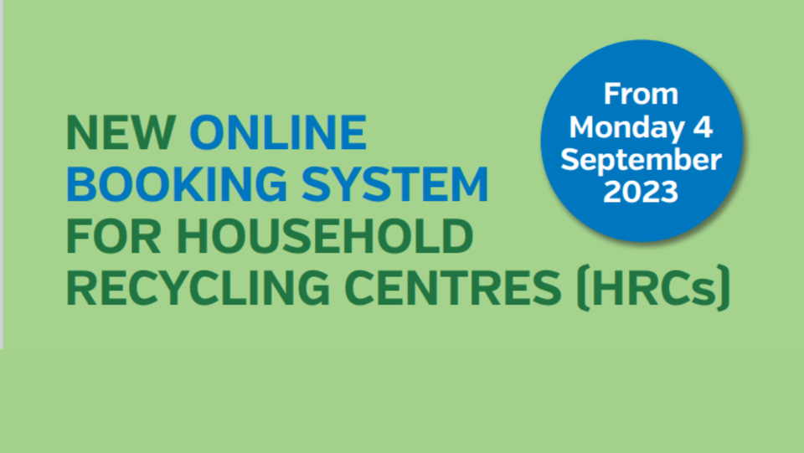

MC2 - 13 articles were published in print press and online (including 6 Bin-ovation news articles).

MC3 – 29 community engagement and education events were delivered.

- 5 Recycling Educational Presentations
- Over 230 attendees
- 24 Summer Schemes
- 500 participants engaged in a recycling education themed game and craft events

Household Recycling Centre Indicators

HRC1 – Volume of blue bin recyclable materials separated from mixed waste by residents on-site: 762,460 litres

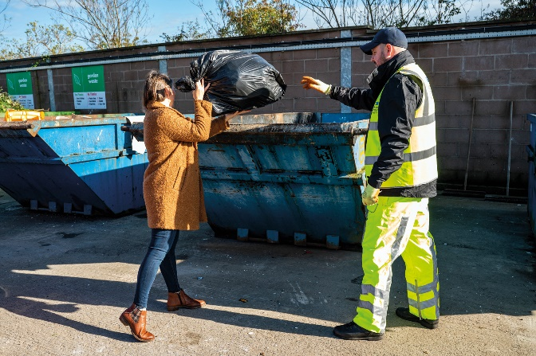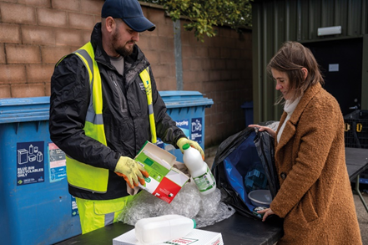

That equated to approximately 32 tons of blue bin waste; whilst that was a relatively modest weight of material, it represented a very large/visible volume of recyclable waste extracted from bags of mixed waste which was initially intended to be placed in landfill skips at HRCs. A collateral benefit of that practice of requiring removal of blue bin recyclables from black bags of mixed waste before using the landfill skip was that it should help to ‘educate’ householders - promoting more efficient separation of waste in the home and greater use of blue bins at the kerbside.

That represented just one type of recyclable waste category which was prevented from entering landfill skips at HRCs as a consequence of the Council’s more focused attention to supervision of landfill skip access; many other recyclable waste types would also have been prevented from entering the landfill skips as reflected in KPI, HRC3.

HRC2 – Number of out-of-Borough visitors turned away from site: 397
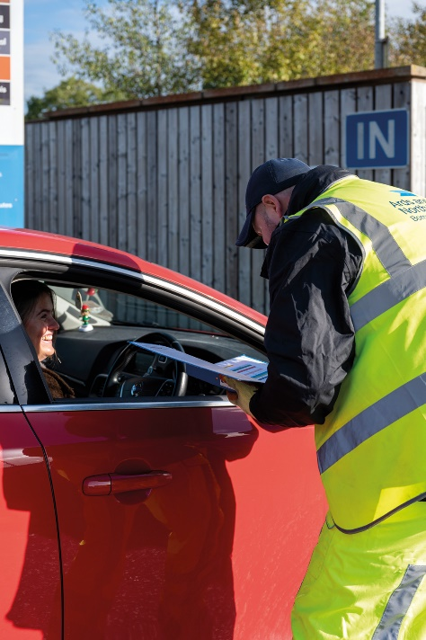
That was a significant number in itself, but it was likely to be the case that a significant number of out of Borough residents would have avoided coming to the Council’s sites because of the widely publicised focus upon checking ID for everyone entering and those turned away would in all probability avoid further attempts to enter and use the HRCs; the impact of that would also be reflected in HRC3 and other KPIs.

HRC3 – % change in tonnage of total waste received (compared to same period in baseline year 2021-22)

- The Council experienced a 26% decrease in the total amount of waste received at its HRCs, down from 9249T to 6873T.

HRC4 - % change in tonnage of waste received for landfill (compared to same period in baseline year 2021-22)

- The Council experienced a 42% decrease in the amount of waste received for landfill at its HRCs, down from 3664T to 2127T.

HRC5 - % change in tonnage of waste received for recycling (compared to same period in baseline year 2021-22)

- The Council experienced an 15% decrease in the amount of waste received for recycling its HRCs, down from 5585T to 4746T.

HRC6 - % change in proportion of HRC waste materials collected for recycling (compared to same period in baseline year 2021-22)

- The Council experienced a 9.1% increase in the proportion of all waste received at HRCs which was collected for recycling, up from 60% to 69.1%.

Kerbside Household Waste Collections Indicators
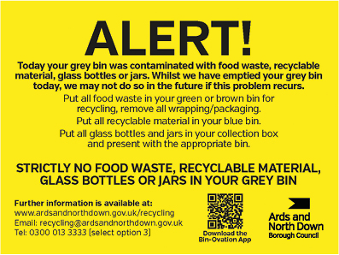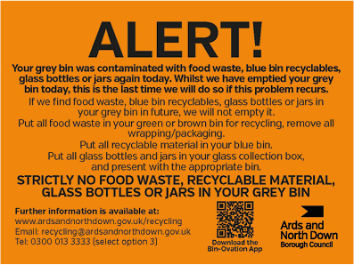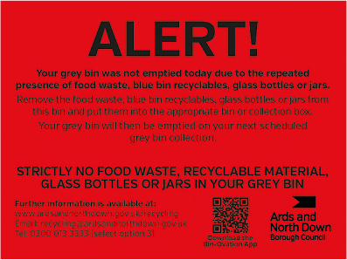
KSI – Number of recycling alert stickers applied to grey bins (yellow): 6079
KS2 – Number of recycling alert stickers applied to grey bins (amber): 414
KS3 - Number of recycling alert stickers applied to grey bins (red): 179
KS4 – % change in tonnage of total waste collected (compared to same period in baseline year 2021-22)
- The Council experienced almost no change in the total amount collected at the kerbside, 15,165T to 15,185T.
KS5 - % change in tonnage of grey bin waste collected for landfill (compared to same period in baseline year 2021-22)
- The Council experienced a 16.5% decrease in the amount of grey bin waste collected, down from 6509T to 5433T.
KS6 - % change in tonnage of waste collected for recycling (compared to same period in baseline year 2021-22)
- The Council experienced a 13% increase in the amount of waste collected for recycling, up from 8656T to 9752T.
KS7 – % change in proportion of kerbside waste materials collected for recycling (compared to same period in baseline year 2021-22)
- The Council experienced a 7% increase in the proportion of kerbside waste that was collected for recycling, up from 57% to 64%.

Summary and Trend Analysis of Indicators
Indicator Reference | Monitoring Period 1  (December 2022 – March 2023*)  *Waste tonnage indicators reflect period January to March 2023 only | Monitoring Period 2  (April 2023 – June 2023)
MC1  Social media posts | 25 | 23
MC2  Print press and online articles | 10 | 13
MC3  Engagement events/sessions | 17 | 29
HRC1  Blue bin waste | 1,322K Litres | 762,460 litres
HRC2  Visitors denied entry | 1742 | 397
HRC3  Total HRC waste compared to 2021/22 | 16% Decrease | 26% Decrease
HRC4  Landfill skip waste compared to 2021/22 | 27% Decrease | 42% Decrease
HRC5  Recycling skip waste compared to 2021/22 | 8% Decrease | 15% Decrease
HRC6  Proportion of HRC waste collected for recycling compared to 2021/22 | 5.5% Increase | 9.1% Increase
KS1  Yellow warning stickers on grey bins | 2784 | 6079
KS2  Amber warning stickers on grey bins | 255 | 414
KS3  Red warning stickers on grey bins | 52 | 179
KS4  Total kerbside waste compared to 2021/22 | 4.8% Increase | 0% No Change
KS5  Grey bin waste compared to 2021/22 | 9.3% Decrease | 16.5% Decrease
KS6  Kerbside waste collected for recycling compared to 2021/22 | 20.7% Increase | 13% Decrease
KS7  Proportion of kerbside waste collected for recycling | 7.2% Increase | 7% Increase

Summary Analysis of Indicators

The report showed a very encouraging picture, and generally conveyed continued reversal of the downward trend that the Council had experienced in its sustainable waste resource management performance over the past couple of years. Following the changes to the waste service model design and the associated education and engagement campaigns, the Council was experiencing sustained and further improving falls in the amount of landfilled waste as well as improvements in recycling rates. During the reporting period, the Council experienced:

- A further fall in the total amount of landfill waste both at HRCs and kerbside, with no increase in kerbside waste volumes. Overall, it received/collected 2,691 tons less of waste destined for landfill over a 3-month period (April to June 2023) compared to the same period in the baseline year of 2021/22; at current landfill cost (£127.42/T), that represented a £342,887 landfill saving.
- A significant further rise in the recycling rate at HRCs. The percentage of materials collected for recycling at HRCs rose by 9.1% compared to the same period in the baseline year of 2021/22. The Council’s overall Borough household waste recycling rate rose by 9% compared to the same period in 2021/22.

Whilst the indicators set out in the report were very encouraging indeed and reflected a lot of hard work and dedication on the part of the waste and recycling teams, undoubtedly there was much further progress to make if the Council had any chance of ultimately reaching the 70% recycling target for 2030 that was laid down in the Climate Change Act (Northern Ireland) 2022. Continued bedding in and ongoing careful management of the new booking system for HRC access, the planned review of the kerbside collections model and a strategic review of HRC capital assets, would be critical.

It was important to stress that ‘step change’, sustained improvements in both the HRC and kerbside recycling rates would be required to move towards the new 70% target.

RECOMMENDED that the Council notes the report.

Proposed by Councillor Rossiter, seconded by Alderman Cummings, that the recommendation be adopted.

Councillor Rossiter was happy to propose the recommendation and asked why the Council’s statistics were higher than the national average. The Director explained that, as outlined in the report, the single biggest issue behind that was the reform of the HRC service delivery model which had begun the previous December. New arrangements were being bedded in and mainstreamed, and the sustainability of those changes had been patently yielding significant fruit for the Council. Step changes were being seen in this quarter’s statistics, and that momentum was building. It was very heartening that the Council appeared to be back on the correct recycling trajectory.

Alderman Cummings agreed that the report was encouraging and was aware of a few glitches in the new HRC booking system, and wondered if most of those had now been resolved. The Director confirmed that there had been a very few relatively minor glitches and that those outstanding would be resolved soon. He was delighted that the changes had been introduced as smoothly as they had, since they had affected 100% of the Council’s customer base and relied upon the use of technology. That was a testament to the officers who had worked extremely hard on the new systems.

Councillor Boyle thanked the Director and thought that it would be remiss not to mention the number of visits permitted by any individual to an HRC and he asked for further information on that. In response the Director said that, as promised, there was no limit to the number of visits a householder could make to the HRC for legitimate household waste disposal needs. However, having said that the system was set up to prevent abuse by individuals coming to sites with material that was not household waste. Built into the system was a mechanism for monitoring how frequently bookings were being made by an address, and when a threshold number of online bookings was reached a very politely worded message appeared on the booking system, asking the user to telephone to make further appointments. However, it was stressed that in genuine circumstances, householders were accommodated with any additional HRC visits required. He advised that the threshold figure built into the system had been set at more than twice the UK average for household HRC visits, to give as much flexibility as possible before anyone was asked to contact the Council to arrange additional bookings. He emphasised that this mechanism was essential to preserve the integrity of the system and to prevent its abuse for non-household waste disposal purposes.

Councillor Wray thought there was a lot of good news in the report and the message was clear that if the Council was to meet targets by 2030, change needed to be radical. He asked about best practice and was informed that Directors of Councils were in touch and experience was shared. Waste disposal was a key service of Councils and Elected Members were rightly cautious about how they embraced change, but it was important to recognise the scale of the financial, economic and social impacts of their decisions in this service field. The Northern Ireland government was shortly due to consult upon a common collections framework, that would establish the minimum standards that would be required in Council waste and recycling collection models.

Councillor Edmund referred to the size of some people’s gardens and their need to use the HRCs frequently for garden waste. The Director confirmed that where a householder specified disposal of compostable waste as the reason for their HRC visit, there was no limit to the number of online bookings that could be made – and site staff would simply check that such bookings were indeed being used for that specific purpose.

Councillor Cathcart asked about the timeframe for adapting the system to allow for more visits to the HRC if there was a genuine reason for that. The Director explained that officers were working on that, and it was hoped to be resolved soon and before Christmas. The Member was pleased that the Council was moving in the right direction and looked forward to further reports.

Councillor Douglas referred to a family of six in her constituency and it had reached the quota for online HRC bookings. The majority of that family’s waste was recycling, and she asked if they could get back to being authorised for making further online bookings before Christmas. The Director felt that was possible, and he stated that one of the benefits that had been discovered through speaking to householders that had triggered the online booking threshold, was discovering that some local people were not receiving all the other waste and recycling services from the Council that they were entitled to. For example, some residents in the legacy Ards Council area still only had the old 140L blue bin which had originally been introduced for paper and card collections only. The family Councillor Douglas referred to might be entitled to a larger blue bin, the cost of which would be less than the cost of driving regularly to the HRC and much more convenient.

The Chair thanked the Director and his staff who had contributed towards the excellent progress outlined in the report and looked forward to the position getting even better.

AGREED TO RECOMMEND, on the proposal of Councillor Rossiter, seconded by Alderman Cummings, that the recommendation be adopted.

8. q4 LICENSING ACTIVITY REPORT (JAN TO MARCH 2023)

PREVIOUSLY CIRCULATED: Report from the Director of Environment detailing that the information provided in the report covered, unless otherwise stated, the period from 1 Jan to 31 March 2023. The aim of the report was to provide Members with details of some of the key activities of the Licensing Service, the range of services it provided along with details of level of performance.

Applications Received

The Service dealt with a wide range of licensing functions which required the officers to consult with the PSNI, NIFRS and a range of other internal Council Sections in making their assessment of an application.

 | Period of Report  1 Jan to 31 March 2023 | Same quarter last year  1 Jan to 31 March 2022
Entertainment Licence | 36 | 33
Cinema Licence | 0 | 0
Amusement Permits | 2 | 2
Marriage & Civil Partnership Place Approval | 4 | 2
Pavement Café Licence | 2 | 0
Street Trading Licence | 4 | 0
Lottery Permits | 8 | 8

Most of the licences issued were for renewals and hence the workload was constant year on year. Renewing a licence still entailed considerable work to access the application and consult with the other bodies.

Regulatory Approvals

That was the number of licences, approvals and permits that had been processed and issued.

 | Period of Report  1 Jan to 31 March 2023 | Same quarter last year  1 Jan to 31 March 2022
Entertainment Licence | 22 | 31
Cinema Licence | 0 | 0
Amusement Permits | 2 | 2
Marriage & Civil Partnership Place Approval | 3 | 3
Pavement Café Licence | 5 | 1
Street Trading Licence | 2 | 0
Lottery Permits | 10 | 9

Off Street Car Parking

Whilst the Off Street Car Parks usage had been steadily increasing since the lifting of the Covid-19 restrictions, they had not fully returned to pre Covid levels. An indication of the activity in the car parks was shown by considering the level of PCN’s issued. The recorded income though showed a marked reduction.

 | Q4 Income 2022/23 | Q4 Income 2021/22
Total ticket sales income | £191,937 | £210,264

PCN’s Issued

 | Period of Report  1 Jan to 31 March 2023 | Same quarter last year  1 Jan to 31 March 2022
Bangor | 383 | 231
Holywood | 256 | 259
Newtownards | 386 | 300
Total | 1025 | 790

The Car Parking Strategy had yet to be implemented and offered an opportunity to redevelop that valuable asset. As the Members would be aware there was a problem with the legislation introduced by DFI in 2015 and that prevented Councils from changing their Car Parking Orders. This mainly prevented the Council from changing Tariffs and introducing EV charging on its sites. DFI had now recognised the problem and were establishing a Working Group to look at ways to amend the legislation.

RECOMMENDED that the Council notes the report.

AGREED TO RECOMMEND, on the proposal of Councillor Edmund, seconded by Councillor Boyle, that the recommendation be adopted.

9. RESULT OF COURT PROCEEDINGS (1 APRIL - 30 JUNE 2023)
(Appendix II)

PREVIOUSLY CIRCULATED: Report from the Director of Environment detailing:

The following convictions were secured at Newtownards Magistrate’s Court between 1 April 2023 and 30 June 2023. See Appendix A attached.

In accordance with the instructions of the Resident Magistrate, the Council’s solicitor would notify defendants upon first appearance in court in response to a summons, that they may seek to have the matter withdrawn upon payment of legal costs and any fixed penalty notice previously offered. The cases were then adjourned to permit a further opportunity for payment. That had resulted in a number of cases being settled on the day of court upon payment of all costs and fines.

The pie chart illustrated in the report outlined each of the 19 prosecution cases which were disposed of during the period of the report. Convictions were secured against 12 defendants during that period.

Please note in some cases a defendant may be prosecuted for more than one offence. In total three cases were ‘Withdrawn/Settled’, i.e., withdrawn following payment of the relevant fixed penalty sum along with Court and Council legal costs and in one case the criminal prosecution of the defendant was withdrawn in accordance with legal advice following the dog destruction order being imposed.

Two cases were heard in respect of a person being the keeper of a dog with no valid dog licence held and those resulted in granting of an absolute discharge in one case and the other a conditional discharge.

In a further case in which a dog had attacked another dog and a person, as well as breach of control conditions the Judge convicted the defendant of permitting two dogs to attack a person and a dog and sentenced the defendant to three months imprisonment. However, due to a previously clear record, he suspended the sentence for two years. He conditionally discharged the defendant for two years in respect of the remaining charges of keeping dogs which had attacked another animal and the breaches of the control conditions. He ordered the defendant to pay £50 and £250, by way of compensation orders. He awarded £250 towards the Council’s legal costs, together with the court fee of £42. He also made a contingent dog destruction order. He informed the defendant that if they committed another offence they would be brought back to court and face a custodial sentence, and the dogs would be destroyed.

The enforcement process carried out by the NET was detailed in the report.
RECOMMENDED that the Committee notes the report.

AGREED TO RECOMMEND, on the proposal of Alderman Cummings, seconded by Councillor Edmund, that the recommendation be adopted.

10. RESULT OF COURT PROCEEDINGS (1 JULY TO 30 SEPTEMBER 2023)

PREVIOUSLY CIRCULATED: Report from the Director of Environment detailing:

The following convictions were secured at Newtownards Magistrate’s Court between 1st July 2023 and 30th September 2023. See Appendix A attached.

In accordance with the instructions of the Resident Magistrate, the Council’s solicitor would notify defendants upon first appearance in court in response to a summons, that they may seek to have the matter withdrawn upon payment of legal costs and any fixed penalty notice previously offered. The cases were then adjourned to permit a further opportunity for payment. That had resulted in a number of cases being settled on the day of court upon payment of all costs and fines.

The pie chart in the report showed 2 prosecution cases which were disposed of during the period of the report. Convictions were secured against 1 defendant during the period. Please note there was court recess in July.

Only one case was heard for a littering offence in which the defendant was fined a total of £385 and a second case was withdrawn as the defendant had moved away and summons was unable to be served.

The enforcement process carried out by the Neighbourhood Environment Team was outlined in the report

RECOMMENDED that the Committee notes the report.

Proposed by Alderman Cummings, seconded by Councillor Edmund, that the recommendation be adopted.
Alderman Cummings referred to the matter about sending out a court summons when a resident had moved on and the case could not be closed. He urged the Council to follow that up, if possible, but the Director replied that it was in the hands of the Courts Service and the Council was not able to control that.

Councillor Boyle welcomed the reports, and it was important that residents saw that enforcement action was being taken in such matters. He thought that sometimes the Council was slow to sell its successes to local residents. Members were informed that while prosecution details were often reported by the press that covered the Court sittings, the Council also periodically produced a press release on enforcement action taken and he would ensure that that continued on a regular basis.
AGREED TO RECOMMEND, on the proposal of Alderman Cummings, seconded by Councillor Edmund, that the recommendation be adopted.

11. REVIEW OF CHARGES RELATING TO WASTE COLLECTION SERVICES FOR 2024 - 2025

PREVIOUSLY CIRCULATED: Report from the Director of Environment detailing that the preparation and approval process for charging schedules (previously called pricing policies) had changed from that used previously. In summary, charges that were within the control of the Council should be increased by inflation, which was currently 6.7%. The new charges would be applicable from April 2024, but the review was carried out now as part of the Rates review process.

In terms of the supply of new and replacement waste containers, the Council continued to supply them at cost price with free delivery of the containers. Finance had commented that the service should be moving to cost recovery including deliveries. Officers had agreed to review that aspect of the service in future but recognised that it was not a straightforward issue with several factors that impacted on that element of cost.

Increases in line with the policy were reported to the relevant Committee for information.

The revised charges for 2024 – 2025 were set out in the table below.

Revised Commercial Waste Charges for 2024 - 2025

Commercial Residual Waste (Grey Bin)
Container size | Current charge | Revised Charge from 1 April 2024
140 litres | £4.00 | £4.25
240 litres | £7.50 | £8.00
360 litres | £9.25 | £9.85
660 litres | £15.00 | £16.00
1100 litre | £20.80 | £22.20

Commercial Waste – Mixed Dry Recyclables (blue bin)
Container size | Current charge | Revised Charge from 1 April 2024
240 litres | £2.30 | £2.45
360 litres | £3.50 | £3.75
660 litres | £5.80 | £6.20
1100 litres | £10.40 | £11.10

Commercial Waste – Food Waste (Brown/Green bin)
Container size | Current charge | Revised Charge from 1 April 2024
240 litres | £4.10 | £4.35

Commercial Waste – Glass (Red bin)
Container size | Current charge | Revised Charge from 1 April 2024
240 litres | £2.90 | £3.10

Bulky Collection Charge (up to 6 items)
Current Charge | Revised Charge
£30.00 | £32.00

RECOMMENDED that the Council notes the revised charges for 2024-25.

Proposed by Councillor Boyle, seconded by Councillor Wray, that the recommendation be adopted.

Councillor Boyle considered that the increases were inflation based. Councillor Cathcart noted that it would be looked at as part of the Rate setting process and was in line with inflation but pointed out that the bulky waste charge had been £20 for a long time and had risen £12 in the space of a year which seemed excessive. He wondered what other options were available to residents.

The Head of Waste and Cleansing Services stated that there were other services available to collect items, but the Council was providing good value for money. Alderman McAlpine added that the Council would collect up to six items for that fee.

The Director clarified that the above inflationary price rises were in accordance with agreed Council policy and would therefore not be subject to change through the estimates process; rather the projected income from those new charges would be reflected in the draft estimates that would be brought before the Council in coming weeks and months.

AGREED TO RECOMMEND, on the proposal of Councillor Boyle, seconded by Councillor Wray, that the recommendation be adopted.

12. NOTICE OF MOTION

There were no Notices of Motion.

13. ANY OTHER NOTIFIED BUSINESS

There were no items of Any Other Notified Business.

EXCLusion of Public/Press

AGREED, on the proposal of Alderman Cummings, seconded by Councillor Edmund, that the public/press be excluded during the discussion of the undernoted items of confidential business.

14. CAR PARKING ENFORCEMENT CONTRACT UPDATE

***IN CONFIDENCE***

NOT FOR PUBLICATION SCHEDULE 3 – INFORMATION RELATING TO THE FINANCIAL OR BUSINESS AFFAIRS OF ANY PARTICULAR PERSON

A report relating to tenders for the provision of car parking enforcement services was considered.

It was agreed that the contract for car parking enforcement, cash collection and PCN processing, be awarded to Marsden Holdings.

15. UPDATE REPORT ON KERBSIDE WASTE COLLECTIONS REVIEW

***IN CONFIDENCE***

NOT FOR PUBLICATION SCHEDULE 3 – INFORMATION RELATING TO CONSULTATIONS OR NEGOTIATIONS

An update report on the work of the Elected Member Working Group that has been established in relation to the review of the Council’s kerbside waste collection services model, was considered.

It was agreed that the report be noted.

Re-admittance of public/press

AGREED, on the proposal of Alderman Cummings, seconded by Councillor Edmund, that the public/press be re-admitted to the meeting.

Termination of meeting

The meeting terminated at 8.41 pm.

