Ards and North Down Borough Council

A hybrid meeting (in person and via Zoom) of the Environment Committee was held at the Council Chamber, Church Street, Newtownards and via Zoom, on Wednesday, 6th September 2023 at 7.00 pm.

PRESENT:

In the Chair: Councillor Morgan

Aldermen: Armstrong-Cotter McAlpine (via Zoom)
Cummings

Councillors: Blaney Kerr
Boyle Rossiter
Cathcart Smart
Douglas Woods
Edmund Wray
Irwin

Officers: Director of Environment (D Lindsay), Head of Waste and Cleansing Services (N Martin), Head of Assets and Property Services (P Caldwell), Building Control Services Manager (R McCracken), and Democratic Services Officer (H Loebnau)

1. Apologies

There were no apologies received.

NOTED.

2. Declarations of Interest

Councillor Cathcart and Councillor Blaney declared an interest in Item 22 – Tender Award Report.

NOTED.

3. dEPUTATION BY KEVIN BAIRD – PORT MARINE SAFETY CODE

Kevin Baird, Harbour Master, Bangor, was introduced to the meeting and invited to make his presentation in respect of the Port Marine Safety Code. He began by stating that he was Harbour Master at Bangor and was also the Designated Person under the Port Marine Safety Code for the Council’s other five Harbours.

He outlined the history behind the Code, how it had been developed, its roles and responsibilities, the Marine Safety Management System and the external audits that it required.

The Port Marine Safety Code was developed in 2000 and it offered a national standard for port safety in the United Kingdom. The aim was to improve safety for those who used or worked in ports, their ships, passengers and cargoes and the environment. It was introduced in 2002 as a voluntary code and was reviewed every three years. The Code was regulated by the MCA (Maritime and Coastguard Agency) and compliance statements were required every 3 years.

The various roles and responsibilities at harbours under the Code were outlined.

For the Council as Duty Holder, its members were individually and collectively responsible for complying with the Code and ensuring the safe operations in the harbour and its approaches. The Duty Holder could not assign or delegate its accountability.

After the presentation Members were invited to ask questions.

Councillor Cathcart sought clarity in terms of liability when a safety issue occurred at any harbour since this was not law but rather a Code. Members were informed that the Duty Holder was responsible for the Code and while the Council could not be prosecuted under that it could be prosecuted under other relevant legislation. The guidance set out in the Code was designed to assist the Duty Holder in avoiding breaking the law and making harbours as safe as possible.

Councillor Edmund referred to what could be trip hazards in and around piers and asked how safety could be implemented there. Members were informed that the public would be made aware that they were entering a marine environment and as such there were hazards to be aware of. He asked Mr Baird to look at lighting at Ballywalter since he had received a number of complaints on that matter.

There were no further questions and Mr Baird left the meeting at 7.20 pm.

NOTED.

4. ENVIRONMENT DIRECORATE BUDGETARY CONTROL REPORT – APRIL TO JUNE 2023

PREVIOUSLY CIRCULATED: Report from the Director of Environment detailing that
the Environment Directorate’s Budgetary Control Report covered the 3-month period 1 April to 30 June 2023. The net cost of the Directorate was showing an underspend of £149k (2.2%) – box A on page 3.

Explanation of Variance
Environment’s budget performance was further analysed on page 3 into three key areas:

Report | Type | Variance | Page
Report 2 | Payroll Expenditure | £82k favourable | 3
Report 3 | Goods & Services Expenditure | £130k favourable | 3
Report 4 | Income | £63k adverse | 3

Explanation of Variance
The Environment Directorate’s overall variance could be summarised by the following table (variances over £15k): -

Type | Variance  £’000 | Comment
Payroll | (82) | Mainly due to vacant posts across the Directorate which should be filled as the year progresses.
Goods & Services
Waste & Cleansing | (85) | Waste disposal costs. Mainly due to tonnages being mostly less than budget: -  Landfill down (298T).  Blue bin waste down (45T).  Garden waste up 12T.  Food waste down (361T).
Assets & Property | (40) | Electricity – (£39k) – cost per kwh lower than budget.  Gas – (£12k) – cost per kwh lower than budget.  Vehicle fuel – (£63k) price per litre has fallen 20% since end of 2022.  Vehicle maintenance - £17k.  Technical Services – £53k – statutory work.
Income
Regulatory Services | 68 | Car Park income £45k.  NET – fine income £25k.

RECOMMENDED that the Council notes this report.

AGREED TO RECOMMEND, on the proposal of Alderman Cummings, seconded by Councillor Edmund, that the recommendation be adopted.

5. UPDATE ON FLEET DECARBONISATION AGENDA
(Appendix I)

PREVIOUSLY CIRCULATED: Report from the Director of Environment detailing that the Council currently operated a fleet of 182 vehicles to deliver its services. Those vehicles consumed approximately 757,661 litres of diesel and emitted around 2,538 tonnes of CO² every year. The Council’s annual fuel bill was around £1,032,353.

Due to the significance of that cost and CO² emissions, measures to increase efficiency and reduce CO² emissions were ongoing and had been the subject of various reports to the Council in the past.

The first step in the hierarchy of actions to reduce CO² emissions, was to reduce the amount of fuel being used by limiting the number of vehicles and the mileage that they travelled. Those measures largely lay within the control of each service unit that deployed the vehicles in the delivery of their respective services, but a challenge process was built into the vehicle replacement policy whereby the Fleet Manager robustly assessed any vehicle purchase/replacement request to ensure that the vehicle purchase/replacement was essential and if so that the proposed vehicle was suitably specified, before authorising its procurement. Furthermore, the service unit that deployed most vehicles in the Council’s fleet, Waste Collections, had undertaken a major review of the collection routes to ensure they were optimised, and that process of route efficiency optimisation was now ongoing – facilitated by sophisticated route planning software deployed by the Council.

The report aimed to highlight additional measures implemented by the fleet management service unit and areas of focus for further investigation.

Measures Taken to Date

Solar Power

Eight of the Council’s Refuse Collection Vehicles (RCVs) had been fitted with solar panels which produced renewable energy to reduce the amount of power that the alternator required from the engine to operate the vehicle (including bin lifters, compactors). For the month of June 2023 those solar panels saved 1.2 tonnes of CO² emissions, and 440 litres of diesel, producing 220 KWh of solar energy. That innovation was now incorporated into the standard specification for all new RCV’s procured by the Council.

Driver Telematics

A number of smaller vehicles (50 no.) had been fitted with the ‘Lightfoot’ vehicle telematics system which was designed to improve petrol and diesel fleet with real-time driver coaching and gamification. It helped deliver higher fuel savings, lower emissions, reduced downtime, increased road safety, and enhanced efficiency, by guiding fleet drivers towards a smoother driving style. The system typically provided fuel savings between 5 and 35%. Unfortunately, the system was not available for heavier vehicles but trials with the manufacturer were ongoing.

Current Investigations

Alternative Fuels
Officers had reviewed the potential for HVO (hydrotreated vegetable oil) as a direct replacement for diesel. Claims were made by the manufacturers that HVO could result in a 92% saving in emissions but that included the manufacturing process.

Presently the Council would not have the capacity to test the emissions from its vehicles if it made the switch, as it did not have the necessary test equipment. It was estimated that there was a tail pipe reduction in greenhouse gasses of between 7 and 31% depending on the vehicle. Officers met with the supplier in Ireland in July and obtained more detail and evidence of reductions in greenhouse gases.

Presently, HVO was approximately 50ppl more expensive than diesel and there was currently no duty relief on HVO. That may change when the Autumn statement was announced. On one of the vehicles which would be a large consumer of diesel, an extra 50ppl fuel cost for HVO would equate to an additional fuel bill of £60,305 over the life of the vehicle.

LGV Electrification

Electrification of the LGV fleet would require a significant investment in both vehicles and infrastructure. At present electric van prices were on average 50% more expensive than the diesel equivalent, meaning they were difficult to justify in financial terms and requiring vehicles to be incurring significant annual mileage before the additional capital purchase cost could be recouped. Officers were routinely reviewing payback calculations when replacing each van on a case-by-case basis, to assess the financial viability of switching to an EV model. To date it had been concluded that it would not be economically beneficial to switch to EV for any of the Council’s van purchases/replacements, but as indicated that was being continually reviewed in the light of changes in EV vehicle costs etc. The Council was currently looking at EV leasing options as well as outright purchase.

Before procuring any electric vans, the Council would need an EV charging infrastructure installed. Vans which were required to tow trailers at present were not suitable for change, as electric vans presently had no towing capacity. With electric vans the batteries were guaranteed for eight years and at present the Council kept vans for at least ten years under the vehicle replacement policy. As manufacturers were not quoting costs for replacement batteries so that the Council could budget for potential maintenance spend after year 8, this was a further challenge that needed to be overcome. The council was presently unsure as to residual value of EVs or potential disposal costs.

Future Measures

Electric Trucks

Electric trucks were presently between two and three times more expensive than the diesel equivalent (for example a standard diesel powered RCV cost c£250,000, compared to an electrically powered RCV at 500,000). That was a significant consideration, and currently it would not be possible to secure financial payback of the additional capital purchase cost through fuel cost savings; rather the net financial cost to the Council would be considerable.

At present there was no charging infrastructure available to make the transition, and the existing power network would not be adequate to meet the additional electricity demand. Officers had met with NIE regarding requirements for upgrade to the existing substations, and the Council would now require engagement of consultants to determine a specification for the chargers before NIE could provide a cost.

Officers had made initial contact with a company that was offering initial consultation free of charge as part of endeavours to explore and progress the issue. NIE had also indicated that due to the high current requirement the Council would most likely need to install power banks on site, which would be charged by solar and then would assist with the overnight charging of vehicles. NIE had advised that those measures would also require two to three years to implement.

Hydrogen Powered Trucks

Hydrogen was also being explored as another alternative fuel source. As with electric, the cost of vehicles was more than double that of diesel equivalents and there was presently no infrastructure in place for the production and distribution of hydrogen fuel. However, at this stage that seemed like a more viable option for decarbonisation of heavy vehicles in the medium to longer term future.

CNG (Compressed Natural Gas)

CNG vehicles had been reviewed, with a site visit to Virginia, County Cavan, to look at infrastructure and vehicles using CNG from the gas network. There would be a large cost for infrastructure and the vehicle cost was in the region of 30% higher than diesel. The gas network was at present using fossil fuels which achieved a 20% reduction in emissions. Gas from renewable meant such anaerobic digestion plants was possible, but there was presently uncertainty of supply. Currently, officers did not think that was a viable long-term solution.

Feasibility Studies

The Council was working with East Border Region (EBR) as part of a consortium which was looking at alternative fuels for the Council’s fleet. The consortium was led by Louth County Council, and EBR had secured 100% funding for the project. Objectives included:

- Develop an internal knowledge base and expertise within the participating Authorities in regard to current available technologies, as well as technologies under development that may allow the Authorities to develop a zero-carbon roadmap for HGVs and other large plant and equipment.
- Develop a baseline for the carbon use of each participating Authority. The baseline would consider inter alia vehicle types and numbers, the work that the vehicles were involved in, consumption rates etc., and would provide a benchmark against which any future savings could be measured.
- Develop options for decarbonising the fleet. The options should align with government policy of both jurisdictions.
- Develop bespoke solutions for each Authority including cost projections whilst considering the regional needs and implications of the study.
- Develop a realistic timeline for implementing the findings of the study.
- Present the study’s findings to each of the Authorities.
Officers would present the consultant’s findings in due course.

Attached at an appendix was a letter that had recently been received from the DfI Permanent Secretary regarding the Council’s participation in a working group, which DfI was content to lead, to bring forward an Action Plan for the decarbonisation of the local council public sector fleet. The Director of Environment would represent the Council on that group and would move forward on the subject.

RECOMMENDED that the Council notes this update report in relation to the journey towards decarbonisation of its fleet.

Proposed by Councillor Wray, seconded by Councillor Woods, that the recommendation be adopted.

Proposing the recommendation Councillor Wray asked how much solar panels for RCVs cost and the time period to make savings. The Head of Assets and Property Services informed the meeting that the solar panels paid for themselves rapidly and he would circulate more detailed information on that query. The Member then asked about the electric vehicles themselves and how long those would take to pay for themselves and how other Councils were progressing in the move to electric.

The Head of Assets and Property Services explained that the Council was constantly accessing the pay back periods for those investments and currently, considering the mileage that would be necessary to achieve savings, the investment could not be justified in terms of financial payback. Other Councils also shared the concern that the infrastructure was still not in place to permit sufficient numbers to move to electric vehicles at this stage.

The Director drew Members attention to the appendix of the report which was a letter from the Permanent Secretary, Department for Infrastructure, which addressed that very subject. There were significant impediments to the extensive roll out of electric vehicle fleets in the public sector and the Council was asking for a co-ordinated centralised approach. He believed it was heartening to receive the letter from the Department and advised that the Council officers would be engaging fully with the Department on the subject.

Councillor Woods thanked officers for the review and move to electric vehicles and wondered about timings to completion at various sites and noted there would be engagement with NIE and consultants. Members were informed that the Council would take a lead on its own sites and that would be presented at a later point to NIE for review.

Councillor Cathcart referred to the letter from the Permanent Secretary and if the Department would fund Councils in the development of the infrastructure. The Head of Assets and Property Services stated that one of the key points would be the next steps on how the Council could meet the requirements under the legislation. The Director added that the Council wished to discuss with the Department collaboration funding as one of the key agenda items and he would update the Committee on that in time.

AGREED TO RECOMMEND, on the proposal of Councillor Wray, seconded by Councillor Woods, that the recommendation be adopted.

6. PROPOSED STREET NAMING – CRAWFORDSBURN GATE, BANGOR

PREVIOUSLY CIRCULATED: Report from the Director of Environment detailing that a small development comprising of five dwellings was currently under construction on lands at 131 Crawfordsburn Road, Bangor. One dwelling would be addressed as a replacement for 131 Crawfordsburn Road.

An existing dwelling addressed 2a Wandsworth Road, Bangor, would now be accessed from the new street due to the developer changing their drive access, and the occupier wanted to remain 2a Wandsworth Road. Therefore, when the street sign was erected, it will read ‘Crawfordsburn Gate, leading to 2a Wandsworth Road’.

The developer had suggested the name Crawfordsburn Gate, for the remaining four dwellings which was in keeping with the general neighbourhood.

RECOMMENDED that the Council:
- adopts the street name of Crawfordsburn Gate for this development.
- accepts the general name and delegates acceptance of suffixes to the Building Control department.

AGREED TO RECOMMEND, on the proposal of Councillor Kerr, seconded by Councillor Smart, that the recommendation be adopted.

7. PROPOSED STREET NAMING – GRANSHA LANE, BANGOR

PREVIOUSLY CIRCULATED: Report from the Director of Environment detailing that a small development comprising of nine dwellings was currently under construction on lands at 80 and 82 Gransha Road, Bangor.

The developer had suggested the name Gransha Lane, which was in keeping with the general neighbourhood and the new street was accessed off the main Gransha Road.

RECOMMENDED that the Council:
- adopts the street name of Gransha Lane for this development.
- accepts the general name and delegates acceptance of suffixes to the Building Control department.

AGREED TO RECOMMEND, on the proposal of Councillor Cathcart, seconded by Councillor Kerr, that the recommendation be adopted.

8. RESULT OF COURT PROCEEDINGS – NET (january to march 2023)

PREVIOUSLY CIRCULATED: Report from the Director of Environment detailing that the following convictions were secured at Newtownards Magistrate’s Court between 1 January 2023 and 31 March 2023. (See Appendix attached).

In accordance with the instructions of the Resident Magistrate, the Council’s solicitor would notify defendants upon first appearance in court in response to a summons, that they may seek to have the matter withdrawn upon payment of legal costs and any fixed penalty notice previously offered. The cases were then adjourned to permit a further opportunity for payment. That had resulted in a number of cases being settled on the day of court upon payment of all costs and fines. Please note there was no departmental court day in March 2023 due to the Bank Holiday.

The above pie chart outlined each of the nine prosecution cases which were disposed of during the period of the report. Convictions were secured against four defendants during the period.

Please note in some cases a defendant may be prosecuted for more than one offence. One further case was ‘Withdrawn/Settled’, i.e., withdrawn following payment of the relevant fixed penalty sum along with Court and Council legal costs, and four cases were withdrawn for various procedural/evidential reasons.

The enforcement process carried out by the NET was detailed in the report.

RECOMMENDED that the Council notes the report.

Proposed by Alderman Armstrong-Cotter, seconded by Councillor Cathcart, that the recommendation be adopted.

Councillor Woods had some questions that related to both this and the following report relating to court proceedings. She noted that the Council did not always receive the full recoupment of the costs that it had incurred. The Director agreed, stating that the Council was the statutory enforcing authority and the defendant was penalised at the discretion of a Judge who took into account a range of factors when making that decision. There was often a deficit in recoupment of enforcement costs, but certain Judges had indicated in the past that was considered a reasonable cost borne by ratepayers at large for the wider benefit of the community.

While Councillor Cathcart understood that the Council bore the responsibility as the enforcement body, he questioned why costs were not awarded to it in terms of the legal matters. He felt it was ridiculous that someone could litter or permit their dog to foul, and the ratepayers ended up paying for it when the defendant was convicted as an offender.

The Director explained that there had been an ongoing debate over the years on where the financial burden of the enforcement process should lie. However, the key message from the Council must be that if a person committed an environmental offence, they are liable to suffer significant personal financial cost for that through fines and court costs – and this should act as a deterrent to committing such offences.

In concluding the item, the Chair asked that columns in the penalties tables were totalled going forward to make them easier to read and understand.

AGREED TO RECOMMEND, on the proposal of Alderman Armstrong-Cotter, seconded by Councillor Cathcart, that the recommendation be adopted.

9. RESULT OF COURT PROCEEDINGS – NET (APRIL TO JUNE 2023)

PREVIOUSLY CIRCULATED: Report from the Director of Environment detailing the
following convictions were secured at Newtownards Magistrate’s Court between 1 April 2023 and 30 June 2023. (See Appendix attached).

In accordance with the instructions of the Resident Magistrate, the Council’s solicitor would notify defendants upon first appearance in court in response to a summons, that they may seek to have the matter withdrawn upon payment of legal costs and any fixed penalty notice previously offered. The cases were then adjourned to permit a further opportunity for payment. That had resulted in a number of cases being settled on the day of court upon payment of all costs and fines.

The above pie chart outlined each of the 19 prosecution cases which were disposed of during the period of the report. Convictions were secured against twelve defendants during the period.

Please note in some cases a defendant may be prosecuted for more than one offence. In total three cases were ‘Withdrawn/Settled’, i.e., withdrawn following payment of the relevant fixed penalty sum along with Court and Council legal costs and in one case the criminal prosecution of the defendant was withdrawn in accordance with legal advice following the dog destruction order being imposed.
Two cases were heard in respect of a person being the keeper of a dog with no valid dog licence held and those resulted in one case granted an absolute discharge and the other a conditional discharge.

In a further case in which a dog had attacked another dog, and a person, and breach of control conditions the Judge convicted the defendant of permitting two dogs to attack a person and a dog and sentenced the defendant to three months imprisonment. However, due to a previously clear record, he suspended the sentence for two years. He conditionally discharged the defendant for two years in respect of the remaining charges of keeping dogs which had attacked another animal and the breaches of the control conditions. The defendant was ordered to pay £50 and £250 pounds, by way of compensation orders. £250 was awarded towards the Council’s legal costs, together with the court fee of £42. The Judge also made a contingent dog destruction order. He informed the defendant that if they committed another offence they would be brought back to court and face a custodial sentence, and the dogs would be destroyed.

The enforcement process carried out by the NET was detailed within the report.

RECOMMENDED that the Council notes the report.

AGREED TO RECOMMEND, on the proposal of Alderman Armstrong-Cotter, seconded by Councillor Cathcart, that the recommendation be adopted.

10. NET Q4 ACTIVITY REPORT (JANUARY TO MARCH 2023)

PREVIOUSLY CIRCULATED: Report from the Director of Environment detailing that the following convictions were secured at Newtownards Magistrate’s Court between 1 April 2023 and 30 June 2023. (See Appendix attached).

In accordance with the instructions of the Resident Magistrate, the Council’s solicitor would notify defendants upon first appearance in court in response to a summons, that they may seek to have the matter withdrawn upon payment of legal costs and any fixed penalty notice previously offered. The cases were then adjourned to permit a further opportunity for payment. That had resulted in a number of cases being settled on the day of court upon payment of all costs and fines.

The above pie chart outlined each of the 19 prosecution cases which were disposed of during the period of the report. Convictions were secured against twelve defendants during this period.

Please note in some cases a defendant may be prosecuted for more than one offence. In total three cases were ‘Withdrawn/Settled’, i.e., withdrawn following payment of the relevant fixed penalty sum along with Court and Council legal costs and in one case the criminal prosecution of the defendant was withdrawn in accordance with legal advice following the dog destruction order being imposed.

Two cases were heard in respect of a person being the keeper of a dog with no valid dog licence held and those resulted in one case granted an absolute discharge and the other a conditional discharge.

In a further case in which a dog had attacked another dog, and a person, and breach of control conditions the Judge convicted the defendant of permitting two dogs to attack a person and a dog and sentenced the defendant to three months imprisonment. However, due to a previously clear record, he suspended the sentence for two years. He conditionally discharged the defendant for two years in respect of the remaining charges of keeping dogs which had attacked another animal and the breaches of the control conditions. The defendant was ordered to pay £50 and £250 pounds, by way of compensation orders. £250 was awarded towards the Council’s legal costs, together with the court fee of £42. The Judge also made a contingent dog destruction order. He informed the defendant that if they committed another offence they would be brought back to court and face a custodial sentence, and the dogs would be destroyed.

The enforcement process carried out by the NET was detailed within the report.

RECOMMENDED that the Council notes the report.
AGREED TO RECOMMEND, on the proposal of Councillor Edmund, seconded by Councillor Blaney, that the recommendation be adopted.

11. NET Q1 ACTIVITY REPORT (APRIL TO JUNE 2023)
(Appendix II)

PREVIOUSLY CIRCULATED: Report from the Director of Environment detailing that the information provided in the report covered, unless otherwise stated, the period
1 April to 30 June 2023. The aim of the report was to provide Members with details of some of the key activities of the team, the range of services it provided along with details of level of performance.

Applications to the Neighbourhood Environment Team
The Dogs (NI) Order 1983

It should be noted that these figures included block licences where one licence could be issued for multiple dogs in specific circumstances.

 | Period of Report  April – June  2023 | Same 3 months  April – June  2022
Dog licences issued during the three months | 4794 | 4953

Concessionary licences remained at 83% of dog licences issued over the period. That included the categories of neutering (£5) / over 65 (Free – first dog) / over 65 subsequent dog (£5) and income related benefits (£5). Standard dog licence £12.50 and block licence £32.

Investigations
The Neighbourhood Environment Team responded to a range of service requests. In terms of time spent, some types of service requests would be completed immediately whilst others required a longer-term strategy to find a resolution. The total number of service requests had been outlined together with a sample of the types of requests received.

 | Period of Report  April – June 2023 | Same 3 months  April – June 2022
Service requests received the three months | 798 | 832

Non-Compliance
Prosecutions

 | Period of Report April – June 2023 | Same 3 months  April – June 2022
Total Prosecutions | 19 | 17

Fixed Penalty Notices
In addition to cases being prosecuted through the court, 51 fixed penalty notices had been issued in respect of various matters. That continued to demonstrate a sustained Council focus upon detecting and punishing those who persisted in committing environmental offences in the Borough and highlighted one patrolling outcome of the Neighbourhood Environment Team achieved despite the reduction in staffing levels due to sickness and vacant posts.

The main categories of fixed penalties were shown below. Other categories existed i.e., breach of dog control conditions, exclusion order and off lead offences. The offer of an £80 Fixed Penalty Fine was an opportunity to discharge liability to prosecution.

A payment period of 28 days was permitted. If paid within 14 days the fine was discounted to £60. As staff recruitment and retention remained a challenge that had impacted on the number of notices issued during the quarter. Over the past year additional efforts had been made to reduce the dog licence renewal backlog and we now saw fewer unlicenced dogs as a result. The higher fixed penalty fines for litter and fouling offences applied from 1 June 2023 i.e. £200 reduced to £150 if paid within 14 days.

 | Period of Report  April – June 2023 | Same 3 months April – June 2022
Fouling | 9 | 14
Litter | 26 | 81
No Dog Licence | 5 | 11
Straying | 10 | 15
Control of Greyhounds | 1 | 0

The following graphs demonstrated:

- The total number of fixed penalties issued by the Neighbourhood Environment Team during each month of the period of report.
- The fixed penalties issued during the period of report by type.

Appendix A to this report provided a street level location for each of the penalty fines issued during the period of report 1 April to 30 June 2023.

Environmental Education Programme – Preliminary Actions
Members would recall that the Neighbourhood Environment Team had been working on a revamped Environmental Education Programme, Project ELLA (Environmental,
Learning, Lifestyle and Action). That project sought to provide new and innovative
solutions in the delivery of environmental education and awareness.

The launch event took place on Friday 9 June 2023 at Pink’s Green playpark in Donaghadee with P4 pupils from Donaghadee Primary School who were joined by the Mayor, Councillor Jennifer Gilmour, David Lindsay (Director) and staff from Neighbourhood Environment. The children engaged in rockpool events and litter picking which was a great success on a lovely sunny day.

An email would be sent to all primary schools within the Borough attaching a link to the on-line flyer (Appendix) which would provide details of project ELLA and invite teachers to contact the department to arrange for school visits, presentations and workshops.

It would be the intention to undertake promotional work and to engage with schools from September to December 2023 and begin with Year 7 presentations in schools in January 2024.

RECOMMENDED that the Council notes the report.

Proposed by Alderman Armstrong-Cotter, seconded by Councillor Cathcart, that the recommendation be adopted.

Councillor Wray referred to graffiti around the Borough and in particular that of a political nature. He had always been impressed by the Council’s swift response to removing that but asked if he could have further information on the policy for addressing graffiti.

The Director explained that the Council did have a comprehensive policy around graffiti for Council property and for the property of a third party. It set out action where graffiti was visible to the wider public, its type and severity with priority given to its removal as soon as possible either on the same day or as soon as possible after that.

The Member went on to ask about littering and dog fouling figures around the Borough. He noted that there were many recorded incidents in Bangor, Newtownards and Millisle and wondered if enforcement stopped at that point on the Ards Peninsula. It was explained that enforcement was often targeted to hot spot areas considering the finite resources that the Council had. The Council welcomed local knowledge and reporting by the public within communities and would address those issues as they arose, but in many ways it was natural to have more incidents detected in areas with higher populations such as Bangor and Newtownards.

Councillor Woods asked when the last graffiti policy had been reviewed and the Director agreed to check on that and report back. Further to that the Member asked about Project ELLA and how the Council would be engaging with local schools. The Director explained that the team would be liaising with schools until the end of the year to draw up a timetable of engagement, with a view to engagement sessions from January next year. He would keep the Committee informed on how that work was progressing in future NET activity reports.

Councillor Boyle added to the comments on graffiti and praised the response of the Council and wondered why the Department for Infrastructure did not think it fell under its responsibility. He put on record that litter and dog fouling remained a problem in Portaferry.

Councillor Rossiter referred to an incident of offensive graffiti which had been placed along the North Down coastal path where the foul language was removed but the rest of the graffiti was left exposed. He asked if there was a policy instructing that, and the Director agreed to check that and report back to the Member.

The number one issue raised to Councillor Edmund by constituents was dog fouling and he wondered if Enforcement Officers always travelled in marked vehicles because he felt that made them stand out and if so, was there a way to address that. The Director replied that he would check on the Council’s arrangements for officer transport when undertaking enforcement duties/patrols and report back.

Councillor Blaney advised constituents had spoken to him about the same matter since communities knew that the problem started up again when Council or police vehicles left the area. He asked if technology could be used to tackle that, and it was explained that mobile deployable cameras could be used to help tackle certain types of offending.

Councillor Cathcart raised a point on dog licensing and the reduction in fee if a dog was neutered. He explained that many vets were now advising against neutering and thought that the Council’s guidance should be examined. The Director replied that he was not aware of that and advised that the terms of concessionary licence fees were set out in legislation over which the Council had no direct control.

Councillor Smart also praised the Council on how it responded to remove offensive graffiti but asked about the colour of the paints used. He thought that black was commonly used and in itself that was striking on a paler wall so wondered if various colours to tone in with walls could be considered. Officers agreed look at this issue.

AGREED TO RECOMMEND, on the proposal of Councillor Edmund, seconded by Councillor Blaney, that the recommendation be adopted.

12. RESPONSE TO NOTICE OF MOTION ON PARK AND RIDE PROPOSAL – BANGOR SPORTSPLEX

PREVIOUSLY CIRCULATED: Report from the Director of Environment detailing that a Notice of Motion debated at Corporate Services Committee in March 2022 and subsequently ratified by Council stated:

“We ask this Council to engage with Translink to establish the possibility of using part of the car park at Bangor Sportsplex as a park and ride. This is to, hopefully, find a way to mitigate the parking issues residents and commuters are facing daily, in Bangor West. A bus service departing from here to Belfast or/and the train station using a booking system could potentially offer a solution to the ongoing problems.”

A letter was subsequently sent from the Chief Executive on 20 April 2022 to the Chief Executive of Translink and a reply was received on 17 May 2022 giving details of their contact officer.

Officers from the Environment Directorate were to initiate contact and report future progress through the Environment Committee.
Following an unfortunate delay in communications regarding follow up on the matter, the Licensing and Regulatory Services Manager, who had responsibility for car parking matters, immediately contacted the Translink Officer requesting a site meeting.
The Translink Officer indicated that the most pertinent matter at this stage was the issue of funding the service, with a service operating at peak hours only costing in excess £100k per year. Neither DfI nor Translink were currently in a position to fund that and therefore a new/additional funding stream would need to be sourced from elsewhere.
A meeting was held to discuss the matter further and the following issues were raised in addition to the funding issue already raised by Translink:
The Council would not be in a position to provide funding or assist in sharing the funding as outlined by Translink, at this time.
- The proposal was to try to mitigate the parking issues around the train stations in Bangor West, Carnalea and Bangor. It was considered that the reason for people driving to and parking near to the stations, was for convenience. They would be unlikely to add 15/20 mins to their travel times in each direction to make use of this car park and bus service.
- The Sportsplex car park was used for sporting events and people accessing the playground etc. Using it for an all-day parking place would interfere with the current usage.

For the above-mentioned reasons, it was recommended that no further action be taken at this stage to progress the proposal for a Park and Ride facility at Bangor Sportsplex.

RECOMMENDED that the Council take no further action at this stage to progress the development of a Park and Ride facility at Bangor Sportsplex.
Councillor Rossiter asked to bring forward an alternative proposal which was seconded by Councillor Irwin.

“Council take no further action at this stage to progress the development of a Park and Ride facility at Bangor Sportsplex, but will engage further with Translink and the Department for Infrastructure to scope other options of addressing parking around rail halts across North Down.’

Councillor Rossiter proposed this since he wished at some point to continue the conversation with Translink to improve the position of local residents. Councillor Irwin was in agreement and while the Sportsplex was not suitable she did not want the conversation to stop and hoped that in time resources could be found to help address the problems that had arisen with parking. Both public and active transport were important long-term goals and the Director agreed to keep the dialogue open on that.

Councillor Blaney broadly agreed and stated that Bangor West was not the only station affected by all day parking but that similar congestion issues existed at all the stops to Holywood. He was encouraged that the Council would continue to engage with Translink on that matter. He believed that Translink was of the view that it was good that people used the trains, but it did not seem to be able to address the problems that often came with that. He hoped that as Bangor city centre was being developed that the infrastructure would be put in place to plan with a long-term view for public transportation.

Councillor Cathcart was in agreement and hoped that going forward land would be zoned for parking since the popularity of park and ride was only going to increase.

AGREED TO RECOMMEND, on the proposal of Councillor Rossiter, seconded by Councillor S Irvine, that Council take no further action at this stage to progress the development of a Park and Ride facility at Bangor Sportsplex, but will engage further with Translink and the Department for Infrastructure to scope other options of addressing parking around rail halts across North Down.

13. TRANSFER OF ENTERTAINMENT LICENCE

PREVIOUSLY CIRCULATED: Report from the Director of Environment detailing that an application had been received for the transfer of an Entertainment Licence as followed:

The Grand Social, 17-21 High Street, Bangor

Applicant: Mr Damian Fusco, 3 Downshire Court, Bangor

Days and Hours: Monday to Sunday during the permitted hours when alcohol may be served on these premises under the Licensing (NI) Order 1996

Type of entertainment: Indoor dancing, singing and music.

There were no objections to the application.

RECOMMENDED that the Council grants the application.

AGREED TO RECOMMEND, on the proposal of Councillor Boyle, seconded by Councillor Cathcart, that the recommendation be adopted.

14. REVIEW OF PAVEMENT CAFÉ LICENSING
(Appendix III)

PREVIOUSLY CIRCULATED: Report from the Director of Environment detailing that the Department for Communities was undertaking an evaluation to help determine the broad level of stakeholder awareness of the statutory licensing scheme for the regulation of pavement cafés by district councils, and how successful the legislation which established the scheme had been in delivering its original policy objectives.

The Licensing of Pavement Cafés Act (Northern Ireland) 2014 (the Act) was commenced on 1 October 2016. The Act introduced a statutory licensing scheme for the regulation of pavement cafés by district councils. In effect, the Act made provision for the regulation by district councils of the placing in public areas of furniture for use for the consumption of food or drink.

The aim of the legislation was to facilitate the controlled expansion of suitable premises, such as cafés, restaurants, and pubs, in support of the creation of a vibrant daytime and evening economy and for the general wellbeing of communities.

An online survey had been provided by the Department and a draft response to it provided below. Completed surveys were requested by the 29 September 2023.

A copy of the full survey was attached.

RECOMMENDED that the Council considers the replies as indicated in Appendix A to the Department’s survey.

AGREED TO RECOMMEND, on the proposal of Councillor Rossiter, seconded by Councillor Wray, that the recommendation be adopted.

15. REVIEW OF ROAD CLOSURE LEGISLATION FOR SPECIAL EVENTS
(Appendices IV & V)

PREVIOUSLY CIRCULATED: Report from the Director of Environment detailing that the Roads (Miscellaneous Provision) Act (Northern Ireland) 2010 amended the Road Traffic Regulation (Northern Ireland) Order 1997 (RTRO) to provide the specific power to hold Special Events on public roads.

The legislation was enacted on 13 August 2010 and the parts specifically related to the holding of Special Events on roads were commenced on 4 September 2017. That gave the authority to Councils to make road closure orders for Special Events.

A ‘Special Event’ was defined as sporting, social or entertainment event, or film making. The Council could make an Order if such events took place on a public road.

In response to concerns raised by a number of local Councils, NILGA, SOLACE and some sporting bodies, the Department committed to carrying out a review of the operation of the Roads (Miscellaneous Provisions) Act (Northern Ireland) 2010 legislation.

As part of the review, the Department sought the views of those with an interest or involvement in planning and running Special Events. A copy of their findings was attached in an appendix.

The Department had now formally responded to the views received and had set out possible actions that could potentially help to resolve the issues raised by stakeholders. A copy of their Response document was also attached as an appendix.

RECOMMENDED that the Council notes the review and findings.

Proposed by Councillor Rossiter, seconded by Councillor Woods, that the recommendation be adopted.

Councillor Rossiter thought that the recommendations were positive for grassroots government but questioned what could be done about reducing costs to groups for licence applications. The Director suggested that there were various methods to limit or decrease the charges for charities and community groups, but that there was a limit to that. If the Council did not impose full cost recovery upon the applicant, the deficit would naturally fall to the ratepayers at large - so the balance of the financial burden always needed to be considered.

Councillor Woods considered that much was being expected from the Councils and asked if suggested changes were entirely within the remit of the Council. The Director explained that it was not all within the remit of the Council, but would require some work centrally through the Department. He did not believe that the Department was minded to make any significant change to the core legislative arrangements that it had put in place, and reminded Members that this road closure regime had been contentious from the beginning. Councillor Woods believed that the Department was in no doubt passing the buck to the Council, without the necessary resources being allocated to it.

AGREED TO RECOMMEND, on the proposal of Councillor Wray, seconded by Councillor Rossiter, that the recommendation be adopted.

16. PUBLIC RECYCLING AT COUNCIL EVENTS

PREVIOUSLY CIRCULATED: Report from the Director of Environment detailing that
Members may be aware that various efforts had been made in the past to promote recycling of waste by the public when attending Council organised events in the Borough. Those efforts had unfortunately often achieved limited success, with many event goers either ignoring recycling bins provided and using general litter bins instead, or being indiscriminate in what they placed in recycling bins with the result that the contents had often been so grossly contaminated that they were unsuitable for sending for processing by the Council’s recycling contractors.

New Events Recycling Strategy
Officers from the Waste and Cleansing Department had worked with the Events Manager and her team to develop a new strategy to this subject, aimed at securing better recycling outcomes. The new approach comprised several key elements/features:

- Restricting access to permanently located general litter bins that exist in the environs of the event that is being held. That involved physically closing off access to the bins for the deposit of mixed waste/litter - with clear signage being placed on those bins and more widely in the environs of the event, directing the public to the ‘Event Recycling Station’.

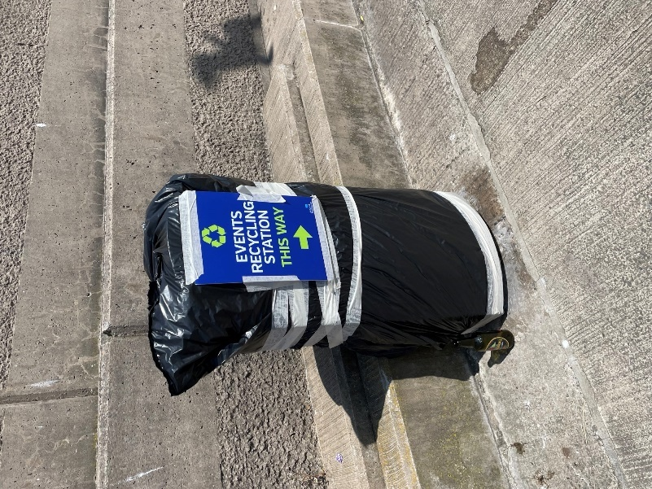

- Placement of a significant prominent/centrally located and signposted ‘Recycling Station’ at the event venue, with receptacles for separate disposal food, glass and blue bin recyclable waste/litter items.

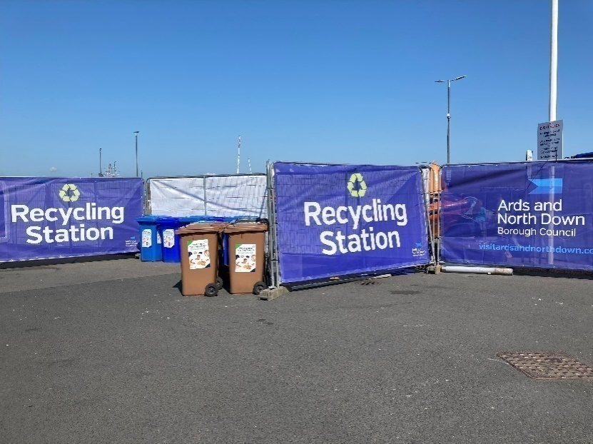

- Continuous supervision of the Recycling Station by Council staff throughout the duration of the event, who were able to monitor/control what was placed where and support the public with advice in that regard.

Recent Event Recycling Outcomes
The implementation of the new strategy on Events Recycling had been hugely successful, as evidenced by outcomes achieved at the following high profile Borough events:

- At the Sea Bangor event in June, the Council secured zero cross contamination of litter disposal bins, with a staggering 98.5% of litter being successfully collected in the correct container for recycling – resulting in almost four tonnes of recyclable waste (blue bin recyclables, organic compostable waste and glass) being diverted from landfill.
- At the Comber Earlies Festival in June, the Council secured 97.6% recycling – again with zero cross contamination of bins. Two tonnes of waste was diverted from landfill.
- At the Pipe Band Championships in July, the Council again achieved zero cross contamination of waste in bins, with 98.5% recycling of public litter secured and over one tonne of waste diverted from landfill.

The approach was now the standard protocol for managing litter waste at all Council events and was now consistently demonstrating an almost 100% effectiveness in diversion of recyclable litter waste from landfill. Cleansing and Events staff had remarked at the level of public support there had been for the initiative, with many event goers taking time to commend staff at how pleased they were with the highly visible efforts being taken by the Council to secure event litter recycling outcomes.

Impact Upon Wider Borough Recycling Strategy
Whilst the landfill and cost savings were relatively modest for the recycling of waste at Council organised events (relative to the overall municipal waste arisings), there were however several other key strategic benefits to be gained:

- It sent out a clear, visible demonstration of the Council’s commitment to promoting and ‘living out’ sustainability its own activities.
- It elevated the specific subject of recycling as a key part of the overall sustainability agenda; everyone (numbering thousands of people) who attended Council events was brought into direct contact with recycling messaging when they disposed of the litter waste they generated during their day out.
- As people took note and directly experienced recycling messaging and saw the lengths the Council was going to in order to secure maximum recycling of items of litter at events, they were inclined to think more about which bin they were placing their waste into at their homes - and ultimately to engage more fully in the Council’s kerbside and HRC recycling services.
- It helped place Ards and North Down firmly on the map in terms of its sustainable tourism offering, appealing to people from far and wide who were likely to be attracted into the Borough to events as a consequence of the Council’s strident efforts to promote recycling and the wider sustainability agenda.

It had been a significant challenge to find an effective strategy to address the issue, and officers from the Events and Waste and Cleansing Departments were to be commended on their persistent endeavours; the Council now led the way in promoting recycling engagement by the public at events. It would continue to consistently and rigorously apply that protocol to the management of litter waste at all Council events going forward, with officers working collaboratively across departments in that regard – and the activity would be promoted as a key strand of the Council’s overall sustainable waste resource management messaging programme.

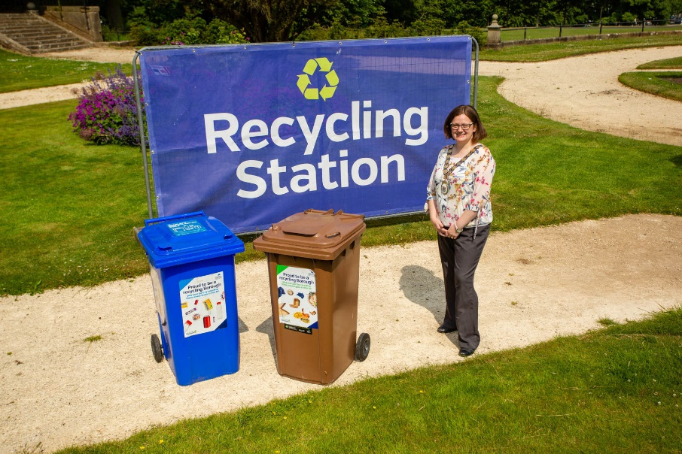

RECOMMENDED that the Council notes the report.

Proposed by Councillor Irwin, seconded by Councillor Edmund, that the recommendation be adopted.

Proposing the recommendation Councillor Irwin put on record her thanks to the Sea Bangor team who had been extremely helpful. Councillor Edmund was in agreement and referred to the Tide and Turf festival and noted if figures of 100% were not reached it was certainly not Council officers that would be at fault.

Councillor Wray agreed stating that the staff had been fantastic but a minor point was that he had heard of a few complaints about the location of the recycling station at the Tide and Turf event, but he recognised that there might have been a valid reason for that and was happy to support the recommendation.

The Director knew that Members were aware that this area was a ‘hard nut to crack’ but the outcome achieved had been excellent testament to officers’ persistence and the public’s response to the initiative.

Councillor Blaney hoped that the Council’s Communications team would get the word out to residents that the Council was performing this aspect of public services very well.

AGREED TO RECOMMEND, on the proposal of Councillor Irwin, seconded by Councillor Edmund, that the recommendation be adopted.

17. NORTHERN IRELAND LOCAL AUTHORITY MUNICIPAL WASTE MANAGEMENT STATISTICS, JANUARY TO MARCH 2023 AND QUARTERLY UPDATE ON RECYCLING PROGRESS
(Appendices VI &VII)

PREVIOUSLY CIRCULATED: Report from the Director of Environment detailing the official waste management statistics for the final quarter of 2022/2023 (January to March 2023) had been released by the Northern Ireland Environment Agency.

Members would recall a report brought to Committee in October 2022 (attached) outlining the strategic challenge facing the Council in respect of its faltering performance on recycling over the previous 2-year period and the legal, financial and environmental implications of that.

At that time the Council approved a package of measures to promote and improve the level of recycling engagement by householders across the Borough, as outlined in the report. To help keep focussed upon the sustained implementation of agreed measures and track progress on delivering the target outcomes, it was agreed that quarterly update reports would be brought to Committee by officers.

Up to now the Council had used 2015/16 as its baseline year when reporting the NIEA waste management statistics to the Committee, tracking progress each quarter from that period. Following the development and commencement of a renewed programme of actions in December 2022 aimed at reinvigorating recycling performance, it was now planned that the baseline year used to track progress and the success of that programme of action, would be 2021-22. Therefore, from this quarterly report onwards the Council would:

- Report key quarterly waste management performance statistics relative to the new baseline year of 2021-22, and
- Provide some detail around operational waste service management activities/actions that had been implemented during the quarter with the aim of improving performance.

Northern Ireland Local Authority Collected Municipal Waste Management Statistics – January to March 2023
The significant headlines contained within the latest DAERA report showed that:

- The Council’s household waste recycling rate increased by 6.5% compared to Q4 last year, (from 42.8% to 49.3%).

- The Council’s household waste recycling rate of 49.3%, was 3.1% higher than the NI average of 46.2%.

- The Council was ranked 4th out of the eleven NI Councils for its household waste recycling rate.

- The Council’s household waste composting rate rose by 4.1% (from 21.2% to 25.3%) and was 4.7% higher than the NI Council average (ranking 3rd out of 11 Councils).

- The Council’s household waste dry recycling rate rose by 2.4% (from 21.1% to 23.5%) and was 1.7% lower than the NI Council average (ranking 8th out of 11 Councils).

- The Council received 13% more waste per capita at its HRCs compared to the average for other NI Councils (down from 36%).

- 64% of HRC waste was collected for recycling (up from 58.5%), compared to a 71% average for other Councils.

- The amount of waste collected for recycling through the kerbside bin collection system was higher than the average for other Councils – 54.2%, compared to an average of 43.3% for other Councils.

Operational Performance Improvement Measures
Programme Launch

The Council’s renewed campaign launched in December 2022 required the development of a range of communications and marketing tools, most significant of which was the new ‘Recycle Guide’ that outlined all key recycling messages. The guide was delivered by mail to every home in the Borough over a three-week period in November 2022.



An electronic version of the guide was added to the Bins and Recycling section of the Council’s web site and publicised through the Council’s Bin-Ovation App.

AND Recycling Guide 2022 (adobe.com)

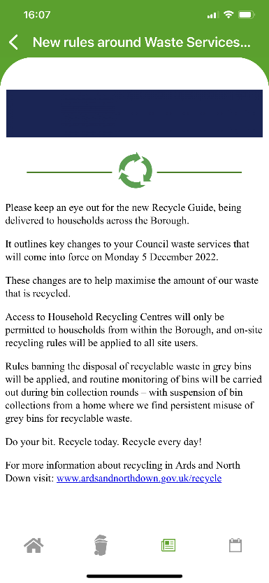
Bin-Ovation Campaign Message

A range of communication channels were used to promote the campaign, including posters in local community hubs, banners in outdoor public spaces, social media posts and local media articles. Those carried two main messages as illustrated below:




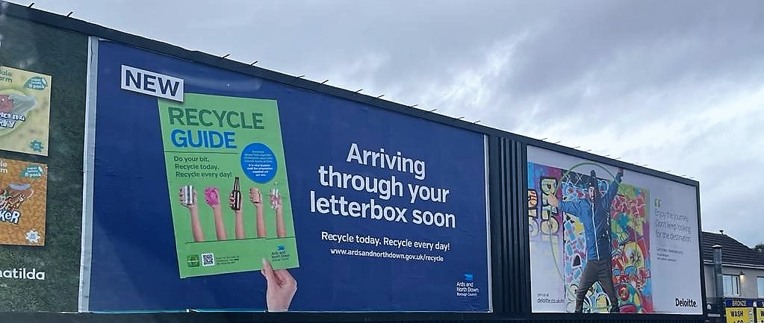

The media release used to launch the campaign was attached.

A feature in the local newspapers also saw a journalist and her family give an insight into their recycling journey.
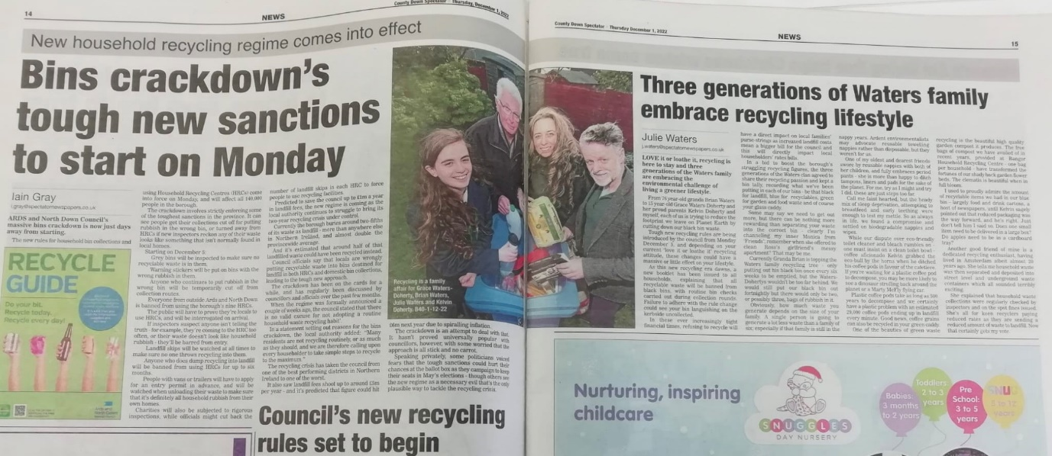

A key strapline message used across communications, was the slogan ‘Recycle today. Recycle every day!’. The aim of that was to promote the ‘normalising’ of recycling as a simple, instinctive, everyday household activity in all homes across the Borough.

Campaign Progress – Performance Outcomes and Indicators
Marketing and Communications Indicators
Our new Recycling Guide was delivered to over 80,000 addresses across the Borough.

MC1 - twenty-five social media posts were issued, with associated engagement/management of feedback across Waste and Recycling on ANDBC corporate channels. Header images on all social media channels were also present throughout campaign.

MC2- ten articles were published in print press and online. The renewed campaign featured in the Spring 2023 edition of the Borough Magazine, delivered to all households in the Borough.

The main recycling page on www.ardsandnorthdown.gov.uk consistently fell within the top three visited pages on the website.

Household Recycling Centre Indicators
HRC1 – Volume of blue bin recyclable materials separated from mixed waste by residents on-site: 1.322M Litres.

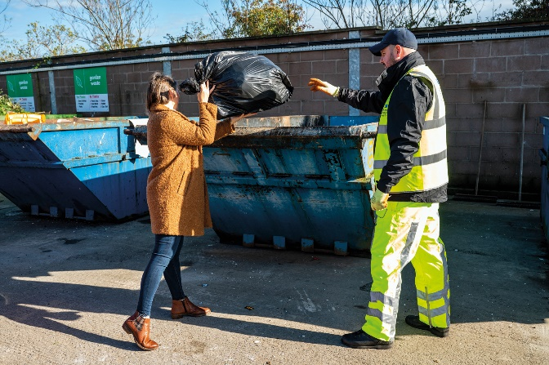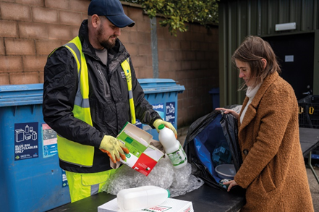

This equates to approximately 55 tons of blue bin waste; whilst that was a relatively modest weight of material, it represented a very large/visible volume of recyclable waste extracted from bags of mixed waste which was initially intended to be placed in landfill skips at HRCs. A collateral benefit of the practice of requiring removal of blue bin recyclables from black bags of mixed waste before using the landfill skip, was that it should help to ‘educate’ householders - promoting more efficient separation of waste in the home and greater use of blue bins at the kerbside.

That represented just one type of recyclable waste category which was prevented from entering landfill skips at HRCs as a consequence of more focused attention to supervision of landfill skip access; many other recyclable waste types would also have been prevented from entering the landfill skips as reflected in KPI, HRC3.

HRC2 – Number of out-of-Borough visitors turned away from site: 1742.
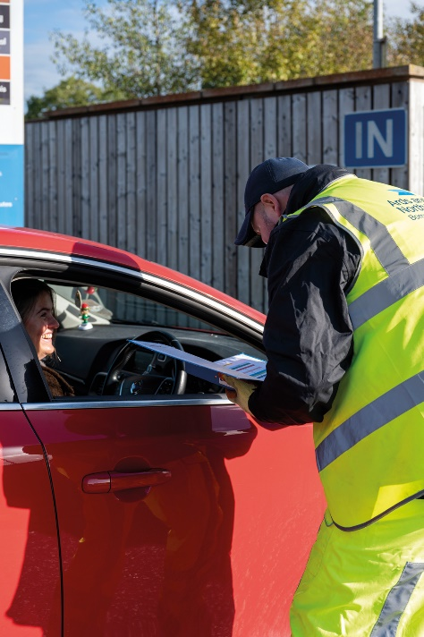

That was a significant number in itself, but it was likely to be the case that a significant number of out of Borough residents would have avoided coming to the Council’s sites because of the widely publicised focus upon checking ID for everyone entering and those turned away would in all probability avoid further attempts to enter and use the HRCs; the impact of that would also be reflected in HRC3 and other KPIs.

HRC3 – % change in tonnage of total waste received (compared to same period in 2021-22)

- Experienced a 16% decrease in the total amount of waste received at HRC, down from 6409T to 5405T.

HRC4 - % change in tonnage of waste received for landfill (compared to same period in 2021-22)

- Experienced a 27% decrease in the amount of waste received for landfill at HRC, down from 2659T to 1942T.

HRC5 - % change in tonnage of waste received for recycling (compared to same period in 2021-22)
- Experienced an 8% decrease in the amount of waste received for recycling at our HRC, down from 3750T to 3463T.

HRC6 - % change in proportion of HRC waste materials collected for recycling (compared to same period in 2021-22)

- Experienced a 5.5% increase in the proportion of all waste received at HRCs which was collected for recycling, up from 58.5% to 64%.

Kerbside Household Waste Collections Indicators

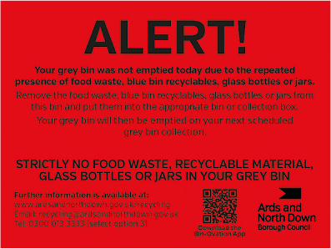
KSI – Number of recycling alert stickers applied to grey bins (yellow): 2784
KS2 – Number of recycling alert stickers applied to grey bins (amber): 255
KS3 - Number of recycling alert stickers applied to grey bins (red): 52
KS4 – % change in tonnage of total waste collected (compared to same period in 2021-22)
- Experienced an 4.8% increase in the total amount collected at the kerbside, up from 12,241T to 12,289T.
KS5 - % change in tonnage of grey bin waste collected for landfill (compared to same period in 2021-22)
- Experienced a 9.3% decrease in the amount of grey bin waste collected, down from 6482T to 5877T.
KS6 - % change in tonnage of waste collected for recycling (compared to same period in 2021-22)
- Experienced a 20.7% increase in the amount of waste collected for recycling, up from 5759T to 6952T.
KS7 – % change in proportion of kerbside waste materials collected for recycling (compared to same period in 2021-22)
- Experienced a 7.2% increase in the proportion of kerbside waste that was collected for recycling, up from 47% to 54.2%.
Summary and Trend Analysis of Indicators
Indicator Reference | Monitoring Period 1  (December 2022 – March 2023*)  *Waste tonnage indicators reflect period January to March 2023 only | Monitoring Period 2  (April 2023 – March 2024)
MC1 | 25  Social media posts
MC2 | 10  Print press and online articles
HRC1 | 1,322K Litres  Blue bin waste
HRC2 | 1742 Visitors  Denied entry
HRC3 | 16% Decrease  Total HRC waste
HRC4 | 27% Decrease  Landfill skip waste
HRC5 | 8% Decrease  Recycling skip waste
HRC6 | 5.5% Increase  HRC recycling rate
KS1 | 2784  Yellow warning stickers on grey bins
KS2 | 255  Amber warning stickers on grey bins
KS3 | 52  Red warning stickers on grey bins
KS4 | 4.8% Increase  Total kerbside waste
KS5 | 9.3% Decrease  Grey bin waste
KS6 | 20.7% Increase  Kerbside recycling waste
KS7 | 7.2% Increase  Kerbside recycling rate

Summary Analysis of Indicators
The first report of this type showed a very encouraging picture, and generally conveyed commencement of a reversal of the downward trend that the Council had experienced in its sustainable waste resource management performance over the past couple of years. Following the relaunch of the recycling education campaign and the focussed/sustained implementation of key HRC and kerbside collections controls, the Council was now seeing two important outcomes:

- A fall in the total amount of landfill waste both at HRCs and at the kerbside. Overall, the Council received/collected less 1,322 tons of waste destined for landfill over a 3-month period (January – March) compared to the same period last year; at current landfill cost (£127.42/T), that represented a £168,449 saving.
- A significant rise in the recycling rate, both at HRCs and at the kerbside. The percentage of materials collected for recycling at HRCs rose by 5.5% and at the kerbside by 7.2% compared to the same period last year. The overall Borough household waste recycling rate rose by 6.5%.

Whilst the indicators set out in the report were very encouraging and reflected a lot of hard work and dedication on the part of the waste and recycling teams, there would undoubtedly be much further progress to make if the Council was to have any chance of ultimately reaching the 70% recycling target for 2030 that was laid down in the Climate Change Act (Northern Ireland) 2022. The new booking system for HRC access, along with the planned review of the kerbside collections model and a strategic review of HRC capital assets – as set out in the transformation agenda report agreed by the Council in April 2023 would be critical in both bedding in/sustaining the gains outlined in the report, as well as facilitating the further step changes in recycling engagement required to propel further towards the 70% recycling target.

It was important to stress that step change, sustained improvements in both the HRC and kerbside recycling rates would be required to move from the current c50% recycling rate towards the new 70% target.

RECOMMENDED that the Council notes the report.

Proposed by Councillor Boyle, seconded by Councillor Edmund, that the recommendation be adopted.

Councillor Cathcart believed that the findings in the report were staggering, and he was encouraged by the improving picture at the HRCs and at the kerbside. While the Council was not nearly at the 70% recycling target, travel was in the right direction. He referred to ‘waste tourism’ which had gone down but had heard from some of his friends and family that ID checks were not always happening.

In response the Director stated that it was now a requirement for ID to be shown to prove the person visiting the site lived in the Borough and was therefore entitled to use the facilities. One of the reasons for the new booking system was so that addresses could be verified before a person arrived on site, but that ID matching the booked address would still have to be shown. He apologised for any instances where ID had not been asked for on entering a HRC and confirmed that managers and supervisors would ensure a continued focus on that. Councillor Cathcart hoped that the message would be pushed out to residents that any inconvenience that was being experienced would likely be saving them money in a Rates bill in the long term.

The Director was in agreement, stating that this key message was at the front and centre of the Council’s communications with the public. Saving money, helping the environment and improving recycling was a benefit to everyone.

Councillor Boyle accepted that it was early days and wondered if there had been reports of any staff facing abuse from the public. In response the Director stated that the system implementation had gone very smoothly and there were very few complaints. The public had shown co-operation and the Council had received emails expressing their positive experience and support for the new system. Several thousand bookings had been made already and the system was working well. The Council would be carrying out a user survey over coming weeks and an implementation report would be coming back to the September Council meeting.

The Member went on to refer to body cameras and asked when those had come in and if they were worn by officers by choice or under instruction. The Director explained that the cameras had been introduced 6-9 months previously and were worn through choice currently to protect staff where they felt it necessary. They were a last resort to protect staff in the very rare event that a member of the public was acting in an unacceptable manner and would provide evidence of this – as well as helping to deter such behaviour in the first instance.

AGREED TO RECOMMEND, on the proposal of Councillor Boyle, seconded by Councillor Edmund, that the recommendation be adopted.

18. EU INTERREG Va PROGRAMME – FASTER EV CHARGER NETWORK

PREVIOUSLY CIRCULATED: Report from the Director of Environment detailing that
Members would recall that at its meeting on 5 July 2023, the Council agreed to sign a collaboration agreement regarding the delivery of an EU Interreg VA funded project to install a network of rapid EV chargers in Northern Ireland. The Council’s involvement in the project was strategically significant; it demonstrated the Council’s commitment as a leading public body to supporting and facilitating the early adoption of EV transport in our jurisdiction, and in turn the successful transition to mainstream green transport that was enshrined in UK law through a ban on the sale of all new conventional petrol and diesel cars and vans from 2030 and hybrids with significant battery range banned from 2035.

Following a competitive public tender process, Easygo had been appointed to install and operate 24 no. 50kw electric vehicle chargers at locations across the Belfast City Council, Ards and North Down Borough and Newry, Mourne and Down district council areas.

Those new chargers would be installed as part of the FASTER Project which had received €6.4 million EU funding under the INTERREG VA programme. The project was managed by the Special EU Programmes Body (SEUPB) to support the transition to electric vehicles and sustainable transport use across Western Scotland, Northern Ireland and the Republic of Ireland (Border Region). Match funding for the project had been provided by the Department for Infrastructure (Northern Ireland) and the Department for Transport (Republic of Ireland) and Transport Scotland.

Steven Clarke Consulting Ltd (based in Holywood) had also been appointed to provide project management support to Ulster University and EasyGo.

Eight of the new 35 rapid EV chargers were scheduled to be installed in the Borough, as followed:

- Bangor Sportsplex (1 x single charger)
- Londonderry Park Newtownards (1 x single charger)
- Bangor Aurora (2 x double chargers)
- Ards Blair Mayne Wellbeing and Leisure Complex (1 x double charger)

Work would now proceed to secure the installation of the new chargers at Council sites by the end of December 2023.

A press release had already been issued and the Council would be engaging with Easygo over coming weeks and months to publicise and promote the new rapid charger network, including the strategic benefits of the new installations for the Ards and North Down Borough.

RECOMMENDED that the Council notes this report.

Proposed by Alderman Cummings, seconded by Councillor L Douglas that the recommendation be adopted.

Alderman Cummings welcomed the report and thought it was fantastic to see plans for the technology coming through. He referred to the infrastructure at Comber which was being put in place but as yet there was no charging point. He asked if that was subject to a tender coming through.

The Head of Assets and Property Services informed the Committee that when Comber car park was resurfaced ducting was put in place at that time in advance of funding becoming available in the future for provision of the necessary electricity supply for EV charge points.

The Director added that there was a problem with spare capacity in the network currently; that was a massive infrastructure issue that needed to be resolved across Northern Ireland and was very much a work in progress.

Councillor Woods also welcomed the report and informed the Committee that the existing Aurora e car charger had been out of action for almost a year now. Officers explained that that charger was not under the Council’s control but would pass the information on. The proposed four new rapid chargers at Aurora would make it one a limited number of EV ‘mini hubs’ in Northern Ireland, and that would make for a great marketing tool for the Borough.

AGREED TO RECOMMEND, on the proposal of Alderman Cummings, seconded by Councillor L Douglas, that the recommendation be adopted.

19. NOTICES OF MOTION

19.1 Notice of Motion submitted by Alderman Adair, Councillors Edmund and Kerr

That Council task officers to bring back a report on the costing to install signage identifying the townlands of Ballyblack and Kirkistown and that officers are tasked to bring forward proposals to incorporate townland signage across our Borough.

Proposed by Councillor Adair, seconded by Councillor Edmund, that the Notice of Motion be adopted.

Councillor Adair thanked Members for the opportunity to speak to the Environment Committee and explained that for those who were unfamiliar with what a townland was it was a small geographical division of land which had originated from Norman times and was common in Ireland and Scotland. He was following from the work of Alderman McCarthy who had had a passion for townlands and wished for them to be preserved for years to come. Not everyone was aware of townlands, but they would be printed on Rates bills and voting cards etc. Many people identified with their own townland perhaps in some instances more so than the village they came from.

He had brought a similar Notice of Motion previously which had fallen but he had since amended it asking for townland signs for Kirkiston and Ballyblack with calls for a report on how a policy of naming townlands could be brought forward for the future when it came to street signs. Other Councils were doing similar, and he felt that a process that had begun in Ards should be continued in the Borough. He asked Members for their support for his Notice of Motion.

Councillor Edmund described townlands as places of belonging for people and stressed the human aspect that often was the mark of a place and believed that people should be given the opportunity to identify with their communities in this way.

Councillor Wray had listened to Councillor Adair and Councillor Edmund and largely supported the Motion as it was. He supported a report being brought back because he was aware of the costs involved and believed that the Council should be careful to consider how the Motion would be implemented fairly across the Borough.

Councillor McAlpine thanked Councillor Adair for acknowledging the work of Alderman McCarthy who was passionate about local history, and she believed that was similar to many with the trend for tracking one’s family history. She supported the Motion as it was now and hoped for suggestions in a report on how it could be implemented.

Councillor Kerr referred to his own townland and was proud of his area and its history, culture and heritage and believed it was important to keep that alive. He called for Members to support the Motion.

Councillor Smart commended the proposer and seconder and welcomed the fact they were seeking a report. He had done some research which showed that there were over a thousand townlands in the Borough and that was quite a staggering number.

Debate took place on what the report was asking for and how many signs would be suitable and where those would be placed. Alderman Adair felt that there had been confusion expressed about what was being asked. He thought one or two small signs marking the townland would be appropriate with possibly plans in the future to put the townland on street signs. He believed the costs would be modest.

Alderman Armstrong-Cotter gave further clarity and showed a similar sign which was relatively small and that was already in place at Loughries.

Members were in agreement with the Motion and looked forward to receiving an officers’ report with options on how to progress. Councillor Adair thanked Members for their support.

AGREED.

20. Any other notified business

There were no items of any other notified business.

Exclusion of Public/Press

AGREED, on the proposal of Alderman Cummings, seconded by Alderman Armstrong-Cotter, that the public/press be excluded during the discussion of the undernoted items of confidential business.

21. CAR PARKING ENFORCEMENT CONTRACT UPDATE

***IN CONFIDENCE***

NOT FOR PUBLICATION SCHEDULE 6 – INFORMATION RELATING TO THE FINANCIAL OR BUSINESS AFFAIRS OF ANY PARTICULAR PERSON (INCLUDING THE COUNCIL HOLDNG THAT INFORMATION)

An update report on progress of the tender award process for a new Car Parking Enforcement Contract. It was recommended that the Council notes the report and agrees to extend the current Car Parking Services Agreement with DFI until 31 March 2024 and permits additional extensions if required until 31 October 2024.
Further recommended Council agrees to share any reasonable additional costs associated with the tender award process with other partner Councils.

The recommendation was agreed.

22. TENDER AWARD REPORT FOR ARC 21 BRING BANK SERVICING CONTRACT 2023

***IN CONFIDENCE***

NOT FOR PUBLICATION SCHEDULE 6 – INFORMATION RELATING TO THE FINANCIAL OR BUSINESS AFFAIRS OF ANY PARTICULAR PERSON (INCLUDING THE COUNCIL HOLDNG THAT INFORMATION)

A report on the provision of Bring Bank services was considered.

It was recommended that the Council agrees the recommendations listed in the attached arc21 tender report.

The recommendation was agreed.

(Councillor Blaney returned to the meeting at 9.35 pm)

23. GOVERNANCE ARRANGEMENTS FOR MANAGEMENT OF COUNCIL HARBOURS
(Appendices VIII – X)

***IN CONFIDENCE***

NOT FOR PUBLICATION SCHEDULE 6 – INFORMATION RELATING TO
A CLAIM TO LEGAL PROFESSIONAL PRIVILEDGE

A report on the arrangements for the governance of Council harbours was considered. It was recommended that the proposals set out in the report be adopted.

It was agreed to defer a decision on the recommendation to the full Council meeting in September.

Re-admittance of public/press

AGREED, on the proposal of Councillor Woods, seconded by Councillor McAlpine, that the public/press be re-admitted to the meeting.

Termination of meeting

The meeting terminated at 9.45 pm.

