Ards and North Down Borough Council

A hybrid meeting (in person and via Zoom) of the Environment Committee was held at the Council Chamber, Church Street, Newtownards and via Zoom, on Wednesday, 14 June 2023 at 7.00 pm.

PRESENT:

In the Chair: Councillor Morgan

Aldermen: Armstrong-Cotter McAlpine (Zoom)
Cummings

Councillors: Blaney (Zoom) Kerr
Boyle McKimm
Cathcart Rossiter
Douglas Smart
Edmund Woods (Zoom, 19:05)
Irwin Wray

Officers: Director of Environment (D Lindsay), Head of Waste and Cleansing Services (N Martin), Head of Assets and Property Services (P Caldwell), Building Control Services Manager (R McCracken), and Democratic Services Officer (S McCrea)

1. Apologies

Apologies were received from Councillor Woods and Councillor Kerr for lateness.

NOTED.

2. Declarations of Interest

Councillor Morgan: Item 13 - Grant of Outdoor Entertainment Licence

NOTED.

3. DEPUTATION – INTERIM PRESENTATION BY WRAP ON WASTE COLLECTIONS REVIEW

The Director of Environment introduced Mr Gardner from WRAP who was leading on a review of Councils’ kerbside waste collection services. In Mr Gardner’s presentation, it was explained that WRAP worked with local authorities extensively and was an independent, registered charity that could bring objective evidence-based support to organisations to help address challenges they may be facing whilst ensuring such objectives aligned with policy priorities. Within common collection guidance proposals, three arms existed. The first was restricted residual which related to reducing available residual capacity resulting in higher recycling participation. It was expected that the amount of residual waste would decline over the next decade with producers of waste looking to replace more and more materials with recyclable content. Flexibility existed within this option by allowing for Councils to either reduce the frequency of residual waste collections or keep collection frequency the same but reduce receptacle size. Ards and North Down Borough’s figures showed that total residual waste volume was relatively positive, but that recycling was sub-par, especially when compared to other Councils.

(Councillor Woods arrived at 7.05pm)

Councillor Smart asked what the view would be to restriction of capacity in relation to a three-week collection or smaller bin model. With the latter, he was curious as to how it may work when including blue bins, and whether benchmarking against other Councils would provide information on trends and the rationale behind poorer recycling figures. Mr Gardner explained that when one measures performance, it is done so by tonnage or, ‘yields,’ as the term would be in the sector. Less yield was considered better for residual waste whilst conversely, higher yields were good for recycling. He believed that Ards and North Down could do better with residual waste and it would be worthwhile discovering how they compared with other Council areas by investigating what they did differently. If this Council were to use a restriction on residual waste method, compensation may be required via extra recycling to balance the scales. He provided some additional examples of how other Councils and authorities had introduced compensatory measures such as additional bins or medical waste bin collections.

Councillor McKimm was curious as to how the Council could create change. He recalled that the Director of Environment and his Department had put clear messaging out to the Borough in regard to sorting rubbish, yet the figures in the presentation showed almost half of what was found in grey bins was recyclable. He believed the Council would need to understand the minds and thought processes of residents in order to provide the correct guidance that would steer the negative trend in the right direction. He asked if the scenarios in the presentation were being proposed as courses of action. Mr Gardner explained that they were just scenarios that were based on evidence and hoped that they were not seen as prescriptive as the information existed only to inform the Council of what common collection guidance may mean in relation to costs, resources or performance of services. He advised it was unlikely that the Council could improve the situation drastically without the assistance of other entities and exampled Wales whose performance stood above others for reduction of refuse and increase in recycling. He believed this had been supported by a nationwide campaign that resulted in a change of social norms.

Councillor Cathcart welcomed a review into waste collection, explaining that using ratepayer money appropriately was paramount given it was one of their greatest financial inputs as well as one of the most important services. He asked the Director of Environment if, as part of looking at waste comprehensively, the Council should look at for example a Bryson style box system for recycling to reach the correct decision for ratepayers. The Director of Environment advised that the presumption was to maintain the existing style of kerbside collections as opposed to the box system used by other councils. This was based on an assessment of the appetite of the Council over the past few terms in regard to scale of change and style of service. If this presumption was wrong, he advised Members that now was an opportunity to raise any suggestions for Mr Gardner to include in his research such as the box-style system.

Councillor Woods asked if, in the absence of dealing with key waste strategy challenges that the scenarios outlined could work. Mr Gardner explained that authorities in England also had to wait on clarification from UK Government stance and strategy but that as time moved on, WRAP’s advice was to explore what options may mean in practice so when clarity was offered from the Government, authorities and Councils would be in a much better position to act with agility. Councillor Woods asked if consideration had been given to the destination of waste to ensure it was not being shipped to poorer countries. Mr Gardner explained that such had not been in the scope of the one agreed. It would be within the scope to look at carbon impact of particular scenarios; something he would discuss with colleagues to discover how practicable it would be to include that detail.

Councillor McAlpine asked for clarification on how figures were compared against other Councils to reach the conclusion that Ards and North Down were not succeeding at recycling. Mr Gardner explained that the process involved tonnes of waste divided by households, so whilst refuse was low compared to other Council areas, with recycling it was the exact opposite and to understand those figures, benchmarking was required. He advised that communication plans were fundamental as there was no point in providing schemes without explaining how they worked or what their benefits would be. Further efforts would be discussed with the Environment Team with a view toward investigating what other Councils had done in relation to policies.

Councillor Edmund asked how often bins were collected in Wales and if such collections consisted of different waste makeups. Mr Gardner explained that Wales had twenty-two authorities and that variation in terms of collection regimes existed. However, they were unified in terms of the types of waste they collected. Whilst some authorities collected food waste weekly, others had reduced frequency which suggested a one size fits all approach was not necessarily appropriate given circumstances were different dependent on location.

The Director of Environment summarised the proposal to Members. A draft review report from WRAP would be brought back to the Council at the end of the Summer which would be reviewed by Officers who would then provide an update to Members at September’s Environment Committee. It was envisaged that a preferred option would be identified that was most likely to give the best return for ratepayers and the various targets the Council hoped to reach. A consultation exercise would then follow facilitated by our Corporate Communications team. With that timeframe, it could potentially allow for decisions to be made by the Council in regard to any changes to its service model, by November/December - allowing any positive financial impacts to be factored into the estimates process for 2024-25.

AGREED, on the proposal of Councillor Smart, seconded by Councillor Edmund, that the presentation be noted.

4. q4 service plan performance reports

4.1 Assets and Property Services

PREVIOUSLY CIRCULATED: Report from the Director of Environment advising that Members would have been aware that the Council was required, under the Local Government Act 2014, to have in place arrangements to secure continuous improvement in the exercise of its functions. To fulfil this requirement, the Council approved the Performance Management Policy and Handbook in October 2015. The Performance Management Handbook outlined the approach to Performance Planning and Management process as:

- Community Plan – published every 10-15 years
- Corporate Plan – published every 4 years (Corporate Plan Towards 2024 in operation)
- Performance Improvement Plan (PIP) – published annually (for publication 30 September 2022)
- Service Plan – developed annually (approved April/May 2022)

The Council’s 18 Service Plans outline how each respective Service would contribute to the achievement of the Corporate objectives including, but not limited to, any relevant actions identified in the PIP.

Reporting approach
The Service Plans was to be reported to relevant Committees on a quarterly basis as undernoted:

Reference | Period | Reporting Month
Quarter 1 (Q1) | April – June | September
Q2 | July – September | December
Q3 | October – December | March
Q4 | January - March | June

The report for Quarter 4 2022-23 is attached.

Key points to note:
- Budget overspend includes substantial increases in utilities costs, diesel costs and the roof repairs at Aurora. These costs were unbudgeted and unavoidable.
- The biofuel trial remains unviable due to ongoing difficulties in sourcing the fuel at a competitive rate. Officers will keep this under review.

Key achievements:
- All refurbishment projects planned for this year were completed, including works at Queens Hall Newtownards, Groomsport boathouse, Kircubbin community centre and Westwinds Community Centre.
- Several regeneration projects were delivered, including Comber car park resurfacing.
- Over 4900 property maintenance defects completed over the year.

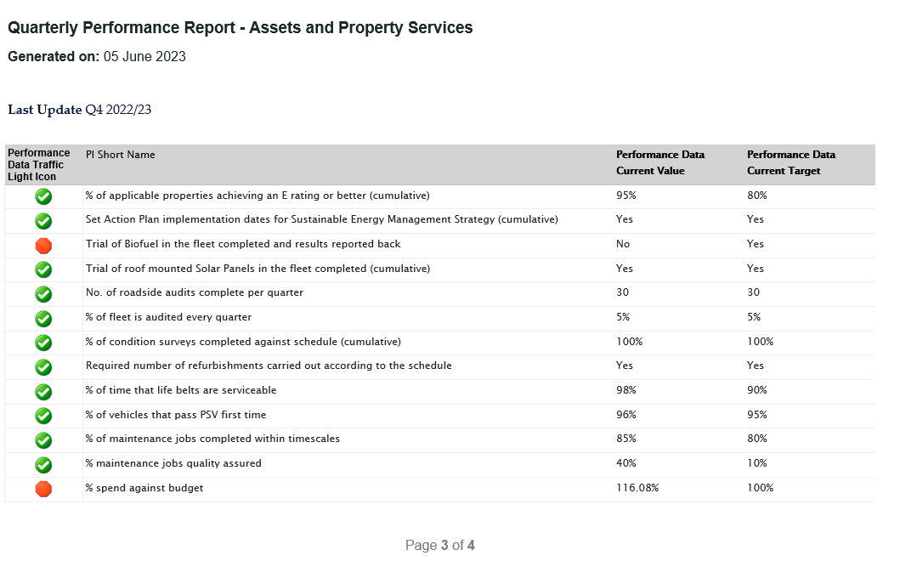

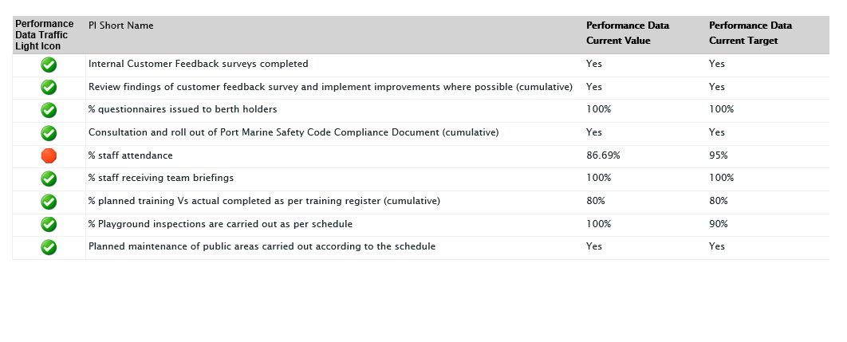RECOMMENDED that the Council notes the report.

Proposed by Alderman Cummings, seconded by Alderman Armstrong-Cotter, that the recommendation be adopted.

Alderman Cummings welcomed the improvement of the Comber car park and would await the local response to the one-way system. He asked if there was an update on the electric charge points to which the Head of Waste and Cleansing Services answered, stating that dock work had been carried out to future proof the possibility of charging points though there was no funding at the moment.

AGREED TO RECOMMEND, on the proposal of Alderman Cummings, seconded by Alderman Armstrong-Cotter, that the recommendation be adopted.
4.2 Regulatory Services

PREVIOUSLY CIRCULATED: Report from the Director of Environment advising that
Members would have been aware that the Council was required, under the Local Government Act 2014, to have in place arrangements to secure continuous improvement in the exercise of its functions. To fulfil this requirement the Council approved the Performance Management Policy and Handbook in October 2015. The Performance Management Handbook outlined the approach to Performance Planning and Management process as:

- Community Plan – published every 10-15 years
- Corporate Plan – published every 4 years (Corporate Plan Towards 2024 in operation)
- Performance Improvement Plan (PIP) – published annually (for publication 30 September 2022)
- Service Plan – developed annually (approved April/May 2022)

The Council’s 18 Service Plans outlined how each respective Service would contribute to the achievement of the Corporate objectives including, but not limited to, any relevant actions identified in the PIP.

Reporting approach

The Service Plans were to be reported to relevant Committees on a quarterly basis as undernoted:

Reference | Period | Reporting Month
Quarter 1 (Q1) | April – June | September
Q2 | July – September | December
Q3 | October – December | March
Q4 | January – March | June

The report for Quarter 4 2022-23 is attached.

Key points to note:

- The objective of developing a cross Borough market working group is now being taken forward through the Council’s Tourism Department.

- The target of redesigning and launching a new environmental education programme (project ELLA) was delayed due to the impact of Covid upon our ability to engage over the past year with schools, but this is now progressing well and will be the subject of a separate report to be brought to Committee.

- The target to maintain a top 3 ranking position in relation to level of fixed penalty activity for environmental offences (dog fouling and littering) is an annual target and NI wide data for the past year compiled by KNIB, is not yet available.

- In relation to the target on distribution of our RCIF budget, we are awaiting a final budget update from our Live Here Love Here Small Grants partners KNIB.

- Our target for 90% self-financing across services within the department was missed by a small margin, largely due to less than budgeted off-street car park income.

- Substantive progress in the implementation of our agreed Car Park Strategy has been stalled, pending the remedying of a legislative impediment which requires a functioning Assembly.

- Development and implementation of a Building Control awareness programme to promote more sustainable building measures has commenced and is ongoing.

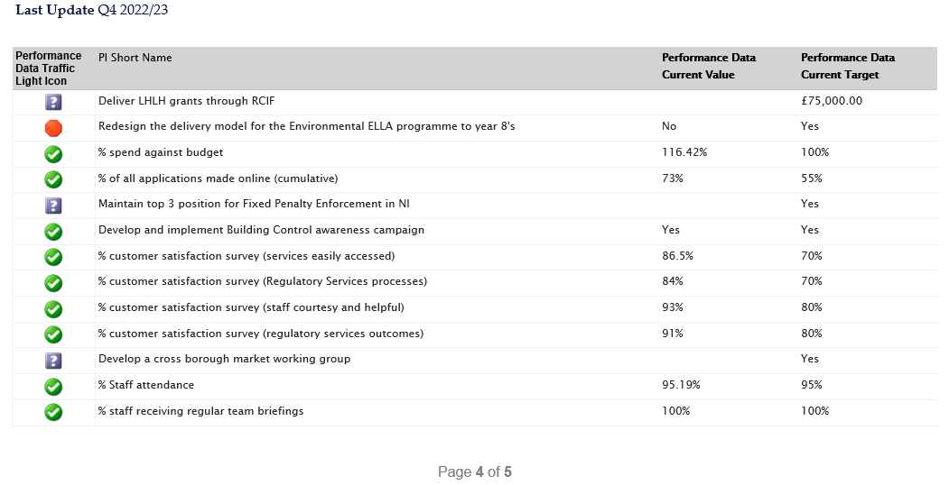
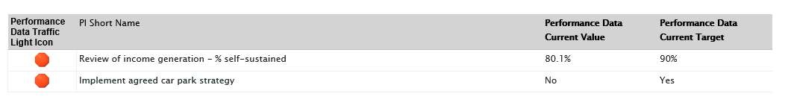
Proposed by Alderman Cummings, seconded by Alderman Armstrong-Cotter, that the recommendation be adopted.

Alderman Armstrong-Cotter explained that several residents had contacted her in relation to Kiltonga Wildlife Reserve and the unusual behaviour of rats in the area and their lack of fear which could lead to a dangerous incident. The Director of Environment advised that he would liaise with the appropriate department.

Councillor Smart asked if recruitment was necessary in regard to maintaining fixed penalty activity for environmental offences. The Director of Environment advised that Neighbourhood Enforcement was now more or less back to a full complement of staff and that they were in the process of regrouping to restore levels of enforcement activity.

Councillor Woods asked if recruitment had been carried out for the Head of Regulatory Services. The Director of Environment explained that this was still on hold in the context of the planned organisational review and in the meantime the three service unit managers had taken on shared Head of Service responsibilities.

Councillor Boyle was concerned as to the over-budget costs and sought further clarification in-committee as to facts and figures relating to other committee in-confidence reports. Following that request, he asked if any updates existed since the report before Members was written under the ‘Live Here, Love Here,’ campaign. The Director of Environment explained that KNIB administered that on the Council’s behalf and he understood that grants had been given out as intended. Update information had not been available at the time of writing the report, but a further report on the subject would be provided in due course.

Councillor Boyle referred to the car park strategy and whether it had been due to a non-functioning government that it had been held back. The Director of Environment explained that before implementation, a new Car Park Order was required for the Borough; that had been drafted by the Council solicitor and was ready for sending when the Assembly restarted.

AGREED TO RECOMMEND, on the proposal of Alderman Cummings, seconded by Alderman Armstrong-Cotter, that the recommendation be adopted.

4.3 Waste and Cleansing Services

PREVIOUSLY CIRCULATED: Report from the Director of Environment advising that Members would have been aware that Council was required, under the Local Government Act 2014, to have in place arrangements to secure continuous improvement in the exercise of its functions. To fulfil this requirement Council approved the Performance Management Policy and Handbook in October 2015. The Performance Management Handbook outlined the approach to Performance Planning and Management process as:

- Community Plan – published every 10-15 years
- Corporate Plan – published every 4 years (Corporate Plan Towards 2024 in operation)
- Performance Improvement Plan (PIP) – published annually (for publication 30 September 2022)
- Service Plan – developed annually (approved April/May 2022)

The Council’s 18 Service Plans outlined how each respective Service will contribute to the achievement of the Corporate objectives including, but not limited to, any relevant actions identified in the PIP.

Reporting approach
The Service Plans were to be reported to relevant Committees on a quarterly basis as undernoted:

Reference | Period | Reporting Month
Quarter 1 (Q1) | April – June | September
Q2 | July – September | December
Q3 | October – December | March
Q4 | January - March | June

The report for Quarter 4 2022-23 is attached.

Key points to note:
- There continues to be an encouraging trend in terms of landfill tonnage falling by over 4000 tonnes in comparison to the previous year. Our renewed recycling engagement campaign was operational during this reporting period and a detailed progress report will be brought to the September meeting of the Environment Committee.
- Problems encountered with the functionality and repair of the new street washing machine have impacted upon the target performance on our in-house street washing programme. This matter is being followed up with the equipment supplier.

Key achievements:

- Most performance targets were met.

Emerging issues:
- The current difficult economic conditions are directly impacting waste arisings, as reductions in tonnages of recyclates collected is also noted. Overall waste arisings were down by almost 5500 tonnes.

Action to be taken:
- Continue to try and resolve the issues with Keep NI Beautiful in relation to providing independent Litter surveys, that arose during Q3 of 22/23 and has resulted in no data being available for the last two quarters.

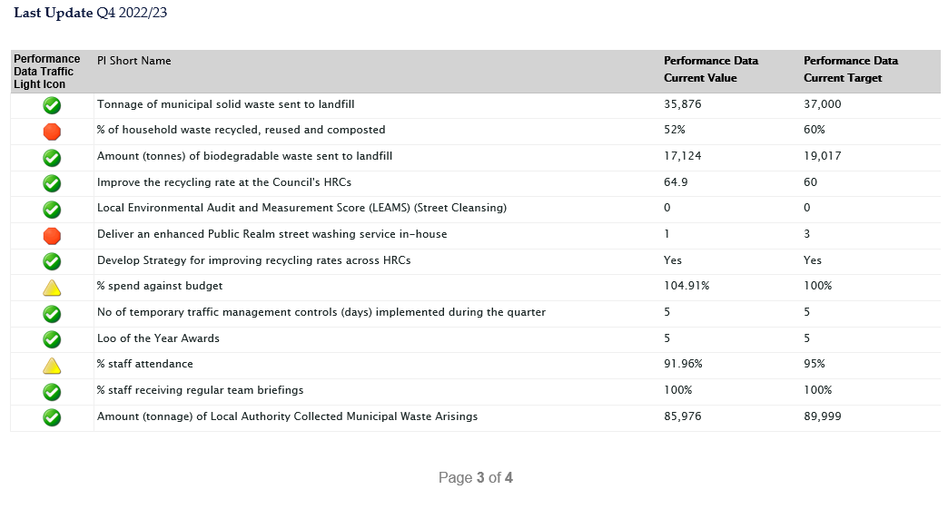
Proposed by Alderman Cummings, seconded by Alderman Armstrong-Cotter, that the recommendation be adopted.

Councillor Woods asked if any update existed on street washing and the supplier. The Head of Waste and Cleansing Services informed Councillor Woods that the street washing machine was back in use and a local supplier had been engaged to deal with any future servicing/repair problems. Comber public realm had been washed again recently and the team was working to get back on planned schedule.

AGREED TO RECOMMEND, on the proposal of Alderman Cummings, seconded by Alderman Armstrong-Cotter, that the recommendation be adopted.

5. hrc access booking system

NOTE: Proposed by Councillor Cathcart seconded by Councillor Edmund, that Item 5 be brought out of confidence on the proviso that in-confidence figures would not be discussed.

PREVIOUSLY CIRCULATED: Report from the Director of Environment advising that Members would have recalled that during the estimates process for 2023-24, the budgets for the HRC service were finalised on the basis that a revised site access model would be adopted, involving an online booking system. A decision had already been taken previously by the Council to adopt an online system to apply for van and large trailer access permits.

Officers had worked with an online booking platform service provider, retained under a procurement framework process used by the Council, to develop an integrated online booking system that would facilitate both general access as well as permit access for vans and large trailers. The cost of this was within the limits of officer authorisation.

Testing of the platform had commenced and officers were confident that the system developed would meet the key requirements of a robust, convenient, user-friendly service portal which would also help deliver upon the other key strategic target outcomes for our HRC services. These booking system features included:

- User web browsers will auto-fill key required information fields such as name and address, making the booking process simpler and faster.
- The standard access booking process takes just 1-2 minutes.
- Bookings can be made between one hour and 14 days prior to visiting a site.
- Booking process directs users quickly and easily to available slots across sites.
- Highlights key recyclable waste streams that are not accepted at certain sites and directs users to book at sites where they can be recycled.
- Highlights key site access and recycling rules at time of booking – prioritising the key rule that waste must be sorted, and recyclable waste will not be permitted in landfill waste containers.
- Regulates the flow of site users through sites, capping the number of bookings accepted during any one time slot and spreading total user numbers evenly across the entire working week – thereby ensuring that each site user is assured of more support and guidance from staff on how and where to dispose of their waste, and maximising recycling outcomes on sites.
- Provides booking confirmation via an automated email, communicating details of the booking slot along with key information about access and recycling rules that must be observed. A detailed HRC site map will also be included in the confirmation email, which guides visitors to the relevant receptacles on site which will make their visit to site more user friendly.
- Calendar confirmation is sent to user at time booking – plus email reminder sent the day before the booked slot.

It is planned that a video demonstration of the new online booking system would be available to show Members at the Committee meeting.

The booking platform would be flexible, and at any time the service provider could make adjustments deemed necessary by the Council to further suit its specific requirements. It had been anticipated that the new system would be ready to commence accepting bookings from 4 September 2023, with booked access commencing Monday 18th September. It was planned that a marketing and promotions campaign would be operated over an 8-week period beforehand. Access to the web-based booking portal would be available through a hyperlink featured on the Bin-ovation App, and the marketing and communications campaign would include text notifications about the new system to Bin-ovation App users.

The booking system would provide a range of key customer benefits:

- Protects the Borough’s HRCs for disposal of household waste by residents/ratepayers of the Borough only, with associated cost savings and greater availability of sites for our own residents.
- Help avoid lengthy queuing outside sites, at traditionally peak periods.
- Smooth out user traffic flow through sites, meaning site users will find it easier to access receptacles for various waste streams and there will be greater availability of site attendant assistance (providing greater guidance on recycling etc.).
- Avoid users turning up when sites outside closing hours.
- Avoids users turning at a site which cannot accept the particular waste material types being disposed of (and having to detour to a different site).

As a consequence of the new booking system, it had been possible to streamline and merge the existing policies regulating HRC access and avoid the need for a separate policy relating to permit access for vans and trailers. Consequently, the attached revised Policy on Access and Use of HRCs covers all aspects of HRC access and use management – with rules around regular car/car plus single axle trailers and other forms of transport, being contained within the one policy. The new booking system meant that we had been able to remove the paperwork/bureaucracy associated with the need to apply for permits for non-standard access, and the previously agreed rules relating to the latter will automatically be applied during the online booking process. The revised single integrated policy also reflected the move to an online access booking system (with the option for telephone assisted bookings where required).

Approval had been sought from the Council meeting held on 12th June 2023, for delegated powers to be granted to the Environment Committee to approve this report.

RECOMMENDED that the Council approves the new integrated online booking system for HRC access and the revised single policy on HRC access and use.

The Director of Environment summarised the decision making that led to an appointment-based system at HRCs and the fact that associated projected savings had been built into the budgets for the 2023-24 financial year. A video was played to the meeting showing a demonstration of a prototype user interface for the online booking system. After it was shown, the Director of Environment explained that second and subsequent bookings would take less time than a first time booking by a resident, due to address, email and car registration details being stored and able to be auto-filled into boxes. A major benefit of the new system was that a separate permit application system would no longer be required – rather, application of permit rules for vans and large trailers would automatically be applied via the online booking system thereby removing the paperwork and bureaucracy associated with that.

In the event that someone attended the HRC on an above-average basis, the system would flag a message to the user asking them to telephone to request further bookings. This feature was necessary to allow Council to identify and weed out attempted continued abuse of sites for non-permitted waste via the booking system. Another feature of the system was a filter to ensure those visiting HRCs with particular types of waste were directed to the correct sites that could facilitate recycling of that material.

Councillor Woods asked who, when and how the prototype had been tested and whether there was scope to include individuals with disabilities under Section 75. The Director of Environment explained that the demonstration shown to Members was only a prototype and was subject to change dependent on feedback from users and pilot-testers. At the time of writing, the user-interface was based on good practice elsewhere and upon already operating working systems in other GB Councils, and if Members agreed on this report officers would look toward further robustness testing before roll out in September. In regard to accessibility, those unable to use the online system would have the option of a telephone service with staff able make bookings for them. Councillor Woods queried the booking confirmation system and whether smaller sites and closing times for refuse emptying would be implemented to block times out for users. The Director of Environment advised that the system would smooth out traffic and volume of material entering HRCs at any one time, which would in itself assist with management of skip servicing and minimise instances of short notice site closure. Staff would also be able to disable certain time slots in advance of planned servicing of sites.

Councillor Woods wanted clarity as to whether access to sites based on transport modes meant that homes were limited to six visits per year or if it was vehicles themselves. The Director of Environment explained that the limit of 6 visits per year for the likes of vans and larger commercial style trailers, related to the residential address and not the actual vehicle registration.

In answer to Councillor Irwin, the Director of Environment advised that the booking system would provide examples of different waste types, such as hard plastics relating to plastic garden furniture and play equipment. In regard to data, the company that would be used already provided services of a similar nature across GB and was very robust in terms of GDPR compliance.

Councillor Rossiter queried transition times and communication plans regarding the new system. The Director of Environment advised that it was planned that communications would begin quickly after tonight’s meeting. Such communications would be multifaceted over a period of weeks including leaflets distributed at HRCs over the summer describing the changes, social media and local press and face to face information sessions at local community venues. Key messaging about the need for and advantages of the system would be highlighted, such as the protecting HRCs from non-Borough and non-household abuse, saving money and better customer recycling experience.

Councillor Wray was concerned that the lead-up time from looking to book an appointment to getting a date could be between one hour and fourteen days given that many HRC visits tended to be more on the spot, and wondered how much of a lead time would be required for bookings as well as whether users will know in advance as to what they’re planning to bring to the HRC. The Director of Environment explained that a one-hour minimum time between booking and attending HRCs existed to avoid users queuing up at sites and trying to book while queuing. He undertook to look at the possibility of reducing the minimum time in advance of a booking from 1 hour to 30 minutes. In relation to materials that a user would list when making the booking, this was not meant to be a definitive/restrictive list but rather designed to encourage residents to think about sorting their waste into particular categories of recyclable waste materials and to help direct them to sites that were capable of accommodating recycling of as much of their waste as possible.

Councillor McAlpine hoped that, as the company had operated with other authorities and Councils, a good portfolio existed to ensure that the work with Ards and North Down communications team would allow for the best possible outcome and that operation would not require additional strains on staff. The Director of Environment had spoken with the company and a plan to use as many communications channels as possible for as long as possible would allow for a wider reach, whilst the system itself could produce automated reports which would not place undue burdens on staff.

Alderman Armstrong-Cotter had several questions and concerns. To these, the Director of Environment provided the following explanations. It was recognised that a proportion of the population would have online accessibility issues and though some may be able to get online booking assistance from family members and friends, the option to make a telephone call would exist for any who didn’t. If the requirement for telephone booking assistance was greater than anticipated, resources would be reviewed to meet demand.

Regarding concerns as to the handing over of personal details for both current and ex-services personnel, the Director of Environment explained that he would take advice on the matter.

As the system would produce a flag message for those using the services above average, it was confirmed that this would only exist to monitor attempted abuses of the system. The system would have quite a lot of flexibility to make changes as necessary through time and experience, though the key parameters would not be changed/loosened to the extent that the system became useless as a means of delivering the key planned/target outcomes.

Councillor Cathcart expanded on Alderman Armstrong-Cotter’s questioning of flexibility, asking if return visits could be carried out in the event that one HRC run was not enough and what would happen if non-attendance was to occur. He also had great concerns that Saturdays would be a big demand given many worked 09:00-17:00 during weekdays and whether there would be enough slots to service the Borough whilst keeping in mind the possibility of non-attendance. Lastly, Councillor Cathcart wanted the reassurance of an assessment period to ensure the phasing and bedding-in period had gone to plan The Director of Environment explained that more than one slot could be booked at a time by a resident, as could recurring slots and the option to cancel a visit would be supplied in the booking confirmation email. With phasing, it was hoped that booking could begin from the 4th September with a dual-system that could last two weeks as suggested.

Councillor Cummings queried if the department was confident that behaviours could be predicted in terms of when the sites would be serviced by lorries and closed to the public. He was also curious as to whether an auto-notification system existed for those who had booked in advance and the plans for communications such as connecting via third party sector like charity groups. The Director of Environment explained that Ards and North Down was by no means the first Council to use the system and that it had been well rehearsed in other authorities. The company that provides the system had offered assurances over the management of the system, to address the issues raised by Cllr Cummings. In the event of a site requiring an unexpected closure, notifications by email could be sent allowing for those who may already have booked appointments to receive notification and book alternative slots. An email reminder would also be sent residents a day in advance of their booked slots, whilst connecting with the public through third party sector would be investigated.

Councillor Blaney was concerned about the ability to make multiple or block bookings and its effect for those who could only visit sites at weekends as well as non-attendance. He also wished to know if a checkbox would be added to notify users of GDPR, the timeframe for such information to be held and whether too many visits would allow for a booking to still be made or if a block would be put in place until a telephone call was made. Finally, Councillor Blaney queried the number of visits that could be made and whether a limit existed. The Director of Environment advised that all appropriate GDPR safeguards would be implemented in the final booking system prototype. As for the system, the user would have to make a call first to bypass the flag for having used the service on an above-average basis. There would most assuredly be no arbitrary binding number of visits per residence, rather the system of flagging above-average visits was merely to prevent fraud. If a pattern was recognised that an individual was disposing of large amounts of waste over and above what would be expected from a normal residential setting, the flagging system would allow for Officers to ensure a business was not masquerading as a residence for the purposes of waste disposal.

Councillor McKimm echoed Councillor Blaney’s concerns, proffering the example of gardeners who attend jobs without knowing how much garden waste may be produced from a job and their ability to make appointments whilst being flagged for using an HRC at an above-average level. It could be that a gardener has to do three or four runs to an HRC instead of what may have been assumed as one visit, all the while being unable to attend the desired HRC due to it being booked out. In addition, he wondered what would happen in the scenario where an individual rang for the third time to bypass the flagged above-average message and the HRC attendants were not happy with the reason given. Lastly, he was curious as to what service or assistance might exist for the less abled who attend HRCs. The Director of Environment described the key rationale for the new online system as closing loopholes for abuses in the use of HRCs, and that genuine householders disposing of their household waste should have no concerns over it. In regard to assistance at sites, general advice had always been if an individual could not manage a specific item to bring necessary support with them. However, if an individual who was less abled arrived on site, exceptional arrangements could be made to assist. In answer to Councillor McKimm’s query of those who carry a blue badge, the Director of Environment would need to discuss the possibility of flagging blue badge holder assistance requests on the booking system.

Councillor Smart sought clarity on the rollout of the program such as whether face-to-face engagements would occur, if any projected savings existed and if extended opening hours could be investigated due to the general belief amongst Members that Saturdays would become an extremely pressured day for bookings. There would also have to be some training of staff. The Director of Environment highlighted that one of the key stated benefits of the booking system was to make for more efficient use of existing opening hours of sites, spreading traffic flow more evenly across the day/week. The projected savings had been explained in the business case with comparisons made in tonnage to other NI Councils and waste received. If Ards and North Down Borough Council could do better than other Councils due to a more efficient system, additional savings could occur above and beyond these estimates. Recycling Officers were undertaking face-to-face engagements whilst training of staff would be undertaken, including a dedicated half day training event for all staff planned for August just before the new system going live.

Proposed by Alderman Armstrong-Cotter, seconded by Councillor Cathcart, the new integrated online booking system for HRC access and the revised single policy on HRC access and use. In addition, starting 4th September, to be reviewed as a matter of process at September Council when a further decision can be made regarding onward implementation.

Councillor Cathcart believed it was important to give delegated authority on functionality and not on the time scale suggesting that the full Council meeting in September would allow for a reasonable timeframe to review the process and agree roll-out.

AGREED TO RECOMMEND, on the proposal of Alderman Armstrong-Cotter, seconded by Councillor Cathcart, that the recommendation be adopted in addition, starting 4th September, to be reviewed as a matter of process at September Council when a further decision can be made regarding onward implementation.

6. NORTHERN IRELAND LOCAL AUTHORITY MUNICIPAL WASTE MANAGEMENT STATISTICS, OCTOBER TO DECEMBER 2022

PREVIOUSLY CIRCULATED: Report from the Director of Environment advising that the official waste management statistics for the third quarter of 2022/2023 (October to December 2022) had been released by the Northern Ireland Environment Agency.

The significant headlines contained within the latest DAERA report showed that:

- Our household waste recycling rate rose by 2.4% compared to Q3 last year, (from 48.5% to 50.9%) but was still 1.2% lower than our peak recorded Q3 rate of 52.3% (in Q3 of 2019/20).

- Our household waste recycling rate of 50.9%, was 1.8% higher than the NI average of 49.1%.

- We were ranked fifth out of the eleven NI councils for our household waste recycling rate.

- Our household waste composting rate rose by 0.8% - from 26.8% to 27.6%. Our household waste dry recycling rate rose by 1.5% - from 21.3% to 22.9%.

- Our household waste composting rate of 27.6% was 3.5% higher than the NI average of 24.1%.

- Our household waste dry recycling rate (i.e. recycling of items other than organic food and garden waste) of 22.9% was 1.9% lower than the N.I. average of 23.8%.

- Our kerbside recycling capture rate of 72.2% for household compostable waste materials compared to a NI council average of 63.2%.

- Our kerbside capture rate for major categories of recyclable materials was as follows:

Kerbside Capture Rate for Recyclable Waste Types - July to September
Recyclable Material | Kerbside Capture Rate for Recycling % | NI Average Kerbside Capture Rate for Recycling %
Glass | 59.9 | 50.2
Paper & Card | 63 | 53.6
Mixed Metals | 40.2 | 32.3
Mixed Plastics | 27.1 | 22.8
Organic/Compostables | 72.2 | 63.2
Waste Electrical and Electronic Equipment (WEEE) | 9.9 | 2.2

- We were at the bottom end of the performance table for ‘dry’ recycling rate, ranking ninth out of eleven councils.

- We received 21% more total waste and 57% more residual/landfilled waste per capita at our HRCs compared to the average for other NI councils.

- The amount of waste collected at our HRC sites for recycling was significantly less than the average for other councils – 61.4%, compared to an average rate of 70.3% for other councils.

- The amount of waste collected for recycling through our kerbside bin collection system was higher than the average for other councils – 56.5%, compared to an average of 45% for other councils.

Our rolling 12-month average recycling rate of 50.4% remained well below our peak annual recycling performance of 54.7% achieved in the 2019/20 reporting year; it is some 20% lower than the target set in the Climate Change Act (Northern Ireland) 2022, which specified at least 70% of waste to be recycled by 2030. Our rolling 12-month landfill rate of 43.6%, is 33.6% higher than the 10% landfill limit set for 2035 by the UK circular economy package.

As part of the estimates process for 2023/24, Members agreed a new system of access management for HRCs based on an online booking platform, and a separate report to the June 2023 Environment Committee provided an update on this subject. This new HRC access management system, coupled with improvements to on-site recycling controls being implemented at the time of writing, would be key measures in the drive towards achieving our statutory recycling and landfill goals. Officers had also commenced the process of reviewing the kerbside waste collections model, in line with another key decision taken by Members during the 2023-24 estimates process. This would also be a key aspect of our strategy to maximise the sustainable management of our waste.

The next quarterly waste statistics report (for Q4 of the 2022-23 reporting year) would correspond with commencement of a renewed recycling engagement programme that we had been implementing since December 2022, targeting both HRC and kerbside waste collection services. This report would detail the progress being made in relation to that.

RECOMMENDED that the Council notes the report.

(A recess was called at 9.26pm, with the meeting resuming at 9.42pm)

The Director of Environment summarised the key points in the report for Members.

AGREED TO RECOMMEND, on the proposal of Councillor Edmund, seconded by Councillor Smart, that the recommendation be adopted.

7. NOTICE OF MOTION REGARDING UNCLAIMED BINS ON PUBLIC FOOTPATHS

PREVIOUSLY CIRCULATED: Report from the Director of Environment advising that, as requested through a recent Notice of Motion, the Council wrote to the Department of Infrastructure regarding the issue of wheeled bins remaining on footpaths between collections, urging the Department to tackle this issue (Appendix 1). A response has been received from the DfI Permanent Secretary (Appendix 2).

As previously indicated, enforcement of the existing relevant statutory provision at the time of writing, fell under Article 88 of The Roads (Northern Ireland) Order 1993 and is a matter for the PSNI.

Presently, where the Council was aware of a problem existing on a particular street, households would be contacted by the Waste Collections Service with an advisory letter (Appendix 3); this had varying degrees of effectiveness but was unfortunately as far as the Council could take the matter as things stood legally.

RECOMMENDED that the Council notes the contents of the correspondence from the Department of Infrastructure.
Proposed by Councillor McKimm, seconded by Councillor Cathcart, that an alternative recommendation be made. That this committee requests a report from officers which includes an Equality Screening of the kerbside collection service that we provide to identify the extent of the disproportionate and negative impact our method of collection had on those with disabilities which blocked footpaths causing considerable problems to those with a range of disabilities. Further, that the report also looked at models of good practice utilised by other Councils in relation to making footpaths accessible to those with disabilities and in particular looks at actions beyond what we have historically used to ensure that unclaimed bins are removed from the footpaths. In addition, that the Council writes to Ards and North Down PSNI, providing the Department’s correspondence, asking how many fines had been issued under the Article 88 of the Roads (Northern Ireland) Order 1993 in the district over the last ten years in respect to bins causing an obstruction of the public road, including a footway. Furthermore, asking what action the Police was taking to enforce this article?
Councillor McKimm related the Equality Act, Section 75 and that since its introduction in 2015, equality screening had not been carried out with regard to kerbside methodology on disabilities; something that was dependent on external bodies. As of the time of writing, no action had been taken beyond letters being sent to those who refused to comply. With the risk of residents involved in accidents on roads and falling hazards, a change was required. Councillor McKimm explained that responsibility lay with the Council to act. He referenced England’s action plans when designing inclusive models of kerbside collection whilst many with disabilities found street accessibility a problem, feeling let down by both central and local governments. The alternative recommendation was potentially the first step in allowing for the delivery of a kerbside collection that was inclusive under Section 75.
Councillor Cathcart, having made the final addition to the alternative recommendation in regard to writing to the PSNI, advised that he had raised the issue as a Notice of Motion months ago as the retrieval of bins by owners appeared to be as difficult as ever with little to no action by various agencies. A response letter had been received by the PNSI which read, ‘Department is happy to support Councils with the promotion of campaigns or enforcing powers…’ He provided an example of a resident in Bangor who, due to the nature of an adjoining street, thirty bins would be positioned beside their address with twenty or more still remaining 24 hours after collection. In instances such as this, Councillor Cathcart suggested the Council should have powers to take action akin to those of Councils in England and wondered whether agencies such as SOLACE, NILGA or others would support legislation for additional powers.
Councillor Irwin agreed with the thoughts of fellow Councillors, as did Councillor Smart who explained that the issue was widespread, whether due to a lack of space or residents not being mindful of their neighbourly duties. He explained it only took one or two bins in a busy area with parked cars for access to be completely halted. That led to Councillor Smart querying if the current kerbside collection was sufficient given how other NI Councils had outsourced with box systems. The other alternative would be reminding residents that they owned bins and if any were to be left, go missing or be damaged, the cost would be theirs to bear.
Councillor Boyle, echoed Councillor Cathcart’s mention of SOLACE suggested the possibility of discovering how other Councils had rectified the issues in their areas. He agreed that the powers of the Council were very limited and if options were exhausted such as letters to other departments etcetera, further action would be required.
An agreement was made on a further addition to the recommendation by Councillor Cathcart; that the Council writes back to the Permanent Secretary at the DfI asking for the Department to legislate for powers to be provided to Councils, similar to those of English local authorities to take potential enforcement action against those that left bins left on public roads and footways long after collection date.

AGREED TO RECOMMEND, on the proposal of Councillor McKimm, seconded by Councillor Cathcart, that an alternative recommendation be made. That this committee requests a report from officers which includes an Equality Screening of the kerbside collection service that we provide to identify the extent of the disproportionate and negative impact our method of collection has on those with disabilities which blocks footpaths causing considerable problems to those with a range of disabilities. Further, that the report also looks at models of good practice utilised by other Councils in relation to making footpaths accessible to those with disabilities and in particular looks at actions beyond what we have historically used to ensure that unclaimed bins are removed from the footpaths” In Addition, That the Council writes to Ards and North Down PSNI, providing the Department’s correspondence, asking how many fines have been issued under the Article 88 of the Roads (Northern Ireland) Order 1993 in the district over the last ten years in respect to bins causing an obstruction of the public road, including a footway. Furthermore, asking what action the Police is taking to enforce this article? And that the Council writes back to the permanent secretary at the DfI asking for the Department to legislate for powers to be provided to Councils similar to that of English local authorities to take potential enforcement action against those that leave bins left on public roads and footways long after collection date.

8. RESULT OF COURT PROCEEDINGS – NEIGHBOURHOOD ENVIRONMENT TEAM FROM 1 OCTOBER TO 31 DECEMBER 2022

PREVIOUSLY CIRCULATED: Report from the Director of Environment advising that the following convictions had been secured at Newtownards Magistrate’s Court between 1 October 2022 and 31 December 2022. See Appendix A attached.

In accordance with the instructions of the Resident Magistrate, the Council’s solicitor would notify defendants upon first appearance in court in response to a summons, that they may seek to have the matter withdrawn upon payment of legal costs and any fixed penalty notice previously offered. The cases were then adjourned to permit a further opportunity for payment. This had resulted in a number of cases being settled on the day of court upon payment of all costs and fines.

The pie chart in the report outlined how each of the nine prosecution cases were disposed of during the period of the report. A further twenty cases were, at the time of writing, awaiting a court hearing. Convictions were secured against seven defendants during the period of the report.

Please note in some cases a defendant may be prosecuted for more than one offence. One further case was ‘Withdrawn/Settled’, i.e., withdrawn following payment of the relevant fixed penalty sums along with Court and Council legal costs, and one case was withdrawn for various procedural/evidential reasons.

One of the seven cases was in relation to a severe dog attack on another dog and a person, which unfortunately resulted in the death of the dog. The defendant was given a prison sentence of four months suspended for three years, and legal costs of £200 and service fee of £42 were awarded to the Council. The report outlined the process followed.

RECOMMENDED that the Council notes the report.

Proposed by Alderman Cummings, seconded by Councillor Kerr, that the recommendation be adopted.

Alderman Cummings advised that the suspended sentence case was a significant penalty and asked what it related to. The Director of Environment explained that it had been due to a dog attack on another dog and person with aggravating factors. The investigating officer could give Alderman Cummings full details if required.

Councillor Wray noted what he believed to be a low number of convictions in relation to littering by comparison to reports of littering online, though he understood this was due to limited resources of the Council. He asked if any information existed on how conviction decisions had been met and if any lessons could be learned on trends and how such perpetrators had been caught. The Director of Environment advised Members that this report was routinely brought separately from the quarterly NET service activity report, which gave details of other enforcement actions such as Fixed Penalty Notices served. The report only gave information on the relatively small number of cases that proceeded to court.

Councillor Woods regarded the figures supplied as having been from some time ago and asked if costs were covered, how much it cost the Council to convict and whether that information was available. The Director of Environment explained that in general, costs were awarded at the discretion of the magistrate on the day of any given court sitting. Generally, there was a net cost to Council for the undertaking of enforcement action. Sometimes a full cost recovery was achieved, but it was more likely for only a proportion of legal costs to be recovered. The Director of Environment would ask the Officer to ensure figures were added to the report in the future as well as the possibility of adding details of when incidents took place.

AGREED TO RECOMMEND, on the proposal of Alderman Cummings, seconded by Councillor Kerr, that the recommendation be adopted.

9. BUILDING CONTROL Q3 ACTIVITY REPORT (OCT TO DEC 2022)

PREVIOUSLY CIRCULATED: Report from the Director of Environment advising that, the information provided in the report covered, unless otherwise stated, the period
1 October 2022 to 31 December 2022 (Q3). The aim of the report was to provide Members with details of some of the key activities of Building Control, the range of services it provided along with details of level of performance. This report format had been introduced across Regulatory Services.

2.0 Applications

Full Plan applications were made to Building Control for building works to any commercial building, or for larger schemes in relation to residential dwellings.

Building Notice applications would be submitted for minor alternations such as internal wall removal, installation of heating boilers or systems, installation of all types of insulation and must be made before work commences. These applications were for residential properties only.

Regularisation applications would consider all works carried out illegally without a previous Building Control application in both commercial and residential properties. A regularisation application considers all types of work retrospectively and under the Building Regulations in force at the time the works were carried out.

Property Certificate applications were essential to the conveyancing process in the sale of any property, residential or commercial, and provide information on Building Control history and Council held data.

 | Period of Report  01/10/2022 – 31/12/2022 | 01/10/2021- 31/12/2021 | 01/10/2020 – 31/12/2020
Full Plan Applications | 153 | 181 | 194
Building Notice Applications | 424 | 547 | 656
Regularisation Applications | 187 | 155 | 244
Property Certificate Applications | 864 | 804 | 1142

The number of Full Plan applications received is very much determined by the economic climate, any changes in bank lending or uncertainly in the marketplace may cause a reduction in Full Plan applications. There were no direct internal means to control the number of applications received.

3.0 Regulatory Approvals and Completions

Turnaround times for full plan applications were measured in calendar days from the day of receipt within the council, to day of posting (inclusive).

Inspections had to be carried out on the day requested due to commercial pressures on the developer/builder/householder, and as such any pressures on that end of the business reflected on the turnaround of plans timescale.

 | Period of Report  01/10/2022 – 31/12/2022 | Same quarter last year | Comparison | Average number of days to turnaround plan
Domestic Full Plan Turnarounds within target  (21 calendar days) | 77% | 52% |  | 21
Non-Domestic Full Plan Turnarounds within target  (35 calendar days) | 85% | 70% |  | 22
4.0 Regulatory Approvals and Completions

The issuing of Building Control Completion Certificates would indicate that works had been carried out to a satisfactory level and met with Building Regulations at the time of writing.

Building Control Full Plan Approval indicated that the information and drawings submitted as part of an application met Building Regulations at the time of writing and works could commence on site.

 | Period of Report  01/10/2022 – 31/12/2022 | 01/10/2021 – 31/12/2021 | 01/10/2020 – 31/12/2020
Full Plan Approvals | 276 | 180 | 200
Full Plan Completions | 386 | 218 | 390
Building Notice Completions | 609 | 276 | 339
Regularisation Completions | 287 | 134 | 173

5.0 Inspections

Under the Building Regulations applicants were required to give notice at specific points in the building process to allow inspections. The inspections would be used to determine compliance and to all for improvement or enforcement.

 | Period of Report  01/10/2022 – 31/12/2022 | 01/10/2021 – 31/12/2021 | 01/10/2020 – 31/12/2020
Full Plan Inspections | 1576 | 1669 | 1900
Building Notice Inspections | 636 | 623 | 779
Regularisation Inspections | 279 | 268 | 366
Dangerous structures initial inspection | 5 | 4 | 2
Dangerous structure re-inspections | 13 | 14 | 8
Total inspections | 2509 | 2578 | 3055

6.0 Non-Compliance

Where it was not possible to Approve full plan applications they were required to be rejected. Building Control Full Plan Rejection Notices indicated that after assessment, there were aspects of the drawings provided that did not meet Building Regulations at the time of writing. A Building Control Rejection Notice set out the changes or aspects of the drawings provided that needed to be amended. After those amendments were completed, the amended drawings should be submitted to Building Control for further assessment and approval.

 | Period of Report  01/10/2022 – 31/12/2022 | 01/10/2021 – 31/12/2021 | 01/10/2020 – 31/12/2020
Full Plan Rejection Notice | 119 | 125 | 141
Dangerous Structure Recommended for legal action | 0 | 0 | 0
Court Cases | 0 | 0 | 0
Other | 0 | 0 | 0

RECOMMENDED that the Council notes the report.

Proposed by Councillor Cathcart, seconded by Councillor Smart, that the recommendation be adopted.

Both Councillor Cathcart and Councillor Wray noted the quick turnaround times and congratulated Officers.

AGREED TO RECOMMEND, on the proposal of Councillor Cathcart, seconded by Councillor Smart, that the recommendation be adopted.

10. REVIEW OF LOCAL AUTHORITY (COUNCIL) PROPERTY CERTIFICATE FEES 2023

PREVIOUSLY CIRCULATED: Report from the Director of Environment advising that Members would have been aware that the Council Property Certificate system arose from an agreement in the early 1990’s between the Law Society (representing solicitors) and local councils, as a means of ascertaining information which was useful in legal searches relating to the conveyancing process for land and property. The Council Property Certificate was a series of questions asked about a specific address, which in our council area, would be answered by mainly Building Control.

Detail

Members may have recalled that in 2020, councils agreed to increase the Council’s Property Certificate fee from £60 to £70 - fixed until a further review in 2023.

This review had since been undertaken by officers at a regional level and given the increasing cost pressures on councils, officers had obtained SOLACE approval for the following proposal.

To mitigate against future inflationary costs to councils, SOLACE had agreed to the concept of applying a 3-year inflationary fee review cycle meaning a further review would not be required until 2026, unless there were significant changes to the Council Property certificate process - in which case, councils would reserve the right to review the fees.
Therefore, an assumption was built in for future rises to Consumer Price Index’s (CPI’s), along with other increasing cost pressures on councils, officers felt that it would be reasonable to propose an increase to the councils’ Property Certificate fee for a standard 10-year search from £70 to £90 fixed for three years.

This proposed increase would assist councils in maintaining adequate resources to ensure that the service as delivered in a prompt, efficient and professional manner.

The slight differential between the Regional Property Certificate and the Council Property Certificate would also address the previous concerns raised by the Law Society that the two fees being the same had sometimes led to confusion among solicitors and agents in relation to property certificate applications.

The above would increase the fees below from 1 July 2023, as outlined below:

Standard Charges
 | Current Fee |  | Inflationary cycle added
- Standard 10 year search | £70 |  | £90
- Search back to 1973 | £95 |  | £122
- Specified 10 year search | £70 |  | £90
- Follow-up 10 year search | £30 |  | £38

Financial and Resource Implications

There would be significant increase to the income raised but exact figure would depend on the number of applications received.

Equality and Good Relations Implications

Officers were not aware of any equality or good relations implications in relation to this report/proposal.

RECOMMENDED that the Council agree the proposals for increase in Council Property Certificate fees set out in this report.

Proposed by Councillor Smart, seconded by Councillor Wray, that the recommendation be adopted.

Councillor Smart asked, in terms of additional fees to make the service fit for resident needs and working with colleagues from a legal perspective, if there was a need to bring additional staff resources in for turnaround times. The Building Control Services Manager explained that with the slowing of the housing market, there was no need for increasing staff at this time but there was an ongoing cost to provision of the system and the backup of it. If the workload was to increase significantly, there may be a possibility in the future for an increase of staff, but not at the current time.

AGREED TO RECOMMEND, on the proposal of Councillor Smart, seconded by Councillor Wray, that the recommendation be adopted.

11. PROPOSED STREET NAMING – TULLYGARVAN MILL, BALLYGOWAN

PREVIOUSLY CIRCULATED: Report from the Director of Environment advising that a small development comprising of a combination of 4 apartments and 6 townhouses was, at the time of writing, under construction adjacent to 44 Ballyknockan Road, Killinchy.

The developer had suggested the name Tullygarvan Mill, Ballygowan, due to the existing building formerly being the Tullygarvan Flax Spinning Mill and was known by the local community as the Tullygarvan Mill which as in keeping with the general neighbourhood.

RECOMMENDED that the Council agrees that the street name of Tullygarvan Mill be adopted for this development and that the Council accepts the general name and delegates acceptance of suffixes to the Building Control department.

Proposed by Councillor Douglas, seconded by Alderman Cummings, that the recommendation be adopted.

Councillor Douglas noted that the document stated the location was adjacent to Killinchy and further down noted being nearer to Ballygowan and asked for clarification. The Building Control Services Manager explained that the location would be off Ballyknockan Road which was not in Killinchy but on its border. Alderman Cummings commented further, stating that it was at the southern end of Ballygowan.

AGREED TO RECOMMEND, on the proposal of Councillor Douglas, seconded by Alderman Cummings, that the recommendation be adopted.

12. CONFIRMATION OF PROVISIONAL AMUSEMENT PERMIT

PREVIOUSLY CIRCULATED: Report from the Director of Environment advising the following:

Premises: Oasis Gaming, 39 High Street, Newtownards

Applicant: Mr Martin Trimble, Gowan Heights, Belfast
Mr Gerald Steinberg, Ailsa Road, Holywood

The Council granted a provisional Amusement Permit for the above premises on 10 October 2022.

A provisional licence application was made before the premises are completed. Once completed to the Council’s satisfaction, the application would need to be brought back to the Council to confirm it.

The permit holder had advised that they hope to finish the premises to the satisfaction of the Council by 5 July 2023 and would hope to open the premises to the public on that date.

It was proposed that the Provisional Amusement Permit is confirmed pending the provision of a satisfactory Building Control Completion Certificate.

RECOMMENDED that the Council agrees to confirm the Provisional Amusement Permit once a Building Control Completion Certificate is provided.

Proposed by Councillor Boyle, seconded by Councillor Smart, that the recommendation be adopted.

Alderman Armstrong-Cotter asked that it be noted she was against the granting of the permit. Though she understood protocols were being followed, there was a strong community feeling against it with the location as it was.

AGREED TO RECOMMEND, on the proposal of Councillor Boyle, seconded by Councillor Smart, that the recommendation be adopted.

13. GRANT OF OUTDOOR ENTERTAINMENT LICENCE

PREVIOUSLY CIRCULATED: Report from the Director of Environment advising that Applications for outdoor entertainment licences had been received from:

Castle Espie, 78 Ballydrain Road, Comber

Applicant: Paul Whitcombe, 24 Woburn Drive, Millisle

The proposal was for an audience of less than 500 on 14 unspecified days.

No objections ad been received to this application from local residents.

Type of entertainment: Public musical / theatrical entertainment events to be held wholly or mainly in the open air.

Walled Garden, Bangor Castle

Applicant: Mr Kieran Gilmore, 16 Quay Street, Bangor

Days and Hours: 16 – 19 August 2023 between the hours of 12 noon and 11pm and 12 noon to 10pm on Sunday.

Type of entertainment: A public musical event to be held wholly or mainly in the open air as part of the Open House Festival.

RECOMMENDED that the Council grants licences with the condition that they will not be issued until the licensees provide and implement Event Management Plans to the satisfaction of the PSNI, NIFRS and Council Officers.

(As the Chair, Councillor Morgan had declared an interest in Item 13, she left the room at 10:21pm and Alderman Cummings as Vice Chair held the meeting.)

AGREED TO RECOMMEND, on the proposal of Councillor Boyle, seconded by Councillor Smart, that the recommendation be adopted.

(Councillor Morgan returned to the room at 10.22pm resuming as Chair).

14. GRANT OF PAVEMENT CAFÉ LICENCES

PREVIOUSLY CIRCULATED: Report from the Director of Environment advising that the following applications had been received for the grant of a Pavement Café Licence:

- The Willow Tree, 10-12 The Square, Comber

Applicant: Mrs Carole Spratt, 15 Dalton Park, Comber

Day and hours of use:

Monday - Saturday 09:00 – 17.00
Sunday 09:00 – 15.00

- Sandwishes, 55 High Street, Bangor

Applicant: Mrs Marlene Base, 8 Coulters Hill Lane, Kircubbin

Day and hours of use:

Monday - Saturday 09:00 – 16.00

- The Narrows, 12 Shore Road, Portaferry

Applicant: Mr Krystof Piorek, 16 Shore Road, Portaferry

Day and hours of use:

Monday - Sunday 08:30 – 21:30

- Nugelato Ice Cream Boutique, 62 High Street, Bangor

Applicant: Mr Nicky Pell, 5 Evesham Lane, Bangor

Day and hours of use:

Monday - Sunday 13:00 – 22:00

- The Portaferry Hotel, 10 The Strand, Portaferry

Applicant: Kieran Quinn, 12 Millview, Portaferry

Day and hours of use:

Monday - Sunday 11:00 – 21:00

Comment

The applications had been publicly displayed on the relevant premises for 28 days as required in the legislation. No objections had been received.

DFI Roads and the Planning Service had been consulted and where necessary, the PSNI. No objections had been raised to these applications.

Under the agreed conditions of licence, the pavement cafes would be required to:

- only use the agreed area to be outlined in the licence,
- provide only the approved furniture,
- completely remove any furniture from the pavement at the end of each day’s trading
- keep the area used for the café to be kept clean of litter and liquid spills.

RECOMMENDED that that the Council grants the above licences.

AGREED TO RECOMMEND, on the proposal of Councillor Boyle, seconded by Councillor Smart, that the recommendation be adopted.

15. GRANT OF STREET TRADING LICENCE

PREVIOUSLY CIRCULATED: Report from the Director of Environment advising that an application had been received for the grant of a Stationary Street Trading Licence to trade at designated sites within the Borough:

Applicant: Olivia Georgina Irvine

Address: 2 Moyle Hill, Ballywalter

Goods to be supplied: Hot beverages, soft drinks, tray bakes.

There were no objections to this application.

RECOMMENDED that the Council grants the Street Trading Licence.

AGREED TO RECOMMEND, on the proposal of Councillor Boyle, seconded by Councillor Wray, that the recommendation be adopted.

16. ANY OTHER NOTIFIED BUSINESS

CIRCULATED FOR INFORMATION

a. Letter from DfI – Unclaimed Bins on Public Footways

As this item had been covered earlier in the meeting, the Committee moved onward to in-committee.

Exclusion of Public/Press

AGREED, on the proposal of Alderman Armstrong-Cotter, seconded by Councillor Edmund, that the public/press be excluded during the discussion of the undernoted items of confidential business at 22:25.

17. nom report – local animal welfare offenders register

***IN CONFIDENCE***

NOT FOR PUBLICATION SCHEDULE 6 – INFORMATION RELATING TO
A CLAIM TO LEGAL PROFESSIONAL PRIVILEDGE

A Notice of Motion report on the potential for publication of a local Animal Abuse Register of Offenders was considered. It was recommended that a local animal welfare offenders register is not created by the Council.

The recommendation was agreed.

18. tender report on the treatment of street sweepings

***IN CONFIDENCE***

NOT FOR PUBLICATION SCHEDULE 6 – INFORMATION RELATING TO THE FINANCIAL OR BUSINESS AFFAIRS OF ANY PARTICULAR PERSON (INCLUDING THE COUNCIL HOLDNG THAT INFORMATION)

A report on the provision of services for the treatment, recycling and disposal of street sweepings was considered.

It was recommended that a contract be awarded to R Heatrick Ltd, as the most economically advantageous tender.

The recommendation was agreed.

19. single tender action – supply of dennis eagle parts

***IN CONFIDENCE***

NOT FOR PUBLICATION SCHEDULE 6 – INFORMATION RELATING TO THE FINANCIAL OR BUSINESS AFFAIRS OF ANY PARTICULAR PERSON (INCLUDING THE COUNCIL HOLDNG THAT INFORMATION)

A report was considered for the supply of replacement parts for our fleet of Dennis Eagle Refuse Collection Vehicles.

It was recommended that Council agrees a contract with Manvik Plant to provide Dennis Eagle parts.

The recommendation was agreed.

20. single tender action – supply bmi ejector trailers

***IN CONFIDENCE***

NOT FOR PUBLICATION SCHEDULE 6 – INFORMATION RELATING TO THE FINANCIAL OR BUSINESS AFFAIRS OF ANY PARTICULAR PERSON (INCLUDING THE COUNCIL HOLDNG THAT INFORMATION)

A report was considered for the supply of trailers for use at the Balloo waste transfer station. It was recommended that Council purchases trailers from BMI Trailers (Dungannon).

The recommendation was agreed.

4.1. Assets and property services

NOT FOR PUBLICATION SCHEDULE 6 – INFORMATION RELATING TO
A CLAIM TO LEGAL PROFESSIONAL PRIVILEDGE

The Committee discussed a question from a Member around maintenance and repairs at Bangor Aurora Aquatic and Leisure Complex.

Re-admittance of public/press

AGREED, on the proposal of Alderman Armstrong-Cotter, seconded by Councillor Edmund, that the public/press be re-admitted to the meeting.

Termination of meeting

The meeting terminated at 22:39

