Ards and North Down Borough Council

A hybrid meeting (in person and via Zoom) of the Environment Committee was held at the Council Chamber, Church Street, Newtownards and via Zoom, on Wednesday, 4 December 2024 at 7.00 pm.

PRESENT:

In the Chair: Alderman McAlpine

Aldermen: Armstrong-Cotter
Cummings

Councillors: Blaney Irwin
Boyle Kerr (7.08pm)
Douglas McKee (Zoom)
Edmund Wray (Zoom)
Harbinson

Officers: Director of Environment (D Lindsay), Head of Assets and Property Services (P Caldwell), Head of Waste and Cleansing Services (N Martin), Head of Regulatory Services (R McCracken), and Democratic Services Officer (P Foster)

1. Apologies

The Chairman (Alderman McAlpine) sought apologies at this stage.

Apologies had been received Councillors Cathcart and Morgan.

NOTED.

2. Declarations of Interest

The Chairman sought Declarations of Interest at this stage and none were made.

NOTED.

REPORTS FOR APPROVAL

3. FIXED PENALTY NOTICES FOR THE OFFENCE OF ABANDONING VEHICLES AND REVISION OF ABANDONDED VEHICLES POLICY (FILE 92014)

PREVIOUSLY CIRCULATED:- Report from the Director of Environment detailing that the Offence of Abandonment outlined in Article 29 of the Pollution Control and Local Government (Northern Ireland) Order 1978 made it a criminal offence to abandon a motor vehicle or anything that had formed part of a motor vehicle on any land in the open air or on any other land forming part of a road.

A person found guilty of such an offence may be punished on summary conviction with a fine not exceeding Level 5 on the standard scale (currently £5,000), or in the case of a second or subsequent conviction, to such a fine or to imprisonment for a term not exceeding three months or both.

For certain types of abandoned vehicles, district Councils were required to take steps to trace the owner of a vehicle and, if successful, give them seven days written notice that the Council intended to dispose of the vehicle if it was not collected within that time. If the owner was traced, the Council had the option of serving a fixed penalty notice as an alternative to prosecution for the offence of abandoning the vehicle.

Section 7 of the Clean Neighbourhoods and Environment Act (Northern Ireland) 2011 inserted a new Section 29A into the 1978 Order, allowing an authorised officer of a district Council to issue a fixed penalty notice as an alternative to prosecution for the offence. The fixed penalty was set at £200, and an authorised officer must be an employee of a district Council authorised in writing by that Council to issue fixed penalty notices.

It was sometimes difficult to identify an offender when a vehicle had changed ownership and DVLA records were not accurate and the added use of a fixed penalty enforcement option would be beneficial, when evidence existed, to enable officers to deal expediently with a vehicle without the necessity of a court case.

There had been 290 abandoned vehicle reports investigated by the Neighbourhood Environment Team in the last 12 months. It would be expected that only a small percentage of those would attract an FPN.

Fixed Penalty Notices

The fixed penalty amount was set statutorily at £200 however the Council may permit a discounted fine for 14 days to encourage early payment.

Officers did not currently have Council authority to issue FPN for this offence and similarly the discounted rate had not yet been set by the Council.

A district Council may use its fixed penalty receipts only for the purposes of:

(a) its functions under this Part; (29C Pollution Control and Local Government (Northern Ireland) Order 1978)
(b) its functions under Part 8 of the Road Traffic Regulation (Northern Ireland) Order 1997;
(c) its functions relating to the enforcement of Sections 2 and 3 of the Clean Neighbourhoods and Environment Act (Northern Ireland) 2011; and
(d) such other of its functions as may be specified in Regulations made by the Department.

For Information - The Removal and Disposal of Vehicles (Prescribed Periods) Regulations (Northern Ireland) 2012

The Regulations prescribe the period during which the occupier of land may object to the removal of an abandoned vehicle from that land (Regulation 3) and the period during which the owner of a vehicle may remove it from the custody of a district council. This is seven days from the day on which the notice is served (Regulation 4) and the period commences on the date the district council notifies the person in writing that he may remove the vehicle and ending on the seventh day after that date, or at the time when the vehicle is disposed of, whichever is the later (Regulation 5).

The following proposals were made in relation to the Council’s enforcement of offences relating to abandoned vehicles:

- Officers be authorised to issue fixed penalty notices for persons abandoning vehicles under Section 7 of the Clean Neighbourhoods and Environment Act (Northern Ireland) 2011 where sufficient evidence is obtained.
- The discounted fixed penalty notice fine be set at £150 if paid within 14 days of issue.
- The Abandoned Vehicles policy was to be revised:
- To permit a maximum holding period of 21 days prior to disposal as a scrap value vehicle or auction/sale were judged to have more than scrap value, where the owner could not be traced or the traced owner has failed to respond to the seven day notice served on them.
- To substitute the current £10 fee with “The owner of a vehicle impounded by the Council shall be liable for any expenses that the council or contractor incurred in respect of its removal, this may also include a daily storage fee determined by Council or authorised Contractor.”

RECOMMENDED that the Council agrees to the proposals set out in this report relating to the enforcement of offences relating to abandoned vehicles.

Alderman Cummings proposed, seconded by Councillor Harbinson, that the recommendation be adopted.

The proposer, Alderman Cummings welcomed the suggestions which had been put forward to redeem some of the costs associated with abandoned vehicles. He asked if officers had been able to identify where those hotspot areas where in the Borough.

In response the Head of Regulatory Services indicated that it would be possible for officers to identify any hotspot areas but added that the issue was predominantly widespread throughout the Borough. He added that he could provide the member with those details via email in due course.

Commenting as seconder, Councillor Harbinson also indicated that he would be interested in having sight of those details referred to by the previous speaker. Continuing he referred to Page 3 of the report and in particular 3b which stated:

“a)To substitute the current £10 fee with “The owner of a vehicle impounded by the Council shall be liable for any expenses that the council or contractor incurred in respect of its removal, this may also include a daily storage fee determined by Council or authorised Contractor.”

He sought further clarification around that.

The Head of Regulatory Services advised that a contract was in place for the removal and storage of such vehicles and the figures referred to formed part of that contract. He indicated that he would confirm those figures and report back to the member in due course.

AGREED TO RECOMMEND, on the proposal of Alderman Cummings, seconded by Councillor Harbinson, that the recommendation be adopted.

4. GRANTING OF AN AMUSEMENT PERMIT (FILE 90101)

PLEASE SEE AMENDMENT AT COUNCIL MEETING – 18.12.24

PREVIOUSLY CIRCULATED: Report from the Director of Environment detailing that an application had been received for the Grant of an Amusement Permit as follows:

Premises: Jewel Casino Ltd, 105 Bloomfield Road South, Bangor

Applicant: Mr Francis Brady, 5 Dunamallaght Park, Ballycastle

Application for an amusement licence had been made under Article 108 (1) (ca) of the Order to provide gaming machines with a maximum cash prize pay-out of £25. Access to the premises would be restricted to over 18-year-olds only.

The application had been publicly advertised as required by the Order and there had been no objections.

The PSNI had also confirmed that they did not have any objection to the grant.

Should the Council be minded to refuse this application or wish to impose further restrictions on the applicant then the Council was required to serve Notice on the applicant stating the proposed grounds for the refusal or additional restrictions. The applicant then had 14 days to inform the Council in writing their desire to show cause, in person or by a representative as to why the application should not be refused or the additional conditions applied.

RECOMMENDED that the Council considers the application and confirms if it wishes to grant an amusement permit or indicate its intention to refuse it.

Councillor Boyle proposed that the Council grants the amusement permit. There being no seconder the proposal fell.

At this stage Councillor Edmund indicated that he did not think he could support the application. He expressed the view that it was a strange location for this type of premises adjacent to a large retail park and he believed it would not add anything to the locality.

(Councillor Kerr entered the meeting at this stage – 7.08pm)

Councillor Edmund proposed, seconded by Alderman Armstrong-Cotter that the Council confirms to the applicant, its intention to refuse the Amusement Permit application.

The proposer Councillor Edmund expressed the view that the location for this was wrong adding that it would not bring any betterment to the local area.

Supporting those comments, the seconder Alderman Armstrong-Cotter referred to a recent University Study which had been undertaken and found that many gaming establishments were located in deprived areas, and as such what was before them was an excellent example of that. She stated that she would have her concerns with this application particularly given the close proximity of Bloomfield Primary School and she did not believe this was the right location for such an establishment.

Sharing those concerns Councillor Wray noted the maximum cash prize pay-out of £25 commenting that given the ongoing issues with anti-social behaviour in the area this could only add to those ongoing issues. He asked if the proposals had been advertised and if any feedback had been received.

The Director of Environment confirmed that the application had been previously advertised and no objections had been received.

Continuing Councillor Wray expressed some concern that those within the local community may not be aware of the proposal.

In response the Director commented that it was not in the Council’s gift to consult on matters such as this.

At this stage Councillor McKee stated that he could not recall if the Council had ever previously denied such an application and as such he asked if there could be any consequences in doing so.

The Director advised that it was up to the Council to make a decision on such applications following the appropriate advertisements being made and engagement undertaken with the PSNI. He indicated that concerns raised by members would be taken into account and if the Council was minded to refuse the application, notice would be given to the applicant of the intention to deny and they would be offered the opportunity to attend a future meeting of the Committee to put forward their views. The matter would then be brought back to Council for further consideration.

Thanking the Director, Councillor McKee expressed his support for the proposal adding that he too would have concerns about the location particularly as he had never even heard of the business.

At this stage the Head of Regulatory Services advised that the premises referred to was part of a complex and had included a public house and a garage. The business itself being considered was not yet in operation and noted that a previous application had been made in 2022.

Councillor Blaney agreed with the concerns which had been raised by his colleagues adding that to site a premises such as what was being suggested in this location would not be considered a good move in his opinion.

The Director added that if the Council was minded to refuse the application, the applicant would be given the opportunity to attend a future Committee meeting to put forward their views prior to a final decision being made. If the Council refused the application, the applicant has a right of appeal.

By way of summing up the proposer, Councillor Edmund thanked officers and members for their comments and support. He reiterated his concerns with the application particularly given its close proximity to the Primary School, a large retail park and housing estate and the impact it could have on the local community.

AGREED TO RECOMMEND, on the proposal of Councillor Edmund, seconded by Alderman Armstrong-Cotter, that the Council confirms to the applicant, its intention to refuse the Amusement Permit application.

5. ELECTED MEMBER TASK AND FINISH WORKING GROUP – STRATEGIC REVIEW OF HRC ESTATE (FILE 47049)

PREVIOUSLY CIRCULATED: Report from the Director of Environment detailing that members may recall that in October 2024, the Council agreed to undertake a strategic review of its HRC estate. It was suggested that a Members’ Working Group of Members should guide this process, in similar fashion to the review of the kerbside waste collections model.

The Members’ Working Group for the review of kerbside waste collections model was established using the d’Hont method, and it was therefore proposed that this be used once again for the establishment of the HRC review group.

Members may wish to utilise the same Kerbside Waste Collections Review Working Group membership for the HRC estate review group or nominate new representatives, again using the d’Hont method.

The current membership of the Elected Member Kerbside Waste Collections Working Group was, Aldermen Adair, Graham, McAlpine and McIlveen and Councillors Cathcart, Harbinson, Irwin, McKimm, Morgan, Smart and Wray.

RECOMMENDED that nominations be made for membership of an Elected Member Task and Finish Working Group for the Strategic Review of Council’s HRC Estate, using the d’Hont method.

Alderman Cummings proposed, seconded by Councillor Edmund, that the membership of the Elected Member Task and Finish Working Group - Strategic Review of HRC Estate should be the same as that of the HRC Kerbside Working Group.

Councillor McKee advised that the Independent and Small Party Group wished to nominate Councillor Boyle onto the Working Group.

The Director sought clarification that Councillor Boyle would replace Councillor McKimm, and Councillor McKee confirmed that this was the case.

Councillor Boyle asked if there was a timing structure for this piece of work, to which the Director replied no, adding that they were still trying to finalise the work undertaken by the Kerbside Working Group. He advised that it was planned to see what the next few months brought in respect of that piece of work, before commencing the work associated with the Strategic Review of Council’s HRC Estate. He added that the reason for that was purely down to resources.

Continuing Councillor Boyle asked that if by chance on occasion he was unable to attend a meeting of the Working Group could someone from the Independent and Small Party Group attend in his place. The Director advised that he would need to check that with the Council’s Director of Corporate Services in line with the Council’s Standing Orders but indicated that could be explored.

At this stage Councillor Blaney stated that he was content with that as long as one of his Party representatives could attend in his place if need be. He added that other Party’s should not be disadvantaged by not having the ability to do so particularly if the Independent and Small Party Group were permitted to do that.

At this stage the Director reminded members that the other main Party’s would already have a number of representatives on the Working Group while the Independent and Small Party Group only had one representative on the Group. As such if that person was unable to attend, that Grouping would not be represented. Continuing the Director indicated that he was keen to hear the views of the Committee and take the request back to check if it was in line with Standing Orders.

Alderman Armstrong-Cotter commented that she believed this principal applied to each Council Committee and as such if she was unable to attend a meeting there was no capacity for her to nominate someone to attend in her place. She added that she believed that it was not a matter to be considered by the Committee and instead was a procedural issue which required management consideration. However having said that she agreed that it was a question which should be asked.

Concurring with what had already been said, Councillor Irwin suggested this could open a can of worms however she agreed that it would be interesting to learn what the procedures were and what the Standing Orders said on such matters. Continuing she did suggest that it may be considered differently to Committees particularly in respect of voting rights.

At this stage the Director summarised the comments made by members reminding them that they had agreed for the Working Groups to be set using the d’Hont method. He indicated that he would seek clarification and report back to members in due course.

AGREED TO RECOMMEND, on the proposal of Alderman Cummings, seconded by Councillor Edmund, that the membership of the Elected Member Task and Finish Working Group - Strategic Review of HRC Estate should be the same as that of HRC Kerbside Working Group with the exception of Councillor McKimm to be replaced by Councillor Boyle. Furthermore that clarification was sought around if a member was unable to attend for any reason that a substitute may attend in their place.

REPORTS FOR NOTING

6. Q2 NET ACTIVITY REPORT (1 JULY TO 30 SEPTEMBER 2024) (FILE 92009)

PREVIOUSLY CIRCULATED: Report from the Director of Environment detailing that the information provided in the report covered, unless otherwise stated, the period
1 July to 30 September 2024. The aim of the report was to provide members with details of some of the key activities of the Team, the range of services it provided along with details of performance levels.

Applications to the Neighbourhood Environment Team

Dog Licences

Concessionary licences remained at 81% of dog licences issued over the period. This includes the categories of neutering (£5) / over 65 (Free – 1st dog) / over 65 subsequent dog (£5) and income related benefits (£5). Standard dog licence £12.50 and block licence £32. The application fees were set by statute. It should be noted that the figures included block licences where one licence could be issued for multiple dogs in specific circumstances.

 | Period of Report  July – Sept 2024 | Period of Report  July – Sept 2023
Dog licences issued during the three months | 5414 | 5062

DOG CONTROL – Dog Licences | 2024 | 2023
Full Cost | 990 | 938
Reduced – Neutered | 2731 | 2646
Reduced – Benefits | 628 | 506
Free – Over 65 | 949 | 851
Reduced – Over 65 Subsequent Dogs | 101 | 106
Block Licence | 15 | 15
TOTAL | 5414 | 5062

Investigations

The Neighbourhood Environment Team responded to a range of service requests. In terms of time spent, some types of service requests would be completed immediately whilst others required a longer-term strategy to find a resolution. The breakdown within the categories for the types of service requests received had been detailed in Appendix 1.

 | Period of Report July – Sept 2024 | Same 3 months  July – Sept 2023
DOG CONTROL | 201 | 447
ENVIRONMENTAL CONTROL | 351 | 332

Fixed Penalty Notices

The Neighbourhood Environment Team issued 79 Fixed Penalty Notices for various environmental offences in the Borough.

 | Period of Report July – Sept 2024 | Same 3 months July – Sept 2023
DOG CONTROL | 40 | 47
ENVIRONMENTAL CONTROL | 39 | 24

Prosecutions

Breakdown of cases being prosecuted through the Court.

 | Period of Report July – Sept 2024 | Same 3 months July – Sept 2023
DOG CONTROL | 1 | 0
ENVIRONMENTAL CONTROL | 2 | 1

Educational Programme

Correspondence was sent to all primary schools within the Borough attaching a link to the on-line flyer which provided details of Project ELLA and inviting teachers to contact the department to arrange for school visits, presentations and workshops.

For the period of this report which included the school holidays of July and August - the following activities took place:-

JULY | School Holidays
AUGUST | School Holidays
SEPTEMBER | Donaghadee Primary School – 1 Rock Pool; 1 Beach Clean; 1 Scavenger Hunt

To date the uptake of the ELLA Programme had been lower than anticipated. The method of delivery was currently being reviewed and the team would be reaching out to local schools and communities.

Attached (Appendix 3) was an impact card from Keep Northern Ireland Beautiful containing information for the Live Here Love Here and Eco-Schools programmes within the Ards and North Down Council area.

APPENDIX 1 – JULY – SEPTEMBER 2024

 | Period of Report July – Sept 2024 | Same 3 months  July – Sept 2023
DOG CONTROL | 201 | 447
ENVIRONMENTAL CONTROL | 351 | 332

DOG CONTROL – Service Requests | 2024 | 2023
Dog Attack on Other Domestic Animal | 21 | 13
Dog Attack on Person | 19 | 12
Dog Attack on Livestock | 0 | 0
Barking | 51 | 48
Breeding Establishments | 3 | 6
Collection/Stray | 39 | 42
Control Conditions Issued | 11 | 11
Dangerous Breed | 7 | 3
Detection No Licence | 0 | 5
Dogs Education / Awareness / Events | 0 | 18
Dogs Off Lead | 2 | 2
Expired Dog Licence Calls * | 3 | 239
Greyhound Control | 0 | 0
Inadequate Dog Control | 13 | 15
Straying | 28 | 16
Welfare Initial Response | 4 | 17
TOTAL | 201 | 447
*Those calls were carried out to cleanse the database as and when required.
ENVIRONMENTAL CONTROL – Service Requests | 2024 | 2023
Abandoned Shopping Trolleys | 4 | 0
Abandoned Vehicles | 97 | 69
Bye-Laws | 0 | 3
Dog Fouling | 68 | 62
Enviro Education / Awareness / Events | 0 | 1
Fly-Posting | 0 | 0
Fly-Tipping | 104 | 145
Graffiti | 24 | 22
Littering | 49 | 30
Littering Detection (Under 18 yr olds) | 3 | 0
Motorhomes | 1 | 0
Nuisance Parking | 0 | 0
Repairing Vehicles on a Road | 1 | 0
Shellfish Gathering | 0 | 0
Vehicles Exposed For Sale on a Road | 0 | 0
TOTAL | 351 | 332
Separate Fly-Tipping Incidents Recorded by Month for the Past 4 years.
 | Jan | Feb | Mar | Apr | May | Jun | Jul | Aug | Sept | Oct | Nov | Dec
2020 | 37 | 31 | 52 | 59 | 71 | 60 | 44 | 51 | 40 | 38 | 43 | 32
2021 | 37 | 58 | 51 | 55 | 39 | 53 | 27 | 38 | 31 | 33 | 30 | 28
2022 | 38 | 37 | 41 | 50 | 19 | 31 | 36 | 42 | 36 | 22 | 27 | 23
2023 | 53 | 47 | 40 | 21 | 32 | 34 | 36 | 40 | 56 | 47 | 21 | 28
2024 | 36 | 34 | 15 | 31 | 42 | 32 | 32 | 32 | 36

Fixed Penalty Notices

 | Period of Report July – Sept 2024 | Same 3 months  July - Sept 2023
DOG CONTROL | 40 | 47
ENVIRONMENTAL CONTROL | 39 | 24

 | 2024  July - Sept |  |  | 2023  July - Sept
DOG CONTROL | July | Aug | Sept | July | Aug | Sept
No Dog Licence | 24 | 4 | 5 | 6 | 9 | 13
Straying | 4 | 1 | 2 | 6 | 7 | 4
Breach of Control Conditions | 0 | 0 | 0 | 0 | 1 | 0
Control of Greyhounds | 0 | 0 | 0 | 0 | 0 | 1
TOTAL | 28 | 5 | 7 | 12 | 17 | 18
ENVIRONMENTAL CONTROL | 2024  July - Sept |  |  | 2023  July - Sept
Litter | 6 | 10 | 15 | 4 | 13 | 5
Fly-Tipping | 0 | 0 | 0 | 0 | 0 | 0
Fouling | 1 | 3 | 4 | 0 | 2 | 0
TOTAL | 7 | 13 | 19 | 4 | 15 | 5

APPENDIX 2

Offence | Area | Town
No Licence | Prospect Cottage | Ballygowan
No Licence | Meadow Road | Ballygowan
No Licence | Bartleys Wood | Ballywalter
Fouling | Springvale Road Car Park | Ballywalter
Litter | Ballywalter Beach | Ballywalter
No Licence | Hawthorn Rise | Ballywalter
No Licence | Hawthorn Rise | Ballywalter
No Licence | Faulkner Heights | Bangor
No Licence | Inglewood Park | Bangor
Litter | KFC Balloo | Bangor
No Licence | Henderson Drive | Bangor
No Licence | Henderson Drive | Bangor
No Licence | Manor Park | Bangor
Straying | Lord Wardens Hollow | Bangor
No Licence | Lord Wardens Hollow | Bangor
No Licence | Springfield Road | Bangor
No Licence | Ballyholme Road | Bangor
No Licence | Cloverhill Drive | Bangor
Litter | Springhill Shopping Centre | Bangor
Litter | Springhill Shopping Centre | Bangor
No Licence | Clandeboye Estate | Bangor
Fouling | Signal Centre | Bangor
Litter | Kingsland Car Park | Bangor
Fouling | Bangor Sportsplex | Bangor
Litter | Smyths Toys Car Park | Bangor
Litter | Bloomfield Shopping Centre | Bangor
LItter | Bloomfield Shopping Centre | Bangor
LItter | Bloomfield Shopping Centre | Bangor
Litter | Balloo Link | Bangor
Litter | Asda Main Street | Bangor
Litter | Old Belfast Road | Bangor
Litter | Asda Car Park | Bangor
No Licence | Marquis Rise | Bangor
No Licence | Marquis Rise | Bangor
Straying | Marquis Rise | Bangor
Litter | Bloomfields Shopping Centre | Bangor
Fouling | City Hall, path leading to top car park | Bangor
No Licence | Ballygowan Road | Comber
No Licence | Bruce Avenue | Comber
Straying | Loughview Cemetery | Comber
Litter | The Square | Comber
No Licence | Bridgelea Park | Conlig
Offence | Area | Town
No Licence | Bridgelea Park | Conlig
Straying | Ballymenoch Park | Holywood
Straying | Seafront Road | Holywood
Fouling | Seapark | Holywood
Fouling | Seapark | Holywood
Fouling | Seapark near Playpark | Holywood
No Licence | Blackhall Street | Kircubbin
No Licence | McKenna Road | Kircubbin
No Licence | Cornmill Way | Millisle
Fouling | Millisle Beach | Millisle
Litter | Millisle Car Park beside Spar Shop | Millisle
Straying | Movilla Road | Newtownards
Straying | Movilla Road | Newtownards
No Licence | Ashbourne Park | Newtownards
No Licence | Bangor Road | Newtownards
No Licence | Abbot Court | Newtownards
Litter | Castlebawn Car Park | Newtownards
No Licence | Rathmullan Drive | Newtownards
Litter | Ards Shopping Centre Car Park | Newtownards
Litter | Ards Shopping Centre Car Park | Newtownards
Litter | Ards Shopping Centre Car Park | Newtownards
Litter | Ards Shopping Centre Car Park | Newtownards
Litter | Ards Shopping Centre Car Park | Newtownards
Litter | Ards Shopping Centre Car Park | Newtownards
Litter | Ards Shopping Centre Car Park | Newtownards
Litter | Ards Shopping Centre Car Park | Newtownards
Litter | Ards Shopping Centre Car Park | Newtownards
Litter | Ards Shopping Centre Car Park | Newtownards
Litter | Ards Shopping Centre Car Park | Newtownards
No Licence | Ardmillan Crescent | Newtownards
Litter | Castlebawn Car Park | Newtownards
Litter | IMC Cinema Car Park | Newtownards
Litter | IMC Cinema Car Park | Newtownards
No Licence | Tullymally Road | Portaferry
No Licence | Tullymally Road | Portaferry
No Licence | Seahaven Drive | Portavogie
No Licence | New Road | Portavogie

APPENDIX 3

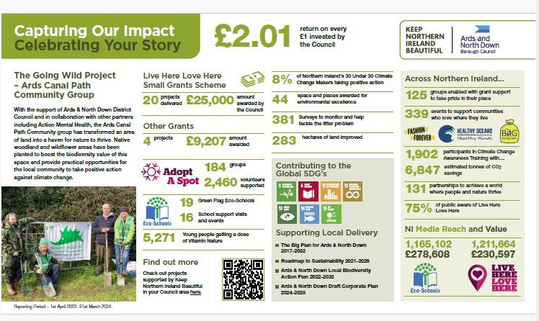

RECOMMENDED that that the Committee notes the report.

Councillor Wray proposed, seconded by Councillor McKee, that the recommendation be adopted.

The proposer Councillor Wray noted the low uptake referred to in the report in respect of Project ELLA adding that he was aware how positive the Programme was. He added that he knew a number of schools which were keen to become involved but had been unable to do so due to issues with Council resources. He asked if it would be possible for updated information on Project ELLA to be circulated to members who could in turn pass that on to schools.

The Head of Regulatory Services advised that the numbers in the report were low as they were reflective of the lower uptake during the months of July and August. He reported that officers had considered how Project ELLA had been delivered and efforts were currently being made to reach out to local schools. It was noted there had been a few issues within the requesting system which had been resolved and it was recognised that education was one of the most successful methods of dealing with Litter and Dog Control issues. The officer indicated that he would be happy to provide information to members which could then be circulated.

At this stage Councillor McKee referred to the Fixed Penalty Notices (FPN) on Page 5 of the report and noted a decrease in Dog Control and an increase in the Environmental Control penalties. He welcomed the increase in Dog Control FPNs issued and sought further clarity around those issued in relation to a breach in control conditions and asked if that related to those areas where there were controls around dogs being on a on lead.

In response the Head of Regulatory Services advised that those controls related to where control conditions had been placed on a specific dog due to a problem which had occurred and the conditions were an attempt to mitigate against any further incidents.

Councillor McKee referred to the figures and asked if there was any way of differentiating if anyone had been issued with a FPN for not having their dog on a lead in a controlled area.

The Head of Regulatory Services suggested no from what he could see in the report, but indicated that he would look into it and report back to the member in due course. At this stage members were reminded of an increase in visible patrols being undertaken in those areas where there were dog on lead controls in place.

Councillor McKee welcomed the increase in patrols stating that he believed it was useful for the Committee to be able to scrutinise the FPNs issued particularly in areas such as Ballyholme, Bangor Seafront and Ward Park, Bangor. He added that it was important for elected members and members of the public to be confident that the matter was being taken seriously.

The Head of Regulatory Services advised that he would be happy to report back to the member in due course.

At this stage Councillor Edmund noted the amount of dog licences issued during the period was 5,414 and asked if officers knew the total number of dog licences for the entire Borough.

In response members were advised that while that information was not immediately to hand, it was the case that it would generally be a fairly even and consistent number throughout the year. The Head of Regulatory Services added that he would report back to the member with the figure as requested.

AGREED TO RECOMMEND, on the proposal of Councillor Wray, seconded by Councillor McKee, that the recommendation be adopted.

7. NORTHERN IRELAND LOCAL AUTHORITY MUNICIPAL WASTE MANAGEMENT STATISTICS – APRIL TO JUNE (FILe 53042)

PREVIOUSLY CIRCULATED: Report from the Director of Environment detailing that the official waste management statistics for the first quarter of 2024/2025 (April to June 2024) had been released by the Northern Ireland Environment Agency.

The aim of this report was to:

- Report key quarterly waste management performance statistics relative to the same period last year (found in part 1 of the report) and to the baseline comparator year of 2021-22 (found in the KPI section of part 2 of the report), and
- Provide some detail around operational waste service management activities/actions that had been implemented during the quarter with the aim of improving performance.

In summary, all key indicators were positive for this reporting period. They showed that not only had the Council sustained the overall gains achieved since it started a renewed programme of performance improvement in 2021-22, but it had also made further significant progress. The reduction in the landfill burden seen over recent quarters had been maintained and further improved upon. Moreover, for the second successive reporting period, our HRC recycling rate had surpassed the average rate achieved in other NI Councils.

Looking at the ‘quality’ of the recycling performance, an important statistic included in DAERA’s report was the proportion of waste sent to landfill which was biodegradable (and therefore more harmful to the environment in terms of landfill gas production). Once again, the Council had the lowest percentage of biodegradable municipal landfill waste, at 35.8% compared to a NI Council average of 46.6%. This reflected the relative success in capturing more biodegradable waste materials for recycling, such as compostable food and garden waste.

Furthermore, in terms of assessing sustainable waste resource management performance, which must be judged in terms of not just recycling rates but also reduction and reuse of waste, it was significant to note that the Council had continued to experience the greatest fall in total municipal waste tonnage of all NI Councils. It achieved an 11.7% drop in municipal waste arisings during this reporting period compared to the same quarter in its baseline assessment year of 2021-22. The average drop across other Councils was just 4%.

Summary Table of Key Changes Q1 2024-25

 | 2021-22 | 2022-23 | 2023-24 | 2024-25 | Change on Previous Yr
Household Waste Recycling Rate | 49.5% | 54.9% | 58.5% | 59.8% | 1.3%
Recycling Rate Ranking | 9th | 6th | 4th | 3rd | 1 place
Composting Rate | 29.6% | 35.1% | 38% | 38.8% | 0.8%
Dry Recycling Rate | 19.6% | 19.5% | 20.2% | 20.6% | 0.4%
Total HRC Waste | 9249T | 7235T | 6873T | 5769T | 16.1%
HRC Residual/Landfill Waste Received | 3664T | 2463T | 2127T | 1474T | 30.7%
HRC Recycling Waste Received | 5585T | 4772T | 4746T | 4295T | 9.5%
Proportion of HRC Waste Received for Recycling | 60% | 66% | 69% | 74.4% | 5.4%
Total Kerbside Waste | 15165T | 16184T | 15185T | 15760T | 3.8%
Kerbside Residual Waste Received | 6509T | 6414T | 5433T | 5645T | 3.9%
Kerbside Recycling Waste Received | 8656T | 9770T | 9752T | 10115T | 3.7%
Proportion of Kerbside Waste Received for Recycling | 57.1% | 60.4% | 64.2% | 64.2% | Same

Spotlight on Landfill Cost Savings to ANDBC Ratepayers

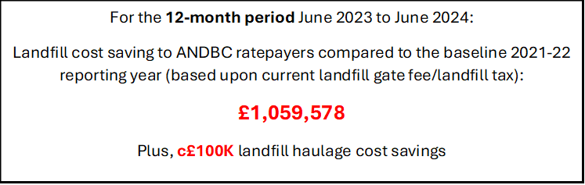

Spotlight on HRCs – Impact of New Access Controls
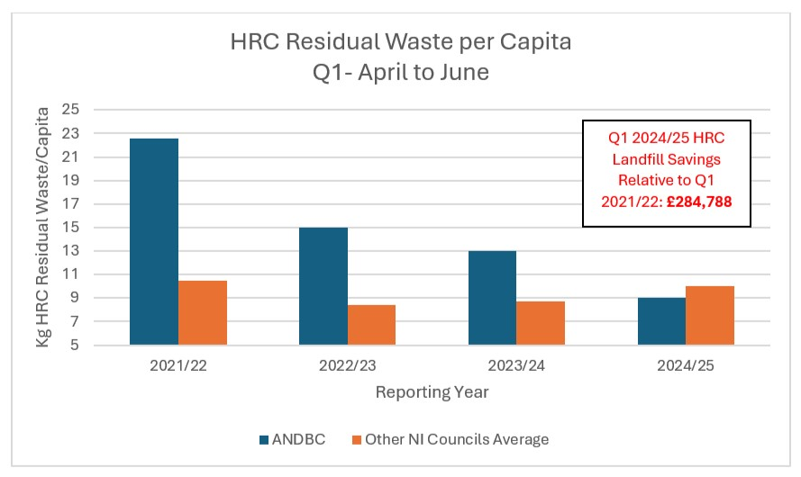

1.0 Northern Ireland Local Authority Collected Municipal Waste Management Statistics – October to December 2023

The significant headlines contained within the latest DAERA report showed that:

- The household waste recycling rate rose by 1.3% compared to Q1 last year, from 58.5% to 59.8%.

- The household waste recycling rate of 59.8%, was 5.3% higher than the NI average of 54.5%.

- The Council ranked third out of the eleven NI Councils for its household waste recycling rate, up one place from last year.

- The Council’s household waste composting rate rose by 0.8% - from 38% to 38.8%. The Council’s household waste dry recycling rate rose by 0.4% - from 20.2% to 20.6%.

- The Council’s household waste composting rate of 38.8% was 6.3% higher than the NI average of 32.5%.

- The Council’s household waste dry recycling rate (i.e. recycling of items other than organic food and garden waste) of 20.6% was 1.2% lower than the N.I. average of 21.8%.

- The Council’s kerbside recycling capture rate of 81.4% for household compostable waste materials was the highest in NI and compared to a NI Council average of 73.8%.

- The Council’s lowest kerbside capture rate for recyclable materials was for mixed plastics, at 25.2%.

Kerbside Capture Rate for Recyclable Waste Types – October to December
Recyclable Material | Kerbside Capture Rate for Recycling % | NI Average Kerbside Capture Rate for Recycling %
Glass | 66.1 | 55.3
Paper & Card | 63.8 | 53
Mixed Metals | 37.9 | 31.6
Mixed Plastics | 25.2 | 22.5
Organic/Compostables | 81.4 | 73.8

- The Council was ranked 9th in the Council performance table for ‘dry’ recycling rate and 1st for composting rate.

- The Council received 9.1% less total waste per capita at its HRCs compared to the average for other NI Councils, compared to 15% more waste during the same period the previous year.

- The received 10% less residual/landfill waste per capita at its HRCs compared to the average for other Councils, compared to 49% more during the same period the previous year.

- For the second successive quarter, the proportion of waste collected at its HRC sites for recycling was more than the average for other Councils – 70.4%, compared to an average rate of 70% for other Councils.

- The Council collected 9.6% more waste per capita from homes through its kerbside bin collection services compared to the average for other Councils.

- The Council collected 17.9% less residual/landfill waste per capita from homes through its kerbside bin collection services compared to the average for other Councils.

- The proportion of waste collected for recycling through its kerbside bin collection system was significantly higher than the average for other Councils – 64.2%, compared to an average of 52.1% for other Councils.

2.0 Operational Performance Improvement Measures

2.1 Marketing and Communications Indicators

MC1 – Twenty social media posts were issued, with associated engagement/ management of feedback across Waste and Recycling on the Council’s corporate channels. Topics included Recycling aluminium, spring cleaning, battery recycling and holiday bin collections.
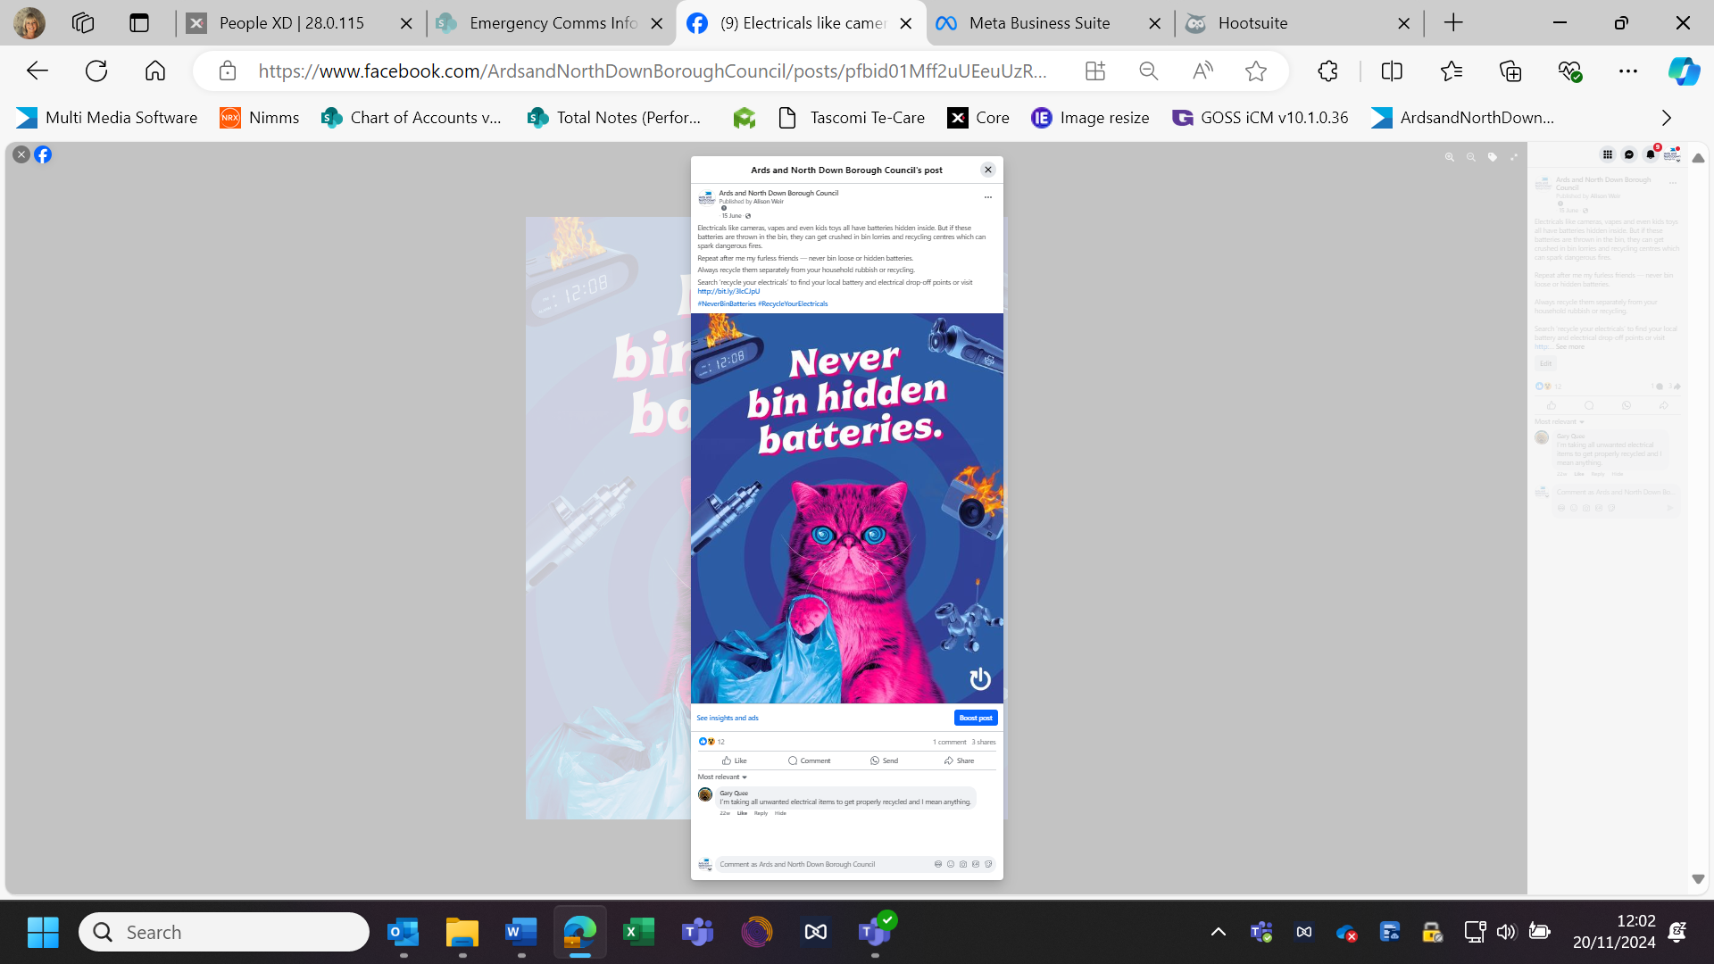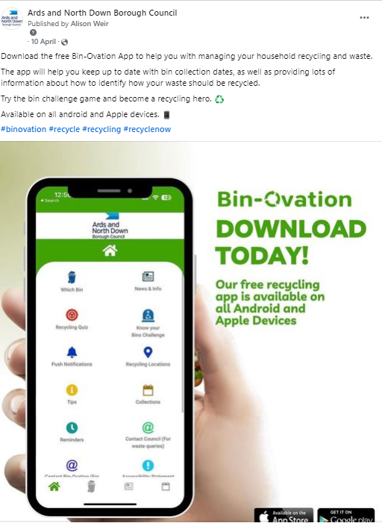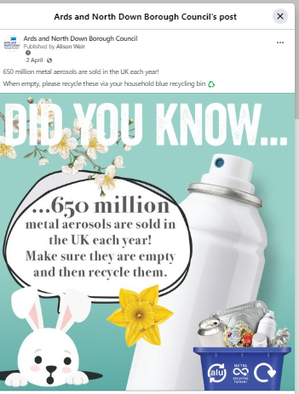
MC2 – Eight Bin-Ovation ‘News and Info’ articles were published, seven Bin-ovation ‘Push Notifications’ issued, and 1683 Bin-ovation downloads recorded.



MC3 – Officers delivered fourteen community and engagement events, talking to over 870 people.

- 9 Community groups and schools
- 1 Community information event
- 4 Summer schemes
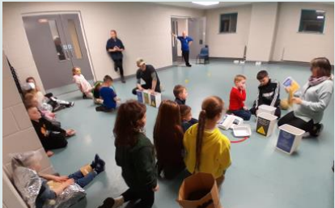

2.2 Household Recycling Centre Indicators

HRC1 – Volume of blue bin recyclable materials separated from mixed waste by residents on-site: 738,380 litres.

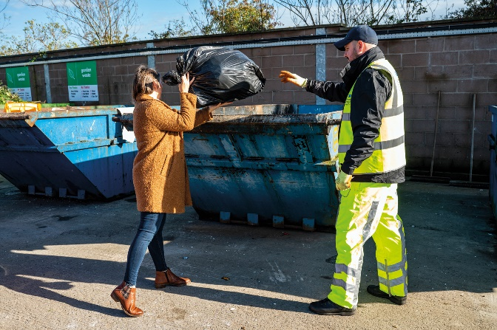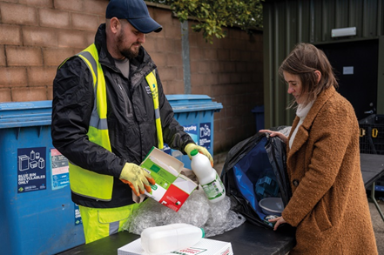
This equated to approximately 31 tons of blue bin waste; whilst this was a relatively modest weight of material, it represented a very large/visible volume of recyclable waste extracted from bags of mixed waste which was initially intended to be placed landfill skips at HRCs. A collateral benefit of this practice of requiring removal of blue bin recyclables from black bags of mixed waste before using the landfill skip was that it should help to ‘educate’ householders - promoting more efficient separation of waste in the home and greater use of blue bins at the kerbside.
This represented just one type of recyclable waste category which was prevented from entering landfill skips at HRCs as a consequence of its more focused attention to supervision of landfill skip access; many other recyclable waste types would also have been prevented from entering the landfill skips as reflected in KPI, HRC3.

HRC2 – Number of visitors turned away from site: 573
This was a significant number in itself, but it was likely to be the case that a significant number of out of Borough residents would have avoided coming to the sites because of the widely publicised focus upon checking ID for everyone entering and those turned away would in all probability avoid further attempts to enter and use the HRCs; the impact of this would also be reflected in HRC3 and other KPIs.

HRC2a – Number of HRC bookings: 84,451
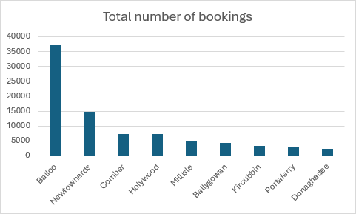
HRC2b – Average number of HRC visits per household: 1.18 (averaged across the 71,698 households in the Borough)
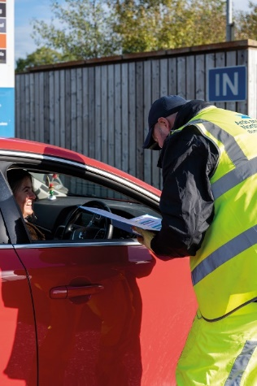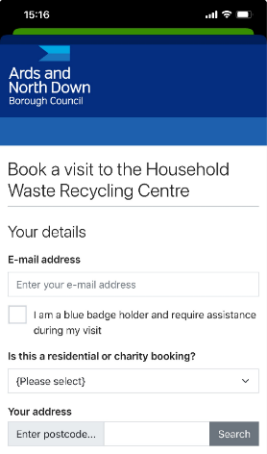

HRC3 – % change in tonnage of total waste received (compared to same period in baseline year 2021-22)

- Council experienced a 38% decrease in the total amount of waste received at its HRCs, from 9249T to 5769T.

HRC4 - % change in tonnage of waste received for landfill (compared to same period in baseline year 2021-22)

- Council experienced a 60% decrease in the amount of waste received for landfill at its HRCs, down from 3664T to 1474T.

HRC5 - % change in tonnage of waste received for recycling (compared to same period in baseline year 2021-22)

- Council experienced a 23.1% decrease in the amount of waste received for recycling at its HRCs, down from 5585T to 4295T.

HRC6 - % change in proportion of HRC waste materials collected for recycling (compared to same period in baseline year 2021-22)

- Council experienced a 14.4% increase in the proportion of all waste received at HRCs which was collected for recycling, up from 60% to 74.4%.

2.3 Kerbside Household Waste Collections Indicators

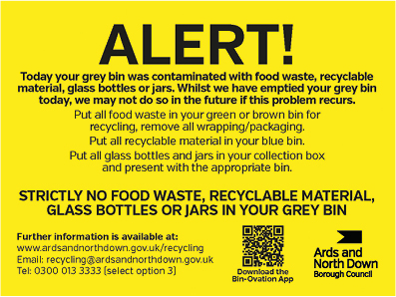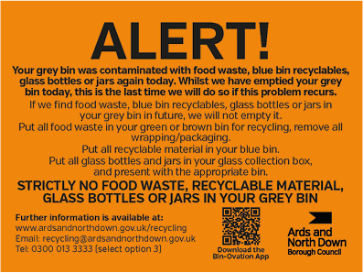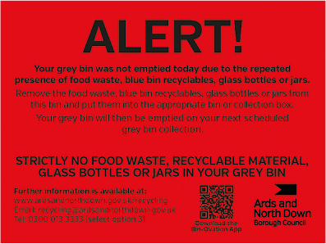
KSI – Number of recycling alert stickers applied to grey bins (yellow): 2505
KS2 – Number of recycling alert stickers applied to grey bins (amber): 231
KS3 – Number of recycling alert stickers applied to grey bins (red): 164
KS4 – % change in tonnage of total waste collected (compared to same period in baseline year 2021-22)

- Council experienced a 3.9% increase in the total amount collected at the kerbside, up from 15165T to 15760T.

KS5 - % change in tonnage of grey bin waste collected for landfill (compared to same period in baseline year 2021-22)

- Council experienced a 13.3% decrease in the amount of grey bin waste collected, down from 6509T to 5645T.

KS6 - % change in tonnage of waste collected at kerbside for recycling (compared to same period in baseline year 2021-22)

- Council experienced a 16.9% increase in the amount of waste collected at kerbside for recycling, up from 8656T to 10115T.

KS7 – % change in proportion of kerbside waste materials collected for recycling (compared to same period in baseline year 2021-22)

- Council experienced a 7.1% increase in the proportion of kerbside waste that was collected for recycling, up from 57.1% to 64.2%.

2.4 Summary and Trend Analysis of Indicators
Indicator Reference | Monitoring  Period 1  (December 2022 – March 2023*)  *Waste tonnage indicators reflect period Jan to March 2023 only | Monitoring Period 2  (April 2023 – June 2023) | Monitoring Period 3  (July 2023 – Sept 2023) | Monitoring Period 4 (October 2023 – Dec 2023) | Monitoring Period 5 (January 2024 – Mar 2023) | Monitoring Period 6 (April 2024 – June 2024
MC1  Social media posts | 25 | 23 | 43 | 36 | 31 | 20
MC2  Print press and online articles | 10 | 13 | 55 | 7 | 12 | 15
MC3  Engagement events/sessions | 17 | 29 | 14 | 5 | 12 | 14
HRC1  Blue bin waste (litres) | 1,322,000 | 762,460 | 604,600 | 769,002 | 862,000 | 738,380
HRC2  Visitors denied entry | 1742 | 397 | 262 | 1258 | 528 | 573
HRC2a  No. of bookings | N/A | N/A | 22,199 | 72,423 | 68,353 | 84,451
HRC2b  Average no. of HRC visits per household in the Borough | N/A | N/A | 0.3 | 1.02 | 0.96 | 1.18
HRC3  Total HRC waste compared to same period 2021/22 | 16% Decrease | 26% Decrease | 19% Decrease | 34% Decrease | 26% Decrease | 38% Decrease
HRC4  Landfill skip waste compared to same period 2021/22 | 27% Decrease | 42% Decrease | 32% Decrease | 50% Decrease | 47% Decrease | 60% Decrease
HRC5  Recycling skip waste compared to same period 2021/22 | 8% Decrease | 15% Decrease | 11% Decrease | 24% Decrease | 11% Decrease | 23.1% Decrease
HRC6  Proportion of HRC waste collected for recycling compared to same period 2021/22 | 5.5% Increase | 9.1% Increase | 6% Increase | 9.5% Increase | 11.7% Increase | 14.4% Increase
KS1  Yellow warning stickers on grey bins | 2784 | 6079 | 2714 | 2269 | 2939 | 2505
KS2  Amber warning stickers on grey bins | 255 | 414 | 226 | 165 | 281 | 231
KS3  Red warning stickers on grey bins | 52 | 179 | 92 | 55 | 116 | 164
KS4  Total kerbside waste compared to 2021/22 | 4.8% Increase | 0% No Change | 5% Decrease | 1% Decrease | 8.2% Increase | 3.9% Increase
KS5  Grey bin waste compared to 2021/22 | 9.3% Decrease | 16.5% Decrease | 17.4% Decrease | 10% Decrease | 2% Decrease | 13.3% Decrease
KS6  Kerbside waste collected for recycling compared to same period 2021/22 | 20.7% Increase | 13% Decrease | 4.9% Increase | 6.2% Increase | 20.4% Increase | 16.9% Increase
KS7  Proportion of kerbside waste collected for recycling compared to same period 2021/22 | 7.2% Increase | 7% Increase | 5.2% Increase | 4.3% Increase | 5.2% Increase | 7.1% Increase

Summary Assessment

This report confirmed continued improvement in the sustainable waste resource management performance. Following the changes to waste service model design and the associated education and engagement campaigns, the Council was experiencing sustained falls in the amount of landfilled waste as well as improvements in recycling rates. During this reporting period, the Council experienced:

- A significant sustained reduction in the amount of landfill waste received at our HRCs, as well as a significant fall in kerbside collected landfill waste. In total, it received/collected 3054 tons less of landfill waste at the kerbside and HRCs over this three-month reporting period compared to the same period in the baseline year of 2021/22; at prevailing landfill cost (£130.04/T), this represented a £397,142 landfill saving (plus other handling and transport cost savings).
- Sustained significant fall in the total amount of waste collected at HRCs and kerbside. In total the municipal waste arisings had fallen by 11.7% compared to the same period in the baseline year of 2021-22; this compared to a fall of just 4% on average across other NI Councils.
- A significant rise in the kerbside recycling rate. The percentage of materials collected for recycling at the kerbside had risen by 7.1% compared to the same period in the baseline year of 2021/22.
- An even more significant rise in our HRC recycling rate. The percentage of materials collected for recycling at our HRCs had risen by 14.4% compared to the same period in the baseline year of 2021/22.

Whilst the information set out in this report maintained a very encouraging picture of progress and reflected a lot of hard work and dedication on the part of the waste and recycling teams, the Council must maintain a sustained focus upon the further progress that would be required if it was to have any chance of ultimately reaching the 70% recycling target for 2030 that was laid down in the Climate Change Act (Northern Ireland) 2022. Continued bedding in and careful monitoring and management of the HRC access booking system, the ongoing review of kerbside collections model and a future strategic review of our HRC capital assets, would be critical.

It was important to reiterate that further ‘step change’, sustained improvements in both the HRC and kerbside recycling rates would be required to move the Council towards the new 70% target.

RECOMMENDED that the Council notes the report.

Councillor Edmund proposed, seconded by Councillor Irwin, that the recommendation be adopted.

The proposer Councillor Edmund welcomed the report and congratulated officers on the savings which had been achieved.

Echoing those comments the seconder Councillor Irwin sought an update on the Textile Recycling Service.

The Head of Waste and Cleansing Services indicated that at present there had been no market improvements in this area and instead the situation had got worse.

The Director acknowledged that members were very invested in this particularly as textiles were a very recyclable material. He confirmed that Council facilities still accepted textiles and was keen to expand upon that as soon as possible particularly as the kerbside collection infrastructure was already in place. He assured members that officers would be closely monitoring the situation and would proceed with kerbside textile collection arrangements as soon as they were confident that they could secure market off-take for these.

Councillor Irwin welcomed officers comments adding that part of the issue was over consumption and fast fashion and suggested that people should instead consider shopping more sustainably.

At this stage Alderman Armstrong-Cotter also welcomed the report and continuing she sought some clarification around procedures at the Council’s HRCs following an issue which had been raised with her by a constituent. The constituent in question advised that she had sorted her waste appropriately but on arrival at the HRC had been asked to take it to the sorting table where the HRC Operatives had opened it to find it contained various sanitary products, leaving the constituent somewhat embarrassed. As such Alderman Armstrong-Cotter asked if there was anyway sanitary products could be dealt with differently at HRCs. She added that this incident had occurred at the Newtownards HRC site and while the constituent did not wish to get anyone into trouble she had felt vulnerable and as such would not wish for anyone to have to go through what she had. Continuing Alderman Armstrong-Cotter then referred to the Dry Recycling Rates which were down and asked if there were any plans to try to increase that or was it a case those rates were settling at this point.

In response the Director advised that the Council’s tonnage in relation to dry recyclables was one of the best in UK, but our residual waste was also high – keeping the dry recycling ‘rate’ low in comparison. He advised that this was a key area of consideration for the Kerbside Collections Working Group, and the group was looking at how the collections model could help improve that alongside education. Referring specifically to the issue raised by Alderman Armstrong-Cotter the Director asked that any complaint by members of the public at any of the Council sites should be reported to officers to allow follow up on the particulars of that particular incident. This was the first time an issue of this nature had been raised as far as he was aware. He reminded members that all households were issues with a 240l grey waste bin collected on a fortnightly basis and that would be the usual means of disposal for those items referred to by Alderman Armstrong-Cotter. Continuing he advised that it would be normal practice for HRC operatives to periodically ask members of the public to open any black bags brought to the facility and retrieve recyclable waste items, as most of the time they contained up to 90% of dry recyclables. He added however that he was not aware of HRC staff taking the black bags from members of the public and sorting through them in the manner outlined by the member.

In response Alderman Armstrong-Cotter stated that she had been asked by the constituent to raise the matter to ensure no one else would have to go through what she had went through. She added that two HRC Operatives one male and one female had brought her waste over to the sorting table. Continuing Alderman Armstrong-Cotter asked if there was anyway a further option for bathroom waste could be added to the drop down list of options on the HRC booking system.

The Director advised that it was normal practice for that type of waste to go into the grey bin with very little amounts of this waste being brought to HRCs. He added that officers were keen not to over complicate the booking system by providing a large variety of options and thereby putting people off using the system.

Alderman Armstrong-Cotter advised that the constituent in question had indicated that she would not return to the HRC which was a shame as the HRCs were there to dispose of any types of waste. Therefore she asked for further consideration to be given to how bathroom waste was dealt with.

AGREED TO RECOMMEND, on the proposal of Councillor Edmund, seconded by Councillor Irwin, that the recommendation be adopted.

8. QUARTERLY SUSTAINABLE ENERGY management STRATEGY PROGRESS REPORT Q2 2024-25 (FILE 50002) (appendix I)

PREVIOUSLY CIRCULATED: Report from the Director of Environment detailing that in June 2024 the Council agreed the Sustainable Energy Management Strategy and Action Plan. One of the actions within the Plan was to “Improve governance arrangements to ensure that energy management had effective oversight and accountability within the Council.”

Improving oversight and accountability within the Council for energy management would ensure that consumption performance and the implementation of the Strategy and this action plan would be continuously monitored. Improved monitoring and governance would improve energy performance by ensuring actions were effectively implemented and consumption trends routinely monitored, which should result in reduced consumption, costs, and emissions.

Reporting Periods

The following was a schedule of planned routine quarterly reports that looked at energy consumption against a 2019 baseline and outlined current and forthcoming energy saving initiatives and provided some detail around our progress in relation to sustainable energy management and associated carbon emission reduction targets set out in the Climate Change Act.

Period: | Reported in:
Quarter 1: April to June | September
Quarter 2: July to September | December
Quarter 3: October to December | March
Quarter 4: January to March | June

Energy Consumption for this Period

Electricity

As could be seen in the graph above the electricity consumption decreased by 16.6% for Q2 in comparison to the baseline year of 2019/2020. The Council had been reviewing its electric consumption year on year and had made conscious efforts to replace light fittings with LED as part of our general maintenance and also replace equipment with more energy efficient versions generally.

There had been a significant decrease in Q2 in comparison to the baseline year, and it would be aiming to reduce this further by introducing additional measures and educating staff to help move towards the 2030 target.

Natural Gas

With regard to the natural gas consumption this reduced by 8.3% for Q2 in comparison to the baseline year of 2019/2020.This had been the result of reviewing time controls for boilers and reducing temperatures where possible. It had also been due to a number of internal reviews that led to AHU operating times being reduced to suit higher occupancy times in buildings.

Kerosene

Kerosene consumption increased from the baseline year of 2019/20 for Q2, and this was similar to the buildings using electric heating. More cold snaps in the region during Q2 meant that oil fired heating boilers have had to be in operation more than was usual for that time of year.

Diesel

The figures showed that the Council also increased the use of Derv (Diesel) in the second period of the business year in comparison to the baseline year. It was hoped that could be improved further in Q3.

Targets and Trends

In the graph below it showed the current overall fuel emissions for each of the periods, and the 2030 target. The Linear trendline showed the path the Council should be on in order to meet its 48% reduction by 2030, and it could be seen that there was some work to do to further reduce emissions to match the trendline.

Energy Consumption Costs

The costs of the fuels could be seen in the table below for consumption in each of the years, the cost per unit of fuel had also been shown for the respective years so that the difference could be seen in the market costs.

Quarter 2 | 2019/20 | £/unit | 2024/2025 | £/unit
Utility
Electric | £149,319 | £0.12 | £262,040 | £0.20
Gas | £154,365 | £0.05 | £192,088 | £0.06
Kerosene | £204 | £0.42 | £3,093 | £0.58
Derv | £194,027 | £1.03 | £238,934 | £1.14
Total Cost | £497,916 |  | £696,154

Cumulative and Historic Combined Target for 2024/2025

The charts below showed a cumulative total for Q1 and Q2 in 2024/25.

The chart above showed cumulative totals for Q1 and Q2 in the baseline year of 2019/20, the current year of 24/25 and what the target would be for Q1 and Q2 in 2030. It showed that so far, the Council had a 18% reduction in emissions for 2024/25 in comparison to its baseline year of 2019/20. This meant that it needed a further reduction of circa 36% over the next five years if it was to achieve its 48% reduction on the 2019/20 baseline figures.

Highlights of Energy Saving Initiatives Taken in This Period

- LED lighting and controls upgrade at Walled Garden Depot Work Shed
- Controls Maintenance at Londonderry Park and Hamilton Hub
- LED Lighting Replacement schemes at Community Centres
- Electric Showers, and Instantaneous Water Heaters at Ward Arras Sports Pavilion to replace existing hot water calorifiers.
- High Efficiency boiler replacements to a number of communities properties.
- Early stages of pre-planning for Data Centre at ABMWLC and Aurora for heat recovery to provide pool water heating.
- Progressing with PV installation following a cross-border grant award.
- Installation of EV charging points for small and medium vans in fleet had started at North Road Depot.

The updated Sustainable Energy Action Plan attached at Appendix 1 provided a full update on each of the actions noted.

Future Measures Currently Under Consideration/Planning

- Replacement of boilers at various Council properties and upgrade of control systems.
- Lighting control and LED replacement projects at numerous Council properties.
- PV Installation at chosen Council properties.
- Park lighting projects.
- Walk-round surveys of properties to examine existing controls and settings.
- Surveys of existing assets for insulation installation to be carried out.
- Energy targets and KPI’s for service unit managers to be agreed for 2025/2026
- Possible introduction of Automatic Meter Reading (AMR) systems in highest consuming buildings

RECOMMENDED that the Council notes this progress report.

Councillor Edmund proposed, seconded by Councillor McKee, that the recommendation be adopted.

The seconder Councillor McKee commented that it was a positive report and he welcomed it coming forward.

AGREED TO RECOMMEND, on the proposal of Councillor Edmund, seconded by Councillor McKee, that the recommendation be adopted.

9. ANY OTHER NOTIFIED BUSINESS

There were no items of Any Other Notified Business.

NOTED.

Exclusion of Public/Press

AGREED, on the proposal of Alderman Cummings, seconded by Councillor Kerr, that the public/press be excluded during the discussion of the undernoted items of confidential business.

REPORTS FOR APPROVAL

10. TENDERS FOR THE DESIGN, SUPPLY, INSTALLATION AND MAINTENANCE OF SOLAR PV SYSTEMS AT VARIOUS COUNCIL PROERTIES (FILE 77001)

***IN CONFIDENCE***

NOT FOR PUBLICATION SCHEDULE 6 – INFORMATION RELATING TO THE FINANCIAL OR BUSINESS AFFAIRS OF ANY PARTICULAR PERSON (INCLUDING THE COUNCIL HOLDNG THAT INFORMATION)

A report on tenders for the Design, Supply, Installation and Maintenance of Solar PV Systems at Various Council Properties, was considered.

It was agreed that a contract be awarded to Solmatix Limited.

11. ITEM WITHDRAWN

The Chairman advised that the item had been withdrawn.

NOTED.

Re-admittance of public/press

AGREED, on the proposal of Councillor Boyle, seconded by Alderman Cummings, that the public/press be re-admitted to the meeting.

Termination of meeting

The meeting terminated at 8.05pm.

