Ards and North Down Borough Council

A hybrid meeting (in person and via Zoom) of the Environment Committee was held at the Council Chamber, Church Street, Newtownards and via Zoom, on Wednesday, 4th September 2024 at 7.00 pm.

PRESENT:

In the Chair: McAlpine

Aldermen: Armstrong-Cotter
Cummings

Councillors: Blaney Irwin
Boyle McKee (Zoom)
Cathcart Morgan
Douglas Smart (Zoom)
Edmund Wray

Officers: Director of Environment (D Lindsay), Head of Waste and Cleansing Services (N Martin), Head of Assets and Property Services (P Caldwell), Head of Regulatory Services (R McCracken) and Democratic Services Officer (H Loebnau)

1. Apologies

Apologies were received from Councillor Rossiter.

NOTED.

2. Declarations of Interest

There were no declarations of interest.

NOTED.

3. RESPONSE TO nOTICE OF MOTION – STATION ROAD DOG CONTROL ORDER

PREVIOUSLY CIRCULATED:- Report from the Director of Environment detailing that a Notice of Motion was agreed by the Council as followed:

That Council brings a report with a view to implementing a “dogs on leads” policy on that part of the Coastal Path which traverses the private road serving the properties 91 to 117 Station Road, Holywood inclusive.

Aim of Introducing a Dog Control Order
The Members bringing the Motion had received a complaint about dogs fouling on the pathway and of dogs straying into private gardens and fouling there.

The aim of the proposed Dog Control Order would be to reduce dog fouling along this approximately 470m length of the North Down Coastal Path, by requiring dogs to be kept on a lead of not more than 2m length when on that stretch of the coastal path.

When dogs were kept on a lead in that manner, the opportunity to foul without the knowledge of the responsible person was reduced.

This stretch of the coastal path was a private road, which was a shared private driveway, over which there was a public access right of way.

Enforcement History
In a search of Council records for the past year, there had only been one reported incident on this section of the coastal path, of a ‘dog not under adequate control’. There have been no recorded incidents of dog fouling in that time period.

Power to Make Dog Control Orders
The Clean Neighbourhoods and Environment Act (NI) 2011 (Sect. 40) provided the Council with the power to create an Order establishing a specified offence or offences relating to the control of dogs in respect of any land in its district (known as a “Dog Control Order”). In relation to dogs on leads, this part applied to any land which was open to the air and to which the public were entitled or permitted to have access (with or without payment).

Specified offences included ‘not keeping dogs on leads in a designated area’, and the Dog Control Orders (Prescribed Offences and Penalties, etc.) Regulations (Northern Ireland) 2012 provided the method of creating such an Order. It was not possible to completely exclude dogs from a road since that particular control was exempted on roads (as defined by The Controls on Dogs (Non-applicable to Designated Land) Order (Northern Ireland) 2012).

Dog Control Orders: Supplementary
Section 41 of the Act provided for the Department to prescribe the penalties, or maximum penalties, which may be provided for in a Dog Control Order in relation to any offence. A fine may not exceed Level 3 on the standard scale in relation to any offence (currently £1000).

The current level agreed for all Dog Control Order offences was £80 fixed penalty, discounted to £60 if paid within 14 days.

The Members bringing the NOM had received a complaint about dogs fouling on the roadway and of dogs straying into private gardens and fouling there.

Consideration of Possible Introduction of Dog Control Order
Benefits of creating this particular Dog Control Order included the regulation of a section of coastal path where:

- residents directly affected may welcome the introduction of such a control
- dogs on leads cannot stray into adjacent gardens
- dogs on leads were unlikely to foul without the knowledge of the responsible dog walker
- dogs on leads were more likely to be under control and be less likely to be involved in attacks or incidents with runners or cyclists.

Disbenefits of creating this Dog Control Order included:

- the added restriction imposed on dog exercise may be opposed
- Council enforcement capacity would be limited due to staffing capacity and the difficulties associated with identifying offenders
- potential to create an expectation of further control areas elsewhere in the Borough, with the resource pressures that would create.
- no offence was committed where the person had a reasonable excuse for failing to keep the dog on a lead, or the owner, occupier or other person or authority having control of the land had consented (generally or specifically) to the person failing to do so. Landowners and occupiers would be exempt and could permit others to walk dogs without leads, only on the land owned by them. They may also oppose introduction.

Land Ownership
The area of land under consideration was a section of the coastal path, between points A and B on the map below. It was a private road with a public access right of way over it. It was not owned or maintained by the Council and officers were aware of previous land dispute issues in the vicinity.

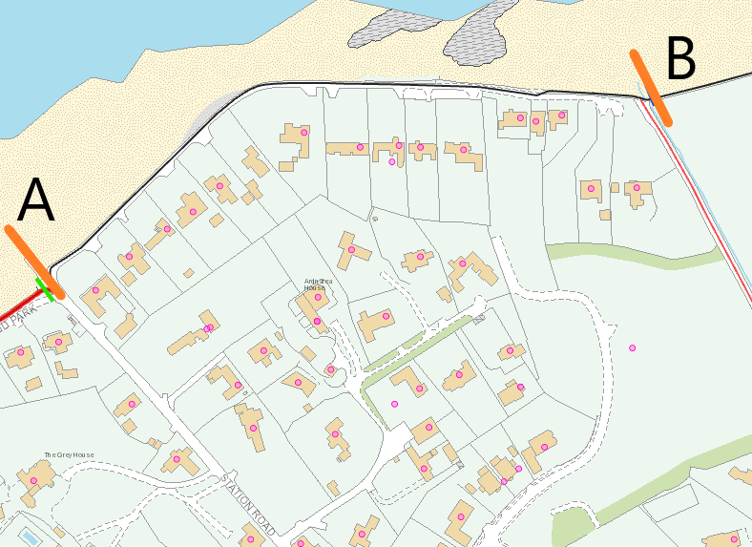

Statutory signage would be required at either end of the designated roadway.

Unfortunately, the land at both ends of the proposed restricted section was unregistered and the Lands Section had been unable to establish ownership.

In order to erect poles and signage it would be necessary for the Council to do so at risk. The Order could not be enforced without signage.

The specified wording to be used in, and the form of, a Dog Control Order was detailed at Appendix A. The statutory procedure for implementing Dog Control Orders was outlined in Appendix B.

Next Steps
Should the Council decide to progress the making of a Dog Control Order, the actions required would include:

- Further attempted clarification of land ownership/use for erecting
signage
- A public consultation exercise
- The hearing of any representations by the Council
- A final decision by the Council on the making of an Order.

Cost to the Council of implementation (consultation process and signage) was envisaged to be in the region of £500. That did not allow for any legal costs associated with potential land dispute issues that may arise with the making of an Order at this location.

It would be anticipated that a 6-month time frame could be expected.

RECOMMENDED that the Council decides whether to proceed with the process of making a Dog Control Order as set out in this report.

Proposed by Councillor Cathcart, seconded by Councillor Edmund, that the Council proceed with making a Dog Control Order as set out in this report.

Councillor Cathcart thanked officers for the detail within the report which had come about following a Notice of Motion brought by Alderman Graham to the Environment Committee. He stressed that this was quite a unique part of the coastal path and agreed that it was inappropriate not to have dogs on leads in that area. It was also for that reason that he did not believe it should set a precedent for other parts of the Borough.

Councillor Edmund saw the very real problem in this place with the path being close to local residents’ gardens and he understood that dogs straying into private property would be an annoyance and he stressed the need to take appropriate action to improve the situation for residents.

Councillor Morgan also supported the recommendation but had concerns about setting a precedent and pointed out that while dog fouling was horrible, dog owners already had a duty to clear it up. She asked where the funding of £500 for signage was coming from and the Head of Regulatory Services explained that would come from the existing NET budget.

Councillor Wray was happy to support the proposal and knowing the area he thought it made sense. He shared the concern about further calls for similar control in other residential areas and believed it should be stressed that this was a very specific area of the coastal path, and the Council had no plans to extend it further.

The Member went on to query the land ownership of that area and if that could be established and in response the Head of Regulatory Services explained that that was ongoing work and did not affect the setting up of a Dog Control Order.

AGREED TO RECOMMEND, on the proposal of Councillor Cathcart, seconded by Councillor Edmund, that the recommendation be adopted and that the Council proceed with making a Dog Control Order as set out in this report.

4. REQUEST FROM LIDL REGARDING SUNDAY TRADING
(Appendix I)

PREVIOUSLY CIRCULATED: Report from the Director of Environment detailing that
Members would recall that a report was brought to Committee in June 2024 advising that Lidl Northern Ireland Limited had written to request that the Council consider making Newtownards and Bangor ‘seasonal towns’ in order that they could benefit from extended Sunday opening hours.

Currently, large shops with a retail space over 280 sq. metres can only open on a Sunday between the hours of 1pm and 6pm excluding Easter Sunday or Christmas Day; with a few exceptions including petrol stations, pharmacies and shops selling motor supplies and accessories.

Under the Shops (Sunday Trading &c) (NI) Order 1997 a Council can designate an area as a holiday resort which would permit extended Sunday trading hours in large shops between 1 March and 30 September each year, on up to 18 days. The term holiday resort was not defined in the Order.

Ards Borough Council had previously designated Donaghadee and Ballywalter.

It was agreed that “Council engages with both Bangor and Ards Chambers of Commerce, along with relevant unions to seek views regarding the request from Lidl to extend Sunday opening”.

Officers engaged with the four Trade Unions listed as representing the retail in Northern Ireland; GMB, SIPTU, USDAW and Unite, who were asked to make any comments on the matter by 16 August 2024.

Unite requested additional information, however, did not make any comments.

The response in Appendix 1 was received from USDAW who stated they firmly believed that no decision to extend Sunday trading hours should be made without considerable further consultation with retail workers who would have their working and personal lives directly impacted by the decision. USDAW also advised they would be happy to facilitate a meeting should the Council decide to progress with the designation process. No comments were made by GMB or SIPTU.

Officers also engaged with Bangor and Ards Chambers through the City and Town Advisory Groups. Ards Chamber opposed the designation of Newtownards as a holiday resort under the Shops (Sunday Trading &c) (NI) Order 1997.

Bangor Chamber stated they would be supportive of the designation of Bangor as a holiday resort under the Shops (Sunday Trading &c) (NI) Order 1997. They referred to the Queens Parade re-development and how it would be advantageous to have more flexible opening times for tourists and shoppers in the city when it was completed.

One further expression of support for the designation of holiday resorts was received by email from an individual who stated they were in agreement. This individual’s interest and connection to the retail sector was currently unknown.

The designation process was set out in the Order. If the Council made a designation, it shall publish a notice of the designation.

RECOMMENDED that the Council considers the responses from the Trade Unions and Bangor and Ards Chambers and decide if it wishes to designate Bangor and/or Newtownards as holiday resorts.

Proposed by Alderman Armstrong-Cotter, seconded by Councillor Edmund that the report be noted and that neither Bangor nor Ards be designated as holiday resorts at this time.

Alderman Armstrong-Cotter was mindful that this was a relatively easy decision to make in terms of Newtownards where the Chamber of Commerce had shown support for the needs of families, those who would be expected to work additional hours and also people who observed a day of rest as part of their faith. She referred to student employment she had had when younger and the pressure she had felt to work on a Sunday and indeed had had a job offer retracted because of her unwillingness to work on that day. She had not heard any argument to suggest that a change was necessary and until a strong reason was presented, she believed the position should remain as it was.

Councillor Edmund referred to the pressures faced by those who worked in retail, and he said it happened across the board and at different times of the year. He believed that making this decision protected staff, students and their wider families and allowed them to enjoy a longer day of recreation.
Although Councillor McKee respected the views of Bangor Chamber of Commerce on this issue, he was also happy to support the proposal not to pursue extended opening hours for either Bangor or Newtownards. He thought there were sufficient hours in a week and a day off was important to protect a balance for retail workers. He did not think it was appropriate to decide at the present time without having consulted with those who would be affected by the decision. He reminded Members that long term sustainable growth within the economy relied on more than the retail sector alone.

Councillor Boyle stated that Sunday Trading hours came before the Council from time to time and while he understood the very important position of the family and faith within society, he had run a retail business most of his life and recognised the needs of businesses. His view was that the Council had a duty to protect small businesses throughout the Borough and there were many family businesses who had a personal attachment to their customers, and he was sure that the big multi nationals did not care so much about individuals as long as they were making a profit. He cautioned allowing these large businesses to become a one stop shop which would be very detrimental to villages and towns across the Borough. He viewed Newtownards as having more of an affinity with small businesses so whether a person did not want to work due to their faith, family time, the need for a break, no wish to work seven days a week, equal protection should be given to the businesses that had operated locally for generations. It was clear that big businesses were welcome, but he thought people should be wary of giving them a free run while forgetting to protect the Borough’s own small business ratepayers.

Councillor Cathcart asked what form of consultation would take place if the Council was to proceed and the Committee was informed that there was no formal process in terms of consultation and that it was in the gift of the Council to agree. The Member stated that in his opinion the existing legislation was clumsy and referred to the differences between Bangor and Newtownards. He did not think that holiday makers and tourists were actively seeking to shop in Lidl on a Sunday morning and had concern for smaller businesses and retail workers. While it was known that there was legal protection for workers there remained pressure for those people when additional hours were added. He would have preferred to have explored the options for Bangor more fully but would prefer to explore that under new legislation.

Councillor Morgan expressed that she would struggle to support the proposal and pointed to the protection workers had under the Shops (Sunday Trading) NI Order 1997 and reminded the Committee that the decision only related to 18 Sundays each year. She considered that shopping was a leisure activity for many people and thought that Bangor was clearly a tourist destination with Pickie, the Marina and the fairground.

Councillor Smart felt he could support the proposal and it was clear from the Chamber of Commerce in Newtownards that the intention was to support small businesses since the Sunday Trading legislation was one of the few advantages that they had at this time. He viewed the proposal as the right way forward and the Council would respond and consider Bangor further in time.

Alderman Armstrong-Cotter thanked Members for their comments, and she understood the points that had been raised against her proposal however she warned against a knock-on effect on smaller shops which could break them. While protections were in place under current legislation, she doubted many students would be in the position to take legal action to enforce their rights if necessary. She believed that power lay with the Council currently and she was not hearing any points that suggested she should reconsider her proposal.

When a vote was taken with a show of hands 9 voted in Favour of the proposal, 2 voted Against, one Abstained and the proposal was CARRIED.
AGREED TO RECOMMEND, on the proposal of Alderman Armstrong-Cotter, seconded by Councillor Edmund, that neither Bangor nor Ards be designated as holiday resorts at this time.

5. GRANT OF ENTERTAINMENT LICENCE

PREVIOUSLY CIRCULATED: Report from the Director of Environment detailing that applications had been received for the Grant of an Entertainments Licence as followed:

- McKenna Community Centre, McKenna Road, Kircubbin, BT22 1AS

Applicant: Emma Keith, 19a Deerpark Road, Portaferry, BT22 1PN

Days and Hours:
Monday to Sunday during the permitted hours when alcohol may be served on these premises under the Licensing (NI) Order 1996

Type of entertainment:
A theatrical performance;
Dancing, singing or music or any other entertainment of a like kind;
Any entertainment which consists of or includes a public contest match, exhibition or display of boxing, wrestling, judo, karate or any similar sport, billiards, pool, snooker or any similar game, darts. Equipment for Playing Snooker or Similar Games.

There had been no objections received.

- Alexanders, 57 High Street, Holywood, BT18 9AQ

Applicant: Ben Stewart, 80 Belfast Road, Antrim, BT41 1PQ

Days and Hours:
Monday to Sunday during the permitted hours when alcohol may be served on these premises under the Licensing (NI) Order 1996

Type of entertainment:
Dancing, singing or music or any other entertainment of a like kind.

There had been no objections received.

RECOMMENDED that the Council grants an Entertainments Licence to McKenna Community Centre, and to Alexanders Holywood, subject to satisfactory final inspection by Licensing and Regulatory Services.

AGREED TO RECOMMEND, on the proposal of Councillor Wray, seconded by Councillor Cathcart, that the recommendation be adopted.

6. ENVIRONMENT DIRECTORATE BUDGETARY CONTROL REPORT – JULY 2024

PREVIOUSLY CIRCULATED: Report from the Director of Environment detailing that the Environment Directorate’s Budgetary Control Report covered the 4-month period 1 April to 31 July 2024. The net cost of the Directorate was showing an underspend of £209k (2.2%) – box A on page 3.

Explanation of Variance

Environment’s budget performance was further analysed on page 3 into 3 key areas:

Report | Type | Variance | Page
Report 2 | Payroll Expenditure | £231k favourable | 3
Report 3 | Goods & Services Expenditure | £46k favourable | 3
Report 4 | Income | £70k adverse | 3

Explanation of Variance
The Environment Directorate’s overall variance could be summarised by the following table: -

Type | Variance  £’000 | Comment
Payroll | (231) | - Waste and Cleansing (£91k) – vacancies within Waste Collection which are in the process of being recruited.  - Assets and Property (£75k) – vacancies within Property Operations and Fleet Management.  - Regulatory Services (£66k) – vacancies within Building Control and Neighbourhood Environment Team.
Goods & Services
Assets & Property | (48) | - Mainly fleet costs under budget (vehicle fuel)
Income
Waste & Cleansing | 38 | - Trade waste income £35k.  - Special collections income £11k.
Assets & Property | (15) | - Wind Turbine (£17k).
Regulatory Services | 47 | - Building Control income (£33k).  - Car Park income £63k.  - Licensing income £8k.  - NET – fine income £6k.

RECOMMENDED that the Council notes this report.

Proposed by Alderman Cummings, seconded by Councillor Douglas, that the recommendation be adopted.

Councillor McKee asked about staff vacancies and if the Council had sufficient staff to offer a sustainable service. In response the Director stated that he was not aware of any specific problems other than the general problem of recruitment and retention currently within the public sector. The Council was looking at that and seeking to market the Council as an employer of choice. The Member had also noted a deficit in trade waste income and the Head of Waste and Cleansing explained that the estimates were based on the current and the previous year so businesses would come and go and the competitive private sector for business collection was being marketed aggressively at the current time. This year the trade waste requests had been fewer and the figures would be adjusted accordingly for the coming year.

Following from that Councillor Cathcart asked if the collection of trade waste was a gain or a loss to the Council finances. The officer reported that the Council had a duty to collect waste if requested and was also duty bound to make a reasonable charge. He went on to explain that the Council’s service generally suited small businesses and larger businesses often required a more frequent service which often was better suited to the private sector.

The Member also asked about the revenue collected from car parking which was adverse and was advised that the car park income had not fully recovered since the Covid pandemic. Pricing had not been increased for many years either, so this was all affecting income for the future.

While Councillor Morgan accepted that the Council was not a business, she suggested that if the car parks were not producing a suitable revenue then it would be difficult to maintain them, and many were already in a poor condition. The Director replied that provision of car parking was a discretionary rather than a mandatory Council service, and any nett cost of providing that service would have to be borne by the ratepayers at large whether they used the car parks or not.

He shared the concern of the growing challenge about the condition of the Council’s car parks and Council had agreed help address that by amending car park tariffs through its Car Park Strategy, but that had been hampered by the legislative situation at present. However there had been encouraging signs lately that the Department was moving to resolve that issue. The Council would exert urgency by writing to the Department if the situation was not resolved soon.

Councillor Edmund saw the need for balance in car parking charges pointing out that it was often the retailers wish for cheaper car parking to encourage activity in town centres.

AGREED TO RECOMMEND, on the proposal of Alderman Cummings, seconded by Councillor Douglas, that the recommendation be adopted.

7. Q4 NET ACTIVITY REPORT – JANUARY TO MARCH 2024
(Appendices II - V)

PREVIOUSLY CIRCULATED: Report from the Director of Environment detailing that the information provided in the report covered, unless otherwise stated, the period
1 January to 31 March 2024. The aim of the report was to provide Members with details of some of the key activities of the Team, the range of services it provided along with details of level of performance.

Applications to the Neighbourhood Environment Team

Dog Licences - The Dogs (NI) Order 1983

It should be noted that these figures included block licences where one licence could be issued for multiple dogs in specific circumstances.

 | Period of Report  Jan – March 2024 | Same 3 months Jan – March 2023 | Comparison
Dog licences issued during the three months | 4825 | 5165

Concessionary licences remained at 82% of dog licences issued over the period. That included the categories of neutering (£5)/over 65 (Free – 1st dog)/over 65 subsequent dog (£5) and income related benefits (£5). Standard dog licence £12.50 and block licence £32. The application fees were set by statute.

DOG CONTROL – Dog Licences | 2024 | 2023
Full Cost | 890 | 928
Reduced - Neutered | 2449 | 2651
Reduced - Benefits | 483 | 512
Free – Over 65 | 877 | 956
Reduced – Over 65 Subsequent Dogs | 112 | 105
Block Licence | 14 | 13
TOTAL | 4825 | 5165

Investigations

The Neighbourhood Environment Team responded to a range of service requests. In terms of time spent, some types of service requests would be completed immediately whilst others required a longer-term strategy to find a resolution. The breakdown within the categories for the types of service requests received had been detailed in Appendix 1.

SERVICE REQUESTS
 | Period of Report Jan – March 2024 | Same 3 months  Jan – March 2023 | Comparison
DOG CONTROL | 371 | 591
ENVIRONMENTAL CONTROL | 441 | 511

Fixed Penalty Notices

The Neighbourhood Environment Team issued 107 Fixed Penalty Notices for various environmental offences in the Borough.

FIXED PENALTY NOTICES
 | Period of Report  Jan – March 2024 | Same 3 months Jan – March 2023 | Comparison
DOG CONTROL | 71 | 25
ENVIRONMENTAL CONTROL | 36 | 47

Prosecutions

Breakdown of cases being prosecuted through the Court.

PROSECUTIONS
 | Period of Report Jan – March 2024 | Same 3 months  Jan – March 2023 | Comparison
DOG CONTROL | 2 | 0
ENVIRONMENTAL CONTROL | 3 | 9

Educational Programme

Project Ella began its roll out in schools and had been well received. The most popular topics were outlined below together with the number of presentations carried out in the quarter.

Project ELLA Topics | Jan – March 2024
500 Million Years Ago
Anti-Litter Presentation
Beach Cleans
Cry Wolf
Debating Forum
ELLA Education Talk
ELLA In the Community
Litter Picks | 9*
Rock Pooling
Rubbish Quiz
Scavenger Hunts
Sea Trout | 3 Schools

*Rathmore PS(P4); Greyabbey PS (P6/7); Holywood PS (P6)

RECOMMENDED that the Council notes the report.

Proposed by Alderman Cummings, seconded by Councillor Cathcart, that the recommendation be adopted.

Alderman Cummings asked about staffing within the section and if the Council had its full quota of staff and Members were informed that was the case with one position being recruited currently.

Councillor Cathcart welcomed the increase in Fixed Penalty Notices for the dog patrols and hoped that would continue. He referred to a situation in relation to dogs off leads in Ward Park and considered that there was a lack of appropriate signage in that place and hoped that enforcement would be strong in that area to enforce byelaws and engage with the public.

Councillor Wray had a question around fly tipping which appeared to be levelling out when taken over the past six months and it was noted that there had been no evidence of increased incidences of fly-tipping. He asked how fly-tipping was defined and how that differed from general littering. Members were informed that fly-tipping was considered more that the average person could carry in their hands. When the Council was informed of incidences of fly-tipping those were recorded on the computerised system.

Alderman Armstrong-Cotter referred to farmers who often had to deal with incidences of fly-tipping and thought that they should be offered reasonable assistance to deal with the matter after it was recorded. Landowners had responsibility to deal with the fly-tipping on their land and were encouraged to inform the Council for further investigation, and possible enforcement action. Overall, there had been no evidence that the fly tipping figures were being under- represented, and they had always been recorded in the same way.

Councillor McKee noticed that there appeared to be a spike in offences of dogs off leads and was interested to hear how that had come about. The Committee was informed that there had been an increase in targeting and although the Council was not quite where it wished to be, the work would continue with the resources available. It was pointed out that there had been added signage at Marine Gardens and that enforcement targeting would be necessary for Marine Gardens and other Dog Control areas.

Councillor Blaney referred to dog fouling and it was still one of the main areas of concern for local residents. He asked if it was possible to break down the figures to demonstrate the level of enforcement activity in different problem areas. The Director said that was a good point and the team did identify hot spots, where there was a concentration of problems in the area – which would be targeted proactively with patrols/enforcement, and those interventions could be described in a section of future reports.

Councillor Morgan stated that she always found this report extremely frustrating when it referred to dog fouling and attacks against the public. She suggested the matter needed more publicity and communication in the same way as waste collection, informing dog owners that the Council thought this was unacceptable and could lead to prosecutions.

The Head of Regulatory Services said that there was a body of work ongoing to increase the visibility of enforcement officers across various areas and to help influence social responsibility, but it was a work in progress and required resource allocation. The Director agreed this would be considered along with ongoing social media and other communications interventions.

AGREED TO RECOMMEND, on the proposal of Alderman Cummings, seconded by Councillor Cathcart, that the recommendation be adopted.

8. Q1 NET ACTIVITY REPORT – APRIL TO JUNE 2024
(Appendices VI – IX)

PREVIOUSLY CIRCULATED: Report from the Director of Environment detailing that the information provided in this report covered, unless otherwise stated, the period
1 April to 30 June 2024. The aim of the report was to provide Members with details of some of the key activities of the Team, the range of services it provided along with details of level of performance.

Applications to the Neighbourhood Environment Team

Dog Licences - The Dogs (NI) Order 1983

It should be noted that these figures included block licences where one licence could be issued for multiple dogs in specific circumstances.

 | Period of Report  April – June 2024 | Same 3 months April – June 2023 | Comparison
Dog licences issued during the three months | 4783 | 4794

Concessionary licences remained at 83% of dog licences issued over the period. This included the categories of neutering (£5)/over 65 (Free – 1st dog)/over 65 subsequent dog (£5) and income related benefits (£5). Standard dog licence £12.50 and block licence £32. The application fees were set by statute.

DOG CONTROL – Dog Licences | 2024 | 2023
Full Cost | 790 | 776
Reduced - Neutered | 2441 | 2518
Reduced - Benefits | 506 | 480
Free – Over 65 | 912 | 888
Reduced – Over 65 Subsequent Dogs | 120 | 117
Block Licence | 14 | 15
TOTAL | 4783 | 4794

Investigations

The Neighbourhood Environment Team responded to a range of service requests. In terms of time spent, some types of service requests would be completed immediately whilst others required a longer-term strategy to find a resolution. The breakdown within the categories for the types of service requests received had been detailed in Appendix 1.

SERVICE REQUESTS
 | Period of Report April - June 2024 | Same 3 months  April – June 2023 | Comparison
DOG CONTROL | 385 | 440
ENVIRONMENTAL CONTROL | 348 | 361

Fixed Penalty Notices

The Neighbourhood Environment Team issued 95 Fixed Penalty Notices for various environmental offences in the Borough.

FIXED PENALTY NOTICES
 | Period of Report  April - June 2024 | Same 3 months April – June 2023 | Comparison
DOG CONTROL | 37 | 16
ENVIRONMENTAL CONTROL | 58 | 35

Prosecutions

Breakdown of cases being prosecuted through the Court.

PROSECUTIONS
 | Period of Report April – June 2024 | Same 3 months  April – June 2023 | Comparison
DOG CONTROL | 7 | 11
ENVIRONMENTAL CONTROL | 5 | 8

Educational Programme

Project Ella began its roll out in schools and had been well received. The most popular topics were outlined below together with the number of presentations carried out in the quarter.

Project ELLA Topics | April – June 2024
500 Million Years Ago
Anti-Litter Presentation
Beach Cleans | 2
Cry Wolf
Debating Forum
ELLA Education Talk
ELLA In the Community
Litter Picks | 15
Rock Pooling | 2
Rubbish Quiz
Scavenger Hunts | 2
Sea Trout

RECOMMENDED that the Council notes the report.

Proposed by Councillor Wray, seconded by Councillor Morgan, that the recommendation be adopted.

Alderman Armstrong-Cotter referred to the number of severe dog attacks in one of the housing estates of Newtownards. It was encouraging that she had spoken with one lady who had praised the Council’s response to her complaint and the help she had received. The Member wondered if it was within the Council’s remit for officers to patrol areas where the dog attacks were taking place since some residents were frightened in their own neighbourhoods and a situation where dogs were not under control was unacceptable.

The Committee was informed that the Council did not have the ability to take action until a dog strayed, attacked, or was out of control. The presence of Dog Wardens may provide a feeling of increased safety and could be considered but the Council needed to be mindful of its resources which were limited.

Following from that the Director praised the dedicated team within the Council which dealt with these matters but the key message was that if any member of the public had a concern about dog safety or welfare, they should report it and officers would assess, gather information and do their best to intervene and follow up.

Councillor McKee noticed an increase in Fixed Penalty Notices for litter and that was very welcome. It was clear that many people were being caught in car parks and retail establishments and he asked for the rationale in targeting those areas. Responding the Director stated that these were not soft targets and that car parks were busy areas and invariably located in main thoroughfares, and therefore those areas received the most complaints of littering and the higher penalty numbers reflected that.

AGREED TO RECOMMEND, on the proposal of Councillor Wray, seconded by Councillor Morgan, that the recommendation be adopted.

9. NI MUNICIPAL WASTE MANAGEMENT STATISTICS JANUARY TO MARCH 2024

PREVIOUSLY CIRCULATED: Report from the Director of Environment detailing that the official waste management statistics for the final quarter of 2023/2024 (January to March 2024) had been released by the Northern Ireland Environment Agency.

The aim of this report was to:

- Report key quarterly waste management performance statistics relative to the same period last year (found in part 1 of the report) and to our baseline comparator year of 2021-22 (found in the KPI section of part 2 of the report), and
- Provide some detail around operational waste service management activities/actions that had been implemented during the quarter with the aim of improving performance.

In summary, all key indicators were positive for this reporting period. They showed that the Council had largely been successful in maintaining the overall gains achieved since it started a renewed programme of performance improvement since 2021-22. The reduction in the landfill burden seen over recent quarters had been maintained. Very significantly, the HRC recycling rate had, for the very first time, surpassed the average performance for other NI Councils.

Looking at the ‘quality’ of recycling performance, an important statistic included in DAERA’s report, was the proportion of waste sent to landfill which was biodegradable (and therefore more harmful to the environment in terms of landfill gas production). The Council had the lowest percentage of municipal waste to landfill which was biodegradable, at 51.9% compared to a NI Council average of 57.9%. That reflected the relative success in capturing more biodegradable waste materials for recycling, for example organic/compostable waste.

Furthermore, in terms of assessing sustainable waste resource management performance, which must be judged in terms of not just recycling rates but also reduction and reuse of waste, it was significant to note that ANDBC has experienced the greatest fall in total municipal waste tonnage of all NI Councils. The Council achieved a provisional 8.2% drop in municipal waste arisings over the 12 months to March 2024, compared to the baseline assessment year of 2021-22. The average across other Councils was 2.9%.

Northern Ireland Local Authority Collected Municipal Waste Management Statistics – October to December 2023

Summary Table of Key Changes Q4 2023-24 v Q4 2022-23

 | 2022-23 | 2023-24 | Change
Household Waste Recycling Rate | 49.3% | 48.5% | 0.8%
Recycling Rate Ranking | 4th | 4th |  same
Composting Rate | 25.3% | 26.1% | 0.8%
Dry Recycling Rate | 23.5% | 21.9% | 1.6%
Total HRC Waste | 5405T | 4753T | 12.1%
HRC Residual/Landfill Waste Received | 1942T | 1416T | 27.1%
HRC Recycling Waste Received | 3463T | 3337T | 3.6%
Proportion of HRC Waste Received for Recycling | 64% | 70.2% | 6.2%
Total Kerbside Waste | 12829T | 13284T | 3.5%
Kerbside Residual Waste Received | 5877T | 6352T | 8%
Kerbside Recycling Waste Received | 6952T | 6932T | 0.3%
Proportion of Kerbside Waste Received for Recycling | 54.2% | 52.2% | 2%

The significant headlines contained within the latest DAERA report showed that:

- The Council’s household waste recycling rate dropped slightly by 0.8% compared to Q3 last year, from 49.3% to 48.5%.

- The Council’s household waste recycling rate of 48.5%, was 2.1% higher than the NI average of 46.4%.

- The Council was ranked fourth out of the eleven NI Councils for its household waste recycling rate, the same ranking as last year.

- The Council’s household waste composting rate rose slightly by 0.8% - from 25.3% to 26.1%. The household waste dry recycling rate fell by 1.6% - from 23.5% to 21.9%.

- The Council’s household waste composting rate of 26.1% was 5% higher than the NI average of 21.1%.

- The Council’s household waste dry recycling rate (i.e. recycling of items other than organic food and garden waste) of 21.9% was 3.1% lower than the NI average of 25%.

- The Council’s kerbside recycling capture rate of 68.2% for household compostable waste materials compared to a NI Council average of 59.4%.

- The Council’s lowest kerbside capture rate for recyclable materials was for mixed plastics, at 18.9%.

Kerbside Capture Rate for Recyclable Waste Types – October to December
Recyclable Material | Kerbside Capture Rate for Recycling % | NI Average Kerbside Capture Rate for Recycling %
Glass | 61.3 | 50.9
Paper & Card | 57.1 | 53
Mixed Metals | 31.6 | 31.5
Mixed Plastics | 18.9 | 21.3
Organic/Compostables | 68.2 | 59.4

- The Council ranked 9th in the Council performance table for ‘dry’ recycling rate and 3rd for composting rate.

- The Council received 5.6% less total waste per capita at its HRCs compared to the average for other NI Councils; during the same period the previous year it received 13% more HRC waste per capita.

- The Council received 13.8% less residual/landfill waste per capita at its HRCs compared to the average for other Councils, compared to 42% more during the same period the previous year.

- For the very first time, the proportion of waste collected at the Council’s HRC sites for recycling was more than the average for other Councils – 70.2%, compared to an average rate of 69.3% for other Councils. During the same quarter the previous year, the HRC recycling rate was 64%, compared to an average of 70.2% for other Councils.

- The Council collected 4.7% more waste per capita from homes through its kerbside bin collection services compared to the average for other Councils. During the same period the previous year, it collected 1% more.

- The Council collected 11.4% less residual/landfill waste per capita from homes through its kerbside bin collection services compared to the average for other Councils. During the same period last year, it collected 18% less.

- The proportion of waste collected for recycling through the kerbside bin collection system was significantly higher than the average for other Councils – 52.2%, compared to an average of 43% for other Councils.

Operational Performance Improvement Measures

Marketing and Communications Indicators

MC1 – 31 social media posts were issued, with associated engagement/management of feedback across Waste and Recycling on ANDBC corporate channels.


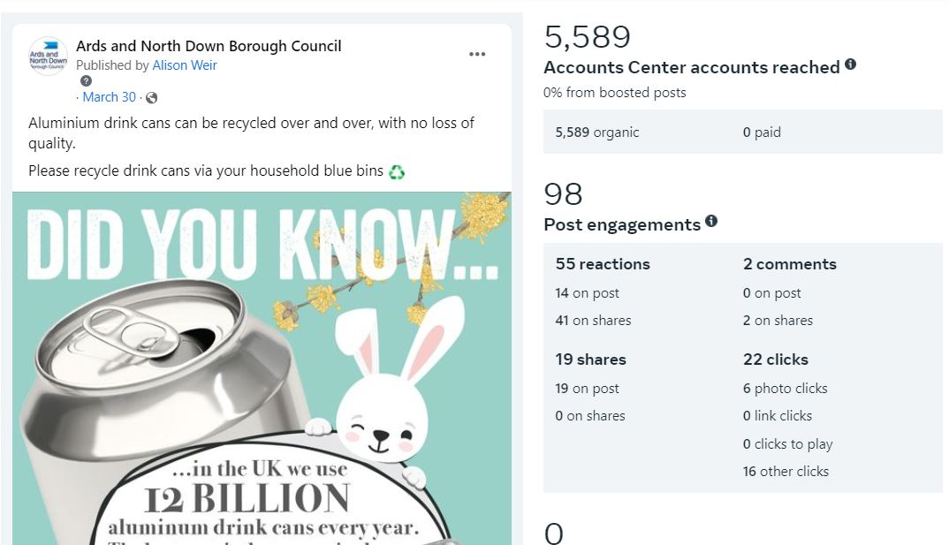
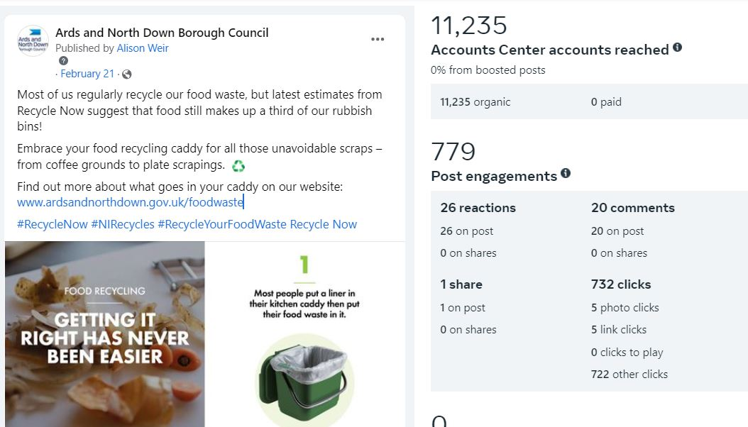

MC2 – 5 Bin-Ovation ‘News and Info’ articles were published,
7 Bin-ovation ‘Push Notifications’ issued, and 1931 Bin-ovation downloads recorded.

MC3 – Officers delivered 12 community and engagement events, talking to over 270 people.

- 10 x Recycling Educational Presentations
- 2 x Pre-school Recycling Education session

Household Recycling Centre Indicators

HRC1 – Volume of blue bin recyclable materials separated from mixed waste by residents on-site: 862,000 litres.

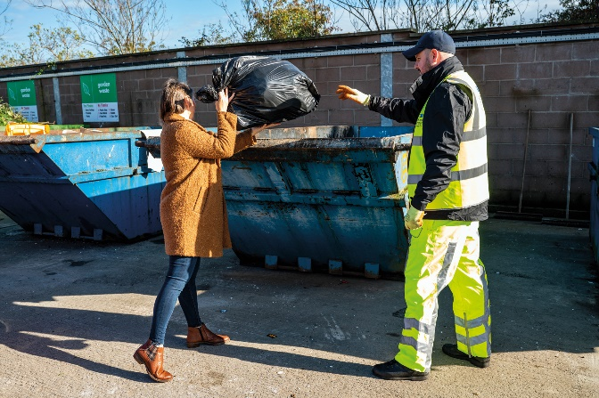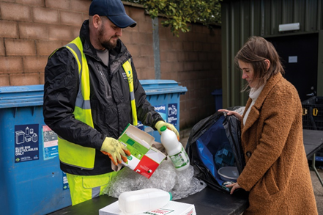

That equated to approximately 36 tons of blue bin waste; whilst that was a relatively modest weight of material, it represented a very large/visible volume of recyclable waste extracted from bags of mixed waste which was initially intended to be placed in landfill skips at HRCs. A collateral benefit of the practice of requiring removal of blue bin recyclables from black bags of mixed waste before using the landfill skip was that it should help to ‘educate’ householders - promoting more efficient separation of waste in the home and greater use of blue bins at the kerbside.

That represented just one type of recyclable waste category which was prevented from entering landfill skips at HRCs as a consequence of the more focused attention to supervision of landfill skip access; many other recyclable waste types would also have been prevented from entering the landfill skips as reflected in KPI, HRC3.

HRC2 – Number of visitors turned away from site: 528
This was a significant number in itself, but it was likely to be the case that a significant number of out of Borough residents would have avoided coming to our sites because of the widely publicised focus upon checking ID for everyone entering and those turned away would, in all probability, avoid further attempts to enter and use the HRCs; the impact of that would also be reflected in HRC3 and other KPIs.

HRC2a – Number of HRC bookings: 68,353

HRC2b – Average number of HRC visits per household: 0.96 (averaged across the 71,182 households in the Borough)
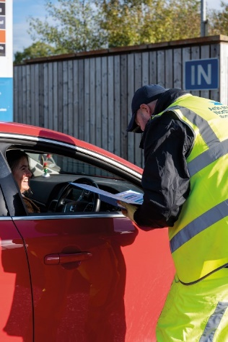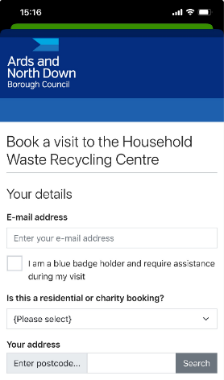

HRC3 – % change in tonnage of total waste received (compared to same period in baseline year 2021-22)

- The Council experienced a 26% decrease in the total amount of waste received at its HRCs, from 6409T to 4753T.

HRC4 - % change in tonnage of waste received for landfill (compared to same period in baseline year 2021-22)

- The Council experienced a 47% decrease in the amount of waste received for landfill at its HRCs, down from 2659T to 1416T.

HRC5 - % change in tonnage of waste received for recycling (compared to same period in baseline year 2021-22)

- The Council experienced an 11% decrease in the amount of waste received for recycling at its HRCs, down from 3750T to 3337T.

HRC6 - % change in proportion of HRC waste materials collected for recycling (compared to same period in baseline year 2021-22)

- The Council experienced a 11.7% increase in the proportion of all waste received at HRCs which was collected for recycling, up from 58.5% to 70.2%.

Kerbside Household Waste Collections Indicators


KSI – Number of recycling alert stickers applied to grey bins (yellow): 2989
KS2 – Number of recycling alert stickers applied to grey bins (amber): 281
KS3 - Number of recycling alert stickers applied to grey bins (red): 116
KS4 – % change in tonnage of total waste collected (compared to same period in baseline year 2021-22)
- The Councl experienced an 8.2% increase in the total amount collected at the kerbside, up from 12,241T to 13,248T.

KS5 - % change in tonnage of grey bin waste collected for landfill (compared to same period in baseline year 2021-22)
- The Council experienced a 2% decrease in the amount of grey bin waste collected, down from 6482T to 6352T.

KS6 - % change in tonnage of waste collected at kerbside for recycling (compared to same period in baseline year 2021-22)
- The Council experienced a 20.4% increase in the amount of waste collected at kerbside for recycling, up from 5759T to 6932T.

KS7 – % change in proportion of kerbside waste materials collected for recycling (compared to same period in baseline year 2021-22)
- The Council experienced a 5.2% increase in the proportion of kerbside waste that was collected for recycling, up from 47% to 52.2%.

Summary and Trend Analysis of Indicators
Indicator Reference | Monitoring  Period 1  (December 2022 – March 2023*)  *Waste tonnage indicators reflect period Jan to March 2023 only | Monitoring Period 2  (April 2023 – June 2023) | Monitoring Period 3  (July 2023 – Sept 2023) | Monitoring Period 4 (October 2023 – Dec 2023) | Monitoring Period 5 (January 2024 – Mar 2023)
MC1  Social media posts | 25 | 23 | 43 | 36 | 31
MC2  Print press and online articles | 10 | 13 | 55 | 7 | 12
MC3  Engagement events/sessions | 17 | 29 | 14 | 5 | 12
HRC1  Blue bin waste (litres) | 1,322,000 | 762,460 | 604,600 | 769,002 | 862,000
HRC2  Visitors denied entry | 1742 | 397 | 262 | 1258 | 528
HRC2a  No. of bookings | N/A | N/A | 22,199 | 72,423 | 68,353
HRC2b  Average no. of HRC visits per household in the Borough | N/A | N/A | 0.3 | 1.02 | 0.96
HRC3  Total HRC waste compared to same period 2021/22 | 16% Decrease | 26% Decrease | 19% Decrease | 34% Decrease | 26% Decrease
HRC4  Landfill skip waste compared to same period 2021/22 | 27% Decrease | 42% Decrease | 32% Decrease | 50% Decrease | 47% Decrease
HRC5  Recycling skip waste compared to same period 2021/22 | 8% Decrease | 15% Decrease | 11% Decrease | 24% Decrease | 11% Decrease
HRC6  Proportion of HRC waste collected for recycling compared to same period 2021/22 | 5.5% Increase | 9.1% Increase | 6% Increase | 9.5% Increase | 11.7% Increase
KS1  Yellow warning stickers on grey bins | 2784 | 6079 | 2714 | 2269 | 2939
KS2  Amber warning stickers on grey bins | 255 | 414 | 226 | 165 | 281
KS3  Red warning stickers on grey bins | 52 | 179 | 92 | 55 | 116
KS4  Total kerbside waste compared to 2021/22 | 4.8% Increase | 0% No Change | 5% Decrease | 1% Decrease | 8.2% Increase
KS5  Grey bin waste compared to 2021/22 | 9.3% Decrease | 16.5% Decrease | 17.4% Decrease | 10% Decrease | 2% Decrease
KS6  Kerbside waste collected for recycling compared to same period 2021/22 | 20.7% Increase | 13% Decrease | 4.9% Increase | 6.2% Increase | 20.4% Increase
KS7  Proportion of kerbside waste collected for recycling compared to same period 2021/22 | 7.2% Increase | 7% Increase | 5.2% Increase | 4.3% Increase | 5.2% Increase

Summary Analysis of Indicators

This report confirmed continued improvement in the Council’s sustainable waste resource management performance. Following the changes to the waste service model design and the associated education and engagement campaigns, the Council was experiencing sustained falls in the amount of landfilled waste as well as improvements in recycling rates. During the reporting period, the Council experienced:

- A further improved reduction in the amount of landfill waste received at HRCs. In total, we received/collected 1,373 tons less of landfill waste at the kerbside and HRCs over the 3-month reporting period compared to the same period in the baseline year of 2021/22; at prevailing landfill cost (£127.42/T), that represented a £178,545 landfill saving (plus other handling and transport cost savings).
- Falls in the total amount of waste collected at HRCs and kerbside. In total our municipal waste arisings fell by 3.8% compared to the same period in the baseline year of 2021-22; this compared to a 2.7% increase on average across other NI Councils.
- A significant further rise in the Council’s HRC recycling rate. The percentage of materials collected for recycling at HRCs rose by 11.7% compared to the same period in the baseline year of 2021/22. Although we saw a 2% drop in the proportion of materials collected at the kerbside for recycling compared to the same period the previous year, the Council had maintained a rise of 5.2% in this rate compared to the same period in the baseline year of 2021-22. The recent modest deterioration experienced in kerbside recycling performance would be addressed through sustained and enhanced focus upon the kerbside grey bin monitoring programme to further improve kerbside recycling engagement. The overall Borough household waste recycling rate rose by 5.7% compared to the same period in the baseline year of 2021/22.

Whilst the information set out in this report maintained a very encouraging picture of the Council’s progress and reflected a lot of hard work and dedication on the part of our waste and recycling teams, we undoubtedly had much further progress to make if we were to have any chance of ultimately reaching the 70% recycling target for 2030 that was laid down in the Climate Change Act (Northern Ireland) 2022. Continued bedding in and ongoing careful management of the new booking system for HRC access, the ongoing review of the kerbside collections model and a future strategic review of HRC capital assets, would be critical.

It was important to reiterate that further ‘step change’, sustained improvements in both our HRC and kerbside recycling rates would be required to move the Council towards the new 70% target.

RECOMMENDED that the Council notes the report.

Proposed by Councillor Wray, seconded by Alderman Cummings, that the recommendation be adopted.

Councillor Wray thought that the report largely read well but noticed the rise of residual waste collected at the kerbside and he questioned if that was due to householders making fewer visits to the Household Recycling Centres (HRCs). The Director suggested that that was probable, and indeed people were being encouraged to use kerbside collection services to the maximum rather than make unnecessary car journeys to HRCs.

The figures within the report came from a larger report showing Northern Ireland wide figures and officers took time each quarter to carefully analyse all the report data, so that trends could be noted. It was unfortunate that the local press sometimes took figures out of context, misrepresenting the key messages arising from the full report data. The Director noted that the Council had generally held on to the overall Borough recycling rate rise that had been achieved the previous year, and the sub trends were even more encouraging. For the first time the Council was showing an HRC recycling rate that was above the Northern Ireland average, due to the significant changes that had been made around HRC access and use.

Councillor Wray was encouraged by that and asked about the collection of textiles at the kerbside and when that was likely to become available. The Director said that there was currently a depression in the textile recycling market, and he hoped that there would be movement on the matter soon, with a report being brought to the Committee.

Alderman Cumming acknowledged the change in trends and asked about the high numbers of people being turned away from Household Recycling Centres and how the booking process was impacting that figure. The Director agreed that it was right that this was looked at, but it was also a testament to the effectiveness of the booking system. The fact that some people who potentially were not entitled to use the Borough’s HRCs, were still trying to gain access, showed the need for the ongoing strict application of the new system – to ensure that those individuals continued to be kept out of the sites.

Councillor Morgan passed on her thanks to the entire team, reporting that she had visited the Balloo site recently and the staff had been most helpful and were a positive reflection of the work the Council was doing. Although she was encouraged to see the amount of waste falling, she noted that the Council was not performing quite so well on the recycling of mixed plastics and recognised the confusion of householders. She was aware that the public mainly wanted to do the right thing, so she called on more education and information campaigns.

The Director agreed stating that one of the benefits of the report and the detailed analysis and auditing had shown that only 20% of plastic recyclable material was being captured in kerbside collections. There was now a vast range of plastic items that could be recycled – plastic bottles, pots, tubs and trays of all shapes sizes and colours - but for some reason that message was not getting through and that would be a focus for urgent progress going forward.

Alderman Armstrong-Cotter believed that the BinOvation App was very helpful and showed the latest plastic items that could be recycled, and she felt it was important to get the message out. She remembered previously a booklet being sent out with the Borough magazine and thought that could be helpful. The Member asked for monthly figures to be presented but was advised that was not possible due to the weekly collection system and a more accurate picture would be presented over the quarter period. She stressed the need to view trends and asked to show figures against the baseline year 2021-2022 when the changes to waste services began.

Councillor Cathcart referred to the sticker system on household bins and thought that could be confusing for elderly residents particularly and felt that people should be informed directly of what they were doing wrong. He asked for more detailed communication to keep the public engaged.

AGREED TO RECOMMEND, on the proposal of Councillor Wray, seconded by Alderman Cummings, that the recommendation be adopted.

10. QUARTERLY ENERGY CONSUMPTION UPDATE
(Appendices X & XI)

PREVIOUSLY CIRCULATED: Report from the Director of Environment detailing that in June 2024 the Council agreed the Sustainable Energy Management Strategy and Action Plan. One of the key actions within the Plan was to “Improve governance arrangements to ensure that energy management has effective oversight and accountability within the Council.”

Improving oversight and accountability within the Council for energy management would ensure that consumption performance and the implementation of the Strategy and this action plan would be continuously monitored. Improved monitoring and governance would improve energy performance by ensuring actions were effectively implemented and consumption trends routinely monitored, which should result in reduced consumption, costs, and emissions.

Reporting Periods

This was the first of routine, quarterly reports that looked at energy consumption against a 2019 baseline, outlining current and forthcoming energy saving initiatives and tracking progress with implementation of the Council’s Sustainable Energy Management Strategy Action Plan.

Period: | Reported in:
Quarter 1: April to June | September
Quarter 2: July to September | December
Quarter 3: October to December | March
Quarter 4: January to March | June

Energy Carbon Emissions for this Period

Electricity

As could be seen in the graph above carbon emissions from electricity consumption had reduced by 16.3% in comparison to the baseline year of 2019/2020. The Council had been reviewing its electric consumption year on year and had made conscious efforts to replace light fittings with LED on a general maintenance scheme and also replacing equipment with more energy efficient versions when replacing items.

There had been a slight increase in the first quarter this year compared to the previous year; efforts to reduce that going into the next quarter of the year would focus upon educating staff on energy awareness - switching off lights and equipment when not required etc., and by implementing lighting replacement and control schemes.

It was worth noting that ANDBC had several buildings that were heated by electricity, and that it had been necessary to keep the heating switched on in 2024 over a few additional periods due to cold snaps in the weather. It was suspected this to be the reason for the electricity usage increasing slightly from the same period in 2023.

Natural Gas

The Council’s carbon emissions from gas consumption had reduced by 14.1% in comparison to the baseline year of 2019/2020. That had been the result of reviewing time controls for boilers and reducing temperatures where possible. It had also been due to a number of internal reviews that led to Air Handling Unit (AHU) operating times being reduced to better suit higher occupancy times in buildings.

The Council had reduced its carbon emissions from gas usage in the first quarter from the same period last year by 3% and hopefully could improve further on that in Quarter 2.

Kerosene

Carbon emissions from Kerosene consumption increased slightly from the baseline year of 2019/20 for this quarter, and that was similar to the situation for buildings using electric heating. Oil fired boilers had to be in operation more due to colder weather snaps in the region during Quarter 1.

Diesel

The figures showed that the Council had also increased carbon emissions from Derv (Diesel) in the first period of the business year in comparison to the baseline year. It was believed that that was largely due to all the tractors and landscape machinery being switched from Gasoil to Derv.

Target Consumption/Emissions

In the graph below it showed the Council’s current overall fuel carbon emissions for each of the periods and the 2030 target. The linear trendline showed the path needed to meet the 48% carbon reduction by 2030, and it could be seen that there was some work to do to reduce consumption to match the required trendline. However, there were moves in the right direction, and with improvements and ongoing projects through Quarters 2, 3 and 4 it was aimed to get back on track.

Consumption Costs

The costs of the fuels could be seen in the table below for consumption of fuel in Q1 of each of the reference years, based on current unit costs.

Quarter 1 | 2019/20 | 2023/2024 | 2024/2025
Utility
Electric | £163,709 | £152,106 | £169,108
Gas | £234,079 | £207,997 | £202,112
Kerosene | £3,218 | £9,138 | £4,555
Derv | £12,147 | £11,786 | £16,275
Total Cost | £413,153.76 | £381,026.62 | £392,049.30

Energy efficiency measures taken since the baseline year of 2019/20 had yielded a Q1 saving of £21,104 in utility costs, based upon current unit costs.

Energy Saving Initiatives taken in this Period

- LED lighting and controls upgrade at Walled Garden Depot Work Shed.
- Controls Maintenance at Londonderry Park and Hamilton Hub.
- LED lighting replacement schemes at Community Centres.
- Installation of Electric Showers and Instantaneous Water Heaters at Ward Arras Sports Pavilion to replace existing hot water calorifiers.
- High Efficiency boiler replacements to a number of Communities properties.

See updated Sustainable Energy Action Plan attached, to show a full update on each of the actions noted.

Future Measures Currently Under Consideration/Planning

- Replacement of boilers at various Council properties and upgrade of control systems.
- Lighting control and LED replacement projects at numerous Council properties.
- Photo Voltaic (PV) Installation at chosen Council properties.
- Park lighting efficiency projects.
- Data Centre at ABMWLC for heat recovery to provide ‘free’ pool water heating.
- Installation of EV charging points for small and medium vans in fleet.
- Walk-round surveys of properties to examine existing controls and settings.

RECOMMENDED that the report be noted.

Proposed by Councillor Morgan, seconded by Alderman Armstrong-Cotter, that the recommendation be adopted.

Councillor Morgan thanked officers for the report which showed that there was a large amount of work to be done. It was clear that making real change would be dependent on much investment which was not available at the present time.

Seconding the recommendation Alderman Armstrong-Cotter was in agreement that much of this was down to the Council’s finances and affordability. She encouraged the Council to look for government grants if, and when, they became available.

AGREED TO RECOMMEND, on the proposal of Councillor Morgan, seconded by Alderman Armstrong-Cotter, that the recommendation be adopted.

11. HARBOUR KPI REPORT AND HARBOUR 5 YEAR SAFETY PLAN
(Appendices XII & XIII)

PREVIOUSLY CIRCULATED: Report from the Director of Environment detailing that
at the March Environment Committee meeting, Members agreed a number of recommendations by the Council’s Designated Person for Harbours, as part of his routine audit.

This report followed a standardised template to address a number of the recommendations and keep Members informed about ongoing safety measures and statistics at Harbours. It also addressed some key elements of the Marine Safety Management System and specifically the need to keep the Environment Committee, as “Duty Holder” (under the Port Marine Safety Code), fully informed of relevant matters at our Harbours.

The report covered the period 1st January to 31st June 2024.

Harbours Key Performance Indicators
See Appendix attached.

Marine Safety Training Scheme (MSTS)
The MSTS utilised the income from the slipway permit system to educate local users via a variety of marine-based safety initiatives. In this reporting period a safety day took place in Donaghadee Harbour. It was attended by berth-holders, slipway users, open-water swimming groups and members of the public who were offered the chance to win one of two new lifejackets.

One of the benefits of holding the safety day was that it enabled Harbours staff to conduct surveys to establish any perceived training needs amongst the users. VHF radio training was a popular choice and was subsequently arranged. MCA approved VHF radio courses were part funded by the MSTS and 14 candidates successfully completed the course.

Items Reviewed Under the 5-year Safety Plan

The 5-year safety plan (Appendix) set out a schedule of reviews for the extensive safety plan covering all marine based activities. During that period the following reviews took place:

- Marine Safety Management System
- Operation Risk Assessments
- Harbour User Risk Assessment
- Navigational Risk Assessments
- Training for harbour staff in Sea Survival, First Aid, Oil Spill Response, Firefighting and Safety Awareness.
- Hydrographic survey at Ballyhalbert
- Structural Survey at Ballyhalbert
- Emergency Response Plan
- Oil Spill Response Plan
- Port Waste Management Plan
- Operational check of Work boats

There were no notable developments from any of the above reviews.

Harbour Stakeholder Group Meeting

The newly formed Harbour Stakeholder Group was being set up with invitations sent to berth holders, harbours fisherman, local water sport and safety groups along with the Chair of the Environment Committee.

Any notes from future meetings would be included in this section of future half-yearly reports.

RECOMMENDED that the Council notes the half-yearly harbours safety update.

Proposed by Councillor Boyle, seconded by Councillor Edmund, that the recommendation be adopted.

Councillor Boyle welcomed the report, and it was something that had been started some time ago. He said it was good that income from the use of slips was being reinvested back into the community through training provision. In relation to the vessel recently abandoned on the shore of Strangford Lough, the Head of Assets and Property Services confirmed that the vessel was not on Council property and did not therefore fall within Council remit in relation to arranging removal/disposal.

Councillor Edmund was encouraged by the report and passed on his thanks to the team.

AGREED TO RECOMMEND, on the proposal of Councillor Boyle, seconded by Councillor Edmund, that the recommendation be adopted.

12. ANY OTHER NOTIFIED BUSINESS

There were no items of Any Other Notified Business.

Exclusion of Public/Press

AGREED, on the proposal of Councillor Blaney, seconded by Councillor Edmund, that the public/press be excluded during the discussion of the undernoted items of confidential business.

13. EXTENSION OF EXISITNG GLASS RECYCLING CONTRACT

***IN CONFIDENCE***

NOT FOR PUBLICATION SCHEDULE 3 – INFORMATION RELATING TO THE FINANCIAL OR BUSINESS AFFAIRS OF ANY PARTICULAR PERSON

A report on extension of an existing contract for glass recycling, was considered.

It was agreed to recommend an extension of the Glass Processing Contract for a further 12-month period under the existing Tender Option.

14. NOM REPORT – DONAGHADEE HARBOUR
(Appendix XIV)

***IN CONFIDENCE***

NOT FOR PUBLICATION SCHEDULE 3 – INFORMATION RELATING TO THE FINANCIAL OR BUSINESS AFFAIRS OF ANY PARTICULAR PERSON

A report on a Notice of Motion relating to sea defences at Donaghadee, was
considered.

It was agreed to recommend that Council proceeds as proposed in section 4 of the
report, with the outcome of engagement outlined being reported back to the
Environment Committee by January 2025.

Re-admittance of public/press

AGREED, on the proposal of Alderman Armstrong-Cotter, seconded by Councillor Blaney, that the public/press be re-admitted to the meeting.

Termination of meeting

The meeting terminated at 9.22 pm.

