Ards and North Down Borough Council

A hybrid meeting (in person and via Zoom) of the Environment Committee was held at the Council Chamber, Church Street, Newtownards and via Zoom, on Wednesday, 6 March 2024 at 7.00 pm.

PRESENT:

In the Chair: Councillor Morgan

Aldermen: Armstrong-Cotter (7.10 pm Zoom)
Cummings
McAlpine

Councillors: Blaney Kerr (7.10 pm Zoom)
Boyle McKee (Zoom)
Cathcart Smart
Douglas Rossiter
Edmund Wray
Harbinson

Officers: Director of Environment (D Lindsay), Head of Waste and Cleansing Services (N Martin), Head of Assets and Property Services (P Caldwell), Head of Regulatory Services (Temporary) (R McCracken) and Democratic Services Officer (H Loebnau)

1. Apologies

Apologies for lateness were received from Alderman Armstrong-Cotter.

2. Declarations of Interest

There were no declarations of interest.

NOTED.

3. PROPOSED STREET NAMING – COASTLANDS, BALLYHALBERT

PREVIOUSLY CIRCULATED:- Report from the Director of Environment detailing that a small development comprising six dwellings was currently under construction on lands at Shore Road, Ballyhalbert.

The developer had requested the name Coastlands for the new development.

The name was appropriate for the site and its location and was in keeping with the general neighbourhood.

RECOMMENDED that the Council agree to adopt the street name Coastlands for this development, and that the Council accepts the general name and delegates acceptance of suffixes to the Building Control department.

AGREED TO RECOMMEND, on the proposal of Councillor Edmund, seconded by Councillor Wray, that the recommendation be adopted.

4. GRANT OF ENTERTAINMENT LICENCES

PREVIOUSLY CIRCULATED:- Report from the Director of Environment detailing that applications had been received for the Grant of an Entertainment Licence as followed:

- Trinity Presbyterian Church Hall, 69 Main Road, Cloughey

Applicant: Geoffrey C Stewart, Seahaven Drive, Portavogie

Days and Hours: Monday to Sunday 1pm – 10.30pm

Type of entertainment: Theatrical performance, dancing, singing or music or any other entertainment of a like kind.

- Exploris Aquarium, The Rope Walk, Castle Street, Portaferry

Applicant: Kieran Quinn, Millview, Portaferry

Days and Hours: The permitted hours during which intoxicating liquor may be sold or consumed on these premises under the Licensing (NI) Order 1996

Type of entertainment: Dancing, singing or music or any other entertainment of a like kind.

There were no objections to those applications.

RECOMMENDED that the Council grants the applications.

AGREED TO RECOMMEND, on the proposal of Councillor Boyle, seconded by Councillor Wray, that the recommendation be adopted.

5. REVIEW OF PAVEMENT CAFÉ LICENCE FEES

PREVIOUSLY CIRCULATED:- Report from the Director of Environment detailing that the Council in November 2023 agreed proposed new fees for Pavement Café Licences as shown below and to consult upon those (the Act specifically required such consultation where pavement café licence fees were being set or altered).

 | Previous fee | Proposed fee
Grant fee | £225 (£147 non-refundable plus refundable £78) | £240 (£157 non-refundable plus £83)
Renewal fee | £150 (£103 non-refundable plus refundable £47) | £160 (£110 non-refundable plus £50)
Variation fee | £85 | £91

The Council was permitted to charge a fee to administer the Pavement Café Licensing regime.

In June 2020 the Council reduced the application fee from £225 to nil to help premises in their recovery from the COVID emergency. That was reviewed in June 2021 and the nil fee was retained at that time.

Currently 51 premises held a pavement café licence.

Consultation

All current licence holders were written to and advised of the proposed new fees and that they could provide their comments within 28 days.

At the end of the consultation period one email was received from Camphill Café, Holywood objecting to the increase (copy attached).

Given that the substantive issue raised in the letter of objection of other non-hospitality traders using public footpaths to display/sell goods, was not an issue that was under Council control but rather an issue for the Department for Infrastructure, and the fact that other Council goods and services had been increased annually, it was proposed that the fees for grant, renewal and variation of Pavement Café Licenses should be increased as set out in this report.

RECOMMENDED that the Council agrees to changes to Pavement Café Licensing fees as set out in this report.

Proposed by Alderman Cummings and seconded by Councillor Blaney that the recommendation be adopted.

Councillor Rossiter thought that the letter which the Council had received from Camphill Café was worth noting and the discrepancy which existed in Holywood, and many other towns, that all businesses were not under the same legislation while using footpaths during trading. He asked how that was enforced and if there was anything that the Council could do about the situation.

In response the Director was aware of incidences where there was a sense of intrusion on to footpaths by traders which impeded their easy use particularly for people using wheelchairs or for prams. The Council could contact the Department of Infrastructure where that was occurring and indeed on the website reports could be made by members of the public directly and those would be investigated.

AGREED TO RECOMMEND, on the proposal of Alderman Cummings, seconded by Councillor Blaney, that the recommendation be adopted.

6. LICENSING FEE SCHEDULE 2024/25

PREVIOUSLY CIRCULATED:- Report from the Director of Environment detailing that services were required to publish their list of fees on an annual basis and Council policy required all fees to be increased by the rate of inflation where possible. Statutory fees set out in the various pieces of legislation and could only be changed by the Assembly and were therefore not subject to increase as part of this fees policy.

RECOMMENDED that the Council notes the fees for 2024-25.

Proposed by Councillor Smart, seconded by Councillor Douglas that the recommendation be adopted.

Councillor Smart welcomed the fact that the same service was being offered for a very moderate increase in price.

AGREED TO RECOMMEND, on the proposal of Councillor Smart, seconded by Councillor Douglas, that the recommendation be adopted.

7. DESIGNATED PERSONS RECOMMENDATIONS

PREVIOUSLY CIRCULATED:- Report from the Director of Environment detailing that Members would recall that during the audit results presentation to Committee in January 2024, the Council’s Designated Person, Kevin Baird made a number of recommendations in regard to management of the Council’s harbours under the Port Marine Safety Code.

The purpose of the report was to update Members on how those recommendations would be addressed.

Recommendation 1: “I would recommend that the letter of Compliance issued to the MCA on 1st Dec 2023 be published (online) alongside the MSMS & Consultation Info.”
Action to be taken: Officers would update the “Harbours” section of the Council website with the information.
Recommendation 2: “I would recommend the Councils website relating to the harbours be updated to reflected recent changes and to include updated Notices to Mariners.”
Action to be taken: As per action 1 above, all relevant information would be updated on the Council website. However, Notices to Mariners typically comprised time-sensitive information, for example to advise mariners about navigational hazards. Therefore, officers did not deem the website as the most appropriate means to disseminate that information. Harbour staff currently used a text message system to alert all berth holders instantly of such matters. Printed versions were also placed on all harbour notice boards. In addition, the information was also distributed via Bangor Marina’s Facebook page (8.5k followers). The existing measures were thought to be sufficient.
Recommendation 3: “I would recommend that printed copies of the PMSC and Guide to Good Practice be issued to every member of this committee.”
Action to be taken: The Port Marine Safety Code comprised 39 pages and the associated guide to good practice was 195 pages. Therefore, in the interests of reducing our use of paper, the relevant web link was provided below as part of the report.
Port marine safety code - GOV.UK (www.gov.uk)
Recommendation 4: “I would recommend that the Council publish a 3-year safety plan, stating safety objectives with suitable timelines to add to its relevance.”
Action to be taken: Some activities were programmed over 5 years so it was thought that a 5 year plan was more appropriate. A draft 5-year plan was attached for Members’ approval.
Recommendation 5: “I would recommend that that this committee be regularly briefed (every 6 months) by the HM or an appointed Council Officer on the higher ranked hazards and incident reports as a standing agenda item at committee meetings.”
Action to be taken: A 6 month briefing had been included in the above safety plan and a template attached for approval.
Recommendation 6: “There is clear evidence of Stakeholder engagement with mooring holders and water users. It is worth considering establishing one or more forum/fora to ensure all stakeholders, including contractors, have been given an opportunity to comment on the safety of operations. These meetings to minuted/ recorded.”
Action to be taken: Officers proposed to set up a Marine Safety Stakeholder’s group and hold a meeting every 6 months, or more regularly if subsequently deemed appropriate by the group.

RECOMMENDED that the Council approve and implement the above actions to address the recommendations noted by the Council’s “Designated Person”, Kevin Baird.

AGREED TO RECOMMEND, on the proposal of Councillor Edmund, seconded by Alderman Cummings, that the recommendation be adopted.

8. PRODUCER RESPONSBILITY OBLIGATIONS (PACKAGING AND PACKAGING WASTE) REGULATIONS 2024

PREVIOUSLY CIRCULATED:- Report from the Director of Environment advising and updating Members on discussions which had taken place at a national level with regard to agreeing proposals across the four nations of the United Kingdom in respect of proposals/draft regulations for Extended Producer Responsibility (EPR) for packaging waste scheme.

To seek Member approval to recruit a shared waste specialist to deal with the implications of EPR, representing and assisting District Councils and NILGA on national forums with regard to policy development for EPR, a Deposit Return Scheme (DRS) and Common Collections Guidance in consideration of meeting waste, circular economy and climate goals.

Background
‘Producer responsibility’ was a concept used widely within the waste regulation sector aimed at ensuring that businesses that manufactured, imported and sold products onto the open market were responsible for their end-of-life environmental Impact.

The regulations required businesses to minimise waste arising from those products and promoted their reuse.

The current producer responsibility system for packaging had been in operation since 1997 however it had not covered the full costs of recovering/disposing of packaging waste.

DAERA launched a public consultation on packaging EPR in July 2023. The consultation was UK wide and ran until 9 October 2023. The purpose of the consultation was to test the clarity of the obligations created in the regulations and test their operability.

Following the consultation closure further discussions took place with all stakeholder organisations following which it was agreed to pause the process to allow for further and detailed engagement across all UK regions.

This engagement had developed into practical implementation, with local government being brought together with the packaging sector, as part of the whole collection and packaging value chain in a Steering Group to design a “Scheme Administrator” which would be responsible for delivery of the pEPR scheme from 2025.

The new UK pEPR scheme would move the cost of dealing with packaging waste away from the taxpayer and on to packaging producers, who would pay for the full cost of managing packaging waste from households. Through the fees they paid to Councils, producers would be incentivised to use less packaging, to use packaging that could be recycled, and to meet higher recycling targets.

Key Issues

Extended Producer Responsibility (EPR) would move the full cost of dealing with packaging waste from households away from local ratepayers and councils to the packaging producers (applying the Polluter Pays principle) giving producers responsibility for their packaging throughout its life cycle.

The scheme/regulations once finalised would encourage producers to reduce their
use of packaging and use packaging that was easier to recycle. Producers would be required to pay more for less sustainable packaging, incentivizing producers that used less material and which was easier to recycle.

Producers would also be responsible for meeting ambitious new recycling targets
and to use clear recycling labelling to make it easier for consumers to do the right thing.

A national Steering Group was being established with representatives from local
government across the UK invited to participate so as to ensure that the views and considerations of local authorities were fully reflected in the design and implementation of the finalised scheme.

In consideration of the above it was the considered view of SoLACE, Council Waste Forum (CWF) and NILGA that a dedicated resource be appointed to represent all of Northern Ireland’s District Councils on this steering group, and related (preparatory) national meetings of local government.

Following discussions with SIB, they had agreed to recruit and manage this resource with the postholder working 2.5 days per week on EPR and related matters for the 11 district councils.

The postholder would report to and receive direction from a co-ordinating group of SoLACE (via CWF), SIB and NILGA on a regular basis.

Implications
The Regulations were consistent with the Council’s commitment to reduce waste and to encourage greater recycling whilst delivering positive climate benefits.
The extended EPR regulations played a part in the UK government’s strategy in meeting net zero carbon emissions by 2050. The new EPR regime aimed to deliver a more circular economy and achieve a reduction in the environmental impact of packaging through its life cycle.

The impact of those regulations for Council would result in a net gain as producers made payments for the costs of managing household waste. That was thought to provide an estimated £1.2 billion of funding to local authorities across the United Kingdom each year for managing packaging waste easing pressures on Council’s current tight budgets.

Councils were asked to provide funding to support the appointment of this resource for a minimum 2-year period with each authority contributing £5k per annum.

RECOMMENDED that the Council approves this approach and our participation in the funding of a shared waste specialist to represent all Northern Ireland Councils in the development and finalisation of the new EPR regime.

Proposed by Councillor Rossiter, seconded by Councillor Cathcart, that the recommendation be adopted.

Councillor Rossiter reiterated some of the support for the initiative and thought it was timely. He referred to the deposit return scheme which had been introduced recently in the Republic of Ireland and the impact it was having on the levels of recycling. Having the initiative implemented in Northern Ireland would be good for waste collection statistics and would effectively provide a trickle down benefit with less waste for the Council to collect. He believed that the ‘polluter pays’ principle was very important, and he welcomed the roll out and hoped that it would be successful.

(Councillor Kerr and Alderman Armstrong-Cotter entered the meeting at 7.10 pm)

Councillor Cathcart stated that Ards and North Down Borough Council had been looking at this for a long time and Members had been made aware that action needed to be taken at a higher level to have less waste produced in the first instance. He welcomed the extra funding which would be made available to Councils and on the advice of the Director those figures were expected later this year. He stressed that recycling paid and it was good to encourage it further.

The Director replied that it had come to the point of fruition where tangible benefits would be see and Councils could help negotiate the final shape and format of the EPR regulations. He believed that it was certain that Councils who were performing better in terms of recycling would receive more funding and that would be a further incentive.

Councillor McKee welcomed the report and the changes coming forward and said that the Environment Committee and officers acting for this Committee had been vocal in lobbying to improve the environment and it was good to have in place a system for Northern Ireland as a whole and he hoped it would be fit for purpose for everything it needed to be.

Speaking as Chair of the Committee, Councillor Morgan asked the Director for timely reports on how this was progressing.

AGREED TO RECOMMEND, on the proposal of Councillor Rossiter, seconded by Councillor Cathcart, that the recommendation be adopted.

9. PROPOSED ADDITIONAL “DOGS ON LEAD” SIGNAGE FOR BANGOR SEAFRONT

PREVIOUSLY CIRCULATED:- Report from the Director of Environment detailing that in May of 2013 legacy North Down Borough Council exercised its power under the Clean Neighbourhoods and Environment Act (NI) 2011 to introduce the Dog on Leads (Promenades and Gardens) Order for 10 specific areas including Ballyholme Promenade and Bangor Seafront. Dog Control Orders replaced the previous system of byelaws for the control of dogs and the statutory procedure (including consultation) was followed at the time for the introduction of such Orders.

It was subsequently noted that an absence of signs to advise dog walkers, restricted the impact of this dog control order. In February 2023 the Council agreed to a trial of surface markings and signage at Ballyholme Promenade. The signage trial was aimed at encouraging better compliance with existing legal controls, and no decision was being sought from the Council about changes or extensions to such controls.

The area was the subject of monitoring prior to the display of new signage and reviewed one year later. Since introduction of the new signage, no complaints had been received concerning uncontrolled dogs on the promenade and whilst fouling still occurred sporadically, the level appeared to have reduced because of the greater supervision of dogs by dog walkers. The Council’s Cleansing Section had confirmed that there was now no highlighted reason for concern about the fouling levels in the area.

Further inspections of Ballyholme Promenade had been carried out and full compliance at the time of patrolling had been noted, with all dogs in the area being walked on a lead.

Following the successful signage trial at Ballyholme Promenade, officers had inspected the Bangor seafront area with a view to providing signage at access points - to encourage compliance once again with the existing control order that applied to the area. The area between Pickie Breakwater and Eisenhower Pier was a popular mixed use/shared space, where unfortunately some dog walkers appeared not to be aware of the dogs on lead requirement and no appropriate signage existed.

It was estimated that some eleven signs would be needed immediately with some required to be held in reserve. The estimated cost of erecting 15 x A2 Aluminium signs was £1,542. That could be facilitated from the existing budget.

RECOMMENDED that the Council expands the provision of ‘dogs on lead’ signage as outlined in this report.

Proposed by Councillor Harbinson, seconded by Alderman Cummings, that the recommendation be adopted.

Councillor Harbinson was pleased to see the report in respect of Ballyholme and it was clear that the signage and ground markings were working well and would help residents and visitors to understand the requirements when visiting with their dogs.

Alderman Cummings believed that the direction being taken would be reasonable to most dog owners. He asked about extended leads which were often problematic when dog owners had limited control over their animal, and it was noted that those types of leads would be prohibited.

Councillor McKee agreed with the direction the Council was taking at that location and he had been contacted by a runner who described the negative contact with dogs while in open spaces. The Member and the runner both loved dogs but recognised that something needed to be done and it was good that the action being taken was having a positive effect. He added that this was a new system, and it could not be assumed that the average resident would know immediately how and where to comply with the legislation.

It was noted that at Ballyholme there were ground markings to show the enforcement area and Councillor McKee enquired if Bangor seafront would have footpath markings as well as signage on posts. The Head of Regulatory Services (Temporary) informed the Member that that was dictated by the surface finishes and although it would be possible to do that it was felt that it would be inappropriate. The Director added that the situation in that area would be monitored and reviewed and changes could be made where thought necessary.

AGREED TO RECOMMEND, on the proposal of Councillor Harbinson, seconded by Alderman Cummings, that the recommendation be adopted.

10. Q1LICENSING SERVICE ACTIVITY REPORT (APRIL – JUNE 2023)

PREVIOUSLY CIRCULATED:- Report from the Director of Environment detailing that the information provided in the report covered, unless otherwise stated, the period from 1 April to 30 June 2023. The aim of the report was to provide Members with details of some of the key activities of the Licensing Service, the range of services it provided along with details of level of performance.

Applications Received

The Service dealt with a wide range of licensing functions which required the officers to consult with the PSNI, NIFRS and a range of other internal Council Sections in making their assessment of an application.

 | Period of Report  April – June 23 | Same quarter last year April – June 22
Entertainment Licence | 40 | 6
Cinema Licence | 0 | 0
Amusement Permits | 1 | 1
Marriage and Civil Partnership Place Approval | 2 | 6
Pavement Café Licence | 23 | 3
Street Trading Licence | 0 | 2
Lottery Permits | 0 | 1

Most of the licences issued were for renewals and hence the workload was constant year on year. Renewing a licence still entailed considerable work to assess the application and consult with the other bodies.

Regulatory Approvals

This was the number of licences, approvals and permits that had been processed and issued.

 | Period of Report  April – June 23 | Same quarter last year April – June 22
Entertainment Licence | 24 | 4
Cinema Licence | 0 | 0
Amusement Permits | 0 | 0
Marriage and Civil Partnership Place Approval | 5 | 7
Pavement Café Licence | 10 | 1
Street Trading Licence | 2 | 0
Lottery Permits | 0 | 1

Inspections

The service carried out a range of inspections in connection with the grant and renewal of licences to establish if the premises were suitable. In some cases, Council officers inspected with officers from the NIFRS.

During performance inspections were an important element in ensuring the licensees were abiding by their licence terms and conditions and that they were safe for patrons.

 | Period of Report  April – June 23 | Same quarter last year April – June 22
Initial/ renewal Entertainment Licence Inspections | 24 | 4
During performance Inspections | 52 | 17
Initial Inspections of Street Cafes | 23 | 3
Initial Inspections of Places of Marriage and Civil part. | 1 | 0
High Hedges Site Investigations | 1 | 1

The Service had an annual planned programme of ‘during performance inspections’ which concentrated on the higher risk premises such as night clubs through the year.

CCTV Management

The following table provided a breakdown of incidents captured on town centre CCTV during the 6-month period, 1 January 2023 to 30 June 2023.

Date | Time | Incident | Action
13.01.23 | 11.20 | Road Traffic Accident High Street, Holywood | CCTV footage provided to driver
23.01.23 | 11.55 | Road Traffic accident High Street, Holywood | CCTV footage provided to PSNI
12.01.23 | 23:25 | Altercation between two individuals in High Street Bangor | No request from PSNI
21.01.23 | 21:45 | Accidental injury to pedestrian -  High Street Bangor | Contacted Safe Zone who gave her First Aid
02.02.23 | 22:50 | Altercation between two individuals at Taxi Rank Abbey Street, Bangor | No request from PSNI
11.02.23 | 11.45 | Altercation between two individuals - Main Street, Bangor | No request from PSNI
17.02.23 | 21:20 | Altercation between two individuals – High St, Bangor | No PSNI request
12.03.23 | 2:10 | Altercation between three individuals at Taxi Rank Bridge Street, Bangor | No PSNI request
26.03.23 | 00:40 | Altercation between group of individuals - High Street, Bangor | No PSNI request
12.04.23 | 14.45 | Altercation between two individuals - High Street, Bangor | No PSNI request
08.06.23 | 21.20 | Altercation between two individuals - Main Street, Bangor | No PSNI request
09.06.23 | 01.10 | Assault High Street, Bangor | Footage provided to PSNI
09.06.23 | 15.20 | Assault Main Street, Bangor | Footage provided to PSNI
16.06.23 | 11.50 | Bicycle incident - Bridge Street, Bangor | No PSNI request
17.06.23 | 01.45 | Altercation between two individuals - High Street, Bangor | No PSNI request

In line with agreed protocol, minor altercations were not proactively reported or CCTV footage provided to PSNI, unless a police complaint was made and/or PSNI requested the information. More serious incidents (eg. ongoing significant issue, altercation involving injury etc.) were proactively reported to the PSNI. The PSNI could access CCTV footage of any incident/timeframe/location upon request.

Off Street-Car Parking

The Council currently operated 22 pay and display car parks in Bangor, Holywood and Newtownards. Ticket sales and usage had not returned yet to pre-Covid levels.

Table 1: Income from Ticket Sales

 | Period of Report | Previous year
Income from ticket sales | £192,784 | £154,671

Table 2: PCN’s Issued

 | Period of Report | Same quarter previous year
Bangor | 227 | 341
Holywood | 300 | 264
Newtownards | 360 | 449
Total | 937 | 1054

RECOMMENDED that the Council notes the report.

Proposed by Councillor Wray, seconded by Councillor Cathcart, that the recommendation be adopted.

Councillor Wray referred to the CCTV systems and questioned the thresholds for cases to be reported to the PSNI and if the images were fit for purpose. In response the Director explained that there was a Protocol with the PSNI if officers noted an altercation. If there was no apparent or significant injury the information would not be passed on but, for a more serious altercation, where it looked like a crime was being committed, the information would be proactively sent to the Police. PSNI procedures, along with time and privacy matters, would not permit the reporting back to the Council on any detail that followed from the supply of the images.

Councillor Wray was aware of some cases where the quality of the images recorded by the CCTV system were not of good quality and it was his opinion that the system was not fit for purpose and he asked that his views be recorded.

Councillor Cathcart asked about investigations on high hedges and mentioned that no feedback on the legislation had been given along with how useful it had been. It was explained that the legislation was at times lacking in some detail and was not easy to use. The Member asked for a report on how that legislation was used within the Borough and the Director agreed to provide it indicating that it was one of these delegated powers, dealt with by environment health, that was done routinely. He explained that the complainant needed to show that they had engaged with the neighbour in the first instance and to make a payment to the Council to investigate and that would be refunded if the complaint was upheld. It was clunky legislation which at times was difficult to use.

Following that Councillor Edmund asked the Director if the report could include the number of refunds given and he expressed concern that cost could discourage people from making contact with the Council for what could be a genuine grievance.

Referring back to the CCTV systems Councillor Blaney was unaware if the images were good enough quality but if they were not, it seemed foolish for the Council to continue to pay so he thought advice should be sought. He thought it could come back to ‘bite’ the Council if pictures could not solve crimes.

The Director explained that the system was examined under a review made a few years previously and while the images were not useless it was significantly impaired in its value. It was hoped that through prudent management of resources it could be reconsidered and Councillor Blaney believed that that should be a key priority so that the public could have confidence in it.

The Chair echoed the comments of Councillor Blaney and hoped that the system could be reviewed as soon as possible.

AGREED TO RECOMMEND, on the proposal of Councillor Wray, seconded by Councillor Cathcart, that the recommendation be adopted.

11. NORTHERN IRELAND LOCAL AUTHORITY MUNICIPAL WASTE MANAGEMENT STATISTICS, Q2JULY TO SEPTEMBER 2023

PREVIOUSLY CIRCULATED:- Report from the Director of Environment detailing that the official waste management statistics for the second quarter of 2023/2024 (July to September 2023) had been released by the Northern Ireland Environment Agency.

The aim of this report was to:

- Report key quarterly waste management performance statistics relative to the new baseline year of 2021-22, and
- Provide some detail around operational waste service management activities/actions that had been implemented during the quarter with the aim of improving performance.

In summary, all key indicators had been positive for this reporting period relative to the comparator 2021-22 baseline year. The Council had experienced a decrease in its total municipal waste arisings and falls in both total waste and landfill waste received at HRCs and kerbside. The landfill disposal cost saving for the quarter, relative to the same period during the 2021-22 baseline year, equated to almost £277k at the current landfill gate fee and tax rate. The Council’s recycling rates both at HRCs and kerbside had increased, and overall Borough household waste recycling rate increased by 6.2% against the same quarter in the 2021-22 baseline reporting year - compared to a NI Council average increase of just 1.1%.

Northern Ireland Local Authority Collected Municipal Waste Management Statistics – July to September 2023

The significant headlines contained within the latest DAERA report showed that:

- Household waste recycling rate increased by 5.8% compared to Q2 last year, from 51.8% to 57.6%.

- Household waste recycling rate of 57.6%, was 3.5% higher than the NI average of 54.1%.

- The Council was ranked fourth out of the eleven NI Councils for our household waste recycling rate.

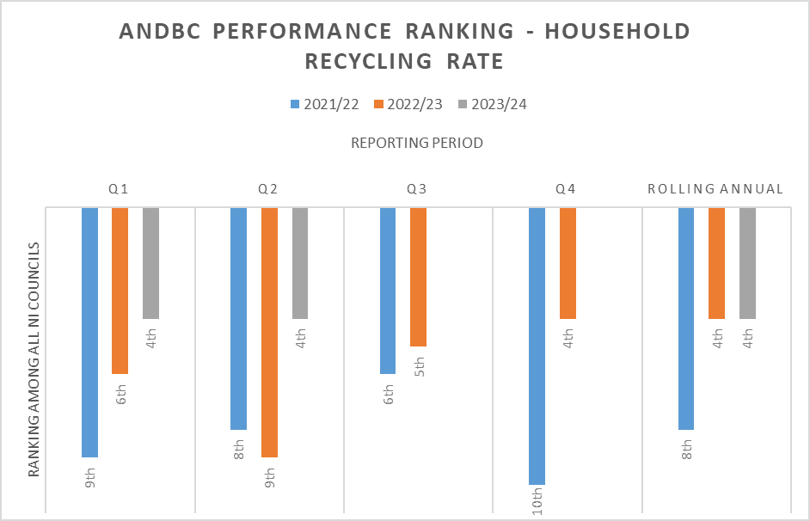

- The Council’s household waste composting rate rose significantly by 5.2% - from 33.2% to 38.4%. Our household waste dry recycling rate rose marginally by 0.4% - from 18.3% 18.7%.

- The Council’s household waste composting rate of 38.4% was 5.6% higher than the NI average of 32.8%.

- The Council’s household waste dry recycling rate (ie. recycling of items other than organic food and garden waste) of 18.7% was 2.3% lower than the NI average of 21%.

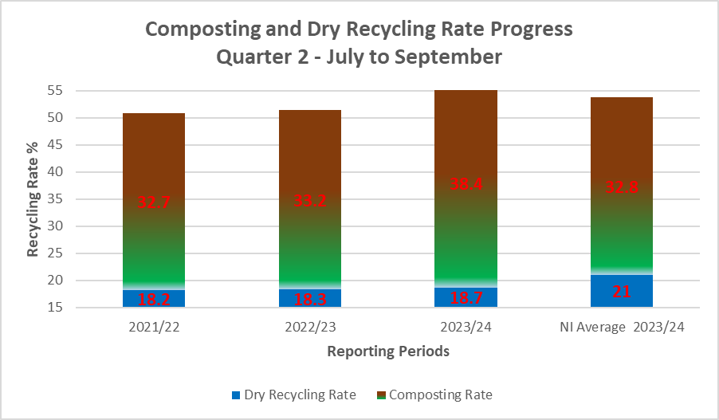

- The Council’s kerbside recycling capture rate of 80.1% for household compostable waste materials compared to a NI Council average of 72.6%.

- The Council’s lowest kerbside capture rate for recyclable materials was for mixed plastics, at 21.6%.

Kerbside Capture Rate for Recyclable Waste Types - July to September 2023
Recyclable Material | Kerbside Capture Rate for Recycling % | NI Average Kerbside Capture Rate for Recycling %
Glass | 55 | 48.5
Paper & Card | 58 | 52.2
Mixed Metals | 35 | 30.6
Mixed Plastics | 21.6 | 21.5
Organic/Compostables | 80.1 | 72.6

- The Council was still at the bottom end of the performance table for ‘dry’ recycling rate, ranking ninth out of eleven Councils.

- The Council received 17.4% more waste per capita at its HRCs compared to the average for other NI Councils, although that was significantly down from the 38% differential experienced during the same period the previous year.

- The amount of waste collected at the HRC sites for recycling was less than the average for other Councils – 71%, compared to an average rate of 76.1% for other Councils.

- The Council collected 3% more waste per capita from homes through its kerbside bin collection services compared to the average for other Councils.

- The amount of waste collected for recycling through the kerbside bin collection system was significantly higher than the average for other Councils – 61.2%, compared to an average of 51.1% for other Councils.

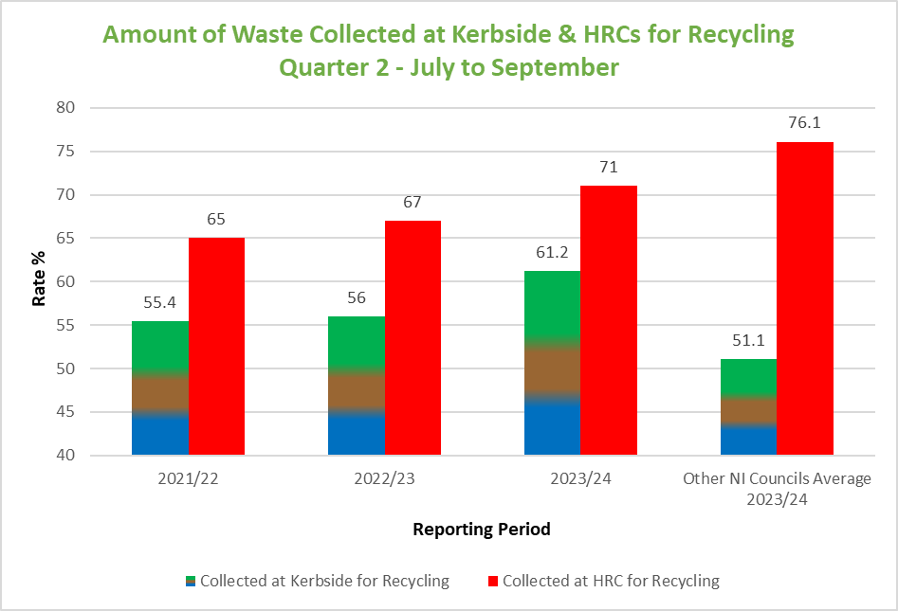

Operational Performance Improvement Measures

Marketing and Communications Indicators

MC1 – 43 social media posts were issued, with associated engagement/management of feedback across Waste and Recycling on ANDBC corporate channels.

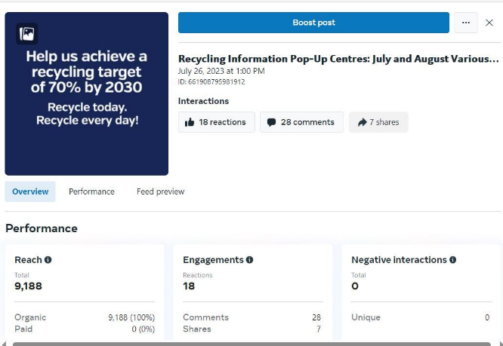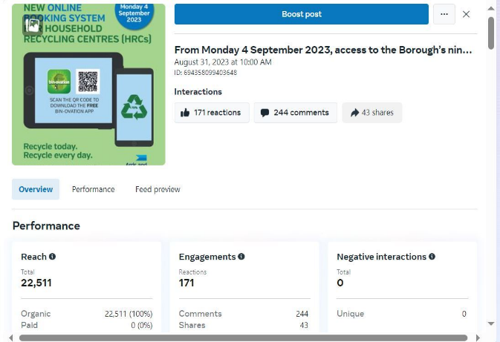

MC2 - 55 articles were published in print press and online (including 4 Bin-ovation news and info articles and 7 Bin-ovation push notifications).

MC3 – 14 community engagement and education events were delivered.

- 2 Recycling Educational Presentations
- 11 Drop-In Sessions
- 1 Event Attended (over 260 attendees)

Household Recycling Centre Indicators

HRC1 – Volume of blue bin recyclable materials separated from mixed waste by residents on-site: 604,600 litres.

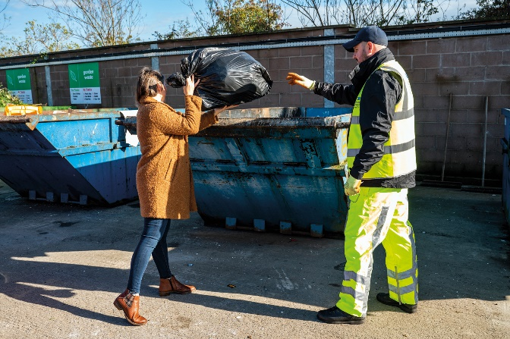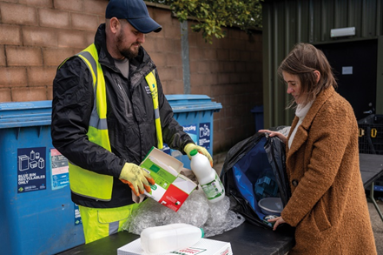

That equated to approximately 25 tonnes of blue bin waste; whilst that was a relatively modest weight of material, it represents a very large/visible volume of recyclable waste extracted from bags of mixed waste which was initially intended to be placed in landfill skips at HRCs. A collateral benefit of that practice of requiring removal of blue bin recyclables from black bags of mixed waste before using the landfill skip was that it should help to ‘educate’ householders - promoting more efficient separation of waste in the home and greater use of blue bins at the kerbside.

That represented just one type of recyclable waste category which was prevented from entering landfill skips at HRCs as a consequence of more focused attention to supervision of landfill skip access; many other recyclable waste types would also have been prevented from entering the landfill skips as reflected in KPI, HRC3.

HRC2 – Number of visitors turned away from site: 262
That was a significant number in itself, but it was likely to be the case that a significant number of out of Borough residents would have avoided coming to the Council’s sites because of the widely publicised focus upon checking ID for everyone entering and those turned away would, in all probability, avoid further attempts to enter and use the HRCs; the impact of that would also be reflected in HRC3 and other KPIs.

HRC2a (new indicator) – Number of HRC bookings: 22,199

HRC2b (new indicator) – Average number of HRC visits per household: 0.3 (averaged across the 71,079 households in the Borough)

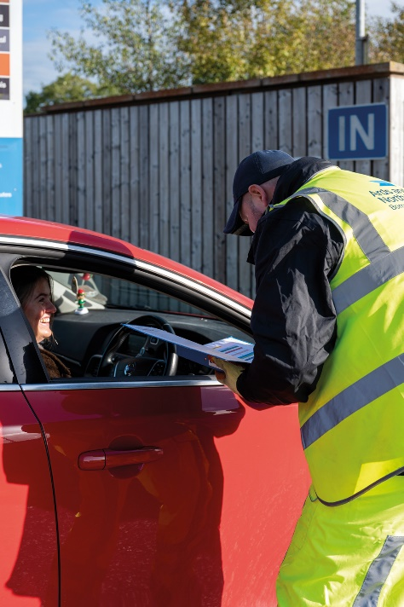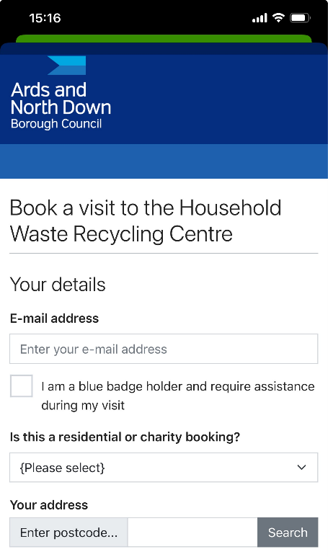

HRC3 – % change in tonnage of total waste received (compared to same period in baseline year 2021-22)

- The Council experienced a 19% decrease in the total amount of waste received at its HRCs, from 8602T to 6995T.

HRC4 - % change in tonnage of waste received for landfill (compared to the same period in baseline year 2021-22)

- The Council experienced a 32% decrease in the amount of waste received for landfill at its HRCs, down from 2998T to 2035T.

HRC5 - % change in tonnage of waste received for recycling (compared to same period in baseline year 2021-22)

- The Council experienced an 11% decrease in the amount of waste received for recycling at its HRCs, down from 5604T to 4960T.

HRC6 - % change in proportion of HRC waste materials collected for recycling (compared to same period in baseline year 2021-22)

- The Council experienced a 6% increase in the proportion of all waste received at HRCs which was collected for recycling, up from 65% to 71%.

Kerbside Household Waste Collections Indicators

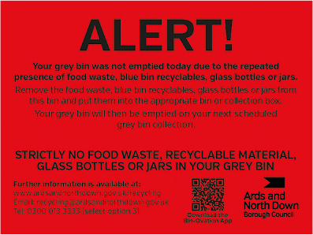
KSI – Number of recycling alert stickers applied to grey bins (yellow): 2714
KS2 – Number of recycling alert stickers applied to grey bins (amber): 226
KS3 – Number of recycling alert stickers applied to grey bins (red): 92
KS4 – % change in tonnage of total waste collected (compared to same period in baseline year 2021-22)

- The Council experienced a 5% decrease in the total amount collected at the kerbside, down from 15,596T to 14,812T.

KS5 - % change in tonnage of grey bin waste collected for landfill (compared to same period in baseline year 2021-22)

- The Council experienced a 17.4% decrease in the amount of grey bin waste collected, down from 6956T to 5747T.

KS6 - % change in tonnage of waste collected at kerbside for recycling (compared to same period in baseline year 2021-22)

- The Council experienced a 4.9% increase in the amount of waste collected at the kerbside for recycling, up from 8640T to 9065T.

KS7 – % change in proportion of kerbside waste materials collected for recycling (compared to same period in baseline year 2021-22)

- The Council experienced a 5.2% increase in the proportion of kerbside waste that was collected for recycling, up from 56% to 61.2%.

Summary and Trend Analysis of Indicators

Indicator Reference | Monitoring  Period 1  (December 2022 – March 2023*)  *Waste tonnage indicators reflect period January to March 2023 only | Monitoring Period 2  (April 2023 – June 2023) | Monitoring Period 3  (July 2023 – Sept 2023)
MC1  Social media posts | 25 | 23 | 43
MC2  Print press and online articles | 10 | 13 | 55
MC3  Engagement events/sessions | 17 | 29 | 14
HRC1  Blue bin waste | 1,322K Litres | 762,460 Litres | 604,600 Litres
HRC2  Visitors denied entry | 1742 | 397 | 262
HRC2a  No. of bookings | N/A | N/A | 22,199
HRC2b  Average number of HRC visits per household in the Borough | N/A | N/A | 0.3
HRC3  Total HRC waste compared to same period 2021/22 | 16% Decrease | 26% Decrease | 19% Decrease
HRC4  Landfill skip waste compared to same period 2021/22 | 27% Decrease | 42% Decrease | 32% Decrease
HRC5  Recycling skip waste compared to same period 2021/22 | 8% Decrease | 15% Decrease | 11% Decrease
HRC6  Proportion of HRC waste collected for recycling compared to same period 2021/22 | 5.5% Increase | 9.1% Increase | 6% Increase
KS1  Yellow warning stickers on grey bins | 2784 | 6079 | 2714
KS2  Amber warning stickers on grey bins | 255 | 414 | 226
KS3  Red warning stickers on grey bins | 52 | 179 | 92
KS4  Total kerbside waste compared to 2021/22 | 4.8% Increase | 0% No Change | 5% Decrease
KS5  Grey bin waste compared to 2021/22 | 9.3% Decrease | 16.5% Decrease | 17.4% Decrease
KS6  Kerbside waste collected for recycling compared to same period 2021/22 | 20.7% Increase | 13% Decrease | 4.9% Increase
KS7  Proportion of kerbside waste collected for recycling compared to same period 2021/22 | 7.2% Increase | 7% Increase | 5.2% Increase

Summary Analysis of Indicators

The report showed a very encouraging picture, and generally conveyed continued reversal of the downward trend that the Council had experienced in its sustainable waste resource management performance over the past couple of years. Following the changes to the waste service model design and the associated education and engagement campaigns, the Council was experiencing sustained and further improving falls in the amount of landfilled waste as well as improvements in its recycling rates. During the reporting period, the Council experienced:

- Sustained falls in the total amount of landfill waste both at HRCs and kerbside. In total, it received/collected 2,691 tonnes less of landfill waste at kerbside and HRCs over the 3-month reporting period compared to the same period in the baseline year of 2021/22; at current landfill cost (£127.42/T), that represented a £276,756 landfill saving.
- Falls in the total amount of waste collected at both HRCs and kerbside. In total municipal waste arisings fell by 7.2%.
- A significant further rise in the recycling rate at HRCs. The percentage of materials collected for recycling at HRCs rose by 6% compared to the same period in the baseline year of 2021/22. The overall Borough household waste recycling rate rose by 5.8% compared to the same period in 2021/22.

Whilst the indicators set out in the report were very encouraging indeed and reflected a lot of hard work and dedication on the part of the waste and recycling teams, the Council undoubtedly had much further progress to make if it was to have any chance of ultimately reaching the 70% recycling target for 2030 that was laid down in the Climate Change Act (Northern Ireland) 2022. Continued bedding in and ongoing careful management of the new booking system for HRC access, the planned review of the kerbside collections model and a strategic review of HRC capital assets, would be critical.

It was important to reiterate that ‘step change’, sustained improvements in both the HRC and kerbside recycling rates would be required to move towards the new 70% target.

RECOMMENDED that the Council notes the report.

Proposed by Councillor Harbinson, seconded by Councillor McKee, that the recommendation be adopted.

Councillor Harbinson was pleased that generally the results were good, showing big decreases where they were needed and while it was early days following some major changes to the system, he was happy to note the report and looked forward to the next one.

Councillor McKee also welcomed the progress that had been made and raised a matter with regard to recycling alert stickers which were being discussed on social media. It was important that bins were checked to ensure as much compliance as possible at the kerbside but he hoped that those who had recycled wrongly would be given information which helped them not to repeat that because often people were simply unaware of where they were going wrong.

The Director explained the alert sticker system stating that the sticker was a generic one and he thanked collection crews, often working in cold and unpleasant conditions, who helped to implement the system for the Council. Where stickers were put on bins a record was made in the cab of the vehicle and that was fed back to recycling officers who in turn generated a letter to the householder which had more information. Following that, if ambiguity existed, the resident could email or phone and officers would make contact with follow up information.

Councillor Cathcart welcomed the improvements being shown in the figures and he hoped that the rewards would be translated to the householders to provide further encouragement. He questioned the figures and asked why 2020/21 was being used as a baseline year. The Director explained that had been chosen as the reset year since up to that date the Council’s waste services were on a positive trajectory and had declined since. Figures following the implementation of the booking systems were also shown so the picture provided was a full analysis of progress.

In terms of wider savings Councillor Cathcart asked when the Committee would receive a report on staffing at the recycling sites. In response the Director said it had been agreed that a significantly lower number of manpower hours would be needed going forward since the system was now bedded in.

Referring to vehicle types it was confirmed that where it was clear that a vehicle had been adapted for use by someone with a disability or where a business vehicle was clearly being used privately by an individual householder there would be no issues raised by staff at household recycling centres.

Councillor Douglas thanked officers for the comprehensive report and the encouraging results. She had been contacted on three occasions the previous week about fly tipping in the Comber area and wondered if that was something that the Council needed to be concerned about and if the figures were rising elsewhere.

The Director confirmed that the figures of fly tipping had been closely monitored following the implementation of the Council’s booking system and no correlation was being shown at all between the two around the Borough.

AGREED TO RECOMMEND, on the proposal of Councillor Harbinson, seconded by Councillor McKee, that the recommendation be adopted.

12. REMOVAL OF CARCASSES FROM FORESHORE

PREVIOUSLY CIRCULATED:- Report from the Director of Environment detailing that in January 2024 the Council agreed a Notice of Motion stating;

“That this Council notes the continuing issue of dead seals washed up on our beaches and coastline and the negative impact that this has on the use of beaches when the carcasses are not picked up in a timely manner. It therefore tasks officers to bring forward a report to ensure seal carcasses are prioritised for removal as soon as possible after reporting to ensure that our beaches continue to be a clean, safe, and well-managed coastal environment to be enjoyed by everyone.”

During the discussion reference was made that the response times for removal had recently deteriorated and there was a specific focus upon a recent service response which had allegedly taken 14 days.

Service Response Statistics

The following statistics had been obtained from our job monitoring system:

Year | No. of Carcases Lifted | Average Response time for removal (days)
2016 | 7 | 2
2017 | 6 | 2
2018 | 11 | 1
2019 | 22 | 3
2020 | 17 | 3
2021 | 22 | 2
2022 | 14 | 2
2023 | 10 | 3

The figures above indicated that there had been no considerable change in response times, although 2023 response times where in the slower end of average range.

Given the comments and concerns raised during the NOM debate with regard to a specific incident in Portavogie, where it was alleged that it took two weeks to remove a seal carcase, officers investigated this incident, and a timeline was noted below.

Thu 23 Nov 14:20 | Cllr Wray reported dead seal at Ratallagh to the Cleansing and Parks Services
Sat 25 Nov 08:00 | Cllr Wray emailed Assets and Property Services (A&PS) about the seal
Sun 26 Nov 13:01 | Cleansing Service forwarded original email to A&PS
Mon 27 Nov 10:31 | A&PS responded to Cllr Wray seeking exact location
Mon 27 Nov 12:21 | Cllr Wray sent images to identify location
Mon 27 Nov 14:12 | A&PS advised the job had been issued to the contractor and may take a few days to action.
Tues 28 Nov 16:22 | Cllr Wray advised seal still there
Tues 28 Nov 16:25 | A&PS responded to Cllr Wray to advise contractors currently had high workload and would action as soon as possible.
Tues 28 Nov 16:30 | Cllr Adair emailed A&PS & CE to ask if seal could be removed, stating it was reported previously
Wed 29 Nov | Job complete

The above timeline confirmed that the seal was first reported on 23 November, but it was not until 27 November that the appropriate department (Assets and Property Services) was provided with details in relation to the specific location.

The seal was lifted on 29 November, giving a 2-day response time from the date on which A&PS received specific location information. Furthermore, it was apparent that the time from initial receipt of any notification of that specific service request by Council (initially Cleansing and Parks) to the removal of the seal, was 6 days - rather than the14 days referred to during the debate on the Notice of Motion. The response period was longer than the average - largely due to the service request initially being received by services other than the A&PS which managed the carcass removal service with the contractor, and a delay in receipt of detailed location information that could then be passed on to the contractor.

Factors Affecting Removal of Carcasses

Response times varied for a number of reasons.

- Reporting. Quite often the carcasses were not reported to the correct department or were sent to one person who may be off on leave or was unavailable, slowing response time.
- Workload. Carcasses were removed by the Council’s general works contractors who were typically working on various civil works projects throughout the Borough on most days. It was considered unfeasible to ask the contractor to pack up their equipment, make safe and secure the site and travel to remove a carcass immediately upon receipt of the service request. To do that would add significant time and cost to ongoing projects. Officers therefore typically asked the contractor to deal with the carcass the next day or as soon as possible when they were expected to be in the area. The table above suggested that approach normally resulted in a timely response.
- Other Agencies. When feasible, the Department for Agriculture, Environment and Rural Affairs (DAERA) may need to examine the recently deceased carcasses of seal pups or small cetaceans for signs of disease, so may need to be consulted before removal. Whilst DAERA requested that carcasses were reported to directly to them, that could potentially add time to their removal as DAERA officers would need to visit the site, assess the carcass and then notify Council for removal. If the request came to officers in the first instance, the Council could notify DAERA if necessary.
- Access. Quite often carcasses were washed up on rocky outcrops, making access difficult and removal of large carcasses practically impossible. DAERA’s advice was not to remove those more inaccessible carcasses, noting that they formed part of a natural eco-system and were often washed back out to sea, providing food for marine scavengers.

Next Steps

Officers noted Members’ desire for a timely carcass removal service, but that must be balanced against limited resources and competing priorities. Officers noted the slight dip in response time in 2023 and would endeavour to rectify that, ensuring those requests were prioritised so far as was practicable. In order to make removals as swift as possible, Members were encouraged to:

- Use the following email address to report the request: apsadmin@ardsandnorthdown.gov.uk;
- Enter an appropriate subject line on the email. Emails without a subject line cannot be grouped/identified as readily, making delayed response more likely;
- Include as much detailed location information and photos/maps as possible.

RECOMMENDED that the Council note this report.

Proposed by Councillor Boyle, seconded by Councillor Cathcart, that the recommendation be adopted.

Councillor Boyle remembered this Motion being brought to the Committee and at the time had wondered if the Council could do better. The recommendation on the report brought before the Committee was to note but there had been some startling facts outlined within it which he believed should be raised. He thought that the report should be a lesson to Members that they were in place to work with officers having a common denominator of providing a service to residents of the Borough.

When the Motion was brought at first it had been stated that the Council had taken two weeks to remove a dead seal from a beach and that was shown to simply not be the case. The report had shown that Councillor Wray had actively tried to progress the matter followed by Alderman Adair, it had not been reported through the proper channels, but had it been it would have been dealt with promptly and even in the case outlined it was not two weeks but rather six days before the dead seal was collected.

The media had ripped apart the Council and its officers for being slow to respond when that had not been the case and he hoped that those who had been so quick to criticise would now step in to rectify the misinformation.

Councillor Cathcart said he was disappointed with Councillor Boyle’s response urging him not to attack a Member who had raised what he considered to be a genuine concern. It was not intended to ‘have a go’ at officers the procedure was complicated because it fell between the work of two Council Directorates, and he welcomed the clarity for the future that had been laid out in the report.

Councillor Wray thought that it was important that Members were fair and careful with their language and accepted that everyone made mistakes at times but the reporting procedure had been outlined for future reference. He had supported the Motion because he considered that every dead animal should be collected within two to three days due to the dangers posed to other animals and humans.

(Councillor Blaney left the meeting at 8.00 pm)

Councillor McAlpine reported that Alderman Adair had accepted an amendment to his Motion to include all mammal carcasses and the Head of Property and Assets confirmed that those were collected in the same way as seals and no differentiation was made.

AGREED TO RECOMMEND, on the proposal of Councillor Boyle, seconded by Councillor Cathcart, that the recommendation be adopted.

13. NOTICES OF MOTION

13.1 Notice of Motion submitted by Councillor McKee, and Councillor Kendall

This Council notes the importance of outdoor lighting on Council land and buildings for public safety, security, and tourism. Moreover, it acknowledges the benefits of energy efficient lighting in the Council’s decarbonisation journey and the financial savings that are realised.

However, this Council also notes the negative consequences artificial lighting has on our wildlife despite the importance and benefits outdoor lighting can bring. As a Borough committed to improving biodiversity, this Council will ensure that all future installation or retrofitting of outdoor lighting is nature friendly and take cognisance of our obligations for protection of priority species in the Local Biodiversity Action Plan. Furthermore, that the Council’s current outdoor LED lighting is assessed for the potential for retrofitting.

Councillor McKee began by making a small amendment to his Notice of Motion as outlined below in the second paragraph.

“This Council notes the importance of outdoor lighting on Council land and buildings for public safety, security, and tourism. Moreover, it acknowledges the benefits of energy efficient lighting in the Council's decarbonisation journey and the financial savings that are realised.

However, despite the importance and benefits outdoor lighting can bring, there can be negative consequences for wildlife. Officers are tasked with ensuring that all future installation or retrofitting of outdoor lighting is nature friendly and take cognisance of our obligations for protection of priority species in the Local Biodiversity Action Plan. Furthermore, that current outdoor LED lighting is assessed for the potential impact on wildlife and suitable adaptations are made where possible”.

Proposed by Councillor McKee, seconded by Councillor Kendall that the Notice of Motion be adopted.

Councillor McKee thanked the Committee for hearing his Motion and stated that as custodians of public spaces and a provider of community facilities the Council had an obligation to ensure that public safety, security and crime prevention were considered in the management of lighting in outdoor spaces. The Council also must ensure that it supported local hospitality, the arts and retail businesses in ensuring people were kept safe when they were spending time outside in times of darkness.

With increases to energy costs affecting the Council and with the technological advances in lighting, it was right that the benefits achieved by retrofitting lighting should be realised and he said that officers were doing a great job in providing outdoor lighting to support the Council’s functions and their drive to make finances stretch further and be more sustainable were welcomed.

However, he thought that one aspect was missing and that was the question of how outdoor artificial lighting affected nature. In the Biodiversity Crisis facing the planet, according to recent figures, compiled in the Living Planet Index, a metric developed by WWF and the Zoological Society of London, wildlife populations had plunged by an average of 69% between 1970 and 2018.

Although there was a massive list of causations for the Biodiversity Crisis, one well researched and clear threat to nature came from outdoor artificial lighting. A 2009 paper estimated that 100 billion insects died in Germany each year as a direct result of attraction to artificial light sources. That indicated that light pollution may be a driver of the “catastrophic insect population collapse” observed over the last two decades and some estimates predicted up to 40% of insects would go extinct within the next decades.

That mass extinction had knock on effects for birds, mammals and so many other species including humans, whose interdependency relied on insects and whose numbers were decreasing year on year.

He went on to say that in years gone by it would have been commonplace after long journeys, to have to clean windscreens to maintain visibility, due to all the unfortunate insects who would have perished on the front of vehicles and he doubted many motorists were finding that anymore due to the dwindling number of insects that were in the environment.

One priority species that deserved focus were bats, whose success was so dependent on abundance of insects and could be directly impacted by lighting that was not nature friendly. He reported that he had been fortunate enough to see bats flying around Bangor Castle in the last couple of months and that had been a real pleasure and a delight to see them in an urban location. Unfortunately, some outdoor lighting had a detrimental effect on bats’ ability to forage and without food their numbers were now under threat. Some species of bat were especially negatively impacted by the introduction of LED lighting.

LED lighting mostly emitted light in the blue part of the light spectrum. That had been found to be bad for wildlife and there was a big focus on how those lights affected humans too more people used more LED screens. People were seeing the negative effects they could have on sleep patterns as a result.

The reason he and his colleague, Councillor Kendall, had brought this Motion was that in a time when the Council was rightly focussed on greater efficiency to help lower the Council’s CO2 emissions and seeking to cut costs of the energy needed to provide lighting, they believed that the opportunity to make Council outdoor lighting nature friendly must not be lost.

It was not envisaged that budget increases and lavish spending was required to make a big difference, the fundamental thing that must be done was to ensure assessments were made when retrofitting and making fresh installations of outdoor lighting.

There were already great industry standard guidance and case studies that could help inform the Council’s lighting choices and help to make a real positive change for nature. The Motion sought to give officers the direction of the Council that this must be part of the focus moving forward and not something to have thought of after changes to lighting were made.

The Borough had so many residents who valued nature and wanted to see the Council doing all it could to adjust what could be done for the benefit of the planet. He finished by saying he hoped all Members of the Committee would be able to support the Motion.

Councillor Kendall said that there was a clear commitment from the Members and Council as a whole to improve the Borough’s biodiversity and make positive changes for the planet and she hoped the Motion would receive support.

She outlined two examples that showed how huge, positive impacts upon biodiversity could be made, when working with the community and thinking about, and making basic changes to lighting. Those were the Comber Greenway and Albert Bridge in East Belfast.

Last year, after the completion of a public consultation the Department for Infrastructure installed artificial lighting on the Comber Greenway for the first time. It was clear from consultation responses that residents, environmentalists, and NGOs were concerned about the potential damage that could be caused by artificial lighting on the Greenway – it was an important nature corridor, used by so many species for nesting, foraging and navigating the urban and countryside landscapes. The Department listened, and used a design that utilised a red-light spectrum to minimise disturbance to bat colonies, while back louvres on the light heads and shorter columns minimised light spill into the hedgerows to shield wildlife and diminish light pollution into adjoining properties.

She remembered enjoying a bus journey home from Belfast over the Albert Bridge and watching the starling murmurations. As a result of new public realm works in that area, including the installation of new lighting under the Albert Bridge, there was a sharp decline in starlings in the area and the famous murmurations almost disappeared. However, following successful lobbying from environmentalists and the local community, the Department installed mitigations to minimise the impact of the new lighting. That had resulted in hundreds of starlings returning to roost and the return of the spectacular amazing murmurations.

She stressed that much could be done to ensure that outdoor lighting met the social needs of people, saved money, and was nature friendly including;

- Carefully assessing the need for new installations of lighting
- Minimising the number of lights installed could cut costs and help darkness remain where lighting was not required.
- Timers and sensors which triggered lighting to be activated, only when people were present, and facilities were occupied.

All of those could cut the costs of installation, energy and benefit to wildlife.

As has been used successfully by the Department, red spectrum lighting, louvers and filters could be used to prevent damaging ultraviolet or blue spectrum light. Those steps were simple but necessary mitigations to prevent negative consequences for wildlife.

Excessive, misdirected, and intrusive use of light impacted plants and animals, including humans, who all relied on natural light cycles, to regulate life-sustaining behaviours like reproduction, nourishment and sleep. The Council’s Local Biodiversity Action Plan, clearly set out the responsibility to Protect, Manage, Enhance, restore and to raise awareness of the importance of Biodiversity. The outcomes from the Motion had the potential to do all those things.

To quote Chad Moore, formerly of the US National Park Service, “When we add light to the environment, it has the potential to disrupt habitat, just like running a bulldozer over the landscape can”.

So much of nature that enriched human life and was fundamental for the survival of the human race, could be negatively impacted by outdoor artificial lighting. Although the Council was not responsible for all of the lighting in the Borough, it could enhance its own, and through making those changes, could inspire other landowners to take the issue seriously.

Councillor Rossiter was happy to support the Motion and paid tribute to the ecologist, Conor McKinney, who had done a lot of work in Belfast looking at how lights were designed and placed. He asked about the impact of the Motion to the Council and officers were unaware of any projects in the immediate pipeline that would be affected by this.

Councillor Cathcart also welcomed the Notice of Motion and referred to the obligations the Council had under the Biodiversity Action Plan along with balance of public safety. Appropriate lighting could make a major financial saving to the Council along with retrofitting and he looked forward to the Council exploring the matter further.

Councillor Smart thanked Members for the Motion and the proposal struck the right balance in his opinion. He referred to the lighting at Londonderry Park which had led to the development of a thriving running club but equally recognised that not far from that park land development had had a negative impact upon the bird numbers in the area. This was however a good balance and the Council should be cognisant of that moving forward.

Councillor Boyle also rose to support and agreed that it should be balanced. He thought with good design the Motion should be fairly easy to implement.

Councillor McKee thanked Members for their positive comments and support.

AGREED.

14. ANY OTHER NOTIFIED BUSINESS

There were no items of Any Other Notified Business.

Exclusion of Public/Press

AGREED, on the proposal of Alderman Cummings, seconded by Councillor Edmund, that the public/press be excluded during the discussion of the undernoted items of confidential business.

15. TENDER FOR THE PROVISION OF FUEL OIL SUPPLIES

***IN CONFIDENCE***

NOT FOR PUBLICATION SCHEDULE 3 – INFORMATION RELATING TO THE FINANCIAL OR BUSINESS AFFAIRS OF ANY PARTICULAR PERSON

A report on a tender for the provision of fuel supplies, was considered.

It was agreed that a contract be awarded to Nicholl Fuel Oils as set out in the report.

16. TENDER FOR THE REPAIR OF PLUMBING WORKS AT COUNCIL PROPERTIES

***IN CONFIDENCE***

NOT FOR PUBLICATION SCHEDULE 3 – INFORMATION RELATING TO THE FINANCIAL OR BUSINESS AFFAIRS OF ANY PARTICULAR PERSON

A report on a tender for plumbing works at Council properties, was considered.

It was agreed that a contract be awarded to Irwin M+E Ltd as set out in the report.

17. COSTS FOR EXTERNALLY LIGHTING BUILDINGS

***IN CONFIDENCE***

NOT FOR PUBLICATION SCHEDULE 6 – INFORMATION RELATING TO
A CLAIM TO LEGAL PROFESSIONAL PRIVILEDGE

A report on the external lighting of Council property was considered. It was agreed that the preferred option set out in the report be adopted, subject to an agreed amendment.

18. UPDATE REPORT ON REVIEW OF KERBSIDE WASTE COLLECTION SERVICES

**IN CONFIDENCE**

NOT FOR PUBLICATION SCHEDULE 3 – INFORMATION RELATING TO CONSULTATIONS OR NEGOTIATIONS

An update report on the work of the Elected Member Working Group that has been established in relation to the review of the Council’s kerbside waste collection services model, was considered.

It was agreed that the report be noted.

RE-ADMITTANCE OF PUBLIC AND PRESS

AGREED, on the proposal of Alderman Cummings, seconded by Councillor Edmund, that the public/press be excluded during the discussion of the undernoted items of confidential business.

Termination of meeting

The meeting terminated at 8.57 pm.

