ARDS and North Down Borough Council

A meeting of the Community and Wellbeing Committee was held at the Council Chamber, Church Street, Newtownards, on Wednesday 19 June 2024 at 7.00 pm.

Present:

In the Chair: Councillor Boyle

Aldermen: Adair

Councillors: Ashe Harbinson
Chambers Kendall
Cochrane Martin
Douglas

Officers in Attendance: Director of Community and Wellbeing (G Bannister), Head of Environmental Health, Protection and Development (A Faulkner), Head of Community and Culture (N Dorrian), Head of Leisure Services (I O’Neill), Head of Parks and Cemeteries (S Daye) and Democratic Services Officer (H Loebnau)

MATTERS OF BUSINESS

The Chair of the Community and Wellbeing Committee advised that Alderman Brooks, had given apologies for the meeting and the Vice Chair, Councillor Boyle, took the role for the duration of the meeting.

On behalf of the Community and Wellbeing Committee the Chair expressed deepest condolences to Councillor W Irvine following the death of his mother. He informed the Committee that Mrs Irvine’s funeral would take place on Saturday 22 June at Trinity Presbyterian Church, Bangor.

NOTED.

The Chair shared his delight on the recent success of Portaferry athlete Ciara Mageean on winning a gold medal for a 1500 metres race recently in Rome. He said that Ciara was a fantastic ambassador for Portaferry and the entire Borough. The Council had provided funding to Ciara and he knew that she never forgot those who had helped to support her. He reported that she was currently training for the Paris Olympics which would be taking place in August and he wished her continued success for that.

Alderman Adair believed that Ciara’s success should be recognised by the Council and it was suggested that a letter of congratulation be sent to her from the Mayor.

AGREED.

1. Apologies

Apologies for inability to attend were received from Aldermen Brooks, Cummings and McRandal and Councillors Hollywood, S Irvine, W Irvine and Moore.

2. Declarations of Interest

The following declarations of interest were notified:

Councillor Martin – Item 5 and Item 26
Councillor Chambers – Items 4, 22 and 26

NOTED.

ORDER OF BUSINESS

Under Standing Orders Alderman Adair proposed, seconded by Councillor Cochrane that Item 27 be taken Out of Committee. Alderman Adair suggested that there was huge public interest in the Item and he would be careful not to let the discussion stray in to confidential matters.

AGREED.

3. DEputation Resolute M;nds

The Chair introduced a Deputation from Resolute M;nds and welcomed Rory Sloan to the meeting and invited him to make his presentation to the Committee.

Rory thanked the Community and Wellbeing Committee for the opportunity to speak and informed them that he was the founder of Resolute M;nds. He explained that the semi colon used in the name was a symbol for mental health. He was 23 years old and described his background having struggled with substance abuse in his early teenage years. After a brief recovery the Covid pandemic struck and Rory developed an eating disorder, started drinking heavily and began using Cocaine. That downward spiral lead to criminal activity and soon after his 21st birthday Rory spent a short time in prison.

At that time, he was introduced to Northern Ireland Alternatives which led him through therapy and restorative justice and that opened his eyes to the harm he was causing himself and others. He explained that his wish now was to tell his story to young people to open their eyes to the dangers that they could be led in to unintentionally through drink, drugs and criminal activity. He had recently been a One Young World leader for the first time and was given an opportunity to tell his story. He received good feedback from that and it had led him to launch Resolute M;nds.

Resolute M;nds was launched in the Culloden Hotel in May and in an effort to make every voice heard they offered workshop support, one to one help and a soon to be completed online forum. He believed that he could show something different to young people as a person who was young himself but had lived experience. In turn he hoped that would be empowering to young people through work in schools.

Alderman Adair thanked Rory for sharing his inspiring story and asked if he had engaged with any schools in the Borough already. In response Rory said that he was still considering the best approach to that but he had worked with his former school. Alderman Adair knew the work would help many people in the future and said that he would help to promote Rory’s work when in discussion with schools and youth leadership.

Councillor Kendall commended Rory for his confidence and bravery and it was inspiring how he was using his skills, drive and enthusiasm to help others. There was a drugs epidemic and she thought it was important that more therapeutic, persuasive interventions be introduced including help for mental health rather than locking people in prisons. Rory shared that view and was a huge believer in restorative work stating that some people were not necessarily ‘bad’ but were unfortunate to be caught up in a dangerous situation but could turn their life around with help and support. He felt that focus could be on wellbeing of the body along with physical and mental fitness that could make people happier and in turn they could live more productive lives. The Member asked Council officers to link Rory with the PCSP.

Councillor Martin told Rory that he had communicated his story very effectively and
it had been very moving and redemptive in how he had managed to turn his life around. The Member had been impressed by Rory’s lived experience and thought that could be used very positively in schools.

Councillor Douglas praised Rory for sharing his remarkable story and the courage he demonstrated. She had a son who had just turned 18 and was aware of the dangers that young people were facing and thought it excellent that he should wish to speak in schools encouraging those who may be challenged by mental illness or addictions. She fully supported him and said she would be willing to help him if she could.

Councillor Chambers told Rory that his story was one of success and drug abuse was an epidemic in society for people of all backgrounds and he understood how he would be relatable to young people. He asked him how ambitious he hoped to be and in response Rory said that he was determined and worked hard on everything he put his mind to. He reminded Members that everyone was addicted to something even if in a more minor way than the use of hard drugs.

Councillor Ashe thanked Rory for his incredible story which had been very moving and said he should be proud of his sobriety and asked him how his programme would be run. Rory replied that he would like to run four-week programmes in schools but would need to source funding for that.

In closing the Chair told Rory that he had sat as a Councillor for almost twenty years and Rory’s story had been one of the most inspiring that he had ever heard expressed in the Chamber he wished him every success for the future.

Rory thanked the Committee and left the meeting at 7.28 pm.

(Have declared an interest in Item 4 Councillor Chambers left the meeting at 7.28 pm).

4. Ards and north down sports forum grants
(Appendices I – VII)

Previously circulated:- Report from the Director of Community and Wellbeing detailing that Members would be aware that on the 26 August 2015 the Council delegated authority to the Ards and North Down Sports Forum, in order to allow it to administer sports grants funding on behalf of the Council. £45,000 had been allocated within the 2023/2024 revenue budget for that purpose.

The Council further authorised the Forum under delegated powers to award grants of up to £250. Grants above £250 still required Council approval. In addition, the Council requested that regular updates were reported to Members.

During April 2024, the Forum received a total of 55 applications: 1 Anniversary, 1 Coach Education, 1 Equipment, 2 Goldcard, 50 Individual Travel/Accommodation Grants. A summary of the 53 successful applications was detailed in the attached Successful Anniversary, Successful Coach Education, Successful Equipment.

Successful Goldcard, Successful Individual Travel/Accommodation and Successful Club Travel/Accommodation Appendices.

For information, the annual budget and spend to date on grant categories was as followed:
2023/24 Budget £45,000 | Annual Budget | Funding Awarded  April 2024 | Remaining Budget
Anniversary | £1,000 | £0 | £250.00
Coach Education | £3,000 | £0 | £1,453.75
Equipment | £14,000 | £0 | -£4,558.76
Events | £6,000 | £0 | *-£442.53
Seeding | £500 | £0 | £55.01
Travel and Accommodation | £14,500 | £0 | *-£5,282.81
Discretionary | £1,000 | £0 | £1,000.00
Schools/Sports Club Pathway | £5,000 | £0 | £3,252.96
28 Goldcards in total during 2023/24.

*The proposed remaining budget for Travel and Accommodation of -£5,282.81 was based on a reclaimed amount of £553.38.

*The proposed remaining budget for School/Sports Club Pathway of £3,252.96 was based on a reclaimed amount of £250.96.

The proposed remaining budget for 2023/24 was -£4,272.38 (109% of the 2023/24 budget spent).

2024/25 Budget £45,000 | Annual Budget | Proposed Funding Awarded April 2024 | Remaining Budget
Anniversary | £1,000 | *£249.90 | £0.10
Coach Education | £3,000 | *£256.25 | £2,743.75
Equipment | £14,000 | *£1,000.00 | £13,000.00
Events | £6,000 | £0 | £3,319.95
Seeding | £500 | £0 | £500.00
Travel and Accommodation | £14,500 | *£6,169.00 | £3,701.00
Discretionary | £1,000 | £0 | £1,000.00
Schools/Sports Club Pathway | £5,000 | £0 | £5,000.00
2 Goldcard Awarded in April (5 Goldcards in total during 2024/25)

*The proposed remaining budget for Anniversary of £0.10 was based on a proposed award this month of £249.90.

*The proposed remaining budget for Coach Education of £2,743.75 was based on a proposed award this month of £256.25.

*The proposed remaining budget for Equipment of £13,000.00 was based on a proposed award this month of £1,000.00.

*The proposed remaining budget for Travel and Accommodation of £3,701.00 was based on a proposed award this month of £6,169.00.

The proposed remaining budget for 2024/25 is £29,264.80 (35% of the 2024/25 budget spent).

RECOMMENDED that the Council approves the attached applications for financial assistance for sporting purposes valued at above £250, and that the applications approved by the Forum (valued at below £250) were noted.

AGREED TO RECOMMEND, on the proposal of Councillor Martin, seconded by Councillor Douglas, that the recommendation be adopted.

(Councillor Chambers re-entered the meeting at 7.29 pm)
(Councillor Martin left the meeting at 7.29 pm)

5. Macmillan cancer support move more co-ordinator funding 2024-2025

Previously circulated:- Report from the Director of Community and Wellbeing detailing that Members would be aware that, since November 2018 Ards and North Down Borough Council had worked with MacMillan Cancer Support and Northern Community Leisure Trust (NCLT) to support the provision of a MacMillan Move More Co-ordinator in the Borough, based on a matched funding partnership agreement (25% Council, 25% NCLT, 50% MacMillan).

The role had provided an opportunity for public services to work in partnership to make a real difference to cancer sufferers lives, strengthening engagement between health trusts and their coterminous local councils and leisure services and offering support for people living with and beyond cancer to identify the opportunities to ensure that physical activity became an integral part of their lifestyle.

In the period of November 2019 to March 2021 a total of 298 referrals were made by the South East Trust however it was noted that there was a significant drop in referrals in 2021 due to the effects of Covid-19, with cancer treatments being cancelled or postponed, and a significant drop in red flag referrals from GPs and cancer screening services being stopped during the first lockdown.

In September 2021 MacMillan was awarded a grant of £926k from the Department of Health Northern Irelands Cancer Charities Support Fund, which was utilised from January 2022 to August 2024 to provide 50% funding to the Council partners. That enabled further investment into the Macmillan Move More Coordinators within each of the 11 Councils throughout the period, and also to provide the necessary project management within each Trust to establish the service model and support integration which was core to the success of the work.

Following a report to Council in November 2021, ANDBC committed to provide funding contributions towards the Move More Coordinator in its budget for 2022-2023 and 2023-2024.

Ards and North Down – Update and current position

Coming out of the pandemic, with cancer services resuming and services reopening, the number of referrals had recovered somewhat, with a total of 203 referrals noted in the period of September 2022 to December 2023.

Throughout the term of the project, the Move More Co-ordinator had been employed by Northern Community Leisure Trust, with 50% of project funding met by MacMillan and 25% provided by Council. A breakdown of associated costs in the 22/23 and 23/24 financial years was set out below:

Costs | 2022/23 | 2023/24
Base Salary | £27,741 | £28,936
Salary on costs | £4,161.15 | £8,709
Travel | £2,000 | £2,000
Facility Hire | £756 | £0
Total | £34,658.15 | £39,645
Cancer Support funding towards salary costs only | £20,000 | £20,000
Estimated cost to NCLT/Serco | £7,329.07 | £9,822.50
Estimated cost to Council* | £7,329.08 | £9,822.50

The Move More Co-ordinator had been primarily based in Bangor Aurora but had delivered classes and support to patients from across the Borough, with 98 clients from Bangor and Holywood and 105 from Ards and Comber in the last reporting period.

Participants were mostly referred by a health professional in the South Eastern Trust however, individuals could self-refer directly to the Co-ordinator as well. All referrals were contacted directly and could have one to one consultation in the leisure centre of their choice, followed by tailored programme advice for exercise. That could range from attending specifically designed and delivered exercise classes, using home exercise booklets with future updates, or individual/group gym-based training sessions.

The Co-ordinator had noted that the cancer specific classes run in the Borough were vital for patients who may never have been active before or patients who had lost a lot of confidence following their diagnosis. They enabled people living with cancer to get active in an environment that they felt comfortable in during a time of great change and uncertainty in their lives. The programme also offered a roadmap for progression for patients who had the opportunity to discuss tailored/guided programmes with the Co-ordinator as a means of entry back into mainstream fitness classes run in leisure centres.

Funding from September 2024 onwards

At the conclusion of the current period of funding in August 2024, MacMillan had advised each of the 11 Councils across Northern Ireland that due to a reduction in charitable donations, rising costs and budgetary restrictions, the funding agreement for the Move More Co-ordinator posts would conclude, and subsequently, Councils would be required to take on full 100% funding of the associated costs of the programmes or cease to deliver a programme in their area.

MacMillan had outlined the possibility of a new contract, commencing 1 September 2024 through which funding of up to £15,000 over a period of three years (i.e. £5,000 per annum) could be made available but only for training and development for the Move More Coordinator and wider delivery team.

The proposed way forward

ANDBC Leisure Officers had included a sum of £10,000 in the Leisure budget for 2024/25, planning for continued provision of the Macmillan Move More Co-ordinators post in line with the previous year’s funding agreement (25% match). As Macmillan had now advised that they were not now in a position to continue to fund their contribution to the post, ANDBC Leisure Officers and their operating partners in NCLT had been faced with the challenge of identifying a new operating model that enabled ANDBC/NCLT to best utilise the available resources, relationships cultivated and knowledge gained to ensure that that valuable provision for people with Cancer in the Borough was continued.

NCLT had confirmed its commitment to continue to offer the resource and together with Council Leisure Officers had formulated a proposal which would enable Cancer prehabilitation and rehabilitation referrals to be taken. It was proposed that NCLT would retain the member of staff currently within the Move More Co-ordinator role within the NCLT staffing structure. The member of staff would be employed in a new, wider wellbeing role, which would encompass aspects of both the PARS (PHA physical activity referral scheme) and Cancer rehabilitation. The focus of the role would be assisting in growing the ANDBC PARS programme as well as continuing to take cancer prehab/rehab referrals directly from the South Eastern Trust clinical team at leisure facilities across the entire Borough.

As the role was being retained within the NCLT staffing structure and would continue to be based primarily at Bangor Aurora Leisure Complex, it was proposed that NCLT would be responsible for 75% of the salary costs, with Council continuing to commit to the already agreed 25% funding towards this post (£10,000) in 2024/25 as per the previous agreement with MacMillan. It was proposed that in return for this commitment from Council, the post holder would work within Leisure Ards facilities at Ards Blair Mayne and Comber Leisure Centre for 8 hours of the working week, carrying out one to one consultations, direct delivery of classes for both PARS and Cancer rehab/prehab clients, as well as hosting gym floor ‘drop in sessions’ where clients would be able to meet the Co-ordinator at either centre for any assistance required including inductions, programme updates etc.

It was proposed that the emphasis would largely be on group training, with the Co-ordinator then referring clients on to other memberships/classes and leisure’s other GP Referral qualified staff at each site where appropriate.

It was envisaged that that operating model would have several key benefits, including:

- The ability to retain the existing Co-ordinator in post, subsequently retaining the knowledge base and key relationships built with clinical staff over the course of the Macmillan Move More programme.
- Maintain provision of specialist prehabilitation and rehabilitation opportunities for members of the community across the Borough who had been diagnosed with Cancer.
- Increase the number of clients that could be referred through the PHA PARS scheme through increased delivery of specific group training sessions at Leisure sites across the Borough.

It should be noted that the proposed funding to NCLT was to secure the post and support for PARS and Cancer rehabilitation from September 2024 to August 2025. There would be a requirement to review the agreement as part of the Council’s budget setting process for 2025/26 in order to determine the success of the role and/or consider any alternative operating models which may become available upon further upskilling of other Leisure staff.

In addition to the above, NCLT and Council Leisure Officers had also submitted an application to Macmillan Cancer Support in relation to the funding available post August 2024. The application was currently with Macmillan and, if successful, could lead to a grant amount of £15,000 over the next 3 years which it was understood must be utilised for upskilling of the Wellbeing Co-ordinator and other staff across all leisure sites. Leisure Officers and NCLT would continue to attend meetings of the multidisciplinary NI cancer prehab steering group in order to maintain links with the clinical professionals in the field.

RECOMMENDED that the Council note the above Report and approve proceeding on the basis outlined above including the contribution of £10,000 from this year’s budget towards the costs for the Co-ordinator.

Proposed by Alderman Adair, seconded by Councillor Harbinson, that the recommendation be adopted.

The Chair welcomed Councillor Harbinson as a new Member of the Community and Wellbeing Committee and said it had been remiss of him not to do that at the start of the meeting.

Alderman Adair congratulated Councillor Boyle on his position of Vice Chair of the Community and Wellbeing Committee and commended the recommendation to Members. Macmillan provided a vital service in end-of-life care to many constituents; they had a centre for people to go to but at end of life they supported people to stay in their own homes to have vital and precious moments with their loved ones.

Seconding the recommendation Councillor Harbinson agreed that the organisation stepped in during the most difficult of circumstances and it was only right that the Council assisted them.

AGREED TO RECOMMEND, on the proposal of Alderman Adair, seconded by Councillor Harbinson, that the recommendation be adopted.

(Councillor Martin entered the meeting at 7.31 pm)

6. pLay areas workshop outcome
(Appendix VIII)

Previously circulated:- Report from the Director of Community and Wellbeing detailing that the Play Areas Refurbishments 2024-2025 report, as considered by Members in April 2024, outlined the following sites for refurbishment:

- To replace the Millisle Outdoor Gym
- Refurbish New Harbour Road Play Park, Portavogie
- Shorefront and Springwell Crescent, Groomsport (requires Consultation)
- Northfield and Beechfield, Donaghadee (requires Consultation)
- Londonderry Park
- Ward Park (Ballyholme, Banks Lane and Pickie will be part of the Waterfront regeneration)

The Council agreed to the following in relation to that report:

That Council proceed with upgrades at sites contained in the report that required no community consultation but paused a decision on those sites that required community consultation, with the exclusion of Ward Park. That would enable a Members’ workshop to take place on the future of the Council play strategy.

Therefore, the following projects would be delivered in this Financial Year:

- Millisle Outdoor Gym
- New Harbour Road play park, Portavogie
- Londonderry Park
- Ward Park

It should be noted that a consultation exercise was undertaken as part of the wider Ward Park Regeneration Scheme on 20 April in the Bangor Carnegie Library and the results were that the majority were in favour of relocating the play park from its current location to that of the currently unused tennis courts.

In relation to the second part of the decision, a Members’ Workshop was held in the City Hall, Bangor on Thursday 30 May where 9 Members were in attendance along with the Director of Community and Wellbeing and 3 Officers.

The background to the Play Strategy was presented (Presentation attached in Appendix) in terms of:

- Why play is important
- Why we have a Play Strategy
- When it was commissioned, what methodology and evidence was used to formulate the approach outlined in the Strategy
- What were the main elements in the Play Strategy
- What decisions were agreed following the adoption of the Play Strategy
- What the Play Strategy has delivered

A number of questions were then posed to those in attendance to begin the discussions. Those were as follows:

- Do you agree with the refurbishment plan as identified by the annual independent inspector's report?
- Do you agree with the consolidation approach (offer a smaller number of bigger and better facilities as opposed to a larger number of lower grade play parks.)
- Shall we continue with the consultation process in its current form? Most consultations have not been accepted.

The general feedback was as followed:

Question | Comments | Approach
Do you agree with the refurbishment plan as identified by the annual independent inspector's report? | Generally, Members were content that the approach to refurbishments continues to be driven by the Independent Inspectors Annual Report. | Officers would explore to see if this pragmatic approach can be incorporated in some way into the Independent Inspectors Report or taken account of that when outlining the yearly refurbishments list. It is likely to only happen on rare occasions.  It was suggested that the Play Development Officer can help facilitate further engagement going forward and speak to local schools and community groups about their needs.  It was caveated that because of the complexities of play park design due to Health and Safety requirements etc the engagement approach would focus on themes, locations, facility type (in relation to the older children provision) certain elements within the design etc.  It was explained that equipment can no longer be reused as it is being removed because it is no longer fit for purpose, and in any case generally gets damaged further during removal which would compromise its integrity and nullify its health and safety standards and due to British, European and RoSPA requirements additional elements cannot be retrofitted.
 | It was suggested that a pragmatic approach be taken, when for example, a settlement has one good play park and then a lesser one, which is scoring low, and if another settlement which only has one play park doesn’t score as low as the other, it is prioritised first to give that settlement a good play park.
 | It was also suggested that generally more Community Engagement is carried out (as opposed to a one-off Consultation Event) to get a feel for what the local communities want.
 | It was suggested that we reuse removed equipment at other sites to improve the play value.
Do you agree with the consolidation approach (offer a smaller number of bigger and better facilities as opposed to a larger number of lower grade play parks.) | While bigger and better play parks with better play value would be the ideal, the idea of closing one and upgrading another has divided one settlement already (Kircubbin) and that is likely to occur in other settlements where this approach is proposed. | The consensus was that we shouldn’t be closing any play parks and that the consultations don’t provide a fully definitive answer as not everyone engages to justify removal.  Need to keep the existing ones where they are to ensure that they are locally and easily accessible on foot.  It was highlighted that while this approach can be adopted it will have a financial implication in terms of the refurbishment and maintenance budgets (outlined below).  External funding can be explored but cannot be relied upon to cater for the refurbishment of those now being retained, the standard refurbishments nor the Tier upgrades etc. as it is uncertain when or if external funding will become available and it is a competitive process.  It was discussed that potentially those that were proposed for Tier upgrades could be considered, but that that would have another financial impact especially when taken into consideration that there will be no closures to offset the Teir upgrades.
 | People were used to having the existing ones there. Need to be mindful of areas of need/deprivation. Strategy viewed by some as a play park closure strategy.
 | It was posed that it might be a case of people use their local play parks, albeit with a lower play value on a regular basis and then travel to the bigger and better ones once a week for example.
 | There was brief discussion around the proposed Tier upgrades. Given that these were dependent on a smaller one closing and it is now being proposed not to close any where does that leave the upgrade approach. Kircubbin is getting a Tier upgrade at The Green/Shore and Parsonage Road is to be retained for example.
 | It was suggested that the Strategy focused on Tourism too much.
Shall we continue with the consultation process in its current form? Most consultations have not been accepted. | It was put forward that if we don’t close any play parks then the consultations won’t be required.  Consultations would only be needed where there is a proposed relocation and for the older children provision, to establish what type of facility and if applicable, which location is preferred. | Again, more wide ranging and longer term engagement could be facilitated with local communities by the Play Development Officer to engage more people than a one off consultation provides. Engaging with schools, where applicable the Town Advisory Groups and local community groups etc. Try to do this over different times to engage more people.  Where consultations are required, they would be limited to relocations (although there are no further relocations planned unless the existing site won’t accommodate a more modern play park in terms of space) and that in relation to the older children’s facilities offering facility options and potentially locations.  Any online voting elements could be restricted to one vote per email/address.
 | It was also suggested that the consultation (in Kircubbin) potentially asked too many questions or the wrong questions and that some people got confused.
 | The online voting process allowed people to vote multiple times, should be a mechanism to only allow one vote per address.

Members should be aware that prior to this issue arising in March, Officers had become cognisant that the current refurbishment budget of £500k that had been agreed as part of the adoption of the Play Strategy in 2021 (and associated Business Case) was no longer delivering the same number or standard of play parks due to the costs of inflation. The same would apply to the Maintenace Budget of £300k.

In 2022 the play park at Castle Park, Portaferry, was refurbished and costed just over £170k, to deliver the same play park today would cost an additional 39%, the same was true of Aurora, Bangor which was completed at the same time.

The separate, respective contractors repriced both at today’s rates and demonstrated similar inflationary costs. It was therefore envisaged that Officers would have been submitting a revised Business Case to cover the Refurbishment Budget for the next financial year in any case, to increase it to cover the costs of inflation and to ensure that the play parks the Council delivered were still at the previous Tier 1, 2 and 3 standards. The previous indicative costs as outlined in the Play Strategy for the various Tiers were as shown in Table 1 below and for the past number of years, the Council had been delivering play parks at the upper limit of each scale, as applicable.

Play Provision | Indicative Cost
Tier 0/Flagship play area | £200,000 - £250,000
Tier 1/Destination play area | £150,000 - £175,000
Tier 2/Local Facility play area | £100,000 - £120,000
Tier 3/Doorstep Facility play area | £50,000 - £60,000
Table 1. Indicative costs as outlined in 2021

At today’s prices (40% increase) the indicative costs would need to be revised to the following:

Play Provision | Indicative Cost
Tier 0/Flagship play area | £300,000
Tier 1/Destination play area | £245,000
Tier 2/Local Facility play area | £168,000
Tier 3/Doorstep Facility play area | £84,000

Table 2. Indicative costs taking into account of inflation in 2024

To that end, just to cover the inflationary costs, the Refurbishment Budget would need to be increased to £700,000 per annum. Similarly, the Maintenace Budget would also need to be increased to £420,000.

Even by increasing the annual refurbishment budget to £700k that would only allow for example:

- 2 x Tier 1 and 1x Tier 2 to be delivered per year
- 1x Tier 1 and 2x Tier 2 and 1x Tier 3 to be delivered per year

Business cases with options would be developed as part of the future budget setting consideration for play provision. It was anticipated that significant increases would be required in the refurbishment and maintenance budgets if the Council wished to continue with the implementation of the play strategy, while maintaining a policy of not removing any older facilities going forward.

Based on the agreed budget allocation the following projects could be delivered this financial year:

- Millisle Outdoor Gym. Replace in situ
- New Harbour Road play park, Portavogie. Replace in situ
- Londonderry Park. Replace in situ
- Ward Park. Relocate and replace.
- Complete upgrade and new MUGA at Kircubbin
- Tier Upgrade to the Green Kircubbin

Also given this year’s budget, the Council was unable to progress playpark development at Donaghadee or Groomsport as originally envisaged, nor replace the playground at Parsonage Road Kircubbin. Those would be reassessed for 2025/26 as would the application of priorities and use of consultation to deliver the current play strategy, along with associated business cases going forward.

RECOMMENDED that the Council, based on the outcome of the Workshop, agree that this financial year, within the confines of the already approved 2024/2025 budgets:

- To deliver the 6 projects as listed above,

- Not to close any play parks at this time,

- That consultations and engagement will only occur where the relocation of a facility is proposed or to establish what type (and if applicable, what location) of new, older children facility is to be delivered, and

Also, agree that beyond 2024/25, Council will review the Play Strategy and will reconsider the approach to facilitate improvements, re-evaluating the refurbishment and maintenance budgets, subject to Business Case approval and the rate setting process.

Proposed by Alderman Adair, seconded by Councillor Cochrane, that the recommendation be adopted.

Alderman Adair thanked the Head of Parks and Cemeteries for facilitating the Workshop where the issues around play provision could be discussed and commended the recommendation to Members. He was disappointed that some had taken to social media to criticise the workshop taking place and that it was not a secret but had proved very beneficial in shaping the report between officers and members alike now in from of them. He said that ratepayers had demonstrated that playparks were very important to them and felt that it was important that the Council listened to them, that play mattered, and it should be given investment rather than the suggestion of closures. He was mindful that the budget was not enough to provide 21st century facilities but stressed that playparks needed to be accessible to all children and he welcomed the progress that had been made to date. He praised the officer for having been able to source a limited amount of external funding.

Councillor Cochrane agreed that the Playpark Strategy Workshop had been useful to enable the Council to listen to the views of the Borough’s residents who had spoken of speculation about closures in social media. He stressed the ongoing clear communication between the Council and the public in helping to allay fears.

Councillor Chambers had been pleased to read the report and echoed what had been said to reassure the public of the Council’s future intentions. He asked about plans for Ward Park where it was suggested that the playpark would be moved from its existing location to another part of the park which was prone to flooding and asked what the intentions were to circumnavigate that. The Head of Parks and Cemeteries informed him that work was being done to alleviate the negative issues there and remedial work would be carried out and the Council did not envisage future problems. There was a proposal to put a Dementia Friendly Garden in the area where the existing playpark had been.

AGREED TO RECOMMEND, on the proposal of Alderman Adair, seconded by Councillor Cochrane, that the recommendation be adopted.

7. food service plan 2024-2025
(Appendix IX)

Previously circulated:- Report from the Director of Community and Wellbeing detailing that the Food Service Plan had been produced as a requirement of the Food Standards Agency Framework Agreement on Official Feed and Food Controls. All Local Authorities were required to provide a plan of the Council’s Food Control function for the Borough and review on an annual basis.

The Plan was attached for Council approval and a year-end update would be provided to the Council.

RECOMMENDED that the Council approve the attached Food Service Plan for 2024/2025.

Proposed by Councillor Martin, seconded by Councillor Kendall that the recommendation be adopted.

Councillor Martin was encouraged that the vast majority of the Borough’s food premises were either good or very good and that was pleasing to hear. Councillor Kendall shared that view and praised the work of the amazing food and drink establishments in the Borough and the environmental health teams.

The Chair said that he spoke from his almost 40 years working in the food industry locally and found the Environmental Health Officers willing to assist and give advice and if that was taken and applied, he felt businesses would be on a straight path. He congratulated the team on the level of expertise they provided.

AGREED TO RECOMMEND, on the proposal of Councillor Martin, seconded by Councillor Kendall, that the recommendation be adopted.

8. beach of dreams – beat carnival

Previously circulated:- Report from the Director of Community and Wellbeing detailing that Beach of Dreams was a national outdoor and digital creative programme exploring and activating the UK’s coastlines, across England, Northern Ireland, Scotland and Wales, beginning in June 2024 and culminating in a UK wide walking arts festival to be held from 1 May to 1 June 2025.

As part of the festival activities, people would be invited to walk together along their own lengths of the UK coastline in a collective moment of reflection and action. It was an opportunity to be a part of a spectacular international movement, that re-imagined our relationship with the coast and inspired positive climate action. Belfast-based Beat Carnival, the Northern Ireland partner in Beach of Dreams, would deliver local activity including artistic commissions with communities. The art programme would engage local people in creation of new artworks in response to the coastal environment and climate emergency. A NI coastal finale, during the UK festival, was proposed to be at Millisle Beach on 17th May 2025.

Beach of Dreams has 9 UK Regional Partners –

- Activate, Dorset
- Bay of Colwyn Town Council, Wales
- Beat Carnival, Northern Ireland, prioritising the Ards Peninsula and County Down coast
- Estuary 25, Thames Estuary
- Fife Coast and Countryside Trust, Scotland
- MSL Projects, Hastings
- Out There Arts, Great Yarmouth
- Stronger Shores, South Tyneside
- T100 Festival, Thurrock

Arts Council England had granted an award to Beach of Dreams as a 'nationally significant project'. Beat Carnival was managing a local creative arts commission through this award provision providing a core to the Northern Ireland programme that would enable further funds to be raised.

Project Purpose
- To explore together through combining walking, nature connection and creativity, how we could and would take care of the coastal environment, communities, and ourselves.
- To support health, wellbeing, and happiness.
- To build stronger connections between participants, communities and with nature.
- To celebrate lives along our coast: life and culture that existed because of the coast.
- To activate climate awareness for future generations through shared creativity, ideas, inspiration, pledges, and resources.

Beach of Dreams 2025 would be a partnership of arts, cultural, environmental, and community organisations across the UK and in local regions, which would bring artists together with communities to creatively understand coastal life, celebrate it and respond to challenges presented by the climate emergency. Stories and dreams would be gathered, community by community, shared on digital platforms with a global audience, showcased in artistic displays and portrayed on locally designed pennants and banners made and carried by the public to inspire and catalyse positive change.

Resources and Support
Engagement of local authorities and other relevant organisations would be essential to delivering a high-quality programme. The two relevant authorities for the County Down coastline area that Beat was prioritising were Ards and North Down Borough Council and Newry, Mourne & Down Council.

Outline of Activity
Beat Carnival proposed experiences, collaborations and skills building with coastal communities in a programme of arts workshops; environment, climate awareness and action sessions; local story gathering with individuals and communities including communities of interest such as fishing, Ulster Scots culture, boat building, and a number of coastal artwork and performance events, culminating with a large-scale Beach of Dreams event with a public audience at Millisle in May 2025. Beat considered Millisle to have the required facilities of an attractive beach, public event infrastructure, a community hub, visitor accessibility and was appropriately located along the peninsula coastline.

The working title for the Millisle festival event was Siren Song. Coastal stories would inform artistic design for the final event creation and composition of a song performed by communities. Coastal walks and the final event would have carnival procession and atmosphere, with puppet making, fabric painting and the creation of a giant structure, a carnival-float-style mermaid centrepiece for the siren song performance. Complementary figures/characters/structures would be created in/visit /tour participating communities. Some would travel by sea to the Millisle event as well as by coastal land journeys.

Budget and Funding
Beat Carnival's budget target for the project, summer 2024 to summer 2025 was £100,000. £20,000 had been raised initially, which enabled the project to get underway. Beat Carnival wished to submit a project proposal to ANDBC with a request for community programme and event funding.

Outline of Activity
While the Ards Peninsula was the primary area of focus for NI's Beach of Dreams, Beat Carnival was talking with other areas on NI's coast, such as the north coast (Derry Playhouse) and Newcastle, Annalong, Kilkeel in the south. Significant organisations that had expressed interest and support included the National Trust NI; Friends of the Earth NI; Keep Northern Ireland Beautiful; Queens' University Belfast (Sustainability, Equality & Climate Action dept – active citizenship, democracy and green politics); Climate Craic Festival; and Marine Historic Environment Advisor |Marine & Fisheries | NI Gov. Dept of Agriculture, Environment and Rural Affairs.

Beneficiaries
The activity will increase opportunities (in the short and long-term) for: people who did not currently get involved in creativity and culture, ie the general public, families and individuals of all ages from children to elderly, people who were only involved a little in creative and cultural activity, and people with occasional experience at local festivals and events programmes. The project would enable school groups and those involved with sports, walking, and maritime groups to access creative arts opportunities. It offered further opportunities to people who were already taking part in creative and cultural activity. Individuals and communities engaged in arts through a range of local providers, who participated with others in this new programme, would gain new skills, experience and social connections.

Creatively connecting with the coastline would enable all of us to understand it better, empowering people and their communities to take care of themselves, each other, and the local environment.

It was hoped there would be:
- 1,500 community participants
- 25 creative practitioners or artists
- 100 volunteers
- 5,000 in a live audience
- 10,000+ in an online audience.

Following the May 2025 Beach of Dreams Festival, artwork and digital documentation would tour UK venues.

Beat Carnival was Northern Ireland's Carnival arts company with 30 years' experience of managing that type of project with communities and artists.

Beat encouraged neighbourhoods and communities to think big about celebrating their creative community life in ways that were culturally inclusive, artistically ambitious and welcoming to all.

RECOMMENDED that the Council support the development of the Beach of Dreams project to culminate in a large-scale finale at Millisle Beach in May 2025.

An indicative budget of up £40,000 may be requested subject to approval of the draft programme of activity that will be brought to Council in October 2024. This will be sought through the estimates for 2025/26.

Proposed by Alderman Adair, seconded by Councillor Martin, that the recommendation be adopted.

Alderman Adair was delighted to see the recommendation before the Committee and Millisle had a beautiful, award-winning beach which was the backdrop to the Borough’s Kite Festival. Last year that festival had attracted over 4,000 people to the area, and he hoped that would be the first of many. One issue of concern however was disability access to the beach and he noted that the existing access had been damaged due to coastal erosion. That matter had already been raised with the Council and the Northern Ireland Environment Agency and he strongly believed that there was an obligation under the Disability Discrimination Act to make the appropriate adjustments. He urged the Council to put pressure on the Environment Agency to be reasonable and he would like to see repairs in time for the Kite Festival in August.

AGREED TO RECOMMEND, on the proposal of Alderman Adair, seconded by Councillor Martin, that the recommendation be adopted.

9. uLSTER scots action plan response to notice of motion
(Appendix X)

Previously circulated:- Report from the Director of Community and Wellbeing detailing that the following Notice of Motion was agreed by the Council in December 2023:

“That this Council notes the importance of this Borough as the birthplace of the Ulster Scots community from 1606 onwards and the role of those settlers in the development of the lands known as the Hamilton-Montgomery Estates which make up the majority of this Borough;

Notes the rich heritage of the Borough in relation to Ulster-Scots language and literature;

Notes that 19,685 people in the Borough registered a level of ability in the Ulster-Scots language in the most recent census, representing 12.4% of the population;

Notes the significant potential of Ulster-Scots language, heritage and culture as a catalyst for social and cultural development in the Borough;

Notes the thriving interest in the Ulster-Scots language, heritage and culture within the Borough;

Notes the Council's responsibility under the European Charter for Regional or Minority Languages to take resolute action to promote Ulster-Scots;

Notes the recent recognition of the Ulster-Scots community as a National Minority of the United Kingdom under international law;

Notes the weakness of this Council's engagement with Ulster-Scots Language Week this year and in previous years;

And tasks officers to develop a budget to ensure and encourage participation in future Ulster Scots Language Weeks; and to develop an action plan, with advice from the Ulster-Scots Agency, to develop all aspects of the Borough's rich Ulster-Scots heritage”.

Officers from the Good Relations section and Arts and Heritage section together with officers from the Ulster Scots Agency had produced an Action plan attached for the 2024 -2025 financial year using the £10,000 budget agreed by Council.

Funding for provision in 2025-2026 would be included in the Community and Culture proposed budget as part of the rate setting process.

RECOMMENDED that the Council agree the Action Plan for 2024-2025.

Proposed by Councillor Ashe, seconded by Councillor Martin, that the recommendation be adopted.

Proposing Councillor Ashe thought this was an interesting agenda and was an important cause to promote and she was encouraged by young people getting involved which would showcase the talent of the Borough.

Councillor Martin was pleased to welcome the report especially since the Borough had strong historic Ulster Scots roots.

Councillor Douglas remembered that the Notice of Motion had come from her colleagues Alderman McIlveen and Councillor Kennedy, and they looked forward to the initiative being progressed.

AGREED TO RECOMMEND, on the proposal of Councillor Ashe, seconded by Councillor Martin, that the recommendation be adopted.

10. performance report q3 and q4 leisure services

Previously circulated:- Report from the Director of Community and Wellbeing detailing that Members would be aware that the Council was required, under the Local Government Act 2014, to have in place arrangements to secure continuous improvement in the exercise of its functions. To fulfil that requirement the Council approved the Performance Management Policy and Handbook in October 2015. The Performance Management Handbook outlined the approach to Performance Planning and Management process as:

- Community Plan – published every 10-15 years
- Corporate Plan – published every four years (Corporate Plan Towards 2024 in operation)
- Performance Improvement Plan (PIP) – published annually in September
- Service Plan – developed annually (approved April/May 2023)

The Council’s 18 Service Plans outlined how each respective Service would contribute to the achievement of the corporate objectives including, but not limited to, any relevant actions identified in the PIP.

Reporting approach

The Service Plans would be reported to relevant Committees on a half-yearly basis as undernoted:

Reference | Period | Reporting Month
Quarter 2 (Q2) | April – September | December
Q4 | October – March | June

The report for Leisure Services was attached.

Key points to note:

- The Leisure section returned an excellent performance against budget coming in over half a million pound below budget (£562,921 under our £1,931,000) target). A significant benefit for the ratepayer.
- Sport Capital and Forum grants continued to be well received and there was significantly more demand than available budget as the Borough’s sporting success continued.
- Swimming lessons continued to grow and develop at both Aurora and ABMWLC Centres.
- Footfall was slightly below target, Serco reported that that was due to the two main pools in Bangor Aurora having reduced operating for significant periods over the last year due to floor failures.
- While there was a nil return on team briefings it should be noted that there were numerous team meetings throughout all levels of the service, leisure needed to find a way of capturing that data to report.
- Community Centres and Hall’s (CCH) had seen a positive trend in usage, evidenced by significantly higher than expected total hours booked (32,242 against a target of 22,500) and footfall (144,415 against a target of 85,000), demonstrating an extremely successful first full year post Covid and the demand for those facilities across the Borough.

Key achievements:

- All four leisure centres had retained Quest.
- Swimming lessons continued to grow across both aqua sites, that was due to good water management by the aqua managers at both sites who had to work within limited timeframes for the lesson programmes.
- The move from a traditional Sports Directory Book to an online Directory had been justified with over 4,000 views.
- The Leisure section returned an excellent performance against budget coming in over half a million pound below budget (£562,921 under our £1,931,000) target). A significant benefit for the ratepayer.
- The CCH budget was also significantly beneficial for the ratepayer despite significant increases in staff costs due to the work done by the team on attracting additional bookings to facilities which already were being utilised and thereby reducing net cost per booking.

Emerging issues:

- Staffing continued to be a major problem for all sites with recruitment and retention issues leading to temporary closure of some facilities and suspension of activities. The strain of the situation was also causing significant issues for the wellbeing of the remaining staff.
- Whilst the Council had some relatively new leisure facilities a significant element of its leisure estate was well beyond 20 years of age and significant investment in refurbishment/new facilities would be needed over the next 10 years to ensure the service continued to operate at the levels expected. That included Comber and Holywood leisure complexes and the artificial pitches across the Borough.
- Rising costs of goods and services would continue to have a significant impact on costs of providing services over the next couple of years.
- Memberships for over 50s were very popular and a significant user group across all sites.
- The Council would need to provide additional sport forum grants to continue to support the blossoming sporting success.

Action to be taken:

- Budget was approved to commence a three phased Transformation project within the CCH section, that would seek to secure the appropriate resources, inclusive of staffing structures, consultation work, and user engagement to meet CCH’s budget management and operational aspirations.
- Further modernisation projects were planned to increase the online presence of CCH that included a significantly improved webpage, opportunities to engage with customers, and potentially online bookings.
- A period of stability was required within the leisure service to facilitate the staff transformation process and the wellbeing of leisure staff being prioritised.
- The cost per visitor to the Community halls (estimated at over £8 per visit) needed to be considered when compared to the cost per visitor to the leisure centres of less than £1 per visitor.
- The development of a leisure strategy would need to be prioritised to ensure the service was delivered based on the expectations of the key stakeholders.

RECOMMENDED that Council note the report.

Proposed by Councillor Kendall, seconded by Councillor Ashe, that the recommendation be adopted.

Councillor Kendall asked if she could raise a matter in relation to staffing matters later in the meeting In Committee. Councillor Ashe also wished to raise a matter in confidence later in the meeting.

AGREED to RECOMMEND on the proposal of Councillor Kendall, seconded by Councillor Ashe, that the recommendation be adopted and AGREED that a matter arising from the report be discussed in committee.

11. performance report q3 and q4 parks and cemeteries

Previously circulated:- Report from the Director of Community and Wellbeing detailing that Members would be aware that Council was required, under the Local Government Act 2014, to have in place arrangements to secure continuous improvement in the exercise of its functions. To fulfil that requirement the Council approved the Performance Management Policy and Handbook in October 2015. The Performance Management Handbook outlined the approach to Performance Planning and Management process as:

- Community Plan – published every 10-15 years
- Corporate Plan – published every 4 years (Corporate Plan Towards 2024 in operation)
- Performance Improvement Plan (PIP) – published annually in September
- Service Plan – developed annually (approved April/May 2023)

The Council’s 18 Service Plans outlined how each respective Service would contribute to the achievement of the Corporate objectives including, but not limited to, any relevant actions identified in the PIP.

Reporting approach

The Service Plans would be reported to relevant Committees on a half-yearly basis as undernoted:

Reference | Period | Reporting Month
Half Yearly 1 | April – September | December
Half Yearly 2 | October – March | June

The report for Parks & Cemeteries was attached.

Key achievements and points to note:

- Local Biodiversity Action Plan Agreed at Council
- Design team for the Ward Park Project
- Volunteer programme in Bangor Castle Walled Garden has attracted many members.
- Green Flag Awards retained for Castle Park, Londonderry Park, Kiltonga Nature Reserve, Linear Park and Ballymenoch Park.
- Cemetery Post Box Scheme in place at Clandeboye and Movilla cemeteries.
- Floodgates Park Business Plan progressing towards planning.
- Rewilding scheme plans for a further 120,000sqm.
- Schools Growing Club - six schools selected in Year One i.e.: Towerview Primary (Bangor), Andrews Memorial Primary, (Comber), Loughries Primary (Newtownards), Holywood Primary School, St Patricks Primary (Portaferry) & St Marys Primary (Kircubbin).
- Local Biodiversity Action Plan New Year Roadshows took place.
- 18,000 plus trees planted this winter in multiple locations including Castle Park, Skipperstone Community Centre, Ballymenoch Park, Londonderry Park, Ballycran (Kircubbin).
- Planned programme of Winter Events including Tree Week and other STAND4TREES activities took place.
- New Orchard at Holywood Nature Park, Kircubbin Pavilion & Laurel Bank Lane (Comber).
- Staff Business Planning Day took place (1st December) with all staff involved in working on the Service Plan for 2024.

Action to be taken:

- Local Biodiversity Action’s being progressed for Summer Programme.
- New Parks & Cemeteries Machinery Replacement & Utilisation Strategy agreed and being implemented.

RECOMMENDED that the Council note the report.

Proposed by Councillor Kendall, seconded by Councillor Harbinson, that the recommendation be adopted.

Councillor Kendall welcomed the report and was pleased to read about the number of initiatives being undertaken in her own area.

Alderman Adair shared that view and commended the work of the Head of Parks and Cemetries. He referred to the sports pitches on the Ards Peninsula and the annual sowing of those which was due to start in May but for the past three years there had been problems. He described crisis meetings in relation to the pitches and thought that it was paramount that the maintenance was timely. The local clubs in that area were united in their disappointment and thought that the position they had been placed in was unacceptable.

The Member understood that the issue straddled two different Council directorates which he felt should be examined but meanwhile the residents in the area paid the same rates as everyone else and they wanted to be treated in the same way. He asked the Head of Parks and Cemeteries when work on the ground was expected because he was concerned that the pitches would be unplayable during the summer league.

In response the officer explained that work was already ongoing and accepted that there had been a delay on the part of the contractor appointed. The contractor only played one part in the overall maintenance programme and the Council also carried out work. Generally, the pitches were well maintained and, in most cases, useable.

A capital programme had begun in Millisle as the first pitch being replaced and the Council had met with the local community and agreed the programme of work. The officer had put in a business case for the capital programme, and it would make a tangible difference over the coming years to provide the changes needed.

Alderman Adair disagreed with the state of the pitches and thought that the contractor should have been on the ground by the end of May and the community believed that the contractors were not doing a good job. Indeed, he reported that in Portavogie the pitch had deteriorated so much that play had to be cancelled. He added that the Council used to do well in maintenance because it started in May as it should, but the contractors seemed to offer little more than delays and excuses and he hoped that the Council could put in place a schedule to avert more crisis meetings ahead of the start of the summer league.

The officer hoped that the work would be completed next week and he reminded the Committee that the contractor had been changed after issues in previous years but there were a limited number of companies providing this work in Northern Ireland. He stated that an alternative course of action would be to buy machinery and do the work in house but that was an expensive option. Alderman Adair was in support of Council staff doing a better job and it was suggested that the equipment could potentially be hired by the Council. Alderman Adair thanked the officer and reminded everyone of the strong history of football on the Peninsula.

The Chair (Councillor Boyle) agreed with the Alderman’s comments that the general consensus of the five clubs was that there was inadequate communication with the Council. The officer replied that there was a known dedicated officer for the football teams to use in Leisure Services with whom he believed they were in touch regularly and they were aware of that. A prompt service was always provided to the teams.

AGREED TO RECOMMEND, on the proposal of Councillor Kendall, seconded by Councillor Harbinson, that the recommendation be adopted.

12. rewilding intiative update

Previously circulated:- Report from the Director of Community and Wellbeing detailing that Members would be aware that the Parks and Cemeteries Service commenced with a Rewilding initiative in 2018. Following the successful launch of the Local Biodiversity Action Plan (LBAP), Parks were committed to implementing the actions stated within this plan, specifically “Creation of a council grassland management strategy.” Creation of the strategy was underway, which would guide the Council’s future work.

Rewilding required converting frequently mown amenity grasslands to managed grassland habitats that could support a much more diverse range of floral species, pollinators and insects and thus improving Biodiversity.

At present just over 90,000m2 of grassland was being managed for rewilding. In addition to Biodiversity Net Gain, the Council’s Rewilding initiative had climate change benefits such as reducing carbon emissions by using less fuel as a result of cutting less grass. It also improved workload planning by increasing the staff’s capacity to work in other areas within parks and open spaces.

Rewilding was about the restoration of natural ecosystems to encourage an equilibrium between people and the rest of nature, where each could thrive. It was not solely focused on rural landscapes. The creation and maintenance of meadow grasslands was taking place in public open spaces across the UK and making a noticeable improvement to biodiversity.

The promotion of biodiversity was a statutory requirement under the Wildlife and Natural Environment Act (Northern Ireland) 2011. Biodiversity was defined as the variety of life on earth. Moreover, it was the variety of flora and fauna and the functions that existed between them. Once such function was the interaction between the natural environment and recreational value of open spaces. As part of the Council’s statutory obligations, it was pleased to launch the new Local Biodiversity Action Plan. The LBAP was a partnership effort to target actions for key habitats and species in Ards and North Down.

Development of the Plan raised awareness, understanding and a joint ownership of the challenges facing the Borough’s wonderful and diverse environment. Highlighted throughout the plan was the need to effectively manage grassland to the benefit of the environment. The LBAP had been recently presented to communities across the Borough through a series of Roadshows, focussed on connecting residents with the action plan and encouraging participation in associated activities.

By improving the biodiversity and creating a place for wildlife to thrive the Council had opened opportunities for education by creating outdoor classrooms where schools and local members of the community could discover the natural world and develop an understanding of environmental issues through first-hand experience. Educational activities continued to be carried out in meadow grasslands including bug hunts, flower species identification, sketching flowers etc. The importance of those sites to the constituents and visitors to the area was shown though the positive feedback that was regularly received, which highlighted the positive impact the scheme had made to people’s lives in addition to the obvious biodiversity benefit.

Current Sites

It was the intention that the current sites would still continue to be subject to the alternative management techniques outlined above with a view to encouraging an increased variety of species. The rewilding scheme included areas at the following Council owned sites:
- Ballystockard Open Space, Comber
- Cloughey Road, Portaferry
- Tullymalley, Portaferry
- Linear Park, Bangor
- Ballymenoch Park, Holywood
- Stricklands Glen/Connor Park, Bangor
- Seapark, Holywood
- Brompton Coastal Path, Bangor
- North Street, Greyabbey
- Bowtown Road, Newtownards
- Lands Adjacent (Parsonage Road) to Kircubbin Cemetery
- Demesne View, Portaferry
- Whitespots Country Park
- Glenlyon, Holywood
- Windmill Stump, Portaferry
- Whiterock Car Park

In addition to the ongoing maintenance, the schedules would be altered to take account of infrequent event use on certain sites. It was critical that the rewilding project worked in harmony with the overall use of parks and a balanced offering was available across the Parks portfolio. Events and community use would be catered for in the integrated grassland management of each chosen site.

It should be noted that those sites were in addition to areas transformed from closely mown grasslands into new tree plantations under the STAND4TREES initiative, which had seen in excess of 45,000 trees planted.

Rewilding Initiative Expansion

Parks and Cemeteries were committed to expansion of the rewilding initiative following successful implementation at the afore mentioned current sites. A further audit of grassland maintenance across the Borough was currently being undertaken by Parks and Cemeteries officers and operational teams with the view to extend the Council’s existing rewilding portfolio with a target total of 120,000m2 of grassland being managed for rewilding. Officers secured funding through Strangford Lough and Lecale Partnership for a bespoke piece of mowing equipment designed to provide a cut and lift across smaller areas of land. On that basis, it was possible to roll out the initiative across a range of new sites.

Proposed Additional Sites

Jacks Cut, Newtownards
5,000m2

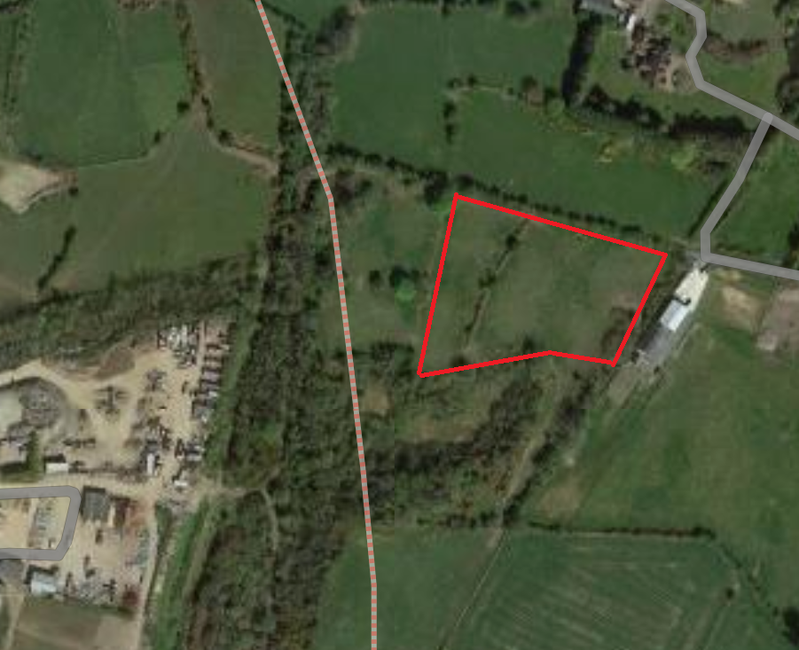

Dalton Glade, Comber
2,000 m2

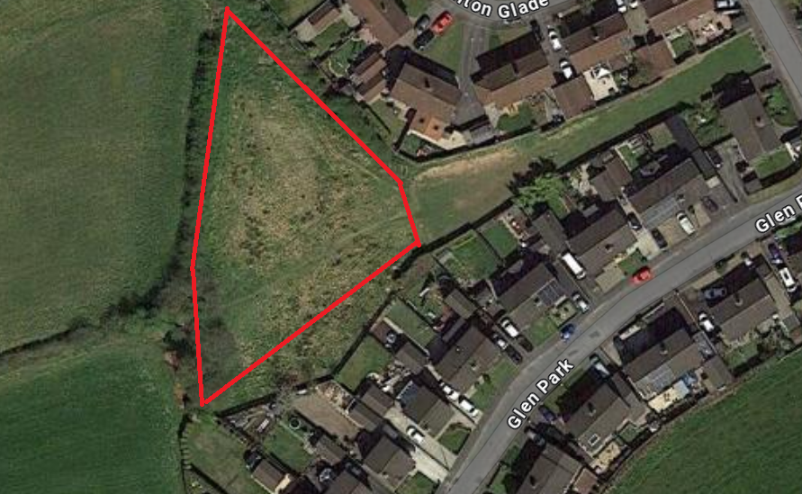

Linear Park, Bangor
1,100m2

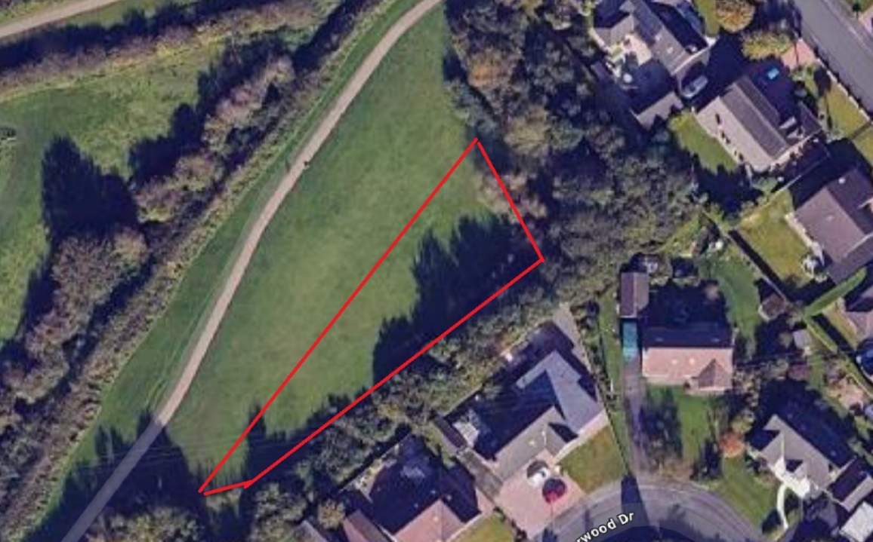

Upper Crescent, Comber
6,600m2

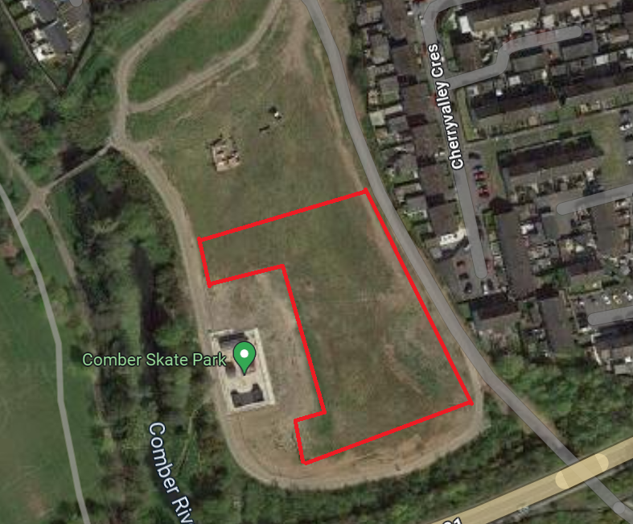

Castle Park, Bangor
9,300m2

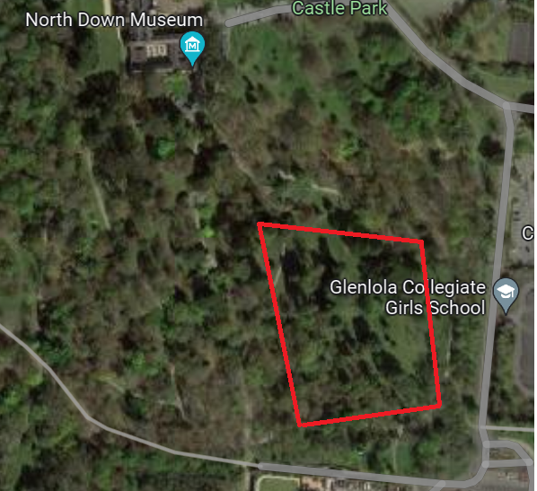

The Commons, Donaghadee
6,700m2

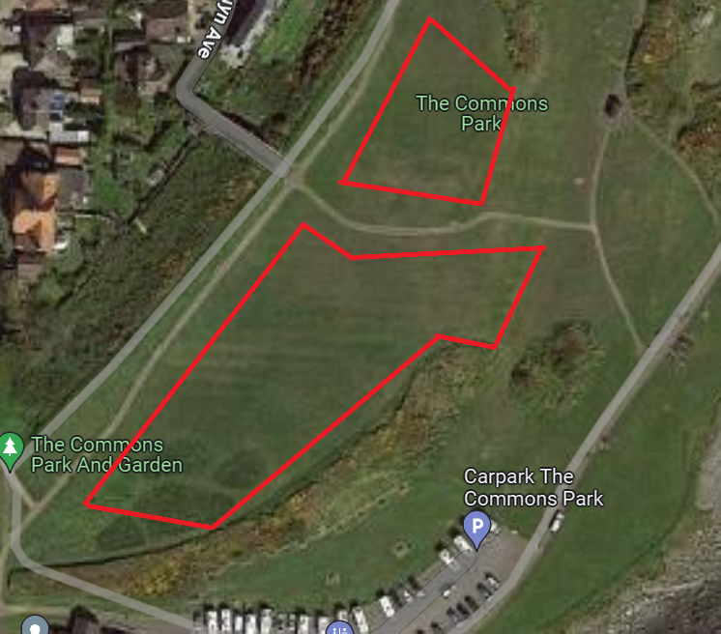

Dermott Gardens, Comber
2,100m2

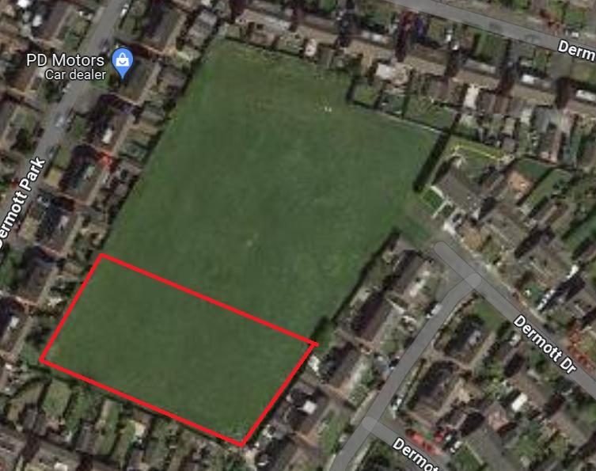

RECOMMENDED that the Council notes and continues to support the ongoing development of the rewilding project as outlined within this report to enhance and promote biodiversity across the Borough.

Proposed by Councillor Kendall, seconded by Councillor Chambers, that the recommendation be adopted.

Councillor Kendall thanked officers for the tangible work and she was pleased that the Council was prioritising biodiversity above the statutory requirement and hoped that would continue and spread further.

Councillor Chambers said that people often spoke of striking a balance and he thought that the right balance had been achieved. He asked about educational signage so that people would understand the Council’s intention and avoid the criticism that areas were being neglected. The Head of Parks and Cemeteries added that some signage was in place at many of the sites but plans were underway to invest in more.

Councillor Cochrane agreed that signage was helpful and referred to the Friends Groups throughout these areas which worked to encourage the thriving biodiversity around the Borough. He mentioned Linear Park and if there was direct engagement with the residential area around that and if rewilding there could cause increased activity of rats. In response the Head of Parks and Cemeteries said that anyone could join a ‘Friends of’ group and take part in the activities within parks. Rewilding did not encourage rats as such since it was not a habitat for them and it would be more likely that field mice would live in rewilding areas. Where residents had concerns they could contact the environmental health section.

The Chair (Councillor Boyle) referred to a rewilding project close to Portaferry Football Club and asked how consultation took place in these areas. The officer replied that there were no hard and fast rules or boundaries for rewilding and adjustments could be made where necessary and that had always been the position.

AGREED TO RECOMMEND, on the proposal of Councillor Kendall, seconded by Councillor Chambers, that the recommendation be adopted.

13. Local boiodiversity action plan progress

Previously circulated:- Report from the Director of Community and Wellbeing detailing that the following report summarised progress made against the Council’s Local Biodiversity Actions Plans (LBAP) that was agreed in 2023. The report also provided Members with an update on the Re-wilding Initiative.

Background

The provision of biodiversity was a statutory requirement under the Wildlife and Natural Environment Act (Northern Ireland) 2011 or WANE Act. The Act required public bodies to take reasonable steps to further the conservation of priority habitats and species or to promote such actions by others. The production and delivery of the LBAP would assist in demonstrating the Council’s compliance with the statutory duty. Under the WANE Act, the Council was responsible for considering five key aspects of biodiversity. Those were:

- Protection of Biodiversity
- Maintenance of Biodiversity
- Enhancing Biodiversity
- Restoring Biodiversity
- Promoting Biodiversity

The Borough’s second Biodiversity Action Plan was approved and adopted in April 2023 and had helped to coordinate efforts to protect and enhance biodiversity across the Borough. The development of the plan was an important step in recognising the importance of our local biodiversity. It aimed to ensure that international, national, regional and local biodiversity objectives were achieved through a range of partnerships.

A total of 84 actions were proposed across four themes in the LBAP, the actions listed were to help protect, conserve, and enhance those priority habitats and species within the Borough identified through the audit. LBAP actions were listed under one of the following 4 themes:

Theme 1: Education and Awareness – 28 actions in total
Theme 2: Research and Monitoring – 7 actions in total
Theme 3: Land Management – 33 actions in total
Theme 4: Building Partnerships – 16 actions in total

Progress during 2023

Theme 1. Education and Awareness
During 2023 a total of 4 actions were addressed under this theme, including:

Action: Support participation in national and international biodiversity awareness campaigns

Action: Encourage participation in citizen science wildlife projects and engage the public in biodiversity recording and awareness

Update: In summary, encouraging participation in citizen science wildlife projects and engaging the public in biodiversity recording and awareness could greatly enhance data collection, public education, community involvement, scientific research, and policy-making, all of which were crucial for effective biodiversity conservation.

International Dawn Chorus
Dawn Chorus Event at Cairn Wood
7th May 2023

Taking place on the first Sunday of May, International Dawn Chorus Day was the worldwide celebration of nature's greatest festival of birdsong at dawn. One of the key reasons for the popularity of International Dawn Chorus Day was the opportunity it provided for citizen science.

The event was led by expert guide David Thompson and was a wonderful success. Participants were taken on a slow hike through Cairn Wood stopping occasionally to listen and identify the birds of the woodland. A total of 16 species were identified on the morning of the event. Those recordings were passed onto the Centre for Environmental Data and Recording (CEDaR), which helped to gather and record information about local wildlife and habitats in Northern Ireland.

The event was a wonderful opportunity for participants to experience the serene and inspiring sounds of nature, helping to foster a deeper connection and appreciation of the environment as well as highlighting the need to protect bird habitats and biodiversity.

National Insect Week
Moth Identification Event Ballyphilip Playing Fields, Cloughey Road, Portaferry
17th June 2023

Insect Week (19th – 25th June) was organised every two years by the Royal Entomological Society and was supported by several partner organisations across the UK and Europe. It encouraged people of all ages to learn more about insects and raised awareness of their essential role as pollinators aiming to raise awareness about their importance in the ecosystem and to encourage interest in entomology.

The event was led by expert guide Ross McIlwrath and was a wonderful success. Ross was able to provide the participants with some interesting background ecology of moths and their habitats. A total of 42 species were caught and identified at this rewilding site. The large number of moths trapped was a positive indication of the
grassland management changes made by Parks under the rewilding initiative. Moth recordings were passed onto CEDaR, the Centre for Environmental Data and Recording.

Mini-Beast Hunt, Castle Park, Bangor
24th June 2023

This was a wonderful family friendly event with over 40 children attending on the day. Participants were taken on a trail of diverse habitats around Castle Park where they searched for and were able to observe small invertebrates in their natural habitats. The event gave families the opportunity to get up close to nature and hands on with wildlife. Using equipment and resources provided, children were able to use their observation skills to identify and record all the minibeasts they found during the event.

Minibeast hunts were not only fun but also fostered a deeper appreciation for nature and its tiny inhabitants. Those events also provided educational and engaging ways to learn about ecology, biology, and the diversity of life.

Wildflower Identification Event, Greyabbey Rewilding Open Space
1st July 2023

This event took place at the Greyabbey rewilding site which had been managed under the Council’s rewilding initiative since 2021. The event focused on the rationale behind rewilding, identifying and learning about local wildflowers and the essential role they played in the survival of our pollinators. Participants also had the opportunity to try some cyanotype photography and botanical drawing which all helped to develop their wildflower identification skills.

Rewilding amenity sites could create vibrant, biodiverse environments that benefited both people and nature. By shifting the focus from traditional landscaping to ecosystem restoration, the Council could foster healthier, more resilient communities.

Wild Days Out
Castle Park
31st July – 4th August 2023

To promote local biodiversity the Council held Biodiversity public engagement events over five days at Castle Park in Bangor. The events were designed to coincide with Love Parks Week. All five daily events were aimed at families with children under 14. The events were fun and entertaining with five different biodiversity themes including bug hunts, wildlife survival skills, bird care and identification and a celebration of the Park’s wonderful trees.

International Bat Night
Bat Walk & Talk Event, Castle Park, Bangor
25th August 2023

International Bat Night was observed on the last full weekend of August every year. It was an opportunity to raise awareness about bats and their ecological significance in relation to pollination and pest control. The event was led by conservationist Caroline Finlay from Conservation Detection Dogs NI (CDDNI) who was joined by Rufus, a springer spaniel employee. Participants had the opportunity to learn about CDDNI’s important conservation work, the threats bats faced, as well as having the opportunity to use bat detectors to identify local bat species within Castle Park. There was huge interest in the event which reached full capacity very quickly.

International Bat Night offered a unique opportunity for communities to come together to celebrate and protect bats, contributing to the overall effort to preserve biodiversity and healthy ecosystems.

Action: Promote ‘Gardening for Wildlife’ and support the All-Ireland Pollinator Plan 2021-2025

Update: Promoting and supporting Gardening for Wildlife and the All-Ireland Pollinator Plan had been met through a variety of Park initiatives and projects including the rewilding initiative, STAND4TREES initiative, sustainable planting, ‘in bloom’ community competitions and Pesticide and the Pesticide and Herbicide Reduction Policy.

Action: Publicize the BAP within the council and beyond through existing information centres and museums (e.g. Bangor Library)

Update: The LBAP Roadshow consisted of 7 events, the initial launch event and a further 6 presentation evenings across the borough shown below.

LOCATION | Date | Time | TOWN/VILLAGES
Signal Business Centre | 29/11/2023 | 13:00 | Elected members, Local NGOS, Staff, Towerview PS
Donaghadee Community Centre | 11/01/2024 | 7pm-8pm | Groomsport/Six road ends/Millisle
West Winds Community Centre | 17/01/2024 | 7pm-8pm | Newtownards/Conlig
Marquis Hall, Bangor | 25/01/2024 | 7pm-8pm | Helens Bay/Crawfordsburn/  Holywood
Carrowdore Community | 31/01/2023 | 7pm-8pm | Ballywalter/Greyabbey/Kircubbin
Comber Leisure Centre | 07/02/2024 | 7pm-8pm | Ballygowan/Lisbane/Killinchy
Portaferry Community Centre | 14/02/2024 | 7-8pm | Ballyhalbert/Portavogie/Cloughey

The launch event was well attended with over 30 present including Elected Members, representatives from NGOS, local conservation groups and staff. A presentation was delivered on the LBAP outlining the benefits and importance of the document to the Council and residents. The following events shown above across the Borough were open to all to attend and advertised on Facebook, via direct invitation to community groups in parks and through Community Development.

The roadshows had an average of 14 people attend, mostly residents representing local community groups. The roadshows were aimed at those groups, and the presentation delivered in a way that showcased the usability of the document as a tool for groups to get ideas for events and contributions that they could make.
Since the delivery of the roadshow, local community groups such as Helens Bay and Crawfordsburn Residents’ Association had delivered their own session on local biodiversity.

Theme 3. Land Management
During 2023 a total of 10 actions were addressed under this theme, including:

Action: Secure funding to commission a feasibility study to explore the options for habitat restoration and management at Laurel Bank and Crawfordsburn Glen.

Update: Parks and Cemeteries Service commissioned feasibility studies as described above. The Council was now in receipt of a report demonstrating options for habitat restoration and management at Laurel Bank and Crawfordsburn Glen. Those reports would guide further actions on both sites.

Action: Restore or plant new native species-rich hedgerows for biodiversity with emphasis on connecting woodlands and other habitats. These hedgerows should act as demonstration sites for good practice hedgerow management.

Update: The Council had an annual tree/hedgerow-planting programme which saw many trees of both native and interesting varieties planted over each Autumn/Winter season. For example, our STAND4TREES initiative aimed to plant a tree for every person in the Borough, that was approximately 160,000 trees. Through planting season 2023-2024 in excess of 15,000 new trees were planted in the Borough. To date, the Council had planted over 45,000 new trees which had seen the creation of new woodland, orchards and hedgerows, the yearly breakdown was:

• 2021/22 – 12,435
• 2022/23 – 15,223
• 2023/24 – 18,269

Action: Continue to manage and monitor lowland meadows under the council rewilding initiative and increase the extent of species-rich wildflower meadow habitat by creating new meadows and expanding the area of existing meadows, in both urban and rural locations. Opportunities to connect to other habitats should be identified and prioritised.

Update: The Council’s rewilding portfolio had increased to a total 90,000m2. New areas added included former Conacre sites at Kircubbin and Bowtown Road. In addition the creation of new wildflower meadows took place at two locations along the coastal path in 2023. The seed was harvested from Crawfordsburn Country Park less than 2km from the new sites. Both wildflower meadows were situated along one of Buglife’s B-lines. By creating a wildflower meadow at those sites, the Council was helping to meet the vision of the project. B-Lines were an innovative solution to the problem of the loss of flowers and pollinators.

Action: Actively pursue the use of local provenance seed (tree and wildflower) and hold workshops on seed harvesting, collection, storage and growing. Including the establishment of local / community tree nurseries.

Update: Engaging local people could take many forms with events and local community planting schemes being an essential mechanism to ensure wide community buy-in for the Council’s Tree and Woodland Strategy which included the STAND4TREES initiative. One other aspect of community engagement Council officers had been developing was a network of Community Tree Nurseries and Community Seed Gathering Projects. The new initiative was called Seed2Leaf. Community tree nurseries allowed the local community to come together and gather local tree seeds, plant them and care for them to become young trees. Trees were important and the act of growing a tree could help create a link to nature for many people. It was also something that anyone, anywhere could get involved in. Each year Council officers developed an application pack which was circulated to the local community. Groups were encouraged to apply for funding to help develop their new community tree nursery. For the 23/24 season, two community groups would have Council support for developing their own Community Tree Nursery.

Action: Ensure all built structures and mature trees on council owned sites are adequately scoped for the presence of bats prior to any works (even minor works such as limb / ivy removal) occur.

Update: It was the responsibility of Council approved tree surgeons to scope for bats before any work was carried out on trees. The Council may only actively remove ivy from trees to further a tree survey. Heavy forming Ivy could at times hinder a tree survey by covering potentially damaging fungi which could weaken the structure of the tree.

Action: Creation of a council grassland management strategy.

Update: A draft version of a new grassland management strategy has been developed by officers in conjunction with staff through a dedicated Task and Finish Group. That strategy aimed to deliver a sustainable grassland management policy, empowering the Council to increase local biodiversity through the recovery of natural habitats, whilst reducing the impact on resources.

The strategy aimed to:

- improve Biodiversity across the Borough in line with the Local Biodiversity Action Plan.
- contribute to Councils Net Zero targets on carbon emissions by reducing the amount of fuel used and provided grasslands that were sequestering and storing more carbon.
- increase efficiency throughout Parks and Cemeteries Service Operations.
- increase community participation and engagement with the local environment.

A full version of the grassland management strategy would be reported to Members when complete.

Action: Investigate with our partners the feasibility of providing wild bird cover for farmland birds

Update: A habitat management plan was produced for Bowtown Road rewilding site. Council officers were investigating the suitability of the site for providing wild bird cover for priority farmland bird species.

Action: Reduce, replace and where possible eliminate the use of herbicides, pesticides and fertilisers on council land

Update: Following agreement on a Herbicide Reduction Policy, a Task and Finish Group had been established among staff to focus on the creation of herbicide free sites, evaluating them in terms of control success and also public perception. Each site had differing levels of success. Kiltonga experienced no negative impact and indeed benefited greatly from the approach. In the case of Hunts Park, the ageing infrastructure reduced the effectiveness of the alternative methods. That was being reviewed and a project for path refurbishment and repurposing would be implemented through this financial year. That would enable a more sustainable herbicide free approach to the site.

The Task and Finish Group identified a number of key areas for the further reduction in the use of herbicide. Those included:
• The cessation of treating kerb lines and mature tree bases as appropriate.
• Allowing boundary edges to naturalise.
• Increased used of weed suppressant mulching
• Localised herbicide free zones within selected areas.

Overall, the above measures had led to a 30% reduction in chemical weed control since 2021.

Going forward and to reduce the use of herbicide further, the following techniques were being explored and trialled:
• Additional mechanical sweeping equipment deployed across the teams.
• Non-Herbicide based products trialled for use on hard surfaces.
• Exploration of Electrical Weed Control – eWeeding

It was important to note that this Policy Statement would not apply to the management of Invasive Species, sports pitches, fine turf areas such as bowling greens, where chemical control was the most appropriate control option currently available. Invasive species weed control was being carried out by In house teams.

Action: Ensure a collection of diverse tree colonies through the planting of native trees across the Borough with the creation of an equitable canopy map.

Update: In general, trees planted would be native species such as oak, elder, hazel, hawthorn and birch, in line with the Council’s Local Biodiversity Action Plan, unless there was a specific ornamental scheme which required cultivated species. An example of that was Castle Park (Bangor) and Ballymenoch Park (Holywood) which were regarded as historic tree arboretums and would require rare and unusual trees as replacements. That was intended to ensure that there was a diverse collection of tree colonies across the Borough.

Over the past year, Council officers had been developing a new interactive tree map which was available for public view via the council website. The Ards and North Down Borough Council's new tree map reflected a progressive commitment to environmental stewardship and community engagement. That initiative aimed to catalogue and display the diverse array of trees within Ards and North Down’s Borough Woodlands, Parks, and urban areas, promoting awareness of the region's rich biodiversity. The tree map served as an interactive tool, allowing residents to explore and learn about individual tree species. The map contributed to a sense of community involvement, as residents could actively participate by reporting tree-related issues or suggesting potential locations for new tree plantings. The technology helped create a user-friendly and accessible tree map and demonstrated a forward-thinking approach to environmental conservation and community engagement, fostering a sense of pride and responsibility among residents for their local green spaces. The map would also allow residents to view upcoming scheduled tree works.

Action: Develop an ambitious planting plan starting with the planting of 160,000 native trees across the Borough with further increased planting to contribute to regional and national targets

Update: STAND4TREES initiative aimed to plant a tree for every person in the Borough, that was approximately 160,000 trees. Through planting season 2023-2024 in excess of 15,000 new trees were planted in the Borough. To date, the Council has planted over 45,000 new trees.

Theme 4. Building Partnerships

During 2023 a total of 3 actions were addressed under this theme, including:

Action: Promote biodiversity objectives in the management of golf courses and encourage all golf courses in the Borough to secure the GEO certified label.

Update: A presentation was delivered to Helen’s Bay and Crawfordsburn Residents Association in 2024. Taking place at Helen’s Bay Golf Club the presentation promoted ANDBC’S LBAP with particular focus on the opportunity Golf Clubs had in playing a role in nature conservation, how they could maximise biodiversity on their courses and the benefits that biodiversity could have on the clubs and their members. Case studies of Golf Courses recognised for their positive changes for biodiversity in NI was also discussed.

Action: Work in partnership with bodies, NGO’s and local groups to support the conservation of the red squirrel and pine marten and identify road mortality black spots where warning signs can be erected.

Update: Council officers engaged closely with the North Down Red Squirrel and Pine Marten Group (NDRSPMG) which received ongoing support from ANDBC in relation to the control of grey squirrels on council owned land.

Action: Improve the value of urban green spaces for biodiversity by setting up ‘Friends of’ Groups at selected sites

Update: As the Council continued to work towards promoting biodiversity in local parks, engagement efforts were yielding some positive results. The Council’s LBAP roadshow had been a success, traveling to various locations and providing residents with information on how they could make a positive impact on the environment. Which led to groups such as Helen’s Bay and Crawfordsburn, who had hosted their own biodiversity meeting to discuss how they could contribute to conservation efforts on a local level using other groups from Donaghadee to input along with Parks staff. Those meetings had not only provided valuable insights but also fostered a sense of community and ownership among residents.

The Council was also excited to announce that its partnership with local In Bloom groups was promoting more sustainable practices and promoting better biodiversity, such as the adoption of perennial planting schemes, which would provide a vital source of food and shelter for local wildlife rather than traditional bedding schemes. Additionally, a new "Friends of Hunts Park" group which was operating under Donaghadee Community Development Association, which would focus on protecting and enhancing the park's natural habitats. The group had already carried out planting of 400 native trees and the establishment of a new community orchard in the area, which would not only enhance biodiversity but also provide a beautiful green space for residents to enjoy.

Other efforts to introduce a new friends of group in Linear Park were underway, with regular events and engagement with residents to bring them along the journey of making positive changes within Linear Park to better help them and biodiversity within the park such as the possible introduction of a Community Orchard in 2025 and new rewilding sites. The group had already taken part in clearing self-seeded phormiums within native tree clumps in the park.

As the summer season approached, the Council would see a full schedule of events for residents to get involved in and sign up to help volunteer across parks leading to the creation of more Friends of Groups across the Borough.

RECOMMENDED that the Council notes the progress of the Local Biodiversity Action plan and continues to support future projects and initiatives.

AGREED TO RECOMMEND, on the proposal of Councillor Kendall, seconded by Councillor Martin, that the recommendation be adopted.

14. pErformance report q3 and q4 environmental health protection and development

Previously circulated:- Report from the Director of Community and Wellbeing detailing that Members would be aware that the Council was required, under the Local Government Act 2014, to have in place arrangements to secure continuous improvement in the exercise of its functions. To fulfil that requirement the Council approved the Performance Management Policy and Handbook in October 2015. The Performance Management Handbook outlined the approach to Performance Planning and Management process as:

- Community Plan – published every 10-15 years
- Corporate Plan – published every 4 years (Corporate Plan Towards 2024 in operation)
- Performance Improvement Plan (PIP) – published annually in September
- Service Plan – developed annually (approved April/May 2023)

The Council’s 18 Service Plans outlined how each respective Service would contribute to the achievement of the Corporate objectives including, but not limited to, any relevant actions identified in the PIP.

Reporting approach

The Service Plans would be reported to relevant Committees on a half-yearly basis as undernoted:

Reference | Period | Reporting Month
Quarter 1&2 | April – September | December
Quarter 3&4 | October – March | June

The report for Quarter 3 and 4 was attached.

Key points to note:
- Staff absence rates had been challenging with a number of staff on long term sick and maternity leave. The Council had been unable to fill some of those temporary vacancies and that had led to targets missed in health and safety inspections and licensing.
- The underspend position for year end was again due to vacant posts and the withdrawal of affordable warmth mid-year.
- The tascomi business case appeared on the dashboard as not progressed however that was not a true reflection of the status. The leadership of the project had been taken over by IT on a collaborative basis for a Council upgrade including other regulatory services.
- The Q4 target for PTO inspections was not met as during the period officers worked to complete property inspections that were delayed as a result of Covid lockdowns. That backlog had now been cleared and should not impact future achievement of targets. The Council was confident that the property inspection service had now recovered to pre-Covid levels of performance and that would be indicated positively on future reports.

Key achievements:
- The Service had generally performed well against the KPI’s for Q4
- The target for PTO inspections was not met in the previous year and that backlog had now been cleared.
- Similarly significant progress had been made on clearing the backlog of food inspection and that should be completely cleared in this financial year.
- Development of a four-year Age Friendly Strategy

Emerging issues:

- The businesses plan for 2024/25 listed a number of emerging areas presenting challenges for the service including the Windsor framework, a new food delivery model, transfer of landlord registration to local government, new legislation, blue green algae and increasing use of vapes.

Action to be taken:

- Continue to progress with recruitment of EHO’s and technical staff.

RECOMMENDED that the Council note the report.

Proposed by Alderman Adair, seconded by Councillor Kendall, that the recommendation be adopted.

Alderman Adair commended the work of the Environmental Health section and said that it always seemed to be able to solve the issues that many other government agencies were not able to, and he asked for his appreciation to be passed on to the team for their professionalism.

AGREED TO RECOMMEND, on the proposal of Alderman Adair, seconded by Councillor Kendall, that the recommendation be adopted.

15. pErformance report q3 and q4 community and culture

Previously circulated:- Report from the Director of Community and Wellbeing detailing that Members would be aware that the Council was required, under the Local Government Act 2014, to have in place arrangements to secure continuous improvement in the exercise of its functions. To fulfil that requirement the Council approved the Performance Management Policy and Handbook in October 2015. The Performance Management Handbook outlined the approach to Performance Planning and Management process as:

- Community Plan – published every 10-15 years
- Corporate Plan – published every 4 years (Corporate Plan Towards 2024 in operation)
- Performance Improvement Plan (PIP) – published annually in September
- Service Plan – developed annually (approved April/May 2023)

The Council’s 18 Service Plans outlined how each respective Service would contribute to the achievement of the Corporate objectives including, but not limited to, any relevant actions identified in the PIP.

Reporting approach

The Service Plans would be reported to relevant Committees on a half-yearly basis as undernoted:

Reference | Period | Reporting Month
Quarter 2 (Q2) | April – September | December
Q4 | October – March | June

The report for October 2023 – March 2024 was attached.

Key points to note:

- Significant budget reduction (47%) in the Letter of Offer from The Executive Office to provide for delivery of the Good Relations Action Plan.
- PEACEPLUS Plan – significant additional work required in relation to theme 1 -capital projects.
- Four key positions in the department vacant due to delay in recruitment, retirement and long-term sick leave.
- The Community Development team and the Externally Funded programmes team were relocated from South Street offices to smaller premises in the Signal Centre, Bangor.

Key achievements:

- PCSP Action Plan 2023 – 2024 delivered.
- Good Relations – Cultural Expressions programme and Shared Voices programme delivered.
- Asylum seekers and refugees programme delivered in Partnership with North Down YMCA.
- PEACEPLUS Plan nearing completion.
- Community Safety Officers increased working in partnership with PSNI Neighbourhood Officers to tackle community safety issues around the Borough.
- Provision of Summer schemes and Council clubs despite staffing issues.

Emerging issues:

- Cultural Expressions agreement was outdated and would require updating in the near future.
- Multiply Officer post to be implemented in the near future as funding had been granted until March 2025.

RECOMMENDED that the Council note the report.

AGREED TO RECOMMEND, on the proposal of Councillor Martin, seconded by Councillor Douglas, that the recommendation be adopted.

16. GOOD RELATIONS ANNUAL REPORT
(Appendix XI)

Previously circulated:- Report from the Director of Community and Wellbeing detailing that attached was the Good Relations Annual Report for 2023-2024 outlining the work of the section in delivering the Good Relations Action Plan for 2023-2024.

The Good Relations Strategy (2022-2025) informed an annual action plan, which was submitted to The Executive Office for assessment. The Action Plan was based on the four key themes of the Executive’s Strategy Together Building United Communities:

- Children and Young People
- Shared community
- Safe Community
- Cultural Expression

The Good Relations section is normally externally funded 75% from the Executive Office and 25% by Council. In 2023-2024 the budget allocated from The Executive Office was reduced to 53% to £90,128.36 making the total Good Relations budget available for 2023-2024 to £120,171.15. The significant reduction in funding had a detrimental effect on the delivery of all programmes in the Action Plan.

The Good Relations section worked closely with PCSP, PEACE and Community Development sections to avoid duplication and ensure a cohesive delivery of programmes to the community.

RECOMMENDED that the Council note the Good Relations Annual Report for 2023-2024.

AGREED TO RECOMMEND, on the proposal of Councillor Ashe, seconded by Councillor Kendall, that the recommendation be adopted.

17. MAE MURRAY GROOMSPORT BEACH 2024-2025

Previously circulated:- Report from the Director of Community and Wellbeing detailing that Ards and North Down Borough Council continued to work in partnership with The Mae Murray Foundation and the Inclusive Beach initiative based at Groomsport. That was the third year operating during the summer to provide a specialised equipment hire scheme.

The initiative was created to bring a change so that people of restricted mobility were no longer excluded from using the beach. Groomsport beach was the first inclusive beach in the Ards and North Down area.

The season would begin Saturday 15th June and run to Sunday 15th September 2024 inclusive, operating from 10.00 – 16.00 every Saturday and Sunday (subject to staff availability).

Advertisement of the Groomsport Inclusive Beach would be released via ANDBC website, social media platforms including Facebook, with Community Development run additional needs club (The Hub) and shared via the Community Development Database. Further posts would be shared throughout the season to raise awareness.

Groomsport Inclusive Beach operated via an online booking system but also welcomed “drop ins”. The mobility equipment such as beach chairs and walking aids assisted participation on sand and sea, whilst hoist, shower, seating and changing bench options facilitated a wide range of personal care needs provided within a “changing places” area funded by Sports NI.

In addition to offering beach equipment for individual loan, Groomsport Inclusive Beach would be hosting 5 family fun day events and activities this year, delivered by Mae Murray Foundation team and Ards and North Down Brough Council. That would include a range of experiences and activities for everyone to enjoy such as visit from Lamas and puppet show. Further details of all events would be available on the Council website.

RECOMMENDED that the Council notes the above.

Proposed by Councillor Cochrane, seconded by Councillor Chambers, that the recommendation be adopted.

Councillor Cochrane was happy to welcome the report and referred to disability access to the beach at Groomsport and how the Council worked with DAERA. Work was ongoing although the Council was aware of problems with excessive seaweed last year. The Head of Community and Culture said that had been dealt with last year, and at the launch this year there was no issue with access caused by seaweed. Staff worked hard to keep that clear.

AGREED TO RECOMMEND, on the proposal of Councillor Cochrane, seconded by Councillor Chambers, that the recommendation be adopted.

18. COUNCIL GRANTS POLICY UPDATE RESPONSE TO NOM WORKING GROUP
(Appendices XII & XIII)

Previously circulated:- Report from the Director of Community and Wellbeing detailing that a meeting of the Elected Member Community Development Grants Working Group was held on 16th May 2024 and the minutes of the meeting were attached for information together with copy of presentation given at the meeting.

RECOMMENDED that the Council note the minutes.

Proposed by Councillor Douglas, seconded by Councillor Martin, that the recommendation be adopted.

AGREED TO RECOMMEND, on the proposal of Councillor Douglas, seconded by Councillor Martin, that the recommendation be adopted.

19. ARTS AND HERITAGE PANEL (A&HP) MINUTES
(Appendix XIV)

Previously circulated:- Report from the Director of Community and Wellbeing detailing that a meeting of the Arts and Heritage Panel was held on 15 April 2024 in Signal Centre, Bangor. The minutes were attached.

RECOMMENDED that the Council note the minutes.

AGREED TO RECOMMEND, on the proposal of Councillor Martin, seconded by Councillor Harbinson, that the recommendation be adopted.

20. NOTICE OF MOTION

20.1 Notice of Motion submitted by Councillor Cochrane and Councillor Thompson

That this Council notes with concern the temporary closure of Groomsport Tennis Courts due to issues around the safety of the playing surface. Further to this Council tasks officers to bring back a report on Tennis Court maintenance throughout the Borough and will commit to ensuring all our Tennis Court facilities are properly maintained and are fully accessible to all. Council will also promote the use of Tennis facilities in the Borough as we approach the Spring/Summer season.

Proposed by Councillor Cochrane, seconded by Councillor Thompson, that the Notice of Motion be adopted.

Councillor Cochrane began by saying that he had brought his Notice of Motion following concern from local residents about the closure of Groomsport Tennis Courts. He and Councillor Thompson decided to bring the Motion in respect of the condition and maintenance of all tennis courts throughout the Borough.

Residents in Groomsport had expressed their frustration about the closure of the much-used facilities in their village. It was welcomed, however, to see that work had recently been completed and he looked forward to the improved courts opening soon. He said the maintenance carried out had been a long time coming and he and his Party colleagues had been calling for the playing surface to be repaired since last year.

He believed sport had such a positive influence within communities. Tennis was particularly popular and was enjoyed by people of all ages and backgrounds which was why he believed that courts needed to be properly maintained and fully accessible to all.

His Motion called on Council officers to monitor and report back to this Committee on the condition of tennis courts throughout the Borough outlining any issues discovered during inspections and informing Members of any closures that may be required to carry out maintenance works. He would like to see defects and issues with the playing surface to be fixed as soon as possible to avoid a prolonged period of closure for courts maintenance. He also would appreciate if officers could advise where there were timescales for tennis court upgrades. He was aware that Donaghadee Tennis Club and others had also been waiting for an upgrade of the facilities there. He was also aware that Council staff had been engaging with local Clubs on the status of upgrades/works scheduled and called for regular communication between the Council and Clubs to continue.

Further to that, he called for the Council to carry out a promotional campaign to encourage the use of its tennis courts throughout the Borough on its social media platforms and website outlining the locations and terms/conditions for the usage of each court. During the summer interest in playing tennis peaked so he hoped that the Council could capitalise on that interest and encourage individuals to get active and socialise through this wonderful sport.

He asked that officers ensured all courts were also fully wheelchair accessible and that as part of the promotional campaign wheelchair tennis was promoted. That would help people with disabilities feel more included and encourage them to get active and enjoy the benefits of exercise.

Ultimately, he believed the Council owed it to its residents and ratepayers to provide a high standard for leisure provision throughout the Borough including tennis courts which was why he had brought his Motion and to ensure that the facilities were maintained and accessible. He asked the Committee to support his Motion.

Seconding the Motion Councillor Thompson did not think there was much to add and he was pleased that repairs had been carried out at Groomsport but he looked at tennis provision as a health and wellbeing opportunity and a means to encourage tourism development.

Councillor Harbinson was happy to support the Motion and he welcomed opportunities to increase physical activity within the Borough. He asked about development of facilities at Ward Park, Bangor with Ulster Tennis and asked about the outcome of that. Officers agreed to come back to him on that.

Councillor Martin also supported the Motion and was glad to hear that the Groomsport tennis courts were back up and running and said that they were superb, particularly since they were free of cost and were a good way for families who simply wanted to have a fun game in the open air.

Alderman Adair commended his colleagues for bringing the Motion and remembered when the former Councils came together in 2015 there was talk of a tennis strategy. He thought that the tennis courts within his DEA, such as Greyabbey and Ballywalter could be improved. He added that if those were lit the sport could be extended into the winter months.

Councillor Chambers supported the Motion referring to a request he had made a number of years ago and believed that it was good to keep monitoring sports facilities.

In closing Councillor Cochrane thanked Members for their support and looked forward to a report in due course.

Proposed by Councillor Cochrane, seconded by Councillor Thompson, that the Notice of Motion be adopted.

20.2 Notice of Motion submitted by Councillor Ashe and Councillor Morgan

That this Council recognises the importance of ensuring that our parks and open spaces are inclusive and accessible to those with speech, language, and communication needs and that it recognises the positive role of communication boards in achieving this. That it commits to working with relevant organisations to bring back a report regarding communication boards considering, but not limited to, the following points:
- How communication boards would integrate with the required existing signage;
- Identifying possible locations for the communication boards, such as a specific Tier of park; and
- An indicative budget.

Proposed by Councillor Ashe, seconded by Councillor Harbinson, that the recommendation be adopted.

Councillor Ashe explained that she had brought her Motion in response to being contacted by a speech and language therapist in her DEA who had been disappointed that there was no provision within playparks locally for those with speech and language difficulties. It had been established that play was essential to the cognitive, physical and emotional development of children and a recent report had shown that Northern Ireland was seriously lagging behind other parts of the United Kingdom when it came to early years communication. She called for support by the Council to see what could be achieved within the Borough’s playparks.

Seconding the Motion Councillor Harbinson thought that any additional help to children was important to ensure that they could have the best possible start in life.

Councillor Adair gave his support and said that every child mattered and it was important to ensure that playparks could be used by all children and he commended the Members for bringing it to the attention of the Council.

Councillor Martin was aware of the figures expressed by Councillor Ashe and regretted that Northern Ireland was falling behind other regions and he hoped that this would provide an opportunity to make the playparks more accessible to all children.

Councillor Ashe thanked Members for their expressions of support and gave particular thanks to the Head of Parks and Cemeteries who had been enthusiastic of her suggestion to him.

Proposed by Councillor Ashe, seconded by Councillor Harbinson, that the Notice of Motion be adopted.

21. Any Other Notified Business

There were no items of Any Other Notified Business.

Before the meeting went in to Committee the Chair advised Members that it had been agreed earlier in the meeting to discuss Item 27.

27. CEMETERY MAINTENANCE RESPONSE TO NOTICE OF MOTION

Previously circulated:- Report from the Director of Community and Wellbeing detailing that in September 2023 the following Notice of Motion was agreed by the Council.

“That Council notes the increasing complaints regarding the poor condition and appearance of our cemeteries across the Borough and tasks officers to bring back a report on options to improve the maintenance of our cemeteries which are places of special significance to those who have lost loved ones.”

A response to the Notice of Motion was tabled at the Community and Wellbeing meeting in December 2023 and Members requested a further detailed report to be presented on tangible options to improve the maintenance within Cemeteries.

Service Overview

The Parks and Cemeteries Service had responsibility for the maintenance and development of approximately 292 hectares of Parks and other open spaces including responsibility for burials in 12 active cemeteries and the maintenance of a total of 19 cemeteries. In the management of the 19 cemeteries spread across the Borough, the operational Parks and Cemeteries team carried out service activities regarding the burial process and overall cemetery grounds maintenance. That was currently delivered by a multidisciplinary skilled team who worked to a suite of Standard Operating Procedures.

Following several issues raised at some cemetery locations, the management of the cemeteries had been reviewed and several interventions put in place to avoid further issues.

The basis of the report was to detail current operational practices and highlight how those had been adapted to ensure continuous improvement and respond to the issues which had been raised and the impacts of changing climate patterns over recent seasons.

Burial Service

The burial service was dictated by the Burial Grounds Regulations 1992 (NI) and all service elements were carried out in line with the legislation. All gravedigging was carried out by skilled in-house teams. Working to the Standard Operating procedures, that element of the service includes the opening and subsequent closing of graves along with the interment service.

Given the more recent prevailing weather patterns and excessive levels of prolonged rainfall, there had been many challenges presented to the teams in protecting the ground during the gravedigging process. While the use of ground guards was deployed to protect the surrounding ground while digging and travel direction of machinery, it was invariably the case that there was some ground disturbance. Staff were acutely aware of the need to minimise those impacts and if damage was caused, remedial repairs were carried out once the burial had taken place. In a further attempt to mitigate against ground damage, additional ground guards had been purchased to ensure there was enough to provide protection where higher burial numbers impacted on several sites at one time.

In addition to the ground conditions, the prevailing wet weather had impacted on the level of grave collapses across some of the cemetery sites. To further mitigate against that, additional shoring equipment had been sourced and deployed.

Grass Cutting Operations

The grass cutting element of the service comprised of several methods of cutting depending on the cemetery layout and configuration. Those methods ranged from the use of ride on equipment to pedestrian and handheld equipment. The schedules for grass cutting generally aligned to a weekly day cycle during the growing period and were dependent upon weather conditions, burial demand, and availability of staff.

The changing weather patterns had impacted on grass growth over the last number of years with milder winters extending the growing period significantly. Additionally, the wetter summer periods led to increased growth rates which put pressure on the cyclic nature of the cutting schedule.

To address those impacts, investments had been made in additional equipment and configuration of staffing. That included a capital investment of more than £50,000 this financial year. In addition, new technologies were being explored to assist in the operation.

A recent tender process had been completed to appoint external support for Parks and Cemeteries ground maintenance using contracted partners. While the use of the Council’s own staff was the preferred option, the implementation of the contract would allow for an uplift in workload capacity through challenging periods, ensuring negative impacts on service provision were mitigated.

Infrastructure Developments
To improve the aesthetics of cemetery facilities, several initiatives had been put in place. The aim of those was to create efficiencies in the maintenance requirements while also improving the appearance of each site.

Those included:

- The installation of drainage solutions to avoid flooding.
- The increase in spacing within new sections and installing ground reinforcing pathways to reduce the impact of machinery on the grounds.
- The installation of additional width strip foundations to reduce the impact on headstones from grass clippings.
- The installation of formal bin storage locations.
- Resurfacing of access roads in Greyabbey and Comber.

The developments in the infrastructure would be further enhanced by improved housekeeping across sites by the cemetery teams.

Staffing Profiles

The Cemeteries management team was constantly reviewing staffing profiles to ensure the service could adapt to changing demands and pressures. Given the complex nature of the service, it was critical to have appropriate staffing resources in the right locations to address service needs. To ensure flexibility in the service, the cemetery teams were centralised at two key locations where they were dispatched to the relevant areas of work. To support that further and to ensure continuity of service, particularly regarding grass cutting, additional support was provided to the cemetery team by selected parks staff. That enabled a continued grounds maintenance service delivery when burial service was at its peak.

The Parks and Cemeteries Transformation project would further enhance the flexibility within the service to be more adaptive to changing service demands.

In addition to staffing, it was critical that the level of skill across the team be retained and developed. Following significant cuts in training budgets last year, officers had secured additional training budgets for 2024/25 to ensure continued staff development across the service.

Service Monitoring

Given the geographical nature of the Borough and the dispersal of sites, it had been identified that there was a greater level of monitoring required to support both the operational teams and the service as a whole. To that end, the Technical Supervisors had been allocated defined areas of responsibility with the remit to ensure a greater level of quality control was carried out across the service. In addition, the Green Flag Award criteria would be used as a national benchmark accreditation to quality open green space. While one cemetery was being put forward for Green Flag accreditation in 2024, the criterial would be applied consistently across the service.

There would be an adoption of a structured and efficient cemetery maintenance schedule to ensure cemeteries were maintained to the highest standard. That would involve the use of a detailed database for planning and tracking cemetery conditions. The information would be monitored daily by designated supervisors and overseen by the Bereavement Services Officer. Proper maintenance of cemeteries was vital to honour the memory of those interred and provide a serene environment for visitors. Currently, maintenance activities lacked systematic oversight, resulting in variable standards across different cemeteries. Implementing a structured maintenance schedule would ensure consistency and quality.

A comprehensive report would include detailed maintenance tasks, such as grass cutting, cleaning, and repair works. Each cemetery would be assigned specific maintenance tasks with clearly defined frequency for example daily, weekly, monthly. The Supervisors would use the maintenance spreadsheet to plan their daily activities and ensure all tasks were completed as scheduled, alongside monitoring cemetery maintenance on a rotational basis daily, ensuring that each cemetery received the necessary attention. The Supervisors would conduct thorough inspections, focusing on certain areas such as pathways and grave sites and would document their findings and the completion of tasks in the spreadsheet, noting any issues or areas needing additional attention.

The Bereavement Services Officer would provide oversight to ensure the inspections and maintenance tasks were carried out effectively and would perform periodic audits, independently verifying the reports and conducting their own inspections. The Bereavement Services Officer would also be responsible for addressing any significant maintenance issues that arose and coordinating the response to those issues.

RECOMMENDED that the Council note the contents of the report.

Proposed by Alderman Adair that the recommendation be adopted and that further the Council review in six months. That was seconded by Councillor Cochrane.

Alderman Adair put on record his thanks to the Head of Parks and Cemeteries for his work. He had asked for the item to be heard out of committee because he felt that it was a matter of public interest. He explained that he had brought a Notice of Motion last summer relating to the poor maintenance of cemeteries after having been contacted by upset relatives. When the Head of Parks and Cemeteries was appointed to his post it felt that someone was willing to listen to residents’ concerns. He stressed that cemeteries were special resting places of loved ones and that the Council should do all it could to care for them and show respect and that would send a powerful message to residents. He hoped that he would never have to raise this matter in future.

The Head of Parks and Cemeteries explained that work undertaken had included improved drainage to address frequent flooding in some places and strips to protect headstones. The entrance to the Greyabbey cemetery had also been resurfaced. Regular cutting of grass was also being carried out.

Councillor Douglas also expressed her thanks to officers who had been happy to meet with some of her constituents and agreed that it was a concern for some residents.

In closing Alderman Adair stated that grief would affect everyone and he hoped that the action taken would bring comfort to many people.

AGREED TO RECOMMEND, on the proposal of Alderman Adair, seconded by Councillor Cochrane, that the recommendation be adopted and that the Council review in six months.

Exclusion of Public/Press

AGREED, on the proposal of Councillor Douglas, seconded by Councillor Kendall that the public/press be excluded during the discussion of the undernoted items of confidential business.

22. AURORA POOL FLOORS SINGLE TENDER ACTION

**IN CONFIDENCE**

NOT FOR PUBLICATION SCHEDULE 3 – EXEMPTION RELATING TO THE FINANCIAL OR BUSINESS AFFAIRS IF ANY PARTICULAR PERSON.

A report was presented to Community and Wellbeing recommending that Council use its Single Tender Action process to appoint a contractor for Aurora Pool Floors.

The Report recommended that Council agreed to the process.

The recommendation was agreed.

AGREED TO RECOMMEND, on the proposal of Councillor Ashe, seconded by Councillor Cochrane, that the recommendation be adopted.

23. HOME SAFETY EQUIPMENT CONTRACT EXTENSION

**IN CONFIDENCE**

NOT FOR PUBLICATION SCHEDULE 3 – EXEMPTION RELATING TO THE FINANCIAL OR BUSINESS AFFAIRS IF ANY PARTICULAR PERSON.

A report was presented to Community and Wellbeing detailing the contract extension for Home Safety equipment.

The Report recommended that Council extend the contract for one year.

The recommendation was agreed.

AGREED TO RECOMMEND, on the proposal of Councillor Douglas, seconded by Alderman Adair, that the recommendation be adopted.

24. AWARD OF THE SOCIAL SUPERMARKET SERVICE LEVEL AGREEMENT

**IN CONFIDENCE**

NOT FOR PUBLICATION SCHEDULE 3 – EXEMPTION RELATING TO THE FINANCIAL OR BUSINESS AFFAIRS IF ANY PARTICULAR PERSON.

A report was presented to Community and Wellbeing detailing the service level agreement for the Social Supermarket.

The Report recommended that Council award the service level agreement in line with the process and continue to secure other providers for the remainder of the Borough.

The recommendation was agreed.

AGREED TO RECOMMEND, on the proposal of Councillor Kendall, seconded by Councillor Cochrane, that the recommendation be adopted.

25. WORKS IN DEFAULT TO RESIDENTIAL PROPERTY

**IN CONFIDENCE**

NOT FOR PUBLICATION SCHEDULE 6a – EXEMPTION STATUTORY PROVISION

A report was presented to Community and Wellbeing detailing carrying out works in default to abate a statutory nuisance.

The Report recommended that Council approve the process.

The recommendation was agreed.

AGREED TO RECOMMEND, on the proposal of Councillor Harbinson, seconded by Councillor Chambers, that the recommendation be adopted.

26. NORTHERN COMMUNITY LEISURE TRUST Q4 2023-2024

**IN CONFIDENCE**

NOT FOR PUBLICATION SCHEDULE 3 – Exemption relating to the financial or business affairs of any particular person

A report was presented to Community & Wellbeing detailing NCLTs quarter 4 activity and performance.

The report recommended that Council note the report.

The recommendation was agreed.

AGREED TO RECOMMEND, on the proposal of Councillor Kendall, seconded by Councillor Harbinson, that the recommendation be adopted.

27. CEMETERY MAINTENANCE RESPONSE TO NOTICE OF MOTION

**IN CONFIDENCE**

Heard out of committee

28. SOCIAL SUPERMARKET PILOT REVIEW

**IN CONFIDENCE**

NOT FOR PUBLICATION SCHEDULE 2. - Exemption: likely to reveal the identity of an individual

A report was presented to Community & Wellbeing detailing a review of the Social Supermarket Pilot.

The report recommended that Council note the report.

The recommendation was agreed.

AGREED TO RECOMMEND, on the proposal of Councillor Ashe, seconded by Councillor Kendall, that the recommendation be adopted.

RE-ADMITTANCE OF PUBLIC/PRESS

AGREED, on the proposal of, seconded by, that the public/press be re-admitted to the meeting.

TERMINATION OF MEETING

The meeting terminated at 9.26 pm.

