ARDS and North Down Borough Council

A meeting of the Community and Wellbeing Committee was held at the Council Chamber, Church Street, Newtownards on Wednesday 15 May 2024 at 7.00 pm.

Present:

In the Chair: Councillor Martin

Aldermen: Adair
Brooks
Cummings

Councillors: Ashe S Irvine
Chambers W Irvine
Cochrane Irwin
Douglas Kendall
Hollywood Moore

Officers: Director of Community and Wellbeing (G Bannister), Head of Environmental Health, Protection and Development (A Faulkner), Head of Community and Culture (N Dorrian), Head of Leisure Services (I O’Neill), Head of Parks and Cemeteries (S Daye) and Democratic Services Officer (R King)

1. Apologies

Apologies for inability to attend were received from Councillor Boyle and Councillor Creighton.

2. Declarations of Interest

The following declarations of interest were notified:

Councillor Martin (Chair), Councillor W Irvine and Councillor Chambers – Item 21 - Leisure Services Contract - update on recent claims concerning compensation events.

Councillor S Irvine declared an interest in Item 15.1 (Notice of Motion) but would only exclude himself from the meeting if he felt it appropriate during the discussion.

NOTED.

3. Arts Project Grants 2024-2025 (FILE ART 05 R1/24)

Previously circulated:- Report from the Director of Community and Wellbeing detailing that the second round of the Arts Project Grants for 2024-2025 opened for application in March 2024 with a closing deadline of Monday 22 April 2024. The grants were advertised in the local press, social media and on the Council’s website.

An assessment panel met on Wednesday 24 April 2024 to assess the 10 applications received by the closing date. The panel comprised of the following members:

- Moira O’Rourke
- Dympna Curran
- Amy McKelvey

A maximum of £1,000 was available per application. The total available budget in this round was £4,175. Total amount requested was £9,646.98. Pass mark was agreed at 60%.

Table 1 below provides a summary of the applications, the scores received and comments.

Table 1
 | Name of Organisation | Requested Amount | Project | Score | Comments | Amount awarded (54%)
1 | Holywood Shared Town | £993 | Arts workshops with Redburn Over 55’s Group | 90 | Excellent facilitators and varied programme which will support the growth of Redburn Over 55’s | £536.22
2 | Orchardville Society (previously AMH Promote) | £1,000 | Development of Christmas show with disabled clients | 90 | Excellent project with huge benefit to the clients of Orchardville | £540
3 | Boom! | £1,000 | Development of volunteer programme with 16 – 18 yr olds | 86 | Excellent project targeting an important age group and offering valuable learning skills | £540
4 | Ulster Guild of Spinners weavers and Dyers | £1,000 | Workshop Programme in traditional textiles | 86 | Great application and a project that will support new interest and development in the group | £540
5 | Ards Camera Club | £1,000 | Photography Workshops | 76 | Great programme | £540
6 | Kilcooley Women’s Centre | £1,000 | Harp playing workshops | 73 | Interesting and unique idea | £540
7 | Cedar Foundation | £712 | Art Workshop with Clients with brain injury | 70 | Good idea but application needed a little development | £384.48
8 | Valhalla theatre Group | £990 | Workshops and development of Historical walking tour of Bangor Castle and surrounding | 69 | Great idea but value for money and demand for the project was slightly lacking | £534.60
9 | D’dee Community Development | £1,000 | Design and creation of D’dee Kilt | 52 | Didn’t represent value for money | Did not reach pass mark
10 | D’dee Heritage Preservation Company | £951.98 | Art workshop days | 48 | Poor application | Did not reach pass mark
 | Total | £9,646.98 |  |  |  | £4,155.30

Eight organisations scored above the pass mark of 60, however, due to the limited monies available the panel discussed a number of options for a fair distribution of the funds available.

Council's normal practice was to divide the amount available by the total amount applied for that met the pass mark and award in proportion to that ratio. Therefore, in this case, that would result in an award of 54.2% of monies requested by each successful applicant.

RECOMMENDED that Council approves the eight awards from the Arts Project Grant Fund for 2024-2025 at 54.2% as per Council normal practice described above.

Proposed by Councillor Irwin, seconded by Councillor W Irvine, that the recommendation be adopted.

The Deputy Mayor, Councillor Irwin, noted that two applications had been unsuccessful, with one described in the report as being a ‘poor application’. She asked if that organisation had been given feedback which could assist it in future applications and the Head of Community and Culture explained that officers would be undertaking that process and offering to meet with the unsuccessful applicants.

AGREED TO RECOMMEND, on the proposal of Councillor Irwin, seconded by Councillor W Irvine, that the recommendation be adopted.

4. UK Government Multiply Agenda - Offer of funding (FILE CW170)

Previously circulated:- Report from the Director of Community and Wellbeing detailing that the government’s new £560 million programme to help transform the lives of hundreds of thousands of adults across the UK started in Spring 2022 and would be delivered through the UK Shared Prosperity Fund, as Multiply Funding. Northern Ireland’s Multiply funding was delayed due to the absence of the Assembly. Funding was now being made available, but the Department for the Economy had a short timeframe to deliver funding before the closing date of March 2025.

The aim of the funding was:
Numeracy was the ability to understand and use maths in daily life, home, and work. Whether that be improving household finances, helping children with homework, making more sense of the stats and facts in the media, or improving numeracy skills specific to your line of work.
UK Government Multiply Agenda
Multiply was a fully funded government scheme that offered maths courses to adults aged 19 years and older. The aim of the funding was to reach the hardest to reach learners/residents, to engage in basic maths for everyday life, delivered in the heart of the community.
Council Officers were initially made aware of the programme at a meeting held on 21st March 2024. The programme included funding towards employment of a Multiply Officer to enable Council to co-ordinate a full programme and manage the funding.
The deadline to apply for funding towards a Multiply Officer was 28th March 2024 and for submission of bids for programme funding was 26th April 2024. Due to the extremely tight turnaround the Chief Executive granted permission to apply for funding for a Multiply Officer and seek permission retrospectively.
A Letter of Offer had been received from the Department for the Economy for provision to employ a Multiply Officer. Responsibilities of the post would include:
- Management and coordination of Multiply Projects.
- Project administration, including liaison with DfE.
- Promotion and marketing of Multiply projects.
- Procurement.

The post was a temporary role until 31st March 2025.
At the time of writing this report, five bids for programme funding had been submitted before the closing date of 26 April 2024. The bids total £314,668 were submitted under the following four themes:
- Engaging with Mature Learners
- Numeracy Bootcamp (two separate applications submitted under the one theme)
- Bring a grown up
- Maths for speakers of other languages.
The Department for the Economy had estimated that there may be £200,000 available per eligible applicant but were unable to confirm amounts at this stage. The scheme would be delivered locally via an open call to community partners to ensure local delivery of the scheme by March 2025. A further update would be brought to Committee once a Letter of Offer for programme funding has been received.
RECOMMENDED that Council retrospectively approves the request to employ a Multiply Officer using the full funding on offer.

Proposed by Councillor Hollywood, seconded by Councillor S Irvine, that the recommendation be adopted.

Councillor Hollywood welcomed the recommendation and felt that essential skills in subjects such as maths were imperative in terms of gaining access to employment and enhancing career opportunities. It was important that the Council grabbed the funding opportunity with both hands.

Welcoming the scheme, Alderman Cummings asked how it would be measured in terms of outcomes and accountability, wondering if there would be qualifications awarded. The Head of Community and Culture advised that the programme was only to provide basic training and that no qualifications would be awarded. She confirmed that earlier that day external funding of £238,000 had now been confirmed to allow the scheme to proceed.

AGREED TO RECOMMEND, on the proposal of Councillor Hollywood, seconded by Councillor S Irvine, that the recommendation be adopted.

5. Community Development Grants Funding (FILE CDV28)

Previously circulated:- Report from the Director of Community and Wellbeing detailing that the Community Development (CD) Fund 2024-25 was match funded by the Department of Communities via the Community Support Programme and the Council Community Development Section.

Correspondence had now been received from DfC (Minister of Communities), Gordon Lyons MLA, to advise that due to budget uncertainty and ongoing negotiations, the budget position for 2024/25 for all Government departments remained unclear.

In response to the budget uncertainty DfC was making an interim allocation to help sustain services and for a three-month period up to 30 June 2024. This had been based on the 2023/24 Letter of offer.

In April 2023 Council agreed to award £91,625.04 to forty-nine successful groups, subject to a Letter of Offer being received from DfC. £41,100 of this was required from DfC through the Community Support Programme with the rest being Council funding.

Given the current budget uncertainty, it was recommended that Council released Letters of Offer to the successful applicants totalling 100% of the Council contribution for 2024/2025 and 25% (quarter 1) of the DfC budget.

The balance the Departments contribution to the total grant budget could be released once a further Letter of Offer had been received.

RECOMMENDED that Council approve the recommendation that Letters of Offer for Community Development running costs are issued with 100% of the Council budget awarded and 25% of the DfC contribution until further confirmation is received from DfC on the next three quarters of 2024/2025 financial year.

Proposed by Councillor W Irvine, seconded by Councillor S Irvine, that Council adopt the recommendation and further that Council write to the DFC Minister outlining the importance of the Community Support Programme to many groups across the community and voluntary sector and called for an increase in funding for this financial year.

Speaking to his alternative proposal, Councillor W Irvine, believed that everyone was aware of the financial pressures on the community and voluntary sectors, with many groups being responsible for community houses that required additional running costs due to increases in energy bills for example. He noted that only £40,000 had been contributed last year from the DfC, and while Council was acutely aware of the budget pressures across the NI Executive as a whole, this was an area of priority and he recognised the benefits of the programme which were hugely relied upon.

The seconder, Councillor S Irvine, indicated his support for the alternative proposal, along with Councillor Kendall who recognised the significant pressures on regional budgets and the reliance that community groups had on the funding. Councillor Kendall asked the officer if she had received any indication of what the amount of external funding would be but the Head of Community and Culture advised that she had queried the likely amount and timeline with DfC but had not received an answer.

AGREED TO RECOMMEND, on the proposal of Councillor W Irvine, seconded by Councillor S Irvine, that the recommendation be adopted and further that Council write to the DFC Minister outlining the importance of the Community support programme to many groups across our community and voluntary sector and calls for an increase in funding for this financial year

6. Ards and North Down Sports Forum Grants (WG April 2024) (FILE SD151)
(Appendix I – III)

Previously circulated:- Report from the Director of Community and Wellbeing detailing that Members would be aware that on the 26th August 2015 Council delegated authority to the Ards and North Down Sports Forum, in order to allow it to administer sports grants funding on behalf of the Council. £45,000 had been allocated within the 2023/2024 revenue budget for this purpose.

The Council further authorised the Forum under delegated powers to award grants of up to £250. Grants above £250 still required Council approval. In addition, the Council requested that regular updates are reported to members.

During March 2024, the Forum received a total of 33 applications: 1 Event, 3 Goldcard, 29 Individual Travel/Accommodation Grants. A summary of the 30 successful applications were detailed in the attached Successful Goldcard and Successful Individual Travel/Accommodation Appendices.

For information, the annual budget and spend to date on grant categories was as follows:
2023/24 Budget £45,000 | Annual Budget | Funding Awarded  March 2024 | Remaining Budget
Anniversary | £1,000 | £0 | £250.00
Coaching | £3,000 | £0 | £1,453.75
Equipment | £14,000 | £0 | -£4,558.76
Events | £6,000 | £0 | *-£442.53
Seeding | £500 | £0 | £55.01
Travel and Accommodation | £14,500 | £0 | *-£5,836.19
Discretionary | £1,000 | £0 | £1,000.00
Schools/Sports Club Pathway | £5,000 | £0 | £3,002.00
28 Goldcards in total during 2023/24.

*The proposed remaining budget for Event of -£442.53 was based on a reclaimed amount of £80.80.

*The proposed remaining budget for Travel and Accommodation of -£5,836.19 was based on a reclaimed amount of £100.

The proposed remaining budget for 2023/24 is -£5,076.72 (111% of the 2023/24 budget spent).

2024/25 Budget £45,000 | Annual Budget | Proposed Funding Awarded March 2024 | Remaining Budget
Anniversary | £1,000 | £0 | £250.00
Coaching | £3,000 | £0 | £3,000
Equipment | £14,000 | £0 | £14,000
Events | £6,000 | £0 | £3,319.95
Seeding | £500 | £0 | £500
Travel and Accommodation | £14,500 | *£3,710.00 | £9,870.00
Discretionary | £1,000 | £0 | £1,000
Schools/Sports Club Pathway | £5,000 | £0 | £5,000
3 Goldcard Extensions Awarded in March

*The proposed remaining budget for Travel and Accommodation of £9,870.00 was based on a proposed award this month of £3,710.00, and £920.00 awarded previously.

The proposed remaining budget for 2024/25 is £36,939.95 (18% of the 2024/25 budget spent), as £750.00 for Anniversary Grants, £2,680.05 for Events and £920.00 for Travel and Accommodation, was awarded previously.

RECOMMENDED that Council approves the attached applications for financial assistance for sporting purposes valued at above £250, and that the applications approved by the Forum (valued at below £250) are noted.

Proposed by Councillor S Irvine, seconded by Councillor Douglas, that the recommendation be adopted.

Councillor S Irvine reflected on the success of the Ards and North Down Sports Forum, believing it had been the most successful group since the formation of Ards and North Down Borough Council. Demand for grants was so high that the Forum was running out of money and he urged officers to look at allocating further funding to meet the level of need.

AGREED TO RECOMMEND, on the proposal of Councillor S Irvine, seconded by Councillor Douglas, that the recommendation be adopted.

7. Play Provision in Loughries Update to Notice of Motion (FILE CW4)

Previously circulated:- Report from the Director of Community and Wellbeing detailing that Members would recall a previous Notice of Motion was agreed by Council in October 2022: “That Council task officers to carry out a review of Play Provision in Loughries with a view to its inclusion in the Councils Play Strategy going forward.”

A report on this was brought to Council in December 2022 with the following recommendation, which was agreed with an amendment:

It is recommended that Council review the potential for play provision for Loughries in the future when the thresholds as outlined above have been met unless provision is made as a result of the planned discussion with others outside of Council. Council notes the report and will review Play Provision in Loughries in 2024.
Context
The Council’s Play Strategy was finalised in 2021 and outlines the strategic approach to play provision in the Borough until 2032. Loughries was assessed in the development of the strategy, but no specific actions in relation to the settlement were included.

This was because Loughries was classified as a Small Settlement (as defined in the Ards and North Down Area Plan 2015). The approach to play provision for Small Settlements and rural areas was outlined in the Council’s agreed Play Strategy (Section 6.4) as follows:

Rural Provision Providing fixed play areas in rural settings needs to be measured and balanced against a range of factors including those outlined above in terms of demographics, distance to other settlements and playparks, as well as the need for land acquisition and budget constraints. In rural areas households tend to be generally dispersed within the landscape. In some cases, clusters of dwellings are defined as Small Settlements in terms of the settlement hierarchy which is outlined in the relevant Local Development Plan. The approach in other Council areas in Northern Ireland is to only provide formal fixed play provision in settlements which are classified as Villages and above. In planning terms, the need for play areas is outlined under Planning Policy Statement 8, Open Space, Sport and Outdoor Recreation (Policy OS 2, Public Open Space in New Residential Development). This is a useful benchmark to consider along with the previously mentioned considerations when determining the need for play provision.

Therefore, a fixed play area will be considered if a Small Settlement has:

- More than 100 residential units within the defined Settlement Limit (as delineated by the Area Plan) or
- Minimum of 100 residential units within the catchment radial of the play area

If a Small Settlement met the criterion and in conjunction with the other considerations as outlined above, then the installation of a play area would be considered (if suitable land can be acquired if the Council did not have any other land available within the settlement). If a play area was deemed necessary, then it was considered that a Tier 3/Doorstep Facility would be appropriate.

Alternatives to fixed play provision could be deployed in rural areas such as exploration of Play Partnerships with schools (if they had play areas), Play Events and Play Pods which had been discussed previously within the Play Strategy. This would be progressed on the appointment of a Play Development Officer, the recruitment process for this post had started.

The Settlement Limit for Loughries as defined by the Ards and Down Area Plan 2015 was shown below.
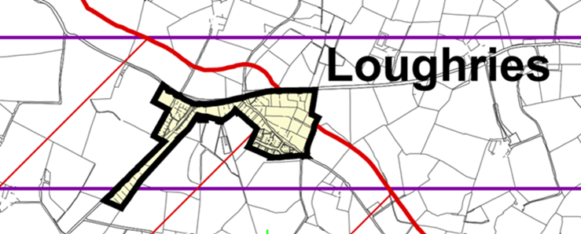
Settlement Limit of Loughries (Ards and North Down Area Plan 2015)

Using the Council’s GIS (Geographical Information System) all address points registered in the Borough were shown. This information was updated on a regular basis using Address Pointer Data received via Land and Property Services. There were currently 98 addresses registered within the Settlement Limit of Loughries with one being the Church and another a school, which were not residential, as was shown below. The black line denoted the Settlement Limit.

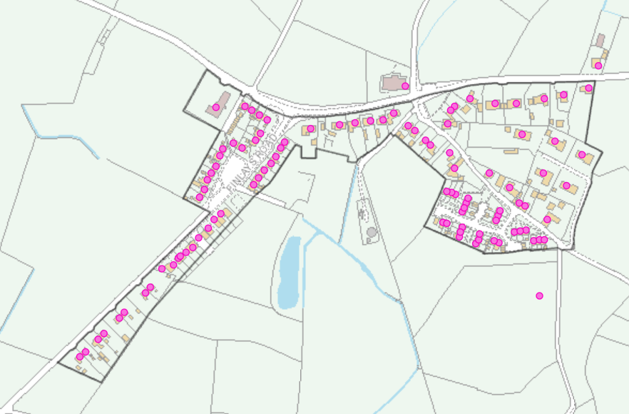
Address Points in Loughries

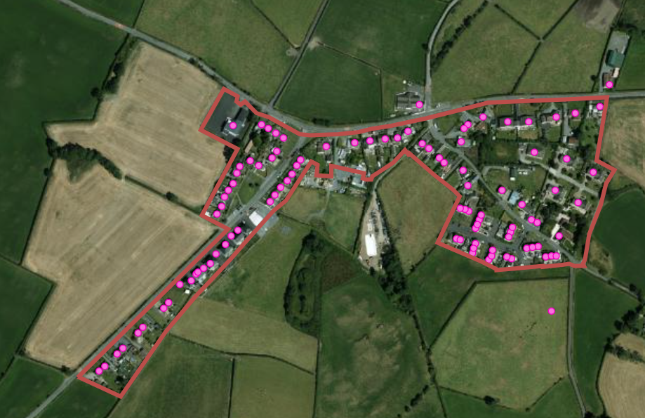
Address Points in Loughries

The above was a recent orthophotography image of Loughries with the address points shown and the Settlement Limit was delineated by the red line. While the number of address points had not changed since the last report in November 2022, it may have been perceived that some new houses had been built along Finlay’s Road, but at the time of that prior report the address points had already been registered with Land and Property Services and were annotated on the map and were therefore counted at that time.

Furthermore, Council currently had no land holdings within or out with the Settlement Limit so therefore land acquisition would be required to deliver any play provision in Loughries.

Summary
Currently Loughries did not meet the criteria as defined in planning policies and outlined in the Play Strategy, as:

1. the threshold of 100 dwellings had not been reached and
2. there was no Council land available.

Future Options
If in the future the residential unit threshold was met, there was the potential to explore a partnership with the Northern Ireland Housing Executive which had some land holdings in Loughries (see map on page 5).

However, even if it was agreeable to transfer some land to Council its lands were limited and it may have further planned for it. In addition, some of the undeveloped land was quite close to houses and therefore a consultation exercise would have to be held with residents to ascertain if they would want a play park close to their houses.

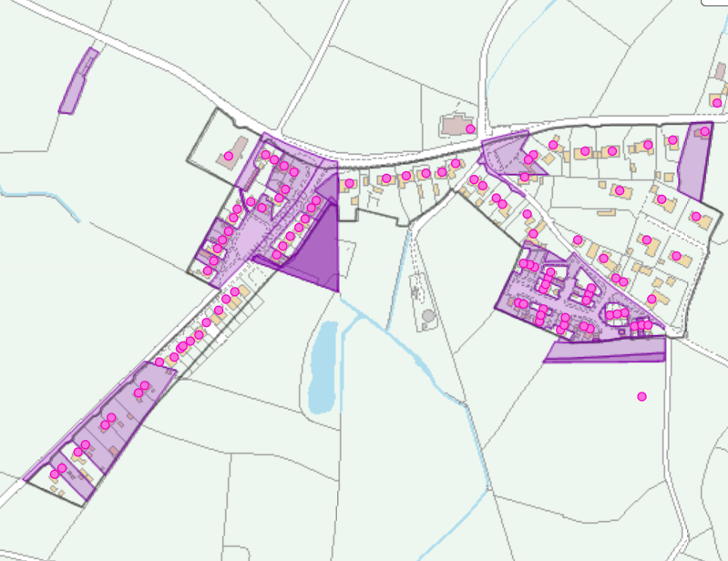
NIHE land shown in purple

It should also be noted that there were other playgrounds which were close to Loughries, with Londonderry Park (Tier 1) being 2.4 miles (by road) and ABMWLC Tier 0 which had an even wider catchment area as shown on the map insert below as well as Abbot Gardens (Tier 2).

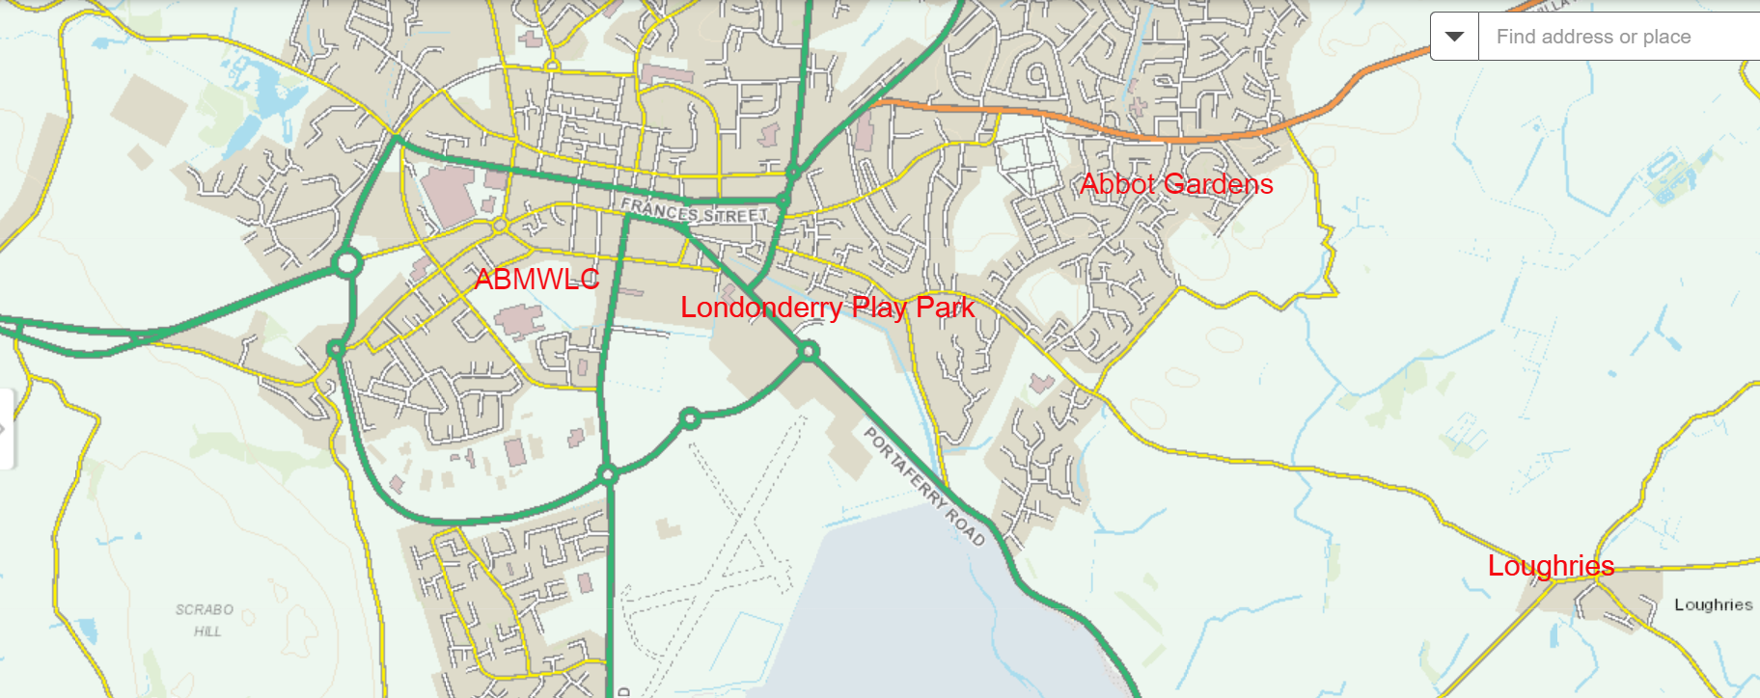
Nearby Playgrounds

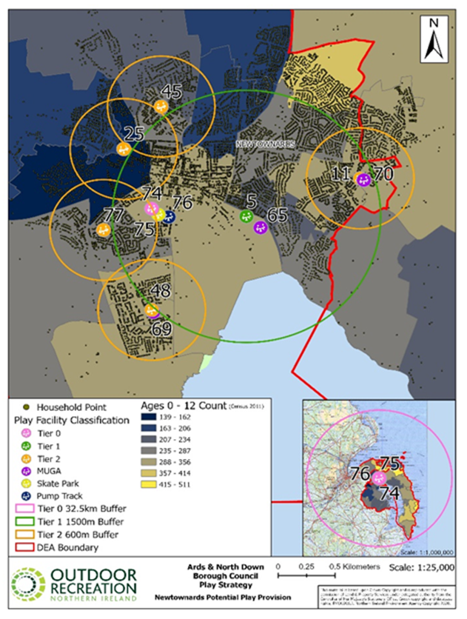
Catchment Areas of Playgrounds in Newtownards

RECOMMENDED that Council

1. Note the above update and agree that play provision in Loughries is not appropriate at this time due to the number of residences and lack of available lands.

2. Furthermore agree that officers review the potential for play provision for Loughries in the future when the thresholds as outlined above have been met.

Proposed by Alderman Adair, seconded by Alderman Cummings, that Council task officers to engage with local landowners with a view to providing an open green space/informal play area for the community of Loughries in line with the Council Play Strategy. Furthermore, the Council agree that officers review the potential for play provision for Loughries in the future when the thresholds as outlined above have been met.

Alderman Adair explained that this report had arisen from a Notice of Motion he had brought two years ago after contact from a local resident and a meeting with Michelle McIlveen MLA and families in the area over concerns about a lack of a safe play area. He explained that Loughries was a hamlet in the north of the Ards Peninsula between Carrowdore and Newtownards which included Loughries Integrated Primary School and Ards Evangelical Church along with an historical farming community in the neighbouring hamlet of Ballyblack. There was currently no safe place for children to play despite a number of private and Housing Executive properties in the area.

He also referred to a new development of turn-key housing which appealed to young families and that only increased the demand further, currently requiring parents and children to travel several miles to the nearest safe play area.

He added that legacy Ards Borough Council used to lease a piece of land from a local landowner and that was provided to the community as open space and used as an informal play area. That arrangement had now ended but he believed there could be scope to do something similar to avoid children playing on busy roads.

Alderman Adair was frustrated that the development was still only two houses short of meeting the threshold for a play area as outlined by Planning Policy and reflected within the Council’s Play Strategy. As a result, Loughries had no safe play area and he urged Members to support his alternative proposal which would task officers to engage with local landowners to try and acquire land for the children of Loughries in the not-too-distant future.

The seconder, Alderman Cummings, rose to support the proposal and reflected on green space at Ballystockart in Comber, which was very popular and used extensively by residents there. It had come about because of the thoroughfare at that land and it had enabled families to use the greenspace at the back end of the development. He understood that it was common practice of the NIHE to allocate 10% of open space which could facilitate a play area.

Councillor Moore added her support to the proposal on behalf of Alderman McAlpine who had also pursued options through the Place and Prosperity Committee.

In summing up, Alderman Adair thanked the Committee for its support which would mean a lot to the residents. It was now important that Council put ‘its best foot forward’ and acquire a safe place to play for the children of Loughries.

AGREED TO RECOMMEND, on the proposal of Alderman Adair, seconded by Alderman Cummings, that Council task officers to engage with local landowners with a view to providing an open green space/informal play area for the community of Loughries in line with the Council Play Strategy. Furthermore Council agree that officers review the potential for play provision for Loughries in the future when the thresholds as outlined above have been met.

8. Vaping and Young People response to Notice of Motion (FILE CW14)

Previously circulated:- Report from the Director of Community and Wellbeing detailing that

In January 2024 Council agreed the following as a result of a Motion

That this Council recognises the growing concerns and impact of single use vapes on our young people, schools and our local environment. Calls on Council Officers to take a full review of options available to address these concerns and work in conjunction with outside agencies in order to do so. The Council also calls on a ban on the importation of illicit vapes and calls on Stormont, at the earliest opportunity, to bring forward legislation to enforce regulations that will combat illicit importations.

This report outlined the outcome of the review requested through the notice of motion and sets out the Councils role and recommendations on what the Council could call on Stormont to progress to address the prevalence of young people vaping.

Background
Vaping is the inhaling of vapour created by an electronic device known as an e-cigarette. Vapour typically contains nicotine and other ingredients, some of which may be harmful. Although vaping was considered less harmful than smoking, the long-term health effects were not fully known, and evidence had shown that they were not harm free. The health advice was that young people and people which had never smoked should not vape. The levels of vaping among local children and young people have however been increasing. According to the Northern Ireland Young Persons behaviour and attitudes survey 2022, 9% of 11–16-year-olds vape compared to 6% in 2019 and the prevalence was higher in older age groups, with 24% of those in Year 12 currently using vapes.

According to the Final Review of the 10 Year Tobacco Control Strategy for Northern Ireland, the growth in the use of disposable vapes are of particular concern. These products are low cost, attractively packaged and available in a range of flavours and appear to appeal to young people.

Vapes could also contain harmful substances other than nicotine. There had been recent reports of vapes laced with illicit substances such as THC or Spice which could have a negative outcome when vaped and the media had reported young people being hospitalised after using vapes with these types of substances added.

There were also concerns over the environmental impact of disposable vapes due to the presence of lithium batteries and hard to recycle components which meant they often ended up as litter or as general waste.

What is Ards and North Down Borough Council currently doing?

Underage Sales
Legislation was introduced in February 2022 which prohibited the sale of Nicotine Inhaling Products (NIPs) (including vapes) to anyone under the age of 18. This was enforced by Tobacco Control Officers within local Councils in Northern Ireland. All identified retailers of NIPs were sent letters and/or visited to inform them of their legal obligations and were advised that test purchasing would be undertaken. In 2023/24, 70 test purchases were carried out in the Ards and North Down area for the underage sale of vapes. The Public Health Agency (PHA) target was 50. During these exercises 8 premises sold NIPs to our child volunteer, and as a result 4 Fixed Penalties and 2 written warnings were issued. 2 investigations were ongoing. Tobacco Control Officers also investigated complaints in relation to underage sales of vapes made by the public.

Officers remained vigilant to businesses starting to sell vapes and new business opening up. This had become very challenging with confectionary shops, beauty and tanning parlours, hairdressers/barbers etc starting to sell vapes. There was currently no obligation for a business to register or seek a licence in order to sell vapes.

Product Safety
The Council had also a product safety role in relation to vapes. The Consumer Protection team enforce a number of pieces of legislation, including the Tobacco and Related Products Relations 2016 (TRPRs) which introduced rules to ensure:
- minimum standards for the safety and quality of all e-cigarettes and refill containers (otherwise known as e-liquids),
- that information is provided to consumers so that they could make informed choices,
- an environment that protected children from starting to use these products.

They also set out standard for e-liquids including:
- Volume of nicotine containing e-liquid for sale in one refill container to be no more than 10ml
- Disposable e-cigarette, a single use cartridge or a tank, capacity of no more than 2ml
- Nicotine strength to be no more than 20mg/ml
- Must not contain certain ingredients including vitamins, colourings and prohibited additives.

TRPRs also included new labelling requirements and warnings and required all e-cigarettes and e-liquids to be notified and published by the Medicines Healthcare Regulatory Authority (MHRA) before they could be sold.

It should be noted that illegal or non-compliant vapes were products that did not meet the requirements set out in the TRPRs and/or were deemed unsafe under the General Product Safety Regulations 2005. For example, vapes that exceeded the maximum tank capacity, vapes that did not fulfil the labelling requirements, vapes that contained illegal ingredients, or those that had not been registered with MHRA.

E-cigarettes also fell under the Electrical Equipment (Safety) Regulations 2016 and therefore must also meet the requirements of these regulations. These were also enforced by the Consumer Protection Team.

To date a scoping exercise had been carried out and intelligence shared within neighbouring Local Authorities regarding labelling irregularities. The Consumer Protection Workplan 24/25 had established a Cross Council task and finish group to research and produce officer guidance on industry developments, training, legislative position and to investigate any changes on enforcement, inspection forms, storage and disposal. This group would link with policy makers to ensure consistency across all Council areas.

Community Safety
In the course of their duties, Community Safety Officers spoke to young people about the reasons they used vapes, how they obtained vapes and if it was refillable, they asked them what type of liquids they put in them. They had also had discussions regarding drugs in vapes and the health implications that could arise from all vape use.

In 2023/24 the Community Safety team added a segment into their talk at BeeSafe on litter, to include the dangers to young people from vapes being discarded in our play parks and green spaces. This was delivered to over 1700 Primary 7 students from Schools within the Borough.

Partnership Working
Following the notice of motion, Council officers discussed establishing a forum with representation from Consumer Protection, Tobacco Control, Community Safety, Neighbourhood Environment, and inviting other stakeholders such as PSNI and the Public Health Agency to share information and identify potential measures to tackle youth vaping. This could include for example introducing a session on the risk of vaping at our BeeSafe events (aimed at P7s) and greater social media coverage. This would progress in the 2024/25 year.

Some of the other organisations involved in vaping include:

The PHA provided funding to Councils in Northern Ireland to employ Tobacco Control Officers to undertake visits to retailers to promote compliance with the age of sale legislation and carry out test purchase exercises. The PHA had indicated that they would be increasing the Council’s target for test purchasing for 2024/25. The PHA also recently published resources to support discussion with young people on vaping and raise awareness of its risks and are available at www.pha.site/vaping. This clear health message was welcome however additional flexibility on how we used the funding including doing more on education would be welcome.

Trading Standards NI were responsible for counterfeit e-liquids and e-cigarettes and if there is a trademark (intellectual property) infringement, for example branding was used on a product that the brand had not allowed (e.g. Haribo)

Border Force and HMRC were currently running Operation CeCe, a joint HMRC-National Trading Standards operation which has been working to seize illicit tobacco in England, Scotland and Wales since January 2021. With more than 27 million illicit cigarettes and 7,500kg of hand-rolling tobacco were seized in its first two years. A new policy paper – Stubbing out the problem: A new strategy to tackle illicit tobacco was launched in January 2024. This detailed the HMRC and Border Force project to combat the supply and sale of illegal tobacco. Funding over £100 million throughout the next 5 years has also been allocated to HMRC, Border Force and Trading Standards to support the delivery of this policy paper which included supporting the delivery of the first smoke free generation. This did not cover Northern Ireland.

Office of Product Safety and Standards (OPSS) had oversight over the electrical safety of e-cigarettes.

PSNI dealt with drugs, including the use of ‘spice’ in e-liquids.

Chartered Trading Standards Institute (CTSI) supported Trading Standards Officers in Great Britain (who enforce product safety legislation). CTSI had Lead Officers in Vaping who provided expertise in this area and provide advice to officers. CTSI was supporting the work of Operation Joesph, which had been set up in England and Wales to tackle the supply and sale of Illegal vapes and e-cigarettes. Funding of £3 million was announced in April 2023 for Operation Joesph. Through this operation, Trading Standards Officers had carried out operations to seize illegal vapes and e-cigarettes, according to BBC news, more than 500,000 illegal vapes had been seized across England in a crackdown by trading standards teams. In addition to this work, an expert panel had been set up to discuss emerging issues and provide advice. While Northern Ireland was not included in the operation, a representative from Northern Ireland sat on the panel as an observer and Northern Ireland Officers could access advice issued by the expert panel.

Restrictions and Challenges

Gaps in legislation
Legislation introduced in 2022 which prohibited the sale of NIPs to anyone under the age of 18 did not:

- prohibit the sale of NIPs from vending machines, despite there being a provision in the Health (Miscellaneous Provisions) Act (NI) 2016 to do so. NIPs vending machines had now been located in a number of premises in our Council area as retailers exploit this loophole. The prohibition of selling tobacco from vending machines had been in operation since 2012.

- prohibited the sale of Nicotine Pouches to under 18s. Current intelligence highlighted that the sale and use of these products was increasing.

- required all retailers of NIPs and pouches to register in the way the tobacco retailers had had to since April 2016. This hindered enforcement as whilst we had been trying to compile lists of vaping retailers these were unlikely to be completely accurate giving the growing number of businesses that appeared to be selling vapes.

- make provision in relation to the retail display or packaging of these products in line with tobacco products. Unlike tobacco, children could see and pick up vapes in retail outlets easily and vape packing could be designed in ways that was more appealing to children.

- make any provision to combat online sales of NIPs/pouches. Online sales represented a huge challenge in relation to these products as there were currently no controls and at the very least some age verification safeguards were required.

Non-nicotine containing e-cigarettes were also a cause for concern given the potential for other harmful contents and undeclared addition of nicotine. The TRPRs did not apply to these products, nor did the regulations around underage sales. We were aware that the use of non-nicotine vapes, and other consumer nicotine products was increasing among young people particularly younger men.

Resources
Whilst the underage sales team was well resourced by PHA, funding the enforcement of E-cigarettes and E-liquids from a product safety angle was very resource intensive. The Consumer Protection team dealt with a wide range of legislation and products with an already limited resource. As OPSS did not have oversight of e-liquids, the funding provided by them could not be used for this work. The team would require additional resource to enforce the Regulations around e-cigarettes and e-liquids more effectively, especially given the large number of businesses that sell these products in the Borough.

Additionally, when e-liquids were withdrawn from sale by officers for non-compliance, the Council did not have systems in place to transport and dispose of these products. E-liquids are a chemical, E-cigarettes contain lithium-ion batteries and disposable e-cigarettes contain both. Chemicals and lithium-Ion batteries required specialist transportation and disposal. Lithium-ion batteries are a fire hazard. Additionally, safe storage was required for seized products while investigations were carried out and legal cases taken. To progress this equipment for the safe storage of products had been ordered and there had been discussions regarding the disposal of any seized vapes with colleagues in waste.

Consultation Proposals
Some of the above restrictions and challenges would hopefully be dealt with by legislation that the UK Government intends to bring forward following the recent Consultation on Smoke Free Generation and Tackling Youth Vaping, in particular measures to:
- Restrict flavours
- Regulate point of sale displays
- Regulate packaging and product presentation
- Apply above restrictions to non-nicotine vapes and other nicotine products such as pouches.

The UK Government also intended to impose age of sale restrictions and ban the purchase of non-nicotine and other nicotine products by others on behalf of those who were under 18.
The UK Government also intended to introduce a ban on sale and supply of disposable vapes and was considering options including a new duty to reduce affordability of vapes.

The Northern Ireland Health Minister recently announced that subject to Assembly approval, Northern Ireland would be included in the new UK laws to tackle youth vaping.

RECOMMENDED that Council, in order to deal with some of the other restrictions and challenges noted, considers the following actions:

- Council to write to the Northern Ireland Minister of Health

- supporting the introduction of the proposed new legislation to tackle youth vaping and

- requesting the introduction of legislation to:
- prohibit the sale of NIPs from vending machines making it more difficult for children and young people to access them,
- requiring retailers of NIPs to register in line with tobacco retailers or introduce a licensing scheme for tobacco retailers and vape retailers
- make provision to combat online sales of NIPs
- apply the above restrictions to other nicotine products and non-nicotine vapes.

- Write to CTSI to request the extension of Operation Joseph to Northern Ireland. This project provides financial resource, as well as guidance and advice to local authorities in England and Wales. If the operation and associated funding could be extended to Northern Ireland it would provide essential resource to the Council.

- Write to HMRC to request extension of Operation CeCe to Northern Ireland. Border Force and HMRC Operation CeCe only targets GB, if this was extended to Northern Ireland it would help with the importation of non-compliant e-liquids and cigarettes.

Proposed by Councillor Hollywood, seconded by Councillor W Irvine, that the recommendation be adopted.

Councillor Hollywood welcomed the response outlined in the report having initially seconded the Notice of Motion that had been brought by Councillor McLaren. It was great to see positive actions and he welcomed the commitment for the extension of Operation Joseph to Northern Ireland. He agreed with all of the recommendations within the report and wished officers well in getting a handle on such an important issue.

Rising to second the proposal, Councillor W Irvine added his support, recognising many gaps and challenges in the regulation of nicotine versus non-nicotine products. He referred in particular to reported challenges around vending machines and asked if that was a new issue and asked the officer for further comment.

The Head of Environmental Health, Protection and Development acknowledged that there had been many challenges around the legislation, explaining that it did not mirror the existing controls around tobacco products that were in place. She explained the challenges around vending machines which had increased in number due to the increased age restrictions in place in shops. Vending machines therefore made those products more accessible but it was an issue that she hoped would be addressed in the new legislation.

The officer highlighted a further concern around unrestricted display of vaping products which unlike nicotine products, could be displayed on shop counters and made more accessible. This had also been flagged in the report and it was hoped it would be addressed in the legislation.

The Deputy Mayor, Councillor Irwin, praised what she felt was a detailed report containing helpful research. She was pleased to see action to address the scourge of nicotine and tobacco on multiple fronts and welcomed a cross agency agreement on tackling the issues, noting that the DAERA Minister intended to ban disposable vaping products.

Rising to support the proposal, Alderman Adair welcomed the DAERA Minister’s announcement to ban single use vaping products and he reflected on the damage of vaping and the detrimental effect it had on the health of young people. He was also aware of environmental and safety risks, understanding that a disposable vape had caused a fire to a clothing bank in Portavogie.

Welcoming the report Councillor S Irvine expressed strong concerns about how easily young people could access vapes, e-liquids and synthetic cannabinoids, commonly known as spice.

He had witnessed firsthand through his work with affected families the devastating impacts of those substances, referring to health, social and academical disruption and that the consequences were far reaching.

Accessibility of those products, he believed was one of the most alarming revelations, and he pointed to social media platforms being used for the sale of substances known as spice. He was aware of incidents where young individuals were targeted by sellers through those channels with enticing offers. He felt that this demanded immediate attention and concerted efforts from all stakeholders and it was imperative that the Council took decisive action to prevent further escalation of the crisis.

He added that the Council needed to make this a top priority and work tirelessly to implement effective measures and curb accessibility. It should include collaboration with law and enforcement agencies, educational institutions and community organisations to strengthen enforcement efforts, raise awareness and provide support to vulnerable individuals and families.

In closing, he added that Council should urge parents, guardians and care givers to remain vigilant and engage in open and honest conversations with young people. Education and awareness were crucial tools in combatting this epidemic.

The Chair, Councillor Martin, agreed with those comments and the content of the report which he felt was a comprehensive and good response.

AGREED TO RECOMMEND, on the proposal of Councillor Hollywood, seconded by Councillor W Irvine, that the recommendation be adopted.

9. Arts and Heritage Advisory Panel Minutes (FILE CW171)
(Appendix IV)

Previously circulated:- Report from the Director of Community and Wellbeing detailing that a meeting of the Arts and Heritage Panel was held online on 5th February 2024 and the minutes were attached.

RECOMMENDED that Council note the minutes.

Proposed by Councillor Kendall, seconded by Councillor W Irvine, that the recommendation be adopted.

Councillor Kendall referred to a recent Notice of Motion about supporting the arts so was glad to see the work being done by the Arts and Heritage Advisory Panel.

AGREED TO RECOMMEND, on the proposal of Councillor Kendall, seconded by Councillor W Irvine, that the recommendation be adopted.

10. Home Office Refugee and Asylum Seeker Funding (FILE CW154)

Previously circulated:- Report from the Director of Community and Wellbeing detailing that in December 2021 Ards and North Down Borough Council became aware that a number of asylum seekers had been placed in hotel in the local area.

In January 2021 a Refugee and Asylum Forum (RAS) was established by North Down Community Network. The forum included members from local churches, community networks and groups, statutory agencies including PSNI, Health, NIHE and Education. Mears Housing who were responsible for the hotel accommodation were also engaged.

The RAS forum also assisted the service users on day-to-day issues e.g. registering with health providers, libraries, CVs, pastoral support and signposting and accompanying to meetings, food banks and clothing banks. Discussions and consultations with the individuals and families in the accommodation allowed the group to identify the needs and programme accordingly. Although individuals and families changed as they achieved refugee status and moved into dispersal accommodation often in other council areas, the needs of the new service users in the hotels usually remained the same.

Following the arrival of asylum seekers dispersal funding was awarded by The Executive Office to Ards and North Down Borough Council in 2022/2023 and 2023/2024. A total amount of £152, 939 was received. The total amount of the funding was provided by the Home Office with no requirement for match funding from Council. Funding was awarded to help integration, language barriers and resettlement into safe areas. Funding was managed in Council via the Good Relations Team.

North Down YMCA were working closing with Council in relation to newcomers to the Borough and a Service Level Agreement was set up with YMCA, as chair of the RAS, to manage a programme of engagement with the asylum seekers.

During 2022-2024 Home Office dispersal funding was used to provide the following:

YMCA:

- Bilingual, culturally sensitive support to refugees and asylum seekers arriving in Ards and North Down.

- Language support and advocacy services to refugees/asylum seekers arriving in Ards and North, such as access to health care, education, welfare and employment.

- Information and support to local organisations and individuals working with asylum seekers and hosting refugees.

- Weekly drop-in advocacy clinics at YMCA North Down (Bangor) and The Link (Newtownards) plus floating support across the Borough (including Ards Peninsula outreach).

- Facilitated access to ESOL classes for refugees/asylum seekers by local churches.

- Facilitated access to support groups and organisations for refugees/asylum seekers.

- Provided a meeting space for refugees/asylum seekers and those supporting them.

- 1216 advocacy sessions provided in Ards and North Down

- 403 refugees and asylum-seeking adults
- 32 sessions of Men’s Group for asylum seeking men including sessions on culture, available activities and sexual health/personal hygiene.

As well as helping service users in hotels YMCA also offered wrap around sessions to Ukrainians, Syrians, settled refugees and migrants settled in the area who needed help and support. Sessions were delivered on coaching courses, financial support including access to food and clothing. Volunteering, housing issues, managed gym passes, biometric residence permits, driving licences, SIM cards, benefits claims, healthcare availability, access to education, job seeking, starting your own business, immigration issues and mental health.

All programmes delivered were the result of a needs-based assessment carried out with all service users.

Boom Studios:

Facilitation of art programmes encouraging service users to use various forms of art to express themselves, art therapy and community cohesion with local residents was delivered. The activities included metalsmithing, digitalaArts, Jesmonite Making, flow art, abstract art and ceramics. Visits to The Ulster Museum and Whitehead Railway Museum, North Down Museum, Sonic Arts Centre and Queens University were also organised. The number of people involved in each quarter were as follows.

Q1 - 170 participants, 6 facilitators, 9 volunteers
Q2 - 114 participants 13 sessions, 8 volunteers
Q3 – 105 participants, 13 sessions, 14 volunteers
Q4 - 103 participants ,12 workshops, 2 visits, 14 volunteers

Boom Studios were continuing to deliver a further 6 weeks with a total of 83 registered between service users and local community.

Volunteer Now

Through Volunteer Now and local churches, volunteer opportunities provided to those who were interested. Volunteer roles were found for two service users and three volunteer roles found for others who then moved to Belfast.

Programmes.

The following summarised programme activities that were provided.

- Gym passes - YMCA disseminated day passes as requested.

- ESOL classes supported by local churches, YMCA and SERC.

- Small World’s Café – Four sessions were delivered with service users invited to take part, introducing different cultures, religions and diversity to the wider public.

- Transport was provided for service users to attend Eid in Belfast.

- Provision of football boots for weekly football programme in conjunction with local church group.

- Transport costs associated with Football programme and visits to Kiltonga Christian Centre re: Clothes and domestic supplies.

- Inclusion in Good Relations Shared Voices Programme.

- CV Writing Workshop for asylum seekers 17 attended – 8 from Marine Court, 7 from Rayanne House and 2 refugees living locally in Bangor.

- Christmas outing organised to the Ulster Folk Museum in Cultra for an evening of celebration and culture. 42 persons attended.

- Cooking programme organised and facilitated by Holywood Baptist Church.

- Assisting with school uniforms.

- Meetings organised and contacts supplied for a service user who is a dentist to explore the possibility of practising in Northern Ireland.

- Providing bags and suitcases as service users move on.

- Assisting service users with orientation of the area.

Compass Project

Compass was a project to help newcomers navigate life in Northern Ireland. Meetings were held to present the project to Good Relations Team, NDYMCA and the Asylum working group. The project was positively received, and permission granted to proceed. One of the service users who had excellent computer/technical skills volunteered and assisted with designing promotional leaflets, PowerPoints etc.

The course was twenty sessions of two-hour sessions per week.

Twenty-six service users registered. The average attendance was 16 service users per session. New arrivals have been given opportunity to join course and catch-up sessions organised.

Countries represented include - Syria, Iran, Eritrea, Sudan, Yemen, El Salvador and Columbia.

Successes:

Through provision of volunteer opportunities, some service users were able to continue their previous professions, interests, hobbies and use transferable skills, i.e., farming, filmography, musicians.

Service users had more access to activities, learned how services such as public transport, GP surgeries, Police and emergency services operated in Northern Ireland. Provided a better understanding of the society they were now part of and promotes integration.

Challenges:

Language barriers posed the largest challenge, with many different languages spoken within the group of service users. ESOL classes had worked well and the progress made by some was very encouraging.

Local resistance to service users through protests outside Marine Court, had had a negative impact on service users mental health, confidence and sense of safety.
Working with PSNI, YMCA and local churches we had attempted to ensure they were away on programmes or otherwise engaged during these times.

RECOMMENDED that Council notes this report.

Proposed by Councillor Irwin, seconded by Councillor Ashe, that the recommendation be adopted.

The Deputy Mayor, Councillor Irwin, recalled a meeting with Stephen Farry MP and the YMCA to hear about the work that the organisation had done, particularly with those asylum seekers placed at the Marine Court Hotel. She welcomed the outcomes that that had been achieved.

Councillor W Irvine understood that the Home Office lease of the Marine Court Hotel was only to be a temporary arrangement for placing asylum seekers and given that the hotel was located in an area of regeneration, he asked if there had been a further extension to that lease.

The Head of Community and Culture explained that officers met regularly with the Home Office and had asked that question a number of times but it was yet to be confirmed.

Councillor W Irvine felt it was crucial that an end date should be reached as soon as possible.

Councillor Kendall understood that the number of asylum seekers and refugees in the Borough was low at the moment and that was due to the good work of this programme which had been successful in supporting them to move on. She was however aware that the YMCA had not heard of future funding, so warned of potential impacts.

The Chair sought agreement on the recommendation going forward but Alderman Brooks indicated that he wished to recorded as against the proposal.

AGREED TO RECOMMEND, on the proposal of Councillor Irwin, seconded by Councillor Ashe, that the recommendation be adopted.

11. Portavogie and Portaferry 3g pitch and Portaferry Sport Centre update response to Notice of Motion (FILE CW74)
(Appendix V – VI)

Previously circulated:- Report from the Director of Community and Wellbeing detailing that in February 2024, Council agreed to the following,

“that Council notes the closure of the training area at Portavogie Football Pitch due to health and safety concerns, recognises the negative impact this has on local provision and sports development and tasks Officers to bring forward a report on options to provide temporary training facilities in the village in the short term and repairs to the pitch in the long term. As a matter of urgency Council tasks Officers to bring forward a bimonthly progress report on the development of the Portavogie 3G Pitch, Portaferry Sports Centre and Portaferry 3G Pitch to this committee.”

Updates

The training pitch in Portavogie was closed following Health and Safety concerns raised by the local football team in December 2023. Upon inspection by Council leisure staff, the pitch was deemed to be safe to use and was immediately reopened. The Club returned to utilise the training facilities once they were reopened and continued to liaise with Council staff to make bookings. The Council’s leisure team recognised that the grass training area was not suited to large groups of young people training for football and would encourage the Club to consider utilising the facilities at other venues if they believed the group size was too big or the grass was in poor condition due to heavy use or weather conditions. The Parks team continued to maintain the grass pitch within the normal levels of provision and would encourage the Club to utilise the area responsibly to ensure the pitch surface is maintained to its full potential.

A regular update on the Portavogie 3G development was produced and shared with the relevant stakeholders. The latest update was attached (Appendix 1).

The Portaferry 3G pitch Board had its most recent meeting on 5th March 2024. Minutes were attached (Appendix 2)

Council Officers were in regular contact with the school regarding the condition of the sports hall floor. To date no commitment had been given by the school as to when the facility will be repaired to facilitate both the school and public use of this critical facility. Council staff had managed to cordon off a small section of the hall which was deemed safe to use and would continue to utilise this space for class delivery.

RECOMMENDED that Council notes this update.

Proposed by Alderman Adair, seconded by Alderman Cummings, that Council task officers to prepare monthly project planning reports incorporating the traffic light system in respect of the Portavogie 3G Pitch, Portaferry 3G Pitch and Portaferry Sports Centre projects to present to the Community and Wellbeing Committee.

Speaking to his alternative proposal, Alderman Adair was disappointed with the report believing that it was a copy and paste of the stakeholder’s update that had been issued previously with no new information and nothing to scrutinise. He explained the background of the situation with the Portavogie 3G pitch, recalling that a business case was agreed one year ago only to be stalled by a material planning consideration raised by Northern Ireland Water. Since this the project had been delayed when urgency was required in order to address a serious need for Portavogie Rangers FC and the community. He explained that the pitch was at the end of its life and required upgrading. He accused the Council of not taking the matter seriously and now hoped to see a monthly update using the traffic light system which had been used previously to provide a clear update.

Alderman Adair added that Councillor Boyle was supportive of the proposal and wanted to see more updates in relation to Portaferry Sports Centre given that the hall floor was still broken. He said that Council needed to hold a stakeholder meeting with St MacNissi’s Trust which owned the building. It was possible that there could be opportunities to apply for external funding but a meeting needed to take place to take that forward.

In closing, he said that people in the Ards Peninsula deserved the same level of services as the rest of the Borough and he hoped that his proposal would send a strong message in getting those much-needed leisure facility upgrades delivered as soon as possible.

Alderman Cummings voiced his support for the proposal, expressing a view that it was about communication, not just with elected Members but with the wider public. He felt that the issues in the Ards Peninsula had implications in other parts of the Borough, referring to issues he was trying to resolve in Comber and Ballygowan.

In summing up, Alderman Adair said he had been speaking with restraint about the issues and hoped that the proposal would provide no wriggle room. He clarified that the stakeholder updates were still important, however.

The Director of Community and Wellbeing asked in order to bring forward the report format that was expected, that Alderman Adair arrange to meet with the Capital Projects Unit to discuss the format he was requesting, to which Alderman Adair agreed.

AGREED TO RECOMMEND, on the proposal of Alderman Adair, seconded by Alderman Cummings, that Council task officers to prepare monthly project planning reports incorporating the traffic light system in respect of the Portavogie 3G Pitch, Portaferry 3G Pitch and Portaferry Sports Centre projects to present to the Community and Wellbeing Committee.

12. Tree and Woodland Strategy Update (FILE PCA4)
(Appendix VII)

Previously circulated:- Attached report from the Director of Community and Wellbeing providing an update on the Tree and Woodland Strategy.

Proposed by Councillor Kendall, seconded by Councillor Ashe, that the recommendation be adopted.

Councillor Kendall welcomed the report and in particular the commitment for more trees and hedges in the coming year. She commented that the Borough in general looked richer in terms of tree coverage and was particularly pleased with orchard community planting work undertaken at Kerr Park, Holywood. She praised the work of Council officers and the wider community who had contributed.

In a query to the officer, she referred to mitigating safety risks and better data collection and asked for further comment and also what the intention was for the environmental data that could be collected in terms of carbon impacts.

The Head of Parks and Cemeteries pointed to the Play Strategy which included a very detailed approach in how Council should protect the trees in its ownership along with the people and buildings. This meant that every tree within the Borough was mapped and searchable online. It was also possible to identify issues with any tree and sometimes the Council was required to remove trees which was always done with a heavy heart, but it was to protect life and property. There were cases where the life of trees came to a natural end and the Council would always try and save as much of the tree as possible, for example sometimes they would leave the stem and he pointed to examples where they were used for art projects. He explained that when trees were felled, they were often left in that same location to provide years of breakdown and biodiversity.

The canopy of the Borough was intended to be increased and that would have major climate benefits. A tree software programme would be used to calculate the emissions and a report would follow on the advantages of additional tree cover.

Councillor Kendall welcomed this approach and use of the data to analyse climate mitigation. She wondered if this, along with the plan, could be shared on the website for the public to access. The officer understood this would also be part of the Corporate Plan and pointed to the additional budget received for trees within the Borough and he believed communities would really notice the difference if that was not the case already.

The seconder, Councillor Ashe, welcomed the report and was pleased that more children would grow up to realise the importance of trees within the ecosystem. She was particularly pleased to see that Andrews Memorial Primary School within her own DEA of Comber had been selected as a Forest School.

Alderman Adair commended the officer for a comprehensive report and he was able to give very positive feedback from constituents in terms of the work and initiatives set out in the report. He also praised the initiatives involving young people.

Councillor W Irvine referred to a tree that had fallen in Ward Park as a result of a recent storm and queried the extent of the damage and whether more could have been done to prevent the incident. The officer explained that he had checked the status of that tree on the Council’s software programme and there was no reported internal damage to the tree. He had been able to verify this with a site inspection. The officer explained that the Council did have access to both internal and external expertise on these matters, but there was always the risk of freak incidents during adverse weather conditions. He reported though that the number of tree fells had been reduced dramatically since the introduction of inspections three years ago.

In a further query, Councillor W Irvine asked what a monolith creation was, and the officer advised that this was where the stem of the tree was retained with the top part being removed and left in the vicinity which was commonly appealing to birds and other wildlife due to the rot.

The Chair commended the report and welcomed in particular the community orchards which were important educational resources for children. He welcomed that there were more planned for 2024/25.

AGREED TO RECOMMEND, on the proposal of Councillor Kendall, seconded by Councillor Ashe, that the recommendation be adopted.

13. North Down Coastal Path Working Group Minutes (FILE CW30)
(Appendix VIII)

Previously circulated:- Report from the Director of Community and Wellbeing detailing that the first meeting of the North Down Coastal Path Working Group was held on 23rd January 2024.

When approving the attached minutes at a subsequent meeting, the chair commented that references to discussion about a map of Councils ownership of lands being provided was not included in the minute. Since the meeting, members of the group had been provided with access to such a map.

RECOMMENDED that Council notes the attached minutes.

The Director of Community and Wellbeing asked the Committee to note that the above minutes had been published with the agenda for this meeting on the Council’s website and this therefore made the minutes publicly available.

AGREED TO RECOMMEND, on the proposal of Councillor W Irvine, seconded by Councillor Kendall, that the recommendation be adopted.

14. Food Service Plan 2023-2024 performance (FILE CW22)

Previously circulated:- Report from the Director of Community and Wellbeing detailing that this report demonstrated the delivery of the Food Service Plan 23/24 which was approved by Council on 13th September 2023. The plan set out the inspections and activities to be carried out by the Food Control team during the year.

Food Hygiene and food standards interventions were carried out as defined in the Food Law Code of Practice and priority had been given to higher risk premises and manufacturers. Intervention activities had been prioritised in accordance with the advice provided by the Food Standards Agency.

Throughout the year the Food Standards Agency had carried out returns to monitor how we were delivering on the plan.

Service Delivery
During the year the food service had had some movement of experienced Officers, new Officers, and 131 new businesses registered, all creating operational challenges. There had been challenges regarding the recruitment of experienced EHO’s and there had been several recruitment processes. Overall, Officers had noted a decline in standards of premises, in particular structural repairs, and an increase in pest activity. This had also been experienced in other food safety sections in neighbouring councils. It was thought that the decline in standards was due to a combination of the increase in utility, commodity, and food prices along with the challenges in attracting staff into the food sector.

The tables below showed the total number of food hygiene and food standards inspections completed in the year 23/24 including the backlog from 2022 and newly registered food businesses. The figures showed that the food team had met or exceeded the targets in the high-risk categories and 197 low risk inspections remained outstanding.

The food hygiene risk rating of a premises determined the frequency of inspection. Category A premises were the highest risk and were inspected every 6 months, category B every 12 months and category C every 18 months. The food hygiene risk rating was determined by several factors such as supply (local, national, or international), type of product, method of handing, hygiene, structure, and the Officer’s confidence in how the business manages food safety.

Food Hygiene Inspections

Food Hygiene risk rating of premises. | Inspections  due in  2023-2024  (including backlog from 2022) | New premises registered in 23-24 | Inspections completed 2023-2024 (includes new premises) | Outstanding inspections
A | 6 | 0 | 6 | 0
B | 44 | 10 | 54 | 0
C | 80 | 27 | 104 | 3
D | 247 | 51 | 204 | 94
E | 238 | 43 | 181 | 100
Total | 615 | 131 | 549 | 197

From the table there were 3 outstanding category C premises which had been inspected in April (1 premises was in the recent fire in Conway Square and the other 2 premises had limited access). As highlighted in the Food Service Plan 23/24 there was a backlog of approx. 680 inspections in the lower risk category premises rated D & E, so the team had made good progress in addressing this leaving 197 inspections outstanding moving into the 2024-25 year.
Food Standards Inspections

Food Standards risk rating of premises. | Inspections  due in  2023-2024 | New premises registered in 23-24 | Inspections completed.  2023-2024 | Outstanding inspections
A | 4 | 0 | 4 | 0
B | 103 | 27 | 70 | 60
C | 430 | 104 | 134 | 400
Total | 537 | 131 | 208 | 460

The Food Service Plan 23/24 reported food standards inspections due. From the table above 208 inspections were completed leaving 460 inspections outstanding which would be addressed in the coming year as the new Food Standards Delivery model would be introduced in November 2024. Two additional temporary posts were being established (subject to funding and approval) to assist with the backlog of food hygiene and standards inspections.

New Business Registrations

All food businesses were legally required to register with the Local Authority.
131 new businesses registered during 23/24, this was a slight decrease in last year’s registrations. New business registrations were triaged by the Service Unit Manager and were then inspected by an Officer, with a target of inspection within 28 days of registration.

Investigation of food poisoning and other infectious diseases

Investigation of food poisoning was provided by Council on behalf of the Public Health Agency. The Food Service Plan estimated 80 individual cases per year however, this year the team had undertaken 88 investigations regarding infectious diseases.79 cases (89.8%) of these were reported from the Public Health Agency and 9 (10.2%) cases were reported by members of the public alleging illness from food consumed within the Borough.

Further information

The Council provided a comprehensive service to consumers and food businesses such as education, advice, and signposting to other resources e.g. Food Standards Agency online allergen training.

Sampling

The Northern Ireland Food Managers Group policy for food sampling been implemented within the Council’s Food Control Service. The target number of bacteriological samples for routine analysis was 12 per week totalling 650-700 for the year. During 23/24 589 ready to eat food samples were collected with the results showing 90.5 % satisfactory and 9.5% unsatisfactory. Unsatisfactory samples were repeated, and advice was given to the business until a satisfactory result was received. Unsatisfactory samples may have arisen from poor handling practices, poor temperature control or incorrect storage conditions.

The Food service plan collected 220 routine chemical samples. The samples were collected and analysed for composition and labelling, allergens, and food complaints 1% of samples failed for composition, 47% were non-complaint for labelling and 52% were complaint.

The Food Control Service assisted business to achieve compliance with the labelling regulations and provided guidance in new product development.

The service participated in the following FSA surveys:
- Nutritional composition of traybakes
- Acrylamide in baked goods
- Mycotoxins in coffee beans
These surveys were part of a UK wide intelligence gathering process to highlight any emerging food risks such as food fraud, and to develop data on nutritional composition and calorie composition.

An inhouse survey was conducted in butcher’s premises for speciation test and levels of Sulphur Dioxide (preservative) in mince beef. The results were as follows:
- Speciation tests 100% compliance
- Sulphur Dioxide was present in 4 samples 28% -Formal samples will be resubmitted in May 2024 after the businesses have been informed of the results.

Complaints and Service Requests

The food section responded to 546 complaints and service requests mainly from members of the public. Of these 342 related to hygiene standards in premises or issues with food products. All service requests were responded to within two days, however depending on the nature of the request they may be acted on immediately where there was an imminent risk to public health e.g., rodents in a commercial kitchen.

Enforcement Actions

The service operated within the Councils Regulatory Services Enforcement policy. A summary of the formal enforcement activity for the year was summarised below:

17 Hygiene Improvement Notices

5 Remedial Action Notices

3 Voluntary Closures

Advice and Education

As outlined in the Food Service Plan, Officers had provided advice and education to businesses including the following:

- Food hygiene training to 5 volunteer catering groups in church settings
- Facilitating a food safety talk to event managers at SERC
- Inspecting and advising food vendors at Sea Bangor in June 2023 and Christmas 2023
- Allergen seminars in Bangor and Newtownards with 126 delegates representing 86 food businesses.

2023/2024

A food Service Plan for 2024/25 was currently under development and would be presented to Council at the June 2024 meeting.

RECOMMENDED that Council notes the delivery of the Environmental Health Protection and Development Service Food Service Plan.

Proposed by Alderman Brooks, seconded by Councillor W Irvine, that the recommendation be adopted.

Alderman Brooks praised officers on their work, explaining that he worked in the hospitality sector and often advised people to engage with the service for advice and guidance rather than place themselves into a position where they had to react.

The seconder, Councillor W Irvine, noted that 131 new hospitality businesses had been reported which he welcomed and asked how that figure compared with previous years. The Head of Environmental Health, Protection and Development advised that the figure was always high and understood that last year it was around 120. However she explained that a new business could be regarded as a change of ownership within an existing establishment so it did not necessarily mean that a new building had been opened. She added that there had been an increase in home-based businesses, particularly since the Covid-19 Pandemic, and that trend had continued.

AGREED TO RECOMMEND, on the proposal of Alderman Brooks, seconded by Councillor W Irvine, that the recommendation be adopted.

15. notices of motion

15.1 notice of motion submitted by councillor Wray and councillor hollywood

This Council values the role that young people play in civic leadership within our Borough Council will engage with Ards and North Down Youth Voice and local members of the NI Youth Assembly, with the view to providing use of our Council Chamber and resources to enable them to conduct an annual meeting. The agenda for the meeting should be decided by the young people with the Mayor chairing the proceedings

(Councillor Wray was invited forward from the public gallery to propose his Notice of Motion – 7.50pm)

Proposed by Councillor Wray, seconded by Councillor Hollywood, that this Council values the role that young people play in civic leadership within our Borough. Council will engage with Ards and North Down Youth Voice, with the view to providing a Council Chamber and resources to enable them to conduct an annual Meeting. The agenda for the meeting should be decided by the young people with the Mayor chairing the proceedings.

Speaking to his proposal, Councillor Wray advised that it differed slightly from what he had submitted initially.

Councillor Wray considered himself to be incredibly lucky and privileged, not only to be a member of this Council, but in a work capacity to have spent his whole working life, engaging with young people around issues that were important to them. He was lucky because his job was not just a job, but a career, a vocation, and even though it had its challenges, it gave him a great deal of joy and achievement.

He felt that all members of the committee would agree that young people were equal citizens, and while they may not have been at the legal age to vote, their voice, their feelings, their opinions, and their ideas about the Borough and province were just as important as anyone else’s.

Not only must Council listen, and take on board what young people said, it needed to ensure they had a platform to articulate themselves. Young people were the future of the community, and they should be part of shaping our community. It was imperative that youth engagement through Council was not tokenistic, but that it was meaningful, with accountability and tangible outcomes.

Councillor Wray set out the context of the group mentioned in this Notice of Motion before outlining what he was proposing should happen.

Youth Voice Ards & North Down was a group of young people aged between 15–18 years which met on a weekly basis, and currently had 24 members from across the Borough of Ards & North Down. He knew elected members had had an opportunity to meet with them, and hopefully would be familiar with their work. The role of Youth Voice members was to take an active role in advocating for other young people living across the Ards & North Down area and addressing important issues that affected them and their communities.

In their first year, members of the Youth Voice had participated in various consultations, engaged in discussions about the rights of children and young people, and familiarised themselves with various issues that had an impact on young people. As they progressed into their second year, they shifted their focus towards identifying specific issues they would like to explore in more detail and organise campaigns to bring about positive change for young people from across the Borough.

Currently, the Youth Council was participating in an Open College Network (OCN) course exploring Advocacy and Active Participation. This course equipped them with the necessary skills and knowledge to effectively advocate for young people and encouraged them to become more active in creating change in their local communities.

The original NOM mentioned the Northern Ireland Youth Assembly, however it was not possible to confirm this at the moment. The current 90 Youth Assembly Members took their seats in October 2023. There were three members of the Assembly from Ards and North Down and two of those came from his own DEA of the Ards Peninsula.

He imagined that every Member here tonight would have whole heartedly agreed with the first section of the Notice of Motion, and he hoped that everyone could join together to say very clearly that we did value the role that young people played in civic leadership within our Borough.

Through discussions with those involved with Youth Voice he believed the Council could help the group to raise that voice, and provide that platform by giving them the opportunity to ‘take over’ one of the Council Chambers for an annual meeting. In terms of which Chamber that was (Ards or Bangor) that could be left to Council Officers and the young people themselves to decide. The meeting would allow the young people to lay out their strategic plan for the year. The agenda would be set by the young people and they would engage with the Mayor who would chair the proceedings. Members of NI Youth Forum should also be invited and have an opportunity to present their plans and priorities. It would be a great opportunity for both groups to be aware of each other’s work and to take learning from each other.

The use of the filming equipment should be provided with the meeting streamed live on YouTube. You would all be aware that meetings were available live but not to view retrospectively. From conversations he had had with officers and the tech team he understood that it would not be a problem to change the settings and allow this video to stay online. This would have allowed the young people to use it as reference but could also promote their work to residents across the Borough. Elected Members could watch of course, and hopefully begin to work in partnership with young people and these groups to deal with issues that were important to them.

The young people may have wanted to hear from Council Officers around the Council’s roles and responsibilities around ‘Community and Wellbeing’, or ‘Planning’, or ‘Environment’. He explained that he was intentionally not being too prescriptive around this because he believed in active participation and he wanted the young people involved to be able to shape the agenda and logistics along with Council Officers, but hopefully tonight the Committee could agree that there was merit in this and it was an opportunity that Council should provide for young people of the Borough.

The seconder, Councillor Hollywood, said the Borough should recognise the invaluable contributions that young people made to the Borough and the crucial role they played in shaping its present and future.

Having worked with many young people over many years and also having met with Youth Voice members he could see how they served as powerful advocates for their respective communities, representing diverse voices and perspectives of young residents.

They brought fresh insights, innovative ideas, and a unique understanding of the challenges and aspirations facing today's youth.

Providing access to Council facilities for Youth Voice members was not just about offering physical space; it was about acknowledging their rightful place in local governance structures. It was about sending a clear message that their voices mattered, their opinions were valued, and their participation was essential to our democratic processes.

He hoped that by using Council facilities, Youth Voice members would have the opportunity to engage in meaningful discussions on issues that affected their lives and the broader community. That access would enable them to amplify their voices, build networks with elected representatives and Council officers, and develop leadership skills that were critical for not just theirs, but our personal and civic growth.

This Motion further aligned with Council's commitment to promoting youth participation, civic engagement, and building bridges between generations. It reflected their belief in the power of collaboration, dialogue, and mutual respect as essential ingredients for building a stronger, more cohesive Borough.

Therefore, he urged all stakeholders, all Members, Council officers and staff, and ratepayers alike, to join in supporting this motion.

The Deputy Mayor, Councillor Irwin, rose to welcome the proposal and thanked the proposer and seconder for bringing it to the Committee. She felt it was crucial to engage more young people in politics and reflected on youth programmes and opportunities that she had taken at university to get involved in politics which had helped her progress into local government.

Adding her support to the Motion, Councillor Kendall explained that she had engaged with officers earlier in the year to set up a Youth Voice meeting in the Chamber along with Council support for live broadcasting. She believed that the dates proposed were the 9th and 10th October.

Alderman Cummings gave his support, adding that he had worked with young people and recognised that they brought something very dynamic and he valued their opinion. He was aware of youth programmes at Parliamentary level and he felt it was important to engage young people at local government level.

Councillor W Irvine also recognised the importance of the Motion and would value the input from young people on projects such as Bangor Waterfront Regeneration. Councillor Chambers recalled sitting on a youth forum with others who had progressed to local government and he recalled the benefits of that. He felt it would be extremely beneficial for young people to be able to debate in the City Hall Chamber with the Mayor.

In summing up, Councillor Wray thanked Members and welcomed the cross-party support along with the support from independent Members. It was important to note that young people were not aligned to party politics which he found refreshing. He appreciated that there had been other efforts ongoing to set up a meeting and thanked Councillor Kendall for making that happen.

AGREED TO RECOMMEND, on the proposal of Councillor Wray, seconded by Councillor Hollywood, that this Council values the role that young people play in civic leadership within our Borough. Council will engage with Ards and North Down Youth Voice, with the view to providing a Council Chamber and resources to enable them to conduct an annual Meeting. The agenda for the meeting should be decided by the young people with the Mayor chairing the proceedings.

(Councillor Wray, Councillor Hollywood and Councillor Kendall left the meeting – 8.09pm)

16. Any Other Notified Business

There were no items of Any Other Notified Business.

Exclusion of Public/Press

AGREED, on the proposal of Councillor Chambers, seconded by Councillor Ashe, that the public/press be excluded during the discussion of the undernoted items of confidential business.

17. Tender for Grounds Maintenance Support Services (FILE PCA17)

**IN CONFIDENCE**

NOT FOR PUBLICATION SCHEDULE 3 – EXEMPTION RELATING TO THE FINANCIAL OR BUSINESS AFFAIRS IF ANY PARTICULAR PERSON.

A report was presented to Community and Wellbeing detailing the tender for Grounds Maintenance Support Services

The Report recommended that Council award the tender in line with the process.

The recommendation was agreed.

18. Comber Greenway Alternative Route (FILE CW30)
(Appendix IX)

**IN CONFIDENCE**

NOT FOR PUBLICATION SCHEDULE 3 – EXEMPTION RELATING TO THE FINANCIAL OR BUSINESS AFFAIRS IF ANY PARTICULAR PERSON.

A report was presented to Community and Wellbeing providing an update on two new routes for an extension to the Comber Greenway.

The Report recommended that Council agree to one of the routes and proceed with next steps.

The recommendation fell.

AGREED NOT TO RECOMMEND.

19. PEACEPLUS Minutes (FILE PEACEPLUS)
(Appendix X)

**IN CONFIDENCE**

NOT FOR PUBLICATION SCHEDULE 3 – EXEMPTION RELATING TO THE FINANCIAL OR BUSINESS AFFAIRS IF ANY PARTICULAR PERSON.

A report was presented to Community and Wellbeing including minutes from the PEACEPLUS meeting on 8th February 2024.

The Report recommended that Council note the minutes.

The recommendation was agreed.

20. PCSP Minutes (FILE PCSP mins)
(Appendix XI)

**IN CONFIDENCE**

NOT FOR PUBLICATION SCHEDULE 3 – EXEMPTION RELATING TO THE FINANCIAL OR BUSINESS AFFAIRS IF ANY PARTICULAR PERSON.

A report was presented to Community and Wellbeing including minutes from the PCSP meeting on 12th February 2024.

The Report recommended that Council note the minutes.

The recommendation was agreed.

21. Leisure Services Contract. Update on recent claims concerning compensation events (FILE CW24)

**IN CONFIDENCE**

NOT FOR PUBLICATION SCHEDULE 5. EXEMPTION: A CLAIM TO LEGAL PROFESSIONAL PRIVILEGE.

A report was presented to Community and Wellbeing providing an update on recent claims concerning compensation events.

The Report recommended that Council note the decisions made under the terms of the Leisure contract

The recommendation was agreed.

Re-admittance of public/press

AGREED, on the proposal of Alderman Adair, seconded by Councillor Ashe, that the public/press be re-admitted to the meeting.

The Vice Chair, Councillor Kendall, took the opportunity to thank the Chair at what would be Councillor Martin’s final meeting in the role throughout the 2023/24 year. Councillor Irwin thanked the Chair on behalf of the Alliance Party while Alderman Adair also added his thanks and praise.

Councillor Hollywood echoed those comments, adding that as a new member of Council he had taken useful learning from the Chair.

The Chair thanked Members for the comments and added that it had been a pleasure to chair the Committee over the past year. He praised the Director and Community and Wellbeing officers for their hard work and thanked them for their help throughout the year.

Termination of meeting

The meeting terminated at 8.31pm.

