ARDS and North Down Borough Council

A meeting of the Community and Wellbeing Committee was held at the Council Chamber, Church Street, Newtownards and via Zoom, on Wednesday 13 March 2024 at 7.00 pm.

Present:

In the Chair: Councillor Martin

Aldermen: Adair
Brooks
Cummings

Councillors: Boyle S Irvine
Chambers W Irvine
Creighton Kendall
Douglas Moore
Irwin

Officers: Head of Environmental Health, Protection and Development (A Faulkner), Head of Community and Culture (N Dorrian), Head of Leisure Services (I O’Neill), Parks and Cemeteries Officer (J Bettes) and Democratic Services Officer (H Loebnau)

1. Apologies

Apologies for inability to attend were received from the Director of Community and Wellbeing, Councillor Ashe, Councillor Cochrane and Councillor Holywood.

2. Declarations of Interest

The following declarations of interest were notified:

Councillor Chambers – Items 13, 14 and 19
Councillor Kendall – Item 4
Councillor W Irvine – Item 13 and 14
Councillor Martin – Item 13 and 14

Order of Business

Proposed by Alderman Adair, seconded by Councillor Boyle, that the Circulated for Information item be taken before the exclusion of public and press. Alderman Adair explained that he had a few comments to make at that point and wished to hand over a petition. The Chair and Members were in agreement.

AGREED.

Reports for approval

3. Ashbury Play Park Update (FILE Cw4)

Previously circulated:- Report from the Director of Community and Wellbeing detailing that the purpose of this report was to update the Committee on the current status of the proposed Ashbury Play Park. Following the last update report in September 2023, Members agreed, ‘That council note that the playpark cannot be delivered until the planning application has been determined. Officers, in the meantime, will return a report to this Committee, detailing alternative options in the event of the current plans not being progressed. In addition, Council Officers meet with NI Water and the developer for an onsite meeting to address the drainage issues.’

BACKGROUND

Under the legacy North Down Borough Council Play Park Strategy 2014, the east Bangor area was identified as having a lack of play provision. The more recent Ards and North Down Borough Council Play Strategy 2021 – 2032 also reiterated the lack of play provision in that area. An area around Ashbury Avenue (Ashbury Shops) and Linear Park was identified as being the best location to deliver a play park in that area to serve the local population. A site in the Lower Linear Park area was considered but was discounted due to the proximity of the dual carriageway. The sites which were identified were a location on the grass area to the front of the Ashbury Shops (not in Council ownership) and another within Linear Park (Council owned). It was proposed that a Tier 2 play park be delivered.

In the summer of 2019, a total of four public consultation events were held (two sets of two sessions), which were facilitated by the Community Development Team of the Council. The events were advertised locally via a leaflet drop (1,000 per session), posters were placed in the shops, local schools were given flyers, and the consultation was promoted on social media. Two of the sessions were held in local Primary Schools in June and a further two sessions were held in a local shop unit in September 2019. A survey in the form of a questionnaire was available at the sessions. A total of 114 questionnaires were completed over the four events.

The two possible locations for the play park were displayed on the map below at the public consultation sessions. Site A being the green space at the front of the shops at Ashbury and Site B within Linear Park.

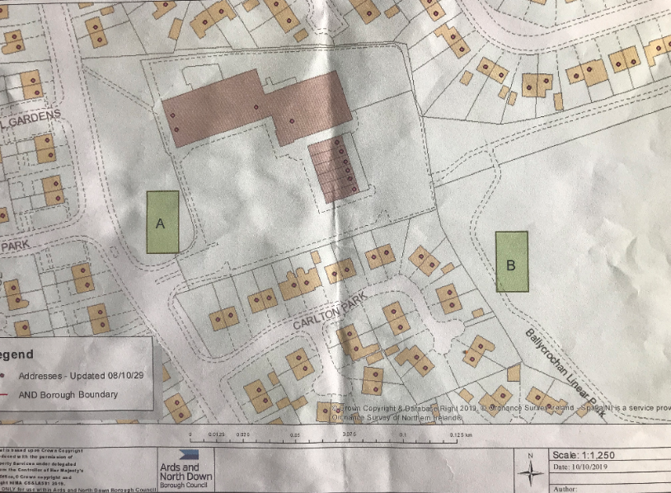

The results were as follows:

- Do you live in the Ashbury/Ballycrochan area? 97% said Yes

- Do you feel there is a need for a play facility in the area? 81% said Yes

- Looking at the map on display where do you feel is the best location for the play facility? 42% preferred Site A. & 46% preferred Site B. 3% indicated they would be happy with either location. 9% did not include a preference.

At a subsequent Council meeting in August 2020, it was determined that the play park should be delivered at Site A, in front of the shops.

Negotiations began with the landowners as well as Land and Property Services to establish if the land could be obtained to deliver the play park and under what conditions. The landowners had aspirations of extending their commercial units at the site and following lengthy negotiations it was finally agreed that they would submit a planning application for their commercial extension. The application included additional commercial units, an extension of the car park and the play park.

The play park was designed by the Council’s contracted installers in line with the normal Council specifications and the drawings were issued to the landowner’s agent for inclusion in the planning application. The Council also paid the element of the planning fee attributable to the play park (£848). Indication was given by the landowners that when they received their planning permission, they would then transfer the land needed for the play park to the Council and it would deliver the play park. The conditions of the land transfer would be determined at that point.

The planning application was submitted on 20th July 2022:

LA06/2022/0750/F: Two class 1 shop units and 1 hot food unit to the ground floor and first floor accommodation for use as class B1(a) or class A2 financial professional and other service use with associated car parking and children's play area.
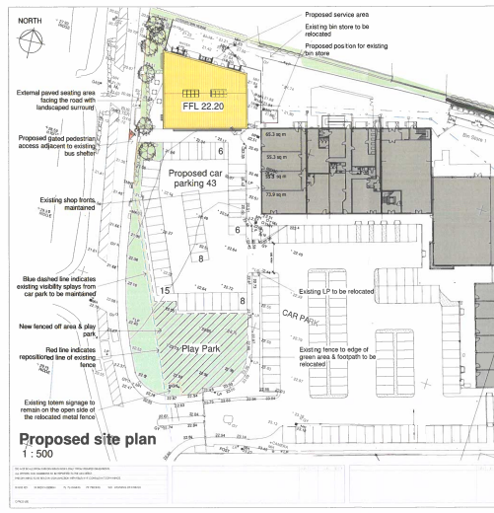

As previously reported, NI Water requested an assessment of the network capacity in the area. The landowners Agent had been liaising with NI Water to resolve the issue.

NI Water had sent its report on their Wastewater Impact Assessment to the applicant (landowner) which they had to pay for, it was received by the landowner on 21 April 2023 and its recommendations were valid for 18 months.

A further report had now been commissioned by the landowner in order to address the recommendations in the NI Water report. That required further investigations to be undertaken along with recommendations for further work, especially in relation to stormwater offsetting (SWO) solutions etc.

NI Water stated:

Once the SWO location has been confirmed with NI Water Clerk of Works on site, then developer will need to provide detailed design to demonstrate how SWO will be completed, and confirm that all consents are in place as detailed in Section 6 of the SER. We would advise that before our Clerk of Works visits the site that the necessary onsite investigation are completed. The visit by our Clerk of works can be arranged by contacting the Impact Assessments Team.

Under certain circumstances there may be a requirement for the developer to undertake a habitat regulations assessment. NI Water may need to complete modelling to determine if the solution meets the requirements of a no detriment solution.

When NI Water are satisfied that there is a suitable solution can be completed on site and the proposed solution is in line with the NIEA agreement, then we can agree to release of the Article 161.

Only once the solution has been agreed with NI Water and all third-party consents are in place will we be in a position to agree a positive response to the planning application associated with the development.

Therefore, until the issue had been resolved to the satisfaction of NI Water and it advised the planners that it was content, the planning application could not be determined by the planners.

An issue relating to open space raised by the planners, had generally been resolved following direction received from the Local Development Plan Team. It stated that the Local Development Plan was not at an advanced enough stage to merit it being a material consideration in relation to this planning application and the potential for the area (the grass area to the front of the shops) to be classified as open space. It did state that further points of clarification relating to the retail and office use may be required.

The play park could not therefore be delivered until the planning process had been completed. The terms of the transfer would then be determined, and the legal transfer process would need to be undertaken. Should the application not be successful then further negotiations would be required. Members subsequently in September 2023 asked that Officers explore other options for the delivery of a play park in this area.

Going back to the public consultation the other site considered during that process was a site within Linear Park (Site B), which was Council owned. Back in 2020 Officers did visit the site and considered the potential of the location.

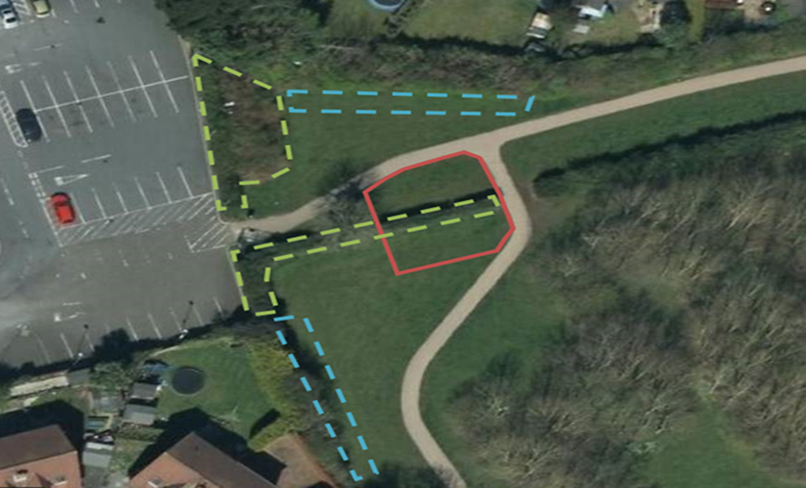

The proposed alternative location was outlined in red within Linear Park. The areas within the dashed blue line would be where bunds (earth mounds) would be located to act as an acoustic barrier and therefore reduce potential noise nuisance to the adjacent dwellings. Those could also be landscaped with evergreen planting to provide a year-round screen to protect the residential amenity of the adjacent dwellings. The area within the dashed green line indicated where vegetation would need to be removed.

The play park location had been selected to increase the separation distance between it and the adjacent houses.

Linear Park (Site B)
Advantages | Disadvantages
No purchase cost | Vegetation would need to be removed to open up the visibility of the site so it could be easier monitored. Compensatory planting would be required.
Easy to deliver | Would require mitigation measures in order to create a noise/privacy buffer between the site and the adjacent houses (additional planting along the boundaries and bunding). Would require mitigation measures to protect the river (silt traps).
Would be locked at night along with the wider Linear Park | Would require planning permission and Habitats Regulation Assessment due to proximity to watercourse which was hydrologically linked to Areas of Special Scientific Interest, Special Protection Areas and Special Areas of Conservation and a Ramsar site.

Some Members would be aware that there was also a reasonable degree of objection from neighbours to a playpark being built within Linear Park.

While Linear Park was designated as a Local Landscape Policy Area (BR 19 Ballycrochan) it was not considered that the development of the play park would adversely impact on those features for which it was designated as followed:

- Area of local amenity importance – A river corridor and associated public pathways developed as a contemporary urban park.
- Area of local nature conservation interest – Structured planting, managed by the Woodland Trust and providing linkage and a wildlife corridor within an urban environment.

Play parks were generally considered as open space so it would generally be acceptable in the location. Given the proximity of the site to the river within Linear Park (approx. 103m) which hydrologically linked to the Outer Ards Ramsar, ASSI and SPA designated area, a Stage 1, Habitats Regulations Assessment (HRA) would be required, and that was likely to require an additional report and a recommendation of the appropriate mitigation measures before any development could occur. Therefore, planning permission would be required to fully consider those aspects as outlined above. Appropriate mitigation measures such as silt traps etc would be required to protect the river from any sediments created during construction.

The existing fencing and gates of Linear Park would remain in situ and the gates would continue to be locked at night to reduce any antisocial behaviour issues. The existing paths would also remain in situ. It should be noted that the entrance gates leading to the commercial site were also locked at night (11pm) and managed by the landowner.

Alternative sites

Alternative sites within Linear Park considered in the areas generally outlined in the dashed blue lines shown below. Those were discounted due to the lack of visibility/access, which would create issues in terms of being able to monitor any antisocial behaviour, child protection issues as well as construction and maintenance access. They would also bring the proposed play park closer to the river corridor. The topography of those sites would also more difficult especially the central area which would make developing this area more expensive and challenging.

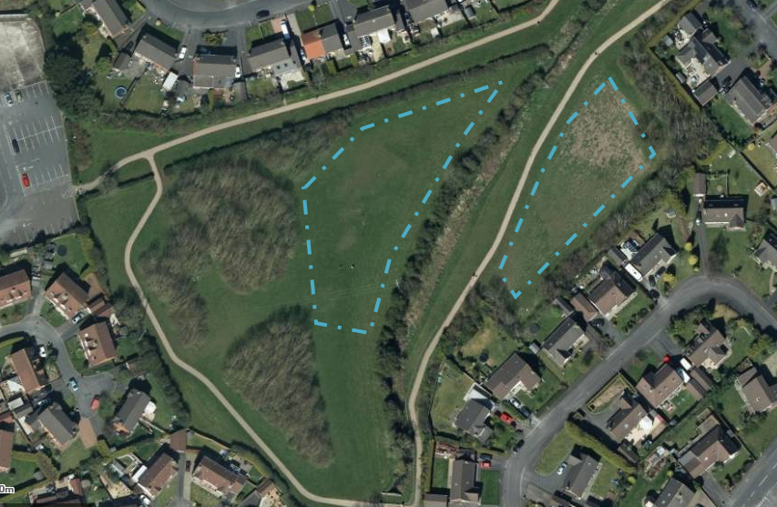

Conclusions

Site A to the front of the shops, had been in the planning system for a considerable time and it was hoped that the negotiations between the developer/landowner and NI Water should be nearing a conclusion. Once they were finalised, the planners could make a decision on the planning application and the delivery of the play park could progress subject to the transfer agreements etc. Should planning approval not be granted then further negotiations with the landowner could be held.

Site B in Linear Park would likely also require a planning application and so that process would have to be initiated and it too could take a considerable amount of time to reach a conclusion as well as costing additional money for the planning fees and the cost of preparing drawings and the Habitats Regulation Assessments etc.

Recommended that Council await the outcome of the current planning application and continue with the delivery of the play park at Site A.

Proposed by Councillor Irwin, seconded by Councillor Chambers, that the recommendation be adopted.

Councillor Irwin was aware that some discussion had taken place before the meeting and she thought that Members were not completely satisfied about taking Site B off the table. Much exasperation, frustration and dismay had been expressed at the slow progress of this playpark proposal which had been under discussion for many years. While Site A was held up in the application process currently, if Site B was to be progressed it would need its own application and she wondered if the officer had any idea how long that would take. The Parks and Cemetries officer indicated that, that application may be more complicated, and it was difficult to be clear about timelines. The Member thought that there was not much more that could be said and that she hoped the application would progress quickly because generations of young people were missing out on play facilities in that area, she thanked officers for bringing the report.

Councillor Chambers agreed that there was not much more to be said and although the proposal had rumbled on it was in no way a criticism of Council officers or even the landowner but rather NI Water causing the delay. He asked officers how long the Council could continue on this road before looking at other options. The advice from the officer was to wait on the outcome of the current application, which was close to expiring, and that would determine the timeline or if other options needed to be considered. The Member was aware that the matters relating to Site A were completely out of the Council’s hands but that there was comfort knowing that obstacles at Site B could be controlled. He advised he had previously called for a site meeting with NI Water officials and Council officers to engage in conversations. The officer reported that there were challenges in arranging the meeting.

Alderman Adair advised that whilst this was not his area, the question he was going to ask for a colleague had already been answered but he wished Members of Bangor East every success. He had previous experience working with NI Water and that had been challenging since it continually moved the goalposts and that was regrettable since he believed that two public bodies should have a common purpose in helping to deliver for the community.

Concluding the discussion, the Chair proposed that the Committee write to NI Water inviting them to address the Community and Wellbeing Committee and if a reply was not made that that matter be addressed with the Minister.

AGREED TO RECOMMEND, on the proposal of Councillor Irwin, seconded by Councillor Chambers, that the recommendation be adopted.

(Having declared and interest in Item 4 Councillor Kendall left the meeting at 7.13 pm)

4. In Bloom Funding and Update
(Appendix I)

Previously circulated:- Report from the Director of Community and Wellbeing attaching the In Bloom Funding Application Table. The report stated that the purpose of the report was to provide an update on the Ards and North Down in Bloom initiative and consider the 22 applications from local community groups for ‘In Bloom’ funding.

Ards and North Down in Bloom Update

The Ards and North Down in Bloom initiative had been developed with three overlapping objectives which were: horticultural excellence, community participation and environmentally sustainable practices. Those were in line with the objectives of national award schemes such as Britain in Bloom and regional awards such as Translink Ulster in Bloom.

By actively supporting this initiative, applicants not only made their communities more attractive, but also contributed to the Borough’s entry to the Translink ‘Ulster in Bloom’ Competition and other regional awards. In recent years that had proved to be a great success, particularly in the towns of Comber (runner-up in 2021 & 2022), Groomsport (runner-up in 2023) and Donaghadee (winner 2021,2022 and 2023) also winning Gold at Britain in Bloom 2023.

While the success was welcomed, the Council’s Parks Service recognised the opportunities for growth through further community engagement and participation. To support communities with their ‘In Bloom’ entries, the Park Service invite annual applications from environmental and community groups and associations within the Ards and North Down Borough, for funding to enable the purchase of flowers, plants, shrub and tree material, for planting within local villages or towns. The allocation of funding was subject to Council budget approval and capped at £1,000 per application. Since 2019, the ‘In Bloom’ Funding Scheme had awarded more than £95,000, supporting 106 projects. The scheme was projected to support a further 21 groups through 2024.

The benefits of the wider ‘In Bloom’ initiative included increased numbers of visitors who travelled around the Borough’s towns and villages to see the floral displays. Shops and businesses in the respective communities reported considerable increase in their business for weeks afterwards. In addition, people perceived those floral places as attractive areas to live resulting in demand for properties, thus increasing property value. The success at Translink’s ‘Ulster in Bloom’ and success of Donaghadee at RHS ‘Britain in Bloom’ enhanced the attractiveness of the Borough across the United Kingdom.

Community Competitions

To further promote and support the ‘In Bloom’ initiative, the Council Parks Service launched the Ards and North Down in Bloom Community Competitions in 2020. The competitions were coordinated by Ards and North Down Borough Council. That community competition encouraged everyone who lived or worked in the Borough to think about their local environment and how attractive flowers, plants, trees and gardens could enhance it. By supporting the competition residents not only made their garden or business more attractive, but also contributed to the Borough’s entry to the Translink ‘Ulster in Bloom’ Competition and other regional awards.

The competitions were designed to attract a wide demographic to become involved in activities that promoted horticultural excellence, increased environmental responsibility and encouraged community participation. The competitions regularly attracted over a thousand entries per year.

The general categories for the Community Competition categories were:
- Best Kept Front Garden
- Gardening for Wildlife Award
- Volunteer of The Year
- Best Kept Commercial Premises
- Best Kept Community Planting Scheme.

The structure of the competitions recognised the importance of educating young people on environmental responsibility, benefiting the Borough now and for future generations. The competitions included categories specifically aimed at entrants aged under 16. The Young People’s Categories for the Community Competitions were:

- Best School Gardening Project
- Painting Competition
- Tallest Sunflower Competition
- Young Volunteer of The Year

The most popular Young People’s category was the Tallest Sunflower Competition. The category was designed to engage young people in a fun horticulture activity, while learning about how to grow and care for plants. The Parks Service had found many stories of children working with friends, neighbours and relatives to grow their sunflower as tall as possible. To support the scheme, free packets of sunflower seeds were distributed to schools across the Borough. In 2023, the scheme saw the delivery of 8,000 packets of seeds (approx. 80,000 seeds) and the Council was continuing the initiative in 2024.

In October 2023, Parks and Cemeteries Services organised the second Ards and North Down ‘In Bloom’ Awards ceremony in Clandeboye Lodge Hotel in Bangor, to celebrate the winners within each category. More than 60 residents and special guests were in attendance. The event proved a huge success with participants and further strengthened the Council commitment to community engagement and support.

In Bloom Funding

Ards and North Down Borough had a reputation for leading the way with ‘In Bloom’ efforts. The Borough had won regional and national competitions in recent years and the common theme throughout all the success was the incredible hard work and enthusiasm shown by Council staff and the local communities they worked with.

The grant scheme assisted the Ards and North Down in Bloom initiative which had been developed with three overlapping objectives: horticultural excellence, community participation and environmentally sustainable practices. Those were in line with objectives of Translink Ulster in Bloom and other regional awards schemes.

Ards and North Down Borough Council currently made budget provision for the allocation of funding to community groups in order to assist with floral displays in the towns and villages throughout the Borough, to assist with the Council’s commitment to the Ulster in Bloom competition.

The allocation for funding was intended to supplement floral display and amenity area maintenance currently carried out by the Council’s Parks and Cemeteries section. That may be in the form of hanging baskets, planters, flower beds etc. on Council property, NIHE property, Roads Service property, or privately owned non-domestic areas in public view.

The maximum limit for funding was £1,000 per annum per group. A further grant may be provided for funding, in whole or in part, appropriate liability insurance covering the floral display work over and above the group’s normal insured activities. Funding would be allocated with 80% advance payment, with the further 20% paid upon the receipt of invoices.

Council wished to encourage a collaborative approach by groups, where there was more than one group applying in a town or village, consideration may only be given to one project.

The 22 applications were assessed against the following criteria:

- Provide a vision as to how the funding would enhance the particular areas and how that would be sustained in subsequent years.
- Evidence of approval from relevant landowners where works were to be carried out.
- When appropriate insurance liability cover was in place, copy of certificate and schedule to be submitted.
- How the works were to be carried out, and by whom.
- Detailed breakdown of how funding would be utilised, and receipts submitted accordingly.

The Appendix clearly demonstrated how each application met each of the criteria.

In the assessment, 21 applications were considered to have met the criteria. That was the greatest number of successful applications received for this funding call and was consistent with the increase in community group activities experienced during the current pandemic.

Currently, there was budget allocation of £21,000 for the In Bloom programme. The 21 successful applications amounted to £20,525 in total.

Recommended that the Council:

- Continue to support the ‘In Bloom’ initiatives across the Borough
- Awards the 21 applications for funding.

Proposed by Alderman Adair, seconded by Alderman Brooks, that the recommendation be adopted.

Alderman Adair commended those who had applied and complemented the ongoing work of the Parks team. The work that the volunteers carried out showed wonderful results and he paid tribute to one of his constituents Ellie Dempster from Portaferry who had pioneered volunteering on the Ards Peninsula encouraging others to become involved. This was a great partnership within the community and with the Council helping to increase civic pride and intergenerational participation to provide a feel-good factor and in turn make local areas beautiful for residents and tourists alike. He thought that the floral displays across the Borough were second to none.

Alderman Brooks shared that view, and he also offered his thanks to Council officers and referred to the recent success of Donaghadee in both Ulster and Britain in Bloom. He was happy to support the recommendation.

Councillor Boyle remembered that several years ago not many villages had taken up the initiative and it was now very encouraging to see many more community groups come on board. It was, in his view, vitally important to recognise the impact the limited funding could produce making it a great return for the Borough. All volunteers should be praised, and this was great news for the Borough and a great return for a modest investment.

Councillor Douglas shared the enthusiasm noting that twenty-one applications had been successful including three in her own area, Comber, Lisbane and Ballygowan.

The Chair took the opportunity to thank all the volunteers and officers for their efforts in helping to transform the appearance of local areas.

AGREED TO RECOMMEND, on the proposal of Alderman Adair, seconded by Alderman Brooks, that the recommendation be adopted.

(Councillor Kendall returned to the meeting at 7.18 pm)

5. Display Bed Applications (PCA5)
(Appendix II)

Previously circulated:- Report from the Director of Community and Wellbeing attaching Display Bed Designs. The report detailed that Members would be aware that Council had an agreed policy for the use of Display Beds in the Borough, the policy required Officers to report to Council any applications received by external organisations.

The Council had received applications for use of multiple display beds, officers had assessed the applications and had determined that all requests met the criteria in the policy and were recommended for approval. The applications were deemed by officers to not require equality screening.

The applications and the proposed designs of the displays were included in the appendices attached to the report. The Parks team would endeavour to replicate the designs as far as possible, however detailed design may alter to facilitate installation. If necessary, the Officer would liaise with the applicant if the installation may have to be significantly different from that proposed.

Name of Group / Organisation | Display Bed applied for | Proposed dates of display | Reason for the display | Drafted Display image
Bryansburn Rangers | Bangor Post Office | 03/06/2024-19/07/2024 | Commemorate 50 Year Anniversary | See Appendix 1
RNLI Holywood | Ballymenoch Park | 15/04/2024-26/05/2024 | 200th Year Anniversary | See Appendix 2
RNLI  Donaghadee | Donaghadee | 15/04/2024-26/05/2024 | 200th Year Anniversary | See Appendix 2

Recommended that Council approve the proposed display bed applications.

Proposed by Councillor W Irvine, seconded by Councillor Irwin, that the recommendation be adopted.

Councillor W Irvine welcomed the applications and commented that the RNLI had had a lot of traction in its anniversary year. Further he commented on Bryansburn Rangers who were a long-established football club and the Member wished the Club well on its 50th Anniversary.

AGREED TO RECOMMEND, on the proposal of Councillor W Irvine, seconded by Councillor Irwin, that the recommendations be adopted.

6. DfE Consultation on Onshore Petroleum Licensing for Northern Ireland
(Appendix III)

Previously circulated:- Report from the Director of Community and Wellbeing attaching DfE Consultation Document. The report detailed that DfE had launched a consultation the purpose of which was to consult on options for onshore petroleum licensing policy in Northern Ireland, provide detail on the proposed policy and to seek views on the issues raised, as well as the way forward. The Council had requested that a response to the consultation was submitted. The full documentation could be found here DfE website.

Background
The petroleum licensing system was the set of rules for how companies could search for and extract onshore oil and gas in Northern Ireland. It was the responsibility of DfE under the Petroleum (Production) Act (Northern Ireland) 1964 and other regulations. Offshore petroleum exploration and production which took place in coastal or open waters was not devolved to the Northern Ireland Executive and was the responsibility of the North Sea Transition Authority (formerly known as the Oil and Gas Authority).

In October 2020, the Northern Ireland Assembly passed a Motion calling for a moratorium on petroleum licensing for exploration, drilling or extraction of hydrocarbons (oil and gas) in Northern Ireland. In advance of the October 2020 Assembly debate, DfE obtained legal advice that a moratorium on fracking or, on petroleum exploration and extraction, prior to the independent research and policy development process completing, could result in a legal challenge with a high likelihood of success. The Climate Change Act (Northern Ireland) 2022
had also been passed. There was considerable public interest in the issue, especially concerning the potential use of hydraulic fracturing (fracking). Those developments demonstrated the need for the review of the onshore petroleum licensing policy position in Northern Ireland to ensure it was fit for purpose.

Key information
The consultation document in the Appendix explained onshore petroleum exploration and production, it outlined Global and regional policies, outlined the situation in Northern Ireland, summarised independent research relating specifically to Northern Ireland and discussed options for the way forward.

Note that within the information in the consultation document, a map was provided showing the areas that had potential for oil and gas exploration, potential conventional hydrocarbon resource and potential unconventional hydrocarbon resource. None of those fell within the perimeter of Ards and North Down Brough Council.

Options
Four options outlined by the consultation were as followed;

Option 1: Status Quo – Do Nothing. That would involve no change to the current licensing rules and no change to the current policies. The open-door policy would remain in place and the focus would continue to be on maximising the economic potential of Northern Ireland’s oil and gas resources.

Option 2: Change from open door policy to licensing rounds in defined areas.
That would maintain the policy to maximise the economic potential of Northern Ireland’s natural resources but remove the open-door policy and adopt a licensing round approach.

Option 3: Moratorium and eventual legislative ban on exploration or production of unconventional hydrocarbons. That would represent a significant shift in the current policy. It would lead to a moratorium and eventual legislative ban on exploration for all unconventional oil and gas (including fracking) in Northern Ireland. Companies would still be able to apply for licences to explore for conventional oil or gas.

Option 4: Moratorium and eventual legislative ban on all forms of onshore petroleum exploration and production. That would represent the most significant shift in the current policy. It would lead to a moratorium and eventual legislative ban on exploration and production of all forms of onshore oil and gas in Northern Ireland. That would introduce a closed-door policy for onshore petroleum exploration and production in Northern Ireland. This was the preferred option proposed by DfE.

There was no strong economic case to support the exploration for and possible
production of any potential onshore oil and gas resources in NI. Such a course of action also ran contrary to the objectives of the NI Energy Strategy and targeted in the Climate Change Act (Northern Ireland) 2022. In addition, both the Hatch Report and BGS Report on Seismic Activity in NI Basins raised concerns about the environmental and social impacts of onshore oil and gas exploration and extraction. On that basis, the recommended preferred policy was a moratorium and eventual legislative ban on exploration and production of all forms of onshore oil and gas in Northern Ireland.

The Consultation
The consultation asked five questions which were outlined below with a draft response showing support for the preferred option.

- Do you agree with the assessment of the policy context and potential for onshore oil and gas resource in Northern Ireland? Yes
- Do you agree with the assessment of the economic impacts of potential onshore oil and gas exploration and production in Northern Ireland? Yes
- Do you agree with the assessment of the potential social and environmental impacts of onshore oil and gas exploration and production in Northern Ireland? Yes
- Do you agree with the preferred option for onshore petroleum licensing policy? Yes
- Do you think there are alternative options for onshore petroleum licensing policy in Northern Ireland which should be considered? No

Recommended that Council approves the response to the consultation and agrees that the response was submitted by the Head of Environmental Health and Development on behalf of the Council to DfC by the deadline of 12th April 2024.

Proposed by Councillor Kendall, seconded by Councillor Irwin, that the recommendation be adopted.

Councillor Kendall was pleased with the recommendation and thanked officers for bringing forward the report which had reiterated that this Council was aware of its responsibilities in combating the climate emergency. She referred to the huge profits being made by the energy companies and believed that investment should be made into renewables and that there should also be an outright ban on all forms of oil and gas exploitation.

Seconding the recommendation Councillor Irwin thanked the officers for the report and commented that she was glad to see that progress was being made following a return to government at Stormont.

AGREED TO RECOMMEND, on the proposal of Councillor Kendall, seconded by Councillor Irwin, that the recommendations be adopted.

7. 2018 Public Consultation on Anti-Social Behaviour (ASB) Legislation (FILE ASB – PCSP)
(Appendix IV)
Previously circulated:- Report from the Director of Community and Wellbeing attaching draft response to the public consultation on ASBs legislation. The report detailed that in April 2018, the Department of Justice (DoJ) carried out a public consultation to review the criminal legislation framework to tackle anti-social behaviour.
Following that consultation a multi-agency, cross-governmental ASB Delivery Group was formed to take forward the out workings of the consultation. The group was tasked to consider five powers that were consulted upon, as well as four additional powers that were raised as a result of the 2018 consultation.
The ASB Delivery Group considered nine legislative powers as followed:
- Criminal Behaviour Orders (post-conviction order to stop individuals engaging in ASB by placing prohibitions and requirements on them);
- Public Space Protection Orders (order imposing conditions on use of designated areas);
- Closure Powers (power to close premises that are being used, or likely to be used, to commit nuisance or disorder);
- On-Street Drinking (commencement of sections 68 to 72 of the Criminal Justice (NI) Order 2008);
- Powers in section 54 of the Civic Government (Scotland) Act 1982 to address noise nuisance through seizure of sound producing devices;
- Civil Injunctions (power to stop individuals engaging in ASB by placing prohibitions and requirements on them);
- Absolute Grounds for Possession (power for possession of secure and assured tenancies where ASB / criminality has been proven by another court);
- Dispersal Powers (power to direct a person who is in a public place to leave the locality and not return for a specified period); and
- ASB Case Review /Community Trigger (power for victims of ASB to request a review of actions taken to address ASB).
Conclusions of the ASB Legislative Review Delivery Group
The ASB Delivery Group undertook a detailed scoping exercise to identify, where possible, an evidence base that would indicate how successful some of the proposed legislative measures were in addressing ASB in other jurisdictions. It was also necessary to compare the powers under consideration with those already in place in Northern Ireland to ascertain whether their introduction would bring any tangible benefit.
Not all of the powers were deemed suitable for progression and the Delivery Group concluded that legislative amendments could be progressed for four of the nine powers. Therefore, together with the Department for Communities (DfC), DoJ was seeking views on those four pieces of legislation, policy responsibility for which fell across both departments, with a view to ensuring relevant authorities had effective and proportionate powers to help address ASB and its effects within communities. The proposals related to:
  - Amendments to the Anti-Social Behaviour (NI) Order 2004 (amendments to ASBOs) - DoJ
  - Amendments to the Criminal Justice (NI) Order (amendments to on- street drinking legislation) – DoJ / DfC
  - Amendments to Housing (NI) Order 2003 (amendments to ASB Injunctions for housing providers) – DfC
  - Amendment to the Housing (NI) Order 1983 (introduction of Absolute Grounds for Possession of secure tenancies) – DfC
The purpose of the consultation was to seek the views of stakeholders on those proposed amendments to ensure that powers available to relevant authorities (Councils, Police and Social Housing providers) were proportionate, effective and would have an appropriate impact on addressing ASB and its effects within communities.
recommended that Council approves the attached consultation response.

Proposed by Alderman Cummings, seconded by Councillor W Irvine, that the recommendation be adopted.

Alderman Cummings was delighted to propose the recommendation and thanked officers for the report. He referred to the good working relationship that the Council had with the PSNI and other agencies and was pleased with the progress that was being made.

Seconding the recommendation Councillor W Irvine thought that anything that added more powers should be welcomed and he asked about the next steps. The Head of Community and Culture said that this would be reported back to the Department for Justice following the Council meeting at the end of March.

Councillor Kendall stated that unfortunately she could not entirely support the response and had some concern about it. She quoted that the minimum age of responsibility was ten years old and that receiving an ASBO could lead to a criminal conviction and there was evidence that historically ASBOs had not worked well in Northern Ireland. She thought that early contact with the Justice system for children was not helpful and that such punitive measures might not be the best solution as it also put additional pressure on the PSNI. Instead, she believed that decision makers needed to go back to the drawing board and consult more widely and include restorative justice methods. She also stated that the consultation had not included talking to children and young people.

The Chair asked that a vote be taken by a show of hands and 9 voted IN FAVOUR of the recommendation, 3 were AGAINST and 1 ABSTAINED so the recommendation was CARRIED.

AGREED TO RECOMMEND, on the proposal of Alderman Cummings, seconded by Councillor W Irvine, that the recommendation be adopted.

8. Ards and North Down Sports Forum Grants (WG February 2024) (FILE SD149)
(Appendices V-IX)

Previously circulated:- Report from the Director of Community and Wellbeing attaching Successful Goldcard Report for Noting 23-24, Successful Individual Travel & Accommodation Report for Noting 23-24, Successful Club Travel & Accommodation Report for Noting 23-24, Unsuccessful Report 23-24 and Successful Individual Travel & Accommodation Report for Noting 24-25. The report detailed that Members would be aware that on the 26th August 2015 Council delegated authority to the Ards and North Down Sports Forum, in order to allow it to administer sports grants funding on behalf of the Council. £45,000 had been allocated within the 2023/2024 revenue budget for this purpose.

The Council further authorised the Forum under delegated powers to award grants of up to £250. Grants above £250 still required Council approval. In addition, the Council requested that regular updates were reported to Members.

During January 2024, the Forum received a total of 15 applications: 1 Event, 6 Goldcard, 7 Individual Travel/Accommodation and 1 Club Travel/Accommodation Grant (1 Individual Travel/Accommodation Grant was for an event in April 2024, hence, that was assessed as a 2024/25 Grant). A summary of the 14 successful applications were detailed in the appendices attached to the report.

For information, the annual budget and spend to date on grant categories was as followed:
2023/24 Budget £45,000 | Annual Budget | Funding Awarded  January 2024 | Remaining Budget
Anniversary | £1,000 | £0 | £250.00
Coaching | £3,000 | £0 | £1,453.75
Equipment | £14,000 | £0 | *-£4,755.74
Events | £6,000 | £0 | -£523.33
Seeding | £500 | £0 | £55.01
Travel and Accommodation | £14,500 | *£980.00 | -£4,088.99
Discretionary | £1,000 | £0 | £1,000.00
Schools/Sports Club Pathway | £5,000 | £0 | £3,002.00
*Goldcards proposed during the period January 2024 is 6 (27 Goldcards in total during 2023/24).

*The proposed remaining budget for Travel and Accommodation of -£4,088.99 was based on a proposed award of £980.00 – for Noting.

*The proposed remaining budget for Equipment of -£4,755.74 was based on a withdrawn amount of £2,000.00 and reclaimed amount of £121.29.

The proposed funding for January was £980.00 and the proposed remaining budget for 2023/24 was -£3,607.30 (108% of the 2023/24 budget spent).

The proposed funding for January 2024, relating to 2024/2025 budget was £200. That would be deducted from the Travel and Accommodation grant allocation 2024/25 subject to confirmation of the 2024/2025 Budget.

Recommended that Council approves the attached applications for financial assistance for sporting purposes valued at above £250, and that the applications approved by the Forum (valued at below £250) are noted.

Proposed by Councillor Boyle, seconded by Councillor S Irvine, that the recommendation be adopted.

Councillor Boyle said that he always welcomed these reports celebrating the sporting activities and achievements of local people. He further commented on his recent attendance at the Sports Awards and how he would have liked to have seen more of the Borough’s elected representatives in attendance and urged the Council to continue to provide funding for this event annually.

There was obviously great sporting talent locally and he had enjoyed hearing about the successes and phenomenal support shown through coaching and family commitment and sacrifice. He also thought that Council officers and sponsors should be given thanks for their commitment and hard work behind the scenes and that should be built upon.

Councillor S Irvine was in agreement and thought that this was one of the Borough’s greatest successes. A few parents had made contact with him to express their thanks and he pointed to world champions within the local community. He further stated that the Council could not rest of its laurels but continue to push the Sports Awards further. He asked that homecoming recognitions be made for all the athletes, including those who competed while living with disabilities. Officers agreed to provide Members with information on how that could be achieved.

AGREED TO RECOMMEND, on the proposal of Councillor Boyle, seconded by Councillor S Irvine, that the recommendation be adopted.

Reports For Noting

9. Cairn Wood Post Project Evaluation (FILE PCU38)
(Appendix X)
Previously circulated:- Report from the Director of Community and Wellbeing attaching Cairn Wood Post-Project Evaluation. The report detailed (PPE) should be carried out on all capital works following completion of project. The ‘Carin Wood Recreation Project’, funded and administered by the Department of Agriculture, Environment and Rural Affairs (DAERA), Forest Service, through the Tackling Rural Poverty and Social Isolation Fund (TRIPSI) was completed by 4 February 2022.
The Post Project Evaluation (PPE) was service led and was an assessment of the projects results, activities, and processes. It was an essential tool to show that the project objectives had been met and, in terms of public accountability, to demonstrate what had been achieved with the investment of public funds. It also facilitated recognition of project achievements and acknowledged people's work. This phase was also used to capture any learnings gained from the project while the memory of any issues encountered were still recent. The PPE primarily evaluated:
- If the benefits, scope and deliverables of the project, as stated in the Project Brief, have been met;
- The performance of the building/facility;
- Lessons to be learned from the experience which may help future projects.

Members should note that DAERA, Forest Service had verified and paid all claims and a separate PPE had been submitted to them at their request and using their templates etc.

recommended that Council notes this report.

Proposed by Councillor Kendall, seconded by Councillor W Irvine, that the Council notes the report and further that;

In light of the impact on priority species, such as red squirrels and pine martens in Cairn Wood, this Council, in preparing a management plan, will explore any possible replanting, rewilding and other measures to improve biodiversity within the Wood and to mitigate, as far as possible the impacts of increased footfall.

Councillor Kendall welcomed the improvements that had been made at Cairn Wood which had been well done but with extra footfall some of the priority species such as red squirrels and pine martens had fallen. She hoped that the Council could look at replanting and rewilding in places to improve biodiversity and to mitigate the impacts of the increased footfall.

Councillor W Irvine praised what had been a successful project with many more visitors using the opportunity to enjoy the Wood and outdoor environment but hoped that protections would be put in place to preserve the beauty and biodiversity of the area.

The Chair supported the amendment stating that it was known that red squirrels and pine martens needed to be protected to allow them to thrive in the competition of the grey squirrel.

AGREED TO RECOMMEND, on the proposal of Councillor Kendall, seconded by Councillor W Irvine, that the recommendation be adopted and further that in light of the impact on priority species, such as red squirrels and pine martens in Cairn Wood, this Council, in preparing a management plan, will explore any possible replanting, rewilding and other measures to improve biodiversity within the Wood and to mitigate, as far as possible the impacts of increased footfall.

10. Notice of Motion

(a) Notice of Motion submitted by Alderman Adair, seconded by Councillor Edmund

That Council note the increasing growing population in the village of Ballyhalbert and the current lack of public open spaces in the village and task officers to bring forward a report on options to provide a public green open space to promote health and wellbeing of the local community and further tasks officers to engage with developer to ensure the new play park planned for Saint Andrews is delivered in line with our Council play strategy.

Proposed by Alderman Adair, seconded by Councillor Edmund, that the Notice of Motion be adopted.

Alderman Adair brought his Motion on behalf of the constituents of Ballyhalbert, which was located on the Ards Peninsula and was the most easterly point on the island of Ireland. Over a period of about thirty years the population of the village had grown from approximately 300 and was now about 2,000. The sad reality was that while the population had grown, the services and infrastructure locally had not. Everyone was aware of the importance of green space and its benefits for wildlife and human wellbeing and the community lacked that, which was a shame. A ray of hope had been provided when the developer of Saint Andrews/Longfield had amended its plans to develop a playpark in that area but sadly that did not meet the Council’s specification. He hoped that negotiations could continue with the developer to provide a playpark that was in line with the Council’s strategy and that could be delivered for everyone. He hoped that the Council could provide for the people of Ballyhalbert who deserved the same facilities as everyone else and he asked Members for their support.

Councillor Edmund also referred to the large population in Ballyhalbert over recent years, the lack of an adequate connecting footpath around the village and the need to provide facilities that would encourage the people to enjoy community life outdoors. He reported that this was the only village on the Peninsula that did not have its own football pitch for the local team. All of that needed to be examined to meet the needs of people living in Ballyhalbert.

Councillor Boyle expressed his support and thanked Alderman Adair, and Councillor Edmund for bringing forward the Motion. He thought that in Ballyhalbert life had moved on rapidly except for the provision of facilities and services. While being unsure of the developer’s obligations, under the Council’s own Play Strategy, Ballyhalbert still required a playpark over and above what was suggested within the new housing development at Saint Andrews.

Alderman Adair summed up and thanked Members for their positivity and said that Councillor Boyle was quite right, Ballyhalbert needed a playpark in the centre of its village. The one that had been built in the centre of the village in 2005 was coming to the end of its life. He hoped that the developer and the Council together could work with other stakeholders to provide the best possible outcome for residents, and he wanted to see quality playparks that would be maintained. He believed that the people of Ballyhalbert deserved better.

AGREED.

11. Any Other Notified Business

There were no items of Any Other Notified Business.

Circulated For Information

Parsonage Road Play Park Petition
(Appendix XVIII)

Alderman Adair rose to present a petition in respect of Parsonage Road Play Park, Kircubbin. He explained that there were 400 names of local people living in the village who were opposed to the closing of the Parsonage Road playpark and who had signed the petition. They had met with local representatives earlier in the day to hand over the petition and make their views known.

The Member went on to say that at the time the Council presented its findings based on consultation in Kircubbin it showed that 88% supported the removal of the playpark and he wondered that not all views had been expressed. He thought that the Council had got things wrong, and this was an opportunity to put that right. Many of the people he had spoken with had not been given an opportunity to express their views in the original consultation. He suggested there was also misinformation circulating that the Member himself was thought to be in support of the closing of the playpark when in fact he had proposed the installation of a sensory garden. He stressed that the Council was in place to serve people and the children of Kircubbin should have the best facilities and they deserved these as much as anyone else.

Councillor Boyle concurred with the comments of Alderman Adair, and it was important to make clear that this was a collective approach. Members had met at different times and had much communication with local people who were passionate about holding on to their current playground. The consultation process may not have been everything it could have been, and he referred to one school being consulted and another school was not even though it was located just beside the playpark. He hoped that the people’s voices would be listened to.

NOTED.

Exclusion of Public/Press

AGREED, on the proposal of Alderman Cummings, seconded by Councillor W Irvine, that the public/press be excluded during the discussion of the undernoted items of confidential business.

Reports for approval (***In confidence***)

12. Extension to the Tender for the provision of Pre

and Post Bonfire Services

***IN CONFIDENCE***

NOT FOR PUBLICATION SCHEDULE 3 – Exemption relating to the financial or business affairs of any particular person.

A report was presented to Community & Wellbeing detailing the tender for the provision of a Pre and Post Bonfire Services.

The report recommended that Council award the tender in line with the process.

The recommendation was agreed.

AGREED TO RECOMMEND, on the proposal of Councillor W Irvine, seconded by Councillor S Irvine, that the recommendation be adopted.

13. Aurora Pool Floors Outline Business Case (OBC)

***IN CONFIDENCE***

NOT FOR PUBLICATION SCHEDULE 5 – A claim to legal professional privilege

A report was presented to Community & Wellbeing detailing the Outline Business Case and options.

The report recommended that Council approve the progression to the preferred option.

The recommendation was agreed.

AGREED TO RECOMMEND, on the proposal of Councillor Boyle, seconded by Councillor S Irvine, that the recommendation be adopted.

14. Extension to the Tender for the provision of an

Integrated Consultancy Team for Replacement of Moveable Pool Floors at Bangor Aurora Aquatic and Leisure Complex

***IN CONFIDENCE***

NOT FOR PUBLICATION SCHEDULE 3 – Exemption relating to the financial or business affairs of any particular person.

A report was presented to Community & Wellbeing detailing the tender for an Integrated Consultancy Team for Replacement of Moveable Pool Floors at Bangor Aurora Aquatic and Leisure Complex.

The report recommended that Council award the tender in line with the process.

The recommendation was agreed.

AGREED TO RECOMMEND, on the proposal of Councillor Brooks, seconded by Councillor S Irvine.

15. Social Supermarket Pilot Review

***IN CONFIDENCE***

NOT FOR PUBLICATION SCHEDULE 3 – Exemption relating to the financial or business affairs of any particular person.

A report was presented to Community & Wellbeing detailing a review of the Social Supermarket Pilot.

The report recommended that Council agrees to launch an open call application process in April 2024 to procure social supermarket provision across the whole Borough, subject to funding being made available from DfC.

The recommendation was agreed.

AGREED TO RECOMMEND, on the proposal of Councillor W Irvine, seconded by Councillor Irwin, that the recommendation be adopted.

16. PEACEPLUS Partnership Minutes

**IN CONFIDENCE**

NOT FOR PUBLICATION SCHEDULE 3 – Exemption relating to the financial or business affairs of any particular person.

A report was presented to Community & Wellbeing detailing the confidential minutes of the PEACEPLUS Partnership meeting on 7th December 2023.

The report recommended that Council note the minutes.

The recommendation was agreed.

AGREED TO RECOMMEND, on the proposal of Councillor W Irvine, seconded by Councillor Kendall, that the minutes be noted.

17. PCSP Minutes

**IN CONFIDENCE**

NOT FOR PUBLICATION SCHEDULE 3 – Exemption relating to the financial or business affairs of any particular person.

A report was presented to Community & Wellbeing detailing the confidential minutes of the PCSP meeting on 20th November 2023 and 15th January 2024.

The report recommended that Council note the minutes.

The recommendation was agreed.

AGREED TO RECOMMEND, on the proposal of Alderman Cummings, seconded by Councillor Moore, that the minutes be adopted.

18. Leisure Transformation Phase 3

**IN CONFIDENCE**

NOT FOR PUBLICATION SCHEDULE 2 – Exemption likely to reveal the identity of an individual.

A report was presented to Community & Wellbeing detailing the progress and next steps regarding the Council’s Leisure Services transformation project.

The report recommended that Council note the progress.

The recommendation was agreed.

AGREED TO RECOMMEND, on the proposal of Councillor W Irvine, seconded by Councillor Irwin, that the recommendations be adopted.

19. Northern Community Leisure Trust Quarter 3 2023-

2024

**IN CONFIDENCE**

NOT FOR PUBLICATION SCHEDULE 3 – Exemption relating to the financial or business affairs of any particular person.

A report was presented to Community & Wellbeing detailing NCLTs quarter 3 activity and performance.

The report recommended that Council note the report.

The recommendation was agreed.

AGREED TO RECOMMEND, on the proposal of Councillor W Irvine, seconded by Councillor Boyle, that the recommendations be adopted.

RE-ADMITTANCE OF PUBLIC/PRESS

AGREED, on the proposal of Councillor Irwin, seconded by Alderman Cummings, that the public/press be re-admitted to the meeting.

TERMINATION OF MEETING

The meeting terminated at 9.01pm.

