ARDS and North Down Borough Council

A meeting of the Corporate Services Committee was held at the Council Chamber, Church Street, Newtownards on Tuesday 16 April 2024 at 7.00 pm.

PRESENT:

In the Chair: Councillor Moore

Aldermen: Graham (7.09 pm) McIlveen
McAlpine

Councillors: Cochrane Kennedy (7.08 pm)
Irwin McCracken
Irvine, S McRandal
Irvine W

Officers: Director of Corporate Services (M Steele), Head of Administration (A Curtis), Head of Transformation and Performance (S Denny) and Democratic Services Officer (J Glasgow)

1. Apologies

Apologies for inability to attend were received from The Mayor (Councillor Gilmour), Alderman Brooks and Councillor Chambers.

2. Declarations of Interest

The Chair (Councillor Moore) declared an interest in Item 12 - Renewal of lease to Community Advice Ards and North Down – Premises at Hamilton Hub.

3. Deputation – Sustainable NI
(Appendix I)

Previously circulated:- Copy of powerpoint presentation.

The Chair introduced and welcomed Dr Francesca Di Palo to the meeting.

Dr Di Palo undertook a powerpoint presentation covering the undernoted key areas:

- Background: Sustainability and Climate Action
- Where were things left?
- The role of Local Authorities
- What can we do together?
- Challenges, Barriers, Drivers and Key Priorities
- SNI Services: User Survey
- Facts
- Sustainability Membership Plan.

(Councillor Kennedy (7.08 pm) and Alderman Graham (7.09 pm) entered the meeting during the presentation)

The Chair invited questions from Members.

Alderman McIlveen noted that SNI undertook lobbying work as well as offering consultancy and he questioned how the line could be drawn between advancing policies and giving assistance to organisations. Dr Di Palo stated that it was recognised that there was more of a need to give support to public bodies to allow them to move forward in their path to net zero. SNI would continue campaigning through responses to public consultations but move more towards a consultancy role offering SNI’s expertise and skills.

Alderman McIlveen expressed concern that by SNI offering a service to complete consultation responses essentially it was the voice of SNI being heard in the consultation rather than the client’s voice.

Dr Di Palo stated that she wished to include scientific evidence rather than personal opinion in consultation responses. Along with including potential evidence based solutions that client’s such as Councils could use. SNI were in touch with Sustainability Officers within the Council’s.

Referring to the slide on the sustainability membership plan, Councillor McRandal asked if that was a new offering. Dr Di Palo advised that until now SNI were offering only one type of membership price which was different at a cost of £6,000. Through conversations and the outcome of the surveys, SNI recognised that there was a need for more training and support with an understanding and knowledge gap to be filled.

Councillor McRandal asked if SNI were at the similar stage with the other Council’s. Dr Di Palo advised that she had been speaking with each of the Council’s and some were at the approval stage. The level of membership could be upgraded during the
year and the difference paid in the levels if it was felt that was required.

Councillor W Irvine asked what was meant by scope 3 emissions. Dr Di Palo advised that scope 3 emissions had 15 categories. Recent studies and research had shown that the biggest two categories for Council’s were procurement and employee commute that had the most impact on emissions. Scope 1 emissions were those that Council’s had direct control, emissions that were linked to operational activities e.g. heating. Scope 2 emissions were indirect emissions, but the Council could still have control e.g. electricity. Scope 3 emissions contained everyone that was feeding into scope 1 and 2 emissions in the local area. The idea was that suppliers in the local area would feed into a mitigation strategy to reduce emissions overall.

The Chair thanked Dr Di Palo for her attendance and she withdrew from the meeting.

NOTED.

4. Annual Service Plans
(Appendices II - VII)

Previously circulated:- Report from Director of Corporate Services attaching Service Plans. The report detailed that since 2017/18 Service Plans had been produced by each Service in accordance with the Council’s Performance Management policy.

Plans were intended to:
- Encourage compliance with the new legal, audit and operational context
- Provide focus on direction
- Facilitate alignment between Corporate, Service and Individual plans and activities
- Motivate and develop staff
- Promote performance improvement, encourage innovation and share good practice.
- Encourage transparency of performance outcomes
- Better enable us to recognise success and address under performance.

Draft Service Plans for 2024/25 year were attached for the following Services:
- Community Planning
- Corporate Communications and Marketing
- Finance
Strategic Transformation and Performance
- Administration
- Human Resources

The plans had been developed to align with the outcomes of the Big Plan for Ards and North Down and with our draft Corporate Plan 2024-28, ‘Towards a Sustainable Borough’.

The Service Plans highlight where the services contribute to the Corporate Priorities as set out in the draft Corporate Plan 2024-28 Towards a Sustainable Borough and, where that was the case, sets out the objectives of the service for the 2024/25 year. It further identified the performance measures used to illustrate the level of achievement of each objective, and the targets that the Service would try to attain along with key actions required to do so.

The Service Plans also identify key risks to the services along with analysis of those and necessary actions to mitigate/manage risks. Key risks impacting the services were mapped to the Corporate Risk Register.

The plans were based on the agreed budget for 2024/25. It should be noted that, should there be significant changes in-year (e.g., due to Council decisions, budget revisions or changes to the community planning legislation) the plans may need to be revised.

Recommended that the Council adopts the attached Service Plans.

Proposed by Alderman McIlveen, seconded by Councillor McRandal, that the recommendation be adopted.

In respect of Service Plan (b) – Corporate Communications and Marketing; Councillor McCracken felt there was gap in communications in terms of information getting out. That was referenced under weaknesses where it was recognised that other members of the team needed to liaise more regularly with other Council service areas. There was a lot of really good work being done within the Council however he felt that message was not getting out to the public sufficiently and there was not a sufficient volume of information being communicated through the various channels. Councillor McCracken felt the weaknesses and threats identified within the report were significant issues and he would like to see those being actioned.

The Director noted that the Corporate Communications and Marketing section did not fall within his directorate but the Chief Executive’s. As outlined, one of the challenges in terms of communications was internal teams not sharing information correctly or not sharing any information. That was identified in the weaknesses and threats and Officers were conscious that more needed to be done in that area.

Councillor McCracken sought greater reassurance that more information would be communicated. He was raising this issue not to be critical but supportive.

In respect of Service Plan (a) – Community Planning; Councillor McRandal noted that from reading the service plan it looked like there had been no meetings held of third sector Community Planning forum.

The Director stated that Community Planning fell within the remit of the Chief Executive, and he undertook to check on the matter.

In respect of Service Plans - (c) Finance & (f) Human Resources; Councillor McRandal referred to the target for staff appraisals and noted the number of appraisals completed in each of the sections was low. The Director explained that a new appraisal process had been established. The target was to have all of the employee appraisals conducted by the end of the 2023-24 financial year and there would be a delay in ensuring all those were completed. He expected moving forward into the financial year the employee appraisal uptake would have increased.

AGREED TO RECOMMEND, on the proposal of Alderman McIlveen, seconded by Councillor McRandal, that the recommendation be adopted.

5. Rural Needs Act (NI) 2016 - Monitoring Return for the period 1 April 2023 - 31 March 2024 (RA2)
(Appendix VIII)

Previously circulated:- Report from the Director of Organisational
Development and Administration attaching Rural Needs Monitoring Return - 1 April
2023 - 31 March 2024. The report detailed that as Members would be aware, section 1 of the Rural Needs Act (Northern Ireland) 2016 placed a duty on public authorities, including Councils, to have due regard to rural needs when developing, adopting, implementing or revising policies, strategies and plans, and when designing and delivering public services. In carrying out this duty and in line with guidance issued by the Department of Agriculture, Environment and Rural Affairs (DAERA), the Council carried out rural screening exercises on its policies. Those screening exercises were carried out simultaneously by officers when completing section 75 screening of policies.

The 2016 Act placed a further obligation on public authorities to compile information on the exercise of its functions under section 1 of the Act (i.e., information on completed screening exercises), and to report this annually to DAERA.

DAERA had produced a template for public authorities to complete when compiling the information for their annual return. DAERA then collated all the returns it received and produced an annual Rural Needs Monitoring Report.

The Council’s draft return for 1 April 2023 - 31 March 2024 was attached to this report at Appendix 1 and provided detail on the rural screening exercises completed during this period.

recommended that Council agrees to submit the Rural Needs monitoring return for 2023/24 (Appendix 1) to DAERA.

AGREED TO RECOMMEND, on the proposal of Alderman Graham, seconded by Councillor W Irvine, that the recommendation be adopted.

6. The Climate Adaptation Plan
(Appendix IX)

Previously circulated:- Report from the Director of Corporate Services attaching draft AND Climate Adaptation Plan. The report detailed Northern Ireland’s second Climate Change Adaptation Programme (NICCAP2) was published in September 2019 and it covered the period 2019-2024. The programme contained the NI Civil Service response to the risks and opportunities relevant to Northern Ireland as identified in the UK Climate Change Risk Assessment 2017, setting out the policies and strategies to deliver against the priority areas.

NICCAP2 also contained a chapter which sits outside government, titled ‘Civil Society and Local Government Adapts’. The chapter was written by Climate NI, in conjunction with stakeholders outside government, and was the first of its kind in the UK. Recognising that central government cannot act alone, this chapter was the first attempt to report on how Civil Society and Local Government sectors contributed to the national priority areas for action on climate risk and adaptation.

SOLACE supported two actions in the NICCAP2 for local government which were now due for an update on progress. One of those actions was to:

Work with local councils to embed the adaptation cycle across local council planning with the aim of encouraging councils to complete a minimum of step 1 by 2021 and step 4 by 2024.
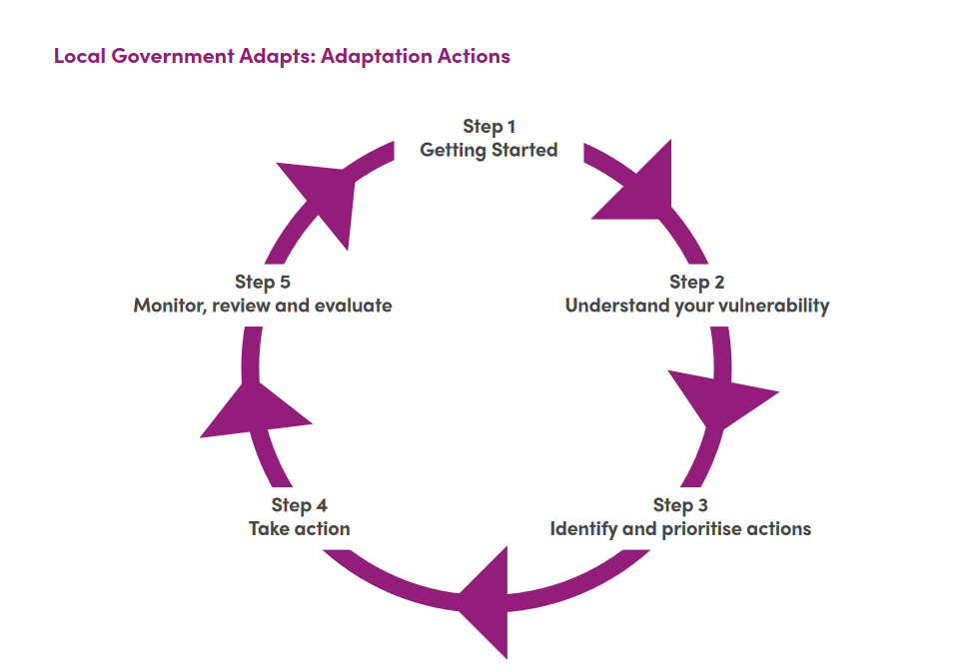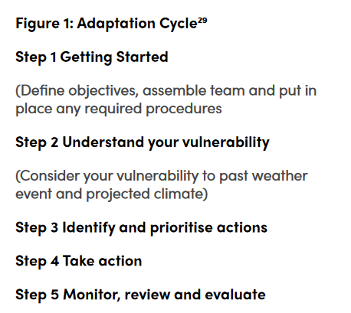

Since the development of NICCAP, the Climate Change Act (Northern Ireland) 2022 (‘the Act’) received Royal Assent on 6th June 2022.

The Act would ‘confer power to impose climate change reporting duties on public bodies’. This included ‘progress made in implementing Northern Ireland Climate Change Adaptation Programmes.’

As part of the Councils Roadmap to Sustainability, Action 17, was to ‘Develop a Climate Adaptation Plan for the Council and Borough.’

Climate NI had been supporting Ards and North Down Borough Council in preparing its own Adaptation Plan. The development of this Adaptation Plan would allow council to meet its commitments to NICCAP, future reporting duty requirements within the Climate Change Act NI and its own Roadmap to Sustainability.

Recommended that Council approve the draft Climate Adaptation Plan as presented.

AGREED TO RECOMMEND, on the proposal of Councillor McRandal, seconded by Councillor Irwin, that the recommendation be adopted.

7. Updated Business Continuity Policy and Plan (FILE
(Appendices X, XI)

Previously circulated:- Report from the Director of Corporate Services attaching Business Continuity Policy v2.0 and Business Continuity Plan. The report detailed that given the changes in Council structures since the legacy Council, Business Continuity Plans were implemented, it was identified that the legacy Plans were not fit for purpose in the event of Council service disruption and therefore a review and internal consultation was undertaken in 2023. The Business Continuity plan was approved by the Corporate Leadership Team in December 2023.

Business Continuity Management was a process that involved organisations identifying their vulnerabilities to business interruption and making arrangements to reduce risk and mitigate against the effects of any disruptions.

The Council was committed to ensuring that critical services could continue, or be recovered in a timely manner, in the event of a disruption or emergency. Council’s Business Continuity Management arrangements were underpinned by the Business Continuity Policy and Plan.

The Business Continuity Plan provided overall guidance to Ards and North Down Borough Council’s Corporate Leadership Team, Heads of Service Team and Service Unit Managers to build resilience so that the Council could:

- Respond to a disruptive incident.
- Maintain delivery of critical activities/ services during an incident.
- Recover from and return to ‘business as usual’ in a timely manner following an incident.

Business Continuity Planning would aim to achieve the following outcomes:

- Protect the safety of staff, visitors, and the wider community.
- Protect vital assets e.g. equipment, data, reputation etc.
- Ensure service delivery is not adversely affected, statutory and regulatory priority requirements are met and disruption to all services is minimised.
- Ensure customer expectations continue to be met, or managed, in such a way that customers are not adversely affected.
- Ensure the Council’s reputation among stakeholders and the public is not negatively affected following the disruption.

The Plan worked at the worst loss level, however, for less severe incidents only the relevant sections of the Plan would be selected.

Business Continuity training and exercising would be completed annually in conjunction with Emergency Planning training and exercising.

recommended that Council approve the attached updated Business Continuity Policy and Plan.

Proposed by Councillor McCracken, seconded by Councillor W Irvine, that the recommendation be adopted.

Councillor McCracken noted that business continuity was an area that could be increasingly called upon in the future. The Borough had recently seen the impact of flooding, the damage that caused and the relative lack of preparedness in some areas. Councillor McCracken sought assurances that the plan would assist with such issues to the level that was required and was there enough resource contained for the resilience of the Borough to ensure that if an unexpected disaster occurred the Council could respond effectively.

The Director explained the reasoning for bringing the report to Committee which was the outcome of audit recommendations. The Council’s internal auditors had raised concerns regarding the Council’s lack of business continuity planning in certain areas. Taking those concerns and audit recommendations on board, Officers had undertaken a significant amount of work over the past 12 months to make the plan more robust. Business Continuity Plans also needed to be kept live and options were being explored to undertake some live testing of the plan in the event of an emergency incident. To provide reassurance, the Director stated that the issue was being taken seriously and felt that was demonstrated through the significant information within the plan along with training to be rolled out to the relevant staff.

Councillor McCracken asked if there had been sufficient resource for the plan and if there had been an increase in resource as part of the new plan. The Director stated that the level of resource was proportionate and appropriate of what to be expected for an organisation such as Council for business continuity planning. Business continuity planning was more internally focused, there was reference to external organisations within the plan that may provide support in particular incidents. However, the plan was focused on how the Council would approach incidents and it was important to be clear on the various roles.

From a governance point of view, Alderman Mcllveen felt it would have aided Members to highlight the changes in the policy and the detail of the audit recommendations to allow Members to consider the changes.

The Director took those comments on board.

AGREED TO RECOMMEND, on the proposal of Councillor McCracken, seconded by Councillor W Irvine, that the recommendation be adopted.

8. ANDBC Digital Strategy
(Appendix XII)

Previously circulated:- Report from Director of Corporate Services detailing that as part of the Council’s Strategic Transformation and Efficiency Programme (STEP), the Council was committed to developing a Digital Strategy (a plan that outlined how Council would invest in digital technology to make a wide range of Council services work better for staff, residents and partners).
BT Digital Transformation Consulting started working with Officers in October 2023 to help Council undertake a ‘Digital Discovery’ journey – which was the first key step in developing the strategy.

Digital Discovery aimed to help us understand more fully what we want to achieve and how we should go about achieving it. It included:
- Agreeing digital principles for the Council so we have a clear and shared understanding of our goals.
- Identifying high-level outcomes that the Council aims to achieve through its IT operations, strategies, and initiatives.
- Developing a project register of all ongoing IT-related projects.
- Establishing the digital maturity of the Council i.e. assessing how effectively the Council has embraced digital tools and strategies to achieve its goals, optimise processes, and foster innovation.
- Undertaking a gap analysis to identify what needs to be done to achieve our agreed outcomes.

The output of all of the above activities was the production of a Transformation Roadmap. The roadmap outlined a strategic and phased plan for the council's journey toward digital maturity and innovation (structured and prioritised over 3-5 years). It provided a visual representation of key milestones, initiatives, and activities essential for achieving the council's vision.

The Digital Strategy concluded with a comprehensive view of the organisation's project landscape. This included the current project register detailing ongoing initiatives. That was followed by the proposed project register. Each proposed project was individually detailed, offering a breakdown of its envisioned outcomes, associated resource requirements, and projected costs. Together, those projects form a strategic bridge, connecting the current state to a vision of transformative projects aligned with the council's digital journey.

Next Steps
Following approval of this Digital Strategy:
- A Digital Transformation Board would be established.
- A programme of digital transformation projects would be defined.
- The projects would be prioritised and an overall workplan with individual workstreams and governance would be developed.
- Project resource requirements would be defined (and this may include the identification of external expertise in some instances).
The above actions would enable the Council to commence the implementation of its digital transformation journey.

recommended that Council approves the Digital Strategy.

The Head of Transformation and Performance spoke to the report outlining the salient points. She advised that as part of the Council’s Strategic Transformation and Efficiency programme the Council committed to developing a digital strategy. The digital strategy was a plan on how the Council intended to invest in digital technology to improve its services for staff, residents and Council’s partners. As outlined in the report, the process began in October 2023 when the Council engaged with BT Digital Transformation Consulting to assist Council in drafting its digital strategy. From the internal studies, a transformation roadmap had been produced which formed part of the digital strategy. The next stage was to develop a full programme of work for implementation of the strategy.

Proposed by Councillor W Irvine, seconded by Councillor S Irvine, that the recommendation be adopted.

Councillor W Irvine questioned what the Council was hoping to achieve from the strategy. The Head of Transformation and Performance explained that the plan contained internal and external elements. Internally, the plan was to undertake a number of projects, making processes more efficient and digitising as much as possible in particular in respect of records management. There would also be externally facing pieces, letting residents and customers understand what they were achieving from the process.

AGREED TO RECOMMEND, on the proposal of Councillor W Irvine, seconded by Councillor S Irvine, that the recommendation be adopted.

9. Any other notified business

There were no items of any other notified business.

Exclusion of Public/Press

AGREED, on the proposal Alderman Graham, seconded by Alderman McIlveen, that the public/press be excluded during the discussion of the undernoted items of confidential business.

Reports for Approval

10. Printing Service Contract Extension (FILE CMM/2024/)

***IN CONFIDENCE***

Not for publication

Schedule 6:3 - relating to the financial or business affairs of any particular person.

The Council was asked to consider extending the arrangements for Printing Services by a further 12-month period under the revised Tender Option.

The recommendation was agreed.

11. Request for permission to install a defibrillator at Spafield
(Appendix XIII)

***IN CONFIDENCE***

Not for publication

Schedule 6:5 - A claim to legal professional privilege.

Council was asked to consider a request from Holywood Ladies Football Club to install a defibrillator on the fencing at Spafield. It was recommended that Council approve granting a licence to Holywood Ladies Football Club for 1 year for the installation and maintenance of a defibrillator at Spafield subject to the terms and conditions as listed.

The recommendation was agreed.

12. Renewal of lease to community advice ards and north down – premises t hamilton hub
(Appendices XV, XVI)

***IN CONFIDENCE***

Not for publication

SCHEDULE 6:3 – INFORMATION RELATING TO THE FINANCIAL OR BUSINESS AFFAIRS OF ANY PARTICULAR PERSON (INCLUDING THE COUNCIL HOLDING THAT INFORMATION)

Council was asked to consider the renewal of the Lease of part of the premises in Hamilton Hub. It was recommended that the Council renewed the Lease.

The recommendation was agreed.

13. Request from NI Water to purchase land at Clanbrassil
(Appendices XVII - XIX)

***IN CONFIDENCE***

Not for publication

SCHEDULE 6:3 – INFORMATION RELATING TO THE FINANCIAL OR BUSINESS AFFAIRS OF ANY PARTICULAR PERSON (INCLUDING THE COUNCIL HOLDING THAT INFORMATION)

Council was asked to consider a request to sell a portion of land at Clanbrassil to NI Water. It was recommended that the Council acceded to the request.

The recommendation was agreed.

14. Request to issue legal proceedings for unauthorised use of Council Land at Manor Street Car Park, Donaghadee
(Appendices XX - XXIII)

***IN CONFIDENCE***

Not for publication

Schedule 6:1 - relating to an individual

Council was asked to agree to issuing legal proceedings for unauthorised use of Council Land at Manor Street Car Park, Donaghadee.

The recommendation was agreed.

15. Request from CRD Events Limited to hold 2no. concerts at Ward Park, Bangor in August 2024
(Appendix XXVI, XXVII)

***IN CONFIDENCE***

Not for publication

Schedule 6:3 - relating to the financial or business affairs of any particular person.

Council received a request from CRD Events Limited to hold 2 concerts at Ward Park, Bangor in August 2024 and it was recommeded that Council agree to the request.

The recommendation was agreed.

16. STEP Board Report update March 2024

***IN CONFIDENCE***

Not for publication

Schedule 6:3 - relating to the financial or business affairs of any particular person.

Council was asked to note an update from the Head of Strategic Transformation and Change on the work of the STEP Board since September 2023.

The recommendation was agreed.

Re-admittance of public/press

AGREED, on the proposal of Alderman McIlveen, seconded by Councillor Irwin, that the public/press be re-admitted to the meeting.

Termination of meeting

The meeting terminated at 8.04 pm.

