ARDS and North Down Borough Council

A hybrid (in person and via Zoom) meeting of the Place and Prosperity Committee was held at the Council Chamber, Church Street, Newtownards on Thursday 8 May 2025 at 7.00 pm.

Present:

In the Chair: Councillor Gilmour

Alderman: Adair (Zoom) McDowell
Armstrong-Cotter

Councillors: Ashe Hollywood
Blaney McCollum
Edmund (Zoom) McCracken
Hennessy Smart

Officers in Attendance: Director of Place (B Dorrian), Head of Regeneration (A Cozzo), Head of Economic Development (A Stobie), Capital Project and Programme Manager (S Ferguson), and Democratic Services Officer (R King).

1. APOLOGIES

Apologies for inability to attend were received from Councillor McKimm, Councillor McLaren, Councillor Thompson and the Director of Prosperity.

2. Declarations of Interest

There were no declarations of interest notified.

3. ITEM WITHDRAWN

4. Donaghadee Signage – Response to Notice of Motion 628 (FILE RDP14)

Previously circulated:- Report from Director of Place detailed as follows:

Background
A Notice of Motion was agreed at Council, October 2024 “That Council Officers be instructed to consider options for appropriate signage to direct the public to the Camera Obscura in Donaghadee. That Council Officers should explore and consider opportunities for securing sponsorship for the signage from local businesses and organisations.”

Urban Regeneration Programme
The Council had secured funding from the Department for Communities (DfC) to deliver an Urban Regeneration Programme. Within this programme an action identified was the design, production, and installation of directional and informational car park signage for both Bangor and Donaghadee.

Donaghadee Signage Working Group
Considering the Notice of Motion and the action under the Urban Regeneration Programme, a Signage Working Group was established to lead on both projects collaboratively and avoid any potential duplication.

The Signage Working Group consisted of elected members, representatives from Donaghadee Community Development Association (DCDA) and Council officers. It should be noted that representatives from Sir Samuel Kelly Project had also been in attendance on occasion.

The Signage Working Group had completed an audit of existing signage and had agreed the following signage proposals considering both projects.

Signage Proposals

Location | Current Signage | Request | Image
Crommelin Car Park | 2no signs already in place | Combine both signs into one sign. Can be incorporated within the Crommelin Car Park scheme. | 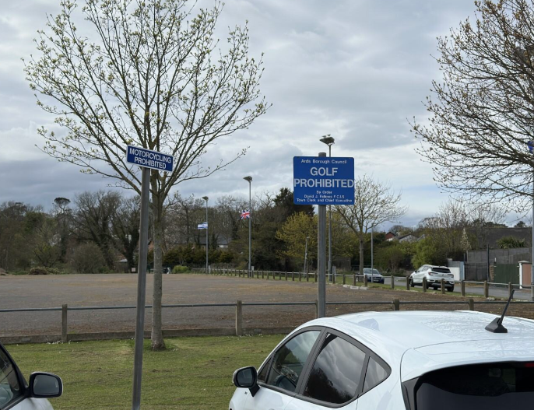
Crommelin Car Park | Double sided P located at the bottom of Union Street at grass area | Another ‘P’ sign is required on opposite side of road further up for Donaghadee direction traffic (located nearby Moat Street garage)  The existing ‘P’ sign is sufficient for vehicles approaching the car park and is double sided for both directions of traffic.  Additional signage for approaching the car park from the Moat Street garage will require DfI approval. Application to be submitted. | 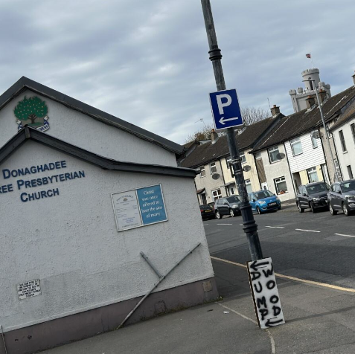
Crommelin Car Park | New Request | Request for signage to Welcome Visitors to Crommelin Park.  Double sided signage can be installed within entrance to car park with car park rules on one side and welcome/visitor information on reverse side. Will also incorporate details of places of interest nearby such as Moat, Camera Obscura, Sir Samuel Kelly etc.
Moat Car Park | New Request | Informational signage located in car park.  Double sided signage can be installed within entrance to car park with car park rules on one side and Moat/ Camera Obscura information on reverse, with listing of places of interest nearby. | 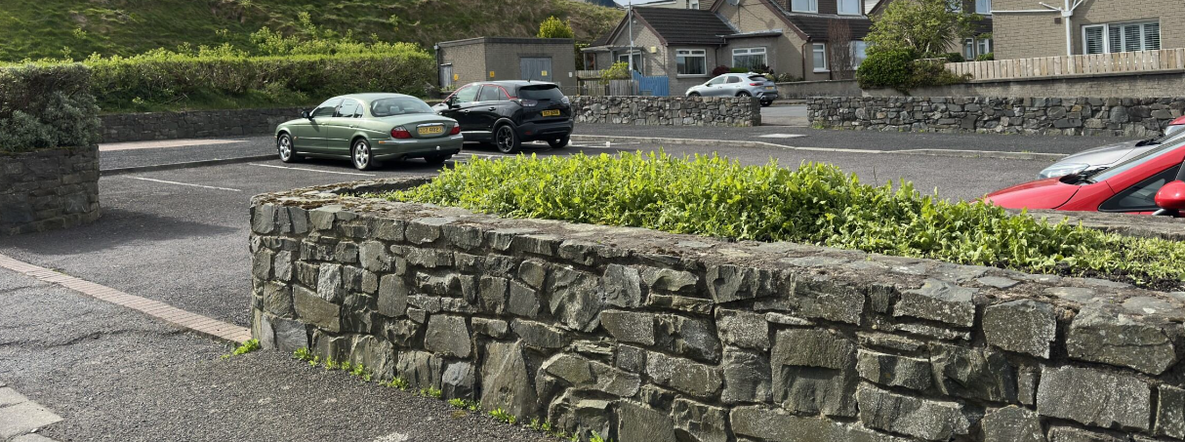
Copeland Distillery Signage | White and blue sign with arrow pointing to Copeland Distillery | Remove and replace existing signage with approved directional signage to Visitor Attractions.  Directional signage to Copeland Distillery, Sir Samuel Kelly Project, The Commons and include car parking | 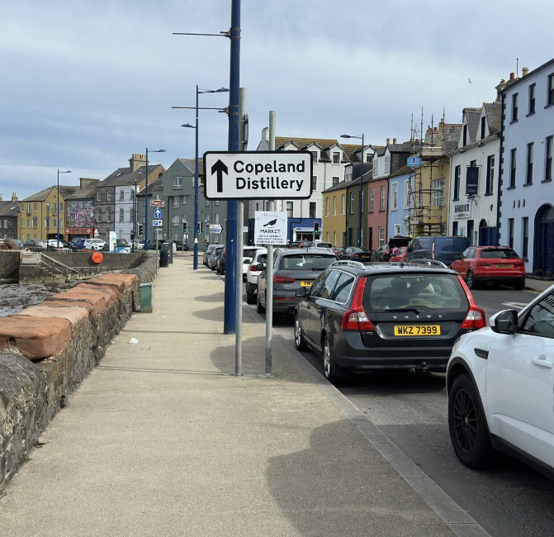  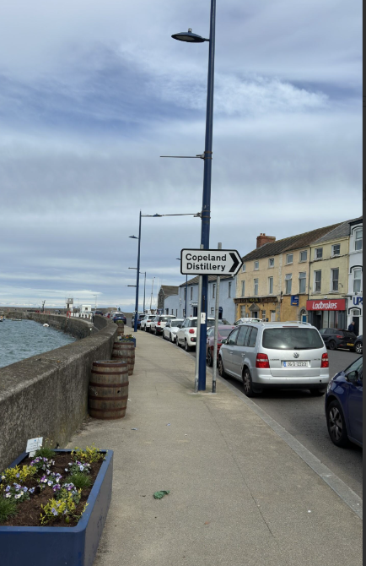
William Street Car Park | New Request | Additional ‘P’ sign required on wall at Bow Bells.  The previous car park directional signage was on a pole that may have been removed under the public realm scheme. To reinstate the pole the signage to Bow Bells would be blocked.  Proprietor consent required to install wall signage to Gordons Chemist. | 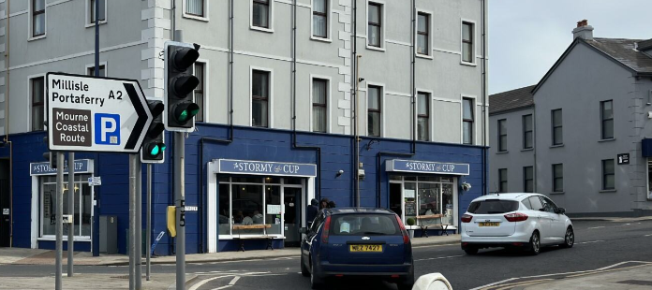
Harbour | New Request | Wayfinding Signage  Placement of wayfinding markers fixed to existing buildings to reduce street clutter (locations to be included - Sir Samuel Kelly Project, Copeland Distillery, The Commons, Moat/ Camera Obscura.
Community Centre  Car Park | New Request | Commons East/Harbour Car Park and Sir Samuel Kelly directional signage.
Commons East/Harbour Car Park | New Request | Wayfinding Signage  Finger posts to direct visitors to places of interest nearby such as Pinks Green Playpark, Lemon’s Wharf Playpark, The Commons, Copeland Plaza. | 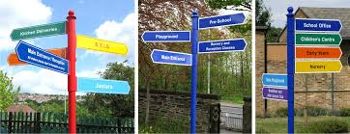
Lemon’s Wharf Play Park | New Request | Wayfinding Signage  Finger posts to direct visitors to key sites – Sir Samuel Kelly Project, The Commons, Crommelin Park, Moat and Camera Obscura, Public Toilets

In addition to the agreed signage requests detailed above, the Signage Working Group had identified further opportunities to enhance movement within the town should funding become available:

Location | Request | Image
High Street | Directional/ informational signage vinyl applied to vacant/ derelict property located on High Street.  This will serve as a wayfinding guide to pedestrians and highlight the key sites within the town.  Note – proprietor consents will be required. | 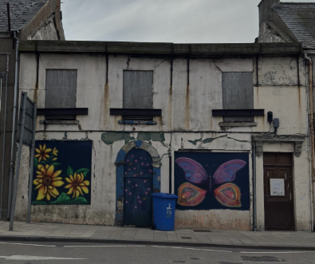  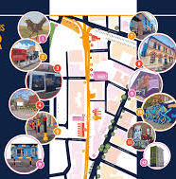
Moat Entrance, Moat Street | Upgrade of archway leading to Moat and Camera Obscura, making it more prominent and visually appealing.  Will require relevant consents and funding source. | 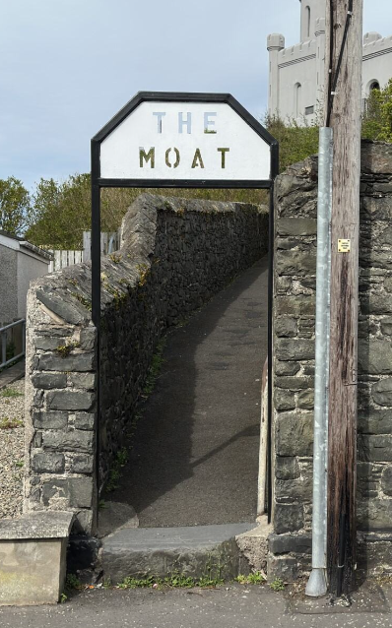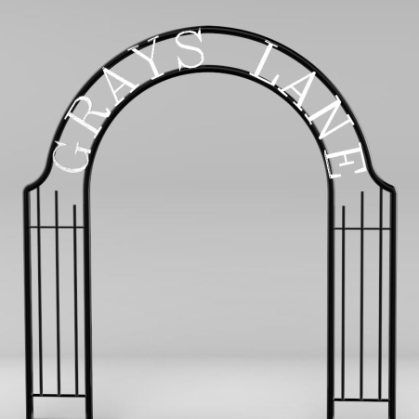
Print Materials | Review of existing print materials in circulation within the town and online – update as necessary and distribute to local sites including but not limited to the Library, Public Toilets, Visitor Information point, Community Centre, Moat, etc.
External Information Board | An external information board is in situ at the Public Toilets. This is updated with print materials by the DCDA. Potential to look at other options for providing visitor information and directional/ informational signage in replacement of the notice board.

Urban Regeneration Programme Variance Request
It was proposed to submit a variance request under the Urban Regeneration Programme to increase the allocated budget for Directional and Informational Car Park Signage and to expand the description to include directional and information signage to places of interest. Officers had held discussions with DfC officials who were supportive of the proposed request.

Please refer to Item 13 report on the Urban Regeneration Programme.

RECOMMENDED that the Council approves officers to proceed to:
- Submit the variance request under the Urban Regeneration Programme to increase the allocated budget and extend the project description to include informational and directional signage to nearby places of interest,
- Should the variance be approved, officers proceed to make the necessary applications to the Department for Infrastructure (DfI) for the required consents,
- Officers proceed to work with the Signage Working Group to deliver the Signage Programme (within the budget parameters), and
- Officers continue to seek funding opportunities for any items listed within the Signage Programme that cannot be met under the Urban Regeneration Programme due to budget constraints.

Proposed by Councillor McCollum, seconded by Councillor Hennessy, that the recommendation be adopted.

The proposer, Councillor McCollum explained that she had spoken to Alderman Brooks who had proposed the original notice of motion and he too had welcomed the report. She commended officers for taking advantage of opportunities that this funding provided, and bringing this together, establishing leadership and a pathway.

Councillor McCollum added that she had taken part in the signage audit and it had been a fantastic experience to visit a town from a different perspective and felt that the experience had been beneficial.

The seconder, Councillor Hennessy added that he had attended two signage meetings to date and thanked officers for their support. He recalled that everyone at the meeting, including the community representatives, had been happy with the progress and that their ideas and opinions had been considered. He explained that wider feedback from people in the town had also been positive.

AGREED TO RECOMMEND, on the proposal of Councillor McCollum, seconded by Councillor Hennessy, that the recommendation be adopted.

5. Concept Design Bingham Lane (FILE RDP152)

Previously circulated:- Report from Director of Place detailed as follows:

Background
The Regeneration Unit had an annual budget allocated to work up future projects. The budget provided the opportunities for projects to be developed to the design and/or planning stage.

In June 2024, Members agreed the development of a concept design for a pedestrian walkway in Bangor, from Bingham Lane to Main Street, to be taken forward. The project aimed to develop a design to transform this key connecting laneway into a vibrant and inviting public space in alignment with Priority C ‘Make the Streets People Friendly’ and Priority D ‘Connect with the Centre’ of the Bangor Masterplan.

Appointment of Consultants
In November 2024, officers issued an invitation to quotation to seven local consultants for the delivery of a concept design. OGU (Lead Consultant) and MMAS architects were successfully awarded the contract and commenced in December 2024.

Concept Design
The appointed consultants assessed the current site, identified medium to long-term opportunities, and proposed immediate short-term actions to revitalise this connecting walkway.

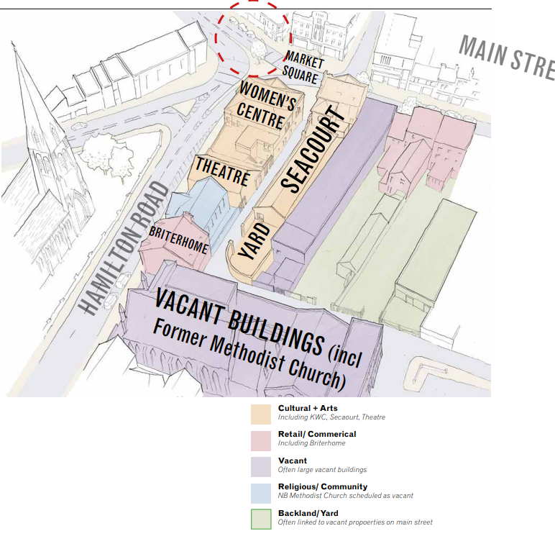
Bingham Lane was located off the Market Square at the geographical centre of Bangor. The lane had developed a cluster of community, retail, and cultural buildings around it.

- Historic and geographical centre of Bangor
- Public transport links
- Filtering streets to the public realm and future Waterfront and Queen’s Parade development
- Availability of parking (shown in yellow)
- Primary route along Hamilton Road
- Direct link to the Main Street
- Direct link to the High Street
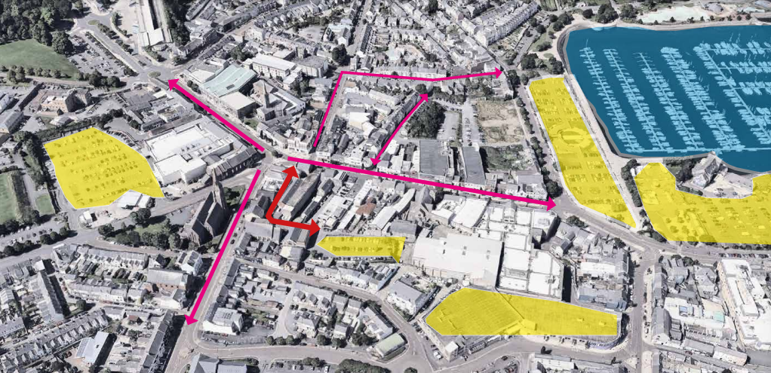

The consultants looked at the existing conditions, as well as drawing on its assets and opportunities:

Assets and Opportunities:
- Existing condition – the area had significant assets but faced issues like direct lack of access and low surface quality. Improvements could enhance its roles as a primary site.
- Market Square entrance – featured high quality stone paving and listed buildings but lacked clear connection to Bingham Lane. Opportunities existed to improve visual and physical engagement.
- Reuse of historic buildings – successful reuse of heritage buildings by Seacourt Print Workshop and Kilcooley Women’s Centre had created active community hubs. Potential existed to expand cultural uses, including the vacant Methodist Church.
- Cluster of cultural spaces:
- Seacourt Print Workshop – offers printmaking workshops, studios and a gallery but could improve visibility and connections to the street.
- Kilcooley Women’s Centre – provided diverse community services and was working toward full restoration of its building.
- Studio 1A – a long-standing cultural asset.
- Artist Studios – Seacourt and Boom Studios – 40 affordable studios with demand for more. Greater visibility for artists and evidence-based support for additional spaces are needed.
- Yard Spaces – Seacourt’s Yard could be opened to activate Bingham Lane with potential outdoor workshops and events.

- Heritage features – historic walls, concertina gates, and architectural features could be repurposed to enhance the area’s character and activity.
- Back-land sites – underutilised yards and buildings offered opportunities for housing or studio spaces, supporting the cultural quarter and city vitality.
- Vacancy – vacant Methodist Church – a key site with potential for cultural and community uses. Short-term activation and long-term redevelopment were possible.
Main Issues:
- Lack of activity and connections along Bingham Lane.
- Poor pedestrian access from Bingham Street.
- Low surface quality and informal car parking.
- Graffiti, which could be addressed through high-quality street art.
Opportunities:
- Improved signage, connections, and surface quality.
- Activate spaces like Seacourt’s yard and Kilcooley Women’s Centre gate.
- Repurpose vacant buildings, including the Methodist Church. A large portion of Bingham Lane was fronted by the church complex which was now vacant.
- Develop back-land sites strategically for long-term quality. There were several yards and back-land sites which were underutilised.
- Encourage activity by exploring how some of the spaces could open or engage better.
- Bangor had a perceived high number of artists living and working in the Borough and this therefore had created a vibrant scene for various scales of arts businesses and activities.
Public Engagement
A public engagement workshop was held on Wednesday 19th March 2025 in Market House, Bangor. Members of the public were invited to attend and view the concept design proposals and provide their feedback, 25 people were in attendance. In addition to the public engagement workshop, the designs were available to view online with an opportunity to provide feedback.

Short, Medium, and Long-Term Proposals
The concept design had provided the following proposals as short, medium, and long term interventions:

Short Term | Summer 2025

Bingham Lane Festival
The idea of a Bingham Lane Festival was to build momentum around what might happen with the street and its spaces. This was about testing and piloting what could happen more frequently or permanently. A festival or event would help put Bingham Lane back on the radar of people who did not know much about it or the buildings and organisations along it. This would in turn drive usage and footfall along the lane as a shortcut and thoroughfare during normal days. This method allowed the street to be tested when it was in a different ‘destination’ mode with activity along it.

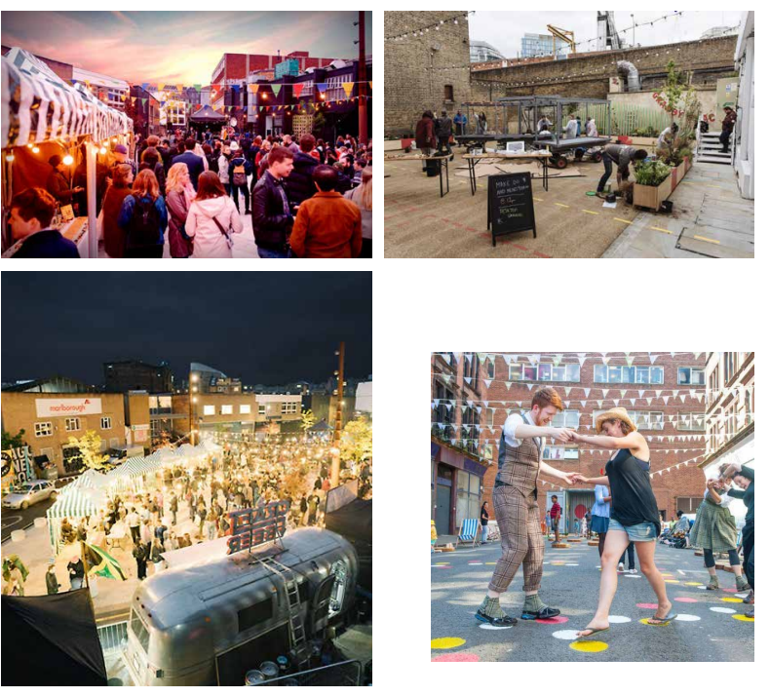
Short Term | 12 months

Cleaning and Maintenance
During the public engagement it was mentioned by a few people that beginning the process of cleaning and tidying up the alleyway would be a good starting point. It should be noted that the laneway was owned by the Department for Infrastructure, and it was therefore its overall responsibility. Litter picking and some general tidying could be organised. The ‘Love Your Laneways’ project in Melbourne was an inspirational project that showed the impact of getting some of the basics right around cleaning, bins and maintenance - this was now a primary attraction in the city.

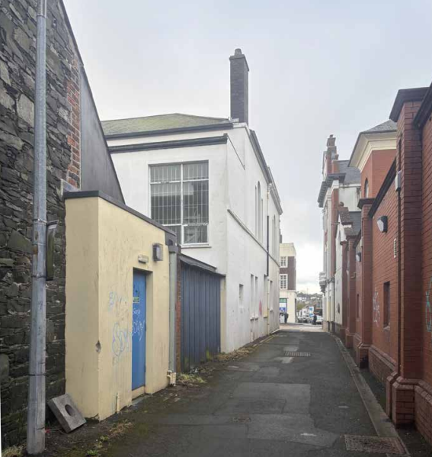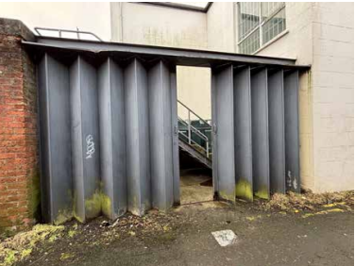
Existing conditions.

Street Art
Bangor (and Northern Ireland generally) had a vibrant street art and mural scene. There were high level street artists working locally as well as a wealth of international artists working in Northern Ireland. This could add another dimension of discovery along the laneway - with the large gable above the Seacourt Yard being an obvious site to do something significant and impactful. The walls along the laneway were also potential sites.

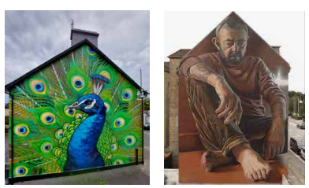

Seacourt Sign
Seacourt was a prominent and important part of the entrance to and along the lane (alongside the Kilcooley Women’s Centre/ Market House building). Located within a listed former bank, its presence was not always obvious for people who did not know it was there or were not regular gallery visitors. An appropriate sign could enhance the existing building in a way that helped people to discover what Seacourt was. This would also support and work with the art yard idea and people moving within the building. If there were issues in terms of the historic context and hand painting (similar to previous examples)- it would be possible to discuss removeable vertical signage.

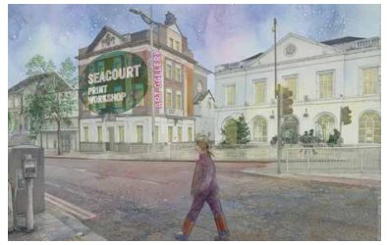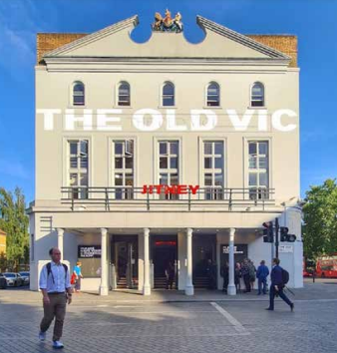

Bingham Lane Sign
Developing footfall and activity on the lane was the main purpose of most proposals. Wayfinding and signage could be important in designating spaces as public and safe. Bingham Lane was not on the ‘mental map’ of Bangor for many people walking past. Alongside other measures discussed, a quality metal sign, lit in an appropriate way for the context of the listed buildings would be helpful in identifying it as a safe route for pedestrians to use.
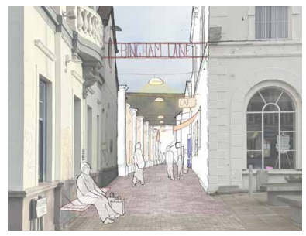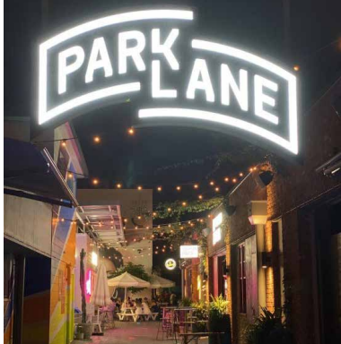

Hatch
An early proposal by the Kilcooley Women’s Centre during initial engagement recognised that the street needed activity along it. A hatch along Bingham Street at the existing metal side window was discussed. Two options/ locations for exploration had been provided. The capacity and idea of this could be tested during the street festival.

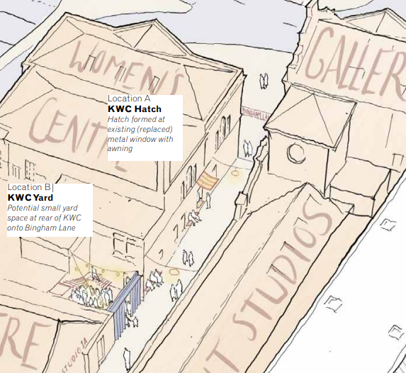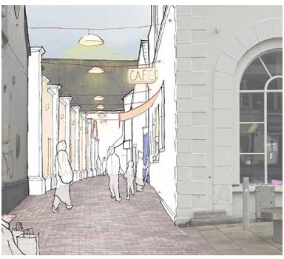

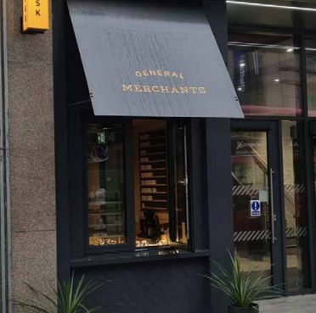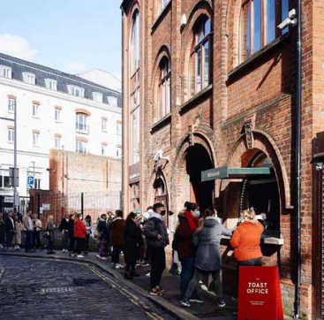

Art Yard
One of the most impactful projects in the short term would be to repurpose the yard to the rear of Seacourt into something which was an outdoor hub for the building. It could be informal and the kind of place that people would drop into casually. The Bingham Lane Festival would be a chance to test how it might function and develop as a space in the longer term.

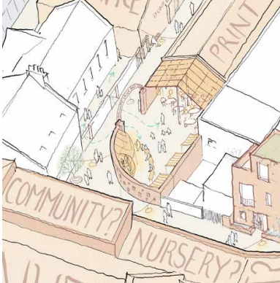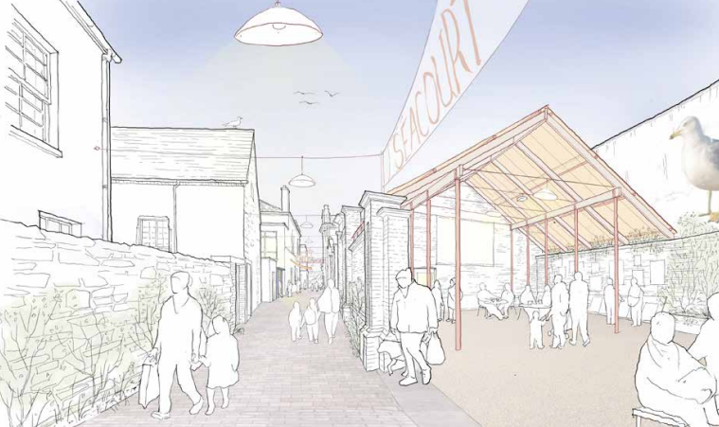

Greening
Adding planting and greening either in rain gardens and integrated ways or edge planters and pots could be a useful way of improving lanes and yards. The ‘Love Your Laneways’ movement generally showed lots of good examples of where this had been completed effectively. The planting could also be included in controlled spaces in yards and expand out onto the public realm.

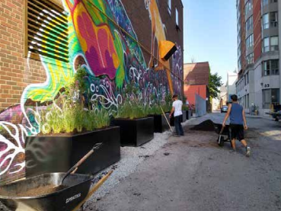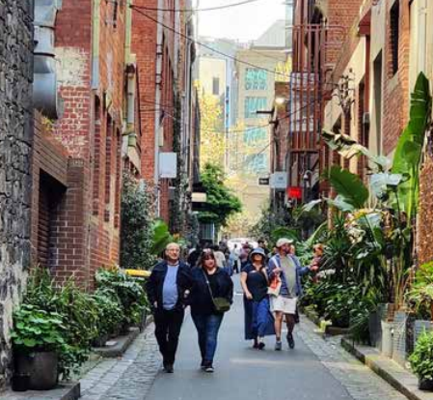

Medium Term | 1-3 years

Surface Improvements and Seating
The existing Market Square had been landscaped in good quality stone paving. The quality of this should be extended along the laneway, supporting the laneway as a public route and encouraging use. Alongside other measures (like improved lighting and signage) this would help encourage more people to use the laneway as other developments take shape.
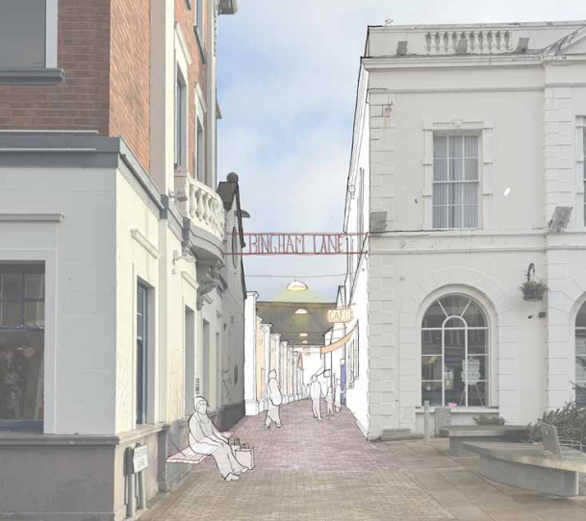

Lighting
Good quality catenary lighting with low maintenance provided a sense of intimacy and human scale that would support the street as a public space and help the feeling of safety in the laneway. It would make it much more utilised as a local connecting lane and (with other developments) a destination in its own right. It must be noted that lighting should carefully consider the listed context of adjacent buildings and had a quality befitting the type of atmospheric developing laneway the project was encouraging with cultural and community spaces along it (this was not a scheme for basic infrastructural lighting typically provided by DfI).

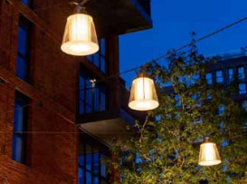

More Direct Connections on the Lane
There were a number of places (i.e. vacant church building) if occupied by other types of users could open onto Bingham Lane. This would help promote the use of the street as a destination as well as a connecting pedestrian route.

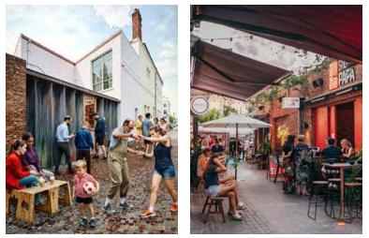

Long Term | 2-5 years

Permanent Cultural/Community Space in Repurposed Church Buildings
The church buildings had an interesting layout with a series of spaces which would support a range of community and cultural uses. The approach here could be light touch in terms of investment such as 2 Royal Avenue in Belfast which was about getting the doors back open or potentially with some refurbishment to repurpose the building if a partner organisation was involved.

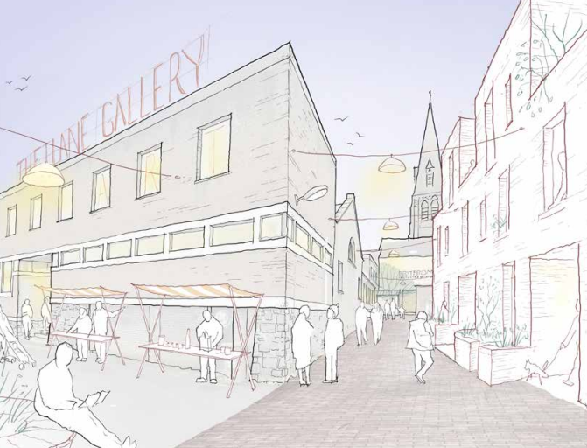

Mews Housing
It was now recognised that towns and cities which had large numbers of people living in the central cores - helped to support all sorts of commercial, retail, and cultural uses. The back-land sites of Bangor and Bingham Lane as a demonstrator showed how an atmospheric mixed-use street could develop. There was a clear need for housing in NI and this housing could support artists living near their studios and older people wanting to live centrally with facilities and a train station on their doorstep.

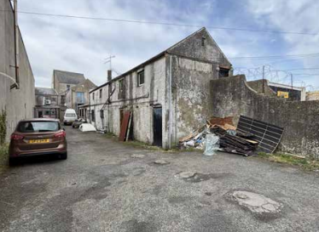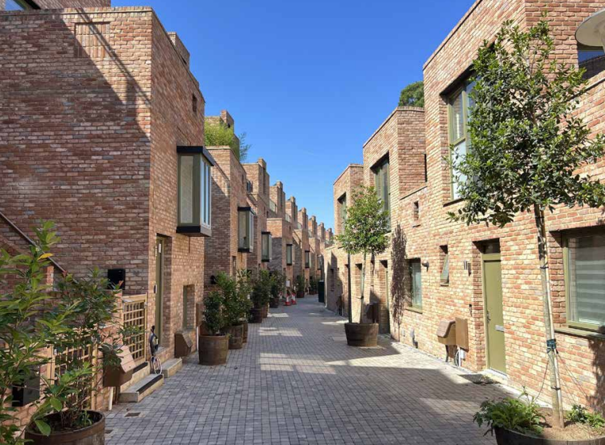

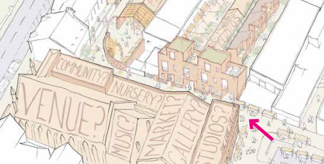

The proposals had been carefully designed to acknowledge the importance of this central location and its associated heritage and cultural assets. Feedback from local stakeholders, public input, and insights from relevant case studies had informed this proposal, showcasing a variety of short, medium, and long-term proposals that had the potential to significantly enhance this vital connecting route.

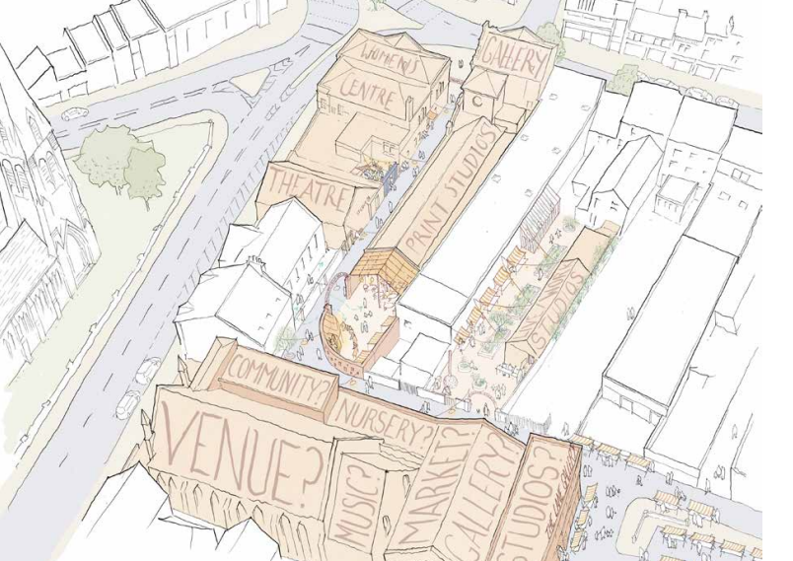

RECOMMENDED that the Council notes this report and the intention of officers to explore various funding opportunities for each of the proposed elements and report to the Committee should any funding opportunities be identified. Officers will additionally assist stakeholders, if requested to, in obtaining funding for a Bingham Lane Festival in 2025/2026 to serve as a trial for the proposed future uses.

Proposed by Councillor McCracken, seconded by Councillor Blaney, that the Council notes this report and requests that officers take forward a planning application for the draft proposals. That would support the intention of officers to explore various funding opportunities for each of the proposed elements and report to the Committee should any funding opportunities be identified. In addition, officers would consult stakeholders about the potential for a Bingham Lane Festival and would support them in obtaining funding if requested to do so.

Speaking to his alternative proposal, Councillor McCracken praised the report, explaining that he had worked personally with the architects involved so had a good understanding of the quality that they had brought to this.

He felt that the work had captured a sense of place for Bingham Lane and thought through how the different elements could cluster and mutually reinforce one another to create something that worked well beyond the sum of its parts.

The proposer was aware however, from previous experience, pointing to an example in Holywood, that the funding from Central Government was very short term in nature and contained tight deadlines within its terms and conditions. Those deadlines were completely unrealistic if planning consent was required.

Pointing to various positive elements of the scheme - he highlighted signage and lighting - but believed they would all require planning permission. He felt therefore it would be prudent to invest a small amount in to getting the planning consent before perusing those external funding opportunities. It would mean that projects would be ready to go.

He believed that a quick win could be to undertake a deep clean of the lane which he understood would be welcomed by businesses.. That would at least start the process of enhancing the lane.

Continuing, Councillor McCracken queried how that would work in terms of DfI involvement and if any conversations had already taken place with DfI officials and the Head of Regeneration confirmed that there had been some initial engagement with DfI in terms of a deep clean and how that could look. He said that officers had agreed that it would help improve the attractiveness of the area.

Councillor McCracken queried the festival, explaining that he would be less concerned about holding a festival this summer, in 2025, given the area was not looking its best, but he felt some quick wins at this stage would work and the festival could take place next year with the possibility of capital funding. He felt that a discussion with stakeholders would be beneficial but the Council should not force the issue.

The Director of Place felt that this could be a good starting point as a ‘bid project’ and complement the larger plans for the area.

The seconder Councillor Blaney welcomed the project and felt it was what the Council needed to look at across the Borough, particularly in this area of Bangor.

Main Street had endured its share of dereliction and he noted that a hardware store that backed on to the area had recently become vacant too. He also felt that this area tended to be avoided and the underpass in Main Street was often favoured instead.

Continuing, Councillor Blaney felt that this area could be turned into a vibrant hub. He praised officers for their work and hoped that what was a great idea on paper could be turned into a final product. He therefore supported the alternative proposal and felt that small quick steps were a good way to start instead of just waiting for the entire project to be completed at once. If the Council was halfway towards this within a year or two, it would be good progress.

Councillor Smart welcomed what he felt was an exciting project particularly given an emerging art scene in Bangor. It was a good opportunity to develop that and build on it in terms of the festival offering. He was supportive of the alternative proposal and agreed with the proposer in terms of having the planning permission in place being key to securing the funding when it became available.

He queried the task required to pull that planning application together, noting that the work would involve other partners. He wondered if it was the right time to proceed with that and if officers felt it was achievable.

The Head of Regeneration said his team felt it was worth pursuing and it was known from experience that if projects were already worked up to a shovel ready stage, the Council was in a good position to act when funding became available.

AGREED TO RECOMMEND, on the proposal of Councillor McCracken, seconded by Councillor Blaney, that the Council notes this report and requests that officers take forward a planning application for the draft proposals. This will support the intention of officers to explore various funding opportunities for each of the proposed elements and report to the Committee should any funding opportunities be identified. In addition, officers will consult stakeholders about the potential for a Bingham Lane Festival and will support them in obtaining funding if requested to do so.

The Chair welcomed the Strategic Capital Project and Programme Manager to what was his first meeting of the Committee and advised that he was overseeing the Bangor Waterfront project.

6. Update report on the Deputation from Donaghadee Heritage Preservation Company (Sir Samuel Kelly Centre) (FILE RDP42)

Previously circulated:- Report from Director of Place detailed as follows:

Background
Members would recall a deputation by representatives from Donaghadee Heritage Preservation Company (Sir Samuel Kelly Centre) on 9 January 2025. Included in the deputation was a concept design for a Visitor and Heritage Centre to provide a suitable permanent site to store the Sir Samuel Kelly Lifeboat. The design also proposed a kitchen and café, toilets, a space for other heritage items, meeting rooms, and a balcony.

It was subsequently agreed that officers should present a report detailing the steps necessary to take forward the requests made by Donaghadee Heritage and Preservation Society.

Update
Three requests of the Council were detailed in the deputation. Each request and the subsequent considerations were detailed below.

1. Council to grant the Company a long lease on the site

Location of the Centre

Donaghadee Heritage Preservation Company had detailed the intention to apply for a 99-year lease on the current site. The current lease expired in October 2028. It was envisaged that a long-term lease would increase the likelihood of the Company securing the substantial funding required to deliver and operate the Centre.

Since the deputation, consideration had been given to relocate the site from its existing location to an area closer to the entrance of the car park. Envisaged benefits of this relocation included:

- Improved proximity and connectivity to the town centre
- Improved access from the coastal path
- Increase the unobstructed view to and from the Centre
- The potential to store the lifeboat in a rectangle rather than a square which would be of operational and visitor benefit

Planning considerations

Subject to any agreement on securing the land, Planning Permission would need to be applied for. The Sir Samuel Kelly representatives would be advised to submit a Pre Application Discussion (PAD) to the Council’s Planning Department identifying this area. This would enable officers to assess the proposal in advance of any formal submission being made to consider if the proposal complies with the local area plan and prevailing planning policy. In addition, this would be an opportunity to garner views of statutory consultees in particular with regard to potential infrastructure and traffic implications.

Consideration of applicable rent costs

An additional consideration as part of the decision-making process to grant a 99-year lease included the cost of the use of land for the duration of the agreement. The current rent to Council was nominal given that the Company was a charity and was leasing the land for the purposes of restoring the Council owned lifeboat. The nominal rent was approved by the Department for Communities (DfC).

The proposal detailed a request from the Company that the lease would permit an agreed range of activities that would be deemed non-commercial, and any profit arising from sales would go back into the project. For example, the sale of refreshments, branded merchandise, and hire charges for use of the meeting rooms.

Additionally, the proposal detailed the intention to facilitate a commercial tenant/s to generate funds to contribute towards the Centre’s operational costs. If the proposal was approved and in readiness for this possibility, flexibility within the rent charged would need to be documented. Advice would be taken from the Council’s valuer on the applicable rent costs.

2. Council recommendation to decide upon a site by the Summer 2025

To enable an informed and meaningful decision-making process to be completed and agreed by the Council, a decision by Summer 2025 would be unfeasible owing to the following processes:

- A pre application discussion (PAD) with the Planning Service.
- The Lands Department initiating an internal consultation process regarding a potential 99-year lease agreement. The request for a lease would need to be reported to the Corporate Services Committee.
- The request for a below market value charge of rent for a substantial timeframe, and the associated impacts, will need careful consideration by the Council. Advice from the Council’s valuer will be sought and a final decision would most likely be dependent on agreement from DfC
- Any potential limitations for other uses or infrastructure requirements of the car park was required to also inform part of the decision-making process.

3. Council to assist the project going forward

To date, Regeneration and Lands officers had worked in collaboration with representatives from Donaghadee Heritage Preservation Company (Sir Samuel Kelly Centre) and this would continue.

Next steps
If the project progressed, Council officers would collaborate further given the multi-faceted nature of the project and to ensure effective communication with the Sir Samuel Kelly representatives as necessary.

RECOMMENDED that the Council notes this report.

Proposed by Councillor Hennessy, seconded by Councillor McCollum, that the recommendation be adopted.

Councillor Hennessy reported that Donaghadee Heritage Preservation Company was excited by this progress since its deputation in January. He was aware that it had brought forward additional proposals which looked at re-siting to a more prominent position, closer to the path. The organisation accepted that this was subject to Planning approval and its representatives hoped to engage with the Planning Service in respect of a pre-planning discussion (PAD) which had been requested at the end of January.

He was aware that the organisation had not yet had a response and feared that it may not get a decision before the end of the year. The proposer asked for an update on that process and the Director of Place would follow that up with the Planning Service.

The seconder, Councillor McCollum was pleased with the report which had resulted from her proposal at the meeting where the deputation had taken place. She added that the planning process in terms of the PAD was important to enable DHPC to prepare plans and stay on top of any funding opportunities that became available.

The Chair was aware that DHPC was extremely active in exploring all avenues, pointing out that Peter Martin MLA had set up a meeting with the DfC Minister. She would be glad to see the boat in its final home.

AGREED TO RECOMMEND, on the proposal of Councillor Hennessy, seconded by Councillor McCollum, that the recommendation be adopted.

7. Update on Village Plans 2025-2035 (FILE 160135)

Previously circulated:- Report from Director of Place detailed as follows:

Background
Regeneration officers were currently developing a new set of Village Plans for each of the villages within the Borough. The new Village Plans were required as the existing plans had now expired and were no longer fit for purpose.

Village Plans 2025-2035
The new Village Plans aimed to provide a strategic framework for the development of each village over the next ten years, prioritising adaptability through annual reviews in collaboration with the community groups to ensure they remained relevant and reflective of the changing needs and aspirations of the community.

Process of Developing the Village Plans
The development of the new Village Plans had been a three-stage process and officers were currently in the final stage.

Stage 1 – Desktop Research and Public Engagement (Completed)

April 2024 – November 2024
- Extensive desktop research was completed for each village and an analysis of statistical data completed by officers.

- Extensive public engagement was delivered between May 2024 and October 2024, this included public workshops, involvement of community groups and local activity groups, local primary school workshops, attendance at public events, conducting on-street surveys, and supported with an online survey.

Stage 2 – Identify and Refine Priorities (Completed)

December 2024 – April 2025
- In December 2024, officers commenced the process of analysing the data from the various public engagement, identifying emerging themes, and priorities for each village.

- A further stage of public engagement was delivered to ensure the emerging themes and priorities were indeed reflective of the community’s needs whilst providing an opportunity to refine these further. This included a public workshop in each village and an online survey. Stage 2 closed for responses on 28th February 2025.

- Between March and April 2025, a final review of the emerging themes and priorities was delivered in collaboration with each of the community groups.

Stage 3 – Draft Plans for Review (In Progress)

May 2025 – June 2025
- Workshops with each of the various internal departments had commenced to gather their insights and contributions, recognising that many of the identified priorities would require collaboration across various departments. This process would enable forward work planning and provide an opportunity for Regeneration and other departments to secure the required resources to begin to deliver on the themes and priorities.

- Officers had commenced developing the Village Plan template and were currently populating a template for each village.

- Following a request from the community groups, officers had agreed that the final draft of each Village Plan would be issued to each of the community groups for a final review before sign-off.

- Officers would arrange a meeting of the various rural partnership groups (North Down, Strangford, and Peninsula) in June 2025 to agree the final set of plans.

Completion and Launch of New Village Plans
It was expected that the Village Plans would be launched in September 2025, consisting of a central launch and village specific launches.

The Village Plan would be in digital format as a ‘live’ document, this would enable the themes and priorities to be reviewed and updated annually by Regeneration officers. Each plan would feature a video introduction. Further video content and live links could be added to showcase and evidence project delivery.

Each plan would be accessible on mobile, iPad, laptop or similar devices and could also be downloaded as a pdf.

In addition to the digital plan, a printed summary flyer would be available for each village, outlining the key themes and priorities identified.
Village Plan Communications
Officers were currently developing a communications strategy for both the launch and delivery of the Village Plans, this would include both internal and external communications.
Effectively communicating the delivery of the Village Plans would be essential to maintaining the long established and more recently established working relationships with each of the villages and the wider village partnerships. The communications would be focused on showcasing success and demonstrating local views were valued, with the core message emphasising ‘your village – your voice, and, ‘you spoke – we listened’.
Officers would bring a report to committee in June 2025, this would include:
- The themes and priorities identified for each village
- The Communications Strategy for the delivery of the Village Plans
- The proposed methodology for assessing project prioritisation

RECOMMENDED that the Council notes this report and acknowledges the slight delay in completion due to the additional time needed for the community groups to review the final drafts.

Proposed by Alderman Adair, seconded by Councillor Edmund, that the recommendation be adopted.

Alderman Adair praised officers on their work in progressing the village plans, noting that in Greyabbey and Portaferry over 100 people had attended public consultation events. He had noticed a strong appetite from the community in taking part in the process and asked if the views expressed had been taken in to account.

The Head of Regeneration explained that all of the views provided throughout the process had been considered and the plans once completed would be brought back to each village for confirmation. He also referred to a communications plan which would aid that process. He added that officers had engaged with everyone that had given responses to the consultation process and it was not just the views of one specific consultation group which had been a further concern raised by the proposer.

Alderman Adair described the previous work around village plans as a copy and paste job, so he was reassured by the officer’s response. He thanked the Regeneration team and looked forward to the published plans which would be important for accessing funding when it became available.

Councillor Edmund added his thanks to the Regeneration team and recognised it was a totally different consultation to the previous one which had been put out to consultants. This process had been more sensitive to the views of village representatives. He looked forward to the plans being finalised and that everyone’s views had been taken in to account.

Councillor McCollum endorsed those comments believing that the process was working extremely well, reflecting on her time representing two different DEAs during this Council’s mandate. While there was a level of variance in terms of engagement between the two areas, she felt that was possibly due to the demographic of those particular areas.

Councillor McCollum was aware of feedback from Conlig Community Regeneration Group which had queried what tangible actions were expected from their village plan and had raised a further query which sought clarity on the boundary of Conlig village. She requested that officers provide further engagement with the group and the officer was happy to do so. He explained that it was hoped each village would undergo one development within the first year of the plans which he hoped would provide reassurance as a tangible action. He clarified that it would not necessarily be delivered by the Regeneration service but possibly other sections of the Council where appropriate.

The officer would also provide details of the boundary lines for Conlig village and it was clarified that it was only recognised as a village in the context of Regeneration’s Village Plans but officially it was a suburb of Bangor.

The Chair noted that there were frustrations around previous village plans and that many aspirations had failed to materialise due to the lack of available funding. However, she was pleased that these plans were being drawn up by Council officers, as opposed to appointing consultants, as the officers knew each village well.

AGREED TO RECOMMEND, on the proposal of Alderman Adair, seconded by Councillor Edmund, that the recommendation be adopted.

8. Belfast Region City Deal (BRCD) Update (FILE RDP22/RDP56)
(Appendix I)

Previously circulated:- Report from Director of Place and Director of Prosperity detailed as follows:

- Background
As previously advised, the Belfast Region City Deal (BRCD) represented a transformative £1 billion capital investment programme designed to drive inclusive economic growth across the Belfast City Region. The Deal focused on four strategic pillars: Innovation and Digital, Tourism and Regeneration, Infrastructure, and Employability & Skills. Collectively, the BRCD aimed to create up to 20,000 new and better jobs, accelerate economic recovery, and deliver long-term benefits for people and communities across the region.

- BRCD Update
The BRCD Programme Director post still remained unfilled with the Programme Managers currently fulfilling the operational functions associated with the programme.

2.1 Council Panel
Mid and East Antrim Borough Council hosted a meeting on 26th March 2025 of the BRCD Council Panel. Minutes of the meeting, as yet, had not been circulated. Councillor McKimm attended the meeting with the Interim Director of Place.

3. Digital & Innovation Update
Innovation Commissioner: The post was advertised in June 2024 and Dr Adrian Johnston MBE took up the role in January 2025 contributing to the Digital Pillar.

Innovation Challenge Fund Programme: This programme collaborated with the BRCD Centres of Excellence to complement capital investments. It works with SMEs in relevant sectors to unite academia, researchers and businesses together to develop solutions for:
- Smart buildings
- Reducing emissions in the supply chain
- Low carbon processed in manufacturing
- Green computing for waste energy recovery
- Smart integrated power systems.

Augment the City Challenge Fund Project: This project supported the creative digital sector offered a challenge fund for SMEs to create solutions to engage citizens and visitors to Belfast.

- Phase 1: 10 companies received up to £10k to test ideas through a 5G installation at Belfast City Hall.
- Phase 2: Six companies received up to £35k to further develop their projects.
- Phase 3: Held in April 2025, this phase was held in Belfast City Hall to reduce the number of companies from six to three. All six companies presented their
- concepts which use immersive and digital technologies to gather, curate, and present stories about Belfast and its people. The selected three companies would receive up to £100k to develop prototypes, with learnings shared among BRCD partners.

Enabling Infrastructure Fund Project: Led by Digital Catapult this fund was seen as a key enabler across the region prioritising wireless connectivity.

The investigation into the investment required to establish a 5G ecosystem across the City Deal region had been completed. Key findings highlighted the need for significant investment in infrastructure to support widespread 5G deployment, including the installation of new base stations and the upgrading of existing ones.

Efforts were underway to build capacity among BRCD partners to ensure preparedness for future funding opportunities. This included training programs and workshops to enhance technical and strategic capabilities of the partners. As more details were shared updates would be provided as appropriate.

4. Employability and Skills
Skills Assessment: The Advanced Manufacturing Skills Assessment and Digital Skills Assessment reports had now both been approved by the BRCD Executive Board. A review of the identified actions was currently being undertaken to determine suitable actions for inclusion in the BRCD Employability and Skills action plan.
Advanced Manufacturing Innovation Centre Skills Strategy: This strategy was being progressed, and Members would be updated upon conclusion.

- Bangor Waterfront Update
The Bangor Waterfront Project Board continued to meet regularly to oversee delivery of this major project. Progress remained on track and in line with the Milestone Dates set out in the Contract for Funding. A detailed update on all current workstreams was provided in Appendix 1.

RECOMMENDED that Council notes the report.

Proposed by Councillor McCracken, seconded by Councillor Hollywood, that the recommendation be adopted.

Councillor McCracken noted the appendix referred to five character areas from Skippingstone in the west to Banks Lane in the east. He queried what the other three areas were and the Capital Project and Programme Manager advised that the route started in the west at Skippingstone, then covered Bangor Marina, Seacliff Road, Kingsland and ended at Bank’s Lane.

Referring to the Kingsland area, Councillor McCracken felt that it was a strong asset along that stretch and while once popular had suffered degeneration over the years and hadn’t received the attention it deserved. He felt it was right to focus on five areas for the £18million investment rather than spread the pot too thinly over 3.2km of coastline.

He asked what development was expected to take place in the Kingsland area and how it would link in with Ballyholme Yacht Club.

The Capital Project and Programme Manager explained that an ICT process was about to commence and advised that in relation to Kingsland there were proposals for a number of kiosk type facilities, a cafe area and it also included some play space for young children. There was also an urban sports facility and parkland in and around that location. There were no direct links to Ballyholme Yacht Club.

Councillor McCracken felt that an attractive public realm was important for what would be a water sports centre of excellence but he felt what was being discussed sounded positive.

In a further query, he had noted that the Council had appointed consultants to work up private investments for the Waterfront scheme. He was aware that consultants would be tasked to undertake the same process for the separate Queen’s Parade development plans which was on the same stretch of coastline. He asked how officers would ensure there was no duplication between the two consultants of the two separate projects which were likely to have competing objectives.

The Director of Place advised that the two private consultants should not be in competition. There needed to be some synergy between them to attract money into the Borough. While the two would be communicating, he explained that the type of investment for each project would be different and the Council would focus on the 2.2 mile stretch that it was responsible for. He clarified that the land side of the Queen’s Parade development was the responsibility of Bangor Marine and the Department for Communities.

(Alderman Adair left the meeting – 7.33pm)

The seconder Councillor Hollywood welcomed the progress and was pleased to see that at least one aspect of development along the seafront was moving in a positive direction.

The Chair raised a query around the planned installation of a playpark within the Marine Gardens development to replace the one at Pickie Fun Park which would make way as part of separate development at that location. Given those two developments were intended to complement one another, she wondered if delays to the Marine Gardens development would change the plans at Pickie Fun Park.

The Director of Place explained that it was intended to install the tier one playpark in advance and while he was unable to clarify a start date for the Pickie development he advised that it would be out of the Council’s control if the private operator of Picke Fun Park closed off the park for development but that was not a concern at this time.

Councillor Blaney welcomed the update but felt that a lot of the plans were a long way off development. He questioned whether the Council was in fact delaying other assets from being developed because it was waiting on this ‘great plan’.

He referred to unused land at Kingsland which would not see money spent on it for a quite a while and he felt that a commercial opportunity could be developed there for a café for example. This could go some way to regenerating the area before the masterplans were fulfilled. He feared that in this case, great could be the enemy of good.

He pointed to the success of the Council’s former bike shed at Ward Park which was now a very successful café. He felt that Council therefore could make pieces of land here available for commercial use and which could be up and running within six months.

The officer advised that the ICT process would consider that option and look at the opportunities over the 2.2-mile stretch. Those could be brought to the Committee for agreement to be put out as a development brief ahead of reaching the final plans. He explained that officers had discussed what could be done, in terms of a commercial element, outside of the Waterfront plan.

In a further suggestion, Councillor Blaney felt that building commercial pods now for example would be more attractive for someone to open a shop. In Kingsland for example, it would have a knock-on effect of lowering the value of a Council owned building that was currently used by a Camera Club due to commercial activity already being established in the area.

AGREED TO RECOMMEND, on the proposal of Councillor McCracken, seconded by Councillor Hollywood, that the recommendation be adopted.

9. Any Other Notified Business

There were no items of any other business.

Councillor McCracken wished to place on record that he had attempted to bring an item of Any Other Notified Business but it had been rejected by the Chair in advance of the meeting.

Exclusion of public/press

AGREED, on the proposal of Alderman Armstrong-Cotter, seconded by Councillor Ashe, that the public/press be excluded during the discussion of the undernoted items of confidential business.

10. Belfast Region City Deal (BRCD) Issues (FILE RDP22)

**IN CONFIDENCE**

SCHEDULE 6:3 – EXEMPTION RELATING TO THE FINANCIAL OR BUSINESS AFFAIRS IF ANY PARTICULAR PERSON.

Council was asked to agree with recommendations in relation to the Court House Development Phase 2, the Marina and also note the Innovation Hub update. Further discussions on these if agreed will be held with the relevant government departments.

11. Revive Our High Streets Programme Proposal (FILE RDP43)

**IN CONFIDENCE**

SCHEDULE 6:4 – EXEMPTION RELATING TO CONSULTATIONS AND NEGOTIATIONS.

Consultations with DfC officials are ongoing and have been in advance of a formal application, pending approval by the Council. Any reporting of potential funding amount, or projects, are likely to negatively impact the application process and working relationship with DfC.

Additionally, the full details of Level 2 are yet to be finalised and therefore any reporting of the scheme could potentially negatively impact its design or delivery.

12. Castle Street Gap Site Comber – response to Notice of Motion 639 (FILE RDP14)
(Appendix )

**IN CONFIDENCE**

SCHEDULE 6:1 – EXEMPTION RELATING TO AN INDIVIDUAL.

Given the previous media attention the private landowner has received upon reporting of a previous report on this project it is strongly recommended that this report be In Confidence. Additionally, the report being In Confidence would seek to protect the integrity of the ongoing negotiations with the landowner, DfC, and officers.

13. DfC/ANDBC Urban Regeneration Programme (FILE RDP43)
(Appendix IV)

**IN CONFIDENCE**

SCHEDULE 6:4 – EXEMPTION RELATING TO CONSULTATIONS AND NEGOTIATIONS.

Consultations with DfC officials are ongoing and have been in advance of a formal application, pending approval by the Council. Any reporting of potential funding amount, or projects, are likely to negatively impact the application process and working relationship with DfC.

NB – Appendix 001 DFC ANDBC Urban Regeneration Programme 2024 – 26 Action Plan should also be In Confidence.

Re-admittance of public/press

AGREED, on the proposal of Alderman Armstrong-Cotter, seconded by Councillor Smart, that the public/press be re-admitted to the meeting.

Termination of meeting

The meeting terminated at 8.50pm.

