ARDS and North Down Borough Council

A hybrid (in person and via Zoom) meeting of the Environment Committee was held at the Council Chamber, Church Street, Newtownards, and via Zoom, on Wednesday 11 June 2025 at 7.00 pm.

Present:

In the Chair: Councillor Kendall

Alderman: Armstrong-Cotter (7.26pm)
Cummings (Zoom)
McAlpine

Councillors: Ashe (7.03pm) Edmund
Blaney (Zoom, 7.05pm) Harbinson
Brady Kerr (Zoom, 7.06pm)
Cathcart (Zoom) McLaren (Zoom)
Douglas Wray

Officers in Attendance: Director of Environment (D Lindsay), Head of Assets and Property Services (P Caldwell), Interim Head of Regulatory Services (R McCracken), Head of Waste and Cleansing Services (N Martin) and Democratic Services Officer (R King)

Other Officers in Attendance: Kristopher Calder (RPS) and Catherine Ferguson (RPS)

1. APOLOGIES

The Chairman (Councillor Kendall) sought apologies at this stage and noted that an apology for lateness had been received from Alderman Armstrong-Cotter and Councillor Ashe.

NOTED.

2. Declarations of Interest

There were no declarations of interest made.

NOTED.

3. Response to Notice of Motion - Donaghadee Sea Defenses (FILE 62704 / NOM 616)
(Appendix I - II)

PREVIOUSLY CIRCULATED:- Report from the Director of Environment detailing that in April 2024, the Council agreed the following Notice of Motion:

“That this Council recognises the significant opportunities which the redevelopment of Donaghadee Harbour could bring to the local economy in terms of leisure sailing and tourism and thus instructs officers to work with local groups to scope potential operational facilities which could enhance the offering in the Harbour and further brings back a feasibility report on the various options, including costings and possible funding streams.

Further, that this Council recognises the issues associated with high winds and coastal change and reviews the original 2020 Harbour Study conducted by RPS including the necessity for an offshore breakwater and agrees to bring back a report in time to be presented to Council in September 2024, outlining the budget required to undertake this work, any key considerations, next steps and identify which stakeholders would need to be involved.”

An update report was presented to the Council in September 2024 providing information on works completed to date.

“Officers met with representatives from the Sailing Club and other relevant groups on 9 May and discussed a number of potential small-scale operational improvements to the harbour. Officers felt the meeting was productive and a number of low or no-cost improvements have been implemented.”

To address the second part of the NoM concerning the review of the RPS report, the September update report also proposed some questions that would be put to the Consultants and form the scope of a subsequent technical report.

In November 2024 it was reported to Members that The Council had received confirmation from the Secretary of Levelling Up, Housing and Communities, that the Council had been allocated the funding (£21,100) required to undertake the ‘Phase 1’ further investigation work as set out in the September report to Committee, from the UK Shared Prosperity Fund.

This report aimed to update Members on the findings of the RPS Phase 1 report and outline potential next steps.

Key Points from the RPS Report
The full report was attached at Appendix 1 for Members information; however, the key points were summarised below.

2.1. The efficacy of the offshore breakwater at protecting the town’s shoreline

Given the content of the report by Donaghadee Community Development Association (DCDA) that prompted the Notice of Motion, and the nature some of the comments made at Environment Committee in relation to the need to protect homes and businesses, it was clear to officers there was a belief that the offshore breakwater (fig1) would protect the shoreline of Donaghadee. However, this was not the original design intent. Rather, its sole focus was improving tidal conditions within the Harbour itself. Therefore, it was essential that the primary focus of the review should have been in characterising the coastal flood risk to Donaghadee with a view of developing effective flood relief measures rather than be limited to refining the plan for an offshore breakwater.

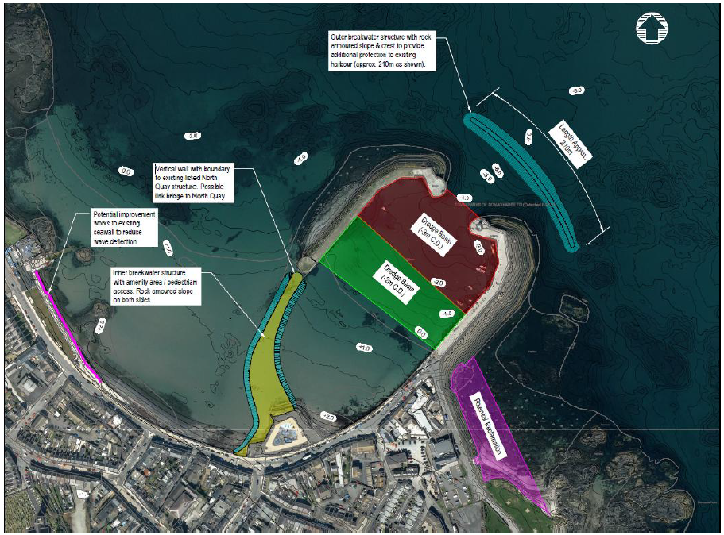Fig. 1

When considering which specific areas of shoreline that were “at risk” the RPS report referred to the “inner parade/East of Lemon’s Wharf” and “outer parade/West of Lemons wharf” so these areas were identified below and referred to throughout this report, for consistency.

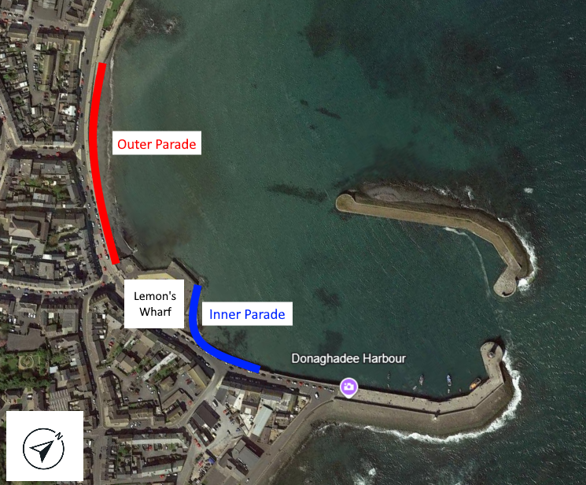 Fig 2

The limited effects of the offshore breakwater in protecting homes and businesses within the Inner and Outer parade was described on page 40 of the report, within table 5.1, excerpt below.

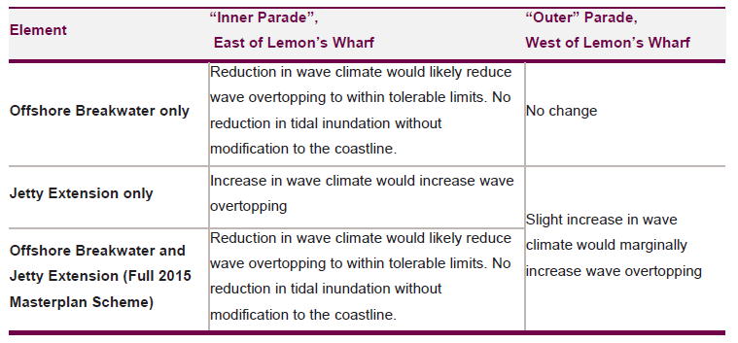

2.2 Characterising the coastal flood risk to Donaghadee

Page 59 of the report summarised the flood risk and indicates that:

- Whilst the initial harbour plan developed as part of the initial Donaghadee Harbour study (RPS, 2020) and illustrated in Figure 1 improves wave conditions within the harbour as per the study objectives, the scheme did not reduce coastal flooding from tidal inundation and only partially reduced the potential of flooding caused by wave overtopping.
- Under existing conditions, coastal flooding from tidal inundation was unlikely to be a significant issue, with only Lemon’s wharf being at risk. However, given the lack of built assets at risk here or in the surrounding area, there was unlikely to be an economic justification for extensive flood relief measures.
- Under future climate conditions, sea level rise increased the risk of coastal flooding with many commercial and residential premises along the “Inner” Parade and half of the “Outer” Parade becoming vulnerable to tidal inundation.
- Based on present day conditions, the risk of mean wave overtopping across all examined sections was considered “tolerable” for all sections examined during a 1 in 1 year return period event. During a 1 in 50-year return period event, only the overtopping at some sections was considered tolerable, whilst overtopping discharge rates exceeded tolerable conditions across all sections during a 1 in 200-year return period scenario.
- Advanced Computational Fluid Dynamic (CFD) modelling demonstrated that the maximum wave overtopping rates exceeded tolerable conditions by up to a factor of x4 across examined sections during a 1 in 200-year return period event.

Thus, whilst there was not a significant risk of coastal flooding across the study area based on present day conditions, wave overtopping during extreme events result in discharge rates which were considered unacceptable in context of pedestrians, vehicles and structures.

Having identified this risk, the next section of the report examined options to reduce wave overtopping rates during an extreme 1 in 200 return period storm event based on present day conditions, to within acceptable thresholds.

2.3 Developing effective flood relief measures

Having identified the risk associated with wave overtopping, RPS considered various coastal management measures to reduce overtopping rates to within tolerable limits. Options considered and the supporting rational for the areas to the west and east of Lemon’s Wharf were summarised below:

West of Lemon’s Wharf (Outer Parade):

- Rock Armour Revetment: The revetment structure could effectively dissipate wave energy and momentum to reduce overtopping.
- Recurve Seawall: Could deflect up-rushing water seawards as waves impacted the seawall. A recurve already provided effective protection for a Section of the coast further west; thus a recurve option here would effectively continue this existing defence.

East of Lemon’s Wharf (Inner Parade):

- Rock Armour Revetment: Similar to the west, aimed at mitigating wave impacts.
- Recurve Seawall: As with the west, this could deflect waves on impact. This option required less space on the foreshore, which may have been important as the land in this area was privately owned.
- New Promenade: Proposed to enhance public access, with an additional area for public amenity, while increasing the distance from the waterfront to sensitive receptors, thereby providing additional flood protection.

Potential Solutions
Advanced modelling was again undertaken to test the effectiveness of these options at both locations for relevant conditions.

This “proof of concept” analysis found that:

- To the west of Lemon’s Wharf, both options were found to significantly reduce wave overtopping, with the rock armour solution providing a better reduction in overtopping rates. The initial design of the recurve seawall could be refined to achieve a similar level of performance. A recurve seawall would be the preferred option for this area given that it would tie in with the recently constructed scheme further west and occupy less space on the foreshore than a rock armour revetment option.

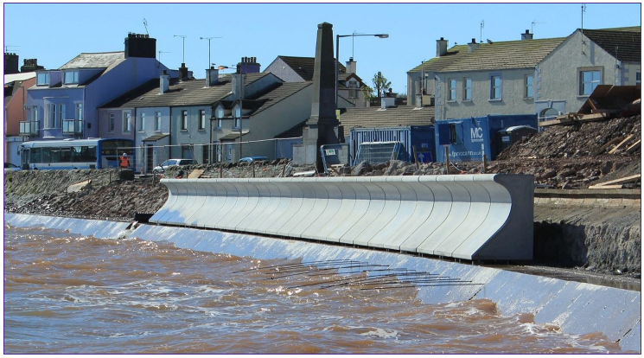
Image of existing recurve seawall at the outer Parade, west of lemons wharf, under construction in 2015, photo by Moore Concrete

- To the east of Lemon’s Wharf, both a rock revetment and recurve seawall were found to significantly reduce wave overtopping. Whilst the recurve seawall was found to be more effective, RPS identified limitations of the modelling approach which effectively assessed overtopping on a one-dimensional basis whereas the processes in this area were highly two dimensional (i.e., waves could approach from different oblique angles and result in wave focusing).

Recognising this limitation, it was RPS’s view that aside from significantly increasing the dimensions of a rock armour revetment option, the most effective solution would be to increase the extent of the existing promenade by reclaiming a localised section of the foreshore which would extend from Kelly’s Steps to Lemon’s Wharf.

This option would increase the distance between the point of wave overtopping to vulnerable receptors, including the footpath, road and nearby buildings.

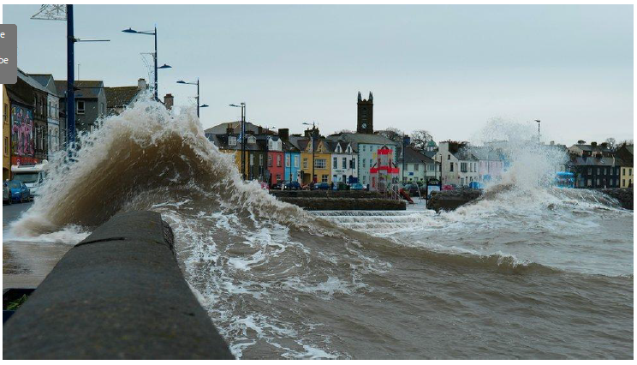
Example of oblique waves becoming “focused” and running along the existing sea defence at the inner parade, east of lemons wharf.

This area would provide enhanced recreational benefits during normal conditions and be allowed to overtop and partially flood during extreme conditions, similar to Lemon’s Wharf. In doing do, the reclaimed area / promenade feature would provide important flood mitigation to the surrounding area.

Given that this parcel of land was understood to be under private ownership, it would be critical to engage with local landowners and other relevant parties to reach an agreement on the extent of reclamation. Whilst this was beyond the scope of this study, an indicative area that could be reclaimed to achieve these objectives was illustrated in green, below.
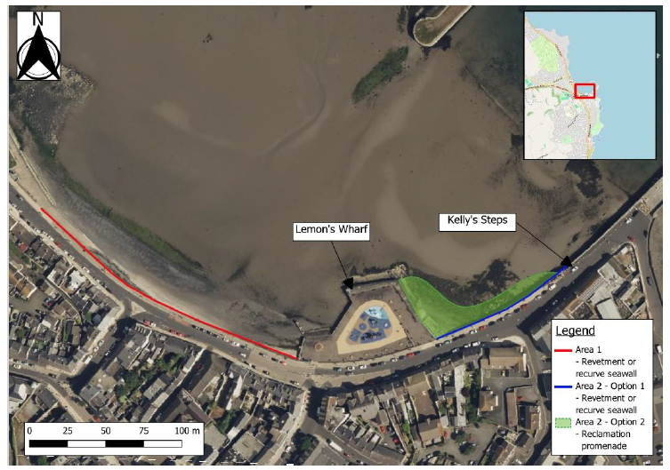

It was noted that additional modelling would be required to refine the preferred option and to inform the engineering design and associated capital costs estimates.
Preliminary estimates indicated that subject to detailed design and additional modelling, the capital costs associated with the recurve wall option to the west and the new promenade option to the east of Lemon’s Wharf would equate to c. £0.5 mil and £3.5 mil respectively. Any development in either location would require consultation with relevant statutory authorities as well as marine and planning consent.

Conclusion
Officers would conclude the following points from this report:

- The outer breakwater originally suggested in the 2020 report was intended to improve the tidal conditions within the Harbour only and would “not reduce coastal flooding from tidal inundation and only partially reduce the potential of flooding caused by wave overtopping”. Therefore, with cognisance of the limited wider benefits in protecting the town’s homes and businesses, there was unlikely to be an economic justification for this project.
- There would appear to be a need arising to provide some protection to the inner parade, east of Lemons Wharf, however this would require the acquisition of land from a third party.
- There would also appear to be a need arising to provide some protection to the outer parade, west of Lemons Wharf.

The Department for Infrastructure (DfI) had overall responsibility for flood risk
management and policy in Northern Ireland, with the Department’s Rivers Agency having the following amongst its key objectives:

- reduce the number of properties currently at risk of flooding from rivers and the sea
- maintain flood defence and drainage infrastructure in a satisfactory condition

Given the conclusions of the AECOM report, of the not insignificant risk of flooding caused by wave overtopping at both the inner and outer parades in Donaghadee, it was proposed that the Council should now proceed to share these findings with the Department and lobby for the progression of enhanced coastal protection schemes along the lines of those outlined in the report.

RECOMMENDED that the Council writes to the Department for Infrastructure Rivers Agency, sharing the findings of the study undertaken by AECOM, and asking that enhanced coastal defence schemes be progressed for the inner and outer parades in Donaghadee. An update report to be brought back to Council within 6 months.

Mr Kristopher Calder and Ms Catherine Ferguson, of RPS, outlined the attached report to Members. Following the presentation, the Chair invited questions from the Committee.

(Councillor Ashe entered the Council Chamber (7.03pm) and Councillor Blaney and Councillor Kerr joined the meeting remotely (7.05pm))

Councillor Edmund appreciated that rock armour was the only suitable solution in some places to protect property, but he was wary that it could be detrimental to the seabed. He provided an example of the long-term impacts of that at what used to be a white sandy beach in Ballyhalbert Bay and he feared the same issue would occur at Warren Road. He wondered if the curved wall option could also go in front of the potentially reclaimed greenbelt area or if rock armour would still be required.

Mr Calder explained that in this particular location while there would be no interference with a dune system, he referred to a coastal process called beach-drawdown where the beach dropped and drew water in, so he agreed that the Member had a valid point. This was also an environmentally designated area so the detrimental effects of rock armour would need to be fully considered.

The consultant agreed that the neatest solution would be a curved sea wall to the east of Lemon’s Warf. There was no need for rock armour because there would be no assets in terms of buildings or infrastructure other than the park, at risk above that sea wall.

Councillor Edmund wondered if it would be an option to extend the north breakwater to the beach and the consultant explained that whilst that would reduce wave over-topping in certain conditions it would not provide protection to the harbour itself from those storms which approached from the east and northeast. In response to a final query from Councillor Edmund, the consultant advised that the extension would make the harbour more sheltered and accessible to larger vessels but there were environmental considerations to take into account and it had potential for disrupting the sediment transportation regime, a key factor in the area’s designation.

Councillor Harbinson noted references to the Masterplan regarding the outer breakwater. He further highlighted reference to comments in the report, that ‘if there was no motivation to improve wave climate in the harbour then construction of an offshore breakwater may not be the preferred solution’. Councillor Harbinson sought clarity on what was behind that motivation and if it was financial for example.

Mr Calder explained that there was an aspiration in the Masterplan to restore the harbour in terms of recreational and tourist appeal. He warned that whilst the breakwater would tick those boxes it would still not prevent the risk of coastal flooding which would continue regardless of the breakwater. He explained that that harbour configuration could also create a phenomenon known as wave resonance. Closing the harbour off would cause all of the water to move up and down without appropriate mitigation measures in place.

Councillor Harbinson sought clarity on the costs presented on pages 71 and 72 and the consultant explained that the costs on page 71 included those in relation to the initial scheme presented in 2020 in terms of harbour improvements. The costs on page 72 were exclusively for the flood protection options. He further clarified that the costs for construction of the breakwater extension alone were between £16m to £27m, also presented on page 71.

Councillor Blaney queried the projected ongoing maintenance costs and longevity for the different options and Mr Calder advised that both options could have a design life of 50 or 100 years. Maintenance of rock armour was advised to be undertaken once every ten years to re-situate stones that may have slipped or fallen. The seawall may have required maintenance due to potential damage from boulders being thrown at it from large waves, for example, which could result in cracking. Both however were relatively low maintenance options. In response to a further query around future proofing and providing a solution that was multi-generational, the consultant added that rock armour was very adaptable to climate change and further layers could be added in the future. He warned that there was never a maintenance free option however, due to the nature of what was a high energy coastal environment.

(Alderman Armstrong-Cotter entered the Council Chamber – 7.26pm)

The Chair thanked Mr Calder and Ms Ferguson for their presentation and had found it interesting but also worrying in terms of the costs required.

(Councillor Hennessy, as a non-Committee member had been granted speaking rights and was invited forward by the Chair).

Councillor Hennesy explained that having worked in Donaghadee for more than 20 years, he had a great interest in its development which was why he had requested speaking rights on this item.

He thanked officers for the work that had gone into this project to date which had included accessing £21,000 from the UK Shared Prosperity Fund which had enabled Phase 1 investigative work to proceed, thus addressing the second part of the motion.

Thanking RPS for its work in producing a detailed study, he explained that it had however caused a great deal of frustration and some disappointment for stakeholders in Donaghadee.

He referred to Donaghadee Harbour and the aims to improve its amenities and birthing facilities and making it a generally better used asset for the town and the Borough. The second part of this was to protect Donaghadee’s homes and businesses from the high tides and strong waves smashing over the harbour wall and flooding the road nearest the sea known as the Parade.

In various reports dating back to 2015, all had pointed to the construction of an outer breakwater and the creation of a pontoon birthing facility to increase the economic viability of the harbour. The protective barrier was always intended to protect the worst of the storm waves and had never been intended to protect tidal inundation.

Page 45 of the recent RPS study stated whilst the breakwater option would reduce wave overtopping it would not prevent tidal inundation. He had heard it likened to saying the Thames flood barrier in London was a great thing but it did not stop tidal inundation on the northeast coast of England. Of course that was not the intention of what it was supposed to do and neither was the intention of the offshore breakwater in Donaghadee. In June and September 2024 and January 2025, officers agreed to move away from the harbour development plan to flood relief management.

This had been to the disappointment of stakeholders in Donaghadee who had rightly felt that the goal posts had changed. They had been taken unawares that this report sidelined harbour improvements and shifted focus to effective flood measures. This was an essential government responsibility, and while it was welcomed, he felt this created a red herring by shifting people’s attention away from essential harbour improvements.

In that respect he looked forward to the rest of the Council officer’s report which would address the first half of the Notice of Motion. He hoped that the Committee would consider including stakeholders of Donaghadee and allow them more time to give their feedback to this report.

The Director advised that the report from several years ago had focused primarily on the conditions in Donaghadee Harbour and the proposed solution of a breakwater.

He recalled that around 18 months ago, the community had produced a report and he had also attended a public meeting where very significant concern had been raised by the community at that time in relation to the flooding along the Parade during storm events. The point made at the time was that this breakwater may not have any impact on such very loudly voiced concerns by the community. That had led to the commissioning of this study and the brief for this was to look at the issue. He did not want Members to feel that there had been any attempt to introduce a red herring and deflect from any information in the original report because there were two very distinct issues of concern in Donaghadee. Officers had been very concerned that there had been a lobby to find ways of progressing with a breakwater when there was expert evidence that showed that progressing with that would have little or no effect in terms of the conditions along the Parade in Donaghadee. He felt that from the first report to this one, there was now a much fuller picture of the different problems in Donaghadee in relation to the Harbour and the conditions along the Parade. The report also included revised costings for the originally identified breakwater works.

The Chair sought a proposer for the officer’s recommendation and Councillor Harbinson rose to make the following alternative proposal:

That the Council writes to the Department for Infrastructure Rivers Agency, sharing the findings of the study undertaken by AECOM, and asking that enhanced coastal defence schemes be progressed for the inner and outer parades in Donaghadee. Further, it is recommended that Council officers make meaningful engagement with local stakeholders and incorporate their responses in an update report to be brought back to Council within 6 months.

It was seconded by Councillor Edmund.

The proposer acknowledged that this was not the old switcheroo and that there were legitimate concerns around storm surges and overtopping. He appreciated the outreach so far to local stakeholders and he believed that should continue earnestly to improve the asset for locals and the Borough and was beneficial to all, and ensuring it had buy-in would mean this amenity was there for decades to come.

The seconder, Councillor Edmund asked if a health and safety assessment had been undertaken and the Head of Assets and Property Services explained that there had not been one undertaken to date and at this stage it was only a concept design.

Councillor Wray was happy with the proposal and said it was something he felt strongly about as a member of the Northern Ireland Drainage Council and the Ards Peninsula Coastal Erosion Group. He had shared Councillor Edmund’s concerns in terms of the rock armour option and if that simply moved the problem on.

In addition to what was being proposed, he felt that when Council was talking to the DfI Rivers Agency it should ask for the reestablishment of the NI Coastal Forum. He understood that this Forum would potentially be meeting but it was not yet decided on which Government Department was going to lead on that. That would not be decided in this mandate. He could not understand why that could not be decided before then and he would be discussing bringing this to the full Council after discussions with his colleagues.

The Director clarified that the DfI was the statutory body in relation to flooding both from sea and rivers. Coastal erosion was a separate albeit related issue, and the long running issue was that there was no statutorily designated lead Department for that.

AGREED TO RECOMMEND, on the proposal of Councillor Harbinson, seconded by Councillor Edmund, that the Council writes to the Department for Infrastructure Rivers Agency, sharing the findings of the study undertaken by AECOM, and asking that enhanced coastal defence schemes be progressed for the inner and outer parades in Donaghadee. Further, it is recommended that Council officers make meaningful engagement with local stakeholders and incorporate their responses in an update report to be brought back to Council within 6 months.

4. STREET NAMING – QUARRY MEWS (FILE Fp/2025/0677/MAST / 91200)

PREVIOUSLY CIRCULATED:- Report from the Director of Environment detailing that a development comprising 22 dwellings was currently under construction on lands at North Road and Quarry Heights, Newtownards.

The developer had requested the name Quarry Mews, which was in keeping with the general neighbourhood and the new development would be accessed off the existing street, Quarry Heights. Three of the houses were accessed directly off North Road, and would be allocated North Road addresses, with the remaining 19 houses accessed from the new street, Quarry Mews.

RECOMMENDED that the Council adopt the street name of Quarry Mews for this development.

AGREED TO RECOMMEND, on the proposal of Councillor Edmund, seconded by Alderman Armstrong-Cotter, that the recommendation be adopted.

5. Street Naming – Priory Gate, Holywood (FILE Fp/2022/1807/MAST / 91200)

PREVIOUSLY CIRCULATED:- Report from the Director of Environment detailing that a development comprising 11 apartments and 4 townhouses was currently under construction on lands at 2 Priory Park, Holywood

The developer had requested the name Priory Gate, which was in keeping with the general neighbourhood due to the new development being accessed from the existing street, Priory Park, and the neighbouring street serving existing apartments was named Priory Manor.

RECOMMENDED that the Council adopt the street name of Priory Gate for this development.

AGREED TO RECOMMEND, on the proposal of Councillor Harbinson, seconded by Councillor Ashe, that the recommendation be adopted.

6. Fly-Tipping Statutory Enforcement Provision (FILE 92016)

PREVIOUSLY CIRCULATED:- Report from the Director of Environment detailing that further to a report to Council on 16 January 2023 regarding the revision of fly-tipping statutory enforcement provisions.

Officers had powers under Article 4 of Waste and Contaminated Land (NI) Order 1997 to enforce against Unauthorised or Harmful Deposit, Treatment or Disposal, of Waste Offences with a fixed penalty fine of £400 and it had been approved for a discounted fee for payment within 14 days to be set at £300 (discounted). This was approved in January 2023.

Officers also had powers under Article 5 of Waste and Contaminated Land (NI) Order 1997 to enforce offences relating to ‘Duty of Care’ with a fixed penalty fine of £300. To promote the payment of fixed penalty fines, without recourse to court proceedings for relevant offences, it was recommended that the discounted fee for payment within 14 days be set at £225 (a 25% reduction in line with other fixed penalty discounts).

RECOMMENDED that Council approve the Fixed Penalty amount for Article 5 offences ‘Duty of Care’ to be set at £300 (full) and £225 (discounted) in line with other fixed penalty discounts.

Proposed by Councillor Cathcart, seconded by Councillor Ashe, that the recommendation be adopted.

Through a line of questioning to the Interim Head of Regulatory Services, Councillor Cathcart was able to establish that the current fixed penalty was set at £300 but there had been a change to the legislation which allowed a discounting to £225. That was in line with other fixed penalty notices which encouraged the payment of a higher number of penalties, avoiding the necessity for court proceedings.

The offence of littering was generally deemed to involve a handful of waste whereas fly-tipping was a larger amount such as the content of a boot of a car. Larger amounts of fly-tipped waste such a lorry load would be something that the Northern Ireland Environment Agency would be involved with in terms of investigation and enforcement. There was no variation in the fixed penalty fine that could be issued in relation to the scale of fly-tipped waste.

The Director referred to the relevant legislation and the protocol between Council and NIEA in terms of enforcement depending upon the scale of fly-tipping and explained how that was used to determine which agency proceeded with enforcement. Previously the Council could only issue littering fixed penalties of £80 even in situations where the scale of waste illegally deposited was larger, but the legislation now enabled a higher more proportionate penalty for fly-tipping offences as an alternative to prosecutions through the Court system.

The seconder, Councillor Ashe, praised the Council’s Neighbourhood Environment Team which had responded efficiently to fly-tipping incidents in Comber which she had reported, and she felt it right that there were provisions and deterrents in place to prevent the offence.

AGREED TO RECOMMEND, on the proposal of Councillor Cathcart, seconded by Councillor Ashe, that the recommendation be adopted.

7. Grant/Variation of an Entertainments Licence (FILE 90101)

PREVIOUSLY CIRCULATED:- Report from the Director of Environment detailing that an application had been received for the Grant of an Entertainments Licence as follows:

- Picnic in the Park, Ward Park Bandstand, Hamilton Road, Bangor

Applicant: Keiran Gilmore, Open House Festival, 16 Quay Street, Bangor, BT20 5ED

Days and Hours: Sunday afternoons 3pm – 5pm from Sunday 6th July until Sunday 31st August 2025 inclusive

Type of entertainment: Outdoor musical entertainment

There had been no objections received from PSNI, NIFRS or Environmental Health.

Applications had been received for the Variation of an Entertainments Licence as follows:

- The Ranch, 95 Green Road, Bangor, BT19 7QA

Change of Licensee to: John Hamilton, 523 Ballycrochan Road, Bangor, BT19 7PY

There had been no other changes to the licence proposed.

- Royal North of Ireland Yacht Club, Seafront Road, Holywood, BT18 0BB

Change of Licensee to: Alanna Thallon, 5 Broomhill Park, Bangor, BT20 5QZ
There had been no other changes to the licence proposed.

- Royal North of Ireland Yacht Club Marquee, Seafront Road, Holywood, BT18 0BB

Change of Licensee to: Alanna Thallon, 5 Broomhill Park, Bangor, BT20 5QZ

There had been no other changes to the licence proposed.

- Donaghadee Golf Club, 84 Warren Road, Donaghadee, BT21 0PQ

Change of Licensee to: Barry Davison, 6 Seahill, Donaghadee, BT21 0SH

There had been no other changes to the licence proposed.

RECOMMENDED that the Council grants an Entertainments Licence to Picnic in the Park, subject to satisfactory final inspection by Licensing and Regulatory Services, and grants variations of Entertainments Licences as per this report.

The Chair advised that under the Council’s Scheme of Delegation this item was delegated to this Committee for approval.

Proposed by Councillor Wray, seconded by Councillor Cathcart, that the recommendation be adopted.

Councillor Cathcart welcomed the recommendation for what was a lovely event and he hoped that it would be able to enjoy good weather.

RESOLVED, on the proposal of Councillor Wray, seconded by Councillor Cathcart, that the recommendation be adopted.

8. Northern Ireland Local Authority Municipal Waste Management Statistics, Q3 October to December 2024 (FILE 53042)

PREVIOUSLY CIRCULATED:- Report from the Director of Environment detailing that the official waste management statistics for the third quarter of 2024/2025 (October to December 2024) had been released by the Northern Ireland Environment Agency.

The aim of this report was to:

- Report key quarterly waste management performance statistics relative to the same period last year (found in part 1 of the report) and to our baseline comparator year of 2021-22 (found in the KPI section of part 2 of the report), and
- Provide some detail around operational waste service management activities/actions that had been implemented during the quarter with the aim of improving performance.

In summary, key indicators had remained positive for this reporting period. However, whilst our HRC recycling performance had steadily improved year on year, the same pattern had not occurred with kerbside services – which, unlike our HRC service, had not been subject to service model reform over the past few years.

1.0 Northern Ireland Local Authority Collected Municipal Waste Management Statistics – October to December 2024

Summary Table of Key Changes Q3 2024-25 v Q3 2023-24

 | 2023-24 | 2024-25 | Change
Household Waste Recycling Rate | 54.6% | 53.6% | 1%
Recycling Rate Ranking | 3rd | 3rd | Same
Composting Rate | 30.9% | 30% | 0.9%
Dry Recycling Rate | 23.3% | 23.3% | Same
Total HRC Waste | 4509T | 4555T | 1%
HRC Residual/Landfill Waste Received | 1376T | 1245T | 9.5%
HRC Recycling Waste Received | 3133T | 3310T | 5.6%
Proportion of HRC Waste Received for Recycling | 69.5% | 72.7% | 3.2%
Total Kerbside Waste | 12940T | 13571T | 4.9%
Kerbside Residual Waste Received | 5346T | 5762T | 7.8%
Kerbside Recycling Waste Received | 7594T | 7809T | 2.8%
Proportion of Kerbside Waste Received for Recycling | 59% | 57.5% | 1.5%

The significant headlines contained within the latest DAERA report showed that:

- Our household waste recycling rate decreased slightly by 1% compared to Q3 last year, from 54.6% to 53.6%, although this was less than the average fall across all Councils of 1.3%.

- Our household waste recycling rate of 53.6%, was 5.4% higher than the NI average of 48.2%.

- We were ranked third out of the eleven NI Councils for our household waste recycling rate, the same ranking as the previous year.

- Our household waste composting rate fell slightly by 0.9% - from 30.9% to 30. Our household waste dry recycling rate remained the same, at 23.3%.

- Our household waste composting rate of 30% was 6.4% higher than the NI average of 23.6%.

- Our household waste dry recycling rate (i.e. recycling of items other than organic food and garden waste) of 23.3% was 1% lower than the N.I. average of 24.3%.

- Our kerbside recycling capture rate of 73.3% for household compostable waste materials compared to a NI Council average of 62%.

- Our lowest kerbside capture rate for recyclable materials was for mixed plastics, at 24.6%.

Kerbside Capture Rate for Recyclable Waste Types – October to December
Recyclable Material | Kerbside Capture Rate for Recycling % | NI Average Kerbside Capture Rate for Recycling %
Glass | 63.7 | 48.8
Paper & Card | 63.8 | 52.8
Mixed Metals | 37 | 31.6
Mixed Plastics | 24.6 | 23
Organic/Compostables | 73.7 | 62

- We ranked 8th in the Council performance table for ‘dry’ recycling rate and 3rd for composting rate.

- We received 10.6% less total waste per capita at our HRCs compared to the average for other NI Councils.

- We received 15.6% less residual/landfill waste per capita at our HRCs compared to the average for other Councils.

- The proportion of waste collected at our HRC sites for recycling was higher than the average for other Councils – 72.7%, compared to an average rate of 71.2% for other Councils.

- We collected 7.3% more waste per capita from homes through our kerbside bin collection services compared to the average for other Councils.

- The proportion of waste collected for recycling through our kerbside bin collection system was significantly higher than the average for other Councils – 57.5%, compared to an average of 43.9% for other Councils.

2.0 Operational Performance Improvement Measures

2.1 Marketing and Communications Indicators

MC1 – 53 social media posts were issued, with associated engagement/ management of feedback across Waste and Recycling on ANDBC corporate channels. Topics included Recycling Week, International E-Waste Day, Holiday Bin Collection dates, Christmas Recycling, Service messages and competitions.

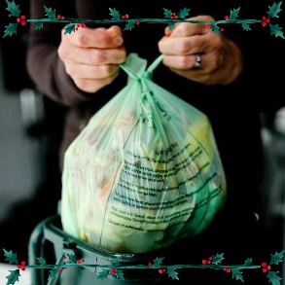

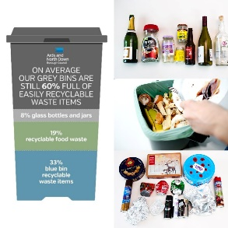

1 x press release issued (22/10/24) Council Accepts Used Vapes at all Household Recycling Centres - Ards and North Down Borough Council

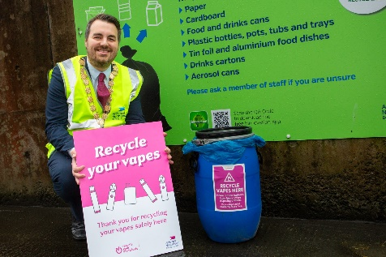

MC2 – 9 Bin-Ovation ‘News and Info’ articles were published, 10 Bin-ovation ‘Push Notifications’ issued and 2781 Bin-ovation downloads recorded.

MC3 – Officers delivered 13 community and engagement events, talking to over 580 people.

- 5 x Schools/Nursery’s
- 1 x Positive Ageing Roadshow
- 1 x Information stall
- 3 x Scout/Brownie groups
- 3 x Other

2.2 Household Recycling Centre Indicators

HRC1 – Volume of blue bin recyclable materials separated from mixed waste by residents on-site: 800,300 litres.

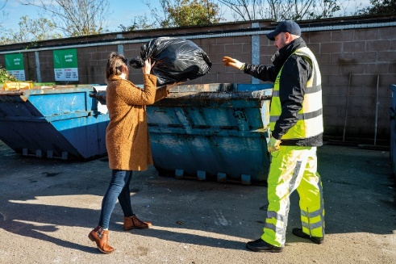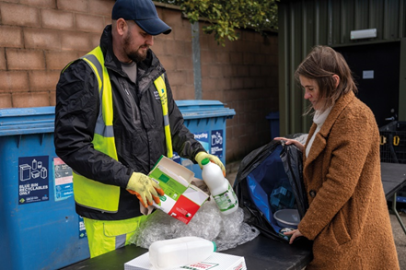
This equated to approximately 33 tons of blue bin waste; whilst this was a relatively modest weight of material, it represented a very large/visible volume of recyclable waste extracted from bags of mixed waste which was initially intended to be placed landfill skips at HRCs. A collateral benefit of this practice of requiring removal of blue bin recyclables from black bags of mixed waste before using the landfill skip was that it should help to ‘educate’ householders - promoting more efficient separation of waste in the home and greater use of blue bins at the kerbside.

This represented just one type of recyclable waste category which was prevented from entering landfill skips at HRCs as a consequence of our more focused attention to supervision of landfill skip access; many other recyclable waste types would also have been prevented from entering the landfill skips as reflected in KPI, HRC3.

HRC2 – Number of visitors turned away from site: 800
This was a significant number in itself, but it was likely to be the case that a significant number of out of Borough residents would have avoided coming to our sites because of the widely publicised focus upon checking ID for everyone entering and those turned away would in all probability avoid further attempts to enter and use our HRCs; the impact of this will also be reflected in HRC3 and other KPIs.

HRC2a – Number of HRC bookings: 70,843

HRC2b – Average number of HRC visits per household: 0.99 (averaged across the 71,907 households in the Borough)

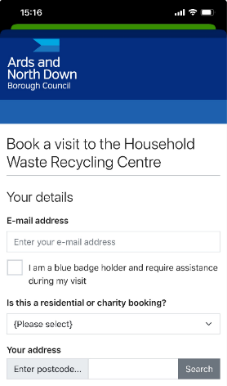

HRC3 – % change in tonnage of total waste received at HRCs (compared to same period in baseline year 2021-22)

- We experienced a 33.7% decrease in the total amount of waste received at HRCs, from 6875T to 4555T.

HRC4 - % change in tonnage of waste received for landfill at HRCs (compared to same period in baseline year 2021-22)

- We experienced a 54.3% decrease in the amount of waste received for landfill at our HRCs, down from 2727T to 1245T.

HRC5 - % change in tonnage of waste received for recycling at HRCs (compared to same period in baseline year 2021-22)

- We experienced a 20.2% decrease in the amount of waste received for recycling at our HRCs, down from 4148T to 3310T.

HRC6 - % change in proportion of HRC waste materials collected for recycling (compared to same period in baseline year 2021-22)

- We experienced a 12.7% increase in the proportion of all waste received at HRCs which was collected for recycling, up from 60% to 72.7%.

2.3 Kerbside Household Waste Collections Indicators


KS1 – Number of recycling alert stickers applied to grey bins (yellow): 2187
KS2 – Number of recycling alert stickers applied to grey bins (amber): 154
KS3 – Number of recycling alert stickers applied to grey bins (red): 76
KS4 – % change in tonnage of total waste collected at kerbside (compared to same period in baseline year 2021-22)
- We experienced a 3.7% increase in the total amount collected at the kerbside, up from 13,085T to 13,571T.

KS5 - % change in tonnage of grey bin waste collected at kerbside for landfill (compared to same period in baseline year 2021-22)

- We experienced a 2.9% decrease in the amount of grey bin waste collected, down from 5934T to 5762T.

KS6 - % change in tonnage of waste collected at kerbside for recycling (compared to same period in baseline year 2021-22)

- We experienced a 9.2% increase in the amount of waste collected at kerbside for recycling, up from 7151T to 7809T.

KS7 – % change in proportion of kerbside waste materials collected for recycling (compared to same period in baseline year 2021-22)

- We experienced a 2.8% increase in the proportion of kerbside waste that was collected for recycling, up from 54.7% to 57.5%.

2.4 Summary and Trend Analysis of Indicators
Indicator Reference | Monitoring Period 7 (July 2024 – September 2024) | Monitoring Period 8 (October 2024 – December 2024
MC1  Social media posts | 20
MC2  Print press and online articles | 3
MC3  Engagement events/sessions | 12 | 13
HRC1  Blue bin waste (litres) | 640,660 | 800,300
HRC2  Visitors denied entry | 844 | 800
HRC2a  No. of bookings | 85,381 | 70,843
HRC2b  Average no. of HRC visits per household in the Borough | 1.19 | 0.99
HRC3  Total HRC waste compared to same period 2021/22 | 31% Decrease
HRC4  Landfill skip waste compared to same period 2021/22 | 52% Decrease
HRC5  Recycling skip waste compared to same period 2021/22 | 19% Decrease
HRC6  Proportion of HRC waste collected for recycling compared to same period 2021/22 | 10.8% Increase
KS1  Yellow warning stickers on grey bins | 2837 | 2187
KS2  Amber warning stickers on grey bins | 224 | 154
KS3  Red warning stickers on grey bins | 112 | 76
KS4  Total kerbside waste compared to 2021/22 | No change
KS5  Grey bin waste compared to 2021/22 | 12% Decrease
KS6  Kerbside waste collected for recycling compared to same period 2021/22 | 10% Increase
KS7  Proportion of kerbside waste collected for recycling compared to same period 2021/22 | 4.8% Increase

2.5 Summary Analysis of Indicators

This report confirmed continued improvement in our sustainable waste resource management performance. Following the changes to our waste service model design and the associated education and engagement campaigns, we were experiencing sustained falls in the amount of landfilled waste as well as improved recycling rates relative to the position in our 2021/22 baseline year. During this reporting period, we experienced:

- Sustained falls in the total amount of landfill waste both at HRCs and kerbside. In total, we received/collected 1,654 tons less of landfill waste at kerbside and HRCs over the 3-month reporting period compared to the same period in the baseline year of 2021/22; at prevailing residual waste disposal cost, this represented a £191,748 landfill saving (plus other handling and transport cost savings).
- Falls in the total amount of waste collected at both HRCs and kerbside. In total our municipal waste arisings fell by 9.6% compared to the same period in 2021/22; across other Councils waste arisings fell by just 3.8%.
- A significant further rise in our recycling rate at HRCs; the percentage of materials collected for recycling at our HRCs rose by 12.7% compared to the same period in the baseline year of 2021/22. Our overall Borough household waste recycling rate was 5.1% higher than the same period in 2021/22.

Whilst the information set out in this report was very encouraging indeed and reflected a lot of hard work and dedication on the part of our waste and recycling teams, we undoubtedly had much further progress to make if we were to have any chance of ultimately reaching the 70% recycling target for 2030 that was laid down in the Climate Change Act (Northern Ireland) 2022. Continued bedding in and ongoing careful management of the new booking system for HRC access, the ongoing review of our kerbside collections model and a future strategic review of our HRC capital assets, would be critical.

It was important to reiterate that further ‘step change’, sustained improvements in both our HRC and kerbside recycling rates would be required to move us towards the new 70% target.

The graphic at the top of page 3 (Household Waste Recycling Rate Trends) of this report illustrated that whilst we had achieved a significant and steadily growing improvement in our HRC recycling rate over the past 3 years, we had not seen the same pattern in relation to our kerbside recycling rate. This was indicative of the fact that whilst we had developed and implemented a service transformation programme for our HRCs, we had not yet progressed with the implementation of a new kerbside waste collections model.

RECOMMENDED that the Council notes the report.

Proposed by Councillor Wray, seconded by Councillor Harbinson, that the recommendation be adopted.

Councillor Wray welcomed an encouraging report which showed that recycling was higher and the amount of waste going to landfill was reducing which had financial benefits for the ratepayer. While HRC trends were positive, kerbside recycling had not had the same success and he felt that education was important in order to bring improvement along with the kerbside waste collections model progressing.

Despite the upward trend, Councillor Wray was always aware of the 70% target deriving from the Climate Act, so it was important for Council to remember that goal.

He recognised that improvements had been made by Council and residents, who had made sacrifices and acted responsibly when it came to their waste management. He asked the Director how he felt, from his own feedback from other Boroughs in Northern Ireland, how realistic achievement of the 70% recycling target by 2030 was.

The Director noted the provisional 2024/25 year end figure was likely to be around 56%, and the Council had set sustainable waste resource management as a strategic priority back in 2015. Over the years a range of changes had been agreed for its kerbside collections and at HRCs.

The public had engaged really well and in relative terms this Borough had seen the largest improvement in recycling rates across Northern Ireland since 2015. He believed that it was possible to improve by another 14% towards the 70% target, pointing to the awaited publication of DAERA’s response to the consultation on kerbside recycling collection models. Council had remodelled its kerbside recycling to a degree over past years, and that had yielded good returns well above the Northern Ireland average for kerbside recycling rates. However, he referred to estimates that the grey bin on average still contained 60% of recyclable materials and if that tonnage was transferred across to recycling containers instead, that would have a massive impact on our Borough recycling rate. The kerbside system still required further redesign, as the current allocation of different types of bin space to residents was not proportionate to the scale of recyclable material now generated in homes. That had been the thrust of the DAERA consultation which aligned with the findings of the Council’s own recent review. He hoped that the Department’s consultation response would be published soon, to allow Council to recommence and finalise its own kerbside waste collections review.

Councillor Harbinson welcomed the year-on-year progress and looked forward to seeing the next set of statistics.

The Chair, Councillor Kendall, felt that the report showed that residents were doing well at recycling but she felt a significant difference could be made if producers were more responsible in the packaging they used. She wondered if there was any way the Council could hold them to account and asked them to be more responsible.

The Director referred to the Extended Producer Responsibility Scheme and recalled that for many years those involved in waste management had called for producers to take a more responsible approach. There were now financial incentives in place for producers because the more landfill waste they produced the more they were required to remunerate Councils for treating it. This was to help compensate the ratepayer for the cost of having to deal with that waste. He felt this mechanism should help the end user and would ultimately lead to less and more recyclable packaging being placed on the market.

Councillor Cathcart felt it was clear that DAERA needed to provide direction on this, to allow Council to make an informed decision on separation of materials. He also noted the 70% recycling rate imposed by Stormont and it now needed to provide Councils with the correct resources to achieve that. He wondered if the Director had received any indication of a timeframe in relation to a decision from DAERA and any likely funding.

The Director explained that a response had been expected from DAERA for eight months and now officers were lobbying DAERA for a decision. He explained it would have been preferable to have a response from DAERA before the Council further progressed its own kerbside waste collections review. He noted that other Councils’ current kerbside waste collections models were in some cases very different to the proposals set out in the DAERA consultation, and any required change would therefore cause great upheaval compared to the case for Ards and North Down.

(Councillor Kerr left the meeting – 8pm)

There was a fund administered by DAERA to improve recycling rates and it was understood that there was still money available in this to apply for, but it was unclear on what the future of that scheme would be or if the funding would be increased in the event of DAERA requiring remodelled collections systems. Council would be lobbying for that increase however, to support any changes that were required.

The Head of Waste and Cleansing Services explained that an announcement by the Chancellor referred to the funding that Councils would receive from the packaging waste producers and suggested that the money would be used to improve recycling rates. That could affect future DAERA funding.

Alderman Armstrong-Cotter had initially welcomed that announcement but had found the officer’s interpretation of the potential impacts concerning. In terms of businesses, she noted that there were local companies taking strides in relation to packaging and she pointed to the use of biodegradable peanuts as a good example. There were small companies taking that approach at their own greater expense and Council needed to be aware and recognise that.

Alderman Armstrong-Cotter also pointed to the benefits of engagement and education and recalled a positive experience when recycling officers engaged with young people at her church. That education though needed to be in tandem with the suppliers to encourage them to avoid using non sustainable packaging. She wondered if there could be a way Council could reach out to those businesses using a sensitive approach to engagement, but she appreciated that was a huge though worthwhile piece of work.

AGREED TO RECOMMEND, on the proposal of Councillor Wray, seconded by Councillor Harbinson, that the recommendation be adopted.

9. Christmas Lighting 2025 (FILE 65281)

PREVIOUSLY CIRCULATED:- Report from the Director of Environment detailing that Members would be aware of a number of proposals in relation to Christmas lighting/trees in 2025, and this report provided a brief progress update to Members on these.

Bangor Lighting
As per the NoM agreed in April 2025, officers had been tasked with investigating the feasibility of festoon lighting, crossing the road at high level, along Main Street, Bangor. Officers had been liaising with DfI representatives and were currently working through the requirements to apply for necessary DfI approval. Once these set of requirements had been confirmed, officers would prepare a short list of potential lighting options and present them to the City Advisory Group for a decision based on their preference. At this stage however, it was important to note that final approval of an application to DfI was not guaranteed.

Newtownards Artificial Tree
A sum of £20k for an artificial tree for Conway Square was included in budgets as part of the rates setting process. Officers had approached our tendered supplier for a quote and a visual representation of the selected tree was included below. The Newtownards Chamber of Trade had been consulted on this proposal and was very supportive of it.



Costs/Specification for this tree are:

- 9.3m Artificial Christmas Tree (Dressed); came built in sections with lights and baubles pre-installed: £13,950
- Tree topper: £600
- Installation & Removal: £2,000

Total cost £16,550*.

* Note that the installation and removal cost was an annual cost that needed to be budgeted for in future years.

It should also have been noted that the same budget had been included in the 2026 capital plan for a replacement artificial tree for Bangor.

Other Borough Towns
Officers had already begun planning trips to a number of forests in the hope of securing better quality trees for this year. Each year it became more difficult to source trees of appropriate size and quality, but by booking early the chances were maximised.

Furthermore, as part of the agreed Notice of Motion relating to lighting enhancements for High Street, Bangor, officers would be working to establish any learning points from the Bangor pilot scheme and would meet with the various Town Advisory Groups (TAGS) to establish potential for improvements in their locations in time for Christmas 2026. Budgets to cater for such enhanced schemes would be proposed as part of the 2026/27 estimates process.

RECOMMENDED that the Council notes the above proposals in relation to the Christmas Lighting planning process.

Proposed by Councillor Cathcart, seconded by Councillor Edmund, that the recommendation be adopted.

Councillor Cathcart welcomed the progress in relation to the Notice of Motion regarding Bangor lighting.

He asked when the discussions with DfI were expected to conclude, noting that Bangor City Advisory Group was due to meet the following week and the matter was not included on its agenda for that meeting.

The Head of Assets and Property Services advised that officers had met with DfI representatives the previous week to gain an understanding of what information was required for the Department to process an application. The next step was to get a structural engineer to provide calculations on wind load and weight. Once that was completed then officers would produce a shortlist of options which would be brought to the City Advisory Group.

Councillor Cathcart raised a further query around the quality of Christmas trees and asked how confident officers were in obtaining a better standard of tree this year. The Head of Assets and Property Services advised that officers would be looking to reserve trees within the next month and hoped that they would be of an improved standard this year.

Councillor Edmund asked for further details on the appearance of the artificial tree proposed for Conway Square, Newtownards, and how that compared with the artificial tree that had been used in Bangor for many years. The officer understood it would be similar to the tree used in Bangor with some improvements to the design to aid better transport, installation and storage.

He clarified that officers had consulted only with the Chamber of Trade but had not felt it necessary or practical, given the timescale, to consult with the wider public.

Alderman Cummings queried the timeframe for consultation with the TAG’s around replacement lighting planned for 2026, querying if officers would need to take the forthcoming year’s rate setting process into account. The officer advised that an amount based on previous costs of replacement lights plus inflationary increases, would be included in the estimates process for 2026/27.

In a further comment, Alderman Cummings hoped that officers could at least put a concept design forward at this stage.

Particularly in relation to Comber, Councillor Douglas welcomed that officers planned to acquire trees at this early stage in order to maximise a more positive outcome for the other towns in the Borough.

Alderman Armstrong-Cotter had consulted some retailers over the proposal for an artificial tree and reported that there was a preference for a real tree. She understood the challenges of sourcing quality large trees though and recalled the negative public response to the real tree that was used last year. She was therefore torn on the issue but warned that if the artificial tree did not meet expectations this year, then she would call for the return of a real tree.

Alderman McAlpine queried the lifespan, durability and value for money of the artificial tree used in Bangor. She also asked if artificial trees could be recycled at the end of their life. The officer understood that the Bangor tree had been purchased eight years ago and was now approaching the end of its life having undergone repairs when it was used last year. He said that there were lessons that had been learned in terms of storage, installation and dismantling challenges of the tree. That learning would be taken forward in future procurement processes. The artificial tree was largely constructed from metal and the majority would be recycled.

AGREED TO RECOMMEND, on the proposal of Councillor Cathcart, seconded by Councillor Edmund, that the recommendation be adopted.

10. Sustainable Energy Management Strategy Update, Q4 2024-25 (FILE 50002)
(Appendix III)

PREVIOUSLY CIRCULATED:- Report from the Director of Environment detailing that in June 2024 the Council agreed the Sustainable Energy Management Strategy and Action Plan. One of the actions within the Plan was to “Improve governance arrangements to ensure that energy management has effective oversight and accountability within the Council.”

Improving oversight and accountability within the Council for energy management would ensure that consumption performance and the implementation of the Strategy and this action plan would be continuously monitored. Improved monitoring and governance would improve energy performance by ensuring actions were effectively implemented and consumption trends routinely monitored, which should have resulted in reduced consumption, costs, and emissions.

Reporting Periods
This report was part of our ongoing quarterly series, tracking energy consumption against our 2019/20 baseline and highlighting current and upcoming energy-saving initiatives.

Period: | Reported in:
Quarter 1: April to June | September
Quarter 2: July to September | December
Quarter 3: October to December | March
Quarter 4: January to March | June

Energy Consumption for this Period

Electricity

As shown in the graph above, electricity consumption has continued to trend downwards, with a cumulative reduction of 21.2% across Q1–Q4, resulting in a 293.72 tCO₂ emissions reduction compared to our 2019/2020 baseline year.

This progress reflected our ongoing efforts to improve energy efficiency, including the phased replacement of older equipment with modern, energy-efficient alternatives and promoting energy-conscious behaviours among staff.

Q4 also showed a notable reduction compared to the baseline year. We aimed to build on this momentum by implementing further energy-saving measures and continuing to raise awareness among both new and existing staff about the importance of energy conservation in helping us meet our 2030 emissions reduction target.

Natural Gas

Natural gas consumption had seen a cumulative reduction of 5% across Q1–Q4, resulting in a 146.67 tCO₂ emissions reduction compared to our 2019/2020 baseline year.

This improvement was largely due to ongoing optimisation efforts, including the review and adjustment of boiler time controls and temperature settings. Additionally, we had been assessing and fine-tuning the Building Management System (BMS) controls and parameters in selected buildings to enhance efficiency.

Kerosene

Kerosene oil stocks were typically procured at the end of Q4 each year in preparation for increased demand during the spring season. This advance stocking ensured adequate supply when usage rose. However, we suspected that kerosene oil stocks ahead of the 2019/20 spring season were not procured as usual, likely due to disruptions caused by the pandemic. These may have included supply chain issues, reduced operational capacity, or shifts in demand forecasting, leading to a shortfall in expected inventories.

Our analysis showed that kerosene consumption had seen a cumulative reduction of 41% across Q1–Q4, resulting in a 68.62 tCO₂ emissions reduction compared to 2023/24. This improvement followed the installation of more efficient boilers and upgraded heating controls.

Our kerosene stock data however showed an apparent increase in kerosene purchased during the past year, compared to the baseline 2019/20 year, for the reasons outlined above.

Diesel

Carbon emissions figures for gas oil (red diesel) used in small plant and Derv (diesel) used in the road fleet have been combined to provide a cumulative total for 2019/20 diesel emission, in line with the 2022 reform on red diesel usage.

Considering the combined reporting of diesel consumption, overall usage had decreased by 3.2% across Q1–Q4, leading to a reduction of 71.95 tCO₂ emissions compared to the 2019/20 baseline year.

Notwithstanding the above situation regarding comparison of 2024/25 with the baseline year of 2019/20, diesel usage has increased over the past year compared to 2023/24. This was primarily due to an additional 38,069 miles travelled by the waste collections service fleet – equating to an additional 26593 litres consumed and 70.87 tCO2 emitted. Fleet operational efficiency measures had been implemented to help offset fuel usage; however, this rise in mileage had directly contributed to the higher fuel consumption identified during 2024/25 compared to the previous year.

Targets and Trends

The graph below illustrated our overall fuel emissions for each reporting period, set against the 2030 target. The linear trendline represented the trajectory required to achieve our 48% emission reduction target by 2030. A modest level of overall progress had been made towards achieving our emissions reduction goals. While we were currently behind the linear trendline target, with continued efforts particularly regarding transition to a greener fleet, officers believed that we would achieve our long-term targets.

Consumption Costs
The table below presented fuel consumption costs for each year, along with the corresponding unit prices. This allowed for a comparison of both usage and changes in market rates over time.

Quarter 4 | 2019/20 | £/unit | 2024/2025 | £/unit
Utility
Electric | £223,294 | £0.16 | £417,662 | £0.30
Gas | £412,515 | £0.09 | £318,444 | £0.07
Kerosene | £1,539 | £0.42 | £14,046 | £0.55
Derv | £168416 | £1.00 | £228,031 | £1.15
Gasoil | £14,283 | £0.52 | N/A | N/A
Total Cost | £820,047 |  | £978,183

Cumulative and Historic Combined Target for 2024/2025

The chart above illustrated the cumulative emissions totals for Q1–Q4 in our baseline year (2019/20), the current reporting year (2024/25), and our projected target for Q1–Q4 in 2030. To date, we had achieved a 6.2% reduction in emissions compared to the 2019/20 baseline. To meet our goal of a 48% reduction by 2030, a further decrease of approximately 41.74% would be required over the next five years.

Highlights of Energy Saving Initiatives Taken in This Reporting Period
- Controls Maintenance at Londonderry Park and Hamilton Hub.
- LED Lighting Replacement schemes at Community Centres.
- High efficiency boiler replacements to a number of communities properties.
- Early stages of pre-planning for Data Centre at ABMWLC and Aurora for heat recovery to provided free pool water heating.
- Installation of EV charging points for small and medium vans in fleet at NRD now complete.
- Installation of Solar PV panels at both Walled Garden Depot and North Road Depot Portacabin
- Progress started on the project to install 100kWp Solar PV at North Road Depot main building.

Members could refer to the attached updated Sustainable Energy Action Plan for comprehensive updates on all noted actions.

Future Measures Currently Under Consideration/Planning
- Use the Council’s monthly newsletter to share energy-saving best practices with staff, encouraging their active participation in further reducing energy consumption.
- Replacement of boilers at various Council properties and upgrade of control systems.
- Lighting control and LED replacement projects at numerous Council properties.
- Solar PV Installation at chosen Council properties.
- Park lighting LED installation.
- Walk-round surveys of properties to examine and review existing controls and settings.
- Surveys of existing buildings for insulation installation to be carried out and implemented.
- Energy targets and KPI’s for service unit managers to be agreed for 2025/2026.
- Possible introduction of Automatic Meter Reading (AMR) systems in highest energy consuming buildings.
- Installation of double-glazed windows at Church Street Offices.

RECOMMENDED that Council notes the latest quarterly sustainable energy management strategy update.

AGREED TO RECOMMEND, on the proposal of Councillor Wray, seconded by Councillor Edmund, that the recommendation be adopted.

11. Q4 NET Activity Report (1 January 2025 to 31 March 2025 (FILE 92009)
(Appendix IV – VIII)

PREVIOUSLY CIRCULATED:- Report from the Director of Environment detailing that the information provided in this report covered, unless otherwise stated, the period 1 January to 31 March 2025. The aim of the report was to provide members with details of some of the key activities of the Team, the range of services it provided along with details of level of performance.

Applications to the Neighbourhood Environment Team

Dog Licences - The Dogs (NI) Order 1983
It should be noted that these figures included block licences where one licence could be issued for multiple dogs in specific circumstances.

 | Period of Report  Jan – Mar 2025 | Same 3 months Jan – Mar 2024 | Comparison
Dog licences issued during the three months | 4798 | 4825

Concessionary licences remained at 83% of dog licences issued over the period. This included the categories of neutering (£5) / over 65 (Free – 1st dog) / over 65 subsequent dog (£5) and income related benefits (£5). Standard dog licence £12.50 and block licence £32. The application fees were set by statute.

DOG CONTROL – Dog Licences | 2025 | 2024
Full Cost | 793 | 890
Reduced - Neutered | 2449 | 2449
Reduced - Benefits | 500 | 483
Free – Over 65 | 915 | 877
Reduced – Over 65 Subsequent Dogs | 117 | 112
Block Licence | 11 | 14
Exemption (XL Bully - £12.50) | 13 | 0
TOTAL | 4798 | 4825

Investigations
The Neighbourhood Environment Team responded to a range of service requests. In terms of time spent, some types of service requests would be completed immediately whilst others required a longer-term strategy to find a resolution. The breakdown within the categories for the types of service requests received had been detailed in Appendix 1.

SERVICE REQUESTS
 | Period of Report Jan – Mar 2025 | Same 3 months  Jan – Mar 2024 | Comparison
DOG CONTROL | 238 | 371
ENVIRONMENTAL CONTROL | 447 | 441

Fixed Penalty Notices
The Neighbourhood Environment Team issued 64 Fixed Penalty Notices for various environmental offences in the Borough.

FIXED PENALTY NOTICES
 | Period of Report  Jan - Mar 2025 | Same 3 months Jan – Mar 2024 | Comparison
DOG CONTROL | 39 | 71
ENVIRONMENTAL CONTROL | 25 | 36

Prosecutions
Breakdown of cases being prosecuted through the Court.

PROSECUTIONS
 | Period of Report Jan – Mar 2025 | Same 3 months  Jan – Mar 2024 | Comparison
DOG CONTROL | 10 | 2
ENVIRONMENTAL CONTROL | 6 | 3

Educational Programme
Project E.L.L.A. (Environment, Learning, Lifestyle, Action) was designed to improve and protect our local environment by way of education and community engagement. This in turn would help tackle many of the issues facing us today both locally and globally.

During the first quarter of 2025 the following activities were delivered:

- Plastic Oceans – this presentation and hands on activity explored the importance of our oceans to the planet’s health and the threats posed by plastic pollution and littering.

- Ballyholme Primary School – 3 x Primary 5 classes (90 pupils approx.)
- Elim Church (Ards) Explorers
- Bloomfield Primary School – 2 x Primary 5 classes (60 pupils approx.)
- STRIDES (a group for young adults with learning issues)

- Atlantic Salmon Conservation Project – this initiative saw a fish egg hatchery set up in the classroom and the pupils recorded the changes as the eggs hatched into small fry. This allowed the pupils to understand the importance of lifecycles and why conservation of this threatened and important native species.

An informative introductory talk was given to each group and at the end of the project the small fry were taken back to the River Bush Salmon Research Station where they would eventually be released back into the wild. A video of this return was made so that the groups could follow the young salmon on this part of their journey.

- Bloomfield Primary School – 2 x Primary 5 classes (60 pupils approx.)
- Donaghadee Primary School – 2 x Primary 4 classes (60 pupils approx.)
- STRIDES group (a group for young adults with learning issues)

- Rock Pooling and Beach Clean – this activity which allowed pupils to collect and identify the vast array of marine mini-beasts that we had on our shores as well as beach litter pick was organised and delivered to the STRIDES group at a location in Donaghadee.

RECOMMENDED that the Council notes the report.

Proposed by Councillor Wray, seconded by Councillor Harbinson, that the recommendation be adopted.

Councillor Wray noted an increase in the number of fly tipping incidents and appreciated the enforcement challenges in terms of catching the offender. He wondered if it would be possible for Members to be provided with geographical information on where those offences were occurring to enable them to keep an eye on those areas which he assumed were more likely to be rural than urban locations.

The Interim Head of Regulatory Services confirmed that the majority of offences took place in rural and non-residential locations. He referred to the new legislation discussed earlier and how that had helped in terms of enforcement. He advised that it should be possible to include a geographical tag on reports and it may be a timely exercise in terms of considering how to present that information.

The Chair referred to a complex case of fly-tipping in her own DEA and appreciated the work of the team as it had been a significant issue.

AGREED TO RECOMMEND, on the proposal of Councillor Wray, seconded by Councillor Harbinson, that the recommendation be adopted.

12. Response from Minister for Infrastructure regarding Off Street Parking Order (FILE 90303)
(Appendix IX)

PREVIOUSLY CIRCULATED:- Report from the Director of Environment detailing that the Council wrote to the Minister for Infrastructure regarding the delay in revoking the Off-Street Parking Order 2000, as this was preventing the Council from creating our own Order.

The Minister’s response was attached.

RECOMMENDED that Council notes the response.

Proposed by Councillor Edmund. seconded by Alderman Armstrong-Cotter, that the recommendation be adopted.

The proposer was disappointed by the short response and was extremely frustrated by how the Department for Infrastructure had passed over the responsibility of car parks to Council without any support or approved legislation. He dismissed the response as another excuse and he would continue to keep raising the matter.

The Director of Environment explained that the Chief Executive had written to her counterparts in other local Councils and had noted that some other local authorities had confirmed the making of their own orders was imminent or complete. It was hoped that through SOLACE this could be progressed.

Alderman Armstrong-Cotter welcomed the Chief Executive’s action on this and expressed concern that the Council was being held to ransom by those who did not see this as a priority. This Borough was missing out necessary changes to provide a function adequately. She requested an update at the Committee meeting in September and wondered if the Chief Executive could officially take the matter to SOLACE at that stage if there was no progress.

The Chair shared her disappointment on the matter as another example of being passed on responsibilities without any thought or action.

AGREED TO RECOMMEND, on the proposal of Councillor Edmund, seconded by Alderman Armstrong-Cotter, that the recommendation be adopted.

13. Evaluation of the Impact of the Licensing of Pavement Cafés Act (Northern Ireland) 2014 (FILE 90101)
(Appendix X)

PREVIOUSLY CIRCULATED:- Report from the Director of Environment detailing that the Department for Communities had published a report on the findings of an Evaluation of the Impact of the Licensing of Pavement Cafés Act (Northern Ireland) 2014, which it carried out in 2023.

A copy of the report was attached.

As could be seen in the report, in Ards and North Down Borough, we had the highest number of Pavement Cafés behind Belfast and well above average across the 11 Council areas.

As part of the ongoing engagement and support for businesses, Licensing Officers recently surveyed the Pavement Cafés operating in the Borough and continue to liaise with business owners to ensure compliance. During 25/26, it was intended that stakeholder engagement sessions would take place to offer further support to those wishing to operate a Pavement Café.

RECOMMENDED that the Council notes this report and the attached appendix.

Proposed by Councillor Wray, seconded by Councillor Ashe, that the recommendation be adopted.

The Chair, while happy with the report and the Council’s performance, highlighted an ongoing issue that was the source of frustration for the hospitality sector because any other type of retailer was not equally made to comply and consider accessibility issues. She felt that the process was unfair.

The Director of Environment referred to general enforcement powers of DfI Roads that applied to all, so there was a mechanism there for anyone to report an obstruction on the footpath.

AGREED TO RECOMMEND, on the proposal of Councillor Wray, seconded by Councillor Ashe, that the recommendation be adopted.

14. Response to Notice of Motion - Letter from DAERA Minister on XL Bully Dogs (FILE 92000 / NOM 653)
(Appendix XI)

PREVIOUSLY CIRCULATED:- Report from the Director of Environment detailing that a letter of response was received from DAERA Minister following a letter sent by Council as requested in Notice of Motion 653 on XL Bully Dogs.

RECOMMENDED that the Council notes response.

Proposed by Councillor Ashe, seconded by Councillor Douglas, that the recommendation be adopted.

Councillor Ashe felt that the Minister had provided a fulsome response and had addressed the concerns particularly around ownership. She agreed that the Council having knowledge of a dog’s location would help alleviate concerns around any future attacks and be able to hold owners accountable.

AGREED TO RECOMMEND, on the proposal of Councillor Ashe, seconded by Councillor Douglas, that the recommendation be adopted.

15. Notice of Motion submitted by Councillor Morgan and Councillor Irwin

This Council is pleased with the recycling rates for waste that have been achieved in the Borough, however there are currently limited facilities to recycle litter. This sends out a poor message to our residents and visitors. This Council asks that officers bring back a report that explores how, and when recycling litter bins could be introduced to the Borough. Indication of costs should be included.

(Councillor Morgan joined the meeting remotely – 8.30pm)

Proposed by Councillor Morgan, seconded by Councillor Ashe, that the notice of motion be adopted.

Councillor Morgan knew that the Committee would be familiar with the mantra ‘reduce, reuse, recycle’ and went on to express concern that this Council did not provide street recycling for litter while other Councils such as Belfast City Council did. The current recycling rate was around 50% in this Borough and there was still a lot to do to meet the 70% target by 2030.

Continuing, the proposer highlighted the importance of education in terms of recycling but she also pointed out that many people wanted to recycle but there were barriers in terms of factors that were difficult to influence such as inadequate processing facilities and demand for recycling materials. Education and good habits needed to be encouraged all the time and the Council’s work to date should not be underestimated.

Councillor Morgan suspected that among the most common sources of street litter were glass and plastic bottles, tin cans and takeaway trays which were all recyclable. All this was currently been sent to landfill due to contamination which was a real pity.

The proposer also felt that the lack of recycling bins sent out a poor message to residents and visitors and she felt it did not reflect the care that this Borough had for its recycling rates.

The proposer referred to educational literature within the Borough and its messaging of ‘Recycle Today, Recycle Everyday’. In Ards and North Down, you could not recycle every day because appropriate recycle bins were not provided around town centre streets. This motion was therefore about walking the talk and she felt that the use of on-street recycling bins could be used to reinforce the message about what materials could be recycled. She wondered if there could be some new painted boxes with imaginative messaging.

Councillor Morgan appreciated there would be costs involved, so she felt it important to start the journey by looking at how Council could do this.

In closing, Councillor Morgan added that this motion was about expanding the Council’s recycling service and sending out a positive message about recycling to residents and visitors and she hoped that Members could support it.

The seconder, Councillor Ashe added that the proposer had raised an excellent point that residents were working hard to meet ambitious targets and this motion acknowledged the number of visitors to the Borough and the importance that they were seeing the hard work that this Borough was doing in terms of recycling.

Rising to support the motion, Councillor Douglas was aware this was an issue raised in the past and she pointed to large events where recycling teams directed people to the correct bins to avoid contamination which could be an issue. She appreciated that the cost of this would be a further challenge but she looked forward to the report coming back to the Committee.

Alderman Armstrong-Cotter was also supportive and recalled a previous report in relation to the potential for an on-street recycle bin and it highlighted challenges in being able to provide it, noting difficulties faced by other Councils which operated the service. She hoped that the report would take that information into account and advise whether it was still relevant for what was being proposed here and how Council could better encourage on-street recycling.

Supportive of the motion, Councillor Wray felt it provided an opportunity for the Council to review where it located its bins, highlighting a complaint of a limited or possibly zero number of bins on the boardwalk in Cloughey but yet there were around 14 bins located in the car park area.

Alderman McAlpine also recalled previous discussions around on-street recycling and suspected that the level of knowledge had increased significantly since then, which could allow for a more successful service now. She went on to emphasise the importance of education, recalling a visit to the eco-school awards as the outgoing Chair where she had encouraged children to go home and educate their parents, wider family and friends. She gave her support to the motion, adding that it was important to take every opportunity to recycle given the targets.

The Chair felt that there was no harm in revisiting the possibility for on-street recycling bins and pointed to the success of this at events where officers had been in attendance to offer guidance.

In summing up, Councillor Morgan thanked Members for their support and the valid points which she hoped would be incorporated into the report.

AGREED TO RECOMMEND, on the proposal of Councillor Morgan, seconded by Councillor Ashe, that the notice of motion be adopted.

(Councillor Morgan left the meeting – 8.43pm)

16. ANY OTHER NOTIFIED BUSINESS

The Chairman advised that there were no items of Any Other Notified Business.

NOTED.

EXCLUSION OF PUBLIC/PRESS

agreed, on the proposal of Councillor Edmund, seconded by Alderman Armstrong-Cotter, that the public/press be excluded during the discussion of the undernoted items of confidential business.

17. Action by Council – High Hedges Act (NI) 2011 (FILE 90505)

**IN CONFIDENCE**

NOT FOR PUBLICATION SCHEDULE 6 – INFORMATION RELATING TO AN INDIVIDUAL

A report in relation to a High Hedges enforcement issue was considered, and it was agreed to proceed as recommended by officers.

18. Extension of Current Contractual Arrangements for the Treatment and Recycling of Street Sweepings (FILE 77060)

**IN CONFIDENCE**

NOT FOR PUBLICATION SCHEDULE 6 – INFORMATION RELATING TO THE FINANCIAL OR BUSINESS AFFAIRS OF ANY PARTICULAR PERSON (INCLUDING THE COUNCIL HOLDNG THAT INFORMATION)

A report in relation to extension of a contract for the treatment and recycling of street sweepings was considered, and it was agreed to extend the existing contract with R Heatrick Ltd. for a further period of 12 months under the existing contractual arrangements.

RE-ADMITANCE OF PUBLIC/PRESS

AGREED, on the proposal of Alderman Armstrong-Cotter, seconded by Councillor Douglas, that the public/press be re-admitted to the meeting.

TERMINATION OF MEETING

The meeting terminated at 9.02pm.

