Ards and North Down Borough Council

A hybrid meeting (in person and via Zoom) of the Environment Committee was held at the Council Chamber, Church Street, Newtownards and via Zoom, on Wednesday, 7th May 2025 at 7.00 pm.

PRESENT:

In the Chair: McAlpine

Aldermen: Armstrong-Cotter
Cummings (Zoom 8.15 pm)

Councillors: Blaney (Zoom) McKee (Zoom)
Boyle McLaren
Cathcart (Zoom) Morgan
Douglas Smart
Edmund Wray
Kerr

Officers: Director of Environment (D Lindsay), Head of Waste and Cleansing Services (N Martin), Head of Assets and Property Services (P Caldwell), Head of Regulatory Services (Interim) (R McCracken), Licensing and Regulatory Services Manager (D Martin) and Democratic Services Officer (H Loebnau)

1. Apologies

Apologies were received from Councillors Irwin and McKimm. Apologies for lateness were received from Alderman Cummings.

NOTED.

2. Declarations of Interest

There were no declarations of interest.

NOTED.

3. NOM Supplementary Report – Reintroduction of Pedestrian Access at Council HRCs

PREVIOUSLY CIRCULATED:- Report from the Director of Environment detailing that further to the report on pedestrian access to the Council HRCs brought to the April 2025 meeting of the Committee, officers had reviewed bookings at both Holywood and Donaghadee HRCs. The review undertaken through the online booking system considered the number of bookings made in one-hour blocks from 8.00am – 5.00pm and the times when service vehicles were on-site. In both cases the first hour (8.00am – 9.00am) was the most underused slot and only a minor adjustment would be needed at Donaghadee to avoid the presence of service vehicles. Historically site use peaked at weekends and dropped off from Monday through to Thursday. As a trial it was proposed that a one-hour slot be provided from 8.00am – 9.00am for three days per week at the respective sites (Monday to Wednesday at Holywood HRC and Tuesday to Thursday at Donaghadee). It was further proposed that the trial be conducted for three months to determine if the demand justified a permanent arrangement for pedestrian users.

RECOMMENDED that the Council agree that a three-month trial be undertaken as outlined in the report.

Proposed by Councillor Morgan, seconded by Councillor Harbinson, that the recommendation be adopted.

Councillor Morgan was happy to propose the three month trial but expressed a small degree of concern with the time chosen since it was generally a slot of lower demand and therefore not a true trial and she thought that the Council should be mindful of that. It was her opinion that ideally it would be better to have a Saturday slot or one in the late afternoon, but she appreciated that that might be difficult.

Councillor McKee had been disappointed in the report but welcomed the fact that it had been acted upon quickly. He thought that it would not give a true understanding of the needs of residents and wondered how residents in the real world would be able to use the proposed time slots. He thought the time suggested in the report was baffling since, while it might suit the Council, it might be inconvenient for those the Council was trying to assist. He did not think it was widely convenient, nor did he think it was an equitable or fair option and for that reason he could not support the recommendation.

The Director clarified the Council’s position and stated that officers had not chosen this time for its own convenience but rather it would minimise disruption to both pedestrians and those arriving by private transport. He stressed that this was a decision for Members and that officers could look at different times if that was considered to be preferable.

The Head of Waste and Cleansing informed Members that later in the day, on any working day of the week, external contractors could visit sites at short notice to take away recycled materials and that would result in short closures while those operations took place. The benefit to pedestrians of the earlier time slot was that they could be assured that there would be no contractors, and therefore no delay, on the site at that early time and access would be guaranteed during the booked timeslot.

Councillor McLaren made it clear that she was happy with the report and assumed that when officers had considered this request Saturday had been looked at but discounted due to large demand from vehicular traffic. She added that what was being proposed might not be ideal, but it gave consideration to the serious health and safety risk at these sites and would allow the Council to record the level of interest that existed for those coming on foot.

Alderman McAlpine asked if a report would be brought back to the Committee on the trial and the Director confirmed that was the intention, and also that other options could be considered on the back of Councillor McKee’s earlier comments. He emphasised that those would have to give consideration to the operational servicing of sites at unpredictable times after 9 am each working day.

Following a question from Alderman Armstrong-Cotter about accessibility and servicing of the sites the Head of Waste and Cleansing Services explained the process of the monitoring and filling of skips and how those were serviced by external contractors. A service user could potentially have an appointment at a site at a time when it needed to be closed for servicing and the option in that case was to wait or the booking could be transferred to an alternative site in the Borough. There were different materials collected by different service vehicles and it was impossible to predict precisely when this would be required for each, as this very much depended upon the volume of recyclable material being brought to sites over any particular time period.

Given that information, Alderman Armstrong-Cotter understood the reticence that could be expressed about changing times to pedestrian slots later in the day.

Councillor Blaney had two questions; first if the Council would record what was being recycled by pedestrians and secondly what level of interest would be considered to be a success. The Director confirmed that site staff could record material types brought by pedestrian customers, and this would supplement information captured by the online booking process itself. On the second question, officers had no preconceived ideas about what success would look like in terms of the numbers of people visiting the site on foot. That would be for Members to decide going forward.

With the exception of Councillor McKee, Members were in agreement to accept the recommendation.

AGREED TO RECOMMEND, on the proposal of Councillor Morgan, seconded by Councillor Harbinson, that the recommendation be adopted.

4. NOM Report – townland names signage

PREVIOUSLY CIRCULATED: Report from the Director of Environment detailing that in September 2023 the Council agreed a Notice of Motion stating:

“That council task officers to bring back a report on the costing to install signage identifying the townlands of Ballyblack and Kirkistown and that officers are tasked to bring forward proposals to incorporate townland signage across our Borough”.

Quantity of Signs Required

Officers had produced the below maps to show potential quantities of signs for the two requested townlands.

Townland | Quantity of signs required
Ballyblack | 2
Kirkistown (main roads only) | 3

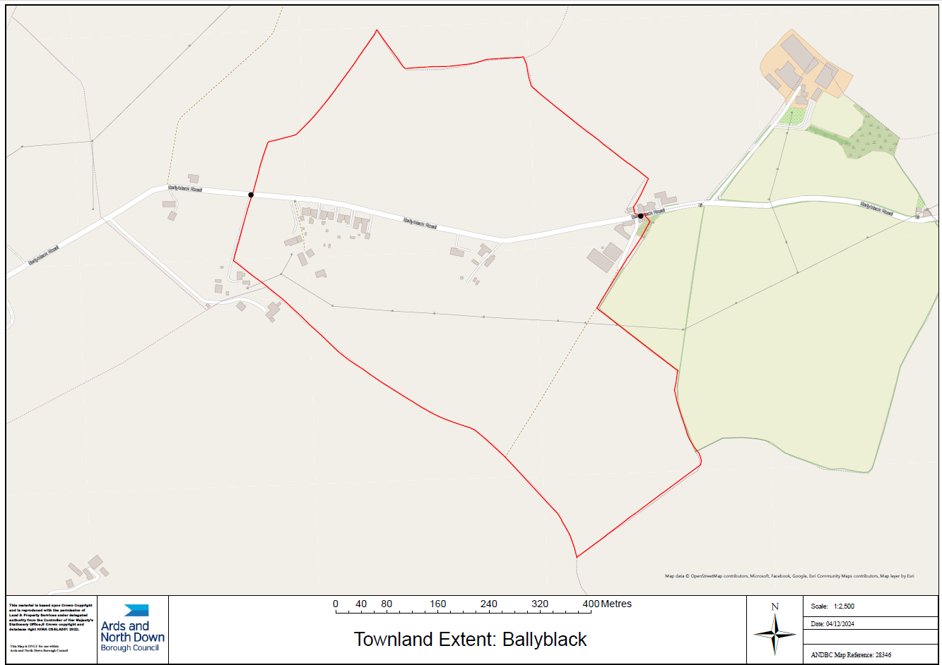

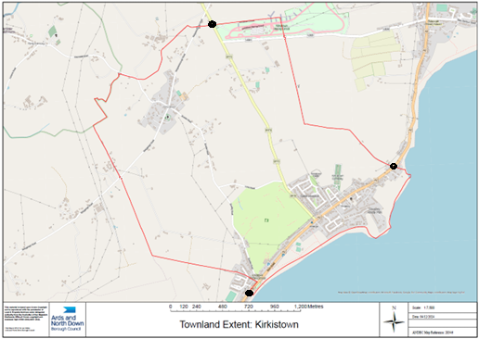

Costs
Each sign cost approximately £500 for installation and on average cost £275 per sign to manufacture, giving an approximate total of £775 per sign. Therefore, the requested signage would cost £3,875.00 for the main roads in both townlands.

Associated Costs of Borough-Wide Implementation
There were 287 townlands within the Borough; allowing an average of three signs in each townland would equate to £2,325 per Townland or £667,275 for the whole Borough.

Given that, prior to this request, there had only previously been a couple of requests for townland signage within the Borough, it would seem inappropriate to spend such a sum on its blanket implementation.

In consideration of the infrequency of these requests, officers would suggest that future requests for townland signage be brought by Members on a case-by-case basis, using a Notice of Motion.

RECOMMENDED that the Council:

- agrees to adopt a policy of installing townland signage only when specifically requested by elected Members, via a Notice of Motion.
- decide if they wish to proceed with the signs at Kirkistown and Ballyblack, at a cost of £3,875, utilising existing maintenance budgets.

RECOMMENDED that the Council notes the report.

Councillor Edmund made an alternative proposal which was seconded by Councillor Kerr.

That Council agree the recommendations and proceed to install signage at Kirkistown and Ballyblack as outlined in the report utilising existing budgets and agrees to adopt a policy of installing townland signage only when specifically requested by elected Members via Notice of Motion.

Councillor Edmund explained that to many communities, particularly those on the Ards Peninsula, townlands offered a strong sense of uniqueness, belonging and identity and he urged Members of the Committee to support the recommendation and suggested that future requests be brought through Notice of Motions.

Seconding the amendment Councillor Kerr agreed with his colleague that townlands were very important on the Peninsula and that at this stage the two named, Ballyblack and Kirkiston, should be given priority.

Councillor Cathcart thanked the Chair for the opportunity to speak and suggested that while it was not explicit in Standing Orders, Alderman Adair had requested speaking rights on the Item, and it might have been useful to hear what he had to say before the Committee discussed the matter.

Alderman Adair was invited to speak, and he explained that a townland was a small territorial division but was inclusive of everyone and was part of our shared heritage. He paid tribute to a past colleague in Council, Kieran McCarthy, who had carried out a lot of work to preserve that heritage and he asked that his thanks for that be put on record. The reason that he had brought the Motion was due to the requests that he had received from local residents who felt a strong connection to both of these townlands, and he was asking for agreement due to that local demand. He pointed out that the cost of that could be met through existing maintenance budgets and so he encouraged Members to support the proposal and in doing so support the area’s history and heritage.

Councillor Wray asked for clarification on the current position which was to install the signs in the two townlands requested and have future proposals brought through Notice of Motions. He stressed that this was a massive amount of money for a limited amount of signs and he was not swayed by the fact it was not additional funding since the budget was still tight. Generally, he was happy to support signage for these areas and he was aware of the local pride expressed by people living in these townlands.

The Head of Assets and Property Services described the signs which were the size of a normal street plate, and the cost depended on the length of each one; so, an average was taken to illustrate costs. It had become a significant cost generally to the Council to replace signs and they were repaired as far as possible rather than being replaced.

Councillor Boyle thanked Councillor Wray for his comments but had difficulty with the proposal and while appreciating the strong support to identify with townlands in some areas the Council could potentially be opening a can of worms, because there was not a large enough budget to support further desires for signs. This was a serious amount of money in his opinion and while there might be a desire to draw a line, practically that might not be possible. While he had every sympathy for the proposal, he thought that the bigger picture needed to be considered.

Councillor Morgan was in agreement with Councillor Boyle’s comments and questioned why those two areas were more important than other townlands around the Borough. She felt that sloppy financial management should be avoided and while she saw the aspiration behind the proposal, she could not give it her support.

Councillor McLaren understood both sides of the debate, she had witnessed the pride and ownership that people local to those areas had for their townlands but was also wary of opening a door that could not later be closed.

Alderman Armstrong-Cotter had a couple of questions and wondered how many requests had been received since Kieran McCarthy had first spoken about preserving townlands on the Peninsula. This had been the only one in the past eighteen months and there had only been a couple in the past ten years. She stressed that requests such as these were rare and not utilised often and even if they were to be it could be allocated in the rates, a precedent had been set and one of the benefits of the Council was that it could move and breathe and react to decisions under its own policies. If the Council did not want to agree to further signage in the future it would be free to do that, but the Committee should not pretend that it was impossible to agree to this for Ballyblack and Kirkiston.

Councillor McKee had listened to the debate and thought that it had cemented his opinion to approve the proposal, and he viewed it as a sensible way forward and that the Council could be guided by the policies it had in place.

At this stage Alderman Armstrong-Cotter requested a recorded vote.

On the proposal being put to the meeting with 7 voting For, 3 voting Against, 3 Abstaining and 3 Absent it was declared CARRIED.

FOR (7) | AGAINST (3) | ABSTAINING (3) | ABSENT (3)
Alderman  Armstrong-Cotter  Councillors  Cathcart  Douglas  Edmund  Kerr  McKee  Wray | Councillors  Boyle  Harbinson  Morgan | Alderman  McAlpine  Councillors  Blaney  McLaren | Alderman  Cummings  Councillors  Irwin  McKimm
AGREED TO RECOMMEND, on the proposal of Councillor Edmund, seconded by Councillor Kerr that Council agree the recommendation and proceed to install signage at Kirkistown and Ballyblack as outlined in the report utilising existing budgets and agrees to adopt a policy of installing townland signage only when specifically requested by Elected Members, via Notice of Motion.

5. outcome to NOM – station road dog Control Order
(Appendix I)

PREVIOUSLY CIRCULATED: Report from the Director of Environment detailing that a Notice of Motion was agreed by the Council as followed:

“That Council brings a report with a view to implementing a “dogs on leads” policy on that part of the Coastal Path which traverses the private road serving the properties 91 to 117 Station Road, Holywood, inclusive.”

A report was subsequently brought to the Committee, and the Council agreed to proceed with the statutory process for making a Dogs on Leads Order.

A public consultation exercise was undertaken in the month of March and details of correspondence received were attached in Appendix A.

Enforcement History
In a search of Council records for the past year, there had only been one reported incident on this section of the coastal path, of a ‘dog not under adequate control’. There had been no recorded incidents of dog fouling in that time period.

Consideration of Possible Introduction of Dog Control Order
Benefits of creating this particular Dog Control Order included the regulation of a section of coastal path where:

- Residents directly affected may welcome the introduction of such a control
- Dogs on lead cannot stray into adjacent gardens
- Dogs on lead are unlikely to foul without the knowledge of the responsible dog walker
- Dogs on lead are more likely to be under control and be less likely to be involved in attacks or incidents with runners or cyclists

Disbenefits of creating this dog control order include:

- The added restriction imposed on dog exercise may be unpopular
- Council enforcement capacity will be limited, with associated difficulties associated with identifying offenders
- Potential to create an expectation of further control areas elsewhere in the Borough, with the added resource pressures that would create
- No offence is committed where the person has a reasonable excuse for failing to keep the dog on a lead, or the owner, occupier or other person or authority having control of the land has consented (generally or specifically) to the person failing to do so. Landowners and occupiers will be exempt and can permit others to walk dogs without leads, only on the land owned by them. They may also oppose introduction.

Land Ownership
The area of land under consideration was a section of the coastal path, between points A and B on the map below. It was a private road with a common law asserted public right of way over it. It was not owned or maintained by the Council and officers were aware of previous land dispute issues in the vicinity.

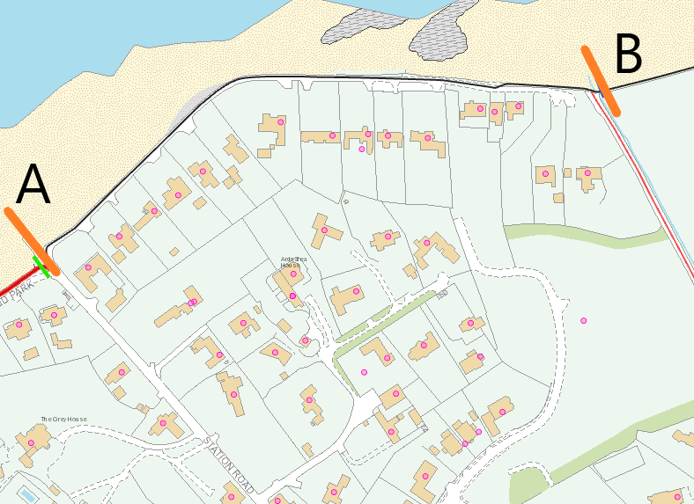

Statutory signage would be required at either end of the designated roadway. If officers were unable to establish ownership of those sections, then the installation of poles and signage would be at risk. The Order could not be enforced without signage.

The specified wording to be used in, and the form of, a Dog Control Order was detailed at Appendix B. The statutory procedure for implementing Dog Control Orders was outlined in Appendix C.

Next Steps
Should the Council decide to make a Dog Control Order as set out in this report, the cost to the Council of implementation was envisaged to be in the region of £1,000. That did not allow for any legal costs associated with potential land dispute issues that may arise with the making of an Order at this location.

RECOMMENDED that the Council considers this report along with the consultation responses received and decides whether to make a Dog Control Order (Dogs on Leads Order) as described.

Proposed by Councillor Cathcart, seconded by Councillor Edmund, that the Council proceeds to make a Dog Control Order as described in the report.

Proposing the recommendation Councillor Cathcart stated that when Alderman Graham had originally brought the Motion forward, he had been wary of restrictions in general but pointed to the fact that this was a very small area of the coastal path in front of residential properties. He could not speak about greater dog fouling in the area but thought that if they were to escape into people’s gardens, that was a general nuisance and he did not believe that responsible dog owners would object to the small changes being suggested. Indeed, he as a dog owner would not object and thought it a perfectly fair proposal. As seconder Councillor Edmund was in agreement and felt that the case had been made well.

AGREED TO RECOMMEND, on the proposal of Councillor Cathcart, seconded by Councillor Edmund, that the Council proceeds with making a Dog Control Order as set out in the report.

6. ITeM WIthdrawn

7. ards and north down off-street parking (public car parks) order 2025
(Appendices II & III)

PREVIOUSLY CIRCULATED: Report from the Director of Environment detailing that in July 2024, the Council enacted the Ards and North Down Off-Street Parking (Public Car Parks) Order 2024 (2024 Order) under the Road Traffic Regulations (NI) Order 1997, in respect of certain Council owned car parks. A copy of the Order was attached as Appendix 1.

The public car parks covered by this Order were legacy car parks owned by the Council and the former DFI owned car parks were currently included in the Off Street Parking Order 2000 (2000 Order) which currently remained in force.

A Car Parking Order set out the powers and regulations that applied within each of the car parks which could be enforced by the Council, normally through the action of the Traffic Attendants.

As Members may be aware, Council officers had been liaising with DfI to encourage them to repeal the 2000 Order, which would allow the Council to implement control measures (including a new tariff structure), as agreed in the Car Park Strategy.

Officers had prepared a new Car Park Order which would be required when the 2000 Order was repealed by DfI, attached at Appendix 2. Deletions were tracked with additions and amendments to the Order highlighted in yellow.

The Proposed Order would:

- Bring both the legacy Council owned car parks as included in the 2024 Order and the former DFI car parks as per the 2000 Order, into the same Order under Council control.
- Implement the tariffs as agreed by Council in 2022 as part of the Car Park Strategy, as stated in Schedule 2 of the Order.
- Amend the current contravention in relation to caravans (motorhomes) using the car parks in Schedule 1 to allow the Traffic Attendants to take more effective action in respect of offenders. An Officer’s working group is examining the potential for motorhome parking facilities across the Borough (and any further amendments of the Order that may be necessary as a consequence of that work, can be considered by Council thereafter).
- Legislate for buses/coaches.
- Remove provision 18 from the Order. The 2024 Order includes a provision for blue badge parking which is not in line with the provisions of the current 2000 Order and which cannot be facilitated within the capabilities of the current pay and display system; it is proposed that this can be further reviewed at a later date, as technology changes/permits.
- Bring the charging hours for all charged car parks across the Borough into line, as 8am – 6pm.
- Extend the maximum stay in all car parks from 12 hours to 14 hours.

The Order repealed the existing 2024 Order and would not be enacted until the DFI Order (the 2000 Order) had been repealed. It would then allow the Traffic Attendants to enforce within all car parks listed in Schedule 1 as required.

Enactment Process

The process to enact an Order was specified in the Road Traffic Regulations (NI) Order 1997

- The Council agrees the draft Order.
- The Council must then consult with such persons as the Council considers appropriate. It is proposed that the Town and City Steering Groups are consulted as per the consultation process previously used for the 2024 Order, and any other party as deemed appropriate based on Council’s legal advice.
- Place a Public Notice in a newspaper(s) circulating in the area advising that objections must be received within 21 days of the Notice. A copy of the draft Order will be placed on the Council website.
- Consider any objections and confirm the Order (with amendments if required).
- Advertise in the local press that the Order has been made and the date of implementation.

RECOMMENDED that the Council agrees the Ards and North Down Off-Street Parking (Public Car Parks) Order 2025 as per Appendix 2 and proceeds with the enactment process as detailed in this report.
Proposed by Councillor Morgan, seconded by Councillor Wray, that the recommendation be adopted.
Councillor Morgan was pleased to see the recommendation coming forward but was aware that it might be some time before it was enacted due to action required by the Assembly, but at least the Council would be prepared and ready when that happened. Councillor Wray was also pleased to see the progress and asked about the situation with overnight motorhome stays in car parks. The Director provided an update and stated that the Council could not legally facilitate overnight stays at the moment, and that was a holding position until it could facilitate that aspect of tourism demand – at which time the Car Park Order could be appropriately amended. Currently, motorhomes could park in car parks but were not permitted to stay overnight.

Councillor Cathcart asked for clarification in relation to where the Department was in terms of amendment of the current Car Park Order covering former DfI car parks, and the Director replied that since the Council had prepared the report before Members it had received a response from the Minister which would be brought to next month’s meeting of the Environment Committee. He went on to say that it was clear that progress was unlikely to be made quickly, since the Department was stressing the need for all Councils to indicate they were in a state of readiness with their own Car Park Orders such as this one. Councillor Cathcart expressed his frustration stressing that the Department had had a decade to consider the matter.

Councillor McKee agreed with Councillor Cathcart’s frustration and was staggered that the matter had been delayed for so long while suggesting that the Council write to the Department reminding it of its obligations to the Council. He had a number of questions on the Order itself such as the enforcement of certain restrictions such as idling of vehicles and if there would be guidance provided for that. The Director indicated that he was unaware of any specific prescribed guidance for enforcement or such restrictions, indicating that generally any effective enforcement action would stand or fall on the strength of the evidence gathered in any particular instance.

AGREED TO RECOMMEND, on the proposal of Councillor Morgan, seconded by Councillor Wray, that the recommendation be adopted.

(Alderman Cummings entered the meeting at 8.15 pm via Zoom)

8. grant of an entertainments licence

PREVIOUSLY CIRCULATED: Report from the Director of Environment detailing that an application had been received for the Grant of an Entertainments Licence as followed:

- All Weather Pitch, Parkway, Comber

Applicant: Roy Murray, Comber Regenerations Community Partnership, 29 Dermott Avenue, Comber, BT23 5JE

Days: 21st June and 30th August 2025

Type of entertainment: Outdoor musical entertainment

There had been no objections received from PSNI, NIFRS or Environmental Health.

- Ballyphilip Parish Centre, Church Street, Portaferry

Applicant: Rhoda Dorndorf, 9 Rockfield Park, Newtownards

Days and Hours: 14 Unspecified days within 12 months 8am – 10pm

Type of entertainment: A theatrical performance, Dancing, singing or music or any other entertainment of a like kind, Equipment for playing snooker or similar games.

There had been no objections received from PSNI, NIFRS or Environmental Health.

- Kirkistown Race Circuit, 130 Rubane Road, Kircubbin, Newtownards, BT22 1AU

Applicant: Darren Gilmore, 22 Parsonage Road, Kircubbin, BT22 2RJ

Days and Hours: 14 Unspecified days within 12 months 8pm – 1am

Type of entertainment: Dancing, singing or music or any other entertainment of a like kind.

There had been no objections received from PSNI or Environmental Health. NIFRS had requested further information.

The application had been received in order to facilitate an event on 15 June 2025. At the time of writing this report, no objections had been received, however, objections could be made up until 15 May 2025. Should objections be received a further report outlining those would be brought to the Council in May for consideration.

RECOMMENDED that the Council grants Entertainments Licences to Comber Regeneration and Ballyphiilip Parish Centre subject to satisfactory final inspection by Licensing and Regulatory Services, and to Kirkistown Race Circuit subject to no objections being received by 15 May 2025 and to satisfactory final inspection by Licensing and Regulatory Services.

Proposed by Councillor Kerr, seconded by Councillor Boyle, that the recommendation be adopted.

Proposing the recommendation Councillor Kerr thought these were all very worthwhile events and he was happy to propose. Councillor Boyle agreed and supported the licences being given to the three organisations.

AGREED TO RECOMMEND, on the proposal of Councillor Kerr, seconded by Councillor Boyle, that the recommendation be adopted.

9. XL BULLY INCIDENT ON 3 APRIL 2025
(Appendix IV)

PREVIOUSLY CIRCULATED: Report from the Director of Environment detailing that a dog attack took place at a dwelling in Rathmullan Drive, Newtownards on the evening of 3 April 2025 in which two adults were injured.

The attack involved an XL Bully dog which was licensed and had an Exemption Certificate issued by the Council in accordance with the relevant legislation.

The PSNI responded to the incident. Council officers were not contacted or involved in the incident which took place outside normal working hours.

While there had been much speculation on social media channels, the Council’s Neighbourhood Environment Team had not received any actionable complaints about this dog prior to the incident.

Following the Notice of Motion submitted to the Council in regard to the Rehoming of XL Bully dogs, the response to the letter requested by Council had been received and was attached in Appendix 1.

RECOMMENDED that the Council notes this report.

Proposed by Councillor Morgan, seconded by Councillor Harbinson, that the recommendation be adopted.

Councillor Boyle asked the Director to explain what noting a report meant and if it was agreeing. The Director explained that for this report no follow up action was being recommended, and he considered that a Member did not necessarily have to agree with the content of a report in order to agree to note it.

Councillor McKee referred to the response from the Minister in context of the incident which had been horrendous but had been dealt with well by Council officers. He thought members of the public were right to have safety concerns but he was of the opinion that breaches in the legislation were the wrong way to approach that. There had been a furore in the media reporting leading to a campaign around XL Bullies. He thought the dogs themselves were guilty of circumstances and the strengthening of the law had directly led to an increase in dodgy breeding and the euthanasia of healthy animals. He concluded by stating that in his opinion the system needed to be changed.

Alderman Cummings reiterated the points made by Councillor McKee agreeing that it had been a traumatic incident that had required swift action. He thought that there might be lessons to be learnt, such as the contact made and if there would be an obligation on the Council’s enforcement staff to investigate further. There were implications in terms of the safe housing of dogs and the ability of the owner to look after a dog.

The Director highlighted that the Council and its Neighbourhood Environment Team had not received any actionable complaints from the owner or anyone else, and the Council would respond to a complaint of an alleged attack. As it stood Council officers had received no actionable complaints, the Council was aware of the dog and an exemption certificate had been issued for this animal through the proper protocol.

Alderman Armstrong-Cotter asked about the difference between an actionable complaint versus one that was not actionable. The Director advised that it would not be appropriate to go in to the detail of this specific case, but confirmed that complaints may be received in respect of which the Council was unable to take any enforcement action – compared to complaints received which could be followed up with some form of enforcement action.

Councillor McLaren understood that this was an extremely emotive subject, many people loved animals but the Council was discussing banned breeds and they were banned for a reason since historically they were predisposed towards aggression. She had witnessed the injuries first-hand and stated that if those could be done to an adult, she dreaded to think of what the dog could do to a toddler. She thanked the team which had worked tirelessly to make sure that people adhered to the exemption certificate rules in keeping the public safe. She welcomed the letter which had come from the Minister outlining the reasons why a banned breed could not be rehomed.

AGREED TO RECOMMEND, on the proposal of Councillor Morgan, seconded by Councillor Harbinson, that the recommendation be adopted.

10. Q3 LICENSING ACTIVITY REPORT (OCT – DEC 2024)

PREVIOUSLY CIRCULATED: Report from the Director of Environment detailing that the information provided in this report covered, unless otherwise stated, the period from 1 October 2024 – 31 December 2024. The aim of the report was to provide Members with details of some of the key activities of the Licensing Service.

Applications Received
The Service dealt with a wide range of licensing functions which required officers to consult with the PSNI, NIFRS and a range of other Council Services in making their assessment of an application.

 | Period of Report  1 October 2024 - 31 December 2024 | Same quarter last year 1 October 2023 - 31 December 2023
Entertainments Licence | 71 | 58
Cinema Licence | 1 | 0
Amusement Permits | 3 | 4
Marriage and Civil Partnership Place Approval | 1 | 0
Pavement Café Licence | 0 | 5
Street Trading Licence | 0 | 0
Lottery Permits | 4 | 5

Most of the licences issued were renewals and hence the workload was constant year on year. Renewing a licence still entailed considerable work when assessing
the application and consulting with the other bodies.

Regulatory Approvals
This was the number of licences, approvals and permits that had been processed and issued.

 | Period of Report  1 October 2024 - 31 December 2024 | Same quarter last year 1 October 2023 - 31 December 2023
Entertainment Licence | 30 | 23
Cinema Licence | 0 | 0
Amusement Permits | 0 | 5
Marriage and Civil Partnership Place Approval | 0 | 1
Pavement Café Licence | 2 | 4
Street Trading Licence | 0 | 0
Lottery Permits | 2 | 0

Inspections
The Service carried out a range of inspections in connection with the grant and renewal of licences to establish if the premises were suitable. In some cases, they inspected with the NIFRS.

During performance inspections were an important element in ensuring the licensees were abiding by their licence terms and conditions and that premises were safe for patrons.

The Service had been unable to complete its annual planned programme of ‘during performance inspections’ which concentrated on the higher risk premises such as night clubs through the year due to resourcing issues.

 | Period of Report  1 October 2024 - 31 December 2024 | Same quarter last year 1 October 2023 - 31 December 2023
Initial/ renewal Entertainment Licence Inspections | 12 | 35
During performance Inspections | 0 | 0
Initial Inspections of Pavement Cafes | 0 | 0
Initial Inspections of Places of Marriage and Civil partnerships | 0 | 0

High Hedges
High Hedge legislation required complainants to attempt to resolve their complaint informally prior to lodging a formal complaint with the fee of £360. That generated a large volume of queries for officers in an advisory role, which were not reflected in the statistics for ‘formal complaints’.

 | Period of Report  1 October 2024 - 31 December 2024 | Same quarter last year  1 October 2023 - 31 December 2023
Formal Complaints | 0 | 0

CCTV incidents

Period: 1 October 2024 - 31 December 2024

Date | Location | Incident | Action
12/10/24 | High Street, Bangor | Assault | Requested by and provided to PSNI
10/10/24 | High Street, Bangor | Cyclist damages car wing mirror | No requests made
19/10/24 | High Street, Bangor | Theft | Requested by and provided to PSNI
3/11/24 | Main Street, Bangor | Theft | Requested by and provided to PSNI
6/11/24 | Conway Square, Newtownards | Surveillance | Internal request to monitor Paddington Bear
16/11/24 | High Street, Bangor | Assault | Requested by and provided to PSNI
29/11/24 | High Street, Bangor | Assault | Requested by and provided to PSNI
25/12/24 | High Street, Newtownards | Murder Enquiry | Requested by and provided to PSNI
28/12/24 | High Street, Bangor | Two males fighting | Requested by and provided to PSNI

Off Street Car Parking
The Council currently operated 22 pay and display car parks in Bangor, Holywood and Newtownards.

Table 1: Income from Ticket Sales

 | Period of Report  1 October 2024 - 31 December 2024 | Previous year  1 October 2023 - 31 December 2023
Income from ticket sales | £204,147.23 | £196,205.19

Table 2: PCN’s Issued

 | Period of Report  1 October 2024 - 31 December 2024 | Previous year  1 October 2023 - 31 December 2023
Total | 1064 | 1213

RECOMMENDED that the Council notes the report.

Proposed by Councillor Edmund, seconded by Councillor McLaren, that the recommendation be adopted.

Councillor McLaren had a question for the Director in relation to the issuing of pavement café licences and noticed that the applications were only in single digit numbers when it seemed that when the sun shone there was a proliferation of pavement cafes around the Borough. She hoped that they were paying the necessary fee for that and adhering to the Council’s guidance.

The Director explained that the figures only related to applications for the period described and any application lasted for three years so there was a cumulative effect in the overall numbers of extant licences over time. In total there were 57 licensed pavement cafés in the Borough and that was periodically reviewed by officers.

The Director highlighted that he had attended the ten year celebration of the Community Plan at Clandeboye Lodge Hotel, Bangor, earlier in the day and informed the Committee that the Chair of the Disability Forum, who was registered blind, reported a marked improvement in conditions for disabled people on the high streets of the Borough as a consequence of the Council’s enforcement of the Pavement Café Licence regime.

AGREED TO RECOMMEND, on the proposal of Councillor Edmund, seconded by Councillor McLaren, that the recommendation be adopted.

Exclusion of Public/Press

AGREED, on the proposal of Councillor Kerr, seconded by Councillor Emund, that the public/press be excluded during the discussion of the undernoted items of confidential business.

11. REVIEW OF CITY/TOWN CENTRE CCTV
(Appendix V)

***IN CONFIDENCE***

NOT FOR PUBLICATION SCHEDULE 6 – INFORMATION RELATING TO THE FINANCIAL OR BUSINESS AFFAIRS OF ANY PARTICULAR PERSON (INCLUDING THE COUNCIL HOLDNG THAT INFORMATION)

A report on the review of Council’s Town Centre CCTV system was considered.

It was agreed that officers should liaise further with the PSNI in relation to Option 2 as set out in the report, with the view to bringing back a further report to the Council.

Re-admittance of public/press

AGREED, on the proposal of Councillor Kerr, seconded by Alderman Armstrong-Cotter, that the public/press be re-admitted to the meeting.

12. ANY OTHER NOTIFIED BUSINESS

There were no items of Any Other Notified Business.

Termination of meeting

The meeting terminated at 8.50 pm.

