Ards and North Down Borough Council

A hybrid meeting (in person and via Zoom) of the Environment Committee was held at the Council Chamber, Church Street, Newtownards and via Zoom, on Wednesday, 5 March 2025 at 7.00 pm.

PRESENT:

In the Chair: Alderman McAlpine

Aldermen: Armstrong-Cotter (Zoom)
Cummings

Councillors: Blaney (Zoom) Kerr (Zoom)
Boyle McKee (Zoom)
Douglas McKimm (Zoom)
Edmund Morgan
Irwin Wray

Officers: Director of Environment (D Lindsay), Head of Waste and Cleansing Services (N Martin), Interim Head of Regulatory Services (R McCracken), and Democratic Services Officer (H Loebnau)

1. Apologies

Apologies were received from the Mayor (on Council business), Councillor Harbinson and Councillor McLaren.

NOTED.

2. Declarations of Interest

There were no Declarations of Interest.

NOTED.

3. 2025-26 Service Plans

PREVIOUSLY CIRCULATED:- Members would be aware that the Council was required, under the Local Government Act 2014, to have in place arrangements to secure continuous improvement in the exercise of its functions. To fulfil that requirement the Council approved the Performance Management Policy and Handbook in October 2015. The Performance Management Handbook outlined the approach to the Performance Planning and Management process as:

Community Plan – published every 10-15 years
Corporate Plan – published every 4 years (Corporate Plan 2024 - 2028 in operation)
Performance Improvement Plan (PIP) – published annually
Service Plan – developed annually

The Council’s 18 Service Plans outlined how each respective Service would contribute to the achievement of the corporate objectives including, but not limited to, any relevant actions identified in the PIP.

Attached were the 2025-26 Service Plans for Assets and Property Services, Regulatory Services and Waste and Cleansing Services in accordance with the Council’s Performance Management Policy and Handbook.

Plans were intended to:

- Encourage compliance with the new legal, audit and operational context.
- Provide focus on direction.
- Facilitate alignment between Corporate, Service and individual plans and activities.
- Motivate and develop staff.
- Promote performance improvement, encourage innovation and share good practice.
- Encourage transparency of performance outcomes.
- Better enable the Council to recognise success and address underperformance.

The attached Plans:

- Had been developed to align with the objectives of the Big Plan (2017 – 2032) and the Corporate Plan 2024 – 2028 and had been developed in conjunction with staff, officers and management, and in consultation with key stakeholders where relevant.
- Set out the objectives for the Service for 2025-26 and identified the key performance indicators used to illustrate the level of achievement of each objective, and the targets that the Service would try to attain along with key actions required to do so.
- Were based on the agreed budget. It should be noted that, should there be significant changes in-year (e.g. due to Council decisions, budget revisions or changes to the PIP), the Plans may need to be revised.
- Would be reported to the Committee on a six-monthly basis as undernoted.

Reference | Period | Reporting Month
Quarter 1 and Q2 | April – September | December
Q3 and Q4 | October – March | June

RECOMMENDED that the Council approve the Directorate Service Plans.

3.1 Assets and Property Services
(Appendix I)

RECOMMENDED that the Council approve the Assets and Property Services Directorate Service Plan.

AGREED, on the proposal of Alderman Cummings, seconded by Councillor Edmund, that the recommendation be adopted.

3.2 Waste and Cleansing Services
(Appendix II)

RECOMMENDED that the Council approve the Waste and Cleansing Service Directorate Service Plan.

Proposed by Councillor Boyle, seconded by Councillor Wray, that the recommendation be adopted.

Councillor Wray referred to the SWOT analysis for the section and asked for an explanation of the issue with street washing and traffic management. The Head of Waste and Cleansing replied that staff could not work on high speed roads without a traffic management plan. Permission was also required from DfI Roads which stipulated the conditions. He went on to give the example of the A2 road to Belfast where cleansing was only permitted at weekends and not at all during the month of December. It was also noted that one of the two street washing machines was out of order and difficulty had been experienced in sourcing spare parts for that. Alternatives such as leasing or hiring equipment were being considered.

AGREED TO RECOMMEND, on the proposal of Councillor Boyle, seconded by Councillor Wray, that the recommendation be adopted.

3.3 Regulatory Services
(Appendix III)

RECOMMENDED that the Council approve the Regulatory Services Directorate Service Plan.

Proposed by Councillor Douglas, seconded by Councillor Boyle, that the recommendation be adopted.

Councillor Douglas asked about why Project Ella had been stalled within local schools and it was explained that there had been issues around communication, which had now been addressed and the programme would be restarted and further progressed within the new school year.

AGREED TO RECOMMEND, on the proposal of Councillor Douglas, seconded by Councillor Boyle, that the recommendation be adopted.

4. iTEM WITHDRAWN

5. grant of an entertainments licence

PREVIOUSLY CIRCULATED: Report from the Director of Environment detailing that an application had been received for the Grant of an Entertainments Licence as follows:

1. Circus Vegas, land adjacent to 10 Comber Road, Newtownards, BT23 4QP

Applicant: Olivia Mulvaney, Circus Vegas American Circus, 1 Earl Street, Longford, Co Longford

Days and Hours: 14 Unspecified days within 12 months, 11am – 10.30pm

Show times usually followed the below schedule:
Thursday 4.30pm & 7.30pm
Friday 4.30pm & 7.30pm
Saturday 2pm & 5pm
Sunday 2pm & 5pm or 12noon & 3pm

Type of entertainment: A Circus

There had been no objections received from PSNI, NIFRS or Environmental Health.

RECOMMENDED that the Council grants an Entertainments Licence to Circus Vegas subject to satisfactory final inspection by Licensing and Regulatory Services.

AGREED TO RECOMMEND, on the proposal of Councillor Boyle, seconded by Councillor Morgan, that the recommendation be adopted.

6. car park capital resurfacing works

PREVIOUSLY CIRCULATED: Report from the Director of Environment detailing:

Strategic Context

The Council’s agreed Maintenance Strategy incorporated a “needs based” approach for its refurbishment programme.

Car Parks were scored every year and the lowest scoring of them was earmarked for resurfacing, subject to budgetary constraints.

Capital Budget

As resurfacing works were carried out from the Council’s capital budget, a set amount was required to be identified each year to facilitate accurate capital budget forecasting.

Historically, an annual figure of £50k was included in the capital budget, however as noted in previous reports and the Council’s Car Park Strategy, that amount was inadequate in terms of achieving a vision of a modern, attractive and fully fit for purpose public car park estate.

Maintenance Issues within Car Parks

A large proportion of the Council’s 70+ car parks were transferred to the Council from DfI during the Review of Public Administration in 2015. Many of those car parks were in a poor state of repair, with poor surfacing and marking and old inefficient lighting. Many car parks still had not had the title transferred from DfI and some had issues involving land ownership and unauthorised entries/rights of way.

Modernisation of Car Parks

The Council’s Car Park Strategy, agreed in 2021, set out a vision for a high standard public asset that realised its full potential in helping to promote a sustainable Borough – driving forward economic, environmental and social well-being. The implementation of a number of key improvements to the car parks was essential, including:

- Resurfacing
- New line marking, utilising the upper end of the standard widths for parking spaces to help accommodate the larger, SUV type vehicles that had increased in popularity in recent years.
- New fully DDA compliant spacing with drop-kerbs for wheelchair use.
- LED lighting that provided a clearer, brighter light but used less power and incorporated automatic dimming features.

In addition to the above, several further enhancements had been identified as being important in terms of realising the Council’s vision for high quality modern car parks, including:

- Enhanced signage
- Enhanced environmental features, planting etc.
- Bicycle and motorcycle parking facilities
- EV charging infrastructure

The implementation of such an improvement programme would not be possible within the current budget availability.

Cross-Departmental Working

Cognisance of wider strategies and plans for those assets was essential to reducing the likelihood of spending significant sums of money on assets that may be disposed of or replaced in the foreseeable future. Therefore, discussions with relevant officers had taken place to ensure that proposed works reflected any known plans for the assets concerned.

Any car parks with known imminent works to be carried out had been exempted from the scoring.

Condition Scores

The table below provided a list of all car parks. They had been surveyed and ranked in order of their condition. Pay and Display car parks had had a weighting added to lower their scores so that they gained priority over others. Similarly, car parks within town/village centres had also had a (slightly lesser) weighting added so that they could be prioritised over the less frequently used, more rural car parks. Works identified, and costings provided generally only related to more ‘essential’ maintenance/enhancement works (resurfacing) and did not include the further desirable enhancements set out above.

Required Works

Line marking was seen as priority work in the Council’s charged car parks as defective lines could contribute to incorrect parking and disputes over ticketing. However, in some car parks the surfacing was in a relatively poor condition and line marking could not be carried out until it had been resurfaced. As indicated in the table above, around £16k of line marking was proposed for this year. The work could not be capitalised so must be taken from routine maintenance revenue budgets.

As highlighted previously in the report, the Council currently had budgeted £50k per year in capital budgets for car park resurfacing. Unfortunately, that was insufficient to complete all of the necessary works to the lowest scoring car park - Holborn Avenue, Bangor.

Notwithstanding that, an ongoing legal matter meant that it was inadvisable to proceed with substantial works at this car park until this had been further resolved. In the meantime, more minor essential repair works would be undertaken there during the incoming financial year.

The second lowest scoring location, Old Cross East, Newownards could however be resurfaced within the budget allocated for the year.

Potential for Increasing Budget

As indicated in the table above, the Council currently had £171k of priority capital works required to its car parks that fell below a 75% condition score (shaded red), and that budget requirement increased to £2.1M if a higher condition score of 85% was to be achieved (shaded amber). Note: An 85% condition threshold was in line with what had generally been considered acceptable for its buildings over past budgeting cycles.

At the current budget allocation, achievement of an 85% condition score would take 38 years to complete, and in the meantime those and other car parks would continue to deteriorate and require further work. Indeed, the expected lifespan of the bitmac surface would be approximately 20 years, meaning the Council would perpetually be “behind the curve” when trying to address the backlog of work with the budget available. It was therefore clear that the current budget allocation was insufficient if even a reasonable standard of car park condition was to be achieved.

Members would be aware that a new tariff structure for charged car parks had been agreed as part of the Car Park Strategy, with financial modelling showing that that should yield approx. £0.5M in additional income based upon current usage patterns. However, implementation of the new tariffs had been delayed pending the outcome of efforts to ensure legislative support for that. Officers were currently actively working on options to move forward in that regard, and a further report would be brought to the Council on that subject as soon as possible.

When new tariffs could be introduced, the projected additional income would provide much needed additional funds to support an expansion of the annual capital programme for car park maintenance and enhancements, and a report would be brought in due course regarding that. That would ensure that the car park users paid for that service (which was not a statutory service provided for by default rates income), rather than the cost being levied through general rates to all ratepayers irrespective of whether they used car parks.

In the meantime, within the current limits of the agreed 2025-26 capital budget for car park works, it was planned that the following works would be undertaken in accordance with the prioritisation process outlined in the report:

- Line marking at various car park listed
- Resurfacing of Old Cross East, Newtownards
- Localised repairs to Holborn Avenue Car Park

RECOMMENDED that the Council notes the planned car park works for 2025-26.

Proposed by Alderman Armstrong-Cotter, seconded by Councillor Boyle, that the recommendation be adopted.

Alderman Armstrong-Cotter understood that this was a relatively small sum of money to spend on improvements to the car parks of the Borough and suggested that if lines were being re-marked that they be made a little bigger to accommodate the larger vehicles and even coaches. Other works required to the car parks would need substantial capital. The Director agreed and pointed out that it had been highlighted in the report that designated parking bay size would be towards the upper end of the standard set for width, although he was unsure of the technical detail around that. Referring to coach parking spaces officers were also alive to that, and locations were identified within certain car parks under the Car Park Strategy proposals.

Councillor Boyle thanked officers for the report but recognised that the Council would have a long term financial and legal challenge both to maintain car parks and in dealing with landowner issues. The Director stated that there may be some light at the end of the tunnel with the new tariffs that the Council had agreed, and the financial modelling suggested that income under the new tariff structure should much more adequately cater for the maintenance and improvement of the car parks going forward. Councillor Boyle hoped that would be the case and thanked the Director for his comments.

Councillor Wray agreed with the challenges in relation to the car parks which had deteriorated badly and that it was difficult to do anything significant with such a small pot of current funding. He considered that it seemed that some car parks were not well used and wondered if the land could be sold to bring revenue to the Council. The Director replied that as part of the Car Park Strategy, all car parks were assessed and one or two were suggested for potential repurposing or redevelopment - but they were all kept under ongoing review, the Strategy was not set in stone but was fluid and dynamic and could be adjusted and amended as necessary.

Councillor Morgan stressed the need to remember the placement of cycle parking facilities in car parks and thought that the Council needed to be sharper when considering that. She also asked what the timeframe was for new tariffs. In response the Director said that proposals for cycle parking featured in the Car Park Strategy and was an integral part of the Council’s vision. He went on to state that the Strategy could only be fully implemented with a sufficient revenue stream, and it was hoped that the agreed new tariff structure could be implemented in the current financial year following positive reassurances from the Department.

It was proposed by Councillor Morgan, seconded by Councillor Irwin, that the recommendation be adopted with the addition that the Council write to the Department for Infrastructure to urge the implementation of promised legislative changes around the making and repealing of Car Park Orders, which was necessary to allow the Council to progress with implementation of its Car Park Strategy.

Councillor Morgan thought this should be added to make it clear to the Department the position the Council found itself in. The Member referred to her disappointment that there were no cycle racks proposed to be placed at Queen’s Parade and the Director explained that decision was constrained due to the limited budget and the fact that the new car park area referred to was designed to be temporary.

Councillor Irwin raised the point made previously by Alderman Armstrong-Cotter in respect of the size of car parking spaces and also asked for sufficient disability as well as parent and child spaces going forward.

Councillor Edmund believed that assessment should be made on whether cycle parking was really necessary and referring to South Street in Newtownards, he indicated that he had never seen bicycles parked there.

Councillor Douglas informed officers that some DfI signs were still in place within car parks and encouraged the Council to follow up on that. The Head of Regulatory Services explained that the old signage was in the process of being changed across the Council’s car park estate and should be dealt with in the near future.

Councillor McKimm referred to cycle parking and remembered the budget for safe cycle parking coming from an external source in the past. Responding the Director was not aware of that initiative, but he was aware that there were external sources potentially available and the Member had made a good point. The Council would scan the environment for funding opportunities to develop that further. Sustainable travel had been discussed at length and the Council would place cycle parking in the right locations and market that availability to residents and visitors to the Borough.

AGREED TO RECOMMEND, on the proposal of Councillor Morgan, seconded by Councillor Irwin, that the recommendation be adopted and further agreed to write to the Department for Infrastructure to urge the implementation of promised legislative changes around the making and repealing of Car Park Orders, which is necessary to allow Council to progress with implementation of its Car Park Strategy.

7. environment directorate budgetary control report – december 2024

PREVIOUSLY CIRCULATED: Report from the Director of Environment detailing that the Environment Directorate’s Budgetary Control Report covered the 9-month period 1 April to 31 December 2024. The net cost of the Directorate was showing an underspend of £310k (1.5%) – box A.

Explanation of Variance

Environment’s budget performance was further analysed into 3 key areas:

Report | Type | Variance | Page
Report 2 | Payroll Expenditure | £699k favourable | 3
Report 3 | Goods & Services Expenditure | £344k adverse | 3
Report 4 | Income | £45k adverse | 3

Explanation of Variance
The Environment Directorate’s overall variance could be summarised by the following table (variances over £25k): -

Type | Variance  £’000 | Comment
Payroll | (699) | - Waste and Cleansing (£366k) – vacancies within Waste Collection which are being recruited  - Assets and Property (£161k) – vacancies within Property Operations and Fleet Management  - Regulatory Services (£170k) – vacancies within Building Control and Neighbourhood Environment Team
Goods & Services
Waste and Cleansing Services | (116) | - Waste disposal costs (£199k)  - Landfill (£73k)  - Recycled Waste (£127K)  - Borough Cleaning £25k. Range of running costs over budget to date.  - Waste Collection £21k. Range of running costs over budget to date.
Assets and Property | 420 | - Statutory and Planned maintenance £436k – Aurora pool floor repairs large part of this.  - Energy costs (£225k) – electric £129k, gas (£163K), Oil (£32k), Derv (£165k)  - Sewerage/ trade effluent charges £83k.  - Other expenditure £124k – Transport running costs
Income
Waste and Cleansing | 160 | - Trade waste income £132k.  - Special collections income £26k.
Assets and Property | (163) | - Wind Turbine (£91k).  - Property Maintenance (£37k)  - Technical Services (£37k)
Regulatory Services | 48 | - Building Control income (£60k).  - Car Park income £69k  - Licensing income £21k

RECOMMENDED that the Council notes this report.

AGREED TO RECOMMEND, on the proposal of Councillor Morgan, seconded by Councillor Edmund, that the recommendation be adopted.

8. letter to daera – nappy recycling service (NOM 635)
(Appendix IV)

PREVIOUSLY CIRCULATED: Report from the Director of Environment detailing that further to a Notice of Motion agreed by the Council in November 2024 highlighting the need for a nappy collection scheme in Northern Ireland, the Council wrote as agreed to the DAERA Minister.

A letter of response has now been received from the DAERA Minister as attached.

RECOMMENDED that the Council notes the contents of the DAERA Minister’s response.

Proposed by Councillor Douglas, seconded by Alderman Armstrong-Cotter, that the recommendation be adopted.

As proposer Councillor Douglas explained that the Notice of Motion had been brought by Alderman McIlveen and she appreciated the Minister’s response noting that although there were no plans to introduce a scheme at this point, officials were keen to engage with local Councils to explore the initiative further.

Alderman Armstrong-Cotter also welcomed the Minister’s comments and asked about setting up a working group. The Director informed Members that there was a Government Waste Working Group which focussed on strategic issues affecting both central and local government, and he would look at ensuring that this issue was tabled at that forum.

AGREED TO RECOMMEND, on the proposal of Councillor Douglas, seconded by Alderman Armstrong-Cotter, that the recommendation be adopted.

9. DEPOSIT RETURN SCHEME REPORT

PREVIOUSLY CIRCULATED: Report from the Director of Environment detailing that the Deposit Scheme for drinks containers (England and Northern Ireland) Regulations 2025 were approved by both the House of Commons and the House of Lords and came into force on Friday 24 January 2025.

Similar schemes already operated in more than 50 countries worldwide with Germany, Sweden and the Republic of Ireland reporting an average return rate of over 90% for single use drinks containers.

The introduction was seen as contributing to the Circular Economy with returned containers recycled into new containers. Single use drinks containers were also recognised as a major contributor to street and roadside litter, and to beach/marine litter, so it was anticipated that the measures would have a positive impact in terms of reducing litter.

As all the containers within the scope of the scheme could currently be recycled through the Council’s blue bin collection service it would help with capacity issues for some households, although aluminium, steel and PET plastics attracted the best prices in terms of recycling, so a reduction in their presence in blue bin materials may impact the overall value of our blue bin recyclables mix.

The regulations provided powers to appoint the Deposit Management Organisation (DMO) which would operate the Deposit Return Scheme (DRS) that would launch on 1 October 2027. The regulations also set out:

• The scope of the DRS
• The role of retailers, drinks producers and suppliers
• The functions of the DMO
• The monitoring, compliance and enforcement measures that would be in place to support the running of the scheme.

From 1 October 2027, customers would pay a refundable deposit for certain single-use drink containers under the new DRS.

Businesses that produced or sold drinks in England and Northern Ireland would have new responsibilities. A DMO would be appointed in April 2025. They would provide detailed guidance for businesses and set the deposit amount.

Drinks Containers Included in the Scheme

The deposit would apply to all single-use drinks containers that:

- Were made wholly or mainly from aluminium or steel, or polyethylene terephthalate (PET) plastic.
- Had a capacity of between 150 millilitres and 3 litres.
- Were likely to be used only once or for a short period of time.

Containers with a lid made from other materials were still included.

The deposit would not apply to containers if they were:

- Not single use
- Made from high-density polyethylene (HDPE) – that was the material used to make milk bottles, for example.
- Made from glass
- Used for liquid medicines

The scheme did not include any liquid which was used only to add flavour to, or enhance the flavour of, a beverage suitable for human consumption, or to sweeten a beverage suitable for human consumption, such as coffee flavouring syrup, sugar syrup or hot sauce.

The attached appendix set out in detail the responsibilities for:

• Suppliers
• Producers
• Retailers
• Those selling drinks for consumption on premises
• The DMO
• Enforcement authorities

RECOMMENDED that the Council notes the contents of the report.

Proposed by Alderman Cummings, seconded by Councillor Morgan, that the recommendation be adopted.

Councillor Morgan welcomed this initiative and hoped that it would have a positive impact on litter. Councillor McKee referred to the long delay in reaching this point but pointed to other great examples around the world of the success of this type of scheme that the Council could learn from. He knew that when a similar scheme had been introduced in the Republic of Ireland it had led to a positive impact on litter levels and was one part of solving the problem of litter. Councillor Kerr agreed with the comments and was struck by 90% of the litter being single use containers.

AGREED TO RECOMMEND, on the proposal of Alderman Cummings, seconded by Councillor Morgan, that the recommendation be adopted.

10. REVIEW OF CITY / TOWN CENTRE CCTV

PREVIOUSLY CIRCULATED: Report from the Director of Environment detailing that in September 2022, the Council agreed to undertake a review of the current town centre CCTV system. An internal project group had been scoping the subject, but did not have the relevant expertise or capacity to undertake the full detailed review process in a sufficiently robust way. It was therefore agreed that expert consultancy support be engaged to complete the review and provide options/recommendations for the Council’s consideration.

It was estimated that the review process would cost circa £35k. A dedicated budget was not allocated for the current financial year, however in year budget underspend within the Environment Directorate could now be utilised to complete the review by 31 March 2025. In accordance with procurement requirements, AECOM was appointed to commenced the review.

The review would include the following factors as identified by Council officers with PSNI input in 2022:

- The ageing infrastructure that currently existed, with ongoing operational challenges and defects arising that affected the reliability and continuity of the service (at the time of writing the report, the latest significant issue arising was a complete breakdown of the recording function, with the Council’s maintenance contractor currently assessing the viability of repair/cost).
- The technical limitations of the outdated equipment, and the likelihood that that was impairing the potential value of the system as an optimised community safety tool.
- The views of various stakeholders in relation to the role of a future town centre CCTV system, including local town centre chambers of commerce, PSNI and PCSP.
- The potential options for new CCTV technology and relative merits/added value.
- Potential future scope/coverage of a town centre CCTV system, towns covered, camera locations etc.
- Routine management arrangements for a future town centre CCTV system, operational responsibility/control, system review and reporting etc.
- Data protection/legal issues.
- Potential funding models and opportunities, internal/external.

A report detailing the outcome and recommendations of the review would be brought back to the Council for consideration.

RECOMMENDED that the Council notes this report.

Proposed by Councillor Morgan, seconded by Councillor Wray, that the recommendation be adopted.

Councillor Morgan believed that this was a positive development, and the Council had been waiting for it for some time. Councillor Wray shared that view and had been delighted to read the report. Alderman Cummings acknowledged the partners around the table and that was critical to ensure the work was future proofed and sustainable. The Director explained that options would be considered and then agreement would be reached on the way forward. He indicated that there would be significant costs involved in the implementation of any agreed improvement programme, and if funding needed to come from the Council’s internal budgets it would have to be budgeted in the 2026/27 financial year at the earliest.

AGREED TO RECOMMEND, on the proposal of Councillor Morgan, seconded by Councillor Wray, that the recommendation be adopted.

11. Q3 SUSTAINABLE ENERGY MANAGEMENT STRATEGY PROGRESS REPORT
(Appendix V)

PREVIOUSLY CIRCULATED: Report from the Director of Environment detailing that in June 2024 the Council agreed the Sustainable Energy Management Strategy and Action Plan. One of the actions within the Plan was to “Improve governance arrangements to ensure that energy management has effective oversight and accountability within the Council.”

Improving oversight and accountability within the Council for energy management would ensure that consumption performance and the implementation of the Strategy and the action plan would be continuously monitored. Improved monitoring and governance would improve energy performance by ensuring actions were effectively implemented and consumption trends routinely monitored, which should result in reduced consumption, costs, and emissions.

Reporting Periods
This quarterly report looked at energy consumption against a 2019 baseline and outlined current and forthcoming energy saving initiatives.

Period: | Reported in:
Quarter 1: April to June | September
Quarter 2: July to September | December
Quarter 3: October to December | March
Quarter 4: January to March | June

Energy Consumption for this Period

Electricity
As could be seen in the graph above the Council’s electricity consumption had maintained a cumulative decrease of 21% for Q3 in comparison to its baseline year of 2019/2020. The Council had been reviewing its electric consumption year on year and had made conscious efforts to replace lesser energy efficient equipment with modern efficient versions as well as pushing the ethos to staff to reduce energy where they could.

There had been a decrease in Q3 in comparison to the baseline year, and the Council would try to reduce that further by continuing to introduce measures and educating new and existing staff to help move towards the 2030 target.

Natural Gas
With regard to the Council’s natural gas consumption that had cumulatively reduced by 6.2% for Q3 in comparison to the baseline year of 2019/2020. That had been the result of reviewing time controls for boilers and reducing temperatures where possible. The Council had also been reviewing the BMS controls of certain buildings and the parameter settings.

Kerosene
Kerosene consumption had cumulatively increased from the baseline year of 2019/20 for Q3, and that was similar to the buildings using electric heating. Additional kerosene was needed to temporarily heat premises while new energy efficient gas and electric boilers were being installed during the period.

Diesel
The figures showed that the Council had decreased the cumulative consumption of Derv (Diesel) in the third period of the business year in comparison to the baseline year. It was hoped that it could continue to improve on that in Q4.

Targets and Trends
In the graph below it showed the Council’s overall fuel carbon emissions for the period, against the 2019/20 baseline and the 2030 target. The Linear trendline showed the path the Council should be on to meet its 48% reduction by 2030, and it could be seen that it was progressing reasonably well towards that.

Consumption Costs

The costs of the fuels could be seen in the table below for consumption of fuel in each of the years; the cost per unit of fuel had also been shown for the respective years so that the difference could be seen in the market costs.

Quarter 3 | 2019/20 | £/unit | 2024/2025 | £/unit
Utility
Electric | £218,370 | £0.15 | £348,032 | £0.29
Gas | £175,759 | £0.04 | £287,282 | £0.07
Kerosene | £2,412 | £0.43 | £4,381 | £0.52
Derv | £165,454 | £1.01 | £220,912 | £1.11
Total Cost | £561,993.89 |  | £860,606.67

Cumulative Emissions for 2024/2025

The charts below showed a cumulative total for Q1 – Q3 in 2024/25, against the same period in the baseline year of 2019/20 and the target year 2030.

So far, the Council had achieved a 13.3% reduction in emissions for 2024/25 in comparison to its baseline year of 2019/20. That meant that it needed a further reduction of circa 35% over the next five years if the Council were to achieve a 48% reduction on the 2019/20 baseline figures.

Highlights of Energy Saving Initiatives taken in this Period
- LED lighting and controls upgrade at Walled Garden Depot Work Shed
- Controls maintenance at Londonderry Park and Hamilton Hub
- LED lighting replacement schemes at Community Centres
- Electric showers and instantaneous water heaters at Ward Arras Sports Pavilion to replace existing hot water calorifiers
- High efficiency boiler replacements to a number of communities properties
- Early stages of pre-planning for Data Centre at ABMWLC and Aurora for heat recovery to provide pool water heating
- Progressing with PV panel installation following a cross-border grant award
- Installation of EV charging points for small and medium vans in fleet has commenced at North Road Depot

Attached was an updated Sustainable Energy Action Plan which showed a full update on each of the actions noted.

Future Measures Currently Under Consideration/Planning
- Replacement of boilers at various Council properties and upgrade of control systems
- Lighting control and LED replacement projects at numerous Council properties
- PV panel installation at chosen Council properties
- Park lighting projects
- Walk-round surveys of properties to examine existing controls and settings
- Surveys of existing assets for insulation installation to be carried out and implemented
- Energy targets and KPI’s for service unit managers to be agreed for 2025/2026
- Possible introduction of Automatic Meter Reading (AMR) systems in highest consuming buildings

RECOMMENDED that the Council notes this report.

Proposed by Councillor McKee, seconded by Councillor Morgan, that the recommendation be adopted.

Councillor McKee was happy to read the report and knew that it was something that everyone could support and indeed the Council had been working on this agenda for some time. Effectively it was a spend to save initiative. He referred to the point in the report that the Council was pre-planning for a Data Centre at Ards Blair Mayne Wellbeing and Leisure Complex for heat recovery to provide pool water heating, and considered that an excellent move towards sustainability. The Director confirmed those investigations had started, and there was the potential to have an additional such facility at Bangor Aurora as well. Officers were actively engaged in terms of the technical issues, and it was hoped to bring back a report to the Council on that in the near future.

Seconding the recommendation Councillor Morgan suggested that these were hard won gains and there was still a lot more hard graft required to make improvements, but she thanked officers for the report and thought it was in a ‘win-win’ position.

AGREED TO RECOMMEND, on the proposal of Councillor McKee, seconded by Councillor Morgan, that the recommendation be adopted.

12. Q3 NET ACTIVITY REPORT (OCT – DEC 2024)

PREVIOUSLY CIRCULATED: Report from the Director of Environment detailing that the information provided in the report covered, unless otherwise stated, the period
1 October to 31 December 2024. The aim of the report was to provide Members with details of some of the key activities of the Team, the range of services it provided along with details of level of performance.

Applications to the Neighbourhood Environment Team

Dog Licences - The Dogs (NI) Order 1983
It should be noted that those figures included block licences where one licence could be issued for multiple dogs in specific circumstances.

 | Period of Report  Oct – Dec 2024 | Same 3 months Oct – Dec 2023 | Comparison
Dog licences issued during the three months | 4576 | 4822

Concessionary licences remained at 81% of dog licences issued over the period. That included the categories of neutering (£5) / over 65 (Free – 1st dog) / over 65 subsequent dog (£5) and income related benefits (£5). Standard dog licence £12.50 and block licence £32. The application fees were set by statute.

DOG CONTROL – Dog Licences | 2024 | 2023
Full Cost | 869 | 777
Reduced – Neutered | 2308 | 2500
Reduced – Benefits | 462 | 486
Free – Over 65 | 810 | 935
Reduced – Over 65 Subsequent Dogs | 113 | 113
Block Licence | 14 | 11
TOTAL | 4576 | 4822

Investigations
The Neighbourhood Environment Team responded to a range of service requests. In terms of time spent, some types of service requests would be completed immediately whilst others required a longer-term strategy to find a resolution. The breakdown within the categories for the types of service requests received had been detailed in an appendix.

SERVICE REQUESTS
 | Period of Report Oct - Dec 2024 | Same 3 months  Oct – Dec 2023 | Comparison
DOG CONTROL | 680 | 142
ENVIRONMENTAL CONTROL | 363 | 374

Fixed Penalty Notices

The Neighbourhood Environment Team issued 84 Fixed Penalty Notices for various offences in the Borough.

FIXED PENALTY NOTICES
 | Period of Report  Oct - Dec 2024 | Same 3 months Oct – Dec 2023 | Comparison
DOG CONTROL | 57 | 25
ENVIRONMENTAL CONTROL | 27 | 31

Prosecutions
Breakdown of cases being prosecuted through the Court.

PROSECUTIONS
 | Period of Report Oct – Dec 2024 | Same 3 months  Oct – Dec 2023 | Comparison
DOG CONTROL | 9 | 3
ENVIRONMENTAL CONTROL | 10 | 1

Educational Programme

October 2024
Plastic Oceans – The presentation which highlighted the issues with the health of our seas, problems with litter and impact on biodiversity was delivered to –

- P4 – Clandeboye PS, approximately 30 pupils were in attendance.

December 2024
- An information session was delivered to teachers in Donaghadee Primary School regarding Project ELLA and a new innovative art project that would be available in early 2025. That has led to the Art Club at the school committing to engaging with the art project in January 2025.

- Cry of the Wolf – The interactive presentation which looked at the history of human impacts on the local landscape and the natural world was delivered to P4, Ballywalter Primary School – 30 pupils were in attendance.

RECOMMENDED that the Council notes the report.

Proposed by Councillor McKimm, seconded by Councillor McKee, that the recommendation be adopted.

Councillor McKimm asked the Director if he was aware of a recent spike in reports of dogs being off leads in Castle Park. The Head of Regulatory Services responded that the Department was aware of that and had increased patrolling in the area which was now considered a ‘hot spot’ for enforcement targeting.

Seconding the recommendation Councillor McKee referred to the improvements in the statistics and the increased issuing of Fixed Penalty Notices which showed that the Council was taking its work seriously and had staff on the ground to make sure that the public was abiding by the rules.

AGREED TO RECOMMEND, on the proposal of Councillor McKimm, seconded by Councillor McKee, that the recommendation be adopted.

13. Q2 NI LOCAL AUTHORITY MUNICIPAL WASTE MANAGEMENT STATISTICS – JULY TO SEPTEMBER 2024

PREVIOUSLY CIRCULATED: Report from the Director of Environment detailing that the official waste management statistics for the second quarter of 2024/2025 (July to September 2024) had been released by the Northern Ireland Environment Agency.

The key aims of the report were to:
- Report progress in relation to key quarterly waste management performance statistics.
- Provide some detail around operational waste service management activities/actions that had been implemented during the quarter with the aim of improving performance.

In summary, all key indicators had again been very positive for the reporting period relative to the Council’s comparator 2021-22 baseline year. The residual (non-recycled) waste disposal cost saving for the quarter, relative to the same period during the 2021-22 baseline year, equated to almost £257k at the current disposal cost. Our overall Borough household waste recycling rate increased by 6.7% against the same quarter in the 2021-22 baseline reporting year - compared to a Northern Ireland Council average increase of just 0.7%.

Summary Table of Key Changes Q2 2024-25

 | 2021-22 | 2022-23 | 2023-24 | 2024-25 | Change on Previous Yr
Household Waste Recycling Rate | 51.4% | 51.8% | 57.6% | 58.1% | 0.5%
Recycling Rate Ranking | 9th | 6th | 4th | 3rd | Same
Composting Rate | 32.7% | 33.2% | 38.4% | 38.1% | 0.3%
Dry Recycling Rate | 18.2% | 18.3% | 18.7% | 19.5% | 0.8%
Total HRC Waste | 8602T | 7675T | 6995T | 5971T | 14.6%
HRC Residual/Landfill Waste Received | 2998T | 2527T | 2035T | 1445T | 29%
HRC Recycling Waste Received | 5604T | 5148T | 4960T | 4526T | 8.8%
Proportion of HRC Waste Received for Recycling | 65% | 67% | 71% | 75.8% | 4.8%
Total Kerbside Waste | 15596T | 14443T | 14812T | 15666T | 5.8%
Kerbside Residual Waste Received | 6956T | 6366T | 5747T | 6136T | 6.8%
Kerbside Recycling Waste Received | 8640T | 8077T | 9065T | 9530T | 5.1%
Proportion of Kerbside Waste Received for Recycling | 55.4% | 56% | 61.2% | 60.8% | 0.4%

Northern Ireland Local Authority Collected Municipal Waste Management Statistics – July to September 2024

The significant headlines contained within the latest DAERA report showed that:
- The Council’s household waste recycling rate increased by a further 0.5% compared to Q2 last year, from 57.6% to 58.1%. The Northern Ireland Council average decreased by 0.4%.

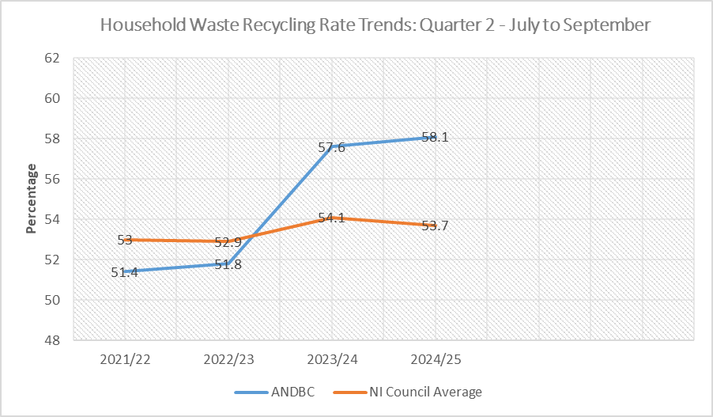

- The Council’s household waste recycling rate of 58.1%, was 4.4% higher than the Northern Ireland average of 53.7%.

- The Council was ranked third out of the eleven Northern Ireland Councils for its household waste recycling rate.
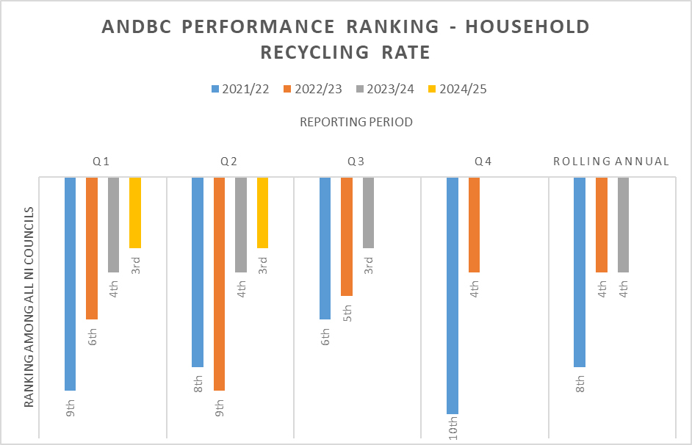

- The Council’s household waste composting rate fell slightly by 0.3% - from 38.4% to 38.1%. The household waste dry recycling rate rose by 0.8% - from 18.7% to 19.5%.

- The Council’s household waste composting rate of 38.1% was 6.8% higher than the Northern Ireland average of 31.3%.

- The Council’s household waste dry recycling rate (i.e. recycling of items other than organic food and garden waste) of 19.5% was 2.7% lower than the Northern Ireland average of 22.2%.

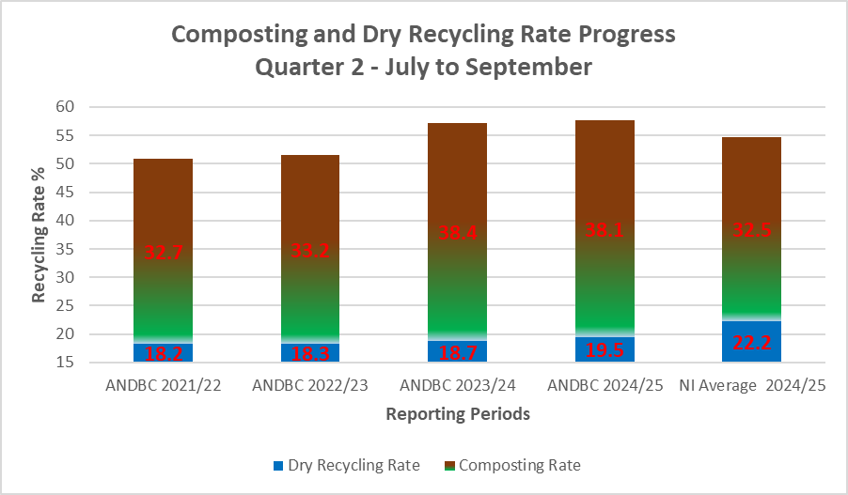

- The Council’s kerbside recycling capture rate of 79.3% for household compostable waste materials compared to a Northern Ireland Council average of 71.8%.

- The Council’s lowest kerbside capture rate for recyclable materials was for mixed plastics, at 21.4%.

Kerbside Capture Rate for Recyclable Waste Types - July to September
Recyclable Material | Kerbside Capture Rate for Recycling % | NI Average Kerbside Capture Rate for Recycling %
Glass | 63.8 | 49.6
Paper & Card | 59.4 | 53.2
Mixed Metals | 32.7 | 31
Mixed Plastics | 21.4 | 22.5
Organic/Compostables | 79.3 | 71.8

- The Council was still at the bottom end of the performance table for ‘dry’ recycling rate, ranking ninth out of eleven Councils.

- The Council received 7.2% less waste per capita at its HRCs compared to the average for other Northern Ireland Councils, compared to 17.4% more during the same period the previous year.

- The proportion of waste collected at the Council’s HRC sites for recycling was more than the average for other Councils – 75.8%, compared to an average rate of 74.6% for other Councils.

- The Council collected 12.6% more waste per capita from homes through its kerbside bin collection services compared to the average for other Councils.

- The proportion of waste collected for recycling through the Council’s kerbside bin collection system was significantly higher than the average for other Councils – 60.8%, compared to an average of 50.8% for other Councils.

- The percentage of total municipal waste to landfill which was biodegradable was the lowest of any Northern Ireland Council – 37.3% compared to a Northern Ireland Council average of 46.9%.

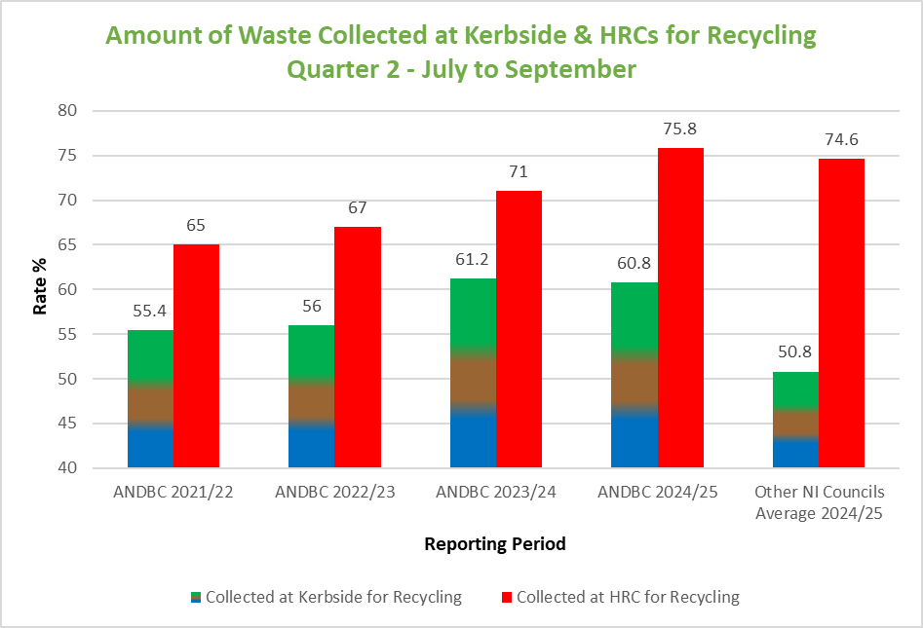

Operational Performance Improvement Measures

Marketing and Communications Indicators

MC1 – 20 social media posts were issued, with associated engagement/management of feedback across Waste and Recycling on ANDBC corporate channels.

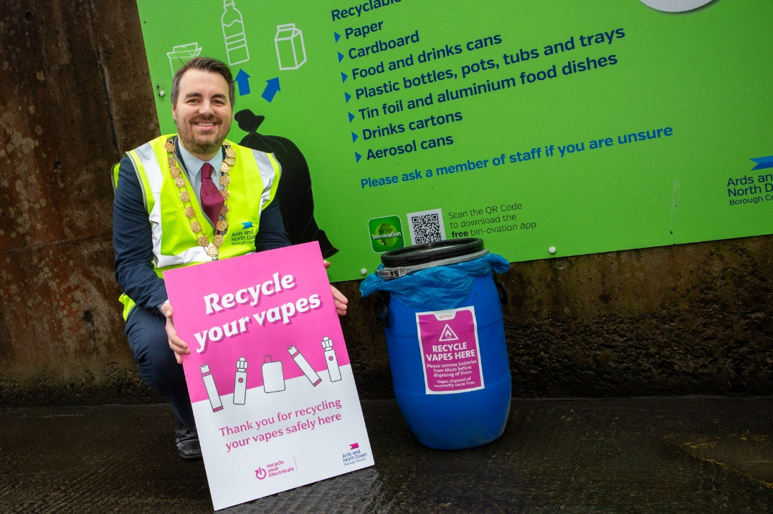

MC2 – 3 Bin-Ovation ‘News and Info’ articles were published,
5 Bin-ovation ‘Push Notifications’ issued, and 1922 Bin-ovation downloads recorded.
We currently have a total of 70,531 Bin-ovation householder users across the Borough.


MC3 – 12 community engagement and education events were delivered, talking to over 840 people.

- 6 summer schemes
- 5 schools
- 1 Council event
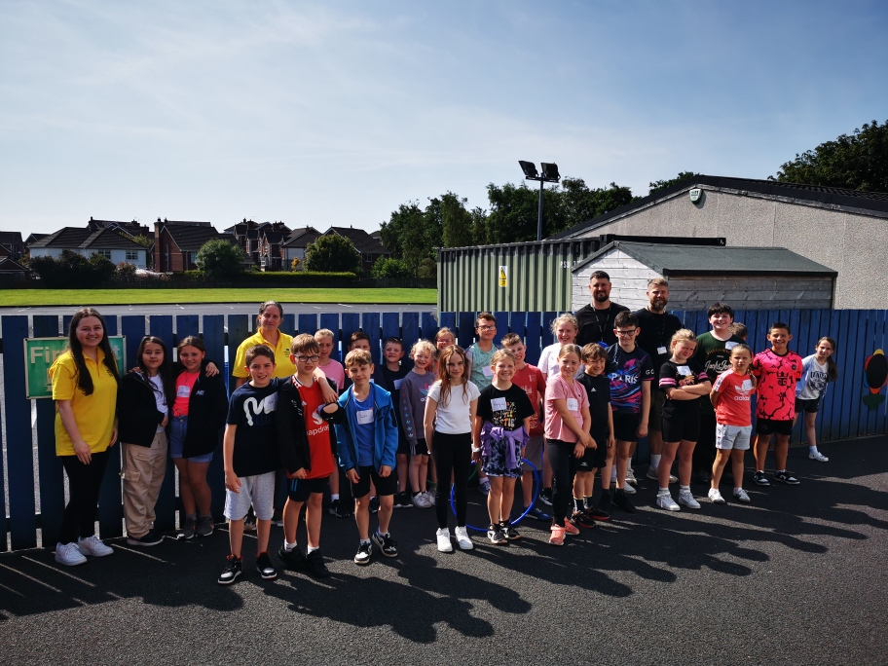

Household Recycling Centre Indicators

HRC1 – Volume of blue bin recyclable materials captured on-site for recycling: 640,660 litres

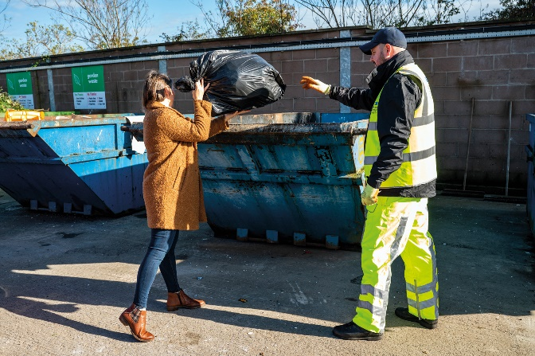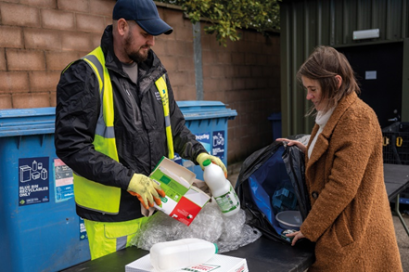
That equated to approximately 27 tons of blue bin waste, a significant proportion of which was recyclable waste extracted from bags of mixed waste that was initially intended to be placed landfill skips at HRCs. A collateral benefit of that practice of requiring removal of blue bin recyclables from black bags of mixed waste before using the landfill skip was that it should help to ‘educate’ householders - promoting more efficient separation of waste in the home and greater use of blue bins at the kerbside.

That represented just one type of recyclable waste category which was prevented from entering landfill skips at HRCs as a consequence of the Council’s more focused attention to supervision of landfill skip access; many other recyclable waste types would also have been prevented from entering the landfill skips as reflected in KPI, HRC3.

HRC2 – Number of visitors turned away from site: 844

That was a significant number in itself, but it was likely to be the case that a significant number of out of Borough residents would have avoided coming to the Council’s sites because of the widely publicised focus upon checking ID for everyone entering and those turned away would, in all probability, avoid further attempts to enter and use the Council’s HRCs; the impact of that would also be reflected in HRC3 and other KPIs.

HRC2a (new indicator) – Number of HRC bookings: 85,381

HRC2b (new indicator) – Average number of HRC visits per household: 1.19 (averaged across the 71,788 households in the Borough)

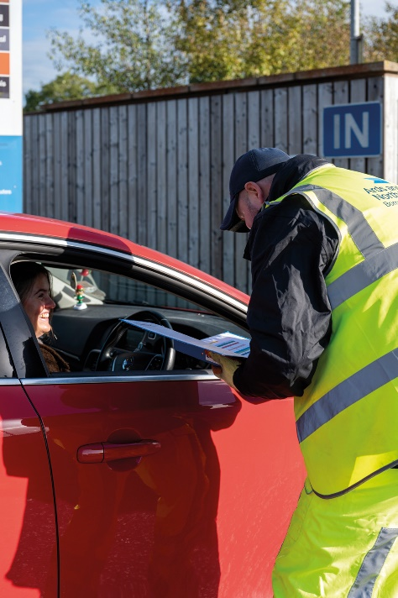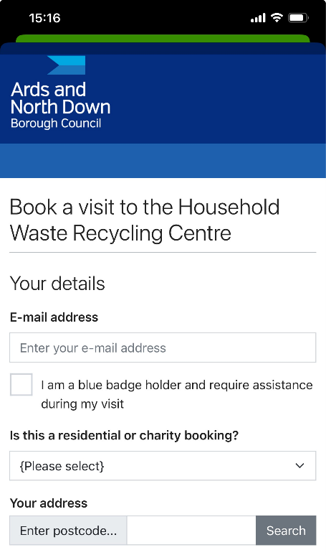

HRC3 – % change in tonnage of total waste received (compared to same period in baseline year 2021-22)

- The Council experienced a 31% decrease in the total amount of waste received at its HRCs, from 8602T to 5971T.

HRC4 - % change in tonnage of waste received for landfill (compared to same period in baseline year 2021-22)

- The Council experienced a 52% decrease in the amount of waste received for landfill at its HRCs, down from 2998T to 1445T.

HRC5 - % change in tonnage of waste received for recycling (compared to same period in baseline year 2021-22)

- The Council experienced an 19% decrease in the amount of waste received for recycling at its HRCs, down from 5604T to 4526T.

HRC6 - % change in proportion of HRC waste materials collected for recycling (compared to same period in baseline year 2021-22)

- The Council experienced a 10.8% increase in the proportion of all waste received at HRCs which was collected for recycling, up from 65% to 75.8%.

Kerbside Household Waste Collections Indicators
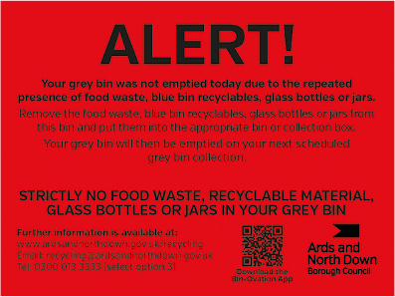
KSI – Number of recycling alert stickers applied to grey bins (yellow): 2837
KS2 – Number of recycling alert stickers applied to grey bins (amber): 224
KS3 – Number of recycling alert stickers applied to grey bins (red): 112
KS4 – % change in tonnage of total waste collected (compared to same period in baseline year 2021-22)
- The Council experienced a similar total amount of waste collected at the kerbside, slightly up from 15,596T to 15,666T.

KS5 - % change in tonnage of grey bin waste collected for landfill (compared to same period in baseline year 2021-22)
- The Council experienced a 12% decrease in the amount of grey bin waste collected, down from 6956T to 6136T.

KS6 - % change in tonnage of waste collected at kerbside for recycling (compared to same period in baseline year 2021-22)
- The Council experienced a 10% increase in the amount of waste collected at kerbside for recycling, up from 8640T to 9530T.

KS7 – % change in proportion of kerbside waste materials collected for recycling (compared to same period in baseline year 2021-22)
- The Council experienced a 4.8% increase in the proportion of kerbside waste that was collected for recycling, up from 56% to 60.8%.

Summary and Trend Analysis of Indicators
Indicator Reference | Monitoring Period 7 (July 2024 – September 2024
MC1  Social media posts | 20
MC2  Print press and online articles | 3
MC3  Engagement events/sessions | 12
HRC1  Blue bin waste (litres) | 640,660
HRC2  Visitors denied entry | 844
HRC2a  No. of bookings | 85,381
HRC2b  Average no. of HRC visits per household in the Borough | 1.19
HRC3  Total HRC waste compared to same period 2021/22 | 31% Decrease
HRC4  Landfill skip waste compared to same period 2021/22 | 52% Decrease
HRC5  Recycling skip waste compared to same period 2021/22 | 19% Decrease
HRC6  Proportion of HRC waste collected for recycling compared to same period 2021/22 | 10.8% Increase
KS1  Yellow warning stickers on grey bins | 2837
KS2  Amber warning stickers on grey bins | 224
KS3  Red warning stickers on grey bins | 112
KS4  Total kerbside waste compared to 2021/22 | No change
KS5  Grey bin waste compared to 2021/22 | 12% Decrease
KS6  Kerbside waste collected for recycling compared to same period 2021/22 | 10% Increase
KS7  Proportion of kerbside waste collected for recycling compared to same period 2021/22 | 4.8% Increase

Summary Analysis of Indicators
The report showed another very encouraging picture and generally conveyed a sustained improvement in its sustainable waste resource management performance against its baseline year of 2021-22. Following changes to the waste service model design and the associated education and engagement campaigns, the Council was experiencing sustained and further improving falls in the amount of landfilled waste as well as improvements in its recycling rates. During the reporting period, the Council experienced:

- Sustained falls in the total amount of landfill waste both at HRCs and kerbside. In total, the Council received/collected 2,278 tons less residual/non-recycled waste over the 3-month reporting period compared to the same period in the baseline year of 2021/22; at current landfill cost, that represents a £257k landfill saving.
- Falls in the total amount of waste collected at both HRCs and kerbside. In total the Council’s municipal waste arisings fell by 10% compared to the same period in 2021/22, compared to just a 2.4% drop across other Councils.
- A significant further rise in the recycling rate at HRCs. The percentage of materials collected for recycling at HRCs rose by 10.8% compared to the same period in the baseline year of 2021/22. The overall Borough household waste recycling rate rose by 6.7% compared to the same period in 2021/22.

Whilst the indicators set out in this report were very encouraging indeed and reflected a lot of hard work and dedication on the part of the Council’s waste and recycling teams, the Council undoubtedly had much further progress to make if it was to have any chance of ultimately reaching the 70% recycling target for 2030 that was laid down in the Climate Change Act (Northern Ireland) 2022. Continued bedding in and ongoing careful management of the new booking system for HRC access, the planned review of the kerbside collections model and a strategic review of the Council’s HRC capital assets, would be critical.

It was important to reiterate that ‘step change’, sustained improvements in both the Household Recycling Centre and kerbside recycling rates would be required to move the Council towards the new 70% target.

RECOMMENDED that the Council notes the report.

Proposed by Councillor Wray, seconded by Councillor Edmund, that the recommendation be adopted.

Councillor Wray thanked officers for the report and recognised that the Council had achieved improving statistics. Councillor Edmund echoed that and was pleased to see the turnaround after all the effort that the Council had put in to improve its recycling figures.

Councillor Morgan asked why Ards and North Down was at the bottom of the list for its dry recycling and the Director replied explaining that most other Councils had contracts in place to retrieve recyclables from grey bin waste before going for incineration, which was adding to their overall dry recycling rates. Ards and North Down Borough Council had recently awarded a similar contract, which should contribute to its official dry recycling in the future. The Council was also looking at ways of remodelling its kerbside waste collections model to promote diversion of more of the significant amount of recyclable from grey bins to recycling bins, and that would further improve the reported dry recycling rate helping to move closer to the target 70% Borough recycling rate.

AGREED TO RECOMMEND, on the proposal of Councillor Wray, seconded by Councillor Edmund, that the recommendation be adopted.

14. NOTICES OF MOTION

14.1 Notice of Motion submitted by Alderman Cummings and Councillor Douglas

That this Council brings back a report outlining the design, cost and positioning of an additional plaque on the War Memorial in Comber, to accommodate a list of historically researched names, currently being collated as per War Memorial Trust guidelines, of the fallen in the Great War 1914-1918, which were previously not included.

Alderman Cummings introduced his Motion explaining that the Comber branch of the Royal British Legion had been presented with a list of names, historically researched and collated, as being omitted from the town’s War Memorial. The period of time covered the 1914-1918 First World War.

On receiving the information, the branch undertook to start a process as per the War Memorial Trust Guidelines by establishing a working group to further scrutinise the names and began a process of verification. The reason the Motion was being presented to the Council was due to the Council being the custodian of the memorial and gardens and the desire of the Legion to establish the guidelines around the design and positioning of the additional plague(s).

He went on to say that there was no request for financial assistance as the Legion stated that it felt strongly, indeed duty bound, that it should undertake this responsibility.

An initial meeting between the Legion and the Council outlining their plans had already taken place and officers had indicated willingness to work together with a view to facilitating the Comber Royal British Legion in their endeavours.

The Alderman asked Members for their support to authorise officers to commence the process.

Councillor Douglas said that she was grateful for the opportunity to second this Motion being brought by her colleague. She agreed with his comments and would like to acknowledge the efforts that had already been made regarding the fact gathering and research information of the fallen Comber heroes during the First World War and that they deserved to be included on the War Memorial in Comber.

She hoped that everyone would agree that recognition of the people who had fought and died for peace and freedom should not be forgotten. Without their sacrifice she said we would be living in a very different world.

On a personal note, her great uncle had lost his life in the First World War and even though his remains were lying at the bottom of the Mediterranean Sea, he had a headstone in the Church of Ireland graveyard in Comber, which commemorated the sacrifice he had made. That had been a great comfort to generations of her family knowing that he was remembered for giving his life for freedom.

She finished by asking that the Notice of Motion be given support and that a report be brought back outlining the design, cost and positioning of an additional plaque on the War Memorial in Comber Square to include names of further historically researched individuals.

Councillor Wray rose to support the Motion and thanked the Members for bringing it before the Committee. He agreed that it was important to remember the fallen heroes and he paid tribute to the volunteers and those doing the research and for the Royal British Legion in the payment for the work.

Councillor Morgan rose to support what was a really important Motion and she agreed that all the fallen heroes should be represented at the memorial in Comber.

Alderman Cummings thanked Members for their support.

AGREED, on the proposal of Alderman Cummings, seconded by Councillor Douglas, that the Notice of Motion be adopted.

15. ANY OTHER NOTIFIED BUSINESS

There were no items of Any Other Notified Business.

Exclusion of Public/Press

AGREED, on the proposal of Councillor Edmund, seconded by Councillor Douglas, that the public/press be excluded during the discussion of the undernoted items of confidential business.

16. ASSETS AND PROERTY SERVICES STAFFING REVIEW

***IN CONFIDENCE***

NOT FOR PUBLICATION SCHEDULE 6 – INFORMATION WHICH IS LIKLEY TO REVEAL THE IDENTITY OF AN INDIVIDUAL

A report relating to proposed changes in staffing arrangements below Service Unit Manager Level within the Assets and Property Services Department was considered.

It was agreed to recommend that the Council approves the implementation of the proposed staffing changes as set out in the report.

17. EXTENSION OF VARIOUS EXISTING TENDERS

***IN CONFIDENCE***

NOT FOR PUBLICATION SCHEDULE 6 – INFORMATION RELATING TO THE FINANCIAL OR BUSINESS AFFAIRS OF ANY PARTICULAR PERSON

A report on the extension of various tenders was considered.

It was agreed to recommend that the Council agrees to the following contracts being extended for one further year, in line with the terms set out in the original tender.

- Provision of New and Replacement Play Areas
Lot 1 Northern Area – Garden Escapes (Ireland) Ltd.
Lot 2 Southern Area – Play and Leisure Services.

- Repair of Plumbing Works
Irwin M+E Ltd.

18. CAR PARK ENFORCEMENT OUTSTANDING DEBT

***IN CONFIDENCE***

NOT FOR PUBLICATION SCHEDULE 6 – INFORMATION RELATING TO THE FINANCIAL OR BUSINESS AFFAIRS OF ANY PARTICULAR PERSON

A report relating to outstanding car parking enforcement debt was considered.

It was agreed to recommend that the Council approves write off of the outstanding debt from the former car park enforcement contract as detailed in the report.

Re-admittance of public/press

AGREED, on the proposal of Alderman Cummings, seconded by Councillor Edmund, that the public/press be re-admitted to the meeting.

Termination of meeting

The meeting terminated at 8.53 pm.

