ARDS and North Down Borough Council

A hybrid (in person and via Zoom) meeting of the Community and Wellbeing Committee was held at the Council Chamber, Church Street, Newtownards, and via Zoom, on Wednesday 10 September 2025 at 7.00 pm.

Present:

In the Chair: Alderman McRandal

Alderman: Adair Brooks (Zoom)
Cummings

Councillors: Boyle S Irvine
Chambers McBurney
Cochrane McClean
Douglas McKee (Zoom)
Hollywood Moore

Officers in Attendance: Director of Community and Wellbeing (G Bannister), Director of Active and Healthy Communities (A Falkner), Head of Community and Culture (N Dorrian), Head of Leisure Services (I O’Neill - Zoom), Head of Parks and Cemeteries (S Daye), Acting Head of Environmental Health, Protection and Development (G Kinnear), Head of Finance (S Grieve from 8.30pm) and Democratic Services Officer (R King).

1. APOLOGIES

The Chairman (Alderman McRandal) sought apologies at this stage and noted none had been received.

CHAIRMAN’S REMARKS

The Chair noted that this was the final meeting of the Community and Wellbeing Committee prior to its transition to the Active and Healthy Communities Committee. He welcomed Adele Falkner as the newly appointed Director of Active and Healthy Communities and extended his congratulations on her recent appointment.

It was further noted throughout the discussion that, from October 2025, under the recent directorate restructure:

• The current Director of Community and Wellbeing would assume the role of Director of Environmental Services.
• The Head of Parks and Cemeteries would report to the Director of Environmental Services.

The Chair also congratulated the Head of Leisure Services on his upcoming retirement at the end of September, acknowledging that this would be his final meeting. He expressed thanks for the officer’s years of service and wished him well in his retirement.

Alderman Adair joined the Chair in congratulating the new Director of Active and Healthy Communities and extended his thanks to the retiring Head of Leisure Services, along with best wishes to officers moving to the new directorate.

Councillors Boyle and Chambers echoed those sentiments, with Councillor Chambers paying tribute to the retiring Head of Leisure Services, acknowledging his support for Liverpool Football Club by concluding with: “You’ll Never Walk Alone.”

NOTED.

2. Declarations of Interest

The Chairman sought Declarations of Interest at this stage.

The following declarations of interest were notified:

Councillor Douglas – Item 9 – Arts and Heritage Grant Schemes.

Alderman Brooks – Item 7 – Britain in Bloom Awards 2025 (declared at 8pm).

NOTED.

DEPUTATIONS

3. Smartphone Free Childhood NI
(Appendix I)

Rosalind McClean, a parent and spokesperson for Smartphone-Free Childhood NI, referred to the attached slides, highlighting concerns over children's smartphone use, describing it as a new parenting challenge that the organisation referred to as ‘the new frontier of parenting’. Ms McClean referred to Ofcom data showing that 24% of UK children aged 5–7 owned smartphones, rising to 89% by age 12, despite 94% of primary school parents believing they were harmful.

Ms McClean emphasised adolescent worries, noting two-thirds of 16 -18-year-olds saw smartphones as harmful, with half feeling addicted to social media. Peer pressure and online communication made resisting smartphones difficult. Tech companies profited most, she argued, and studies linked early use to poorer mental health. Data from Northern Ireland showed a sharp rise in suicide ideation among girls.

She referenced high rates of exposure to explicit content, with 51% of UK children aged 11-13 having viewed hardcore pornography, which nowadays was violent, misogynistic and degrading to women. She felt that needed to be highlighted further in society and provided further statistics of many young smart phone users receiving unwanted explicit images.

Smartphones were "addictive by design," leading British 12-year-olds to spend 29 hours weekly on their devices and young teens to spend over seven hours online daily.

NHS statistics showed outdoor accidents had dropped while self-harm had surged. Ms McClean reflected on her own active childhood and questioned whether children were now overprotected physically but under protected online. She acknowledged parents' dilemmas and urged community action while noting slow governmental progress.

Smartphone-Free Childhood encouraged delaying access to smartphones until age 14, promoting simpler devices instead. The movement attracted about 300,000 UK parents, including nearly 3,000 children in Northern Ireland. Ms McClean concluded by seeking Council support to raise awareness and distribute information to more families.

Members raised a series of questions. Councillor Cochrane, expressing alarm at the statistics, asked for examples of other councils that had participated in the Smartphone-Free Childhood initiative. In response, Ms McClean explained that Barnet, a London borough, was the first to go smartphone-free, with a move towards use of only brick phones. She also noted collaborative efforts in Greystones, Co Wicklow, where schools had collectively advised parents against purchasing smartphones, and remarked that school principals in North Down had been supportive of the scheme. She also felt that the Members of this Committee, as Councillors, were well placed to spread the message.

Councillor Chambers highlighted the negative impact of smartphones on children’s temperament and mental health, observing that such challenges began at home with adult behaviour. He suggested that the campaign could be extended to reduce adult screen-time habits. Ms McClean acknowledged this idea, referring to her own practice of leaving her phone downstairs at night and raising the potential for parent-focused healthy technology programmes. She understood the challenges though for parents in terms of wanting their child to fit in with a smartphone rather than a brick phone. She further suggested that the Council could support or even lead on parent education campaigns which would be valuable.

Councillor McBurney, expressing concern at the statistics presented, sought further details on how the Council might support the campaign, suggesting it could encourage donations of brick phones.

Ms McClean would welcome that and she mentioned an example of a school in Sevenoaks, where every P6 (equivalent to P7 in NI) child received a brick phone, and suggested that Council funding for flyers could help engage families and raise awareness. She recounted her involvement with primary schools and a presentation to North Down principals, hosted by MP Alex Easton and the PSNI, that had advocated smartphone-free approaches. She further encouraged increased funding for youth work initiatives including youth spaces, community centres, and play parks.

Councillor McClean asked if the presentation slides could be shared with the public, believing the statistics would be alarming to a wider audience. He also raised questions about empowering schools and parents to take action, the possibility of achieving strong parental support, and why more schools had not participated.

Ms McClean replied that primary schools had been supportive and distributed materials, and pointed to St Albans in Wicklow as an example where schools had taken a firm approach. She felt that the responsibility for achieving smartphone-free status rested with secondary schools and that the solution had to be parent-led. She called for Council assistance in reaching families and stressed that a public health campaign and a society-wide effort were necessary.

Councillor Hollywood, noting that his question had already been asked, thanked Ms McClean for the presentation and added that, as a parent, he had found the information valuable and informative.

The Chair thanked Ms McClean for attending and she returned to the public gallery.

Councillor Cochrane proposed, seconded by Councillor McClean, that officers bring back a report based on the matters raised in the deputation in terms of how this Council can support Smartphone Free Childhood for the safety and wellbeing of all our children.

Councillor Cochrane explained that he had been moved by the campaign and the statistics presented, and he wanted to bring forward this proposal to look at how the Council could assist.

AGREED TO RECOMMEND, on the proposal of Councillor Cochrane, seconded by Councillor McClean, that officers bring back a report based on the matters raised in the deputation in terms of how this Council can support Smartphone Free Childhood for the safety and wellbeing of all our children.

4. U3A – UNIVERSITY OF THE THIRD AGE
(Appendix II)

The Chair welcomed Valerie Dickson, Valerie Goodchild and Mary Cromey representing North Down and Ards University of the Third Age (NDA U3A).

The Committee received a presentation from Ms Goodchild outlining the background, structure, and activities of the University of the Third Age (U3A), both nationally and locally. U3A was described as a self-help educational organisation for those no longer in full-time employment, promoting informal learning within a social context. Membership was open to all, regardless of age or employment status.

Founded in France in 1973 and introduced to the UK in 1981, the UK model was based on three principles: Third Age, Self-Help Learning, and Mutual Aid. The Third Age was defined as the life stage following reduced career or family responsibilities but preceding older age and infirmity. U3A was non-religious and non-political.

Nationally, the Third Age Trust supported over 1,000 U3As and 430,000 members. In Northern Ireland, 24 U3As served over 8,000 members, with North Down and Ards U3A—established in 1997—among the largest, with approximately 1,300 members.

North Down and Ards U3A operated as a registered charity, funded primarily through membership fees (£15 per person), with occasional grant support. It offered over 100 interest groups across a wide range of topics, most led by volunteers, with some physical activities facilitated by paid instructors. Group formation was member-driven, with recent additions including psychology and astronomy.

The organisation was managed by a 10-member committee and likened to a small government department. Members were encouraged to contribute, even in small roles, and new members were informed of this expectation.

Ms Goodchild shared her personal experience of joining U3A following bereavement, describing it as a lifeline. She highlighted the group’s social ethos—reflected in its motto “Learn, Laugh, Live”—and its wide-ranging activities, including themed events, concerts, quizzes, and an intergenerational programme supporting local schools and youth initiatives.

She expressed appreciation for Council support, including subsidised venue access and grant guidance, and proposed further collaboration to reach underrepresented groups. She suggested displaying U3A posters in community venues to raise awareness and described U3A as one of the UK’s best-kept secrets.

The presentation concluded with photographs showcasing U3A activities, including painting, nature walks, Canasta, ukulele performances, and the new psychology group.

The Chair invited questions from Members and Councillor Hollywood queried the group’s existing use of venues.

In response, Ms Cromey explained that smaller U3A groups often met in members’ homes. The organisation also utilised public spaces such as libraries, but the majority of its activities took place in council-owned venues with Hamilton Road Community Hub in Bangor one of their most frequently used facilities.

Ms Cromey noted that there were approximately 34,000 retired individuals in the Borough and expressed surprise that U3A had not been more actively consulted in local strategy development. With over 3,000 members across Holywood, Ards Peninsula, and North Down, she emphasised that U3A represented a significant demographic and could offer valuable input. She recommended that future workshops and consultations include the organisation’s perspective and questioned the effectiveness of recent engagement efforts, citing a Department for Communities consultation that had received only 91 responses across Northern Ireland.

Councillor Boyle commended the work of NDA U3A and remarked that the organisation appeared to be in capable hands under the leadership of the three representatives. He had understood that the group operated with limited grant support and asked whether there was a specific annual figure required to sustain itself.

In response, Ms Cromey advised that the oversight group the U3A Trust recommended maintaining six months’ running costs, estimated at £6,000 to £7,000. She confirmed that current membership fees were sufficient to meet this target. The organisation was managed efficiently, with minimal expenditure, and membership income was primarily used to fund equipment and support group activities.

NDA U3A had invited its activity groups to request support for equipment needs, with a modest fund set aside for that purpose. Ms Goodchild referred to the bridge and Canasta groups, whose shared tables required refurbishment, and outlined plans to explore repair options through an upcycling centre. Ms Cromey said that contributions toward such improvements would be welcomed.

Councillor Douglas raised a query around a U3A group in Comber and asked about its involvement with NDA U3A. Ms Goodchild explained that Comber was part of Ards Peninsula U3A and referenced a regional group covering Ards and North Down. Ms Cromey added that the Chair of North Down and Ards U3A also chaired the local U3A network, which included Comber, Ards Peninsula, Belfast, Lisburn, and North Down. The network facilitated the exchange of ideas and best practice, with Comber recently contributing a new approach to language learning.

Councillor McClean expressed appreciation for the presentation and remarked that more meetings should begin with contributions from local groups working to combat isolation. He described U3A as one of the UK’s best-kept secrets and was struck by the scale and dedication of its membership. He suggested the Council go beyond permitting posters in community halls by actively monitoring their visibility and considering further strategic support for the organisation.

In response, Ms Goodchild highlighted ongoing frustrations with posters being removed from halls and suggested that formal Council permission might help address that. She acknowledged the Council’s support at Hamilton Road Community Hub but noted that the U3A message board had been relocated to a poorly visible location.

The Chair thanked the deputation and both Ms Goodchild and Ms Cromey returned to the public gallery.

The Deputy Mayor, Councillor Moore, acknowledged the impressive scope of the organisation’s activities, noting that despite operating primarily on membership fees, it delivered a wide range of classes and events with consistency throughout the year.

Councillor Moore proposed, seconded by Alderman Adair, that officers bring back a report to consider how the Council could support the work of U3A.

The Deputy Mayor, Councillor Moore, spoke of the importance of the Council engaging with North Down and Ards U3A as a valuable community resource. She emphasised that the older population represented a significant demographic within the Borough and cautioned that, without collaborative efforts to reflect their needs and expectations, the Council risked missing a vital opportunity.

She requested that the forthcoming report consider ways to strengthen partnership working and explore how the Council could benefit from the extensive knowledge and expertise held within NDA U3A.

The seconder, Alderman Adair, praised the organisation’s work and noted that Ards and North Down had the highest proportion of older residents in Northern Ireland. He stressed the value of initiatives that encouraged community engagement among older people and looked forward to the forthcoming report.

He was particularly moved by the personal account shared by Ms Goodchild, who had found support through U3A following bereavement. He remarked that many of his constituents who were elderly, bereaved, or experiencing loneliness could similarly benefit from the organisation’s work.

AGREED TO RECOMMEND, on the proposal of Councillor Moore, seconded by Alderman Adair, that officers bring back a report to consider how the Council can support the work of U3A.

5. item withdrawn

6. North Down Coastal Path Proposed Planning Application (FILE CW30)
(Appendix III)

PREVIOUSLY CIRCULATED:- Report from the Director of Community and Wellbeing detailing that after the planning application for a proposed greenway along the North Down Coastal Path (LA06/2020/0530) was withdrawn in February 2023, the ‘North Down Coastal Path Task & Finish Working Group’ was established to look at the approaches to addressing issues on the path including maintenance, signage, promotion and future options surrounding its use.

Officers from Parks & Cemeteries had supported the Working Group, which had made some proposals to address issues identified. One such project had been prioritised, and to progress it, there was a need to submit a planning application. This project would have addressed the section which had been agreed by the group as a priority in terms of needing remedial work to ensure that the path was more usable and provided better connectivity between Royal Belfast Golf Club and Seahill.

Drawings had been prepared, and these had been presented and circulated to the members of the Working Group for consideration. Any proposed amendments were to be discussed and incorporated where possible before the drawings were finalised.
The proposal would have covered the section from the bridge at Seahill to the Royal Belfast Golf Club, approximately 2km long. This section was particularly narrow, uneven underfoot as the gravel had been periodically washed out, exposing kerbs etc., had overgrown verges, and the section along the Royal Belfast Golf Club was at risk of collapse given that the rock armour underneath it had slipped, leaving the path unsupported in places.

Discussions were required with the respective landowners prior to the submission of the planning application. Certain surveys were required, and these were being explored. It had been proposed by the Working Group that photomontages were incorporated alongside the planning drawings so that the proposed improvements could be clearly understood. These were the minimal interventions to ensure the durability of the path and improve its condition only; however, they would still have required planning permission given the designations along the coastline. The majority of the path was in the coastal flood inundation zone, and in places it was considered prudent to create a raise in freeboard/levels by approx. 300mm to raise it slightly out of the inundation zone to ensure the durability of the path.

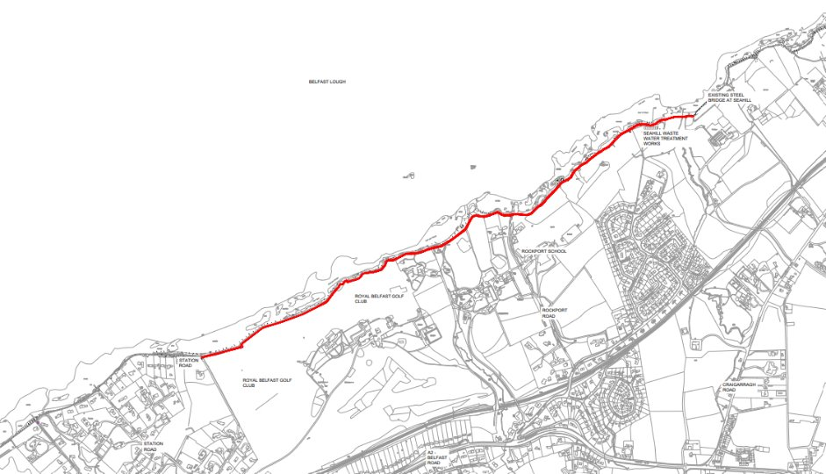
Proposed extent of the planning application

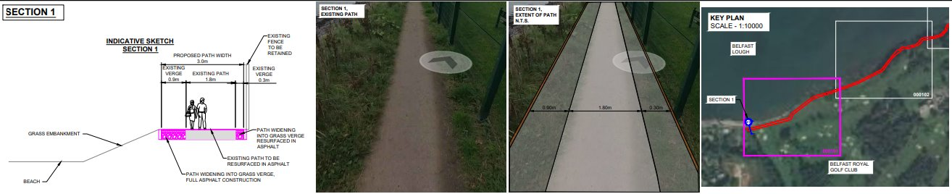
Example of the proposed drawings, Section 1 along Royal Belfast Golf Club (Path as existing, proposed verges cleared, path resurfaced, and rock armour reinforced.

Funding sources and landowner permissions would be investigated as part of the next stage of this project development process.

RECOMMENDED that Council approves further development of the details of this proposal with the working group and the eventual submission of a planning application pertaining to the section as outlined in the above map.

Councillor Chambers proposed, seconded by Councillor McKee, that the recommendation be adopted.

Councillor Chambers felt that the proposed path improvement project was an essential piece of work. Councillor McKee agreed, stating that while no one wished to see actions that might cause friction, it was vital to preserve the uniqueness of the path and strike the right balance. He emphasised the importance of learning from previous issues, maintaining clear communication with the public, and ensuring that the project’s objectives and outcomes served both the community and the environment.

Councillor Hollywood enquired about the next steps in the path improvement project, specifically regarding funding sources, landowner permissions and timescales.

The Head of Parks and Cemeteries advised that funding had been allocated within the Council’s budget to support a portion of the path improvement works. However, the exact costs remained uncertain and he explained that groundwork could be complex and unpredictable, and the Council was currently undertaking survey work to inform the next steps.

In terms of timescales, it was anticipated that the path would need to be closed for several weeks during the works. That temporary closure was considered essential to safeguard the long-term future of the path, which had been significantly undermined and would likely require permanent closure in the coming years if repairs were not undertaken.

The Chair explained he was very familiar with that particular section of the coastal path and was pleased that the project was moving forward, noting that it was in clear need of repair.

AGREED TO RECOMMEND, on the proposal of Councillor Chambers, seconded by Councillor McKee, that the recommendation be adopted.

(Alderman Brooks, attending remotely, declared an interest in Item 7 and was excluded from the meeting at 8pm)

7. Britain in Bloom Awards 2025 (FILE PCA121)

PREVIOUSLY CIRCULATED:- Report from the Director of Community and Wellbeing detailing that Donaghadee was representing Northern Ireland in the Small-Town category of the 2025 Royal Horticultural Society (RHS) Britain in Bloom competition.

Britain in Bloom was one of the largest horticultural campaigns in Europe, was run by the Royal Horticultural Society (RHS) and worked year-round to create a cleaner and greener Britain through community action. As well as celebrating horticultural excellence, Britain in Bloom promoted cleanliness, sustainability and community participation.

As such, the campaign complimented several council initiatives and strategies aimed at enhancing the visual appearance and sustainability of the Borough.

In preparation for the RHS Britain in Bloom judging visit, Officers from the Parks and Cemeteries Service had worked in close partnership with Donaghadee Community Development Committee and local volunteer groups to present the town befitting of the Britain in Bloom campaign criteria.

Judging took place on Monday 1st August 2025 when the judges were taken on a guided tour of the town to assess under the marking criteria of Horticultural Achievement, Environmental Responsibility, and Community Participation.

The announcement of the results was to be held at a ceremony in the Royal Horticultural Society in Brighton on 31st October 2025 between 12pm and 5pm. An invitation had been received for up to 5 persons to attend the Award Ceremony, and it was proposed that the Mayor, one Council Officer and three members of Donaghadee Community Development Committee would attend the ceremony. It was envisaged that the cost for five persons to attend this prestigious event would be approximately £600 for flights.

RECOMMENDED that Council approves attendance at the Britain in Bloom Awards ceremony in London of the Mayor, one Council Officer and three members of Donaghadee Community Development Committee.

Councillor Cochrane proposed, seconded by Councillor Chambers, that the recommendation be adopted.

At the outset, Councillor Cochrane noted that the ceremony was taking place in Brighton and not London as stated in the recommendation. He reflected on his attendance at the In Bloom Judging Day on 1st August, alongside several other councillors from the DEA. He commended the strong sense of community spirit and praised the efforts of Donaghadee Community Development Association and local residents in showcasing the town to the judges. He described Donaghadee as a fantastic coastal town and remarked that it was truly “blooming” and extended his best wishes for the awards ceremony.

AGREED TO RECOMMEND, on the proposal of Councillor Cochrane, seconded by Councillor Chambers, that the recommendation be adopted.

(Alderman Brooks was returned to the meeting – 8.03pm)

8. Hygiene Bank at Ards and North Down Borough Council Leisure Sites (FILE LEI23)

PREVIOUSLY CIRCULATED:- Report from the Director of Community and Wellbeing detailing that the Hygiene Bank (THB) was a registered UK Charity (1181267) who stated they were a grassroots people-powered charity grounded in their community and totally managed in Northern Ireland by dedicated volunteers. They believed that everyone deserved to be able to care for themselves and their family, and they believed that access to hygiene products was critical for people to maintain their health and wellbeing. Their purpose was to ensure no one was held back from participating in society because of hygiene poverty. They believed in building stronger, resilient communities by working together to shape a more just society.

The charity placed collection points for hygiene products in locations that the public had access to. These locations included shops, pharmacies etc. throughout Northern Ireland. The donated products were then collected and distributed by partner foodbanks, charities and some schools.

There were fourteen similar schemes throughout Northern Ireland run by volunteers and project coordinators. These were proving a success, and it was proposed that a scheme coming to the Borough would expand this provision for residents within the Ards and North Down Borough. This proposal, however, would be unique in Northern Ireland in that it would involve a collaboration between a local authority and the charity, with local authority sites being utilised as potential collection locations for the charity.

Proposal to Establish Collection Points within the Borough
The Hygiene Bank NI were proposing to enter into a collaboration with Ards and North Down Borough Council. They had proposed establishing collection points at the Council’s centres where members of the public could leave hygiene products. These products would then be collected by THB NI volunteers and donated to distribution partners within the community. All donated products would remain within the Borough.

The Community Partners who were registered with THB NI within the Borough were:

- Newtownards Foodbank
- Belfast Central Mission based in Newtownards
- Bowtown Community Development Group Newtownards
- The Warehouse (ND Community Works) Newtownards
- The Storehouse Bangor
- Bangor Foodbank and Community Support
- Bangor Sure Start
- Belfast Central Mission based in Bangor
- St Mary's PS Comber
- St Malachy's PS Bangor
- Kilcooley Women's Centre Bangor
- Holywood Family Trust Holywood
- Kiltonga Christian Centre, Conlig

Operationally, their local volunteers would call regularly to collect any donations. Initially, they intended to visit sites and empty donation boxes every 2–3 weeks. At the time of collection, the volunteers took a note as to how full the boxes were in case the frequency of collections needed to increase. In addition, THB NI also had their mobile number written on the inside of the box if it was filling up quickly, and
Council colleagues could call the local coordinators to prompt a pickup.

It was proposed that initially a few facilities would be selected by THB NI and donation points would be established at those sites by way of a trial. Over time, the scheme, if successful at these sites, would be extended to other sites across the Borough to facilitate more access to donation points and ultimately more support for those in the community who would benefit from this support.

RECOMMENDED that Council engages with The Hygiene Bank to provide collection points at some Council facilities throughout the Borough and if an initial trial period proves successful Officers and THB NI would expand the scheme across other suitable Council sites across the Borough.

Councillor Douglas proposed, seconded by Councillor Hollywood that the recommendation be adopted.

Councillor Douglas stated that while access to basic hygiene products was often taken for granted, many residents in the borough were forced to choose between such essentials and food due to the ongoing cost-of-living crisis. She emphasised that the scheme would provide vital support to those facing financial hardship.

Councillor Hollywood expressed his support for the initiative and enquired about how its success would be measured and the proposed duration of the trial.

The Head of Leisure Services confirmed that the initiative would be assessed by THB NI, who had prior experience in delivering similar schemes. Success would be determined by levels of public uptake and donations received. The trial was expected to run for a period of three to six months.

Councillor McBurney also voiced her support, describing it as deeply unfortunate that individuals continued to rely on hygiene banks in 2025. She called for greater support through the welfare system to address the underlying issues.

AGREED TO RECOMMEND, on the proposal of Councillor Douglas, seconded by Councillor Hollywood, that the recommendation be adopted.

(Councillor Douglas withdrew from the meeting having a declared an interest in Item 9 – 8.03pm)

9. Arts and Heritage Grant Schemes (FILE ART 14 2026/27, ART 06 2026/28, ART 14 2026/27, ART 14 2026/27 and HER 01 2026/27)
(Appendix IV – VIII)

PREVIOUSLY CIRCULATED:- Report from the Director of Community and Wellbeing detailing that the Arts and Heritage Service operated a number of grants programmes.

Attached were application forms and guidance criteria for five of these programmes.

Arts Project Grant Application and Criteria 2026–27 – Appendix 1
The aim of the Grant was to support community-based arts projects, events or activities taking place in the Ards and North Down Borough Council area. A maximum of £1,000 could be awarded to support groups undertaking creative activities per annum.

Multi-Annual Arts Grant Application and Criteria – Appendix 2
The Multi-annual Arts Grant scheme was open to constituted arts organisations in the Borough who met the eligibility criteria. The scheme opened every two years and awarded a grant of up to £5,000 for Core funding or up to £4,000 for an annual one-off Arts Festival.

Youth Art Training Grants 2026–27 – Appendix 3
The aim of Ards and North Down Borough Council’s Youth Arts Training Grant was to help support young people (aged 11–21 years) in their artistic development through training and development opportunities. The Fund was available for training and residencies up to £250.

Individual Artist Grants 2026–27 – Appendix 4
The annual Individual Artist Grant scheme was open to professional artists working and living in the Borough to apply for support towards training costs and artistic residencies. The Fund was available for training and residencies up to £250.

Heritage Project Grants 2026–27 – Appendix 5
The annual Heritage Project Grant scheme was open to professional artists working and living in the Borough to apply for support towards training costs and artistic residencies. The Fund was available for training and residencies up to £250.

Under the new Grants Policy, these schemes required approval from Council prior to launching.

RECOMMENDED that Council approves the schemes for the listed grants programmes and as detailed in the appendices to this report.

Councillor Moore proposed, seconded by Councillor McBurney, that the recommendation be adopted.

The Deputy Mayor, Councillor Moore, expressed support for the grant scheme. She queried the youth, individual, and heritage grant categories, noting that the £250 maximum award was modest given rising costs. She asked how recipients typically used the funding and whether the scheme could be restructured to offer fewer but larger awards, maintaining the overall budget while increasing impact. She also queried the current level of demand for the grants programme.

The Head of Community and Culture explained that the types of projects varied widely. The funding served as a contribution toward the artist’s total costs and she clarified that the Heritage category allowed grants up to £500, not £250 as stated in the report. While a restructure to increase individual awards was possible, she explained that the application process was already oversubscribed and she went on to provide a breakdown of the total funding available for each category.

AGREED TO RECOMMEND, on the proposal of Councillor Moore, seconded by Councillor McBurney, that the recommendation be adopted.

(Councillor Douglas returned to the meeting – 8.08pm)

10. Request to Support a Blue Plaque to honour William Sharman Crawford (FILE HER 06 09/25)
(Appendix IX)

PREVIOUSLY CIRCULATED:- Report from the Director of Community and Wellbeing detailing that the Ulster History Circle had approached Officers to request that Ards and North Down Borough Council support the proposal of a Blue Plaque to William Sharman Crawford (1780–1861) of Crawfordsburn, a leading advocate of tenant-right land reform in the mid-1800s. The Ulster History Circle had identified a possible location in Crawfordsburn village as a site for the plaque and was seeking approval from the owners.

A number of years ago, an informal commitment had been made by Ards and North Down Borough Council to support one blue plaque per annum in the Borough. Most recently, a plaque in honour of Viscount Castlereagh had been unveiled in Newtownards in 2023. No request had been made in 2024.

The cost to Council would be £1,300 to cover the fabrication and installation of the plaque and a small reception with catering to mark the unveiling.

It was proposed that the plaque be unveiled in the autumn of 2025.

A biographical note on William Sharman Crawford was attached at Appendix 1.

RECOMMENDED that Council support the erection and unveiling of an Ulster History Circle Blue Plaque in honour of William Sharman Crawford.

Alderman Adair proposed, seconded by Councillor McClean, that the recommendation be adopted.

Alderman Adair welcomed the recommendation, emphasising the importance of preserving the history and heritage of Ards and North Down. He praised the Ulster History Circle’s decision to honour William Sharman Crawford with a blue plaque, noting that such tributes celebrated personal stories that resonated with the public. He hoped to see more plaques erected across the Borough in future.

AGREED TO RECOMMEND, on the proposal of Alderman Adair, seconded by Councillor McClean, that the recommendation be adopted.

11. Public Drinking Water Supply 2024 (FILE CW98)
(Appendix X)

PREVIOUSLY CIRCULATED:- Report from the Director of Community and Wellbeing attaching the Drinking Water Quality Report produced by Northern Ireland Water (NIW) for the Ards and North Down Borough Council area for 2024. The report indicated a 99.9% level of compliance with an extensive array of drinking water quality parameters as laid down in the Water Supply (Water Quality) Regulations (Northern Ireland) 2017, as amended in 2018.

One serious water quality failure had been recorded for the Borough during the year. This failure had been caused by algal blooms in Lough Neagh, which provided a small proportion of the water supply for the Borough. The algal blooms had caused a significant deterioration in the raw water quality in Lough Neagh. This was classed as a ‘taste and odour’ event, rather than a safety failure, as algae produced compounds detectable at very low limits, which could give water an earthy/musty flavour and odour. NIW had undertaken work at Castor Bay Water Treatment Works to help improve removal of these taste and odour-related chemicals. An enhanced sampling and monitoring programme for these compounds, in both the raw and treated drinking water, was in place.

There had been five significant drinking water quality events that impacted the Borough, all relating to raised levels of aluminium in the water supply at Drumaroad Water Treatment Works. Aluminium could occur naturally in water within certain catchments. However, aluminium compounds were used in the treatment process to help remove impurities. Any aluminium compounds added during the treatment process were removed before the final treated water left the treatment works. The Drinking Water Inspectorate (DWI) had enforcement measures in place to deal with aluminium contraventions at Drumaroad WTW by September 2025. The Environmental Health, Protection and Development Service would write to DWI in September to ask for an update on progress on this matter.

A number of minor water quality events impacting the Borough were contained within the report, broken down by water supply zone.

The map below showed the various supply zones for Ards and North Down, as well as compliance levels from 2019 onwards.

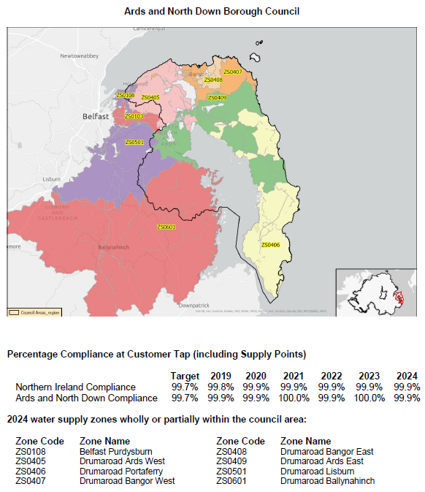

RECOMMENDED that Council note the report.

The Acting Head of Environmental Health, Protection and Development referred Members to page 1 of the report, which referenced a serious water failure that had impacted some properties within the Borough. He clarified that the DWI had stated following further investigation, that it was confirmed that the affected supply was not serving this Borough at the time, and therefore, there had been no local impact.

AGREED TO RECOMMEND, on the proposal of Councillor McBurney, seconded by Councillor Moore, that the recommendation be adopted.

12. Ards and North Down Sports Forum Grants (FILE SD155)
(Appendix XI – XIII)

PREVIOUSLY CIRCULATED:- Report from the Director of Community and Wellbeing detailing that the Ards and North Down Sports Forum administered grants for sporting purposes on behalf of Council under the Council’s Grants Policy agreed in 2024.

£70,000 had been allocated within the 2025/2026 revenue budget for this purpose.

During August 2025, the Forum had received a total of 36 applications: (6 Goldcards and 30 Individual Travel/Accommodation).

A summary of the 26 successful applications was detailed in the attached 2025/26 Successful Goldcard and Travel/Accommodation Appendices.

2025/26 Budget £70,000 | Annual Budget | Proposed Funding Awarded August 2025 | Remaining Budget
Anniversary | £2,000 | £0 | £500.00
Coach Education | £3,000 | £0 | £2,275.00
Equipment | £22,000 | £0 | £8,276.70
Events | £10,000 | £0 | -£1,085.43
Seeding | £2,000 | £0 | £1,192.09
Travel and Accommodation | £28,000 | *£4,950.00 | -£3,110.45
Discretionary | £1,000 | £0 | £660.00
Schools/Sports Club Pathway | £2,000 | £0 | £2,000
2 Goldcards Awarded in August 25 (16 Goldcards in total during 2025/26)

The proposed remaining budget for Travel and Accommodation of -£3,110.45 was based on a proposed award that month of £4,950.00.

The proposed remaining budget for 2025/26 was £10,707.91 (85% of the 2025/26 budget spent).

Noting the high volume of grant applications received thus far in 2025/26, with 85% of the budget allocated in the first five months of the financial year, Officers had carried out a forecasting exercise utilising expenditure to date in 2025/26 and the last two financial years.

Considering the remaining seven months of the financial year, including soon-to-be-released tranches for sports equipment and sports events, Officers advised Members that it was possible an additional sum of circa £12,000 could be required above the £70,000 budget agreed for 2025/26 to meet the expected level of applications if the current trend continued.

It was proposed that this funding be financed from the additional income at ABMWLC to ensure Council continued to fund this grant programme. The leisure team were confident that sufficient additional income to cover all predicted applications would be available at year end based on the current sales figures from ABMWLC. It was also proposed to seek additional funding in the 2026/27 rate-setting process to ensure Council continued to support the sport development grants programme, which provided essential assistance to the sporting community as they represented the Borough on the sporting stage.

RECOMMENDED that Council note the attached report and the reallocation of £12,000 to the grant fund by officers to support the ongoing demand for sports grants.

Councillor Boyle proposed, seconded by Councillor S Irvine, that the recommendation be adopted.

Councillor Boyle felt that the allocation of 80% of the Ards and North Down Sports Forum funding within five months reflected the strong demand and success of sport and physical activity in the Borough. He therefore welcomed the reallocation of additional funding.

He also considered the recommendation as a reflection of the success of Ards Blair Mayne Wellbeing and Leisure Complex - both in terms of financial performance and its capacity to contribute £12,000 toward sports development, while continuing to operate effectively. He emphasised that this had been achieved under an in-house operating model, with the Council directly managing its own services.

AGREED TO RECOMMEND, on the proposal of Councillor Boyle, seconded by Councillor S Irvine, that the recommendation be adopted.

13. Bi-Monthly Update on Portavogie 3G, Peninsula 3G and Portaferry Sports Centre Floor (FILE CW74)
(Appendix XIV – XVII)

PREVIOUSLY CIRCULATED:- Report from the Director of Community and Wellbeing detailing that in February 2024, Council agreed to the following:

“that Council notes the closure of the training area at Portavogie Football Pitch due to health and safety concerns, recognises the negative impact this has on local provision and sports development and tasks Officers to bring forward a report on options to provide temporary training facilities in the village in the short term and repairs to the pitch in the long term. As a matter of urgency Council tasks Officers to bring forward a bimonthly progress report on the development of the Portavogie 3G Pitch, Portaferry Sports Centre and Portaferry 3G Pitch to this committee.”

This report provided the three updates requested on a bi-monthly basis, and for the two capital projects, in a ‘RAG’ format as further requested by the proposer in May 2024.

1. The update report for the Portavogie 3G project was attached at appendix 1.
2. The update report for the Peninsula 3G project was attached at appendix 2. A further report on financial matters had been provided for Members’ consideration in the ‘in confidence’ section of the committee’s agenda.
3. The status update for the defective floor at Portaferry Sports Centre was attached at appendix 3.

In addition, Council had made a further decision to seek the advice of a roads engineer with a view to challenging the Department for Infrastructure’s requirements to enhance the access to the Portavogie pitch site. This had been duly commissioned, and a report was received in August 2025. The report was attached at appendix 4.

The conclusion of the expert was that the technical review of the comments provided by DfI Roads in the latest planning response had confirmed that the issues raised aligned with the current standards and requirements of the Design Manual for Roads and Bridges (DMRB). Also, the proposed parking provision complied with the Planning Service’s Parking Standards guidance document. Therefore, it would have seemed unwise for the Council as the applicant to challenge the requirements as set out by DfI.

RECOMMENDED that Council notes the three update reports and the Road Engineers expert opinion on the Departments comments on the planning application pertaining to access and parking.

The Director of Community and Wellbeing advised that, while the report indicated no further progress regarding Portaferry Sports Centre, a recent call from the school principal confirmed that several preliminary surveys had been undertaken. Those included checks on the water systems to identify potential leaks and an assessment of the floor condition by the insurance company. One final survey remained outstanding. Although no physical works had commenced, these steps were ongoing, and it was hoped that progress would follow once the final survey was completed.

Alderman Adair proposed, seconded by Councillor Boyle, that the recommendation be adopted.

Alderman Adair expressed regret that, despite the appointment of a roads engineer and efforts to pursue all avenues, the Council was unable to challenge the Department for Infrastructure’s objection to the Portavogie 3G pitch. He noted that the Department had initially raised no objection in November 2020 but later changed its position in October 2024. He attributed the setback to the Council ‘dithering and delaying’ over the project which led to the lapse of the original planning permission, requiring a resubmission.

Despite that, Alderman Adair highlighted progress made, including resolution of issues with Northern Ireland Water and near-final agreement with the Education Authority regarding water discharge. He stressed the importance of continuing momentum and noted that land acquisition would be essential to advance the project.

He also referenced the deteriorating condition of the Portavogie grass pitch, which he believed had reached the end of its usable life. Although Council staff had worked hard to maintain it, the pitch was unable to open in line with others, causing delays to the club’s match schedule.

He concluded by welcoming the update on the Portaferry Sports Centre floor, describing it as another positive development for the Ards Peninsula.

Councillor Boyle seconded the proposal but expressed some disagreement with Alderman Adair’s comments. He acknowledged the frustration around the report to challenge the Department for Infrastructure, but felt the report offered no new information and represented poor value for money.

He felt that DfI’s objection appeared justified, particularly regarding the intensification of the site, which he felt had not been fully addressed in the planning process. Drawing on his own experience with similar applications, he stressed the importance of such matters and, referring to previous claims, did not believe the Council had ‘dropped the ball.’

Councillor Boyle had requested clarity on the total costs incurred to date for both the Portaferry and Portavogie projects. He questioned whether the Portaferry pitch project could be scaled back, pointing to the limitations in altering the size of a full-size pitch.

Reflecting on the long history of the Portavogie project, he noted that initial expectations had been for a straightforward process including the resurfacing of an existing pitch but had since become complicated, particularly due to the need to acquire multiple areas of land. He sought confirmation on whether progress was dependent on securing agreement from all landowners.

The Director clarified that the original approach to land acquisition for the Portavogie 3G pitch was no longer viable. A second option was now being pursued, which depended entirely on the agreement of a single landowner. He explained that the new plot would connect to the site but from a different angle. While the Council had expressed interest, formal negotiations had not yet commenced, and it remained uncertain whether the landowner would agree to sell to Council. Should the land be acquired, an amendment to the existing planning application would be required, followed by consultation with the Department for Infrastructure.

In a final comment, Councillor Boyle welcomed the update regarding Portaferry Sports Centre. He acknowledged that it had been two and a half years though since the hall’s closure and urged the Council to maintain momentum and continue applying pressure to progress the matter.

AGREED TO RECOMMEND, on the proposal of Alderman Adair, seconded by Councillor Boyle, that the recommendation be adopted.

14. north down coastal path working group minutes dated 30 march 2025 (FILE CW30)
(Appendix XVIII)

PREVIOUSLY CIRCULATED:- Report from the Director of Community and Wellbeing detailing that the meeting of the North Down Coastal Path Working Group was held on 30th March 2025.

RECOMMENDED that Council note the attached minutes.

AGREED TO RECOMMEND, on the proposal of Councillor Cochrane, seconded by Councillor McBurney, that the recommendation be adopted.

15. Community Trails and Greenways Report 2025 (FILE CW30)
(Appendix XIX)

PREVIOUSLY CIRCULATED:- Report from the Director of Community and Wellbeing detailing that the purpose of this report was to update Elected Members on the progress of the Community Trails and Greenways unit within the Council’s Parks and Cemeteries Service. Members were aware that in 2024 Council had appointed a Development Officer (Community Trails & Greenways) with a clear role to:

• manage and support the development of active travel and outdoor recreation opportunities within the Borough;
• ensure a customer-focused approach by engaging with key stakeholders to identify and implement environmental and commercial measures and sustainable project solutions;
• develop, identify, and promote the appreciation and enjoyment of Council-owned Parks and other open space assets and resources across the Borough;
• seek external funding and commercialisation opportunities.

A suite of events listed in the attached appendix aligned closely with the overarching goals outlined in the Ards and North Down Borough Council’s Corporate Plan 2024–2028, which emphasised creating a ‘sustainable, vibrant, and inclusive community’, specifically:

• Developing the cultural and heritage assets of the Borough: such as the heritage and history walks on the North Down Coastal Path in partnership with the Council’s Heritage Officer.

• Promoting Wellbeing and Quality of Life: Many events, such as outdoor walking and cycling festivals, seasonal walks, and biodiversity walks, supported physical and mental wellbeing by encouraging outdoor activity and community participation.

• Supporting a Green and Sustainable Environment: Activities like Tree and Plant ID, biodiversity walks, and Shorelife Festival directly contributed to environmental awareness and sustainability objectives.

• Encouraging Community Engagement and Inclusion: Events such as inclusive walks and cycling, Coastal Path monthly walks, and local primary school cycling to participate in the coastal BioBlitz. Seasonal series of walks open to individuals helped foster active community involvement, promoting social cohesion and inclusivity.

• Enhancing Education and Lifelong Learning: Themed walks such as History and Heritage walks on the Coastal Path and specialist-led ‘Talking Trees’ walks in woodlands, as well as the Park Pedal initiative, reinforced the Council’s commitment to lifelong learning and environmental stewardship.

• Economic Vitality and Tourism: Activity-focused festivals and large-scale events like Shorelife, Walking Week, and Bike Week attracted visitors, supported local businesses, and boosted the local economy.

In addition, the North Down Coastal Path Working Group had informed the development of several work streams along the path, including path maintenance; signage, promotion and engagement; celebrating the path; and path refurbishment works.

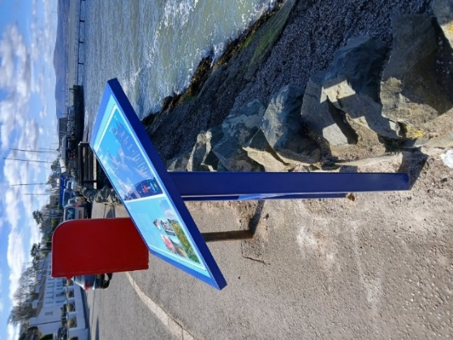 | 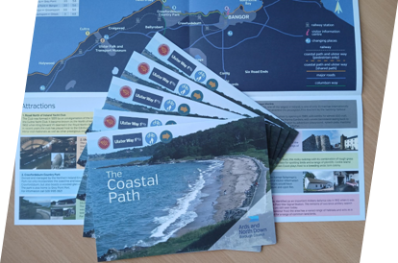
Information signs had been installed along the path,. | An information leaflet had been reviewed, updated and distributed by the Council to outlets across the borough.

Meeting the Service Plan for Parks and Open Spaces:
The events detailed in this report supported the core objectives outlined in the Parks and Cemeteries Service Plan. They focused on getting more people into the Borough’s parks through events and activities which aimed to maintain and enhance Parks and Cemeteries as accessible, safe, and vibrant community assets.
Enhancing Accessibility and Engagement:
Events at various parks, trails, and open spaces—such as inclusive walks, biodiversity walks, inclusive cycling, and outdoor festivals of walking—encouraged community access and active use of parks and open spaces.

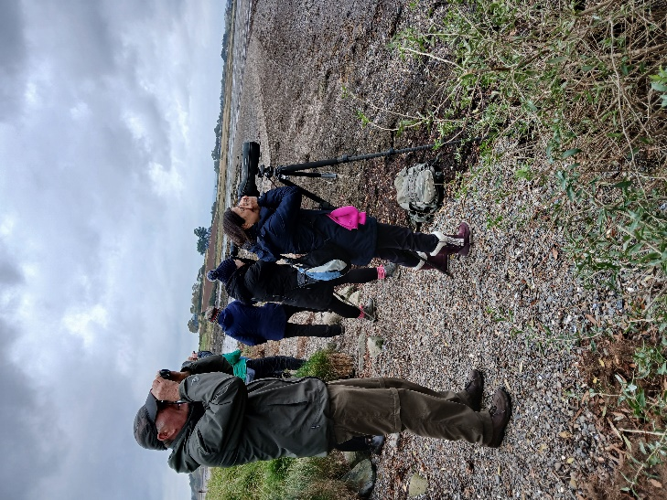 | 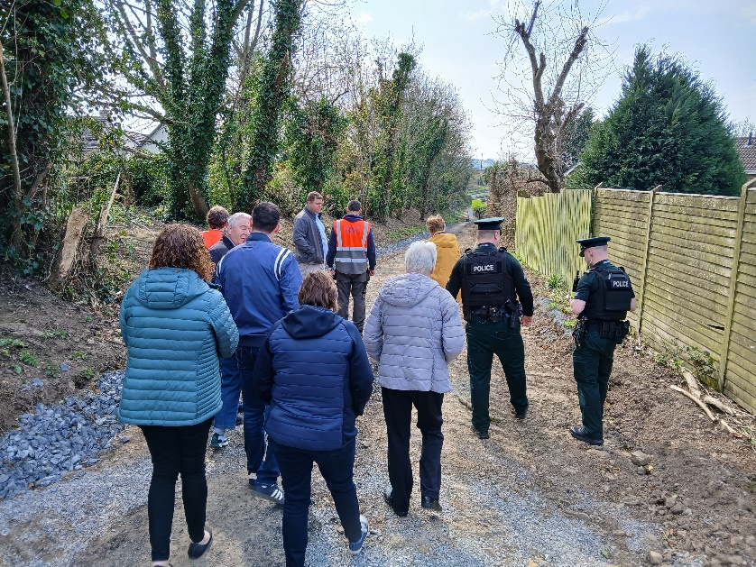
ShoreLife Festival 2024, Island Hill, Comber | Greenway meeting with local residents, PSNI and Councillors, Newtownards
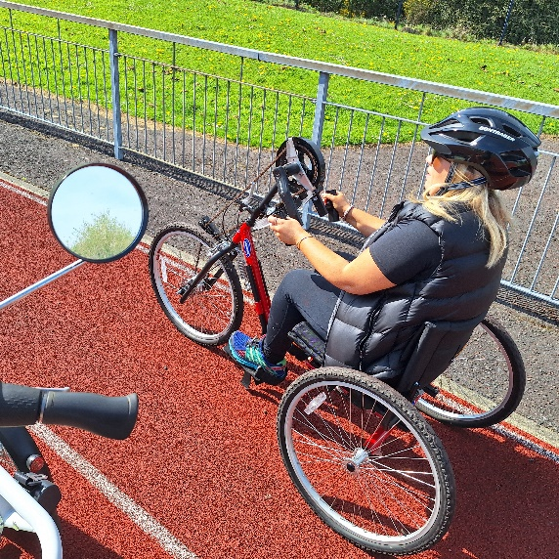 | 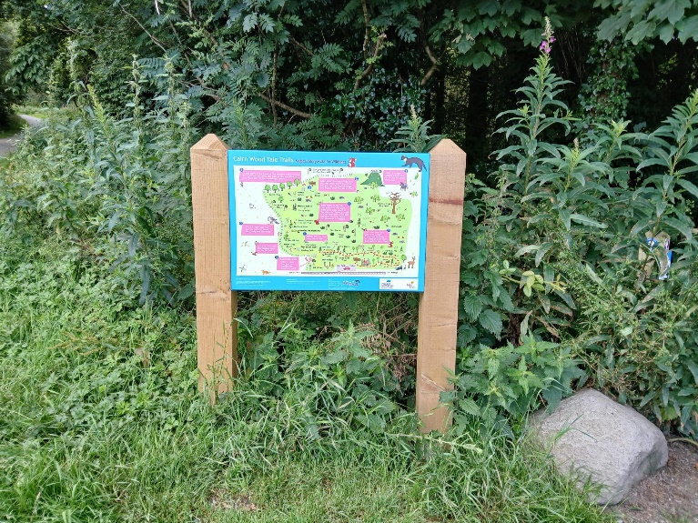
Inclusive bikes at Bangor Sportsplex | Tale Trails map guide at Cairnwood

Promoting Health and Wellbeing:
Activities such as regular walking events, the creation of a children and young people's ‘Tale Trail’ at Cairnwood, and Walking Week and Bike Week events had promoted physical activity, contributing to healthier lifestyles.
Environmental Stewardship:
Bioblitz events and workshops, tree planting, and biodiversity activities had supported conservation efforts, aligning with Parks and Cemeteries’ role in fostering sustainability.

Supporting Community Cohesion:
Provision of events across the Borough, inviting input from local experts and the community to lead events and volunteer opportunities, had fostered social inclusion and local pride, ensuring parks served as focal points for community life.
Embedding of the 5 Steps to Wellbeing into all aspects of events had been achieved, specifically:
• Take Notice – focused on biodiversity such as trees, coastal sea life, and wild plants on Borough community trails, parks, and woodlands
• Keep Learning – new skills had been developed through activities such as mindfulness, artistic printing, observing and drawing, and beach art, as well as specific knowledge provided by walk leaders, artists, and facilitators on regular walks
• Connect – by spending time with other people in the natural environment and outdoors
• Keep Active – participating in regular exercise which had been adjusted to suit all participants
• Give – sharing knowledge and asking questions, offering activities free of charge and open to all

An Active Role in Climate Recovery, Biodiversity Gain & Sustainability:
To enable increased activities such as cycling and sustainable travel, the following elements had been progressed and would continue to be developed to contribute towards a Cycling Friendly Borough:
• Worked with the Department for Infrastructure through participation in panel discussions on cycling in the Borough with the Department’s Active Travel Team
• The Ards and North Down Borough Council Cycling Masterplan had been tendered and successfully commissioned, with work started in July 2025
• Worked with Sustrans on its National Cycling Network and Paths for Everyone Initiative
• The Council’s Greenway network programme had developed activities and community links along the new Greenway corridor from Newtownards to Bangor
• The AND Greenways website link had been displayed as a QR code on all contractor (Charles Brand) Greenway signage, and the website had been updated
• The Cycle to Work Scheme audit had been completed by colleagues in Health & Wellbeing
• The Cycle Friendly Workplace Scheme had been promoted across the year and specifically during Bike Week
• Bike clinics for staff had been provided during Bike Week and monthly during daylight saving months
• A heritage walking and cycling trail of Bangor had been developed with partners, with the trail map printed and made available to the public across the Borough. Regular guided cycles had been offered by a local campaign group
• Cycling in the Borough had been celebrated with the first AND Bike Week, featuring seven events
• Inclusive bike fleet had been promoted and facilitated for public use at Bangor Sportsplex
• Monthly Park Pedal events had been developed with Cycling Ireland
• Installation of two cycle parking facilities within Ward Park had been managed
• Plans had been progressed to install cycle parking at Council offices and facilities to enable staff, guests, and the public to cycle for more local journeys
• Worked with colleagues to audit existing facilities

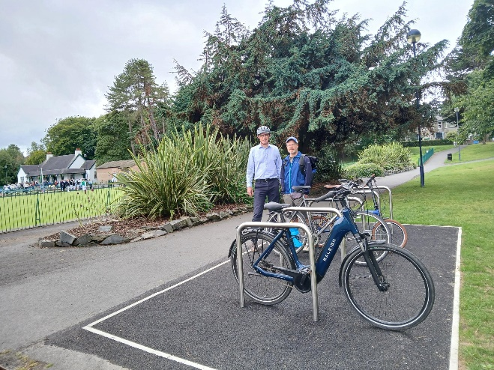 | 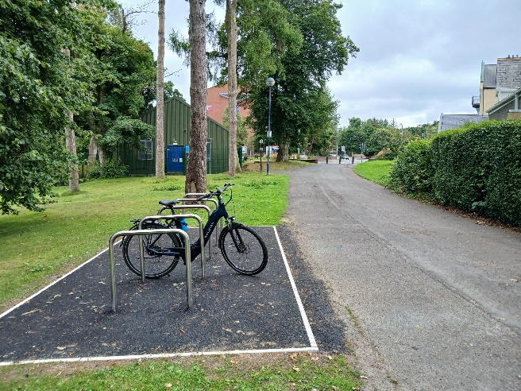
Ward Park cycle parking by bowling green and by the Castle Park Road entrance

The Community Trails & Greenways team had made significant progress in supporting Ards and North Down Borough Council’s strategic vision of fostering a sustainable, vibrant, and inclusive community. Through a diverse and engaging calendar of events, the team had championed active travel, environmental stewardship, and community wellbeing. Events such as Walking Week, Bike Week, and biodiversity-focused activities had enhanced public health, promoted social inclusion, and reconnected residents with local green spaces and heritage.
These initiatives had directly contributed to key objectives within the Council’s Corporate Plan and Parks and Cemeteries Service Plan, including enhanced accessibility, climate action, economic vitality, and community cohesion. Strategic partnerships with stakeholders such as Sustrans and the Department for Infrastructure had also strengthened the Borough’s cycling and sustainable travel infrastructure, culminating in the commissioning of a Cycling Masterplan and increased cycling facilities.

By embedding the Five Steps to Wellbeing and prioritising inclusive, educational, and environmentally conscious programming, the Community Trails & Greenways team had elevated the role of Council in providing essential assets for community engagement and environmental action. This work had ensured that green spaces remained accessible, well-utilised, and central to the Borough’s vision for long-term sustainability and quality of life.

Next Steps
Within the first year, the service had developed successful internal and external partnerships and had programmed a full year’s worth of events while gaining an understanding of Council systems and departments. Communicating with Elected Members and working with internal and external stakeholders had been key to the delivery of the role.

There would be continued delivery of a calendar of events in the coming year, including:

• A series of walks on community trails across the Borough
• Monthly activities on the North Down Coastal Path
• Walking Week and Bike Week celebration events
• Implementation of the Paths for Everyone programme in 2026
• Implementation of the actions within the Cycle Route Masterplan in 2026
RECOMMENDED that Council notes the progress of the development of Community Trails and Greenways to date and future initiatives.

Councillor Moore proposed, seconded by Councillor McKee, that the recommendation be adopted.

The Deputy Mayor, Councillor Moore, welcomed the report and thanked the officers involved. She noted that some residents had expressed concerns about the exposure of their homes to the Greenway, particularly at the rear of their properties, and commended the officers for their responsiveness and constructive engagement with those residents.

She acknowledged the range of ideas presented to enhance public engagement and expressed her personal enthusiasm for initiatives that promoted cycling.

Councillor McKee welcomed the report and the progress made. He noted the positive developments and commended the clear planning for the current year, highlighting the range of activities available to the public and promotion opportunities.

He felt the report demonstrated the value of expanding the Parks team, particularly through the introduction of a development officer role focused on community trails. Councillor McKee thanked the officers for their work and acknowledged their commitment to investing in new roles and innovative approaches.

Councillor McClean emphasised the need for a more strategic approach to how the Council promoted those activities through social media and other channels. He shared a personal example of discovering well-organised, family-friendly events that he felt should have been more widely publicised. While acknowledging that communications did not fall within the Committee’s remit, he asked officers to ensure that teams received appropriate support in terms of communications.

AGREED TO RECOMMEND, on the proposal of Councillor Moore, seconded by Councillor McKee, that the recommendation be adopted.

16. Update on Maintenance of Grass Sports Pitches (FILE PCA131)

PREVIOUSLY CIRCULATED:- Report from the Director of Community and Wellbeing detailing that in September 2024 the following Notice of Motion (630) was agreed by Council:

“That Council notes the increasing complaints from local sports clubs regarding the poor annual summer maintenance of football pitches across the Borough and tasks officers to bring forward a report on options to improve the maintenance of our football pitches to ensure our pitches are maintained to a high standard to meet the sporting needs of local clubs and league requirements.”

Responses to the Notice of Motion had been tabled at the Community and Wellbeing meetings in November 2024 and June 2025. In June, Members had requested a further report to be presented in September 2025. This report provided an update on the completion and outcomes of the 2025 end-of-season maintenance programme for sports pitches across the Borough.

The 2025 maintenance season for bookable pitches had delivered notable improvements in both the quality and efficiency of works carried out. These improvements had been attributed to a combination of early planning, favourable weather conditions, and strategic investment in equipment and materials.

Contractors had been engaged well in advance, allowing for clear scheduling and timely completion of works, with the majority of activity concluded before the end of May, although maintenance and monitoring continued across the summer period. The weather—unusually higher temperatures and low rainfall—had played a supportive role, enabling uninterrupted progress across all sites.

A key development that season had been the Council’s investment in a direct seeding unit, which had allowed in-house teams to carry out an early application of grass seed on all pitches prior to the contractor’s arrival. This proactive approach had ensured seed was applied at the optimal time, reducing the risk of delays and improving establishment rates. The equipment had also enabled targeted reseeding of problematic areas, enhancing overall pitch quality. In addition, all pitches had been fertilised prior to handover to reduce stress on the sward and support healthy growth.

The procurement of high-quality sports seed had further contributed to improved germination and establishment times. Where pitches had required additional work beyond standard maintenance (as identified through specialist agronomist reports), partial remedial action had been taken. Agronomist reports had applied scientific principles to manage and improve the health and performance of turfgrass surfaces. These reports had focused on the interactions between soil, water, plants, and the environment to ensure optimal playing conditions and sustainability.

Engagement with local sports clubs had been another positive aspect of the programme. Officers from Parks & Leisure Departments had met with club representatives on several occasions to discuss maintenance plans and address ongoing concerns. This collaborative approach had significantly improved communication and site management. Clubs had also played an active role in stewarding pitches, helping to deter unauthorised play and address issues such as dog fouling. In one case, a club had even assisted with watering dry areas during a period of drought, demonstrating strong community partnership.

Despite these successes, several challenges remained. Unauthorised use of bookable pitches continued to disrupt seed establishment and top dressing. For example, portable goals had been placed on one pitch without permission, though this had been quickly resolved through engagement with the relevant club, who had issued a public appeal to deter unauthorised use and protect the surface.

Environmental factors had also presented difficulties. A dry spell early in the schedule had affected several pitches, particularly at Portavogie, which was known for its sandy, free-draining soil. Although reseeding had been required, it had been completed within the planned timeframe before the beginning of June. A wetting agent had also been used to help with the dry conditions and reduce the need for club watering. At Greyabbey, tidal water ingress remained a persistent issue, particularly in two corners of the pitch where high salt content and waterlogging hindered seed germination.

Increased usage of pitches continued to place pressure on older surfaces not designed for such high levels of play. While the success of local clubs was to be celebrated, it remained essential that pitches were given adequate rest periods to maintain their condition and ensure the effectiveness of maintenance efforts.
In summary, the 2025 end-of-season maintenance programme had been successful, with all pitches available for booking from Saturday 9th August and in excellent condition. While some environmental and usage-related challenges persisted, the Council remained committed to continuous improvement through ongoing investment, strategic planning, and strong engagement with stakeholders.

RECOMMENDED that Council notes this report.

Councillor Adair proposed, seconded by Councillor Boyle, that the recommendation be adopted.

Alderman Adair referred to the notice of motion he had previously brought forward, which had led to this report. He extended his thanks to the Head of Parks and Cemeteries and the wider Parks team for their hard work, particularly in maintaining pitches over the summer period.

He noted that the majority of the maintenance work had been carried out in-house by Council staff rather than by external contractors, and commended the team for completing the work on schedule. Alderman Adair highlighted that one of the football clubs in Greyabbey, which had previously been critical of the Council’s efforts, had recently published a letter to the editor in the local press, praising the quality and speed of the work undertaken.

He thanked the Head of Parks and Cemeteries and a member of the Parks team called Ryan Wallace, on behalf of the clubs across the Ards Peninsula, acknowledging that all clubs had received a schedule of works which had been followed precisely. He did, however, raise the issue of the pitch in Portavogie, which had reached the end of its usable life and required significant upgrades. While Council staff had maintained the pitch as best they could, and despite great efforts from the committee at Portavogie Rangers, the match schedule had unfortunately been delayed due to the much needed improvements.

Councillor Boyle reflected on the previous year, noting that the officer had faced significant pressure but he had honoured a commitment and the changes had been positive.

In particular, he noted that members of the public had responded to new signage discouraging dogs from entering playing surfaces, and felt this demonstrated how effective those measures had been.

Following on from the proposer’s comments, Councillor Boyle raised a query regarding the status of the existing pitch at Portavogie and asked for clarity regarding Alderman Adair’s statement that the pitch had reached the end of its life.

The Head of Parks and Cemeteries explained that pitch maintenance involved consideration of the playing surface, drainage, and varying soil types. In Portavogie, a high sand content had made it particularly difficult for grass to grow and for the surface to be maintained effectively.

He advised that while sand-based pitches typically included watering systems to support grass growth, there were alternative methods available to manage such conditions. Sand was routinely added to pitches across the Borough, and a variety of grass types were used depending on the location and needs. He cautioned that one particular grass species had the potential to overtake a football pitch and compromise its structural integrity.

To strengthen the playing surfaces, a specific type of seed had been used, along with herbicides to control weed growth. He also referenced future plans for Groomsport and Portaferry, noting that the Council had agreed to capital investment and also highlighted that revenue had increased in previous years, supporting ongoing improvements.

AGREED TO RECOMMEND, on the proposal of Alderman Adair, seconded by Councillor Boyle, that the recommendation be adopted.

17. PCSP Annual Report 2024-2025 (FILE PCSP - Annual Report 2024-2025)
(Appendix XX)

PREVIOUSLY CIRCULATED:- Report from the Director of Community and Wellbeing detailing that a meeting of the Ards and North Down Borough Council PCSP Partnership had been held in Londonderry Park Centre, Newtownards on 16th June 2025. At the meeting, the Partnership had approved the Annual Report for 2024–2025. The Code of Practice for the Exercise and Functions of PCSPs stated that Council was to receive a copy of the PCSP Annual Report each year (Appendix attached).

RECOMMENDED that Council notes the PCSP Annual Report for 2024-2025.

Councillor Moore proposed, seconded by Alderman Cummings, that the recommendation be adopted.

The Deputy Mayor, Councillor Moore, thanked the officers for their work and acknowledged the strength of the partnerships within the PCSP. She also commended the PCSP’s responsiveness to specific incidents throughout the year.

Alderman Cummings praised the work of the PCSP and acknowledged the valuable contributions from the voluntary sector. He commended the Deputy Mayor for her leadership as Chair of the partnership and extended his best wishes to Councillor Wray in that role.

AGREED TO RECOMMEND, on the proposal of Councillor Moore, seconded by Alderman Cummings, that the recommendation be adopted.

18. Community & Wellbeing Directorate Budgetary Control Report - March 2025 & June 2025 (FILE FIN45)
(Appendix XXI – XXII)

PREVIOUSLY CIRCULATED:- Report from the Director of Community and Wellbeing detailing that this report covered two periods for the Directorate. Appendix 1 (page 2) covered the 2024/2025 to March 2025. Appendix 2 (page 5) covered quarter 1 of 2025/26, to June 2025.

RECOMMENDED that the Council notes this report.

The Director of Community and Wellbeing referred to Appendix 1, clarifying that while it was labelled as Quarter 1, the reporting period in fact covered the first four months of the year.

Councillor McBurney proposed, seconded by Councillor Moore, that the recommendation be adopted.

The Deputy Mayor, Councillor Moore requested an update regarding the War Years Remembered project, referencing previous discussions concerning the building and involvement of Building Control. She also asked for a timescale in terms of opening.

In response, the Director of Community and Wellbeing advised that all necessary works had been completed that the grant had been awarded for. He advised that insulation in the roof had initially presented an issue with regards to Building Control compliance, and that was still to be addressed. It was a condition of the grant that the building was required to achieve building control approval before it could be opened to the public and the roof that was why that had not yet happened. The Department for Communities (DFC) had also been engaged recently, and regular contact had been maintained by Council officers. He would query the anticipated timescale with the relevant officer and report back.

AGREED TO RECOMMEND, on the proposal of Councillor McBurney, seconded by Councillor Moore, that the recommendation be adopted.

19. notices of motion

19.1. notice of motion submitted by Councillor McBurney and Councillor McCollum

That this Council recognises the success of Love Ballyholme and thanks all involved for their hard work and commitment; further recognises the importance of community led initiatives to improve community cohesion, while supporting local businesses, and asks officers to bring back a report, which includes a plan and funding opportunities to support the replication of this community led model in the Rathmore area of Bangor.

(The Mayor, Councillor McCollum, joined the meeting remotely – 8.47pm)

Proposed by Councillor McBurney, seconded by Councillor McCollum, that the notice of motion be adopted.

Councillor McBurney commended the success of Love Ballyholme, describing it as a fantastic initiative that had brought people together and fostered a strong sense of community. She praised the dedication of volunteers who had cultivated a collective sense of belonging, resulting in inclusive events such as community fairs, sandcastle competitions, and Christmas lights switch-ons. She noted that local businesses had also benefited from increased footfall and extended opening hours during these events.

She extended her thanks to all those who had contributed their time, skills, and passion to the programme, acknowledging the challenge of building such a thriving and well-connected community in today’s climate. She stated that Love Ballyholme had proven it was not only possible but worthwhile.

Councillor McBurney then turned attention to the Rathmore community, which she described as equally eager to foster a sense of belonging and support local businesses along Rathmore Road. She had joined a working group named Rathmore Together, formed through a series of conversations that reflected a shared desire to strengthen community ties.

She noted that Rathmore Primary School was already doing excellent work and that the group aimed to expand its reach through a series of events throughout the year. The initiative had received support from local churches, businesses, and hopefully political representatives, with the first event - a Christmas lights switch-on - planned for 25th November. She reported that preparations were well underway and that momentum among stakeholders was encouraging.

Councillor McBurney emphasised that such projects required nurturing and support to succeed. She called on the Council to assist Rathmore Together by providing officer guidance on funding opportunities and practical advice for organising and running events, acknowledging that this scale of activity was new to the group.
She concluded by urging all Members to support the motion and help bring the Rathmore community closer together for the benefit of all residents.

The Mayor, Councillor McCollum, seconded the motion, reflecting on her personal connection to the Rathmore community. She recalled that when she first moved to Bangor West over 30 years ago, Rathmore became her home and she recalled walking through the area with her children, attending playgroups, Brownies, and Guides, shopping locally, and forming lasting friendships over coffee in the coffee shop.

She described Rathmore as being highly residential with a broad age range and diverse demographics, noting that the primary school, churches, and shops formed a vital hub that fostered a strong sense of community.

She welcomed the steps taken by the Rathmore Together group to formalise a community identity and praised the surge of enthusiasm that had met their early efforts.

Councillor McCollum emphasised the value of strong community identity, stating that it not only promoted cohesion but also helped deter antisocial behaviour, supported the local economy, and reduced loneliness and isolation. She highlighted the importance of health and wellbeing as a key outcome of such initiatives.

She expressed her hope that the group would receive full support from the Council, not only through funding opportunities, as referenced by Councillor McBurney, but also through officer guidance on event management, risk assessments, governance, and outreach. She commended the officers for their skill, motivation, and emotional investment in their work, and expressed confidence that they would help create something truly special in Rathmore.

Councillor McKee expressed support for the motion, noting a strong appetite among Rathmore residents to build a more structured and connected community.

He wondered how such an initiative had not been developed sooner and felt it appropriate for the Council’s Community Development team to assist the volunteers involved, providing the same level of support and guidance they had successfully offered to other groups.

Councillor McClean also endorsed the motion, describing it as an excellent proposal.

In summing up, Councillor McBurney thanked the Mayor and Councillors McKee and McClean for their comments.

AGREED TO RECOMMEND, on the proposal of Councillor McBurney, seconded by Councillor McCollum, that the notice of motion be adopted.

(The Mayor, Councillor McCollum, withdrew from the meeting – 9.54pm)

19.2. notice of motion submitted by alderman smith and councillor smart

That this Council produces a report to scope the potential of introducing a public hire bicycle scheme similar to Belfast Bikes for use across the new Greenway network. That the report outlines the benefits, risks, costs, potential partnerships and any funding opportunities including those provided through DfI Active Travel to inform a Council decision on progressing such a scheme.

Alderman Smith was invited from the public gallery to propose his Notice of Motion.

Councillor McClean had initially rose to second the motion. However, he withdrew this when Councillor Smart was able to join the meeting remotely, following the resolution of technical issues.

(Councillor Smart, attending on Zoom, was connected to the meeting – 8.56pm)

Proposed by Alderman Smith, seconded by Councillor Smart, that the notice of motion be adopted.

Alderman Smith outlined the motion, emphasising that while the request was for a report, he recognised the significant time and effort officers would invest in its preparation. He highlighted the Council’s substantial investment in a new Greenway network and stressed the importance of maximising its use for the benefit of the community.

He advised that he had consulted with officers, who had expressed interest in exploring the proposal further. The motion aligned with the Department for Infrastructure’s Active Travel Strategy and supported the Council’s transport objectives as outlined in the Local Development Plan.

Alderman Smith explained that the proposal was inspired by the Belfast Bikes scheme, launched in 2015 and recently re-tendered to a new operator, Beryl. He described how users accessed bikes via an app, with a pay-as-you-go model and discounted bundles available. He noted that Belfast had secured sponsorship and funding, including a £500,000 grant from DFI Active Travel to support the introduction of e-bikes.

He pointed out that similar cycle hire schemes operated in cities across the UK - including London, Manchester, Cardiff, and Glasgow - as well as in smaller towns such as Northampton, Southport, and Worthing. He believed there was strong potential to develop a comparable scheme in Ards and North Down.

Alderman Smith outlined a vision in which residents could use bikes or e-bikes to travel along the Greenway network, including potential partnerships with Belfast to enable travel along the Comber Greenway. He referenced a similar proposal recently submitted to Lisburn and Castlereagh City Council, suggesting regional collaboration could help build a broader network.

He concluded by asking Members to support the motion and instruct officers to investigate the feasibility of implementing a cycle hire scheme locally. While acknowledging that it may not be viable, he felt it was worth exploring and hoped Members would lend their support.

The seconder, Councillor Smart expressed support for the motion, noting that while the Council had long championed active travel, it was not sufficient to simply invest in infrastructure such as cycle shelters. He emphasised the importance of creating opportunities that enabled residents to fully engage with their environment.

He welcomed the substantial investment in the Greenway network, describing it as a transformative initiative that would appeal to both residents and tourists. While acknowledging that there were many details still to be worked out, he agreed with Alderman Smith that the proposal represented a significant opportunity for the Borough.

Councillor Smart highlighted the Council’s broader responsibilities, including promoting the health and wellbeing of its residents. He stressed that initiatives like this could contribute meaningfully to helping people lead healthier and more fulfilling lives.

He anticipated that the proposed report would involve engagement with manufacturers and service providers, as well as consultation with local groups. He believed the cycling community would be eager to contribute and hoped that Members would support the motion to help develop the initiative further across the Borough.

RECESS: The meeting went in to recess at 9.02pm and resumed at 9.12pm.

(Councillor Douglas withdrew from the meeting – 9.02pm)

Councillor McKee spoke in support of the motion, stating that it aligned well with similar initiatives being considered in Lisburn and Castlereagh. He emphasised that the Council would be remiss not to explore the proposal, given its potential to reduce car usage and promote healthier modes of travel. He welcomed the opportunity to investigate the feasibility of such a scheme.

Councillor McClean expressed support for the proposal and added a request that, in preparing the report, officers engage directly with local cycling groups.

He specifically referenced the Ards and North Down Cycle Campaign Group, describing it as a knowledgeable and well-respected organisation with a wide range of expertise. He believed the group would be willing to contribute valuable insights and skills to help shape the initiative.

Councillor McClean emphasised that the report should not simply conclude that the scheme was unfeasible due to the lack of economies of scale compared to larger cities like Belfast or London. Instead, he encouraged officers to explore alternative approaches by drawing on local expertise, ensuring the proposal was given the best possible chance of success.

Councillor Chambers spoke in support of the motion, stating that it was important for the Council to be seen to promote healthy and active lifestyles. He noted that cycling and the use of the Greenway network clearly aligned with this objective.

He expressed enthusiasm for the proposed scheme, suggesting it could prove highly popular if effectively managed and promoted. He was particularly interested in learning from other council areas - both within Belfast and across the UK - that had successfully implemented similar initiatives. He felt that understanding how such schemes were administered and maintained would be essential to ensuring success locally and also to avoid misuse and vandalism.

Alderman Cummings gave his full support, describing it as an excellent idea. He acknowledged that the Council had actively promoted the Cycle to Work scheme in the past and believed that this continued to be a valuable initiative.

In relation to the motion, he emphasised the importance of ensuring continuity of service - particularly in relation to the cycle paths and any associated services being proposed. He recalled feedback from users of the Comber section of the network, who had reported issues such as road narrowing and overgrowth along the path. He stressed that such concerns should be taken into account in the preparation of the report.

Alderman Cummings also raised the matter of procurement, suggesting that consideration be given to whether a separate tendering process would be required or whether the Council could align with the existing arrangements in place with Belfast City Council.

In summing up, Alderman Smith thanked Members for their positive contributions and concurred with Councillor McClean on the importance of consulting with relevant groups who could offer expertise to inform the next step.

He acknowledged the challenges posed by scale, noting that larger cities benefited from higher usage volumes, which may be more difficult to replicate locally. However, he maintained that the proposal was still worth exploring.

Referring to user data from Belfast City Council, Alderman Smith highlighted the variation in bike hire rates - ranging from up to 1,000 hires per day in central areas to as few as 20 - 30 in outlying districts. He stressed that the value of such schemes lay not solely in high usage but in providing accessible options and opportunities for active travel.

He concluded by expressing hope that the initiative would be investigated further and, if viable, taken forward. He thanked Members again for their support and looked forward to the report.

AGREED TO RECOMMEND, on the proposal of Alderman Smith, seconded by Councillor Smart, that the notice of motion be adopted.

(Alderman Smith and Councillor Smart withdrew from the meeting – 9.22pm)

19.3. notice of motion submitted by alderman brooks and councillor chambers

That this Council notes the role played by Donaghadee Cricket Club in promoting sport, health, and community engagement in Donaghadee, particularly for our youth. Council further requests that officers prepare a report to look at how sports clubs like Donaghadee could be better supported by Council, particular through the lease charges levied against the clubs acknowledging the great community work these organisations do as well as the role they play in maintaining the facilities.

Proposed by Alderman Brooks, seconded by Councillor Chambers, that the notice of motion be adopted.

Alderman Brooks proposed his Notice of Motion, highlighting a Borough-wide concern regarding the revaluation of lease charges by the Land and Property Services (LPS). He explained that this issue was affecting sports clubs from Portaferry to Holywood, placing significant financial pressure on organisations that provided substantial value to their communities in comparison to the amount of money that the Council was being asked to take under the reviewed lease charges.

He cited the example of Ards and Donaghadee Cricket Club, which had been based at Northfield since 1953. The Club had historically maintained the cricket square and wickets, with the former Ards Borough Council cutting the outfield during the season. In 1975, upon promotion to senior status, the club invested in its own grass-cutting machinery and assumed full responsibility for ground maintenance. A gentleman’s agreement was established at that time whereby the club would not be charged for usage in return for maintaining the facility.

Alderman Brooks noted that the club had since requested a formal lease agreement, recognising the need to formalise the longstanding arrangement. He outlined the Club’s ongoing financial commitments, including machinery upgrades, insurance, utilities, rates, and cleaning costs. He also acknowledged the voluntary contribution of members who dedicated approximately 20 hours per week to ground maintenance during the cricket season.

Over the past 50 years, the Club had invested more than £250,000 in the facility, excluding labour costs. He emphasised the Club’s success, with three senior teams and a thriving youth programme involving over 40 children. He stated that the Council had acknowledged its own limitations in maintaining the ground and praised the Club’s recent investment in new equipment.

Alderman Brooks stressed that many clubs across the Borough were making similarly valuable contributions, and that the lease charges being proposed represented a disproportionate burden. He argued that if the Council were to invest the equivalent amount directly into the community, the impact to Council would be minimal but it represented a massive amount of money to the clubs.

He concluded by encouraging Members to support the motion and to ensure it progressed through the Corporate Committee, where lease issues and LPS revaluations could be properly addressed. He called for a report that would seek to safeguard both small and large clubs across the Borough.

The seconder, Councillor Chambers added his support to the motion, emphasising that the request at this stage was solely for a report, rather than any immediate action. He clarified that the intention was not to place Donaghadee Cricket Club on a different footing from other clubs or organisations within the Borough, but rather to use it as a representative example.

He noted that the Club invested thousands of pounds annually in equipment and maintenance, much of which was carried out by volunteers. In addition, the Club paid lease charges for the use of its facility and contributed significantly to youth engagement and community development.

Councillor Chambers expressed concern that the Club, like others in similar circumstances, could face financial hardship due to rising costs, potentially leading to closure. He acknowledged that this was a realistic risk and stressed the importance of exploring how the Council could better support clubs that were relieving the Council of certain responsibilities and helping reduce its overall costs.

Councillor Cochrane spoke in support of the motion, sharing his firsthand experience of engaging with Donaghadee Cricket Club and acknowledging the considerable challenges involved in running a local sports organisation. He reiterated that the motion was not intended to elevate Donaghadee Cricket Club above others, but rather to highlight the broader issue of the unfairness of lease charges and their impact on sports clubs across the Borough.

He noted that the concerns raised were applicable to many clubs and emphasised the importance of negotiating with Land and Property Services (LPS) regarding rate charges.

Councillor Cochrane questioned why the Notice of Motion had not been directed to the Corporate Committee, given it related to lease agreements. He noted that leases were regularly brought before that committee and suggested it may be a more appropriate forum for discussion. Secondly, he requested an update on the installation of larger netting.

The Head of Leisure Services acknowledged the difficulties that clubs were facing due to the issue around lease charges and the third party valuation that did not take into account the valuable work they did. He believed that Donaghadee Cricket Club was one of nine clubs affected in the Borough, pointing to other applications that were pending.

He reminded Members that they had worked on a Leisure Strategy and the issues raised in the notice of motion had been identified as a priority in Year One. While the motion would bring more emphasis, it was already in the strategy.

Regarding the cricket netting, he was unable to provide an update adding that this was likely delayed due to uncertainty over the Club’s future at Northfield.

The Director of Community and Wellbeing noted that some Notices of Motions straddled multiple directorates. While this motion primarily concerned LPS valuations and lease agreements, it also related to the survival and support of sport in Donaghadee. He explained that in such cases, it was common for a motion to be heard by one committee and reported back to another, which may be the approach taken here.

Alderman Brooks, in summing up, explained that Donaghadee Cricket Club had requested a formal lease agreement, having operated without one for many years. He noted that the club was willing to pay a reasonable amount, but not the full sum currently being proposed, and clarified that they were not seeking to avoid payment entirely.

He added that the Director of Finance had advised the motion be brought to the Community and Wellbeing Committee due to its community-focused nature, though he believed it would ultimately return to the Corporate Services Committee for further consideration.

AGREED TO RECOMMEND, on the proposal of Alderman Brooks, seconded by Councillor Chambers, that the notice of motion be adopted.

20. ANY OTHER NOTIFIED BUSINESS

The Chairman advised that there were no items of Any Other Notified Business.

NOTED.

EXCLUSION OF PUBLIC/PRESS

agreed, on the proposal of Alderman Cummings, seconded by Councillor Cochrane, that the public/press be excluded during the discussion of the undernoted items of confidential business.

21. Appointment of Mobile Sauna Operators (FILE PC143)

**ITEM DELAGATED FOR APPROVAL**

**IN CONFIDENCE**

SCHEDULE 6:3 – information relating to the FINANCIAL OR BUSINESS AFFAIRS OF ANY PARTICULAR PERSON.

PREVIOUSLY CIRCULATED:- Report from the Director of Community and Wellbeing detailing that the purpose of this report was to update Members on the appointment of Mobile Sauna Service providers at various locations in the Borough and to seek approval to move forward following the recent expression of interest period.

Hosting the longest coastline of any Northern Ireland Council Borough and including a number of award-winning beaches and designated bathing waters, Ards and North Down had experienced an influx of residents and visitors enjoying the coastal facilities.

Parks Officers had advertised an expression of interest period of six weeks in local papers and Council communication channels including social media. The closing date for applications was 8th August 2025 at 16:00. Applications had been sought from suitably qualified Mobile Sauna Service providers for three of its visitor car parks for the period 1 October 2025 – 30 September 2026, with the option to extend for a further two one-year periods after review and on written consent of both parties.
A total of 6 bids had been received from 4 businesses for locations assigned in the Mobile Sauna Services documents.

An evaluation panel of Council Officers had evaluated the applications. To ensure a best value approach, the award was based on a combination of quality and price criteria. To achieve this, evaluations were conducted using a 2-stage process

RECOMMENDED that Council approves the application for the provision of Mobile Sauna Services to the top scoring company.

AGREED TO RECOMMEND, on the proposal of Councillor Moore, seconded by Councillor Cochrane, that the recommendation be adopted.

22. Single Tender Action - Willow Beacons

**IN CONFIDENCE**

SCHEDULE 6:3 – information relating to the FINANCIAL OR BUSINESS AFFAIRS OF ANY PARTICULAR PERSON.

PREVIOUSLY CIRCULATED:- Report from the Director of Community and Wellbeing detailing that a Good Relations Strategy (2025–2028) had been agreed by Council in 2025. The Strategy informed an annual action plan, which was submitted to the Executive Office for assessment and approval. The Action Plan was based on the four key themes of the Executive’s Strategy Together Building United Communities:

• Children and Young People
• Shared Community
• Safe Community
• Cultural Expression

Under the Cultural Expression theme, the Good Relations team had managed the Cultural Expression Programme for Council, dealing with a number of bonfire festivals around the borough. As part of the Cultural Expression Programme, Council supplied, when requested by the community, alternatives to traditional bonfires (e.g. Willow Beacons).

Good Relations had received Expressions of Interest for a total of 7 alternative bonfires (e.g. Willow Beacons) as part of the Cultural Expression Agreement 2025. These requests often varied, largely depending on external influences.

RECOMMENDED that Council set aside the recommended procurement policy and approves the Single Tender Action award to awarded to the top scoring company as detailed in this report.

AGREED TO RECOMMEND, on the proposal of Alderman Cummings, seconded by Councillor Moore, that the recommendation be adopted.

23. PSCP Minutes (FILE PCSP MINS)
(Appendix XXIII)

**IN CONFIDENCE**

SCHEDULE 6:7: prevention, investigation or prosecution of crime

PREVIOUSLY CIRCULATED:- Report from the Director of Community and Wellbeing detailing that a meeting of the Ards and North Down Borough Council PCSP Partnership was held on 16th June 2025

At the meeting on the 16th June, the PCSP Partnership approved the minutes of
19th May 2025.

The minutes were attached.

RECOMMENDED that Council note the minutes.

AGREED TO RECOMMEND, on the proposal of Alderman Cummings, seconded by Councillor Moore, that the recommendation be adopted.

24. Leisure Centres Three Year Finance (FILE LS/LA 21)

**IN CONFIDENCE**

SCHEDULE 6:3 – information relating to the FINANCIAL OR BUSINESS AFFAIRS OF ANY PARTICULAR PERSON.

PREVIOUSLY CIRCULATED:- Report from the Director of Community and Wellbeing detailing that Members would be aware from budgetary reports of the ongoing financial growth delivered by its leisure services unit, and in particular the growth in participation of users and the resulting budgetary performance at Ards Blair Mayne Wellbeing and Leisure Complex. This report aimed to set out in detail, for Members’ information, the financial performance of its centres.

Financial Information

The tables below set out the financial performance for Council-run indoor leisure facilities, namely: Comber Leisure Centre, Portaferry Sports Centre, Ards Blair Mayne Wellbeing & Leisure Complex, and Londonderry Park over three years—2024/25, 2023/24, and 2022/23.

RECOMMENDED that Council notes the report.

AGREED TO RECOMMEND, on the proposal of Councillor McKee, seconded by Alderman Brooks, that the recommendation be adopted.

RE-ADMITANCE OF PUBLIC/PRESS

AGREED, on the proposal of Councillor Moore, seconded by Councillor Cochrane, that the public/press be re-admitted to the meeting.

TERMINATION OF MEETING

The meeting terminated at 9.45pm.

