ARDS and North Down Borough Council

A hybrid (in person and via Zoom) meeting of the Community and Wellbeing Committee was held at the Council Chamber, Church Street, Newtownards, and via Zoom, on Wednesday 14 May 2025 at 7.00 pm.

Present:

In the Chair: Alderman Brooks

Alderman: Adair McRandal
Cummings (zoom)

Councillors: Ashe S Irvine
Boyle Kendall
Chambers McBurney
Cochrane McClean
Douglas Moore
Hollywood

Officers in Attendance: Director of Community and Wellbeing (G Bannister), Head of Community and Culture (N Dorrian), Head of Environmental Health, Protection and Development (A Faulkner), Head of Leisure Services (I O’Neill - zoom), Head of Parks and Cemeteries (S Daye), Head of Strategic Capital Development (A Dadley) and Democratic Services Officer (J Glasgow)

1. APOLOGIES

An apology for inability to attend was received from Councillor W Irvine.

On the passing of Councillor W Irvine’s father, Alderman Adair requested that a letter of condolence be sent to Councillor W Irvine on behalf of the Committee.

2. Declarations of Interest

No declarations of interest were notified.

3. DEputations

3.1 Department of education - RAISE
(Appendix I)

The Chair welcomed and introduced Claire McClelland (Director) and Michael McGinley (Programme Manager) to the meeting and invited them to make their presentation.

Mrs McClelland provided an update on progress with the programme overall and also within the Borough. Members had been circulated with a briefing paper. The RAISE Programme was rolling out in 15 localities across Northern Ireland to support the Department of Education’s vision that “every child and young person is happy, learning and succeeding”. The RAISE Programme provided an important opportunity to look afresh at the educational issues caused by deprivation and the barriers to learning and educational achievement that some of our children and young people were facing. The Programme would deliver a range of education support measures to help address educational underachievement and tackle educational disadvantage through a whole community and place-based approach.

Within the Ards and North Down Borough Council area, RAISE would be operating within Millisle and Donaghadee.

The main focus of the RAISE Programme at present was the establishment of Locality Reference Groups to drive forward the development of Strategic Area Plans in each of the localities. The plan would set out the context of the area, current provision and the gaps. Key to that strategic area plan would be setting out of objectives detailing what the locality wanted to achieve through the RAISE funding. Against those objectives, the Department would seek projects, Ms McClelland explained that once the strategic area plan had been developed, it would be assessed by a panel following which a call would be issued for projects and guidance was available with regards the process.

A further element of the RAISE programme, was a series of cross cutting initiatives with 30% of the budget being used to complement locality projects by –
a. responding in a strategic way to cross-cutting priorities; and
b. bringing additional opportunities to communities around key themes e.g. literacy / numeracy support.
The Minister had identified a number of initiatives that he wished to take forward and further information would be published in that regard in due course.

In terms of Millisle and Donaghadee, since the first engagement event in Millisle and Donaghadee in November 2024, the RAISE team had been working with key stakeholders to understand the context of the area and identify the key issues around educational underachievement. Children and young people had been involved in engagement sessions, along with parents. Work had occurred with Stranmillis to undertake a series of engagement sessions to tease out the key issues. A workshop was held on 6 May 2025 to support the development of a Strategic Area Plan for the area with key issues being discussed. The Locality Reference Group consisting of a cross-section of all key stakeholders would meet on 4 June 2025 to finalise the Strategic Area Plan for Millisle and Donaghadee and it was expected the plan would be submitted to the Department for consideration later in June 2025.

In relation to the emerging priorities which children and young people, educators, stakeholders and parents felt that there needed to be a focus on included:

- Transitions and improving pathways
- Improving relationships with education, children/young people and parents
- Attendance
- Building confidence and aspirations of children and young people.

Ms McClelland advised that there was £183k available for Donaghadee and Millisle and she was hopeful to get really good projects to meet the needs of children and young people for rolling out in the new academic year.

The Chair thanked the representatives for the informative presentation and invited questions from Members.

As a representative for Donaghadee, Councillor Chambers noted that there had been an engagement event held in November 2024 and a workshop on 6 May 2025 and questioned the key issues discussed at those. Ms McClelland added that since the first workshop, the locality coordinator had held a series of engagements with schools, youth organisations etc in the locality. From those, an area profile had been built, the needs of children and young people identified, the key issues unpicked, and work was currently occurring on the objectives. It was important that objectives were clear to get the right project and delivery organisations.

Councillor Hollywood asked the rationale for the areas chosen. Ms McClelland recognised there had been concerns on where the project had been chosen to be rolled out. She explained that a series of data was used, firstly breaking down all of the areas in Northern Ireland into super output areas, those were ranked including 7 indicators which included educational indicators e.g. free school meals, educational needs, attendance and GCSE outcomes along with crime and deprivation indicators. Once those super output areas were ranked, they were then prioritised by GCSE attainment. Ultimately the programme would seek to improve educational outcomes and therefore that measure was used. Whilst the 15 localities had been ranked, Ms McClelland stated that it was important to note the Minister had agreed to a degree of flexibility and if there was an area of influence outside the locality then that could be looked at.

Councillor Boyle noted that across the Borough there was a lot of educational disadvantage and deprivation. He questioned if Millisle and Donaghadee were the only schools identified. Ms McClelland stated that the advice that went to the Minister was based on the available data. She clarified that no schools had been identified, the localities had been identified where those pupils with the most disadvantaged backgrounds lived. Any school within a RAISE locality could be involved in the project and no schools had been ruled out. It was recognised that there would be schools outside the locality that would be involved in the programme.

In response to a further question from Councillor Boyle, Ms McClelland explained that the localities identified was based on where the pupils lived rather than where they were attending school.

Councillor S Irvine questioned who would deliver the programmes. Ms McClelland stated that the programme was about a whole community approach to education, recognising that the schools could not do everything. In terms of who would deliver the projects, at this point of time the specifics were not known but project applications but would be expected to be received from community and voluntary organisations, collective group of schools and was open to range of organisations.

Councillor S Irvine noted that there was £183k of funding available and he asked if there was a timeframe to spend the funding. Ms McClelland advised the funding was available via the shared island fund. For the RAISE programme itself there was approximately £16.6m available, 60% of that for the locality programmes, 30% into the cross-cutting programmes and 10% held to administer the programme. The first amount of money was available for two years to 2027. Conversations were occurring with the Irish Government in terms of future funding. It was therefore really important to have the plans and projects on the ground to demonstrate the case for future funding.

In response to a further question from Councillor S Irvine, Ms McCleland advised that Stranmillis and Parent Focus had come to Millisle and Donaghadee to carry out a range of engagement. Millisle Youth Forum had visited Stormont as part of the RAISE programme.

Councillor McBurney raised a question in respect of the longevity of the programme, when the programme ended there would be valuable learning from the specific projects. She was interested to know about the learning from the programme, the best practice and what the DfC approach would be in relation to information sharing. Councillor McBurney welcomed the community approach, within communities there was real aspiration for their children.

Ms McClelland stated that the learning was critical, and evaluation was critical to the programme. Evaluation would be looked at in three levels, at system level, locality level and project level. DfC would shortly be going out to tender for an independent evaluator to evaluate the programme as a whole. The programme was about a whole community approach to education and the DfC already sponsored a number of projects. She reassured the member that they had been really intentional making sure they that the learning was not taken away and embedded future policy. That aligned with the Transform Ed strategy and tackling educational disadvantage was one of the key elements of that.

Councillor Cochrane asked if educational provision was included within the scope of the report. Ms McClelland stated that in terms of the programme funding there was no capital funding available. If there were issues around transport and barriers to education raised those would be reflected.

NOTED.

3.2 Rosemount rec junior football club

(Appendix II)

The Chair invited Paula McConkey (Club Secretary) and Stephen Atcheson (Chairperson) to come forward and present to the Committee.

Stephen Atcheson commenced by explaining that he was in attendance on behalf of the Rosemount Rec Junior Football Club to ask the Council to fund a new multi-use games arena at the site at the tennis courts in Greyabbey. The tennis courts were due to be resurfaced at a significant cost to Council. As part of Greyabbey's village plan, a MUGA was to be placed at a different location in the village however a MUGA would be better suited at the tennis courts.

Stephen Atcheson and Paula McConkey then undertook a powerpoint presentation.

Executive Summary
- RRFC proposed the development of a Multi-Use Games Area (MUGA) on the site of the underused and deteriorating tennis courts adjacent to Greyabbey Village Hall. This facility would serve as a community-focused sports hub, featuring a 3G synthetic surface suitable for football, tennis, basketball, and other recreational activities.
- This would lead to:
- Inclusive Access for All: A muga surface would support a wide range of activities accessible to people of all ages and abilities.
- Increased Health & Well-being Opportunities: The improved facilities would encourage greater participation in physical activity, contributing to the health of our community.
- Better Facilities for Local Youth: Youth teams, including Primary School and church groups would benefit from a modern and safe, all-weather pitch/surface for year-round play.
- Alignment with other Villages: This project would bring the team in line with neighbouring communities that already enjoy benefit from similar facilities.
Rationale
Greyabbey lacked adequate year-round sports infrastructure to support its various community groups. The proposed MUGA would:
- Replace unsafe and outdated Courts
- Encourage local youth participation and retain talent within the area
- Provide inclusive, accessible sports facilities for all ages
- Enhance community health, engagement and cohesion.

In terms of Community Backing, the project was the project was fully supported by a range of groups within the village.

Current site condition
- Existing tennis courts are broken, unsafe, and under-utilised
- Do not meet the needs of the growing community, particularly for youth training.
- Car parking was available, that was a designated area and was a great advantage.
- Enough room around the tennis courts to facilitate the MUGA.

About Rosemount Rec Football Club
- Large Community Club
- Wins a significant number of players &coaches at every level (1 & 2Teams & Youth)
- A committee that encompasses many age groups and backgrounds
- Attracts large crowds to majority of home & away games

- Current Costs
- Currently had to train in Newtownards at Londonderry Park
- Resulted in higher cost & increased travel time for players & staff

- History of Success
- One of the most successful clubs in the borough both historically and in recent years
- Junior Football to the Highest level of Amateur Football inside 10 years 2 5 round appearances in the Irish Cup (vs Glenavon & Loughgall)
- Multiple League & Cup wins
Rosemount Rec Youth Football was established in 2023. It consisted of 3 different age groups with view for expansion (2021 team to start in September). Registrations from Greyabbey, Carrowdore, Ballywalter, Newtownards, Kircubbin & Cloughey. The teams compete in North Down Small Sided Games. They currently train at Trinity Presbyterian Church Hall in winter and Island view pitches in Summer.

The Future of RRFC

- The main reason for Rosemount as a club setting up this new youth academy was to secure its future.
- Rosemount was a huge part of the community in Greyabbey and had provided a platform for many young people to play football. It had brought funding to the area with many supporters of away teams using the villages amenities. With the success it has had it has put the village on the map.
- The problem was that players were moving elsewhere due to the lack of training facilities the club had.
- The club had to use Londonderry park for training at a huge cost.
- This was also an issue as local players were deciding to longer play as they did not want to train outside the village.

Strategic Importance

The MUGA aligned with Greyabbey’s Village Plan, where the proposal received the highest level of community interest and engagement. Greyabbey recorded the highest turnout of any village in the Peninsula at the last planning meeting.

Key Benefits

- Inclusive Access for All: A muga surface would support a wide range of activities accessible to people of all ages and abilities.
- Increased Health & Well-being Opportunities: The improved facilities would encourage greater participation in physical activity, contributing to the health of our community.
- Better Facilities for Local Youth: Youth teams, including primary school and church groups would benefit from a modern and safe, all-weather pitch/surface for year-round play.
- Alignment with other Villages: This project would bring us in line with neighbouring communities that already enjoy benefit from similar facilities.

The Chair thanked the representatives for the presentation and invited questions from Members.

To provide a better understanding to the Committee on the lack of facilities for the children and young people of Greyabbey, Alderman Adair asked the representatives to expand on the challenges faced training in the church hall. Mr Atcheson explained that training currently took place in the church hall, it was quite small, and the surface was a normal hard wooden floor. The main problem was room but also noise and that caused difficulties to coach the children.

Alderman Adair noted the number of residents in the Ards Peninsula that did not have access to a car. Public transport links to Greyabbey were limited and he questioned what difference the facility would make particularly to those children and young people that did not have access to a car.

Mr Atcheson stated that it would allow children to attend locally with no need to drive. The Club had to put a cap on players in the youth due to limited space and the new facility would allow the Club to expand, bring in more coaches, more players and train on more evenings.

Alderman Adair asked if the Council had of went with the original plan to upgrade the tennis courts and not the MUGA what benefits could have been lost to the community in Greyabbey. Mr Atcheson stated that the tennis courts were underutilised. A new facility could be used by a variety of sports.

Alderman Adair welcomed the formation of the youth aspect of the club and felt it was vital for the area.

Councillor Chambers supported the Clubs ambitions stating that he was a huge advocate for having good sports facilities for all the towns and villages. He questioned if the Club had a management model in mind. Mr Atcheson stated that they were open to options in that regard.

Councillor Chambers stated that if the facility came to fruition, it would be a great community asset for Greyabbey. As the Club expanded, he questioned how the facility could remain of use for the whole community and not just for football. Mr Acheson stated that Greyabbey was a close community, and he did not feel there would be any issues for shared use.

Councillor Boyle recognised that the tennis courts were deteriorating, were used less frequently, and the area could be brought to better use. It was clear that the Club had a passion for a new facility. One of the biggest factors was bringing and keeping children of the streets through sport. The facility had community backing and he noted that further conversations could occur on the operating model. In terms of numbers, Councillor Boyle asked how many children the Club had. Mr Acheson advised that the teams were per age group, they had approximately 40 plus kids however that number had to be capped.

Councillor Boyle give his support to the project.

The Chair thanked the representatives for their presentation, and they returned to the public gallery.

Following the deputation withdrawing to the public gallery, it was proposed by Alderman Adair, seconded by Councillor Boyle, that Council incorporates the Rosemount Rec Presentation as part of the Greyabbey MUGA report.

Alderman Adair highlighted that the facility was within the village plan, it was within the Council’s play strategy to provide a MUGA in Greyabbey and there was a need for better facilities for children and young people in the village. Alderman Adair wished to see a positive report coming forward. The facility would be of benefit not only to Greyabbey but for the children and young people across the area.

Councillor Boyle added his support, it was clear a facility was needed for the future of children in Greyabbey.

Councillor S Irvine added his support to the proposal, the facility would be worthwhile working cross community within the village.

Councillor Douglas added her support.

Alderman Adair thanked Members for their support stating that he was determined to bring the needs of Greyabbey to the attention of the Committee. He looked forward to the positive report.

AGREED TO RECOMMEND, on the proposal of Alderman Adair, seconded by Councillor Boyle, that Council incorporates the Rosemount Rec Presentation as part of the Greyabbey MUGA report.

4. social supermarket

PREVIOUSLY CIRCULATED:- Report from the Director of Community and Wellbeing detailing that Members would be aware that an open call was held for the Social Supermarket provision in April and May 2024. Provision for Donaghadee, Bangor and Holywood was awarded to Kilcooley Women’s Centre (KWC) whilst provision for Newtownards, Comber, Ballygowan and Peninsula was awarded to Bangor Food and Community Support (BFCS). This call covered a 3-year period until March 2027, subject to the receipt of funding each year from Department for Communities (DfC).

Council received notification on 1 April 2025 that support had been provided by the Department to cover the three-month period from 1 April to 30 June 2025 totalling £31,955.56. That was based on 2024/25 allocation. The total amount of SSM funding received in 2024/2025 was £127,822.24.

To ensure a continuation in service KWC and BFSC were issued with a Letter of Offer to cover the Quarter one period as follows:

Area |  | Population | Funding for 31 March 2025 – 30 June 2025, based on 2024/25 budget  Quarter 1
Bangor, Holywood, Donaghadee | KWC | 55% | £17,575.56
Ards, Comber, Ballygowan, Killinchy Peninsula | BFCS | 45% | £14,380.00
Total |  |  | £31, 955.56

Recommended that Council retrospectively approves the award of £17,575.56 to Kilcooley Women’s Centre and £14,380.00 to Bangor Food and Community Support for the period 1 April 2025 to 30 June 2025 which ensured immediate continuity of service provision pending a further letter of offer from the Department for Communities.

Proposed by Alderman Adair, seconded by Councillor Hollywood, that the recommendation be adopted.

Alderman Adair commended the service that was available in Portaferry and paid tribute to the work of Bangor Food Bank. Ken Scott had been the driving force of the food bank and was getting out in the community to ensure those people that were most in need could avail of the service. Work had also been occurring with Saint Vincent de Paul, Salvation Army, Church Groups and community groups in the area which was great to see.

(Alderman Adair withdrew from the meeting - 7.57 pm)

Councillor Hollywood supported the recommendation, stating that in his work in the community sector he dealt with many people in poverty and destitution. Continuing the service would go some way to alleviate poverty across the Borough.

AGREED TO RECOMMEND, on the proposal of Alderman Adair, seconded by Councillor Hollywood, that the recommendation be adopted.

5. cultural expressions updated agreement (FILE GREL415)
(Appendix III)

***NOTE COUNCIL 28 MAY 2025***

PREVIOUSLY CIRCULATED:- Report from the Director of Community and Wellbeing attaching updated agreement. The report detailed that Council initially approved a Cultural Expression (CE) Agreement in April 2015, following an extended period of community consultation with relevant groups throughout the Borough. The agreement sets out the principles by which groups that celebrate culture by way of a festival and associated bonfire or beacon around the 11th of July and 31st October may work with the Council.

The Agreement was supported by The Executive Office and Council’s Good Relations Action Plan and contained a number of core principles and local agreements which constituted community groups agree and sign up to in return for funding towards cultural festivals. A number of reviews had taken place since it was first introduced in association with stakeholder community groups and partners.

To carry out a further review, the 2024 Agreement was issued to each of the groups by email in the Autumn of 2024 with an offer of a follow up meeting with the Good Relations Team to discuss any potential amendments.

The circulated agreement contained a number of suggested amendments to update the document and with the support of the communities engaged, a number of changes had been proposed for 2025.

In previous years the CE Agreement advised that advice should be sought from NI Fire and Rescue Service in relation to the proximity of the bonfires to other buildings and the height of bonfires. NI Fire and Rescue Service confirmed a few years ago that it would no longer offer such advice following an incident in Belfast when houses were burned beside a bonfire which NIFRS had provided safety advice towards.

The Council’s Good Relations Team do not provide any advice in relation to size, or proximity of bonfires to surrounding properties, nor impose distance from houses as this would be a matter for specialists to advise upon.

Bonfire and Beacon sites were jointly over seen by a multi-agency statutory group. These partner meetings in relation to bonfire sites, together with weekly site visits to each of the Council, NIHE and EA sites throughout the Borough have begun for 2025.

Staff continued to engage with representatives from each of the sites, when necessary, and following approval of the CE Agreement for 2025 would ask each site to sign up prior to any funding being released.

A further report on the CE programme for 2025 would be brought to the Committee later in the year.

Recommended that Council agrees to the Cultural Expression Agreement 2025-2026.

Proposed by Councillor S Irvine, seconded by Councillor Cochrane, that the recommendation be adopted.

Councillor S Irvine welcomed the agreement. He was of the view that there had been a discussion about issuing the money as soon as possible and questioned why the matter had taken so long to come to Committee.

(Alderman Adair re-entered the meeting – 7.58 pm)

The Head of Community and Culture stated Officers were waiting for the rate to be to be struck to ensure that the monies would be made available.

Councillor S Irvine asked that the monies be issued as soon as possible.

Councillor Cochrane welcomed the report and the work that had went into the agreement. He felt it was great to see the funding available for community groups.

Councillor McBurney referred to point 7 of the agreement which stated that bonfires should be at a safe distance from the surrounding buildings and property. That was one of the conditions of the funding however she noted in the report that the NIFRS or the Good Relations team did not advise on the matter. Councillor McBurney was keen to understand how the bonfires were meeting the agreement. In respect of the environmental impact of the bonfires, one of the key priorities of the agreement was to encourage more environmentally friendly alternatives with one of the aims of the agreement to enable Council to fulfil environmental obligations. However, Councillor McBurney noted that the amount payable was the same for a bonfire, willow burner or gas burner and she did not understand how the money payable could be the same as one which was much more environmentally friendly.

In terms of a safe distance, the Head of Community and Culture stated that the Council Officers advised as much as it could in that regard and within a safe distance. In relation to environmental impact, she noted that the majority of material now wood and a lot less materials were now not being used. Sustainable Willow Burners were encouraged and those would be put in place for communities that wanted them.

Councillor Moore felt that a number of bonfires were not adhering to the agreement. Dumping of potentially toxic materials was still occurring and was masked with pallets. She would have been interested to see the previous agreement and how that compared. There were elements of the agreement that could not be measured and therefore could not be enforced. Councillor Moore viewed the balance in the agreement as disproportionate, with the amount of funding being the same. Insurance was also mentioned in the agreement for the festival however a bonfire could not possibly be insured. Councillor Moore stated that she had concerns in relation to the enforcement of the agreement. The agreement included good principles however none of those were being adhered to by a significant number of bonfires within the Borough.

Councillor Boyle voiced his concerns in relation to the agreement and felt it was letting community groups do what they wanted to their bonfires. He felt the term ‘local agreement’ had been used too many times within the document and in particular in relation to ‘local agreement that emblems and effigies will not be placed on the bonfire’ with a £100 fine associated with that. Councillor Boyle felt that emblems and effigies would continue to be placed on bonfires, progression had not occurred and that was worrying. Councillor Boyle recognised that Officers were working hard, however could not understand why people would want to celebrate their culture by insulting others through the placement of emblems and effigies and viewed that as a strange culture.

Councillor Kendall recognised developing a cultural expression programme, took time and she appreciated the efforts being made to try and move forward. She outlined an issue she had been attempting to deal with in her own DEA and the point within the agreement that ‘only festivals associated with established bonfires that have been in situ for a minimum of 3 years, have followed the core principles and local agreements during the 3 years and under an established constituted group will be considered for funding’. The issue she was dealing with was that the group had held a bonfire for many years but on different pieces of land in the area and the group had contacted her asking about funding and had expressed an interest in a beacon. However, the group did not qualify due to the point in the agreement and instead could put a bonfire in the same place for 3 years to be part of the programme. Councillor Kendall felt the policy had been a detriment in this instance and she would have much preferred to have seen a beacon. Councillor Kendall explained that she wanted to support the agreement, however could not do that if it was going to have a negative impact.

Alderman McRandal emphasised that he would like to see tracked changes in such documents to see the updates that had been made. He stated that he had issue with the timing of the report and felt that the report should be presented in the autumn. The matter was now rushed and there was potential for the debate to get heated. In relation to established bonfire sites, he questioned how many applications had been refused or monies clawed back from in the past number of years.

(Councillor Hollywood withdrew from the meeting – 8.15 pm)

The Head of Community and Culture was not aware of any instances where funding had been clawed back, or any applications having been refused, however there were occasions where receipts were required for reimbursement and if receipts were not provided funds were not paid.

Alderman McRandal stated that there had been instances where the aims had not been complied with, and the Council had shown itself to be toothless in terms of enforcement. He had no issue with the document and the cultural expressions programme however his issue was that on occasions the Council did not take action. There were examples of good bonfires and groups that complied however there were groups that were not content unless they were upsetting people or bending the rules. Until the Council started putting the enforcement of the agreement into practice, he could not support it.

(Councillor Hollywood re-entered the meeting – 8.17 pm)

Alderman Adair commended the Head of Community and Culture and her team and supported the report. He felt there had been progress over the years, but everyone needed to work together to achieve further progress, and the Good Relations team had worked hard in that regard.

The proposal was put the meeting and declared carried with 8 voting FOR, 4 AGAINST, 3 Abstentions and 1 ABSENT.

AGREED TO RECOMMEND, on the proposal of Councillor S Irvine, seconded by Councillor Cochrane, that the recommendation be adopted.

6. re-wilding initiative 2025 update (FILE PCA63)
(Appendices IV, V)

PREVIOUSLY CIRCULATED:- Report from the Director of Community and Wellbeing attaching Existing Rewilding Sites and Strategic Rewilding Links. The report detailed that the purpose of this report was to recommend an extension of the rewilding sites managed by Council, and update Members on the recent progress of the Council’s Rewilding Initiative.

Rewilding was about the restoration of natural ecosystems and encouraging a balance between people and the rest of nature where each could thrive. The creation and maintenance of meadow grasslands was taking place in public open spaces across the UK. The vision of the Rewilding Initiative within Council was to manage the natural assets in a way that promoted natures recovery. Amenity grassland was the Councils biggest landholding and yet the least biodiverse land that we own. Changing the management of this land stood to make the biggest impact for our local biodiversity. The promotion of biodiversity was a statutory requirement under the Wildlife and Natural Environment Act (Northern Ireland) 2011.

The current sites equated to a total of 132,302 m2 as shown in Appendix 1. It was intended those sites continued to be subject to the altered maintenance programmes with a view to encouraging increased diversity and abundance of floral species which would in turn benefit pollinators and overall biodiversity at each site. In addition to the ongoing maintenance, the schedules would be altered to take account of infrequent event use on certain sites. It was critical that the rewilding parks project works in harmony with the overall use of parks and a balanced offering was available across the park’s portfolio. Events and community use would be catered for in the integrated grassland management of each chosen site.

Key updates 2024-2025
Community Engagement
Whitespots Bioblitz: A Bioblitz was held at Whitespots Country Park, Newtownards on the 16th and 17th August 2024 including within the area designated for rewilding under the initiative. The bioblitz was an amazing success with a total of 335 species identified over the 2-day event. This event allowed the invisible benefits of the rewilding initiative visible, bringing the community together, showcasing the benefits of the initiative to both people and nature and strengthening the case for expanding the initiative.
Celebrating the Rewilding Initiative: To coincide with World Rewilding Day on the 20th March 2025, Council promoted its Rewilding Initiative. This involved the placement of the first permanent rewilding sign at Brompton Road Rewilding site. Brompton was unique in that it was the first wildflower meadow created under the initiative, with native wildflower seed harvested from Crawfordsburn Country Park, less than 2km from the site. The permanent rewilding signs provide key information on rewilding and its benefits for nature and people. The signage would help raise awareness of the initiative and inform the public on why areas are being subjected to a different mowing regime, this helps to avoid confusion or negative assumptions. The signage would help build transparency and maintain public trust by being open about land management changes. They would also help to promote understanding. Many people may not be familiar with the environmental benefits of reduced mowing as well as the benefits to their health and well-being. For those wanting to know more about the rewilding initiative a QR code linking back to the Rewilding page on the council website was available on the sign. The development of a new webpage expands on the information from signage giving the community a deeper understanding of the initiative. Over the coming months permanent signage would be placed across the Borough at sites managed under this initiative.

Rewilding Through the Seasons: Parks and Cemeteries had engaged with a local photographer to help visually capture the rewilding process on sites managed under the initiative through the seasons. It was hoped that would help monitor visual changes of the landscape throughout the year and the evolution of the sites over time. That would be used alongside other data and survey results to monitor and evaluate the changes we have made in relation to our maintenance practices. This visual imagery would assist Council to broaden public understanding on rewilding. Images and information on site specific species captured through the project would help showcase biodiversity recovery, seasonal beauty, and nature’s resilience, creating awareness and promoting rewilding practices.

Inclusion of Additional Sites
As well as providing an update on the initial sites where rewilding had been established this report also outlined proposals to extend the Council’s rewilding portfolio by 21,700m2. After further consideration and discussion permission was sought to extend the existing rewilding portfolio to include selected areas as indicated in the report.

- Hunts Park, Donaghadee (5,000m2)
- Holywood Nature Park, Holywood. (11,700m2)
- Ward Park, Bangor. (5,000m2)

Recommended that Council continues to approve the above initiative and supports the ongoing development of the parks rewilding project to enhance and promote biodiversity across the Borough.

Proposed by Councillor Kendall, seconded by Councillor McBurney, that the recommendation be adopted.

Councillor Kendall felt the rewilding projects were doing well. She recognised that it was different to what people were used to. There was a crisis of biodiversity, and something needed to be done about it. Rewilding was widely supported when the communication was right. It was about encouraging grasses to come back, making sure the native species were able to grow, encouraging native flora, fauna, bugs and biodiversity. Councillor Kendall welcomed the approach, slow incremental changes focusing on rewilding in certain pockets at a time and welcomed the communication continuing.

Councillor McBurney welcomed the initiative and in particular the signage that had been placed in Brompton that was keeping people informed.

Councillor Boyle welcomed the report overall however stated that many felt the rewilding was just areas left untidy and untouched. Education was important, there used to be signs in place however they had disappeared, and he asked if more information could be made public. Councillor Boyle wondered if there was a target for rewilding.

The Head of Parks and Cemeteries advised that funding had been received for additional permanent signage, 2 signs had been placed at Brompton and 13 additional signs would be placed throughout the Borough. Temporary signage would be placed in the smaller areas. Education was vital, there were QR codes on signs providing more information and cutting around the area of the grass to provide an understanding that it was a rewilding area. There was a misperception that it was about saving money. That was not case as it was environmental initiative and there was still maintenance required in rewilding. There were no set targets, work occurred with local communities to try to achieve buy-in to the rewilding. Currently 4.4% of the Council’s area was rewilded and that would increase to 5.1% with the inclusion of the recommendation.

Councillor Moore agreed that education was hugely important, and it was not just about informing residents but that the residents then become advocates themselves and become better informed. She referred in particular to the wildflowers at the roundabouts and suggested that communication occur in those busy areas.

Alderman Adair added his support, the way forward was education, and he felt it would be good to get the schools involved. There were other sites within the peninsula that would lend itself to rewilding.

Referring to the plan for Ward Park, Alderman McRandal wondered if that included the bank where the solitary bees were nesting. The Head of Parks and Cemeteries confirmed that was included, expanding the area.

AGREED TO RECOMMEND, on the proposal of Councillor Kendall, seconded by Councillor McBurney, that the recommendation be adopted.

7. Food law code of practice and practice consultation response (FILE CW22)
(Appendices VI, VII)

PREVIOUSLY CIRCULATED:- Report from the Director of Community and Wellbeing Committee attaching Consultation Response and Consultation Pack. The report detailed that the Food Standards Agency had launched a Consultation on the Proposed amendments to the Food Law Code of Practice (Northern Ireland) and Practice Guidance. The Consultation closed on 19 May 2025.

The Code set out instructions and criteria to which District Councils in Northern Ireland must have regard when discharging their duties in relation to the delivery of official food control activities.

Recommended that Council approves the consultation response.

Proposed by Councillor Kendall, seconded by Alderman McRandal, that the recommendation be adopted.

In trying to gain an understanding of the response, Councillor Kendall raised questions in respect of the risk-based model. She felt it was a good response and highlighted the need for the funds and systems to ensure that residents were assured.

The Head of Environmental Health, Protection and Development stated that it was complex but there was a theme flowing in the consultation to make matters more flexible for businesses and Officers. There was a suggestion in the consultation that there would be more self-policing of businesses, the response in that regard was that Council would only be supportive of an element for very low risk category businesses. It was up to the Council to look at ways of monitoring that self-policing, with targeted interventions and spot checks.

In terms of the frequency of turnaround for the risk rating assessment, Officers would be supportive of that however that had a resource element. There was also a question around diluting the qualifications of Officers and having Officers qualified in a different way in order to do food inspections, the response detailed that Officers would not generally be supportive of that to ensure standards and quality was maintained high. The Head of Environmental Health, Protection and Development noted that post Covid Officers had to do a lot of work to bring businesses back up to standard from when inspections were not taking place.

Councillor Kendall thanked the Officer for the explanation and was grateful for the protective response.

AGREED TO RECOMMEND, on the proposal of Councillor Kendall, seconded by Alderman McRandal, that the recommendation be adopted.

8. mae murray foundation partnership (FILE CDV55)

PREVIOUSLY CIRCULATED:- Report from the Director of Community and Wellbeing Committee detailing that a partnership arrangement between Ards and North Down Borough Council and the Mae Murray Foundation resulted in the development of the first inclusive beach in the Ards and North Down area at Groomsport, where people of differing physical abilities can take part in activities independently. The unique specialised equipment loan scheme and purpose-built changing room facilities enable people who live with mobility challenges to experience the Groomsport Beach freely alongside people of all ability.

To access the equipment at the Inclusive Beach, pre booking was required and could be accessed via Mae Murray Foundation. A trained member of staff was also at hand upon the arrival of the user.

Season 2024 overview
The programme attracted over 600 people in total attending the Groomsport inclusive beach. In addition, there were a series of family fun days during June to September 2024, which the Mae Murray Foundation delivered, funded by ANDBC through the Events and Festival Fund.
Numerous schools and organisations visited the inclusive beach in 2024, including:
- Clifton School
- Everton Day Centre
- Sydenham Court
- Gateway organisation

Operation for 2025
The initiative was now moving into its third year and would operate for the season from Friday 30 May 2025 to Sunday 24 August 2025. There would be some adjustments to the schedule based on lessons learned from previous seasons.

The specialised loan equipment scheme would be available on Fridays and Sundays from 11am until 5.00pm. The ANDBC Community Development section provided funding to allow for two staff members both trained directly by the Mae Murray Foundation. In previous years the service was available on Saturday and Sundays from 9.30am until 5.30pm. The change followed a review of last year’s attendance, which demonstrated limited public interest on Saturdays. There were also older people homes that expressed an interest in being able to visit the beach during the working week.

Additional dates would be available this year during July. The service would extend to cover six additional days ensuring greater accessibility during the peak holiday periods:

Tuesday 8 July, Wednesday 9 July, Thursday 10 July, Tuesday 15 July,
Wednesday 16 July and Thursday 17 July 2025.

Opening Season 2025
The season for 2025 would be launched on Friday 30 May 2025 with press coverage, to raise awareness of the Inclusive Beach initiative at Groomsport and encourage community participation. Mae Murray Foundation representatives would be in attendance and there would be activities for young people and families to enjoy including the full range of equipment out on the sand ready for use.

The Groomsport inclusive beach was advertised widely using social media platforms, Mae Murray Foundation website, ANDBC website, and Visit Ards and North Down – tourism.

RECOMMENDED that Council notes this report.

Proposed by Councillor Ashe, seconded by Councillor Chambers, that the recommendation be adopted.

Councillor Ashe felt the initiative was an excellent one and important for the Council to champion inclusivity. The report included a list of organisations that had enjoyed access to the beach she wondered if it was necessary to be part of an organisation that was linked to Mae Murray to access the beach. The Head of Community and Culture explained that users had to register and book the equipment.

Councillor Ashe asked about the provision of transport and if there was any underspend for that to be considered. The Head of Community and Culture stated that the budget was tight, she would like to have staff on site more often however the budget was not available.

Councillor Chambers praised the partnership between Council and the Mae Murray Foundation. The fun days had been extremely successful. He wondered if there was a target for participation. The Head of Community and Culture stated that there was no target any longer and it was about encouraging as many as possible to use the facility.

Councillor Hollywood enjoyed reading such reports, he felt it was a fantastic initiative and commended those involved.

AGREED TO RECOMMEND, on the proposal of Councillor Ashe, seconded by Councillor Chambers, that the recommendation be adopted.

9. Good relations annual (FILE GREL424)
(Appendix VIII)

PREVIOUSLY CIRCULATED:- Report from the Director of Community and Wellbeing attaching the Good Relations Annual Report for 2024-2025 outlining the work of the section in delivering the Good Relations Action Plan for 2024-2025.

The Good Relations section was normally externally funded 75% from The Executive Office (TEO) and 25% by Council. However, the total Good Relations budget from TEO was reduced in 2024-2025 to £110,534.72.

The Good Relations Strategy (2022-2025) informed an annual action plan, which was submitted to The Executive Office for assessment. The Action Plan was based on the four key themes of the Executive’s strategy, Together Building United Communities:
- Children and Young People
- Shared community
- Safe Community
- Cultural Expression

The Good Relations section works closely with PCSP, PEACE and Community Development sections to avoid duplication and ensure a cohesive delivery of programmes to the community.

Recommended that Council notes this report.

Proposed by Councillor Kendall, seconded by Alderman McRandal, that the recommendation be adopted.

Councillor Kendall felt the report was really positive and she thanked Officers for continuing to progress. She remarked on the Youth Voice event which had been really positive and looked forward to next round of Good Relations work.

Alderman McRandal enjoyed reading the report about the great work and engagement that was occurring. He thanked the Head of Community and Culture and the team for the hard work throughout the year.

Alderman Cummings commended the Officers for the good relations work that occurred across the Borough. He noted that there had been a 25% decrease in the budget that came from the Executive Office last year and he asked if the Council had seen a significant drop in programmes or had the Council had to contribute to that budget.

(Councillor Kendall withdrew from the meeting – 8.42 pm)

Continuing, Alderman Cummings stated that statistical returns and outcomes were important to measure, and he would like to know if there had been any negative impact.

The Head of Community and Culture advised that the cut in the budget meant that the programs had to be reduced. The Good Relations team had been working hard to deliver programmes that did not cost a lot of money to mitigate against that, and delivering programs in partnership. The budget for this year similarly had been impacted and next month she would be bringing an updated Action Plan to the Committee for 2025/26 outlining the offered budget and the impact. While the Council had already agreed the Action Plan, a letter of offer had been received and that included a significant reduction.

(Councillor McClean withdrew from the meeting – 8.43 pm)

Alderman Cummings looked forward to the outcome of the report and noted that the partnerships played a significant role going forward.

AGREED TO RECOMMEND, on the proposal of Councillor Kendall , seconded by Alderman McRandal, that the recommendation be adopted.

10. Funding opportunities for st vincent de Paul (SVP)

PREVIOUSLY CIRCULATED:- Report from the Director of Community and Wellbeing detailing that it was agreed by Council in March 2025 that officers bring forward a report to the Community and Wellbeing Committee that considered support and funding opportunities from Council to assist the work of St Vincent De Paul Ards and North Down.

Background to DfC Hardship Funding
Members would be aware the Council was awarded Hardship Funding for 2023–2024 from Department for Communities to the value of £344,027.

The purpose of the fund was to address hardship due to the then cost of living crisis, particularly the increases in energy and food costs. The Hardship Funding Programme was developed in recognition of the difficult financial circumstances which existed for communities.

The Hardship Funding invited applications for grants between £10,000 to £30,000 as an open call. The grants were advertised on the Council grants webpage, Council social media and sent to all contacts on the Community Development Database. Following the call, Council approved 23 grants totalling £330,186.61 with SVP obtaining a grant of £20,100.

At the Community and Wellbeing Committee in November 2023, concern was expressed that one organisation had been able to avail of two grants due to citing two different areas of the Borough being covered and Members requested that the criteria be reconsidered in future to ensure this did not happen again.

During March 2024, the organisation concerned contacted the Head of Service to confirm it was unable to produce required receipts for the allocated funding of the two grants totalling £40,000 and therefore they were unable to claim the funding allocated. Subsequently a request was made to the Department of Communities to carry forward the funding of £40,000 to 2024–2025, in addition to a small underspend of £7,000.

At the Council meeting held on 28th August 2024, it was agreed that “Council writes to the Department for Communities to highlight our disappointment at their failure to provide Hardship Funding this year. Furthermore, that this Council asks The Department for Communities to commit to use funding in future monitoring rounds to provide hardship funding in 2024-2025”. A letter was sent to this effect on 17th September 2024.

A response dated 24th September 2024 was received from Colum Boyle, Permanent Secretary of Department for Communities stating that due to the financial constraints on the Department’s budget the Department was currently unable to provide any hardship funding for 2024-2025, and due to the continuing uncertainty in funding, it would not be possible to consider a recurrent funding model at this time.

The Community Development section launched a call in relation to the funding pot of £47,000 on 9 September 2024, with a deadline of 24 September 2024 for grants up to a maximum of £3,000 per group/organisation. The application process was amended to take account of Members concerns that the process should be fair and equitable. Application and guidance notes stated that only one application would be allowed per group/organisation.

The call was advertised on Council grants webpage, Council social media, sent to all contacts on the Community Development Database and also in the Newtownards Chronicle and Spectator Newspapers. 31 applications were received by the deadline. 22 applications met the pass mark which equated to the total value of £64,751.00 and each received a percentage of the total pot with SVP awarded £2,190.00.

As outlined by the Minister, Hardship funding would not be made available for the foreseeable future and therefore there would not be any further funding calls for Hardship grants at this time.

Alternative funding opportunities
- Council’s Community Development section circulates a weekly newsletter via email to all those registered on the Community Development database outlining details of a number of funding opportunities. The Team conduct “Grant Finder” searches on a daily and weekly basis to ensure all relevant funding opportunities are maximised within the Borough.

- Staff can also provide one to one advice on funding and support with applications, where required and upon request.

- All Council grant funding opportunities are advertised widely and open to all relevant sections of the community to apply.

- Council channels funding for two social supermarkets to cover the whole Borough and SVP are able to refer clients to the services.

- Foodbanks are also available throughout the Borough and SVP are able to access and signpost services to those in need.

- Contact had been made with representatives of each of the 6 conferences of SVP in the Borough to invite them to submit the required form to allow their details to be held on the database to ensure they are each made aware of all future funding opportunities.

Future Hardship funding
Should Hardship funding be forthcoming from the Department in the future, updated guidance and an updated application form would be screened and brought to Committee for approval prior to the fund being advertised, in line with the updated Grants policy. Members would be able to determine at that time how they would wish the fund to be administered in the Borough.

Recommended that Council notes this report.

Proposed by Alderman Adair, seconded by Councillor Boyle, that the recommendation be adopted.

(Councillor Kendall re-entered the meeting – 8.44 pm)

(Councillor McBurney withdrew from the meeting – 8.44 pm)

Alderman Adair felt that going forward there was a need to ensure the matter was done right and the report detailed a roadmap to provide better use of the hardship fund to assist those most in need.

Councillor Boyle noted that previously the awards were made on the basis of the Councils agreed policy, and there were social supermarkets and food banks which St Vincent de Paul could signpost and refer those in need.

(Councillor McClean and Councillor McBurney re-entered the meeting – 8.42 pm)

He felt it was worth noting that St Vincent de Paul received 85% funding from those who attend mass, yet they tried to distribute to around 100% of the Borough. He felt that should be given some thought and maybe churches could contribute. SVP did fantastic work yet had received no increase in funding.

Alderman McRandal was disappointed that nothing more could be done for SVP at this stage but that the report gave some comfort for the way forward if there was a future hardship fund.

AGREED TO RECOMMEND, on the proposal of Alderman Adair, seconded by Councillor Boyle, that the recommendation be adopted.

11. community development annual report (FILE CDV54)
(Appendix IX)

PREVIOUSLY CIRCULATED:- Report from the Director of Community and Wellbeing attaching Community Development Annual Report. The report detailed Please find attached the Community Development Annual Report for 2024-2025 outlining the work of the section throughout the year.

The Community Development section worked closely with the PCSP, PEACEPLUS and Good Relations sections of the Community and Culture Department to avoid duplication and ensure a cohesive delivery of programmes to the community.

Recommended that Council notes the report.

Proposed by Councillor Kendall, seconded by Councillor Ashe, that the recommendation be adopted.

Councillor Kendall noted that across many areas the community development team had shown the impact it had through engagement, grant support and community support. She thanked the community development team for their ongoing work and commitment. Councillor Kendall felt community development was a really important part of the Council services, she viewed it as one of Council’s most vital services. Many residents looked to community development, they helped and enabled the community both directly and indirectly and brought indirect social, economic and cultural outcomes. The work the team done was vast and she felt the Committee needed to mindful of that when setting budgets for the section as she felt it was really important to keep enabling and supporting groups, organisations and people within the Borough to deliver for their own communities.

Councillor Hollywood was in agreement and felt that the community development team did vital work. He noted that the Neighbourhood Renewal programme was distributing a new Kilcooley newsletter and he asked if members could be copied in.

AGREED TO RECOMMEND, on the proposal of Councillor Kendall, seconded by Councillor Ashe, that the recommendation be adopted.

12. ards and north down sports forum grants (WG april 2025) (FILE SD155)
(Appendices XI - XIV)

PREVIOUSLY CIRCULATED:- Report from the Director of Community and Wellbeing attaching Successful Event Report, Successful Goldcard Report, Successful Individual Travel Accommodation Report and Unsuccessful Report. The report detailed that The Ards and North Down Sports Forum administers grants for sporting purposes on behalf of Council under the Council’s Grants Policy agreed in 2024. The report outlined the March 2025 grants that have been administrated and approved by the Ards and North Down Sports Forum and was for noting purposes only. That was in line with the Council’s Grants Policy effective from 5 December 2024. £70,000 had been allocated within the 2025/26 revenue budget for this purpose.

During March 2025, the Forum received a total of 31 applications: (1 Coach Education, 2 Events, 9 Goldcards, 1 Club Travel/ Accommodation and 18 Individual Travel/Accommodation).

A summary of the 28 successful applications were detailed in the attached 2025/26 Successful Events, Successful Goldcard, and Successful Individual
Travel/Accommodation Appendices.

2025/26 Budget £70,000 | Annual Budget | Proposed Funding Awarded March 2025 | Remaining Budget
Anniversary | £2,000 | £0 | £2,000
Coach Education | £3,000 | £0 | £3,000
Equipment | £22,000 | £0 | £22,000
Events | £10,000 | £1,818.80 | *£6,181.20
Seeding | £2,000 | £0 | £2,000
Travel and Accommodation | £28,000 | £3,016.87 | *£24,683.13
Discretionary | £1,000 | £0 | £660
Schools/Sports Club Pathway | £2,000 | £0 | £2,000
8 Goldcards Awarded in March 2025 (8 Goldcards in total during 2025/26)

*The proposed remaining budget for events of £6,181.20 was based on an award of £1818.80.

*The proposed remaining budget for Travel and Accommodation of £24,683.13 is based on a proposed award this month of £3,016.87

The proposed remaining budget for 2025/26 was £62, 524.33 (11% of the 2025/26 budget spent).

RECOMMENDED that Council notes this report.

Proposed by Councillor Ashe, seconded by Councillor Boyle, that the recommendation be adopted.

Councillor Ashe congratulated the recipients and in particular made mention of North Down Hockey Club for their inclusion hockey sessions which had been very popular.

Councillor Boyle congratulated the team who worked on the grants.

In respect of travel and accomodation, Councillor Douglas raised a question in respect of the amounts requested and the amounts awarded. The Head of Leisure Services explained that additional funding had been secured for the grants, a higher amount had been available which the applicant may not have been aware of. No funding was awarded unless receipts were provided.

AGREED TO RECOMMEND, on the proposal of Councillor Ashe, seconded by Councillor Boyle, that the recommendation be adopted.

13. BI-monthly update report on portavogie 3G, Peninsula 3G & Portaferry Sports cENTRE (CW74)
(Appendices XV – XVII)

PREVIOUSLY CIRCULATED:- Report from the Director of Community and Wellbeing attaching Portavogie 3G Update February 2025, Peninsula 3G Update February 2025 and Status Update on Portaferry Sports Centre Floor Repair. The report detailed In February 2024, Council agreed to the following:

“that Council notes the closure of the training area at Portavogie Football Pitch due to health and safety concerns, recognises the negative impact this has on local provision and sports development and tasks Officers to bring forward a report on options to provide temporary training facilities in the village in the short term and repairs to the pitch in the long term. As a matter of urgency Council tasks Officers to bring forward a bimonthly progress report on the development of the Portavogie 3G Pitch, Portaferry Sports Centre and Portaferry 3G Pitch to this committee.”

This report provided the three updates requested on a bi-monthly basis, and for the two capital projects, in a ‘RAG’ format as further requested by the proposer in May 2024.

1. The update report for the Portavogie 3G project was attached to the report at
appendix 1.

2. The update report for the Peninsula 3G project was attached to the report at appendix 2. A further report on financial matters had been provided for Members consideration in the in confidence section of the committee’s agenda.

3. The status update for the defective floor at Portaferry Sports Centre was attached to the report at appendix 3.

Recommended that Council notes the three update reports.

Proposed by Alderman Adair, seconded by Councillor Douglas, that the Council appoint a Roads Engineer with a view of challenging the Department for Infrastructures Planning Objection.

Alderman Adair’s proposal was in relation to the Portavogie 3G pitch which had experienced a number of hurdles with the latest hurdle being that the DfI had lodged an objection. The proposal originally had full planning permission when DfI had expressed no objection. He did not feel the Council should just accept the objection and would like a road engineer to counteract the DfI objection. A lot of work had gone into the project.

Councillor Boyle sought clarity on the appointment of a road engineer against the DfI objection and questioned how much that would cost. The Director stated that the cost would be impossible to say at this stage. The Council did have an integrated consultancy firm which it could use for advice.

Councillor Boyle was unsure of the reasoning for the need for a roads engineer.

The Head of Strategic Capital Development explained that the entrance to Portavogie 3G pitch was narrow. When the application had been first submitted to planning, DfI had expressed no objection. The application had sat with planning for a number of years due to an issue with NI Water. When that was recified, Planning had renotified and at that stage DfI had expressed an objection with the entrance, they felt it should be wider and should compile to guidance.

Councillor Boyle sought further clarity on the matter and received confirmation that the plans had remained the same.

Alderman McRandal questioned if there had been change to the car park. The Head of Strategic Capital Development advised that no change had been made. He stated that he could ask for further advice from the Planners.

Alderman McRandal asked operationally would such matters be critically assessed. The Head of Strategic Capital Development was unsure at this stage if the matter could be successfully challenged. The laneway was narrow into the facility.

Councillor Kendall was content to explore the options however was hesitant in respect of the cost, the methods and who could assist in the challenge.

Councillor Hollywood questioned if the entrance was narrow why it could not be made bigger. The Director explained that the entrance was landlocked between two properties and to accede to the DfI’ s request would require negotiating with the property owners and buying land.

Alderman Adair clarified that he wished for a roads engineer or planning consultant with a view to challenging DfI’s objection. There had been inaction so many times on the project and it needed progressed for the people of Portavogie. He believed the matter had to be meaningfully explored to see if the objection was challengeable.
Alderman Adair called for a recorded vote.

A recorded vote was undertaken and was declared CARRIED. The vote resulted as follows:-

FOR (13) | AGAINST (0) | ABSTAINED (1) | ABSENT (1)
Alderman |  | Alderman
Adair |  | Brooks
Cummings
McRandal
Councillors |  | Councillor | Councillor
Ashe |  | Kendall | Irvine, W
Boyle
Chambers
Cochrane
Douglas
Hollywood
Irvine, S
McBurney
McClean
Moore

AGREED TO RECOMMEND, on the proposal of Alderman Adair, seconded by Councillor Douglas, that the Council appoint a Roads Engineer with a view of challenging the Department for Infrastructures Planning Objection in relation to Portavogie 3G Pitch.

At this point the chair permitted Councillor Boyle to ask about the status of the Portaferry Sports Hall floor defect. The Director confirmed that the Head of Leisure Services was regularly liaising with the Department of Education and the last update was to say that progress had not yet been made due to other competing priorities.

RECESS

The meeting went into recess at 9.13 pm and resumed at 9.25 pm.

14. North down coastal path working group minutes for 6 january 2025 (CW30)
(Appendix XVIII)

PREVIOUSLY CIRCULATED:- Report from the Director of Community and Wellbeing attaching minutes of the meeting of the North Down Coastal Path Working Group which was held on 6th January 2025.

Recommended that Council notes the minutes.

AGREED TO RECOMMEND, on the proposal of Councillor Cochrane, seconded by Councillor Hollywood, that the recommendation be adopted.

15. local biodiversity action plan 2024-2033 (FILE PCA1)

(Appendix XIX)

PREVIOUSLY CIRCULATED:- Report from the Director of Community and Wellbeing attaching summary of Actions and Updates. The report summarised progress made against the Council’s Local Biodiversity Action Plan (LBAP) that was agreed in 2023.

Background
The provision of biodiversity was a statutory requirement under the Wildlife and Natural Environment Act (Northern Ireland) 2011 or WANE Act. The Act required public bodies to take reasonable steps to further the conservation of priority habitats and species or to promote such actions by others. This production and delivery of the LBAP would assist in demonstrating the Council’s compliance with the statutory duty. Under the WANE Act, the Council was responsible for considering five key aspects of biodiversity:

- Protection of Biodiversity
- Maintenance of Biodiversity
- Enhancing Biodiversity
- Restoring Biodiversity
- Promoting Biodiversity

The Borough’s second Biodiversity Action Plan was approved and adopted in April 2023 and had helped to coordinate efforts to protect and enhance biodiversity across the Borough. The development of the plan was a crucial step in recognising the importance of our local biodiversity. It aimed to ensure that international, national, regional and local biodiversity objectives were achieved through a range of partnerships.

A total of eighty-four actions were proposed across four themes in the LBAP, the actions listed were to help protect, conserve, and enhance those priority habitats and species within the Borough identified through the audit. LBAP actions were listed under one of the following four themes i.e. Theme 1: Education and Awareness, Theme 2: Research and Monitoring, Theme 3: Land Management & Theme 4: Building Partnerships.

Meeting Corporate Objectives
The Local Biodiversity Action Plan (LBAP) played a vital role in supporting the strategic objectives of Council and operational priorities set out in the Parks & Cemeteries Service Plan for 2025–2026. It strengthened the Council’s overarching commitment to environmental sustainability, climate resilience, and active community engagement by providing evidence of ongoing work and measurable progress in local biodiversity.

A key area of alignment was with the strategic objectives of climate recovery and biodiversity gain. This report and associated appendix demonstrate significant contributions to these goals through a range of actions including protecting and enhancing areas for biodiversity, educating and engagement with the public and working in partnership with a variety of key stakeholders to support the LBAP. These efforts contribute directly to carbon sequestration, improved air quality, and enhanced biodiversity. Ongoing monitoring - either formally through formal surveys and bioblitzes, or informal community-based surveys and citizen science type events - would assist us to build a picture of the condition of our local biodiversity and green spaces. The LBAP meets several Service Plan Performance Measures including maintaining 130,000m² of rewilded council land, whilst also contributing to Bloom/Best Kept Awards and 7 Green Flagged Sites.

The Council’s LBAP not only advances environmental and climate goals but also significantly contributes to community wellbeing, aligning closely with the ‘Five Steps to Wellbeing’ framework. Outdoor Initiatives such as bird watching, bioblitzes, dawn chorus events and engagement activities encourages our community to engage more with green spaces and appreciate and protect their local environment. This provides not only health benefits through time spent outdoors but also breaks down feelings of social isolation by bringing people together under a shared interest in their environment.

Recommended that Council note this report.

Proposed by Councillor Ashe, seconded by Alderman McRandal, that the recommendation be adopted.

Referring to the report and the sanddunes in Cloughey, Alderman Adair stated that the Notice of Motion he had brought was in relation to the sand dunes in Cloughey and Portavogie.

The Head of Parks and Cemetaries explained that the NOM was different to the action in the LBAP and confirmed that the actions therein would include Portavogie.

Alderman Adair referred to number 52 and that the Council would not cut grass around the periphery of sports grounds and noted that the Council had reverted that decision in November and he wondered why that had been not been documented. The Head of Parks and Cemetaries stated that the grassland management strategy included that change in decision, the LBAP had not been amended. The LBAP was the document as it was agreed and actions going forward included the amendments made. He confirmed that grass would continue to be cut around the peripherty of sports grounds.

AGREED TO RECOMMEND, on the proposal of Councillor Ashe, seconded by Alderman McRandal, that the recommendation be adopted.

16. tRee and woodland strategy update (FILE PCA4)

(Appendix XX)

PREVIOUSLY CIRCULATED:- Report from the Director of Community and Wellbeing attaching Tree and Woodland Strategy Update report. The purpose of this report was to update Members on the recent progress of the Council’s Tree and Woodland Strategy that was agreed in March 2021. The purpose of the Tree and Woodland Strategy was to recognise the importance of trees, the many benefits they afford us and the increasingly important role they can play in mitigating the effects of climate change. The strategy was required to ensure the Council’s limited budget was focused on positive planting programmes and managing tree care and risks.

Recommended that Council note the progress of the Tree and Woodland Strategy.

Proposed by Alderman Adair, seconded by Alderman McRandal, that the recommendation be adopted.

Alderman McRandal referred to trees that had a story attached to them within the Borough and wondered if any joint up work was to occur to elevate the importance of trees.

The Head of Parks and Cemeteries referred to some of the actions within the strategy which would link art and show the stories and provided an example in that regard. Further updates would be brought to the Committee in celebration of the heritage of trees within the Borough.

AGREED TO RECOMMEND, on the proposal of Alderman Adair, seconded by Alderman McRandal, that the recommendation be adopted.

17. play provision, loughries (CW4)

PREVIOUSLY CIRCULATED:- Director of Community and Wellbeing detailing the undernoted:-

A Notice of Motion was agreed by Council in October 2022:
“That Council task officers to carry out a review of Play Provision in Loughries with a view to its inclusion in the Councils Play Strategy going forward.”

A report on this was brought to Council in December 2022 when the following was agreed.

“That Council review the potential for play provision for Loughries in the future when the thresholds as outlined above have been met unless provision is made as a result of the planned discussion with others outside of Council. Council notes the report and will review Play Provision in Loughries in 2024.”

Play provision was reviewed as agreed in 2024, and in May that year a further report was brought to Council which highlighted that the position had not changed in terms of thresholds being met. At that stage, the following was agreed:

“That Council task officers to engage with local landowners with a view to providing an open green space / informal play area for the community of Loughries in line with the council play strategy. Furthermore, agree that Officers review the potential for play provision for Loughries in the future when the thresholds as outlined above have been met.”

This report provided a further update to the previous work undertaken.

Context
The Council’s Play Strategy was finalised in 2021 and outlines the strategic approach to play provision in the Borough until 2032. Loughries was assessed in the development of the strategy, but no specific actions in relation to the settlement were
included. This was because Loughries was classified as a Small Settlement (as defined in the Ards and North Down Area Plan 2015). The approach to play provision for Small Settlements and rural areas was outlined in the Councils agreed Play Strategy (Section 6.4) as follows:

“Rural Provision Providing fixed play areas in rural settings needs to be measured and balanced against a range of factors including those outlined above in terms of demographics, distance to other settlements and playparks, as well as the need for land acquisition and budget constraints. In rural areas households tend to be generally dispersed within the landscape. In some cases, clusters of dwellings are defined as Small Settlements in terms of the settlement hierarchy which is outlined in the relevant Local Development Plan. The approach in other Council areas in Northern Ireland is only provide formal fixed play provision in settlements which are classified as Villages and above. In planning terms, the need for play areas is outlined under Planning Policy Statement 8, Open Space, Sport and Outdoor Recreation (Policy OS 2, Public Open Space in New Residential Development). This is a useful benchmark to consider along with the previously mentioned considerations when determining the need for play provision.”

Therefore, a fixed play area would be considered if a Small Settlement has:
- More than 100 residential units within the defined Settlement Limit (as delineated by the Area Plan) or
- Minimum of 100 residential units within the catchment radial of the play area

If a Small Settlement meets the criterion and in conjunction with the other considerations as outlined above, then the installation of a play area would be considered (if suitable land can be acquired if the Council does not have any other land available within the settlement). If a play area was deemed necessary, then it was considered that a Tier 3/Doorstep Facility would be appropriate.

Alternatives to fixed play provision could be deployed in rural areas such as exploration of Play Partnerships with schools (if they have play areas), Play Events and Play Pods which have been discussed previously within the Play Strategy. This was to be progressed by the appointment of a Development Officer (Play and Recreation), who was now in post and who had been running a series of events across the Borough since starting in July 2024. Further work in relation to alternative play was being progressed. The Settlement Limit for Loughries as defined by the Ards and Down Area Plan 2015 was shown below.

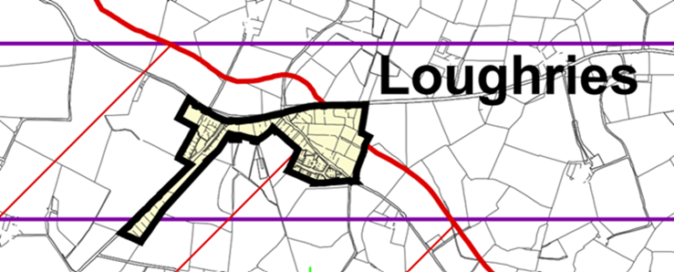
Settlement Limit of Loughries in the Ards and Down Area Plan 2015

Using the Council’s GIS (Geographical Information System) all address points registered in the Borough were shown. This information was updated on a regular basis using Address Pointer Data received via Land and Property Services. There were currently 98 addresses registered within the Settlement Limit of Loughries with one being the Church and another a school, which were not residential, as was shown below. The black line denotes the Settlement Limit.

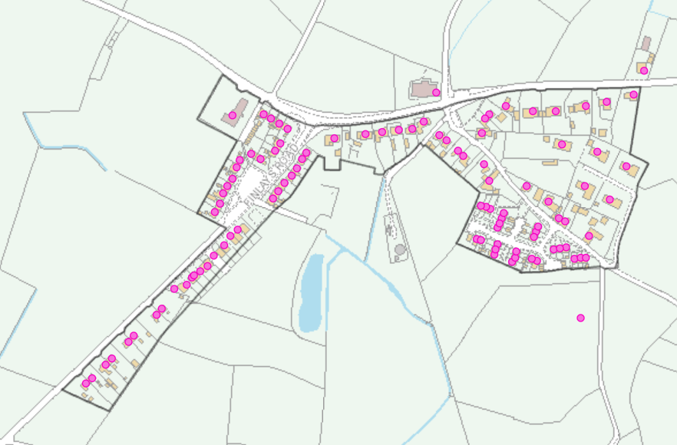
Address Points in Loughries

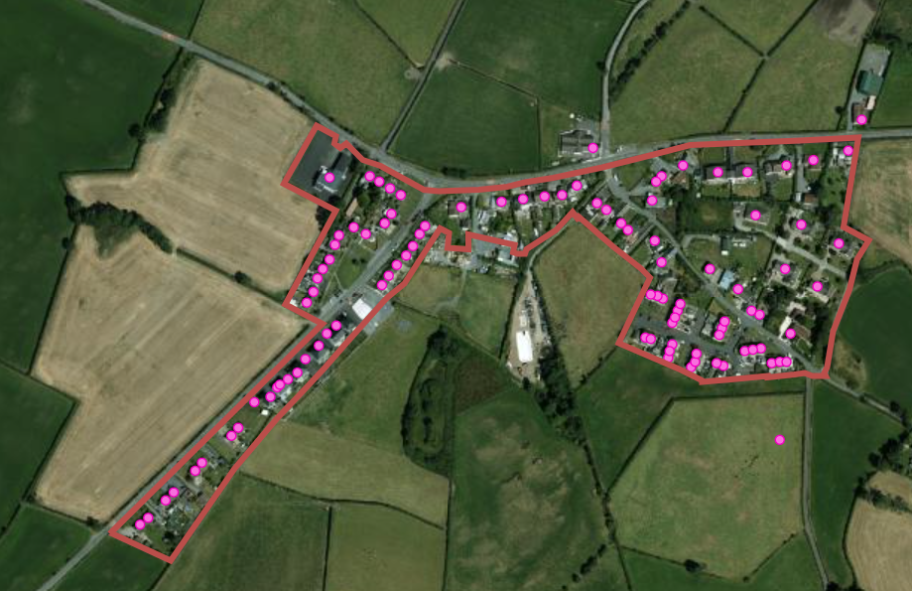
Address Points in Loughries

The above was a recent orthophotography image of Loughries with the address points shown and the Settlement Limit was delineated by the red line. While the number of address points hasn’t changed since the reports in December 2022 and May 2024, it may have been perceived that some new houses have been built along Finlay’s Road, but at the time of the December 2022 report, the address points had already been registered with Land and Property Services and were annotated on the map and were therefore counted at that time.

Furthermore, Council currently had no land holdings within or out with the Settlement Limit, so therefore land acquisition would be required to deliver any play provision in Loughries.

Summary
Currently Loughries did not meet the criteria as defined in planning policies and outlined in the Play Strategy, as:

- the threshold of 100 dwellings has not been reached and
- there is no Council land available.

Future Options
In the May 2024 report, it was put forward that if the residential unit threshold was met, Council could potentially look to explore a partnership with the Northern Ireland Housing Executive who have some land holdings in Loughries (see map on page 5). However, their land holding maps had now been updated and there was no land that would be deemed suitable for the creation of a play area.

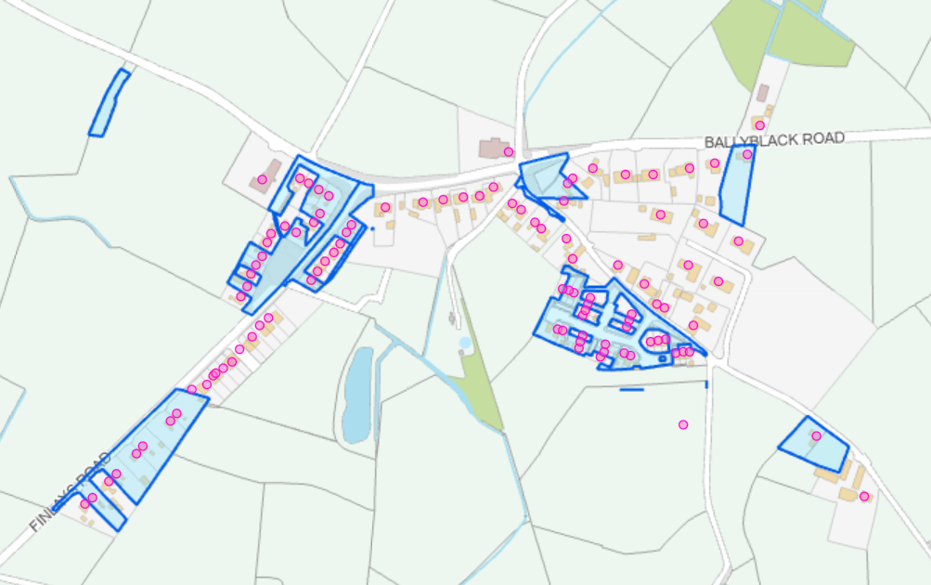
NIHE Land in Loughries

It should also be noted that there are other play parks which were close to Loughries, with the recently refurbished Londonderry Park (Tier 1) being 2.4 miles (by road) and ABMWLC Tier 0 which had an even wider catchment area as shown on the map insert below as well as Abbot Gardens (Bowtown) (Tier 2).

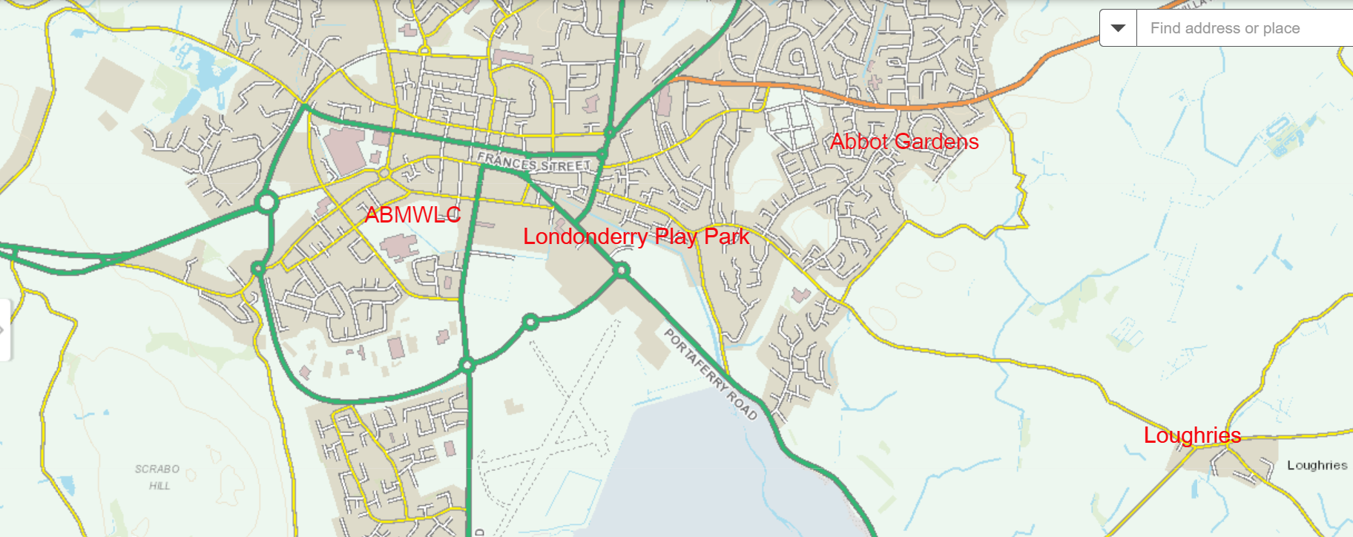
Nearby Play Parks in Newtownards

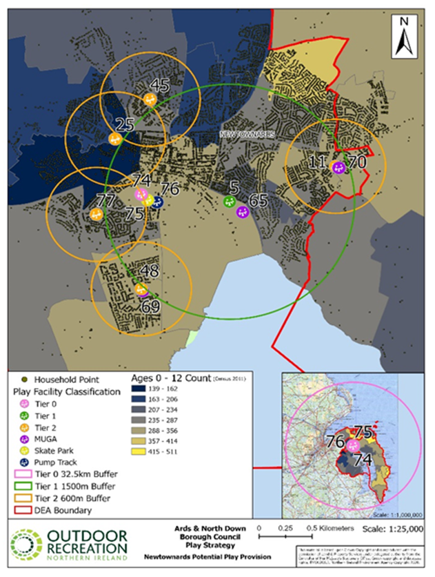
Catchment Areas of Play Parks in Newtownards

Private Land

Officers had written to the landowners of nearby parcels of land. To date Officers had not received any replies to the request to entered into discussions to see if the land could be used for a potential informal play and recreation area. Officers were continuing to make attempts to engage with the landowners to ascertain if the option of acquiring a piece of land for use as an informal play and recreation area was feasible in the future.

Recommended that Council notes this report.

Proposed by Alderman Adair, seconded by Councillor McClean, that the matter be deferred for three months.

Alderman Adair advised that there was prospect of opening up the lines of communication with landowners and he was asking for a small postponement to facilitate that.

AGREED TO RECOMMEND, on the proposal of Alderman Adair, seconded by Councillor McClean, that the matter be deferred for three months.

18. correspondence with the Prime minister’s office on winter fuel payments (CW173)

(Appendices XXI, XXII)

PREVIOUSLY CIRCULATED:- Report from the Director of Community and Wellbeing detailing attaching letter from Council Chief Executive to the Prime Minister and response from the Minister for the Department for Work and Pensions. The report detailed at the meeting of Ards and North Down Borough Council on 30th October, Council stated the position that it strongly opposed the UK Government's recent Winter Fuel Payment policy change and agreed to write to the Prime Minister concerning the matter. A response had now been received.

Recommended that Council notes the correspondence.

Proposed by Councillor Kendall, seconded by Councillor Cochrane, that the recommendation be adopted.

Councillor Kendall expressed her disappointment with the response.

Councillor Cochrane viewed the response as appalling and a disgraceful treatment of pensioners.

Alderman Adair also expressed his disappointment with the response and the changes that the government had made which had targeted the most vulnerable.

Councillor McClean shared a story from a constituent who was 102 years old who had contacted him asking for assistance. He noted that Bryson House had gone above and beyond to assist.

AGREED TO RECOMMEND, on the proposal of Councillor Kendall, seconded by Councillor Cochrane, that the recommendation be adopted.

19. notices of motion

19.1 Notice of Motion submitted by Councillor McCollum and Alderman McRandal

That this Council acknowledges with pride the outstanding achievement of Rory McIlroy in winning the US Masters tournament in August 2025, thereby completing an historic grand slam of Major tournament victories, his enormous contribution to golf through the world and his continued close association with and support for his hometown of Holywood. And further that this Council writes to congratulate Rory on his victory.

Proposed by Councillor McCollum, seconded by Alderman McRandal, that the Notice of Motion be adopted.

Councillor McCollum stated that last month, Rory McIlroy became the sixth player in the world and the first European to complete the career grand slam which put him in the history books alongside legendary names Tiger Woods and Jack Nicklaus. She stated that it give her enormous pride to propose the motion not just as a Councillor for Holywood and Clandeboye but for many years she had served in the parent teacher associations in both Rory’s former schools; St Patrick’s Primary School and Sullivan Upper, Holywood. Throughout her many years in those schools, she remarked that rarely a week went past when a parent or teacher did not point to the legacy of hard work focus and determination of Rory and the inspiration remained for many pupils there. On the morning after the Masters, the mood of Holywood Main Street was one of absolute elation, sheer relief and enormous pride for Rory. Councillor McCollum thanked Council Officers for delivering to all the traders in Holywood really beautiful congratulation posters. She advised that her son had been at the Masters and had spoken about the love and admiration for Rory across the world and were just as jubilant and moved at his sheer stature as a sportsman. Rory retained the grounded humility of which he was raised. He had steadfast refused to get sucked into the politicising and instead focused resolutely on his game. In doing that he was a phenomenal ambassador for Holywood, Northern Ireland, the island of Ireland and throughout the world. Councillor McCollum felt the main message from the historic win was the triumph of hope, determination and resilience. The Mayor had already written a letter of congratulations to Rory, and she was aware Officers were engaging with Rory’s team to try and establish a fitting appropriate tribute from the Borough. She asked that Officer’s continued to engage with Rory’s team with momentum in order to harness the enormous goodwill the historic win had generated.

Alderman McRandal stated that it was great honour to speak on the matter. Rory was born and raised in Holywood and that was where his talent was nurtured. Rory grew up to be one of the world’s best golfers and Holywood was bursting with pride. Rory’s achievements were worth great acknowledgement however highlighted the need to respect to celebrate his success and that it must be with his consent. The Council had a long-standing notice of motion that called for recognition of his achievements. Alderman McRandal asked when a report would be expected to come to Committee.

The Director advised that Officers were meeting with Rory’s team at the end of the month following which a report would be brought to the Committee.

Councillor Hollywood welcomed the motion and rose in support. Rory’s positivity could be seen across the world. He hoped something could be place that was prominent and permanent for all to see. He felt the Council’s appreciation to Rory needed to be highlighted on a much bigger scale.

Councillor McClean believed that there was much more to come from Rory. He highlighted the need to look at golf more strategically with many unbelievable courses in the Borough which he felt was a massive untapped potential.

In summing up, Councillor McCollum welcomed the update from the Director on the engagement. The Borough was the home of Rory, enormous mileage could be yearned from that, and she was aware the Head of Leisure had ideas in that regard in line with new leisure strategy.

AGREED TO RECOMMEND, on the proposal of Councillor McCollum, seconded by Alderman McRandal, that this Council acknowledges with pride the outstanding achievement of Rory McIlroy in winning the US Masters tournament in August 2025, thereby completing an historic grand slam of Major tournament victories, his enormous contribution to golf through the world and his continued close association with and support for his hometown of Holywood.

19.2 Notice of Motion submitted by Councillor Morgan and Councillor Ashe

Postponed to June Community and Wellbeing Committee

We are all aware that dog ownership has increased significantly over the past years. There is a fenced off area on “Muckers” in Comber, which is currently being used by NIW which when they have finished their work might lend itself to creating a dog park. This council should bring back a report that explores the options for creating a dog park in Comber.

20. any other notified business

There were no items of Any Other Notified Business.

Exclusion of public/press

AGREED, on the proposal of Alderman McRandal, seconded by Councillor Hollywood, that the public/press be excluded during discussion of the undernoted items of confidential business.

21. peaceplus tenders – themes 2 and 3 update (FILE PEACV-1)

***IN CONFIDENCE***

NOT FOR PUBLICATION

SCHEDULE 6:3 – information relating to the FINANCIAL OR BUSINESS AFFAIRS OF ANY PARTICULAR PERSON.

A report was considered that recommended the award of tenders for themes 2 and 3 of the Councils proposed PEACEPLUS Action plan

- Theme 2 - Thriving and Peaceful Communities
- Theme 3 - Building Respect for Cultural Identities

It was noted that the committee had delegated authority to approve the tenders on behalf of Council.

Recommended that Council approves the award of the PEACEPLUS tenders for themes 2 and 3 in accordance with assessment carried out on the tenders. Letters of Offer will be issued upon receipt of a Letter of Offer to Council from SEUPB.

AGREED TO RECOMMEND, on the proposal of Alderman McRandal , seconded by Councillor Moore, that the recommendation be adopted.

22. Peninsula 3g updated costs report (FILE CW74)

***IN CONFIDENCE***

NOT FOR Publication

SCHEDULE 6:3 – information relating to the FINANCIAL OR BUSINESS AFFAIRS OF ANY PARTICULAR PERSON.

PREVIOUSLY CIRCULATED:- Report from the Director of Community and Wellbeing detailing that the report provided updates on the required capital requirement, income and operating costs to inform Council of the expenditure to construct, operate and sustain the proposed facilities.

AGREED TO RECOMMEND, on the proposal of Councillor McClean, seconded by Councillor Cochrane, that the committee notes this report; and, in light of the cost overruns, provides as part of the future business case, a number of value-engineered options to be considered alongside to the current proposal so as to ensure the best likelihood of a facility being created in the area.

Re-admittance of public/press

Members paid tribute to the work of Alderman Brooks during his time as Chair of the Community and Wellbeing Committee.

AGREED, on the proposal of Councillor Kendall, seconded by Councillor Boyle, that the public/press be re-admitted to the meeting.

Termination of meeting

The meeting of terminated at 10.22 pm.

